Available online at [www.sciencedirect.com](http://www.sciencedirect.com/)



AASRI Procedia 3 (2012) 262 – 269

2012 AASRI Conference on Modeling, Identification and Control

Research on Permanent Magnet Linear Synchronous Motor Control System Simulation*

Tianwen Lia, Qingdong Yanga, Baoying Pengb

*a.The College Of Mechanical Engineering, Beijing Information Science & Technology University, Beijing, 100192,china*

*b. College of Mechanical Engineering and Applied Electronics Technology, Beijing University of Technology, Beijing 100024,china*

**Abstract**

Based on the analysis of mathematical models of PMLSM and theories of vector control, it puts forward control system modeling method, two control loops which are the inner current-loop and the outer speed-loop are used in Matlab/Simulink, permanent magnet linear synchronous motors mathematical model is also modeled by end effect and three phase asymmetric winding. The simulation results proved the affectivity of the system s model and verified its control calculation way, and it also provided sufficient theoretical basis for designing and adjusting in practical control system

© 2012 The Authors. Published by Elsevier B.V. Open access under [CC BY-NC-ND license.](http://creativecommons.org/licenses/by-nc-nd/3.0/)

© 2012 Published by Elsevier B.V. Selection and/or peer rev[iew under responsi](http://creativecommons.org/licenses/by-nc-nd/3.0/)bility of American Applied Science Research Institute

Selection and/or peer review under responsibility of American Applied Science Research Institute

*Keywords*: PMLSM, SVPWM, modeling, closed  loop, simulation;

# Introduction

The permanent magnet synchronous linear motor that is a new feed transmission, and it does not use mechanical transmissions. The permanent magnet synchronous linear motor was more and more used in factory automation and numerical control systems because they can be operated without indirect coupling

* The national major specialized subjectTop grade CNC machine tools and basic manufacturing equipment (2011ZX04002062) Corresponding Author:Tianwen Li/Email:litianwen19872008@126.com/Tel:18801027570

2212-6716 © 2012 The Authors. Published by Elsevier B.V. Open access under [CC BY-NC-ND license.](http://creativecommons.org/licenses/by-nc-nd/3.0/) Selection and/or peer review under responsibility of American Applied Science Research Institute doi:10.1016/j.aasri.2012.11.043

mechanisms, such as gear boxes, chains and screw coupling, allowing high precision control to be achieved. It is a trance that linear motors are widely used in high performance CNC machine tools [1]. The vector control system of permanent magnet synchronous linear motor doesn t have the advantage of high precision control and high dynamic performance, but also can change speed more conveniently, as a result, the system attract more and more scholars to pay attention home and abroad [2]. The experiment has built the model of vector control system of PMSLM based on the environment of MATLAB software, which can provide the design and work of actual system with a new measure.

# Mathematical model of PMLSM

The model of linear synchronous motor with permanent magnets is given in the "rotor" coordinates; it is derived from the model of rotary PMSM motor, which is based on the general theory of electrical machines.

The model is valid only under the (simplistic) terms: the windings is three-phase, symmetrical, connected in star and with not connected central node, magnetizing characteristic is linear, loss in the magnetic circuit is zero, resistances and inductances are constant, air gap is constant, magnetic field in the air gap has a sinusoidal distribution and in the longitudinal axis is constant, boundary effects and the influence of the grooves is not considered.

*q*

*b*

*d*

0

*a*

*c*

Fig.1. Coordinate system

Because that three phase permanent magnet synchronous linear motor has the characters of Multi variable, nonlinear and strong coupling. Engineers can t control anyone of three phases directly. To control it more conveniently, the model should be described in the d-q coordinate system. According to unified theory of electric motor, the equation from three-phase static coordinates to rotary two-phase coordinates as follow:

*C*3*s*/2*s*



cos cos(

sin sin(

2 )

3

2 )

3

cos(

sin(

2 )

3

2 )

3

1

2

2

3

1

2

1

2

*(1)*

Thus, the following voltages equation of the stator which in the d-q coordinates system is given easily.

*ud ua*

*u * *C u*

*(2)*

*q* 3*s* / 2 *s b*

*u*0 *uc*

The mathematical model of permanent magnet synchronous motor can be described, in the two-axis d q synchronously travelling frame, by the following deferential equation 

The voltage equation in d axis 

*L did*



*d dt*

*R id * *ud * *v Lq iq*

*(3)*

The voltage equation in q axis 

*(4)*

*L diq*

*q dt*

*R iq * *uq * *v Ld id f * *v*

Power calculation is following:

*F* 3 *N* ( *i * (*L * *L* )*i i* )

*(5)*

*e* 2 *p f q d q q d*

The dynamic equation of linear motors 

*M dv*

*dt*

*F e * *Fd * *Bvv*

*(6)*

The velocity of linear motors as follow 

*v * 2 *f*

*(7)*

There, ud, uq and id, iq are respectively voltage and current components in d-q axes. Ld, Lq are d-q axes

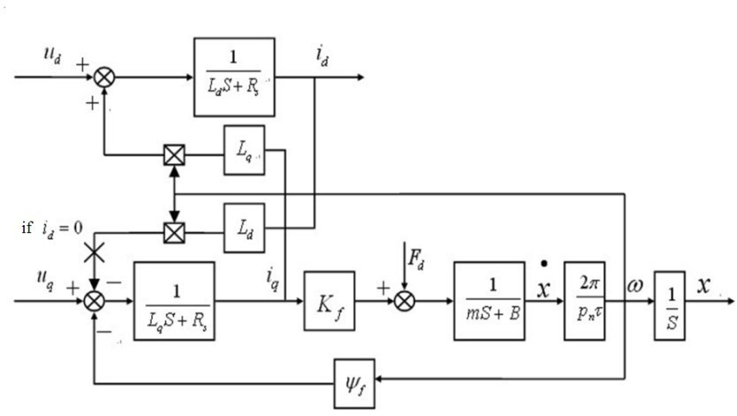

inductance, f is permanent magnet linkage, R is winding resistance, f is linear motor frequency, Np is the

. According these equations, the model can be given:

Figure.2. mathematical model of PMLSM

# Simulation experiment

* 1. *Vector control*

Vector control is based on the principle that to maintain constant magnetic flux in the motor in the d-q axis the stator current vector is decomposed into two components: a component of the rotor flux vector coincides generated magnetic flux, which called the excitation current component; Another one is perpendicular to the flux vector, generated torque, which called torque current component. Through regulating the position and size of the stator current vector, the component of exciting current and torque current can be controlled well. Thus, AC motor can come true decoupling of the magnetic field and torque which is the same as DC motors. The frequency control system of motor speed for AC motors has the same advantage like the DC motors. According to the third equation building abc-dq module as follow

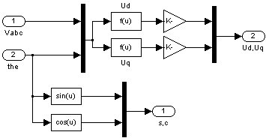

Fig.3. the block of abc-dq

*2.2 Model of PMLSM*

According to the formula (4) and formula (5), establish the module of balance equation of the straight line machine

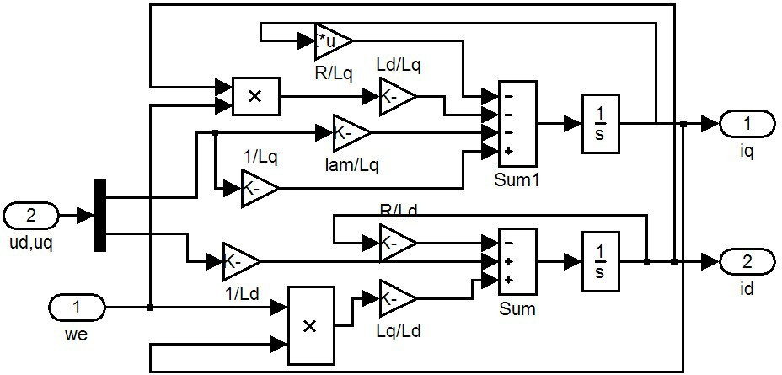

Fig.4. the block of voltage equations of equilibrium

Similarly, according to the equation (6) and Equation (7), built the block of motion of the linear motor, as shown in Figure five:

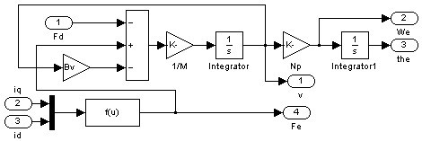

Fig.5. the block of mechanical equation

Connecting the voltage equations of equilibrium module and the mechanical movement equations of equilibrium module, which was packaged as a sub-module system, and forming the linear motor simulation module, shown in Figure 6 below. Applying the package technology on SIMULINK module and packaged module is added to the SIMULINK toolbox, so that the linear motor servo control system can be used directly. Linked the SVPWM module and linear motor module which formed a closed loop system, the simulation model was shown in Figure 7.

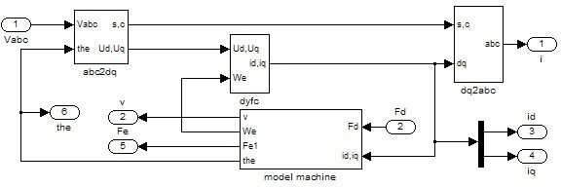

Fig.6. Simulation model block diagram of the linear motor

Based on the simulation environment of Matlab/Simulink, the simulation model of speed loop can be established in conditions of no-load, which be shown in Figure 7. Among them, the role of the current loop is to accept the current deviation signal, and generates a voltage signal which can control the on-off switch of electronic devices of SVPWM (center frequency is 10KHZ). Output of SVPWM was linked directly to the winding of Permanent Magnet Synchronous Linear Motor so that could achieve the goal of controlling s movement. By controlling the extern part of the speed loop, adjust the deviation signal of speed, which was looked as output current command. The inner ring is current loop, and it control received current of PMSLM by regulating controller in current loop.

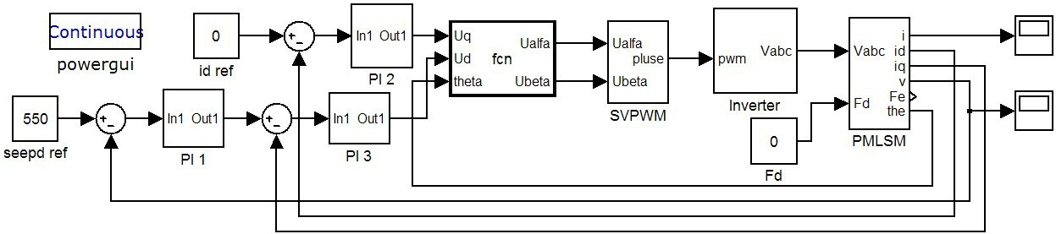

Fig.7. Simulation model of PMLSM control system

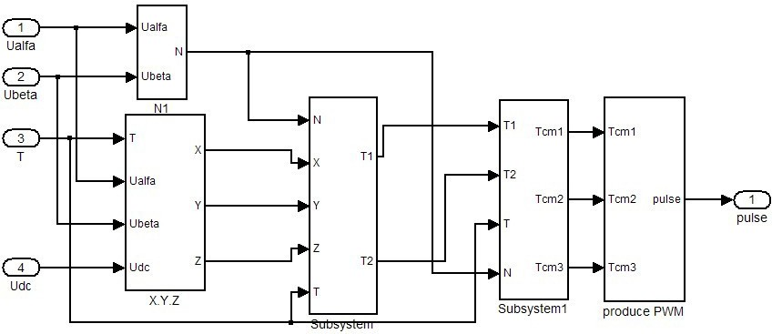

Fig.8. Simulation model of SVPWM.

# Simulation results of PMLSM control system

In order to check whether the simulation model is valid or not, the simulation experiment was completed in Matlab7.1 Software. Because of the nonlinear component, the experiment select ode23td algorithm which is a variable step way, the relative error and absolute error is 0.001; the parameters of PMLSM are: phase resistance R = 3. 2 axis inductance Ld =8mH, q-axis inductance Lq = 8mH, the flux of permanent magnet

2mm,the number of pole pairs Np = 2. Try to select a group of PI parameters which have been optimized, the parameters of speed loop PI are: Kp = 0.28, Ki = 40. The parameters of current loop PI are: Kp = 30, Kpi = 2000. The sampling time of velocity was taken 0.001 second, and the sampling time of velocity was 0.0001 second. The simulation time is 0.4, given the speed command to run the simulation. The waveforms and three-phase current output waveform of PMLSM can be observed through the window of the scope. The obtained experimental results are shown in Figure 9 and Figure 10.

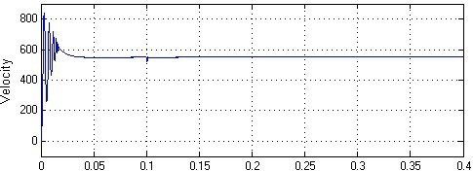

Fig.9.Speed waveform without load

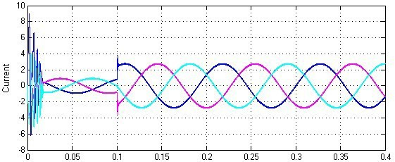

Fig.10. Phase current responses of PMLSM

# Conclusion

For AC servo control system, Rapidity, Accuracy and Stability are the main performance indexes to estimate whether it is efficient. The simulation result shows, when a speed command is given, the permanent magnet linear synchronous motors (PMLSM) can attain the given speed by adjusting the speed loop and current loop and the Rate response curves in time domain is more ideal. The speed loop simulation system can run smoothly and features excellent dynamic and static performances. The experiment fully illustrated and proved the correctness of PMLSM mathematical model and the feasibility of this control algorithm and it offered the thinking for the further designing and adjusting of direct drive system.

# References

1. LAI Guoting, WU Yuhou,FU Dawei. Velocity and Acceleration Feedback Control for Linear Motor Based on PMAC. Journal of Control Engineering of China, vol..6, 2003. (In Chinese).
2. BIMALK BOSE. Modern Power Electronics and AC Drives [M ].[ S. .l ]: Pearson Education, 2001.
3. Wang Chengyuan. Vector control of AC servo drive motors
4. Ye Yunyue. Principle and application of linear motor [M]. China Machine Press, 2002.
5. Myung J. Chung, Moon G.Lee.A Method of Optimal Design for Minimization of Force Ripple in Linear Brushless Permanent Magnet Motor. IEEE Conf. 2000.
6. Lu Junyong Ma Weiming Modeling simulation and testing of linear permanent magnet DC motor[C] The International EML Symposium Potsdam Germany 2006

[7]Y. Kakino. Tools for High Speed and High AccelerationFeed Drive System of NC Maschine Tools.In

Proceedings of the 2th International Symposium on Linear Drives for Industry Applications, pages1521,

Tokyo, Japan, April 1998

[8]H. B. Zhao, J. X. Jin, and J. Cheng. Virtual instrument based fuzzy control system for PMLSM drive. Chengdu: Proceeding of IEEE on Applied Superconductivity and Electromagnetic Devices, 2009: 299-303. [9]L. H. Zheng, and J. X. Jin. Investigation of HTS bulk magnet linear synchronous motors. Chengdu: Proceeding of IEEE on Applied Superconductivity and Electromagnetic Devices, 2009: 17-21.

[10]J. X. Jin, and L. H. Zheng. A permanent magnet linear synchronous motor control system based on space vector pulse width modulation, CAAI Transactions on Intelligent Systems, 2009, 4(3), 251-257.

[11]L. Zhong, M. F. Rarman,W. Y. Hu, et al. Analysis of direct torque control in permanent magnet synchronous motor drives, IEEE Transactions on Power Electronics, 1997, 12(3),528-536.

# Contact of Corresponding Author:

Tianwen Li,litianwen19872008@126.com,18801027570