[Applied Computing and Informatics 15 (2019) 136–143](https://doi.org/10.1016/j.aci.2018.01.003)



Contents lists available at [ScienceDirect](http://www.sciencedirect.com/science/journal/22108327)

Applied Computing and Informatics

journal homepage: [www.sciencedirect.com](http://www.sciencedirect.com/)

Original Article

[](http://crossmark.crossref.org/dialog/?doi=10.1016/j.aci.2018.01.003&domain=pdf)Risk level reduction in construction sites: Towards a computer aided methodology – A case study

Nuno Ferreira a,c, Gilberto Santos b,⇑, Rui Silva c

a *Joaquim Peixoto Azevedo & Filhos, Lda, R. de Longras 44, Vila Verde, Braga, Portugal*

b *College of Design, Polytechnic Institute Cavado and Ave, Barcelos, Portugal*

c *Lusíada University, CLEGI, Vila Nova de Famalicão, Portugal*

# a r t i c l e i n f o

*Article history:*

Received 24 May 2017

Revised 15 January 2018

Accepted 17 January 2018

Available online 31 January 2018

*Keywords:*

Computer aided methodology Occupational health and safety Risk evaluation

Risk distribution chronogram

# a b s t r a c t

There has been increased concern in the evaluation of risk in the construction field and it is common to have it performed for every task, function and machine. Nonetheless this commonly used approach does not take into account most of the intrinsic variables inherent to a site construction and hence several fac- tors reported in literature, as well as experience based analysis, suggest that spatial and temporal vari- ables have a strong influence on risk level distribution. To evaluate the impact of these factors a study was conducted concerning the simultaneity of risks in the construction of an Aged People Hostel, in the district of Braga, Portugal. A method was developed in order to reduce peaks of previously estimated risk levels through the reorganization of tasks in time and space attaining a substantial reduction in peak risk tasks. This study, along with the increasing availability of computing tools pertaining to the construc- tion area, demonstrates the necessity for the development of new strategies regarding integrated risk management and planning during the project phase that substantially mitigate risk peaks during construction.

© 2018 The Authors. Production and hosting by Elsevier B.V. on behalf of King Saud University. This is an

open access article under the CC BY-NC-ND license (<http://creativecommons.org/licenses/by-nc-nd/4.0/>).

1. Introduction

Risk evaluation has begun half a century following the indus- trial revolution in England [1] due to a growing concern regarding working conditions, accidents and other risk factors, which were common in the domain of first industries. Nevertheless it was in the United States of America that the first initiatives regarding risk prevention took place, given the government, entrepreneurs and specialists intervention. In 1928 *The American Engineering Council* had already demonstrated the existing connections between the direct and indirect costs linked to accidents such as payment of non-productive manpower, financial losses and production disrup- tion. In 1931 H.W. Heinrich [2] made public a study revealing the direct and indirect costs of work accidents outlining a method that

* Corresponding author at: ESD - Campus do IPCA, Vila Nova Frescaínha, 4750- 810 Barcelos Portugal.

*E-mail address:* [gsantos@ipca.pt](mailto:gsantos@ipca.pt) (G. Santos).

Peer review under responsibility of King Saud University.

**Production and hosting by Elsevier**

was later known as the domino theory. The study underlined the causality effect as determinant for a cascade effect ruled by five factors: social ambience, human error, dangerous conditions, acci- dent and personal damage [3]. Risk assessment is an important tool for risk prevention at work and regardless of the method its assessment is fundamental [4,5,11].

A greater concern towards both cause and effect of risk has been growing and reported approaches are abundant in literature. Simonds [4] presented a method for the calculation of costs associ- ated with some types of accidents which might result in lesions,

medical assistance, first aid help and accidents without injuries [5]. In 1953 Recommendation n° 97 of *The International Conference of Work* sets some basic guidelines for the protection of health con- cerning the workers: practical actions to prevent, reduce and elim- inate risks, medical care for workers, notification of occupational diseases and facilities for first aid and emergency treatment in case of accident. Bird & Germain [6] published another study where

90,000 accidents in a siderurgical enterprise were analysed giving place to measures that were motivated by the costs resulting from accidents. Towards the end of the 20th century a growing concern emerged on the prevention of risk factor exposure or professional disease [7,8,9,39]. Further, research and practice demonstrated that decisions made prior to work at construction sites can

<https://doi.org/10.1016/j.aci.2018.01.003>

2210-8327/© 2018 The Authors. Production and hosting by Elsevier B.V. on behalf of King Saud University.

This is an open access article under the CC BY-NC-ND license (<http://creativecommons.org/licenses/by-nc-nd/4.0/>).

influence the safety of construction workers [10]. In fact, according to Kuo and Lu [11] an effective risk management of construction projects requires a reliable risk assessment and risk treatment plan. Risk analysis is a core process of safety management [12] and also, safety is a prominent feature in complex systems and there is an abundance of different approaches on how to handle it [13]. By definition, risk analysis deals with uncertain situations, that is, with situations in which there is no complete and accurate knowledge about the state of the system [14]. With the industrial and social development already attained the perspective of risk assessment has gained another dimension.

1. Integrated risk management

Falls represent a major care and cost problem to health and social services world-widely given that 50% of falls result in an injury [15] and it is known that injuries at work have a substantial economic and societal burden [16,17]. Doulamis et al. [40]; Bourke et al. [41] and Li et al. [42] proposed new methodologies based on accelerometers and gyroscopes for the detection of falls neverthe- less the main drawbacks of these studies concern the distinction between involuntary human falls from normal movements similar to falls. The difficulties encountered in these studies demonstrate the importance of detecting and preventing the risk of falls. In gen- eral organizations adopt safety management systems or behavior- based systems approaches to safety functions in an attempt to achieve performance excellence [18,19].

Some authors defend that safety and health management at work should be initiated and integrated during the project period

[20] and safety management must be organized in function of the building processes, the architectonic and structural solution adopted. Santos et al. [21] characterize the Portuguese view on how enterprises deal with the Occupational Health and Safety Management Systems certification process, after receiving the Quality Management System certification. The authors found that in most cases the Occupational Health and Safety Management Systems certification process are the last to be implemented which is corroborated by other authors [22,23,24]. An Occupational Health and Safety Management System is defined as ‘‘a set of tools that enhance safety risk management efficiency related to all the organization‘s work activities” [25,26] however enterprises that have implemented the Quality Management System certification reported improvements in working conditions and in ensuring compliance with applicable health and safety legislation [21]. In high-risk organizations much effort has been made to standardize procedures in order to streamline human action to decrease risk and increase productivity [26].

Badri et al. [27], upon his literature review on the integration and management of safety with the project management, state the existence of many published books (60% of the selected pub- lished books) that envisage the integration of risks management with process control in the civil construction field as a fatality. Lately different approaches to the problem have been suggested, several authors [28,29,30] have tried to combine scheduled tasks to the programming and safety measures. Also, and due to critical nature and high number of working accidents, several researchers have proposed tools to integrate safety management in the process of production programming. The following authors are just a few that made attempts to integrate different aspects regarding risk assessment and control: Hare et al. [29] tried to integrate safety management within the project phase. He used an approach based on discussions with experts on civil construction in order to determine the critical and detriment factors for the development of an integrative model for safety management; Zhang et al. [31] proposed an automatic application integrated in recent systems

Building Information Modelling (BIM) - This application allows for an automatic analysis of the virtual construction model in order to detect and suggest preventive measures. It allows for the iden- tification of locations and periods during which safety measures should be implemented in earlier stages of construction; Yi & Lang- ford [30] introduced the concept of combining the timetable of dif- ferent tasks with the programming of safety measures. They aim at improving the perception of places and periods during which the workers are potentially more prone and vulnerable to serious acci- dents. They defend that if the mentioned places and periods are previously identified necessary and adequate safety measures can be taken to avoid situations of high risk. They also state that safety planning requires coordination with the programming/ chronological register of works to identify situations when the risk exceeds the admissible limits for the project. Besides reducing the accident indexes this coordination concurs for the reduction in the project costs; Doulamis et al. [43] use a different approach and apply a resource allocation algorithm to minimize, but not elimi- nate, overlapping tasks assigned to the same processor.

Other approaches to risk management increasingly take advan- tage of digital technology [8] and its inherent capability to handle massive quantities of information. Zhou et al. [32] established a relationship between the risks in civil construction industry and the digital and technological development verified in the concep- tion of buildings and show the existence of several digital tools which broach the safety questions during the construction period. Nevertheless very few digital tools promote safety during the pro- ject phase integrated into the work planning. They go on saying that the digital tools broaching the safety measures in the project phase are technically precocious. Hadikusumo & Rowlinson [33] developed a tool to visualize the building process taking advantage of recent virtual reality technologies - they developed a model able to see all the constructive process still in the project phase. The use of this tool during construction planning allows managers to access safety management and identify, evaluate and control the existing risks in the construction site. Kartam [28] through the Critical Path Method (CPM) joined safety management with work management programming based on planning, organization, control and leader- ship principles. The proposed methodology has processes of con- trol through engineering procedures, training and the right fulfilment of normative requests and it allows for the program- ming, management and safety control in every phase of the con- struction project. Fung et al. [34] developed a Risk Assessment Model (RAM) for the different periods of a project in the civil con- struction to help safety managers and workers in understanding the real risks in their working functions. This method gives a quan- titative evaluation based on historical data and was tested in a real working atmosphere to validate its credibility. Thus, proactive haz- ard identification and elimination is always safer and more cost effective than reactive hazard management [35]. Liu et al. [36] pre- sents an improved risk priority number approach based on a fuzzy measure and fuzzy integral. A fuzzy measure is used to reflect the importance of the individual indicators and the indicator set and a fuzzy integral is a nonlinear function defined on the basis of fuzzy measure. Molen et al. [37] evaluates the effectiveness of a face-to- face strategy and a direct mailing strategy on safety violations while working from heights among construction companies com- pared to a control condition.

1. Material and methods

The work presented in this paper addresses some of the limitations presented by other approaches regarding the evalua- tion and use of different risk probability variability within a con- struction site location and proposes enhancements concerning

the optimized distribution of risk within the project plan. Taking into consideration the presented approaches for risk assessment and their limitations, this study adds a physical and temporal dimension to the problem and is later assessed through a case study. This paper presents a new methodology for risk assessment in construction sites and it is designed to explore some of the lim- itations of the previously presented studies. It takes into consider- ation previous frameworks and addresses the limited results on the relationship between physical and temporal risk hazard locations providing a map that can be easily assessed to depict critical risk in time and space. There are several theoretical assessment methodologies, however, evaluations that address time and space and are corroborated by a case study have not been yet been pre- sented and validated.

This method was explored and evaluated during the construc- tion of an Aged People Hostel - The building budgeted in 2.5 mil- lion Euro has three floors and approximately 4000 m2 of construction area and a construction period of one year. The infor- mation registered for this construction site was the following: the required working days to accomplish each task, their start and con- clusion date and if applicable the total number of periods of work. Fig. 1 details the information previously described in the form of a chronogram.

Together with task records it was conducted an evaluation of risk for each of the tasks (162 tasks) using the Composed Matrix Method [38]. This method (by the Instituto Nacional de Seguridad e Higiene en el Trabalho, 1995) enables the estimation of risk mag- nitude through the identification of existing deficiencies, their probability of occurrence and associated risk consequence. The Risk Level (RL) is a function of the Probability Level (PL) of some accident and Consequence Level (CL) regarding associated dam- ages, and can be represented as follows:

*RL* ¼ *PL* × *CL*

The Probability Level (PL) can be determined as a function of Deficiency (insufficient) Level (DL) of the preventive measures and Exposure Level (EL) to risk, and can be expressed by:

*PL* ¼ *DL* × *EL*

where the Deficiency Level (DL) is the expectable amplitude between the set of risk factors considered and its direct relation to possible accidents. The Exposure Level (EL) is a measure of fre- quency of occurrence of risk exposure and is estimated on the basis of start times in work areas [38].

The quantification of Deficiency Level, exposure and conse- quence, was performed by direct observation of each task in the real working environment. To get the most rigorous risk assess- ment and therefore reflect the reality of this type of work there was no interference in the form of the work involved or the time required to perform tasks. Only preventive measures were consid- ered, verified and implemented by workers during working hours. The quantification of risk associated with each task was through the matrix represented schematically in Fig. 2. Risk characteristics of each task are represented by the sum of the risks associated with

the different activities required to complete the respective task. The tasks presented in Fig. 2, including filing reinforced con-

crete pillars, filing reinforced concrete stairs, walls roofing filling layer implementation, filling pavements, application of protection guards on balconies and stairs, respectively obtained the following individual levels of risk: 116,330, 92,820, 41,600, 37,980, 17,930 and 17,930. The most observed risks in the majority of task were the following: the risks of falls from higher levels; falls at the same level; incorrect ergonomic postures; and, electrical hazard. The cal- culated risk was distributed along the chronogram of work to get a real chronogram with the quantification of associated risks for each task, that is to say, a risk map. Fig. 3 presents a schematic

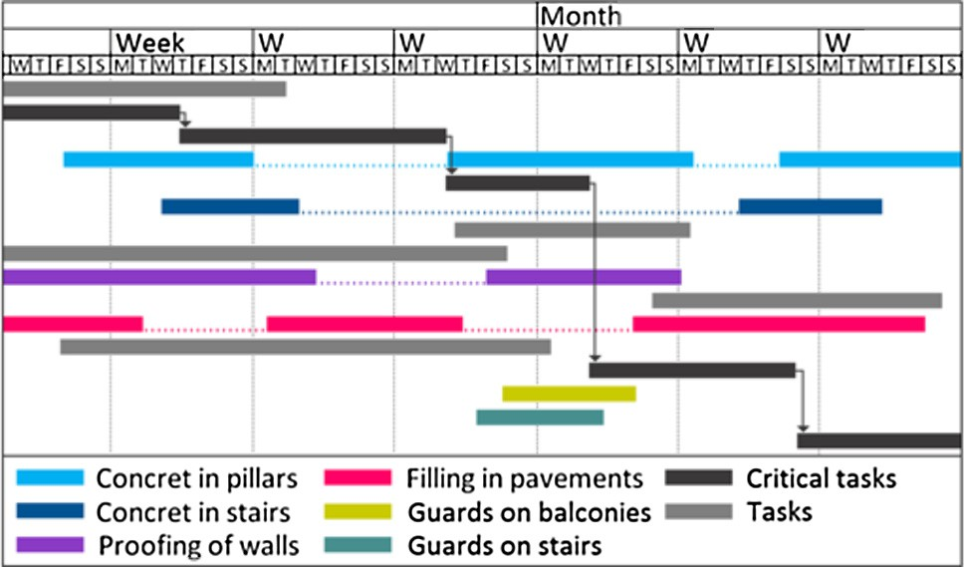

Fig. 1. Schematic representation of the chronogram in the initial works. Adapted from [5].

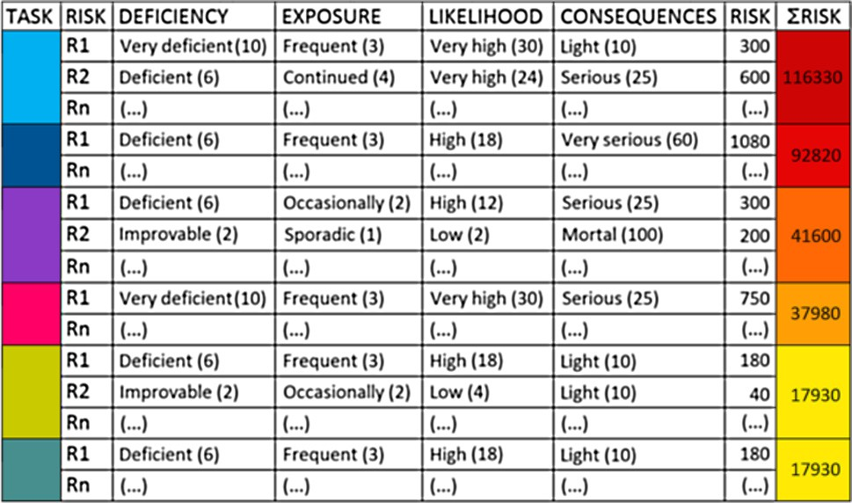

Fig. 2. Schematic representation of the risk assessment matrix. Adapted from [5].

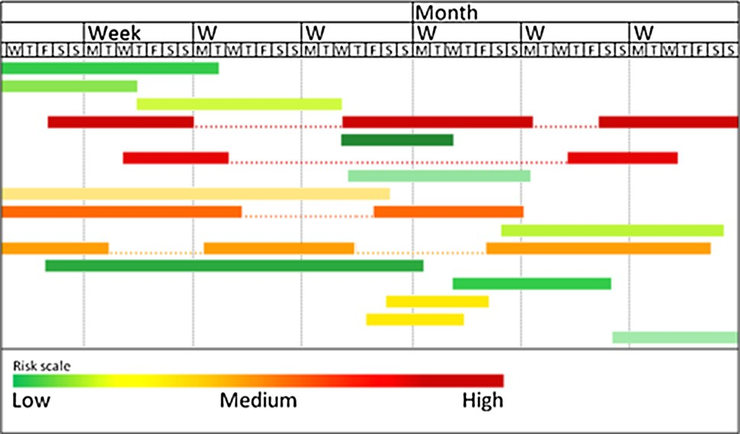

Fig. 3. Schematic representation of the risk distribution by the work schedule. Adapted from [5].

representation of the risk chronogram and associated task risk magnitude.

The obtained risk map combined with the working chronogram and associated risk evaluation makes it possible to quantify the daily level of accumulated risk as function of the work taking place at each spot. Several types of graphics may now be developed con- sidering the temporal factor and the evaluated risk distribution. This new approach can be analysed from different perspectives, according to the relevance of the combined factors, these are:

– For tasks with the same level of risk evaluation, linked but not juxtaposed, a graph of accumulated risk is developed, linear and constant according to Fig. 4. This type of graph is ideal to monitor and treat associated risk. Although in some phases of

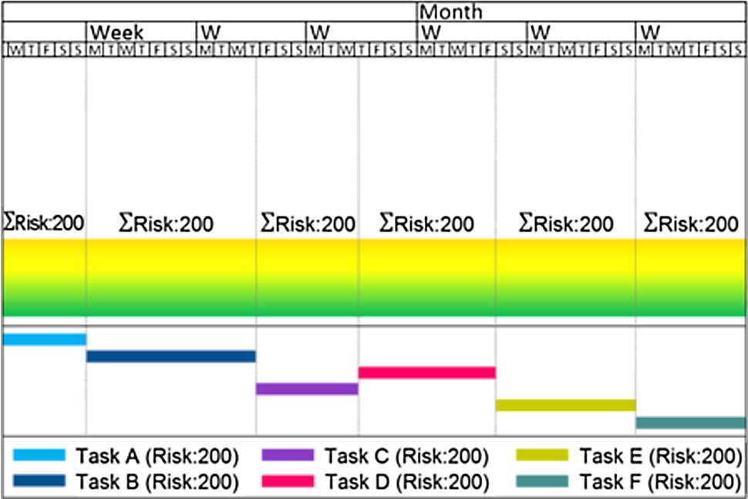 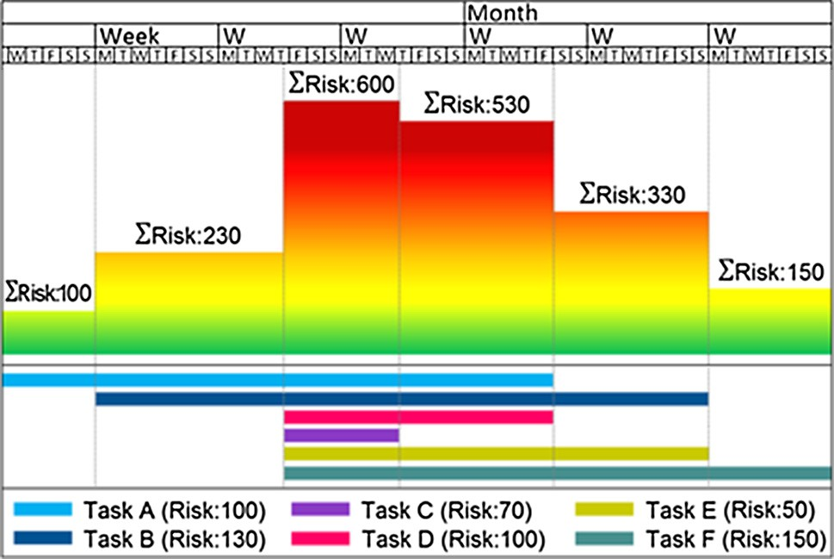

Fig. 4. Schematic representation for tasks with the same level of risk evaluation, linked but not juxtaposed.

Fig. 6. Schematic representation for tasks with different levels of risk simultane- ously executed (in the same period of time).

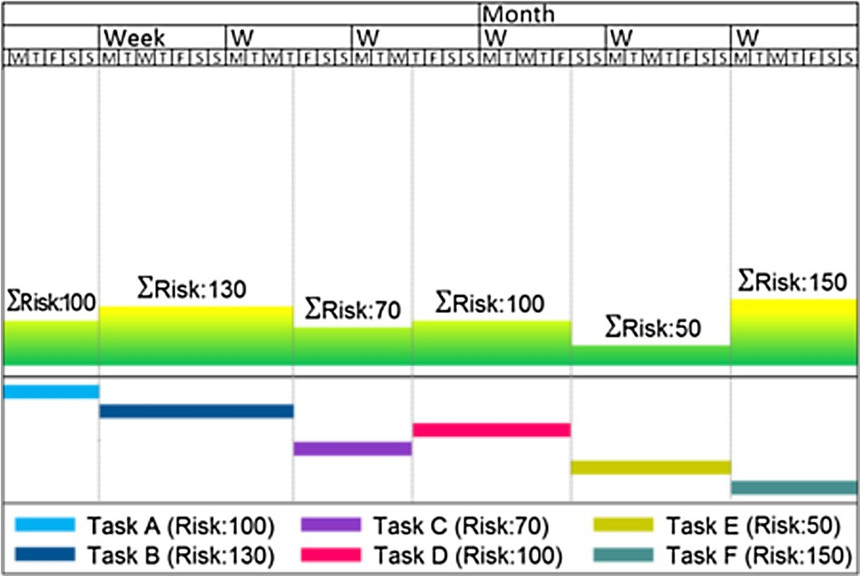

Fig. 5. Schematic representation for tasks with different levels of risk linked sequentially, but not juxtaposed.

construction there are some duly linked tasks which cannot begin without the conclusion of previous ones quantification of individual risk level is not always equal.

* For tasks linked sequentially with different levels of risk, but not juxtaposed, a graph of accumulated variable risk is developed with defined levels according to Fig. 5. This is the type of graph which better mirrors a sequence of tasks of different nature but duly linked. That is to say that this graph characterizes the set of several tasks with different risk level, developed in sequence, one after the other.
* For tasks simultaneously executed with different levels of risk (in the same period of time) a graph of accumulated risk is developed, variable with well-defined levels but with very dif- ferent valuations, according to Fig.6. With the simultaneity of tasks the level of accumulated risk represents the total amount of risk levels juxtaposed. This is the most usual and common graph observed during construction.

Following the identification of the phases of the work with higher risk probability a number of organizational measures were adopted that aimed at reducing peak risks values. The introduced alterations aimed at reducing the number of simultaneous tasks without interfering with critical activities and in the majority of the cases resulted in the adjustment on the days pertaining to the beginning and end of tasks, preserving the working days neces- sary for the site construction. Critical activities are those that can- not have any delay on completion and must be completed at a

Fig. 7. Histogram of level of accumulated risk. Adapted from [5].

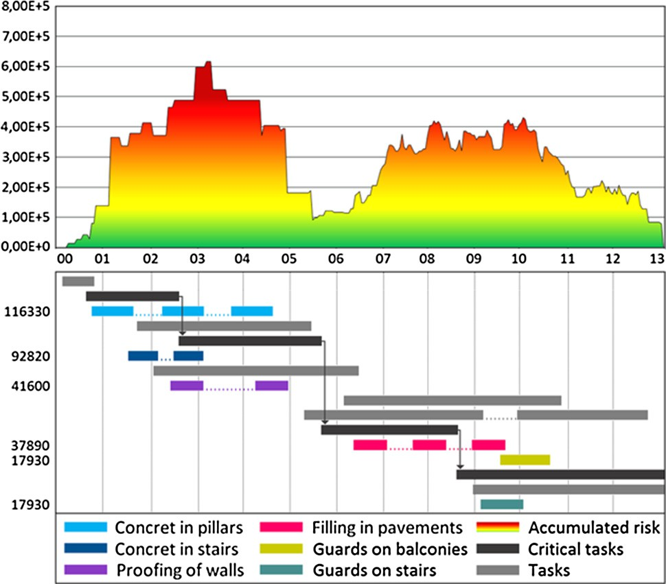defined / scheduled time. Taking into account the initial chrono- gram and the introduced alterations a new histogram of accumu- lated risk was obtained.

1. Results

The following three subsections present the different approaches to risk distribution assessment and prediction as well as a final comparison subsection. In the first part it is presented the traditional analyses carried to determine probable problematic periods concerning risk levels. The second part introduces into the risk assessment analyses the proposed method taking into account time and space redistribution of risk. The final part gives a compar- ison concerning the implementation of this method as well as providing evidences pertaining to its benefits on assessing risk and complementary planning of tasks during construction.

* 1. *Initial histogram*

The obtained risk distribution histogram (Fig.7) is characteristic of this type of construction for the category of building. This type is characterized by two distinct phases of higher risk normally separated by a lower risk period of time. The first period includes

formwork and stripping of every element of concrete which com- pose the building. The second includes the execution of all neces- sary finishing works. Generally, between these phases there is a small appeasement or even a total stop of every kind of work. This appeasement or pause is due to the time required for hardening of the concrete elements, which attain their project resistance after 28 days.

According to Fig. 7 it is shown that the first month of work reveals a small and residual level of risk given the tasks associated, namely the settlement of the dock and cleaning of the ground. Dur- ing the following months tasks such as installation and preparation of every type of support equipment takes place as well as the installation of sanitary facilities and social fittings giving rise to higher levels of risk. Additionally there are a number of different tasks developed simultaneously concerning mainly to the execu- tion of elements in concrete. Generally the execution of tasks in this period have the highest risk index since it involves works in height, digging works and movement of hanging cargoes.

Following this higher level of risk there is a reduction in the number of tasks executed simultaneously that lasts approximately 28 days, the required period for the concrete elements to attain the necessary resistance. It is also shown that works will not cease and hence the correspondent risk associated persists, although smaller. The following four months are characterized by irregular and broad peaks due mainly to the high simultaneity of developed tasks. Although the risks associated with on-going tasks have lower levels there is high simultaneity of tasks and people working in the building causing a rather high accumulated risk. Although the last two months are also characterized by a high simultaneity of tasks the risk level associated with each task is smaller giving rise to a lower accumulated risk, due mainly to finishing tasks, tests and cleaning. Hence, the accumulated risk pattern generated for this construction site reveal two distinct phases of higher risk incidence mainly due to the accumulated risk inherent to simulta- neous execution of tasks. Generally, these histograms are obtained using data collected on site and represent the risk accumulated daily during the period of execution of the work. This method can be applied to other types of construction works.

* 1. *Redistribution of risk and task simultaneity analysis*

Following the identification of risk distribution along the execu- tion plan measures were studied in order to diminishing the risk peaks throughout the timeline of the project. These organizational measures were established, without limiting the correct develop- ment of work, i.e. without interfering with critic activities, consid- ering mostly the reduction of simultaneous tasks with the aim of diminishing the peaks obtained in each of the phases. Critical tasks are those that cannot be delayed and hence be completed within a predefined / scheduled time and determine the critical path.

The modifications introduced preserve the duration of the pro- ject and concern mainly in shifting tasks that are not on the critical path and may have their schedule changed without major impact on the overall project. The proposed and adopted alterations are as follow:

* + - Considering the existence of three distinct periods concerning the setting of concrete on pillars it was considered a shift on the second period anticipating it by eight working days;
    - Concrete setting in stairs were anticipated by eight working days;
    - Wall proofing was anticipated by one working day, while the second phase was delayed three working days;
    - The first pavement filling layer stages, on the very beginning subdivided into three periods, was divided in two, anticipating the second in eleven working days;

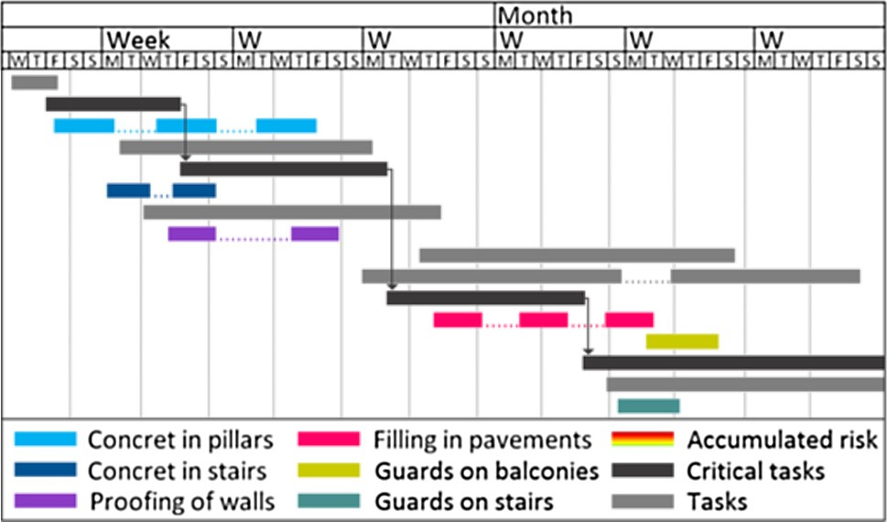

Fig. 8. Schematic representation of the working chronogram before the establish- ment of organizational measures. Adapted from [5].

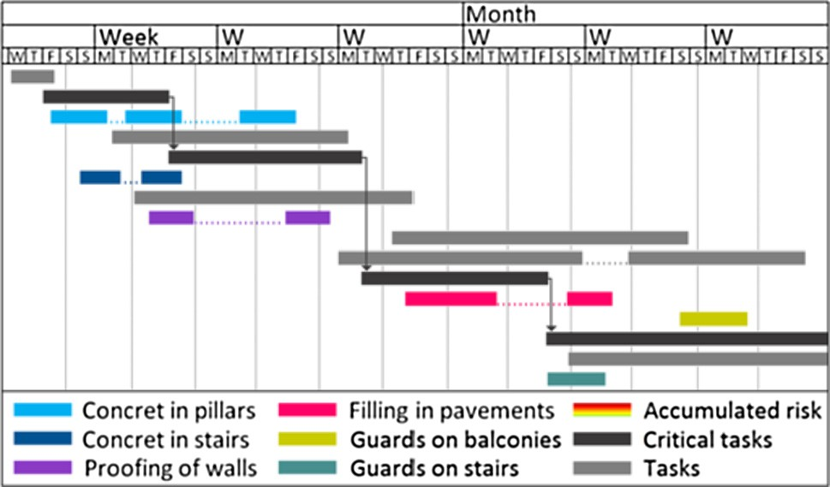

Fig. 9. Schematic representation of the working chronogram after the establish- ment of organizational measures. Adapted from [5].

* + - The task of applying protection guards in interior and exterior openings was delayed seventeen days;
    - The task of applying protection guards in stairs was anticipated nine days.

Project plans before and after the implementation of organiza- tional measures are presented in Fig.8 and Fig.9.

Fig. 10 presents the combined histogram of accumulated risk and working program resulting from the implementation of the presented organizational measures. In the first phase, period dur- ing which the tasks have the highest risk level, a simple reduction on one or two simultaneous tasks causes meaningful reductions in the level of accumulated risk. Further, in the second phase, period during which the tasks have a lower level of risk, the reduction of tasks done simultaneously creates a graph with peaks in more defined levels.

* 1. *Comparison between the initial and final improvements*

The organization measures implemented gave rise to a new risk histogram that reduced peak risk and redistributed the accumu- lated risk in a more homogeneous fashion. This redistribution gave rise to an increase in risk level in some parts where the risk was previously lower but resulted essentially in the reduction of risk peaks that given their hazard brought higher benefits to health and safety and associated costs. As expected global accumulated risk has not been reduced, it was simply redistributed along the timeline of the project. In order to better judge on the redistribu- tion of risk, Fig. 11 shows a comparison between the initial and the latest results.

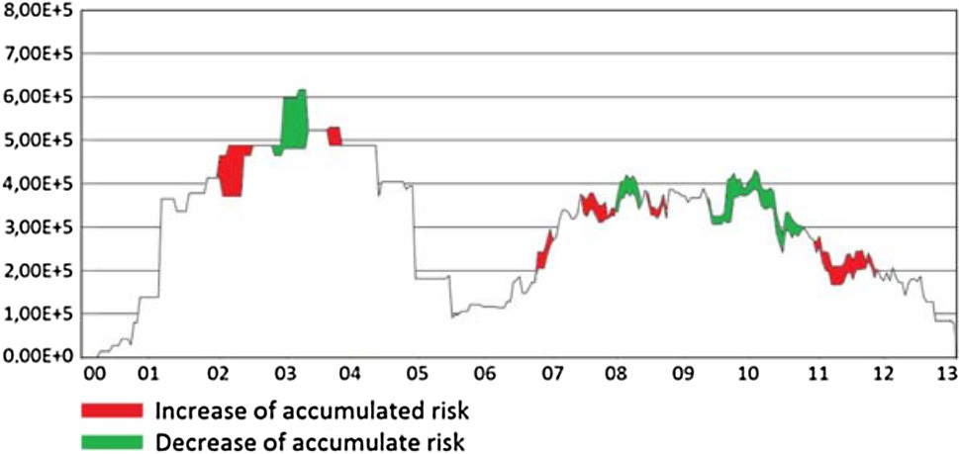

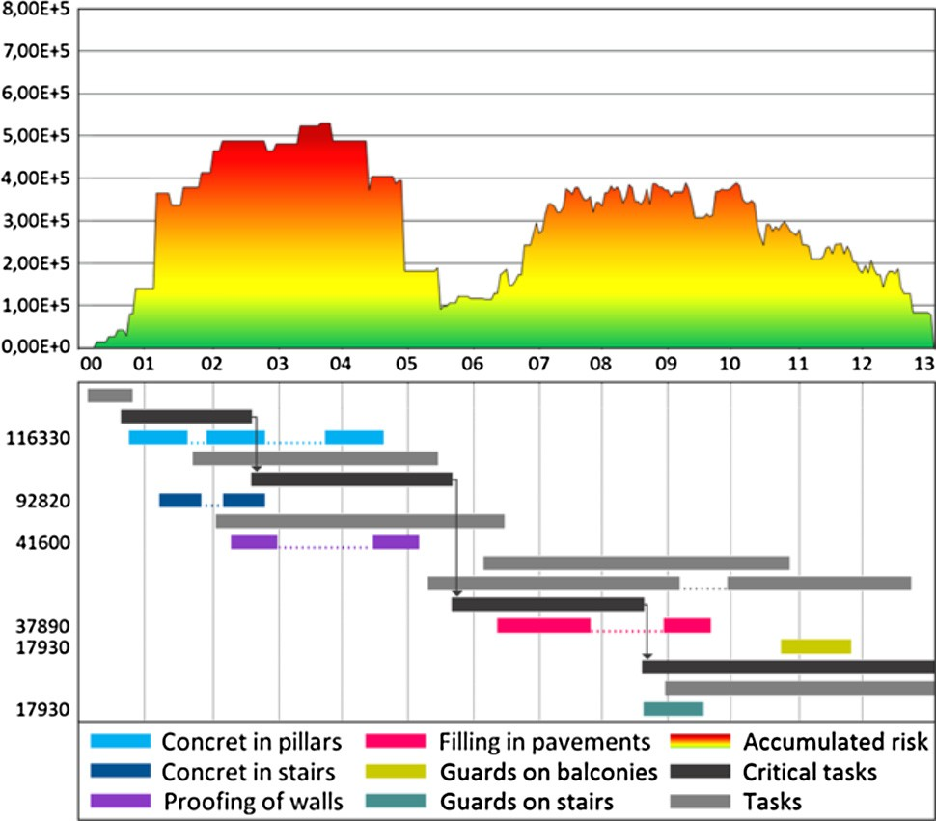Fig. 10. Level of risk accumulated after the introduction of organizational measures. Adapted from [5].

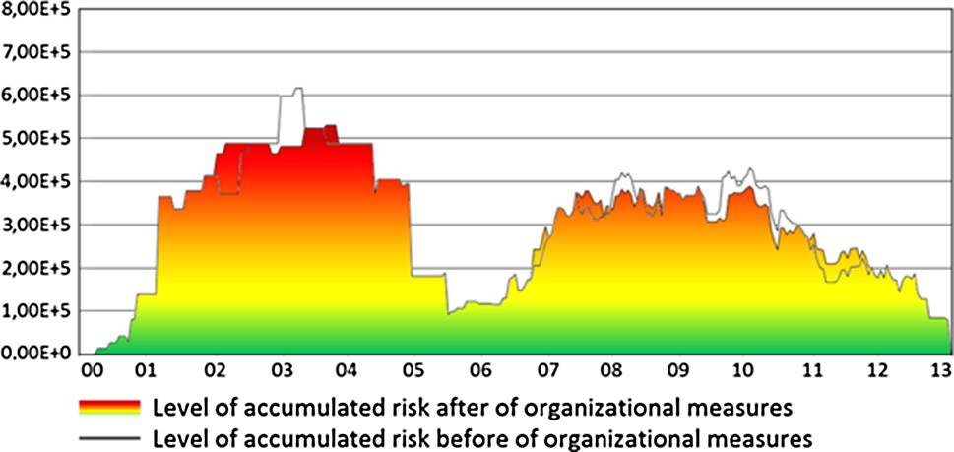

Fig. 11. Comparison of the levels of accumulated risk before and after the implementation of organizational measures. Adapted from [5].

In order to better understand the improvements changes in the histogram were highlighted – different colours were used to high- light changes. According to Fig.12 the areas in green show a decrease of accumulated risk and the areas in red, those with an increase in accumulated risk.

The higher risk levels on the initial setting, corresponding to the beginning of the third month of work, were redistributed along the beginning of the second month. Further, some of the peaks identi- fied in the beginning of the ninth and tenth month of work were redistributed along the seventh, eighth and mainly eleventh month of work.

1. Discussion

The histogram of accumulated risk has shown that this con- struction project is mainly characterized by two distinctive stages. During the first stage the higher risk accumulated tasks demand special attention since higher levels of risk appear mainly due to the cumulative effect of similar tasks duly mixed in the initial con- structive process phase. The second stage is characterized by a high number of activities developed simultaneously with meaningful accumulated risk. That is, lower risk activities in conjunction with the high simultaneity of tasks represent a level of accumulated risk that cannot be underestimated.

Given the previous scenario organizational measures were defined and implemented to diminish the number of simultaneous tasks. Shifting in time one or more of the tasks during the first stage

Fig. 12. Areas of increase and decrease of accumulated risk. Adapted from [5].

should be enough to generate a significant change in the distributed risk since tasks at this stage possess higher levels of risk. The task in the second stage carries a lower level of risk and therefore is more difficult to soften risk peaks levels. With the implementation of the proposed organizational measures in the chronological register of tasks it was possible to reduce the peaks of risk and transform the histogram of accumulated risk into a smother and predictable item. It was also verified that the global potential of existing risk was not reduced; it was simply redistributed along the period of time. The overall accumulated risk, as expected, was not reduced since there was an overall redistribution of chronological tasks. Although simultaneity was not taken into account it is known that an increased number of simultaneous tasks give rise to increased risk and hence a simultaneity coefficient should be introduced. Therefore, as well as redistributing tasks in time, risk should con- template the effect of simultaneity since there is an augmented risk while performing a higher number of tasks.

The results demonstrate that project planning should pay spe- cial attention to risk maps since these have a strong impact in the management of construction sites. Systematic changes in the workforce, the continuous change of conditions and sceneries of work, the exposure to the weather conditions and some other vari- able factors render difficult the task of identifying, observing, eval- uating and gathering data that continuously mutate. It is therefore important that safety managers have access to the risk characteris- tic curves of each type of construction task in order to introduce possible improvements regarding the reduction of accumulated risk in order to accommodate changes in updates of the project plan.

A method was developed in order to reduce peaks of previously estimated risk levels through the reorganization of tasks in time and space attaining a substantial reduction in peak risk tasks. It is a new and innovative method because it allows companies that adopt it to reduce the accumulated risks on a daily basis, and con- sequently reduce accident levels in construction, as shown in Fig.10, Fig.11 and Fig.12.

The organizational measures introduced and detailed previ- ously suggest a number of actions that sustain more generic proce- dures to be adopted by project managers as well as computer aided tools. The following indications provide generic procedures to reduce peak risk:

* Develop first draft of project plan and identify problematic spots;
* Fix critical path tasks and identify a time window for other tasks;
* Avoid simultaneity of high risk tasks when redistributing tasks;
* Identify feasible solutions in the beginning of the project plan that allow for simultaneity;
* Iterate through initial feasible solutions until a minimum risk level is attained;
* Set the initial project plan tasks according to the above solution and proceed, as above, searching for best feasible solutions according to the previous approach.

Together with the reported state of the art concerning the development of computer aided tools, according to the different authors, it is fully justifiable the development of new tools that incorporate and implement some of the presented organizational measures in order to help managing risk under continuously vary- ing construction site conditions taking into account a space dimen- sion. Thus, it is evermore required further research into methodologies that deal with risk assessment linked to project planning in order to reduce construction site risks associated with variable and evolving conditions.

1. Conclusion

With the implementation of the proposed organizational mea- sures with computer aided tools primarily project planning related, it is possible to reduce the peaks of risk and transform the his- togram of accumulated risk into a smother and predictable item. The reduction of risk to lower levels constitute a strong motivation towards this approach since managing lower levels of risk results in lighter risk measures which in turn reduce cost and hazard per- taining to the construction site. Along with the side effects of reducing the risk levels it is possible to envisage a more predictable project planning. Along with the proposed organizational mea- sures this work provides important insights pertaining to the char- acteristic curve of accumulated risk in this type of building construction. In further studies it would be important to determine the curve of accumulated risk characteristic of other types of works and enable a thorough comparison.

This study further unveils the potential pertaining to the devel- opment of new computer aided tools, as well as, new methodolo- gies concerning risk management intertwined with project planning and managing. The reported organizational measures were successful in reducing peak risk levels and contribute towards the development of methodologies regarding risk man- agement and its dynamic control during construction. The follow- ing research step is to evaluate the efficiency of genetic algorithms in optimizing the redistribution of tasks given the restrictions posed by this problem targeted at reducing risk peaks.

Authors’ contributions

The three authors worked together as a team contributing equally to this paper. All authors read and approved the final manuscript.

References

1. [F. Nunes, Segurança e Higiene do Trabalho, Escola Profissional Gustave Eiffel](http://refhub.elsevier.com/S2210-8327(17)30175-8/h0005) [(2009)](http://refhub.elsevier.com/S2210-8327(17)30175-8/h0005).
2. [H.W. Heinrich, Industrial Accident Prevention, A Scientific Approach,](http://refhub.elsevier.com/S2210-8327(17)30175-8/h0010) [McGraw-](http://refhub.elsevier.com/S2210-8327(17)30175-8/h0010) [Hill book Company, Incorporated, 1931](http://refhub.elsevier.com/S2210-8327(17)30175-8/h0010).
3. [E. Lago, Proposta de sistemas de gestão em segurança no trabalho para](http://refhub.elsevier.com/S2210-8327(17)30175-8/h0015) [empresas de construção civil,](http://refhub.elsevier.com/S2210-8327(17)30175-8/h0015) [Programa de pós-graduação em engenharia civil.](http://refhub.elsevier.com/S2210-8327(17)30175-8/h0015) [Universidade católica de Pernambuco, Recife, 2006, p. 195](http://refhub.elsevier.com/S2210-8327(17)30175-8/h0015).
4. ] R.H. Simonds, Safety Management Accident Cost And Control, R.D. Irwin, 1947
5. [N. Ferreira, G. Santos, Simultaneity of risk in the civil site construction: An](http://refhub.elsevier.com/S2210-8327(17)30175-8/h0025) [analysis of accumulated risk, in: Proceedings of the International Symposium](http://refhub.elsevier.com/S2210-8327(17)30175-8/h0025) [on Occupational Safety and Hygiene, SHO,](http://refhub.elsevier.com/S2210-8327(17)30175-8/h0025) [Taylor & Francis Group, London,](http://refhub.elsevier.com/S2210-8327(17)30175-8/h0025) [2014, pp. 259–264](http://refhub.elsevier.com/S2210-8327(17)30175-8/h0025).
6. [F. Bird, G. Germain, Damage control; a new horizon in accident prevention and](http://refhub.elsevier.com/S2210-8327(17)30175-8/h0030) [cost improvement,](http://refhub.elsevier.com/S2210-8327(17)30175-8/h0030) [American Management Association, New York, 1966](http://refhub.elsevier.com/S2210-8327(17)30175-8/h0030).
7. [A.A. Meneghetti, A Importância da Auditoria Comportamental para a](http://refhub.elsevier.com/S2210-8327(17)30175-8/h0035) [Prevenção de Acidentes na Indústria Petroquímica, Universidade Federal](http://refhub.elsevier.com/S2210-8327(17)30175-8/h0035) [Fluminense, Niterói, 2010](http://refhub.elsevier.com/S2210-8327(17)30175-8/h0035).
8. M.F. Rebelo, G. Santos, R. Silva, The integration of standardized Management Systems: managing business risk, Int. J. Quality Reliab. Manage. 34 (3) (2017) 395–405, <https://doi.org/10.1108/IJQRM-11-2014-0170>.
9. [M.F. Rebelo, G. Santos, R. Silva, Integration of management systems: towards](http://refhub.elsevier.com/S2210-8327(17)30175-8/h0045) [the sustained success and development of organizations, J. Clean. Prod. 127](http://refhub.elsevier.com/S2210-8327(17)30175-8/h0045) [(2016) 96–111](http://refhub.elsevier.com/S2210-8327(17)30175-8/h0045).
10. [M. Gangolells, M. Casals, N. Forcada, X. Roca, A. Fuertes, Mitigating](http://refhub.elsevier.com/S2210-8327(17)30175-8/h0050) [construction safety risks using prevention through design, J. Safety Res.](http://refhub.elsevier.com/S2210-8327(17)30175-8/h0050) [(2010) 107–122](http://refhub.elsevier.com/S2210-8327(17)30175-8/h0050).
11. [Y.C. Kuo, S.T. Lu, Using fuzzy multiple criteria decision making approach to](http://refhub.elsevier.com/S2210-8327(17)30175-8/h0055) [enhance risk assessment for metropolitan construction projects, Int. J. Project](http://refhub.elsevier.com/S2210-8327(17)30175-8/h0055) [Manage. 31 (2013) 602–614](http://refhub.elsevier.com/S2210-8327(17)30175-8/h0055).
12. [H.H. Wang, F. Boukamp, An ontology-based representation and reasoning](http://refhub.elsevier.com/S2210-8327(17)30175-8/h0060) [framework for supporting job hazard analysis, J. Comput. Civil Eng. 25 (6)](http://refhub.elsevier.com/S2210-8327(17)30175-8/h0060) [(2011) 442–457](http://refhub.elsevier.com/S2210-8327(17)30175-8/h0060).
13. [L. Harms-Ringdahl, Relationships between accident investigations, risk](http://refhub.elsevier.com/S2210-8327(17)30175-8/h0065) [analysis, and safety management, J. Hazard. Mater. (2004) 13–19](http://refhub.elsevier.com/S2210-8327(17)30175-8/h0065).
14. [G.E. Gurcanli, U. Mungen, An occupational safety risk analysis method at](http://refhub.elsevier.com/S2210-8327(17)30175-8/h0070) [construction sites using fuzzy sets, Int. J. Ind. Ergon. (2009) 371–387](http://refhub.elsevier.com/S2210-8327(17)30175-8/h0070).
15. [M. Marques, M. Terroso, R. Freitas, A.T. Marques, J. Gabriel, R. Simoes, A](http://refhub.elsevier.com/S2210-8327(17)30175-8/h0075) [procedure for a mechanical evaluation of an undefined osteo-protective](http://refhub.elsevier.com/S2210-8327(17)30175-8/h0075) [material, Accident Anal. Prevent. 75 (2015) 285–291](http://refhub.elsevier.com/S2210-8327(17)30175-8/h0075).
16. [P.M. Smith, R. Saunders, M. Lifshen, O. Black, M. Lay, F.C. Breslin, A.D.M.](http://refhub.elsevier.com/S2210-8327(17)30175-8/h0080) [Montagne, E. Tompa, The development of a conceptual model and self-](http://refhub.elsevier.com/S2210-8327(17)30175-8/h0080) [reported measure of occupational health and safety vulnerability, Accident](http://refhub.elsevier.com/S2210-8327(17)30175-8/h0080) [Anal. Prevent. 82 (2015) 234–243](http://refhub.elsevier.com/S2210-8327(17)30175-8/h0080).
17. [P. Monteiro, F. Santos, G. Santos, Costs of safety at work vs. Costs of ‘‘no”](http://refhub.elsevier.com/S2210-8327(17)30175-8/h0085) [safety](http://refhub.elsevier.com/S2210-8327(17)30175-8/h0085) [at work-building sector, in: Proceedings of the International Symposium on](http://refhub.elsevier.com/S2210-8327(17)30175-8/h0085) [Occupational Safety and Hygiene, SHO,](http://refhub.elsevier.com/S2210-8327(17)30175-8/h0085) [Taylor & Francis Group, London, 2013,](http://refhub.elsevier.com/S2210-8327(17)30175-8/h0085)

[pp. 149–152](http://refhub.elsevier.com/S2210-8327(17)30175-8/h0085).

1. [J.K. Wachter, L. Patrick, P.L. Yorio, A system of safety management practices](http://refhub.elsevier.com/S2210-8327(17)30175-8/h0090) [and worker engagement for reducing and preventing accidents: An empirical](http://refhub.elsevier.com/S2210-8327(17)30175-8/h0090) [and theoretical investigation, Accident Anal. Prevent. 68 (2014) 117–130](http://refhub.elsevier.com/S2210-8327(17)30175-8/h0090).
2. [M.F. Rebelo, R. Silva, G. Santos, P. Mendes, Model Based Integration of](http://refhub.elsevier.com/S2210-8327(17)30175-8/h0095) [Management Systems (MSS) – Casy study, TQM Journal. 28 (6) (2016) 907–](http://refhub.elsevier.com/S2210-8327(17)30175-8/h0095)

[932](http://refhub.elsevier.com/S2210-8327(17)30175-8/h0095).

1. S. Nenonen, J. Vasara, Safety management in multiemployer worksites in the manufacturing industry: opinions on co-operation and problems encountered, Int. J. Occup. Safety Ergon. 19 (2) (2013) 168–183, [https://doi.org/10.1080/](https://doi.org/10.1080/10803548.2013.11076976)

[10803548.2013.11076976](https://doi.org/10.1080/10803548.2013.11076976).

1. [G. Santos, A.L. Milán, Motivation and benefits of implementation and](http://refhub.elsevier.com/S2210-8327(17)30175-8/h0105) [certification according ISO 9001 – The Portuguese experience, Int. J. Qual.](http://refhub.elsevier.com/S2210-8327(17)30175-8/h0105) [Res. 7 (1) (2013) 71–86](http://refhub.elsevier.com/S2210-8327(17)30175-8/h0105).
2. D. Podgórski, Occupational health and safety management in polish enterprises implementing total quality management systems, Int. J. Occup. Safety Ergon. 6 (sup1) (2000) 85–101, [https://doi.org/10.1080/](https://doi.org/10.1080/10803548.2000.11105110)

[10803548.2000.11105110](https://doi.org/10.1080/10803548.2000.11105110).

1. J. Rzepecki, Cost and benefits of implementing an occupational safety and health management system (OSH MS) in enterprises in Poland, Int. J. Occup. Safety Ergon. 18 (2) (2012) 181–193, [https://doi.org/10.1080/](https://doi.org/10.1080/10803548.2012.11076927)

[10803548.2012.11076927](https://doi.org/10.1080/10803548.2012.11076927).

1. C. Qiang, W.K. Chow, A discussion of occupational health and safety management for the catering industry in China, Int. J. Occup. Safety Ergon. 13 (3) (2007) 333–339, <https://doi.org/10.1080/10803548.2007.11076732>.
2. [G. Santos, S. Barros, F. Mendes, N. Lopes, The main benefits associated with](http://refhub.elsevier.com/S2210-8327(17)30175-8/h0125) [health and safety management systems certification in Portuguese small and](http://refhub.elsevier.com/S2210-8327(17)30175-8/h0125) [medium enterprises post quality management system certification, Safety Sci.](http://refhub.elsevier.com/S2210-8327(17)30175-8/h0125) [51 (2013) 29–36](http://refhub.elsevier.com/S2210-8327(17)30175-8/h0125).
3. [T. Wold, K. Laumann, Safety management systems – definitions, challenges for](http://refhub.elsevier.com/S2210-8327(17)30175-8/h0130) [use and recommendations for improvements, Safety Sci. Monitor 19 (1)](http://refhub.elsevier.com/S2210-8327(17)30175-8/h0130) [(2015), article 1.](http://refhub.elsevier.com/S2210-8327(17)30175-8/h0130).
4. [A. Badri, A. Gbodossou, S. Nadeau, Occupational health and safety risks:](http://refhub.elsevier.com/S2210-8327(17)30175-8/h0135) [Towards the integration into project management, Safety Sci., 50, 2012, pp.](http://refhub.elsevier.com/S2210-8327(17)30175-8/h0135) [190–198](http://refhub.elsevier.com/S2210-8327(17)30175-8/h0135).
5. [N.A. Kartam, Integrating safety and health performance into construction CPM,](http://refhub.elsevier.com/S2210-8327(17)30175-8/h0140)

[J. Constr. Eng. Manage. 123 (2) (1997) 121–126](http://refhub.elsevier.com/S2210-8327(17)30175-8/h0140).

1. [B. Hare, I. Cameron, A.R. Duff, Exploring the integration of health and safety](http://refhub.elsevier.com/S2210-8327(17)30175-8/h0145) [with pre-construction planning, Eng. Constr. Arch. Manage. 13 (5) (2006) 438–](http://refhub.elsevier.com/S2210-8327(17)30175-8/h0145)

[450](http://refhub.elsevier.com/S2210-8327(17)30175-8/h0145).

1. [K.J. Yi, D. Langford, Scheduling-based risk estimation and safety planning for](http://refhub.elsevier.com/S2210-8327(17)30175-8/h0150) [construction projects, J. Constr. Eng. Manage. 132 (6) (2006) 626–635](http://refhub.elsevier.com/S2210-8327(17)30175-8/h0150).
2. [S. Zhang, J. Teizer, J.K. Lee, C.M. Eastman, M. Venugopal, Building information](http://refhub.elsevier.com/S2210-8327(17)30175-8/h0155) [modeling (BIM) and safety: automatic safety checking of construction models](http://refhub.elsevier.com/S2210-8327(17)30175-8/h0155) [and schedules, Automat. Constr. 29 (2013) 183–195](http://refhub.elsevier.com/S2210-8327(17)30175-8/h0155).
3. [W. Zhou, J. Whyte, R. Sacks, Construction safety and digital design: a review,](http://refhub.elsevier.com/S2210-8327(17)30175-8/h0160) [Automat. Constr. 22 (2012) 102–111](http://refhub.elsevier.com/S2210-8327(17)30175-8/h0160).
4. [B.H. Hadikusumo, S. Rowlinson, Integration of virtually real construction](http://refhub.elsevier.com/S2210-8327(17)30175-8/h0165) [model and design-for-safety-process database, Automat. Constr. 11 (5) (2002)](http://refhub.elsevier.com/S2210-8327(17)30175-8/h0165)

[501–509](http://refhub.elsevier.com/S2210-8327(17)30175-8/h0165).

1. [I.W. Fung, V.W. Tam, T.Y. Lo, L.L. Lu, Developing a risk assessment model for](http://refhub.elsevier.com/S2210-8327(17)30175-8/h0170) [construction safety, Int. J. Project Manage. 28 (6) (2010) 593–600](http://refhub.elsevier.com/S2210-8327(17)30175-8/h0170).
2. [T.M. Toole, J.A. Gambatese, The trajectories of prevention through design in](http://refhub.elsevier.com/S2210-8327(17)30175-8/h0175) [construction, J. Safety Res. 39 (2) (2008) 225–230](http://refhub.elsevier.com/S2210-8327(17)30175-8/h0175).
3. H. Liu, X. Deng, W. Jiang, Risk evaluation in failure mode and effects analysis using fuzzy measure and fuzzy integral, Symmetry 9 (162) (2017) 1–13, <https://doi.org/10.3390/sym9080162>.
4. V. Molen, A. Helder, J. Warning, M.H.W. Frings-Dresen, National evaluation of strategies to reduce safety violations for working from heights in construction companies: results from a randomized controlled trial, BMC Public Health 16

(19) (2016) 1–8, <https://doi.org/10.1186/s12889-016-2693-x>.

1. NTP330, Sistema simplificado de evaluación de riesgos de accidente. Espanã: Ministerio de Trabajo y Asuntos Sociales - Instituto Nacional de Seguridad e Higiene en el Trabajo (1995).
2. [G. Santos, M.F. Rebelo, S. Barros, R. Silva, M. Pereira, G. Ramos, N. Lopes,](http://refhub.elsevier.com/S2210-8327(17)30175-8/h0195) [Developments regarding the integration of the Occupational Safety and Health](http://refhub.elsevier.com/S2210-8327(17)30175-8/h0195) [with Quality and Environment Management Systems (eBook), Chapter](http://refhub.elsevier.com/S2210-8327(17)30175-8/h0195) 6, [The](http://refhub.elsevier.com/S2210-8327(17)30175-8/h0195) [Nova Science Publishers, New York, 2014, pp. 113–146](http://refhub.elsevier.com/S2210-8327(17)30175-8/h0195).
3. [A. Doulamis, N. Doulamis, I. Kalisperakis, C. Stentoumis, A real-time single-](http://refhub.elsevier.com/S2210-8327(17)30175-8/h0200) [camera approach for automatic fall detection ISPRS Commission V, Close](http://refhub.elsevier.com/S2210-8327(17)30175-8/h0200) [Range Image measurements Techniques 38 (2010) 207–212](http://refhub.elsevier.com/S2210-8327(17)30175-8/h0200).
4. [A.K. Bourke, J.V. O’brien, G.M. Lyons, Evaluation of a threshold-based tri-axial](http://refhub.elsevier.com/S2210-8327(17)30175-8/h0205) [accelerometer fall detection algorithm, Gait Posture 26 (2) (2007) 194–199](http://refhub.elsevier.com/S2210-8327(17)30175-8/h0205).
5. Q. Li, J.A. Stankovic, M.A. Hanson, A.T. Barth, J. Lach, G. Zhou, Accurate, fast fall detection using gyroscopes and accelerometer-derived posture information, In: Wearable and Implantable Body Sensor Networks, 2009. BSN 2009. Sixth International Workshop on. IEEE, June 2009, pp. 138–143.
6. [N.D. Doulamis, P. Kokkinos, E. Varvarigos, Resource selection for tasks with](http://refhub.elsevier.com/S2210-8327(17)30175-8/h0215) [time requirements using spectral clustering, IEEE Trans. Computers 63 (2)](http://refhub.elsevier.com/S2210-8327(17)30175-8/h0215) [(2014) 461–474](http://refhub.elsevier.com/S2210-8327(17)30175-8/h0215).

Nuno Ferreira graduated in Civil Engineering, from the Polyt Institute of Bragança – Portugal. He is working in the company Joaquim Peixoto Azevedo & Filhos, in Vila Verde, Braga, Portugal. In 2014 he completed a master course in Integrated Man- agement Systems Quality, Environment and Safety from the Polytechnic Institute Cávado e Ave. Nuno is a PhD student since 2014 at Lusíada University in Vila Nova de Famalicão – Portugal.

Gilberto Santos graduated in Mechanical Engineering from the Slovaks Technical University. He completed a postgraduate course in quality engineering at the New University of Lisbon (Portugal) and he received a PhD in mechanical engineering – production technologies (branch – industrial quality) from the University of Minho in Portugal. Gilberto has worked in the mechanical engineering departments at the New University of Lisbon and the University of Minho. He founded a master’s course ‘‘Integrated Management Systems QES (Quality, Environment and Safety)” at the College of Technology of Polytechnic Institute Cávado e Ave where he is a Professor from 2006 and the Director of the MSc from 2008. Gilberto participates as a speaker in several national and international conferences and he is currently author of several publications in Integrated Management Systems, Quality, Envi- ronment and Safety in international and national journals. He is member of the research team of several IMS – QES research projects and also supervises master and PhD thesis and also serves as a reviewer for international journals. In 2004, Gilberto became a ‘‘senior member” of the Board of the Portuguese Engineer Association and in 2006, he was distinguished by Yorker International University with the Honorary Doctorate of Mechanical Engineering – ‘‘has walked an excep- tional path of Professional life and is the perfect candidate for such degree”. In 2011, he received the badge of silver by the 25 years as a member of Portuguese Engineer Association. Professor Gilberto Santos is the corresponding author and can be contacted at: [gsantos@ipca.pt](mailto:gsantos@ipca.pt)

Rui Silva is an Associated Professor in the Engineering and Technology Faculty at the Universidade Lusíada of Vila Nova de Famalicão, Portugal. He holds a PhD degree in Mechanical Engineering from the University of Glamorgan, UK. His cur- rent research interests include industrial management, operations management and artificial intelligence. He is Cofounder and Principal Investigator of the Engi- neering and Industrial Management Research Centre since 2006. He is the head of the Engineering and Technology Faculty since 2008.