[Arti](https://doi.org/10.1016/j.aiig.2022.03.001)fi[cial Intelligence in Geosciences 2 (2021) 179](https://doi.org/10.1016/j.aiig.2022.03.001)–[191](https://doi.org/10.1016/j.aiig.2022.03.001)





Contents lists available at [ScienceDirect](http://www.sciencedirect.com/science/journal/26665441)

Artificial Intelligence in Geosciences

journal homepage: [www.keaipublishing.com/en/journals/artificial-intelligence-in-geosciences](http://www.keaipublishing.com/en/journals/artificial-intelligence-in-geosciences)

[](http://crossmark.crossref.org/dialog/?doi=10.1016/j.aiig.2022.03.001&domain=pdf)Site suitability for Aromatic Rice cultivation by integrating Geo-spatial and Machine learning algorithms in Kaliyaganj C.D. block, India

Debabrata Sarkar, Research Scholar, Sunil Saha, Research Scholar, Manab Maitra, B.Sc. in Geography, Prolay Mondal, Ph.D., Assistant Professor *

*Department of Geography, Raiganj University, Raiganj, West Bengal, 733134, India*

A R T I C L E I N F O

*Keywords:*

Soil fertility Suitability analysis MCDM-AHP

Machine learning GIS

A B S T R A C T

The purpose of this work is to assess the soil fertility for Tulaipanji rice cultivation in Kaliyaganj C.D. Block using the Analytic Hierarchy Process (AHP) and Machine learning algorithms along with the field survey data and GIS. A total of 40 soil samples from Tulaipanji rice fields (from 0 to 40 cm depth) have been randomly collected for the analysis of the soil health condition. For the purpose of assigning ratings to the parameters, ten experts' opinions were taken into account. The final soil fertility map indicates that 18.01% of the land is in excellent health condition to support Tulaipanji cultivation. The artificial neural networks (ANN), support vector machine (SVM), and Bagging models-based suitability analysis was also done using geo-spatial and soil data for Tulaipanji cultivation. Nevertheless, the ANN is the more appropriate model for locational analysis of Tulaipanji cultivation. The ANN-based findings show that areas of 25.8% (77.89 sq. km) are excellent for growing Tulaipanji rice, about 22.01% (66.45 sq. km) are highly suitable, 19.84% (59.90 sq. km) are moderately suitable, 21.19% (63.97 sq. km) are low suitable and 11.16% (33.69 sq. km) are not suitable for Tulaipanji rice cultivation. The receiver operating characteristic (ROC) curve depicts that the applied models have a high degree of accuracy. This endeavour will aid much in the soil fertility and site suitability assessment that will aid local government officials, academics, and the framers, to utilize the lands in a scientific way.

1. Introduction

According to FAO's definition, in agriculture, the fertility of soil refers to the capacity of a soil to support crop growth by supplying required soil nutrients as well as suitable biochemical, and physical properties as a growing environment for plants. The essential macro- nutrients nitrogen (N), phosphorus (P), and potassium (K), as well as magnesium (Mg), sulphur (S), and calcium (Ca) are all found in plants as micronutrients and by consuming these foods, humans fulfill their nutritional demands. Micronutrients are mostly composed of the ele- ments iron (Fe), copper (Cu), molybdenum (Mo), chlorine (Cl), sele- nium (Se), zinc (Zn), manganese (Mn), and boron (B). Water is required for plant growth! Plants comprise roughly 80%–95% water, and they need water for a variety of purposes as they develop, including photosynthesis, cooling, and transporting minerals and nutrients from the soil into the plant. Soil fertility implications are represented in the majority of the Sustainable Development Goals since they include

economic, social, and environmental dimensions. The principal facility supplied by soil fertility is agricultural production, which is critical for achieving the FAO's planned goal of zero hunger. Fertile soil produces healthy crops that meet the human body's nutritional requirements. Whereas a soil deficit in some critical elements would be unable to produce nutritional foods, ultimately resulting in a nutritional defi- ciency in the human body. Before the worst-case scenario comes where all humans are facing nutrition deficit health issues, we should conserve and maintain good soil health by implementing different management and conservational strategies such as demarcating specific crops for specific land is very essentials.

Rice (*Oryza sativa* L.) is among the most essential cereal crops on the planet, contributing significantly to global food security by providing food for more than half of the global population (Chauhan et al., 2017). Today, around one-third of the world population, while about 1.7 billion people in South Asia, including more than 50 million families, subsist entirely on rice (Manzanilla et al., 2011; Nayak et al., 2019). Rice may become extremely

* Corresponding author. Department of Geography, Raiganj University, India.

*E-mail addresses:* [debabratas077@gmail.com](mailto:debabratas077@gmail.com) (D. Sarkar), [sahasunil2507@gmail.com](mailto:sahasunil2507@gmail.com) (S. Saha), [manabmaitra1@gmail.com](mailto:manabmaitra1@gmail.com) (M. Maitra), [mon.prolay@gmail.com](mailto:mon.prolay@gmail.com) (P. Mondal).

<https://doi.org/10.1016/j.aiig.2022.03.001>

Received 11 November 2021; Received in revised form 10 March 2022; Accepted 10 March 2022

Available online 15 March 2022

2666-5441/© 2022 The Authors. Publishing Services by Elsevier B.V. on behalf of KeAi Communications Co. Ltd. This is an open access article under the CC BY license (<http://creativecommons.org/licenses/by/4.0/>).

important in the future as the demographics of developing nations, which are heavily reliant on rice, rise at a significant rate.

Agriculture contributes nearly 40% of India's Gross National Product (GNP) and ensures subsistence for approximately 70% of its total popu- lation. Almost 67% (two-thirds) of the country's cropland is covered by rain-fed farming (Rath et al., 2018). In India, rice cultivation not only feeds the majority of the people but also helps to flourish associated in- dustries, such as approximately 32% of the country's fertilizer (FAO, 2005) and 22% of pesticides are used in rice cultivation. The government of India in 2016 estimates that around 43.4 million hectares of land and around 60% of water are used each year to produce rice (Reddy et al., 2005). In India, especially on the eastern side of the country's land-intensive used for rice cultivation. Tulaipanji is the indigenous most flavored rice cultivated in the Kaliyaganj block of Uttar Dinajpur District, West Bengal, Eastern India. It is one of the softest rice, which have very much popularity in the market for its unique features. Tulaipanji is tasty, bright, non-sticky, and friable aromatic rice. Tulaipanji is mainly culti- vated in the Kharif season. It grows between the months of August to November. On October 24, 2017, Tulaipanji gets a Geographical Indi- cation (GI TAG) certificate from the Department for promotion of In- dustry and Internal Trade, Govt. of India. Its market price is much higher than the other rice varieties. As this variety returns more profits in comparison to the same quantity of other varieties and cultivation of this rice may have the capacity to improve the economic condition of the farmers if they get proper help to produce and export this rice variety.

The ability to prefer the appropriate areas for farming based on the intended usage and crop practices will help to mitigate adverse natural effects while increasing agricultural productivity and financial advan- tages (Mahmood and Ahmad, 2001; Ashraf and Normohammadan, 2011). Land suitability assessment, described as an appraisal of the “ef- ficiency” of land for specific land uses and crops (Bagheri Bodaghabadi et al., 2015; Saleh et al., 2015), is a critical phase in sustainable devel- opment and land use management. Not only can land suitability assess- ments aid in the betterment of crop production systems and expansion of land efficiency (Prudat et al., 2018; El Baroudy, 2016), but they can often offer insight into the key contributing factors to crop shortages (Halder, 2013). To optimize agricultural land management, taking into account environmental factors and comprehending the primary constraints imposed by local biophysical conditions can aid in crop selection (Kazemi et al., 2016; Mendas and Delali, 2012).

Suitability assessment involves a variety of parameters; thus, expert

opinions integrating analytic hierarchy process (AHP), as well as the collection of numerous criteria, are expected to comprehend crop pro- duction on suitable lands. AHP based on remote sensing and GIS is a popularly adopted tool for geographical decision-making processes. Importantly, the AHP introduced by Saaty (1980) has been combined with GIS (Akinci et al., 2013) as the optimal approach for managing numerous and diverse entities like soil suitability. AHP is a technique for organizing various variables into a hierarchy and deciding their perceived value (Saaty, 2000). This technique has been used in a number of research for analyzing site suitability (Mishra et al., 2016; Bozdag et al., 2016; Amini et al., 2020; Ostovari et al., 2019; Pilevar et al., 2020). Additionally, the GIS techniques facilitate an effective way to analyze site suitability. Nevertheless, in recent times, different machine learning models, such as artificial neural networks (ANN), support vector machine (SVM), random forest (RF), bagging, and decision tree-based site suit- ability analysis have gained significant importance. Nowadays, re- searchers frequently use different machine learning techniques for site suitability analysis (Sarmadian et al., 2014; Rodriguez-Galiano et al., 2015; Mishra et al., 2016; Hengl et al., 2017; Senagi et al., 2017a, b; Thanh Noi and Kappas, 2018; Mekonnen et al., 2019; Mohsenzadeh Karimi et al., 2020; Taghizadeh-Mehrjardi et al., 2020; Moller et al., 2021).

Numerous scientists worldwide have applied remote sensing (RS) and GIS-based strategies for assessing site suitability for rice production as

well as for other crops (Gumma et al., 2009; Samanta et al., 2011; Kuria et al., 2011; Kihoro et al., 2013; Dengiz, 2013). RS and Geographical information systems (GIS) are well-defined, precise, and adaptable methodologies for investigating spatial information in land suitability assessment (Mokarram et al., 2011; Mendas and Delali, 2012). Satellite-based digital information has arisen as a critical resource for producing physical and biological details (e.g., topography and slope) that aid in the evolution of a region's optimum land use strategy for sustainable growth. Thus, the use of RS and GIS for land suitability analysis for rice cultivation seems very compelling. Additionally, over the last quarter-century, remote sensing and GIS techniques have grown in popularity for a wide range of uses, which include land capability assessment (Hamzeh et al., 2014; El Baroudy and Moghanm, 2014; El-Zeiny and Effat, 2019). RS and GIS assessment at a lower cost facilitate a large spatial extent and the outcome is more reliable than conventional analysis (Zhou et al., 2017; Demarez et al., 2019). For analyzing land suitability, high-resolution satellite images such as LISS-III, Sentinel-2, Landsat-8, and Gaofeng-1 are far more acceptable data sources than others (Dong et al., 2015; Kussul et al., 2016). A multi-criteria deci- sion-making (MCDM) framework along with GIS is used to evaluate different conditioning factors and make appropriate land-use decisions (Malczewski, 2006; Cengiz and Akbulak, 2009; Mendas and Delali, 2012). Land Use/Land Cover is a broad term that describes the classifi- cation natural features and human activities on the landscape across time using recognised statistical and scientific techniques. The main objective of the present study is to assess the site suitability for Tulaipanji rice cultivation by combining AHP, machine learning ANN, SVM, and Bagging models and GIS techniques for the Kaliyaganj block of Uttar Dinajpur district, Eastern India. In the first section, the AHP method was used to measure the soil health condition of the study area. In the second phase, soil properties and other physio-climatic variables were used to assess suitable sites for Tulaipanji rice cultivation.

* 1. *Description of the study area*

The present research was conducted at Kaliyaganj block (Fig. 1), situated on the south-eastern side of North Dinajpur in West Bengal, India, with an area of 301.90 sq. km. This region is under fertile mature flat land topography with gentle sloping toward the south. The selected study area comes under the subtropical humid region where the average

highest temperature is recorded in June and a minimum temperature of 15 ◦C is recorded in January (Fig. 2). The average annual rainfall in the

study area is 1540.2 mm and the highest rainfall occurred in July fol- lowed by August. During the field survey, the calculated average hu- midity, 2 m from the soil surface, was 58.59%. The land use land cover scenario depicts intensive farming with 50% of total LULC coming under agricultural land and farming serves as a major source of income in the study block. The loamy-dominated soil with the existing climatic con- ditions created an ideal environment for rice cultivation. Farmers pre- dominantly cultivated a wide variety of rice such as miniket, fourty- ninety four, sorno, joyonti, ranjit, IR-8, tulaipanji, etc. in the study area. Based on the climatic conditions, the soil in this area keeps enough moisture to support plant growth under controlled conditions. Growers mostly use electric and diesel-based pumping machines to extract groundwater to irrigate agricultural crops. River Srimati is an abundant channel of the Tangan river flowing north to east and divides this block into two halves. This river is ephemeral in nature and remains dry for most of the year, which facilities framers for intensive indigenous rice production in the river bed along with other crops, though this leads to an economic debate about whether this practice is appropriate for river ecosystem sustainability or not. The produced aromatic rice is exported all over the country. Farmers' responses reveal that though they face a variety of problems producing these specific types of indigenous rice, the finished product gives a good return in comparison to the other culti- vated crops.

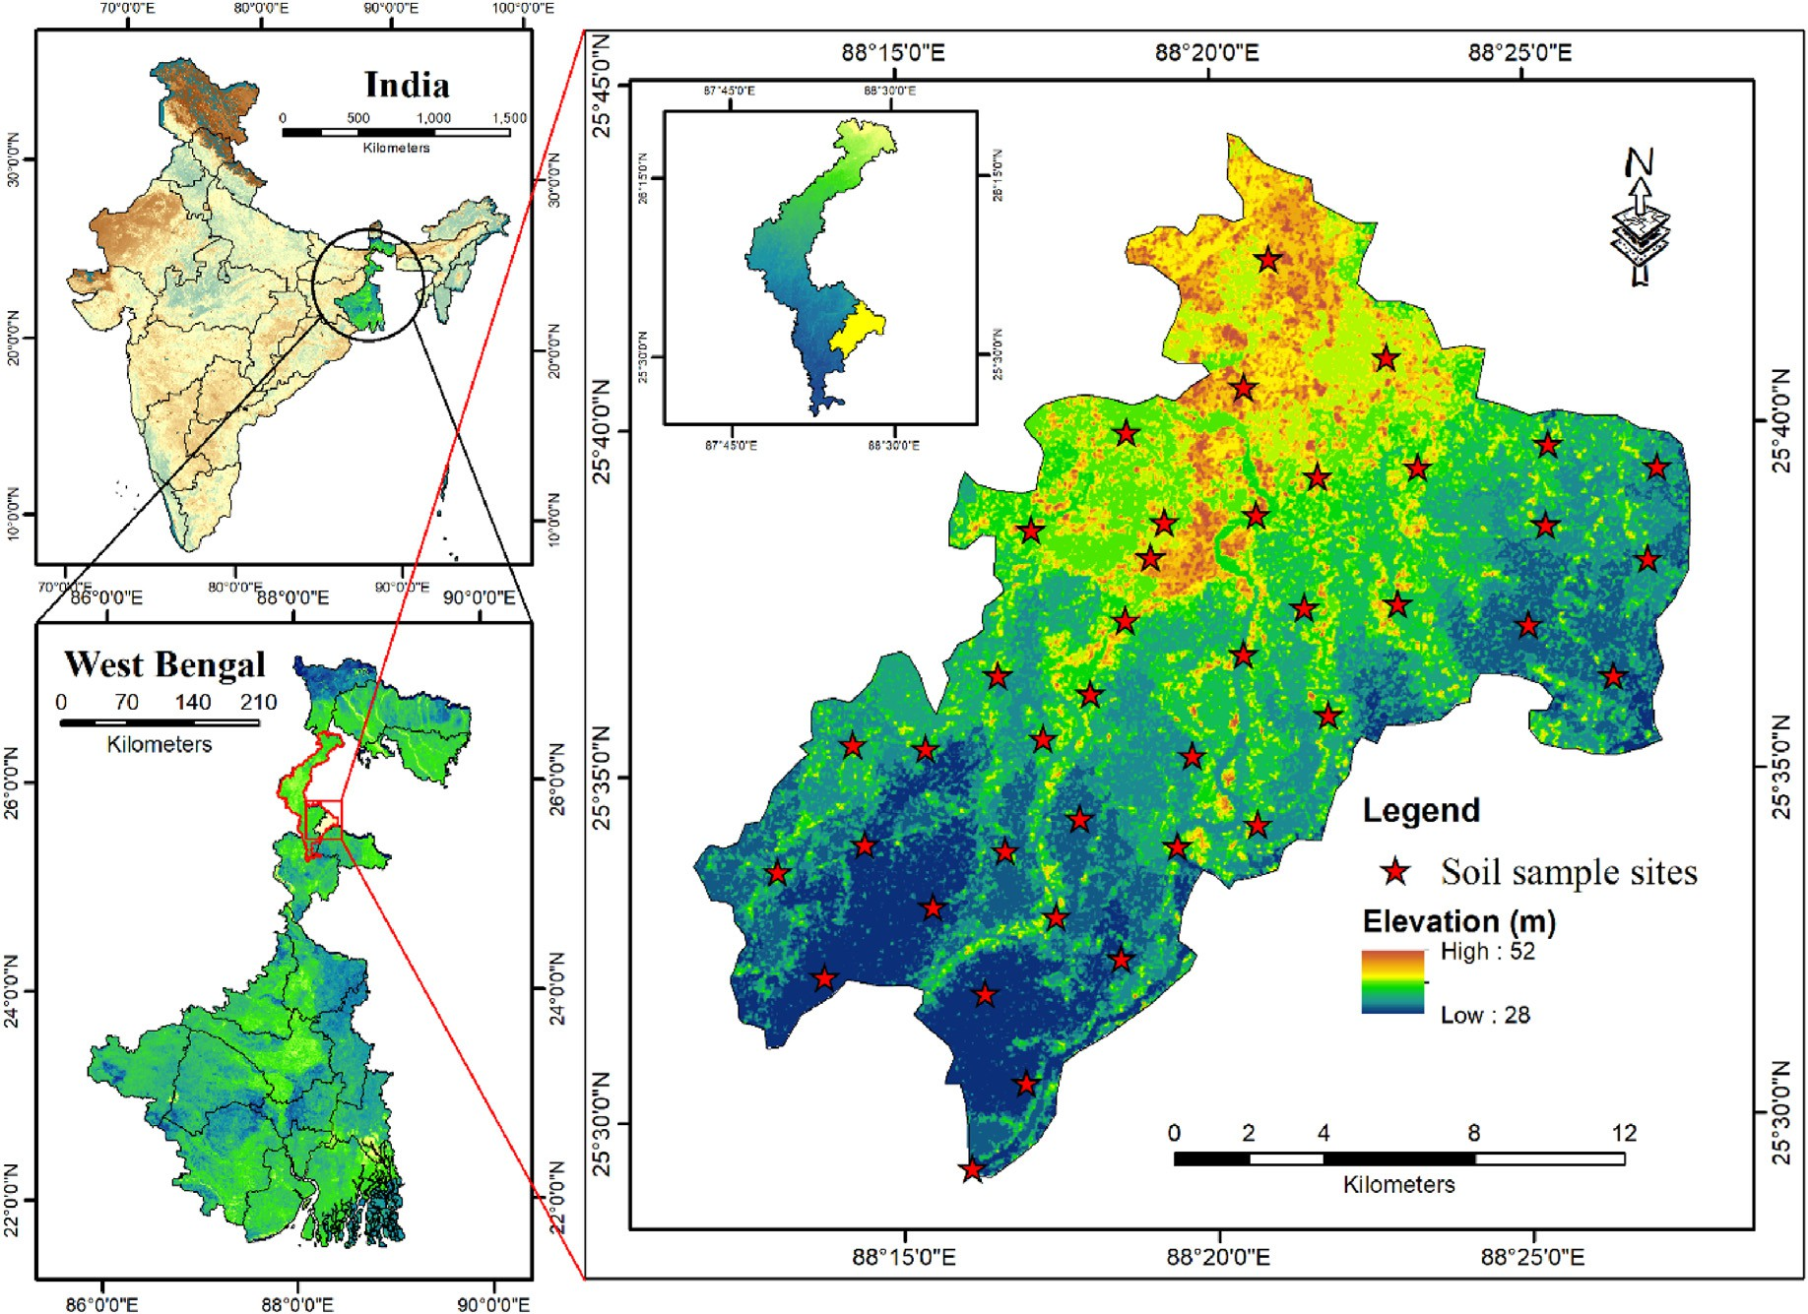

Fig. 1. Location of the study area.

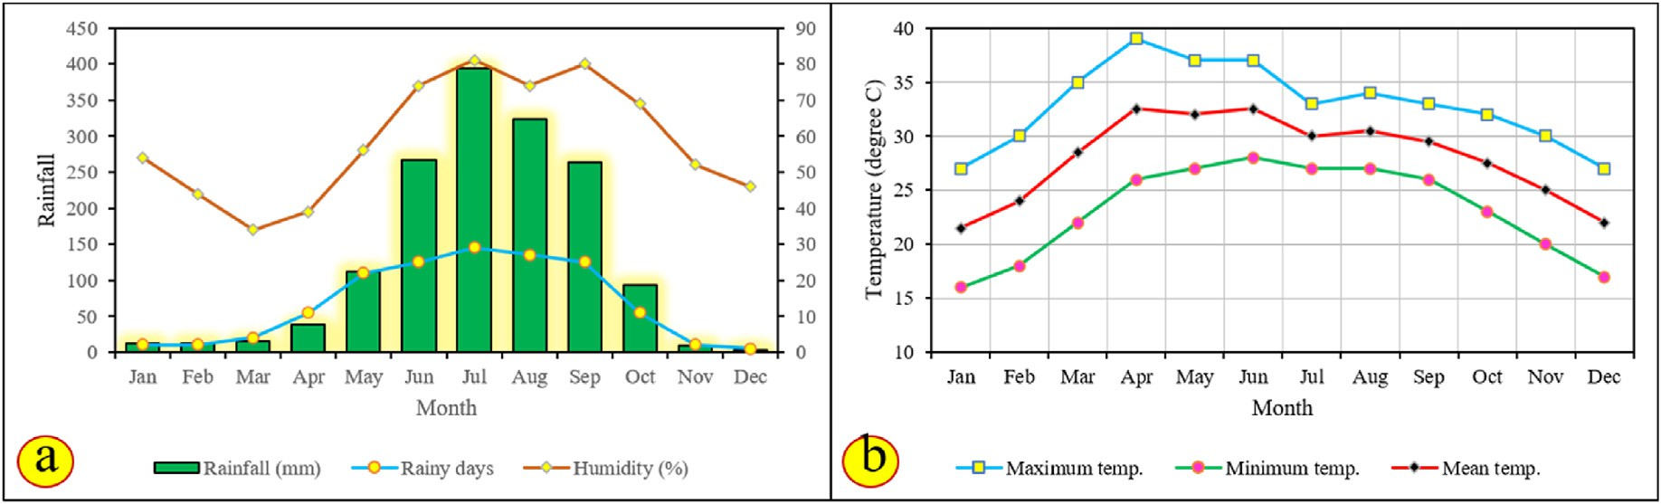

Fig. 2. Climatic conditions (a) monthly rainfall, humidity, and (b) temperature distribution.

1. Database and adopted methods
   1. *Data sources*
      1. *Soil sample collection and laboratory testing*

A total of 40 soil samples were collected from different study sites using hand-held GPS and thermometer instruments in the month of November to December 2020 and from May to June 2021. Firstly, we identified the Tulaipanji rice field in the study area during a pre-field survey considering the local people's perceptions. To collect soil sam- ples, we selected 5 soil sampling sites from 8-g panchayats using a stratified random sampling method. The soil samples were collected at a 40 cm zig-zag depth from the surface. At each soil sample site, five soil samples, with an average distance of 20 m, of about 500 gm were collected and mixed for laboratory analysis. After collecting the soil

samples, the soil is dried up and made into a fine grain size for laboratory purposes. All the soil samples are then tested by the authors with a proper laboratory assistant in the soil laboratory at Raiganj. Some of the glimpses of soil sample collection to laboratory analysis are given in Fig. 3. To analyze the different soil properties such as Nitrogen (N), Po- tassium (K), Phosphate (PO4), Sulphate (SO4), Boron (B), Potential of Hydrogen (pH), Organic carbon (OC), Zinc (Zn), Manganese (Mn), Copper (Cu), Iron (Fe), Soluble Salt (SS), Bulk density (BD), Cation ex- change capacity (CEC) and Moisture Index (MI) (Table 1) of the sampled soil the guidelines proposed by the ministry of agriculture and cooper- ation, the government of India has been followed.

* + 1. *Construction of the selected data layers*

As mentioned earlier, the soil samples were collected from 40 places randomly distributed in the study area using hand handling GPS (GPS

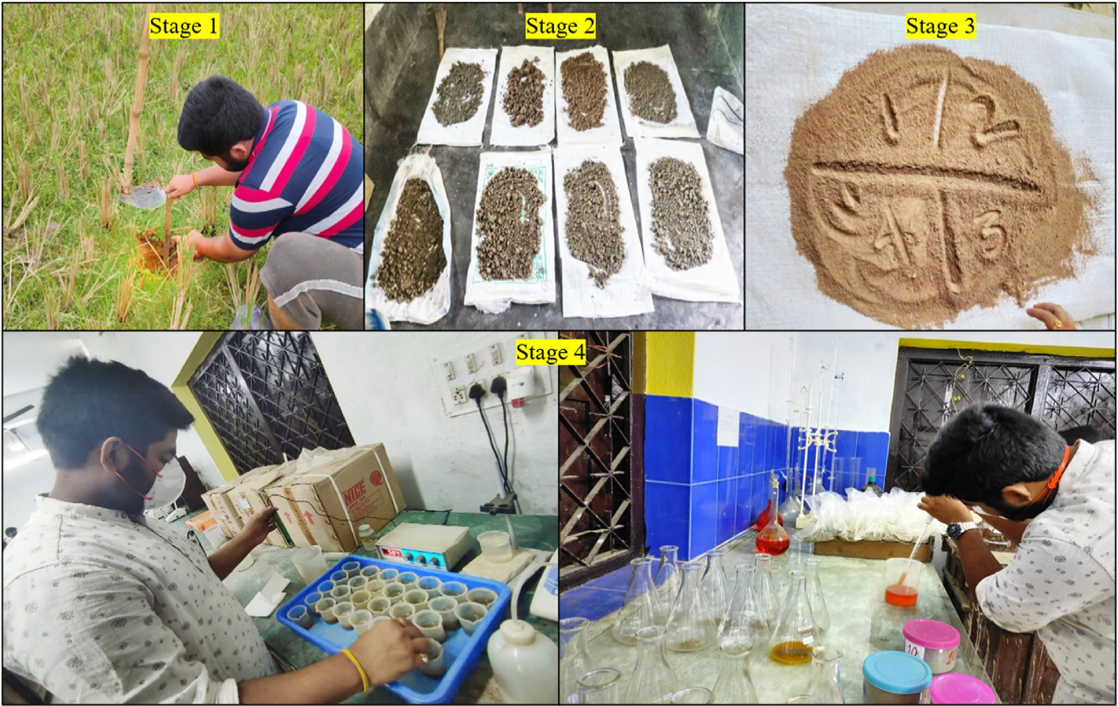

Fig. 3. Soil properties analysing procedure.

name = Garmin Etrex). After analyzing the physical and chemical properties of the sampled soil and the information on respected points or

sample sites, spatial mapping is performed by using inverse distance

(CR) which is used to define the effectiveness requirements for the analytical hierarchy process.

weighting (IDW) algorithms in the Arc GIS v.10.5 environments (Fig. 4). Fig. 4 Spatial data layers; (a) Nitrogen (N), (b) Potassium (K), (c)

*CI* = λmax — *n*

*n* — 1

(2)

Phosphate (PO4),(d) Sulphate (SO4), (e) Boron (B), (f) Potential of Hydrogen (pH), (g) Organic carbon (OC), (h) Zinc (Zn), (i) Manganese (Mn), (j) Copper (Cu), (k) Iron (Fe), (l) Soluble Salt (SS), (m) Bulk density

(BD), (n) Cation exchange capacity (CEC) and (o) Moisture index (MI).

Equation (2) is used to calculate the consistency index. Where λmaxrepresent the principal or highest Eigenvalue from the constructed pair-wise matrix table and n is the total number of influencing variables.

* 1. *The method of assigning ratings to soil fertility analysis parameters*

*CR* = *CI*

*RI*

(3)

* + 1. *Multi criteria decision making method: Analytic hierarchy method (AHP)*

The analytical hierarchy process (AHP) is a multi-criteria decision- making (MCDM) process introduced by Saaty (1980). In the study area, this AHP model is used for assessing soil fertility status that could help in decision making in Tulaipanji cultivation. Saaty developed a nine-point scale using a pair-wise comparison matrix that can assist in extracting the relative weights of the individual influencing parameters (Table 3) (Saaty, 1980). The fundamental pair-wise matrix categorization (Eq. (1)) in AHP is premised on a 1 to 9 reciprocal pertinence rating, with 1 denoting ‘equally important and 9 denoting ‘very important. In an appropriateness assessment, variables were given relative importance based on their respective influence capacity in the decision-making process.

*a*1 *a*2 *a*3

*x*1 =( *a*1/3 *a*1 *a*4 ) (1)

*a*1/2 *a*1/4 *a*1

Akinci et al. (2013) mentioned reciprocity as a feature of matrices that is formally stated as contrast is implemented for n components in pairwise comparison. After the pairwise comparison matrix table is built, the eigenvectors and relative weights of the parameters are estimated. In this AHP model (Saaty, 1980), the incongruities and errors of the model builder are also taken into consideration, which is also one of the strengths of this adopted model. Equation (3) shows the Consistency ratio

The consistency index (CI) and random index (RI) are used to calculate the CR value. CR is the quantification of the policy or decision builder's mistakes or an indication of the magnitude of coherence and or irregularity (Sarkar and Pal, 2018). It represents the probability that the pair-wise matric evaluations were formed arbitrarily. If the calculated CR value is 10% or more, then we need to reconsider the parameters' relative importance judgments to reconstruct the pairwise matrix, but if the calculated CR value is below 10%, then the decision makers accurately judge the importance of the variables towards acceptable results with high precision.

* 1. *Machine learning algorithms and applied methods*

For the present study, three machine learning models, namely, arti- ficial neural network (ANN), support vector machine (SVM), and Bagging were employed to construct the final Tulaipanji farming suitability maps using data mining software namely WEKA. This software is a New Zealand-based Javascript using software developed by Waikato Univer- sity. The produced information is then imported into the Arc GIS plat- form for spatial mapping. The Arc GIS environment offers a wide range of classifier techniques, such as manual, equal interval, defined interval, quantile, natural breaks (Jenks), geometrical interval, standard devia- tion, etc. to classify the produced Tulaipanji farming suitability maps. The natural break is a widely used and accepted method for classifying suitability zones (Sarkar and Mondal, 2020; Saha et al., 2021).

Table 1

Sleeted variables and their measurement.

Parameters Symbol Measuring procedure

Nitrogen N Laboratory based analysis

Potassium K Laboratory based analysis

Phosphate PO4 Laboratory based analysis

Sulphate SO4 Laboratory based analysis

Boron B Laboratory based analysis

H

Remarks

Required for plant proteins. Deficit if nitrogen will show yellowing of the plants.

For plant growth, roots, seed and fruits development it is very essential.

Essential for plants proteins. Essential for plants proteins.

Deficit of Boron will affect the vegetative and reproductive stage of the plant.

has mostly been used to simulate flood susceptibility (Yang et al., 2019). One of the most fundamental disadvantages of modelling using SVM is the difficulty of acquiring important characteristics (Choubin et al., 2019).

* 1. *Bagging model*

One of the simplest yet efficient machine learning ensemble ap- proaches is Bootstrap Aggregation (also known as bagging) (Prasad et al., 2006). Bootstrap Aggregation is a fundamental technique that may be used to decrease variance in algorithms that have a high number of it- erations (Breiman 1996). The goal of bagging is to decrease variance while retaining the bias of a decision tree and avoiding over fitting (Shahabi et al., 2020). The Bagging Tree generates several sets of input

data at random by replacing training samples (Maclin and Opitz 1997).

Potential for P

hydrogen

Laboratory based

analysis

It affects the availability of

plant nutrients.

The chosen subset of data was analyzed to train the assigned trees and

Organic carbon OC Laboratory based

analysis

Zinc Zn Laboratory based analysis

Manganese Mn Laboratory based analysis

Copper Cu Laboratory based analysis

Iron Fe Laboratory based analysis

Soluble salt SS Laboratory based

analysis

Bulk density BD Laboratory based

analysis

Cation exchange CEC Laboratory based capacity analysis

Moisture index MI *Im* = 100 * (*S* —

*D*)/*PE*

High OC increase the CEC which is very important for fertile soil.

In Zn deficit soil, the plant growth stunted.

This help in growth and development of the plant cell compartment.

Help in the photosynthesis and respiration process.

It helps the plant to move oxygen throughout the roots, leaves and other parts of the plant.

High SS in soil will make plant drought stress.

High BD affect the water availability in the soil. Fertile soil indicates good amount of CEC

Deficit of moisture in the soil

will hamper the plant overall growth.

generate models. The average of all forecasts from these trees is then used to create the final conclusion, which is more resilient. Using several replicas of the trained data subset improves the precision of a single tree (Talukdar and Pal, 2019).

* 1. *Constructing suitability maps*
     1. *Weighted linear combination method (WLCM)*

A wide variety of MCDM techniques have been used by researchers for allocating weights and integrating influencing variables of a specific event towards decision making. Several prominent approaches in this respect include AHP, Weighted linear combination method (Eastman, 1997), weighting and integrating parameters based on a correlation matrix (Khatun and Pal, 2016), etc. The GIS environment provides a fascinating environment where we can successfully achieve the required outcomes. For soil fertility status analysis of the study block, the WLC method has been used (Eq. (6)).

X

*n*

Normalized Difference Water Index

NDWI NWDI = (Green-

NIR)/(Green +

NIR)

Deficit of NDWI in the soil will hamper the plant overall growth.

*WLC* =

*j*=1

*aijwj* 6

* 1. *Multilayer Perceptron-ANN model*

A neural network (ANN) is a numerical model of human perception (Kim et al., 2014) that may be taught to perform a specific task (Chak- raborty et al., 1992), based on the data set that is currently available (Valencia Ortiz and Martínez-Gran~a, 2018). The three-layer ANN approach (input, hidden, and output layers) was established and suc- cessfully (Zhao et al., 2020) used for suitability modelling. In the output layer, however, a node was employed that was coded as 1 for cultivated and 0 for non-cultivated regions. The discrepancy between the computed and observed values is characterized as an error. To examine it, a variety of error measuring techniques have been utilized (Falah et al., 2019). The customization of initial weights is carried out using a generalized delta rule to disperse the entire error across the network's neurons (Kazmier- kowski 2002).

* 1. *Support vector machine (SVM) model*

A common machine learning model is the SVM, which uses a set of linear indicator functions. This was introduced by Vapnik (2013) and has been used in the determination of function concerns. The optimum linear hyper-plane has been selected to separate the actual output space. The array was also divided into two categories, such as the area of suitable Tulaipanji cultivation and the region not suitable for Tulaipanji cultiva- tion {1, 0}. Because of the radial basis kernel's flexibility in dealing with different dataset dimensionalities and its high generalization ability, it

where aij demotes the ith ranking of the jth element and wj demotes the jth attribute's weighting.

* + 1. *Machine learning algorithms*

The soil properties, and climatic information related to Tulaipanji are taken into consideration to perform the final site suitability maps for Tulaipanji rice cultivation. In this process, machine learning algorithms such as artificial neural networks (ANN), support vector machine (SVM), and Bagging models come into play. The descriptions of these three methods were previously discussed. The detailed procedure adopted for preparing final site suitability maps for the study area is given in Fig. 5.

1. Results and analysis

A number of fifteen variables were analyzed using various statistical techniques. Boron (B), Zinc (Zn), Nitrogen (N), Phosphate, Potassium, and Manganese (Mn) are the major variables that are considered as prime variables. The standard deviation (SD) of the dataset represents the average level of variability. It informs users how far each score deviates from the mean on average. The SD of N is 70.931, followed by K (36.289), and PO4 (35.415) (Table 2). The kurtosis is a measure of heaviness or the density of distribution tails, whereas skewness is a measure of symmetry in distribution. The skewness of PH, K, PO4, Zn, Fe,

SS, CEC indicates the highly skewed distribution in the soil sample data. The Kurtosis of MI (—0.625), Fe (—0.216), Cu (—0.844), OC (—1.057), B

(—0.297), K (—0.738), N (—0.908) represents a negative which indicates

the Platykurtic kurtosis. The negative kurtosis depicts the lower number of outliers in the distribution.

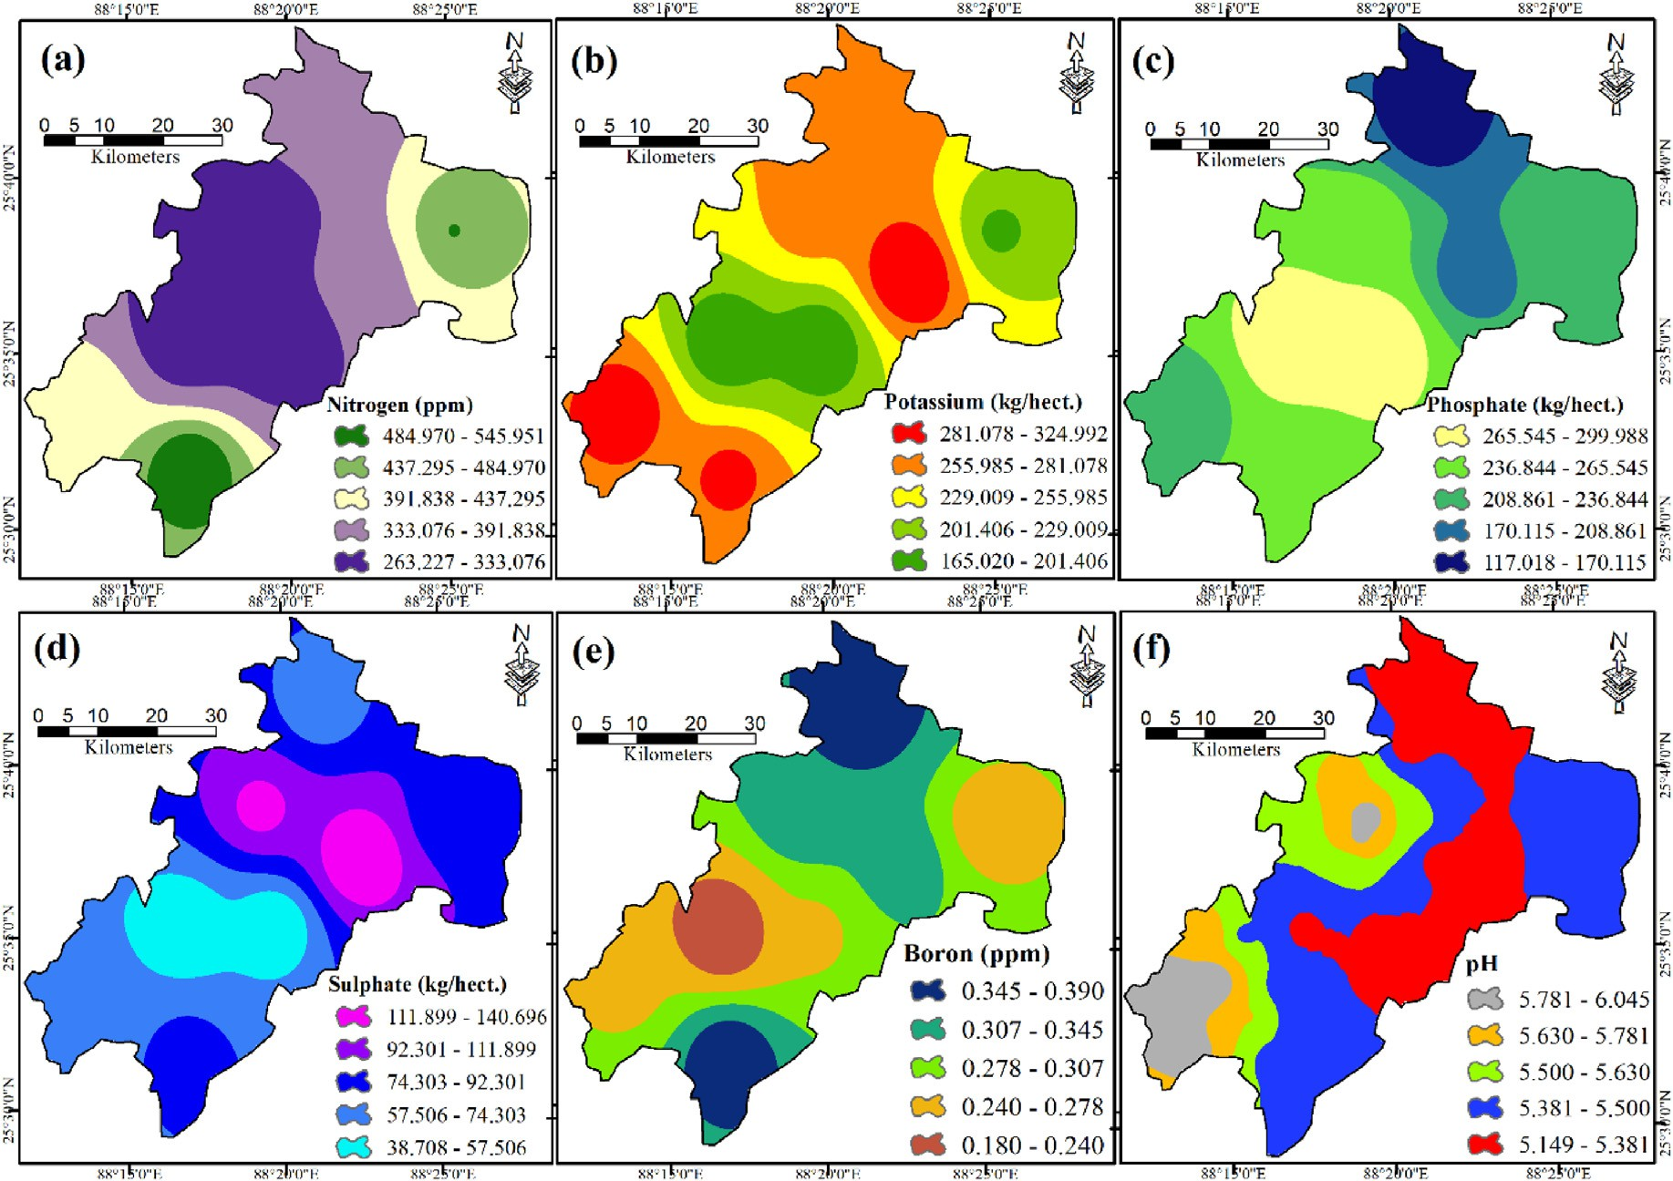

Fig. 4. Spatial data layers; (a) Nitrogen (N2), (b) Potassium (K), (c) Phosphate (PO4),(d) Sulphate (SO4), (e) Boron (B), (f) Potential of Hydrogen (pH), (g) Organic carbon (OC), (h) Zinc (Zn), (i) Manganese (Mn), (j) Copper (Cu), (k) Iron (Fe), (l) Soluble Salt (SS), (m) Bulk density (BD), (n) Cation exchange capacity (CEC) and (o) Moisture index (MI), (p) Elevation, (q) Slope, (r) Rainfall, (s) GWL, (t) Lithology, (u) Geomorphology, (v) LULC, (w) Soil, (x) Dist. from river, (y) Dist. from road, (z) Dist. from KB.

* 1. *Soil fertility mapping (SFM) using AHP and WLC*

Table 3 AHP rating Scale and Random Index (RI) to the formation of the Pair-wise comparison matrix.

From the AHP estimation (Tables 3 and 4, Fig. 6) it is found that the Boron (Br) is the most prominent variable with a 9.19 per cent rating in Soil Fertility Mapping followed by Zinc (Zn) with 8.81 per cent, Potas- sium with 8.39 per cent respectively. A soluble salt is a least influencing variable with a 3.79 per cent of AHP rating.

It is considered that not all the selected parameters have the same influence on soil fertility. As a result, the MCDM-AHP based weighting procedure is used to determine the weights of the selected variables. From Fig. 7, out of the total spatial extension of the study area, 54.38 sq. km of the land seemed to have very high soil fertility for agricultural farming, primarily covering the NE and SW parts of the block. According to the produced SFM, about 41.04 sq. km. (13.60%) is highly fertile and

86.96 sq. km. (28.80%) comes under the moderately fertile zone of the total respectively. About 52.98 sq. km. of the total area, mainly in the South, South-west, and Northern parts of the block, appeared as unsuit- able sites as the soil fertility is very poor (Table 5). Equation (7) demonstrated the performed WLC for soil fertility mapping.

*Zn* 0.088 + *S* 0.0798 + *Slt* 0.0379 + *K* 0.0839+

* 1. *Site suitability mapping using machines learning techniques*

In this present study, the ANN, SVM and Bagging method was used to construct site suitability map for Tulaipanji rice cultivation and classify the produced maps into five categories, such as very high, high, moder- ate, low, and least suitable (Fig. 8). The ANN, SVM, and Bagging-based site suitability models have five suitability categories that are repre- sented in Fig. 8. The findings reveal that 77.89 sq. km (ANN model),

52.62 sq. km (SVM model), and 80.97 sq. km (Bagging model) areas are the most favorable for Tulaipanji rice cultivation. In the case of ANN suitability analysis, the percentages are 25.8, 22.01, 19.84, 21.84, and

11.16 for very high, high, moderate, low, and least suitable zones respectively. Whereas about 17.43%, 27.91%, 22.06%, 22.25%, and 10.35% of the total area is very high, high, moderate, low, and least suitable zone respectively, in the case of the SVM model. The Bagging estimation shows that only 26.82% of the area is most suitable, followed by 21.39% of high suitable, 22.65% of moderate suitable, 19.41% of low suitable, and 9.73% of least suitable respectively (Table 6). It is observed from the models that the very high and high suitability zones were mainly located in the S, W, SE, and NE parts of the block. The least suitable sites for Tulaipanji rice cultivation are found in the N and SW segments of the study region.

*FSM*

*PO*4 0.0775 + *PH* 0.051 + *OC* 0.0685 + *N*2 0.0662+

*WLCM* =( *Mn* 0.0773 + *Fe* 0.0711 + *Cu* 0.0348 + *B* 0.0919+ )

*BD* 0.0576 + *CEC* 0.0661 + *SM* 0.0483

7

* 1. *Validation and comparisons of the results*

It is against the ethical standard if we use any model for planning and management purposes before judging the accuracy and precision of the

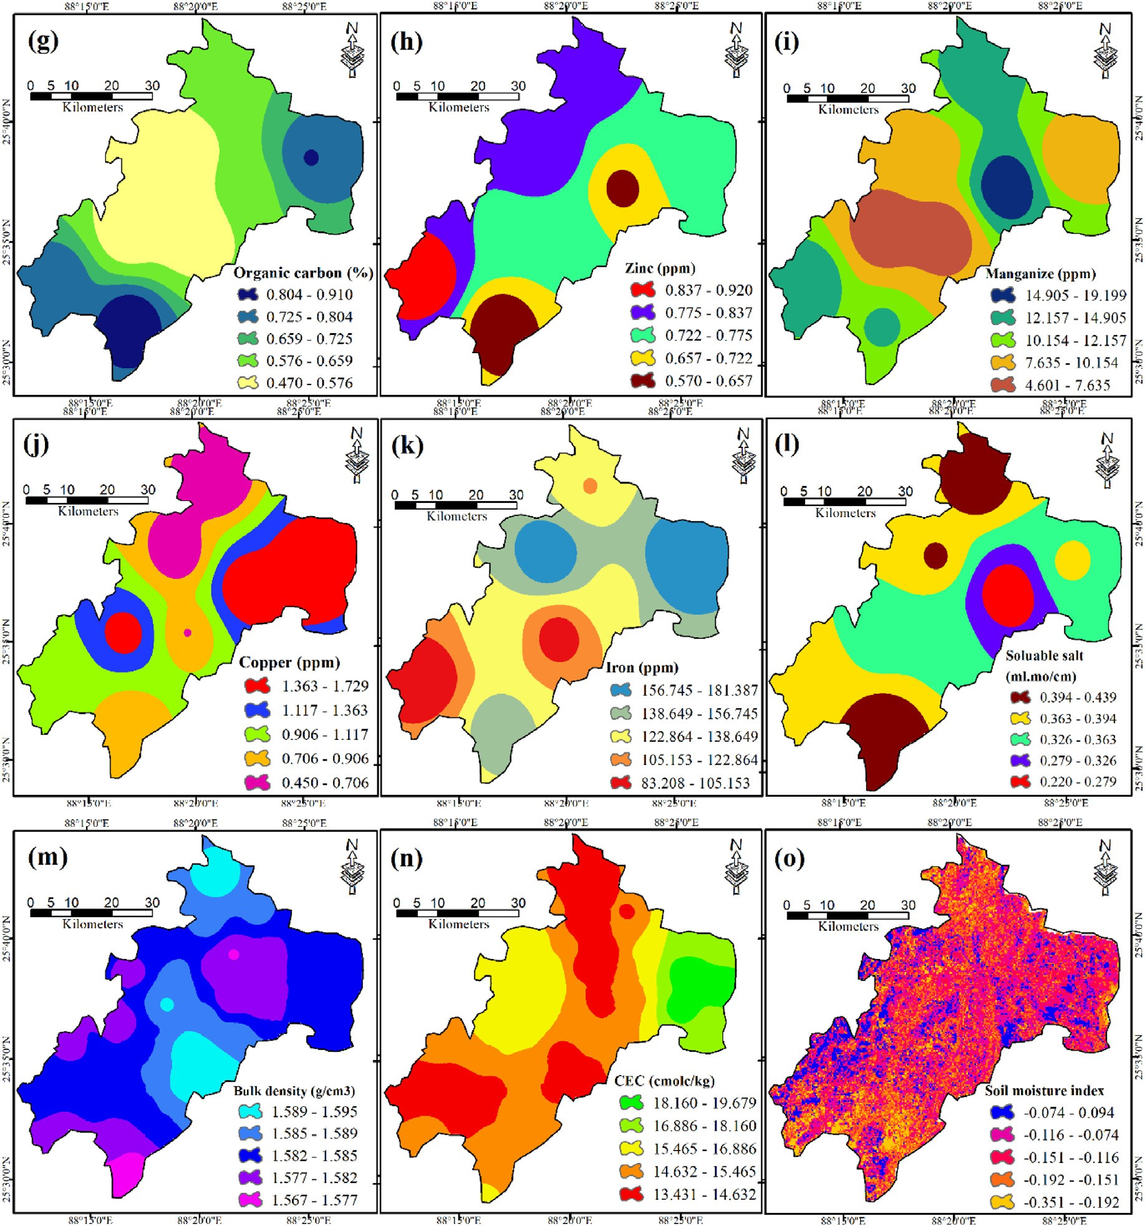

Fig. 4. (*continued*).

produced model (Sarkar and Pal, 2018; Sarkar and Mondal, 2020). The validation of the ANN, SVM and Bagging models has been analyzed using the receiver operating characteristic (ROC) curve, which is generated by utilizing the training and validation points. The training and validation points are given in Fig. 9. The area under the curve (AUC) shows the accuracy level of the performed models. The AUC can be categorized into excellent (0.9–1), very good (0.8–0.9), good (0.7–0.8), average (0.6–0.7), and poor (0.5–0.6). The ROC curve of the training datasets indicates an AUC of 0.936 for ANN, 0.918 for SVM, and an AUC of 0.895 for the Bagging model. The ROC curve indicates the high precision of the pro- duction models. The ANN is the best suitable model for locational anal- ysis of Tulaipanji rice cultivation in the study region.

1. Discussion of the result

According to the SFM, approximately 41.04 sq. km. (13.60 percent) of the total is highly fertile, while 86.96 sq. km. (28.80 percent) is

moderately fertile. Because the soil fertility is quite low, around 52.98 sq. km. of the total area looked to be inappropriate sites, notably in the block's south, south-west, and northern regions. Based on the findings, the areas with the best potential for Tulaipanji rice farming are 77.89 sq. km (ANN model), 52.62 sq. km (SVM model), and 80.97 sq. km (Bagging model). North-eastern part of Dhankoil G.P., North-western of Anantapur G.P., Southern portion of Radhikapur G.P., Maximum portion of Mostafa Nagar G.P. are has high potentiality to Tulaipanji farming. Least part of the study area experienced a very low to moderate potentiality to Tulaipanji cultivation.

People who live in alkaline soils are more likely to have zinc shortages because of the inverse pH of the soil available. Some other things that affect soil fertility are how much sulphur there is in it. Crops that grow quickly can take in a lot of sulphur. Potassium treatments to rice field soils keep the redox potential of the soil from dropping. They also lower

the levels of active reducing chemicals and Fe2+ in the soil. Phosphorus

(P) is a big problem for tropical rice production because it's hard to find.

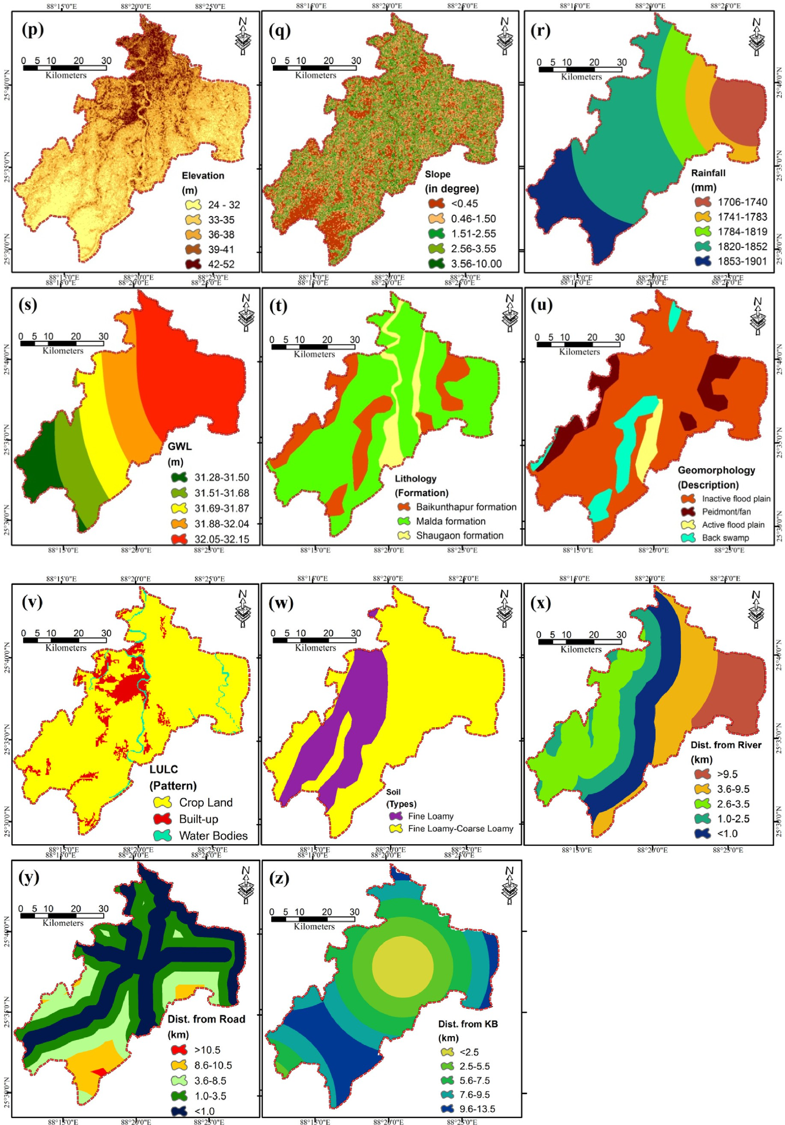

Fig. 4. (*continued*).

Soil PH has a huge effect on the soil and its biological, chemical, and physical properties. Because of the amount of Organic Carbon (SOC) in

the soil, these properties, as well as many others, can be affected. Rice N took up more space in the soil when N energy (fertiliser) was injected at a

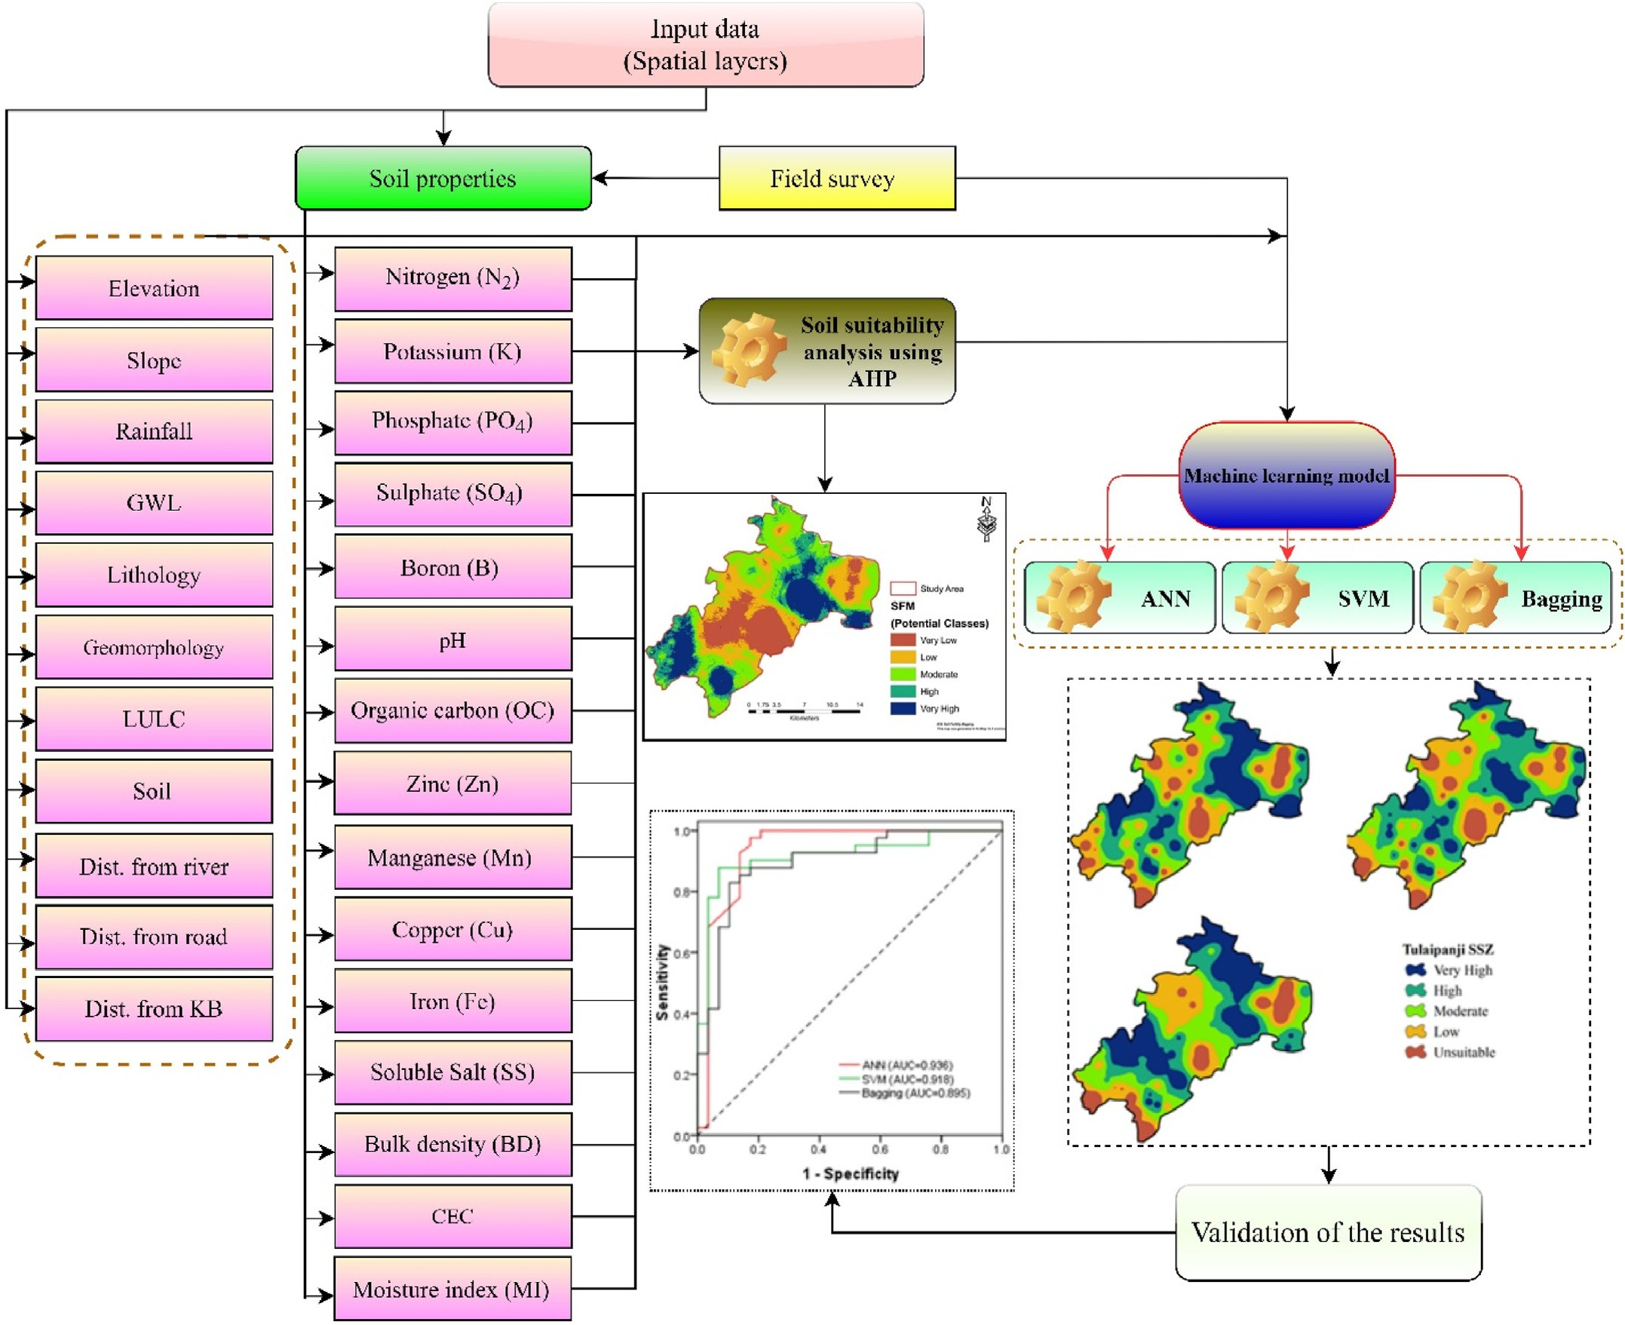

Fig. 5. Flowchart showing the detailed procedure adopted for the present study.

Table 2

Descriptive statistics of the different soil properties.

|  |  |  |  |  |  |  |  |
| --- | --- | --- | --- | --- | --- | --- | --- |
| Soil properties | Minimum | Mean | Median | Maximum | Standard Deviation | Kurtosis | Skewness |
| Nitrogen (N) | 263.327 | 372.579 | 367.367 | 527.742 | 70.931 | —0.908 | 0.288 |
| Potassium (K) | 165.124 | 244.055 | 253.477 | 314.404 | 36.289 | —0.738 | —0.317 |
| Phosphate (PO4) | 130.849 | 238.587 | 243.432 | 299.917 | 35.415 | 1.194 | —0.816 |
| Sulphate (SO4) | 38.769 | 78.38 | 78.437 | 134.223 | 21.968 | 0.002 | 0.515 |
| Boron (B) | 0.195 | 0.297 | 0.296 | 0.38 | 0.043 | —0.297 | —0.052 |

PH 5.15 5.487 5.431 6.045 0.203 1.091 1.2

|  |  |  |  |  |  |  |  |
| --- | --- | --- | --- | --- | --- | --- | --- |
| Organic carbon (OC) | 0.47 | 0.644 | 0.63 | 0.883 | 0.113 | —1.057 | 0.247 |
| Zinc (Zn) | 0.592 | 0.756 | 0.757 | 0.904 | 0.064 | 0.917 | —0.381 |
| Manganese (Mn) | 4.609 | 10.244 | 10.12 | 18.124 | 2.818 | 0.434 | 0.352 |
| Copper (Cu) | 0.483 | 1.051 | 1.001 | 1.665 | 0.313 | —0.844 | 0.159 |
| Iron (Fe) | 87.462 | 136.827 | 135.591 | 181.145 | 23.295 | —0.216 | —0.134 |
| Soluble Salt (SS) | 0.235 | 0.363 | 0.363 | 0.432 | 0.038 | 2.937 | —1.161 |
| Bulk density (BD) | 1.567 | 1.584 | 1.584 | 1.595 | 5.465 | 1.669 | —0.187 |
| Cation exchange capacity (CEC) | 13.431 | 15.491 | 14.929 | 19.679 | 1.543 | 0.641 | 1.136 |
| Moisture index (MI) | —0.223 | —0.138 | —0.149 | —0.055 | 0.044 | —0.625 | 0.344 |

depth of 45 cm, which made it more clear (on average 74 per cent). Having too little iron (Fe) makes it hard for plants to do their job of photosynthesis, which lowers the amount of dry matter they make. Rice plants' metabolic processes, such as photosynthesis and respiration, are

affected by a lack of copper (Cu). There are 132 crops that can't be grown because of a lack of boron in more than 80 countries. The “Bulk Density” of soil is a good way to tell if the soil has been compacted. The bulk density of any soil is affected by its texture and the amount of SOC it has

Table 3

AHP rating Scale and Random Index (RI) to formation of the Pair-wise com- parison matrix.

Scale linguistic rating Random Index (RI)

(33 m–38 m) are better. The highland crops may not be as affected by the flood. The slope of the land is an important part of farming. It's best to have a slope of 3◦ for Tulaipanji farming. When Tulaipanji was grown

after the Monsoon season, it was done. When there is too much rain,

1 Equal importance

3 Moderate importance

5 Strong importance

*n*, *RI*

1, 0.00

2, 0.00

6, 1.24

7, 1.32

Tulaipanji can't grow.

Monoculture and short rotations increase crop species-specific weed, pest, and disease pressure, increasing the need for synthetic chemical

7 Very strong importance

( 3, 0.58 )( 8, 1.41 )

9 Extremely Importance

2,4,5,8 Intermediate Values

1/3,1/5,1/7,1/9 Inverse Comparison

4, 0.90

5, 1.12

9, 1.45

10, 1.49

pesticides, pesticide residues in crops. Consumers believe organic

farming is more sustainable, and that it benefits the environment, biodiversity, and food quality and safety. The combined application of fertilisers and growth regulators can provide another option for miti- gating the negative effects of water logging in crops, with the fertilisers

in it. Cation Exchange Capacity (CEC) controls how much nutrients the soil can hold, as well as how often nitrogen (N) and potassium fertilisers are applied. In a satellite image, the Normalized Difference Water Index (NDWI) is used to emphasise open water features, enabling them to “stand out” against the land and vegetation. The NDWI is quick enough to get information on soil moisture in any area, and it has a reliable method for mapping dry land and water. Elevation is very important to the growth of Tulaipanji. For Tulaipanji farming, areas with high elevations

acting as a nutrient supply and the PGRs assisting with physiological injury repair. Increased specificity of interactions between different management strategies and the environment (soil types, intensity of water logging, etc.) as well as between management practises. In general, all kharif crops in India are cultivated in rainfed circumstances with little irrigation. To sustain Tulaipanji farming, irrigation systems need be installed in the Study area.

Table 4

Normalized pair-wise comparison matrix Criteria Weight, CI, and CR.

|  |  |  |  |  |  |  |  |  |  |  |  |  |  |  |  |  |  |
| --- | --- | --- | --- | --- | --- | --- | --- | --- | --- | --- | --- | --- | --- | --- | --- | --- | --- |
| Variable | Zn | SO4 | Salt | K | PO4 | PH | OC | N | Mn | Fe | Cu | B | BD | CEC | SM | CWI | Consistency result |
| Zn | 1 | 1 | 2 | 1 | 1 | 3 | 2 | 2 | 1 | 1 | 2 | 1 | 1 | 1 | 3 | 0.088088 | CI |
| SO4 | 1 | 1 | 3 | 1 | 1 | 2 | 2 | 1 | 1 | 1 | 2 | 1 | 1 | 1 | 2 | 0.0798 | 0.067 |
| Salt | 0.5 | 0.33 | 1 | 0.33 | 0.5 | 1 | 1 | 1 | 0.5 | 0.5 | 1 | 0.33 | 1 | 0.33 | 0.5 | 0.0379 | CR |
| K | 1 | 1 | 3 | 1 | 1 | 3 | 0.5 | 1 | 1 | 1 | 3 | 1 | 1 | 2 | 2 | 0.0839 | 0.043 |
| PO4 | 1 | 1 | 2 | 1 | 1 | 2 | 2 | 1 | 1 | 1 | 2 | 1 | 1 | 1 | 2 | 0.0775 |  |
| PH | 0.33 | 0.5 | 1 | 0.33 | 0.5 | 1 | 1 | 1 | 0.5 | 1 | 2 | 0.5 | 2 | 1 | 1 | 0.051 | The CI is less 10% |
| OC | 0.5 | 0.5 | 1 | 2 | 0.5 | 1 | 1 | 1 | 0.5 | 1 | 2 | 2 | 2 | 1 | 1 | 0.0685 | Result = ok |
| N | 0.5 | 1 | 1 | 1 | 1 | 1 | 1 | 1 | 1 | 1 | 2 | 1 | 2 | 1 | 1 | 0.0662 |  |
| Mn | 1 | 1 | 2 | 1 | 1 | 1 | 1 | 1 | 1 | 1 | 3 | 1 | 1 | 2 | 2 | 0.0773 |  |
| Fe | 1 | 1 | 2 | 1 | 1 | 2 | 2 | 1 | 1 | 1 | 3 | 0.33 | 1 | 0.5 | 1 | 0.0711 |  |
| Cu | 0.5 | 0.5 | 1 | 0.33 | 0.5 | 0.5 | 0.5 | 0.5 | 0.33 | 0.33 | 1 | 0.5 | 1 | 0.5 | 1 | 0.0348 |  |
| B | 1 | 1 | 3 | 1 | 1 | 2 | 2 | 1 | 1 | 3 | 2 | 1 | 1 | 2 | 2 | 0.0919 |  |
| BD | 1 | 1 | 1 | 1 | 1 | 0.5 | 0.5 | 0.5 | 1 | 1 | 1 | 1 | 1 | 1 | 1 | 0.0576 |  |
| CEC | 1 | 1 | 3 | 0.5 | 1 | 1 | 1 | 1 | 0.5 | 2 | 2 | 0.5 | 1 | 1 | 1 | 0.0661 |  |
| SM | 0.33 | 0.5 | 2 | 0.5 | 0.5 | 1 | 1 | 1 | 0.5 | 1 | 1 | 0.5 | 1 | 1 | 1 | 0.0483 |  |

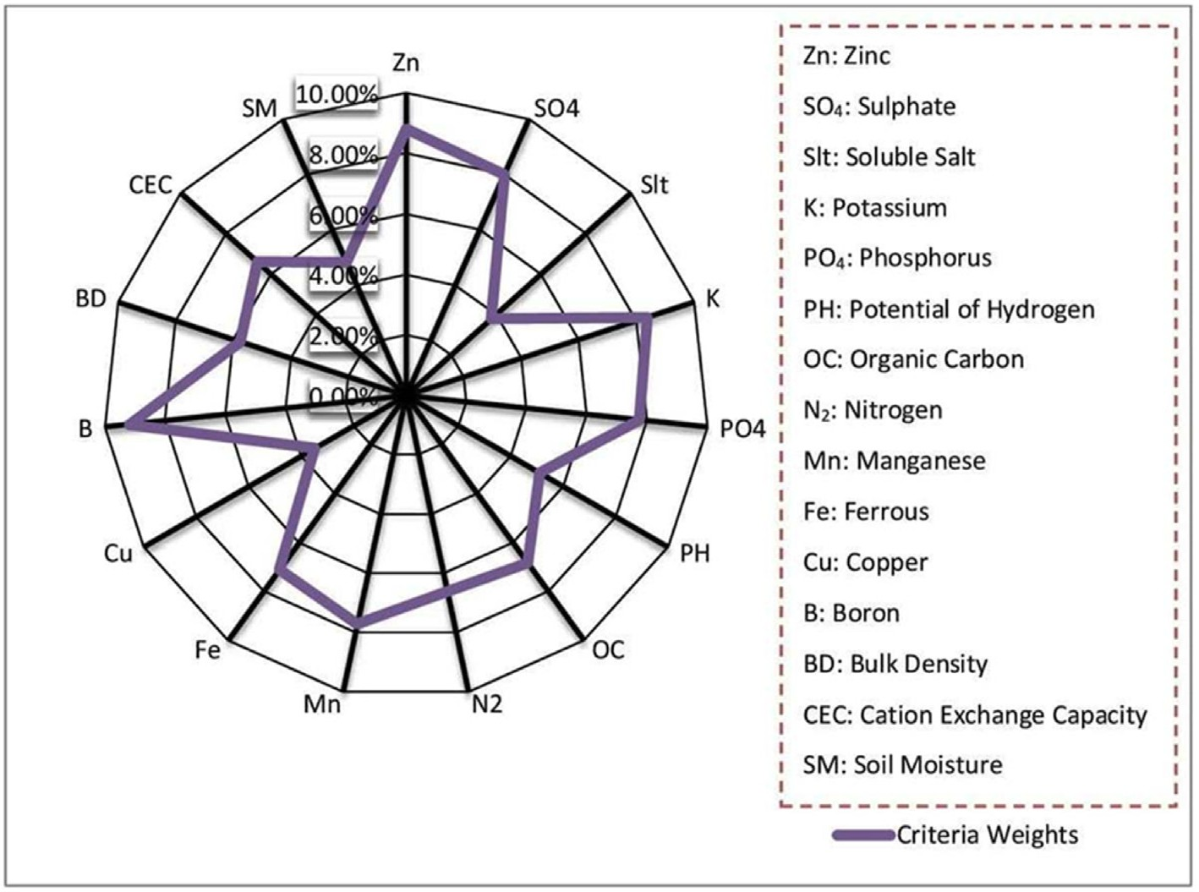

Fig. 6. Soil fertility assessment criteria weights using analytical hierarchy process.

Table 5

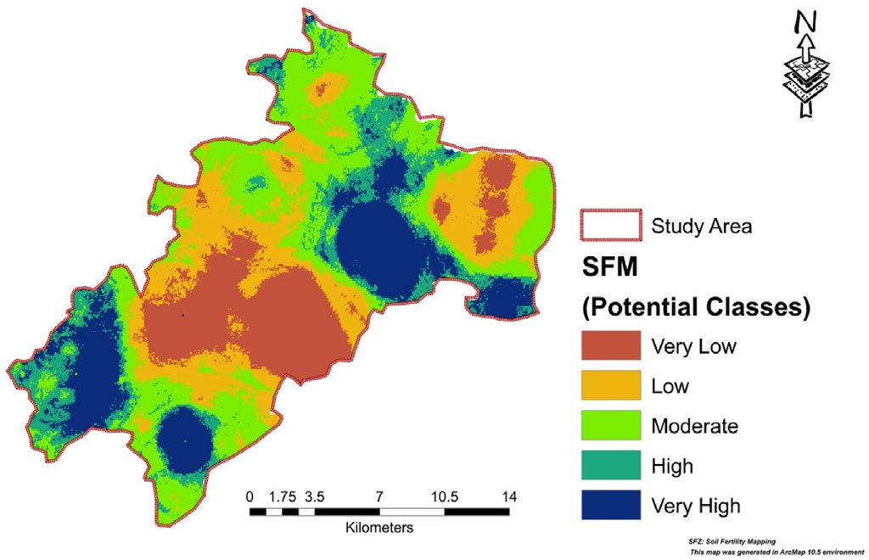Fig. 7. Soil fertility map of Kaliyaganj block using AHP-WLC.

damaging the land with improper land practices. To reduce the unde- sirable impact of environmental features on agricultural productivity and on land, land suitability analysis is the first and foremost step for envi- ronmental management and sustainable agriculture. Land suitability as- sessments not only aid in increasing crop yields but also in maintaining healthy soil conditions for bountiful output. The present study employs AHP, GIS, and machine learning approaches to determine the soil fertility and suitability of land for Tulaipanji rice cultivation in eastern India's semi-humid climatic zone. According to the final soil fertility map, 18.01% of the land is in excellent condition for agricultural production. The generated models were validated using the receiver operating characteristic (ROC) curve. Although the AUC values for the ANN (0.936), SVM (0.918), and Bagging (0.895) models are satisfactory, the ANN model is regarded as the best fit for mapping site suitability for Tulaipanji rice cultivation in the research region. The results of the land capability assessment using the machine learning SVM model indicated that 17.43% (52.62 sq. km) of this block is quite excellent for Tulaipanji cultivation. About 26.82% area is in excellent condition for Tulaipanji cultivation as per the Bagging model. The ANN-based findings indicate that areas with a proportion of 25.8% (77.89 sq. km) are highly suitable,

Areal distribution Soil Fertility mapping (SFM) using AHP.

|  |  |  |
| --- | --- | --- |
| SFM | Area (sq.km.) | Area (%) |
| Very High | 54.38 | 18.01 |
| High | 41.04 | 13.6 |
| Moderate | 86.96 | 28.8 |
| Low | 66.53 | 22.04 |
| Very Low/Unsuitable | 52.98 | 17.55 |

1. Conclusion

Population growth is exponential, yet land is a limited and precious resource on our blue planet. Thus, it is critical to utilize that fixed resource sustainably in order to meet rising food demand without

those with a proportion of 19.84 (59.90 sq. km) are moderately suitable, and those with a proportion of 11.16% (33.69 sq. km) are least or not suitable for Tulaipanji rice farming. The study results may add knowl- edge to our current understanding and provide light on scientific land use for sustainable agriculture and environmental management.

Compliance with ethical standards

The authors hereby declare that there is no conflict of interest and no human or animal involved or harmed in any way during this research work.

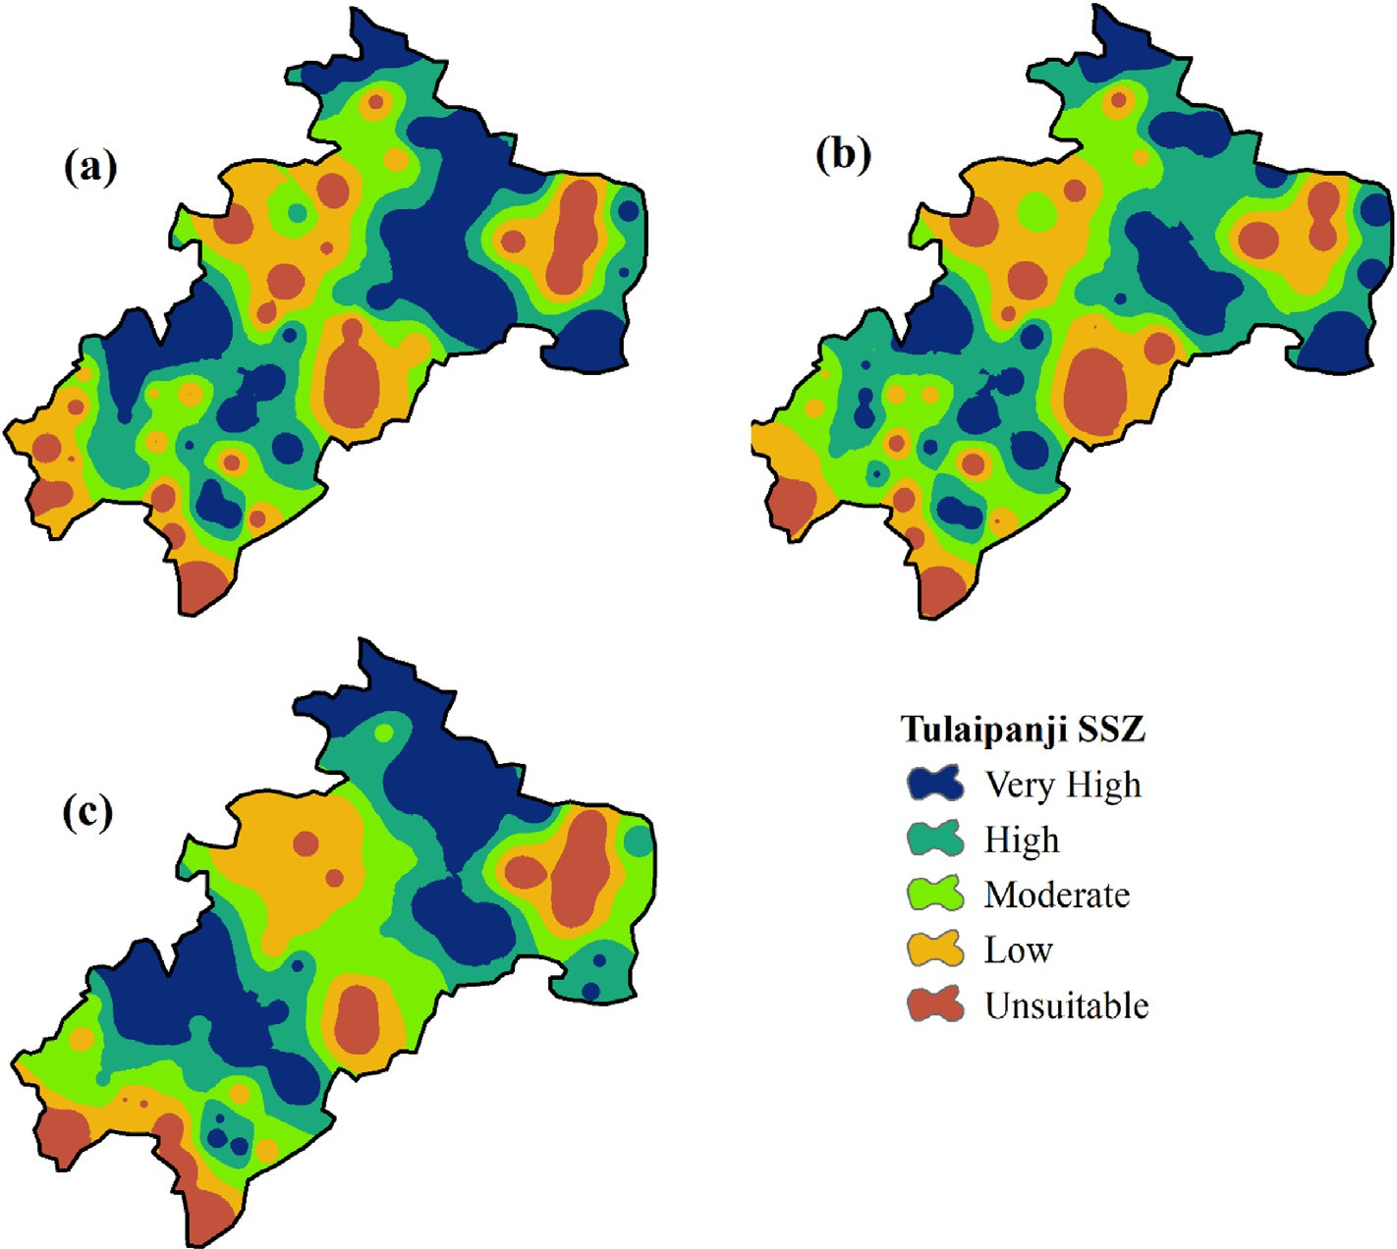

Fig. 8. Tulaipanji rice cultivation site suitability maps; (a) ANN model, (b) SVM model and (c) Bagging model.

Table 6

Areal coverage under different Tulaipanji rice cultivation favorable zones.

|  |  |  |  |  |  |  |  |  |  |  |  |  |
| --- | --- | --- | --- | --- | --- | --- | --- | --- | --- | --- | --- | --- |
| SSZ | ANN |  |  | SVM |  |  | Bagging |  |  | Total |  |  |
|  | Area (sq.km) | Area (%) |  | Area (sq.km) | Area (%) |  | Area (sq.km) | Area (%) |  | Area (sq.km) | Area (%) |
| Very High | 77.89 | 25.8 |  | 52.62 | 17.43 |  | 80.97 | 26.82 |  | 70.49 | 23.35 |  |
| High | 66.45 | 22.01 |  | 84.26 | 27.91 |  | 64.58 | 21.39 |  | 71.76 | 23.77 |  |
| Moderate | 59.90 | 19.84 |  | 66.60 | 22.06 |  | 68.38 | 22.65 |  | 64.96 | 21.51 |  |
| Low | 63.97 | 21.19 |  | 67.17 | 22.25 |  | 58.60 | 19.41 |  | 63.25 | 20.95 |  |
| Very Low | 33.69 | 11.16 |  | 31.25 | 10.35 |  | 29.37 | 9.73 |  | 31.44 | 10.42 |  |

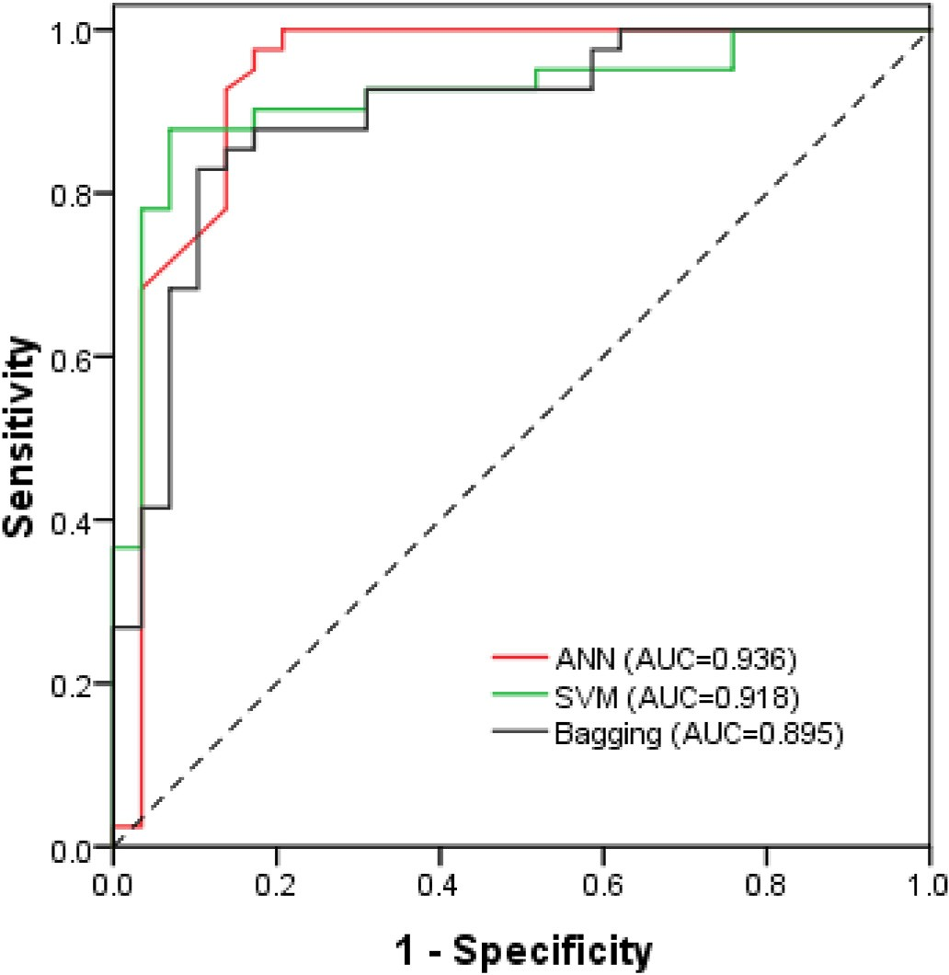

Fig. 9. Validation of the results using ROC curve.

Acknowledgment

Sri Gopal Ch. Ghosh, WBAS (ADMIN.), Assistant Director of Agri- culture, Kaliyaganj Block, Uttar Dinajpur, deserves our deepest gratitude for skilfully guiding us through the whole study process, giving encour- aging suggestions, bringing new aspects to our work, and carefully covering the entire section and making minute adjustments. Addition- ally, the authors want to express their appreciation to the soil Testing Laboratory in Raiganj, Uttar Dinajpur for conducting soil sample testing. We also thank Retd. Professor Dr. Gopal Chandra Debnath (Visva Bhar- ati) and Former Professor Dr. Narayan Chandra Ghosh (Rabindra Bharati University) for their encouragement.

References

[Akinci, H.,](http://refhub.elsevier.com/S2666-5441(22)00008-9/sref1) O€ [zalp, A.Y., Turgut, B., 2013. Agricultural land use suitability analysis using](http://refhub.elsevier.com/S2666-5441(22)00008-9/sref1) [GIS and AHP technique. Comput. Electron. Agric. 97, 71](http://refhub.elsevier.com/S2666-5441(22)00008-9/sref1)–[82](http://refhub.elsevier.com/S2666-5441(22)00008-9/sref1).

[Amini, S., Rohani, A., Aghkhani, M.H., Abbaspour-Fard, M.H., Asgharipour, M.R., 2020.](http://refhub.elsevier.com/S2666-5441(22)00008-9/sref3)

[Assessment of land suitability and agricultural production sustainability using a](http://refhub.elsevier.com/S2666-5441(22)00008-9/sref3) [combined approach (Fuzzy-AHP-GIS): a case study of Mazandaran province, Iran. Inf.](http://refhub.elsevier.com/S2666-5441(22)00008-9/sref3) [Process. Agric. 7 (3), 384](http://refhub.elsevier.com/S2666-5441(22)00008-9/sref3)–[402](http://refhub.elsevier.com/S2666-5441(22)00008-9/sref3).

[Ashraf, S., Normohammadan, B., 2011. Qualitative evaluation of land suitability for](http://refhub.elsevier.com/S2666-5441(22)00008-9/sref4) [wheat in Northeast-Iran Using FAO methods. Indian J. Sci. Technol. 4 (6), 703](http://refhub.elsevier.com/S2666-5441(22)00008-9/sref4)–[707](http://refhub.elsevier.com/S2666-5441(22)00008-9/sref4).

[Bagheri Bodaghabadi, M., Martínez-Casasnovas, J.A., Khakili, P., Masihabadi, M.H.,](http://refhub.elsevier.com/S2666-5441(22)00008-9/sref6) [Gandomkar, A., 2015. Assessment of the FAO traditional land evaluation methods, A](http://refhub.elsevier.com/S2666-5441(22)00008-9/sref6) [case study: Iranian Land Classi](http://refhub.elsevier.com/S2666-5441(22)00008-9/sref6)fi[cation method. Soil Use Manag. 31 (3), 384](http://refhub.elsevier.com/S2666-5441(22)00008-9/sref6)–[396](http://refhub.elsevier.com/S2666-5441(22)00008-9/sref6).

[Bozdag, A., Yavuz, F., Günay, A.S., 2016. AHP and GIS based land suitability analysis for](http://refhub.elsevier.com/S2666-5441(22)00008-9/sref7) [Cihanbeyli (Turkey) County. Environ. Earth Sci. 75 (9), 813](http://refhub.elsevier.com/S2666-5441(22)00008-9/sref7).

[Breiman, L., 1996. Bagging predictors. Mach. Learn. 24 (2), 123](http://refhub.elsevier.com/S2666-5441(22)00008-9/sref8)–[140](http://refhub.elsevier.com/S2666-5441(22)00008-9/sref8).

[Cengiz, T., Akbulak, C., 2009. Application of analytical hierarchy process and geographic](http://refhub.elsevier.com/S2666-5441(22)00008-9/sref10) [information systems in land-use suitability evaluation: a case study of Dümrek village](http://refhub.elsevier.com/S2666-5441(22)00008-9/sref10) [(Çanakkale, Turkey). Int. J. Sustain, Dev. World. 16 (4), 286](http://refhub.elsevier.com/S2666-5441(22)00008-9/sref10)–[294](http://refhub.elsevier.com/S2666-5441(22)00008-9/sref10).

[Chakraborty, K., Mehrotra, K., Mohan, C.K., Ranka, S., 1992. Neural networks and their](http://refhub.elsevier.com/S2666-5441(22)00008-9/sref11) [applications. Rev. Sci. Instrum. 65, 18031832](http://refhub.elsevier.com/S2666-5441(22)00008-9/sref11).

[Chauhan, B.S., Jabran, K., Mahajan, G., 2017. Rice Production Worldwide](http://refhub.elsevier.com/S2666-5441(22)00008-9/sref12).

[Choubin, B., Moradi, E., Golshan, M., Adamowski, J., Sajedi-Hosseini, F., Mosavi, A.,](http://refhub.elsevier.com/S2666-5441(22)00008-9/sref13) [2019. An ensemble prediction of flood susceptibility using multivariate discriminant](http://refhub.elsevier.com/S2666-5441(22)00008-9/sref13) [analysis, classi](http://refhub.elsevier.com/S2666-5441(22)00008-9/sref13)fi[cation and regression trees, and support vector machines. Sci. Total](http://refhub.elsevier.com/S2666-5441(22)00008-9/sref13) [Environ. 651, 2087](http://refhub.elsevier.com/S2666-5441(22)00008-9/sref13)–[2096](http://refhub.elsevier.com/S2666-5441(22)00008-9/sref13).

[Demarez, V., Helen, F., Marais-Sicre, C., Baup, F., 2019. In-season mapping of irrigated](http://refhub.elsevier.com/S2666-5441(22)00008-9/sref15) [crops using Landsat 8 and Sentinel-1 time series. Rem. Sens. 11 (2), 118](http://refhub.elsevier.com/S2666-5441(22)00008-9/sref15).

[Dengiz, O., 2013. Land suitability assessment for rice cultivation based on GIS modelling.](http://refhub.elsevier.com/S2666-5441(22)00008-9/sref16)

[Turk. J. Agric. For. 37 (3), 326](http://refhub.elsevier.com/S2666-5441(22)00008-9/sref16)–[334](http://refhub.elsevier.com/S2666-5441(22)00008-9/sref16).

[Dong, J., Xiao, X., Kou, W., Qin, Y., Zhang, G., Li, L., Moore III, B., 2015. Tracking the](http://refhub.elsevier.com/S2666-5441(22)00008-9/sref18) [dynamics of rice rice planting area in 1986](http://refhub.elsevier.com/S2666-5441(22)00008-9/sref18)–[2010 through time series Landsat images](http://refhub.elsevier.com/S2666-5441(22)00008-9/sref18) [and phenology-based algorithms. Remote Sens. Environ. 160, 99](http://refhub.elsevier.com/S2666-5441(22)00008-9/sref18)–[113](http://refhub.elsevier.com/S2666-5441(22)00008-9/sref18).

[Eastman, J.R., 1997. Idrisi for Windows, Version 20: Tutorial Exercises. graduate School](http://refhub.elsevier.com/S2666-5441(22)00008-9/sref20) [of Geography](http://refhub.elsevier.com/S2666-5441(22)00008-9/sref20)—[Clark University, Worcester, MA](http://refhub.elsevier.com/S2666-5441(22)00008-9/sref20).

[El Baroudy, A.A., 2016. Mapping and evaluating land suitability using a GIS-based model.](http://refhub.elsevier.com/S2666-5441(22)00008-9/sref21)

[Catena 140, 96](http://refhub.elsevier.com/S2666-5441(22)00008-9/sref21)–[104](http://refhub.elsevier.com/S2666-5441(22)00008-9/sref21).

[El Baroudy, A.A., Moghanm, F.S., 2014. Combined use of remote sensing and GIS for](http://refhub.elsevier.com/S2666-5441(22)00008-9/sref22) [degradation risk assessment in some soils of the Northern Nile Delta, Egypt. Egypt J.](http://refhub.elsevier.com/S2666-5441(22)00008-9/sref22) [Remote Sens. Space Sci. 17 (1), 77](http://refhub.elsevier.com/S2666-5441(22)00008-9/sref22)–[85](http://refhub.elsevier.com/S2666-5441(22)00008-9/sref22).

[El-Zeiny, A.M., Effat, H.A., 2019. Environmental analysis of soil characteristics in El-](http://refhub.elsevier.com/S2666-5441(22)00008-9/sref23) [Fayoum Governorate using geomatics approach. Environ. Monit. Assess. 191 (7),](http://refhub.elsevier.com/S2666-5441(22)00008-9/sref23) [1](http://refhub.elsevier.com/S2666-5441(22)00008-9/sref23)–[20](http://refhub.elsevier.com/S2666-5441(22)00008-9/sref23).

[Falah, F., Rahmati, O., Rostami, M., Ahmadisharaf, E., Daliakopoulos, I.N.,](http://refhub.elsevier.com/S2666-5441(22)00008-9/sref24) [Pourghasemi, H.R., 2019. Artificial neural networks for flood susceptibility mapping](http://refhub.elsevier.com/S2666-5441(22)00008-9/sref24) [in data-scarce urban areas. In: Spat Modeling in GIS R Earth Environ Sci. Elsevier,](http://refhub.elsevier.com/S2666-5441(22)00008-9/sref24)

[pp. 323](http://refhub.elsevier.com/S2666-5441(22)00008-9/sref24)–[336](http://refhub.elsevier.com/S2666-5441(22)00008-9/sref24).

FAO, 2005. Fertilizer Use by Crop in India First Version. FAO, Rome published by. <http://wwwfaoorg/docrep/009/a0257e/A0257E05html>.

[Gumma, M., Thenkabail, P.S., Fujii, H., Namara, R., 2009. Spatial models for selecting the](http://refhub.elsevier.com/S2666-5441(22)00008-9/sref26) [most suitable areas of rice cultivation in the Inland Valley Wetlands of Ghana using](http://refhub.elsevier.com/S2666-5441(22)00008-9/sref26) [remote sensing and geographic information systems. J. Appl. Remote Sens. 3 (1),](http://refhub.elsevier.com/S2666-5441(22)00008-9/sref26) [033537](http://refhub.elsevier.com/S2666-5441(22)00008-9/sref26).

[Halder, J.C., 2013. Land suitability assessment for crop cultivation by using remote](http://refhub.elsevier.com/S2666-5441(22)00008-9/sref27) [sensing and GIS. J. Geogr. Geol. 5 (3), 65](http://refhub.elsevier.com/S2666-5441(22)00008-9/sref27).

[Hamzeh, S., Mokarram, M., Alavipanah, S.K., 2014. Combination of Fuzzy and AHP](http://refhub.elsevier.com/S2666-5441(22)00008-9/sref28) [methods to assess land suitability for barley: case Study of semi arid lands in the](http://refhub.elsevier.com/S2666-5441(22)00008-9/sref28) [southwest of Iran Desert, 2, 19, pp. 173](http://refhub.elsevier.com/S2666-5441(22)00008-9/sref28)–[181](http://refhub.elsevier.com/S2666-5441(22)00008-9/sref28).

[Hengl, T., Leenaars, J.G., Shepherd, K.D., Walsh, M.G., Heuvelink, G.B., Mamo, T.,](http://refhub.elsevier.com/S2666-5441(22)00008-9/sref29) [Kwabena, N.A., 2017. Soil nutrient maps of Sub-Saharan Africa: assessment of soil](http://refhub.elsevier.com/S2666-5441(22)00008-9/sref29) [nutrient content at 250 m spatial resolution using machine learning. Nutrient Cycl.](http://refhub.elsevier.com/S2666-5441(22)00008-9/sref29) [Agroecosyst. 109 (1), 77](http://refhub.elsevier.com/S2666-5441(22)00008-9/sref29)–[102](http://refhub.elsevier.com/S2666-5441(22)00008-9/sref29).

[Kazemi, H., Sadeghi, S., Akinci, H., 2016. Developing a land evaluation model for faba](http://refhub.elsevier.com/S2666-5441(22)00008-9/sref31) [bean cultivation using geographic information system and multi-criteria analysis (A](http://refhub.elsevier.com/S2666-5441(22)00008-9/sref31) [case study: Gonbad-Kavous region, Iran). Ecol. Indicat. 63, 37](http://refhub.elsevier.com/S2666-5441(22)00008-9/sref31)–[47](http://refhub.elsevier.com/S2666-5441(22)00008-9/sref31).

[Kazmierkowski, M.P., 2002. Neural networks and fuzzy logic control in power](http://refhub.elsevier.com/S2666-5441(22)00008-9/sref32) [electronics. Selected Prob. Cont. Power Electro. 351](http://refhub.elsevier.com/S2666-5441(22)00008-9/sref32).

Khatun, S., Pal, S., 2016. Identification of prospective surface water available zones with multi criteria decision approach in Kushkarani River basin of eastern India. Arch. Curr. Res. Int. 4 (4), 1–20. <https://doi.org/10.9734/ACRI/2016/27651>.

[Kihoro, J., Bosco, N.J., Murage, H., 2013. Suitability analysis for rice growing sites using a](http://refhub.elsevier.com/S2666-5441(22)00008-9/sref34) [multicriteria evaluation and GIS approach in great Mwea region, Kenya. SpringerPlus](http://refhub.elsevier.com/S2666-5441(22)00008-9/sref34) [2 (1), 1](http://refhub.elsevier.com/S2666-5441(22)00008-9/sref34)–[9](http://refhub.elsevier.com/S2666-5441(22)00008-9/sref34).

[Kim, D.H., Kim, Y.J., Hur, D.S., 2014. Artificial neural network based breakwater damage](http://refhub.elsevier.com/S2666-5441(22)00008-9/sref35) [estimation considering tidal level variation. Ocean Eng. 87, 185](http://refhub.elsevier.com/S2666-5441(22)00008-9/sref35)–[190](http://refhub.elsevier.com/S2666-5441(22)00008-9/sref35).

[Kuria, D., Ngari, D., Waithaka, E., 2011. Using geographic information systems (GIS) to](http://refhub.elsevier.com/S2666-5441(22)00008-9/sref36) [determine land suitability for rice crop growing in the Tana delta. J. Geogr. Reg.](http://refhub.elsevier.com/S2666-5441(22)00008-9/sref36)

[Plann. 4 (9), 525](http://refhub.elsevier.com/S2666-5441(22)00008-9/sref36)–[532](http://refhub.elsevier.com/S2666-5441(22)00008-9/sref36).

[Kussul, N., Lemoine, G., Gallego, F.J., Skakun, S.V., Lavreniuk, M., Shelestov, A.Y., 2016.](http://refhub.elsevier.com/S2666-5441(22)00008-9/sref37) [Parcel-based crop classi](http://refhub.elsevier.com/S2666-5441(22)00008-9/sref37)fi[cation in Ukraine using Landsat-8 data and Sentinel-1A data.](http://refhub.elsevier.com/S2666-5441(22)00008-9/sref37) [IEEE J. App. Earth Observ. Remote Sens. 9 (6), 2500](http://refhub.elsevier.com/S2666-5441(22)00008-9/sref37)–[2508](http://refhub.elsevier.com/S2666-5441(22)00008-9/sref37).

[Maclin, R., Opitz, D., 1997. An Empirical Evaluation of Bagging and Boosting AAAI/IAAI,](http://refhub.elsevier.com/S2666-5441(22)00008-9/sref39) [1997, pp. 546](http://refhub.elsevier.com/S2666-5441(22)00008-9/sref39)–[551](http://refhub.elsevier.com/S2666-5441(22)00008-9/sref39).

[Mahmood, N.N., Ahmad, D., 2001. Use of Remote Sensing and GIS Technologies in](http://refhub.elsevier.com/S2666-5441(22)00008-9/sref40) [Precision Farming for Rice Crop in Malaysia Newsletter of the Malaysian Centre for](http://refhub.elsevier.com/S2666-5441(22)00008-9/sref40) [Remote Sensing](http://refhub.elsevier.com/S2666-5441(22)00008-9/sref40).

[Malczewski, J., 2006. GIS-based multicriteria decision analysis: a survey of the literature.](http://refhub.elsevier.com/S2666-5441(22)00008-9/sref41)

[Int. J. Geogr. Inf. Sci. 20 (7), 703](http://refhub.elsevier.com/S2666-5441(22)00008-9/sref41)–[726](http://refhub.elsevier.com/S2666-5441(22)00008-9/sref41).

[Manzanilla, D.O., Paris, T.R., Vergara, G.V., Ismail, A.M., Pandey, S., Labios, R.V.,](http://refhub.elsevier.com/S2666-5441(22)00008-9/sref42) [Mackill, D.J., 2011. Submergence risks and farmers' preferences: implications for](http://refhub.elsevier.com/S2666-5441(22)00008-9/sref42) [breeding Sub1 rice in Southeast Asia. Agric. Syst. 104 (4), 335](http://refhub.elsevier.com/S2666-5441(22)00008-9/sref42)–[347](http://refhub.elsevier.com/S2666-5441(22)00008-9/sref42).

[Mekonnen, Y., Namuduri, S., Burton, L., Sarwat, A., Bhansali, S., 2019. Machine learning](http://refhub.elsevier.com/S2666-5441(22)00008-9/sref44) [techniques in wireless sensor network based precision agriculture. J. Electrochem.](http://refhub.elsevier.com/S2666-5441(22)00008-9/sref44) [Soc. 167 (3), 037522](http://refhub.elsevier.com/S2666-5441(22)00008-9/sref44).

[Mendas, A., Delali, A., 2012. Integration of Multi-Criteria Decision Analysis in GIS to](http://refhub.elsevier.com/S2666-5441(22)00008-9/sref45) [develop land suitability for agriculture: application to durum wheat cultivation in the](http://refhub.elsevier.com/S2666-5441(22)00008-9/sref45) [region of Mleta in Algeria. Comput. Electron. Agric. 83, 117](http://refhub.elsevier.com/S2666-5441(22)00008-9/sref45)–[126](http://refhub.elsevier.com/S2666-5441(22)00008-9/sref45).

[Mishra, S., Mishra, D., Santra, G.H., 2016. Applications of machine learning techniques in](http://refhub.elsevier.com/S2666-5441(22)00008-9/sref46) [agricultural crop production: a review paper. Indian J. Sci. Technol. 9 (38), 1](http://refhub.elsevier.com/S2666-5441(22)00008-9/sref46)–[14](http://refhub.elsevier.com/S2666-5441(22)00008-9/sref46).

[Mohsenzadeh Karimi, S., Kisi, O., Porrajabali, M., Rouhani-Nia, F., Shiri, J., 2020.](http://refhub.elsevier.com/S2666-5441(22)00008-9/sref47) [Evaluation of the support vector machine, random forest and geo-statistical](http://refhub.elsevier.com/S2666-5441(22)00008-9/sref47) [methodologies for predicting long-term air temperature. ISH J. Hydra. Eng. 26 (4),](http://refhub.elsevier.com/S2666-5441(22)00008-9/sref47) [376](http://refhub.elsevier.com/S2666-5441(22)00008-9/sref47)–[386](http://refhub.elsevier.com/S2666-5441(22)00008-9/sref47).

[Mokarram, M., Marnani, S.A., Moezi, A.A., Hamzeh, S., 2011. Land suitability evaluation](http://refhub.elsevier.com/S2666-5441(22)00008-9/sref48) [using ordered weight averaging with fuzzy quantifier in Shavoor plain, Iran. Res.](http://refhub.elsevier.com/S2666-5441(22)00008-9/sref48) [Crop 12 (2), 593](http://refhub.elsevier.com/S2666-5441(22)00008-9/sref48)–[599](http://refhub.elsevier.com/S2666-5441(22)00008-9/sref48).

[Moller, A.B., Mulder, V.L., Heuvelink, G., Jacobsen, N.M., Greve, M.H., 2021. Can we use](http://refhub.elsevier.com/S2666-5441(22)00008-9/sref49) [machine learning for agricultural land suitability assessment? Agronomy 11 (4), 703](http://refhub.elsevier.com/S2666-5441(22)00008-9/sref49). [Nayak, A.K., Shahid, M., Nayak, A.D., Dhal, B., Moharana, K.C., Mondal, B., Pathak, H.,](http://refhub.elsevier.com/S2666-5441(22)00008-9/sref50) [2019. Assessment of ecosystem services of rice farms in eastern India. Ecol. Process 8](http://refhub.elsevier.com/S2666-5441(22)00008-9/sref50)

[(1), 1](http://refhub.elsevier.com/S2666-5441(22)00008-9/sref50)–[16](http://refhub.elsevier.com/S2666-5441(22)00008-9/sref50).

[Ostovari, Y., Honarbakhsh, A., Sangoony, H., Zolfaghari, F., Maleki, K., Ingram, B., 2019.](http://refhub.elsevier.com/S2666-5441(22)00008-9/sref53)

[GIS and multi-criteria decision-making analysis assessment of land suitability for](http://refhub.elsevier.com/S2666-5441(22)00008-9/sref53) [rapeseed farming in calcareous soils of semi-arid regions. Ecol. Indicat. 103,](http://refhub.elsevier.com/S2666-5441(22)00008-9/sref53) [479](http://refhub.elsevier.com/S2666-5441(22)00008-9/sref53)–[487](http://refhub.elsevier.com/S2666-5441(22)00008-9/sref53).

[Pilevar, A.R., Matinfar, H.R., Sohrabi, A., Sarmadian, F., 2020. Integrated fuzzy, AHP and](http://refhub.elsevier.com/S2666-5441(22)00008-9/sref55) [GIS techniques for land suitability assessment in semi-arid regions for wheat and](http://refhub.elsevier.com/S2666-5441(22)00008-9/sref55) [maize farming. Ecol. Indicat. 110, 105887](http://refhub.elsevier.com/S2666-5441(22)00008-9/sref55).

[Prasad, A.M., Iverson, L.R., Liaw, A., 2006. Newer classification and regression tree](http://refhub.elsevier.com/S2666-5441(22)00008-9/sref56) [techniques: bagging and random forests for ecological prediction. Ecosystems 9 (2),](http://refhub.elsevier.com/S2666-5441(22)00008-9/sref56) [181](http://refhub.elsevier.com/S2666-5441(22)00008-9/sref56)–[199](http://refhub.elsevier.com/S2666-5441(22)00008-9/sref56).

[Prudat, B., Bloemertz, L., Kuhn, N.J., 2018. Local soil quality assessment of north-central](http://refhub.elsevier.com/S2666-5441(22)00008-9/sref57) [Namibia: integrating farmers' and technical knowledge. Soi 4 (1), 47](http://refhub.elsevier.com/S2666-5441(22)00008-9/sref57)–[62](http://refhub.elsevier.com/S2666-5441(22)00008-9/sref57).

[Rath, S.S., Panda, J., Annadurai, R., Nanda, S., 2018. A study on land suitability for rice](http://refhub.elsevier.com/S2666-5441(22)00008-9/sref59) [cultivation in Khordha District of Odisha (India) using remote sensing and GIS. Earth](http://refhub.elsevier.com/S2666-5441(22)00008-9/sref59) [Syst. Environ. 2 (1), 119](http://refhub.elsevier.com/S2666-5441(22)00008-9/sref59)–[132](http://refhub.elsevier.com/S2666-5441(22)00008-9/sref59).

[Reddy, V.R., Reddy, P.P., Reddy, M.S., Raju, S.R., 2005. Water use ef](http://refhub.elsevier.com/S2666-5441(22)00008-9/sref60)fi[ciency: a study of](http://refhub.elsevier.com/S2666-5441(22)00008-9/sref60) [system of rice intensi](http://refhub.elsevier.com/S2666-5441(22)00008-9/sref60)fi[cation (SRI) adoption in Andhra Pradesh. Indian J. Agric. Econ.](http://refhub.elsevier.com/S2666-5441(22)00008-9/sref60) [60 (902), 2016-67428](http://refhub.elsevier.com/S2666-5441(22)00008-9/sref60).

[Rodriguez-Galiano, V., Sanchez-Castillo, M., Chica-Olmo, M., Chica-Rivas, M.J.O.G.R.,](http://refhub.elsevier.com/S2666-5441(22)00008-9/sref61) [2015. Machine learning predictive models for mineral prospectivity: an evaluation of](http://refhub.elsevier.com/S2666-5441(22)00008-9/sref61) [neural networks, random forest, regression trees and support vector machines. Ore](http://refhub.elsevier.com/S2666-5441(22)00008-9/sref61) [Geol. Rev. 71, 804](http://refhub.elsevier.com/S2666-5441(22)00008-9/sref61)–[818](http://refhub.elsevier.com/S2666-5441(22)00008-9/sref61).

[Saaty, T.L., 1980. The Analytical Hierarchy Process, Planning, Priority. Resource](http://refhub.elsevier.com/S2666-5441(22)00008-9/sref62) [Allocation. RWS publications, USA](http://refhub.elsevier.com/S2666-5441(22)00008-9/sref62).

[Saaty, T.L., 2000. Fundamentals of Decision Making and Priority Theory with the Analytic](http://refhub.elsevier.com/S2666-5441(22)00008-9/sref63) [Hierarchy Process, 6. RWS publications](http://refhub.elsevier.com/S2666-5441(22)00008-9/sref63).

[Saha, S., Sarkar, D., Mondal, P., Goswami, S., 2021. GIS and multi-criteria decision-](http://refhub.elsevier.com/S2666-5441(22)00008-9/sref64) [making assessment of sites suitability for agriculture in an anabranching site of sooin](http://refhub.elsevier.com/S2666-5441(22)00008-9/sref64) [river, India. Model Earth Syst. Environ. 7 (1), 571](http://refhub.elsevier.com/S2666-5441(22)00008-9/sref64)–[588](http://refhub.elsevier.com/S2666-5441(22)00008-9/sref64).

[Saleh, A.M., Belal, A.B., Mohamed, E.S., 2015. Land resources assessment of El-Galaba](http://refhub.elsevier.com/S2666-5441(22)00008-9/sref65) [basin, South Egypt for the potentiality of agriculture expansion using remote sensing](http://refhub.elsevier.com/S2666-5441(22)00008-9/sref65) [and GIS techniques. Egypt J. Remote Sens. Space Sci. 18 (1), S19](http://refhub.elsevier.com/S2666-5441(22)00008-9/sref65)–[S30](http://refhub.elsevier.com/S2666-5441(22)00008-9/sref65).

[Samanta, S., Pal, B., Pal, D.K., 2011. Land suitability analysis for rice cultivation based on](http://refhub.elsevier.com/S2666-5441(22)00008-9/sref66) [multi-criteria decision approach through GIS. Int. J. Sci. Emerg. Technol. 2 (1),](http://refhub.elsevier.com/S2666-5441(22)00008-9/sref66)

[12](http://refhub.elsevier.com/S2666-5441(22)00008-9/sref66)–[20](http://refhub.elsevier.com/S2666-5441(22)00008-9/sref66).

[Sarkar, D., Mondal, P., 2020. Flood vulnerability mapping using frequency ratio (FR)](http://refhub.elsevier.com/S2666-5441(22)00008-9/sref67) [model: a case study on Kulik river basin, Indo-Bangladesh Barind region. Appl. Water](http://refhub.elsevier.com/S2666-5441(22)00008-9/sref67) [Sci. 10 (1), 1](http://refhub.elsevier.com/S2666-5441(22)00008-9/sref67)–[13](http://refhub.elsevier.com/S2666-5441(22)00008-9/sref67).

[Sarkar, D., Pal, S., 2018. Construction of avulsion potential zone model for Kulik River of](http://refhub.elsevier.com/S2666-5441(22)00008-9/sref68) [Barind Tract, India and Bangladesh. Environ. Monit. Assess. 190 (5), 1](http://refhub.elsevier.com/S2666-5441(22)00008-9/sref68)–[17](http://refhub.elsevier.com/S2666-5441(22)00008-9/sref68).

[Sarmadian, F., Keshavarzi, A., Rooien, A., Zahedi, G., Javadikia, H., Iqbal, M., 2014.](http://refhub.elsevier.com/S2666-5441(22)00008-9/sref69) [Support vector machines basedmodeling of land suitability analysis for rainfed](http://refhub.elsevier.com/S2666-5441(22)00008-9/sref69) [agriculture. J. Geosci. Geomatics 2, 165](http://refhub.elsevier.com/S2666-5441(22)00008-9/sref69)–[171](http://refhub.elsevier.com/S2666-5441(22)00008-9/sref69).

[Senagi, K., Jouandeau, N., Kamoni, P., 2017a. Using parallel random forest classi](http://refhub.elsevier.com/S2666-5441(22)00008-9/sref70)fi[er in](http://refhub.elsevier.com/S2666-5441(22)00008-9/sref70) [predicting land suitability for crop production. J. Agric. Info 8 (3), 23](http://refhub.elsevier.com/S2666-5441(22)00008-9/sref70)–[32](http://refhub.elsevier.com/S2666-5441(22)00008-9/sref70).

[Senagi, K.M., Jouandeau, N., Kamoni, P., 2017b. Machine learning algorithms for](http://refhub.elsevier.com/S2666-5441(22)00008-9/sref71) [predicting land suitability in crop production: a review. In MDA 1](http://refhub.elsevier.com/S2666-5441(22)00008-9/sref71)–[13](http://refhub.elsevier.com/S2666-5441(22)00008-9/sref71).

[Shahabi, H., Shirzadi, A., Ghaderi, K., Omidvar, E., Al-Ansari, N., Clague, J.J., Ahmad, A.,](http://refhub.elsevier.com/S2666-5441(22)00008-9/sref72) [2020. Flood detection and susceptibility mapping using sentinel-1 remote sensing](http://refhub.elsevier.com/S2666-5441(22)00008-9/sref72) [data and a machine learning approach: hybrid intelligence of bagging ensemble](http://refhub.elsevier.com/S2666-5441(22)00008-9/sref72) [based on k-nearest neighbor classi](http://refhub.elsevier.com/S2666-5441(22)00008-9/sref72)fi[er. Rem. Sens. 12 (2), 266](http://refhub.elsevier.com/S2666-5441(22)00008-9/sref72).

[Taghizadeh-Mehrjardi, R., Nabiollahi, K., Rasoli, L., Kerry, R., Scholten, T., 2020. Land](http://refhub.elsevier.com/S2666-5441(22)00008-9/sref75) [suitability assessment and agricultural production sustainability using machine](http://refhub.elsevier.com/S2666-5441(22)00008-9/sref75) [learning models. Agron 10 (4), 573](http://refhub.elsevier.com/S2666-5441(22)00008-9/sref75).

[Talukdar, S., Pal, S., 2019. Effects of damming on the hydrological regime of Punarbhaba](http://refhub.elsevier.com/S2666-5441(22)00008-9/sref76) [river basin wetlands. Ecol. Eng. 135, 61](http://refhub.elsevier.com/S2666-5441(22)00008-9/sref76)–[74](http://refhub.elsevier.com/S2666-5441(22)00008-9/sref76).

[Thanh Noi, P., Kappas, M., 2018. Comparison of random forest, k-nearest neighbor, and](http://refhub.elsevier.com/S2666-5441(22)00008-9/sref78) [support vector machine classi](http://refhub.elsevier.com/S2666-5441(22)00008-9/sref78)fi[ers for land cover classi](http://refhub.elsevier.com/S2666-5441(22)00008-9/sref78)fi[cation using Sentinel-2](http://refhub.elsevier.com/S2666-5441(22)00008-9/sref78) [imagery. Sens 18 (1), 18](http://refhub.elsevier.com/S2666-5441(22)00008-9/sref78).

[Valencia Ortiz, J.A., Martínez-Gra](http://refhub.elsevier.com/S2666-5441(22)00008-9/sref80)n~[a, A.M., 2018. A neural network model applied to](http://refhub.elsevier.com/S2666-5441(22)00008-9/sref80)

[landslide susceptibility analysis (Capitanejo, Colombia). Geomatics, Nat. Hazards](http://refhub.elsevier.com/S2666-5441(22)00008-9/sref80) [Risk 9 (1), 1106](http://refhub.elsevier.com/S2666-5441(22)00008-9/sref80)–[1128](http://refhub.elsevier.com/S2666-5441(22)00008-9/sref80).

[Vapnik, V., 2013. The Nature of Statistical Learning Theory. Springer Science](http://refhub.elsevier.com/S2666-5441(22)00008-9/sref81) & [Business](http://refhub.elsevier.com/S2666-5441(22)00008-9/sref81) [Media, Berlin/Heidelberg, Germany](http://refhub.elsevier.com/S2666-5441(22)00008-9/sref81).

[Yang, T., Sun, F., Gentine, P., Liu, W., Wang, H., Yin, J., Liu, C., 2019. Evaluation and](http://refhub.elsevier.com/S2666-5441(22)00008-9/sref82) [machine learning improvement of global hydrological model-based](http://refhub.elsevier.com/S2666-5441(22)00008-9/sref82) fl[ood](http://refhub.elsevier.com/S2666-5441(22)00008-9/sref82) [simulations. Environ. Res. Lett. 14 (11), 114027](http://refhub.elsevier.com/S2666-5441(22)00008-9/sref82).

[Zhao, J., Fan, W., Zhai, X., 2020. Identi](http://refhub.elsevier.com/S2666-5441(22)00008-9/sref83)fi[cation of land-use characteristics using bicycle](http://refhub.elsevier.com/S2666-5441(22)00008-9/sref83) [sharing data: a deep learning approach. J. Transport Geogr. 82, 102562](http://refhub.elsevier.com/S2666-5441(22)00008-9/sref83).

[Zhou, T., Pan, J., Zhang, P., Wei, S., Han, T., 2017. Mapping winter wheat with multi-](http://refhub.elsevier.com/S2666-5441(22)00008-9/sref84) [temporal SAR and optical images in an urban agricultural region. Sens 17 (6), 1210](http://refhub.elsevier.com/S2666-5441(22)00008-9/sref84).