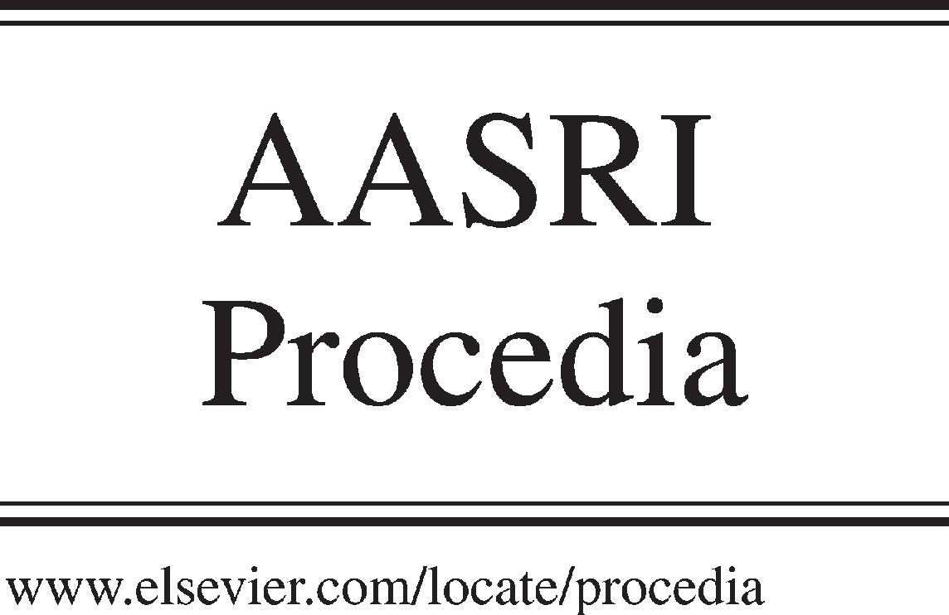Available online at [www.sciencedirect.com](http://www.sciencedirect.com/)



AASRI Procedia 3 (2012) 224 – 229

2012 AASRI Conference on Modelling, Identification and Control

Springback Behaviour in Sheet Metal Forming for Automotive Door

S.Sulaiman, M.K.A.M.Ariffin and S.Y. Lai

*Department of Mechanical and Manufacturing Engineering, Universiti Putra Malaysia, 43400 Serdang, Selangor, MALAYSIA*

Abstract

This project is basically an investigation of springback behavior during sheet metal forming process on different parameters by using numerical method. Non linear numerical simulation was performed by using finite element commercial ABAQUS/CAE software. Two different parameters were used in the simulation, which is the material type of sheet metal and the sheet thickness. In evaluating the effect of material types on springback behavior, the boron steel (AISI 15B48H) and composite (Carbon fiber reinforced plastics) were used. The computational results show the carbon fiber reinforced plastic has less springback than the steel. The computational results show that thicker sheet exhibits smaller springback compared to thin sheet. The results were verified with available data obtained from literature. Current and future trends on automotive door are briefly discussed in this project and some recommendations are made in order for future development of the simulation.

© 2012 The Authors. Published by Elsevier B.V. Open access under [CC BY-NC-ND license.](http://creativecommons.org/licenses/by-nc-nd/3.0/)

© 2012 Published by Elsevier B.V. Selection and/or peer rev[iew under respon](http://creativecommons.org/licenses/by-nc-nd/3.0/)sibility of American Applied Science Research Institute

Selection and/or peer review under responsibility of American Applied Science Research Institute

*Keywords:* Springback; Carbon fiber reinforced plastic (CFRP); steel; friction coefficient; sheet thickness

1. Introduction

Sheet metal forming is widely used in most industries for forming sheets into appropriate shapes by plastically deforming the sheet material beyond its yield strength to achieve permanent deformation. The major application of sheet metal is in automotive industry which includes doors, fenders, bumpers, roof panels and seat frames. As automotive industry is growing rapidly, the demand for precise and accurate information

2212-6716 © 2012 The Authors. Published by Elsevier B.V. Open access under [CC BY-NC-ND license.](http://creativecommons.org/licenses/by-nc-nd/3.0/) Selection and/or peer review under responsibility of American Applied Science Research Institute doi:10.1016/j.aasri.2012.11.037

concerning parts design and formability of metal sheet becomes essential [1]. Strong understanding of forming process is critical to produce high quality and cost effective products.

However, there will be a condition that occurs when release of the forming force, the material has a tendency to partially return to its original shape due to its elastic recovery, this is so called springback. Springback represents a challenge for manufacturers who desire to meet specific dimensions. This issue is critical when accurate assembly of components in the automotive or aircraft industry necessitates that the parts meet certain tolerances. Therefore, controlling and minimizing springback would enable designers to achieve better process control and at the same time reduce reject parts [2].

Nowadays, finite element methods are widely used to compensate springback for various metal forming operations. For example, an accurate analysis of the elastic springback in bending is extremely important when determining the over-bending angle required to compensate for the springback effect. An appropriate model and simulation is set up to investigate the springback phenomenon early in the new product design process. It is very important to predict springback in early stage in order to reduce trial and error, rework and scrap [3].

1. Methodology
   1. *Parameter Design*

The factors and parameters that play important role in affecting the output of the result must be first determined. Three simulation frameworks are carried out with different combination of parameters i.e material and thickness. In the first simulation, other parameters will be set to be constant and parameters that play around to get the output will be type of materials. For second simulation, another set of simulation with thickness of 3 mm is simulated to compare with the 1 mm set.

1. Results and Discussion

In the model, there is three rigid parts (die, punch and binder) and one deformable part (sheet metal blank). A rigid part represents a part that is so much stiffer than the rest of the model that its deformation can be considered negligible. Only deformable part is measured. Therefore, data are measure from the deformable sheet metal blank in this model. The data collected from the finite element analysis are including the contour plot of von mises stress, strain, displacement, section thickness and energy graph. All the data collected from blank part in both sheet forming and springback simulation.

* 1. *Material*

Table 1: Comparison of results for different material (Forming simulation).

|  |  |  |  |
| --- | --- | --- | --- |
| Material | von Mises Stress (MPa) | PEEQ | Difference (mm) |
| AISI 15B48H Steel | 504.2 | 0.7571 | 0.7452 |
| CFRP | 459.2 | 0.7493 | 0.5344 |

*Difference = Max. Section Thickness – Min. Section Thickness

Table 1 shows the comparison of results obtained from the simulation for AISI 15B48H Steel and CFRP. From the von Mises stress contour plot (refer Fig. 2), the high stress region indicated by the red color areas. The stress wave is concentrated on the impact area where the punch radius is contact with the blank. For AISI

15B48H Steel, the maximum von Mises stress for whole model is 504.2MPa which is below the value of its ultimate tensile strength (600MPa). Therefore, the FE model will undergoes plastic region but fracture will not occur. The maximum von Mises stress for CFRP is 459.2MPa (refer Table 1) and its tensile strength value is much higher than the maximum von Mises stress. Thus, the model will not undergo fracture.

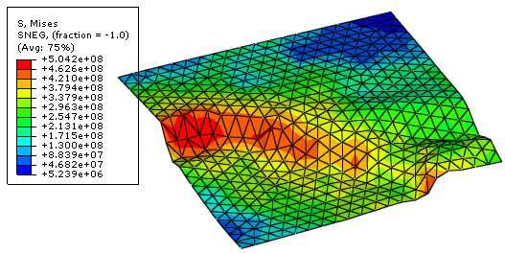

Fig. 2. Von Mises Stress contour plot for AISI 15B48H Steel (Forming).

The equivalent plastic strain (PEEQ) in a material is a scalar variable that is used to represent the material's inelastic deformation [4]. If this variable is greater than zero, the material has yielded. Those areas that show in dark blue (Fig. 3) indicate that they still have elastic material behavior. The AISI 15B48H Steel yielded more due to its ductility behavior.

The differences between maximum section thickness and minimum section thickness for AISI 15B48H Steel is greater compared to CFRP. This means that the thickness distribution for CFRP is better and more constantly. This is important for the quality of a product.

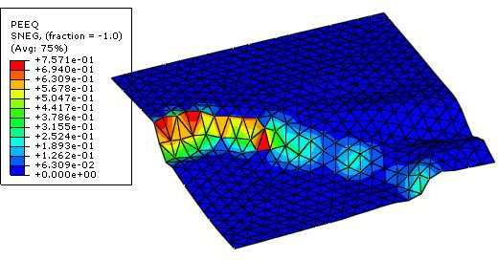

Fig. 3. PEEQ contour plot for AISI 15B48H Steel.

The springback displacements will be referred to the original undeformed configuration [4]. From the results obtained, the springback of AISI 15B48H Steel is 2.398mm, which is greater than CFRP (1.421) due to its stiffness.

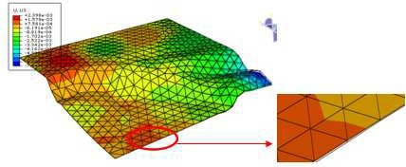

Fig. 4. Displacement contour plot for AISI 15B48H Steel.

From the displacement contour plot, there is more red color area for AISI 15B48H Steel (refer Fig. 4), this means that more sections in the part is having springback.

* 1. *Thickness*

From Table 2, it can be observed that the von Mises stresses for 1mm and 3mm thickness model are less than its ultimate tensile strength 600MPa. Hence, both models can be formed without fracture. The PEEQ value for 3mm sheet metal blank is higher, which means it will exhibit less springback after punch removed. The section thickness cannot be compared as the thickness is not the constant parameter in this case.

Table2: Comparison of results for different thickness (Forming simulation).

|  |  |  |  |
| --- | --- | --- | --- |
| Thickness(mm) | von Mises Stress (MPa) | PEEQ | Difference (mm) |
| 1 | 504.2 | 0.7571 | 0.7452 |
| 3 | 504.6 | 0.7761 | 1.45 |

*Difference = Max. Section Thickness – Min. Section Thickness

Thinner part will have more springback if compared to thicker part because thicker part is having greater stiffness. From the results obtained (Table 3), 3mm sheet metal has less springback, which is 1.657mm. From the displacement contour plot, there is more red color area for thickness 1 mm, this means that more sections in the part is having springback. Refer Fig. 4 for 1mm displacement contour plot and Fig. 5 for 3mm displacement contour plot.

Table 3: Comparison of results for different thickness.

|  |  |  |
| --- | --- | --- |
| Thickness(mm) | von Mises Stress (MPa) | Displacement (mm) |
| 1 | 2.398 | 448.3 |
| 3 | 1.657 | 424.5 |

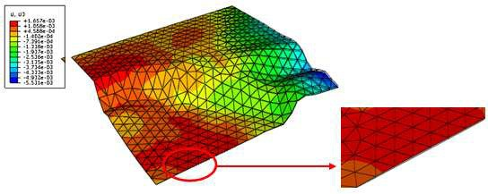

Fig. 5. Displacement contour plot for thickness 3 mm

1. Verification of Results

Since there is no real impact test in this study, hence, results of simulation can only be verified by comparing with the literature reviews.

* 1. *Calculation for Energy*

As explained in [7], if the ratio of ALLSD/ALLIE is less than 0.5 in the studies, it is therefore concluded that the results are virtually unaffected by adding damping in the steps and is acceptable. Energy value can be obtained from the energy graphs and ratio calculation for each of the framework as shown in Table 4.

Table 4: ALLSD/ALLIE Ratio for different parameter.

|  |  |
| --- | --- |
| Conditions | ALLSD/ALLIE Ratio |
| (a) AISI 15B48H Steel, thickness 1mm and friction coefficient 0.25 | 0.32 |
| (b) CFRP, thickness 1mm and friction coefficient 0.25 | 0.40 |
| (c) AISI 15B48H Steel, thickness 1mm and friction coefficient 0.1 | 0.75 |
| (d) AISI 15B48H Steel, thickness 3mm and friction coefficient 0.25 | 0.40 |

From the calculations above, we can observe that ratio number for framework (a), (b) and (d) are less than 0.5, which is acceptable, whereas for (c), the value is slightly greater than 0.5. This happens maybe because of the coarse meshing in the model.

* 1. *Comparison to Previous Research*

From [8], harder material, higher friction coefficient, and thinner sheet will display higher springback value. In the springback simulation carried out in this project, thinner part (1mm), high friction coefficient (0.25) and stiffness material (AISI 15B48H Steel) displaying higher value of springback. Therefore, the results obtained are similar to the previous work from [8].

1. Conclusion

The modeling and simulation method for forming process and springback have been discussed in details in this project. The theoretical was compare to the simulation result. From the results, it can be conclude that the stress distributions are reasonable. Consequently, computer aided simulation can help reduce the number of physical test required and thus shorter the time to market.

CFRP displayed a better result than the steel in terms of section thickness distribution throughout whole model and also the springback after forming process. Since the CFRP has potential in reduce weight of vehicle, improve fuel efficiency, reduce the emissions and also reduce the springback and improve the quality of the automotive door. Therefore, it is suitable to be used widely in the automotive industry. Higher friction coefficient will produce higher springback and thicker sheet metal will exhibits less springback because thicker sheet will has higher metal's stiffness.

The results obtained might be a little different with the real life result, but as long as the error does not exceed 3%, it is still acceptable since we expect the error due to meshing problem.

Acknowledgements

The authors wishes to thanks Universiti Putra Malaysia for financial support towards the success of this project.

References

1. Hakim S.S.A and Hamouda A.M (2009). Finite Element Analysis of Sheet Metal Forming Process.

*European Journal of Scientific Research*. 33 (1): 57-69.

1. Ahmed F.F., (2000). *Finite Element and Experimental Studies of Springback in Sheet Metal Forming*. Master Thesis. University of Toronto, Canada.
2. Patel K.I., (2002). *Evaluation of springback prediction capability using uniform pure bending*. Master Thesis. Sardar Patel University, India.
3. *ABAQUS documentation Version 6.6*, SIMULIA: United States, 2006.
4. Kadkhodayan M. and Zafarparandeh I. (2008). On the relation of equivalent plastic strain and springback in sheet draw bending. *International Journal of Materials Forming.* 1(S1):141-144.
5. Dassault Systemes (2006). Springback Analysis in ABAQUS/Standard. *Getting Started With ABAQUS (pp. 498-502).* United States: ABAQUS Inc. Publishers.
6. Becque J. and Rasmussen K. *Numerical investigation and design methods for stainless steel columns failing by interaction of local and overall buckling*. School of Civil Engineering, Research report R888. The University of Sydney: Sydney, 2008.
7. Imhemed, R.M., (2004). *Finite Element Analysis of Springback Phenomenin in V-Bending of Sheet Metal*, Master Thesis, Universiti Putra Malaysia.
8. Andersson A., (2005). Numerical and experimental evaluation of springback in a front side member.

*Journal of Materials Processing Technology*. 169 (3): 352-356.