Available online at [www.sciencedirect.com](http://www.sciencedirect.com/)



AASRI Procedia 3 (2012) 166 – 171

2012 AASRI Conference on Modelling, Identification and Control

Study on Spray Drying Process of Characteristics of Distillers' Hops

Li Li, Xuyan Zong*, Huibo Luo, Chunhui Wei, Hongyu Gan

*College of Bioengineering, Sichuan University of Science & Engineering, Sichuan, Zigong 643000, China*

**Abstract**

To increase use range of distillers' hops, and to retain the original nutrients and characteristics of distillers' hops, inlet temperature and outlet temperature and sample concentration has been studied of yield and rehydration rate with orthogonal design, quadratic polynomial stepwise regression, and response surfaces. The results showed that optimum conditions of spray drying is when inlet temperature is 162  , outlet temperature is 84  , sample concentration is 3.4g/200ml, feed temperature is 70 ~ 80  , fan power is 95%, fluid flow rate is 0.25L/h. In this condition, product yield is 56.432%, rehydration rate is 183.647%.

© 2012 The Authors. Published by Elsevier B.V. Open access under [CC BY-NC-ND license.](http://creativecommons.org/licenses/by-nc-nd/3.0/)

© 2012 Published by Elsevier B.V. Selection and/or peer rev[iew under responsi](http://creativecommons.org/licenses/by-nc-nd/3.0/)bility of American Applied Science Research Institute

Selection and/or peer review under responsibility of American Applied Science Research Institute

*Keywords:* Distillers' hops, spray drying, properties, protein powder

China is a beer-producing country, and has been the world's largest producer for many years (Dai and Zhang, 2010). Distillers' hops are one of beer-producing waste, which isolated solids with heat-coagulum and hop-residue in whirlpool tanks (Liu, 2004). Distillers' hops were produced 1.5 ~ 4.0kg / t of raw materials (Zong et al., 2009). Each year more than 20 million tons of distillers' hops were produced. Distillers' hops are rich-nutrition, high water content, so can easily corruption, and were greatly impact treatment and use.

* Corresponding author. Tel.: +86-813-550-6666; fax: +86-813-550-6666.

*E-mail address:* [suse62651@139.com.](mailto:suse62651@139.com)

2212-6716 © 2012 The Authors. Published by Elsevier B.V. Open access under [CC BY-NC-ND license.](http://creativecommons.org/licenses/by-nc-nd/3.0/) Selection and/or peer review under responsibility of American Applied Science Research Institute doi:10.1016/j.aasri.2012.11.028

Spray drying is a very important industrial drying means (Liu et al., 2011). It has a very wide range of industrial applications, such as foods, medicines etc (Xiang et al., 2011). Advantages of spray-dried are drying quickly, large drying area, good product quality, less destruction of active ingredients, etc (Wang et al., 2011). In order to protect original nutrients and characteristics of distillers' hops, yields and rehydration characteristics of distillers' hops samples with spray-dried were studied. New way of processing for distillers'

hops was attempted to explore.

# Materials and methods

* 1. *Materials*

Distillers' hops, containing 33.78% protein, 5.37% fat, 20.85% crude fiber, 3.29% ash, and 36.71% other substances on dry basis, and 74.81% moisture, was obtained from China Resources Snow Breweries (Zigong) Co,. Ltd. Distillers' hops with four times water were homogeneous (10000r/min, 10min, T18, IKA Co., Ltd. Germany), then were centrifuge (4000r/min, 10 min, U-3010, Hitachi High-Technologies Corporation, Japan), the precipitations were keep for use.

* 1. *Rehydration rate of spray-dried samples*

Centrifuge tubes (2.5ml) were dried, weighed, and labeled. 1.000g sample and 2mL water were added in tubes, were vortex (5min, Vortex-Genie 2, Scientific Industries Co., Ltd. USA), then were centrifuge (5000r/min, 10 min). The precipitations were weighed and calculated rehydration rate (Zeng et al., 2007).

*W M* 3

*M* 2

*M*1 100%

*M*1

where W is rehydration rate of sample, while M1 is weight of centrifugal tube, M2 is weight of centrifugal tube and samples, M3 is weight of centrifugal tube and samples after absorbing water.

* 1. *Yield of spray-dried samples*

Weights of distillers' hop that before and after spray drying were measured. Moistures of distillers' hop that before and after spray drying were also measured. Then yields of spray-dried samples of distillers' hop were calculated (Chen et al., 2010).

*X M* 2 (1

*M*1 (1

*W* 2)

*W*1)

100%

where X is yield of sample, while M1 is weights of distillers' hop that before spray drying, M2 is weights of distillers' hop that after spray drying, W1 is moistures of distillers' hop that before spray drying, W2 is moistures of distillers' hop that after spray drying.

* 1. *Spray drying process*

The distillers' hops was taken to a laboratorial spray dryer BUCHI, B-290. Feed temperature of 70 ~ 80  , 95% of fan powers, fluid flow rate of 0.25L/h are set according to the results of single factor experiment (data not shown). Inlet temperatures, outlet temperatures, sample concentrations were varied in accordance with the levels defined at the experimental design.

* 1. *Orthogonal designs*

Three factors that were feed concentration, inlet temperature, and outlet temperature and four levels of every factors were selected according to the results of single factor experiment (data not shown), were constructed orthogonal test L16 (45), and targets were rehydration rates and yields of spray-dried samples. Experiment schemes of orthogonal designs were listed in table 1.

Table 1 Experiment schemes of orthogonal designs

Factors

Levels

|  |  |  |  |
| --- | --- | --- | --- |
| 1 | Inlet Temperature ( )  150 | Outlet Temperature ( )  75 | Feed Concentration (g /200mL)  2.5 |
| 2 | 160 | 80 | 3 |
| 3 | 170 | 85 | 3.5 |
| 4 | 180 | 90 | 4 |

* 1. *Established mathematical models*

The results of orthogonal test were used to established mathematical models with quadratic polynomial stepwise regression method. Response surfaces between any two of the factors were drawn.

# Results and discussion

* 1. *Analysis of results of orthogonal test*

Orthogonal tests were carried out with orthogonal design. Range analyses were taken for the results of orthogonal design.

Table 2 Results of orthogonal designs and range analyses



Inlet Temperature Outlet Temperature Feed Concentration Yield (%) Rehydration rate (%)



1 1 1 1 12.40 35.06

2 2 2 2 49.35 175.66

3 3 3 3 53.57 174.42

4 4 4 4 18.60 53.58

5 1 2 3 42.64 137.75

6 2 1 4 33.17 100.13

7 3 4 1 26.60 93.67

8 4 3 2 31.51 107.16

9 1 3 4 41.23 119.99

10 2 4 3 51.77 158.65

11 3 1 2 27.42 106.78

|  |  |  |  |  |  |  |
| --- | --- | --- | --- | --- | --- | --- |
|  | 12 | 4 | 2 | 1 | 13.50 | 53.30 |
| 13 | 1 | 4 | 2 | 33.68 | 110.87 |
| 14 | 2 | 3 | 1 | 45.26 | 140.60 |
| 15 | 3 | 2 | 4 | 38.24 | 137.85 |
| 16 | 4 | 1 | 3 | 16.74 | 49.40 |
|  | K1 | 129.95 | 89.73 | 97.76 |  |  |
|  | K2 | 179.55 | 143.74 | 141.96 |  |  |
| Yield | K3 | 145.82 | 171.57 | 164.72 |  |  |
|  | K4 | 80.35 | 130.65 | 131.24 |  |  |
|  | R | 99.20 | 81.84 | 66.96 |  |  |
|  | K1 | 403.66 | 291.37 | 322.62 |  |  |
|  | K2 | 575.04 | 504.55 | 500.46 |  |  |
| Rehydration rate | K3 | 512.72 | 542.17 | 520.22 |  |  |
|  | K4 | 263.44 | 416.77 | 411.54 |  |  |
|  | R | 311.60 | 250.80 | 197.60 |  |  |

From range analysis results table 2, we can obtain that the orders of every factor affect yield and rehydration rate are Inlet Temperature>Outlet Temperature>Feed Concentration. The optimal conditions of yield and rehydration rate are that inlet temperature are 160  , outlet temperature are 85  , feed concentration are 3.5g/200mL.

* 1. *Established mathematical models*

Using DPS (Data Processing System), test data were analyzed with quadratic polynomial stepwise regression. The mathematical models were established. The process conditions were optimized. The mathematical models of the relationship between yield and rehydration rate with the various factors are as follows:

Y1 = -62.125 + 3.140* (X1-140) + 6.686* (X2-70) + 54.710* (X3-2) - 7.193E(-2)* (X1-140)* (X1-140)  0.2373* (X2-70)* (X2-70)  19.420* (X3-2)* (X3-2) *(1)*

(R=0.9869, F=42.7466, p=0.0001)

Y2 = -230.702 + 11.938* (X1-140) + 23.231* (X2-70) + 193.392* (X3-2) -0.2629* (X1-140)* (X1-140)  0.8465* (X2-70)* (X2-70)  71.628* (X3-2)* (X3-2)  1.190E(-5)* (X1-140)* (X2-70) *(2)*

(R=0.9993, F=835.3309, p=0.0001)

Where Y1 is yield of samples, while Y2 is rehydration rate, X1 is inlet temperature, X2 is outlet temperature, and X3 is feed concentration.

Analysis of the two mathematical models showed that the two equations are lack of interaction terms or the coefficient interaction terms are extremely small. It can be seen from analysis of variance for the two regression equation, that the contribution of all interaction terms are very small to the regression model and were to be removed (Liu et al., 2010).

The mathematical models are different with the single-factor test results. The reason may be that the interaction of factors make the optimal level offset, or because of the number of trials is less than normal (Luo et al., 2012).

* 1. *Analysis of response surfaces*

Response surfaces were drawn according to the two mathematical models, were shown in Figure 1.

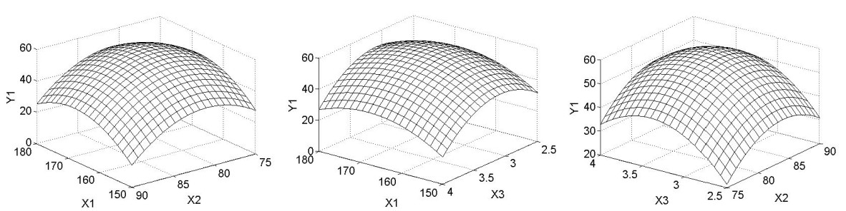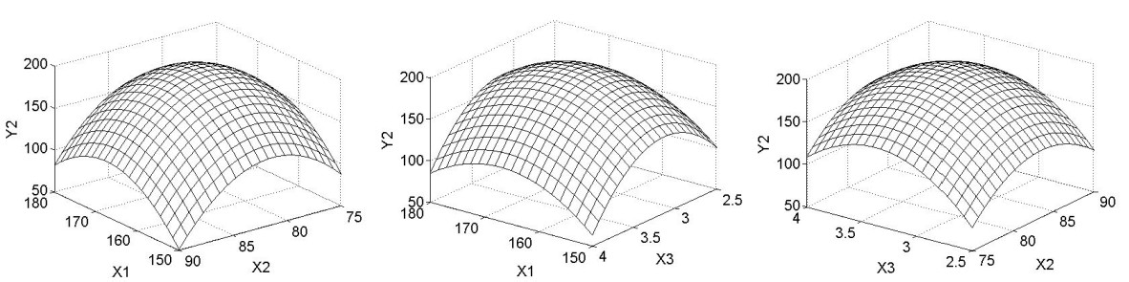

Figure 1 Response surfaces of yield and rehydration rate

It can be seen from the degree of bending of the surface in Figure 1. When one of the factors was fixed, Yield and Rehydration rate will increase and then reduce with another factor increases. The interactions between factors are not significant. Inlet Temperature has significant performance on Yield and Rehydration rate for the most surface steepest. The impact of Outlet Temperature is followed with Inlet Temperature. Feed Concentration has significant performance on the Yield and Rehydration rate, but slightly lower than the other two factors.

* 1. *Optimization of Process Conditions*

From the response surface we can see, maximum points are in the range of experimental design. Partial derivatives of independent variables in the model equations are calculated, respectively. Set them to zero, then the extremum condition will get.

X1=161.828, X2=84.087, X3=3.409, Y1=57.765 X1=162.703, X2=83.722, X3=3.350, Y2=194.745

It can be seen from the results of optimization, that the optimal conditions for product yields and rehydration rates are not the same levels. This shows that the best conditions for product recovery are not necessarily the optimal conditions of characteristics, and there are gaps between different characteristics of optimal conditions.

In this experiment, the gaps of optimal conditions for product yields and rehydration rates are not too much. And to facilitate operation, verification conditions were selected Inlet temperature are 162  , Outlet temperature are 84  , and Feed concentration are 3.4g/200mL. The results showed that yields are 56.432% and rehydration rates are 183.647%. Relative errors are 2.36% and 6.04%, respectively.

# Conclusions

Yield of the samples and rehydration rate of distillers' hops with spray drying which were affected by inlet temperature, outlet temperature, feed concentration were studied with orthogonal design. Mathematical models were established by quadratic polynomial stepwise regression on the experimental results. The models are reasonable and reliable which were proved, can be used to predict the yield of the samples and rehydration rate. Response surfaces were drawn, and studied factors and their interactions. It was proved that three factors have not significant interactions. Optimum conditions solved for the models are Inlet temperature are 162  , Outlet temperature are 84  , and Feed concentration are 3.4g/200mL. Under these conditions, yield of the samples and rehydration rate in verification tests are 56.432% and 183.647%, respectively.

# Acknowledgements

This research was funded in Fund project of Sichuan provincial Department of Education (11ZB248), Science & technology project of Sichuan University of Science & Engineering (2010XJKRL002). The authors also thank China Resources Snow Breweries (Zigong) Co,. Ltd. for supplying the distillers' hops.

# References

1. Dai X., Zhang G. Brewery wastewater treatment and resource recovery by photosynthetic bacteria Z08.

Journal of Harbin Institute of Technology 2010; 42: 937-940

1. Liu X. Effect of Resting Time in the Whirlpool on Wort Quality. China Brewing 2004: 35-38
2. Zong X., Liu C., Li L. protease. Science and Technology of Food Industry 2009; 30: 108-112
3. Liu J., Ma S., Liu B., et al. Effects of spray-drying technology on solubility of Fe enrichment egg powder.

Transactions of the Chinese Society of Agricultural Engineering 2011; 27: 365-371

1. Xiang J., Su Y., and Shi J. Studies on Drying Process of Compound Zhajin Particulates By Spray Drying Method. Chinese Archives of Traditional Chinese Medicine 2011; 29: 2682-2684
2. Wang J., Gao C., Song X., et al. Study on Process Optimization of the Spray Drying for Qiguiseng Capsules. China Pharmacist 2011; 14: 1597-1599
3. Zeng S., Liang J., Zheng B., et al. Effects of different drying technology on the quality of lotus seed.

Transactions of the Chinese Society of Agricultural Engineering 2007; 23: 227-231

1. Chen Q., Huang H., Wang J., et al. Optimization of spray drying technology in processing banana powder.

Transactions of the Chinese Society of Agricultural Engineering 2010; 26: 331-337

1. . China Brewing 2010:

104-106

1. Luo H., Zong X., Huo D., et al. Application of BP neural network for formation conditions of higher alcohols in liquor production. Food Science and Technology 2012; 37: 90-93