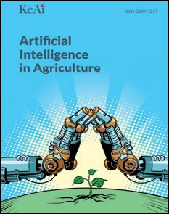[Artificial Intelligence in Agriculture 1 (2019) 14–26](https://doi.org/10.1016/j.aiia.2019.02.002)

Contents lists available at [ScienceDirect](http://www.sciencedirect.com/science/journal/)

Artificial Intelligence in Agriculture

journal homepage: [http://www.keaipublishing.com/en/j ournals/artificial- intelligence-in-agriculture/](http://www.keaipublishing.com/en/journals/artificial-intelligence-in-agriculture/)

[](http://crossmark.crossref.org/dialog/?doi=10.1016/j.aiia.2019.02.002&domain=pdf)Study on body temperature detection of pig based on infrared technology: A review

Zaiqin Zhang 1, Hang Zhang 1, Tonghai Liu ⁎

*School of Computer and Information Engineering, Tianjin Agricultural University, Tianjin 300384, China*

a r t i c l e i n f o

*Article history:*

Received 5 December 2018

Received in revised form 28 January 2019

Accepted 4 February 2019

Available online 29 March 2019

*Keywords:*

Pig body temperature measurement Non-contact

Infrared image processing

Contents

a b s t r a c t

Body temperature is an important physiological indicator in the whole process of pig breeding. Temperature measurement is also an effective means to assist in disease diagnosis and pig health monitoring. In the conven- tional method of measuring body temperature, a mercury column is used to obtain the rectal temperature. The operation of this method is complicated and requires a large amount of labor. This kind of temperature measure- ment method is contact and can make the pig stressed, which is disadvantageous for the healthy growth of pigs. Therefore, rectal temperature measurement no longer meets the needs of the large-scale pig industry in China's welfare agriculture. In recent years, the emerging pig body temperature detection technologies are electronic temperature measurement technology, infrared temperature measurement technology and so on. Infrared tem- perature measurement technology has been the main means of measuring the temperature of pig body surface with its advantages of non-contact, long distance and real-time. At present, infrared temperature measurement technology and infrared image processing technology used in pig breeding are still in the exploration stage. Now- adays, the infrared temperature measurement equipment based on point-by-point analysis represented by infra- red thermometer and temperature measurement equipment based on full-field analysis represented by infrared thermal imager have been applied to pig breeding industry. These types of temperature measurement are more in line with the needs of the pig breeding industry to transform and upgrade to the automation, in line with the development concept of welfare farming and smart agriculture, and its development prospects are very impressive.

© 2019 The Authors. Publishing services by Elsevier B.V. on behalf of KeAi Communications Co. Ltd. This is an open access article under the CC BY-NC-ND license (<http://creativecommons.org/licenses/by-nc-nd/4.0/>).

1. Introduction 14
2. Progress in measuring body temperature of pig 15
   1. The significance of measuring body temperature of pig 15
   2. Traditional pig body temperature measurement method 15
   3. Emerging temperature measurement method of livestock and poultry 16
3. Research status of infrared technology in the measurement of body temperature of livestock and poultry 17
   1. Infrared temperature measurement technology and sensor system 17
   2. Application of infrared technology in body temperature measurement of livestock and poultry 19
   3. Application and development of infrared image processing technology in livestock and poultry breeding industry 22
4. Conclusion and future trends 24

Acknowledgments 25

References 25

* Corresponding author.

*E-mail address:* [tonghai_1227@163.com](tonghai_1227%40163.com) (T. Liu).

1 These authors contributed equally to this work and should be considered co-first authors.

1. Introduction

The pig industry has long been the backbone of China's livestock and poultry farming. In recent years, China's pork production ranks first in

<https://doi.org/10.1016/j.aiia.2019.02.002>

2589-7217/© 2019 The Authors. Publishing services by Elsevier B.V. on behalf of KeAi Communications Co. Ltd. This is an open access article under the CC BY-NC-ND license ([http://](http://creativecommons.org/licenses/by-nc-nd/4.0/) [creativecommons.org/licenses/by-nc-nd/4.0/](http://creativecommons.org/licenses/by-nc-nd/4.0/)).

the world, accounting for about 50% of the world's total production. About 700 million pigs are slaughtered each year. Pork production ac- counts for about 64% of all meat production (Yuan and Yuanping, 2016; National Bureau of Statistics of the People's Republic of China website, 2018). According to statistics, the annual output of pigs, cattle, sheep and poultry in 2017 was 84.31 million tons, of which pork pro- duction was 53.4 million tons. Therefore, pork industry is the absolute pillar of China's meat industry (China Government Network, 2018).

Although the proportion of pigs in the livestock and poultry industry is in an absolute position, the China's pig industry is still lagging behind. The pig industry is dominated by decentralized farmers, and the indus- trialization and modernization of the aquaculture industry is relatively low. In 2016, the contribution rate of pigs with a size of b500 to the mar- ket pork accounted for about 55%. More than half of them have prob- lems caused by poor farming environment, poor farming technology, suffering from various diseases, feed self-matching and management disorder (Guangan, 2017). The informal pig breeding model not only produces a great waste of resources, but also causes frequent occurrence of various pig diseases and increases the risk of pig breeding process. The industrial upgrading of the pig breeding industry from the decentralized farming model to the intensive modernization is very urgent.

In recent years, the concept of welfare farming has been increasingly valued by the industry and the health of pigs has received increasing at- tention. However, due to various problems in resource management of pig breeding enterprises, such as poor farming pig houses, poor breed- ing environment and non-standard farming techniques, they are com- mon in free-range farmers or small-scale pig farms, which have led to insufficient disease prevention and disease monitoring in pigs, the diag- nosis and treatment of diseases are not timely (Jizhu et al., 2016). At this stage, effective prevention and diagnosis of pig disease is still a major issue related to the economic benefits of pig breeding enterprises. Timely access to body temperature data can help alert and diagnose pig disease, real-time and fast access to pig body temperature is of great significance to the stable and healthy development of pig breeding enterprises, which also could promote the development of welfare farming concept in the pig breeding industry.

With the progress of China's urbanization construction and the need for environmental protection, the pig breeding model began to acceler- ate the evolution from individual decentralized farming to large-scale farming, and pig breeding industry is beginning to enter a new trend (Zhenling, 2018). The development of the agricultural Internet of Things (IoT) has made it possible to perceive the body temperature informa- tion of pigs in real time. With the development of industrialization and intensive farming mode, the scale of breeding has been expanded continuously, and the problems of environmental pollution in pig houses have begun to become prominent. Severe environmental pollu- tion has a series of effects on the growth, development and reproduc- tion of pigs, and the deteriorating environment of pig breeding has made the health of pigs increasingly serious. In the high-density breed- ing environment with frequent diseases and frequent epidemics, mon- itoring the body temperature of pigs in real time is conducive to grasping the health status of pigs at any time. It is important to the pre- vention and diagnosis of pig diseases, which becomes a key task for in- tensive farming.

1. Progress in measuring body temperature of pig
   1. *The significance of measuring body temperature of pig*

Temperature regulation is one of the most important mechanisms to maintain the homeostasis of the whole organism. Body temperature is the temperature of the deep part of the animal body (Juxiong and Yang, 2011), which is an objective reflection of the activity in the animal body, it is a physiological signals that is very pivotal to reflect the health status of pig. The body temperature change can reflect the health status

change of the pig in time. A huge fluctuation in the body temperature of pigs may be caused by the physiology of pigs being disturbed, abnormal body temperature indicates the occurrence of certain diseases, espe- cially infectious diseases in the incubation period (Yufeng and Yanping, 2012). Body temperature information is very helpful for the di- agnosis and treatment of animal diseases, which helps to detect sick an- imals early, explore the extent of the disease, determine the severity of the disease, etc. Therefore, if the physiological indicators of pig body temperature change are correctly recognized and rationally used, some pig diseases can be detected early, diagnosed early and treated early (Lu et al., 2015). On the other hand, the change in sow body tem- perature is an important condition for judging the estrus of sows. The identification of sow estrus is essential for pig production (Xudong et al., 2013). Accurate identification of estrus sows by body temperature measurement, which can achieve timely breeding to improve the con- ception rate of sows. Real-time control of temperature changes in preg- nant sows is also conducive to testing the health of sows, according to the body temperature situation, the relevant breeding work can be ar- ranged to increase the sow's birth rate (Weihan, 2017). With the devel- opment of agricultural IoT technology, timely and real-time access to pig body temperature data has become a reality. In addition, the acqui- sition of real-time pig body temperature information can help monitor the health of pigs. For group pigs, if early detection of abnormal pigs with infectious diseases can control the epidemic early and reduce eco- nomic losses. Real-time access to the body temperature information of pigs has become an important part of the work of pig breeding.

In the actual pig raising process, the rectal temperature is generally used to represent the body temperature of the pig, the range for healthy pigs is 38–40 °C and there are some gaps between different types of pigs (Yundong, 2012). There are many reasons for the abnormal high fever of pigs in the actual breeding process (Hanchun, 2007). Among them, “high fever” is a general term for a series of diseases that can cause hy- perthermia in pigs. Clinically, 80% of cases are mainly fever, mainly viral high fever, and some bacterial hyperthermia. Under normal circum- stances, the sudden temperature rise of the pig's body to above 40 °C is an early warning of certain diseases. Pigs are often accompanied by some other complications when they are sick and hot. According to the complications and the body temperature of the pigs, it can effec- tively diagnose the diseases of pigs. In the process of breeding, we should pay attention to the abnormal changes of body temperature in pigs in real time, and refer to the high temperature complications to strictly diagnose the disease and prescribe the right medicine. In addi- tion, the body temperature of sow will also change significantly in the estrus state, which can be identified according to the accompanying ab- normal behavior of the sow during estrus, so as to rationally arrange the breeding production activities (Qiaoping, 2011).

* 1. *Traditional pig body temperature measurement method*

Traditional pig body temperature measurement is manual. Lubricat- ing the mercury column before measurement, hold the end of the ther- mometer with a string of about 15 cm, attach a wire clip to the other end of the string. Insert the mercury column into the pig anus when measur- ing, the iron clip clamps the hair above the pig's tail for fixing. Remove the thermometer after 5 min, wipe the mercury column and read the data. It is necessary to appease the pigs of different temperaments be- fore measuring the rectal temperature of the pigs, which can reduce the strong stress of pigs, so as not to affect the healthy growth of pigs (Jiao, 2017).

The method of manually measuring the rectal temperature of pigs has the advantage that the rectal temperature obtained in the absence of stress of the pig can accurately reflect the body temperature informa- tion of the pig, but in general, contact-type manual measurements cause intense stress in pigs, resulting in rapid rise in rectal temperature, which will make measurement data inaccurate (Godyn and Herbu, 2017). Moreover, measuring the rectal temperature of a pig usually requires

16 *Z. Zhang et al. / Artificial Intelligence in Agriculture 1 (2019) 14*–*26*

2–3 workers to take about 6 min to complete (Hanchun, 2007). This method consumes a large amount of labor in large-scale farming. More- over, in the process of contact measurement, there is a risk that the dis- ease crosses and touches between humans and animals. All show that the pig breeding industry needs more scientific and efficient ways to ob- tain the body temperature of pigs and technologies based on remote measurements are the most needed for this field.

* 1. *Emerging temperature measurement method of livestock and poultry*

Cai et al. (Yong, 2015) developed a system for automatically obtaining the temperature of the cow's body surface using radio fre- quency technology and contact temperature sensing technology, realiz- ing automatic monitoring of the body surface temperature of the cows for 24 h. Through the statistical analysis and equalization of the data, the correction formula of the body surface temperature of the cow was fitted, and the diurnal variation of the temperature of the cow body surface was obtained, which had accumulated experience in scien- tifically measuring the body temperature of fur animals. After the pigs were anesthetized the measurement picture is shown in Fig. 1a. Krizanac et al. (2010) inserted a temperature measuring trachea with 3 probes into the respiratory tract of the pig to measure the tracheal temperature, the measured temperature was almost the same as the lung tracheal temperature, the measuring device is shown in Fig. 1b. Zhang et al. (Ziyun, 2015) implanted the temperature measuring elec- tronic chip into the left side of the sow neck during the estrus to obtain the subcutaneous temperature, and the rectal temperature was ob- tained by using a mercury column thermometer as a reference. The re- lationship between body temperature changes and estrus behavior was found: the body temperature of sows before and after estrus was first increased then decreased, and then returned to normal. Therefore, it was recommended to match the gestation status of sows according to body temperature changes. Hentzen et al. (Hentzen, 2012) invented a capsule-type wireless sensor that was implanted into the neck of a pig- let, which was then able to achieve a measurement that was consistent with the manual measurement of the rectal temperature. The measure- ment accuracy was high, but the surgical injection of the capsule was re- quired for the piglet, the measuring device is shown in Fig. 1c. Jose M. (Requejo et al., 2018) used a button temperature collector (DS1923) to collect the skin temperature of the pig's ear, obtained the correlation between ear temperature and feed efficiency of the pig by phase space diagram, further discussed the body temperature regulation of the pig and energy conversion issues. Andersen et al. (2008) used ear tag tem- perature sensor (QSS2000) to measure the ear temperature of pigs and studied the relationship between ear temperature and intensity of be- havioral activity. A diurnal rhythm in the ear skin temperature (EST) was found, with the EST being highest at night and lowest in the afternoon.

About the implantable temperature measuring device, after the de- vice is implanted into the livestock and poultry body at one time, does reduce the stress response of the livestock and poultry during the mea- surement, and is convenient for future experimental measurements.

However, when the device is implanted into the target to be tested for the first time, the animal need to be anesthetized and then implanted. Hentzen et al. (Hentzen, 2012) noted the disadvantages of such a method, principally associated with the necessity of immobilising the pigs. It is easy to cause damage to animals and reduce animal welfare. Moreover, electronic implantable and fixed temperature measuring de- vices often need to be recalibrated after a period of use, and the opera- tion process is complicated.

Godyn et al. (Godyn and Herbu, 2017) compared the invasive mea- suring techniques and the noninvasive measuring techniques. Various continuous temperature measurements in the studies on pigs were an- alyzed. The advantages and the limitations of each method also have been showed. Invasive measuring techniques is contact, like using rectal thermometer to get the temperature, apart from the stress caused by holding, the result of the measurement can be disturbed by measure- ment process. In 1974, Bligh et al. (Bligh and Heal, 1974) first proposed the application of wireless remote sensing technology to the surface temperature monitoring of animals, and discussed the feasibility of using wireless telemetry to obtain animal temperature and the hin- drances faced by practical applications. Bai et al. (Guangyu, 2014) real- ized temperature measurement for sows in real time by using wireless radio frequency communication technology and infrared temperature sensor technology. The MLX90614 infrared temperature sensor was used to obtain the temperature of the sow buttocks. The measured tem- perature was sent to the server through the gateway node, and accord- ing to the relationship between the hip temperature and the rectal temperature, the measured temperature of the node was compensated to improve the temperature measurement accuracy. Chen et al. (Li et al., 2017) designed a breeding monitoring system that monitors the physi- ological signs and environmental parameters of pigs using wireless sen- sor network technology. The resources such as single chip microcomputer, wireless sensor network, WIFI communication module and body temperature acquisition module are connected and integrated through the server. The Android mobile phone or PC were used to ob- tain the vital body parameters such as the body temperature of the pig, and the temperature and humidity data of the breeding environ- ment. The hardware design of the temperature measuring system is shown in Fig. 2.

Dewulf et al. (2003) evaluated the suitability of infrared thermome- try by an experiment, which was set up to assess whether it was possi- ble to predict the rectal temperature based on the body surface temperature of pig. The body surface temperatures of the ears, feet, sides and anus were measured in 12 weaned piglets for 45 consecutive days. These temperatures were compared with daily rectal tempera- tures. The results clearly demonstrate that there was no reliable predic- tion of rectal temperatures from these temperatures, but most of them were significantly correlated with rectal temperatures. Libo et al. (2010) used a mercury column thermometer, an electronic thermome- ter, and an infrared thermometer to measure the temperature of 1000 pigs respectively before slaughter in a slaughterhouse. It was found that the detection rate of the high-temperature pigs was about 93% by comparing the rectal temperature obtained from the mercury column

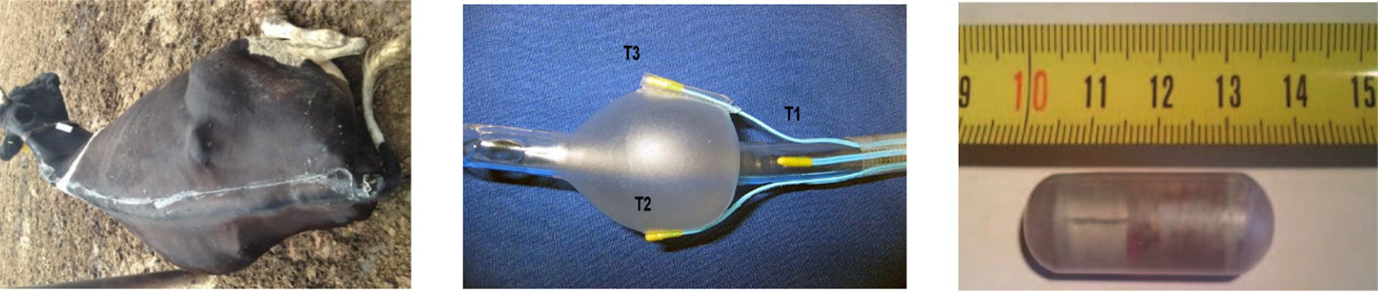

a[17] b[18] c[20]

Fig. 1. The contact type measuring devices.

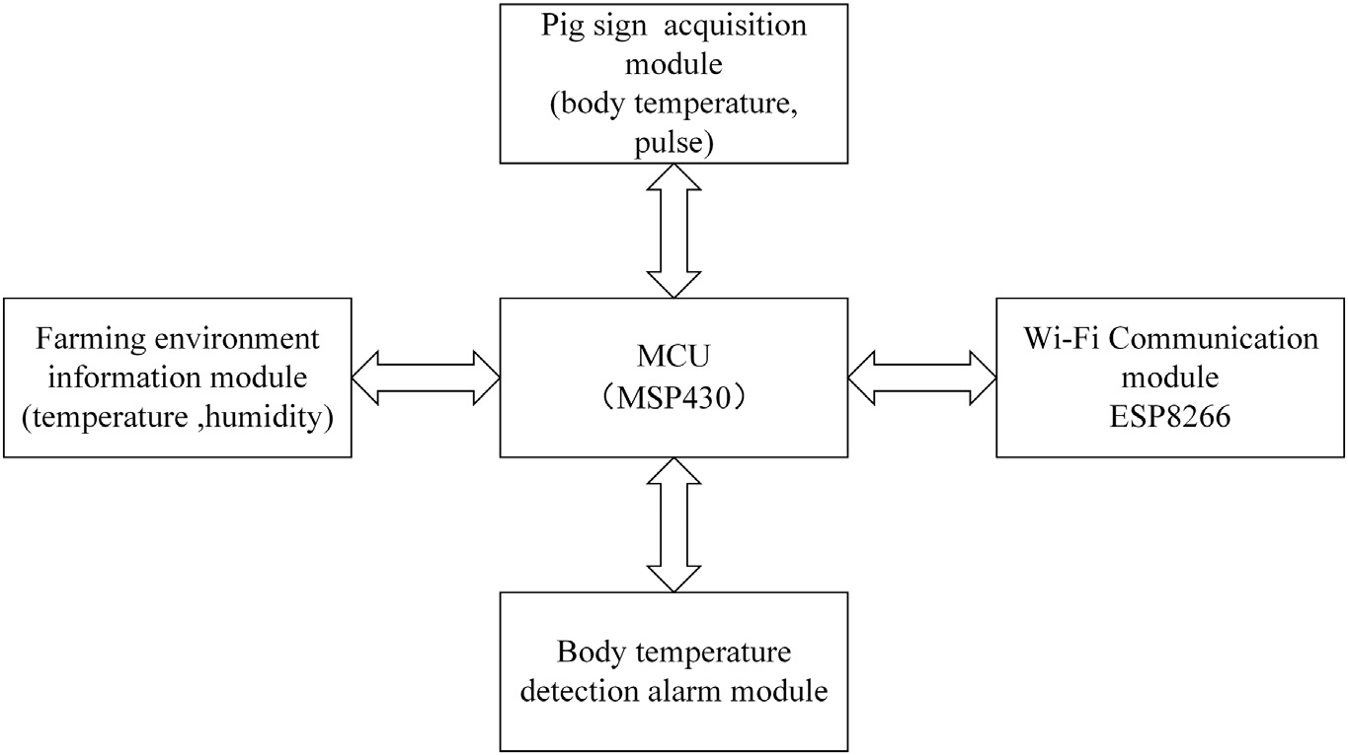

Fig. 2. Hardware design of the temperature measuring system (National Bureau of Statistics of the People's Republic of China website, 2018).

with the surface temperature of the ear root obtained by the infrared thermometer. Berry et al. (2003) utilized infrared camera to detect the temperature of the cow's breast, and established a model of cow's breast temperature change based on the daily data of the cow's breast temper- ature. The temperature correlation between the ambient and the cow's rectum was obtained. The breast temperature and ambient temperature parameters can successfully predict by the current breast temperature, which could achieve early detection of cow mastitis. Qin et al. (Yongxiao, 2015) combined infrared temperature measurement tech- nology with RFID technology to realize the intelligent detection for the temperature of the group of pigs through the deployment of multiple temperature monitoring points, the system structure is shown in Fig. 3. Telemetry, wireless sensor network, infrared and other temperature measurement methods, when the system is completed to measure tem- perature, almost no stress on livestock and poultry, which is in line with the concept of welfare farming, less labor input during measurement, improving work efficiency and facilitating the development of large- scale intensive farming (Libo et al., 2010; Berry et al., 2003). However, the temperature measurement method using the telemetry and wire- less sensor network has high accuracy requirements for temperature data acquisition devices because it cannot directly contact the target. Moreover, in the process of data information transmission, there are

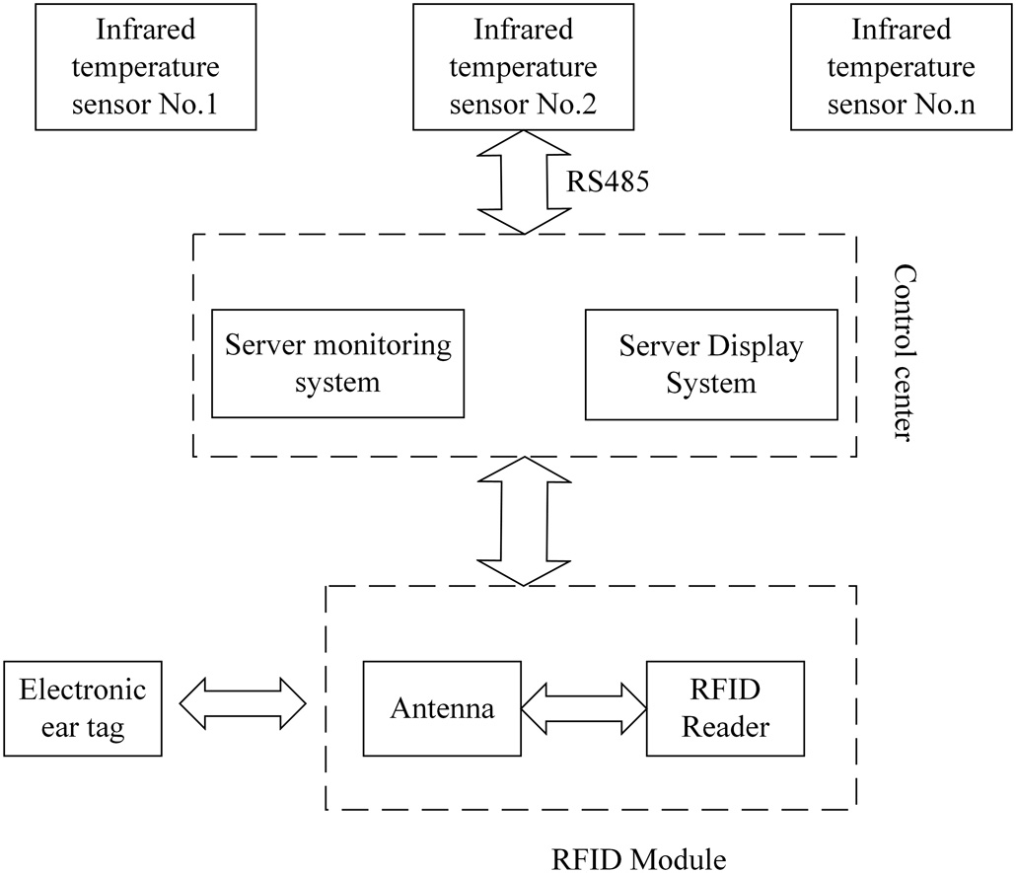

Fig. 3. System structure (Dewulf et al., 2003).

signal interference and other problems that will cause data loss (Bligh and Heal, 1974).

In general, most of the emerging methods for measuring body tem- perature are automatic or semi-automatic in the process of obtaining body temperature data. Temperature collection equipment can con- tinue to use for a certain number of years. For large-scale pig breeding companies, emerging body temperature measurement methods are less economical in the face of increasing labor costs. It is in line with the development concept of resource conservation and is increasingly favored by the breeding industry. Among them, the advantages of infra- red temperature measurement technology are more obvious. The tem- perature measurement accuracy is high, the temperature measurement system has strong stability, the temperature measurement mode is sim- ple, and real-time remote temperature measurement operation can be realized. It can complete the temperature data acquisition in the un- manned environment, does not make the pigs stress, and makes the ob- tained temperature data more accurate and effective. Compared with contact, implantable and wireless sensor network temperature mea- surement methods, the development and application prospect of infra- red temperature measurement technology is better. Table 1 shows the emerging temperature measurement technology mentioned.

1. Research status of infrared technology in the measurement of body temperature of livestock and poultry
   1. *Infrared temperature measurement technology and sensor system*

Infrared technology was used in military surveillance, industrial in- spection, medical diagnosis and other fields firstly. In recent years, it has been applied in the field of agriculture, and has been continuously explored and developed in the fields of crop growth monitoring, agri- cultural product quality inspection, and livestock and poultry disease detection. According to different methods, infrared technology can be divided into based on point temperature analysis and based on field analysis. The point-based analysis system is represented by the infrared thermometer, and there are hand-held and fixed temperature measur- ing devices. The field-based temperature measurement system is repre- sented by infrared camera. The development of infrared camera began in the late 1920s. Infrared imaging technology can break through the obstacles of the night environment and broaden the limitations of human vision. It can provide real-time monitoring of all heat radiating objects. Infrared cameras have been widely used since their inception and continue to evolve. Using infrared camera to get pig body tempera- ture can reduce labor consumption, simple operation process, reduce pig stress, avoid cross-infection of livestock, reduce farming costs, and

Table 1

Emerging livestock and poultry measurement technology application table

No. Method Technology Animal System or tool Measuring part Results or conclusions Insufficients or prospect Ref

1. Contact Radio frequency

technology and electronic technology

Cow Cow body surface

temperature automatic acquisition system

Hind leg hoof 1. The average difference between body surface temperature and actual rectal temperature is 0. 0260 ° C, the maximum does not exceed 0.2 ° C

* 1. Reveal the diurnal variation of the bovine body surface: the lowest temperature occurs at 5-6 points, and the highest temperature occurs at 13-14 points.

Day and night changes in cow temperature do not take into account seasonal factors

Yong, 2015

1. Contact Electronic technology

Pig thermocouple Trachea, respiratory

tract

Respiratory tract temperature is an effective alternative to tracheal temperature in the treatment of cardiac arrest in pigs

Only relevant to male pigs, the applicability of the conclusion is limited

Krizanac et al., 2010

1. Contact Electronic technology
2. Contact Electronic technology, wireless sensor network technology

Pig Electronic temperature measuring chip

Pig Wireless temperature measurement system

Neck subcutaneous 1. There is a significant difference between the subcutaneous body temperature and the rectal temperature of Meishan sow, but there is a significant positive correlation.

* 1. Sows are more active during estrus than during non-estrus

Neck Capsule measurement temperature is consistent with rectal temperature measurement， the slope is very close to 1

General anesthesia of sows when measuring temperature electronic chip implantation, reducing the welfare of sow breeding

1. Implantable device is not conducive to pig activity
2. There are problems such as calibration and long tuning time during wireless measurement.
3. There is signal interference in the radiation communication system.

Ziyun, 2015

Hentzen et al., 2012

1. Contact Electronic technology

Pig Button temperature collector

Ear It is found that the temperature in the ear region of the pig is more related to feed efficiency and physical activity.

Helps estimate feed efficiency during full growth of animals Requejo et al.,

2018

1. Contact Wireless sensor network technology

Pig Ear tag temperature sensor

Ear 1. The diurnal variation of the surface temperature of the ear: the highest at night and the lowest in the afternoon

2, the pig rests at a higher temperature than the ear surface temperature when the pig is active

According to the surface temperature of the ear, the thermal comfort temperature of the pig can be explored to provide a basis for the welfare of pigs.

Andersen et al., 2008

1. Non-contact Remote Sensing

Technology

All animal

Telemetry system Body surface 1. No stress in pigs during temperature measurement.

* 1. Achieve remote and natural animal measurement.

1. When sensors are implanted, they will cause damage to animals.
2. the development cost of the system is very high, and is limited by transmission

distance and transmitter battery life.

Bligh and Heal, 1974

1. Non-Contact Infrared technology,

wireless sensor network technology

Sow Wireless sensor node

system

Hip 1.System error is 0.21 °C ，the effective communication distance of the sensor network node is 30 m, and the sow body temperature can be obtained in real time.

Data loss occurs when the node is N 10 m away from the gateway Guangyu, 2014

1. Non-contact Wireless sensor

network technology

Pig Pig breeding monitoring system

Rectum 1.The measured data is positively correlated with the rectal temperature measured by the thermometer, coefficient K=1，

* 1. No stress in pigs during temperature measurement.
  2. The mobile terminal obtains temperature data in real time.

1. High performance dependence on nodes during communication
2. The system is limited by the node battery usage time

Li et al., 2017

1. Non-contact Infrared technology Piglets Infrared camera Ear, feet, sides, anus 1.there is no reliable prediction of rectal temperatures
   1. most of the measured body surface temperatures are significantly correlated with rectal temperatures
2. Non-contact Infrared technology Pig Infrared thermometer Ear 1. The coincidence rate between the detection results of the

infrared thermometer and the mercury thermometer is 93.33%.

* 1. Infrared thermometers are more suitable for pre-slaughter quarantine body temperature screening of larger scale slaughterhouses.

1. Non-contact Infrared technology, Cow Infrared camera Breast 1. The circadian rhythm of the cow's breast temperature was

found.

* 1. Highly accurate and accurate prediction of current breast temperature based on daily breast temperature and ambient temperature parameters

Did not find a stable relationship between body temperature and rectal temperature and could not predict rectal temperature directly from pig body temperature,

Did not consider the influence of factors such as seasons and regions

Predicting the difference between breast temperature and actual breast temperature within the detectable range of inflammatory response

Dewulf et al., 2003

Libo et al., 2010

Berry et al., 2003

1. Non-contact Infrared technology,

18

*Z. Zhang et al. / Artificial Intelligence in Agriculture 1 (2019) 14*–*26*

radio frequency technology

Pig Infrared sensor Body surface Quickly obtain information on the body temperature of a

group of pigs

Cannot achieve round-the-clock detection Qin et al., 2015

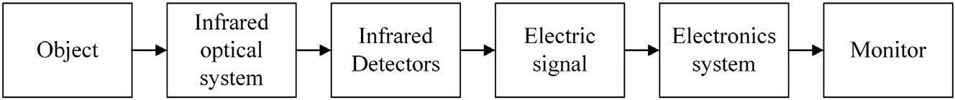

Fig. 4. Principle of infrared camera working.

improve aquaculture production efficiency. It is increasingly favored by the pig breeding industry (Yuhong et al., 2018).

Infrared camera is an imaging temperature measuring device. The object radiates energy outward in the form of electromagnetic waves, and the infrared radiation intensity of different objects is different. The principle of infrared thermal imaging is to use the difference between temperature and emissivity between the target and the surrounding en- vironment to generate different thermal gradients, which shows the in- frared radiation energy density distribution map, that is the “thermal image”. Human vision is not sensitive to infrared light, the thermal image seen by humans is that the infrared radiation emitted by the ob- ject is converted by the thermal imager. The different temperatures of the object are represented by different colors on the infrared image. The lighter the color, the higher the temperature of the surface of the object, and the darker the color, the lower the temperature of the sur- face of the object. Infrared camera converts infrared radiation into visi- ble light image in two steps. The working principle of infrared camera is shown in Fig. 4, the first step is to convert the infrared radiation into an electrical signal through an infrared detector. The intensity of the infra- red radiation is reflected by the magnitude of the signal. The second step is to display the distribution of the target infrared radiation on the dis- play through the display screen. The electrical signal completes the transition from electricity to light, and finally the visible image that re- flects the target temperature distribution.

* 1. *Application of infrared technology in body temperature measurement of livestock and poultry*

McManus et al. (2016) studied the application of infrared thermal imaging technology in animal metabolism, nutrition, inflammation pro- cess, disease, ectoparasite detection and reproduction is described, re- sulted that infrared thermal imaging is innovative, low-cost, fast and effective. It is sensitive to changes in animal heat patterns, but this method may not be sufficient to determine the cause of animal fever. Soerensen et al. (Soerensen and Pedersen, 2015) evaluated the applica- tion of infrared temperature measurement technology in the measure- ment of pig body temperature, explored the relationship between skin,

environment and body temperature. It had been found that the optimal skin position that is highly correlated between skin temperature and rectal temperature is likely to be hot windows (the commonly used measuring hot window is shown in the Fig. 5) such as the ear, eyes and breasts, however, this relationship may vary with age, stress and bi- ological state, for example Childbirth may change the extent of this cor- relation, and analyzed the prospects for the development of infrared thermometers in the diagnosis of future pig diseases.

Schaefer et al. (2004) applied infrared camera to the early detection and prediction of animal diseases, and inoculating viral diarrhea strains (24515) to 10 calves, seting up an uninfected control group, collecting images an infrared image is shown Fig. 6)with infrared features (nose, ear, back) of infected calves and control groups. The blood and salivary cortisol was obtained and immunoglobulin A and other parameters were analyzed to detect whether the cow is ill. The experiment con- cluded that the infrared facial scan can detect the temperature increase of infected calves from 1.5 °C to 4 °C (P b 0.01) before 1 week, the which shows that infrared heat measurement can be used for early detection and prediction of burdock disease.

Xie et al. (2004) used the rat breast adenocarcinoma 13762 MAT (a tumor that has been used for the identification of anti-angiogenic drugs) as a research object, and explored the feasibility of infrared imag- ing technology for detecting angiogenesis of malignant tumors. No tumor surface temperature elevation associated with the tumor was ob- served in the experiment, but some constant and very significant tem- perature reductions were found to be produced by relatively small tumors (N0.5 cm diameter), yielding a conclusion that temperature changes were independent of tumor size. It is speculated that this phe- nomenon may be due to the poor vascularity of rapidly growing tumors. Analysis showed that elevated peripheral temperature of breasts re- ported in breast cancer patients is unlikely to be caused by tumor growth leading to angiogenesis, possibly due to chronic inflammatory reactions around breast tumors, which means infrared imaging may have a considerable prognosis value. Liu et al. (Jinqi, 2016) obtained clinical mastitis, recessive mastitis, and normal lactating cow breast temperature through infrared camera, and found that the differences in breast surface temperature of the three types of lactating cows

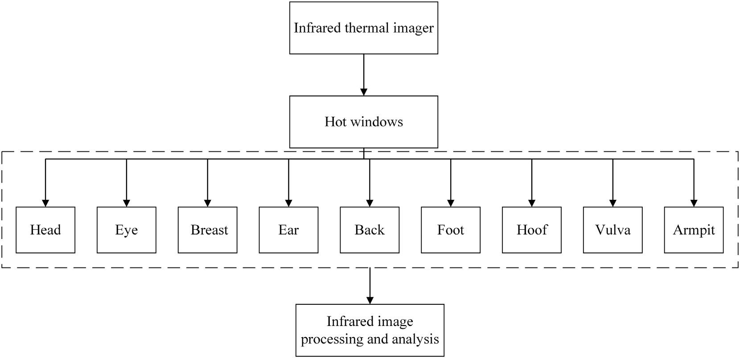

Fig. 5. The commonly used measuring hot window of animal.

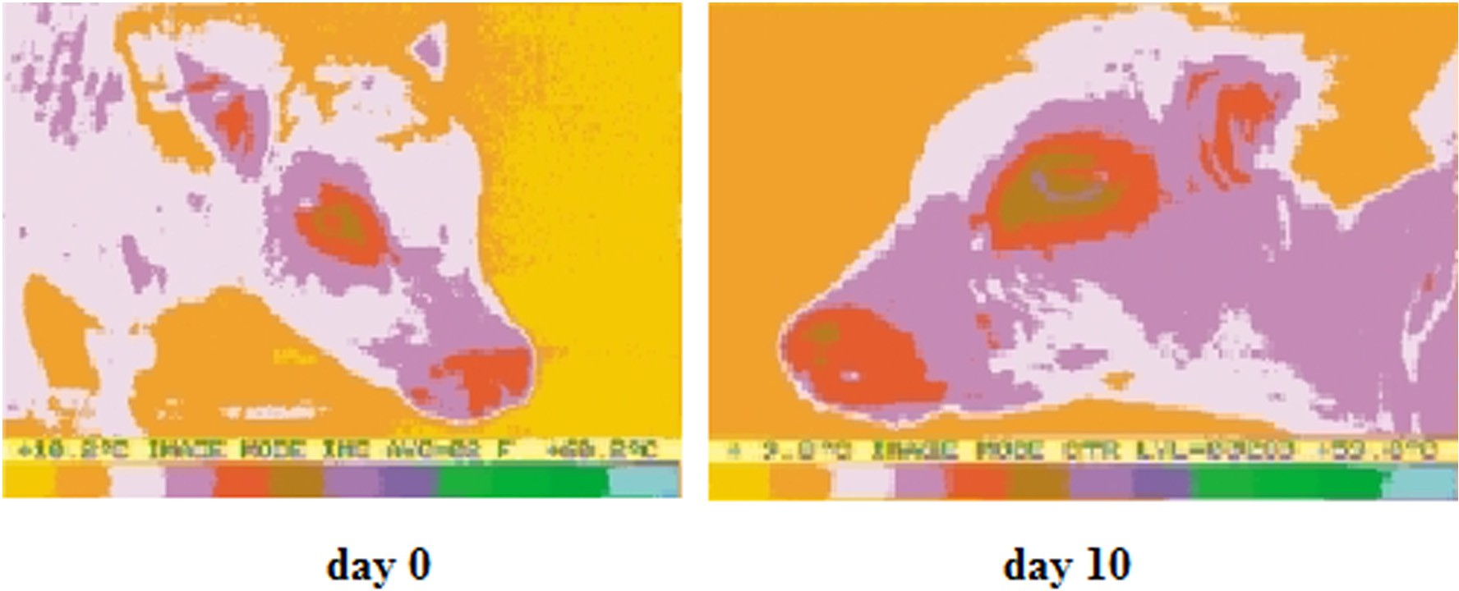

Fig. 6. Infrared facial images of a calf before and following infection with virus in Schaefer et al. (2004).

reached extremely significant levels (P b 0.01). It provides a viable method for early diagnosis of lactating cow mastitis. Amezcua et al. (2014) described the use of infrared thermography to detect inflamma- tion of sows' lower extremities to identify different degrees of lameness in sows. The selected areas ranged from top to bottom: 1 - t bone, 2 - upper jaw bone, 3 - lower jaw bone, and 4 - phalanx (Fig. 7). This shows that infrared thermography has become an effective method for diagnosing animal disease.

Taeho et al. (2010) found that non-contact infrared thermometry (NIFT) could serve as a valid alternative to manual rectal thermometry in portable germ-free facility without disturbing experimental animals. The development of NIFT body temperature assessment without animal restrictions is clinically beneficial, especially in reproductive piglets, and much less stressful for laboratory procedures in aseptic facilities. Knizkova et al. (2007) discussed the use of thermal imaging cameras in the field of veterinary medicine as a diagnostic for orthopedic dis- eases in livestock and poultry, analyzed the significance of infrared

thermal imaging as a breeding tool, which can participate in the ther- moregulation of the breeding process to increase animal welfare and participate in the process of assisting lactating milk. Schaefer et al. (2012) used an automated, RFID driven, noninvasive infrared thermog- raphy technology to determine bovine respiratory disease (BRD) in cat- tle. Routine parameters (core temperature, hematology, serum cortisol) and infrared image for 65 cattle of approximately 220 kg were obtained. The acquisition equipment located in a feedlot pen around a water sta- tion with RFID driven, non-invasive IRT scanning station was showed in Fig. 8. The BRD positive and negative cattle were determined by routine parameters, and the peak temperature of the infrared images was com- pared. The positive average peak value was 35.7 ± 0.35 °C, and the neg- ative average peak value was 34.9 ± 0.22 °C. The study suggests that infrared imaging technology can be used to wirelessly collect biometric data and help diagnose animal diseases.

Rainwater-Lovett et al. (2009) studied the feasibility of using infra- red cameras to detect foot-and-mouth disease (FMD) virus of cattle.

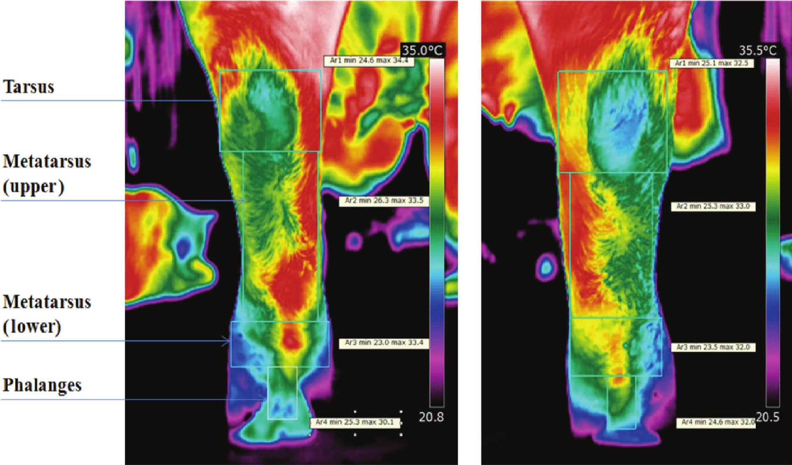

Fig. 7. Infrared thermal images of the left and right hind legs of a sow at various anatomical areas when evaluating lameness in Amezcua et al. (2014).

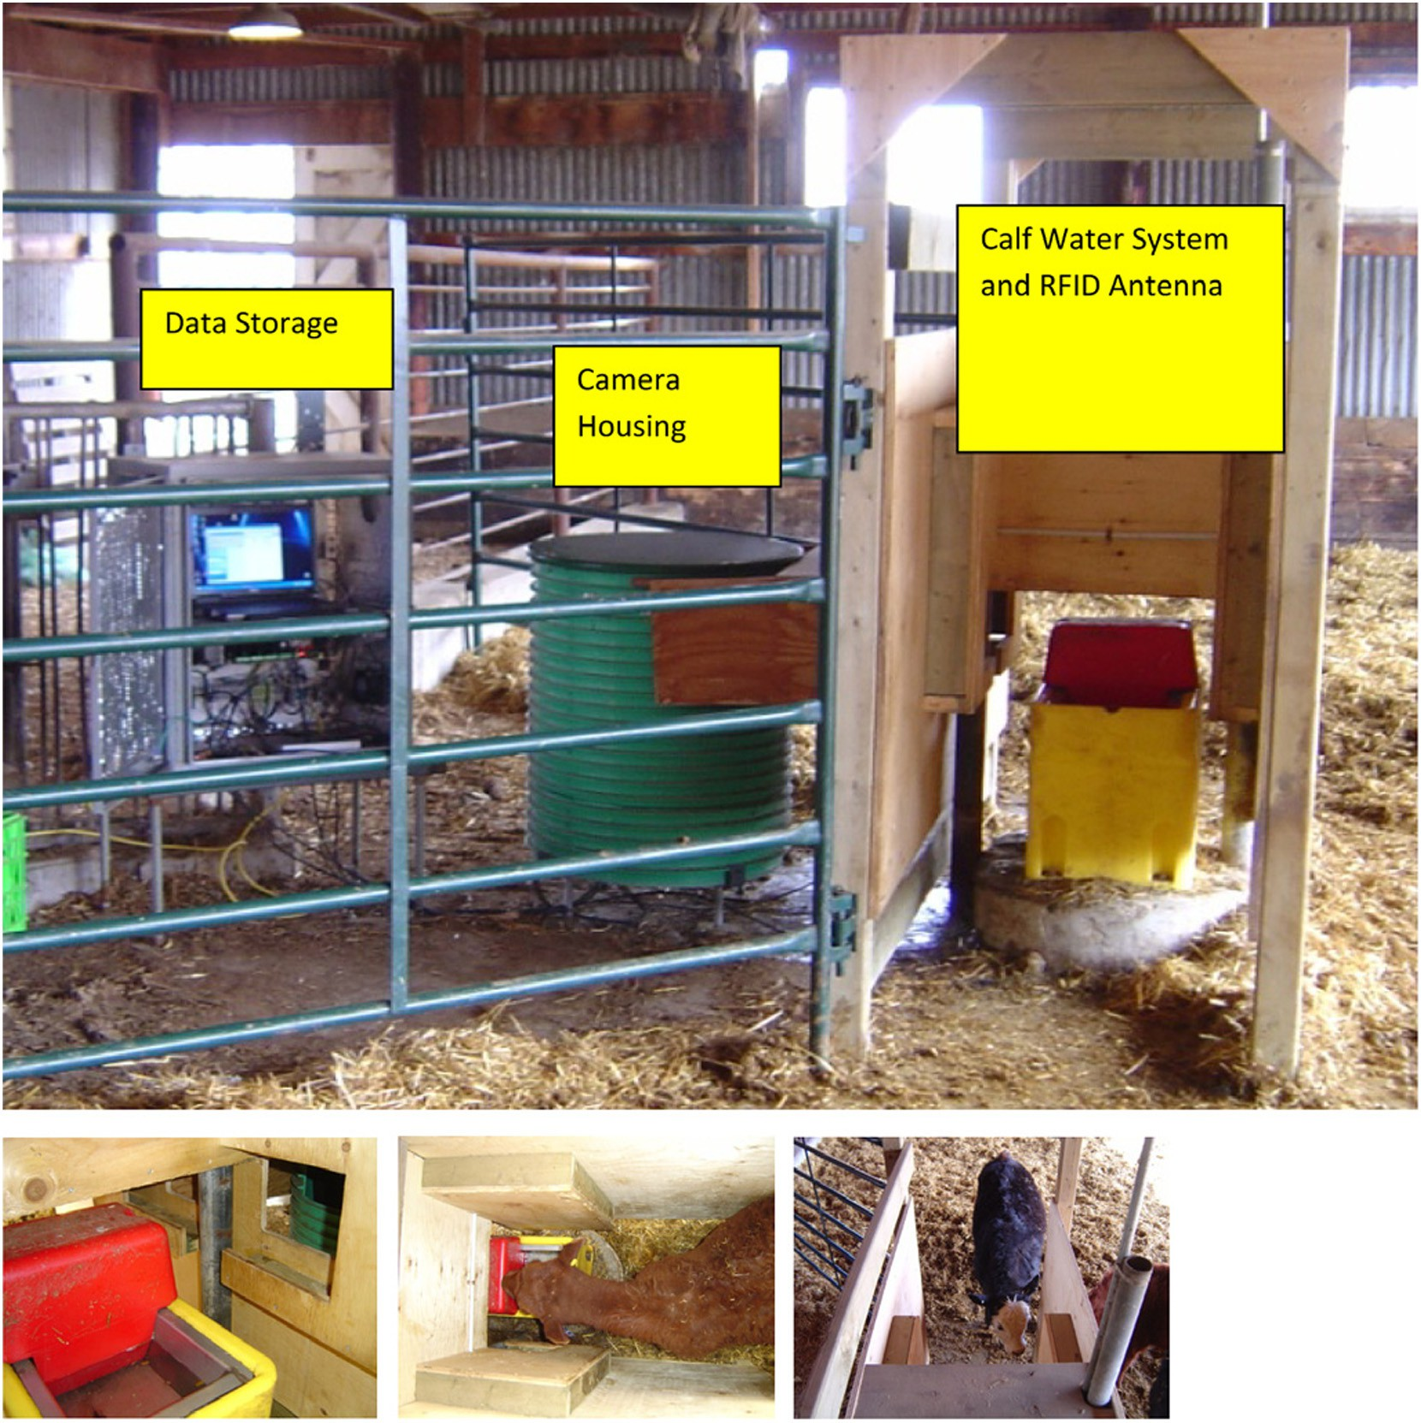

Fig. 8. Image of automated, RFID driven, non-invasive IRT scanning station located in a feedlot pen around a water station (Schaefer et al., 2012).

Through analyzing the maximum foot temperatures of healthy, directly inoculated, contact, and vaccine tria cattle were measured, the conclu- sion was that infrared thermography was a promising screening tech- nology that enabled rapid identification of potentially infected animals during a FMD outbreak for confirmatory diagnostic testing. However the technique needs to be further evaluated to determine the value of IRT in detecting mild clinical symptoms or subclinically infected animals.

Skykes et al. (Sykes et al., 2012) used digital infrared thermal imag- ing (DITI) equipment to obtain the temperature of the sow vulva, in- cluding the minimum (MIN), maximum (MAX), mean (AVG) and standard deviation (SD) of temperature gradients, ambient (AMB) and rectal temperatures (RT). The blood samples were analyzed and the serum progesterone (P4) concentration was determined. The MIN, MAX and AVG of the pig vulva temperature in the thermal image were found to be positively correlated with each other (P b 0.01), and positively correlated with the AMB (P b 0.01). MAX and AVG were higher in estrus than in diestrus. There was no significant difference in MIN and SD between estrus and diestrus, and no difference in RT be- tween the stages (P b 0.05), and RT was not significantly associated with vulvar thermal images. Vulva thermal images from defined regions of interest, as shown in Fig. 9. It was indicated that digital infrared ther- mal imaging (DITI) can measure the genital surface temperature during estrus and identify the estrus period of the sow.

Meng et al. (Xiangxue, 2016) measured the epidermal temperature of the buttocks, vulva and eyes of nearly 1000 normal pregnant sows by infrared camera, and analyzed the correlation of skin temperature of the three parts. It was concluded that the vulva of the estrus is higher and the estrus of the sow can be identified, so that the actual production can be guided through the temperature change.

Health assessment of animal is getting more and more attention. Marcia et al. (Salles et al., 2016) tested 24 small cows in 35 days, using infrared cameras to capture infrared images of different areas of the cow, including the left and right eye areas, right and left eyes, left fore- limb tail, left forelimb skull, left and right flank and forehead. In all the body regions studied, the thermal imaging forehead temperature has the highest correlation with the rectal temperature. The forehead and left and right flanking temperatures are related to the ambient temper- ature and humidity closely, which could be used to studied the body temperature regulation and body heat generation in the future. LokeshBabu et al. (2018) used the thermal imaging camera to measure the collateral-related cervical injury crown band and hoof skin temper- ature from the perspective of animal welfare and economic loss. It was found that when the hoof has a lesion, the surface temperature of the squat leg will increase, and an early thermal detection of the lesion can be performed using an infrared camera. Siewert et al. (2014) mea- sured the temperature of the pig's head by a thermal imaging camera and detected the early fever of the pig by differential ROI (region of

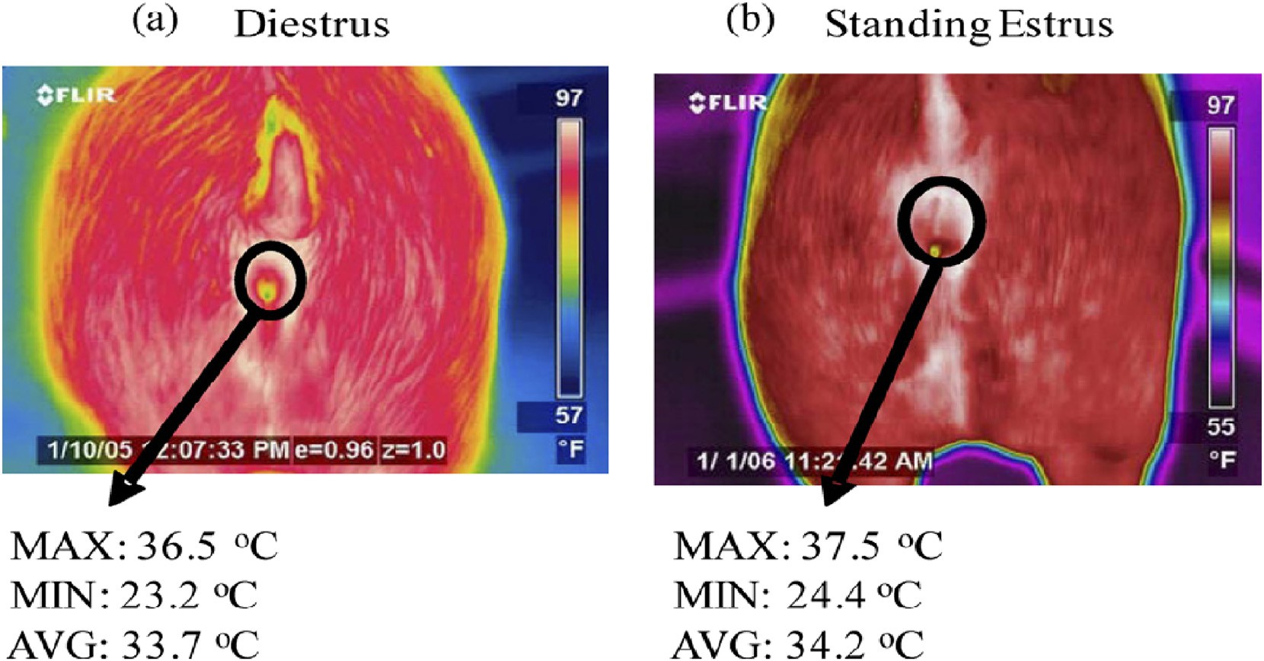

Fig. 9. Vulva thermal images from defined regions of interest (Sykes et al., 2012).

interest). The specificity of the method in the experiment is about 85% and the sensitivity is 86%. Kammersgaard et al. (2013) evaluated the thermal status of newborn piglets by infrared thermal imaging. After comparing 1695 infrared image data with 915 rectal temperature data, it was found that the maximum temperature (IRmax) of the infra- red image was highly correlated with rectal temperature. And the IRmax of the infrared thermogram is mainly located in the ear (27/ 50), the head area (12/50) and other parts of the armpit area (8/50). The IRmax of infrared thermal image can be used as a basis for evaluat- ing the thermal status of newborn piglets. The main applications of in- frared thermal imager in livestock and poultry breeding have been showed in Fig. 10.

Using infrared temperature measurement technology, under the premise of no contact with pigs, the measurement temperature of pig under non-stress condition is obtained, which is closer to the real body temperature of pigs, and the data accuracy is high. Many studies found that the measurement results of infrared temperature measuring equipment are relatively stable within a certain distance range (Yuhong et al., 2018). Therefore, the consistency of measurement distance should be maintained when using infrared equipment to obtain temperature data multiple times. In addition, the temperature difference between different parts of the pig is very large, the temperature at the anus, eyes, ear roots, and armpits is significantly higher than the temperature

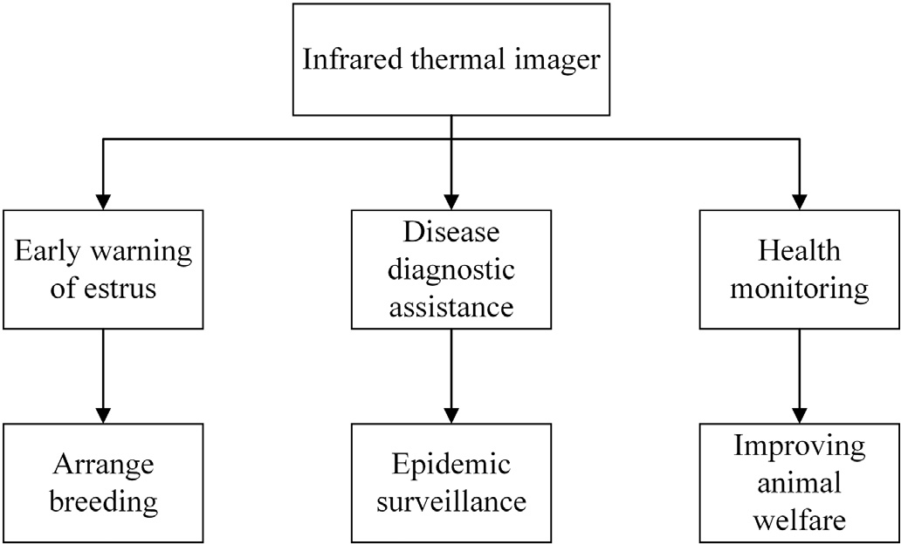

Fig. 10. The main applications of infrared thermal imager in livestock and poultry breeding.

at other parts of the body surface (McManus et al., 2016; Soerensen and Pedersen, 2015; Schaefer et al., 2004). This may be related to the emis- sivity of different parts of the pig. Soerensen et al. (2014) analyzed the best infrared measurement site of the pig by studying the emissivity of different parts of the sow to obtain an accurate infrared thermogra- phy. In the actual measurement, the same part of the pig is selected for measurement. Some scholars have found in the process of measur- ing the body temperature of pigs by infrared equipment: the tempera- ture of pig ear root (that is the junction between the ear and the back) is significantly higher than other parts of the head. Moreover, there is a clear correlation between the temperature of the ear root and the body temperature of the pig (Requejo et al., 2018; Andersen et al., 2008). So the body temperature status of pigs can be characterized by measuring the temperature of the pig ear roots. In livestock and poultry farming and pig breeding, infrared technology can be used for non- contact body temperature measurement of animals, which could be ap- plied to health assessment and monitoring of pig, and animal disease detection. It has been a technology for disease prevention and treat- ment. It can also be used to guide breeding work, to predict and test es- trus, to improve the conception rate of sows. Details of infrared temperature measurement technology are shown in Table 2.

* 1. *Application and development of infrared image processing technology in livestock and poultry breeding industry*

With the continuous exploration of the application of infrared tech- nology in the livestock and poultry breeding industry, the infrared image processing technology based on livestock and poultry breeding industry is also exploring and developing constantly. The image pro- cessing method based on active shape model proposed by Cootes et al. (Cootes, 2000) which is a method for searching for an object of a specific type in an image. Wirthgen et al. (2011) applied this method to infrared image processing for the first time, expounded the comprehensive ap- plicability of thermal infrared image to this method, and proposed an improved algorithm. Through the image processing, landmark display, shape creation and initialization, 2 million infrared images of cows is handled successfully, which revealed that the direction of further re- search is to process and analyze the infrared images of moving animal targets. Liu et al. (Bo et al., 2013; Bo, 2014) used the infrared camera and visible light camera to obtain the target pig image at the same time, and proposed an image registration algorithm based on ray con- tour feature points for multi-source images. Using the characteristics

Table 2

Application of infrared camera in livestock and poultry breeding.

No. Animal Application

field

Measuring part Results or conclusions Insufficients or prospect Ref

* + 1. Beef cattle, pigs, chicks, dairy cows

Disease diagnosis, health monitoring

Eye, foot, Flank, rump, rear area, and foot,

et al.

Infrared thermal imaging is innovative, low-cost, fast and effective to obtain the temperature of the animal

Infrared thermal imaging could detect fever but could not analyze the cause of fever

McManus et al. (2016)

* + 1. Pig Disease diagnosis, health monitoring
    2. Cattle Disease diagnosis, health monitoring
    3. Rat Disease diagnosis

Ear, eye, breast Further verification is required before the

thermal imaging camera is used as a diagnostic tool

Nose, ear, back Thermal imaging camera can be used to

develop early prediction index of burdock infection

Body surface Infrared imaging may have considerable prognostic value

Making infrared thermography as an effective means of detecting disease, requiring a metrological method for standard measurement

The use of infrared thermography may be an important increase in current clinical evaluation

Temperature changes have nothing to do with tumor size and growth, probably due to chronic inflammatory reactions around the breast tumor causing an increase in temperature

Soerensen et al. (Soerensen and Pedersen, 2015)

2015

Schaefer et al. (2004)

Xie W et al. (Xie et al., 2004) 2003

* + 1. Lactating cow

Disease diagnosis, health monitoring

Eye, breast, buttock The difference in surface temperature of bovine

breasts with different degrees of disease reached a very significant level (P b 0.01).

Provides a viable method for early diagnosis of lactating cow mastitis

Liu et al. (Jinqi, 2016) 2016

* + 1. Sow Disease diagnosis

Foot Identify different levels of sow foot Infrared thermography has become one of the

effective methods for diagnosing animal disease damage

Amezcua et al. (2014)

* + 1. Cow, pig, sheep, poultry

Disease diagnosis breeding

Body surface Thermal imaging cameras are tools that can be

used for pig, cattle, sheep and poultry breeding research.

When using IRT, must consider some limiting factors (sunlight, moisture, dirt, weather conditions, etc.)

Knizkova et al. (2007)

* + 1. Cattle Disease diagnosis

Body surface Infrared imaging technology can be used to

wirelessly collect biometric data and help diagnose animal diseases

Such a system would have clear utility in bio-surveillance and bio-security programs.

Schaefer A L et al. (Schaefer et al., 2012) 2011

* + 1. Cattle Disease diagnosis

Foot Infrared thermography is a promising screening technology that enables rapid identification of potentially infected animals during a FMD outbreak for confirmatory diagnostic testin

The technique needs to be further evaluated Rainwater-Lovett

et al. (2009)

* + 1. Sow Breeding Vulva 1. There is no significant correlation between

vulvar temperature and rectal temperature.

2. Infrared thermometer can measure the change of surface temperature of gilt surface in estrus.

Use the temperature change of the vulva to identify the estrus in the sow and guide the production

Skykes et al. (Sykes et al., 2012) 2012

* + 1. Pregnant sow

Breeding Hip, vulva, eyes 1. Receptor temperature effects on the buttocks,

vulva, and eye temperature of pregnant sows

2. Changes in vulva and hip temperature can be used to identify the estrus of the sow

Temperature change of vulva and hip can be used to identify the estrus of the sow

Meng X et al. (Xiangxue, 2016)

2016

* + 1. Cow Health monitoring
    2. Cattle Health monitoring disease diagnosis

Right eye, left eye, left forelimb, tail, left forelimb skull, left and right flank, forehead

Hoof injury crown band, hoof skin surface

1. Infrared thermography has the highest correlation between forehead temperature and rectal temperature.
2. Forehead and left and right flanking temperatures are closely related to environmental temperature and humidity.

It is found that when the hoof has a lesion, the surface temperature of the squat leg will increase.

The thermal state characteristics of different parts can be used to regulate the body temperature and to study the body heat generation.

Early hoof lesions can be detected using an infrared camera.

Marcia et al. (Salles et al., 2016) 2016

LokeshBabu et al. (2018)

* + 1. Pig Health monitoring
    2. Piglet Health monitoring

Head Infrared imaging and analysis with different ROI (region of interest) methods for early detection of elevated pig body temperature (N39.5 °C)

Ear, head, armpit Infrared image maximum temperature IRmax

has a great correlation with rectal temperature

Head temperature is used as an aid in the diagnosis of pig health

Infrared thermography IRmax can be used as a basis for evaluating the thermal status of newborn piglets

Siewert et al. (Siewert et al., 2014) 2013

Kammersgaard et al. (2013)

of the infrared image to get a clear outline of the pig's foreground firstly, the problem is transformed from image registration to parameter matching of the feature point set. 50 infrared and visible images had been matched automatically with a registration rate of 94% and the av- erage registration error is b1 pixel, which is better than manual registra- tion. Based on this, a fusion method of visible image and infrared image of pigs based on non-subsampled contour wave is proposed. Through the fusion application of infrared image and visible image, more surface and behavior data of pig are obtained, the body surface temperature of pig ear root could be get in time, flow chart of pig ear root area

extraction is showed in Fig. 11. The monitoring of abnormal behaviors such as fever and surface ulceration of pigs was achieved, which laid a foundation for the monitoring of abnormal behavior of pigs and the ex- traction of characteristics of pigs based on multi-source images.

Lu et al. (2018) evaluated the health status of piglets using an infra- red camera. An automatic extraction of the ear-based temperature algo- rithm based on the top view is proposed. Firstly, the head of the piglet was identified by the training classifier, and then the two ear base points were located based on the feature points of the head contour, and the highest temperature in the circle centered on the ear base point was

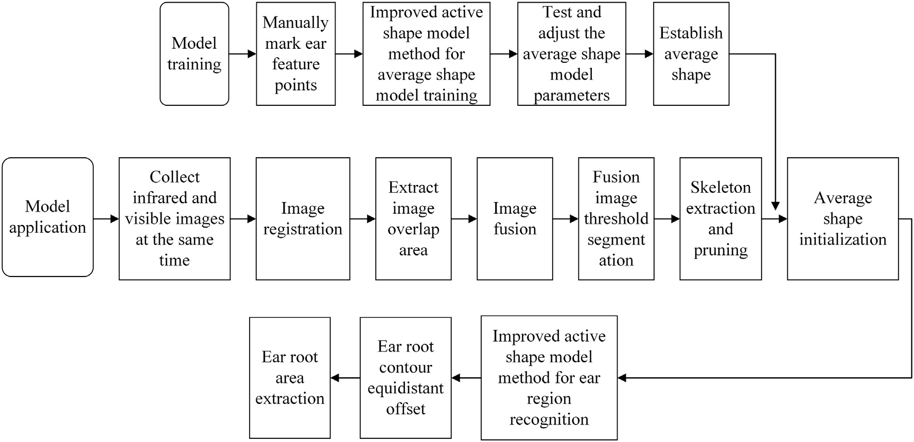

Fig. 11. Flow chart of pig ear root area extraction.

extracted to represent the two ear bases temperature. 100 images were processed by this method, and the extracted temperature was com- pared with the temperature obtained manually using Fluke Smart View 3.14. For the left and right ear bases, 97% and 98% of the test im- ages had errors in the range of 0.4 °C. Li et al. (2015) proposed a sow in- frared image segmentation algorithm based on improved geometric active contour model. The point operation was used to enhance the con- trast, reduced the background interference, and the energy weights were dynamically equalized by the weight function which can change with the overall contrast of the image and the local contrast. Through all of that the 300 thermal infrared images of sows were segmented. The average time of single infrared image segmentation was 49.67 s, and the correct segmentation rate is 98%. It provided the possibility for further application of infrared video monitoring. Leizi et al. (2016) proposed a method for measuring the surface temperature of animals based on Kinect sensor and infrared camera. The relationship between temperature and angle of view was analyzed, and the mathematical model of compensating the angle of view was established. The correla- tion coefficient was above 0.99. At the same time, the depth and infrared thermal image fusion method of the synchronized image were established, and the angle of view of each pixel was calculated. By this method, the temperature measurement error caused by the angle of view can be compensated, and the significant influence of the measure- ment angle of view on the measured temperature was reduced.

There is a certain correlation between temperature and body tem- perature in the ear region of pigs (Berry et al., 2003; Schaefer et al., 2012). Weixing et al. (2015) simultaneously acquired infrared and visi- ble light images, and proposed an improved active shape model for de- tecting pig ear regions based on image fusion. The feature region of the ear root was extracted according to the shape feature, and the average shape initial pose was improved in combination with the head skeleton model. After processing 50 images, comparing segmentation ear region with the manual segmentation ear region, the coincidence degree which N0.8 account for 84%, which showed the detection effect was sat- isfied. Zhou et al. (Liping et al., 2016) described a method based on the improved Otsu algorithm for detecting the infrared image of pigs, using a self-designed infrared image acquisition system to collect images of pigs. Through the improved Otsu algorithm, the image of the ear roots of piglets, finishing pigs and pregnant pigs could be detected. This method can correctly detect pigs with complete ear root feature areas, and 23% of piglets with incomplete root characteristics can be found correctly, 25% of fattening pig images can be detected correctly, 33% of pregnant pig images could be found correctly. It is impossible to detect

images of pigs that do not have the characteristics of the ear roots. Use this method to detect images with inaccurate focus or too few image pixels during the acquisition process, the result is good, which avoid in- accurate detection areas due to relatively low resolution of acquired images.

It is a very complicated process to process the infrared image and get the body temperature information of the pig. Effective data acquisition enables image processing to be more efficient and faster. In the process of infrared image processing, some scholars have found that visible light has a greater impact on the quality of acquired infrared images. Infrared images acquired in low illumination conditions are less noisy when seg- mented, as the illuminance increases, the noise increases, resulting in unsatisfactory target segmentation. Therefore, attention should be paid to choose the appropriate illuminance when acquiring infrared im- ages. In addition, the ambient temperature also has a great influence on the infrared image, higher noise at higher temperatures. Avoid high temperature and hot weather when acquiring infrared images, and se- lect appropriate ambient temperature for data acquisition. In the pro- cess of data processing, the effective extraction of the target area of the infrared image is particularly important. Pigs have obvious shape features, easy to detect feature points, and analyze feature areas. Pig body extraction method based on feature points and feature regions is the most widely used. Visible light images contain more detailed infor- mation than infrared images, which can compensate for the limitations of infrared images. Register and combine infrared and visible images to get more information firstly, then processing fused images to obtain temperature information, this method is also constantly being explored.

1. Conclusion and future trends

Body temperature can be used as an important indicator to assess the health status of pigs, diagnose pig diseases, and guide pig breeding. Emerging pig body temperature measurement techniques can be di- vided into contact and non-contact. With the development of the concept of welfare farming, non-contact infrared temperature measure- ment technology will be more and more recognized. At present, the ap- plication of infrared temperature measurement technology in the pig breeding industry is still in the initial stage of development. The mea- suring equipment that has been introduced mainly includes infrared thermometers for point analysis and infrared cameras for field analysis. People are still exploring new application modes of infrared technology in measuring body temperature of pigs. However, based on the transfor- mation needs of the intensive pig breeding model, the need for welfare

farming, and the need for smart agriculture to actively explore, the trend of infrared temperature measurement to replace traditional man- ual temperature measurement is becoming clearer.

At the same time, infrared temperature measurement technology is increasingly prominent in the fields of health monitoring of pigs, disease diagnosis, and identification of sow estrus, and because of its real-time, efficient, convenient and accurate advantages, it is more and more rec- ognized by the breeding industry. Compared with traditional mercury column temperature measuring equipment or electronic temperature measuring equipment, infrared equipment costs much more. It is more difficult to promote and apply in small farms or personal breeding. Some infrared equipment and temperature measuring system are com- plicated to install. Moreover, the data collection operation requires more professional workers and a higher level of knowledge. It is not conducive to the promotion in actual breeding.

The development of infrared temperature measurement technology in the pig breeding industry will continue to advance with the develop- ment of the information society. High-precision, high-stability, portable, easy-to-operate infrared equipment is currently the most needed for Chinese pig breeding companies. The infrared temperature measuring equipment in actual production application is mainly an infrared ther- mometer based on point analysis, and the application of the infrared camera is relatively small. However, the infrared camera based on field analysis has higher precision and more comprehensive tempera- ture information. How to reduce costs, improve stability and generate product promotion trends is the key to the future application of infrared cameras in the livestock industry.

Many infrared image processing technologies used in other fields have begun to explore the applicability in the pig industry, which fur- ther promotes the development of infrared temperature measurement. However, infrared image processing technology generally has problems such as large imaging noise, low image contrast, and narrow gray scale. Infrared imaging is easily affected by non-uniformity and invalid pixels, resulting in low actual resolution. These image processing challenges will still hinder the development of infrared temperature measurement technology in the pig breeding industry in the future. The enhancement of key technologies for infrared image processing will further promote the application of infrared camera temperature measurement in the pig industry. The exploration of the applicability of infrared image pro- cessing technology in other fields in the pig breeding industry will fur- ther promote the achievement and product development of infrared temperature measurement technology.

Today, with the continuous development of Internet of Things agri- culture, the pig breeding industry is also changing in the direction of informationization and automation. The non-contact, real-time and long-distance characteristics of infrared temperature measurement technology represented by infrared camera conform to the concept of IoT agriculture. In the process of development, we continuously ex- plored the combination with other information management technolo- gies and emerging farming technologies, laying a foundation for building a more efficient farming model and breeding process, and its future development prospects are very bright.

Acknowledgments

This work was supported by National Key Research and Development Program (2017YFD0701601-3), Research Platform Construction Project and Graduate Training Quality Improvement Project (2017YAL009) of Tianjin Agricultural University.

References

Amezcua, R., Walsh, S., Luimes, P.H., et al., 2014. [Infrared thermography to evaluate lame-](http://refhub.elsevier.com/S2589-7217(19)30002-9/rf0005) [ness in pregnant sows.[J]. Canadian Veterinary Journal La Revue Vétérinaire](http://refhub.elsevier.com/S2589-7217(19)30002-9/rf0005) [Canadienne 55 (3), 268–272](http://refhub.elsevier.com/S2589-7217(19)30002-9/rf0005).

Andersen, M.L., Jørgensen, E., Dybkjær, L., et al., 2008. [The ear skin temperature as an in-](http://refhub.elsevier.com/S2589-7217(19)30002-9/rf0010) [dicator of the thermal comfort of pigs[J]. Appl. Anim. Behav. Sci. 113 (1), 43–56](http://refhub.elsevier.com/S2589-7217(19)30002-9/rf0010).

Berry, R.J., Kennedy, A.D., Scott, S.L., et al., 2003. [Daily variation in the udder surface tem-](http://refhub.elsevier.com/S2589-7217(19)30002-9/rf0015) [perature of dairy cows measured by infrared thermography: potential for mastitis de-](http://refhub.elsevier.com/S2589-7217(19)30002-9/rf0015) [tection[J]. Can. J. Anim. Sci. 83 (4), 687–69](http://refhub.elsevier.com/S2589-7217(19)30002-9/rf0015)3.

Bligh, J., Heal, J.W., 1974. [The use of radio-telemetry in the study of animal physiology[J].](http://refhub.elsevier.com/S2589-7217(19)30002-9/rf0020)

[Proc. Nutr. Soc. 33 (2), 17](http://refhub.elsevier.com/S2589-7217(19)30002-9/rf0020)3.

Bo, Liu, 2014. [Study of Pig Skin Temperature and Gait Features Extraction Method Based](http://refhub.elsevier.com/S2589-7217(19)30002-9/rf0025) [on Multi-source Images[D]. Jiangsu University (in Chinese with English abstract)](http://refhub.elsevier.com/S2589-7217(19)30002-9/rf0025).

Bo, Liu, Weixing, Zhu, Bin, Ji, et al., 2013. [Automatic registration of IR and optical pig im-](http://refhub.elsevier.com/S2589-7217(19)30002-9/rf0030) [ages based on contour match of radial line feature points[J]. Trans. Chinese Soc. Agric.](http://refhub.elsevier.com/S2589-7217(19)30002-9/rf0030) [Eng. 29 (2), 153–160 (in Chinese with English abstract](http://refhub.elsevier.com/S2589-7217(19)30002-9/rf0030)).

China Government Network, 2018. 2017 economic operation is stable and better than ex- pected. <http://www.gov.cn/xinwen/2018-01/18/content_5257967.htm>.

Cootes, T., 2000. [Model-based methods in analysis of biomedical images. Image Process-](http://refhub.elsevier.com/S2589-7217(19)30002-9/rf0040) [ing and Analysis. Oxford University Press, Oxford, pp. 223–24](http://refhub.elsevier.com/S2589-7217(19)30002-9/rf0040)8.

Dewulf, J., Koenen, F., Laevens, H., et al., 2003. [Infrared thermometry is not suitable for the](http://refhub.elsevier.com/S2589-7217(19)30002-9/rf0045) [detection of fever in pigs[J]. Vlaams Diergeneeskundig Tijdschrift 72 (5), 373–37](http://refhub.elsevier.com/S2589-7217(19)30002-9/rf0045)9.

Godyn, Dorota, Herbu, Piotr, 2017. [Applications of continuous body temperature mea-](http://refhub.elsevier.com/S2589-7217(19)30002-9/rf0055) [surements in pigs – a review. Anim. Sci. 56 (2), 209–22](http://refhub.elsevier.com/S2589-7217(19)30002-9/rf0055)0.

Guangan, Zhang, 2017. [Status and development trend of China's pig industry [J]. Vet.](http://refhub.elsevier.com/S2589-7217(19)30002-9/rf0060)

[Guid. 07, 19–20 (in Chinese](http://refhub.elsevier.com/S2589-7217(19)30002-9/rf0060)).

Guangyu, Bai, 2014. [Design of Sow Body Temperature Monitoring Node Based on Wire-](http://refhub.elsevier.com/S2589-7217(19)30002-9/rf0065) [less Sensor Network. Nanjing Agricultural University (in Chinese with English](http://refhub.elsevier.com/S2589-7217(19)30002-9/rf0065) [abstract)](http://refhub.elsevier.com/S2589-7217(19)30002-9/rf0065).

Hanchun, Yang, 2007. [Occurrence and prevalence of porcine hyperthermia syndrome[J].](http://refhub.elsevier.com/S2589-7217(19)30002-9/rf0235)

[Pig Sci. (01), 78–80 (in Chinese)](http://refhub.elsevier.com/S2589-7217(19)30002-9/rf0235).

Hentzen, 2012. [Design and Validation of a Wireless Temperature Measurement System](http://refhub.elsevier.com/S2589-7217(19)30002-9/rf0070) [for Laboratory and Farm Animals Proceedings of Measuring Behavior (Utrecht, The](http://refhub.elsevier.com/S2589-7217(19)30002-9/rf0070) [Netherlands, August 28–31, 2012)](http://refhub.elsevier.com/S2589-7217(19)30002-9/rf0070).

Jiao, Wang, 2017. [How to check the body temperature of pigs [J]. Anim. Hus. Vet. Sci.](http://refhub.elsevier.com/S2589-7217(19)30002-9/rf0075)

[Technol. Inf. 02, 5 (in Chinese)](http://refhub.elsevier.com/S2589-7217(19)30002-9/rf0075).

Jinqi, Liu, 2016. [Application of Infrared Thermography in the Field Detection of Dairy](http://refhub.elsevier.com/S2589-7217(19)30002-9/rf0085) [Cow's Skin Temperature. Northeast Agricultural University (in Chinese with English](http://refhub.elsevier.com/S2589-7217(19)30002-9/rf0085) [abstract)](http://refhub.elsevier.com/S2589-7217(19)30002-9/rf0085).

Jizhu, Dong, Jinyuan, Zhao, Yanchun, Li, 2016. [Current status and development prospects](http://refhub.elsevier.com/S2589-7217(19)30002-9/rf0090) [of China's pig industry[J]. South. Agric. Mach. 47 (01), 37 (in Chinese)](http://refhub.elsevier.com/S2589-7217(19)30002-9/rf0090).

Juxiong, Liu, Yang, Huanmin, 2011. [Animal Physiology [M]. Higher Education Press, Bei-](http://refhub.elsevier.com/S2589-7217(19)30002-9/rf0095) [jing (in Chinese)](http://refhub.elsevier.com/S2589-7217(19)30002-9/rf0095).

Kammersgaard, T.S., Malmkvist, J., Pedersen, L.J., 2013. [Infrared thermography—a non-](http://refhub.elsevier.com/S2589-7217(19)30002-9/rf0100) [invasive tool to evaluate thermal status of neonatal pigs based on surface tempera-](http://refhub.elsevier.com/S2589-7217(19)30002-9/rf0100) [ture.[J]. Animal 7 (12), 2026–2034](http://refhub.elsevier.com/S2589-7217(19)30002-9/rf0100).

Knizkova, I., Kunc, P., Gurdil, G.A.K., et al., 2007. [Applications of infrared thermography in](http://refhub.elsevier.com/S2589-7217(19)30002-9/rf0105) [animal production[J]. 22 (3), 329–33](http://refhub.elsevier.com/S2589-7217(19)30002-9/rf0105)6.

Krizanac, D., Haugk, M., Sterz, F., et al., 2010. [Tracheal temperature for monitoring body](http://refhub.elsevier.com/S2589-7217(19)30002-9/rf0110) [temperature during mild hypothermia in pigs[J]. Resuscitation 81 (1), 87–92](http://refhub.elsevier.com/S2589-7217(19)30002-9/rf0110).

Leizi, Jiao, Daming, Dong, Xiande, Zhao, et al., 2016. [Compensation method for the influ-](http://refhub.elsevier.com/S2589-7217(19)30002-9/rf0080) [ence of angle of view on animal temperature measurement using thermal imaging](http://refhub.elsevier.com/S2589-7217(19)30002-9/rf0080) [camera combined with depth image[J]. J. Therm. Biol. 62, 15–19](http://refhub.elsevier.com/S2589-7217(19)30002-9/rf0080).

Li, Ma, Yuyao, Duan, Ze, Zong, et al., 2015. [Segmentation of thermal infrared image for](http://refhub.elsevier.com/S2589-7217(19)30002-9/rf0140) [sow based on improved convex active contours[J]. J. Agric. Mach. 46 (S1), 180–186](http://refhub.elsevier.com/S2589-7217(19)30002-9/rf0140) [(in Chinese with English abstract)](http://refhub.elsevier.com/S2589-7217(19)30002-9/rf0140).

Li, Chen, Tonghui, Qian, Shizhen, Zhang, et al., 2017. [Design of pig signs and breeding en-](http://refhub.elsevier.com/S2589-7217(19)30002-9/rf0115) [vironment monitoring system based on wireless sensor network. Tech. Autom. Appl.](http://refhub.elsevier.com/S2589-7217(19)30002-9/rf0115) [36 (05), 61–64 (in Chinese with English abstract)](http://refhub.elsevier.com/S2589-7217(19)30002-9/rf0115).

Libo, Gao, Gang, Duan, Gefen, Yin, et al., 2010. [Trial effect of infrared thermometer in body](http://refhub.elsevier.com/S2589-7217(19)30002-9/rf0050) [temperature screening of pig slaughterhouse[J]. China Anim. Hus. Vet. Med. 37 (09),](http://refhub.elsevier.com/S2589-7217(19)30002-9/rf0050) [235–237 (in Chinese)](http://refhub.elsevier.com/S2589-7217(19)30002-9/rf0050).

Liping, Zhou, Zhi, Chen, Da, Chen, et al., 2016. [Pig ear root detection based on adapted](http://refhub.elsevier.com/S2589-7217(19)30002-9/rf0120) [Otsu[J]. J. Agric. Mach. 47 (04) (228-232+14. in Chinese with English abstract)](http://refhub.elsevier.com/S2589-7217(19)30002-9/rf0120).

LokeshBabu, D.S., Jeyakumar, S., Vasant, Patil Jitendra, et al., 2018. [Monitoring foot surface](http://refhub.elsevier.com/S2589-7217(19)30002-9/rf0125) [temperature using infrared thermal imaging for assessment of hoof health status in](http://refhub.elsevier.com/S2589-7217(19)30002-9/rf0125) [cattle: a review [J]. J. Therm. Biol. 78, 10–21](http://refhub.elsevier.com/S2589-7217(19)30002-9/rf0125).

Lu, Wang, Yonghua, Hui, Chunxiao, Wei, et al., 2015. [Application of body temperature](http://refhub.elsevier.com/S2589-7217(19)30002-9/rf0130) [changes in the diagnosis and treatment of swine diseases[J]. Anhui Agric. Sci. Bull.](http://refhub.elsevier.com/S2589-7217(19)30002-9/rf0130) [21 (05), 108–110 (in Chinese)](http://refhub.elsevier.com/S2589-7217(19)30002-9/rf0130).

Lu, Mingzhou, Heb, Ju, Chen, Chao, et al., 2018. [An automatic ear base temperature extrac-](http://refhub.elsevier.com/S2589-7217(19)30002-9/rf0135) [tion method for top view piglet thermal image[J]. Comput. Electron. Agric. 155,](http://refhub.elsevier.com/S2589-7217(19)30002-9/rf0135) [339–34](http://refhub.elsevier.com/S2589-7217(19)30002-9/rf0135)7.

McManus, C., Tanure, C.B., Peripolli, V., et al., 2016. [Infrared thermography in animal pro-](http://refhub.elsevier.com/S2589-7217(19)30002-9/rf0145) [duction: an overview.[J]. Comput. Electron. Agric. 123 (C), 10–16](http://refhub.elsevier.com/S2589-7217(19)30002-9/rf0145).

National Bureau of Statistics of the People's Republic of China website, 2018. [http://data.](http://data.stats.gov.cn/easyquery.htm?cn=C01) [stats.gov.cn/easyquery.htm?cn=C01](http://data.stats.gov.cn/easyquery.htm?cn=C01).

Qiaoping, Zhang, 2011. [Judging method of pig disease based on body temperature detec-](http://refhub.elsevier.com/S2589-7217(19)30002-9/rf0155) [tion[J]. Mod. Agric. Sci. Tech. (20) (352+354. in Chinese)](http://refhub.elsevier.com/S2589-7217(19)30002-9/rf0155).

Rainwater-Lovett, K., Pacheco, J.M., Packer, C., et al., 2009. [Detection of foot-and-mouth](http://refhub.elsevier.com/S2589-7217(19)30002-9/rf0160) [disease virus infected cattle using infrared thermography[J]. Vet. J. 180 (3), 317–324](http://refhub.elsevier.com/S2589-7217(19)30002-9/rf0160). Requejo, Jose M., Garrido-Izard, Miguel, Correa, Eva C., et al., 2018. [Pig ear skin tempera-](http://refhub.elsevier.com/S2589-7217(19)30002-9/rf0165) [ture and feed efficiency: Using the phase space to estimate thermoregulatory effort.](http://refhub.elsevier.com/S2589-7217(19)30002-9/rf0165)

[ScienceDirect 174, 80–88](http://refhub.elsevier.com/S2589-7217(19)30002-9/rf0165).

Salles, Marcia Saladini Vieira, da Silva, Suelen Corrêa, Salles, Fernando André, et al., 2016. [Mapping the body surface temperature of cattle by infrared thermography[J].](http://refhub.elsevier.com/S2589-7217(19)30002-9/rf0170)

[J. Therm. Biol. 62 (Pt A), 63–69](http://refhub.elsevier.com/S2589-7217(19)30002-9/rf0170).

Schaefer, A.L., Cook, N., Tessaro, S.V., et al., 2004. [Early detection of inflammation and in-](http://refhub.elsevier.com/S2589-7217(19)30002-9/rf0175) [fection using infrared thermography[J]. Can. J. Anim. Sci. 84 (1), 73–80](http://refhub.elsevier.com/S2589-7217(19)30002-9/rf0175).

Schaefer, A.L., Cook, N.J., Bench, C., et al., 2012. [The non-invasive and automated detection](http://refhub.elsevier.com/S2589-7217(19)30002-9/rf0180) [of bovine respiratory disease onset in receiver calves using infrared thermography[J].](http://refhub.elsevier.com/S2589-7217(19)30002-9/rf0180) [Res. Vet. Sci. 93 (2), 928–93](http://refhub.elsevier.com/S2589-7217(19)30002-9/rf0180)5.

Siewert, C., Dänicke, S., Kersten, S., et al., 2014. [Difference method for analysing infrared](http://refhub.elsevier.com/S2589-7217(19)30002-9/rf0185) [images in pigs with elevated body temperatures[J]. Z. Med. Phys. 24 (1), 6–15](http://refhub.elsevier.com/S2589-7217(19)30002-9/rf0185).

Soerensen, D.D., Pedersen, L.J., 2015. [Infrared skin temperature measurements for moni-](http://refhub.elsevier.com/S2589-7217(19)30002-9/rf0190) [toring health in pigs: a review[J]. Acta Vet. Scand. 57 (1), 5 1(2015-02-03)](http://refhub.elsevier.com/S2589-7217(19)30002-9/rf0190).

Soerensen, D.D., Clausen, S., Mercer, J.B., et al., 2014. [Determining the emissivity of pig](http://refhub.elsevier.com/S2589-7217(19)30002-9/rf0195) [skin for accurate infrared thermography[J]. Comput. Electron. Agric. 109, 52–58](http://refhub.elsevier.com/S2589-7217(19)30002-9/rf0195).

Sykes, D.J., Couvillion, J.S., Cromiak, A., et al., 2012. [The use of digital infrared thermal im-](http://refhub.elsevier.com/S2589-7217(19)30002-9/rf0200) [aging to detect estrus in gilts.[J]. Theriogenology 78 (1), 147–15](http://refhub.elsevier.com/S2589-7217(19)30002-9/rf0200)2.

Taeho, C., Woosung, J., Euihwa, N., et al., 2010. [Comparison of rectal and infrared ther-](http://refhub.elsevier.com/S2589-7217(19)30002-9/rf0205) [mometry for obtaining body temperature of gnotobiotic piglets in conventional por-](http://refhub.elsevier.com/S2589-7217(19)30002-9/rf0205) [table germ free facility.[J]. Asian Australas. J. Anim. Sci. 23 (10), 1364–1368.](http://refhub.elsevier.com/S2589-7217(19)30002-9/rf0205)

Weihan, Cai, 2017. [Estrus identification and sowing time of sows[J]. Chinese J. Anim. Hus.](http://refhub.elsevier.com/S2589-7217(19)30002-9/rf0210)

[Vet. Med. 33 (10), 71 (in Chinese)](http://refhub.elsevier.com/S2589-7217(19)30002-9/rf0210).

Weixing, Zhu, Liu, Bo, Jianjun, Yang, et al., 2015. [Pig ear area detection based on adapted](http://refhub.elsevier.com/S2589-7217(19)30002-9/rf0275) [active shape model[J]. J. Agric. Mach. 46 (03), 288–295 (in Chinese with English](http://refhub.elsevier.com/S2589-7217(19)30002-9/rf0275) [abstract)](http://refhub.elsevier.com/S2589-7217(19)30002-9/rf0275).

Wirthgen, T., Zipser, S., Franze, U., et al., 2011. [Automatic Segmentation of Veterinary In-](http://refhub.elsevier.com/S2589-7217(19)30002-9/rf0215) [frared Images With the Active Shape Approach[M] Image Analysi. Springer, Berlin](http://refhub.elsevier.com/S2589-7217(19)30002-9/rf0215) [Heidelberg](http://refhub.elsevier.com/S2589-7217(19)30002-9/rf0215).

Xiangxue, Meng, 2016. [Application of Infrared Thermography in the Field Detection of](http://refhub.elsevier.com/S2589-7217(19)30002-9/rf0220) [Sow's Skin Temperature [D]. Northeast Agricultural University (in Chinese with En-](http://refhub.elsevier.com/S2589-7217(19)30002-9/rf0220) [glish abstract)](http://refhub.elsevier.com/S2589-7217(19)30002-9/rf0220).

Xie, Wei, Mccahon, P., Jakobsen, K., et al., 2004. [Evaluation of the ability of digital infrared](http://refhub.elsevier.com/S2589-7217(19)30002-9/rf0225) [imaging to detect vascular changes in experimental animal tumours.[J]. Int. J. Cancer](http://refhub.elsevier.com/S2589-7217(19)30002-9/rf0225) [108 (5), 790–794](http://refhub.elsevier.com/S2589-7217(19)30002-9/rf0225).

Xudong, Shi, Yuling, Bai, Jinfang, Zhang, et al., 2013. [Estrus and estrus identification of](http://refhub.elsevier.com/S2589-7217(19)30002-9/rf0230) [sows[J]. Pig Sci. 30 (04), 56–58 (in Chinese](http://refhub.elsevier.com/S2589-7217(19)30002-9/rf0230)).

Yong, Cai, 2015. [The Study on the Designing of the Automatical Acquisition System for](http://refhub.elsevier.com/S2589-7217(19)30002-9/rf0245) [Cow Surface Temperature and the Fitting for Surface Temperature With Rectal Tem-](http://refhub.elsevier.com/S2589-7217(19)30002-9/rf0245) [perature [D]. Chinese Academy of Agricultural Sciences (in Chinese with English](http://refhub.elsevier.com/S2589-7217(19)30002-9/rf0245) [abstract)](http://refhub.elsevier.com/S2589-7217(19)30002-9/rf0245).

Yongxiao, Qin, 2015. [Research on Pig Body Temperature Collection System Based on In-](http://refhub.elsevier.com/S2589-7217(19)30002-9/rf0250) [frared Temperature Measurement Equipment[A]. Information Technology Branch of](http://refhub.elsevier.com/S2589-7217(19)30002-9/rf0250) [China Animal Husbandry and Veterinary Society. Proceedings of the 10th Symposium](http://refhub.elsevier.com/S2589-7217(19)30002-9/rf0250) [of Information Technology Branch of China Animal Husbandry and Veterinary Society](http://refhub.elsevier.com/S2589-7217(19)30002-9/rf0250) [[C]. 3. China Animal Husbandry and Veterinary Learning Information Technology](http://refhub.elsevier.com/S2589-7217(19)30002-9/rf0250) [Branch (in Chinese)](http://refhub.elsevier.com/S2589-7217(19)30002-9/rf0250).

Yuan, Liu, Yuanping, Zhang, 2016. [National live pig production development regulations](http://refhub.elsevier.com/S2589-7217(19)30002-9/rf0255) [(2016–2020) [J]. China Anim. Hus. (10), 30–40 (in Chinese)](http://refhub.elsevier.com/S2589-7217(19)30002-9/rf0255).

Yufeng, Yang, Yanping, Shao, 2012. [Cause analysis and common diseases of pig body tem-](http://refhub.elsevier.com/S2589-7217(19)30002-9/rf0240) [perature rise [J]. Aquac. Technol. Consultant 05, 153 (in Chinese)](http://refhub.elsevier.com/S2589-7217(19)30002-9/rf0240).

Yuhong, Liu, Xiulin, Liu, Wang, Fujie, et al., 2018. [Application of infrared thermal imaging](http://refhub.elsevier.com/S2589-7217(19)30002-9/rf0260) [technology in animal and poultry disease detection [J]. Chinese Poult. 40 (05), 70–72](http://refhub.elsevier.com/S2589-7217(19)30002-9/rf0260) [(in Chinese](http://refhub.elsevier.com/S2589-7217(19)30002-9/rf0260)).

Yundong, Zhao, 2012. [Pig fever [J]. Aquac. Technol. Consultant 06, 172 (in Chinese](http://refhub.elsevier.com/S2589-7217(19)30002-9/rf0265)).

Zhenling, Zhang, 2018. [Reflections on the “healthy farming” of pigs in China under the](http://refhub.elsevier.com/S2589-7217(19)30002-9/rf0270) [new situation and the prospect of “welfare farming”[J]. Pig Sci. 35 (01), 126–129](http://refhub.elsevier.com/S2589-7217(19)30002-9/rf0270) [(in Chinese](http://refhub.elsevier.com/S2589-7217(19)30002-9/rf0270)).

Ziyun, Zhang, 2015. [Detected Onset of Estrus and Behavior in the Different Varieties of](http://refhub.elsevier.com/S2589-7217(19)30002-9/rf0280) [Gilts Using the New Electronic Chip. Sichuan Agricultural University (in Chinese](http://refhub.elsevier.com/S2589-7217(19)30002-9/rf0280) [with English abstract)](http://refhub.elsevier.com/S2589-7217(19)30002-9/rf0280).