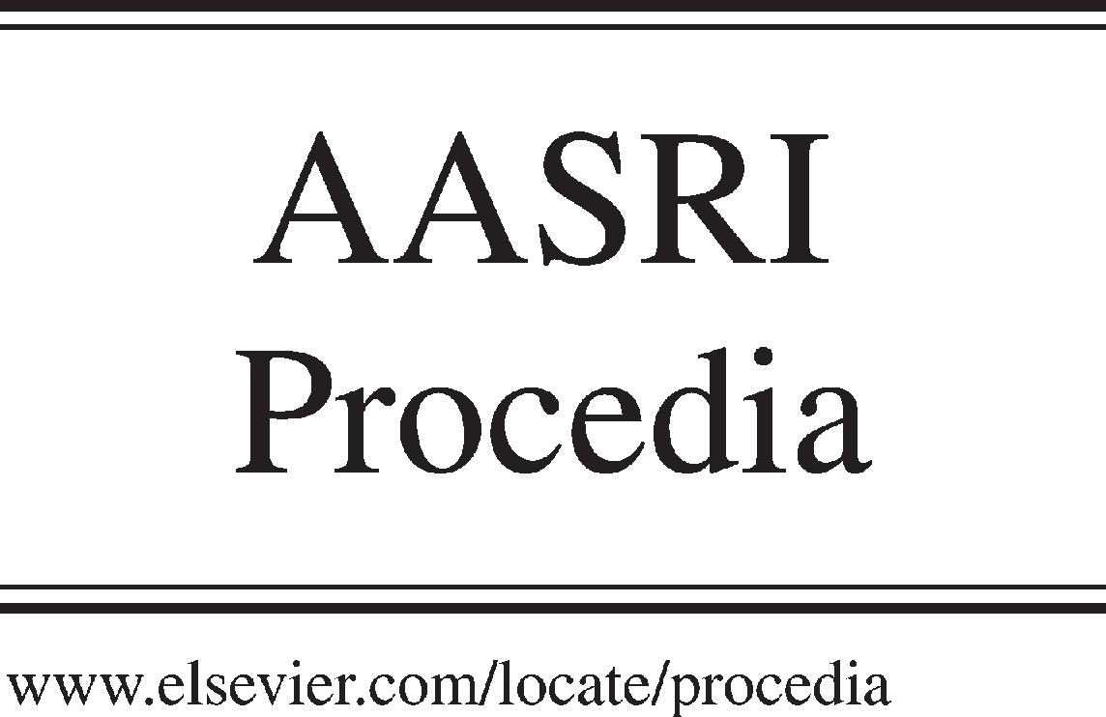Available online at [www.sciencedirect.com](http://www.sciencedirect.com/)



AASRI Procedia 3 (2012) 73 – 77

2012 AASRI Conference on Modeling, Identification and Control

The Influence of the Structure Peculiarity of the Polyvinyl Alcohol Structure on the Direct Blackening Photostimulated Processes in the Polyvinyl Alcohol-zink oxude-bismuth Chloride Composition

Dmitry Shtareva, Konstantin Makarevicha,b, Sergey Rogovb, Alexander Syuya

*aDepartment of Natural Science, Far Eastern State Transport University, 47 Seryshev Street, Khabarovsk 680021, Russia*

*bInstitute of Material Science Far Eastern Branch of Russian Academy of Sciences, 153 Tihookeanskaya Street, Khabarovsk 680042, Russia*

Abstract

In presented paper, we will investigate the photosensitivity of a composition which consists of a polyvinyl alcohol, zinc oxide and bismuth chloride (PVA-ZnO-BiCl3). Advanced, is an experimental result of the dependence between the photosensitivity of a similar system and the content of the acetate groups in the polymer structure, and its explanation.

© 2012 The Authors. Published by Elsevier B.V. Open access under [CC BY-NC-ND license.](http://creativecommons.org/licenses/by-nc-nd/3.0/)

© 2012 Published by Elsevier B.V. Selection and/or peer rev[iew under respon](http://creativecommons.org/licenses/by-nc-nd/3.0/)sibility of American Applied Science Research Institute

Selection and/or peer review under responsibility of American Applied Science Research Institute

*Keywords* direct blackening photostimulated processes, direct blackening photosensitive compositions, polyvinyl alcohol-zink oxude- bismuth chloride composition.;

1. Introduction

In this paper the dependence of the photographic properties of PVA-ZnO-BiCl3 from the rate of the acetate group in the polyvinyl alcohol (PVA) are investigated, and the assumption about of its role in the direct blackening photostimulated processes is made.

Photosensitive compositions which consist of a polymer matrix dispersed with a photocatalyst, and sensitized by a salt of metal, are widely researched on the following examples: polyvinyl alcohol – zinc oxide – bismuth chloride (PVA-ZnO-BiCl3) [1-3], polyvinyl alcohol – zinc oxide / titanium dioxide – lead acetate

2212-6716 © 2012 The Authors. Published by Elsevier B.V. Open access under [CC BY-NC-ND license.](http://creativecommons.org/licenses/by-nc-nd/3.0/) Selection and/or peer review under responsibility of American Applied Science Research Institute doi:10.1016/j.aasri.2012.11.013

(PVA-ZnO/TiO2-Pb(CH3COO)2) [4], polyvinyl alcohol – cuprum chloride / ferric chloride [5] and some others. These classes of compositions exhibit photosensitivity to UV irradiation. Another general factor for these compositions are realizing the direct blackening processes in it, which means that the visible image forms directly under irradiation without an additional development stage.

Improving or changing any properties of such photosensitive compositions – improving the photosensitivity and/or maximal density of the optical blackening, changing the spectral sensitivity range, - is key. As a rule, such changes of the properties of the photosensitive compositions are achived from modifications in the photocatalyst or salt of metal (sensitizer). The influences of the polymer matrix on the photosensitive composition properties were not studied.

The photosensitive composition samples of PVA-ZnO-BiCl3 were prepared by the well-known technique

[1] with insignificant changes.

To prepare samples in the first stage it is necessary to disperse the zinc oxide into the polymer matrix. For this, 12 grams of zinc oxide (II) moistened with water was put into 100 ml of the 10% PVA water solution (which was homogenate on the bain-marie before it). After one hour of settling time, the 60 grams of the resulting mixture was coated on the glass plate with an area of 234 sq.cm. Then the composition was dried in a horizontal orientation at room temperature for 24 hours.

Next, the sensitizing of the compositions was made by dipping the PVA-ZnO composition for the 30 seconds in 1 M bismuth chloride aqueous solution (to obtain the PVA-ZnO-BiCl3 photosensitive composition). Finally, the photosensitive compositions are dried in a heated air flow for 5 minutes to eliminate moisture.

In the way described, three sets of samples were prepared. Each one differed by the type of the usable polyvinyl alcohol. It is well known [6] that a different PVA type has a different count of the acetate groups in its structure. In table 1, the acetate group concentration in the different PVA types, which were used in the experiment, are shown. The acetate group concentration was determined by the standard method [6].

Table 1. The acetate group concentrations in the PVA used in the different sample sets

|  |  |  |
| --- | --- | --- |
| Sample sets sign | The PVA type | Acetate group  concentration, % |
| PVA-ZnO-BiCl3 (I) | 11/2 | 1.24 – 1.25 |
| PVA-ZnO-BiCl3 (II) | 16/1 | 1.31 – 1.32 |
| PVA-ZnO-BiCl3 (III) | 18/11 | 13.72 – 13.78 |

1. Experimental

To determine the rate of influence of the used PVA on the direct blackening photochemical processes which occurs in the photosensitive composition, it was chosen to use the characteristic curve construction method. It was applied to the each set of three samples, whereupon the basic photographic characteristics of the photosensitive compositions were determined on the basis of getting characteristic curves.

To achieve these aims, samples of the photosensitive compositions were exposed to the integrated spectrum light of a DRT-125 mercury-vapor lamp during various exposure times. The illumination on the sample surface was E=0.105 W/sq.cm., and the optical blackening determination was carried out by the approved method using the author's hardware-software complex [3].

1. Results

Fig. 1 show the characteristic curves of the PVA-ZnO-BiCl3 (I-III) photosensitive composition.

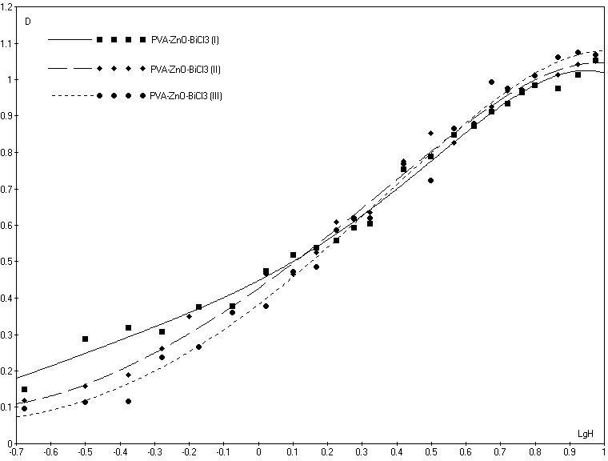

Fig. 1. Characteristic curves of the PVA-ZnO-BiCl3 photosensitive compositions containing various rates of the acetate group

From the figure, it is obvious that both the maximal density of the optical blackening, and the rate at which it rises, depend on the chemical structure of the PVA being used. The basic photographic characteristics of PVA-ZnO-BiCl3 (I-III) photosensitive composition, were calculated on the basis of their characteristic curves, and are described below in table 2.

Table. 2. The basic photographic characteristics of PVA-ZnO-BiCl3 and PVA-ZnO-Pb(CH3COO)2 photosensitive compositions are dependent on the PVA chemical structure

|  |  |  |  |  |
| --- | --- | --- | --- | --- |
| Sample sets sign | Acetate group concentration, % | Maximal density of the optical blackening | Photosensitivity, SISO | Contrast |
| PVA-ZnO-BiCl3 (I) | 1.245±0.005 | 1.15 | 4.20 | 0.76 |
| PVA-ZnO-BiCl3 (II) | 1.315±0.005 | 1.07 | 6.81 | 0.75 |
| PVA-ZnO-BiCl3 (III) | 13.75±0.03 | 1.12 | 11.83 | 0.83 |

From the table it can be seen that the acetate group concentrations in the polymer structure have influence on the photosensitive composition sensitized by the bismuth chloride. So, for the PVA-ZnO-BiCl3 composition, the acetate group volume in the PVA structure has no significant influence on the contrast and the maximal density of the optical blackening, but strongly influences the photosensitivity (fig. 2).

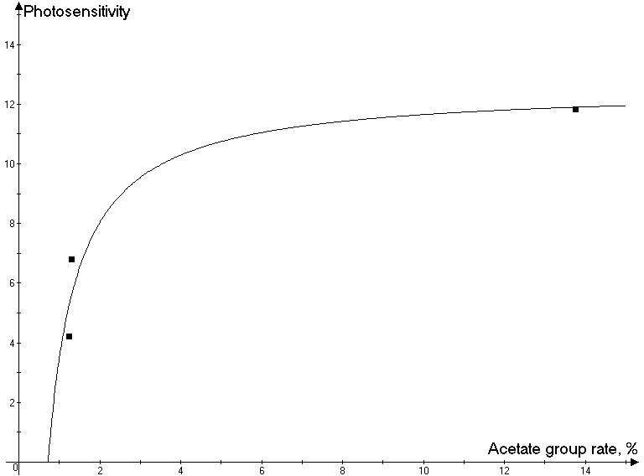

Fig. 2. The dependence of the PVA-ZnO-BiCl3 photosensitivity by the concentration of acetate group in the PVA

1. Conclusions

Getting results allows the conclusion that the chemical structure of the polymer matrix (the acetate group rate) can influence the photosensitivity of the polymer – semiconductor – salt of metal photosensitive compositions. Of notable importance is that photosensitivity is a value that is proportional to exposure, which changes the density of the optical blackening of the sample surface on the 0.1 in the comparison with the unexposed sample. So, this characteristic describes the increasing density of the optical blackening value in the early stage of the image formation process. On the other hand, it is well known that in the small values of the optical density, the following equation is correct: D~σ, (D – density of the optical blackening, σ – colour centre surface density).

Thus, the dependence identified is evidence that the acetate group in the PVA structure is participating in the early stage of the visible image formation on the PVA-ZnO-BiCl3 photosensitive composition surface.

As shown previously [1] in the PVA-ZnO-BiCl3 composition, modification of the polymer (PVA), due to the formation of conjugated double bonds (-C = C-)n, has a significant contribution to the visible blackening formation. The formations correspond with the PVA dehydrogenation and dehydration reactions.

Thus, in all likelihood, the presence of the acetate groups in the PVA structure initiate the PVA deacylation reactions (removal of the acetic acid residue) in the early stage of the irradiation. It is well known that deacylation reaction occurs more easily in the presence of an electrophilic agent due to its high polarity of the  bond. Such an agent in the PVA-ZnO-BiCl3 composition may be a hydrogen ion H+, formed in the composition during the photoinitiated processes [1].

Therefore, the blackening in the initial stage of visible image formation occurs with more intensity in cases

with more acylated polymer matrices. This means that the formation of a conjugated double bond's array in

the early stage of the photostimulates processes, are stipulated by the removal of the acetic acid residue. Once these processes are complited, then the dehydrogenation and dehydration reactions begin. From this it can be explained that the more rapid increase of the optical blackening density in cases, when the 18/11 type of the PVA was used (nearly 14% of the acetate group). Versus other types of PVA, which contain a lesser order of magnitude (table 1).

References

[1] Shtarev D.S., Makarevich K.S., Syuy A.V. Behavioral features of photostimulated processes in the heterogeneous composition of polymer - semiconductor - salt of a metal. Journal of Photochemistry & Photobiology A: Chemistry Vol 222 (2011), p. 146-158.

[2]. Syui A.V., Shtarev D.S. Photosensitive Composition Based on Polyvinyl Alcohol. Optics and Spectroscopy Vol. 110, No. 2 (2011), p. 224–226.

1. Shtarev D.S., Makarevich K.S., Syuy A.V. Impact of a chlorine ions concentration in sensitizer solution on the photographic characteristics of polyvinyl alcohol – zinc oxide – bismuth chloride composition. Optik - International Journal for Light and Electron Optics 123 (2012), pp. 1095-1097.
2. Prosanov I.Ju.. The journal of the scientific photography and cinematography. Vol. 48, No 1 (2004), p. 67- 69 (in Russia).
3. Sirec O.F. The journal of the scientific photography and cinematography. Vol. 30 No 6 (1985), p. 408-412 (in Russia).
4. Finch C.A. Polyvinyl Alcohol, Properties and application. - New York: John Wiley, 1973. - 622 p.