Available online at [www.sciencedirect.com](http://www.sciencedirect.com/)



AASRI Procedia 3 (2012) 172 – 176

2012 AASRI Conference on Modelling, Identification and Control

The Intelligent Control system of Immersion cyclic corrosion test chamber

Fang Kangling Li Xiao Chen Guonian

*College of Information Science and Engineering, Wuhan University of Science and Technology Wuhan 430081, China*

Abstract

The immersion cycle corrosion test chamber is various steel accelerated corrosion test equipment. An intelligent control system is designed in this paper, to control temperature and humidity of the chamber during the test. There are an expert controller to control temperature, and a fuzzy controller to control humidity of the chamber. The practical application has achieved good results.

© 2012 The Authors. Published by Elsevier B.V. Open access under [CC BY-NC-ND license.](http://creativecommons.org/licenses/by-nc-nd/3.0/)

© 2012 The Authors. Published by Elsevier B.V.

Selection and/or peer review under responsibility of American Applied Science Research Institute

Selection and/or peer review under responsibility of American Applied Science Research Institute

Key word: immersion cycle corrosion test chamber; intelligent control system; expert controller; fuzzy controller

1. Introduction

Steel corrosion is a very serious problem; atmospheric corrosion is the most common type of corrosion. Atmospheric corrosion related to many other factors, such as air temperature, humidity, and hours of sunshine, rainfall, dust fall, alternate wetting and drying of the frequency and so on. Natural environment exposure experiment is to study the atmospheric corrosion of the most commonly used test methods.

* Corresponding author. Tel.:13720146898. E-mail address: [22745524@qq.com](mailto:22745524@qq.com)

2212-6716 © 2012 The Authors. Published by Elsevier B.V. Open access under [CC BY-NC-ND license.](http://creativecommons.org/licenses/by-nc-nd/3.0/) Selection and/or peer review under responsibility of American Applied Science Research Institute doi:10.1016/j.aasri.2012.11.029

The outdoor exposure test true and accurate, but are often very long experimental period. Impregnated dry and humid combined cycle test of the steel in the laboratory, and short-term accelerated corrosion is an effective method, can simulate the atmospheric corrosion process, the approximate speculated that the long- term outdoor exposure test results, and then predict steel life to resistant atmospheric corrosion.

Accelerated corrosion test is generally carried out in the immersion cyclic corrosion test chamber. The main indicators are temperature and humidity during the test of the chamber.

The temperature and humidity control of closed chamber is difficult. Once the overshoot occurs, either the temperature or humidity is very difficult to adjust to the desired value. Obviously, this is a controlled object in poor working conditions and with a variety of uncertainties. The model uncertainty of the process makes the control system more complex. Due to the nonlinear and difficult modeling, this system becomes difficult to control. Conventional PID control strategy is commonly used, can not meet the requirements of temperature control and humidity control in Immersion cyclic corrosion test chamber.

In actual industrial field, there are a lot of bad work environment and control of certain parameters that require high object. Such difficult to control system can achieve good control by the experience of the experts and skilled technicians.

To solve the above problem, the intelligent control system is designed in this paper for weathering steel corrosion test. The system includes a simple temperature expert controller and a humidity fuzzy controller by correction factor method. The proposed method has been successfully used for weathering steel corrosion test, and achieved satisfactory results.

1. Testing Process In The Test Chamber

The accelerated corrosion test is generally carried out in the immersion cyclic corrosion test chamber. Using infrared heating lamps (heated air temperature) and the refrigeration equipment (inhibit excessive temperature) controlling the chamber temperature. Using steam atomizer to control the humidity of the test chamber, the method of control pulses to control the speed of the humidification Infrared heating lamps and a steam atomizer are installed in the test chamber shown as Fig 1.

A practical control system of immersion cyclic corrosion test chamber consists of four work-piece infrared heat lamps, two infrared heat lamps for temperature adjustment of the test chamber, cooling fan, steam atomizer(pulse-type humidifier), temperature and humidity sensors.

The steel specimen is installed in the low-speed rotation of the axle, by regulating heat lamps, cooling fan and pulse-type humidifier to regulate temperature and humidity of the test chamber. The steel member is sequentially immersed in 5% NaCl solution.

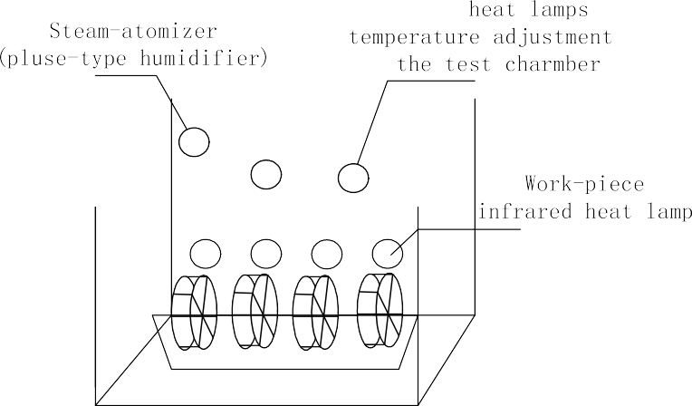

Fig.1Schematic diagram of an immersion cyclic corrosion test chamber

1. The Intelligent Cotrol System Of The Test Chamber

In this paper the Intelligent Control system consists of two parts: a rule-based expert temperature controller and a humidity fuzzy controller.

A. Rule-based expert Temperature Controller

The key is how to control the temperature of hot air, cooling fan and light intensity. According to the process characteristics and the experience of experts, rule-based expert controller complete logic control of the cooling fan, hot air and heat lamps.

The knowledge base of expert controller in the form of the rule base, and its rules is the rules used by the

storage reasoning. Expression by

*IF* ⋯*THEN*

form of rules, for example, expressed as follows:

Let

*T*2 = *T*1 - *T*

Where *T* is desired temperature value

*T*1 is actual temperature value

*T*2 is temperature deviation value Rule1:

*IF* (*T*1  *T* )*and* (*T*2

Turn on cooling fan

Stop hot air Rule 2:

* 0.6) *THEN* Turn off infrared heat lamps,

*IF* (*T*1  *T* )*and* (*T*2  0.5)

# *THEN*

Turn on infrared heat lamps,

Turn off cooling fan

* 1. *Humidity Fuzzy Controller*

The pulse-type humidifier controls the humidity of the test chamber, humidifier pulse signal trigger control to produce steam for humidification, making humidity changes uneven in the chamber. The humidity of the test chamber by a variety of interference, there are many uncertainties. Therefore, it is not possible to establish the mathematical model used to control humidity.

The fuzzy set theory is introduced by Zadeh to deal with the uncertainty and imprecision related with information concerning several parameters. The fuzzy control has emerged as one of the most active fruitful areas for research in the application fields. Fuzzy controller has been considered as a reasonable and effective alternative to solve nonlinear, complex, and poorly mathematical model problems in industrial process control. In a fuzzy controller the control actions are handled by fuzzy rules, which is a logical model of the human behaviour of the process operator. The method of fuzzy control does not require an internal precise mathematical model or transfer functions for practical control system. Fuzzy control theory has been one of major application in the control fields.

The chamber humidity control actuator is pulse-type humidifier, closed-loop control system shown in Fig.2.



*H*

_

*KE*

*E*

*H*1

*K*

*d EC*

*EC dt*

*u*

The chamber

pulse-type humidifier

Fuzzy Cotroller

Fig.2 The closed-loop control system of humidity for the chamber

The output value of the controller is used to control pulse generation cycle, adjusting the speed of the humidification.

The controller of this system is a humidity fuzzy controller by correction factor method.

# *dE*

Let *E* = *H* - *H*1 ,

*EC* 

# *dt*

Where *H* is desired humidity value

*H*1 is actual humidity value

*E* is humidity deviation value

*EC* is The rate of change of the humidity deviation Fuzzy control strategy for the correction factor is

*u*(*k* )  *E*(*k* )  (1  ** )*EC*(*k* )

Where *u*(*k* ) is the output value of the fuzzy controller.

1. Operating Results

The system described in the paper has been applied to the Bridge Steel corrosion test in Wuhan Iron and Steel Cooperation of China.

Fig.3(a) shows temperature control effect of a conventional PID method, Fig.3(b) shows the effect for the temperature expert control system in this paper. The two control effect shown in the set temperature of 45  . The temperature fluctuations of PID control in the range of ±8  . The temperature fluctuations of this paper an expert control system is in the range of ±1  , to meet temperature requirements of the chamber.

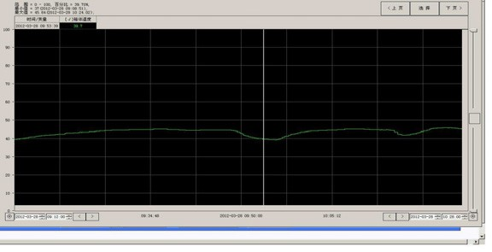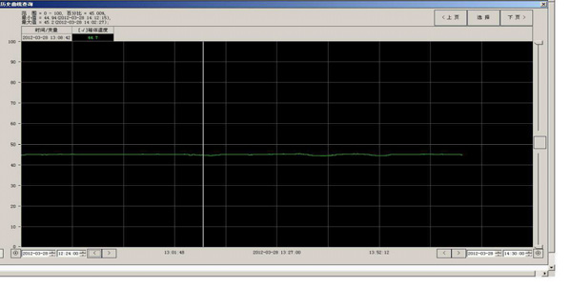

(a) The control effect for a conventional PID (b) The control effect for expert system in this paper.

Fig 3 The temperature control effect

Fig.4(a) shows humidity control effect of a conventional PID method, Fig.4(b) shows the effect for the humidity control system in this paper. The humidity fluctuations of PID control in the 10% range. The humidity fluctuations of the fuzzy control system in this paper are in the range of ±1  , to meet humidity requirements of the chamber.

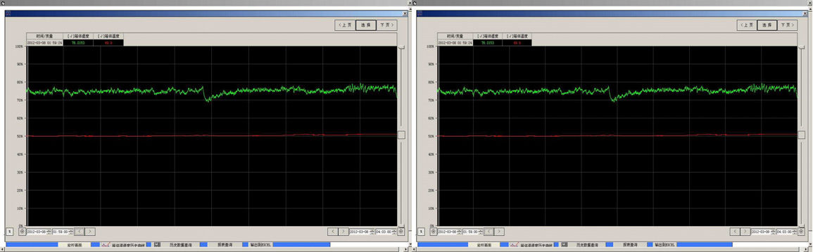

(a) The control effect for a conventional PID (b) The control effect for fuzzy system in this paper.

Fig.4 The humidity control effect

1. Conclusion

The design control system solved the control temperature and humidity problem of immersion cyclic corrosion test chamber, with the poor working conditions and many uncertain factors. The actual results also show that the intelligent control system in this paper has achieved good effect.

References

1. Shankar KG, Control of boiler operation using PLC-SCADA, in Proceedings of the international multi conference of engineers and computer scientists, 2008:19–21.
2. Yang Qiwei. Common temperature Control Methods contrast control technology [J], Measurement and Control Technology 2005
3. Fang Kangling Process Control Systems [M] Wuhan, Wuhan University of Technology Press, 2002