Available online at [www.sciencedirect.com](http://www.sciencedirect.com/)



AASRI Procedia 1 (2012) 428 – 434

AASRI

Procedia

[www.elsevier.com/locate/procedia](http://www.elsevier.com/locate/procedia)

2012 AASRI Conference on Computational I ntelligence and Bioinformatics

# The Research of the Regional Financial Risk Early-Warning Model Integrating the Regression of Lagging Factors

KeNa Zhu1,2, DongSheng Liu1,2, JiCheng Wu3 and Lan Sun3

*1College of Computer Science & Information Engineering*

*2Center for Studies of Modern Business ,Zhejiang Gongshang University,HangZhou,China* [*zhukenadyx@163.com*](mailto:zhukenadyx@163.com)

*3Sunyard System Engineering Co., Ltd* [*lhy@sunyard.com*](mailto:lhy@sunyard.com)

**Abstract**

This paper make the explained variables our financial stress index consist of the synchronous variables financial systemic risk, and make the explanatory variables the macroeconomic variable, currency credit variable, asset price variable and the macroeconomic variable of correlative economic powers, then use stepwise regression method to establish the financial systemic risk best predict equation, thus set up the reasonable and practical financial systemic risk early-warning index system; besides, use the best prediction equations predicts the financial systemic risk status in 2011. The predicted results show that Chinese financial systemic risk is on the rise in the first three quarters and higher than the peak of 2008; financial systemic risk start to decline since the fourth quarter.

2012 Published by Elsevier B.V. Selection and/or peer review under responsibility of American Applied Science Research Institute Open access under [CC BY-NC-ND license.](http://creativecommons.org/licenses/by-nc-nd/3.0/)

*Keywords:* Financial systemic risk; the optimum forecast equation; early-warning index system.

## Introduction.

Financial security is the core of the national economic security, and ensuring financial security that is the core of financial risk prevention and control. Financial risk early-warning mainly analyses and forecasts the possibility of the financial assets loss and the damage of the financial system in the financial operation process.

2212-6716 © 2012 Published by Elsevier Ltd. Open access under [CC BY-NC-ND license.](http://creativecommons.org/licenses/by-nc-nd/3.0/)

doi:10.1016/j.aasri.2012.06.067

But what the financial risk really terrible is that it not only influences the current, it will also produce the subsequent effect in the after-operation. And the current domestic and foreign research seldom considers that these factors will have a lagging effect in financial risk.

So, based on the research about the factors which have the hysteresis effect in financial risk both at home and abroad, this paper restudies the issue, ensure the hysteresis factors which have significant influence in financial risk. This paper aims to put forward a kind of early-warning model considering the hysteresis factors, raise the connection between the financial risk and hysteresis factors, make the model researched from the analysis of hysteresis factors, and improve the accuracy of forecasting the financial risk.

## Regional financial risk factors

* 1. *Regional financial risk factors analysis.*

Regional financial risk that not only influenced by the external factors, but also be restricted by specific economic environments and market structure in this area. Imbalance development in regional economy and finance will make the financial risk having a strong regional characteristic. Otherwise, the resistance ability to local risk of regional finance is weaker; the local financial turmoil could trigger regional financial crisis and even national financial crisis.

However, financial risk factors operate with an obvious lag. Regional financial crisis would produce a lagging effect of impact and influence to the whole financial system and the substantial economy.

So the article chooses the factors which produce a lagging effect to the regional financial to have index analysis, and based on this to construct a regional financial risk early-warning model integrating lagging factors’ return.

* 1. *Regional financial risk factors’ index design.*

Regional financial crisis exists diffusivity, the regional financial crisis would cause wholesale financial crisis, even the global financial crisis. This financial crisis caused by America’s subprime crisis evolves from part to entire word, transmits from the developed countries to the emerging market countries and developing countries, and spreads from the financial territory to the substantial economy territory.

Economic growth has enormous influence to the financial crisis, and we often use economic monetized degree to measure a country’s economic development level.

According to our country’s commonly used method at present, namely using the method M2 (generalized currency)/GDP to show the economic monetized index. We could calculation the result as following:

Table 1. Chinese economic monetized index

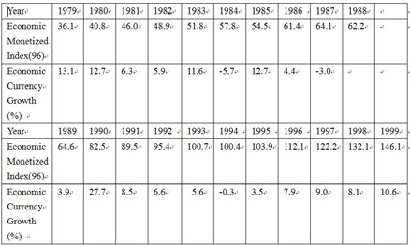

Source: established according to phases of “China Statistical Yearbook” and “1999 China Statistics Bulletin”.

From the calculated results, we see that along with the rapid development of the economy, Chinese economic monetized growth situation was very significant, in other words, currency relations as a form of economic relations has got a fair degree of deepening and generalization in our country.

M2 not only reflect the reality purchasing power, but also reflect the underlying purchasing power. We commonly use DM2 (generalized currency growth rate) to measure M2.

Another important content of economic growth is foreign trade. Foreign trade is the core of various countries’ foreign economic relations, which plays an irreplaceable role in the economic development of all countries. Import and export trade’s balance of payments of a country is the important part of current account in its international payments; it is also the significant factor which could affect countries’ balance of payments. Foreign trade multiplier theory of Keynesian economics suggests that exports produce double aggrandized effect to national income and output, and the imports produce double shrank effect to its national income. The scale of the trade balance would eventually affect the economic development in China, and then

influence the financial risk indirectly.

In addition to factors related to the economic growth, banking, estate and other factors might also have a lagging effect in financial risk. The expansion of the commercial banks’ credit would accumulate bigger risk, the impact of small financial crisis would make the centralized outbreak of the borrowers’ credit risk, it also could make the problems about the increasing uncertainty risk of estate market’s development completely exposed.

Meanwhile, the international oil price, the economic growth and the deposit interest margin that trading close with China will also have a certain effect in financial risk condition.

## Regional financial risk early-warning model

* 1. *Financial risk early-warning model analysis.*

Due to the factors that influence the financial risk have obvious lagging, we could first build up a general regression model with a lag dependent variable.

Considering about diffusivity of regional financial risk, so this paper we choose our comprehensive index of financial systemic risk, namely Financial Stress Index of China(CFSI in short),to be the explained variable in the financial risk early-warning model.

The first to propose the concept of financial stress and construct financial stress index is the economists Illing and Liu in Canadian Bank. According to the description of Illing and Liu (2003):”Financial stress is a continuous variable, its extremum is called financial crisis”. The financial stress will increase with the increase of expect financial loss, risk or uncertainty.

According to the lagging-influence factors of financial risk and referring to the literatures, the explanatory variables are eventually determined: CFSI lagging variables (AR (K)), GDP (GDP), GDP growth (DGDP), economic monetized degree (MRATE), broad money growth rate (DM2), balance of trade (TRADEBASA), the bank credit balance in our country(SODCSA), Chinese estate price index(HOUSEPINDEX), international crude oil prices rate(OIL), Japanese GDP growth rate(JPDGDP), the one-year deposit spreads between China and the United States(DR).

* 1. *The established of the financial risk early-warning model.*

According to the explanatory variables, the explained variables and the correlation between the indexes,

we optimize the regression model:

In formula (1), CFSIt-k represent CFSI lagging K issue, Xt-ki represent other explanatory lagging K issue. Through the stepwise regression analysis, using T-test, R2-test, DW test, AIC information judgment and others, choosing the best combination of variables and the optimal forecasting equation. The statistics test indexes in the equation are the best. In 5 percent of the significant level, all explanatory variables have passed the T-test; the goodness-of-fit of the equation is higher, R-squared and Adjusted R-squared are 0.970219 and 0.949745, parameter sequence is smooth. According to the results of the table below, we can get the following best prediction equation of the financial stress index:

*CFSIt*=38.65159+0.421267*AR*(4)+0.43508*DGDPt-*4+0.39413*HOUSEPINDEXt-*4-4.745299*OILt-4*

-0.001607*GDPt-4*-198.7936*MRt-4*-0.717549*DRt-4*+0.357039*DM2t-4*+0.004065*SODCSAt-4*

+0.066912*TRADEBASAt-6*-0.332322*JPDGDPt-8*•••••••••••••(3)

Table 2 The regression results of best prediction model in Chinese financial stress

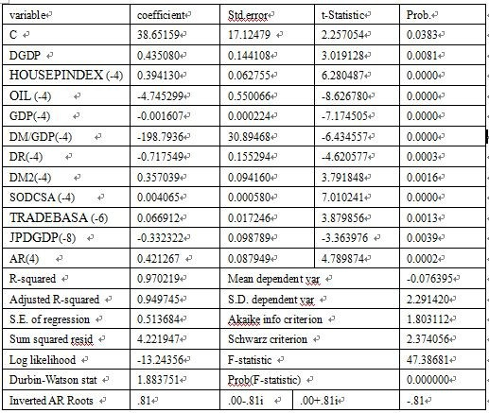

1. **Experimental analysis.**

Using the Eviews software, we can check out the actual value, prediction and residual of our financial stress exponent, and compare the relation between actual value and prediction of our financial stress exponent from 2004 to 2010, the table is below:

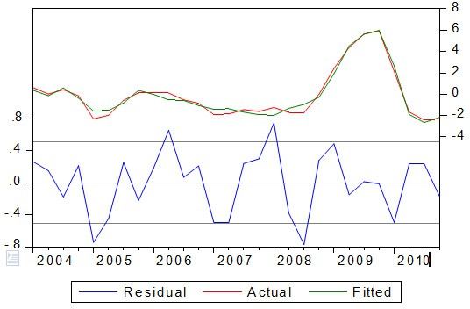

Figure 1 The actual value and predictive value of our financial pressure exponent

Figure 1 shows the relation between the actual value and predicitive value in our financial stress exponent from 2004 to 2010, seeing from the figure, the two values are highly anastomotic. Visibly,the accuracy of the prediction equation is quite satisfactory.

Through the search of literature, we can obtain the data of the explanatory variables in 2011, the following Table 3

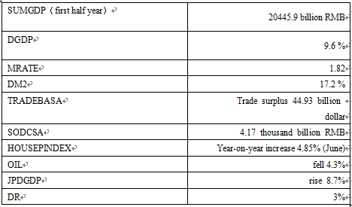

Attention: the data of 2011 is the first half year, the growth is also the year-on-year increase

Now we use the equation (3), taking the data above inside, and then forecast our financial stress in 2011.

The result is available:

Table 4: The Predicted value of CFSI in 2011

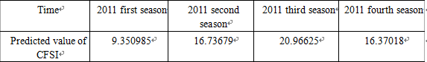

The result shows that in 2011, the financial stress exponents are all higher than the highest since 2002, namely the financial stress is greater than the four seasons in 2008. In the first three quarters in 2011, our financial stress exponents will keep growing, the third quarter will achieve the maximum 20.96625, and the financial stress will have the trend of decline since the last quarter of 2011. Table 4 shows that we use the equation (2) and get the four quarters’ predictive value of our financial stress exponents in 2011. Figure 2 reveal the trend of annual financial stress exponents’ prediction in our country.

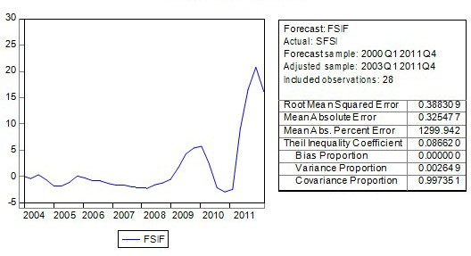

Figure 2: The trend of our financial stress exponents’ prediction

The regression result shows that the GDP growth, real estate price index, broad money growth, the credit balance, the balance of international trade will have positive influence in financial stress exponents, and the price of crude oil rate of change, SUMGDP, the ratio of broad money and GDP, the one-year deposit spreads between China and the United States and Japanese GDP growth will have negative influence. Due to the collinearity existed between the explanatory variables; the consistent of the explanatory variables may not correspond to the actual situation. But, the collinearity will not affect the explanatory variables as a general CFSI to the predictive result.

## Conclusion

On the basis of the research of Illing and Liu (2003), this paper ensure the measure index of financial risk by the financial stress exponents constructing by synchronization index of financial risk, confirm the explanatory variables the financial stress exponent itself and the economic and financial index having prescience, and then with the aid of empirical methods to construct the financial stress index early-warning model. The model shows that the explanatory variables lagging four quarters (there are two variables were lagging six quarters and eight quarters) can better fitting our financial pressure exponent trend. That is, according to the known current financial stress exponent and other value of explanatory variables, we can use the model to predict the financial stress exponents of the future four quarters.

Financial stress exponent CFSI can accurately measure our financial systemic risk; the corresponding explanatory variables can also be obtained timely and accurately. Indeed, the best prediction equations of the financial systemic risk or the financial systemic risk early- warning system is simple and easy to the financial systemic risk prediction, and has great practical value.

## Acknowledgments

This research is supported by National Natural Science Foundation of China (Grant No. 71071140), Technology Plan Project of Hangzhou(Grand No. 20102011A22) as well as Students Science and Technology Innovation project of Zhejiang GongShang University (NO.1130XJ1711228) and Modern business centre of Zhejiang GongShang University. We would like to thank the anonymous reviewers for their insightful comments and constructive suggestions provided during the review process, which have greatly contributed to improve the quality of the original manuscript.

## References

1. Lore M,BorKIovsky L.The professional’s handbook of financial risk management[M],London: Reed Educational and Profession—al Publishing Ltd,2000.
2. Balakrishnan,Danninger,Elekdag,and Tytell,2009.The Transmission of Financial Stress from Advanced to

Emerging Economies, IMF Working Paper. wp/2009/133.

1. Cardarelli,Roberto,Selim Elekdag,and Subir Lall , 2009,Financial Stress, Downturns,and Recoveries, forthcoming,IMF Working Paper. WP/09/100.
2. Demirgüç-Kunt, A. and E. Detragiache,1998, The Determinants of Banking Crises in Developing and Developed Countries., IMF Staff Papers, 45, 81-109.11
3. Frankel, J.A. and A.K.Rose,1996, Currency Crashes in Emerging Markets: An Empirical Treatment, Journal of International Economics, (41):351-366.
4. Hakkio and Keeton,2009 ,Financial stress:What Is It, How Can It Be Measured, and Why Does It Matter?, [www.KansasCityFed.org.](http://www.KansasCityFed.org/)
5. Kaminsky, G. and C. Reinhart,1999 , The twin crises: The causes of banking and balance-of-payments problems. American Economic Review, ( 89) :473-500.
6. Illing, M. and Y. Liu ,2003,An Index of Financial Stress for Canada, Bank of Canada Working Paper 2003-14, June 2003.