Available online at [www.sciencedirect.com](http://www.sciencedirect.com/)



AASRI Procedia 2 (2012) 156 – 162

AASRI

Procedia

[www.elsevier.com/locate/procedia](http://www.elsevier.com/locate/procedia)

2012 AASRI Conference on Power and Energy Systems

# The Smart Use of Biogas: Decision Support Tool

B.Abderezzaka,*, B.Khelidja, A.Kellacia, M.Tahar Abbesb

*aFima laboratory, Khemis Miliana 44225,Algeria*

*bUniversity of Chlef, Chlef 02000, Algeria*

Abstract

Waste-to-energy provides a solution for two problems: waste management and energy generation. Anaerobic digestion is a biological process, thereby valorizing organic matter, usually fatal, produce a renewable energy source and digestates that can be used as fertilizer. Indeed, in the absence of oxygen (anaerobic digestion) and protected from light, organic matter is partially degraded by the combined action of several types of micro-organisms, a series of biological reactions leading to the formation of biogas composed of Carbon Dioxide (CO2), Nitrogen N2, Hydrogen H2, Oxygen O2, Water vapor H2O, hydroxide sulfur H2S and the energy recoverable portion Methane CH4 but very harmful to the environment, or even 22 times more harmful than CO2 which is a greenhouse gas (GHG). Once this portion of recoverable biogas containing methane CH4 is produced or captured as much value it most effectively, however, different ways are possible: heat, power, Combined Heat & Power “CHP”, automotive fuel or the injection into the natural gas network. The purpose of this work is to develop an Excel-based spreadsheet and database program with visual basic that can help to find the optimal scenario to valorize this biogas; firstly this scenario must be based on technical criteria as well as the flow of raw biogas produced, quality and purity of biogas required for each scenario. Secondly, the economic criteria also play an important role (treatment and valorization costs). Finally, this scenario chosen must take into account social and environmental impacts.

© 2012 Published by Elsevier B.V. Selection and/or peer review under responsibility of American Applied Science Research Institute

© 2012 Published by Elsevier B.V. Selection and/or peer review under responsibility of American Applied Science Research Institute

© 2012 Published by Elsevier B.V.

Selection and/o[r peer review under](http://creativecommons.org/licenses/by-nc-nd/3.0/) responsibility of American Applied Science Research Institute

Open access under [CC BY-NC-ND license.](http://creativecommons.org/licenses/by-nc-nd/3.0/)

*Keywords:* Raw Biogas flow, Biogas valorization; technical – economical and environnemental studies; enriched biogas; biogas treatment modes; fossil CO2 emissions; Visual Basic; decision support tool; biogas flow; Heat Power and Biomethane selling prices.

* Corresponding author. Tel.: +213-0-668-026-833.

*E-mail address:* [bilal.abderezzak@hotmail.fr](mailto:bilal.abderezzak@hotmail.fr)

2212-6716 © 2012 Published by Elsevier B.V. Selection and/or peer review under responsibility of American Applied Science Research Institute

Open access under [CC BY-NC-ND license.](http://creativecommons.org/licenses/by-nc-nd/3.0/) doi:10.1016/j.aasri.2012.09.028

1. Introduction

The current use of fossil fuels is rapidly depleting the natural reserves. The natural formation of coal and oil however, it is a very slow process which takes ages. Therefore, a lot of research efforts are put into finding renewable fuels nowadays to replace fossil fuels. Renewable fuels are in balance with the environment and contribute to a far lesser extent to the greenhouse effect.

Nomenclature

PBT payback time on investment

Inv total investment cost in kilo euro (k€)

Rev total revenues from energy sales in kilo euro per annum (k€/annum) Co total operation costs in (k€/annum)

GHG greenhouse gas

1. molar fraction of methane
2. molar fraction of carbon dioxide
   1. *Energy generation from biogas*

Biogas is a renewable fuel and an energy source that can be applied in many different settings. It is defined as a combustible gas mixture produced by the anaerobic fermentation of biomass by bacteria and takes several days to form. In nature, the fermentation process occurs in places where biological material is fermented in an oxygen deprived environment such as swamps.

The main sources of biogas from human activities are domestic garbage landfills, fermentation of manure and raw sewage. The advantage of processing these waste products anaerobically, compared with aerobically, is the larger decrease in volume of wastes. For this reason, the industry nowadays prefers anaerobic fermentation to process waste streams.

Biogas mainly consists of combustible methane (CH4) and non-combustible carbon dioxide (CO2). Besides CH4 and CO2, biogas also contains small amounts of hydrogen sulfide (H2S) and some other pollutants. The composition of biogas strongly depends on its source. Table 1 shows the composition of biogas from various sources, C.Aubry, 2010. It can be seen that biogas from a garbage landfill also contains some nitrogen (N2). CH4 combusts very cleanly with hardly any soot particles or other pollutants, making it a clean fuel. But CO2, the non-combustible part of the biogas, lowers the calorific value of the biogas. Biogas containing 55% CH4 has a calorific value of 21.5 MJ/Nm3 while pure CH4 has a calorific value of 35.8 MJ/Nm3 this is the reason to remove CO2 from raw biogas, J. D. Murphy et al., 2004 and J.C.Verchin et al.2010.

Table 1 Biogas composition from various sources

|  |  |  |  |  |
| --- | --- | --- | --- | --- |
| Biogas sources | CH4 (%) | CO2 (%) | H2S (%) | Si (mg/Nm3) |
| Garbage | 55 to 60 | 40 to 45 | 0 to 0.5 | 0 to 50 |
| Urban sewage sludge | 60 to 65 | 35 to 40 | 0 to 1 | 0 to 20 |
| Industrial effluents | 55 to 75 | 25 to 45 | 0 to 1 | 0 |
| Agro – food wastes | 60 to 70 | 30 to 40 | 0 to 0.5 | 0 |
| Agricultural waste | 50 to 55 | 45 to 50 | 0 to 1 | 0 |
| Landfills gas | 40 to 50 | 25 to 40 | 0 to 0.5 | 0 to 50 |

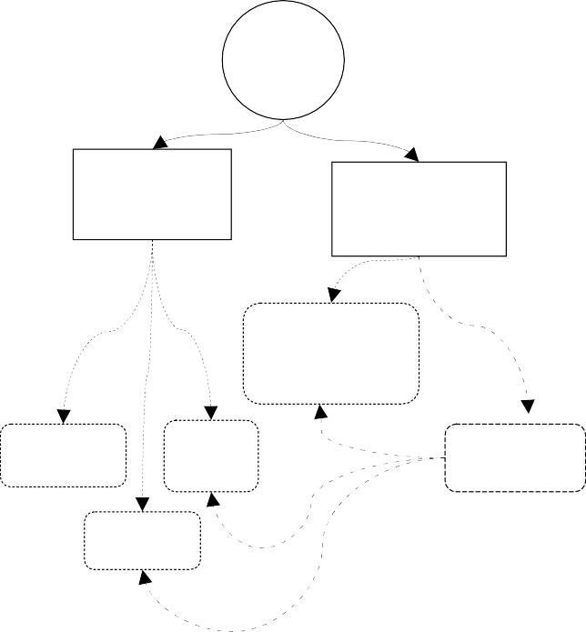

gas Flow

% CH

4

Raw gas

Inv Co GHG

+

Inv Co GHG

X

+

Inv Co GHG

PBT

GHG

Valorisation ex situ when the need of heat or fuel is distant from the production plant

Heat

Injection

CHP

Electricit y

Bio methane Fuel

Valorization in situ

Treatment

« Advanced »

Treatment

« normal »

Raw biogas

Revenues

Energy sales tariff

Energy delivery

Heat Power

Biomethane

Valorization

Treatment

* 1. *Aim of the work*

In favor of sustainable development engagement in many countries, many research programs were born under this topic. The FIMA laboratory in Algeria has decided to lunch an initiative research on the biogas valorization ways. The aim of this work is to develop and test a decision support tool to predict the best way to use biogas, this tool is called “Smart Biogas Decision Support tool, SBDS tool”.

* 1. *Envisaged scenarios*

Different scenario were envisaged, in fact we can use biogas for the production of heat, electricity, combined heat and power “CHP”, automotive fuel and the injection into the natural gas network. Fig.1. presents the summary of the biogas treatment and valorization , C.Aubry, 2010.

Fig. 1 Biogas treatment and valorization Fig. 2 Biogas calculation levels

1. Methodology
   1. *Integrated scenarios analysis criteria*

The used method considers two main indicators to compare the integrated scenarios, the first may be defined as the result of a technical economic balance, while the second is obtained by the stoechiometric biogas combustion, and it is respectively the PBT and the avoided emissions of carbon dioxide, (CO2). Equation (1) presents the PBT relation, P. Morin et al. 2010:

(1)

The value of the Inv represents the sum of all eventual investments during the treatment, valorization and energy delivery processes; the Co value must include also insurance, human resources, maintenance, external energy and chemicals, E. Wusterhaus, 2010. Fig.2 illustrates the calculation key levels. The combustion of

biogas give a biogenic CO2 which continue its natural cycle, 1 kg of biogas give  kg of biogenic CO2.

* 1. *The SBDS tool principle*

The integrated scenarios are compared based on economic, energetic and environmental criteria. The “SBDS tool” is an Excel-based spreadsheet and database program that calculates the pay back times on investment and CO2 avoided emissions. SBDS tool provides extensive technical and economic information about integrated processes, from the incoming raw biogas to the final use of the energy. The investment, operation, and maintenance costs are estimated for each unit necessary for the process. Each scenario requires three mainly steps presented in Fig.3.

The integrated scenario start by introducing the flow of raw gas, and its quality regarding CH4, CO2 and H2S content, this is the first step. The second step is the role of SBDS to make all calculations regarding the four different levels to obtain the PBT and the CO2 avoided emissions. Those four levels are: biogas treatment, treated biogas valorization, energy generated and finally the energy delivery. Normally we can have two kinds of energy recovered from biogas valorization: heat and power, Technical document, 2006. But we can add a fourth level which is the kind of energy delivered into the natural gas network called bio-methane. The final step is the data output and their graphical representations.

1. The SBDS tool test

We have proposed to take an example of a digester which work under mesophilic conditions (35°c), the input wastes are manure, slurry and agricultural waste, the daily raw gas flow is about 3000 Nm3/day or 125 Nm3 / h, we have proposed for this simulation the values of 45 €/MWh for thermal energy selling price, and 100 €/MWh of primary energy for biomethane. The amount of 24 k€/annum was defined as the annual human resources salary. The values of these data will be discussed in the following section.

* 1. *Results and discussion*

Figures 4 (a) and 4 (b) were obtained with SBDS tool with the same input data considerations, they highlights the relationship between the raw gas flow and the energy delivery distance on the investment payback time.

For scenario “Heat”, there is no profitable payback time if the raw gas flow is under 40 Nm3/h and it is about 10 years, if we take the example of 125 Nm3/h, the PBT is about 1,76 years with 1000 meter of thermal energy network according to graphic in Fig. 4 (b), if the distance is about 1000 meter, the PBT will be 3,75 years. The profitable case to make heat valorization is depending on the flow and also on the thermal energy delivery distance, a raw gas flow between 50 and 70 Nm3/h can get a reasonable PBT between 4 and 6 years with 1000 m of grid distance.

For scenario “Power”, the payback time is about 5 years with 125 Nm3/h of raw gas; we can observe the stability in Fig. 4 (b) which means that there is no relationship between the PBT and the distance because the electricity delivery does not depend on the pipelines energy grid. However, the profitable PBT between 4 and 6 years with a range of raw gas flow from 80 to 130 Nm3/h.

There is no profitable payback time under 50 Nm3/h for “CHP” scenario with a distance of 1000 meters, the payback time will be between 6 and 4 years with a range of raw gas flow from 70 to 90 Nm3/h and with no longer than 3200 m of energy delivery grid.



Step 1 : Data in put

Raw gas CH4

flow content

CO2

content

H2S

content

Hrs per annum

Power range

Step 2 : Data analysis & calculation

Step 3 : Data out put

Biomethane (Injection Scenario)

Biomethane (Fuel Scenario)

Pay back times PBT

Financial Surplus

Cogenerator (CHP Scenario)

Treated biogas flow

Net revenue

Gas engine (Electricity Scenario)

Boiler

(Heat Scenario)

Biogas upgrading plant

CO2

emissions

Energy sold

Distance in meter

Fig. 3: SBDS tool key steps

For scenario “Fuel and Injection”, a payback time between 4 and 6 years can be obtained with a range of raw gas flow from 70 to 90 Nm3/h and with no longer than 5000 m of biomethane network.

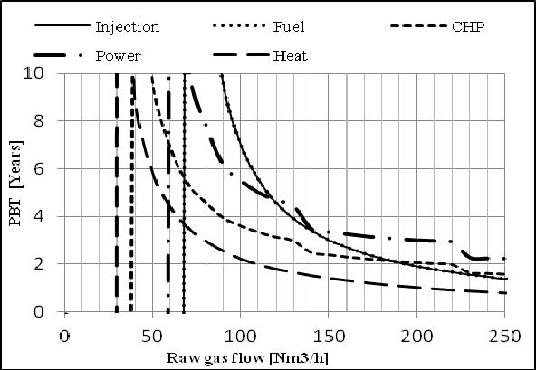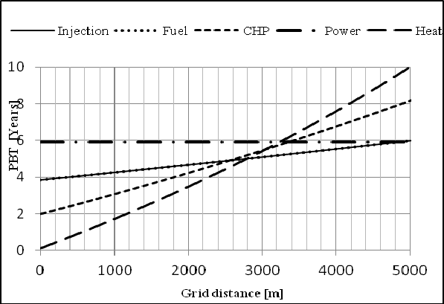

Fig.4 (a) Relationship between PBT & the raw gas flow (b) Relationship between PBT & the grid distance

1. Conclusions

SBDS tool, an Excel-based spreadsheet and database program was developed to calculates the investment and capital costs for biogas upgrading plants, valorization machine (Boiler and CHP motor) and it can determine the PBT on investment and estimate the GHG reduction for each investigated scenario. This tool was used to conduct the present study; variations in the input data gave different economic, energetic and environmental performances.

It is possible for a biogas production plant producing at least 50 Nm3/h to make a heat valorization, a profitable PBT of 1,76 years was obtained with 125 Nm3/h; the delivery network plays an important role in the PBT determination, so a profitable one is obtained for less than 800 meter of thermal energy distribution network.

The “Power” scenario has a reasonable PBT of 5,5 years with a raw gas flow of 100 Nm3/h even the thermal energy is not sold. The addition of thermal energy generation increase the revenues and makes a very favorable way of the biogas valorization, it has the PBT of 3 years even the distance of the thermal energy network is less than 1000 meters and with the condition that 100 % of the produced electricity and 100% of thermal energy are sold. Furthermore, the electricity obligation purchase makes very interesting to invest into power generation with biogas especially when the selling price is about 140 €/MWh.

The injection of biomethane into the natural gas grid is the favorable way to use biogas in a French context with an estimation of the selling price at 100 € / MWh, despite the high investment and running costs of the biogas upgrading plant (BUP), but it has the shortest PBT, and it avoid the maximum emission with 1521 ton of CO2. The “Fuel” scenario has the same results with the “Injection” one because we considered that biomethane must be put into natural gas grid before selling it in the filling stations.The results obtained in this study could be generalized for each case of biogas valorization; a new database will be available once the new fees of the selling price will be ready.

Acknowledgment

This study was carried out as a part of the biogas initiative research project in our FIMA laboratory in Algeria, the authors would like to thanks Mr WUSTERHAUS Eberhart from Schmack Carbotech Gmbh.

References

1. C.Aubry. Qualité du biométhane pour l'injection dans le réseau de distribution. Colloque traitements du Biogaz. ATEE Paris, 12 & 13 October 2010 ; pp1.
2. J. D. Murphy, E.Mc Keogh. Technical/economic/environmental analysis of biogas utilization. Applied Energy 77 (2004); pp 407 – 427.
3. J.C.Verchin, C. Marchais. Biogaz et methanisation en France : Etat des lieux. Association technique énergie environnement. Gaz d'aujourd'hui revue n°5, June 2010 ; pp. 2.
4. E. Wusterhaus, “Biogas upgrading process. Carbotech Viessmann group, Colloque traitements du Biogaz. ATEE Paris. October 2010.
5. P. Morin, B. Marcos, C. Moresoli, Claude.B. Laflamme. Economic and environmental assessment for on the energetic valorization of organic material for a municipality in quebec,Canada. Applied Energy 78(2010) ; pp 275 – 283.
6. Technical document.Power genration from biogas with jenbacher gas engines. Clarke Energy. , 2006.