[Array 14 (2022) 100178](https://doi.org/10.1016/j.array.2022.100178)



Contents lists available at [ScienceDirect](http://www.elsevier.com/locate/array)

Array

journal homepage: [www.elsevier.com/locate/array](http://www.elsevier.com/locate/array)

The evolving roles and impacts of 5G enabled technologies in healthcare: The world epidemic COVID-19 issues

Md Mijanur Rahman a,∗, Fatema Khatun b, Sadia Islam Sami a, Ashik Uzzaman a

a *Department of Computer Science and Engineering, Jatiya Kabi Kazi Nazrul Islam University, Trishal, Mymensingh 2224, Bangladesh*

b *Department of Electrical and Electronic Engineering, Bangabandhu Sheikh Mujibur Rahman Science and Technology University, Gopalganj 8100, Bangladesh*

A R T I C L E I N F O A B S T R A C T

*Keywords:*

5G technology COVID-19 pandemic

eHealth and mHealth platforms Internet of medical things (IoMT) Telemedicine and online consultation Unmanned autonomous systems (UAS)

The latest 5G technology is being introduced the Internet of Things (IoT) Era. The study aims to focus the 5G technology and the current healthcare challenges as well as to highlight 5G based solutions that can handle the COVID-19 issues in different arenas. This paper provides a comprehensive review of 5G technology with the integration of other digital technologies (like AI and machine learning, IoT objects, big data analytics, cloud computing, robotic technology, and other digital platforms) in emerging healthcare applications. From the literature, it is clear that the promising aspects of 5G (such as super-high speed, high throughput, low latency) have a prospect in healthcare advancement. Now healthcare is being adopted 5G- based technologies to aid improved health services, more effective medical research, enhanced quality of life, better experiences of medical professionals and patients in anywhere–anytime. This paper emphasizes the evolving roles of 5G technology for handling the epidemiological challenges. The study also discusses various technological challenges and prospective for developing 5G powered healthcare solutions. Further works will incorporate more studies on how to expand 5G-based digital society as well as to resolve the issues of safety–security–privacy and availability–accessibility–integrity in future health crises.

# Introduction

The latest wireless mobile phone technology, Fifth Generation (5G), was first widely deployed in 2019. While 5G network is at developing stage, some countries including China, South Korea, the UK and the US commercially deployed 5G networks, and some other developed countries are being expecting to put forward commercial 5G networks by 2025 [1]. Comparing to the existing wireless networks, 5G provides high data rate, lower latency, high volume of devices connectivity with energy efficiency, high reliability and mobility support [2]. Thus, the services offered by 5G mobile networks are generally categorized into three group, namely (i) ‘‘enhanced mobile broadband (eMBB)’’,

(ii) ‘‘ultra-reliable low latency communications (URLLC)’’, and (iii) ‘‘massive machine-type communications (mMTC)’’ [3]. In 2019, 67% of the world people have subscribed to cellar devices, of which 65% have used smart phones [4], and 204 billion apps have been downloaded [5]. About 3.8 billion public have eagerly used social media reported in January 2020 [6]. As the number of digital devices connectivity with 5G is dramatically increasing, the extent of variation in exposure to radiofrequency arenas is still under investigation.

In the meantime, the globe is now facing a public health disaster caused by the novel ‘‘coronavirus disease (COVID-19)’’ [7]. China has first identified the virus in December 2019 [8], and many scientists investigated the genetic code of the COVID-19 [9] as well as trying to combat the coronavirus pandemic health emergency. But the COVID- 19 outbreak is deadly affected 219 countries and territories with more than 2.8 million deaths and about 132 millions infected cases in the globe, reported on April 05, 2021 [10,11]. As 50 cities in China first commercially deployed 5G wireless networks in October 2019, many people trying to claim the 5G-coronavirus connectivity theory. The pioneer of 5G technology is South Korea and they first offered com- mercial 5G with mobile hotspot in December 2018 [12]. But the novel coronavirus not get its first start in South Korea, and many countries without having 5G networks, such as Malaysia, India, Bangladesh, Iran, France, Singapore and Nigeria, etc., have been seriously affected by the virus. Thus, it is false claim of the 5G-coronavirus theory, and the novel coronavirus having nothing to do with 5G as well as there is no scientific evidence [13–15]. Several studies have been done and stated that 5G related telecommunications systems do not affect the human immune system [16].

∗ Corresponding author.

*E-mail addresses:* [mijan@jkkniu.edu.bd](mailto:mijan@jkkniu.edu.bd) (M.M. Rahman), [fatema_aece@yahoo.com](mailto:fatema_aece@yahoo.com) (F. Khatun), [samis6077@gmail.com](mailto:samis6077@gmail.com) (S.I. Sami), [ashikurzaman23@gmail.com](mailto:ashikurzaman23@gmail.com) (A. Uzzaman).

<https://doi.org/10.1016/j.array.2022.100178> Received 4 March 2022; Accepted 25 April 2022

Available online 10 May 2022

2590-0056/© 2022 The Author(s). Published by Elsevier Inc. This is an open access article under the CC BY license (<http://creativecommons.org/licenses/by/4.0/>).

**Table 1**

Key sectors in which 5G technology has the potential impacts to handle the epidemiological challenges. 5G applications to assist the COVID-19 impacted sectors

|  |  |  |  |  |
| --- | --- | --- | --- | --- |
| Healthcare [17] | Education [18] | Transportation [19] | Industry [20] | Agriculture [21] |
| Telemedicine, Remote surgery, | Online class, Remote, | Smart transport, Autonomous | Smart manufacturing, Industrial | Smart agriculture, Smart |
| Remote health monitoring, mHealth, Wearables, etc. | assessment, Remote conferencing, Distance learning, etc. | vehicles, Intelligent maps, etc. | Internet, Robot-control process, Remote supply and delivery, etc. | irrigation, Remote crop monitoring, Farm data acquisition, etc. |

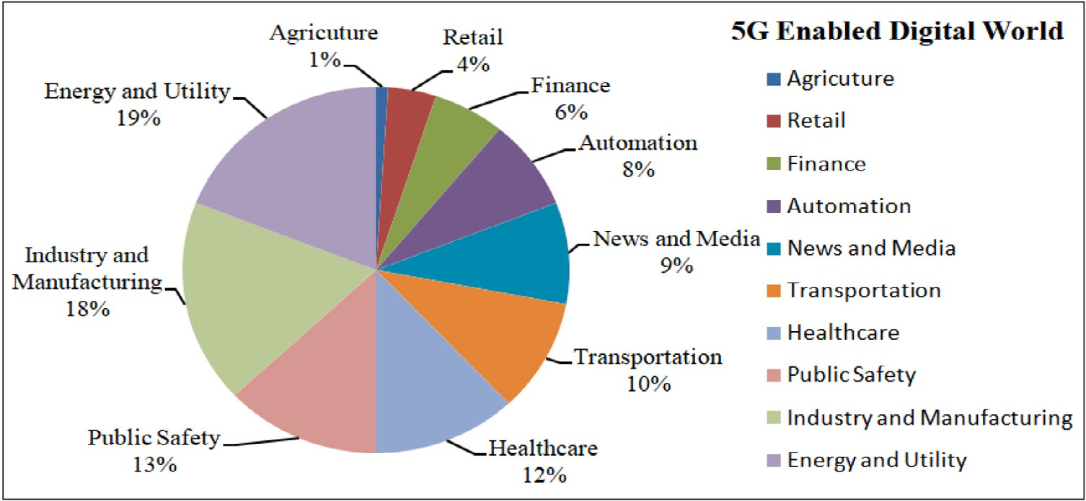

**/ig. 1.** Sectors that win the most from 5G technology [24].

**Table 2**

Impacts of 5G enabled digital technologies in healthcare.

5G enabled digital technologies in confronting the COVID-19 pandemic

|  |  |  |  |  |
| --- | --- | --- | --- | --- |
| AI [33] | IoT [22] | Big data [34] and Cloud computing [35] | Robots and Robotic technology [36] | AR and VR [37] |
| Analyzing real-time health data | Rapidly expanding the number | Allowing more data to be | Deploying to limit human | Deploying new consumer |
| and improving diagnosis | of connected devices and | transmitted quickly and more | resources, to relieve pressure, | devices that support more |
| procedures | providing a diversity of  healthcare solutions | reliably to the cloud | and support effective care | advanced AR and VR apps |

Moreover, 5G technology is anticipated to connect billions of de- vices with improved performance, and 5G supported applications have the potential to deliver transformative impacts in various sectors (see Table 1), such as healthcare, education, resource management, trans- portation, agriculture, etc. to handle the challenges caused the COVID- 19 pandemic [22,23]. It is estimated that 5G enabled digital market revenues will be USD 1.3 trillion by 2026, and sectors that use most 5G technology is shown in Fig. 1 [24]. Since 2020 the world is the COVID-19 related health crisis, the 5G combined with other advanced digital technologies (see Table 2) can support to tackle the coron- avirus challenges in healthcare [25]. These digital technologies includ- ing the ‘‘internet of things (IoT)’’ [26,27], ‘‘big-data analytics’’ [28], ‘‘artificial intelligence (AI)’’ that uses ‘‘machine learning’’ and ‘‘deep learning’’ [29,30], and ‘‘blockchain technology’’ [31], are highly inter- related and will be more effective with 5G technology in healthcare applications. This innovative 5G technology will transform together speedy connectivity, cloud-based storage, billions of smart devices, and enhanced medical services in healthcare sector. Thus, 5G will transform the healthcare sector and enable more than USD 1.1 trillion in economic output in 2035 [32].

The 5G enabled digital technology can aid more effective medi- cal research, diagnose and treatment, as well as improved healthcare services for both medical professionals and patients in anywhere– anytime [38]. Fig. 2 illustrates a simple 5G based health platform that assists both the patients and the medical professionals [39]. Since 5G promises super-speed (about 100Mbs) with high data bandwidth and low latency, AI like advanced technologies implemented in 5G networks can enable an intelligent and autonomous functionality to

limit the COVID-19 epidemic [40,41]. The IHS Market Ltd has reported that 5G will facilitate more than USD 1.0 trillion in products and services in the worldwide healthcare by 2020 [42]. Also, about 50 billion smart devices and about 212 billion sensors are expected to be supported by the 5G network [43,44]. These health devices, medical wearables, and remote sensors in 5G networks have effective contribu- tion in healthcare to support the health emergency issues caused by the COVID-19 epidemic [45]. Now healthcare is being adopted 5G enabled developing technologies that can assist in health services, improving quality of life, better medical stuffs and patient experiences [46]. It also support the faster transmission of large volume of health data or medical reports [17]. 5G enabled telemedicine is an emerging health service, and it expected that the growth of this market will reach at a ‘‘compound annual growth rate (CAGR)’’ of 16.5% until 2023 [47–49].

The usage of 5G enabled technologies is expanding rapidly with its potential impacts in many fields, and it provides a real-time services more than our expectation [50]. The aim of this study is to focus the 5G technology and current healthcare issues as well as to highlight 5G based solutions that can handle the COVID-19 issues in different arenas. This paper emphasizes the evolving roles of 5G enabled technologies, like AI and machine learning, IoT objects, big data analytics, cloud computing and other digital platforms in emerging applications for han- dling the current epidemiological challenges. Besides a comprehensive review of 5G enable technologies to combat the coronavirus outbreak, the study discusses various technological and healthcare challenges as well as prospective for developing 5G powered healthcare solutions.

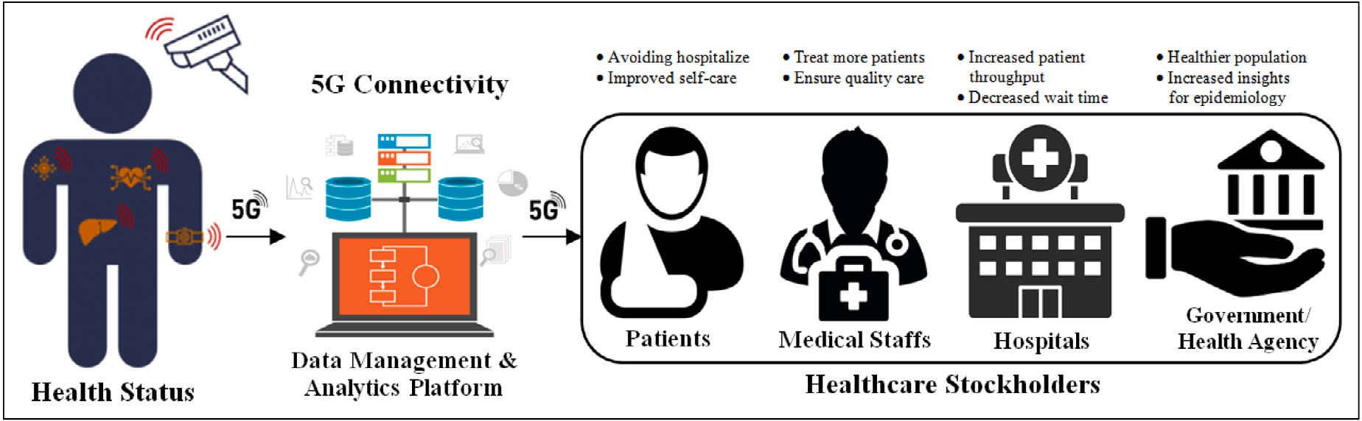

**/ig. 2.** A simple 5G based health platform for remote patient monitoring and treatment [39].

# Background

* 1. *5G-coronavirus false theory*

Each generation of wireless network standard has introduced a new era of telecommunication, and offered improved data-flow capability and latency. The mobile network just began with first generation (1G) in 1980s, 2G represented the digital transmission in 1991, 3G introduced the mobile telephony world in 2000s, 4G introduced the Streaming Era in 2009, and the latest 5G technology is being introduced the Internet of Things Era [51]. But it was asserted that 3G was deployed in 2003 as the year of the SARS epidemic, 4G was first established in 2009 as the year of the swine flu pandemic, and finally, 5G network was introduced in 2019 that is the year of the COVID-19 outbreak [13,52]. But the truth is that 3G was first unrolled in Japan in 2001 and Japan was not affected at that time. According to the ‘‘World Health Organization (WHO)’’ reports, in 2002 the SARS outbreak began in China before unrolling 3G. In late 2009, 4G network first launched in Sweden and Norway [53]. The Swine flu evolved by the H1N1 influenza virus that was first identified in April 2009 in Mexico and the United States before 4G deployment [54,55]. The first COVID-19 case was identified in China on December 31, 2019, and the coronavirus has rapidly spread around the world in 2020. But 5G was first launched in South Korea on December 1, 2018 [56]. The emerged date of 5G- coronavirus matching is coincidence. Many countries without having 5G networks have seriously affected by the coronavirus [57–59]. Al- though 3G, 4G and 5G networks were unrolled at the same years to the SARS, H1N1 influenza virus and novel coronavirus outbreaks, the WHO reported that is no scientific study could link between the wireless technology and the virus outbreak [60].

* 1. *Impact of the COVID-19 epidemic*

The world is still now a health emergency situation due to the COVID-19 caused by the novel coronavirus, which was provisionally named ‘‘2019 novel coronavirus (2019-nCoV)’’ by the WHO in Decem- ber 2019. Several studies showed that the 2019-nCoV is considered a new human-infecting betacoronavirus [61], and allied with mild clin- ical symptoms of (i) ‘‘severe acute respiratory syndrome (SARS) coro- navirus (SARS-CoV)’’ [62], a novel betacoronavirus that first emerged in China in 2002 [63,64], and (ii) ‘‘middle east respiratory syndrome (MERS) coronavirus (MERS-CoV)’’, was first identified in Saudi Arabia in 2012 [65]. Till now (April 5, 2021) the 2019-nCoV has been reported in 219 countries with 132 millions confirmed cases of ‘‘human-to- human transmission’’ [66]. The outbreak of COVID-19 declared as a pandemic that affected our socio-economic environments and all the sectors of healthcare, tourism and hospitality, education, aviation and transportation, manufacturing and distribution, agriculture and supply chain, electronics and energy, financial markets, etc. It was estimated

that the worldwide economy shrink by about 3% due to the COVID-19 pandemic [67]. Some of the COVID-19 affected sectors are highlighted below:

1. **Healthcare:** The number of COVID-19 cases is increasing day by day and this deadly disease cruelly affected the healthcare that leads shortage of healthcare facilities and skilled professionals, insufficient accommodation and hospitality, limited testing kits, ‘‘personal protective equipment (PPE)’’, medications, ventilators, ICUs, etc.[68]. Due to the pressure of the coronavirus cases and limited medical facilities, other non-COVID-19 patient’s treat- ments have been disrupted in hospitals [69]. Also, the medical services and treatment bills have suddenly increased in most of the countries to fight the healthcare challenges.
2. **Education:** The pandemic severely affected on-site academic activities, and about 153 countries around the world have closed their educational institutes. It affected about 1.2 billion students learning carriers, reported on May 2020 [70]. Due to the closing of universities, millions of international students left foreign countries that caused negative impacts on education.
3. **Tour and Travel:** Due to the enforcing of lockdown and ‘‘move- ment control order (MCO)’’, tours and travel are the most badly affected sectors [71]. Reducing the employment, losing jobs and the cancellation of flights have led to billion-dollar loss of the related industries [72].
4. **Industry:** The stuffs and workers in the manufacturing industries cannot work remotely, and many of the small industries are being stopped their operations due to this pandemic [73]. It is often difficult to implement standards of hygiene and social distancing rules in the industrialized jobs and areas.
5. **Agriculture and /ood Supply Chain:** Due to the restrictions on many sectors (like restaurants and hospitality industry) and the reducing of demand, the food supply chains have been disrupted in this pandemic [74]. Especially in poor and develop- ing countries where food preservation facilities are insufficient, farmers are suffering the loss of income and it turned serious impacts on agricultural economy by affecting the areas of food production and supply, livestock production, farmers’ income and employment, sales and trade [75].
6. **Online Platforms and Communication Networks:** As most of the countries in the world are imposing lockdown, the normal operations have disrupted and people working from home using online platforms. The utilization of communication networks is increasing significantly. It is reported that the Internet traffic is increased more than 25% on the typical usage [76]. Ta- ble 3 highlights the impacts of the coronavirus pandemic on the existing mobile networks [23].

Thus, the above impacts of the coronavirus outbreak are now af- fecting the global economy. During this pandemic, losing jobs and decreasing income, restrictions on movement, goods and services have been declined in our social life and normal activities.

**Table 3**

Impacts of the pandemic on the existing wireless networks.

Impact of COVID-19 on the usage of telecommunication networks

|  |  |  |  |  |
| --- | --- | --- | --- | --- |
| Capacity limitation [77] | Service disruption [78] | Energy wastage [79] | Cell outages [23] | Rural-connectivity limitation [80] |
| Increasing network dependency | Increasing demand for high | Increasing number of | Reducing the number of on-site | Limiting in deployment of |
| by many sectors, Surging traffic | mobility support, Poor support | underutilized base station due to | workers, Attack on telecom | network, Erratic electricity |
| demand and demand shift to | for high mobility broadband | shifting traffic demand, Lack of | engineers on-site, Damage to | supply, Low profit compared to |
| residential areas | services, Need for health | autonomous base station | base station equipment | investment |
|  | services | switching mechanisms |  |  |

* 1. *Current healthcare system*

The existing healthcare system is facing a number of challenges and problems. Major global challenges include lack of healthcare services and facilities, lack of digital resources and limited access, lack of quality treatment and high costs, lack of digital devices and systems, etc. [17,81].

1. **Challenges with EHRs and Universal Access:** The ‘‘Electronic Health Record (EHR)’’ stores patient’s health information elec- tronically that can be shared securely with multiple users to provide quality service in integrated health from anywhere in the world [82,83]. The main problem in the existing system is that hospitals and medical staffs are not connected to the EHR system, and thus, the patients‘‘ô record is constrained within clinics and laboratories. In poor and developing countries, the deployment of universal healthcare system is very challenging due to several reasons such as limited medical equipment and resources, lack of skilled professionals, as well as poor people unable to afford medical services [84,85].
2. **Limited Resources and Healthcare /acilities:** Many countries are now suffering the insufficient medical services in fighting the COVID-19 outbreak due to shortage of hospitals and ac- commodation, insufficient healthcare supplies and medications, shortage of skilled staffs and digital systems. About 57 countries are seriously facing the shortage of medical professionals [84, 86], and it is estimated that the world will have a lack of

12.9 million healthcare staffs by 2035 [87]. Thus, it requires the deploying of telemedicine and e-Heath services to support medical staffs as well as patients.

1. **Challenges in Health Information Systems:** As the existing healthcare is suffering troubles in universal health information systems, the development of ‘‘information communications tech- nology (ICT)’’ tools will have a great transformation in the whole healthcare system. It can connect multiple medical devices and equipment, process heterogeneous health data, optimum allo- cate available resources, automate financial transactions and management to provide efficient healthcare services, like remote surgery, wellness monitoring applications, etc. [88,89].
2. **Lacks in Developing Intelligent Healthcare Solutions:** The existing healthcare is suffering for poor data-driven practices in patients assessment in which both patients and staffs are restricted to utilize proper medication procedure and digital de- vices [90]. It sometimes causes over-or under-estimated effects of undesirable drug reaction. The development of intelligent healthcare solutions can provide the best care to the patients as well as to ensure safe and quality services.
   1. *5G technology and health issues*

5G follows the advancement of 2G, 3G and 4G wireless network standards [91,92]. 2G was suitable for calls and text-messages with very-low speed. Beside calls and messaging, 3G also supported data and the Internet services with the speed over 5 Mbps. The existing 4G network supports faster connectivity with the speed over 10 Mbps,

and allows multiple connections of digital devices. The latest 5G tech- nology is expected to have three major features over the existing 4G network [93], such as (i) super-fast connections and speeds (about 10 to 20 Gbps data upload/download speed), (ii) large capacity of users and devices connectivity (up to 1 million devices per square-kilometer), and

(iii) very-low latency or very-fast responsiveness (about 1 mSec). Vari- ous technologies, such as ‘‘Device-to-Device (D2D) communications’’, IoT, ‘‘Massive Multiple Input-Multiple-Output (MIMO)’’, ‘‘millimetre- wave communications’’, full-duplex transmissions, ‘‘Unmanned Aerial Vehicles (UAV)’’ and drone communications are utilizing 5G networks to provide coverage in urban and rural areas [94]. Healthcare, smart- cities, transportation and manufacturing are the major application areas, in which 5G has the potential to offer the more designated services and advanced applications.

The US, China, Japan and South Korea are the leading countries in 5G deployment and development [95], where 5G home-services and some big applications have been developing in many cities [92]. South Korea has demonstrated 5G technology in February 2018 Winter Olympics. They have been rising their 5G networks and expected 5G deployment all over the country by 2022–2023. China has launched commercial 5G networks in 2019, and is expanding 5G communication as its ‘Made in China 2025’ plan in research and development strategies. Japan has launched a commercial 5G network in 2020. Austria, Spain, Switzerland, and some other European countries have been launched 5G services and planned to expand the networks. It is expected that the 5G cloud will cover one-third of the world population with about

1.8 billion connections by 2025 [22,96].

5G is a radiofrequency (RF) based technology that uses electro- magnetic spectrum (same as 4G spectrum) to transmit information involving radiations (the emission of energy) [97]. Radiation is charac- terized by the levels of power on the ‘‘electromagnetic fields (EMF)’’, and separated into two groups, such as ionizing (or higher frequency radiation) and non-ionizing (or lower frequency radiation) [98,99]. Ionizing radiation includes UV-rays, X-rays and gamma-rays, and the excess energy emitted from this radiation damages cells (i.e., breaks the chemical bonds in DNA) and causes cancer. 5G involves non- ionizing radiation (microwave and millimeter wavelength radiation), and this radiation does not emit enough energy that directly damages cells [100].

The WHO deployed an international project on EMF in 1996 [101], and the project investigated the health impacts of exposure to fre- quency radiations in the range of 0 to 300 GHz [102]. Most of the study did not find a link between RF signals from cellular towers or phones and diseases. From some investigations in 2011, the WHO said the radiation from cellular might cause some brain cancers [103]. But radiation does not cause a virus. The international radiation watchdogs,

the `‘IEEE (Institute of Electrical and Electronics Engineers)’’ and the

‘‘ICNIRP (International Commission on Non-Ionizing Radiation Protec- tion)’’ [99] have been conducted the research to set safety guidelines for the usage of 5G frequency, and they confirmed that the frequencies at which 5G will be deployed will be safe for human [97,104,105]. Moreover, the WHO is conducting a study on the health impacts of exposure to RFs covering 5G. They will analyze technical facts related to health risks from 5G radiation, and publish the review report by 2022 [106].

* 1. *5G healthcare opportunities*

5G connectivity is improving the healthcare services in different ways [17] by enabling home healthcare, digitizing pathological anal- ysis, handling patients’ information files, enabling remote surgery and medications, enabling healthcare training and therapeutic, enabling secure staff–patient communication and management, etc. [107,108]. The promising aspects of 5G will also have the strength in the future of medicine and treatment advancement [109], and the utilization of advanced technology in healthcare has been reviewed in several studies [110–113]. A few aspects of the newly commercialized 5G tech- nology relevant to healthcare services, that have potential influences in limiting the COVID-19 pandemic, are highlighted below.

1. **In-home Healthcare Services:** Due to limited number of hospi- tals, high costs and long waiting in the pandemic, the patients want to be treated at home, if they are not seriously affected. 5G is helping to improve the home healthcare services, like online health consultancy, remote health monitoring via digital devices over a secured 5G mobile network.
2. **Digital Pathological Analysis:** 5G is being supporting to de- velop smart hospitals by improving digital pathology and di- agnosis. The healthcare has already experienced the 5G pow- ered computed tomography (CT) scanning remotely in real time [114]. The medical specialists will be able to utilize 5G net- works to access the large volume of health data obtained during diagnosis or surgery from anywhere in any time.
3. **Remote Surgery and Medications:** The promising features of 5G will revolutionize on online treatments and surgery. The 5G healthcare innovations include telemedicine, tele-surgery or robotic-surgery, remotely emergency care, etc. The 5G based telemedicine provides a remote consultation platform, in which the health professionals can treat the patients effectively. The tele-surgery provides a real-time operation, and the surgeons can perform remote surgery using surgical devices through 5G networks [115]. 5G connected ambulances or mobile clinics in rural areas could enable AR assisted operations to serve the patients with appropriate critical care.
4. **Healthcare Training and VR Therapy** 5G also augments the prospect for distant training with audio–visual and real-time communication. Virtual reality (VR) with 5G has already trans- formed many aspects in healthcare industry. The medical profes- sionals and students are using 5G enabled high-end VR to simu- late operations, and clinics are using an innovative VR therapy to assist patients, recover from chronic pain or injuries [116].
5. **Healthcare Research and Education:** The 5G technology rev- olutionizes the link among researchers/scientists, patients, and medical centers. It will be achieved by establishing the envi- ronment with 5G based IoT and ICT tools, intelligent platforms, multi-access edge computing (MEC), cloud computing and big- data analytics to power the facility for research, treatment and wellness education [117].
   1. *5G enabled technologies in healthcare*

Now-a-days, the advanced digital technologies are being trans- formed in healthcare to handle the world epidemic COVID-19 [118]. The promising 5G enabled digital technologies, such as IoT, AI, Big Data Analytics and Cloud Computing, Blockchain, etc. have been augmented the public-health strategies [25] to fix the current healthcare limita- tions and confront the coronavirus disease (COVID-19) pandemic [34].

1. **IoT Aided Healthcare Advancement:** We are observing the growth of IoT aided systems, and it is projected that more than 20 billion devices/sensors will be allied to the Internet by 2020 [119]. These devices can convey information to the cloud

that enables a uprising automation with resource utilization and energy efficiency [120]. While the existing 4G networks support only 4000 devices per square kilometer, 5G can con- nect up to a million devices per kilometer. Thus, IoT with 5G standards is revolutionizing the existing healthcare with a diver- sity of solutions [121], such as remote health monitoring and diagnostics, remote medications and treatment, telemedicine and telesurgery, patient information management, emergency caring, and much more.

1. **Big Data for Healthcare:** 5G digital world enables the connec- tivity of billions of devices and expert systems. These digital devices and technologies relevant to healthcare produce a va- riety of ‘‘electronic health record (EHR)’’, referred to as big data in healthcare [120]. These devices are being utilized in monitoring our daily life, such as constant monitoring of heart- beat and movement, blood-pressure, body-temperature, oxygen- concentration in blood, glucose, human activities and emotions, etc. This large volume of medical data can be used for in- sights analysis in various aspects of human life, developing a patient-centric personalized healthcare system, studying the viral activity, as well as preparing health guidelines for public- health policy and planning, monitoring and controlling the viral outbreak in the pandemic [122,123].
2. **AI in Healthcare:** The real era of AI (machine learning and deep learning) will arise with the deployment of 5G technology. It would be more reliable to utilize machine learning techniques and expert systems for analyzing real-time health data in could platforms using 5G networks [124]. It is now emerging reality that machine learning and deep learning approaches are being developed in improving diagnostic procedures, especially for the detection and diagnosis of COVID-19 cases [125–127].
3. **Robots and Robotic Process in Healthcare:** The robots and robotic automations are being developed to limit the human resources, to relieve pressure of health professionals as well as to enhance diagnostic capabilities with the help of 5G connectivity in this pandemic situation [128]. We have already experienced that 5G powered robots can deliver drugs and meals to patients, inform patients to take medications, measure body temperature, help to ensure social distancing, etc. 5G enabled unmanned vehicles or drone can assist healthcare services in the critical zones. The robot-assisted therapy and surgery with 5G networks have great potentials in remote medications and surgery to treat the patients [129–132].
4. **Other Digital Technologies in Healthcare:** Recent advance- ments in sensing technologies (microelectronics and nanofabri- cation) and wearable computing, bio-engineering and computer- aided surgery, virtual reality (VR) and tactile Internet, smart devices and digital platforms with 5G compatibility have en- abled a dramatic development in the healthcare systems [109, 133]. Various social-media platforms, like Facebook, Twitter, Youtube, WhatsApp, Instagram, are currently used by the public to receive real-time updates as well as by the healthcare author- ities to take initiatives and clarify uncertainties about COVID-19 pandemic [25,134,135]. Furthermore, some AI enabled systems, like facial thermal imaging system, have been implemented to detect high-temperature person at various screening points, such as shopping malls, airports, train stations, bus terminals, etc. [136–139].

# 5G based solutions in limiting COVID-19 outbreak

* 1. *Aspects of 5G technology in healthcare*

A few aspects of 5G technology (see Fig. 3), those have great potentials in healthcare advancements, are highlighted below:

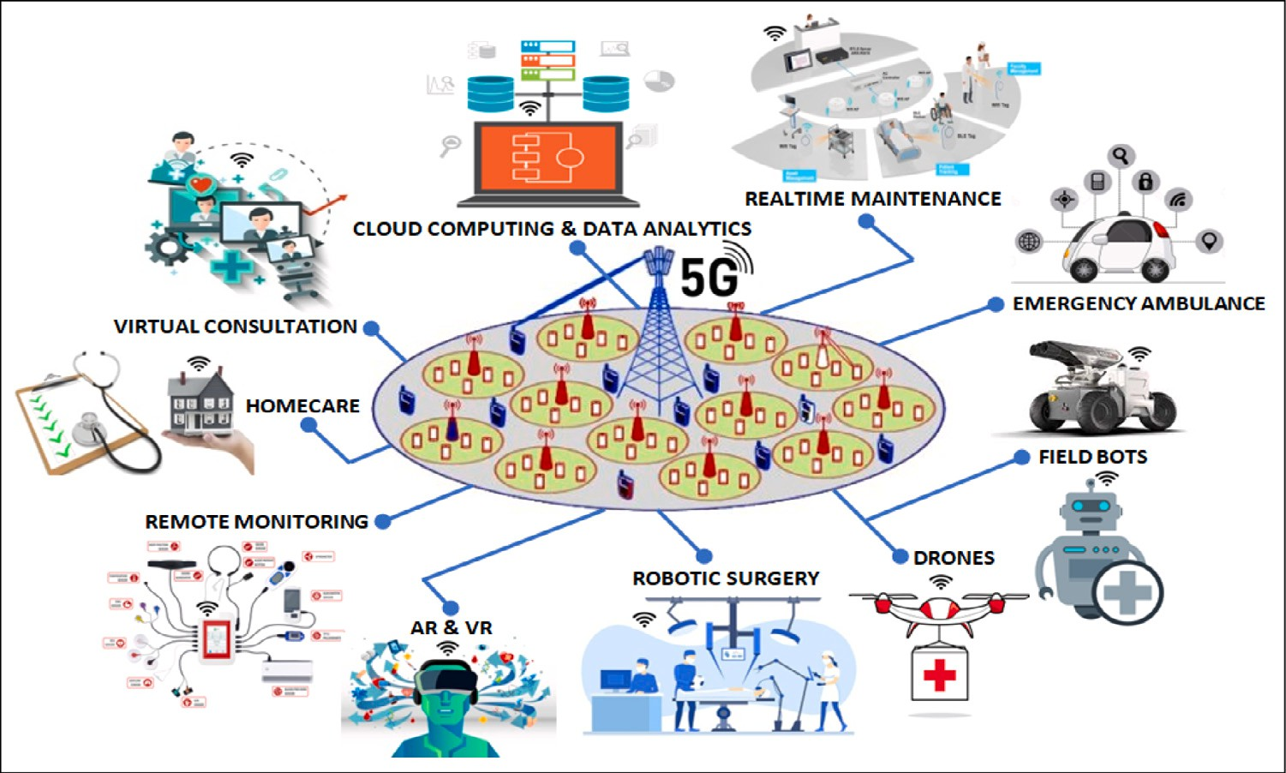

**/ig. 3.** Few aspects of 5G interconnected technologies in healthcare to tackle the pandemic [140].

1. **Telemedicine:** Telemedicine requires a reliable and faster net- work connectivity that will offer quality video and real-time communication. 5G standards can enable proper telemedicine environment that augments online health consultancy [141]. It is estimated that the telemedicine market will raise yearly growth of 16.5 percent from 2017 to 2023 in healthcare [47]. 5G also meets the teleconferencing requirements to enable medical experts to treat patients efficiently from anywhere in anytime.
2. **Telesurgery:** As 5G is a very-low latency and super-fast network, it enables telesurgery or remote medical operation. A health surgeon in China first performed a 5G-assisted remote surgery using da Vinci surgical robots on animal in January 2019 [142]. In March 2019, a telesurgery using 5G mobile network was first performed remotely on human brain in China [115]. Moreover, 5G capabilities can improve the surgical robots and robotic pro- cess that can enhance the surgeon’s capabilities in the pandemic.
3. **Internet of Medical Things (IoMT):** 5G network infrastructure is able to connect a billion of digital devices and wearable med- ical equipments (i.e., IoMT objects) that allow a link between physical and digital worlds, and facilitate real-time analytics to improve health outcomes. It can gather a large volume of health data and store on a cloud as well as assist online accessibility to the users, medical professionals and researchers. The world has already experienced a number of IoMTs and health applications (for instant, 5G thermal imaging systems, smart diagnostic tools, therapeutic kits, etc.) as a part of the emerging 5G innovations in the pandemic [138,143,144].
4. **Remote Diagnosis and Treatment:** 5G connectivity is rev- olutionizing in continuous contagion monitoring and remote diagnosis from anywhere in this pandemic [132,145]. It also enables digital medicine that can share a high-volume of health information across a worldwide network of health specialists for caring patients. In January 2020, China has first developed 5G remote diagnosis and treatment system [146] that can support remote diagnosis and treat patients in this pandemic.
5. **Digitized and Data-Driven Platforms:** Many developed coun- tries, like China, Japan, South Korea and the US, are rapidly set up their specific 5G wireless networks for digitalized, data- driven and Cloud-based emergency platforms that can assist the COVID-19 treatment in hospitals [147,148]. These digital plat- forms support the healthcare systems in the context of improved response times, remote monitoring, data analysis and diagnosis, resource allocation, etc.
   1. *5G powered major solutions*

The emerging innovations using digital technologies rely on a re- liable telecommunication infrastructure and high-speed Internet con- nectivity. The integration of 5G enabled technologies is a transfor- mation of the person-centered care models to the community-based approaches [149,150]. It offers a real-time health solution for the whole population [151]. Some of the pioneering healthcare solutions using 5G enabled digital technologies in response to the COVID-19 pandemic are highlighted in the following sub-sections.

* + 1. *5G-powered ehealth approach*

An innovative eHealth approach [45] has been developed using 5G communication technologies. The mechanisms implemented in eHealth are used for acquiring health data from a variety of sources through IoMTs, processing data, and storing the processed data to the cloud through eHealth 5G platform. As shown in Fig. 4, the eHealth model comprises of the three main modules, such as (i) Data acquisition from heterogeneous sources including IoMT devices, (ii) 5G virtual platform including data management mechanisms and data storage, and (iii) 5G communication and integration allowing a connection between the physical systems and the 5G virtual platforms. This 5G-powered eHealth system can support to improve the real-time healthcare services in this pandemic.

Step 1. **Data Acquisition from Heterogeneous Sources:** A variety of IoMT devices are connected together through the established 5G network. The first step involves the gathering of data from heterogeneous sources via these devices with appro- priate specifications (hardware and software). The composed data from different systems and devices are utilized by either

(i) the patients for in-home monitoring, or (ii) the health specialists for analyzing and assessing the patient’s health status in laboratories and hospitals, or (iii) the patients for outdoor activities.

Step 2. **5G Communication and Integration:** The 5G infrastructure development of the eHealth system comprises of two steps, the 5G communication and integration, which allow the connec- tion between the real world and the virtual world. The data gathered from digital devices takes place at high reliable edge- nodes in the physical systems. These edge-nodes in the phys- ical systems are being connected via a ‘‘5G radio access net- work (5G-RAN)’’ [152]. This network enables the data analy- sis inside the eHealth platforms. Thus, the 5G based eHealth

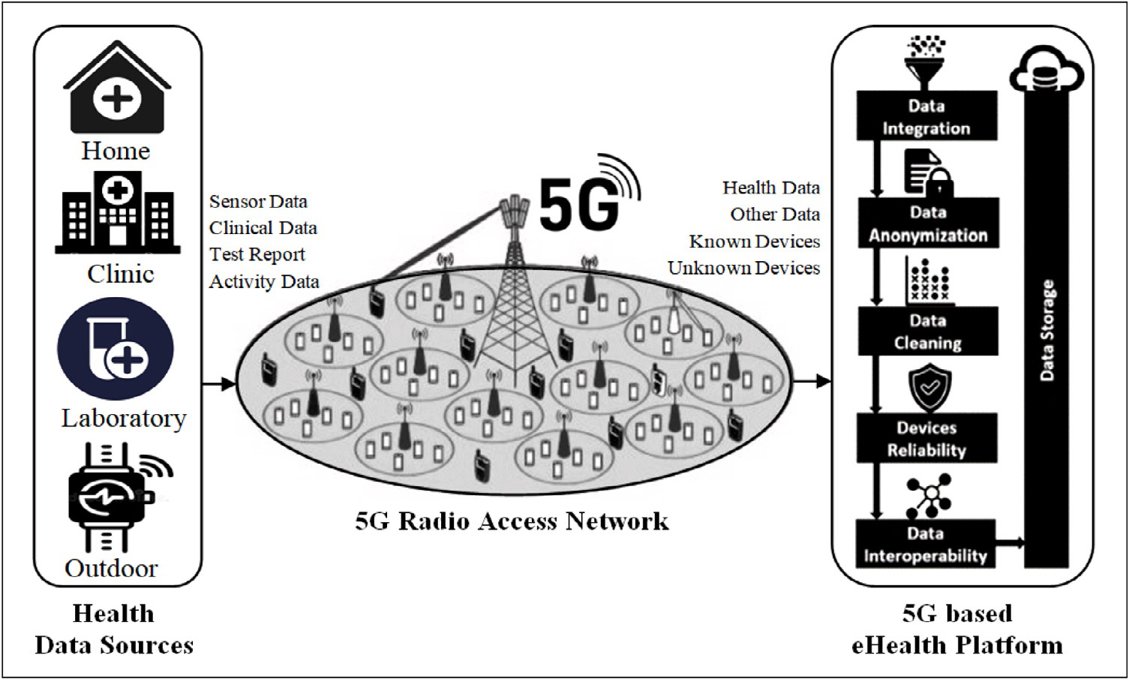

**/ig. 4.** A typical architecture of 5G enabled eHealth Platform [45].

platform has been developed using an appropriate integra- tion of ‘‘virtual network functions (VNFs)’’ [153,154] and ‘‘software defined network (SDN)’’ [155] technologies. This platform is able to offer network virtualization, automation and creation of new services over virtual resources.

Step 3. **Data Management Mechanisms and Storage:** The 5G SDN with virtual networking platform provides all the data man- agement mechanisms, such as data integration, data anonym- ization, data interoperability etc. All the gathered data after transformations (such as, data integration [156], anonymiza- tion [157], cleaning [158], source reliability [159], and data interoperability [160] procedures) is transfigured to a com- mon format, and reserved into the eHealth database. This transformation is a prerequisite for the effective Health plat- form, which can support the virtualization of different eHealth platforms running in different entities, such as in-home, hos- pitals, clinics, laboratories, etc.

* + 1. *Real-time mobile health (mHealth) platforms*

It is very important to know about the public-health related in- formation to forecast the outbreak during the different phases of the epidemic. Mobile technology can assist the estimation of the viral outbreak, and provide emergency treatment during the pandemic. A eHealth platform using mobile technology is referred to as mHealth (mobile health) system. A simple mHealth system is graphically pre- sented in Fig. 5 [159] that enables to connect a variety of digital devices, such as smartphone, tablet, iPad, smartwatch, wearable, etc. It can share the health information and applications to treat the pa- tients in the emergency situations. These devices are generally con- nected through Wi-Fi, ‘‘global positioning system (GPS)’’, and high- speed telecommunication networks (5G networks).

Thus, the mHealth system using 5G wireless network and cloud- based technologies can support to enhance the emergency treatment, health research activities, and other healthcare services in the COVID- 19 pandemic [161,162]. Some of the potential services of the mHealth platforms are highlighted below:

* + - 1. Video conferencing and text messaging, through which a patient can consult a doctor to get precise guidance for the distant treatment.
      2. Contract tracing, through which the patient database can be used for tracing infected patient’s location in case of communal spread of the coronavirus disease.
      3. Telemedicine offers the health consultation to treat the patient remotely. Thus, it facilitates both the health professionals and patients to prevent the transmission of infectious diseases.
      4. Health apps provide the self-monitoring of individual’s health status using wearable devices that can be securely shared with the health professional for proper medications and treatments during the outbreak.

The healthcare agencies and governments in different countries are being used this type of real-time mHealth platform using 5G mobile technologies for controlling the spread of COVID-19 epidemic [163]. Another mobile technology based system is presented in Fig. 6 [159]. The designated system assists in tracking and monitoring of COVID-19 infectious people and giving alerts to the public, as follows:

Step 1. The system collects the information from the network tower to which user smartphone is joined. The apps use this informa- tion in tracking and monitoring the individual’s movement, and aware the emergency situations. The apps also assist the users in better understanding of the COVID-19 spread- ing [164].

Step 2. Using the mHealth database, the healthcare agency announces for infected people and their family to take the isolation, and do the testing procedures at the earlier stage of the COVID- 19 infection. The database of the identified COVID-19 cases can help in contract-tracing during future outbreaks. It can help to inhibit the social interventions by restricting the social contact, outdoor movement, public gathering, etc.

Step 3. The real-time data from the mHealth system can help to estimate the infected cases and death as well as to under- stand the nature of infection. The chance of future outbreaks depends on this estimation. The major affected areas are declared as red zones, and it can assist to declare the full restrictions on movement and public gathering, the closing of offices/institutions, etc., in the red zones [165,166].

* + 1. *5G enabled telemedicine and virtual health environment*

Telemedicine supports long distance healthcare services using ICT tools and high-speed Internet connectivity (5G networks). It can adopt the existing health systems and infrastructure [167] to enhance the treatment procedures in hospitals [168]. 5G also helps to entail durable health education and training, consultancy, and managerial meetings

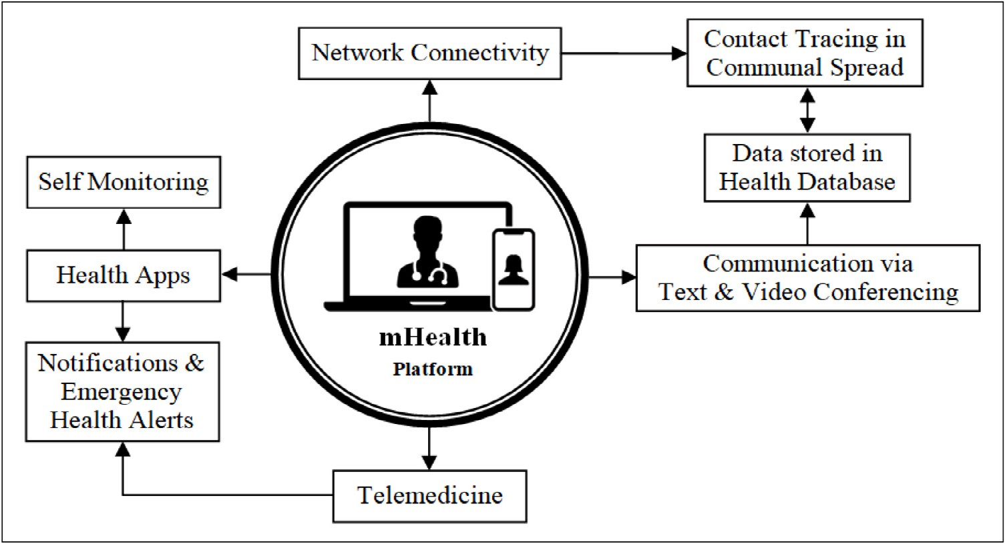

**/ig. 5.** mHealth in various application domains.

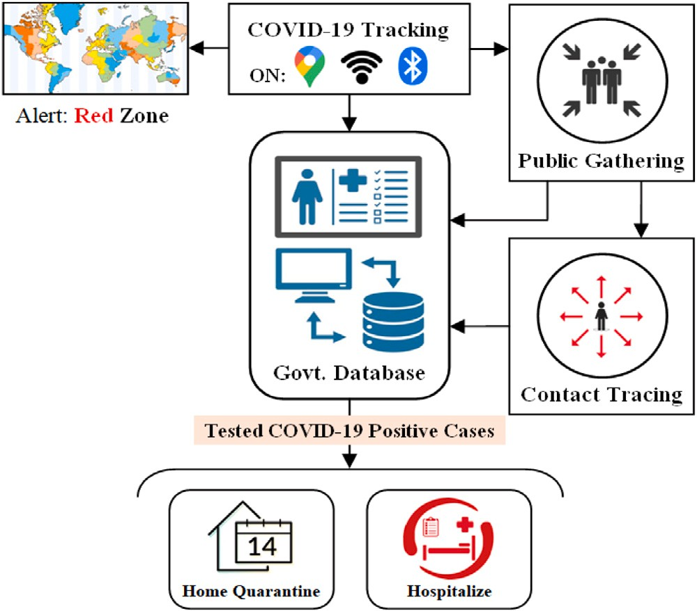 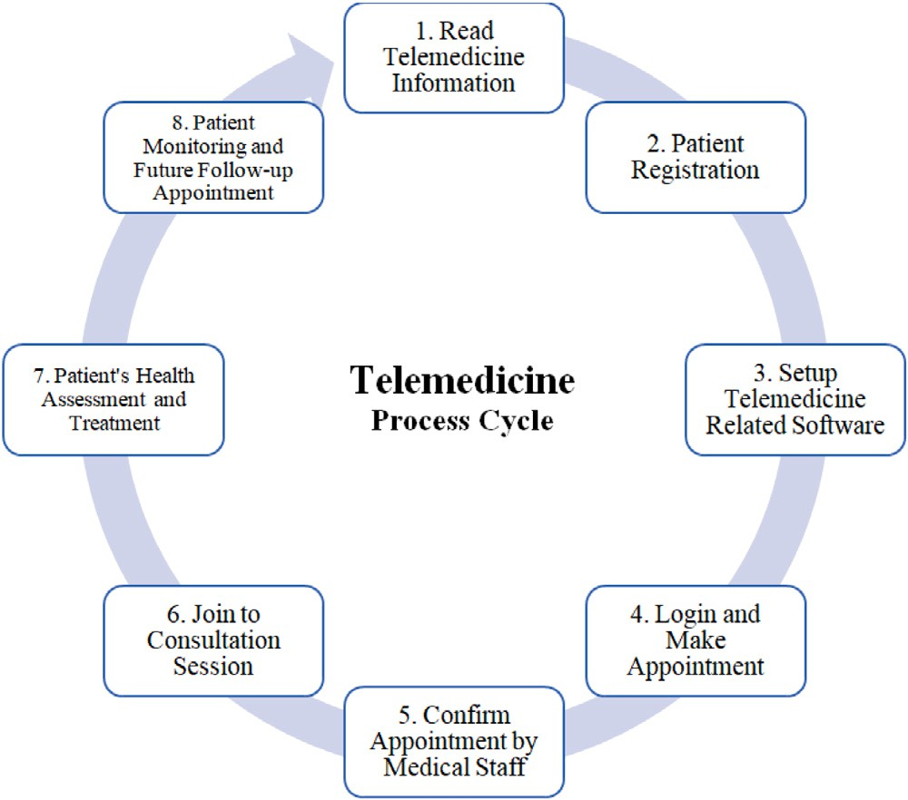

**/ig. 6.** Illustration of mobile technology based COVID-19 tracking system.

using virtual platforms [169]. Fig. 7 illustrates a typical telemedicine process lifecycle that starting with reading telemedicine information and patient registration, and ending with the future follow-up appoint- ment for monitoring patient’s health [141].

Though the doctors utilize virtual platform during online consulta- tion, they try to create the almost real environment as much possible, and maintain confidentiality patient’s privacy and agreement [170]. During online session, they must keep professionality in nature and build a patient–physician relationship [170–172]. They also ensure the telemedicine service within the patient’s health coverage. The patients also will be notified if they use any third-party application during vir- tual consultation regarding the privacy or cyber security issues. Beside high-speed network, the system requires better supporting tools, like smart devices with camera and microphones, proper lighting, noise-free environment, etc., for virtual examination at the both ends [172,173]. Telemedicine ensures a user-friendly and comfortable virtual platform for both the patients and the doctors as well as provides an improved virtual treatment process.

**/ig. 7.** Structure of a typical telemedicine process lifecycle [141].

* + 1. *5G enabled unmanned autonomous systems*

The ongoing COVID-19 pandemic presents itself as a critical chal- lenge for the ICT industries. The autonomous or semi-autonomous systems, like unmanned vehicles, drones, robots, etc., are being de- veloped to assist the controlling of COVID-19 crisis by minimizing the social contact [112]. This ‘‘unmanned autonomous system (UAS)’’ involves a 5G wireless network that connects the system automaton to the cloud, and a management module for the operations [174], as shown in Fig. 8 [112]. Limiting the pandemic, these 5G enabled autonomous systems are being utilizing mainly for two purposes, such as (i) limiting the COVID-19 outbreak, by measuring body temperature, sterilizing the infected areas, delivering and communication remotely,

(ii) security patrol, by facial recognition and other object detection.

1. **Epidemic Prevention Robots:** 5G-powered smart robots using thermal imaging technique are being employed to control the spread of the virus in many countries [175]. These robots were developed by integrating 5G technology, cloud computing and computer vision to accomplish the emergency tasks, like face recognition, temperature screening, etc. in the pandemic [176].

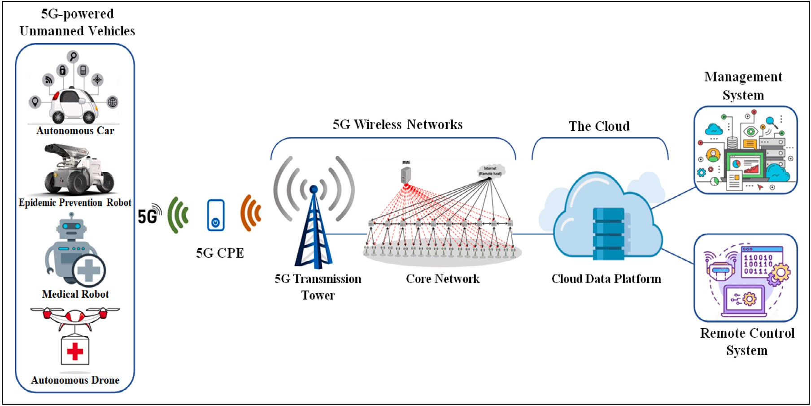

**/ig. 8.** 5G Enabled Unmanned-Vehicle Automation System [112].

The 5G-enabled robots and drones with smart vision sensors have been utilized to patrol the risks zones. They have the ability to track multiple target objects simultaneously while patrolling. They can also monitor the spread of sickness, notify public to wash their hands, detect and notify for wearing masks, etc.

1. **Unmanned Cars:** The self-driving vehicles or unmanned cars are being employed to avoid contact between individuals at infected areas, which greatly reduces the risk of infection. In- tegrating 5G and autonomous driving technology, the cars can perform fully automated and contact-free tasks with improved efficiency [177]. This vehicle is connected to the remote server through 5G network, and used as an intelligent system for dis- infection, transportation, patrolling, epidemic prevention broad- casting, etc.
2. **5G Intelligent Robots:** Another type of intelligent robot by integrating 5G and AI technology assists medical professionals to conduct consultations, disinfection, cleaning, and deliver- ies [178]. The usage of these smart robots can effectively relieve shortages of staffs, which reduce the risks of cross-infection and improve the quarantine-control in the medical centers.
3. **5G-powered Disinfection Robots:** The 5G-powered disinfec- tion robot is designed with a spray sterilization system that can effectively disinfect the contagious area [179]. It can effort autonomously in accordance with a settled disinfection route, setting time, fixed-points, multi-track mobile disinfection and sterilization in the contagious world [180]. Thus, robots are increasingly being deployed at the front lines against the COVID- 19 pandemic in order to reduce cross-infection risks and improve work efficiency and quality [181].
4. **5G-powered Intelligent Drones:** 5G-powered drones with AI technology are being utilized for drugs delivery and aerial spray- ing for disinfection in the virus affected areas [182]. They are being also used to transport samples from patients to medical workers, thus reducing the COVID-19 contagion risks.

# Challenges and prospective

The real-time super-speed and very-low latency aspects of 5G net- work offers a variety of new opportunities that support to expand healthcare applications. The literature shows that 5G enabled tech- nologies have the incredible potentials in healthcare to confront the

coronavirus pandemic. But it will not be sufficiently transportable geographically to achieve the desired services in some cases [183]. In the context of healthcare services in the current epidemic, the key challenges and the prospective of 5G enabled technologies are described in the following sub-sections.

* 1. *Key challenges*

1. **Health Risks:** There is a confusion about suspected health risks due to 5G radio frequency [184]. Public in rural areas are being expressing esthetic concerns and worries about super-speedy net- work’s effect. But many organizations, like NIH, FDA, National Cancer Society, WHO, FCC agreed that there is no validity to the worries about it.
2. **5G’s Range and Coverage:** Occurring obstructions in 5G net- work interrupts its range. Thus, 5G networks require more small devices or antennas in short distance apart to get better 5G signal. It is difficult to deploy 5G network in rural areas that remains the most underserved by healthcare institutions.
3. **Deployment Costs:** The effective development of 5G enabled health solutions require availability of good infrastructure for the patients, physicians and clinics. Thus, the costs of 5G estab- lishment, related devices and infrastructure improvements plus increased maintenance costs are a big issue in 5G healthcare applications. It is logically expected that customers will bear a part of those costs, and hence, the patient will be paid the increased cost for their treatment.
4. **Training and Adaptation of New Technology:** The 5G based health system is gradually delivered through virtually using smart devices and technologies. Both medical staffs and patients require knowledge and skills to adopt new technologies and sys- tems. Thus, proper training is needed to the patients and medical staffs in learning how to use theses new platforms [185]. Many developing countries may not be able to implement a complete 5G-based innovative healthcare solution, specifically in remote and rural areas where the expansion of 4G/5G networks is more difficult [173].
5. **Security Challenges:** Since 5G is capable of fastest data transfer and other healthcare services remotely, security and privacy risks are being increasing day by day. Hence, it requires to give extra attention in 5G security concerns [183] that include

data and device protection, data filtering and digital rights man- agement, patient’s data confidentiality, infrastructure and na- tional security, network security, cybercrime and cyber-security, etc. [186,187].

* 1. *Prospective*

1. **Super-/ast and Accurate Health Services:** The super-fast 5G network can provide quick and reliable transport of large med- ical data. Low latency feature of 5G technology can provide faster and reliable treatment to the patients remotely, and help surgeons for conducting remote robotic-surgery.
2. **Advancements in Healthcare:** 5G technology can improve per- sonalized and preventive care. 5G powered telemedicine en- ables real-time health consultancy and emergency treatment. Moreover, a fully-implemented 5G network will enhance med- ical operations and management as well as quality treatment experiences for both the patients and medical staffs.
3. **Integration of Advanced Technologies:** 5G is being given us the opportunity to utilize ‘‘artificial intelligence (AI)’’, ‘‘Internet of medical things (IoMT)’’, ‘‘augmented reality (AR)’’, ‘‘virtual reality (VR)’’ in healthcare applications. They have the potentials to offer innovative and transformative health facilities as well as enhance real-time treatment and diagnosis procedures.
4. **Cost Optimization and Safeguard Quality:** The use of 5G- powered technologies, like mHealth technology, telemedicine, IoMTs and wearable devices, or digital health platforms [188] can help patient’s living in urban and rural areas by gain- ing remote access to medical assistance [189]. It will obvi- ously save money by avoiding expensive hospital visit without compromising quality-treatment [190]. It will also offer distant doctor-assistance on diagnosis, and will fulfill the desired service standards for a complete medicinal examination [191].
5. **Advancements in Intervention Management and Adminis- trative Operations:** The new insights of 5G-powered healthcare solutions will provide continuity of health caring without having interrupt in data entry and querying tasks, thus, it is a disruptive process in recording medical information [192,193]. It enables improvements in intervention management by facilitating valu- able healthcare resources, like operating theaters, electrocardio- gram monitors, and other medical equipments. These valuable assets enable better management as well as ensure safe and efficient administrative operations.

# Conclusion

The use of 5G network in integrating other digital technologies (like AI and machine learning, IoMTs, big data analytics, cloud computing, etc.) is now a reality in healthcare. From the literature, it is clear that 5G enabled technologies as well as intelligent systems have a prospect to improve healthcare services, such as medical diagnosis, health mon- itoring, treatment, management, etc. As the 5G poses non-ionizing radiation, there is no significant health risk of 5G RF wave below the recommended safety level. There is no evidence that 5G signal causes the spread of the coronavirus. Moreover, 5G enabled digital technolo- gies have been used for limiting the COVID-19 outbreak, and enhancing the public-health strategies in 2020. Some advanced technology giants are conducting their researches on 5G related applications that will combat against the health risks of any undesirable epidemics. The successful utilization of 5G technology to tackle healthcare challenges will enhance the acceptance of such technologies for other sectors in the future.

As it is a new field of research, some issues are to be considered

in deployment of 5G network in healthcare including infrastructure development, technical standards, effective regulations and policy, pri- vacy protection and security, as well as availability of research data.

Further works will incorporate more study on how to expand 5G based digital society as well as to resolve some issues, such as safety–security– privacy, availability–accessibility–integrity, and to augment resilience to future health crises. It is also required to compile laws and prepare proper guidelines to deal with ethical and legal counteractions in managing the online services during the emergency situations. With the new technological innovations, 5G network will provide a com- plete pathway for a smart society with various promising healthcare applications.

# Declaration of competing interest

The authors declare that they have no known competing finan- cial interests or personal relationships that could have appeared to influence the work reported in this paper.

# Acknowledgment

The authors wish to acknowledge the research & extension cell of Jatiya Kabi Kazi Nazrul Islam University, Bangladesh for financial support and cooperation in conducting this research work.

# References

1. Bass B. GSMA: Asia Set to become world’s largest 5G region by 2025. 2018, Online; GSMA Newsroom, [https://www.gsma.com/newsroom/press-](https://www.gsma.com/newsroom/press-release/gsma-asia-set-to-become-worlds-largest-5g-region-by-2025/) [release/gsma-asia-set-to-become-worlds-largest-5g-region-by-2025/](https://www.gsma.com/newsroom/press-release/gsma-asia-set-to-become-worlds-largest-5g-region-by-2025/). [Accessed 10 March 2021].
2. [Agiwal M, Roy A, Saxena N. Next generation 5G wireless networks: A](http://refhub.elsevier.com/S2590-0056(22)00036-4/sb2) [comprehensive survey. IEEE Commun Surv Tutor 2016;18(3):1617–55.](http://refhub.elsevier.com/S2590-0056(22)00036-4/sb2)
3. [Andrews JG, Buzzi S, Choi W, Hanly SV, Lozano A, Soong AC, et al. What will](http://refhub.elsevier.com/S2590-0056(22)00036-4/sb3) [5G be? IEEE J Sel Areas Commun 2014;32(6):1065–82.](http://refhub.elsevier.com/S2590-0056(22)00036-4/sb3)
4. GSM Association. The mobile economy 2020. 2020, Online; GSMA Documents, <https://www.gsma.com/mobileeconomy/>. [Accessed 29 March 2021].
5. [Perez S. App stores saw record 204 billion app downloads in 2019, consumer](http://refhub.elsevier.com/S2590-0056(22)00036-4/sb5) [spend of $120 billion. 2020, Techcrunch.Com, Verizon Media, Online; [Accessed](http://refhub.elsevier.com/S2590-0056(22)00036-4/sb5) [3 April 2021].](http://refhub.elsevier.com/S2590-0056(22)00036-4/sb5)
6. Kemp S. Digital 2020: Global digital overview. 2020, Datareportal, Online; <https://datareportal.com/reports/digital-2020-global-digital-overview>. [Accessed 29 January 2021].
7. [Huang C, Wang Y, Li X, Ren L, Zhao J, Hu Y, et al. Clinical features](http://refhub.elsevier.com/S2590-0056(22)00036-4/sb7) [of patients infected with 2019 novel coronavirus in wuhan, China. Lancet](http://refhub.elsevier.com/S2590-0056(22)00036-4/sb7) [2020;395(10223):497–506.](http://refhub.elsevier.com/S2590-0056(22)00036-4/sb7)
8. [Ji W, Wang W, Zhao X, Zai J, Li X. Cross-species transmission of the newly](http://refhub.elsevier.com/S2590-0056(22)00036-4/sb8) [identified coronavirus 2019-nCoV. J Med Virol 2020;92(4):433–40.](http://refhub.elsevier.com/S2590-0056(22)00036-4/sb8)
9. [Zhou P, Yang X-L, Wang X-G, Hu B, Zhang L, Zhang W, et al. A pneumonia](http://refhub.elsevier.com/S2590-0056(22)00036-4/sb9) [outbreak associated with a new coronavirus of probable bat origin. Nature](http://refhub.elsevier.com/S2590-0056(22)00036-4/sb9) [2020;579(7798):270–3.](http://refhub.elsevier.com/S2590-0056(22)00036-4/sb9)
10. worldometer. COVID-19 CORONAVIRUS PANDEMIC. 2021, Online; [https://](https://www.worldometers.info/coronavirus/) [www.worldometers.info/coronavirus/](https://www.worldometers.info/coronavirus/). [Accessed 5 April 2021].
11. Wikipedia. Template:COVID-19 pandemic data. 2021, Online; https:// en.wikipedia.org/wiki/Template:COVID-19_pandemic_data. [Accessed 5 April 2021].
12. [Samsung. 5G launches in Korea get a taste of the future. White-Paper](http://refhub.elsevier.com/S2590-0056(22)00036-4/sb12) [(Images.Samsung.Com), 2019, Online; [Accessed 4 April 2021].](http://refhub.elsevier.com/S2590-0056(22)00036-4/sb12)
13. [Ahmed W, Vidal-Alaball J, Downing J, Seguí FL. COVID-19 and the 5G](http://refhub.elsevier.com/S2590-0056(22)00036-4/sb13) [conspiracy theory: social network analysis of Twitter data. J Med Internet Res](http://refhub.elsevier.com/S2590-0056(22)00036-4/sb13) [2020;22(5):e19458.](http://refhub.elsevier.com/S2590-0056(22)00036-4/sb13)
14. [Amgain K, Neupane S, Panthi L, Thapaliya P. Myths versus truths regarding](http://refhub.elsevier.com/S2590-0056(22)00036-4/sb14) [the novel coronavirus disease (COVID-2019) outbreak. J Karnali Acad Health](http://refhub.elsevier.com/S2590-0056(22)00036-4/sb14) [Sci 2020;3(1).](http://refhub.elsevier.com/S2590-0056(22)00036-4/sb14)
15. WHO. Coronavirus disease (COVID-19) advice for the public: Mythbusters. 2021, Online; [https://www.who.int/emergencies/diseases/novel-coronavirus-](https://www.who.int/emergencies/diseases/novel-coronavirus-2019/advice-for-public/myth-busters) [2019/advice-for-public/myth-busters](https://www.who.int/emergencies/diseases/novel-coronavirus-2019/advice-for-public/myth-busters). [Accessed 2 April 2021].
16. [Kostoff RN, Heroux P, Aschner M, Tsatsakis A. Adverse health effects of](http://refhub.elsevier.com/S2590-0056(22)00036-4/sb16) [5G mobile networking technology under real-life conditions. Toxicol Lett](http://refhub.elsevier.com/S2590-0056(22)00036-4/sb16) [2020;323:35–40.](http://refhub.elsevier.com/S2590-0056(22)00036-4/sb16)
17. [Latif S, Qadir J, Farooq S, Imran MA. How 5G wireless (and concomitant](http://refhub.elsevier.com/S2590-0056(22)00036-4/sb17) [technologies) will revolutionize healthcare? Future Internet 2017;9(4):93.](http://refhub.elsevier.com/S2590-0056(22)00036-4/sb17)
18. [Lu X, Sun Y. Application of 5g technology in education informatization. Strateg](http://refhub.elsevier.com/S2590-0056(22)00036-4/sb18) [Study Chin Acad Eng 2020;21(6):120–8.](http://refhub.elsevier.com/S2590-0056(22)00036-4/sb18)
19. [Guevara L, Auat Cheein F. The role of 5G technologies: Challenges in smart](http://refhub.elsevier.com/S2590-0056(22)00036-4/sb19) [cities and intelligent transportation systems. Sustainability 2020;12(16):6469.](http://refhub.elsevier.com/S2590-0056(22)00036-4/sb19)
20. [Rao SK, Prasad R. Impact of 5G technologies on industry 4.0. Wirel Pers](http://refhub.elsevier.com/S2590-0056(22)00036-4/sb20) [Commun 2018;100(1):145–59.](http://refhub.elsevier.com/S2590-0056(22)00036-4/sb20)
21. [Tang Y, Dananjayan S, Hou C, Guo Q, Luo S, He Y. A survey on the 5G network](http://refhub.elsevier.com/S2590-0056(22)00036-4/sb21) [and its impact on agriculture: Challenges and opportunities. Comput Electron](http://refhub.elsevier.com/S2590-0056(22)00036-4/sb21) [Agric 2021;180:105895.](http://refhub.elsevier.com/S2590-0056(22)00036-4/sb21)
22. [West DM. How 5G technology enables the health internet of things. 2016, p.](http://refhub.elsevier.com/S2590-0056(22)00036-4/sb22) [1–20, Brookings Center for Technology Innovation, 3.](http://refhub.elsevier.com/S2590-0056(22)00036-4/sb22)
23. Abubakar AI, Omeke KG, Öztürk M, Hussain S, Imran MA. The role of artificial intelligence driven 5G networks in COVID-19 outbreak: opportunities, challenges, and future outlook. Front Commun Netw 2020;1. [http://dx.doi.org/](http://dx.doi.org/10.3389/frcmn.2020.575065) [10.3389/frcmn.2020.575065](http://dx.doi.org/10.3389/frcmn.2020.575065).
24. Martynova O. Top uses of 5G in the energy sector. 2019, Online; [https://www.](https://www.intellias.com/top-uses-of-5g-in-the-energy-sector/) [intellias.com/top-uses-of-5g-in-the-energy-sector/](https://www.intellias.com/top-uses-of-5g-in-the-energy-sector/). [Accessed 2 April 2021].
25. [Ting DSW, Carin L, Dzau V, Wong TY. Digital technology and COVID-19. Nat](http://refhub.elsevier.com/S2590-0056(22)00036-4/sb25) [Med 2020;26(4):459–61.](http://refhub.elsevier.com/S2590-0056(22)00036-4/sb25)
26. [Mohammed IB, Isa SM. The role of internet of things (IoT) in the containment](http://refhub.elsevier.com/S2590-0056(22)00036-4/sb26) [and spread of the novel COVID-19 pandemic. In: Computational intelligence](http://refhub.elsevier.com/S2590-0056(22)00036-4/sb26) [methods in COVID-19: surveillance, prevention, prediction and diagnosis.](http://refhub.elsevier.com/S2590-0056(22)00036-4/sb26) [Springer; p. 109–19.](http://refhub.elsevier.com/S2590-0056(22)00036-4/sb26)
27. [Perkel JM. The Internet of Things comes to the lab. Nature](http://refhub.elsevier.com/S2590-0056(22)00036-4/sb27) [2017;542(7639):125–6.](http://refhub.elsevier.com/S2590-0056(22)00036-4/sb27)
28. [Shilo S, Rossman H, Segal E. Axes of a revolution: challenges and promises of](http://refhub.elsevier.com/S2590-0056(22)00036-4/sb28) [big data in healthcare. Nat Med 2020;26(1):29–38.](http://refhub.elsevier.com/S2590-0056(22)00036-4/sb28)
29. [LeCun Y, Bengio Y, Hinton G. Deep learning. Nature 2015;521(7553):436–44.](http://refhub.elsevier.com/S2590-0056(22)00036-4/sb29)
30. [Ting DS, Liu Y, Burlina P, Xu X, Bressler NM, Wong TY. AI for medical imaging](http://refhub.elsevier.com/S2590-0056(22)00036-4/sb30) [goes deep. Nat Med 2018;24(5):539–40.](http://refhub.elsevier.com/S2590-0056(22)00036-4/sb30)
31. [Heaven D. Bitcoin for the biological literature. Nature 2019;566(7742):141.](http://refhub.elsevier.com/S2590-0056(22)00036-4/sb31)
32. Valencia R. Previewing 5G’s effect on the health care industry. 2017, Online; [https://www.qualcomm.com/news/onq/2017/10/30/previewing-5gs-effect-](https://www.qualcomm.com/news/onq/2017/10/30/previewing-5gs-effect-health-care-industry) [health-care-industry](https://www.qualcomm.com/news/onq/2017/10/30/previewing-5gs-effect-health-care-industry). [Accessed 4 April 2021].
33. [Shi F, Wang J, Shi J, Wu Z, Wang Q, Tang Z, et al. Review of artificial](http://refhub.elsevier.com/S2590-0056(22)00036-4/sb33) [intelligence techniques in imaging data acquisition, segmentation and diagnosis](http://refhub.elsevier.com/S2590-0056(22)00036-4/sb33) [for covid-19. IEEE Rev Biomed Eng 2020.](http://refhub.elsevier.com/S2590-0056(22)00036-4/sb33)
34. [Soldani D. Fighting pandemics by exploiting 5G, AI and bigdata enabled](http://refhub.elsevier.com/S2590-0056(22)00036-4/sb34) [technologies: How 5G can help contain the spread of COVID-19. J Telecommun](http://refhub.elsevier.com/S2590-0056(22)00036-4/sb34) [Digit Econ 2020;8(2):146.](http://refhub.elsevier.com/S2590-0056(22)00036-4/sb34)
35. Chettri S, Debnath D, Devi P. Leveraging digital tools and technologies to alleviate COVID-19 pandemic. 2020, Available At SSRN: [http://dx.doi.org/10.](http://dx.doi.org/10.2139/ssrn.3626092) [2139/ssrn.3626092](http://dx.doi.org/10.2139/ssrn.3626092).
36. [Zemmar A, Lozano AM, Nelson BJ. The rise of robots in surgical environments](http://refhub.elsevier.com/S2590-0056(22)00036-4/sb36) [during COVID-19. Nat Mach Intell 2020;2(10):566–72.](http://refhub.elsevier.com/S2590-0056(22)00036-4/sb36)
37. Agarwal S, Punn NS, Sonbhadra SK, Nagabhushan P, Pandian K, Saxena P. Unleashing the power of disruptive and emerging technologies amid covid 2019: a detailed review. 2020, arXiv preprint[arXiv:2005.11507](http://arxiv.org/abs/2005.11507).
38. [Angelucci A, Kuller D, Aliverti A. A home telemedicine system for continuous](http://refhub.elsevier.com/S2590-0056(22)00036-4/sb38) [respiratory monitoring. IEEE J Biomed Health Inform 2020.](http://refhub.elsevier.com/S2590-0056(22)00036-4/sb38)
39. STLPartners. 10 5G Healthcare use cases transforming digital health. 2020, Online; [https://stlpartners.com/digital-health-telecoms/10-5g-healthcare-use-](https://stlpartners.com/digital-health-telecoms/10-5g-healthcare-use-cases/) [cases/](https://stlpartners.com/digital-health-telecoms/10-5g-healthcare-use-cases/). [Accessed 4 April 2021].
40. [Klaine PV, Imran MA, Onireti O, Souza RD, Tutorials. A survey of machine](http://refhub.elsevier.com/S2590-0056(22)00036-4/sb40) [learning techniques applied to self-organizing cellular networks. IEEE Commun](http://refhub.elsevier.com/S2590-0056(22)00036-4/sb40) [Surv 2017;19(4):2392–431.](http://refhub.elsevier.com/S2590-0056(22)00036-4/sb40)
41. [Letaief KB, Chen W, Shi Y, Zhang J, Zhang Y-JA. The roadmap to 6G: AI](http://refhub.elsevier.com/S2590-0056(22)00036-4/sb41) [empowered wireless networks. IEEE Commun Mag 2019;57(8):84–90.](http://refhub.elsevier.com/S2590-0056(22)00036-4/sb41)
42. Baskaran A. How will 5G impact different industries?. 2018, Online; PreScouter Newsletter, [https://www.prescouter.com/2018/01/5g-impact-](https://www.prescouter.com/2018/01/5g-impact-different-industries/#%3A~%3Atext%3DAccording%20to%20a%20report%20by%2Cof%20traffic%20and%20reducing%20collisions) [different-industries/#:~:text=According%20to%20a%20report%20by,of%](https://www.prescouter.com/2018/01/5g-impact-different-industries/#%3A~%3Atext%3DAccording%20to%20a%20report%20by%2Cof%20traffic%20and%20reducing%20collisions) [20traffic%20and%20reducing%20collisions](https://www.prescouter.com/2018/01/5g-impact-different-industries/#%3A~%3Atext%3DAccording%20to%20a%20report%20by%2Cof%20traffic%20and%20reducing%20collisions). [Accessed 12 March 2021].
43. [Chang LF. Journey to 5G. In: 2019 international symposium on VLSI technology,](http://refhub.elsevier.com/S2590-0056(22)00036-4/sb43) [systems and application. IEEE; p. 11.](http://refhub.elsevier.com/S2590-0056(22)00036-4/sb43)
44. Verizon. The journey to 5G. 2018, Online; [https://www.healthcareitnews.com/](https://www.healthcareitnews.com/news/journey-5g) [news/journey-5g](https://www.healthcareitnews.com/news/journey-5g). [Accessed 17 August 2020].
45. [Mavrogiorgou A, Kiourtis A, Touloupou M, Kapassa E, Kyriazis D, Themis-](http://refhub.elsevier.com/S2590-0056(22)00036-4/sb45) [tocleous M. The road to the future of healthcare: transmitting interoperable](http://refhub.elsevier.com/S2590-0056(22)00036-4/sb45) [healthcare data through a 5G based communication platform. In: Euro-](http://refhub.elsevier.com/S2590-0056(22)00036-4/sb45) [pean, Mediterranean, and Middle Eastern conference on information systems.](http://refhub.elsevier.com/S2590-0056(22)00036-4/sb45) [Springer; p. 383–401.](http://refhub.elsevier.com/S2590-0056(22)00036-4/sb45)
46. [Yuehong Y, Zeng Y, Chen X, Fan Y. The internet of things in healthcare: An](http://refhub.elsevier.com/S2590-0056(22)00036-4/sb46) [overview. J Ind Inf Integr 2016;1:3–13.](http://refhub.elsevier.com/S2590-0056(22)00036-4/sb46)
47. [Bekaroo G, Santokhee A, Augusto JC. 5G smart and innovative healthcare](http://refhub.elsevier.com/S2590-0056(22)00036-4/sb47) [services: Opportunities, challenges, and prospective solutions. 5G Multimed](http://refhub.elsevier.com/S2590-0056(22)00036-4/sb47) [Commun: Technol Multiserv Deployment 2020;279.](http://refhub.elsevier.com/S2590-0056(22)00036-4/sb47)
48. [Moayedi G, Davis C. Insights in public health: Equitable access to abortion](http://refhub.elsevier.com/S2590-0056(22)00036-4/sb48) [care in Hawai ‘I: Identifying gaps and solutions. Hawai’I J Med Public Health](http://refhub.elsevier.com/S2590-0056(22)00036-4/sb48) [2018;77(7):169.](http://refhub.elsevier.com/S2590-0056(22)00036-4/sb48)
49. [Rivezzi M, Tricase C, Rana RL. The telemedicine and ICT as tool to improve](http://refhub.elsevier.com/S2590-0056(22)00036-4/sb49) [the local healthcare. In: New trends in sustainable business and consumption.](http://refhub.elsevier.com/S2590-0056(22)00036-4/sb49) [Editura ASE; p. 1195–202.](http://refhub.elsevier.com/S2590-0056(22)00036-4/sb49)
50. [West DM, Miller EA. Digital medicine: health care in the internet era. Brookings](http://refhub.elsevier.com/S2590-0056(22)00036-4/sb50) [Institution Press; 2009.](http://refhub.elsevier.com/S2590-0056(22)00036-4/sb50)
51. [Salih AA, Zeebaree SR, Abdulraheem AS, Zebari RR, Sadeeq MA, Ahmed OM.](http://refhub.elsevier.com/S2590-0056(22)00036-4/sb51) [Evolution of mobile wireless communication to 5G revolution. Technol Rep](http://refhub.elsevier.com/S2590-0056(22)00036-4/sb51) [Kansai Univ 2020;62(5):2139–51.](http://refhub.elsevier.com/S2590-0056(22)00036-4/sb51)
52. [Staff R. False claim: 3g, 4G and 5G caused SARS, swine flu and the new](http://refhub.elsevier.com/S2590-0056(22)00036-4/sb52) [coronavirus. 2020, Reuters Newletters, Reuters.Com., Online; [Accessed 18](http://refhub.elsevier.com/S2590-0056(22)00036-4/sb52) [January 2021].](http://refhub.elsevier.com/S2590-0056(22)00036-4/sb52)
53. Jansson K. First in the world with 4G. 2015, Online; TeliaSonera, [https://www.teliacompany.com/en/about-the-company/history/first-in-the-](https://www.teliacompany.com/en/about-the-company/history/first-in-the-world-with-4g/#%3A~%3Atext%3DTeliaSonera%20was%20the%20first%20operator%2C4G%20services%20in%2010%20countries) [world-with-4g/#:~:text=TeliaSonera%20was%20the%20first%20operator,4G%](https://www.teliacompany.com/en/about-the-company/history/first-in-the-world-with-4g/#%3A~%3Atext%3DTeliaSonera%20was%20the%20first%20operator%2C4G%20services%20in%2010%20countries) [20services%20in%2010%20countries](https://www.teliacompany.com/en/about-the-company/history/first-in-the-world-with-4g/#%3A~%3Atext%3DTeliaSonera%20was%20the%20first%20operator%2C4G%20services%20in%2010%20countries). [Accessed 29 October 2020].
54. [Begley S. Swine flu outbreak was 15 times deadlier: Study. Reuters. June](http://refhub.elsevier.com/S2590-0056(22)00036-4/sb54) [2009;26:2012.](http://refhub.elsevier.com/S2590-0056(22)00036-4/sb54)
55. [WHO. Influenza a (H1N1) 2009 virus: current situation and post-pandemic rec-](http://refhub.elsevier.com/S2590-0056(22)00036-4/sb55) [ommendations. Wkly Epidemiol Record=Relevé Épidémiologique Hebdomadaire](http://refhub.elsevier.com/S2590-0056(22)00036-4/sb55) [2011;86(08):61–6.](http://refhub.elsevier.com/S2590-0056(22)00036-4/sb55)
56. [Mourad A, Yang R, Lehne PH, De La Oliva A. A baseline roadmap for advanced](http://refhub.elsevier.com/S2590-0056(22)00036-4/sb56) [wireless research beyond 5G. Electronics 2020;9(2):351.](http://refhub.elsevier.com/S2590-0056(22)00036-4/sb56)
57. [Bhardwaj A. 5G for military communications. Procedia Comput Sci](http://refhub.elsevier.com/S2590-0056(22)00036-4/sb57) [2020;171:2665–74.](http://refhub.elsevier.com/S2590-0056(22)00036-4/sb57)
58. [Shahsavari S, Holur P, Wang T, Tangherlini TR, Roychowdhury V. Conspiracy](http://refhub.elsevier.com/S2590-0056(22)00036-4/sb58) [in the time of corona: Automatic detection of emerging COVID-19 conspiracy](http://refhub.elsevier.com/S2590-0056(22)00036-4/sb58) [theories in social media and the news. J Comput Soc Sci 2020;1–39.](http://refhub.elsevier.com/S2590-0056(22)00036-4/sb58)
59. [Shaw R, Kim Y-k, Hua J. Governance, technology and citizen behavior in](http://refhub.elsevier.com/S2590-0056(22)00036-4/sb59) [pandemic: Lessons from COVID-19 in east Asia. Prog Disaster Sci 2020;100090.](http://refhub.elsevier.com/S2590-0056(22)00036-4/sb59)
60. [Hardell L, Carlberg M. [Comment] health risks from radiofrequency radiation,](http://refhub.elsevier.com/S2590-0056(22)00036-4/sb60) [including 5G, should be assessed by experts with no conflicts of interest. Oncol](http://refhub.elsevier.com/S2590-0056(22)00036-4/sb60) [Lett 2020;20(4):1.](http://refhub.elsevier.com/S2590-0056(22)00036-4/sb60)
61. [Lu R, Zhao X, Li J, Niu P, Yang B, Wu H, et al. Genomic characterisation](http://refhub.elsevier.com/S2590-0056(22)00036-4/sb61) [and epidemiology of 2019 novel coronavirus: implications for virus origins and](http://refhub.elsevier.com/S2590-0056(22)00036-4/sb61) [receptor binding. Lancet 2020;395(10224):565–74.](http://refhub.elsevier.com/S2590-0056(22)00036-4/sb61)
62. [Smith RD. Responding to global infectious disease outbreaks: lessons from SARS](http://refhub.elsevier.com/S2590-0056(22)00036-4/sb62) [on the role of risk perception, communication and management. Soc Sci Med](http://refhub.elsevier.com/S2590-0056(22)00036-4/sb62) [2006;63(12):3113–23.](http://refhub.elsevier.com/S2590-0056(22)00036-4/sb62)
63. [Chan-Yeung M, Xu R-H. SARS: Epidemiology. Respirology 2003;8:S9–14.](http://refhub.elsevier.com/S2590-0056(22)00036-4/sb63)
64. [Peiris J, Guan Y, Yuen K. Severe acute respiratory syndrome. Nat Med](http://refhub.elsevier.com/S2590-0056(22)00036-4/sb64) [2004;10(12):S88–97.](http://refhub.elsevier.com/S2590-0056(22)00036-4/sb64)
65. [Zaki AM, Van Boheemen S, Bestebroer TM, Osterhaus AD, Fouchier RA.](http://refhub.elsevier.com/S2590-0056(22)00036-4/sb65) [Isolation of a novel coronavirus from a man with pneumonia in Saudi Arabia.](http://refhub.elsevier.com/S2590-0056(22)00036-4/sb65) [N Engl J Med 2012;367(19):1814–20.](http://refhub.elsevier.com/S2590-0056(22)00036-4/sb65)
66. [Chan JF-W, Yuan S, Kok K-H, To KK-W, Chu H, Yang J, et al. A fa-](http://refhub.elsevier.com/S2590-0056(22)00036-4/sb66) [milial cluster of pneumonia associated with the 2019 novel coronavirus](http://refhub.elsevier.com/S2590-0056(22)00036-4/sb66) [indicating person-to-person transmission: A study of a family cluster. Lancet](http://refhub.elsevier.com/S2590-0056(22)00036-4/sb66) [2020;395(10223):514–23.](http://refhub.elsevier.com/S2590-0056(22)00036-4/sb66)
67. [Fernandes N. Economic Effects of Coronavirus Outbreak (COVID-19) on the](http://refhub.elsevier.com/S2590-0056(22)00036-4/sb67) [World Economy. Working Paper No. WP-1240-E, IESE Business School; 2020,](http://refhub.elsevier.com/S2590-0056(22)00036-4/sb67) [Available At SSRN 3557504.](http://refhub.elsevier.com/S2590-0056(22)00036-4/sb67)
68. Emanuel EJ, Persad G, Upshur R, Thome B, Parker M, Glickman A, et al. Fair allocation of scarce medical resources in the time of Covid-19. N Engl J Med 2020;382:2049–55, URL [https://www.nejm.org/doi/full/10.1056/](https://www.nejm.org/doi/full/10.1056/NEJMsb2005114) [NEJMsb2005114](https://www.nejm.org/doi/full/10.1056/NEJMsb2005114).
69. [Radi G, Diotallevi F, Campanati A, Offidani A. Global coronavirus pandemic](http://refhub.elsevier.com/S2590-0056(22)00036-4/sb69) [(2019-nCOV): implication for an Italian medium size dermatological clinic of a](http://refhub.elsevier.com/S2590-0056(22)00036-4/sb69) [II level hospital. J Eur Acad Dermatol Venereol 2020;34(5):e213–4.](http://refhub.elsevier.com/S2590-0056(22)00036-4/sb69)
70. UNESCO. Education: From disruption to recovery. 2020, Online; [https://en.](https://en.unesco.org/covid19/educationresponse) [unesco.org/covid19/educationresponse](https://en.unesco.org/covid19/educationresponse). [Accessed 15 January 2021].
71. UNWTO. 100% Of global destinations now have COVID-19 travel restrictions, UNWTO reports. 2020, Online; [https://www.unwto.org/news/covid-19-travel-](https://www.unwto.org/news/covid-19-travel-restrictions) [restrictions](https://www.unwto.org/news/covid-19-travel-restrictions). [Accessed 20 January 2021].
72. [Iacus SM, Natale F, Santamaria C, Spyratos S, Vespe M. Estimating and](http://refhub.elsevier.com/S2590-0056(22)00036-4/sb72) [projecting air passenger traffic during the COVID-19 coronavirus outbreak and](http://refhub.elsevier.com/S2590-0056(22)00036-4/sb72) [its socio-economic impact. Saf Sci 2020;104791.](http://refhub.elsevier.com/S2590-0056(22)00036-4/sb72)
73. [Baldwin R, Tomiura E. Thinking ahead about the trade impact of COVID-19.](http://refhub.elsevier.com/S2590-0056(22)00036-4/sb73) [2020, Economics in the Time of COVID-19, 59.](http://refhub.elsevier.com/S2590-0056(22)00036-4/sb73)
74. [Aday S, Aday MS. Impact of COVID-19 on the food supply chain. Food Qual](http://refhub.elsevier.com/S2590-0056(22)00036-4/sb74) [Saf Sci 2020;4(4):167–80.](http://refhub.elsevier.com/S2590-0056(22)00036-4/sb74)
75. [Pan D, Yang J, Zhou G, Kong F. The influence of COVID-19 on agricultural](http://refhub.elsevier.com/S2590-0056(22)00036-4/sb75) [economy and emergency mitigation measures in China: A text mining analysis.](http://refhub.elsevier.com/S2590-0056(22)00036-4/sb75) [PLoS One 2020;15(10):e0241167.](http://refhub.elsevier.com/S2590-0056(22)00036-4/sb75)
76. Branscombe M. The network impact of the global COVID-19 pandemic. 2020, Online; The New Stack, [https://thenewstack.io/the-network-impact-of-](https://thenewstack.io/the-network-impact-of-the-global-covid-19-pandemic/) [the-global-covid-19-pandemic/](https://thenewstack.io/the-network-impact-of-the-global-covid-19-pandemic/). [Accessed 30 March 2021].
77. Saeed N, Bader A, Al-Naffouri TY, Alouini M-S. When wireless communication faces COVID-19: Combating the pandemic and saving the economy. 2020, arXiv preprint [arXiv:2005.06637](http://arxiv.org/abs/2005.06637).
78. [Favale T, Soro F, Trevisan M, Drago I, Mellia M. Campus traffic and e-Learning](http://refhub.elsevier.com/S2590-0056(22)00036-4/sb78) [during COVID-19 pandemic. Comput Netw 2020;176:107290.](http://refhub.elsevier.com/S2590-0056(22)00036-4/sb78)
79. [Klemeš JJ, Van Fan Y, Jiang P. COVID-19 pandemic facilitating energy](http://refhub.elsevier.com/S2590-0056(22)00036-4/sb79) [transition opportunities. Int J Energy Res 2020;45(3):3457–63.](http://refhub.elsevier.com/S2590-0056(22)00036-4/sb79)
80. [Mbunge E. Integrating emerging technologies into COVID-19 contact tracing:](http://refhub.elsevier.com/S2590-0056(22)00036-4/sb80) [Opportunities, challenges and pitfalls. Diabetes Metab Syndrome: Clin Res Rev](http://refhub.elsevier.com/S2590-0056(22)00036-4/sb80) [2020;14(6):1631–6.](http://refhub.elsevier.com/S2590-0056(22)00036-4/sb80)
81. Deloitte. 2017 Global health care sector outlook: Making progress against persistent challenges. 2017, Online; Deloitte Report, [https:](https://www2.deloitte.com/tr/en/pages/life-sciences-and-healthcare/articles/2017-global-health-care-sector-outlook.html)

[//www2.deloitte.com/tr/en/pages/life-sciences-and-healthcare/articles/2017-](https://www2.deloitte.com/tr/en/pages/life-sciences-and-healthcare/articles/2017-global-health-care-sector-outlook.html) [global-health-care-sector-outlook.html](https://www2.deloitte.com/tr/en/pages/life-sciences-and-healthcare/articles/2017-global-health-care-sector-outlook.html). [Accessed 30 November 2020].

1. [Häyrinen K, Saranto K, Nykänen P. Definition, structure, content, use and](http://refhub.elsevier.com/S2590-0056(22)00036-4/sb82) [impacts of electronic health records: a review of the research literature. Int](http://refhub.elsevier.com/S2590-0056(22)00036-4/sb82) [J Med Inf 2008;77(5):291–304.](http://refhub.elsevier.com/S2590-0056(22)00036-4/sb82)
2. [Agarwal D. Universal access to health care for all: Exploring road map. Indian](http://refhub.elsevier.com/S2590-0056(22)00036-4/sb83) [J Commun Med: Off Publ Indian Assoc Prevent Soc Med 2012;37(2):69.](http://refhub.elsevier.com/S2590-0056(22)00036-4/sb83)
3. [Latif S, Rana R, Qadir J, Ali A, Imran MA, Younis MS. Mobile health in the](http://refhub.elsevier.com/S2590-0056(22)00036-4/sb84) [developing world: Review of literature and lessons from a case study. IEEE](http://refhub.elsevier.com/S2590-0056(22)00036-4/sb84) [Access 2017;5:11540–56.](http://refhub.elsevier.com/S2590-0056(22)00036-4/sb84)
4. [Savedoff WD. A moving target: universal access to healthcare services in Latin](http://refhub.elsevier.com/S2590-0056(22)00036-4/sb85) [America and the Caribbean. Working Paper, 2009.](http://refhub.elsevier.com/S2590-0056(22)00036-4/sb85)
5. [Naicker S, Plange-Rhule J, Tutt RC, Eastwood JB. Shortage of healthcare](http://refhub.elsevier.com/S2590-0056(22)00036-4/sb86) [workers in developing countries–Africa. Ethn Dis 2009;19(1):60.](http://refhub.elsevier.com/S2590-0056(22)00036-4/sb86)
6. Organization WH. Global health workforce shortage to reach 12.9 million in coming decades. 2013, Online; [https://www.who.int/mediacentre/news/](https://www.who.int/mediacentre/news/releases/2013/health-workforce-shortage/en/) [releases/2013/health-workforce-shortage/en/](https://www.who.int/mediacentre/news/releases/2013/health-workforce-shortage/en/). [Accessed 11 January 2021].
7. [Aceto G, Persico V, Pescapé A. The role of information and communication](http://refhub.elsevier.com/S2590-0056(22)00036-4/sb88) [technologies in healthcare: taxonomies, perspectives, and challenges. J Netw](http://refhub.elsevier.com/S2590-0056(22)00036-4/sb88) [Comput Appl 2018;107:125–54.](http://refhub.elsevier.com/S2590-0056(22)00036-4/sb88)
8. [Istepanian RS, Woodward B. M-health: fundamentals and applications. John](http://refhub.elsevier.com/S2590-0056(22)00036-4/sb89) [Wiley & Sons; 2016.](http://refhub.elsevier.com/S2590-0056(22)00036-4/sb89)
9. [Brook RH. Possible outcomes of comparative effectiveness research. JAMA](http://refhub.elsevier.com/S2590-0056(22)00036-4/sb90) [2009;302(2):194–5.](http://refhub.elsevier.com/S2590-0056(22)00036-4/sb90)
10. [Ofcom. Connected Nations 2018, UK report. 2018, Online; [Accessed 12](http://refhub.elsevier.com/S2590-0056(22)00036-4/sb91)

[February 2021].](http://refhub.elsevier.com/S2590-0056(22)00036-4/sb91)

1. Segan S. What is 5G?. 2020, Online; [https://sea.pcmag.com/cell-phone-service-](https://sea.pcmag.com/cell-phone-service-providers-products/15385/what-is-5g) [providers-products/15385/what-is-5g](https://sea.pcmag.com/cell-phone-service-providers-products/15385/what-is-5g). [Accessed 30 March 2021].
2. [Cooper M. 5G technology briefing. Itnow 2018;60(3).](http://refhub.elsevier.com/S2590-0056(22)00036-4/sb93)
3. GSA – Global mobile Suppliers Association. The road to 5G: Drivers, ap- plications, requirements and technical development. 2014, Online; [www.](http://www/) gsacom. com, [https://www.huawei.com/minisite/5g/img/GSA_the_Road_to_5G.](https://www.huawei.com/minisite/5g/img/GSA_the_Road_to_5G.pdf) [pdf](https://www.huawei.com/minisite/5g/img/GSA_the_Road_to_5G.pdf). [Accessed 12 December 2020].
4. [Christie L. 5G technology. 2019, UK Parliament POST, POSTbrief 32.](http://refhub.elsevier.com/S2590-0056(22)00036-4/sb95)
5. Ghosh I. Visualizing the state of 5G networks worldwide, Visual Capitalist, Technology.
6. [Bushberg J, Chou C, Foster K, Kavet R, Maxson D, Tell R, et al. IEEE](http://refhub.elsevier.com/S2590-0056(22)00036-4/sb97) [committee on man and radiation—COMAR technical information statement:](http://refhub.elsevier.com/S2590-0056(22)00036-4/sb97) [Health and safety issues concerning exposure of the general public to elec-](http://refhub.elsevier.com/S2590-0056(22)00036-4/sb97) [tromagnetic energy from 5G wireless communications networks. Health Phys](http://refhub.elsevier.com/S2590-0056(22)00036-4/sb97) [2020;119(2):236.](http://refhub.elsevier.com/S2590-0056(22)00036-4/sb97)
7. Talty JT. 1 - Principles of nonionizing radiation. In: Industrial hygiene engi- neering. 2nd ed.. William Andrew Publishing; 1998, p. 564–97. [http://dx.doi.](http://dx.doi.org/10.1016/B978-081551175-5.50045-5) [org/10.1016/B978-081551175-5.50045-5](http://dx.doi.org/10.1016/B978-081551175-5.50045-5).
8. [ICNIRP. ICNIRP statement on the ‘‘guidelines for limiting exposure to time-](http://refhub.elsevier.com/S2590-0056(22)00036-4/sb99) [varying electric, magnetic, and electromagnetic fields (up to 300 GHz)’’. Health](http://refhub.elsevier.com/S2590-0056(22)00036-4/sb99) [Phys 2009;97(3):257–8.](http://refhub.elsevier.com/S2590-0056(22)00036-4/sb99)
9. [WHO. Non-ionizing radiation, vol. 80. World Health Organization; 2002.](http://refhub.elsevier.com/S2590-0056(22)00036-4/sb100)
10. [Repacholi MH. WHO’s international EMF project. Radiat Prot Dosim](http://refhub.elsevier.com/S2590-0056(22)00036-4/sb101) [1999;83(1–2):1–4.](http://refhub.elsevier.com/S2590-0056(22)00036-4/sb101)
11. [ICNIRP. Guidelines for limiting exposure to electromagnetic fields (100 kHz to](http://refhub.elsevier.com/S2590-0056(22)00036-4/sb102) [300 GHz). Health Phys 2020;118(5):483–524.](http://refhub.elsevier.com/S2590-0056(22)00036-4/sb102)
12. WHO. Electromagnetic fields and public health: mobile phones. 2014, Online; [https://www.who.int/news-room/fact-sheets/detail/electromagnetic-fields-](https://www.who.int/news-room/fact-sheets/detail/electromagnetic-fields-and-public-health-mobile-phones)

[and-public-health-mobile-phones](https://www.who.int/news-room/fact-sheets/detail/electromagnetic-fields-and-public-health-mobile-phones). [Accessed 2 December 2020].

1. [Croft R. ICNIRP radiofrequency guidelines public consultation version. In: 2018](http://refhub.elsevier.com/S2590-0056(22)00036-4/sb104) [GLORE meeting. 2018.](http://refhub.elsevier.com/S2590-0056(22)00036-4/sb104)
2. [Hern A. 5G confirmed safe by radiation watchdog. Guardian 2020;10:2020,](http://refhub.elsevier.com/S2590-0056(22)00036-4/sb105) [Retrieved May.](http://refhub.elsevier.com/S2590-0056(22)00036-4/sb105)
3. WHO. WHO research agenda for radiofrequency fields. 2010, p. 38, Office of Press and Public Relations, World Health Organization, URL [https://apps.who.](https://apps.who.int/iris/handle/10665/44396) [int/iris/handle/10665/44396](https://apps.who.int/iris/handle/10665/44396).
4. 5G Infrastructure Association. 5G-PPP white paper on eHealth vertical sector. 2015, Online; <https://5g-ppp.eu/white-papers/>. [Accessed 28 March 2021].
5. [Sarda B. Vision from orange healthcare on 5G. 2017, Orange Healthcare.](http://refhub.elsevier.com/S2590-0056(22)00036-4/sb108)
6. [Aijaz A, Dohler M, Aghvami AH, Friderikos V, Frodigh M. Realizing the tactile](http://refhub.elsevier.com/S2590-0056(22)00036-4/sb109) [internet: Haptic communications over next generation 5G cellular networks.](http://refhub.elsevier.com/S2590-0056(22)00036-4/sb109) [IEEE Wirel Commun 2016;24(2):82–9.](http://refhub.elsevier.com/S2590-0056(22)00036-4/sb109)
7. [Khoumbati K, Dwivedi YK, Srivastava A, Lal B. Handbook of research on](http://refhub.elsevier.com/S2590-0056(22)00036-4/sb110) [advances in health informatics and electronic healthcare applications: global](http://refhub.elsevier.com/S2590-0056(22)00036-4/sb110) [adoption and impact of information communication technologies. Medical](http://refhub.elsevier.com/S2590-0056(22)00036-4/sb110) [Information Science Reference; 2010.](http://refhub.elsevier.com/S2590-0056(22)00036-4/sb110)
8. [Lazakidou AA, Siassiakos KM, Ioannou KG. Wireless technologies for ambient](http://refhub.elsevier.com/S2590-0056(22)00036-4/sb111) [assisted living and healthcare: Systems and applications. Medical Information](http://refhub.elsevier.com/S2590-0056(22)00036-4/sb111) [Science Reference; 2011.](http://refhub.elsevier.com/S2590-0056(22)00036-4/sb111)
9. [Soldani D. Fighting COVID-19 with 5G enabled technologies. White Paper,](http://refhub.elsevier.com/S2590-0056(22)00036-4/sb112) [Huawei Technologies; 2020.](http://refhub.elsevier.com/S2590-0056(22)00036-4/sb112)
10. NGMN Alliance. 5G White paper-executive version, 1.0. 2014, Online; NGMN Ltd., [https://cdn3.scrvt.com/fokus/4e60fae4cbe2fea0/](https://cdn3.scrvt.com/fokus/4e60fae4cbe2fea0/2fc1cf8cd1e9ad0c4c3f883ed9f181ad/141222_NGMN-Executive_Version_of_the_5G_White_Paper_v1_0.pdf) [2fc1cf8cd1e9ad0c4c3f883ed9f181ad/141222_NGMN-Executive_Version_of_](https://cdn3.scrvt.com/fokus/4e60fae4cbe2fea0/2fc1cf8cd1e9ad0c4c3f883ed9f181ad/141222_NGMN-Executive_Version_of_the_5G_White_Paper_v1_0.pdf) [the_5G_White_Paper_v1_0.pdf](https://cdn3.scrvt.com/fokus/4e60fae4cbe2fea0/2fc1cf8cd1e9ad0c4c3f883ed9f181ad/141222_NGMN-Executive_Version_of_the_5G_White_Paper_v1_0.pdf). [Accessed 30 December 2020].
11. Huawei. National telemedicine center of China: Reaching out with fast medical services. 2020, Huawei Health, Huawei Technologies Co., Ltd., URL [https://www.huawei.com/minisite/tech4all/en/Nationaltelemedicinecenter.](https://www.huawei.com/minisite/tech4all/en/Nationaltelemedicinecenter.html?utm_medium=psm&utm_source=corp_twitter&utm_campaign=TECH4ALL) [html?utm_medium=psm&utm_source=corp_twitter&utm_campaign=TECH4ALL](https://www.huawei.com/minisite/tech4all/en/Nationaltelemedicinecenter.html?utm_medium=psm&utm_source=corp_twitter&utm_campaign=TECH4ALL).
12. CGTN. China Performs first 5G-based remote surgery on human brain. 2019, Online; ChinaDaily.com.cn, [http://www.chinadaily.com.cn/a/201903/18/](http://www.chinadaily.com.cn/a/201903/18/WS5c8f0528a3106c65c34ef2b6.html#%3A~%3Atext%3DA%20patient%20suffering%20from%20Parkinson%27s%2Cout%20the%20operation%20on%20Saturday) [WS5c8f0528a3106c65c34ef2b6.html#:~:text=A%20patient%20suffering%](http://www.chinadaily.com.cn/a/201903/18/WS5c8f0528a3106c65c34ef2b6.html#%3A~%3Atext%3DA%20patient%20suffering%20from%20Parkinson%27s%2Cout%20the%20operation%20on%20Saturday) [20from%20Parkinson%27s,out%20the%20operation%20on%20Saturday](http://www.chinadaily.com.cn/a/201903/18/WS5c8f0528a3106c65c34ef2b6.html#%3A~%3Atext%3DA%20patient%20suffering%20from%20Parkinson%27s%2Cout%20the%20operation%20on%20Saturday). [Accessed 30 March 2021].
13. [Mishkind MC, Norr AM, Katz AC, Reger GM. Review of virtual reality treatment](http://refhub.elsevier.com/S2590-0056(22)00036-4/sb116) [in psychiatry: evidence versus current diffusion and use. Curr Psych Rep](http://refhub.elsevier.com/S2590-0056(22)00036-4/sb116) [2017;19(11):1–8.](http://refhub.elsevier.com/S2590-0056(22)00036-4/sb116)
14. [Ever YK, Rajan AV. The role of 5G networks in the field of medical sciences ed-](http://refhub.elsevier.com/S2590-0056(22)00036-4/sb117) [ucation. In: 2018 IEEE 43rd conference on local computer networks workshops.](http://refhub.elsevier.com/S2590-0056(22)00036-4/sb117) [IEEE; 2018, p. 59–63.](http://refhub.elsevier.com/S2590-0056(22)00036-4/sb117)
15. [Budd J, Miller BS, Manning EM, Lampos V, Zhuang M, Edelstein M, et](http://refhub.elsevier.com/S2590-0056(22)00036-4/sb118) [al. Digital technologies in the public-health response to COVID-19. Nat Med](http://refhub.elsevier.com/S2590-0056(22)00036-4/sb118) [2020;26(8):1183–92.](http://refhub.elsevier.com/S2590-0056(22)00036-4/sb118)
16. [Bahga A, Madisetti V. Internet of things: a hands-on approach. Vpt; 2014.](http://refhub.elsevier.com/S2590-0056(22)00036-4/sb119)
17. [Aloi G, Caliciuri G, Fortino G, Gravina R, Pace P, Russo W, et al. A mobile](http://refhub.elsevier.com/S2590-0056(22)00036-4/sb120) [multi-technology gateway to enable IoT interoperability. In: 2016 IEEE first](http://refhub.elsevier.com/S2590-0056(22)00036-4/sb120) [international conference on internet-of-things design and implementation. IEEE;](http://refhub.elsevier.com/S2590-0056(22)00036-4/sb120)

[p. 259–64.](http://refhub.elsevier.com/S2590-0056(22)00036-4/sb120)

1. [Islam SR, Kwak D, Kabir MH, Hossain M, Kwak K-S. The internet of things for](http://refhub.elsevier.com/S2590-0056(22)00036-4/sb121) [health care: A comprehensive survey. IEEE Access 2015;3:678–708.](http://refhub.elsevier.com/S2590-0056(22)00036-4/sb121)
2. [Gilbert M, Pullano G, Pinotti F, Valdano E, Poletto C, Boëlle P-Y, et al.](http://refhub.elsevier.com/S2590-0056(22)00036-4/sb122) [Preparedness and vulnerability of African countries against importations of](http://refhub.elsevier.com/S2590-0056(22)00036-4/sb122) [COVID-19: a modelling study. Lancet 2020;395(10227):871–7.](http://refhub.elsevier.com/S2590-0056(22)00036-4/sb122)
3. [Wu JT, Leung K, Leung GM. Nowcasting and forecasting the potential domestic](http://refhub.elsevier.com/S2590-0056(22)00036-4/sb123) [and international spread of the 2019-nCoV outbreak originating in wuhan,](http://refhub.elsevier.com/S2590-0056(22)00036-4/sb123) [China: A modelling study. Lancet 2020;395(10225):689–97.](http://refhub.elsevier.com/S2590-0056(22)00036-4/sb123)
4. Khosla V. ‘‘20 Percent Doctor Included’’ & Dr. Algorithm: Speculations and musings of a technology optimist. 2016, Online; [https://www.khoslaventures.](https://www.khoslaventures.com/wp-content/uploads/20_percent_doctor.pdf) [com/wp-content/uploads/20_percent_doctor.pdf](https://www.khoslaventures.com/wp-content/uploads/20_percent_doctor.pdf). [Accessed 23 August 2020].
5. [Bullock J, Luccioni A, Pham KH, Lam CSN, Luengo-Oroz M. Mapping the](http://refhub.elsevier.com/S2590-0056(22)00036-4/sb125) [landscape of artificial intelligence applications against COVID-19. J Artificial](http://refhub.elsevier.com/S2590-0056(22)00036-4/sb125) [Intelligence Res 2020;69:807–45.](http://refhub.elsevier.com/S2590-0056(22)00036-4/sb125)
6. [Maghded HS, Ghafoor KZ, Sadiq AS, Curran K, Rawat DB, Rabie K. A novel](http://refhub.elsevier.com/S2590-0056(22)00036-4/sb126) [AI-enabled framework to diagnose coronavirus COVID-19 using smartphone](http://refhub.elsevier.com/S2590-0056(22)00036-4/sb126) [embedded sensors: Design study. In: 2020 IEEE 21st international conference](http://refhub.elsevier.com/S2590-0056(22)00036-4/sb126) [on information reuse and integration for data science. IEEE; p. 180–7.](http://refhub.elsevier.com/S2590-0056(22)00036-4/sb126)
7. [Rao ASS, Vazquez JA. Identification of COVID-19 can be quicker through artifi-](http://refhub.elsevier.com/S2590-0056(22)00036-4/sb127) [cial intelligence framework using a mobile phone–based survey when cities and](http://refhub.elsevier.com/S2590-0056(22)00036-4/sb127) [towns are under quarantine. Infect Control Hosp Epidemiol 2020;41(7):826–30.](http://refhub.elsevier.com/S2590-0056(22)00036-4/sb127)
8. CGTN. Fighting COVID-19 with cutting-edge technologies. 2020, On- line; CGTN Technology, [https://news.cgtn.com/news/2020-03-19/Fighting-](https://news.cgtn.com/news/2020-03-19/Fighting-COVID-19-with-cutting-edge-technologies-OZCrnKSW4g/index.html) [COVID-19-with-cutting-edge-technologies-OZCrnKSW4g/index.html](https://news.cgtn.com/news/2020-03-19/Fighting-COVID-19-with-cutting-edge-technologies-OZCrnKSW4g/index.html). [Accessed 30 March 2021].
9. [Ding J, Lim Y-J, Solano M, Shadle K, Park C, Lin C, et al. Giving patients a](http://refhub.elsevier.com/S2590-0056(22)00036-4/sb129) [lift-the robotic nursing assistant (RoNA). In: 2014 IEEE international conference](http://refhub.elsevier.com/S2590-0056(22)00036-4/sb129) [on technologies for practical robot applications. IEEE; p. 1–5.](http://refhub.elsevier.com/S2590-0056(22)00036-4/sb129)
10. [Lawrie TA, Liu H, Lu D, Dowswell T, Song H, Wang L, et al. Robot-assisted](http://refhub.elsevier.com/S2590-0056(22)00036-4/sb130) [surgery in gynaecology. Cochrane Database Syst Rev 2019;(4).](http://refhub.elsevier.com/S2590-0056(22)00036-4/sb130)
11. [Taylor RH, Menciassi A, Fichtinger G, Fiorini P, Dario P. Medical robotics and](http://refhub.elsevier.com/S2590-0056(22)00036-4/sb131) [computer-integrated surgery. In: Springer handbook of robotics. Springer; 2016,](http://refhub.elsevier.com/S2590-0056(22)00036-4/sb131)

[p. 1657–84.](http://refhub.elsevier.com/S2590-0056(22)00036-4/sb131)

1. [Ye R, Zhou X, Shao F, Xiong L, Hong J, Huang H, et al. Feasibility of a 5G-](http://refhub.elsevier.com/S2590-0056(22)00036-4/sb132) [based robot-assisted remote ultrasound system for cardiopulmonary assessment](http://refhub.elsevier.com/S2590-0056(22)00036-4/sb132) [of patients with coronavirus disease 2019. Chest 2021;159(1):270–81.](http://refhub.elsevier.com/S2590-0056(22)00036-4/sb132)
2. [Andreu-Perez J, Leff DR, Ip HM, Yang G-Z. From wearable sensors to smart](http://refhub.elsevier.com/S2590-0056(22)00036-4/sb133) [implants—toward pervasive and personalized healthcare. IEEE Trans Biomed](http://refhub.elsevier.com/S2590-0056(22)00036-4/sb133) [Eng 2015;62(12):2750–62.](http://refhub.elsevier.com/S2590-0056(22)00036-4/sb133)
3. [Cinelli M, Quattrociocchi W, Galeazzi A, Valensise CM, Brugnoli E, Schmidt AL,](http://refhub.elsevier.com/S2590-0056(22)00036-4/sb134) [et al. The COVID-19 social media infodemic. Sci Rep 2020;10(1):1–10.](http://refhub.elsevier.com/S2590-0056(22)00036-4/sb134)
4. [Saud M, Mashud M, Ida R. Usage of social media during the pandemic: Seeking](http://refhub.elsevier.com/S2590-0056(22)00036-4/sb135) [support and awareness about COVID-19 through social media platforms. J](http://refhub.elsevier.com/S2590-0056(22)00036-4/sb135) [Public Aff 2020;20(4):e2417.](http://refhub.elsevier.com/S2590-0056(22)00036-4/sb135)
5. [Krišto M, Ivasic-Kos M. An overview of thermal face recognition methods.](http://refhub.elsevier.com/S2590-0056(22)00036-4/sb136) [In: 2018 41st international convention on information and communication](http://refhub.elsevier.com/S2590-0056(22)00036-4/sb136) [technology, electronics and microelectronics. IEEE; p. 1098–103.](http://refhub.elsevier.com/S2590-0056(22)00036-4/sb136)
6. [Bhowmik MK, Saha K, Majumder S, Majumder G, Saha A, Sarma AN,](http://refhub.elsevier.com/S2590-0056(22)00036-4/sb137) [Bhattacharjee o. Thermal infrared face recognition—A biometric identification](http://refhub.elsevier.com/S2590-0056(22)00036-4/sb137) [technique for robust security system. In: Reviews, refinements new ideas in face](http://refhub.elsevier.com/S2590-0056(22)00036-4/sb137) [recognition, vol. 7. 2011.](http://refhub.elsevier.com/S2590-0056(22)00036-4/sb137)
7. Scimeca D. AI Assistant uses face recognition and thermal scanning to screen for COVID-19. 2020, Vision Systems Design, URL [https://www.vision-systems.](https://www.vision-systems.com/print/content/14183233) [com/print/content/14183233](https://www.vision-systems.com/print/content/14183233).
8. Newswire P. Optoelectronic technologies assisting in the fight against COVID-19. 2020, Online; [https://apnews.com/press-release/pr-prnewswire/](https://apnews.com/press-release/pr-prnewswire/354aae0738073bc95331ee72a458cb50) [354aae0738073bc95331ee72a458cb50](https://apnews.com/press-release/pr-prnewswire/354aae0738073bc95331ee72a458cb50). [Accessed 30 March 2021].
9. [Dananjayan S, Raj GM. 5G in healthcare: how fast will be the](http://refhub.elsevier.com/S2590-0056(22)00036-4/sb140) [transformation? Irish J Med Sci 2020;1–5.](http://refhub.elsevier.com/S2590-0056(22)00036-4/sb140)
10. [Jnr BA. Use of telemedicine and virtual care for remote treatment in response](http://refhub.elsevier.com/S2590-0056(22)00036-4/sb141) [to COVID-19 pandemic. J Med Syst 2020;44(7):1–9.](http://refhub.elsevier.com/S2590-0056(22)00036-4/sb141)
11. [Cuthbertson A. Surgeon performs world’s first remote operation using ‘5G](http://refhub.elsevier.com/S2590-0056(22)00036-4/sb142) [surgery’on animal in China. The Independent 2019.](http://refhub.elsevier.com/S2590-0056(22)00036-4/sb142)
12. [Singh RP, Javaid M, Haleem A, Vaishya R, Al S. Internet of medical](http://refhub.elsevier.com/S2590-0056(22)00036-4/sb143) [things (IoMT) for orthopaedic in COVID-19 pandemic: Roles, challenges, and](http://refhub.elsevier.com/S2590-0056(22)00036-4/sb143) [applications. J Clin Orthopaed Trauma 2020.](http://refhub.elsevier.com/S2590-0056(22)00036-4/sb143)
13. [Devi MP, Raja GB, Gowrishankar V, Sathya T. IoMT-based smart diagnos-](http://refhub.elsevier.com/S2590-0056(22)00036-4/sb144) [tic/therapeutic kit for pandemic patients. In: Internet of medical things for](http://refhub.elsevier.com/S2590-0056(22)00036-4/sb144) [smart healthcare. Springer; 2020, p. 141–65.](http://refhub.elsevier.com/S2590-0056(22)00036-4/sb144)
14. [Liu L, Gu J, Shao F, Liang X, Yue L, Cheng Q, et al. Application and preliminary](http://refhub.elsevier.com/S2590-0056(22)00036-4/sb145) [outcomes of remote diagnosis and treatment during the COVID-19 outbreak:](http://refhub.elsevier.com/S2590-0056(22)00036-4/sb145) [retrospective cohort study. JMIR MHealth UHealth 2020;8(7):e19417.](http://refhub.elsevier.com/S2590-0056(22)00036-4/sb145)
15. [Vidal-Alaball J, Acosta-Roja R, Hernández NP, Luque US, Morrison D, Pérez SN,](http://refhub.elsevier.com/S2590-0056(22)00036-4/sb146) [et al. Telemedicine in the face of the COVID-19 pandemic. Aten Primaria](http://refhub.elsevier.com/S2590-0056(22)00036-4/sb146) [2020;52(6):418.](http://refhub.elsevier.com/S2590-0056(22)00036-4/sb146)
16. Wills J. 5G technology: Which country will be the first to adapt?. 2020, Online; [https://www.investopedia.com/articles/markets-economy/090916/5g-](https://www.investopedia.com/articles/markets-economy/090916/5g-technology-which-country-will-be-first-adapt.asp) [technology-which-country-will-be-first-adapt.asp](https://www.investopedia.com/articles/markets-economy/090916/5g-technology-which-country-will-be-first-adapt.asp). [Accessed 30 March 2021].
17. [Ho CW-L, Caals K, Zhang H. Heralding the digitalization of life in post-pandemic](http://refhub.elsevier.com/S2590-0056(22)00036-4/sb148) [East Asian societies. J Bioethic Inq 2020;17(4):657–61.](http://refhub.elsevier.com/S2590-0056(22)00036-4/sb148)
18. Ahmed S. A community-based approach is key to truly person- centred care. 2018, Online; The Health Policy Partnership Ltd., [https://www.healthpolicypartnership.com/a-community-based-approach-is-](https://www.healthpolicypartnership.com/a-community-based-approach-is-key-to-truly-person-centred-care/) [key-to-truly-person-centred-care/](https://www.healthpolicypartnership.com/a-community-based-approach-is-key-to-truly-person-centred-care/). [Accessed 30 December 2020].
19. [Franz BA, Murphy JW. The patient-centered medical home as a community-](http://refhub.elsevier.com/S2590-0056(22)00036-4/sb150) [based strategy. Permanente J 2017;21.](http://refhub.elsevier.com/S2590-0056(22)00036-4/sb150)
20. [Pisano GP, Sadun R, Zanini M. Lessons from Italy’s response to coronavirus.](http://refhub.elsevier.com/S2590-0056(22)00036-4/sb151) [Harv Bus Rev 2020.](http://refhub.elsevier.com/S2590-0056(22)00036-4/sb151)
21. [Marsch P, Da Silva I, Bulakci O, Tesanovic M, El Ayoubi SE, Rosowski T, et al.](http://refhub.elsevier.com/S2590-0056(22)00036-4/sb152) [5G radio access network architecture: Design guidelines and key considerations.](http://refhub.elsevier.com/S2590-0056(22)00036-4/sb152) [IEEE Commun Mag 2016;54(11):24–32.](http://refhub.elsevier.com/S2590-0056(22)00036-4/sb152)
22. [Abdelwahab S, Hamdaoui B, Guizani M, Znati T. Network function](http://refhub.elsevier.com/S2590-0056(22)00036-4/sb153) [virtualization in 5G. IEEE Commun Mag 2016;54(4):84–91.](http://refhub.elsevier.com/S2590-0056(22)00036-4/sb153)
23. [Naik P, Kanase A, Patel T, Vutukuru M. LibVNF: building virtual network func-](http://refhub.elsevier.com/S2590-0056(22)00036-4/sb154) [tions made easy. In: Proceedings of the ACM symposium on cloud computing.](http://refhub.elsevier.com/S2590-0056(22)00036-4/sb154)

[p. 212–24.](http://refhub.elsevier.com/S2590-0056(22)00036-4/sb154)

1. [Cho H-H, Lai C-F, Shih TK, Chao H-C. Integration of SDR and SDN for 5G. IEEE](http://refhub.elsevier.com/S2590-0056(22)00036-4/sb155) [Access 2014;2:1196–204.](http://refhub.elsevier.com/S2590-0056(22)00036-4/sb155)
2. [Leventer-Roberts M, Balicer R. Data integration in health care. In: Handbook](http://refhub.elsevier.com/S2590-0056(22)00036-4/sb156) [integrated care. Springer; 2017, p. 121–9.](http://refhub.elsevier.com/S2590-0056(22)00036-4/sb156)
3. [El Emam K. Data anonymization practices in clinical research: a descriptive](http://refhub.elsevier.com/S2590-0056(22)00036-4/sb157) [study. CHEO Research Institute; 2011.](http://refhub.elsevier.com/S2590-0056(22)00036-4/sb157)
4. [Rahm E, Do HH. Data cleaning: Problems and current approaches. IEEE Data](http://refhub.elsevier.com/S2590-0056(22)00036-4/sb158) [Eng Bull 2000;23(4):3–13.](http://refhub.elsevier.com/S2590-0056(22)00036-4/sb158)
5. [Ahmad M. Reliability models for the internet of things: A paradigm shift.](http://refhub.elsevier.com/S2590-0056(22)00036-4/sb159) [In: 2014 IEEE international symposium on software reliability engineering](http://refhub.elsevier.com/S2590-0056(22)00036-4/sb159) [workshops. IEEE; p. 52–9.](http://refhub.elsevier.com/S2590-0056(22)00036-4/sb159)
6. [Ryan A, Eklund P. A framework for semantic interoperability in healthcare: A](http://refhub.elsevier.com/S2590-0056(22)00036-4/sb160) [service oriented architecture based on health informatics standards. Stud Health](http://refhub.elsevier.com/S2590-0056(22)00036-4/sb160) [Technol Inf 2008;136:759.](http://refhub.elsevier.com/S2590-0056(22)00036-4/sb160)
7. [Abeler J, Bäcker M, Buermeyer U, Zillessen H. COVID-19 contact tracing and](http://refhub.elsevier.com/S2590-0056(22)00036-4/sb161) [data protection can go together. JMIR MHealth UHealth 2020;8(4):e19359.](http://refhub.elsevier.com/S2590-0056(22)00036-4/sb161)
8. [Alam MZ, Hoque MR, Hu W, Barua Z. Factors influencing the adoption of](http://refhub.elsevier.com/S2590-0056(22)00036-4/sb162) [mhealth services in a developing country: A patient-centric study. Int J Inf](http://refhub.elsevier.com/S2590-0056(22)00036-4/sb162) [Manage 2020;50:128–43.](http://refhub.elsevier.com/S2590-0056(22)00036-4/sb162)
9. [Anderson RM, Heesterbeek H, Klinkenberg D, Hollingsworth TD. How will](http://refhub.elsevier.com/S2590-0056(22)00036-4/sb163) [country-based mitigation measures influence the course of the COVID-19](http://refhub.elsevier.com/S2590-0056(22)00036-4/sb163) [epidemic? Lancet 2020;395(10228):931–4.](http://refhub.elsevier.com/S2590-0056(22)00036-4/sb163)
10. [Verity R, Okell LC, Dorigatti I, Winskill P, Whittaker C, Imai N, et al. Estimates](http://refhub.elsevier.com/S2590-0056(22)00036-4/sb164) [of the severity of coronavirus disease 2019: A model-based analysis. Lancet](http://refhub.elsevier.com/S2590-0056(22)00036-4/sb164) [Infect Dis 2020.](http://refhub.elsevier.com/S2590-0056(22)00036-4/sb164)
11. [Walker PG, Whittaker C, Watson OJ, Baguelin M, Winskill P, Hamlet A, et](http://refhub.elsevier.com/S2590-0056(22)00036-4/sb165) [al. The impact of COVID-19 and strategies for mitigation and suppression in](http://refhub.elsevier.com/S2590-0056(22)00036-4/sb165) [low-and middle-income countries. Science 2020;369(6502):413–22.](http://refhub.elsevier.com/S2590-0056(22)00036-4/sb165)
12. [Walker PG, Whittaker C, Watson OJ, Baguelin M, Winskill P, Hamlet A, et](http://refhub.elsevier.com/S2590-0056(22)00036-4/sb166) [al. The impact of COVID-19 and strategies for mitigation and suppression in](http://refhub.elsevier.com/S2590-0056(22)00036-4/sb166) [low-and middle-income countries. Science 2020.](http://refhub.elsevier.com/S2590-0056(22)00036-4/sb166)
13. [Tanaka MJ, Oh LS, Martin SD, Berkson EM. Telemedicine in the era of COVID-](http://refhub.elsevier.com/S2590-0056(22)00036-4/sb167) [19: the virtual orthopaedic examination. J Bone Joint Surg 2020;American](http://refhub.elsevier.com/S2590-0056(22)00036-4/sb167) [Volume.](http://refhub.elsevier.com/S2590-0056(22)00036-4/sb167)
14. [Lee I, Kovarik C, Tejasvi T, Pizarro M, Lipoff JB. Telehealth: Helping your](http://refhub.elsevier.com/S2590-0056(22)00036-4/sb168) [patients and practice survive and thrive during the COVID-19 crisis with rapid](http://refhub.elsevier.com/S2590-0056(22)00036-4/sb168) [quality implementation. J Am Acad Dermatol 2020;82(5):1213.](http://refhub.elsevier.com/S2590-0056(22)00036-4/sb168)
15. [Pollock K, Setzen M, Svider PF. Embracing telemedicine into your otolaryn-](http://refhub.elsevier.com/S2590-0056(22)00036-4/sb169) [gology practice amid the COVID-19 crisis: an invited commentary. Am J](http://refhub.elsevier.com/S2590-0056(22)00036-4/sb169) [Otolaryngol 2020;102490.](http://refhub.elsevier.com/S2590-0056(22)00036-4/sb169)
16. [Claypool B. Telemedicine and COVID-19: 6 tips to ace your first visit. Ment](http://refhub.elsevier.com/S2590-0056(22)00036-4/sb170) [Health Wkly 2020;30(17):5–6.](http://refhub.elsevier.com/S2590-0056(22)00036-4/sb170)
17. [Contreras CM, Metzger GA, Beane JD, Dedhia PH, Ejaz A, Pawlik TM.](http://refhub.elsevier.com/S2590-0056(22)00036-4/sb171) [Telemedicine: Patient-provider clinical engagement during the COVID-19](http://refhub.elsevier.com/S2590-0056(22)00036-4/sb171) [pandemic and beyond. J Gastrointest Surg 2020;1.](http://refhub.elsevier.com/S2590-0056(22)00036-4/sb171)
18. [Prasad A, Brewster R, Newman JG, Rajasekaran K. Optimizing your](http://refhub.elsevier.com/S2590-0056(22)00036-4/sb172) [telemedicine visit during the COVID-19 pandemic: Practice guidelines for](http://refhub.elsevier.com/S2590-0056(22)00036-4/sb172) [patients with head and neck cancer. Head Neck 2020;42(6):1317–21.](http://refhub.elsevier.com/S2590-0056(22)00036-4/sb172)
19. [Loeb AE, Rao SS, Ficke JR, Morris CD, Riley III LH, Levin AS. Departmental](http://refhub.elsevier.com/S2590-0056(22)00036-4/sb173) [experience and lessons learned with accelerated introduction of telemedicine](http://refhub.elsevier.com/S2590-0056(22)00036-4/sb173) [during the COVID-19 crisis. J Am Acad Orthop Surg 2020.](http://refhub.elsevier.com/S2590-0056(22)00036-4/sb173)
20. [Soldani D, Innocenti M, Imran M, Sambo Y, Abbasi Q. 5G communication](http://refhub.elsevier.com/S2590-0056(22)00036-4/sb174) [systems and connected healthcare. In: Enabling 5G communication systems to](http://refhub.elsevier.com/S2590-0056(22)00036-4/sb174) [support vertical industries. Wiley; 2019, p. 149–77.](http://refhub.elsevier.com/S2590-0056(22)00036-4/sb174)
21. [Chen B, Marvin S, While A. Containing COVID-19 in China: AI and the robotic](http://refhub.elsevier.com/S2590-0056(22)00036-4/sb175) [restructuring of future cities. Dialogues Hum Geogr 2020;10(2):238–41.](http://refhub.elsevier.com/S2590-0056(22)00036-4/sb175)
22. Xinhua. Xinhua headlines: China goes high-tech in fight against coronavirus. 2020, Online; [http://www.xinhuanet.com/english/2020-03/14/c_138877590.](http://www.xinhuanet.com/english/2020-03/14/c_138877590.htm) [htm](http://www.xinhuanet.com/english/2020-03/14/c_138877590.htm). [Accessed 17 February 2021].
23. [Chamola V, Hassija V, Gupta V, Guizani M. A comprehensive review of the](http://refhub.elsevier.com/S2590-0056(22)00036-4/sb177) [COVID-19 pandemic and the role of IoT, drones, AI, blockchain, and 5G in](http://refhub.elsevier.com/S2590-0056(22)00036-4/sb177) [managing its impact. IEEE Access 2020;8:90225–65.](http://refhub.elsevier.com/S2590-0056(22)00036-4/sb177)
24. [Sun S, Yu K, Xie Z, Pan X. China empowers internet hospital to fight against](http://refhub.elsevier.com/S2590-0056(22)00036-4/sb178) [COVID-19. J Infect 2020;81(1):e67–8.](http://refhub.elsevier.com/S2590-0056(22)00036-4/sb178)
25. [Bogue R. Robots in a contagious world. Ind Robot: Int J Robot Res Appl 2020.](http://refhub.elsevier.com/S2590-0056(22)00036-4/sb179)
26. [Wang XV, Wang L. A literature survey of the robotic technologies during the](http://refhub.elsevier.com/S2590-0056(22)00036-4/sb180) [COVID-19 pandemic. J Manuf Syst 2021.](http://refhub.elsevier.com/S2590-0056(22)00036-4/sb180)
27. Xinhua. Disinfection robots deployed on frontlines to combat coronavirus. 2020, Online; [https://global.chinadaily.com.cn/a/202002/07/](https://global.chinadaily.com.cn/a/202002/07/WS5e3cfe0fa310128217275cd2.html) [WS5e3cfe0fa310128217275cd2.html](https://global.chinadaily.com.cn/a/202002/07/WS5e3cfe0fa310128217275cd2.html). [Accessed 2 April 2021].
28. Yang J, Reuter T. 3 ways China is using drones to fight coronavirus. 2020, Online; [https://www.weforum.org/agenda/2020/03/three-ways-china-is-using-](https://www.weforum.org/agenda/2020/03/three-ways-china-is-using-drones-to-fight-coronavirus/) [drones-to-fight-coronavirus/](https://www.weforum.org/agenda/2020/03/three-ways-china-is-using-drones-to-fight-coronavirus/). [Accessed 20 February 2021].
29. Gue D. 5G in healthcare: 7 advantages & disadvantages for providers to know. 2019, HIT Consultant Media, URL [https://hitconsultant.net/2019/07/18/](https://hitconsultant.net/2019/07/18/#.YHH-COgzZnI) [#.YHH-COgzZnI](https://hitconsultant.net/2019/07/18/#.YHH-COgzZnI). Online; [Accessed 20 October 2020].
30. [Melnick RL. Commentary on the utility of the national toxicology program](http://refhub.elsevier.com/S2590-0056(22)00036-4/sb184) [study on cell phone radiofrequency radiation data for assessing human health](http://refhub.elsevier.com/S2590-0056(22)00036-4/sb184) [risks despite unfounded criticisms aimed at minimizing the findings of adverse](http://refhub.elsevier.com/S2590-0056(22)00036-4/sb184) [health effects. Environ Res 2019;168:1–6.](http://refhub.elsevier.com/S2590-0056(22)00036-4/sb184)
31. [Li P, Liu X, Mason E, Hu G, Yongzhao Z, Li W, et al. How telemedicine](http://refhub.elsevier.com/S2590-0056(22)00036-4/sb185) [integrated into China’s anti-COVID-19 strategies: Case from a National Referral](http://refhub.elsevier.com/S2590-0056(22)00036-4/sb185) [Center. BMJ Health Care Inf 2020;27(3).](http://refhub.elsevier.com/S2590-0056(22)00036-4/sb185)
32. [Ahmad I, Kumar T, Liyanage M, Okwuibe J, Ylianttila M, Gurtov A.](http://refhub.elsevier.com/S2590-0056(22)00036-4/sb186) [Overview of 5G security challenges and solutions. IEEE Commun Stand Mag](http://refhub.elsevier.com/S2590-0056(22)00036-4/sb186) [2018;2(1):36–43.](http://refhub.elsevier.com/S2590-0056(22)00036-4/sb186)
33. [Ji X, Huang K, Jin L, Tang H, Liu C, Zhong Z, et al. Overview of 5G security](http://refhub.elsevier.com/S2590-0056(22)00036-4/sb187) [technology. Sci China Inf Sci 2018;61(8):081301.](http://refhub.elsevier.com/S2590-0056(22)00036-4/sb187)
34. [Darkins A, Ryan P, Kobb R, Foster L, Edmonson E, Wakefield B, et al. Care](http://refhub.elsevier.com/S2590-0056(22)00036-4/sb188) [coordination/home telehealth: the systematic implementation of health infor-](http://refhub.elsevier.com/S2590-0056(22)00036-4/sb188) [matics, home telehealth, and disease management to support the care of veteran](http://refhub.elsevier.com/S2590-0056(22)00036-4/sb188) [patients with chronic conditions. Telemed E-Health 2008;14(10):1118–26.](http://refhub.elsevier.com/S2590-0056(22)00036-4/sb188)
35. [Snell A, Smalley J. Beacon community research study: Reducing hospital](http://refhub.elsevier.com/S2590-0056(22)00036-4/sb189) [readmissions via remote patient management. 2013, Indiana Health Information](http://refhub.elsevier.com/S2590-0056(22)00036-4/sb189) [Exchange.](http://refhub.elsevier.com/S2590-0056(22)00036-4/sb189)
36. [Vashist SK, Luppa PB, Yeo LY, Ozcan A, Luong JH. Emerging technologies for](http://refhub.elsevier.com/S2590-0056(22)00036-4/sb190) [next-generation point-of-care testing. Trends Biotechnol 2015;33(11):692–705.](http://refhub.elsevier.com/S2590-0056(22)00036-4/sb190)
37. [Chou E, Hsieh Y-L, Wolfshohl J, Green F, Bhakta T. Onsite telemedicine strategy](http://refhub.elsevier.com/S2590-0056(22)00036-4/sb191) [for coronavirus (COVID-19) screening to limit exposure in ED. Emerg Med J](http://refhub.elsevier.com/S2590-0056(22)00036-4/sb191) [2020;37(6):335–7.](http://refhub.elsevier.com/S2590-0056(22)00036-4/sb191)
38. [Triantafillou V, Rajasekaran K. A commentary on the challenges of telemedicine](http://refhub.elsevier.com/S2590-0056(22)00036-4/sb192) [for head and neck oncologic patients during COVID-19. Otolaryngol Head Neck](http://refhub.elsevier.com/S2590-0056(22)00036-4/sb192) [Surg 2020;0194599820923622.](http://refhub.elsevier.com/S2590-0056(22)00036-4/sb192)
39. [Uddin MM, Huynh N, Vidal JM, Taaffe KM, Fredendall LD, Greenstein JS.](http://refhub.elsevier.com/S2590-0056(22)00036-4/sb193) [Evaluation of Google’s voice recognition and sentence classification for health](http://refhub.elsevier.com/S2590-0056(22)00036-4/sb193) [care applications. Eng Manag J 2015;27(3):152–62.](http://refhub.elsevier.com/S2590-0056(22)00036-4/sb193)