[Array 6 (2020) 100017](https://doi.org/10.1016/j.array.2020.100017)

 

Contents lists available at [ScienceDirect](http://www.sciencedirect.com/science/journal/25900056)

Array

journal homepage: [www.elsevier.com/journals/array/2590-0056/open-access-journal](http://www.elsevier.com/journals/array/2590-0056/open-access-journal)

The role of AI in capital structure to enhance corporate funding strategies

Ashkan Eliasy a,*, Justyna Przychodzen b

a *School of Engineering, University of Liverpool, Liverpool, L69 3GH, UK*

b *University of Liverpool, Management Online Programme, Laureate Online Education, Haarlebergweg 23C, 1101 BH, Amsterdam, Netherlands*

A R T I C L E I N F O

*Keywords:*

Artificial intelligence Capital structure Investment

CAPM (expected returns) Neural network

Cost of capital

A B S T R A C T

The purpose of this study was to assess if Artificial Intelligence (AI) could be used in the Capital Asset Pricing Model (CAPM) and whether the use of AI could bring a more accurate estimation of expected returns. Cost of capital defines the minimum return expected from any investment made by a firm. Hence for managers to maximise the value of the corporation, it is essential to have an accurate estimation of the cost of capital.

For the purpose of analysing securities, the adjusted closing stock prices of 10 high-tech public companies were studied from January 2013 to January 2019. This research assumed that there is a need to predict returns for the next year. Hence one year of historical data was used to calculate traditional CAPM value and also train the Recurrent Neural Networks (RNN) to predict stock prices of the upcoming year. A generic deep learning network architecture was developed with the use of Long Short Term Memory (LSTM) and dropout layers. After calculating the returns using traditional and AI approaches, two methods for calculation of CAPM were proposed and compared.

Following the analysis, it was found that the use of AI improved the accuracy of cost of equity estimations by over 60%. The strong ability of the selected deep learning neural network to predict stock prices, increased the accuracy of estimating returns by at least 18%. This study concluded that AI has significant potentials to replace traditional asset pricing models in the near future.

1. Introduction
   1. *Cost of Capital*

Corporate investment decisions are made based on two rationals; maximising profit and/or maximising market value. For clarification, profit maximisation rationale implies that an asset should only be ac- quired if it increases shareholders’ net profit [1]. This happens when the expected rate of return exceeds the interest rate. On the other hand, market value maximisation rationale claims that an asset should only be acquired if it has a positive effect on shareholders’ equity which means the cost of acquiring should be less than the value it adds to the market value of the corporation [2]. Hence to be able to make the best invest- ment decisions, the calculation of the cost of capital becomes essential.

Capital structure is defined as the sources of funds to finance growth and operations [3]. The sum of the debt and equity, which forms the capital structure bears a cost to the firm and is defined as the cost of capital. All investments made by the firm should be higher than the cost of capital to satisfy shareholders. Moreover, managers should try to maintain an optimum rate for the cost of capital that balances benefits

and costs and maximises profits and value of the firm [4]. However recent volatilities in the market, for instance, the financial crises, has made this decision challenging as estimating cost of equity capital became more difficult which influences the overall cost of capital [5].

The importance of accurate estimation of the cost of capital is high- lighted in an example. In the early 1980s, the U.S. has started to lose competitiveness against international competitors. A study conducted by Poterba [6] demonstrated that U.S. companies had a much higher cost of capital than, for instance, Japanese firms. As a result of this high rate, the long-term decisions that were made by U.S. managers were very different from Japanese managers and this helped the Japanese to gain competi- tiveness. The article concluded that this was because the Japanese had a low cost of debt which was combined with debt-equity ratios much higher than the U.S. and resulted in an advantage [6]. This, however, has changed, and today the cost of equity is the most critical playing factor in the overall cost of capital as discussed in this section.

Some factors influence the accuracy of the cost of capital calculations. One of these parameters is the risk-free rate of return which is defined as the return available on risk-free security. In U.S. analyst use yield to maturity on government securities to estimate the cost of equity capital.

* Corresponding author.

*E-mail address:* [eliasy.ashkan@gmail.com](mailto:eliasy.ashkan@gmail.com) (A. Eliasy).

<https://doi.org/10.1016/j.array.2020.100017>

Received 17 June 2019; Received in revised form 2 December 2019; Accepted 13 January 2020

Available online 17 January 2020

2590-0056/© 2020 The Authors. Published by Elsevier Inc. This is an open access article under the CC BY license (<http://creativecommons.org/licenses/by/4.0/>).

Since most investments made by a business have a long-term outcome, the financial analyst uses the average of yield to maturity of default-free securities over many years (between 10 to 30 years in the U.S.) as the benchmark of the risk-free rate [4]. Hence sudden drops and rises in these securities can influence the cost of capital but using the average value will eliminate the sensitivity to these critical fluctuations. This was particularly important in financial crises that happened in 2008.

Another parameter to consider is the equity risk premium that is the excess of a return over the risk-free rate which is obtained from the stock market. This volatile value is dependent on the period under consider- ation and many assumptions made to make it a rough estimation for use in the calculation. The volatility of prices or risk associated with in- vestments in securities resulted in the development of a parameter called beta. The benchmark for the beta is the market value which is unstable at any point in time. Beta is essentially showing the volatility of a com- pany’s stock relative to the market for a defined duration of time which varies between analysts [7]. Similarly, simplifications had to be made to estimate beta for use in asset pricing models which introduces further errors in the cost of capital calculations [8].

Time and risk pose significant challenges in the estimation of cost of capital. Analyst simplified these calculations and used average values over a more extended period for some critical parameters to assist with estimation of cost of capital [9]. This study identified these simplifica- tions associated with time and risk in calculation of cost of equity as the main problem and aims to explore more advanced techniques to enable more accurate estimation of expected returns. Artificial Intelligence (AI) has gained tremendous momentum in various fields due to its ability to find intricate patterns and forecast future events more accurately [10]. Many scholars have introduced many different equations that help to improve the estimation of returns [11–14] and the use of neural networks in the financial domain has been proven by others [15]. However, to the authors’ knowledge, no one has used AI in the calculation of the cost of capital to improve the accuracy of estimations.

* 1. *Artificial Intelligence*

Artificial intelligence (AI) is broadly defined as an algorithm that is capable of learning and thinking. Learning is defined as the ability to update coefficients and parameters of an algorithm to enable it to recognise the pattern between input and output data. AI Algorithm is defined in a variety of mathematical models, namely deep learning, neural networks, image recognition, etc. [16]. Deep learning is a form of machine learning that passes the learnings from the input through mul- tiple layers (typically three or more) to gain a better understanding of outputs. One of the most significant applications of AI that perhaps threatened employments is the ability to analyse information, find pat- terns and make better decisions than humans while being empowered to execute activities in many cases [17]. A well-known example of job susceptibility to AI is the driverless cars that have the potential to elim- inate many jobs [18]. In the context of finance, AI has been extensively used for pattern recognition and prediction of future events.

For instance, calculation of financial distress traditionally was done through the utilisation of a simple equation that utilises financial ratios to evaluate the likelihood of this event empirically. Considering the vola- tility of the market, these simplified calculations are associated with a high degree of errors. To calculate distress more accurately, Bae [19] proposed the use of radial basis function support vector machines (RSVM) and compared his findings with other AI algorithms. The study argued that a more accurate prediction of financial distress can assist with the better decision making of CFO and boardroom. It continued that this new information can assist with the better evaluation of firms and will benefit investors.

Stock market prices can provide valuable information about the economy of a country as well as the performance of corporations; hence, accurate prediction of stocks is extremely valuable to several financially related decision makings including cost of capital. Liu and Wang [20]

also appreciated the nonlinearity and complexity of financial information and tried to use AI to predict stock values. They concluded that their method was highly accurate and had the ability to benefit corporate governance, prevent crises, improve performance and attract investors.

A review of more than 60 articles published from 1990 to 1996 showed that the Artificial neural networks (ANN) were mostly applied to bankruptcy and stock price predictions [21]. It is generally discussed that ANN requires the availability of data, and finance is one of the most promising areas that ANN can be used effectively [22]. A more recent study reviewed articles published between 1994 and 2015 to identify the application of neural networks in business [23]. They concluded that most applications of neural networks were still in bankruptcy and stock price predictions, but also in decision making and classification of tasks. The use of AI in financial analysis was considered to be less significant than other business-related fields [24].

* + 1. *ANN*

Artificial neural networks (ANN) are being used to find non-linear and complex regularities in financial data, including stock prices [25]. Although it has been shown that ANN works quite well in mature markets return price predictions, other researchers explained that in emerging markets where there are more inefficiencies, ANN can still function better than traditional methods of calculations [26]. ANN is designed to function similarly to the human brain to organise and accumulate knowledge and identify patterns between them on an ongoing basis. This ability has proven ANN as to be a suitable tool for managers to make better decisions while selecting stocks [27]; hence, time series fore- casting and linear approach to these analyses have proven to be less efficient than ANN [28,29].

The extensive use of ANN in various business-related areas from ac- counting and economics to marketing and information management has proven its success in forecasting future events [30–34]. In multiple studies the power of ANN to outperform statistical methods like regres- sion analysis has been proven [35,36]. Macroeconomic variables and financial ratios including market to book ratio and price-earnings are used as inputs to predict outperforming stocks [37–39]. McNelis [40] tried using stock market of Chile to predict Brazilian stock prices. These studies demonstrate the importance of information availability in the improvement of prediction results in training algorithms including ANN.

* + 1. *AI values*

Many other researchers have demonstrated that AI has much better potentials in prediction, pattern recognition and decision making in the economic context [41–43]. In a report published recently by Accenture

[44] they identified five areas that AI has added value in the context of capital market. These include (1) automation in a way that is intelligent and enables self-learning, (2) improved decision making beyond the capabilities of humans, (3) curation of real-time information and cus- tomisation, (4) ability to tap into new markets by introducing new products and (5) in building trust inside and outside the company.

* + 1. *AI algorithms*

As it was shown in this section, AI is capable of providing more ac- curate estimations in the financial context. However, the main challenge is determining the best algorithm and method of training the AI engines. For every problem, scholars have tried numerous different algorithms to

improve the accuracy and efficiency of the AI. For instance, Go€çken, O€ zçalıcı et al. [45] used AI to predict stock prices in conjunction with

optimisation algorithms to identify the best parameters for a neural network model. Ballings, Van den Poel et al. [46] explored a variety of different models including Random Forest, Kernel Factory, AdaBoost, Logistic Regression, Neural Networks, K-Nearest Neighbor and Support Vector Machines. They concluded that the Random Forest model out- performed others in the prediction of stock prices.

The performance of neural networks can be improved by the addition of neurons, layers, data normalisation and replacement of hyperbolic

tangent with the function for logistic activation [47–51]. This disserta- tion will not go into details of defining various algorithm and techniques in implementing AI as it is outside the scope of this study. Instead, it will pick an AI learning algorithm that is proven in literature to work effec- tively and will use it to estimate the required parameters for calculation of the cost of capital. For the purpose of capital structure performance, generalised regression networks have been used in the literature [52]. In terms of neural networks, Recurrent Neural Networks (RNN) are proven to perform exceptionally well in the prediction of stock prices [53]. This will be discussed in more details in the methodology chapter.

* + 1. *CAPM and ANN*

As it was described in this chapter, CAPM is relying on the linear prediction of asset returns in comparison to the market. It was argued that the beta parameter is able to measure market risk for a particular security. Due to the inaccuracies associated with the traditional beta measurement as described in section 2.5.1.1, other alternative models were introduced that considered different factors while estimating beta (section 2.5.1.3). A study done by Cao, Leggio et al. [26] showed that the use of traditional univariate and 3-factor model in ANN would improve the accuracy of forecasting return prices. They demonstrated that uni- variable CAPM performed better in ANN than the 3-factor model in predicting stock prices. What this study has not looked at is whether the non-linear ANN method can be used for the calculation of beta instead of the traditional linear regression method. They simply used the existing formula and Inputted it into the ANN.

* + 1. *Capital structure and General Regression Neural Networks*

Pao [54] showed that neural networks are able to capture non-linear effects when modelling a capital structure that stays hidden in regression algorithms. General Regression Neural Networks (GRNN) was used to evaluate the capital structure of 163 UK retail companies [52]. In this study, they collect various financial ratios (including growth in assets, net profitability, market to book value, etc.) to predict the debt ratio of retail firms in 2006. They trained the network using the financial data collected from 2002 to 2005, and their objective was to determine which factors have the highest influence on capital structure. They concluded that net profitability and depreciation to sale ratio are the most important com- pounding factors for measurements of capital structure. Their findings were compatible with pecking order theory and they showed that neural networks are able to tolerate noise in data.

* + 1. *Novelty and motivation*

This study contributes to academic discussion on the role of AI in the estimation of cost of capital. In particular, it is attempted to assess if AI could be used in CAPM and whether the use of AI could bring a more accurate estimation of expected returns. The motivation behind this research is to provide a more accurate estimation of the cost of capital and expected returns for business in comparison to traditional methods. Hence, this study contributes to discussion among business practitioners on the best investment decisions and ways of optimising their capital structure towards a better configuration that maximises both profits and market value.

1. Methods

The previous section discussed the importance of capital structure. It then explained that the errors associated with calculations of capital structure using WACC is mostly associated with the equity part. This is because of the need to estimate the expected return on equity using the capital asset pricing model (CAPM) calculation. In this paper, it is attempted to assess if AI could be used in CAPM and whether the use of AI could bring a more accurate estimation of expected returns. As described in the previous section, beta is a measure of the volatility of a security over a defined period and concerning the market benchmark. Any value above 1 shows high volatility; any value below 1 indicates low volatility

and one itself indicates a good match between market and security volatility. The calculation of beta is relatively simple, and these values are available from online sources that report beta of various security. However financial analysts require to calculate the beta based on the portfolio that they are designing. For instance, a short-term trader may require a beta that is computed using quarterly historical data. On the other hand, those who are planning for long-term investment, calculated beta over five or even ten years of historical data. The value of beta is an essential requirement of CAPM calculation.

Similarly, when the management of organisations is estimating their cost of capital to formulate a capital structure strategy, historical values have been considered for CAPM calculation. CAPM is calculating the expected return, which is an event in the future as financial data is considered not reliable to be predicted. In this study, the AI predicted stock prices will be inserted to the CAPM formula. To do this, the equation for CAPM will not be modified, only instead of using historical data, predictions will be used to estimate risk and market returns. Also, since future stock prices are predicted, a return can be calculated directly from these findings.

In this section, both the traditional method of calculating CAPM and the newly proposed methods will be compared. To do this, first analysis for calculating CAPM will be performed. It will be followed by the development of a neural network to predict stock prices. Then a new CAPM will be calculated using predicted data. This will be followed by the calculation of return directly from the predicted data. Finally all these findings will be compared with the actual returns.

The flowchart (Fig. 1) explains the methodology that will be followed in this study. It starts by data acquisition and development of Python code. Using current year data, beta and CAPM will be calculated. Using next year data, the actual return in that year will be calculated. A recurrent neural network will be developed to calculate both CAPM and return using predicted stock prices. All findings are compared at the end.

* 1. *Software*

All the calculations in this paper in terms of both analysis of financial data and the development of a neural network is done in Python (3.7), which is a popular programming language. Microsoft Excel (2019) is used to organise and manage data that are generated using the Python code.

* 1. *Data*

For this study, the data of the top 10 US-based tech companies (based on their stock performance) that are listed in the S&P 500 are being used (Standard & Poor’s 500). The financial data that are used in this paper are exported from “Yahoo! Finance”. The financial data that are required to be extracted in this paper include the adjusted closing stock prices. The range defined for these data includes January 1, 2013 to January 1, 2019. The adjusted price of the S&P 500 is also exported for the same range to calculate market performance. This is needed for CAPM calculation as it compares the return of the security with the market as described in the previous section.

Ten tech companies are selected for this research as they are considered well-performing companies in terms of their share prices. Tech companies experienced huge investments in past decades and are regarded as fast-growing and highly volatile in the stock market [73]. Also, the technology industry is considered to be relying heavily on debt. Brounen, De Jong et al. [74] reported that more than 70% of tech com- panies have a debt ratio of more than 50%. Moreover, this study showed that different industries have different capital structures; hence, the public companies selected for this research are considered to be from the tech industry, to have high volatility, and also have debt in their capital structure as an indicator of their financial health. However, to maintain a diverse range of tech companies, selected companies have different levels of debt-equity ratio that is calculated over 10 years ending December

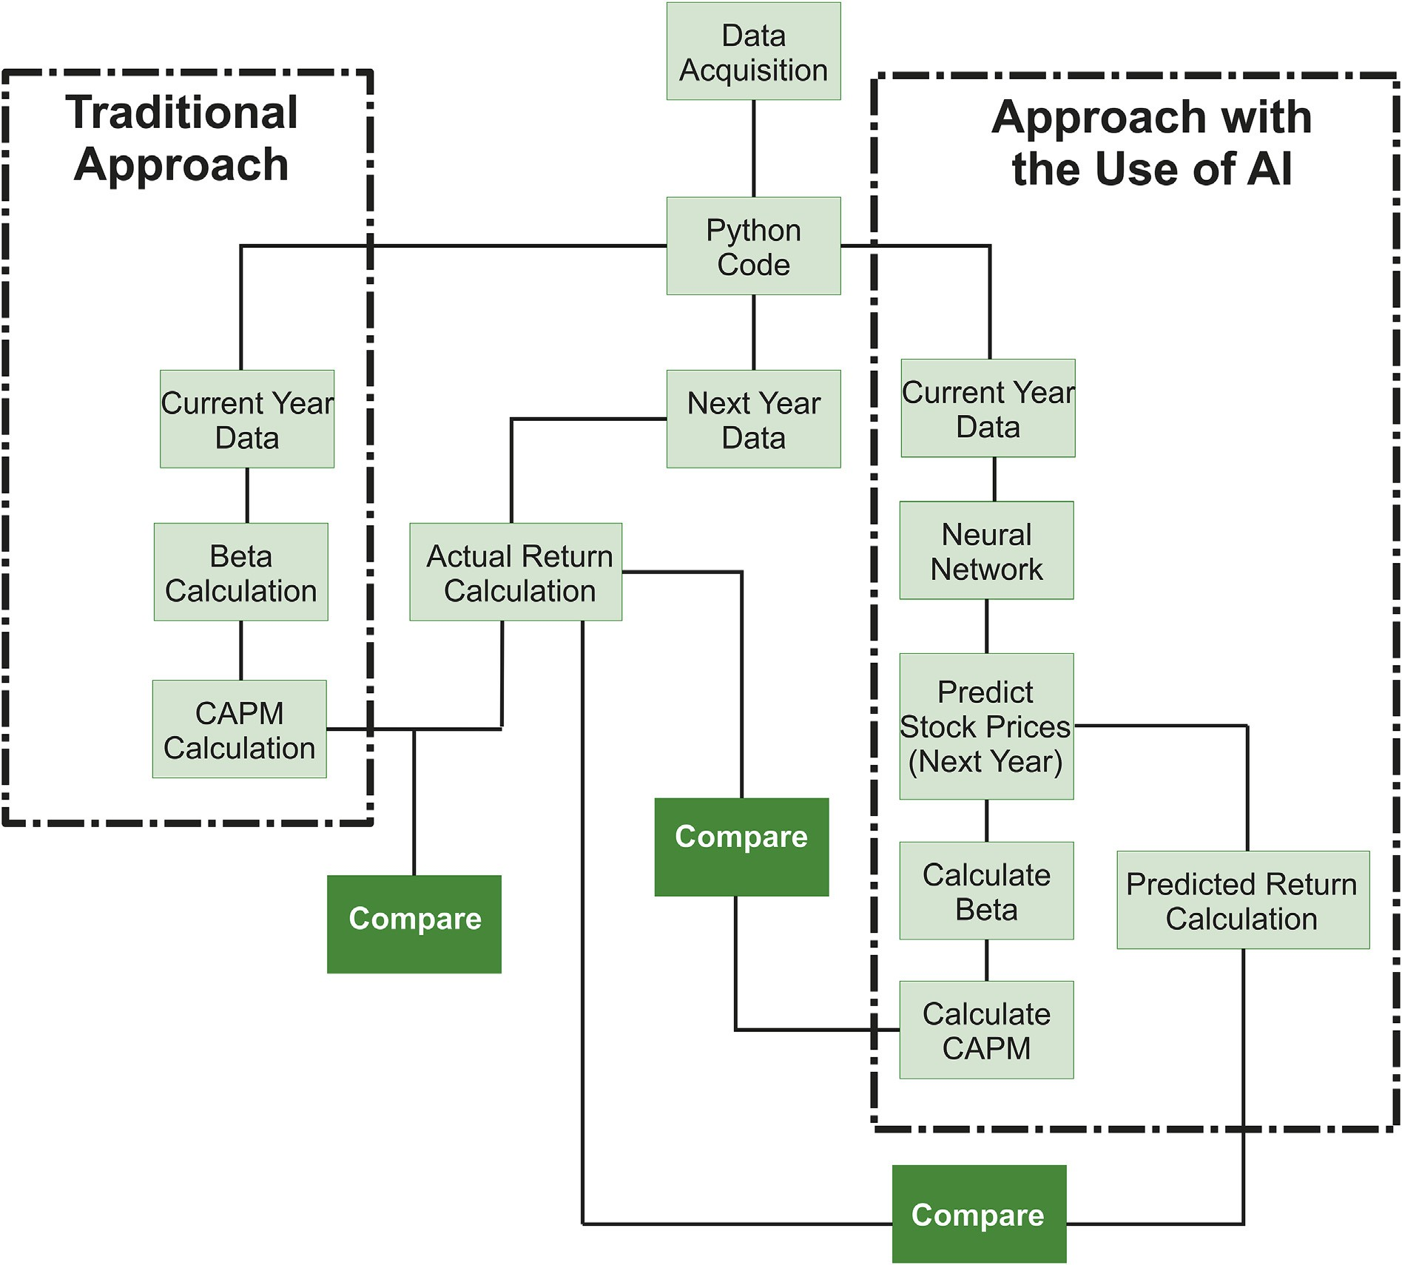

Fig. 1. : Research framework is demonstrated in the flowchart for better understanding of the process. It highlights the traditional and AI approaches while demonstrating which outcomes were compared to satisfy research hypothesis.

2018. These data are collected from [www.macrotrends.net](http://www.macrotrends.net/).

The companies that will be studied in this research include:

|  |  |  |
| --- | --- | --- |
| Company Name | Ticker | Debt to Equity Ratio (10 year) |
| Apple Inc. | AAPL | 0.73 |
| Microsoft Corp. | MSFT | 0.93 |
| Amazon.com Inc. | AMZN | 0.78 |
| Facebook Inc. | FB | 0.01 |
| Netflix, Inc. | NFLX | 1.86 |
| Alphabet Inc A | GOOGL | 0.02 |
| TripAdvisor | TRIP | 0.06 |
| Autodesk, Inc. | ADSK | —4.69 |
| Advanced Micro Devices, Inc. | AMD | 6.04 |
| Cisco Systems, Inc. S&P500 | CSCO  ^GSPC | 0.44 |

* 1. *Calculating Annual Average returns*

*R*log = log *P*1 = log*P*1 — log*P*2 (1)

where Rlog is the logarithmic rate of return, P1 is the adjusted closing price of the previous day and P2 is the adjusted closing price of today. Financial analysts rely on logarithmic return when they calculate the return of a single security. Although there is not an official rule for this calculation, it has been a common practice. It is important to note that since the stock market is open only 5 days every week, in this study for consistency the average daily return is multiplied by 250 to obtain the annual average return.

*P*2

* 1. *Calculating risk*

Financial analysts rely on variance to measure the dispersion of data around their means. Variance (S2) is defined in Equation (2).

The method used to calculate the return is the logarithmic rate of

return which is the logarithm value of ending price divided by the beginning price. This can be calculated using Equation (1):

*S*2 *X*–*Xavg* 2

(*N* — 1)

= X

(2)

To calculate the risk of a security, the variance of its returns that were

obtained in the previous section should be calculated. Once it is obtained, the value should be multiplied by 250 to obtain the annual variance of

security.

* 1. *Beta*

Beta is a measure that shows which stock is safer and which one is riskier. To do this calculation equation (3) should be used.

B = *Cov*(*rx*; *rm*),*stdm*2 (3)

where rx is covariance of stock return and rm is covariance of market return, and stdm is the standard deviation of the market; hence, calcu- lation of beta is an estimate of its riskiness in comparison to the rest of the market.

* 1. *CAPM*

Now that the beta is calculated, CAPM can be used to calculate ex- pected return of security using equation (4).

*ri* = *rf* + *βim* *rm* — *rf* (4)

where ri is the expected return, βim beta between market and stock, rf risk-free rate of return and rm is the market risk. The part in the bracket is also called risk premium. The risk-free value in this study is obtained from the five-year US government bond yield which is approximately 2.5%. Market risk is calculated using the logarithmic estimation of returns using the S&P500 index. This value should be calculated for the time span that is considered for prediction, in this paper it will be one year. Subtracting the market risk from risk free rate would result in a risk premium. Historically a value between 4.5% and 5.5% is used, and for consistency in this study the value of 5% will be used in CAPM calculation.

* 1. *Neural Network*

Neural networks are used to predict the future performance of stocks. Once this is predicted, the data can be used in two possible manners. First, using the predicted AI stock prices an annual return on the security will be calculated using the logarithmic method. Second, using the pre- dicted stock prices, the calculation of the CAPM will be repeated. In the second method, instead of using historical data, the predicted data is used for calculation. In this section, only the information that is required for the understanding of the algorithms are provided to enable a financial analyst to replicate the process. The details on how the equations were obtained and the mathematical concepts will not be discussed as they are outside of the scope of this study.

* 1. *Recurrent Neural Networks*

The recurrent neural network (AI algorithm) will be used to predict stock prices which later will be used in the calculation of expected returns. Stock prices are known as sequential data in the field of finance. Sequential data is defined as the data that follows a unique order, and each new data comes at a specific stage and cannot be randomly placed, for instance, due to being time-dependent. The most advanced and powerful AI that can process these data is called Recurrent Neural Network (RNN). Most major tech companies, including Google and Apple, are using this algorithm for various reasons including translations, voice recognition, adding subtitles and even stock price predictions [75–77].

In standard feedforward neural networks (FFNN), there is only one direction for the data to move. Because of this forward-moving pattern, the data of previous layers will be lost, and essentially there cannot be any internal state or memory. However, in RNN the data goes through a loop which means it can remember the past as well as the new data, (see Fig. 2). As an example, for financial data, it is required to be aware of the

prices in the previous day to predict the next day prices. If FFNN is used, it would not matter in which order the data are entered, and the pre- diction would not consider the sequence of data. However, in RNN and in terms of stock prices, the prediction will be dependent on the price of the previous day(s); hence, RNN is able to identify the differences between the prices and can predict the future with reasonable accuracy.

RNN has one major problem, and that is an issue which is termed as Vanishing Gradient. This occurs when the gradient (partial derivative with consideration of inputs) becomes so small that essentially prevents weights from having any effect. To overcome this problem, a new method has been proposed by Ref. [78] that is called Long Short Term Memory (LSTM). This method is briefly described next as it is used in this study to increase the accuracy of the predictions.

For calculations of RNN, the network is essentially unrolled over time (see Fig. 3), This technique is used to be able to go through the back- propagation for optimising the parameters of the neural network. Each output is essentially fed back into the calculation and this process enables the ability to memorise parameters over time.

* 1. *Long Short Term Memory (LSTM)*

LSTM has three main components that are called input, output and forget gates. The trick that is used in this method is that the cell as shown in Fig. 4, can remember data for a random duration of time and the three main components that act as regulators of information into this cell and out of this cell. Because of this unique structure of the system, the network will not have the vanishing problem and essentially will not forget the parameters. For this reason, LSTM is the best RNN algorithm for application to time series sequential data.

* 1. *Dense layer*

In neural networks, high dimensions of vectors are being used. To change a vector from “n” dimensions to “m” dimensions, a dense layer should be employed (see Fig. 5). In this study, the final layer is defined as a dense layer to reduce the number of outputs to 1 unit. In mathematical terms, matrix manipulation techniques including scaling, translation and rotation are being applied to achieve the desired output.

* 1. *TensorFlow and Cost function*

High-performance computations are commonly done through readily developed packages. TensorFlow is an open-source package developed by Google for developing machine learning and deep learning programs with various architectures [79]. The advantage of using such a platform is that the basic equations and rules are pre-defined in the library and the user can access and reach a solution in a much quicker manner. In this research, TensorFlow is imported in Python 3 for development of LSTM that predicts stock prices.

The cost function is defined as the mean squared error (MSE) as in Equation (5).

*MSE* = 1 X(*y* — ˇ*y* )2 (5)

*n*

*i*

*i*

*n i*=1

where n is the number of data, y is the predicted value and *y*ˇ is the actual value. Once the error was calculated, an optimisation method was used to minimise this value. The optimisation method that is used in this study is one that has proven to work well in deep learning problems and is called Adam optimisation. Due to the complexity of the mathematical concept behind this method, no further explanation is given about this algorithm. However, readers are encouraged to learn more about it from Kingma and Ba [80].

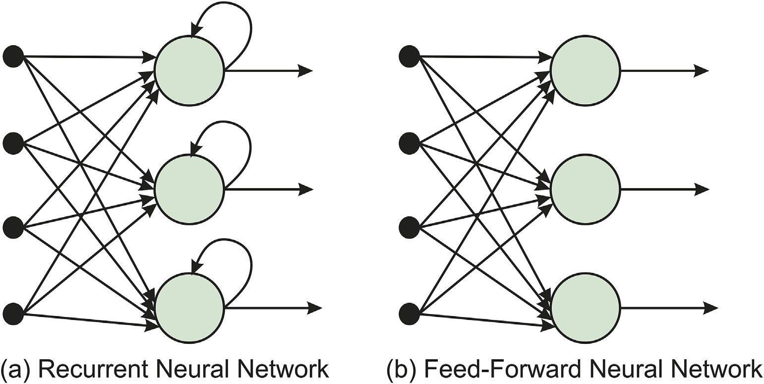

Fig. 2. The comparison between Recurrent Neural Network (RNN) and Feed-Forward Neural Network (FFNN). It demonstrates in FFNN there is only one direction for the data to move, whereas in RNN there is a loop.

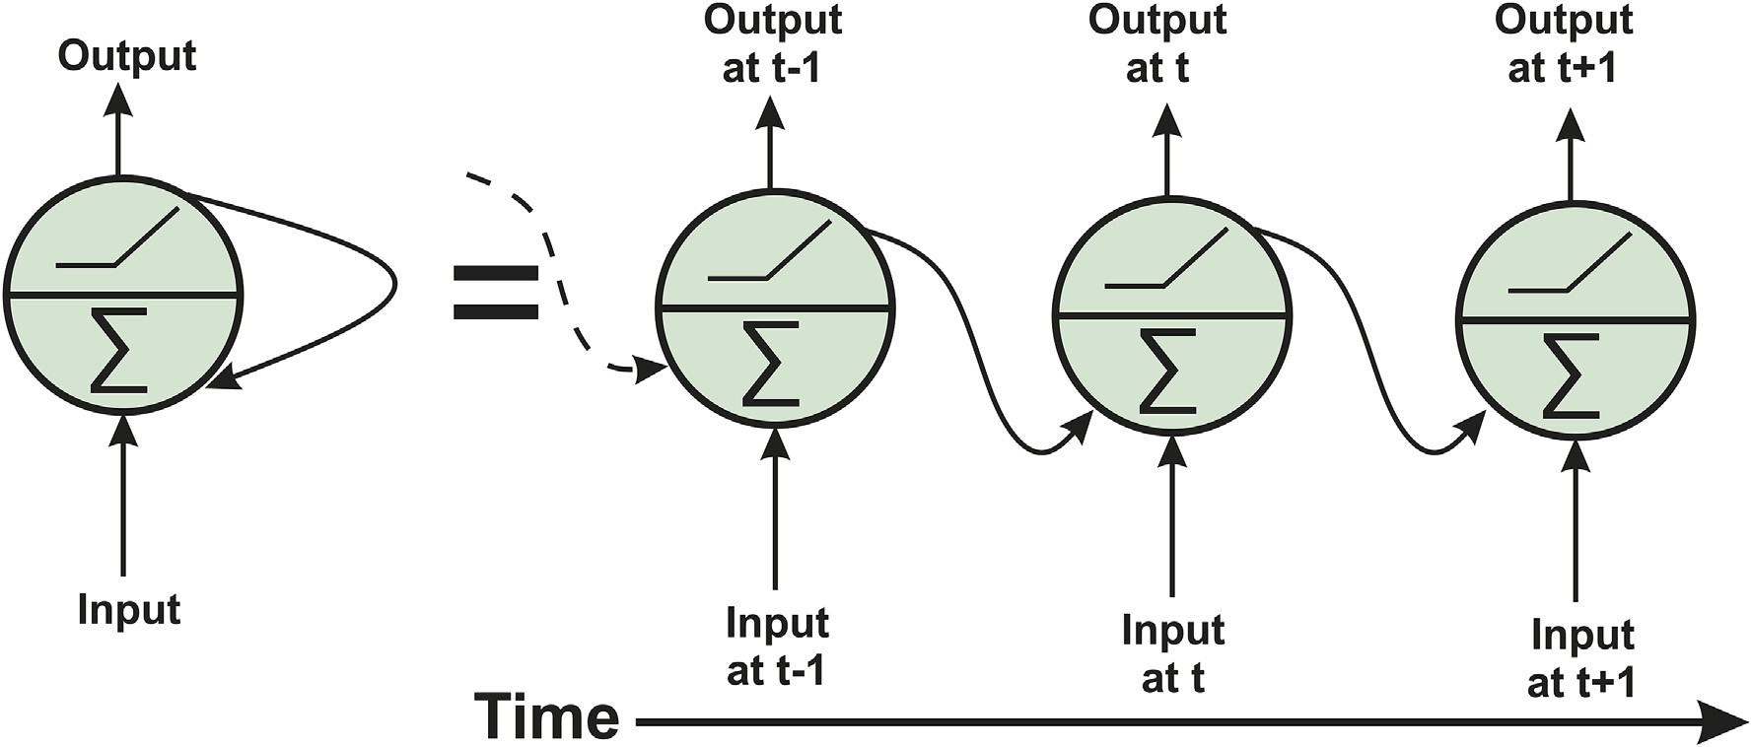

Fig. 3. The unrolled Recurrent Neural Network that is used in forward, and backward calculation is described over time as shown on the right side of the figure.

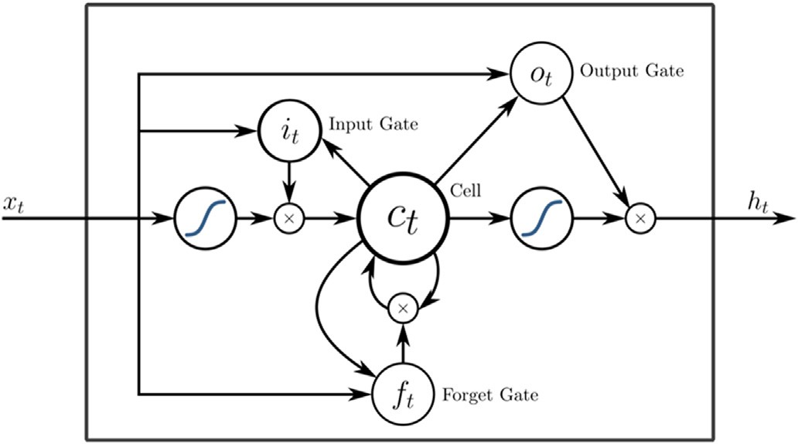

Fig. 4. LSTM unit architecture with three gates and the Cell. The gates can be compared with the neurons of FFNN. Further explanation is provided by Greff, Srivastava et al. [78].

* 1. *Testing and training*

The data is split into 90% training and 10% test sets. The input of the data is one-year stock prices starting and ending on the 1st of January. The reason 90% of data is utilised is that in one year there are

approximately 250 days that the stock market is open and the LSTM requires as many data as possible to predict them with good accuracy. The first 50 days are used as the features, and the subsequent prices are used as the label. Test and validation in this data set are not the same. The network was tested using 10% of the data obtained from the same financial year; however it is validated using the application of network to the upcoming year as shown in Figs. 6 and 7. It is important to note that the data are normalised between 0 and 1 using the training dataset. Then the same normalisation is applied to test data to maintain the consistency but reduce the biases associated with normalisation. This is because the test data is assumed to be unknown.

* 1. *Network architecture*

The network has LSTM layers that allow for a return sequence fol- lowed by one dropout layer. This is repeated three times and followed by a final LSTM layer where the return sequence is not allowed and another dropout layer. Finally, there is one dense layer that predicts one value for the output. Each layer has 40 neurons and the dropout rate is set to 20%. The batch size is set to 40 and epoch is set to 200, Fig. 5. Batch size is referring to the total number of training in each iteration. Each epoch is defined as one complete iteration that leads to the prediction of values and calculation of analysis cost. These parameters can be optimised for

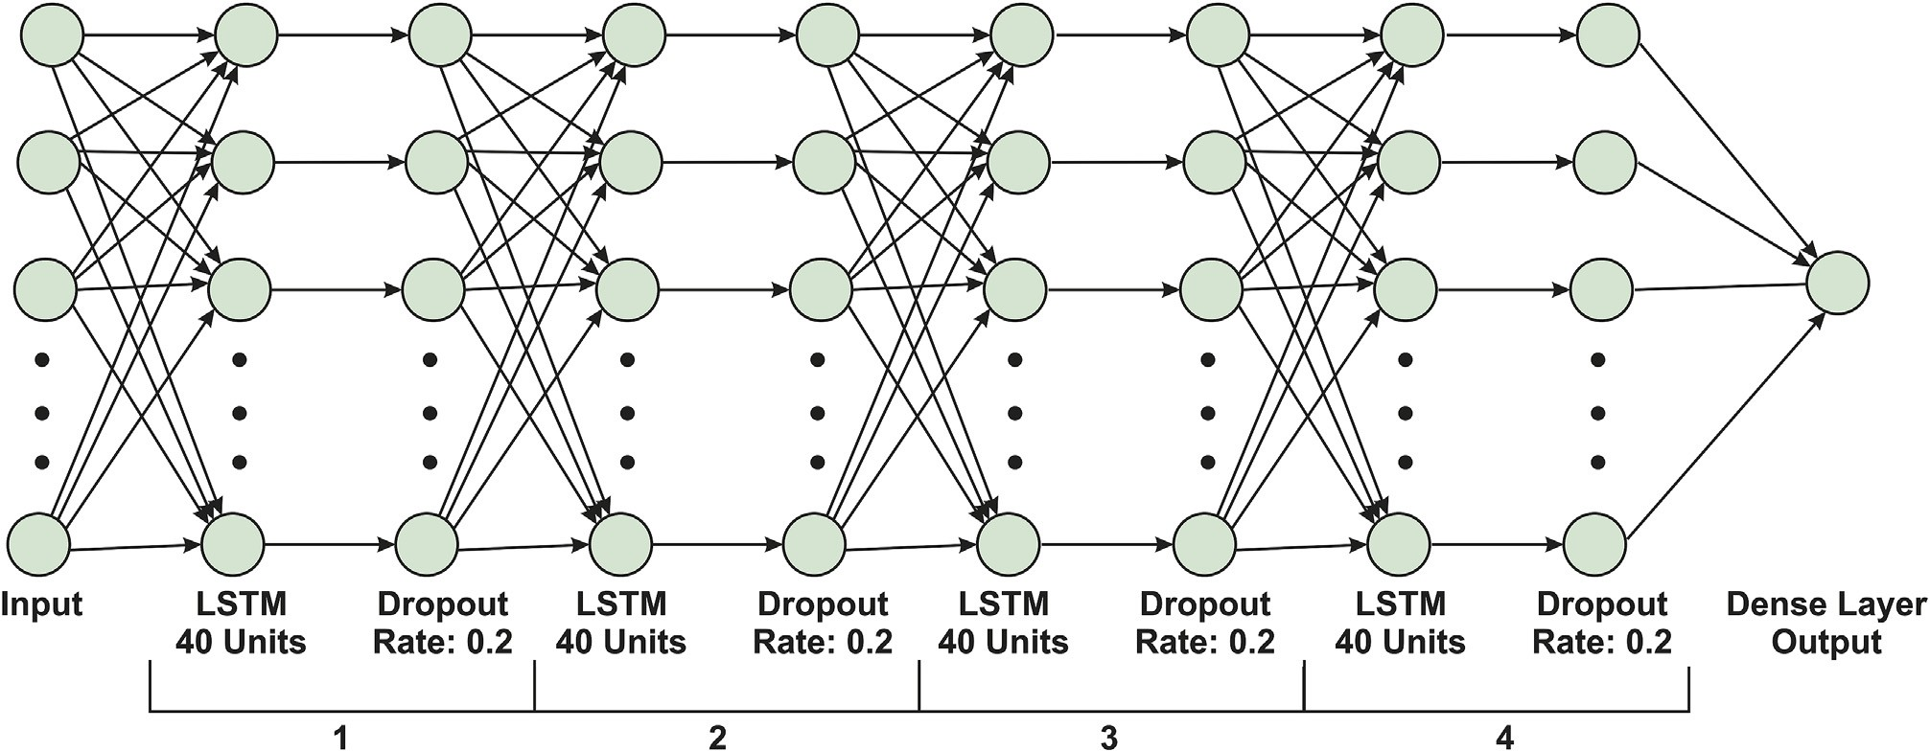

Fig. 5. A deep learning architecture where each hidden layer has 128 neurons and followed by a dropout layer. The final layer has changed dimension to only one neuron for the output through a dense layer. This is the network architecture used in this study.

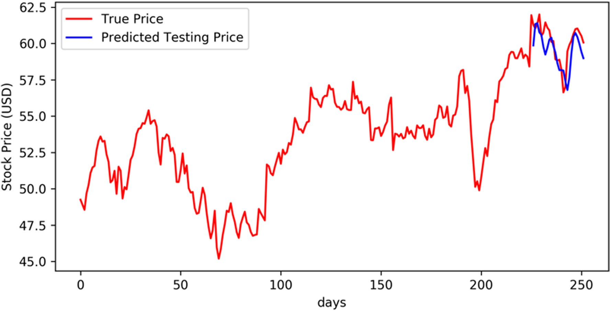

Fig. 6. The actual stock prices that are used to train the network are 90% of the data. 10% remaining of the data were used to test the network and is presented in the blue line.

each dataset to improve the performance of the network. However, for consistency and feasibility of this study, these parameters are kept as constants.

In this study, financial data of 10 companies were extracted. These data are extracted over six years among which five years are used for AI development. Data are entered year by year which means for each company the neural network should be trained five times. Also, this analysis should be repeated for the S&P 500 to predict the market per- formance as they are required in CAPM calculations.

* 1. *Outputs*

For clarity, in this section the outputs of the study should be described to enable the reader to make sense of the data that are produced following the procedures described in methodology section. First, using historical data of the past one year, CAPM (expected return) is calculated. Second, using the same data that are used to calculated CAPM, the LSTM was trained. Upon completion of this training, the network predicts the prices in the upcoming year from which a return is calculated. Third, the

estimated returns that are obtained from prediction of stock prices from the AI, are used in calculation of CAPM. At the same time, the actual return in the upcoming year was calculated from available data. Finally, the three return values that are obtained for the upcoming year are compared to the actual returns. This process repeated for all ten com- panies and for the period of six years. At the end to demonstrate the results, figures and tables are generated to enable a quick comparison of these finding.

* + 1. *Theoretical framework and development of hypotheses*

Scholars have viewed capital structure as either the leverage or ownership structure of the firm. The modern theory of capital structure was established by Modigliani and Miller [55]; and it is around the fact that financial decisions will come either with costs or benefits and the challenge is to estimate and maintain an optimum capital structure. In- vestors require to estimate the risk associated with every investment to determine the expected return [56]. The minimum return that is ex- pected from the capital structure is calculated through the cost of capital theories; hence, estimation of the cost of capital will require to rely on

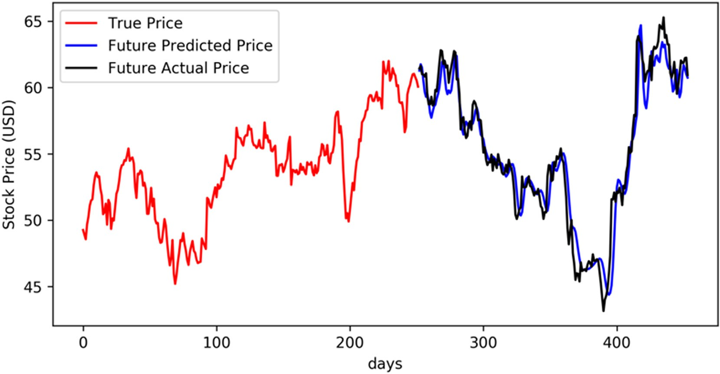

Fig. 7. The prediction of stock prices for the following year in comparison to the predicted values. The plot is showing two years of stock prices from the selected company.

both risk and future return on investments. It has, however, been argued that forecasting the return is perhaps the most problematic part of portfolio management models for investors [57].

It is argued that the efficient market will quickly reflect on the availability of information and prices will adjust accordingly (Fama and Makiel, 1970, Fama, 1991). This theory which is called the Efficient Market Hypothesis (EMH) has generated many arguments regarding predictive models. For instance, random walk theory implies that stock prices follow a random path and predicting them would not be possible [58]. Another theory attempted to estimate the expected return in regards to market risk which is called Capital Assets Pricing Model (CAPM) [59,60]. Many researchers have argued that EMH does not stand true [58]. For example, it was shown that weekly US stock prices are reasonably predictable through the use of pattern recognition tools [61, 62]; hence, this resulted in the development of a new theory called the Adaptive Market Hypothesis (AMH) that claims upon the availability of predictive information, the market will adjust itself [63]. As a result, only short-term predictability may be possible, but in long-term it will be self-destructive; hence, the research in predicting financial information may remain hidden to the public and be sold privately to investors or organisations [64].

Artificial intelligence and the use of learning algorithms and in particular neural network have gained substantial momentum in the field of finance [35]. It is believed that these algorithms are able to function better than both linear and non-linear regression analysis for a number of reasons including the ability to compensate for noise, react to changes in data [65], making no initial assumptions [66] and are able to find the best patterns between input and output data [67]. This leads to the first hypothesis of this research:

Hypothesis 1. Artificial Intelligence can be used in the cost of capital calculation to improve predictability

Multiple researchers have concluded that stock prices are following a non-linear pattern and traditional methods of statistics may not provide accurate predictions [35]. The successful usage of neural networks in the financial domain has been proven by many researchers [15]. Weighted Average Cost of Capital (WACC) is commonly used to determine the minimum return that should be earned by a business based on their capital structure [68]. This calculation relies on CAPM to estimate the cost of equity capital [69]. Although CAPM is still widely used, there are a number of limitations associated with its calculations. Since CAMP relies on the estimation of risk (beta), it is crucial to have an accurate

estimation of this value. Beta is calculated through linear regression analysis over a long period of historical data. As discussed earlier, the market is not behaving linearly and the usage of long-term historical data to linearly estimate risk will not be accurate [70–72]. This leads to the second hypothesis of this research.

Hypothesis 2. Artificial Intelligence can be used for a more accurate estimation of returns in comparison to the traditional method.

1. Results

This section contains all the data generated from this study. It is important to note that six years of adjusted closing stock prices were collected for ten high-tech companies as well as S&P500. These ten companies rely on equity financing with various portions as described in the methodology section. All neural network configurations remained the same, after an initial preliminary study on a few companies that showed the network is able to predict the prices reliably. Due to the substantial size of analysis performed, the graphs related to the perfor- mance of prediction of stock prices are briefly discussed, and an example is presented.

* 1. *AI performance*

The RNN was designed as described in the methodology section. To verify the performance of the network, various plots were produced for each time that the network was trained. Initially, the selected year data was split into two groups of training and testing sets. After the network was trained, a plot was provided to evaluate the performance of the network on the test set. This is only to demonstrate that the network parameters are able to predict reasonable results as it was necessary to be used as part of algorithm development and during programming stage. However, these data by no means are used as validation of the perfor- mance of the network. The network parameters were optimised until the error calculated using the objective function (Equation (5)) was found to be the lowest. To validate the performance, network parameters were deployed for analysis of the following year’s data. Again, to evaluate the performance of the network, another plot was provided where the actual data and predictions are compared.

Due to a large size of analysis in this section, the figures for only one company and only for one year is provided in this section as examples. The selected company is Autodesk, Inc. (ADSK) and the data of 2015–16

was used to predict 2016–17 prices. As shown in Fig. 6, the network was able to accurately predict the test data, which included the last 25 days of the year. The numerical values of the errors obtained from each case is arbitrary and varies from one case to another and since they would not add any information, are not presented.

Now that the network was trained, the financial data of the next year (2016) was extracted to compare them with the network predictions. The AI algorithm was able to predict the stock prices during this year quite accurately, as shown in Fig. 7. The prices of 2015 in conjunction of the actual and predicted prices on 2016 demonstrate that recurrent neural network is a suitable choice for prediction of stock prices and the network was able to establish an intricate pattern between dates and prices for this company that led to high accuracy prediction of the upcoming year prices, Fig. 8. Hence, this method of analysis is considered as reliable to be used on other datasets.

The network hyperparameters are kept constant in this study due the limitation in time and computational cost of the project. Hence, the re- sults of the AI algorithm on other companies or other years may be better or worse than the example provided in this section. However, the per- formance of the network is not the objective of this research. The aim of this section of the study was to demonstrate the selected network ar- chitecture is capable of predicting stock prices with reasonable accuracy. This would be enough to carry on with the rest of the study and satisfy research hypothesis. Hence readers should be aware that the perfor- mance of the network can certainly be improved if the target is to predict the future data more accurately.

* 1. *Comparison of findings*

An overall comparison is provided in this section, Table 1. The AI was able to accurately predict the stock prices in most cases, and this enabled AI to predict the most accurate returns in 9 out of 10 companies. The AI method used to calculate CAPM enabled a more accurate estimation of returns for 7 out of 10 companies in comparison to the traditional method. In 9 out of 10 companies AI was able to predict stock prices with less volatility (standard deviation) than the traditional method. The comparison between AI predicted CAPM and AI predicted return, AI predicted return was more reliable, less volatile and more accurate.

The traditional method of CAPM on average for all companies, using the values presented in Table 1, had an error of 102% and under- estimated the returns. This value (average values of all companies) for AI predicted CAPM was reduced by 18%, but still, returns were

underestimated. The overall error of AI predicted returns was 40% with the lowest standard deviation, Fig. 9. These results provide a clear and consistent message that enables to draw a conclusion on the use of AI in the estimation of returns that can be used to improve the cost of equity calculations. Based on these finding with the use of AI, cost of equity estimation can be improved over 60% which will influence WACC calculation significantly and improve the accuracy to a much higher degree. The results presented in this part were concerned with the ab- solute error to enable this comparison.

1. Discussion

It was discussed by Markowitz [56] that investors require to estimate the risk associated with any investments and this was reflected in the cost of capital calculations. Brock and De Lima [57] argued that forecasting returns are the most problematic part of designing a portfolio. One of the main reasons was that the market would quickly adjust itself as the new information became available. Although this argument formed the Effi- cient Market Hypothesis (EMH) [58], this was criticised by many other authors that predictive algorithms can forecast the return on security investments in short-term [61,62]. Compatible to the findings of these studies, it was clearly demonstrated in this research that up to one year of stock prices could be predicted with the least amount of information available for each of ten companies. This finding is contrary to Random Walk Theory which claims that prediction of market prices is not possible [58].

Two significant factors require an in-depth investigation based on

these literature arguments. First, the estimation of risk or beta parameter may not be needed any more with its current definition. This is because market volatility is not playing a significant role when stock prices can be predicted accurately which also impacts capital asset pricing models; hence, risk should be defined in a new manner that relates to the un- certainty associated with the prediction of stock prices using AI. Two possible methods could be suggested. One approach is to introduce a new algorithm that can incorporate uncertainty (probability of its occur- rences) as a multiplier to the predicted returns on security. Another method would be to evaluate the reliability of predictions on historical data and incorporate the standard deviation as the uncertainty associated with predictions.

Second, the argument provided in regards to market adjustments upon the availability of information or Adaptive Market Hypothesis (AMH) [63] may not stand valid anymore. This is true that the market

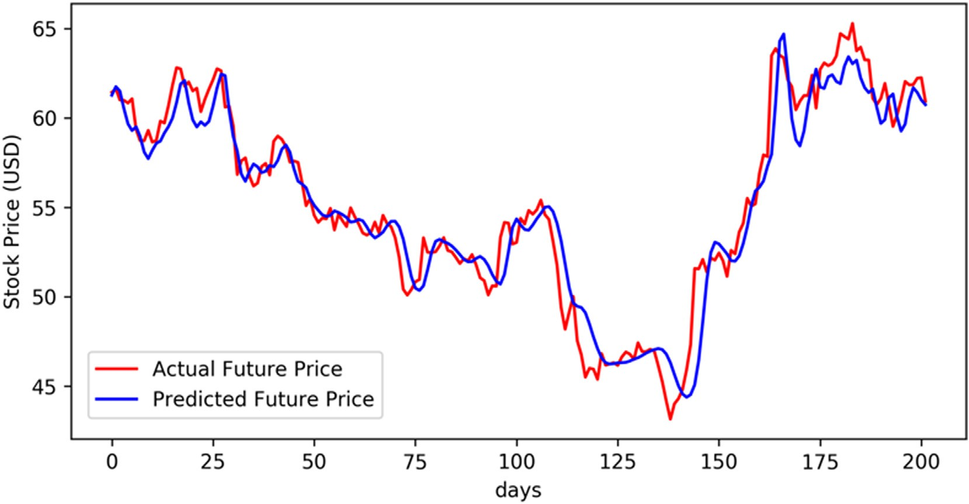

Fig. 8. The stock prices that are predicted for the upcoming year against the actual values. The plot is showing the ability of AI to predicted stock prices quite accurately.

Table 1

Summary of findings using three proposed methods for all 10 companies on average for five years.

|  |  |  |  |  |  |  |  |  |  |  |  |  |  |  |  |
| --- | --- | --- | --- | --- | --- | --- | --- | --- | --- | --- | --- | --- | --- | --- | --- |
|  | *APPL* |  |  | *MSFT* |  |  | *AMZN* |  |  | *FB* |  |  | *NFLX* |  |  |
| Avg. | SD |  | Avg. | SD |  | Avg. | SD |  | Avg. | SD |  | Avg. | SD |
| CAPM Error | —1.700 | 1.603 |  | —0.606 | 0.137 |  | —0.833 | 0.331 |  | —0.821 | 0.334 |  | —0.998 | 0.831 |  |
| AI Predicted CAPM Error | —1.008 | 0.342 |  | —0.696 | 0.207 |  | —1.128 | 0.278 |  | —0.377 | 1.247 |  | —0.873 | 0.169 |  |
| AI Predicted Return Error  CAPM Error | 0.436  *TRIP*  —1.063 | 1.718  0.774 |  | —0.347  *ADSK*  —0.433 | 0.349  0.261 |  | —0.295  *AMD*  —0.991 | 0.442  0.876 |  | 0.039  *GOOGL*  —1.469 | 0.878  1.933 |  | —0.678  *CSCO*  1.297 | 0.600  4.202 |  |
| AI Predicted CAPM Error | —0.562 | 1.405 |  | —0.412 | 1.357 |  | —0.745 | 0.750 |  | —0.737 | 0.911 |  | —1.895 | 2.608 |  |
| AI Predicted Return Error | 0.239 | 0.467 |  | —0.700 | 1.003 |  | —0.262 | 0.637 |  | —0.184 | 0.440 |  | —0.801 | 0.744 |  |

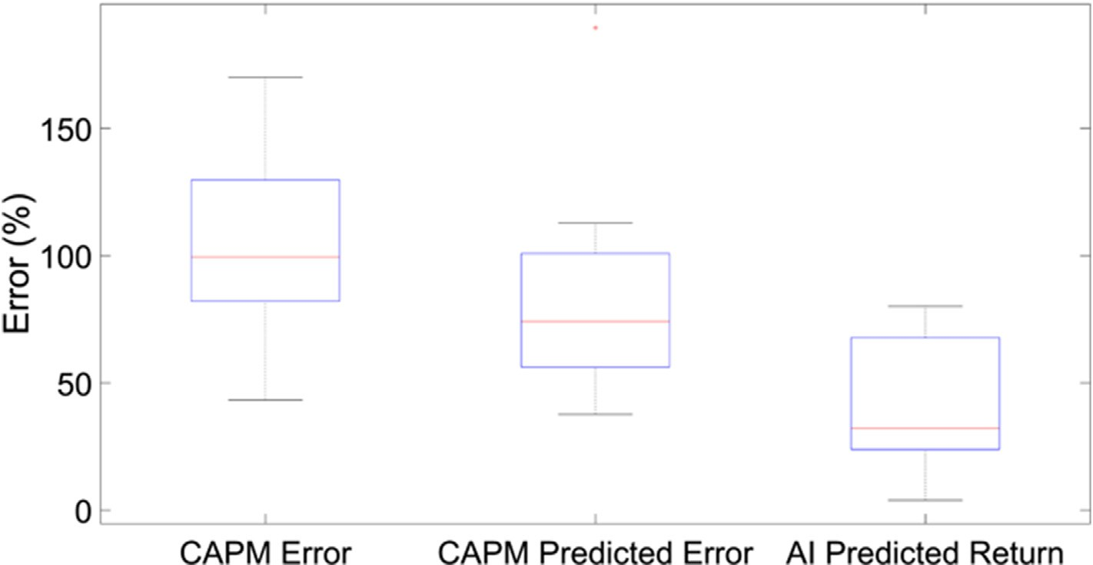

Fig. 9. Plot is demonstrating the mean (red line), standard deviation (blue box) and minimum and maximum value of the error using three methods. The error in this section presents the absolute value in percentage.

will adjust itself upon the availability of new information. However, as it was demonstrated in this research, AI algorithms including Recurrent Neural Networks (RNN) can adjust themselves in real-time. Hence this problem becomes an infinite loop of adjustments through both the market and algorithms to make the prices more volatile. Considering the nature of the stock market and the enormous number of available AI algorithms with various capabilities, it would be unrealistic for the market to be able to maintain this adjustment in a way that it competes with all predictive algorithms; hence, if these algorithms become publicly available and are used on a daily basis by most investors, the impact on the market would be extremely complicated to forecast at this stage. However, there is a good chance that AI can adapt and maintain a reasonably good accuracy of predictions.

A twenty years review on AI algorithms and their application in finance demonstrated that very few studies had used RNN [23]. The application of RNN on the prediction of inflation data was evaluated in a previous study that demonstrated the ability of these algorithms in dealing with non-linear data [81]. RNN was also applied to the prediction of foreign exchange rates and considered to be successful for imple- mentation in real-time prediction platforms [82]. More advanced RNN algorithms such as LSTM which was used in this study demonstrated a much better ability to predict stock prices in the Chinese market [53]. Heaton, Polson et al. [83] concluded that deep learning can detect be- haviours that are not visible to financial theories that currently exist. Compatible to literature, this study found that stock prices can be accu- rately predicted using deep learning recurrent neural networks that incorporated LSTM algorithms.

Direct application of AI to cost of capital could not be found in the literature. However, Nelson, Pereira et al. [84] showed that RNN could accurately predict the trend in the data. This is compatible with the concept of beta that is used as a risk factor in CAPM that attempts to use historical data to predict security trend in comparison to market [85].

This thesis combined the use of RNN with CAPM calculation and demonstrated that indeed it improves the accuracy of predictions compatible with findings of other scholars. Hsia, Fuller et al. [86] con- ducted a study and concluded that traditional beta might not be accurate and moving-average beta is able to predict the risk much more accu- rately. The use of beta in CAPM was only needed to estimate the expected return [87]. This research suggests that the cost of equity should not be estimated using asset pricing models such as CAPM anymore as the future can be predicted with reasonable accuracy. This goes beyond the debated in the literature on the topic that claims, “beta is dead” [86].

There are a number of limitations to this study. The data collected for this study considered only five years of historical data in ten high-tech public companies. This study used only one year of historical data to train the network and kept all hyperparameters and network architecture the same for various stocks. Optimising these parameters or using a larger dataset to train the network is very time consuming and requires unique customisation through trials and errors. Also the method selected for AI relied on literature, and comparison was not conducted between different algorithms. These issues were considered not timely and computationally feasible to be performed in this study; nevertheless they stand for interesting area for further research. This study focused on the US market which is considered a mature market. Researchers have shown that the artificial neural network (ANN) works quite well in these mar- kets [26]. Hence the application of findings in this study to emerging markets may result in a different outcome.

This study argued that the use of AI could provide better estimations of cost of capital and expected returns in comparison with traditional methods. Currently, application of AI requires knowledge of neural net- works and programming languages which may be considered complex to many financial analysts. The complexity of this problem is not associated with the use of the AI program. The complexity is in development of software that is capable of utilising the required (company-specific)

information with the critically selected algorithm to provide accurate estimations. The development of this software requires programming, mathematical and financial knowledge. With the availability of online tutorials, this challenge has become much more straightforward to tackle. Also once an AI engineer designs the network, optimisation of parameters is an easy job and can be done by anyone in the firm.

1. Conclusion

The focus of this study was to evaluate if AI could improve the ac- curacies associated with the estimation of cost of capital and expected returns. To do this, data of 10 public tech companies were collected, and traditional CAPM values were calculated every year for five years. The actual returns were also calculated using historical data. Then two methods of using AI was proposed that included estimation of returns directly from the predicted values, or calculation of CAPM using pre- dicted values.

Many scholars have introduced many different equations that help to improve the estimation of returns [11–14]. However, to the authors’ knowledge, no one has used AI in the calculation of the cost of capital to improve the accuracy of estimations. In this study, AI was used to predict future stock prices, and the algorithm used for this purpose was Recur- rent Neural Networks (RNNs). RNNs, which is a deep learning algorithm, showed an outstanding ability to find intricate patterns between sequential data [84]. The RNN used in this study utilised a recently developed algorithm proposed by Greff, Srivastava et al. [78] that has not been applied to prediction of cost of capital. The performance of this algorithm is further reinforced when the stock prices were predicted in this study to estimate returns.

Two possible methods were considered that would enable the implementation of AI in the cost of equity calculation. First, to predict future stock prices and calculate the returns directly from the predictions. Second, to predict the stock prices and market behaviour and then calculate CAPM using forecasted data. Lastly, to be able to compare the AI method and traditional CAPM calculations and find the one that provides the most accurate prediction of returns, the true value was needed. For this reason, the true value of return was calculated using actual stock prices in the following year.

For the purpose of analysing securities, the adjusted closing stock prices of 10 public tech companies were exported. These prices were collected for the past six years, starting from January 1, 2019. This research assumed that there is a need to predict returns for the next year. Hence one year of historical data was used to calculate traditional CAPM value and also train the RNN to predict stock prices of the upcoming year. As it is known from the nature of AI algorithms, the more data provided, the more accurate the network will become. However, in terms of CAPM calculation, the more data that provided, the less reliable the prediction may become [88]. This is because the future may not reflect historical patterns. For consistency in this study, only one year of historical data was used in both traditional and AI methods.

In regard to the use of AI algorithms, three critical aspects should be considered. These include the cleaning of the dataset, optimisation of hyperparameters and network architecture. In this study, the dataset was collected from “Yahoo Finance!” which was already clean and ready to be used in the network. A generic deep learning network architecture was developed with the use of LSTM and dropout layers. This network was tested on stock prices of a few companies and showed a reasonably strong ability to predict future prices. Also, hyperparameters were tuned for a limited number of data to achieve reasonable accuracy. Tuning the hyperparameters or optimising the architecture of the network is very time-consuming. This is because there is no correct formula for selecting them and they must be achieved through trial and error.

The difficulty of training and using AI algorithms may be a reason that the use of AI in the cost of equity was not explored before. It is natural for a Chief Financial Officer (CFO) to rely on simple equations that can calculate returns very quickly instead of learning how to deal with

sophisticated AI methods. In this study, to overcome this bias of variation in AI algorithms and networks, once the network was optimised on a limited number of data, all the parameters and architecture were kept the same. Of course, in ideal circumstances, these parameters should be optimised. However, the selected method would show whether the use of a generic neural network, designed and developed by an AI engineer, would be superior to traditional methods or not. This would simulate the situation that financial analysts only uses the algorithm without having any prior knowledge of AI or programming to predict stock prices. As a result of this issue, the network may not have performed flawlessly on some of the datasets.

By studying the results, in most cases when traditional CAPM is compared to the actual returns, it was found that the traditional value was consistently underestimating the returns in all ten companies and all five years. In many cases, AI predicted CAPM followed the same pattern. On average, the AI predicted CAPM was able to predict a more accurate return in comparison to the traditional method. This accuracy on average was 18% closer to the actual value. So by replacing this new method into the cost of capital calculation, the results of WACC can be improved by 18%.

When comparing AI predicted returns with traditional CAPM, it was noticed that consistently AI predicted returns were closer to the actual returns. Quantitatively on average AI was calculated to be 60% more accurate. Also, the AI predicted returns had the smallest standard devi- ation, which means there was a reasonably good consistency in the prediction of future returns. The implementation of this method in WACC would significantly increase the accuracy of the cost of capital calcula- tion. It should be noted that if the network parameters and architecture are optimised, these values are likely to improve and get closer to actual returns.

One major challenge was identified from the outcome of this study. It was demonstrated that the cost of equity is significantly underestimated due to the use of CAPM in calculations; hence, using the newly proposed method, the cost of equity capital should increase using the WACC for- mula. This means that the balance for the optimum capital structure will be disturbed if the new method is used and corporations may find that a new balance is required to maximise the value of the firm for share- holders [1,89]. If the same cost of capital is to be maintained, an increase in the debt portion of capital structure would be needed otherwise firms will increase their overall cost of capital. This may limit investment op- tions as higher rates should be considered [6].

As discussed by many researchers [90–93] capital structure cannot be modified instantly; hence, firms try to maintain a balance over time, and there is always a delay in response to the market changes. One signifi- cantly positive advantage of using AI in the cost of capital calculations that is found in this study would be the ability to estimate this value accurately and at any point in time; hence, firms can more accurately plan ahead to optimise their capital structure for achieving a particular cost of capital. This could be an essential asset to guide financial decision made by Chief Financial Officers (CFOs).

The main disadvantage would be the challenges that may arise upon the availability of this information to the public. It was also discussed that due to the ability of AI algorithms to accurately predict stock prices, the use of asset pricing models or estimation of risk (beta) may not be needed anymore; hence, it was proposed that a new parameter should be created to enable estimation of uncertainties related to predicted values. To the author’s knowledge, this is the first time that AI was applied in the estimation of the cost of equity; hence, this study has the potential to disturb the research in the cost of equity estimation to an entirely new era of artificial intelligence that linear or simplistic approaches are no longer a solution. This can only happen if these algorithms are commonly being used and empirical studies to be performed on their ability and impact on financial decisions made by corporations and investors.

There are some suggestions for future research in this field. This study demonstrated that CAPM is consistently underestimating the expected returns. This was concluded based on the data collected from 10 high

tech companies during the period of January 1, 2013 to January 1, 2019; hence, there may be a need to add an offset to CAPM estimation to adjust its value to be closer to the actual returns. The network architecture and hyperparameters should be optimised for each case to improve the ac- curacy of predictions. This can be enhanced by training the network using a much larger dataset. A perfect prediction of stock prices could almost completely eliminate the need to using any asset pricing models or estimation of risk (beta). This study predicted the returns for the up- coming year on any selected security. To design a portfolio, financial analysts may require predicting returns on shorter terms (quarterly) or longer-term (5–10 years); hence, evaluation of AI performance would be necessary for these periods.

As the community starts to trust the prediction of stock prices using AI, there will be a need to develop a new parameter that can evaluate the uncertainties associated with predictions. This could serve as a replace- ment to the beta which measures the risk in any investment. This research focused on the application of AI in one industry (high-tech) that is based in the US market. Future research should evaluate the outcome of this analysis in other markets and industries to increase the reliability of these findings. Since CAPM is used in portfolio planning, future research should explore the impact of using AI in designing portfolios in comparison to traditional CAPM method.

Financial Disclosure(s)

This research did not receive any specific grant from funding agencies in the public, commercial, or not-for-profit sectors.

Contributions

AE conceptualised and designed the project, conducted the research, performed analysis and data interpretation and drafted the manuscript. JP supervised the project, assisted with data interpretation and reviewed the manuscript.

Declaration of competing interest

The authors report no conflicts of interest. The authors alone are responsible for the content and writing of the paper.

References

1. [Abor J. The effect of capital structure on pro](http://refhub.elsevier.com/S2590-0056(20)30002-3/sref1)fi[tability: an empirical analysis of listed](http://refhub.elsevier.com/S2590-0056(20)30002-3/sref1)

[firms in Ghana. J Risk Financ 2005;6(5):438](http://refhub.elsevier.com/S2590-0056(20)30002-3/sref1)–[45](http://refhub.elsevier.com/S2590-0056(20)30002-3/sref1).

1. [Trombley TE, Haddad KM. Cost of capital techniques used by Chinese](http://refhub.elsevier.com/S2590-0056(20)30002-3/sref2) fi[rms: a](http://refhub.elsevier.com/S2590-0056(20)30002-3/sref2) [survey of practice. Quarterly Journal of Finance](http://refhub.elsevier.com/S2590-0056(20)30002-3/sref2) & [Accounting 2018;56](http://refhub.elsevier.com/S2590-0056(20)30002-3/sref2).
2. [Harris M, Raviv A. The theory of capital structure. J Financ 1991;46(1):297](http://refhub.elsevier.com/S2590-0056(20)30002-3/sref3)–[355](http://refhub.elsevier.com/S2590-0056(20)30002-3/sref3).
3. [Fama EF. Risk, return and equilibrium: some clarifying comments. J Financ 1968;](http://refhub.elsevier.com/S2590-0056(20)30002-3/sref4) [23(1):29](http://refhub.elsevier.com/S2590-0056(20)30002-3/sref4)–[40](http://refhub.elsevier.com/S2590-0056(20)30002-3/sref4).
4. [Febrian E, Herwany A. CAPM and APT validation test before, during, and after](http://refhub.elsevier.com/S2590-0056(20)30002-3/sref5) [financial crisis in emerging market: evidence from Indonesia. Int J Business Finance](http://refhub.elsevier.com/S2590-0056(20)30002-3/sref5) [Res 2010;10(1)](http://refhub.elsevier.com/S2590-0056(20)30002-3/sref5).
5. [Poterba JM. Comparing the cost of capital in the United States and Japan: a survey](http://refhub.elsevier.com/S2590-0056(20)30002-3/sref6) [of methods. Fed Reserve Bank N Y Q Rev 1991;15(3](http://refhub.elsevier.com/S2590-0056(20)30002-3/sref6)–[4):20](http://refhub.elsevier.com/S2590-0056(20)30002-3/sref6)–[32](http://refhub.elsevier.com/S2590-0056(20)30002-3/sref6).
6. [Campbell JY, Vuolteenaho T. Bad beta, good beta. Am Econ Rev 2004;94(5):](http://refhub.elsevier.com/S2590-0056(20)30002-3/sref7) [1249](http://refhub.elsevier.com/S2590-0056(20)30002-3/sref7)–[75](http://refhub.elsevier.com/S2590-0056(20)30002-3/sref7).
7. [Brealey RA, et al. Principles of corporate](http://refhub.elsevier.com/S2590-0056(20)30002-3/sref8) fi[nance. Tata McGraw-Hill Education;](http://refhub.elsevier.com/S2590-0056(20)30002-3/sref8) [2012](http://refhub.elsevier.com/S2590-0056(20)30002-3/sref8).
8. [Lakonishok J, Shapiro AC. Stock returns, beta, variance and size: an empirical](http://refhub.elsevier.com/S2590-0056(20)30002-3/sref9) [analysis. Financ Anal J 1984;40(4):36](http://refhub.elsevier.com/S2590-0056(20)30002-3/sref9)–[41](http://refhub.elsevier.com/S2590-0056(20)30002-3/sref9).
9. [LeBaron B, et al. Time series properties of an arti](http://refhub.elsevier.com/S2590-0056(20)30002-3/sref10)fi[cial stock market. J Econ Dyn](http://refhub.elsevier.com/S2590-0056(20)30002-3/sref10) [Control 1999;23(9](http://refhub.elsevier.com/S2590-0056(20)30002-3/sref10)–[10):1487](http://refhub.elsevier.com/S2590-0056(20)30002-3/sref10)–[516](http://refhub.elsevier.com/S2590-0056(20)30002-3/sref10).
10. [Shanken J. Multi-beta CAPM or equilibrium-APT?: a reply. J Financ 1985;40(4):](http://refhub.elsevier.com/S2590-0056(20)30002-3/sref11) [1189](http://refhub.elsevier.com/S2590-0056(20)30002-3/sref11)–[96](http://refhub.elsevier.com/S2590-0056(20)30002-3/sref11).
11. [Eun CS. The benchmark beta, CAPM, and pricing anomalies. Oxf Econ Pap 1994:](http://refhub.elsevier.com/S2590-0056(20)30002-3/sref12) [330](http://refhub.elsevier.com/S2590-0056(20)30002-3/sref12)–[43](http://refhub.elsevier.com/S2590-0056(20)30002-3/sref12).
12. [Adrian T, Franzoni F. Learning about beta: time-varying factor loadings, expected](http://refhub.elsevier.com/S2590-0056(20)30002-3/sref13) [returns, and the conditional CAPM. J Empir Financ 2009;16(4):537](http://refhub.elsevier.com/S2590-0056(20)30002-3/sref13)–[56](http://refhub.elsevier.com/S2590-0056(20)30002-3/sref13).
13. [Abbas Q, et al. From regular-beta CAPM to downside-beta CAPM. Eur J Soc Sci](http://refhub.elsevier.com/S2590-0056(20)30002-3/sref14) [2011;21(2):189](http://refhub.elsevier.com/S2590-0056(20)30002-3/sref14)–[203](http://refhub.elsevier.com/S2590-0056(20)30002-3/sref14).
14. [Enke D, Thawornwong S. The use of data mining and neural networks for](http://refhub.elsevier.com/S2590-0056(20)30002-3/sref15) [forecasting stock market returns. Expert Syst Appl 2005;29(4):927](http://refhub.elsevier.com/S2590-0056(20)30002-3/sref15)–[40](http://refhub.elsevier.com/S2590-0056(20)30002-3/sref15).
15. [Jarrahi MH. Artificial intelligence and the future of work: human-AI symbiosis in](http://refhub.elsevier.com/S2590-0056(20)30002-3/sref16) [organizational decision making. Bus Horiz 2018;61(4):577](http://refhub.elsevier.com/S2590-0056(20)30002-3/sref16)–[86](http://refhub.elsevier.com/S2590-0056(20)30002-3/sref16).
16. [Davenport TH. Rise of the strategy machines. MIT Sloan Manag Rev 2016;58(1):29](http://refhub.elsevier.com/S2590-0056(20)30002-3/sref17).
17. [Frey CB, Osborne MA. The future of employment: how susceptible are jobs to](http://refhub.elsevier.com/S2590-0056(20)30002-3/sref18) [computerisation? Technol Forecast Soc Chang 2017;114:254](http://refhub.elsevier.com/S2590-0056(20)30002-3/sref18)–[80](http://refhub.elsevier.com/S2590-0056(20)30002-3/sref18).
18. [Bae JK. Predicting financial distress of the South Korean manufacturing industries.](http://refhub.elsevier.com/S2590-0056(20)30002-3/sref19) [Expert Syst Appl 2012;39(10):9159](http://refhub.elsevier.com/S2590-0056(20)30002-3/sref19)–[65](http://refhub.elsevier.com/S2590-0056(20)30002-3/sref19).
19. [Liu L, Wang Y. Radial basis function support vector machine based soft-magnetic](http://refhub.elsevier.com/S2590-0056(20)30002-3/sref20) [ring core inspection. In: International conference on computational and information](http://refhub.elsevier.com/S2590-0056(20)30002-3/sref20) [science. Springer; 2005](http://refhub.elsevier.com/S2590-0056(20)30002-3/sref20).
20. [Wong BK, Selvi Y. Neural network applications in finance: a review and analysis of](http://refhub.elsevier.com/S2590-0056(20)30002-3/sref21) [literature (1990](http://refhub.elsevier.com/S2590-0056(20)30002-3/sref21)–[1996). Inf Manag 1998;34(3):129](http://refhub.elsevier.com/S2590-0056(20)30002-3/sref21)–[39](http://refhub.elsevier.com/S2590-0056(20)30002-3/sref21).
21. [Wong BK, et al. A bibliography of neural network business applications research:](http://refhub.elsevier.com/S2590-0056(20)30002-3/sref22) [1994](http://refhub.elsevier.com/S2590-0056(20)30002-3/sref22)–[1998. Comput Oper Res 2000;27(11](http://refhub.elsevier.com/S2590-0056(20)30002-3/sref22)–[12):1045](http://refhub.elsevier.com/S2590-0056(20)30002-3/sref22)–[76](http://refhub.elsevier.com/S2590-0056(20)30002-3/sref22).
22. [Tk´](http://refhub.elsevier.com/S2590-0056(20)30002-3/sref23)aˇc [M, Verner R. Arti](http://refhub.elsevier.com/S2590-0056(20)30002-3/sref23)fi[cial neural networks in business: two decades of research.](http://refhub.elsevier.com/S2590-0056(20)30002-3/sref23)

[Appl Soft Comput 2016;38:788](http://refhub.elsevier.com/S2590-0056(20)30002-3/sref23)–[804](http://refhub.elsevier.com/S2590-0056(20)30002-3/sref23).

1. [Mohamad H, et al. Assessment of the expected construction company’s net pro](http://refhub.elsevier.com/S2590-0056(20)30002-3/sref24)fi[t](http://refhub.elsevier.com/S2590-0056(20)30002-3/sref24) [using neural network and multiple regression models. Ain Shams Eng J 2013;4(3):](http://refhub.elsevier.com/S2590-0056(20)30002-3/sref24) [375](http://refhub.elsevier.com/S2590-0056(20)30002-3/sref24)–[85](http://refhub.elsevier.com/S2590-0056(20)30002-3/sref24).
2. [White H. Neural-network learning and statistics. AI Expet 1989:48](http://refhub.elsevier.com/S2590-0056(20)30002-3/sref25)–[52](http://refhub.elsevier.com/S2590-0056(20)30002-3/sref25).
3. [Cao Q, et al. A comparison between Fama and French’s model and artificial neural](http://refhub.elsevier.com/S2590-0056(20)30002-3/sref26) [networks in predicting the Chinese stock market. Comput Oper Res 2005;32(10):](http://refhub.elsevier.com/S2590-0056(20)30002-3/sref26) [2499](http://refhub.elsevier.com/S2590-0056(20)30002-3/sref26)–[512](http://refhub.elsevier.com/S2590-0056(20)30002-3/sref26).
4. [Kryzanowski L, et al. Using artificial neural networks to pick stocks. Financ Anal J](http://refhub.elsevier.com/S2590-0056(20)30002-3/sref27) [1993;49(4):21](http://refhub.elsevier.com/S2590-0056(20)30002-3/sref27)–[7](http://refhub.elsevier.com/S2590-0056(20)30002-3/sref27).
5. [Sharda R, Patil RB. Connectionist approach to time series prediction: an empirical](http://refhub.elsevier.com/S2590-0056(20)30002-3/sref28) [test. J Intell Manuf 1992;3(5):317](http://refhub.elsevier.com/S2590-0056(20)30002-3/sref28)–[23](http://refhub.elsevier.com/S2590-0056(20)30002-3/sref28).
6. [Qi M, Maddala G. Economic factors and the stock market: a new perspective.](http://refhub.elsevier.com/S2590-0056(20)30002-3/sref29) [J Forecast 1999;18(3):151](http://refhub.elsevier.com/S2590-0056(20)30002-3/sref29)–[66](http://refhub.elsevier.com/S2590-0056(20)30002-3/sref29).
7. [Lenard MJ, et al. The application of neural networks and a qualitative response](http://refhub.elsevier.com/S2590-0056(20)30002-3/sref30) [model to the auditor’s going concern uncertainty decision. Decis Sci J 1995;26(2):](http://refhub.elsevier.com/S2590-0056(20)30002-3/sref30) [209](http://refhub.elsevier.com/S2590-0056(20)30002-3/sref30)–[27](http://refhub.elsevier.com/S2590-0056(20)30002-3/sref30).
8. [Turban E, Trippi R. Neural Networks in Finance and Investing. Using artificial](http://refhub.elsevier.com/S2590-0056(20)30002-3/sref31) [neural intelligence to improve real-world performance. Chicago Illinois,](http://refhub.elsevier.com/S2590-0056(20)30002-3/sref31) [Cambridge, England: Probus Publishing Company; 1996](http://refhub.elsevier.com/S2590-0056(20)30002-3/sref31).
9. [Hu MY, et al. A cross-validation analysis of neural network out-of-sample](http://refhub.elsevier.com/S2590-0056(20)30002-3/sref32) [performance in exchange rate forecasting. Decis Sci J 1999;30(1):197](http://refhub.elsevier.com/S2590-0056(20)30002-3/sref32)–[216](http://refhub.elsevier.com/S2590-0056(20)30002-3/sref32).
10. [Zhu D, et al. Data mining for network intrusion detection: a comparison of](http://refhub.elsevier.com/S2590-0056(20)30002-3/sref33) [alternative methods. Decis Sci J 2001;32(4):635](http://refhub.elsevier.com/S2590-0056(20)30002-3/sref33)–[60](http://refhub.elsevier.com/S2590-0056(20)30002-3/sref33).
11. [Papatla P, et al. Leveraging the strengths of choice models and neural networks: a](http://refhub.elsevier.com/S2590-0056(20)30002-3/sref34) [multiproduct comparative analysis. Decis Sci J 2002;33(3):433](http://refhub.elsevier.com/S2590-0056(20)30002-3/sref34)–[61](http://refhub.elsevier.com/S2590-0056(20)30002-3/sref34).
12. [Zhang G, et al. Forecasting with arti](http://refhub.elsevier.com/S2590-0056(20)30002-3/sref35)fi[cial neural networks:: the state of the art. Int J](http://refhub.elsevier.com/S2590-0056(20)30002-3/sref35) [Forecast 1998;14(1):35](http://refhub.elsevier.com/S2590-0056(20)30002-3/sref35)–[62](http://refhub.elsevier.com/S2590-0056(20)30002-3/sref35).
13. [Fadlalla A, Lin C-H. An analysis of the applications of neural networks in](http://refhub.elsevier.com/S2590-0056(20)30002-3/sref36) fi[nance.](http://refhub.elsevier.com/S2590-0056(20)30002-3/sref36) [Interfaces 2001;31(4):112](http://refhub.elsevier.com/S2590-0056(20)30002-3/sref36)–[22](http://refhub.elsevier.com/S2590-0056(20)30002-3/sref36).
14. [Kimoto T, et al. Stock market prediction system with modular neural networks.](http://refhub.elsevier.com/S2590-0056(20)30002-3/sref37) [Neural Networks. 1990. In: 1990 IJCNN international joint conference on. IEEE;](http://refhub.elsevier.com/S2590-0056(20)30002-3/sref37) [1990](http://refhub.elsevier.com/S2590-0056(20)30002-3/sref37).
15. [Ferson WE, Harvey CR. The risk and predictability of international equity returns.](http://refhub.elsevier.com/S2590-0056(20)30002-3/sref38) [Rev Financ Stud 1993;6(3):527](http://refhub.elsevier.com/S2590-0056(20)30002-3/sref38)–[66](http://refhub.elsevier.com/S2590-0056(20)30002-3/sref38).
16. [McGrath C. Terminator portfolio. Kiplinger’s Personal Finance 2002;56(7). 56-56](http://refhub.elsevier.com/S2590-0056(20)30002-3/sref39).
17. [McNelis PD. A neural network analysis of Brazilian stock price dynamics: tequila](http://refhub.elsevier.com/S2590-0056(20)30002-3/sref40) [effects vs. Pisco sour effects. Georgetown University; 1996](http://refhub.elsevier.com/S2590-0056(20)30002-3/sref40).
18. [Coakley JR, Brown CE. Arti](http://refhub.elsevier.com/S2590-0056(20)30002-3/sref41)fi[cial neural networks in accounting and](http://refhub.elsevier.com/S2590-0056(20)30002-3/sref41) fi[nance:](http://refhub.elsevier.com/S2590-0056(20)30002-3/sref41) [modeling issues. Intell Syst Account Financ Manag 2000;9(2):119](http://refhub.elsevier.com/S2590-0056(20)30002-3/sref41)–[44](http://refhub.elsevier.com/S2590-0056(20)30002-3/sref41).
19. [Adnan Aziz M, Dar H As. Predicting corporate bankruptcy: where we stand? Corp](http://refhub.elsevier.com/S2590-0056(20)30002-3/sref42) [Govern: Int J business in Soc 2006;6(1):18](http://refhub.elsevier.com/S2590-0056(20)30002-3/sref42)–[33](http://refhub.elsevier.com/S2590-0056(20)30002-3/sref42).
20. [Yu L, et al. An intelligent-agent-based fuzzy group decision making model for](http://refhub.elsevier.com/S2590-0056(20)30002-3/sref43) fi[nancial multicriteria decision support: the case of credit scoring. Eur J Oper Res](http://refhub.elsevier.com/S2590-0056(20)30002-3/sref43) [2009;195(3):942](http://refhub.elsevier.com/S2590-0056(20)30002-3/sref43)–[59](http://refhub.elsevier.com/S2590-0056(20)30002-3/sref43).
21. Accenture. AI in capital market. 2017. 2019, from, [https://www.accenture](https://www.accenture.com/gb-en/insight-artificial-intelligence-capital-markets)

[.com/gb-en/insight-artificial-intelligence-capital-markets](https://www.accenture.com/gb-en/insight-artificial-intelligence-capital-markets). [Accessed 24 January 2019].

1. [G](http://refhub.elsevier.com/S2590-0056(20)30002-3/sref45)o€[çken M, et al. Integrating metaheuristics and artificial neural networks for](http://refhub.elsevier.com/S2590-0056(20)30002-3/sref45)

[improved stock price prediction. Expert Syst Appl 2016;44:320](http://refhub.elsevier.com/S2590-0056(20)30002-3/sref45)–[31](http://refhub.elsevier.com/S2590-0056(20)30002-3/sref45).

1. [Ballings M, et al. Evaluating multiple classifiers for stock price direction prediction.](http://refhub.elsevier.com/S2590-0056(20)30002-3/sref46) [Expert Syst Appl 2015;42(20):7046](http://refhub.elsevier.com/S2590-0056(20)30002-3/sref46)–[56](http://refhub.elsevier.com/S2590-0056(20)30002-3/sref46).
2. [Brownstone D. Using percentage accuracy to measure neural network predictions in](http://refhub.elsevier.com/S2590-0056(20)30002-3/sref47) [stock market movements. Neurocomputing 1996;10(3):237](http://refhub.elsevier.com/S2590-0056(20)30002-3/sref47)–[50](http://refhub.elsevier.com/S2590-0056(20)30002-3/sref47).
3. [Wittkemper H-G, Steiner M. Using neural networks to forecast the systematic risk of](http://refhub.elsevier.com/S2590-0056(20)30002-3/sref48) [stocks. Eur J Oper Res 1996;90(3):577](http://refhub.elsevier.com/S2590-0056(20)30002-3/sref48)–[88](http://refhub.elsevier.com/S2590-0056(20)30002-3/sref48).
4. [Zhang Y, Wu L. Stock market prediction of S](http://refhub.elsevier.com/S2590-0056(20)30002-3/sref49)&[P 500 via combination of improved](http://refhub.elsevier.com/S2590-0056(20)30002-3/sref49) [BCO approach and BP neural network. Expert Syst Appl 2009;36(5):8849](http://refhub.elsevier.com/S2590-0056(20)30002-3/sref49)–[54](http://refhub.elsevier.com/S2590-0056(20)30002-3/sref49).
5. [Guresen E, et al. Using artificial neural network models in stock market index](http://refhub.elsevier.com/S2590-0056(20)30002-3/sref50) [prediction. Expert Syst Appl 2011;38(8):10389](http://refhub.elsevier.com/S2590-0056(20)30002-3/sref50)–[97](http://refhub.elsevier.com/S2590-0056(20)30002-3/sref50).
6. [Dai W, et al. Combining nonlinear independent component analysis and neural](http://refhub.elsevier.com/S2590-0056(20)30002-3/sref51) [network for the prediction of Asian stock market indexes. Expert Syst Appl 2012;](http://refhub.elsevier.com/S2590-0056(20)30002-3/sref51) [39(4):4444](http://refhub.elsevier.com/S2590-0056(20)30002-3/sref51)–[52](http://refhub.elsevier.com/S2590-0056(20)30002-3/sref51).
7. [Abdou HA, et al. Determinants of capital structure in the UK retail industry: a](http://refhub.elsevier.com/S2590-0056(20)30002-3/sref52) [comparison of multiple regression and generalized regression neural network. Intell](http://refhub.elsevier.com/S2590-0056(20)30002-3/sref52) [Syst Account Financ Manag 2012;19(3):151](http://refhub.elsevier.com/S2590-0056(20)30002-3/sref52)–[69](http://refhub.elsevier.com/S2590-0056(20)30002-3/sref52).
8. [Chen K, et al. A LSTM-based method for stock returns prediction: a case study of](http://refhub.elsevier.com/S2590-0056(20)30002-3/sref53) [China stock market. In: 2015 IEEE international conference on big data (big data).](http://refhub.elsevier.com/S2590-0056(20)30002-3/sref53) [IEEE; 2015](http://refhub.elsevier.com/S2590-0056(20)30002-3/sref53).
9. [Pao H-T. A comparison of neural network and multiple regression analysis in](http://refhub.elsevier.com/S2590-0056(20)30002-3/sref54) [modeling capital structure. Expert Syst Appl 2008;35(3):720](http://refhub.elsevier.com/S2590-0056(20)30002-3/sref54)–[7](http://refhub.elsevier.com/S2590-0056(20)30002-3/sref54).
10. [Modigliani F, Miller MH. The cost of capital, corporation finance and the theory of](http://refhub.elsevier.com/S2590-0056(20)30002-3/sref55) [investment. Am Econ Rev 1958;48(3):261](http://refhub.elsevier.com/S2590-0056(20)30002-3/sref55)–[97](http://refhub.elsevier.com/S2590-0056(20)30002-3/sref55).
11. [Markowitz H. Portfolio selection. J Financ 1952;7(1):77](http://refhub.elsevier.com/S2590-0056(20)30002-3/sref56)–[91](http://refhub.elsevier.com/S2590-0056(20)30002-3/sref56).
12. [Brock WA, De Lima PJ. 11 Nonlinear time series, complexity theory, and finance.](http://refhub.elsevier.com/S2590-0056(20)30002-3/sref57) [Handbook of statistics, vol. 14; 1996. p. 317](http://refhub.elsevier.com/S2590-0056(20)30002-3/sref57)–[61](http://refhub.elsevier.com/S2590-0056(20)30002-3/sref57).
13. [Malkiel BG. A random walk down wall street [by] burton G. Malkiel. Norton; 1973](http://refhub.elsevier.com/S2590-0056(20)30002-3/sref58).
14. [Sharpe WF. Capital asset prices: a theory of market equilibrium under conditions of](http://refhub.elsevier.com/S2590-0056(20)30002-3/sref59) [risk. J Financ 1964;19(3):425](http://refhub.elsevier.com/S2590-0056(20)30002-3/sref59)–[42](http://refhub.elsevier.com/S2590-0056(20)30002-3/sref59).
15. [Lintner J. The valuation of risk assets and the selection of risky investments in stock](http://refhub.elsevier.com/S2590-0056(20)30002-3/sref60) [portfolios and capital budgets. Stochastic Optimization Models in Finance. Elsevier;](http://refhub.elsevier.com/S2590-0056(20)30002-3/sref60) [1975. p. 131](http://refhub.elsevier.com/S2590-0056(20)30002-3/sref60)–[55](http://refhub.elsevier.com/S2590-0056(20)30002-3/sref60).
16. [Lo AW, MacKinlay AC. Stock market prices do not follow random walks: evidence](http://refhub.elsevier.com/S2590-0056(20)30002-3/sref61) [from a simple speci](http://refhub.elsevier.com/S2590-0056(20)30002-3/sref61)fi[cation test. Rev Financ Stud 1988;1(1):41](http://refhub.elsevier.com/S2590-0056(20)30002-3/sref61)–[66](http://refhub.elsevier.com/S2590-0056(20)30002-3/sref61).
17. [Lo AW, et al. Foundations of technical analysis: computational algorithms,](http://refhub.elsevier.com/S2590-0056(20)30002-3/sref62) [statistical inference, and empirical implementation. J Financ 2000;55(4):1705](http://refhub.elsevier.com/S2590-0056(20)30002-3/sref62)–[65](http://refhub.elsevier.com/S2590-0056(20)30002-3/sref62).
18. [Lo AW. The adaptive markets hypothesis: market ef](http://refhub.elsevier.com/S2590-0056(20)30002-3/sref63)fi[ciency from an evolutionary](http://refhub.elsevier.com/S2590-0056(20)30002-3/sref63) [perspective. 2004](http://refhub.elsevier.com/S2590-0056(20)30002-3/sref63).
19. [Timmermann A, Granger CW. Ef](http://refhub.elsevier.com/S2590-0056(20)30002-3/sref64)fi[cient market hypothesis and forecasting. Int J](http://refhub.elsevier.com/S2590-0056(20)30002-3/sref64) [Forecast 2004;20(1):15](http://refhub.elsevier.com/S2590-0056(20)30002-3/sref64)–[27](http://refhub.elsevier.com/S2590-0056(20)30002-3/sref64).
20. [Sz´eliga MI, et al. Arti](http://refhub.elsevier.com/S2590-0056(20)30002-3/sref65)fi[cial neural network learning of nonstationary behavior in](http://refhub.elsevier.com/S2590-0056(20)30002-3/sref65)

[time series. Int J Neural Syst 2003;13(2):103](http://refhub.elsevier.com/S2590-0056(20)30002-3/sref65)–[9](http://refhub.elsevier.com/S2590-0056(20)30002-3/sref65).

1. [Qi M, Zhang GP. An investigation of model selection criteria for neural network](http://refhub.elsevier.com/S2590-0056(20)30002-3/sref66) [time series forecasting. Eur J Oper Res 2001;132(3):666](http://refhub.elsevier.com/S2590-0056(20)30002-3/sref66)–[80](http://refhub.elsevier.com/S2590-0056(20)30002-3/sref66).
2. [Haykin S. Neural networks and learning machines. PearsonEducation. 2009 [Upper](http://refhub.elsevier.com/S2590-0056(20)30002-3/sref67) [Saddle River, NJ]](http://refhub.elsevier.com/S2590-0056(20)30002-3/sref67).
3. [Miles JA, Ezzell JR. The weighted average cost of capital, perfect capital markets,](http://refhub.elsevier.com/S2590-0056(20)30002-3/sref68) [and project life: a clari](http://refhub.elsevier.com/S2590-0056(20)30002-3/sref68)fi[cation. J Financ Quant Anal 1980;15(3):719](http://refhub.elsevier.com/S2590-0056(20)30002-3/sref68)–[30](http://refhub.elsevier.com/S2590-0056(20)30002-3/sref68).
4. [Da Z, et al. CAPM for estimating the cost of equity capital: interpreting the empirical](http://refhub.elsevier.com/S2590-0056(20)30002-3/sref69) [evidence. J Financ Econ 2012;103(1):204](http://refhub.elsevier.com/S2590-0056(20)30002-3/sref69)–[20](http://refhub.elsevier.com/S2590-0056(20)30002-3/sref69).
5. [Fama EF, French KR. Common risk factors in the returns on stocks and bonds.](http://refhub.elsevier.com/S2590-0056(20)30002-3/sref70) [J Financ Econ 1993;33(1):3](http://refhub.elsevier.com/S2590-0056(20)30002-3/sref70)–[56](http://refhub.elsevier.com/S2590-0056(20)30002-3/sref70).
6. [Ferson WE, Harvey CR. Economic,](http://refhub.elsevier.com/S2590-0056(20)30002-3/sref71) fi[nancial, and fundamental global risk in and out](http://refhub.elsevier.com/S2590-0056(20)30002-3/sref71) [of the EMU. National bureau of economic research; 1999](http://refhub.elsevier.com/S2590-0056(20)30002-3/sref71).
7. [Fraser P, et al. Time-varying betas and the cross-sectional return](http://refhub.elsevier.com/S2590-0056(20)30002-3/sref72)–[risk relation:](http://refhub.elsevier.com/S2590-0056(20)30002-3/sref72) [evidence from the UK. Eur J Financ 2004;10(4):255](http://refhub.elsevier.com/S2590-0056(20)30002-3/sref72)–[76](http://refhub.elsevier.com/S2590-0056(20)30002-3/sref72).
8. [Singh A, et al. Shareholder value maximisation, stock market and new technology:](http://refhub.elsevier.com/S2590-0056(20)30002-3/sref73) [should the US corporate model be the universal standard? Int Rev Appl Econ 2005;](http://refhub.elsevier.com/S2590-0056(20)30002-3/sref73) [19(4):419](http://refhub.elsevier.com/S2590-0056(20)30002-3/sref73)–[37](http://refhub.elsevier.com/S2590-0056(20)30002-3/sref73).
9. [Brounen D, et al. Capital structure policies in Europe: survey evidence. J Bank](http://refhub.elsevier.com/S2590-0056(20)30002-3/sref74) [Financ 2006;30(5):1409](http://refhub.elsevier.com/S2590-0056(20)30002-3/sref74)–[42](http://refhub.elsevier.com/S2590-0056(20)30002-3/sref74).
10. [Graves A, et al. A novel connectionist system for unconstrained handwriting](http://refhub.elsevier.com/S2590-0056(20)30002-3/sref75) [recognition. IEEE Trans Pattern Anal Mach Intell 2008;31(5):855](http://refhub.elsevier.com/S2590-0056(20)30002-3/sref75)–[68](http://refhub.elsevier.com/S2590-0056(20)30002-3/sref75).
11. [Sak H, et al. Long short-term memory recurrent neural network architectures for](http://refhub.elsevier.com/S2590-0056(20)30002-3/sref76) [large scale acoustic modeling. In: Fifteenth annual conference of the international](http://refhub.elsevier.com/S2590-0056(20)30002-3/sref76) [speech communication association; 2014](http://refhub.elsevier.com/S2590-0056(20)30002-3/sref76).
12. [Li X, Wu X. Constructing long short-term memory based deep recurrent neural](http://refhub.elsevier.com/S2590-0056(20)30002-3/sref77) [networks for large vocabulary speech recognition. In: 2015 IEEE international](http://refhub.elsevier.com/S2590-0056(20)30002-3/sref77) [conference on acoustics, speech and signal processing (ICASSP). IEEE; 2015](http://refhub.elsevier.com/S2590-0056(20)30002-3/sref77).
13. [Greff K, et al. LSTM: a search space odyssey. IEEE transactions on neural networks](http://refhub.elsevier.com/S2590-0056(20)30002-3/sref78) [and learning systems 2017;28(10):2222](http://refhub.elsevier.com/S2590-0056(20)30002-3/sref78)–[32](http://refhub.elsevier.com/S2590-0056(20)30002-3/sref78).
14. [Abadi M, et al. Tensor](http://refhub.elsevier.com/S2590-0056(20)30002-3/sref79)fl[ow: a system for large-scale machine learning. 12th](http://refhub.elsevier.com/S2590-0056(20)30002-3/sref79)

[{USENIX} symposium on operating systems design and implementation. 2016](http://refhub.elsevier.com/S2590-0056(20)30002-3/sref79) [({OSDI} 16)](http://refhub.elsevier.com/S2590-0056(20)30002-3/sref79).

1. [Kingma DP, Ba J. Adam: a method for stochastic optimization. 2014. arXiv preprint](http://refhub.elsevier.com/S2590-0056(20)30002-3/sref80) [arXiv:1412.6980](http://refhub.elsevier.com/S2590-0056(20)30002-3/sref80).
2. [Binner JM, et al. Predictable non-linearities in US in](http://refhub.elsevier.com/S2590-0056(20)30002-3/sref81)fl[ation. Econ Lett 2006;93(3):](http://refhub.elsevier.com/S2590-0056(20)30002-3/sref81) [323](http://refhub.elsevier.com/S2590-0056(20)30002-3/sref81)–[8](http://refhub.elsevier.com/S2590-0056(20)30002-3/sref81).
3. [Tenti P. Forecasting foreign exchange rates using recurrent neural networks. Appl](http://refhub.elsevier.com/S2590-0056(20)30002-3/sref82) [Artif Intell 1996;10(6):567](http://refhub.elsevier.com/S2590-0056(20)30002-3/sref82)–[82](http://refhub.elsevier.com/S2590-0056(20)30002-3/sref82).
4. [Heaton J, et al. Deep learning in](http://refhub.elsevier.com/S2590-0056(20)30002-3/sref83) fi[nance. 2016. arXiv preprint arXiv:1602.06561](http://refhub.elsevier.com/S2590-0056(20)30002-3/sref83).
5. [Nelson DM, et al. Stock market’s price movement prediction with LSTM neural](http://refhub.elsevier.com/S2590-0056(20)30002-3/sref84) [networks. In: 2017 international joint conference on neural networks (IJCNN).](http://refhub.elsevier.com/S2590-0056(20)30002-3/sref84) [IEEE; 2017](http://refhub.elsevier.com/S2590-0056(20)30002-3/sref84).
6. [Black F. Beta and return. J Portfolio Manag 1992;1](http://refhub.elsevier.com/S2590-0056(20)30002-3/sref85).
7. [Hsia CC, et al. Is beta dead or alive? J Bus Financ Account 2000;27(3-4):283](http://refhub.elsevier.com/S2590-0056(20)30002-3/sref86)–[311](http://refhub.elsevier.com/S2590-0056(20)30002-3/sref86).
8. [Jagannathan R, Wang Z. The conditional CAPM and the cross-section of expected](http://refhub.elsevier.com/S2590-0056(20)30002-3/sref87) [returns. J Financ 1996;51(1):3](http://refhub.elsevier.com/S2590-0056(20)30002-3/sref87)–[53](http://refhub.elsevier.com/S2590-0056(20)30002-3/sref87).
9. [Ward M, Muller C. Empirical testing of the CAPM on the JSE. Invest Anal J 2012;](http://refhub.elsevier.com/S2590-0056(20)30002-3/sref88) [41(76):1](http://refhub.elsevier.com/S2590-0056(20)30002-3/sref88)–[12](http://refhub.elsevier.com/S2590-0056(20)30002-3/sref88).
10. [Masulis RW. The impact of capital structure change on](http://refhub.elsevier.com/S2590-0056(20)30002-3/sref89) fi[rm value: some estimates.](http://refhub.elsevier.com/S2590-0056(20)30002-3/sref89) [J Financ 1983;38(1):107](http://refhub.elsevier.com/S2590-0056(20)30002-3/sref89)–[26](http://refhub.elsevier.com/S2590-0056(20)30002-3/sref89).
11. [Fama EF, French KR. The equity premium. J Financ 2002;57(2):637](http://refhub.elsevier.com/S2590-0056(20)30002-3/sref90)–[59](http://refhub.elsevier.com/S2590-0056(20)30002-3/sref90).
12. [Welch E. The relationship between ownership structure and performance in listed](http://refhub.elsevier.com/S2590-0056(20)30002-3/sref91) [Australian companies, vol. 287. Australia: AUSTRALIAN GRADUATE SCHOOL OF](http://refhub.elsevier.com/S2590-0056(20)30002-3/sref91) [MANAGEMENT; 2003](http://refhub.elsevier.com/S2590-0056(20)30002-3/sref91).
13. [Kayhan A, Titman S. Firms’ histories and their capital structures. Switzerland:](http://refhub.elsevier.com/S2590-0056(20)30002-3/sref92) [Elsevier Science B.V.; 2007. p. 1. Amsterdam](http://refhub.elsevier.com/S2590-0056(20)30002-3/sref92).
14. [Lemmon ML, Zender JF. Debt capacity and tests of capital structure theories.](http://refhub.elsevier.com/S2590-0056(20)30002-3/sref93) [J Financ Quant Anal 2010;45(5):1161](http://refhub.elsevier.com/S2590-0056(20)30002-3/sref93)–[87](http://refhub.elsevier.com/S2590-0056(20)30002-3/sref93).