Available online at [www.sciencedirect.com](http://www.sciencedirect.com/)



AASRI Procedia 2 (2012) 282 – 287

AASRI

# Procedia

[www.elsevier.com/locate/procedia](http://www.elsevier.com/locate/procedia)

2012 AASRI Conference on Power and Energy Systems

# Three Phase Multicarrier PWM Switched Cascaded Multilevel Inverter as Voltage Sag Compensator

N.Chellammala*, Subhransu Sekar Dasha , S. Premalathaa, Rayagurub

,S.Premalathaa ,N.K.Rajagurub

*aSRM University, Kattankulathur, Chennai-603203, India*

*bMaland college of Engineering,Hassan, Karnataka*

Abstract

This paper presents a cascaded H-bridge multilevel inverter based series active filter intended for installation on industrial and utility power distribution systems. The control strategy based on Synchronous Reference Frame theory is designed so that the voltage injected by active filter is able to mitigate the voltage sag, imbalance in the source voltage and reduce the harmonic content. The active power filter which can be used under the condition of voltage sag and unbalanced or distorted source voltages can compensate the harmonics, reactive and negative sequence currents.Simulations have been carried out on MATLAB/Simulink platform with various types of loads. The analysis and simulation results under unbalanced load and dynamic loading are presented in this paper.

© 2012 Published by Elsevier B.V. Selection and/or peer review under responsibility of American Applied Science Research Institute

© 2012 Published by Elsevier B.V. Selection and/or peer review under responsibility of American Applied Science Research Institute

© 2012 The Authors. Published by Elsevier B.V.

Selection and/or peer review under responsibility of American Applied Science Research Institute

Open access under [CC BY-NC-ND license.](http://creativecommons.org/licenses/by-nc-nd/3.0/)

*Keywords:* Series active filter; Multilevel Inverter; Three phase cascaded H-bridge inverter; Synchronous Reference Frame theory; Harmonic distortion; Voltage sag; Power quality

1. Introduction

Recent years, there has been a considerable interest in the concern of power quality, because of the proliferation of nonlinear loads such as static power converters which has deteriorated power quality in power

* N.Chellammal. Tel.: +91-44 -22593119;

*E-mail address:* [chellammal.n@ktr.srmuniv.ac.in.](mailto:chellammal.n@ktr.srmuniv.ac.in)

2212-6716 © 2012 Published by Elsevier B.V. Selection and/or peer review under responsibility of American Applied Science Research Institute

Open access under [CC BY-NC-ND license.](http://creativecommons.org/licenses/by-nc-nd/3.0/) doi:10.1016/j.aasri.2012.09.047

transmission/distribution systems [1],[3]. Power quality problems like voltage sag, voltage swell, unbalancing and harmonic distortion can cause serious problems to industrial and commercial electrical consumers [6]. Voltage sags are the main cause of more than 80% of the problems experienced in power systems . Voltage sag is a momentary decrease in RMS voltage lasting between half a cycle to few seconds [4]. Voltage sag can affect both the magnitude and phase of the voltage. Even a small deviation in magnitude and phase voltage can result in lots of cost effect disturbances like malfunctioning of sensitive equipment in adjustable speed drives and PLC's [4].

Next power quality problem is the unbalancing in source voltage due to unbalanced load. The unbalanced source voltage may generate low-order harmonic current components in the power system and also cause a negative sequence current and torque reduction in case of electric machine drive systems [1].

The passive filter is often used to improve the power quality for its simple configuration. Bulk passive elements, fixed compensation characteristics and series and parallel resonance are the main drawbacks of using passive filters [7]. The active filters which are custom power devices based on inverter topology are developed to improve the power quality.

1. Series Active Filter

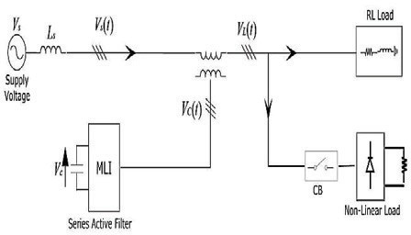

Figure 1 General configuration of series active filter

The main purpose of the active filter is to compensate for current/voltage harmonics and/or current imbalance/voltage imbalance or to provide “harmonic damping” throughout the power distribution systems [3],[5].The series active filter works as a kind of harmonic isolator rather than a harmonic voltage generator, since it provides high impedance for the harmonics while providing zero impedance for the fundamental. Also, the series active power filter can regulate the Point of Common Coupling (POCC) voltage at a desired value by controlling the inverter output so as to compensate for abnormal utility voltage [1].The series converter ensures a balanced, sinusoidal and regulated voltage.

The imbalance or distortion of a three phase system may consists of positive, negative, zero sequence fundamental and harmonic components.

The system (utility) voltagecan be expressed as

*V S*

*t*

 *V S* 

*t*

 *V S* 

*t*

 *V S* 0

*t*   *V*

*t* 

where subscripts ,,0, *sh* refer to the positive, negative, zero-sequence fundamental components, and the harmonics in the voltage respectively.

*Sh*

(1)

Usually, the voltage at POCC is expected to be sinusoidal with a fixed amplitude *VL:*

*VL* *t*   *VS* sin*t*  ** 

Hence the series converter will need to compensate for the following components of voltage:

     

*VC t*  *VL t*  *VS t*

(2)

(3)

In this paper series active power filter has been realized using three cascaded H-bridge five level inverter.

General configuration of series active filter is shown in Fig.1

1. Multilevel Inverter

Multilevel converters can realize the high power and high voltage using semiconductor switches of relative small ratings while avoiding the voltage and current sharing problems associated with series and parallel connection of switches commonly employed in two-level converter realization. Multilevel converters can synthesize the output voltage with smaller steps and reduced harmonic content, while potentially resulting in smaller dv/dt thus lower electromagnetic interference (EMI).The H-bridge cascaded multilevel converter has less storage capacitors and requires simpler control. Modularity nature of the H-bridge cascaded multilevel converter makes an easier realization [2],[8].

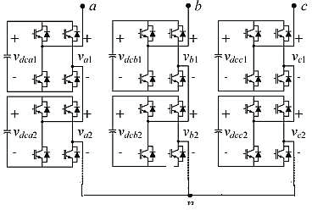

Figure 2 Three phase cascaded five level inverter

In this paper, power circuit for one phase leg of a five-level inverter consists of two cells in each phase with separate dc sources. The resulting phase voltage is synthesized by the addition of the voltages generated by the different cells. Each single-phase full-bridge inverter generates three voltages at the output: +Vdc, 0, and –Vdc. The resulting output ac voltage swings from -2Vdc to +2Vdc with five levels and the staircase waveform is nearly sinusoidal [3]. The structure of three phase cascaded H-bridge five level inverter is shown in Fig. 2.The ac outputs of the converters are connected in series to the power system through transformers, necessarily involves a series injection of the compensating voltage source. Use of the transformers here allows for voltage matching, isolation, series injection and simultaneously multilevel waveform synthesis [2].

1. Modulation Strategy

To obtain a low distortion nearly sinusoidal output voltage, a triggering signal should be generated to control the switching frequency of each power semiconductor switch.[8].Multicarrier Phase-shifted sinusoidal pulse width modulation (PS-SPWM) switching scheme is proposed to operate the switches in the system. Optimum harmonic cancellation is achieved by phase shifting each carrier by: (k-1)π/n rad, where k is the kth inverter, n is the number of series-connected single phase inverters.The number of switched DC levels L that can be achieved in each phase leg is n=(L-1)/2. In this paper, to obtain a five level output, four carriers of triangular in nature having same frequency, amplitude and phase shifted by 90º are used. Gating pulses of switches are generated by comparing the high frequency carriers with the low frequency reference sinusoidal waveform as shown in Fig. 4.

1. Reference Voltage generation using SRF Theory

Synchronous reference Frame theory is based on the transformation of the stationary reference frame three phase variables (a,b,c) to synchronous reference frame variables (d,q,O) whose direct (d) and quadrature (q) axes rotate in space at the synchronous speed ωe. ωe is the angular electrical speed of the rotating magnetic field of the three phase supply, given by ωe =2Пfs, where fs is the frequency of the supply.

Sensed inputs V*sa*, V*sb*, Vs*c* and V*La*, V*Lb*, V*Lc* are fed to the controller. The three- phase source voltages (Vsa, Vsb and Vsc) are applied to three-phase Phase Locked Loop (PLL) to synchronize the three-phase voltages at the converter output with the zero crossings of the fundamental component of the supply phase voltages. V*sa*, V*sb*, V*sc* and V*La*, V*Lb*, V*Lc* are transformed to *d*–*q* frame, where these signals are filtered and transformed back to *abc* frame. Transformed voltages are fed to a multicarrier phase shifted PWM signal generator to generate final switching signals fed to the active filter [9], [1O]. The accuracy of the reference signal generation determines the performance of the SAF.

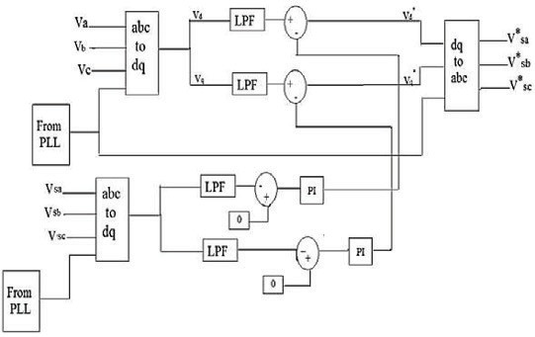

Figure 3 Block diagram of reference signal generation based on synchronous reference theory

1. Simulation Results and Discussion

To prove the capabilities of the above-mentioned control method, the test system is modelled with MATLAB/Simulink and SimPower-System block set. Total Harmonic Distortion (THD) is calculated to verify the efficiency and well-performance of the designed control method.

The power circuit is a three phase system supplied by a sinusoidal balanced three phase voltage of 415 V with a source inductance of 16.58mH and source resistance of O.8929 Ohms.The MLI consists of IGBT based two H-bridges in each phase. An inductor has been connected in series with the MLI to eliminate the high frequency components at the output of the inverter. The performance of designed controller has been verified under various conditions such as Nonlinear unbalanced load condition and Dynamic load condition.

* 1. *Non Linear unbalanced load*

Three single phase uncontrolled rectifiers with different values of resistors connected at their dc side constitute the unbalanced load. Voltage sag is created during simulation by sudden (addition of nonlinear unbalanced load) change of load from t1 = O.2s to t2 = O.4s. Fig.4a shows the performance of SAF for source voltage and source current before and after compensation. With the active filter connected in series with the system, the unbalanced sag created at the source side due to nonlinear unbalanced load has been compensated. % of THD falls from 19.28 to O.95.

* 1. *Dynamic Loading*

During startup an induction motor takes a larger current than normal, typically five to six times large. This current remains high until the motor reaches its nominal speed typically between several seconds and one minute. Because of this larger current, there occurs voltage sag.

As stated above, an induction motor of 5.4 HP is suddenly connected between t1 = 0.2s to t2 = 0.4s.Because of sudden inclusion of induction motor, the source voltage falls from 415 V to 315 V. The 5th and 7th are 0.18 and 0.11% of fundamental frequency respectively.

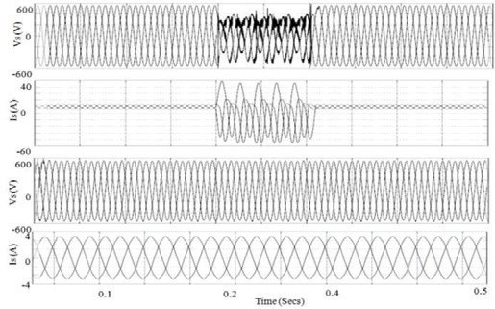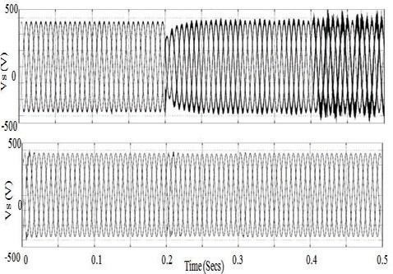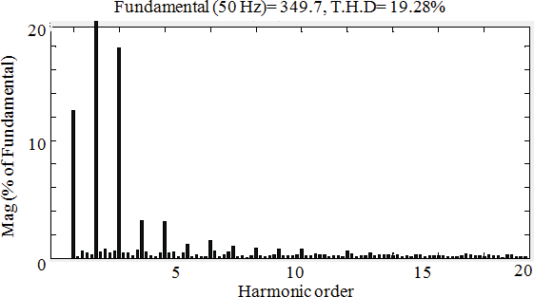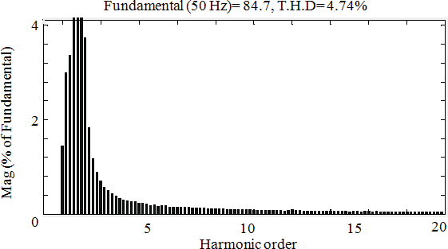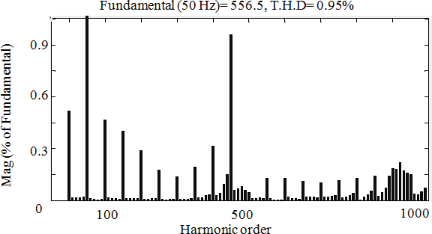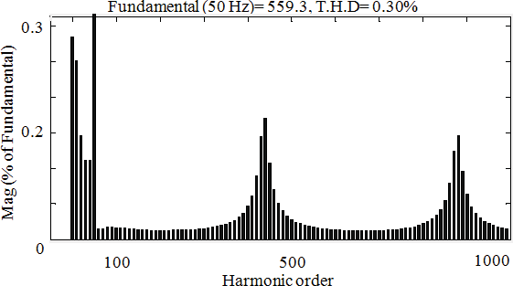During closed loop operation, the controller senses the reduction in voltage and injects the compensation voltage so that the source voltage is maintained at its normal value during the induction motor starting. Fig.4b shows the performance of SAF for source voltage and their harmonic spectrum before and after compensation for dynamic load condition

Figure 4 a,4b Dynamic response of SAF under unbalanced and dynamic loading condition

The performance analysis of phase shifted multilevel inverter as series active filter under various conditions have been carried out and the results are tabulated for easy reference as follows:

Table 1 Harmonic Analysis

|  |  |  |  |  |  |  |
| --- | --- | --- | --- | --- | --- | --- |
|  | Unbalanced condition | | | Dynamic loading | | |
| 5th | 7th | THD % | 5th | 7th | THD % |
| Without active filter | 1.39 | 1.25 | 19.28 | 0.18 | 0.11 | 4.74 |
| With active filter | 0.12 | 0.9 | 0.95 | 0.02 | 0.01 | 0.30 |

1. Conclusion

This paper presented a three phase multilevel inverter operated as a series active filter. The system is designed and simulated using SRF theory. The designed SAF system is capable of injecting voltage while compensating voltage sag, harmonics for unbalanced and dynamic load conditions. The source voltages, THD after compensation is well within the IEEE 519 recommended limits. From the simulation results it has been proved that the three phase MLI along with the suitable controller has mitigated voltage sag, unbalancing and provided harmonic reduction under non-linear unbalanced and dynamic load conditions.

References

1. G. –Myoung Lee, Dong-Choon Lee, Jul-Ki Seok, “Control of Series Active Power Filters Compensating for Source Voltage Unbalance and Current Harmonics”, IEEE Transactions on Industrial Electronics, vol. 51, no. 1, pp. 132 – 139, February 2004.
2. BingSen Wang, Giri Venkataramanan, Mahesh Illindala, “Operation and Control of a Dynamic Voltage Restorer Using Transformer Coupled H-Bridge Converters”, IEEE Transactions on Power Electronics, vol. 21, no. 4, pp. 1053 –1061, July 2006.
3. Hirofumi Akagi, “New Trends in Active Filters for Power Conditioning”, IEEE Transactions on Industry Applications, vol. 32, no. 6, pp. 1312 – 1322, November/ December 1996.
4. Agileswari K.Ramasamy, Rengan Krishnan Iyer,Vigna K. Ramachandramurthy, Dr.R.N. Mukerjee, “Dynamic Voltage Restorer for Voltage Sag Compensation”, IEEE International Conference on Power Electronics and Drive Systems, (PEDS), 2005, pp. 1289–1294.
5. FathimaMekri, Mohamed Machmoum, Nadia Aït-Ahmed, BenyounessMazari, “A Comparative Study of Voltage Controllers for Series Active Power Filters”, Journal on Electric Power System Research 80, pp. 615 – 626,2010.
6. H.Ezoji, A.Sheikholeslami, M.Rezanezhad, H.Livani, “A new control method for Dynamic Voltage Restorer with asymmetrical inverter legs based on fuzzy logic controller”, Journal of Simulation Modelling Practice and Theory 18 , pp. 806 – 819,2010.
7. Bhim Singh, Kamal Al-Haddad, Senior Member, IEEE, and Ambrish Chandra, Member, IEEE “A Review of Active Filters for Power Quality Improvement” IEEE Transactions on Industrial Electronics, vol. 46, no. 5,

October 1999

1. IlhamiColak, ErsanKabalci, RamazanBayindir “Review of multilevel voltage source inverter topologies and control schemes”Journal on Energy Conversion and Management 52, 1114–1128,2011.
2. Sergio Augusto Oliveira da Silva, Rodrigo Augusto Modesto “A Comparative Analysis of SRF-based Controllers Applied to Active Power Line Conditioners” IECON, 2008,pp.no 405-410
3. Bhim Singh and JitendraSolanki “A Comparison of Control Algorithms for DSTATCOM” IEEE Transactions on Industrial Electronics, vol. 56, no. 7, July 2009.