Available online at [www.sciencedirect.com](http://www.sciencedirect.com/)



AASRI Procedia 3 (2012) 155 – 159

2012 AASRI Conference on Modelling, Identification and Control

Tool Wear in Vertical Milling of Polymethyl-methacrylate Sheet

Komson Jirapattarasilpa* and Saming Obmaa

*aDepartment of Production Technology Education, Faculty of Industrial Education and Technology, King Mongkut's University of Technology Thonburi*

*126 Pracha-utid Rd. Bangmod, Thongkru District, Bangkok 10140, Thailand*

Abstract

Polymethyl-methacrylate (PMMA) is thermosetting plastic and called acrylic glass. PMMA sheet used in the industry to make aircraft and aquariums windows, and flat cut out letters. This research was to investigate tool wear, which was vertical milling of Polymethyl- methacrylate (PMMA). The experiment was done with HSS four flute end-milling cutter. The experiment was applied on two factors were consisted of three levels of cutting speed and feed rate. The tool wear was measured by the nose wear of end milling cutter. The results revealed that main factor affected on tool wear was feed rate. On the other hand, cutting speed was not main affected factor. Higher feed would cause of high tool wear than lower feed rate. High cutting speed that applied with high feed rate can be rapidly increase tool wear. Lower feed is better parameter for tool life of HSS end milling cutter. To keep long tool life, the low feed rate together with high cutting speed was recommended to milling PMMA sheets.

© 2012 The Authors. Published by Elsevier B.V. Open access under [CC BY-NC-ND license.](http://creativecommons.org/licenses/by-nc-nd/3.0/)

© 2012 Published by Elsevier B.V. Selection and/or peer review [under responsibility](http://creativecommons.org/licenses/by-nc-nd/3.0/) of American Applied Science Research Institute

Selection and/or peer review under responsibility of American Applied Science Research Institute

*Keyword:* Tool Wear, Polymethyl-methacrylate, PMMA, Milling, Cutting speed, Feed rate

1. Introduction

Polymethyl-methacrylate (PMMA) is thermosetting plastic and called acrylic glass. PMMA can be made by casting process especially PMMA sheet with thickness varying from 3 to 100 millimeters. PMMA sheet can be used as transparent glass substitute because it is good property such as transparent and good impact strength, higher than glass. PMMA sheet used in the industry to make aircraft and aquariums windows, and flat cut out letters. To produce an industrial product, PMMA can be machined by any processes especially milling operation. Based on the machining conditions, milling parameters could be affected to tool wear. Furthermore, cutting conditions such as cutting speed, feed rate could be affected to tool life of cutting tool especially end milling cutter. Previous study showed that machining of material and effect of tool wear. Ali Davoudinejad et al. [1] studied tool wear on Tri-Phase CVD Coated Carbide Tools while turning Aluminum Al6061. János Líska et al.[2] investigated tool wear at machining of Glass Fiber Reinforced Plastic (GFRP). Qi Shi et al.[3] conducted an experiment for tool wear in high speed milling on titanium alloy. Wada A. [4] reported wear of polycrystalline cubic Boron nitride compact tools in cutting hardened steel. Yuan Wei Wang et al.[5] investigated on tool wear of end-milling on Inconel 718. Furthermore, the PMMA has been study on surface finish [6]. However, tool life of vertical milling of PMMA was not study. The objective of this research was to study the factors affected to tool wear of end

* Corresponding author. Tel.: +66-2-470-8554; fax: +66-2-470-8557.

*E-mail address:* [komson.jir@kmutt.ac.th.](mailto:komson.jir@kmutt.ac.th)

2212-6716 © 2012 The Authors. Published by Elsevier B.V. Open access under [CC BY-NC-ND license.](http://creativecommons.org/licenses/by-nc-nd/3.0/) Selection and/or peer review under responsibility of American Applied Science Research Institute doi:10.1016/j.aasri.2012.11.026

milling cutter on PMMA milling. Therefore, this study could be contributed an economics of tool for material processing based on these conditions milling of PMMA.

1. Material, Tool and Equipment

Material used for this experiment was Polymethyl-methacrylate sheets that made from casting process. The specimens were thickness of 60 mm as shown in Fig.1. The properties of PMMA were showed in Table 1. The CNC milling machine ‘*MIKRON model WF 21 D*’ was used for this experiment. The cutting tool was four flutes High Speed Steel (HSS) end milling cutter, as shown in Fig.2. The experimental data, tool wear, were measured by measuring microscope ‘*Olympus CK 40 M’* with image analyser.

Table 1. The Properties of Polymethyl-methacrylate

|  |  |  |  |
| --- | --- | --- | --- |
| Density | Tensile strength | Compressive Strength | Impact strength |
| 1.17-1.20 g/cm3 | 70-80 MPa | 105-124 MPa | 0.18-0.27 J/cm |

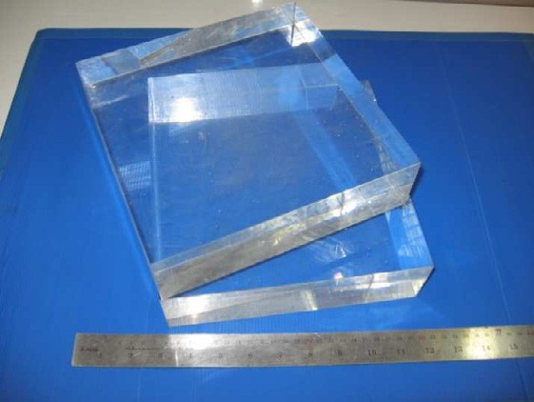

Fig. 1. Specimen of PMMA Sheet



Fig. 2. HSS four-flutes end milling cutter

1. Experimental Procedure

Factorial design experiment was applied with 2 experimental models, up-cut and down-cut milling, as showed in Fig 3. Factors used for this experiment were cutting speed, feed rate. Each factor was set at three levels. Cutting speed was set up at 60, 75, and 90 meter per minute, feed rate was identified at 200, 300, and 400 millimetre per minute. Base on previous study[6], the up-cutting was best direction for milling via surface quality of work pieces. So, this experiment was done on up-cutting direction as shown Fig 3. These experiments were tested by pilot study before running the actual experiment.

The actual experiment was randomly selected run. The response results of each experiment were measured for tool wear. The tool wear was measuring on the nose wear of end milling cutter as showed in Fig.4. The tool wear was identified by mean value of nose wear at the end of four cutting edge. Data were analysed by statistical methods to finding the factors affected to tool life.

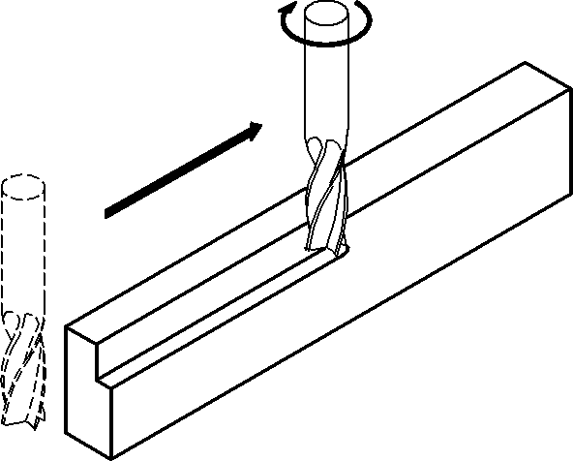

Fig. 3. Up-cut Milling

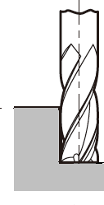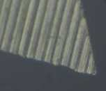

Fig. 4. Nose wear at the end of cutter

1. Results and Discussion

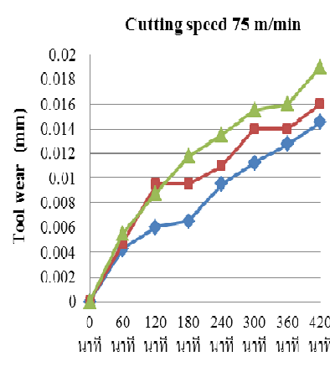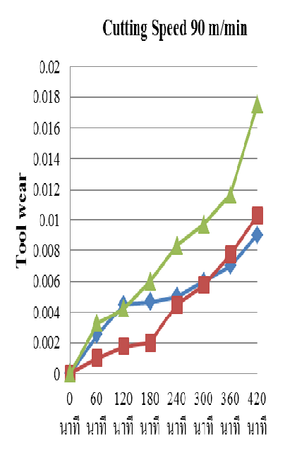The results of the tool wear was measuring in every sixty minutes were showed in Figure 5. The tool wear was determined and result was tested by the normality test. An analysis of variance (ANOVA) for tool wear results at cutting time 420 minutes was done. The ANOVA result indicated that the effect of feed rate was significantly difference at the confident level of .05 but cutting speed was not. Also, interaction between cutting speed and feed rate would be affect to tool wear of milling cutter as shown in table 2.

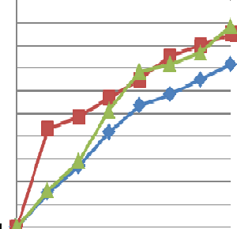

Cutting Time (min) Cutting Time (min) Cutting Time (min)

Fig. 5. Tool Wear at various cutting speed

Table 2. ANOVA of tool wear on Polymethyl-methacrylate milling

|  |  |  |
| --- | --- | --- |
| Source | DF | Seq SS Adj SS Adj MS F P |
| Feed rate | 2 | 0.0000464 0.0000464 0.0000232 7.48 0.045 |
| Cutting Speed | 2 | 0.0000345 0.0000345 0.0000172 5.55 0.070 |
| Feed rate*Cutting Speed | 4 | 0.0000124 0.0000124 0.0000031 |
| Error | 0 | * * * |
| Total | 8 | 0.0000934 |

* 1. *The effect of feed rate*

Because of analysis of variance (ANOVA), feed rate was factor affected to tool wear by statistical significant at the 0.05 level. The feed rate is main effect on tool wear of milling cutter. Meanwhile, the high feed rate can affected to tool wear more than low feed rate. The higher feed rate (400 mm/min) can be produced two times of toolwear with lower feed rate (200 mm/min, at cutting speed 90 m/min) as shown in Fig.6.

The comparison of level was showed in Fig.7. As analysis results, higher feed would cause of high tool wear than lower feed rate. It means that the lower feed better parameter on tool life of HSS end milling cutter.

* 1. *The effect of cutting speed*

The cutting speed was not main factor for tool wear. However, cutting speed is an importance parameter to control wear of cutting edges. Since the high cutting speed was applied with high feed rate, tool wear was increase rapidly. On other hand, high cutting speed that applied with low feed rate was produce less tool wear as showed is Fig.8. In order to keep long tool life, the low feed rate together with high cutting speed was recommended to milling PMMA sheets.

Speed

Feed

0.018

0.017

0.016

0.015

0.014

0.013

0.012

60

75

90

200

300

400

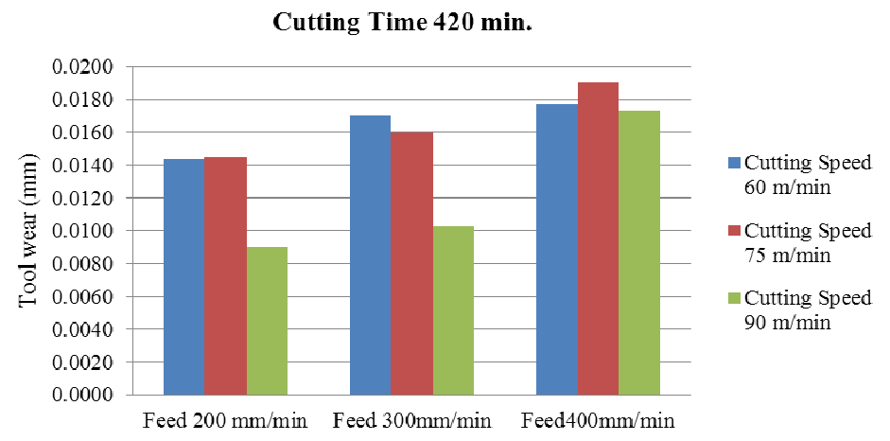

Fig. 6. Comparing of Tool Wear at cutting time 420 min.

Fig. 7. Main effect of Feed rate on Tool wear

Mean

Mean

Fig. 8. Interaction of Cutting speed and Feed rate on Tool wear

0.020

0.018

Speed 60

75

90

0.016

0.014

0.012

0.010

200

300

Feed

400

1. Conclusion

This research was investigated the tool wear experiment of HSS end milling cutter in vertical milling for Polymethyl- methacrylate sheet. It could be conclude that feed rate mainly affected to tool wear. Moreover, the wear was influenced by the interaction of feed rate and cutting speed too. Some concluding as following;

* Higher feed would cause of high tool wear than lower feed rate..
* High cutting speed that applied with high feed rate can be rapidly increase tool wear.
* Lower feed is better parameter for tool life of HSS end milling cutter.
* To keep long tool life, the low feed rate together with high cutting speed was recommended to milling PMMA sheets.

References

1. Davoudinejad A, Ashrafi SA, Niazi A, Effect of Tool Wear on Tri-Phase CVD Coated Carbide Tools Life while Turning Al6061. Adv. Mater. Research, Vols.488-489 (2012), p 457.
2. Líska J, Kodácsy J, Tool Wear and Cutting Temperature at Machining of Composites, Adv. Mater. Research. Vol.325 (2011), p 381.
3. Shi Q, Yang YF, He N, Li L, Zhao W, Experiment Study of Tool Wear and Surface Integrity in High Speed Milling of a New Damage-Tolerant Titanium Alloy*.* Mater. Sci. Forum ,Vol. 723 (2012), p. 177
4. Wada A, Tool Wear of Polycrystalline Cubic Boron Nitride Compact Tools in Cutting Hardened Steel. Adv. Mater.

Research, Vols.488-489 (2012), p.724

1. Wang YW, Li JF, Li ZM, Ding TC, Zhang S, Experimental Investigation on Tool Wear when End-Milling Inconel 718 with Coated Carbide Inserts. Adv. Mater. Research,Vol. 188 (2011), p. 410
2. Obma S, Jirapattarasilp K, The Effect of Vertical Milling on Finished Surface of Polymethyl-methacrylate Sheet. Appl. Mech. and Mater. Vols. 157-158 (2012) p. 263.