Available online at [www.sciencedirect.com](http://www.sciencedirect.com/)



AASRI Procedia 3 (2012) 387 – 393

2012 AASRI Conference on Modeling, Identification and Control

Trend Prediction of FDI Based on the Intervention Model and ARIMA-GARCH-M Model

Hongyan Shia, Xin Zhang b,*,Xiaoming Sua,Zhongju Chenc

*aSchool of Science,Shenyang University of Technolog, Shenyang ShenLiao Road, No. 111, Shenyang, 110000,China bGraduate School,Shenyang University of Technolog, Shenyang ShenLiao Road, No. 111, Shenyang, 110000,China cLiaoning Administrators College of Police and Justice,Shenyang Jialing River Street No.66, Shenyang, 110000,China*

Abstract

For providing the government with effective monitoring of the trends of the economic variables in the future and good reference for developing a reasonable policy, in this paper, we establish a time series model on China's Foreign Direct Investment (FDI) by using wavelet analysis and intervention analysis and time series analysis and predict the trend of FDI in the next several years. This model eliminates the interference of noise for predicting by using wavelet analysis, and describes the autocorrelation and time-varying volatility of the financial time series by using ARIMA- GARCH-M model. The simulation results show that this model explains the dynamic structure of China's FDI trends well.

© 2012 The Authors. Published by Elsevier B.V. Open access under [CC BY-NC-ND license.](http://creativecommons.org/licenses/by-nc-nd/3.0/)

© 2012 Published by Elsevier B.V. Selection and/or peer rev[iew under respon](http://creativecommons.org/licenses/by-nc-nd/3.0/)sibility of American Applied Science Research Institute

Selection and/or peer review under responsibility of American Applied Science Research Institute

*Keywords:* ARIMA model,GARCH-M model,avelet de-noising,autocorrelation, prediction

1. Introduction

In the background of economic globalization, more and more countries have taken part in the global competition with an open attitude. Foreign direct investment (FDI) flows into developing countries is an

* Xin Zhang. Tel.: +86-186-4021-8600

*E-mail address:* [zhangxin198784@126.com.](mailto:zhangxin198784@126.com)

2212-6716 © 2012 The Authors. Published by Elsevier B.V. Open access under [CC BY-NC-ND license.](http://creativecommons.org/licenses/by-nc-nd/3.0/) Selection and/or peer review under responsibility of American Applied Science Research Institute doi:10.1016/j.aasri.2012.11.061

important way to acquire advanced technology and knowledge. The government can not only make the problems of insufficient funds in the economic construction slow down, but also bring technology and talent flow and promote that our national economy develop sustaining, rapidly and healthily through the introduction of FDI benignly. Therefore, it has important reference value and practical significance to study the FDI quantitative rule, predict accurately, calculation and control the risk, to achieve the maximum benefit.

Jing Ma, Guoqing Zhao,2009 find that there is not chaotic attractors in China's FDI by logistic model[1], then China's FDI is not a certain chaos system. Chunlin Li, Huiyan Wang ,2011consider the financial crisis in Asia effects on Hebei province, they set up the Intervention-ARIMA model[2].Since the data of FDI is very small, it's difficult to identify ARCH effect. The study of FDI nonlinear model is very difficult. On the basis of the previous linear research[3]-[7],we can study the nonlinear and time-varying of fluctuation for forecasting the development of FDI in the future.

Based on the deeply study of ARIMA-ARCH model, intervention model and wavelet theory, we can eliminate the interference of random fluctuations and noise for prediction by the advantages of wavelet analysis in eliminating the noise. We can eliminate the interference of emergencies for prediction by using intervention model. In order to test the effectiveness of improved algorithm, we establish a dynamic model on China's FDI. We demonstrate the effectiveness of the model by analyzing the example of China's FDI trends.

1. The trend prediction of China’s FDI time series on Intervention ARIMA-GARCH-M models

In this paper, the data analysis and processing are completed by using MATLAB and Eviews6.0. Wavelet de-noising is completed by MATLAB, Unit root test, differential stability analysis and sequence correlation analysis the intervention ARIMA-GARCH-M model's fitting and forecasting are completed by using Eviews6.0. The time series data of China's FDI value are directly from the CHINA STATISTICAL YEARBOOK.(1985-2011).

* 1. *The wavelet de-noising and intervention analysis of the original series*

The steps of the algorithm are as follows:

* + 1. Wavelet de-noising processing for the data without intervention.

Select the data of China's FDI from1985 to 1997, wavelet threshold de-noising method is used for decomposition and reconstruction of the signal with noise. To eliminate the noise, we limit the threshold for the wavelet coefficients after decomposition. Specific steps include wavelet decomposition, threshold processing and the reconstruction technology for the signal.

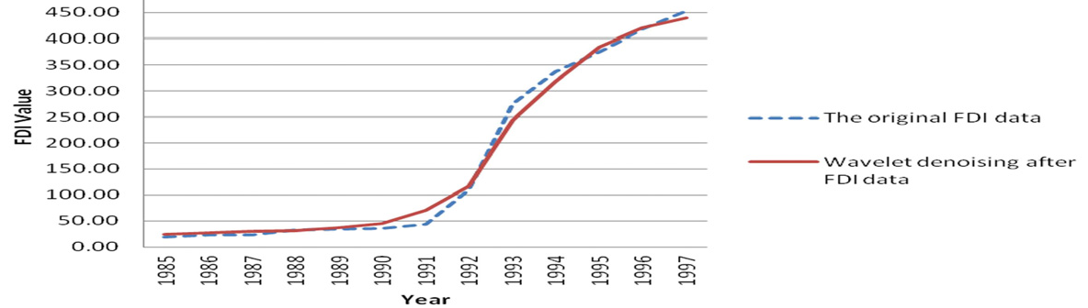

Figure 1 Wavelet de-noising effects

As shown in Fig.1, the data of wavelet de-noising match well with the original value curves, it can express the trend of FDI more effectively and smoothly, it is better to prepare for the establishment of model.

* + 1. Build time series models after wavelet de-noising, and then forecasting by the model, the predicted results obtained as the value without intervention.
       1. Stability recognition

The application of ARIMA model requires that time series are stationary. For the non-stationary time series, difference is usually used for obtaining stationary series. We select the data of China FDI from 1985 to 1997, which have been wavelet de-noising, and then test the sequence of stability by Eviews6.0.

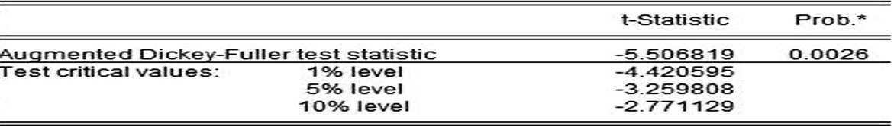

Figure 2 Unit root test for the three order difference sequences of FDI

Unit root test is an effective way to test the stability of time series, the ADF unit root test for the third order differential sequence of FDI is completed by Eviews6.0. Test results have been shown in Figure 2, t- Statistic is -5.51, it is less than the test critical values at 1% level. The results show that the time series pass the ADF test, the sequence after difference is stationary. So the differential order of ARIMA(p,d,q) model is equal to 3.

* + - 1. Model identification of time series

The model can be identified preliminary by the nature of the autocorrelation function (ACF)and the partial correlation function (PACF). Then the order of ARIMA can be identified. Akaike information criterion (AIC) and Bayesian information criterion(BIC) are the standards used commonly for selecting statistical model. According to Figure 3, AIC and BIC, ARIMA(1,3,1) is identified.

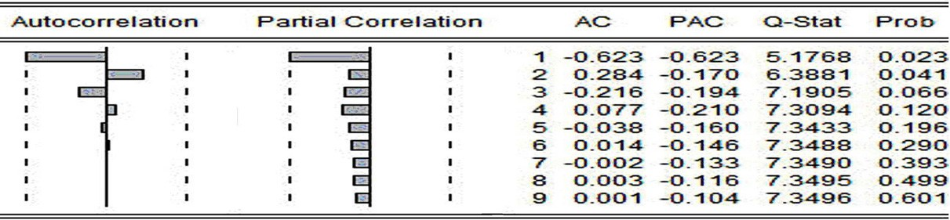

Figure 3 The ACF and PACF of difference sequence

* + - 1. Parameter estimation

The parameter estimation of the time series model is obtained by Eviews6.0. The results are shown in Figure 4.

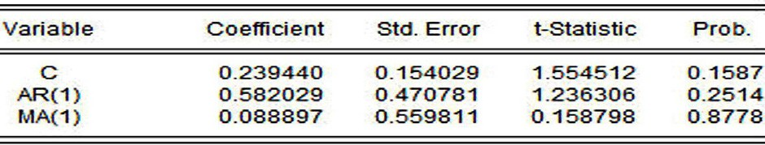

Figure 4 The parameter estimation of ARIMA(1,3,1)

As shown in Figure 4, we can get the time series model:

*Xt*  0.23944  0.582029 *Xt* 1  *t*  0.088897*t* 1

*(1)*

The model is effective due to the residuals sequences pass the test of the white noise. We can obtain that the forecast results of FDI in 1998 and 2001are454.02, 466.56, 476.80 and 485.17, by using Eviews6.0, they are different from the actual value apparently.

* + 1. The analysis of the intervention event's style, make sure the parameters of intervention model.

In this paper, we select the China's FDI from 1985 to 2008as data material, which is from China Statistics Yearbook. China's FDI is affected by the Financial Crisis in Asia. This kind of intervention variables can be expressed as



1,*t* 1998,1999, 2000, 2001

*P*

*t* 0,*t*  1998,1999, 2000, 2001

*(2)*

Because of the intervention event starts suddenly and produces a transient effect, the intervention model can be expressed as

** *Bb T* '

*Yt* 

1  ** *B Pt*

0  **  1

*(3)*

We can improve the intervention model on 1998 to2001. We forecast the values of FDI in 1998 to 2001

by the model *z*1, *z*2 , *z*3 , *z*4 are the in_ter_ven_tio_n effect values which is the difference of the actual value

*x* , *x* , *x* , *x* and the predictive value *x* , *x* , *x* , *x* . Based on the value of the absolute intervention, *P* can

'

1 2 3 4

clearly been expressed as

1 2 3 4 *t*

1.2629,

****0.9169,

*P*'  1.0831,

*t*

*t* 1998 *t* 1999 *t*  2000

*(4)*

0.7371

*t*  2001

 0,

*t* 1998,1999, 2000, 2001

* + 1. Finding out the total improved intervention model

The parameter estimation of improved intervention model is completed by Eviews6.0. To sum up, we can get our country FDI structure model:

*X* 0.2390.582*X*

** 0.089**

1616.49*B*4

− *P*'

*(5)*

*t t*1

*t t*1

11.10*B t*

* 1. *Time series modeling*

After purification, the China's FDI of time series model is built by the following steps:

* + 1. Linear time series modeling
       1. Stability recognition

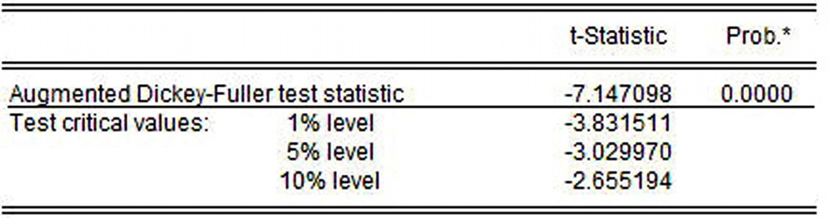

Figure 5 Unit root test for the two order difference sequences of FDI

The ADF unit root test for the third order differential sequence of FDI is completed by Eviews6.0. Test results have been shown in Figure 5, t-Statistic is -7.15, it is less than the test critical values at 1% level. So the differential order of ARIMA(p,d,q) model is equal to 2.

* + - 1. Model identification of time series

The model can be identified preliminary by the nature of the autocorrelation function (ACF)and the partial correlation function (PACF). Then the order of ARIMA can be identified.

Akaike information criterion (AIC) and Bayesian information criterion(BIC) are the standards used commonly for selecting statistical model. According to AIC and BIC, ARIMA(2,2,2) is identified.

* + - 1. Parameter estimation

The parameter estimation of the time series model is obtained by Eviews6.0. The results are shown in Figure 6.

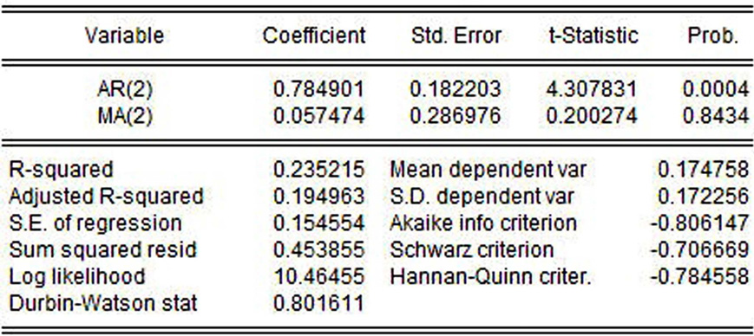

Figure 6 The parameter estimation of ARIMA(2,2,2)

As shown in Figure 6, we can get the time series model:

*X*  0.784901*X* +**  0.057474**

*t t* 2 *t t*  2

The model is effective due to the residuals sequences pass the test of the white noise.

* + 1. The ARCH effect test of ARIMA(2,2,2) model The LM test results shows by the output results,

*(6)*

F  14.99  F

0.05

 3.0

*(7)*

LM  TR 2  14.12  ** 2

0. 05

 5.99

*(8)*

Since the F-statistics and LM of the corresponding probability are less than 0.05, we can get that the value of F and LM are in the right side of the corresponding critical value, namely the null hypothesis of rejection region. The square of residual sequence exists 5 order autocorrelation, namely the error sequence exists autoregressive conditional heteroskedasticity. Test results show that the model has autoregressive conditional heteroskedasticity, we can establish ARCH model on the basis of ARIMA(2,2,2).

We find that the prediction error of ARIMA-GARCH-M is minimum by comparing, so we choose ARIMA-GARCH-M model in this paper.

3 )ARIMA-ARCH models

On the basis of ARIMA, we set up ARCH model. Through the results of prediction in comparison, we choose GARCH-M(1,4) model.

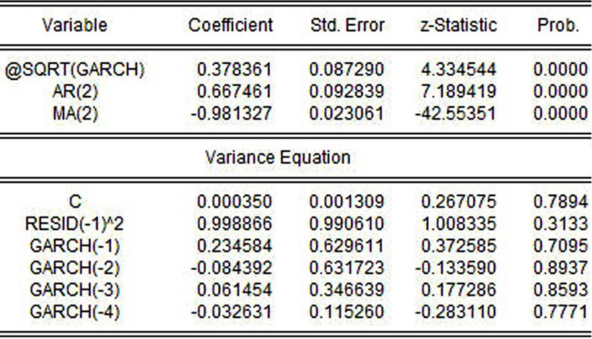

Figure 7 The parameter estimation of ARIMA(2,2,2)-GARCH-M(1,4)

We can get the parameter estimation results as shown in Figure 7 by Eviews6.0. The first part is the estimation results of average equation, the second part is the estimation results of GARCH-M(1,4), the third part is the statistics, the fourth part is the corresponding characteristic root reciprocal value of average equation.

The forecast error results are shown in table 1.

Table 1 The prediction results of three models

|  |  |  |  |  |  |  |
| --- | --- | --- | --- | --- | --- | --- |
| y | ARIMA(2,2,2)-G | ARCH-M(1,4) | ARIMA(2,2,2)-P | ARCH(1,4) | ARIMA(2,2,2)-G | ARCH(1,1) |
| ear | predictive value | error | predictive value | error | predictive value | error |
| 0  9 | 941.97 | 4.62% | 1024.41 | 13.78% | 997.10 | 10.75% |
| 1  0 | 1058.21 | 0.09% | 1162.01 | 9.90% | 1111.16 | 5.09% |
| 1  1 | 1130.23 | -2.75% | 1295.00 | 11.63% | 1187.75 | 2.38% |

Table 1 shows that the precision of ARIMA(4,2,4)- GARCH-M(1,4) model in forecasting is not high, model fitting results are the most significant .

1. Conclusion

In this paper, we can get the conclusion that the ARIMA-GARCH-M model can match with the development situation of our country FDI well by comparing prediction results of ARIMA-GARCH, ARIMA-GARCH-M and ARIMA-PARCH. Especially the model take the Asian financial crisis intervention events as a reasonable factors into the model, wavelet de-noising of the data smoothing make the model more comprehensive and scientific for reflecting the trends of FDI. The conclusion is as follows:

1. China's FDI has obvious heteroscedasticity, it's better to explain the relations between the random error and FDI;
2. The dynamic model of the time series of China's FDI is ARIMA(2,2,2)-GARCH-M(1,4);
3. In recent years , the introduction of China's FDI shows ascendant trend. Our government should strengthen the guidance of the investment field of FDI to ensure that our national economy develop persistently, rapidly and healthily.

Because of the time limit, this paper only analyzes the actual changes of FDI. In fact, a lot of series may be changed by other series. FDI is influenced by the foreign trade structure and so on. If we can put them into the research scope, then we can predict the trend of FDI more accurately. So the research focus is multivariate time series analysis in future.

Acknowledgements

This work is supported by National Natural Science Foundation (NNSF) of China under Grant 61074005.

References

1. Jing Ma, Guoqing Zhao. The Test for Chaotic Atractor in China's FDI Inflow and Its Nonlinear Dynamic Prediction:Based on Logistic Models.Mathematics in Practice and Theory: 2009;39(20):62-72.
2. Chunlin Li, Huiyan Wang. Intervention-ARIMA Forecasts of FDI in Hebei Province.Value Engineering: 2011;(8):124-125.
3. Le Jian, Yun Zhao. An application of ARIMA model to predict submicron particle concentrations from meteorological factors at a busy roadside in Hangzhou. Science of the Total Environment ,2012;426:336- 345.
4. Jihong Zhou, Xiaobin Zhou.Application of ARIMA model on the prediction of medium and long-term run off.Journal of Convergence Information Technology:2012;7(1):290-296.
5. Chichen Wang, Yunsheng Hsu, Chenghwai Liou. A comparison of ARIMA forecasting and heuristic modeling.Applied Financial Economics: 2011; (21):1095-1102.
6. Volkan S.Ediger,Sertac Akar. ARIMA forecasting of primary energy demand by fuel in Turkey. EnergyPolicy,2007; 35:1701-1708.
7. Xiaoxia Dong, Ganqiong Li, Zijie Liu.Choice and Application of Short-term Forecast Method for Agricultural Products Price-Taking Fresh Milk Retail Price as Example.Shandong Agricultural Sciences,2010;(1):109-113.