Available online at [www.sciencedirect.com](http://www.sciencedirect.com/)



**ScienceDirect**

AASRI Procedia 9 (2014) 8 – 11

2014 AASRI Conference on Circuit and Signal Processing (CSP 2014)

Universal Remote Control Systems for Domestic Devices Using Radio Frequency Waves

Shraddha Satish Thumsia, Surbhi Jainb

*aVit University,Vellore,632014,Tamil Nadu,India*

*bVit University,Vellore,632014,Tamil Nadu,India*

**Abstract**

In the present scenario, the existent remote control systems focus only on home theatre, which is useful but restricted in its use. The main aim of this research paper is to introduce a blueprint of a universal remote which provides full control to the user for all the devices like lights, fans, air conditioner, security systems, water heater etc in a house.

With the use of a radio frequency remote control system, and sensors fitted externally to the devices, the status of each device in the house is known to the user, and they can control all of them from a remote area of the house.

© 2014 Published by Elsevier B. V. This is an open access article under the CC BY-NC-ND license ([http://creativecommons.org/licenses/by-nc-nd/3.0/).](http://creativecommons.org/licenses/by-nc-nd/3.0/))

© 2014 Shraddha Satish Thumsi, Surbhi Jain. Published by Elsevier B.V.

Selection and/or peer review under responsibility of American Applied Science Research Institute

Peer-review under responsibility of Scientific Committee of American Applied Science Research Institute

*Keywords:* repeater; star network architecture

# Introduction

In today’s fast paced life, it is quite a challenge to keep work and home running parallel to each other. Under the pressure to report for work on time, and to meet work deadlines, working people often forget to turn off their home appliances which could pose as a great danger and would lead wastage of valuable resources like fuel, electricity, etc.

Much of the research these days is focused on controlling only the DVD, television, VCR and other audio and video devices. Though useful, its use is limited.

Here we device a universal remote control system, which will use radio waves[3] to communicate with each appliance installed in the house. Radio wave sensors[4] will be installed in the home appliances like lights, fans, air conditioners, electric water heaters, microwave ovens, television, music system, DVD/VCD players, digitalized curtains, etc. Its functionality can be enhanced to home security systems like smoke alarms and

2212-6716 © 2014 Published by Elsevier B. V. This is an open access article under the CC BY-NC-ND license ([http://creativecommons.org/licenses/by-nc-nd/3.0/).](http://creativecommons.org/licenses/by-nc-nd/3.0/))

Peer-review under responsibility of Scientific Committee of American Applied Science Research Institute doi:10.1016/j.aasri.2014.09.003

*Shraddha Satish Thumsi and Surbhi Jain / AASRI Procedia 9 (2014) 8 – 11* 9

door control. The central control of the sensor will be in the remote, which will have capacity to communicate and control appliances of various kinds.

# Design And Working

The basic blueprint of the remote is given below.

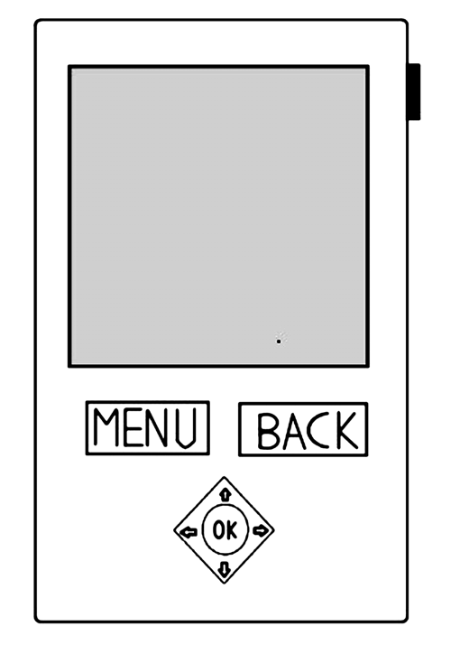

Figure 1

The power on/off button in the top right corner of the remote enables us to lock/unlock the touch screen, so as to conserve battery power.

The basic skeleton is that of a typical television remote with a socket to insert batteries. The touch screen display is roughly of the size 5x3 cm. It is meant to display the current status of the device and gives the user the option to turn it on or off, or set the appropriate mode. We will have a menu button to enter into the settings of the appropriate device. The menu button shows the list of devices controlled by the remote. We navigate through the menu using the + and – buttons provided. The selection of the device can be made using the enter button provided.

10 *Shraddha Satish Thumsi and Surbhi Jain / AASRI Procedia 9 (2014) 8 – 11*

The ‘enter’ button is used to select any particular option, and it acts as power ‘on’ button for the appliance as well. The ‘+’ and ‘-‘ buttons have multiple usage. It is used to navigate through the menu screen. It acts as a temperature controller in case of an air-conditioner, fans, water heater, and microwave ovens .It provides volume control in the speakers in television and music systems. It also controls the brightness of the lights.

# Connections And Networks

To manage efficient control of the system in houses of varying sizes, auxiliary radio frequency remote control systems may be used. Its main function is to behave as a **repeater**[7], wherein it increases the strength of the signal received from the central remote so that the losses incurred due to signal attenuation are compensated for. An auxiliary remote is installed at an appropriate distance from the central control, so that over all connectivity within the vicinity can be improved.

The universal remote control is unicast in nature. It delivers a message to a single specific node/device connected in the network. It utilizes **star network architecture**. The devices are all connected to the central remote, but are independent of each other.

A two-way handshake may be used between the device and the remote.

# Hardware Specifications

The remote control consists of a microcontroller chip such as PIC16C5X. We use 2XAA NiMH [2] rechargeable batteries for the central remote which gives a voltage of 1.5V and a current of 700mA. The remote is formed from a moulded plastic, typically acrylonitrile butadiene styrene, or ABS [1]. The sensor for sending and receiving radio frequency waves is encased with a plastic called acrylic or a poly-carbonate. Capacitive touch screens may be used for the remote to increase ease of use.

The auxiliary remote works similar to a Wi-Fi router. It should contain radio frequency transceivers, the same as that in the central remote. The casing of the auxiliary remote is made using plastic like acrylic or a poly-carbonate [6]. The router can be circular in shape, with radius of about 1.5 inches. The circular shape ensures distribution of good signal strength uniformly in all directions.

# Software Requirements

The most suitable operating system for the remote can be **LinuxMCE** (Linux Media Center Edition) because it is a free and open source software platform which allows a computer to act as a home theatre PC (HTPC) for the living-room TV, personal video recorder, and home automation system. It allows control of everything at home, from lighting and climate to surveillance cameras and home security. The LinuxMCE package is installed on the Kubuntu OS [8].

# Allocation of Bandwidth

The universally accepted citizen radio frequency is 2.4 GHz, which gives a raw over the air data rate of 250 Kbit/s per channel. The distance covered will be in the range of 10 to 20m depending on the construction materials and the number of walls to be penetrated.

To avoid interference between devices, a unique ID is assigned to them, to ensure the remote knows exactly which device is communicating.

*Shraddha Satish Thumsi and Surbhi Jain / AASRI Procedia 9 (2014) 8 – 11* 11

In a residence, each device is assigned a unique identification number of four bytes. One byte is for country code, one for state or province, one for city, locality and vendor code combined and one for the ID of the device being used.

# Improvisations

The features of the present model of the remote can be further used to develop an android application that can be supported on the phone. This will allow our Smartphone to act like a universal remote control. Also the remote can be made fully touch screen to give a better look to it. Given the current trends, this can be incorporated in the coming years.

# Risk Management

In case of failure of any components or sensors, the remote detects the failure as absence of response from the device, during the two way handshake communication. In such a situation, an emergency is notified to the user, and the user can send appropriate commands to control it, without having to physically go near the device, thus avoiding the jeopardy of their safety.

# Conclusion

The domestic devices used at home are meant to make life comfortable and with the advent of this remote control it can be expected that the management of these devices will be much easier. It can also help us save electricity at our houses. With the expertise of the technological manufacturing giants today, enhanced and smart houses will not be a distant dream.

# References

[1]<http://xjh.en.alibaba.com/product/467857257-> 212080896/Newest_Silicone_Rubber_Radium_font_b_carved_b_font_font_b_buttons_b_font_.html [[2]http://en.wikipedia.org/wiki/Alkaline_battery#Voltage](http://en.wikipedia.org/wiki/Alkaline_battery#Voltage) [[3]http://www.rfcontrolsystem.com/index.php?main_page=product_info&cPath=167_375&products_id=678](http://www.rfcontrolsystem.com/index.php?main_page=product_info&cPath=167_375&products_id=678) &zenid=o6e5em6cnc01obmq1t0lbfula4

[4]<http://en.wikipedia.org/wiki/Radio_wave> [[5]http://en.wikipedia.org/wiki/Z-Wave](http://en.wikipedia.org/wiki/Z-Wave)

[6]<http://www.ehow.com/info_12181450_types-plastic-used-make-tv-remotes.html> [[7]http://en.wikipedia.org/wiki/Repeater](http://en.wikipedia.org/wiki/Repeater) [[8]http://en.wikipedia.org/wiki/LinuxMCE](http://en.wikipedia.org/wiki/LinuxMCE)