Available online at [www.sciencedirect.com](http://www.sciencedirect.com/)



AASRI Procedia 2 (2012) 180 – 185

AASRI

Procedia

[www.elsevier.com/locate/procedia](http://www.elsevier.com/locate/procedia)

2012 AASRI Conference on Power and Energy Systems

# Using of RES Potential in the Chosen Region of EU

Csikósová Adrianaa*, Seňová Andreaa, Katarína Čulkováa, Mária Antošováa

*aTechnical University Košice, FBERG, Letná 9, 040 01 Košice, Slovakia*

**Abstract**

Renewable energy sources – RES are one of the main tools that have to lead European Union to the achievement of the energetic policy goals. Contribution deals with analysis of individual RES using. Attention is given to the description of the conveniences and defining of barrier for chosen RES. We have made prognosis of RES development to 2020 and we analyzed in details future development of RES using in condition of Slovak Republic and in other chosen countries of EU. More factors resulted from the performed analysis that will be considered in the contribution.

© 2012 Published by Elsevier B.V. Selection and/or peer review under responsibility of American Applied Science Research Institute

© 2012 Published by Elsevier B.V. Selection and/or peer review under responsibility of American Applied Science Research Institute

© 2012 The Authors. Published by Elsevier B.V.

Selection and/or peer review under responsibility of American Applied Science Research Institute

Open access under [CC BY-NC-ND license.](http://creativecommons.org/licenses/by-nc-nd/3.0/)

Keywords: Renewable energy, biomass, solar energy, geothermal energy, economy

## Present situation of the RES need in Slovakia and in conditions of EU

From the view of national economies renewable energy sources (RES) are domestic sources that can replace or fully decrease consumption of the fossil fuels in the future. They are considered as an important tool for protection of national economy that is necessary to develop with aim economy could avoid stress from the future increase of imported fuels prices and costs that will be necessary for liquidation of environmental damages. Technologies that use RES do not have almost no or only very negligible influence to the living environment and in majority they are without waste, they do not create radioactive waste and there is no risk during big disasters. There is possible to base sustainable development of the society on them in area of energetic and by this way to provide better perspective for future generations [2,3].

*Csikosova Adriana. Tel.: +421- 55-602 3116.

*E-mail address:* [adriana.csikosova@tuke.sk](mailto:adriana.csikosova@tuke.sk)

2212-6716 © 2012 Published by Elsevier B.V. Selection and/or peer review under responsibility of American Applied Science Research Institute

Open access under [CC BY-NC-ND license.](http://creativecommons.org/licenses/by-nc-nd/3.0/) doi:10.1016/j.aasri.2012.09.032

## Conveniences and barriers for RES using Conveniences for RES using

* Stocks of RES are rich; they have geographical and timely variable potential that is filling in both sides that enables diversity of the energetic system. Central system is changing in space distributed and by this way it enables decreasing of cost and loss from transition of primary sources.
* RES produce small or any volume of emissions and gases and by this way they decrease negative impacts to the living environment and health that means they contribute to the climatic changes.
* RES are using as primary source in developing countries, they are basic condition for their economical and social development.
* They bring new working possibilities, economical and social positives; they connect people in regions to the decisions about energetic possibilities.
* They contribute to revitalization and to the slowdown of degradation processes in agriculture and forest economy. Biotechnologies help to get rid of waste in advanced countries.
* They improve professional and education structure of the inhabitants. They give possibility for the expert realization. In present time countries that invested to the research and development of RES, can evaluate obtained knowledge on the international markets.

## Barriers for RES using Market barriers:

* There are no existing support measurements for the inhabitants. There is only few financial stimulus and convenient credits for equipments that use RES
* There is lack of stable long term conditions in the system of repurchase prices for produced energy from RES. Main market barrier is lack of determination for minimal prices for repurchasing of energy from RES for long time. Banks do not want to finance projects that demand high investments.

## Technological barriers:

* Technological development of equipments, using RES – when Technologies are in period of development, they have higher costs.
* Dependence of RES using from natural conditions – some RES are influenced by season and short time variability of the climatic conditions. If there would be big variations, they could have influence to the electricity supplement and to the security.

## Information barriers:

* Not sufficient informing of the inhabitants about conveniences and disadvantages of RES. There is lacking informing and education of inhabitants in area of RES using.
* Not sufficient preparation of experts for RES area. There is lacking system for requalification of persons interested.
* Not sufficient applying of new knowledge in practice and education. Research and science are not very good linked with production sector.
* Lack of regional conceptions for RES using. RES potential are not mapped in the regions.

## Legislative barriers:

* Not existing long term stable conditions that could define repurchase price of produced electricity. Slovakia does not have long term determined repurchase tariff rate for produced energy, given by the law.
* Lack of obligation in the law to buy electric energy from RES. Obligation of electric energy repurchase, produced from RES is not guaranteed [1,4].

1. **Trends of RES using development to 2020**

Every country has different potential for RES using, therefore it is necessary to determine, which source is most effective for the given country. Some RES types have better using in one country and in other country they have worse using. It is caused mainly due to the geographical conditions of the state [5].

* 1. 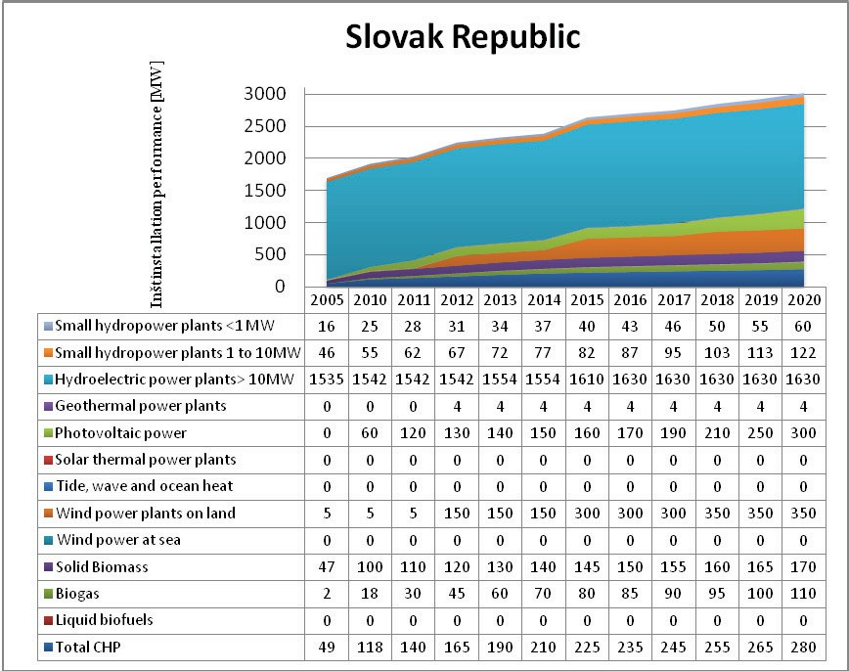*Potential of RES using in Slovakia and Czech Republic to 2020*

Fig. 1. Assumed RES using in Slovakia to 2020 [6]

Figure 1 describes graph for assumed RES using in Slovakia to 2020. Biggest using is assumed in area of water energy, concretely for water hydroelectric power plants with performance more then 10 MW. In 2020 hydroelectric power plants will have highest installed performance. Second place belongs to wind power plants on the continent, then photovoltaic power plants, total combined production of electricity and heat (CPEH), biomass and finally geothermal energy. In Slovakia there are not used some RES types, since Slovakia does not have good conditions for their using.

Figure 2 illustrates RES using in Czech Republic to 2020. Since Slovakia and Czech Republic belong among inland countries and their boundary does not connect the sea, they do not have possibility to use wind power plants on the sea, energy from inflow, waves and ocean heat. Biggest rate on the total RES using in present time belong to photovoltaic power plants. Photovoltaic power plants will have also in 2020 biggest rate on total using and they will remain on top. Water power plants with performance over 10 MW have second highest rate in present time on total RES using, but their using is not planned to be further developing and in 2020 their performance will remain at the same level. Wind power plants will achieve in 2020 value level of water power plants with performance higher then 10 MW.

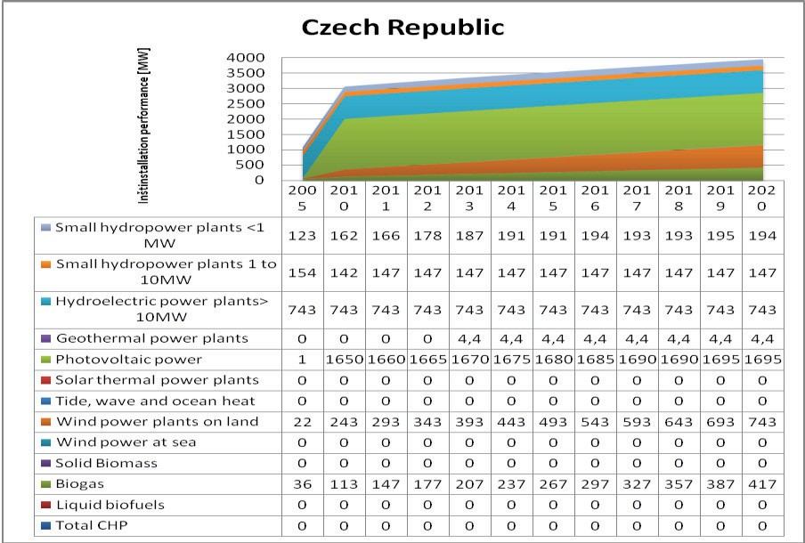

Fig. 2. Assumed RES using in Czech Republic to 2020 [6]

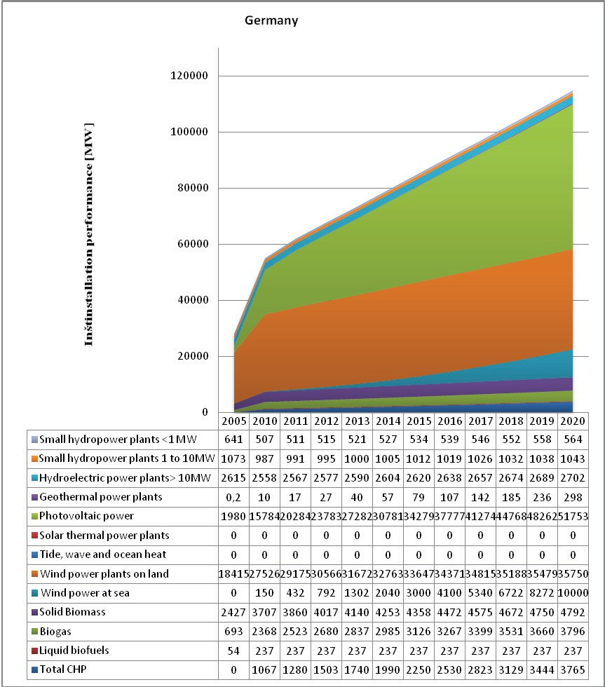

Fig. 3. Assumed RES using in Germany to 2020 [6]

Figure 3 describes graph of assumed RES using in Germany, where there is planned to continue in speed development of photovoltaic. In 2020 photovoltaic will have highest rate on the total RES using. In wind energetic there is precedence in planning of power plants development on the sea. Performance of wind power plants on the continent will be smoothly increasing, but it will have still higher and outstanding performance against performance of wind power plants on the sea. Water power plants have small rate on total RES using in comparison with photovoltaic and wind power plants. But geothermal energy has smallest rate, but against Slovakia and Czech Republic its using is rather greater. Using of energy from biomass to 2020 will not increase considerably.

* 1. *Potential of RES using in Great Britain to 2020*

Figure 4 illustrates assumed RES using in Great Britain to 2020. Great Britain plans mainly using of wind potential at the North Sea. Wind power plants on the continent prevail in present time over performance of power plants on the continent almost doubly. In 2020 their performance will equal. Geothermal energy is not using according the data source. Water and photovoltaic power plants will have in 2020 approximately similar performance. Using of biomass is a little higher then using of photovoltaic and wind power plants.

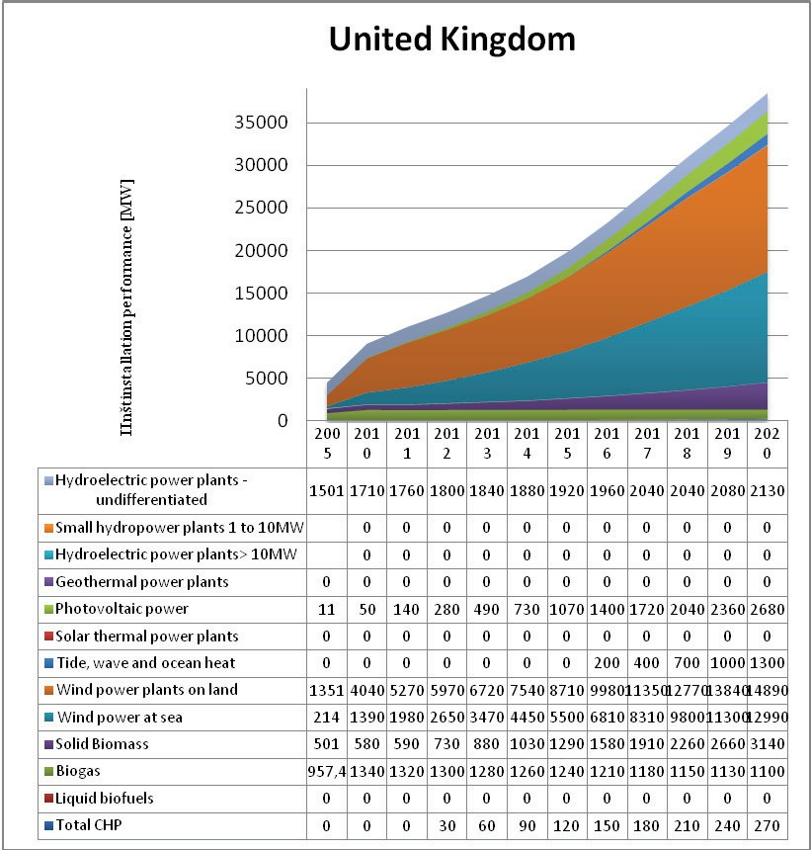

Fig. 4. Assumed RES using in Great Britain to 2020 [6]

## Conclusion

In Slovakia water power plants will have in 2020 highest installed performance. Then wind power plants on continent will follow, next photovoltaic power plants, biomass and finally geothermal energy. In Czech republic photovoltaic will have highest installed performance in 2020, then water energy, wind energy, biomass and geothermal energy. Precedency in highest installed performance in 2020 will belong Germany in area of photovoltaic, next wind energy, biomass, water energy and geothermal energy. In Great Britain water energy will have lowest installed performance in 2020, highest installed performance will belong to wind energy, then biomass and photovoltaic.

## Acknowledgements

The article is a partial output of a research task of Slovakian research agency VEGA No 1/1033/12 - Indicators for social responsible business of small and middle firms in context of regional development.

## References

1. Seňová, A., Antošová, M. Hodnotenie makro a mikro ekonomického prostredia energetickej efektívnosti podnikania s OZE na Slovensku. In: Acta Montanistica Slovaca. roč. 15, 2010, mimoriadne číslo 2, s. 146- 152.
2. Tauš, P., Taušová, M. Ekonomická analýza fotovoltaických elektrární podľa inštalovaného výkonu. Economical analysis of FV power plants according installed performance, 2009. In: Acta Montanistica Slovaca. ISSN 1335-1788. - Roč. 14, č. 1, 2009, s. 92-97. [http://actamont.tuke.sk/pdf/2009/n1/13taus.pdf.](http://actamont.tuke.sk/pdf/2009/n1/13taus.pdf)
3. Naščáková, J., Weiss, E., Červenka, P., Mixtaj, L., Weiss, R.: A support of the renewable source energy utilization and conditions for the biogass station investment. In: Acta Montanistica Slovaca. Roč. 14,

č. 4, 2009, s. 323-329. ISSN 1335-1788. [http://actamont.tuke.sk/pdf/2009/n4/7nascakova.pdf.](http://actamont.tuke.sk/pdf/2009/n4/7nascakova.pdf)

1. Jandačka, J., Malcho, M. Biomasa ako zdroj energie. 2007. [online] http://www.biomasa- info.sk/docs/PriruckaBiomasaZdrojEnergie.pdf. ISBN 978-80-969161-4-6.
2. Šúri, M. Výroba elektriny z hľadiska obnoviteľných zdrojov energie [online] [http://www.agroporadenstvo.sk/oze/oze/energia_z_oze.pdf.](http://www.agroporadenstvo.sk/oze/oze/energia_z_oze.pdf)
3. Národné akčné plány krajín Európskej únie [online] <http://oze.tzb-info.cz/7266-narodni-akcni-plany-zemi-> eu-instalovany-vykon-oze-elektraren.