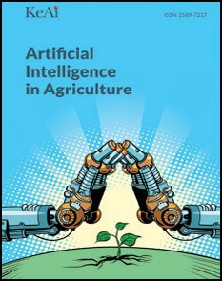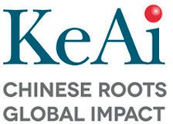[Artificial Intelligence in Agriculture 5 (2021) 252–261](https://doi.org/10.1016/j.aiia.2021.11.002)

Contents lists available at [ScienceDirect](http://www.sciencedirect.com/science/journal/)

Artificial Intelligence in Agriculture

journal homepage: [http://www.keaipublishing.com/en/journa ls/artificial- intelligence- in-agriculture/](http://www.keaipublishing.com/en/journals/artificial-intelligence-in-agriculture/)

[](http://crossmark.crossref.org/dialog/?doi=10.1016/j.aiia.2021.11.002&domain=pdf)Worldwide trends in the scientific production of literature on traceability in food safety: A bibliometric analysis

Aditya Sinha a,⁎, Prashant Priyadarshi b, Mani Bhushan c, Dharmendra Debbarma d

a *Department of Extension Education, Bihar Agricultural College, Bihar Agricultural University, Sabour, Bhagalpur, Bihar 813210, India*

b *Department of Computer Science and Enginnering, National Institute of Technology, Patna, Bihar 800005, India*

c *Department of Extension Education, Bhola Paswan Shastri Agricultural College, Bihar Agricultural University, Sabour, Bhagalpur, Bihar 813210, India*

d *Dept. of Agricultural Extension, College of Agriculture, Tripura, Lembucherra, West Tripura 799210, India*

a r t i c l e i n f o

*Article history:*

Received 16 August 2021

Received in revised form 19 November 2021 Accepted 19 November 2021

Available online 22 November 2021

*Keywords:* Scientometric analysis Food safety Traceability Publications Technology

Contents

a b s t r a c t

Food traceability is an important aspect of the food safety supply chain to ensure efficient tracking of produce to check contamination and other foodborne diseases. The health and nutrition response after the Covid-19 pan- demic requires a robust and diverse food supply chain in which traceability could play a major role. Since it is an emerging field of study with growing interest in the technological front, it is important to study the scientific trend and research activities. This study provides an important insight into the food safety value chain response towards modern food safety management systems through scientometric analysis. Scopus database was used to retrieve the documents from the year 1992–2021. The research papers and conference papers were only chosen. Vosviewer software was used to carry out the scientometric analysis. The distribution and growth trend of documents, country-level distribution of publications, the relationship between authors and co-authors, etc., were analyzed. The intensity of publications from different countries and the collaborations was analyzed using bibliometrix R-package. The year-wise research publication showed a rapid increase in the researchers conducted on traceability systems to enhance food safety from 2014 onwards, mainly from the USA and China. However, the research appeared to be in the developing phase compared to other technology implementation and automation advancements.

© 2021 The Authors. Publishing services by Elsevier B.V. on behalf of KeAi Communications Co., Ltd. This is an open access article under the CC BY-NC-ND license (<http://creativecommons.org/licenses/by-nc-nd/4.0/>).

1. Introduction 253
2. Materials and methods 253
   1. Study design 253
   2. Source of information 253
   3. Search strategy 253
   4. Data analysis 254
3. Results and discussion 255
   1. The distribution and growth trend of publications yearly 255
   2. Publication distribution on a country-by-country basis 255
   3. Authors and co-authors relationship 256
   4. Distribution and co-citation relationship 257
   5. Documents and citation relationships 257
4. Conclusion 257

Author's contribution 260

Availability of data and material 260

Funding 260

Consent for publication 260

* Corresponding author.

*E-mail address:* [inc.aditya@gmail.com](mailto:inc.aditya@gmail.com) (A. Sinha).

<https://doi.org/10.1016/j.aiia.2021.11.002>

2589-7217/© 2021 The Authors. Publishing services by Elsevier B.V. on behalf of KeAi Communications Co., Ltd. This is an open access article under the CC BY-NC-ND license ([http://](http://creativecommons.org/licenses/by-nc-nd/4.0/) [creativecommons.org/licenses/by-nc-nd/4.0/](http://creativecommons.org/licenses/by-nc-nd/4.0/)).

Ethics approval and consent to participate 260

Declaration of Competing Interest 260

Acknowledgements 260

References 260

1. Introduction

The importance of food supply chain was largely felt after the decla- ration of Covid-19 pandemic in March 2020 (WHO, 2020). The food sup- ply chains throughout the world faced intermittent disruption due to the lockdowns and restrictions imposed by the governments (Galanakis, 2020). The United States Centers for Disease Control and Prevention (CDC or U.S. CDC) which acts as the national public health agency of the United States reported over 16,000 Covid-19 cases and 239 deaths among workers of the country in meat processing facilities across 19 states (Dyal et al., 2020). Similarly, China noticed traces of the virus on the beef imports reaching the country from Australia, Brazil, New Zealand, and Bolivia (Singh and Liu, 2020). Similar incidents were also reported from other countries of the world which led to ban on imports and severe measures leading to adverse impact on trade and tariffs.

The food industry is still reliant on a large extent on the physical paper records which mostly remains on the paper and difficult to search and covert into digital form. As such, traceability systems offer the nec- essary solution leading to risk minimization that is critical to the assur- ance of food safety in a connected world (Aung and Chang, 2014). The traceability tool is utilized to identify the movement of food from pro- duction to distribution along with necessary inspection and certification within the system. The transparency in the chain of events through the traceability systems lead to minimization of possible fraud and cheating (Pearson et al., 2019). Several upcoming researches and development organizations are making use of advanced technologies such as Internet of Things (IoT), distributed ledger and block chain technologies, wire- less identification sensor technology, etc., for capture and processing of data leading to the efficiency in management of food systems (Bouzembrak et al., 2019; Iftekhar and Cui, 2021). Blockchain technol- ogy has helped the consumers to track the movement of food products which leads to the reduction of counterfeiting, dilution and adulteration of produce (Garaus and Treiblmaier, 2021). The study on consumer ben- efit through traceability systems have shown an improved access to in- formation for making informed purchase decisions. The retailers also benefit through the access of information related to the origin of the product (Islam and Cullen, 2021). These technological tools are data driven thriving on cloud-based online solutions. The reliability of the data is essential to ensure food safety chains from origin to destination.

The application of traceability on agricultural systems is also useful

in the creation of competitive advantage. The addition of value with the integration of the traceability system and supply chain management processes leads to better management of the business process and im- provement of performance (Wang and Li, 2006). Traceability systems also leads to profitability and improvement in product quality since it makes easy for the producer to recall the products from the market if a defect is detected due to the efficient tracking of the product. This leads to better profitability for the producer along with ensuring the quality of the product available for the consumers (Bechini et al., 2008; Cui et al., 2019; Germani et al., 2015). Furthermore, the integra- tion of blockchain technologies leads to transparencies for all the partic- ipants of the value chain. The storing of data during the process which is irreversible leads to the creation of trust and credibility leading to the sustainable development of the industry along with maintaining a re- cord of clients for further use (Jeppsson and Olsson, 2017; Maity et al., 2021; Malik et al., 2021; Sunny et al., 2020).

The developments in the field traceability related to food safety was observed through bibliometric analysis to measure objectively the

impact of the scholarly publications and the influence as a measure of scientific quality (Van Raan, 2003). However, to our best of knowledge, there is no previous study of a global bibliometric analysis on the aspect focusing the future of food safety using traceability-based solutions. The current article explores the application of traceability solutions in the domain of food safety using different technological applications. The major goal of the paper was to offer a comprehensive overview of recent developments in the realm of food safety and traceability. To ac- complish our goal, we used the Scopus database to undertake a biblio- metric study of documents published in food safety and traceability area. The following were some of the major takeaways from the paper: (1) the distribution and trend of publications over time (2) the distribution of publications from various nations (3) organizations engaged in the area that have published more than two papers (4) rela- tionship between different authors and co-authors (5) authors in the domain who has published more than five documents (6) source and citation relationship of the sources (7) top journals where over ten doc- uments were published (8) top documents which have at least 100 citations, and (8) collaboration between different countries in context of research publication. This paper is structured as follows: In Section 2, we briefly describe the materials and methods adopted for the study. In the third section, we present the findings based on the da- tabase and methodology of the study. In Section 4, we conclude the paper in the light of previous literature.

1. Materials and methods
   1. *Study design*

The bibliometric analysis was performed using articles published until May 2021 in Scopus indexed journals (<https://www.scopus.com/>). Out of various document types, only research articles and conference pa- pers were selected for the study because we are interested in checking the research evidence concerning our major keywords, food safety and traceability.

* 1. *Source of information*

The bibliometric analysis was conducted using publications re- trieved from the Scopus database (Elsevier B.V., USA). Scopus database was used since it is the largest abstract and citation database of peer- reviewed literature encompassing science, technology, social sciences, etc. (Ballew, 2009). Also, it includes other relevant information for the study, such as citations per document and country-wise affiliation of all the authors (Agarwal et al., 2016; Hernández-Vásquez et al., 2018).

* 1. *Search strategy*

The literature search was carried out using the search term in the title and abstract field, as mentioned in Table 1, on a single day, May 27, 2021. The validity of the search strategy was determined by manu- ally reviewing the retrieved documents by two authors. The period restrictions were not applied, resulting in documents published from 1992 to 2021. After removing the duplicates, we were left with 805 doc- uments. The information related to citations, bibliography, abstract and keywords, funding, and others were exported as CSV files for further analysis using bibliometric tools. The Scopus database may involve some errors in bibliometric applications (Falagas et al., 2008), for

Table 1

Combination of keywords used for search on Scopus database.

|  |  |  |  |
| --- | --- | --- | --- |
| Major keyword | Operator | Additional keywords | Number of results |
| Food safety | AND | Traceability | 451 |
| Food safety | AND | Radio-Frequency identification OR RFID OR Radio frequency ident* | 31 |
| Food safety | AND | Timestrip freshness indicator label* OR “Fresh* Indicator” OR Timestrip | 4 |
| Food safety | AND | Bar code | 25 |
| Food safety | AND | QR code OR Quick response code | 9 |
| Food safety | AND | Digital tag* OR Tag* | 77 |
| Food safety | AND | NFC OR Near field communication | 5 |
| Food safety | AND | Digital sensing OR Sensing | 136 |
| Food safety | AND | IoT OR IOT OR Internet of Thing* | 21 |
| Food safety | AND | Wireless identification sensor technology OR Sensor technology OR Identification technology | 13 |
| Food safety | AND | Information AND Communication technology OR ICT | 14 |
| Food safety | AND | Nanotechnology | 81 |
| Food safety | AND | Near infrared spectroscopy | 41 |
| Food safety | AND | Blockchain | 16 |

asterisk (*) is a commonly used symbol to broaden a search by finding words that start with the same letters. It is typically used at the end of a root word. Search terms are not case sen- sitive, so words can be entered in upper case or lower case.

which standardization was necessary for the data. A few documents were detected which were erroneously ascribed to the sphere of author affiliation and country. Thus, a standardization was conducted physi- cally by two authors before conducting the analysis. (See Fig. 1.)

* 1. *Data analysis*

The current study employs VOSviewer version 1.6.16 software (Derviş, 2019; Van Eck and Waltman, 2013) and open-source bibliometrix R-package (Aria and Cuccurullo, 2017) for conducting bib- liometric analysis. VOSviewer software provides maps of various biblio- graphic data that are easy to interpret. VOSviewer can display maps in

different ways along with the functionality of zooming, scrolling, and searching. The popular maps developed using the software are co-authorship, keyword co-occurrence, citation, bibliographic coupling, or co-citation map based on bibliographic data (Van Eck and Waltman, 2010). The maps on VOSviewer are better visualized when the database contains a large number of items (i.e., at least 100 items or more). The other computer programs used in the bibliometric analysis cannot display the maps in such an explicit manner (Pal et al., 2021). The com- prehensive science mapping analysis including the worldwide distribu- tion map of publications and collaborations within the countries was conducted through bibliometrix R-package. The tool is programmed in open source platform R which employs specific tools for both bibliomet- ric and scientometric quantitative research. The co-occurrence network

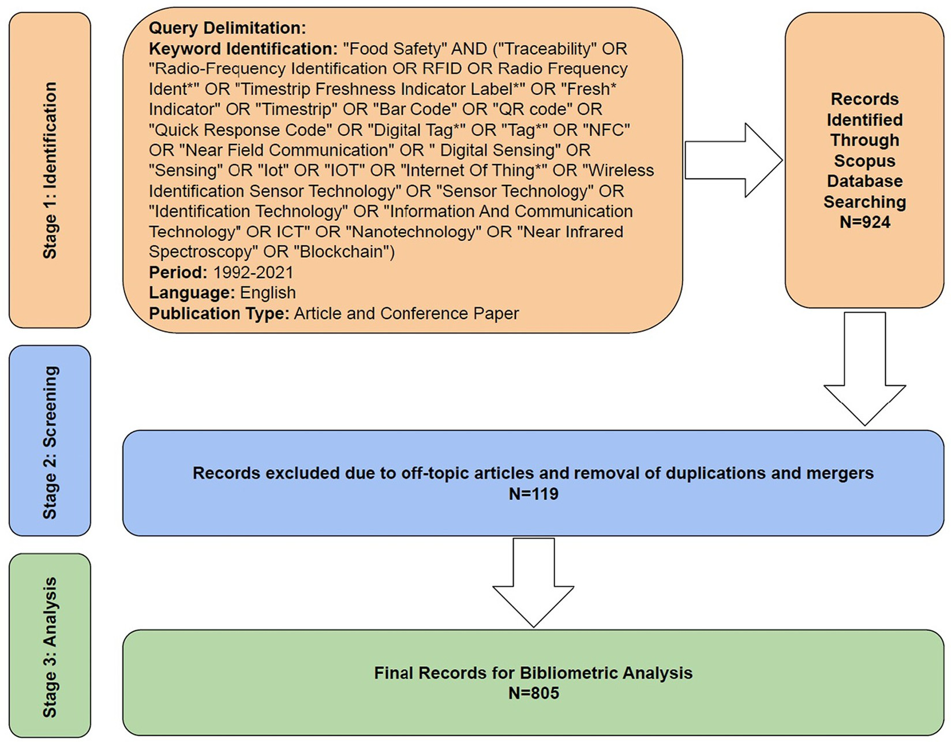

Fig. 1. Outline of search strategy for bibliometric analysis. (Year: 1992–2021).

map and collaboration world maps were prepared using bibliometrix R-package.

1. Results and discussion
   1. *The distribution and growth trend of publications yearly*

The increase in the number of publications in a certain discipline is a fair indication of the research trend in that field. The study of the rising trend in the number of publications can offer answers to a variety of new concerns and the future of the discipline.

A plot of the number of publications and cumulative publications on a year-to-year basis was plotted to analyze the research trend in con- nection to the growing scenario linked to traceability relevant to food safety paradigms (Fig. 2). Traceability about food safety is a relatively recent field, with the first papers dating back to 1992. However, it wasn't until 2008 that researchers began to show a significant increase in this field of study. Every year since 2009, at least 30 papers have been published. This year alone (2021), 48 articles have been published thus far. Furthermore, the cumulative publication graph shows that, since 2003, academics all over the world have been paying close attention to the subject of traceability in the context of food safety. The number of cumulative articles has increased exponentially since 2003, with an R2 value close to 0.85 (*p* < 0.0001).

* 1. *Publication distribution on a country-by-country basis*

The 805 articles came from 85 different nations. China had the most publications (199 articles, or 18.49% of all papers), followed by the United States of America with 185 articles (17.19%) (USA). Italy was on the third position with 77 articles (7.16%) followed by Spain with 49 articles (4.55%). Canada occupied the sixth rank with 34 articles (3.16%). Germany and the Netherlands tied for seventh place, both producing 28 articles (2.60%). Following that, five countries (South Korea, Australia, India, France, and Ireland) produced 20–24 articles. Furthermore, eight countries published articles in the range of ten to nineteen. The remaining 129 countries published less than ten articles on the aspect of traceability linked to food safety. When each country's contributions are added together, the total number of publications is 1076, which is greater than 805. This is evidenced by the fact that there has been a great deal of cross-national collaboration. In total, twenty nations published more than ten publications in the field of food safety connected to traceability. Table 2 shows the data for the various nations.

Table 2 shows that 13 of the top 20 nations have a nominal GDP of

less than $15,000. This shows that economically developed nations

have recognized the benefits of traceability solutions in food safety and are investigating their viability in order to ensure that the country's food is safe. The United States of America has received the most citations out of the 185 papers that have been published in the country. In terms of the number of documents published in the domain, China, the United States of America, and Italy are the top three nations. However, it is worth noting that China ranks fifteenth (15.99), the United States of America tenth (27.04), and Italy thirteenth (20.47) in terms of average citations per document. The European nations of Ireland (86.10), Belgium (46.21), and Spain (46.21) are in top place in terms of average citations per document (37.67).

The Total Link Strength (TLS) is a measurement of a country's collab- orative research with another (Table 2). TLS study revealed that the United States, with a TLS of 98, was by far the most superior country in terms of collaborative research. The US has collaborated on papers with China, the UK, Germany, Italy, the Netherlands, Spain, Ireland, Canada, France, Japan, Belgium, South Korea, India, Norway, Taiwan, Thailand, Kenya, Denmark, Turkey, Chile, and Columbia (Fig. 3). China was in second place, with a TLS of 85. The United States, Italy, the United Kingdom, Canada, Spain, Germany, Ireland, New Zealand, France, Sweden, Columbia, the Netherlands, Japan, Thailand, South Korea, Taiwan, Indonesia, Romania, Singapore, and Hong Kong have all published research documents with China.

The United Kingdom occupied the third position in joint research with a TLS score of 57. Researchers from the United Kingdom, the United States, China, Italy, Canada, Spain, Germany, New Zealand, Ireland, Belgium, France, the Netherlands, Japan, Sweden, Kenya, Finland, and Hungary collaborated on papers. The TLS score and the Country Cooperation Network Map reveal that most nations have a strong research connection with the United States, the United Kingdom, and China. Fig. 3 shows the country collaboration network.

Furthermore, the top organizations that published more than two publications in the same field of research were selected (Table 3). Ac- cording to the bibliometric analysis, eight organizations generated at least three papers during the years. Six of the eight organizations that released more than two publications in the study domain are from China, which is noteworthy.

It was found that the School of Food and Biological Engineering, Jiangsu University, China, had published five documents that received 154 citations. The average citation per document was found to be

30.80. It was followed by the Food Science and Technology Programme, C/o Department of Chemistry, National University of Singapore, Singapore and National University of Singapore (Suzhou) Research In- stitute, Suzhou, Jiangsu, China, with four publications and an equal number of average citations per document (34.50). The average citation per document of China Agricultural University, Beijing was the highest

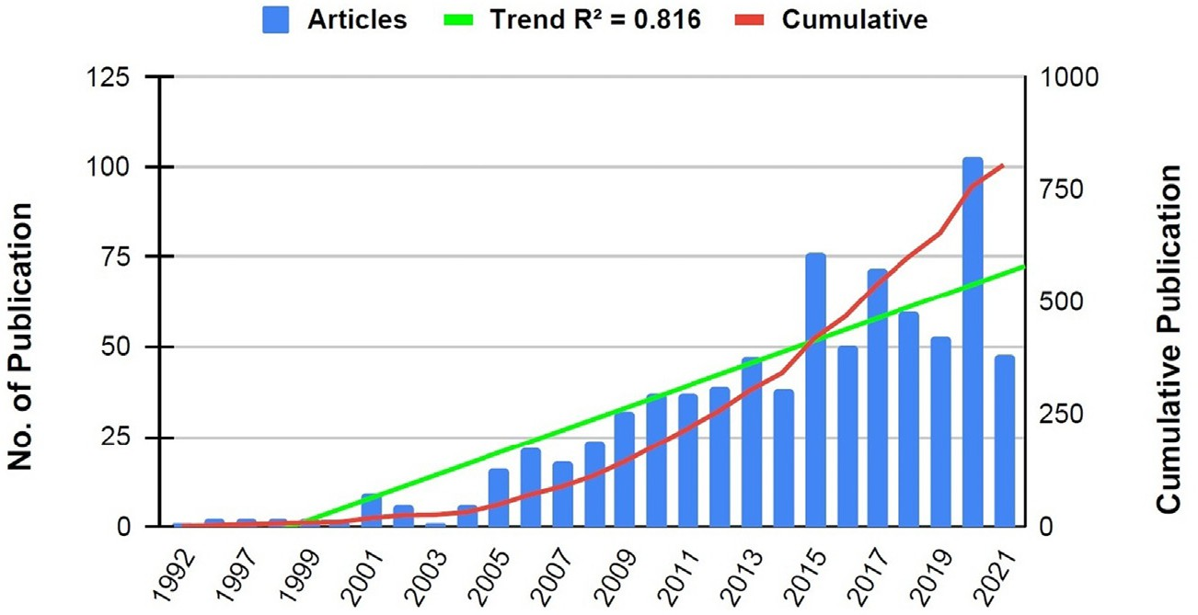

Fig. 2. Year-over-year changes in the number of publications and the total number of publications. (Year: 1992–2021).

Countries with over ten publications. Nominal GDP rank as per the International Monitory Fund.

|  |  |  |  |  |  |  |  |
| --- | --- | --- | --- | --- | --- | --- | --- |
| S·No. | Country | No. of documents | % Documents | No. of citations | Avg. citation per document | Total link strength | Nominal GDP Rank⁎ |
| 1 | China | 199 | 18.49 | 3182 | 15.99 | 85 | 2 |
| 2 | United States | 185 | 17.19 | 5002 | 27.04 | 98 | 1 |
| 3 | Italy | 77 | 7.16 | 1576 | 20.47 | 41 | 8 |
| 4 | Spain | 49 | 4.55 | 1846 | 37.67 | 33 | 14 |
| 5 | United Kingdom | 41 | 3.81 | 1244 | 30.34 | 57 | 5 |
| 6 | Canada | 34 | 3.16 | 1190 | 35.00 | 29 | 9 |
| 7 | Germany | 28 | 2.60 | 761 | 27.18 | 51 | 4 |
| 8 | Netherlands | 28 | 2.60 | 924 | 33.00 | 36 | 17 |
| 9 | South Korea | 24 | 2.23 | 365 | 15.21 | 15 | 10 |
| 10 | Australia | 23 | 2.14 | 672 | 29.22 | 20 | 12 |
| 11 | India | 22 | 2.04 | 435 | 19.77 | 9 | 6 |
| 12 | France | 21 | 1.95 | 734 | 34.95 | 25 | 7 |
| 13 | Ireland | 20 | 1.86 | 1722 | 86.10 | 30 | 29 |
| 14 | Taiwan | 18 | 1.67 | 233 | 12.94 | 6 | 21 |
| 15 | Brazil | 17 | 1.58 | 154 | 9.06 | 2 | 13 |
| 16 | Japan | 16 | 1.49 | 116 | 7.25 | 23 | 3 |
| 17 | Portugal | 16 | 1.49 | 403 | 25.19 | 13 | 49 |
| 18 | Belgium | 14 | 1.30 | 647 | 46.21 | 22 | 25 |
| 19 | New Zealand | 12 | 1.12 | 250 | 20.83 | 11 | 50 |
| 20 | Thailand | 11 | 1.02 | 147 | 13.36 | 10 | 26 |
| 21 | Other 65 countries | 221 | 20.53 | 3480 | 15.75 | – | – |

* Nominal GDP rank as per the International (2021 estimates), World Economic Outlook Database, April 2021.

(50.67) though it produced only three documents with 138 citations. The remaining four universities received less than 20 average citations per document and produced three documents in the research area. From the analysis, it can be concluded that the School of Food and Bio- logical Engineering, Jiangsu University, Zhenjiang, China and China Ag- ricultural University, Beijing, China, plays a significant role in the field of research.

* 1. *Authors and co-authors relationship*

The number of published papers and citation metrics obtained by the authors was used to identify the most active researchers in the area (Table 4). Wang J. has the highest number of publications (16)

followed by Li, J. (13). Liu, Y and Wang, S. had equal number of (12). However, in relation to the citations; Hobbs, J.E. had the maximum number of citations (454), followed by Wu, L. (415) and Kim, M.S.

(355). This suggested that these three researchers are the most active researchers in the study area Fig. 4.

The average number of citations per document, on the other hand, provides information about the most influential scholars. In other words, a high-quality article will have more citations, which may be de- termined by computing the average number of citations per document. It can be observed that Hobbs, J.E. (documents: 6, citations: 149), followed by Kim, M.S. (documents: 6, citations: 355) and Wu, L. (docu- ments: 9, citations: 415), had the highest average citations per docu- ment. This is suggestive that the documents of Hobbs, J.E., Kim, M.S.

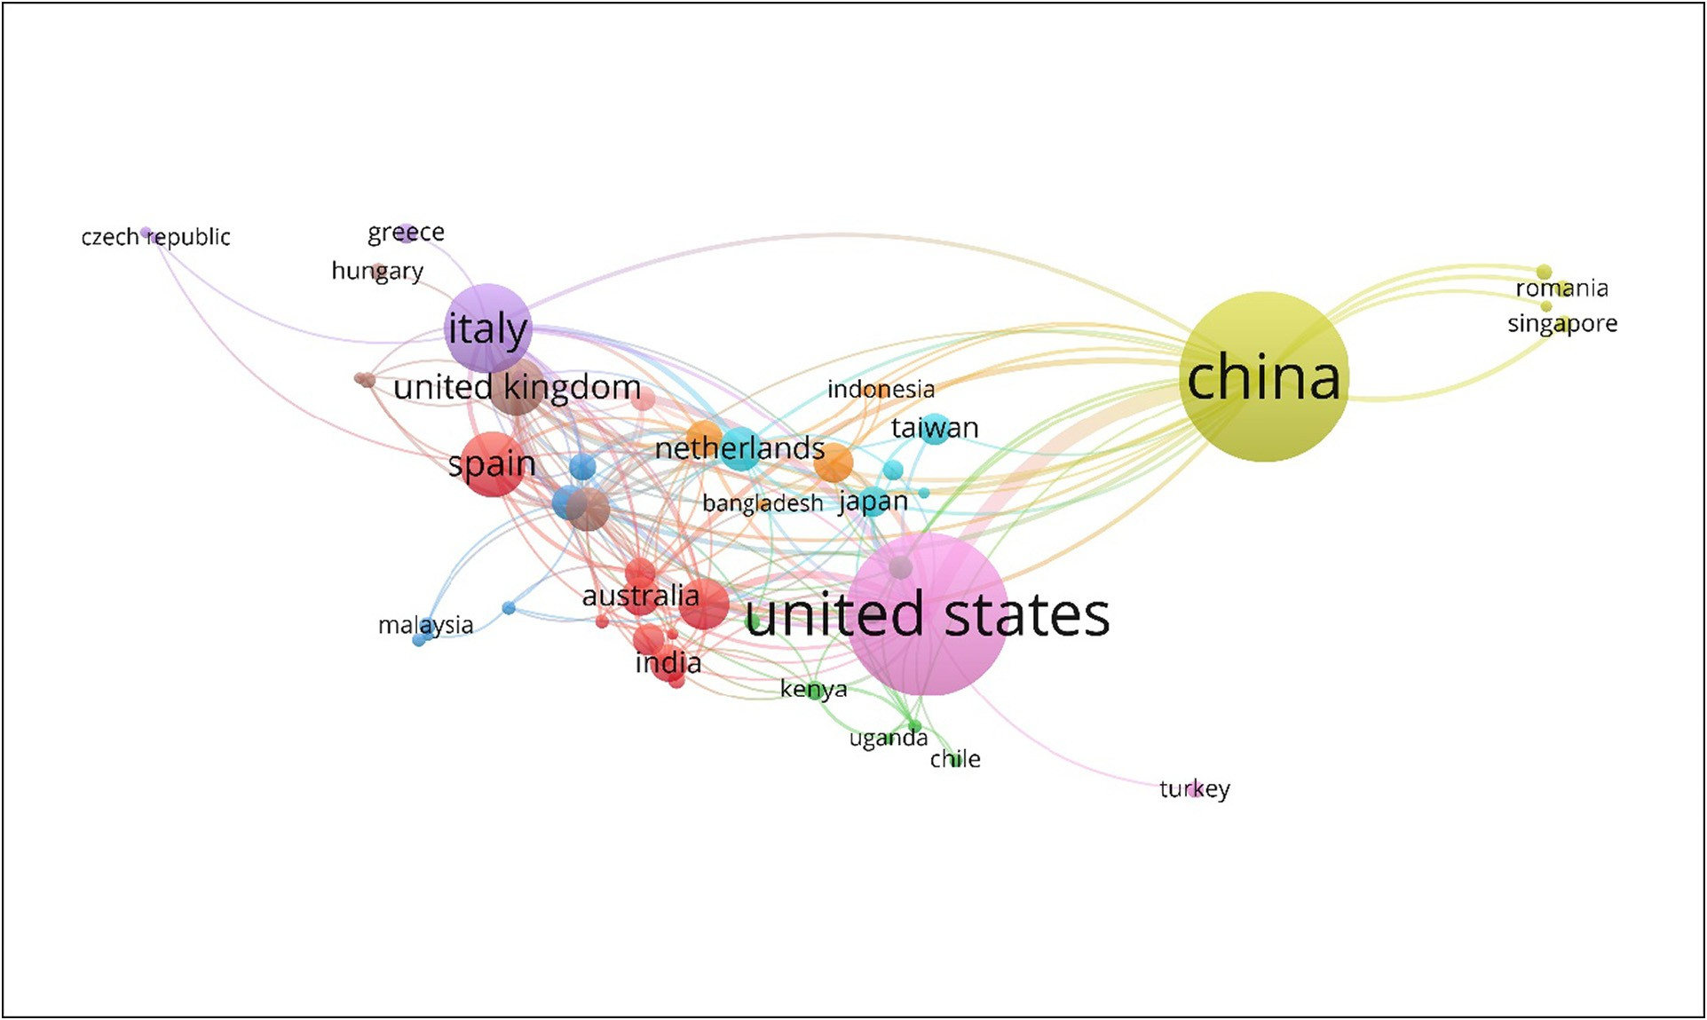

Fig. 3. A network of country collaborations based on the use of traceability in food safety research. (Note: Countries with at least three documents published were considered for the collaboration network).

Table 3

Leading organizations with over two publications.

|  |  |  |  |  |  |
| --- | --- | --- | --- | --- | --- |
| S·No. | Organization | Country | Documents | Citations | Avg citation per document |
| 1 | School of Food and Biological Engineering, Jiangsu University, Zhenjiang | China | 5 | 154 | 30.80 |
| 2 | Food Science and Technology Programme, C/o Department of Chemistry, National University of Singapore | Singapore | 4 | 138 | 34.50 |
| 3 | National University of Singapore (Suzhou) Research Institute, Suzhou, Jiangsu | China | 4 | 138 | 34.50 |
| 4 | China Agricultural University, Beijing | China | 3 | 152 | 50.67 |
| 5 | State Key Laboratory of Food Science and Technology, School of Food Science and Technology, Jiangnan | China | 3 | 54 | 18.00 |
| 6 | University  National Isotope Centre, GNS Science, 30 Gracefield Road, Lower Hutt | New Zealand | 3 | 26 | 8.67 |
| 7 | School of Public Health, Jilin University, Changchun | China | 3 | 20 | 6.67 |
| 8 | College of Biosystems Engineering and Food Science, Zhejiang University, Hangzhou | China | 3 | 1 | 0.33 |

and Wu, L. were more impactful than the others. The average citation per document of Thakur, M. was 31.00 (fourth position) and Zhang, J. was in the fifth position with an average citation score of 27.30. Interest- ingly, Wang, J. was at the first position with 16 documents in the re- search area, indicating that even though Wang, J. is a prolific researcher with strong networking and collaboration skills, his research findings are rarely recognized.

* 1. *Distribution and co-citation relationship*

The relationship between sources and citations indicates which prominent publications the authors choose to publish their findings (Fig. 5). Table 5 shows the major publications/ journals that have pub- lished research articles on traceability in the context of food safety. The most preferred journal for publishing the study on traceability in food safety problems was the Food Control journal. So far, seventy- eight papers have been published in the journal. The journal received 1901 citations as a result of these papers. The Food Chemistry journal came in second, with forty-eight papers published and 870 citations. With twenty-seven publications, the Journal of Agricultural and Food Chemistry came in third. These research papers got 575 citations in the journal. The average number of citations per document indicates the importance of publications published in journals. Food Policy, Jour- nal of Food Engineering, and British Food Journal were the top three journals in terms of average citations per document. This is due to the

Table 4

Leading authors with over five publications.

|  |  |  |  |  |  |
| --- | --- | --- | --- | --- | --- |
| S·No | Author | No. of Documents | Citations | Average citation | Total link strength |
| 1 | Wang J. | 16 | 238 | 14.88 | 22 |
| 2 | Li J. | 13 | 111 | 8.54 | 34 |
| 3 | Liu Y. | 12 | 214 | 17.83 | 23 |
| 4 | Wang S. | 12 | 242 | 20.17 | 23 |
| 5 | Zhang X. | 11 | 271 | 24.64 | 25 |
| 6 | Zhang J. | 10 | 273 | 27.30 | 19 |
| 7 | Zhang Y. | 10 | 115 | 11.50 | 15 |
| 8 | Li Y. | 9 | 92 | 10.22 | 18 |
| 9 | Liu X. | 9 | 67 | 7.44 | 16 |
| 10 | Wu L. | 9 | 415 | 46.11 | 19 |
| 11 | Bhatt T. | 8 | 55 | 6.88 | 8 |
| 12 | Yang H. | 8 | 166 | 20.75 | 13 |
| 13 | Wang X. | 7 | 65 | 9.29 | 18 |
| 14 | Xu L. | 7 | 146 | 20.86 | 16 |
| 15 | Xu Y. | 7 | 46 | 6.57 | 15 |
| 16 | Hobbs J.E. | 6 | 454 | 75.67 | 2 |
| 17 | Kim M.S. | 6 | 355 | 59.17 | 6 |
| 18 | Li M. | 6 | 45 | 7.50 | 10 |
| 19 | Thakur M. | 6 | 186 | 31.00 | 4 |
| 20 | Wang H. | 6 | 97 | 16.17 | 9 |
| 21 | Wang H. | 6 | 97 | 16.17 | 9 |

fact that high-quality research was published in Food Policy, Journal of Food Engineering, and British Food Journal. This is supported by the fact that these journals have an impact factor exceeding 2.30. Except for Acta horticulturae, Advance journal of food science and technology, and Journal of Food Science and Food Technology, the rest of the journals had an impact factor of over 2.30. It is also worth noting that journals with a higher total link strength had a higher average citation per document than those with a lower average citation per document. This points to the fact that these journals were highly cited by papers published in other journals, as seen by the source-citation relationship map (Fig. 6).

* 1. *Documents and citation relationships*

The relationship between the published documents and citations re- ceived is important to understand the quality of the publication. The higher citation count is representative of superior quality of the publica- tion resulting in a greater number of citations by other researchers in the same field. In our study, the articles which have been cited for over 100 times were only selected. This narrowed down the number of articles to 36 (Table 6). The article which was cited the greatest num- ber of times was authored by Gowen et al. (2007), which highlighted hyperspectral imaging as an emerging process for food quality and safety control. Consumer preferences in terms of food safety, country- of-origin labelling, and traceability were reported in the second most referenced paper. The hyperspectral reflectance and fluorescence imag- ing system for food quality and safety was highlighted in the third most referenced document. The paper by (Loureiro and Umberger, 2007) has been cited the most (23 times) by the selected set of 36 articles among these three top-cited pieces. Bertolini et al. (2006) and Angulo and Gil (2007) articles were referenced 10 times by the chosen group. This indi- cates that more high-quality publications in the subject of food safety and traceability follow these two texts.

It can be seen in Fig. 6 that there were two separate and closely linked clusters. The document by Hobbs et al. (2005) received the most citations in the first category. The materials from Gowen et al. (2007) were among the most referenced articles in the second group. To sum up, the documents by Loureiro and Umberger (2007), Hobbs et al. (2005), and Gowen et al. (2007) were the most important publica- tions that had a major influence on the concerned research domain.

1. Conclusion

The results presented in our study showed an increasing trend par- ticularly from the year 2014. The majority of publications and collabora- tions were from countries like the China, US and countries of the European Union. The sources analysis indicated that the organizations publishing more than two documents in the area were mostly from China, Singapore and New Zealand. The findings support the efforts of the developed countries in prioritizing traceability of agricultural

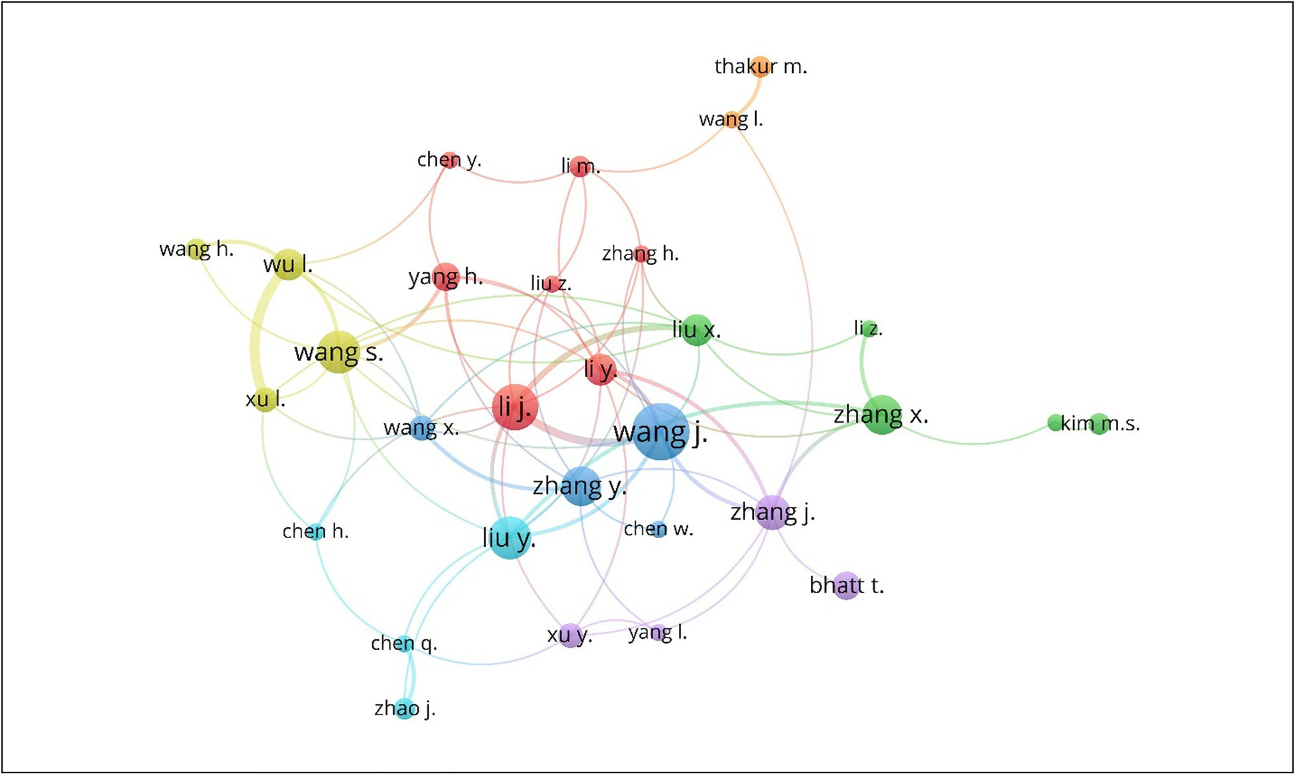

Fig. 4. The relationship between authors and co-authors working in the field of traceability and food safety research. (Note: Authors with more than five publications were considered).

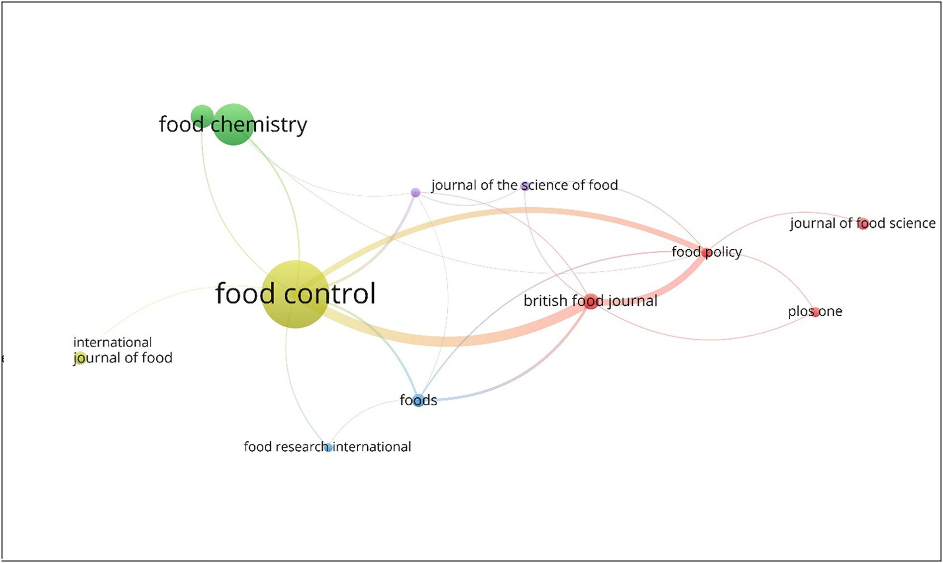

Fig. 5. Relationship between source and citations on published documents of traceability and food safety research. (Note: Only sources with at least 10 documents published were evaluated).

Table 5

Top journals where more than ten documents were published.

|  |  |  |  |  |  |
| --- | --- | --- | --- | --- | --- |
| S.No | Source | No. of documents | Citations | Avg citation per document | Total link strength |
| 1 | Food Control | 78 | 1901 | 24.37 | 102 |
| 2 | Food Chemistry | 48 | 870 | 18.13 | 8 |
| 3 | Journal of Agricultural and Food Chemistry | 27 | 575 | 21.30 | 6 |
| 4 | Acta Horticulture | 23 | 64 | 2.78 | 0 |
| 5 | British Food Journal | 19 | 739 | 38.89 | 105 |
| 6 | Food Technology | 15 | 53 | 3.53 | 0 |
| 7 | Foods | 15 | 53 | 3.53 | 23 |
| 8 | International Journal of Food Microbiology | 15 | 474 | 31.60 | 3 |
| 9 | Advance Journal of Food Science and Technology | 14 | 20 | 1.43 | 0 |
| 10 | Food and Chemical Toxicology | 14 | 196 | 14.00 | 0 |
| 11 | Journal of Food Science | 14 | 98 | 7.00 | 6 |
| 12 | Food Policy | 12 | 1074 | 89.50 | 71 |
| 13 | Journal of the Science of Food and Agriculture | 12 | 116 | 9.67 | 13 |
| 14 | PlosOne | 12 | 229 | 19.08 | 8 |
| 15 | Journal of Food Engineering | 11 | 609 | 55.36 | 24 |

products to ensure food safety and security (Caporale et al., 2001; Salina et al., 2021). The most active author in the domain was (Wang and Li, 2006) with 16 publications and a citation count of 238. The average citation received by the author was 14.88. The publications in the do- main were not dominated by any particular journal. The journal ‘Food Control’ contributed maximum articles in the domain with 78 documents and 1901 citations followed by the journal ‘Food Chemistry’ (48 documents and 870 citations) and ‘Journal of Agricultural and Food Chemistry’ (27 documents and 575 citations). The articles with over 100 citations narrowed down the total number of articles to 36. The article with greatest number of citations was authored by (Gowen et al., 2007), which provided an insight the role of hyperspectral imaging for ensuring food quality and safety control. The collaboration map be- tween the authors of different countries in the research domain showed that the prominent countries in article publication in this domain were USA, China, Australia, India, Brazil, New Zealand and European

countries. Also, the highest collaboration in publications were observed between USA and China. The results are in consistence with the interna- tional collaboration publication output of China and USA which has showed exponential growth in the past two decades. The growth of science in China during the period has led to major collaboration with G7 countries at the research field (He, 2009; Verbeek et al., 2002). The major limitation of the study could be the reliance on the Scopus data- base which is subject to continuous change and updating in the number of indexed journals (Durieux and Gevenois, 2010; Uthman, 2008). This implies that a bibliometric analysis after an interval of few years may provide substantial variations in the results since the researches in the area is continuously growing with the emergence of several novel tech- nologies. There could be a possibility to combine different databases for better depiction of content in the research area. However, the results obtained in the study can help the researchers to dive deeper into the research area and investigate possible research gaps for future study.

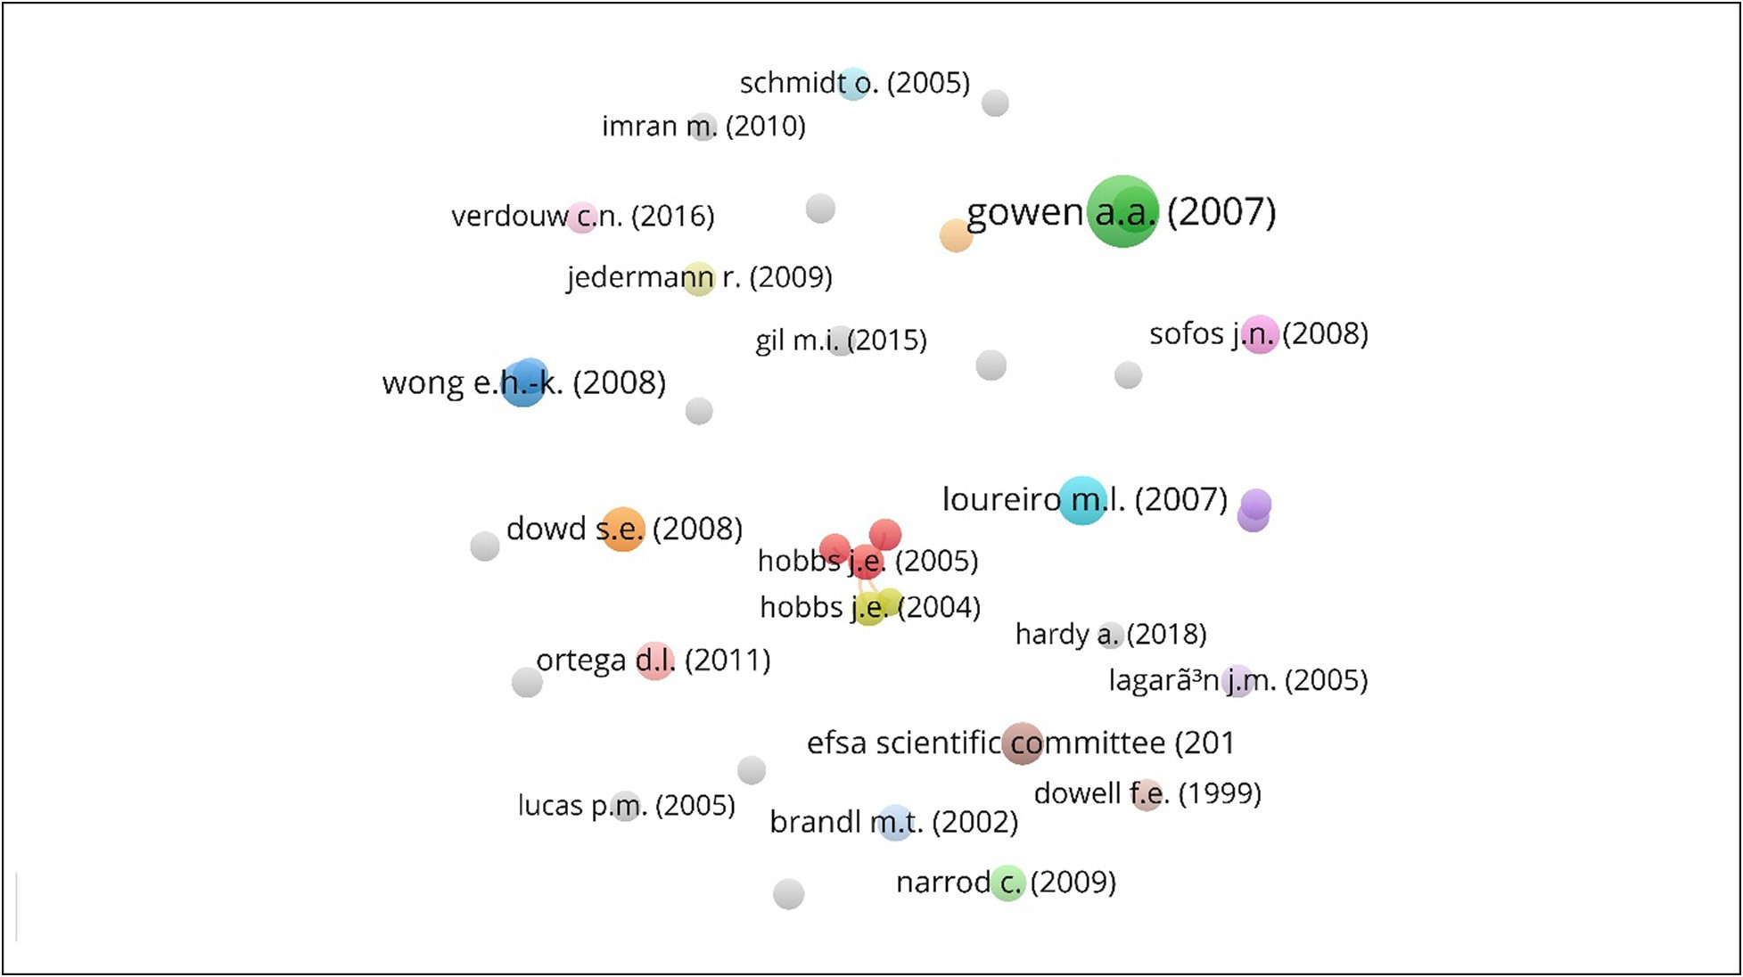

Fig. 6. Relationship between documents and citations for publications that have been cited at least 100 times.

Table 6

Leading documents with at least 100 citations. (Year: 1992–2021).

|  |  |  |  |  |  |
| --- | --- | --- | --- | --- | --- |
| S.No | Document | Citations | Links | References |  |
| 1 | Gowen A.A. (2007) | 859 | 1 | (Gowen et al., 2007) |  |
| 2 | Loureiro M.L. (2007) | 381 | 23 | (Loureiro and Umberger, 2007) |  |
| 3 | Kim M.S. (2001) | 328 | 2 | (Kim et al., 2001) |  |
| 4 | Wong E.H.-K. (2008) | 317 | 3 | (Wong and Hanner, 2008) |  |
| 5 | Dowd S.E. (2008) | 295 | 0 | (Dowd et al., 2008) |  |
| 6 | Sofos J.N. (2008) | 227 | 0 | (Sofos, 2008) |  |
| 7 | Ortega D.L. (2011) | 226 | 17 | (Ortega et al., 2011) |  |
| 8 | Narrod C. (2009) | 196 | 1 | (Narrod et al., 2009) |  |
| 9 | Brandl M.T. (2002) | 194 | 0 | (Brandl and Mandrell, 2002) |  |
| 10 | Barbuto M. (2010) | 185 | 4 | (Barbuto et al., 2010) |  |
| 11 | Hobbs J.E. (2005) | 183 | 31 | (Hobbs et al., 2005) |  |
| 12 | Hobbs J.E. (2004) | 168 | 17 | (Hobbs, 2004) |  |
| 13 | Jedermann R. (2009) | 167 | 1 | (Jedermann et al., 2009) |  |
| 14 | Lagarón J.M. (2005) | 164 | 0 | (Lagaron et al., 2005) |  |
| 15 | Schmidt O. (2005) | 162 | 0 | (Schmidt et al., 2005) |  |
| 16 | Feng Y.-Z. (2013) | 157 | 0 | (Feng et al., 2013) |  |
| 17 | Becker T. (2000) | 149 | 5 | (Becker, 2000) |  |
| 18 | Dowell F.E. (1999) | 149 | 0 | (Dowell et al., 1999) |  |
| 19 | Van Rijswijk W. (2008) | 145 | 7 | (Van Rijswijk and Frewer, 2008) |  |
| 20 | Verdurme et al. (2001) | 142 | 1 | (Verdurme et al., 2001) |  |
| 21 | Bertolini M. (2006) | 140 | 10 | (Bertolini et al., 2006) |  |
| 22 | Busolo M.A. (2010) | 140 | 0 | (Busolo et al., 2010) |  |
| 23 | Lucas P.M. (2005) | 137 | 0 | (Lucas et al., 2005) |  |
| 24 | Gil M.I. (2015) | 136 | 0 | (Gil et al., 2015) |  |
| 25 | Angulo A.M. (2007) | 135 | 10 | (Angulo and Gil, 2007) |  |
| 26 | Chen J. (2012) | 134 | 0 | (Chen et al., 2012) |  |
| 27 | Van Rijswijk W. (2008) | 133 | 17 | (Van Rijswijk and Frewer, 2008) |  |
| 28 | Smith G.C. (2005) | 125 | 8 | (Smith et al., 2005) |  |
| 29 | Souza V.G.L. (2016) | 121 | 0 | (Souza and Fernando, 2016) |  |
| 30 | Potyrailo R.A. (2012) | 118 | 0 | (Potyrailo et al., 2012) |  |
| 31 | Imran M. (2010) | 111 | 0 | (Imran et al., 2010) |  |
| 32 | Garcia-Alonso M. (2006) | 109 | 0 | (Garcia-Alonso et al., 2006) |  |
| 33 | Golberg D. (2011) | 108 | 0 | (Golberg et al., 2011) |  |
| 34 | Dupuy C. (2005) | 106 | 7 | (Dupuy et al., 2005) |  |
| 34  36 | Hardy A. (2018)  Pouliot S. (2008) | 106  104 | 0  5 | (EFSA Scientific Committee et al., 2018)  (Pouliot and Sumner, 2008) |  |

Author's contribution

AS was responsible for conceptualization, drafting the manuscript, reviewing and editing. PP assisted in data analysis and visualization. MS contributed in supervision and validation of results, DD assisted in reviewing and editing. The authors discussed the results and implica- tions of the manuscript at all stages.

Availability of data and material

All relevant data and material are presented in the main paper.

Funding

Not applicable.

Consent for publication

Not applicable.

Ethics approval and consent to participate

Not applicable.

Declaration of Competing Interest

There is no conflict of interest whatsoever between the co-author and me. Any cooperation or institution did not fund this research.

Acknowledgements

The authors are grateful to the National Institute of Technology, Patna, for providing the facilities to access the Scopus database. The au- thors are also thankful to Bihar Agricultural University for their support in conducting the research.

References

Agarwal, A., Durairajanayagam, D., Tatagari, S., Esteves, S.C., Harlev, A., Henkel, R., Roychoudhury, S., Homa, S., Puchalt, N.G., Ramasamy, R., 2016. Bibliometrics: tracking research impact by selecting the appropriate metrics. Asian J. Androl. 18, 296. [https://](https://doi.org/10.4103/1008-682X.171582) [doi.org/10.4103/1008-682X.171582](https://doi.org/10.4103/1008-682X.171582).

Angulo, A.M., Gil, J.M., 2007. Risk perception and consumer willingness to pay for certified beef in Spain. Food Qual. Prefer. 18, 1106–1117. [https://doi.org/10.1016/j.foodqual.](https://doi.org/10.1016/j.foodqual.2007.05.008) [2007.05.008](https://doi.org/10.1016/j.foodqual.2007.05.008).

Aria, M., Cuccurullo, C., 2017. Bibliometrix: an R-tool for comprehensive science mapping analysis. J. Inf. Secur. 11, 959–975. <https://doi.org/10.1016/j.joi.2017.08.007>.

Aung, M.M., Chang, Y.S., 2014. Traceability in a food supply chain: safety and quality per- spectives. Food Control 39, 172–184. <https://doi.org/10.1016/j.foodcont.2013.11.007>. Ballew, B.S., 2009. Elsevier’s scopus® database. J. Electron. Resour. Med. Libr. 6, 245–252.

<https://doi.org/10.1080/15424060903167252>.

Barbuto, M., Galimberti, A., Ferri, E., Labra, M., Malandra, R., Galli, P., Casiraghi, M., 2010. DNA barcoding reveals fraudulent substitutions in shark seafood products: the Italian case of “palombo”(Mustelus spp.). Food Res. Int. 43, 376–381. [https://doi.org/10.](https://doi.org/10.1016/j.foodres.2009.10.009) [1016/j.foodres.2009.10.009](https://doi.org/10.1016/j.foodres.2009.10.009).

Bechini, A., Cimino, M.G., Marcelloni, F., Tomasi, A., 2008. Patterns and technologies for enabling supply chain traceability through collaborative e-business. Inf. Softw. Technol. 50, 342–359. <https://doi.org/10.1016/j.infsof.2007.02.017>.

Becker, T., 2000. Consumer perception of fresh meat quality: a framework for analysis. Br.

Food J. 102, 158–176. <https://doi.org/10.1108/00070700010371707>.

Bertolini, M., Bevilacqua, M., Massini, R., 2006. FMECA approach to product traceability in the food industry. Food Control 17, 137–145. [https://doi.org/10.1016/j.foodcont.](https://doi.org/10.1016/j.foodcont.2004.09.013) [2004.09.013](https://doi.org/10.1016/j.foodcont.2004.09.013).

Bouzembrak, Y., Klüche, M., Gavai, A., Marvin, H.J., 2019. Internet of things in food safety: literature review and a bibliometric analysis. Trends Food Sci. Technol. 94, 54–64. <https://doi.org/10.1016/j.tifs.2019.11.002>.

Brandl, M.T., Mandrell, R.E., 2002. Fitness of Salmonella enterica serovar Thompson in the cilantro phyllosphere. Appl. Environ. Microbiol. 68, 3614–3621. [https://doi.org/10.](https://doi.org/10.1128/AEM.68.7.3614-3621.2002) [1128/AEM.68.7.3614-3621.2002](https://doi.org/10.1128/AEM.68.7.3614-3621.2002).

Busolo, M.A., Fernandez, P., Ocio, M.J., Lagaron, J.M., 2010. Novel silver-based nanoclay as an antimicrobial in polylactic acid food packaging coatings. Food Addit. Contam. 27, 1617–1626. <https://doi.org/10.1080/19440049.2010.506601>.

Caporale, V., Giovannini, A., Di Francesco, C., Calistri, P., 2001. [Importance of the traceabil-](http://refhub.elsevier.com/S2589-7217(21)00033-7/rf0065) [ity of animals and animal products in epidemiology. Rev. Sci. Tech. Off. Int. Epiz 20,](http://refhub.elsevier.com/S2589-7217(21)00033-7/rf0065) [372–378](http://refhub.elsevier.com/S2589-7217(21)00033-7/rf0065).

Chen, J., Fang, Z., Liu, J., Zeng, L., 2012. A simple and rapid biosensor for ochratoxin a based on a structure-switching signaling aptamer. Food Control 25, 555–560. [https://doi.](https://doi.org/10.1016/j.foodcont.2011.11.039) [org/10.1016/j.foodcont.2011.11.039](https://doi.org/10.1016/j.foodcont.2011.11.039).

Cui, Y., Hu, M., Liu, J., 2019. Value and Design of Traceability-Driven Blockchains. SSRN <https://doi.org/10.2139/ssrn.3291661>.

Derviş, H., 2019. Bibliometric analysis using Bibliometrix an R package. J. Sci. Res. 8, 156–160. <https://doi.org/10.5530/jscires.8.3.32>.

Dowd, S.E., Sun, Y., Wolcott, R.D., Domingo, A., Carroll, J.A., 2008. Bacterial tag–encoded FLX amplicon pyrosequencing (bTEFAP) for microbiome studies: bacterial diversity in the ileum of newly weaned Salmonella-infected pigs. Foodborne Pathog. Dis. 5, 459–472. <https://doi.org/10.1089/fpd.2008.0107>.

Dowell, F.E., Ram, M.S., Seitz, L.M., 1999. Predicting scab, vomitoxin, and ergosterol in sin- gle wheat kernels using near-infrared spectroscopy. Cereal Chem. 76, 573–576. <https://doi.org/10.1094/CCHEM.1999.76.4.573>.

Dupuy, C., Botta-Genoulaz, V., Guinet, A., 2005. Batch dispersion model to optimise trace- ability in food industry. J. Food Eng. 70, 333–339. [https://doi.org/10.1016/j.jfoodeng.](https://doi.org/10.1016/j.jfoodeng.2004.05.074) [2004.05.074](https://doi.org/10.1016/j.jfoodeng.2004.05.074).

Durieux, V., Gevenois, P.A., 2010. Bibliometric indicators: quality measurements of scien- tific publication. Radiology 255, 342–351. <https://doi.org/10.1148/radiol.09090626>.

Dyal, J.W., Grant, M.P., Broadwater, K., 2020. COVID-19 among workers in meat and poul- try processing facilities—19 states, April 2020. MMWR Morb. Mortal. Wkly Rep. 69, 557–561. <https://doi.org/10.15585/mmwr.mm6918e3>.

Falagas, M.E., Pitsouni, E.I., Malietzis, G.A., Pappas, G., 2008. Comparison of PubMed, Scopus, web of science, and Google scholar: strengths and weaknesses. FASEB J. 22, 338–342. <https://doi.org/10.1096/fj.07-9492LSF>.

Feng, Y.-Z., ElMasry, G., Sun, D.-W., Scannell, A.G., Walsh, D., Morcy, N., 2013. Near- infrared hyperspectral imaging and partial least squares regression for rapid and reagentless determination of Enterobacteriaceae on chicken fillets. Food Chem. 138, 1829–1836. <https://doi.org/10.1016/j.foodchem.2012.11.040>.

Galanakis, C.M., 2020. The food systems in the era of the coronavirus (COVID-19) pan- demic crisis. Foods 9, 523. <https://doi.org/10.3390/foods9040523>.

Garaus, M., Treiblmaier, H., 2021. The influence of blockchain-based food traceability on retailer choice: the mediating role of trust. Food Control 129, 108082. [https://doi.](https://doi.org/10.1016/j.foodcont.2021.108082) [org/10.1016/j.foodcont.2021.108082](https://doi.org/10.1016/j.foodcont.2021.108082).

Garcia-Alonso, M., Jacobs, E., Raybould, A., Nickson, T.E., Sowig, P., Willekens, H., Van Der Kouwe, P., Layton, R., Amijee, F., Fuentes, A.M., 2006. A tiered system for assessing the risk of genetically modified plants to non-target organisms. Environ. Biosaf. Res. 5, 57–65. https://doi.org/10.1051/ebr:2006018.

Germani, M., Mandolini, M., Marconi, M., Marilungo, E., Papetti, A., 2015. A system to in- crease the sustainability and traceability of supply chains. Proc. CIRP 29, 227–232. <https://doi.org/10.1016/j.procir.2015.02.199>.

Gil, M.I., Selma, M.V., Suslow, T., Jacxsens, L., Uyttendaele, M., Allende, A., 2015. Pre-and postharvest preventive measures and intervention strategies to control microbial food safety hazards of fresh leafy vegetables. Crit. Rev. Food Sci. Nutr. 55, 453–468. <https://doi.org/10.1080/10408398.2012.657808>.

Golberg, D., Kroupitski, Y., Belausov, E., Pinto, R., Sela, S., 2011. Salmonella typhimurium internalization is variable in leafy vegetables and fresh herbs. Int. J. Food Microbiol. 145, 250–257. <https://doi.org/10.1016/j.ijfoodmicro.2010.12.031>.

Gowen, A., Odonnell, C., Cullen, P., Downey, G., Frias, J., 2007. Hyperspectral imaging – an emerging process analytical tool for food quality and safety control. Trends Food Sci. Technol. 18, 590–598. <https://doi.org/10.1016/j.tifs.2007.06.001>.

He, T., 2009. International scientific collaboration of China with the G7 countries. Sciento- metrics 80, 571–582. <https://doi.org/10.1007/s11192-007-2043-y>.

Hernández-Vásquez, A., Alarcon-Ruiz, C.A., Bendezu-Quispe, G., Comandé, D., Rosselli, D., 2018. A bibliometric analysis of the global research on biosimilars. J. Pharm. Policy Pract. 11, 1–8. <https://doi.org/10.1186/s40545-018-0133-2>.

Hobbs, J.E., 2004. Information asymmetry and the role of traceability systems. Agribusi- ness 20, 397–415. <https://doi.org/10.1002/agr.20020>.

Hobbs, J.E., Bailey, D., Dickinson, D.L., Haghiri, M., 2005. Traceability in the Canadian red meat sector: do consumers care? Can. J. Agric. Econ. 53, 47–65. [https://doi.org/10.](https://doi.org/10.1111/j.1744-7976.2005.00412.x) [1111/j.1744-7976.2005.00412.x](https://doi.org/10.1111/j.1744-7976.2005.00412.x).

Iftekhar, A., Cui, X., 2021. Blockchain-based traceability system that ensures food safety measures to protect consumer safety and COVID-19 free supply chains. Foods 10, 1289. <https://doi.org/10.3390/foods10061289>.

Imran, M., Revol-Junelles, A.-M., Martyn, A., Tehrany, E.A., Jacquot, M., Linder, M., Desobry, S., 2010. Active food packaging evolution: transformation from micro-to nanotech- nology. Crit. Rev. Food Sci. Nutr. 50, 799–821. [https://doi.org/10.1080/10408398.](https://doi.org/10.1080/10408398.2010.503694) [2010.503694](https://doi.org/10.1080/10408398.2010.503694).

Islam, S., Cullen, J.M., 2021. Food traceability: a generic theoretical framework. Food Con- trol 123, 107848. <https://doi.org/10.1016/j.foodcont.2020.107848>.

Jedermann, R., Ruiz-Garcia, L., Lang, W., 2009. Spatial temperature profiling by semi- passive RFID loggers for perishable food transportation. Comput. Electron. Agric. 65, 145–154. <https://doi.org/10.1016/j.compag.2008.08.006>.

Jeppsson, A., Olsson, O., 2017. Blockchains as a solution for traceability and transparency. [WWW document]. URL <http://lup.lub.lu.se/student-papers/record/8919957>.

Kim, M.S., Chen, Y.R., Mehl, P.M., 2001. Hyperspectral reflectance and fluorescence imag- ing system for food quality and safety. Trans. ASABE 44, 721. [https://doi.org/10.](https://doi.org/10.13031/2013.6099) [13031/2013.6099](https://doi.org/10.13031/2013.6099).

Lagaron, J.M., Cabedo, L., Cava, D., Feijoo, J.L., Gavara, R., Gimenez, E., 2005. Improving packaged food quality and safety. Part 2: nanocomposites. Food Addit. Contam. 22, 994–998. <https://doi.org/10.1080/02652030500239656>.

Loureiro, M.L., Umberger, W.J., 2007. A choice experiment model for beef: what US con- sumer responses tell US about relative preferences for food safety, country-of-origin labeling and traceability. Food Policy 32, 496–514. [https://doi.org/10.1016/j.foodpol.](https://doi.org/10.1016/j.foodpol.2006.11.006) [2006.11.006](https://doi.org/10.1016/j.foodpol.2006.11.006).

Lucas, P.M., Wolken, W.A., Claisse, O., Lolkema, J.S., Lonvaud-Funel, A., 2005. Histamine- producing pathway encoded on an unstable plasmid in lactobacillus hilgardii 0006. Appl. Environ. Microbiol. 71, 1417–1424. [https://doi.org/10.1128/AEM.71.3.1417-](https://doi.org/10.1128/AEM.71.3.1417-1424.2005)

[1424.2005](https://doi.org/10.1128/AEM.71.3.1417-1424.2005).

Maity, M., Tolooie, A., Sinha, A.K., Tiwari, M.K., 2021. Stochastic batch dispersion model to optimize traceability and enhance transparency using Blockchain. Comput. Ind. Eng. 154, 107134. <https://doi.org/10.1016/j.cie.2021.107134>.

Malik, M., Ghaderi, H., Andargoli, A., 2021. A resource orchestration view of supply chain traceability and transparency bundles for competitive advantage. Bus. Strateg. Envi- ron. 1–16. <https://doi.org/10.1002/bse.2845>.

Narrod, C., Roy, D., Okello, J., Avendaño, B., Rich, K., Thorat, A., 2009. Public–private part- nerships and collective action in high value fruit and vegetable supply chains. Food Policy 34, 8–15. <https://doi.org/10.1016/j.foodpol.2008.10.005>.

Ortega, D.L., Wang, H.H., Wu, L., Olynk, N.J., 2011. Modeling heterogeneity in consumer preferences for select food safety attributes in China. Food Policy 36, 318–324. <https://doi.org/10.1016/j.foodpol.2010.11.030>.

Pal, K., Anis, A., Nayak, A.K., Maji, S., 2021. [A scientometric review of hydrogel-based ocu-](http://refhub.elsevier.com/S2589-7217(21)00033-7/rf0240) [lar drug delivery systems. Advances and Challenges in Pharmaceutical Technology.](http://refhub.elsevier.com/S2589-7217(21)00033-7/rf0240) [Academic Press, pp. 517–537](http://refhub.elsevier.com/S2589-7217(21)00033-7/rf0240).

Pearson, S., May, D., Leontidis, G., Swainson, M., Brewer, S., Bidaut, L., Frey, J.G., Parr, G., Maull, R., Zisman, A., 2019. [Are distributed ledger technologies the panacea for food](http://refhub.elsevier.com/S2589-7217(21)00033-7/rf0245) [traceability? Global Food Security 20, 145–14](http://refhub.elsevier.com/S2589-7217(21)00033-7/rf0245)9.

Potyrailo, R.A., Nagraj, N., Tang, Z., Mondello, F.J., Surman, C., Morris, W., 2012. Battery- free radio frequency identification (RFID) sensors for food quality and safety.

J. Agric. Food Chem. 60, 8535–8543. <https://doi.org/10.1021/jf302416y>.

Pouliot, S., Sumner, D.A., 2008. Traceability, liability, and incentives for food safety and quality. Am. J. Agric. Econ. 90, 15–27. [https://doi.org/10.1111/j.1467-8276.2007.](https://doi.org/10.1111/j.1467-8276.2007.01061.x) [01061.x](https://doi.org/10.1111/j.1467-8276.2007.01061.x).

Salina, A.B., Hassan, L., Saharee, A.A., Jajere, S.M., Stevenson, M.A., Ghazali, K., 2021. As- sessment of knowledge, attitude, and practice on livestock traceability among cattle farmers and cattle traders in peninsular Malaysia and its impact on disease control. Trop. Anim. Health Prod. 53, 1–10. <https://doi.org/10.1007/s11250-020-02458-5>.

Schmidt, O., Quilter, J.M., Bahar, B., Moloney, A.P., Scrimgeour, C.M., Begley, I.S., Monahan, F.J., 2005. Inferring the origin and dietary history of beef from C, N and S stable iso- tope ratio analysis. Food Chem. 91, 545–549. [https://doi.org/10.1016/j.foodchem.](https://doi.org/10.1016/j.foodchem.2004.08.036) [2004.08.036](https://doi.org/10.1016/j.foodchem.2004.08.036).

EFSA Scientific Committee, Hardy, A., Benford, D., Halldorsson, T., Jeger, M.J., Knutsen, H.K., More, S., Naegeli, H., Noteborn, H., Ockleford, C., 2018. Guidance on risk assess- ment of the application of nanoscience and nanotechnologies in the food and feed chain: part 1, human and animal health. EFSA J. 16, 5327. [https://doi.org/10.2903/j.](https://doi.org/10.2903/j.efsa.2018.5327) [efsa.2018.5327](https://doi.org/10.2903/j.efsa.2018.5327).

Singh, S., Liu, R., 2020. China finds coronavirus on frozen meat, packaging from Latin America, New Zealand | Reuters. [WWW Document]. URL [https://www.reuters.](https://www.reuters.com/article/health-coronavirus-china-meat-int-idUSKBN27V0E4) [com/article/health-coronavirus-china-meat-int-idUSKBN27V0E4](https://www.reuters.com/article/health-coronavirus-china-meat-int-idUSKBN27V0E4) (accessed 11.19.21).

Smith, G.C., Tatum, J.D., Belk, K.E., Scanga, J.A., Grandin, T., Sofos, J.N., 2005. Traceability from a US perspective. Meat Sci. 71, 174–193. [https://doi.org/10.1016/j.meatsci.](https://doi.org/10.1016/j.meatsci.2005.04.002) [2005.04.002](https://doi.org/10.1016/j.meatsci.2005.04.002).

Sofos, J.N., 2008. Challenges to meat safety in the 21st century. Meat Sci. 78, 3–13. [https://](https://doi.org/10.1016/j.meatsci.2007.07.027) [doi.org/10.1016/j.meatsci.2007.07.027](https://doi.org/10.1016/j.meatsci.2007.07.027).

Souza, V.G.L., Fernando, A.L., 2016. Nanoparticles in food packaging: biodegradability and potential migration to food—A review. Food Packag. Shelf Life 8, 63–70. [https://doi.](https://doi.org/10.1016/j.fpsl.2016.04.001) [org/10.1016/j.fpsl.2016.04.001](https://doi.org/10.1016/j.fpsl.2016.04.001).

Sunny, J., Undralla, N., Pillai, V.M., 2020. Supply chain transparency through blockchain- based traceability: an overview with demonstration. Comput. Ind. Eng. 150, 106895. <https://doi.org/10.1016/j.cie.2020.106895>.

Uthman, O.A., 2008. HIV/AIDS in Nigeria: a bibliometric analysis. BMC Infect. Dis. 8, 1–7. <https://doi.org/10.1186/1471-2334-8-19>.

Van Eck, N.J., Waltman, L., 2010. Software survey: VOSviewer, a computer program for bibliometric mapping. Scientometrics 84, 523–538. [https://doi.org/10.1007/s11192-](https://doi.org/10.1007/s11192-009-0146-3)

[009-0146-3](https://doi.org/10.1007/s11192-009-0146-3).

Van Eck, N.J., Waltman, L., 2013. [VOSviewer Manual. 1. Univeristeit Leiden, Leiden,](http://refhub.elsevier.com/S2589-7217(21)00033-7/rf0310)

[pp. 1–53](http://refhub.elsevier.com/S2589-7217(21)00033-7/rf0310).

Van Raan, A., 2003. [The use of bibliometric analysis in research performance assessment](http://refhub.elsevier.com/S2589-7217(21)00033-7/rf0315) [and monitoring of interdisciplinary scientific developments. TATuP-Zeitschrift für](http://refhub.elsevier.com/S2589-7217(21)00033-7/rf0315) [Technikfolgenabschätzung in Theorie und Praxis 12, 20–29](http://refhub.elsevier.com/S2589-7217(21)00033-7/rf0315).

Van Rijswijk, W., Frewer, L.J., 2008. Consumer perceptions of food quality and safety and their relation to traceability. Br. Food J. 110, 1034–1046. [https://doi.org/10.1108/](https://doi.org/10.1108/00070700810906642) [00070700810906642](https://doi.org/10.1108/00070700810906642).

Verbeek, A., Debackere, K., Luwel, M., Zimmermann, E., 2002. Measuring progress and evolution in science and technology–I: the multiple uses of bibliometric indicators. Int. J. Manag. Rev. 4, 179–211. <https://doi.org/10.1111/1468-2370.00083>.

Verdurme, A., Gellynck, X., Viaene, J., 2001. [Consumers’ acceptability of GM food. The Food](http://refhub.elsevier.com/S2589-7217(21)00033-7/rf0330) [Consumer in the Early 21st Century, in: Abstract of Papers, 71st EAAE Seminar, 19–20](http://refhub.elsevier.com/S2589-7217(21)00033-7/rf0330) [April, Zaragoza, Spain, pp. 1–40](http://refhub.elsevier.com/S2589-7217(21)00033-7/rf0330).

Wang, X., Li, D., 2006. Value added on food traceability: A supply chain management ap- proach. 2006 IEEE International Conference on Service Operations and Logistics, and Informatics. IEEE, pp. 493–498 <https://doi.org/10.1109/SOLI.2006.329074>.

WHO, 2020. [WHO timeline-Covid-19 [WWW Document]. URL https://www.who.int/](http://refhub.elsevier.com/S2589-7217(21)00033-7/rf0340) [news-room/detail/08-04-2020-who-timeline—covid-19](http://refhub.elsevier.com/S2589-7217(21)00033-7/rf0340).

Wong, E.H.-K., Hanner, R.H., 2008. DNA barcoding detects market substitution in North American seafood. Food Res. Int. 41, 828–837. [https://doi.org/10.1016/j.foodres.](https://doi.org/10.1016/j.foodres.2008.07.005) [2008.07.005](https://doi.org/10.1016/j.foodres.2008.07.005).