|  |  |  |
| --- | --- | --- |
|  | Available online at www.sciencedirect.com |  |
|  |
| AASRI Procedia 3 ( 2012 ) 357 – 361 |

2012 AASRI Conference on Modelling, Identification and Control

A density functional theory study on the armchair (2,2) B-C-N nanotubes with PBC models

Yanli Wang*, Kehe SU, Ying Huang

|  |  |  |  |
| --- | --- | --- | --- |
| *Key Laboratory of Space Applied Physics and Chemistry, Ministry of Education, China* | | | *School of Natural and Applied Sciences,* |
| *Northwestern Polytechnical University, Xi* |  | *an, Shaanxi 710072* | |

**Abstract**

The ultra long tube models of single walled armchair (2,2) B-C-N nanotubes with different ratios of B, C and N atoms were studied with density functional theory of B3LYP/3-21G* and the periodic boundary conditions. The (2,2) B-C-N nanotubes have specially serrated tube structures. The energies were calculated and the band gaps of tubes were within 0.062 eV to 3.874 eV showing metal, semiconductor or insulator conductivity.

© 2012 The Authors. Published by Elsevier B.V. © 2012 Published by Elsevier B.V. Open access under [CC BY-NC-ND license.](http://creativecommons.org/licenses/by-nc-nd/3.0/)

Selection and/or peer review under responsibility of American Applied Science Research Institute

*Keywords*: B-C-N, Nanotubes, (2,2), Band structure;

**1.Introduction**

The ternary system boron carbide nitride (B-C-N) nanotubes have attracted extraordinary attention in past ten years in virtue of potentially interesting properties. The tubes synthesized by CVD experiment were found to be of semiconductor conductivity[1]. Photoluminescence studies revealed that aligned B-C-N nanotubes were also semiconductors exhibiting a band gap of 1.0eV[2]. Additionally, BC2N nanotubes might act as blue and violet light emitting materials such as an efficient field emitter[3–4].

* Corresponding author. Tel.: +086-029-88431672   
*E-mail address:* wangyanli@nwpu.edu.cn.

2212-6716 © 2012 The Authors. Published by Elsevier B.V. Open access under [CC BY-NC-ND license.](http://creativecommons.org/licenses/by-nc-nd/3.0/) Selection and/or peer review under responsibility of American Applied Science Research Institute doi: 10.1016/j.aasri.2012.11.056

358  *Yanli Wang et al. / AASRI Procedia 3 ( 2012 ) 357 – 361*

The thinnest armchair carbon nanotube of (2,2) tubes was supposed in multi-walled carbon nanotubes (MWCNTs) preparation[5] and the cluster models of (2,2) tubes was studied by theory method[6]. In present work, the (2,2) B-C-N tubes with different atom ratio or the isomers with different atom arrangement were studied in the ultra long tube models, it was extended the research to their structure and band structure.

**2.Calculation method**

The density functional theory functional (B3LYP 3-21G*) and periodic boundary conditions (PBC) for one-dimensional models were employed by the Gaussian series packages[7] in this paper. All the tube structures, model energies and the band gaps were obtained by the theoretical calculation for optimized models.

**3.Result**

*3.1.Structure parameter*

For the (2,2) B-C-N nanotubes with different atom ratios (the C atom ratios of 1/4, 1/2 and 3/4) and different atom arrangements, eight stable models were found and examined as shown in Figure 1(a) to (h). The tube structure parameters optimized with B3LYP/3-21G* were listed in Table 1.



(a) (b) (c) (d)



(e) (f) (g) (h)

Fig.1. Structures of the (2,2) B-C-N nanotubes.(a) C6BN(I); (b) C6BN(II); (c) B2C4N2(I); (d) B2C4N2(II); (e) B4C2N2; (f) B3C2N3(I); (g) C2B3N3(II); (h) B3C2N3 (III)

As shown in figure 1, the (2,2) B-C-N nanotubes have serrated tubular structures as the pristine (2,2) carbon nanotube(CNT)[8]. It was found that there were two different kinds of chemical bond, which were the perpendicular (circumferential) bond lengths *L*1(the subscript 1 denotes the bond being perpendicular to the tube axis) and the oblique(axial) bond *L*2(the subscript 2 denotes the bond being oblique with respect to the tube axis), respectively. For most of (2,2) B-C-N models, *L*1were larger than that of the pristine (2,2) CNT where *L*1=0.1373 nm but *L*2 were smaller than that of the (2,2) CNT where *L*2=0.1512 nm[8].

The cross sections of (2,2) B-C-N tubes were distorted. Tube larger diameter (*D*L) or smaller diameter (*D*S) of tube models denoted the largest or shortest distance of two atoms in a same cross section. The slightly distorted models were with the values of *D*L/*D*S being 1.070 for the models BC6N(II) but larger values of *D*L/*D*S being 1.212 for the models B4C2N2(II).

The Mülliken atomic charges were obtained. The doped atom B were found to be positive values (about 0.66~0.85e) and those of the N atom were negative value (about -0.82~-0.59e), respectively. The Mülliken charge was negative value for C atom adjacent to B atom but positive value for them adjacent to N atom. The results were in accordance with the electrone-gativities of B, C and N atoms (respectively being 2.04, 2.55 and 3.04 on the Pauling scale) [9].



*Yanli Wang et al. / AASRI Procedia 3 ( 2012 ) 357 – 361*  359

Table.1. Structure parameters of the (2,2) B-C-N nanotubes obtained with B3LYP/3-21G* method.(The numbers in the subscripted parentheses are the atomic labels shown in Fig.1.)

|  |  |  |  |  |  |  |  |  |  |  |
| --- | --- | --- | --- | --- | --- | --- | --- | --- | --- | --- |
| model | BC6N(I) | | BC6N(II) | B2C4N2(I) | B4C2N2(II) | B4C2N2 | B3C2N3 (I) | B3C2N3(II) | B3C2N3(III) | |
| *L*1(CC), | 0.1469(4-8) | | 0.1390(1-2) | 0.1555 (3-7) a  0.1555 (4-8) a  0.1440 (1-2) b  0.1440 (5-6) b | 0.1372 (1-2) | 0.1523(1-2) a  0.1567(3-7) a  0.1563(4-8) a | 0.1462(1-2) b  0.1582(3-7) a | 0.1370(3-7) | 0.1474(1-2) a  0.1325(3-7) b | |
| *L*1(BC), | 0.1482(5-6)  0.1539(3-7) a  0.1418(1-2) b | | 0.1365(5-6) | 0.1372(5-6) |
| *L*1 (NC) | 0.1383(4-8) |
| /nm |
| *L*1(BN) | - | | 0.1509(3-7) | - | 0.1514 (3-7) | 0.1525(5-6) | 0.1481(5-6) | 0.1505(1-2) | 0.1586(5-6) | |
| /nm | 0.1451(2-4) | | 0.1508(1-3) a | 0.1453(2-4) | 0.1514 (4-8) | 0.1520(1-3) a  0.1519(6-8) a | 0.1473(4-8) | 0.1509(5-6) | 0.1576(4-8) | |
| 0.1503(4-8)  0.1513(1-3) a  0.1524(5-7) b |
| *L*2(CC), | 0.1506(1-3) a  0.1506(5-7) a  0.1522(2-4) b  0.1522(6-8) b | 0.1459(1-3) | 0.1499(2-4) a  0.1500(5-7) b | |
| *L*2(BC), | 0.1454(5-7) | | 0.1453(2-4) | 0.1453(5-7) |
| *L*2(NC) | 0.1458(6-8) | | 0.1453(5-7) |
| /nm |
| *L*2(BN) | 0.1502(1-3) | | - | 0.1493(1-3) | - | 0.1524(2-4) | 0.1488(2-4) | 0.1488(2-4) | 0.1549(1-3) | |
| /nm | 0.2987(7,4) d  0.2791(2,5) e | 0.1493(6-8) | 0.3144(4,7) d  0.2803(2,5) e | 0.1522(5-7) | 0.1491(5-7) | 0.1481(6-8) | 0.1456(6-8) | |
| 0.3173(1-6) 0.2759(2-5) | a  e | 0.1487(6-8)  0.3206(2-5) d  0.2752(1-6) b |
| *D*L/nm | 0.3240(1-6) c  0.2718(2-5) d | 0.3174(4-7) e  0.2838(3-8) c | 0.3090(2-5) d  0.2831(1-6) c | 0.3153(2-5) 0.2801(1-6) | a  c |
| *D*S/nm |
| *D*L/*D*S | 1.150 | | 1.070 | 1.192 | 1.212 | 1.118 | 1.165 | 1.091 | 1.126 | |
| *a* /nm | 0.2493 | | 0.2588 | 0.2513 | 0.2575 | 0.2642 | 0.2538 | 0.2577 | 0.2585 | |

abond or distance of B and C. b bond or distance of N and C.cdistance of two B atoms. ddistance of two N atoms. edistance of two C atoms

*3.2.Energy*

The doping energy ( *E*d) as shown in *Eq*. *(1)* denoted the energy change between the doped and the pure cells averaged for each atom in the gas phase.

*E*d *=* [*E*d,B*x*C*y*N*z*-NT – *E*CNT + (*n*atom-*y*)*E*C atom – (*x E*B atom+*zE*N atom)] / *n*atom*(1)*  in which, *E*d, *E*d,B*x*C*y*N*z*-NT and *E*CNT denoted the energies of the unit cell model of the respective the (2,2) B-C-N nanotube and the pristine CNT; *E*C atom, *E*N atom and *E*C atom denoted the energies of the single atom B, N and C; *n*atom(i.e., *n*atom =*x*+*y*+*z* =8 for (2,2) tube) was the number of the total atoms in a unit model. The doping energies *E*d for the (2,2) B-C-N nanotube models obtained by *Eq*.*(1)* were detailed in Table 2.

It was obvious that the model (I) where the C atom ratio being 3/4 (i.e., BC6N(I) and BC6N(II)) were the more stable conformation due to the lower doping energies *E*d. For the same atom ratio models, *E*d of (I) was lower than (II) and (III), representing that the model (I) was the most stable conformation.

Table.2. Doping energy *E*d [*Eq*.*(1)*] for the single walled (2,2)B-C-N nanotube models

|  |  |  |
| --- | --- | --- |
| NT model | *E*/a.u | *E*d / kJ·mol-1 |
| BC6N(I) | -306.400500 | 176.13 |
| BC6N(II) | -306.390640 | 202.02 |
| B2C4N2(I) | -309.896848 | 261.07 |
| B2C4N2(II) | -309.842775 | 403.04 |
| B4C2N2 | -283.626630 | 319.05 |
| B3C2N3(I) | -313.438138 | 228.01 |
| B3C2N3(II) | -313.417699 | 281.67 |
| B3C2N3(III) | -313.350263 | 458.73 |

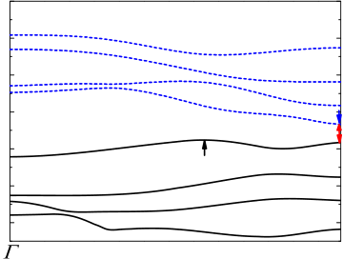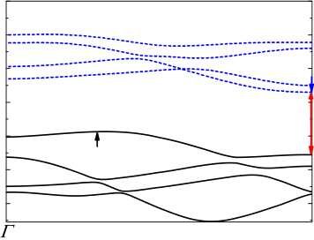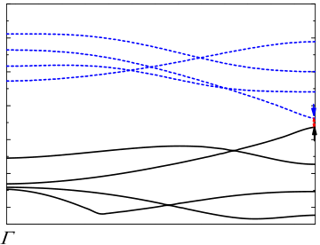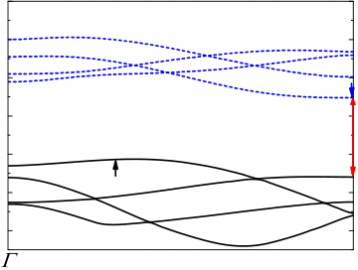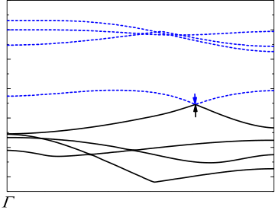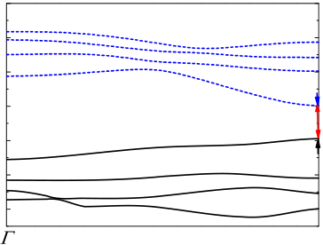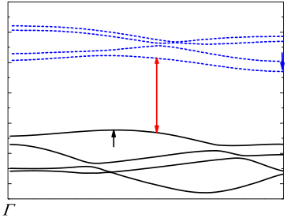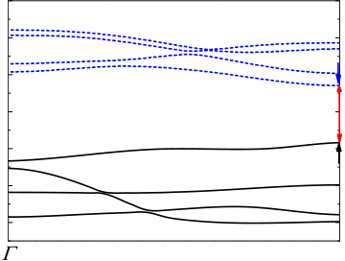

360  *Yanli Wang et al. / AASRI Procedia 3 ( 2012 ) 357 – 361*

*3.3.Energy gap*

The one-dimensional band structures of armchair (2,2) B-C-N nanotubes in the Brillouin zone for different models were shown in Figure 2. The energies of the high occupied crystal orbits (HOCO) (*E*HOCO), the low unoccupied crystal orbits (LUCO) (*E*LUCO) and the band gap (*E*g= *E*LUCO - *E*HOCO) were detailed in Table 3.

The default *k* point of wave vector was adopted in this work. point was the centre of the first Brillouin zone and point to *X* point was a half of Brillouin zone. It was found the models of B2C4N2(I), B4C2N2, B3C2N3(I) and B3C2N3 (III) have direct band gaps where the maximum of valence bands (occupied bands described by solids curves) and the minimum of conduction bands (unoccupied bands described by dashed curves) being in a same *k* point. For the rest models, the band gaps show indirect gaps where the maximum of valence band and the minimum of conduction band being in different *k* point. The maximum of direct band gaps for the most of models were at *X* point besides of the models of B2C4N2 and C2B3N3(II).

|  |  |  |  |  |  |  |  |  |  |  |  |  |  |  |  |  |  |  |  |  |  |  |  |
| --- | --- | --- | --- | --- | --- | --- | --- | --- | --- | --- | --- | --- | --- | --- | --- | --- | --- | --- | --- | --- | --- | --- | --- |
| 2 | | BC6N(I) | | 2 | | | BC6N(II) | | | 2 | | | | B2C4N2(I) | | | 2 | | | | B2C4N2(II) | | *X* |
| 0 | | 0 | | | 0 | | | |
| 0 | | | |
| Energy /eV | -2 -4 -6 | Energy /eV | | | -2 | | Energy /eV | | | | | -2 | | Energy /eV | | | | | -2 | | | |
| -4 | | -4 | | | |
| -4 | |
| -6 | | -6 | | -6 | | | |
| -8 | | -8 | | | | | -8 | | | | | | | -8 | | | | | | | | |
| -10 | | -10 | | | | | -10 | | | | | | | -10 | | | | | | | | |
| 2 | | Wave vector *k* | *X* | | | | Wave vector *k* | *X* | | | | | | Wave vector *k* | *X* | | | | | | Wave vector *k* | *X* |
| (a) (b) (c) (d) | | | | | | | | | | | | | | | | | | | | |
| B4C2N2 | 2 | | | | B3C2N3(I) | | | | 2 | | | B3C2N3(II) | | | | 2 | | | B3C2N3(III) | |
| 0 | | 0 | | | | 0 | | | 0 | | |
| Energy /eV | -2 -4 -6 | Energy /eV | | | | -2 | Energy /eV | | | | | | -2 | Energy /eV | | | | | | -2 | | |
| -4 | -4 | -4 | | |
| -6 | -6 | -6 | | |
| -8 | | -8 | | | | | -8 | | | | | | | -8 | | | | | | | | |
| -10 | | -10 | | | | | -10 | | | | | | | -10 | | | | | | | | |
| Wave vector *k* | *X* | | | | Wave vector *k* | | *X* | | | | | Wave vector *k* | | *X* | | | | | Wave vector *k* | |
| (e) (f) (g) (h) | | | | | | | | | | | | | | | | | | | | |

Fig.2. Band structure of the single walled (2,2) B-C-N nanotube models for different atom ratios and arrangements obtained with PBC-B3LYP/3-21G(d) method. The solid curves are for the four highest occupied bands and the dashed ones are for the four lowest unoccupied bands. The location indicated by an arrow is the minimum of the LUCO or the maximum of the HOCO band. (a) C6BN(I); (b) C6BN(II); (c) B2C4N2(I); (d) B2C4N2(II); (e) B4C2N2; (f) B3C2N3(I); (g) C2B3N3(II); (h) B3C2N3 (III)

We have found (2,2) carbon nanotube[8] showing semiconductor whereas BN-NTs[10] being isolator. It was interesting that the energy gap values of (2,2) B-C-N nanotubes were within 0.062 to 3.874 eV showing metal, semiconductor or insulator conductivity. However, the band structure values or types depending on both the atom ratios and the types of atom arrangement. It was found the B4C2N2 showed the strongest metallic with the structure having two adjacent B atoms. The models [BC6N(I), B2C4N2(I) and B3C2N3(I)] containing the alternant straight -C-C-C-C and -B-N-B-N- strain were typical semiconductor conductivity whereas BC6N(II), B2C4N2(II) and B3C2N3 (II) had larger gap.

Table.3. The energy of HOCO or LUCO (*E*HOCO or *E*LUCO), the energy gap (*E*g= *E*LUCO - *E*HOCO) and the gap type of the armchair single wall nanotubes for different (2,2) B-C-N nanotube models obtained with PBC-B3LYP/3-21G(d) method.

|  |  |  |  |  |  |
| --- | --- | --- | --- | --- | --- |
| CNT[8] | - | - | .836 | 1 | in |
| 5.404 | 3.568 | direct |
| BC6N (I) | - | - | .858 | 0 | in |
| 5.527 | 4.670 | direct |
| BC6N(II) | - | - | 2 | in |

|  |  |  |  |  |  |  |  |  |  |  |
| --- | --- | --- | --- | --- | --- | --- | --- | --- | --- | --- |
| *Yanli Wang et al. / AASRI Procedia 3 ( 2012 ) 357 – 361* | | | | | | | | | | 361 |
| 5.735 | | | 3.400 | | | .335 | | direct | |
| B2C4N2 (I) | - | | | - | | .539 | 0 | rect | di |
| 5.276 | | | 4.737 | |
| B2C4N2 (II) | | - | | - | | .217 | 3 | in | |
| 6.265 | | 3.048 | | direct | |
| B4C2N2 | - | | | - | | .062 | 0 | rect | di |
| 5.107 | | | 5.046 | |
| B3C2N3 (I) | - | | | - | | .932 | 1 | rect | di |
| 5.896 | | | 3.964 | |
| B3C2N3 (II) | | - | | - | | .874 | 3 | in | |
| 6.462 | | 2.589 | | direct | |
| B3C2N3 | - | | | | - | 1 | | di | |
| (III) | 5.680 | | 4.372 | | | .308 | | rect | |
| BN | - | | | | - | 5 | | in | |
| nanotube[10] | 6.798 | | 1.738 | | | .059 | | direct | |

**4.Summary**

The ultra long model of single walled armchair (2,2) B-C-N nanotubes with different ratios of B, C and N atoms were studied with density functional theory of B3LYP/3-21G*. The (2,2) B-C-N nanotubes have serrated tubular structures. The band gaps of tubes were within 0.062 to 3.874 eV showing metal, semiconductor or insulator conductivity, which depend on both the atom ratios and the types of atoms arrangement.

**Acknowledgements**

Part of the calculations was performed in the High Performance Computation Center of the Northwestern Polytechnical University. This work was supported by the National Natural Science Foundation of China (No.50572089) and the Basic Research Foundation of Northwestern Polytechnical University (NO. JC201269) are greatly acknowledged.

**References**

[1] Terrones M, Benito AM, Manteca CD, Hsu WK, Osman OI, Hare JP, Reid DG, Terrones H, Cheetham AK, Prassides K, Kroto HW, Walton D, Chem. Phys. Lett. 1996;257:576-582.

[2] Yu J, Ahn J, Yoon SF, Zhang Q, Rusli, Gan B, Chew K, Yu MB, Bai XD, Wang EG, Appl. Phys. Lett. 2000; 77:1949-1951.

[3] Bai XD, Guo JD, Yu J, Wang EG, Yuan J, Zhou WZ, Appl. Phys. Lett. 2000;76:2624-2626.

[4] Bai XD, Wang EG, Yu J, Yang H, Appl. Phys. Lett. 2000;77:67-69.

[5] Zhao X, Liu Y, Inoue S, Suzuki T, Jones RO, Ando Y. Phys Rev Lett 2004;92(12):125502(1-3). [6] Roberto S, Mauro B, Takahisa O. Chem. Phys. Lett. 2009;480(4-6) 215-219.

[7] Frisch MJ, et al. Gaussian 09, Revision A.02, Gaussian, Inc., Wallingford CTa 2009.

[8] Wang YL, Su KH, Wang X, Liu Y. Acta. Phys. Sin-Ch ED 2011;60 98111(1-6).

[9] Truhlar DG, Isaacson A D, Garrett BC, In The Theory of Chemical Reaction Dynamics, Vol. 4, Baer, M., Ed.CRC Press: Boca Raton, FL, 1985.

[10] Wang YL, Zhang JP, Su KH, Wang X, Liu Y, Sun X. Chinese Physics B. 2012;12(6):060301(1-7).