|  |  |  |  |  |
| --- | --- | --- | --- | --- |
|  |  | Available online at www.sciencedirect.com | |  |
| **ScienceDirect** | |
| AASRI Procedia 9 ( 2014 ) 2 – 7 | |
| 2014 4 AASRI C onference o on Circuit an nd Signal P Processing ( CSP 2014)  A New w Textur re Analy ysis App proach fo or Iris R ecogniti ion  Izem Ham mouchenea, , Saliha Ao ouata,*  *aLRIA Laboratory ry/Computer Scien nce Department, USTHB Universi ity, Algiers,16111 1, Algeria* | | | | |
| *ihamouc chene@usthb.dz,* | | | *saouat@usthb.d dz* | |

**Abst tract**

|  |  |  |  |
| --- | --- | --- | --- |
| One | of the most im mportant authen ntication approa aches is the iris s recognition sy ystem (IRS), w which is based | | on the iris of |
| apers son for the auth hentication.In t this paper, we | | propose a new w iris recognitio on system usin g a novel featu ure extraction | |
| meth hod. The propos sed method, Ne eighborhood-ba ased Binary Pat ttern, compares s each neighbor r of the central | | | pixel withthe |
| next | neighbor to en ncode it by 1 i if it is greater | or 0 if it is lo ower than the c central pixel. T The obtained b binary code is | |
| conv verted into a de cimal number t to construct the e NBP image. I In order to deal l with the rotat tion problem, w we propose an | | | |
| enco ding process to o obtain a rotati ion-invariant im mage. This imag ge is subdivide ed into several b blocks and the | | | mean of each |
| block k is calculated . After, the va ariations of the e means are en ncoded by a bi inary code. The e obtained bin nary matrix is | | | |

consi idered as featur re descriptor of f the iris. In the e evaluation par rt, the CASIA i iris database [1 0] has been use ed to evaluate

|  |  |  |  |  |
| --- | --- | --- | --- | --- |
| the p performance of | the proposed IR RS. The experim ments demonstr rate that the pro oposed method | | gives better rec cognition rate | |
| comp pared to the LB BP method. Exp perimental resu ults show also t that the propos sed system espe ecially the featu ure extraction  meth hod gives promi ising results.  © 2014 The Authors. Published by Elsevier B. V. This is an open access article under the CC BY-NC-ND license © 20 014.Published d by Elsevier B B.V.  (http://creativecommons.org/licenses/by-nc-nd/3.0/). Sele ection and/or p peer review un nder responsib bility of Amer rican Applied Science Rese earch Institute  Peer-review under responsibility of Scientific Committee of American Applied Science Research Institute  *Keyw words :* Iris Recog gnition System; N Neighborhood-bas sed Binary Pattern n; Local Binary P Pattern; Texture a analysis; Mean va ariation. | | | | |
| **1. In ntroduction** | | | | |
| Computer visio on is one of th he most impor rtant areas of | | research, whi ch provides e fficient soluti | | ons to many |
| prob blems. Patten r recognition is mainlyused t to recognize au utomatically d different entiti ies from an im mage. The | | | | |

* Corresponding a author. Tel.: +213 321247187; fax: + +21321247187.

*E-mail address:*sao ouat@usthb.dz.

2212-6716 © 2014 The Authors. Published by Elsevier B. V. This is an open access article under the CC BY-NC-ND license

(http://creativecommons.org/licenses/by-nc-nd/3.0/).

Peer-review under responsibility of Scientific Committee of American Applied Science Research Institute

doi: 10.1016/j.aasri.2014.09.002

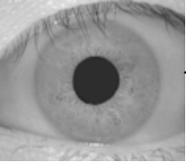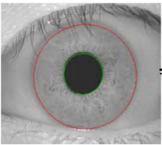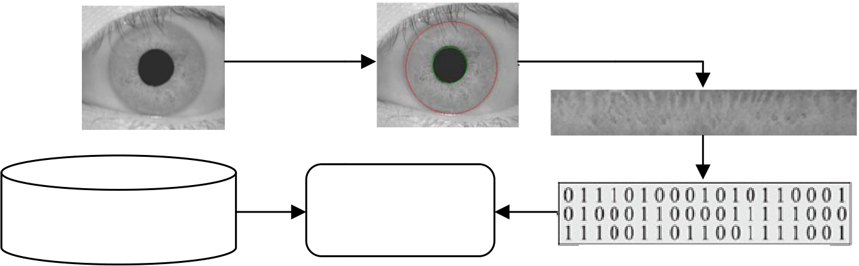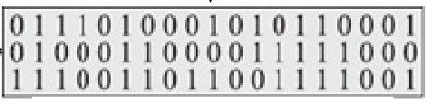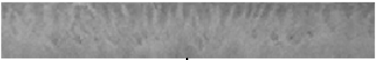

|  |  |  |  |  |  |  |  |  |  |  |  |
| --- | --- | --- | --- | --- | --- | --- | --- | --- | --- | --- | --- |
| *Izem Hamouchene and Saliha Aouat / AASRI Procedia 9 ( 2014 ) 2 – 7*  secu urity field has s shown a rea al interest in c computer visi ion particularl ly for the ide entification. In ndeed, every  hum man has particu ular properties s from others such as shape e, size etc… | | | | | | | | | | | 3 |
| Modern securit ty sciences us se these differe ences to contr rol the access to restricted p places, which | | | | | | | | | is one of the | |
| fund damental prob blems in secu urity field. T he increasing g need of the e security fie eld has given | | | | | | | | | | rise to the |
| deve elopment of r recent and eff ficient authent tication system ms.Old appro oaches of iden ntification suc ch as key or  pass swordare not s satisfactory in n many applic cation areas. T These convent tional method ds can be forgo otten, stolen  or cr racked. For th hese weakness ses, the recent t science is int terested in aut tomatic system ms of identific cation which | | | | | | | | | | |
| are | based on bi ometrics tech hnology [1].B Biometric ide entification is s subdivided | | | | | | | into two m main classes: | | |
| phys siological cha aracteristics su uch as fingerp prints, iris (Fig g 1),and beha avior character ristics such as s voice. The  need d of reliable an nd secure syst tems has invol lved the emer rgence of the b biometric syst tems. Fingerpr rint,face and | | | | | | | | | | |
| spea aker recognitio on have been | | | widely studie ed. Among all l the biometric c recognition | | | | | systems, Iris | Recognition | |
| Syst tem (IRS) is | | the most effi ficient and rel liable system [2] for auth henticity check k. Iris identif fication was | | | | | | | | |
| prop posed by Flom m and Aran [1 12]. Recent su urveys of iris r recognition al lgorithms can n be found in | | | | | | | | | [13]. This is | |
| due | to the stability y of the huma an iris, its inva ariant over tim me and its uniq queness for ea ach person. Ev ven between | | | | | | | | | |
| broth hers or twins [4]. | | | | | | | | | | |
| The IRS is a | | high accurac cy verification n technology | | | [5],and a va alid biometric cs approach f for personal | | | | | |
| iden ntification. Th he IRS has be een wildly stu udied [4] and | | | | | used especia ally in the sec curity fields. | | | | Thus, many | |
| coun ntries use IRS S in order to i improve their r security such h as in airport ts and govern nment buildin gs.Although  the i iris identificat tion theory w was started ear rlier, most im mportant recen nt works [6] h have been insp pired by the  work ks of John Da augman [7].  A classical iris recognition s system include es a series of s steps: image a acquisition, iri is preprocessin ng (includes  loca lization and n normalization) ), feature extra action and mat tching steps [4 4]. These step ps are illustrate ed in Fig 1. | | | | | | | | | | |
| The acquisitio on process is | | | to get an ir ris image fro om a person | | | | using a spec cifically sens sor [4]. The | | | |
| prep processing pro ocess allowsto o remove the | | | | useless infor rmation from | | | the iris imag e and to extr act only the | | | |
| regio on of interes st (ROI), wh hich is only | | | | the iris. Th his includes | | segmentation n and norma alization.The | | | | |
| segm mentation proc cess consists t to isolate the i iris ring from | | | | | the iris image e. The normal lization proce ss is applied | | | | | |
| to p | roduce an inv variant iris ar rea.It transfor rms the circul lar iris region n into a recta angular region n with fixed | | | | | | | | | |
| dime ensional.In fa act, the inner a and outer bou undary can ap pproximately b be taken as ci ircles.But, the e two circles  are n not co-centric . Daugman [7 7] proposed to o apply the Int tegro-differen tial operator t to detect the in nner and the | | | | | | | | | | |
| oute er boundaries. | | Acquisition | Segmentat tion | | | | | | | |

Normalization

Matching Feature extra action

Similarity

Feat ture Database value

Fig.1 . Typical iris reco ognition system.

This method ( (integro-differ rential) is use ed to transform m the image from the Car rtesian (x,y) to the polar

coor rdinate(r, �) s space [4]. The e center of th he pupil is illu ustrated by a green point. The center o of the iris is

illus strated in red p point in Fig 2 2.We can noti ice that the tw wo boundaries s are not co-c centric.Fig 2 i illustrates an

iris image in the e Cartesian co oordinates an nd its rectang gular transform mation result .The third is the feature

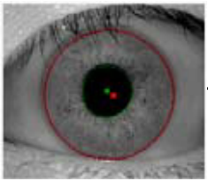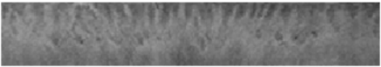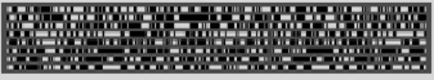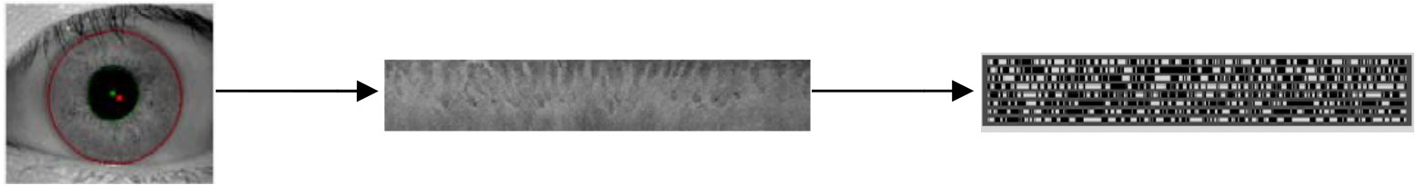

4  *Izem Hamouchene and Saliha Aouat / AASRI Procedia 9 ( 2014 ) 2 – 7*

extra action step. Th he goal is to c capture the rel levant inform ation from im mage. Daugma an applied the Gabor filter

on th he rectangular r iris. He used d a multiscale quadrate meth hod on the ob tained image. This method encodes the

sign s of the real a and the imagin nary part of th he Gabor coef fficients. Each h pixel is enco oded by two b binary codes.

The generated bin nary code is ca alled ‘Iris Cod de’ (Fig 2).

Iris ima age Rect tangular iris Iris code

Fig.2 . Normalization u using Daugman’s s rubber sheet mo odel and extractio n of the Iris code e.

Fig. 2 illustrate es an example e of an iris ima age and its iris s code. The po ositive coeffic cients are repre esented by a

whit te line and the e negatives by y a black line . For the Mat tching step, a distance mea sure between a generated

iris c code and stor red iris code i is calculated.

The query iri is is considere ed authentic i if the distance e measure is

belo ow a threshold d. Daugman ha as considered the quality of f the iris imag ge, and extract ted a matching g mask from

the i iris image. H He used the H Hamming dista ance (HD) to calculate the e distance bet tween two iri ises. For the

iden ntification, Da augman fixed the threshold d of the matc ching around 0.34 [8]. Th e iris recogni ition system

prop posed by Daug gman is often used and is a basis of all cu urrent iris reco ognition system ms.

In n order to ex xtract the rele evant informat tion from an iris image, w we propose a a novel featur re extraction

meth hod. The prop posed method is inspired by y the Local Bin nary Pattern ( LBP) method d. Some impro ovements are

mad de to capture t the local infor rmation and d describe bette er the iris text ture. This pap per has been o organized as

follo ows: In sectio on 2, our prop posed method d for iris text ture analyses is explained. Section 3illu ustratessome

expe erimental resu ults.The conclu usion of this p paper is given in section 4.

**2. Pr roposed meth hod**

In n this section , we will deta ails the propo osed texture a analysis metho od. This meth hod is inspired d from LBP

meth hod. So, the L LBP method is s briefly expla ained. After th hat, the propos sed method is detailed on tw wo parts.Part

1 ex xplains our N NBP method, ,Part 2 illustr rates the inv

ariance to ro otation of NB BP. Anillustra ation which

summ marizes the p roposed archi itecture of the e IRS will be also given.Th he Local Binar ry Pattern (LB BP) operator

was proposed by Ojala and Pie etikainen in 19 996 [9].And u used in recent works [3][11 ].This method d uses a 3x3

analy ysis window. The neighbor rhood of the c central pixel i s thresholded by the value of the central l pixel. Each

neig ghbor is coded d by 1 if its va alue is above o or equal than the central pix xel value, and d encoded by 0 otherwise.

Bina ary code is obt tained from th he analysis wi indow and con nverted into a decimal numb ber LBP numb ber.

By studying th he iris recogni ition system d detailed earlier r, we can noti ice that the m main step of re ecognition is

the f feature extract tion. A novel transformatio on, called Neig ghborhood-ba ased Binary Pa attern (NBP), is proposed

to ex xtract the loca al features from m the texture.

*2.1. Neighborhoo d-based Binar ry Pattern*

The NBP extr racts the bina ary pattern by y thresholdin ng each neigh hbor of the c central pixel b by the next

neig ghbor (starting g from the top-left neighbor r and going cl lockwise). The e binary value e of one neigh hbor is equal

to 1 if its gray va alue is greater r than the nex xt neighbor, 0 0 otherwise.Fi ig 3 illustrates s an example of the NBP

meth hod. The first neighbor (4) has a gray le evel value less s than its next t neighbor (6) ). Thus, its bin nary code is

equa al to 0. After r that, the ob btained binary y code (1101 10) is conver rted into a d ecimal numb er (26) and

cons sidered as the value of the central pixel. Finally, the central pixel in the origina al image (5) w will have the

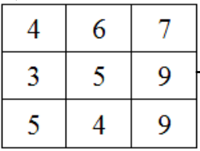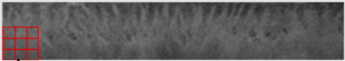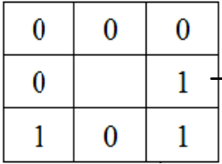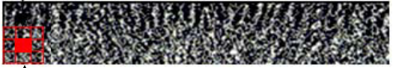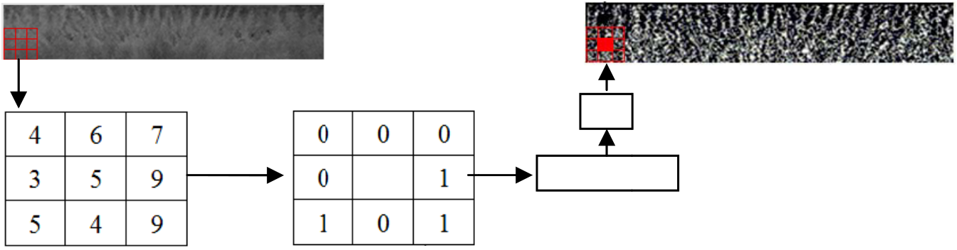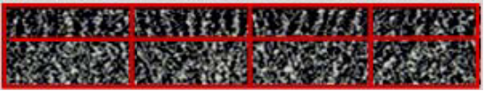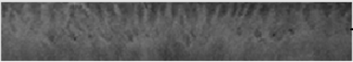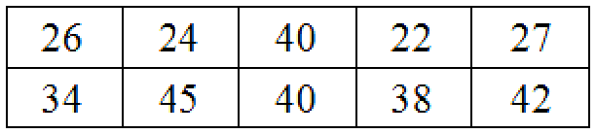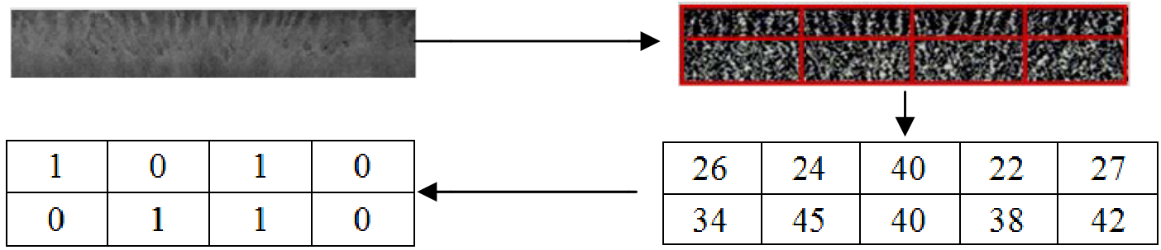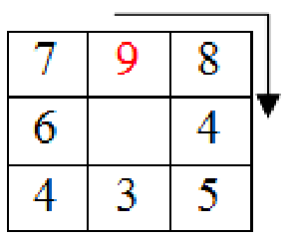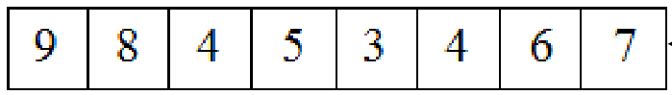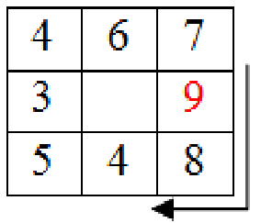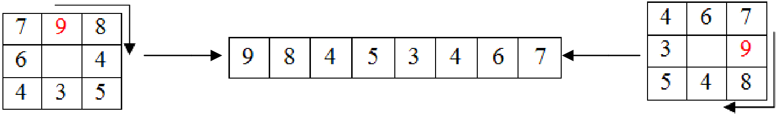

*Izem Hamouchene and Saliha Aouat / AASRI Procedia 9 ( 2014 ) 2 – 7*  5

valu ue 26 in the NB BP image. NB BP gets the re elative connec tion between

3.

26

each neighbo or of the centra al pixels Fig

NBP

000110 010

Fig.3 . Extraction of th he NBP pattern.

*2.2. Rotation inva ariant Neighbo orhood-based d Binary Patte rn*

In ndeed, a small l rotation of th he same analy ysis window g generates a dif fferent NBP c code. In order to deal with

the r rotation probl lem of the N NBP method, w we proposed an encoding process. This s encoding pr rocess starts

relat tively from th he higher neig ghbor of the an nalysis windo ow.Thus, even n if the pattern n is rotated, th he encoding

proc cess gives the same code. Th his encoding p process is illu ustrated in Fig4 4.

NBP C Code

Fig.4 . Rotation-invaria ant NBP method.

In n order to des scribe the NBP P image, we p proposed to u se a decompo osing architect ture.First, the NBP image

is de ecomposed in nto several blo ocks. The me ean of each b block is calcu ulated. After t that, the varia ations of the

mean ns are encod ed. One bloc ck is encoded d by 1 if its mean are gre eater than its rightneighbo or’s mean, 0

othe erwise. A bina ary matrix of th he variation m means are extr racted and use ed as template of the iris(Fig g5).

Original imag ge NBP image e

Var iation of mean ns Mean ns

Fig.5 . Mean variations s encoding proces ss.

Fig. 5 illustrate es the variatio on encoding p process. First, , the NBP me ethod is applie ed on the iris image. The

obta ained NBP im age is decomp posed into 2* 4 blocks in re ed. The mean of each block k is calculated d. After that,

the v variation of th he mean of ea ach block is e encoded. For example, the mean of the f first block is equal to 26,

whic ch is greater th han its right n eighbor 24. T Therefore, the first variation is coded by 1 1.

For the matchi ng step, the in ntersection sim milarity measu ure is used. In n order to com mpare two iris s images, the

������� ���� � ����������� �� ���� ����� � ������� � ����� ����� � ���� ����� � ���������� *(1)* simi ilarity distance e between the acted are calcu ulated followi ing (1).

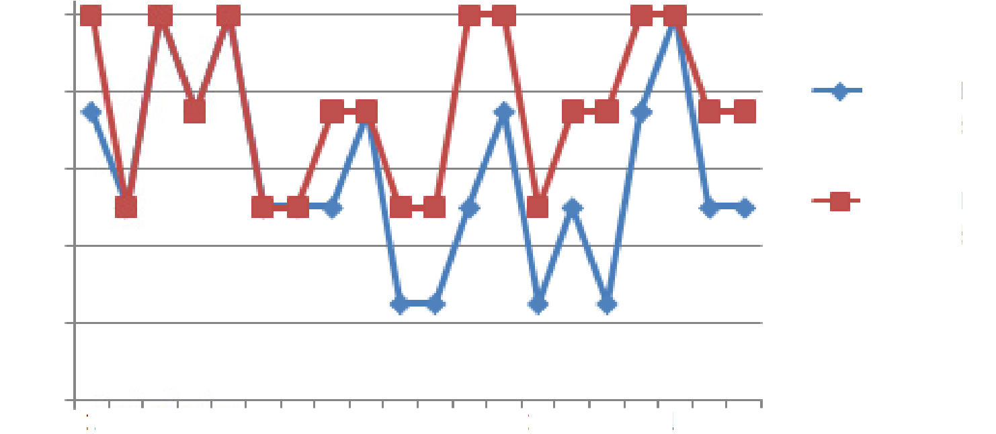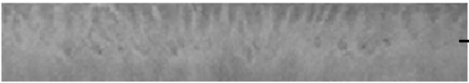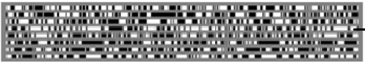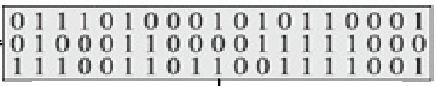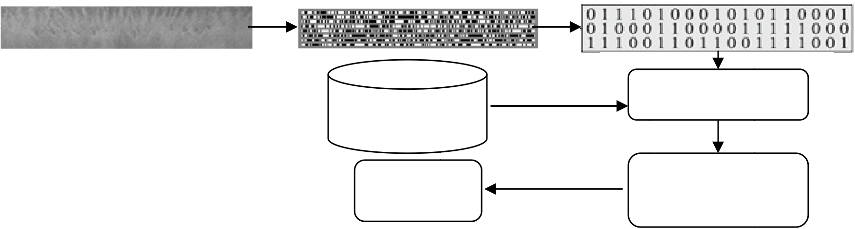

6  *Izem Hamouchene and Saliha Aouat / AASRI Procedia 9 ( 2014 ) 2 – 7*

Where M1, M2 2 are the vari ation binary c codes of the tw wo iris image es. S is equal t to 1 if the ith blocks from

M1 a and M2 are th he same, 0 oth herwise. Nb is the number o of blocks whic ch depends on n the decompo osition of the

iris i image. If the d distance Dis is s above a thre shold, the two o irises are con nsidered of th he same person n.

**3. E xperimental results**

|  |  |  |  |  |  |  |  |  |  |  |  |  |
| --- | --- | --- | --- | --- | --- | --- | --- | --- | --- | --- | --- | --- |
| In n order to eva aluate our syst tem performan nce, we have u used the publi ic iris databas se CASIA [10 | | | | | | | | | | | | ], which is a |
| most t used benchm mark in the iri s recognition research.In th he evaluation p process, three | | | | | | | | | | | images from | each person |
| have e been taken a as a reference e and four as t test. In order | | | | | | to compare th he LBP metho od and the pro oposed NBP | | | | | | |
| meth hod, twenty p persons taken | | | randomly fro om the databa ase are used | | | | | | in the experim mental proces ss. Thus, 60 | | | |
| imag ges are used | | as references and 80 as a | | | test images. | | Each test im mage is consid dered as query y. The LBP | | | | | |
| histo ogram is extra acted and the m mean variatio n of the NBP | | | | | | | image is extr racted. After th hat, the hamm mingdistance | | | | | |
| betw ween the query y’s feature and d the features extracted fro m all referenc ce images of t the database is s calculated. | | | | | | | | | | | | |
| The | obtained ham mming distanc es are sorted | | | from the most t similar to th he dissimilar c comparing to t the query. A | | | | | | | | |
| majo ority vote of | | the top three e is consider red and the q query iris is | | | | | | | classified fol lowing the m majority. An | | | |
| expe erimental exam mple is illustra ated in Fig 6. | | | | | | | | | | | | |
| Query y iris | | | NBP im mage | | | | | | Feature vect tor | | | |
| Hamming g | | | | | | | | | | | | |
| Feature | | | | | | | | | distance | | | |
| database | | | | | | | | | Sort ed top 3 | | | |
| Decisio on | | | | | | | | Major rity vote | | Person 1 | | |
| Person 1 | | |
| Person 1 | | | | | | | |
| Person 2 | | |
| Fig.6 | . Example of the recognition proc ess | | | | | | | | | | | |
| The recognition ra ates (R.R) of t the two metho ods are illustra ated in Fig 7. T The global rat teof the LBP m method is | | | | | | | | | | | | |

100

|  |  |
| --- | --- |
| 80 | Using LB BP method |

60

|  |
| --- |
| Using NB BP method |

40

20

|  |  |  |  |  |
| --- | --- | --- | --- | --- |
| Fig.7 | 0 | 1 2 3 4 5 5 6 7 8 9 | | 10 11 12 13 1 14 15 16 17 1 8 19 20 |
| . Recognition rate e of each person | | using LBP and N NBP | |

*Izem Hamouchene and Saliha Aouat / AASRI Procedia 9 ( 2014 ) 2 – 7*  7

58.75% and the NBP method is 76.25%.We can notice, from the results, that the NBP method is better than the classical LBP method.Because in fact, the neighborhood of the central pixel is thresholded by its value using the LBP method.So, LBP get the relationship between each neighbor and the central pixel.However, the NBP method describes each pixel by the relationship of its neighborhoods.Experimental results demonstrate that it is more interesting to capture the relative pertinent information between the neighbors.Thus, the results have shown the robustness and the efficiency of the proposed NBP method.

**4. Conclusion**

In this paper, we have proposed a new IRS system. This system used a new feature extraction method NBP. The NBP method extracts the relative connection between neighbors of pixels. Each neighbor of each pixel is thresholded by the next neighbor and encoded.After that, the NBP image is decomposed into several blocks. The mean of each block is calculated. Then, the variations of the meanare encoded. The resulted binary matrix is used as a feature descriptor of the iris. In the experimentation, the CASIA iris database is used. Good performance has been obtained for the proposed IRS. We can summarize that the proposed NBP method is interesting since it gets the relative relevant information between the neighbors of pixels.In future works, we will study the combination of the NBP method with other approaches like Gabor transform.

**References**

[1] B.Fang,Y.Y.Tang, “Elasticregistrationforretinal images based on reconstructedvascular trees”, IEEE Trans. on BiomedicalEngineering,vol. 53, no. 6, pp. 1183–1187, June 2006.

[2] R. Szewczyk, K. Grabowski,M. Napieralska, W. Sankowski, M. Zubert, A. Napieralski, “A reliable iris recognition algorithm based on reverse biorthogonal wavelet transform”, Pattern RecognitionLetters, Volume 33, Issue 8, Pages 1019–1026,2012.

[3] Shu-Ren Zhou, Jian-Ping Yin, Jian-Ming Zhang,“Local binary pattern (LBP) and local phase quantization (LBQ) based on Gabor filter for face representation”. Neurocomputing, Vol.116 ,pp. 260-264, 2013.

[4] J.G. Daugman, “High Confidence Visual Recognition of Persons by a Test of Statistical Independence”, IEEE Trans. on Pattern Analysis and Machine Intelligence, vol. 15, no. 11, pp.1148-1161,1993.

[5] J.Daugman,C.Downing, “Epigenetic randomness, complexity, and singularity of human iris patterns”, Proceedings of the Royal Society (London) Series B: Biological Sciences,vol. 268, pp.1737–1740. 2001. [6] Abidin, Z.Z.; Manaf, M.; Shibghatullah, A.S.; Anawar, S.; Ahmad, R., "Feature extraction from epigenetic traits using edge detection in iris recognition system," IEEE International Conference on Signal and Image Processing Applications (ICSIPA), pp.145-149, 2013.

[7]J. Daugman, “How iris recognition works”, IEEE Trans. on Circuits and Systems for Video Technology, vol. 14, no.1, pp. 21-30,2004.

[8] J. Daugman, “New methods in iris recognition”, IEEE Trans. on System, Man, and Cybernetics, vol. 37, no. 5, pp. 1167-1175, 2007.

[9] J. Daugman “The importance of being random: statistical principles of iris recognition”, Pattern recognition, vol. 36, no.2, pp. 279-291.2003.

[10]CASIA iris image database (v1.0), The National Laboratory of Pattern Recognition (NLPR), Institute of Automation, Chinese Academy of Sciences (CAS), 2006.

[11] Hamouchene I. Aouat S, Lacheheb H. “New segmentation architecture for texture matching using the LBP method”. IEEE Technically Co-Sponsored SAI Conference, London UK, 2013.

[12] L. Flom and A. Safir, “Iris Recognition System”, U.S. Patent 4,641,349, 1987.

[13] Kevin W. Bowyer, Karen P. Hollingsworth, Patrick J. Flynn, “A Survey of Iris Biometrics Research: 2008–2010”, Handbook of Iris Recognition, pp. 15-54, 2013.