

[Artificia](https://doi.org/10.1016/j.ailsci.2021.100018)l[IntelligenceintheLifeSciences1(2021)100018](https://doi.org/10.1016/j.ailsci.2021.100018)

|  |  |  |
| --- | --- | --- |
|  | Contentslistsavailableat[ScienceDirect](http://www.ScienceDirect.com) |  |
| ArtificialIntelligenceintheLifeSciences |
| journalhomepage:[www.elsevier.com/locate/ailsci](http://www.elsevier.com/locate/ailsci) |

Review   
Candeeplearningrevolutionizeclinicalunderstandinganddiagnosisof opticneuropathy?

MohanaDeviSubramaniama,∗,AbishekKumarBa,RuthBrightChirayatha,AswathyPNaira, MahalaxmiIyerb,BalachandarVellingiric   
a*SNONGCDepartmentofGeneticsandMolecularBiology,VisionResearchFoundation,SankaraNethralaya,Chennai,TamilNadu600006,India* b*LivestockFarmingandBioresourceTechnology,TamilNadu,India*   
c*DepartmentofHumanGeneticsandMolecularBiology,BharathiarUniversity,Coimbatore641046,India*

|  |  |  |
| --- | --- | --- |
| article | info | abstract |
| *Keywords:*  Artificialintelligence  Deeplearning  Ophthalmology  Leber’shereditaryopticneuropathy Diagnosis | | Artificialintelligence(AI)basedondeeplearning(DL)hassparkedtremendousglobalinterestinrecentyears. DeepLearninghasbeenwidelyadoptedinspeechandimagerecognition,naturallanguageprocessingwhich hasanimpactonhealthcare.Intherecentdecade,theapplicationofDLhasexponentiallygrowninthefield ofOphthalmology.Thefundoscopy,slitlampphotography,opticalcoherencetomography(OCT),andmagnetic resonanceimaging(MRI)wereemployedforclinicalexaminationofvariousocularconditions.Thesedataserved asaperfectplatformforthedevelopmentofDLmodelsinOphthalmology.Currently,theapplicationofDLinoc-ulardisordersismajorlystudiedinDiabeticretinopathy(DR),age-relatedmaculardegeneration(AMD),macular oedema,retinopathyofprematurity(ROP),glaucoma,andcataract.InOphthalmology,DLmodelsaregradually expandingtheirscopeinopticneuropathies.Glaucomaandopticneuritisareopticnervedisorders,whereDL modelsarecurrentlystudiedforclinicalapplications.ForfurtherexpansionofDLapplicationininheritedoptic neuropathies,wediscussedtherecentobservationalstudiesrevealingthepathophysiologicalchangesattheoptic nerveinLeber’shereditaryopticneuropathy(LHON).LHONisaninheritedopticneuropathyleadingtobilateral lossofvisioninearlyagegroups.Henceforearlymanagement,furtherfootstepsintheapplicationofDLinLHON willbenefitbothophthalmologistsandpatients.Inthisreview,wediscusstherecentadvancementsofAIinthe OphthalmologyandprospectiveofapplyingDLmodelsinLHONforclinicalprecisionandtimelydiagnosis. |

**Introduction**

Artificialintelligence(AI)hastakenoverhealthcarebyplayingama-jorpartinrevolutionizingdiagnosisinthepresentera.Anycomplexity inhealthcareprecision,theAImodelfindsitsapplication.Indiagnosis, AIacedinmimickinghumanbehaviourthroughmachinelearning(ML) technologytoincreaseefficiency.AIcomprehendmachinelearningpro-videstechniquesoralgorithmsthatempowerscomputerstomakeeffec-tivepredictionsorjudgementusingavailableinputdata.Itrequiresa largenumberoftrainingdatatobuildanexactmodel[1].Deeplearn-ing(DL)isasubgroupofMLwhichhassignificantaccuracyinmany domainsincludingnaturallanguageprocessing,recommendersystems, soundrecognition,andimagerecognition.Itcanalsorecognizecom-plex,unstructured,andinterconnecteddatawithfairaccuracy[2]. Gulshanetal.[3]firstintroducedthealgorithmofDLindiabetic retinopathy(DR).SoonafterthedevelopmentofDLinDR,researchers wereinterestedtoworkondifferentalgorithmsandsuccessfullydevel-opedDLmodels,thatcoulddetectandmoderateocularconditionslike

∗Corresponding[author.](mailto:geneticmohana@gmail.com)

*E-mailaddress:*[geneticmohana@gmail.com](mailto:geneticmohana@gmail.com)(M.D.Subramaniam).

Age-relatedmaculardegeneration(AMD),glaucoma,retinopathyofpre-maturity(ROP),andcataract[4].Todate,twocompletealgorithmshave beensuccessfullyapprovedbytheFDA.Amongstthem,IDx-DRisadig-italdiagnosissystemforDR.TheotheroneisViz.AI,whichanalysesim-agesindicatingastroke.Thesedevicesaretermed“Lockedalgorithms”[5].ThesealgorithmsforMLhavethepotentialtoevolvecontinuously andarehighlyadaptiveintheapplicationofotherfields.

ArtificialIntelligenceinneuro-ophthalmologyisanemergingfield andAIalgorithmshaveshownhighaccuracyindetectingneuro-ophthalmicdiseasesinpapilledemaandglaucoma.AlgorithmsinAI aredevelopedfordetectingneuro-ophthalmicdiseasesthroughmoni-toringretinalnervefibrelayer(RNFL)thicknessandopticdiscalter-ationsusingfundusandOCTimages[6].Thisemergingtechnologyin neuroOphthalmologyfurthersignifiesinsighttoexpanditsapplica-tionininheritedopticneuropathyespeciallyLHON.Thisreviewdis-cussesthecurrentapplicationandrecentinnovationsofAIinOph-thalmology,andthepossibleroleofAI-basedmodelsininheritedoptic neuropathy.

<https://doi.org/10.1016/j.ailsci.2021.100018>  
[Received30June2021;Receivedinrevisedfo](https://doi.org/10.1016/j.ailsci.2021.100018)rm18November2021;Accepted18November2021   
Availableonline21November2021   
[2667-3185/© 2021TheAuthors.PublishedbyElsevi](http://creativecommons.org/licenses/by-nc-nd/4.0/)erB.V.ThisisanopenaccessarticleundertheCCBY-NC-NDlicense (<http://creativecommons.org/licenses/by-nc-nd/4.0/>)

*M.D.Subramaniam,A.K.B,R.B.Chirayathetal.*

**PotentialofAIinhealthcare**

ThemajorreasonfortheexponentialgrowthofAIworldwideisdue todemandinbigdataprocessingandtoenhancehumanworkinhealth-carediagnostics[7].Atpresent,tremendousgrowthindiagnosticsand imagingisbenefitingradiologists,ophthalmologists,andothertreat-mentmanagingsectors(Fig.4).Therefore,AImodelsinthefieldof Ophthalmologyarerapidlyincreasing[8].DeepLearningisemployed inseveralmedicalimagingofdiseaseconditionsliketuberculosisfrom chestX-rays[9],malignantmelanomaonskinphotography[10],lymph nodemetastasestobreastcancerfromtissuesections[11],lungcancer usingchestimages[12],cardiovascularriskusingcomputerCT[13], PulmonaryembolismusingCTangiography[14],polypsusingvirtual colonoscopy[15],gliomausingMRI[16],Alzheimer’sdiseasedetection usingfunctionalMRI[17].

Ophthalmologyinvolvesthelatestelectrical,acoustic,mechanical, andopticalimagingtechniques.Therefore,theapplicationofAIinOph-thalmologyiswidelyimplementedandaccepted.UsingadvancedDL models,AIclassifiesimagesbasedonpatternrecognition[8].Incollab-orationwiththeopticsystem,differentmodelsofDLalgorithmslike neuralnetworkingaresuccessfullyappliedinvariousdiseasediagnoses andit’sprogression[18].InDR,continuousmonitoringisrequiredto observethediseaseprogression.However,theintroductionofAIhas madeitpossibletoimagethefundusofpatientswithearlyDReffi-ciently.Inthefuture,requirementsforcontinuousmonitoringofDR patientsmaybecompromised,asAIcandemonstratethedevelopment andprogressionofthedisease[19].

**AIalgorithmsfordiagnosis**

Inophthalmology,MLrequiresalgorithmswithhugeinputdata totrainforpredictingocularconditionsandtostandardizeitsperfor-mance.BuildingastructuredalgorithminMLisacrucialstepforde-velopingAImodelsfordiagnosis.Fundusimagesoftheopticconditions serveasthemajordatabaseforbuildinganAIalgorithminOphthal-mology[20].Otherthantraditionalfundusphotography,opticalco-herencetomography(OCT)scanscanalsobeusedfordevelopingal-gorithms[21].Combingboththe2-dimensionalfundusimagesand3-dimensionalOCTcanimprovethesensitivityandspecificityoftheAI algorithm.Thesedatabasesarefedintosystemswithappliedlogarithms fordecision-makingthroughAI[22].

ThetwoformsofAIaresupervisedlearningandunsupervisedlearn-ing.SupervisedlearningisthetraditionalMLmethod.IntraditionalML, expertknowledgeisutilizedtolabeltheclinicalfeaturesandprogno-sisofophthalmicconditions.Thesortedimagesrepresentingtheclin-icalseverityarethenusedforclassificationbytrainedMLmodels.To buildapreciseMLmodel,alargernumberoflabelleddatabyexperts shouldbefedtotrainandvalidatethealgorithm[23].Someofthepop-ularAIalgorithmsusedforMLinOphthalmologyincludedecisiontree, Bayesianclassifiers,randomforests,supportvectormachines,k-means, k-nearestneighbors,discriminateanalysis,andneuralnetworks[19]. Inunsupervisedlearning,DLisappliedwhichenablestoskipthestep involvingthesupervisionoftheexpert.InDLtheauthorizedinputdata fromclinicaldiagnosisareextractedfromsecondarysourceslikepub-lisheddata,medicalrecords,etc.forself-learningandtoclassifythe ophthalmicconditionsbasedonthediagnosisandseverity[22].The twopowerfulDLClassificationsystemforidentificationincludescon-volutionalneuralnetwork(CNN)andmassive-trainingartificialneural network(MTANN)[23].ThecharacteristicsoftheAIsysteminOph-thalmologyarepresentedinFig.1.

ForbuildingAIalgorithmsforOphthalmology,therawimagedata mustbesorted,validated,andpre-processed.Thesestepsinvolvehuman intelligencetovalidateanalgorithmanditalsoreflectsonthesensitiv-ityandspecificityoftheAIsystem.Pre-processingoftheimageincludes noisereduction,integration,andselectionofthemostrelevantdata. Thiswillimprovetheefficiencyofimageprocessingfortheoutcome.

2

*M.D.Subramaniam,A.K.B,R.B.Chirayathetal.*  *ArtificialIntelligenceintheLifeSciences1(2021)100018*

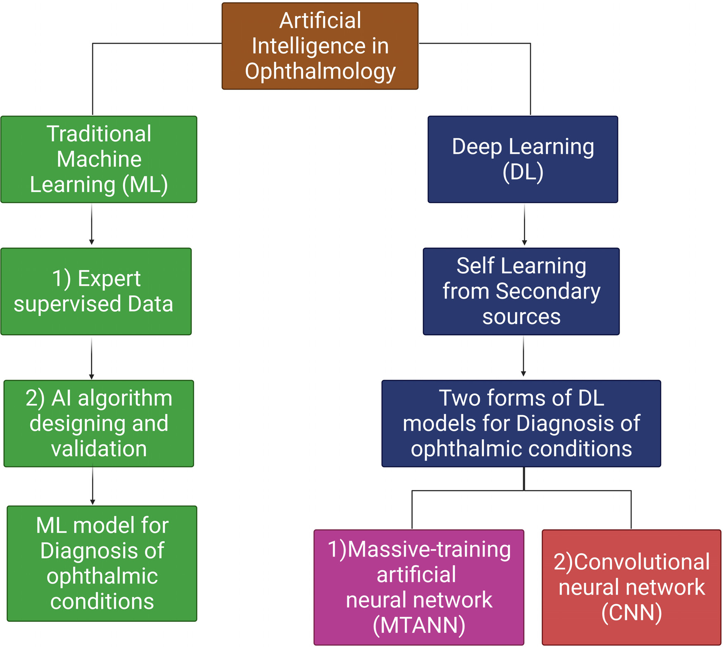

**Fig.1.**AIalgorithmsinthetraditionalMLandDLmodelsforthediagnosisinOphthalmology.

DLapplicationintheAMDarepreliminary,manystudiesandclinical trialswithgreaterstudygroupsareongoingforsuccessfulapplication [40,41].Fromtheobservedstudies,thetestsensitivityofDLinAMDis *>*87%[42].ButtheapplicationofOCTimagesofAMDintheDLmodel increasedsensitivity,specificity,andaccuracy[43].TheOCTenables theDLtodetectthevariationsinmorphology,intraretinalorsubretinal fluidaccumulations.TherecentevaluationofOCTimagesobtainedfrom thelargerpatientgroupstodeveloptheCNNplatformintheDLmodel fordiagnosishasshownaccuracygreaterthan90%[44,45].Bogunovic etal.testedanalgorithmtoobservetheanti-VEGFtreatmentrespon-dersusingOCTimages[46].IncorporatingMLinOCTimagespredicts thepossibilityofretreatmentanditachievessignificantperformancein predictinglowandhighretreatmentrequirements[47].Anotherstudy reportedadeepconvolutionneuralnetwork(DCNN)usingOCTimages fordecisionmakingonanti-VEGFinjection[48]andthesestudiesare importantintheimage-guidedpredictionoftreatmentintervalsinthe managementofAMD.Recently,scientistscreatedandvalidatedanAI modelforAMDscreeningandpredictinglatedryandwetAMDprogres-sion.Thismodelhas99.2%accuracyforAMDscreening[49].

Cataractcausesopacificationofthelensintheeyewithapromi-nentcloudyappearance.Theearlydiagnosisofcataractsiscrucialfor management,whichisachallengingtaskthroughclinicalobservation. HencetheDLfindstheapplicationincataractsbythedevelopmentof CNNalgorithmsforslit-lampimagesfordiagnosisoftheearlystageof cataract.TheperformanceoftheDLmodelincataractscomparedtothe traditionalclinicalgradingwasachievedonly70%[50].AnotherDL

3

*M.D.Subramaniam,A.K.B,R.B.Chirayathetal.*  *ArtificialIntelligenceintheLifeSciences1(2021)100018*

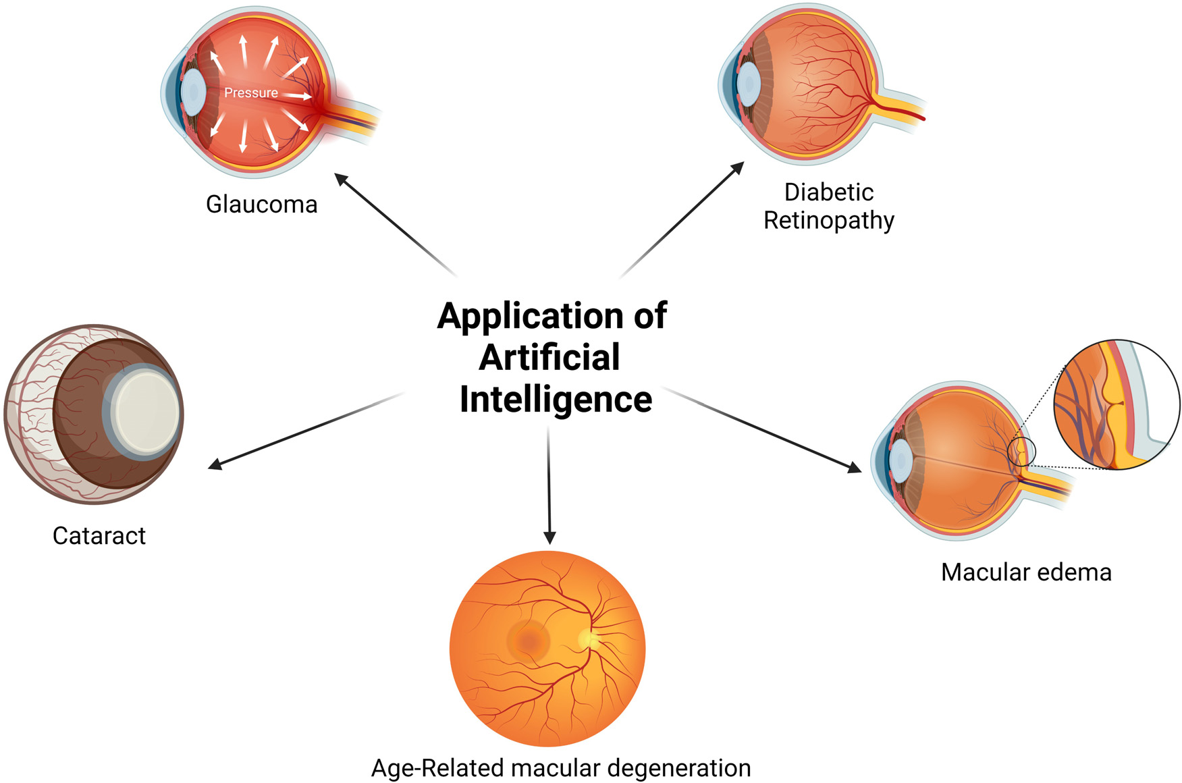

**Fig.2.**ThemajorareasofapplicationofAImodelsinOphthalmology.

nessbasedonsegmentationtechniqueusingOCTimagesanditshowed 87%accuracy[55].Anotherstudydesignedafullyautomatedmodelto classifyangle-closureglaucomausingOCTscansanditreported89.2% accuracy[59].StudieshaveevaluatedtheDLalgorithmtodetectglauco-matousopticdiscchangesusingfundusimagesanditshowshighsensi-tivityandspecificity[60,61].Visualfieldsareverydifficulttointerpret andAIintheinterpretationofvisualfieldhavebeenreportedusing afeed-forwardneuralnetworktoidentifypre-perimetricvisualfields [62,63].

Inotheroculardiseases,Ohsugietal.developedDLwhichcande-tectrhegmatogenousretinaldetachmentfromultra-wide-fieldfundus imageswithhighsensitivityandspecificity[64].Xuetal.designed adual-stageDLsystemtoidentifypigmentepithelialdetachmentin polypoidalchoroidvasculopathy(PCV)fromOCTimages[65].Another studyfromretinitispigmentosaandLebercongenitalamaurosispatients hasemployedanML-basedapproachtopredictperimetryfromOCTim-ages[66].TheMLdecisiontreemodelhasbeenintroducedtopredict thecomplexityofreconstructivesurgeryaftertheexcisionofperiocular basalcellcarcinoma[67].InOphthalmology,AIholdsmanyadvantages likecornealtopography,IOLpowerprediction,predictingtheoutcome ofthetreatment,screening,anddiagnostics.ArtificialIntelligencehas notonlyproventobeefficientandstructuredbutalsocost-effective whencomparedtohigh-endscreeninganddiagnostictechniques[68].

**CurrentstatusofAIinthediagnosisofopticneuropathy**

Opticneuropathyoccurswhentheopticnerveisdamagedcausing structuralchangesintheeyeandvariationsinthebloodflow[69].In mostcases,opticneuropathyleadstovisionlossstartingwithfading ofvision,lossofcolourvision,blurriness,peripheralvisionloss,and clouding.Itisimportanttodetectopticnervedamageearlyandtreat it.Researchersaretryingtostudyvariousmethodstoderivebetterand quickdiagnosesusingAI.[70].Currently,somestudiessupporttheuse ofAIinvariousdiseasesrelatedtoopticneuropathy.Recentstudieson MLsystemattemptsindetectingopticdiscabnormalitiesthroughreti-nalfundus,focusingonopticdiscatrophyandpapilledema.Thecom-

4

*M.D.Subramaniam,A.K.B,R.B.Chirayathetal.*  *ArtificialIntelligenceintheLifeSciences1(2021)100018*

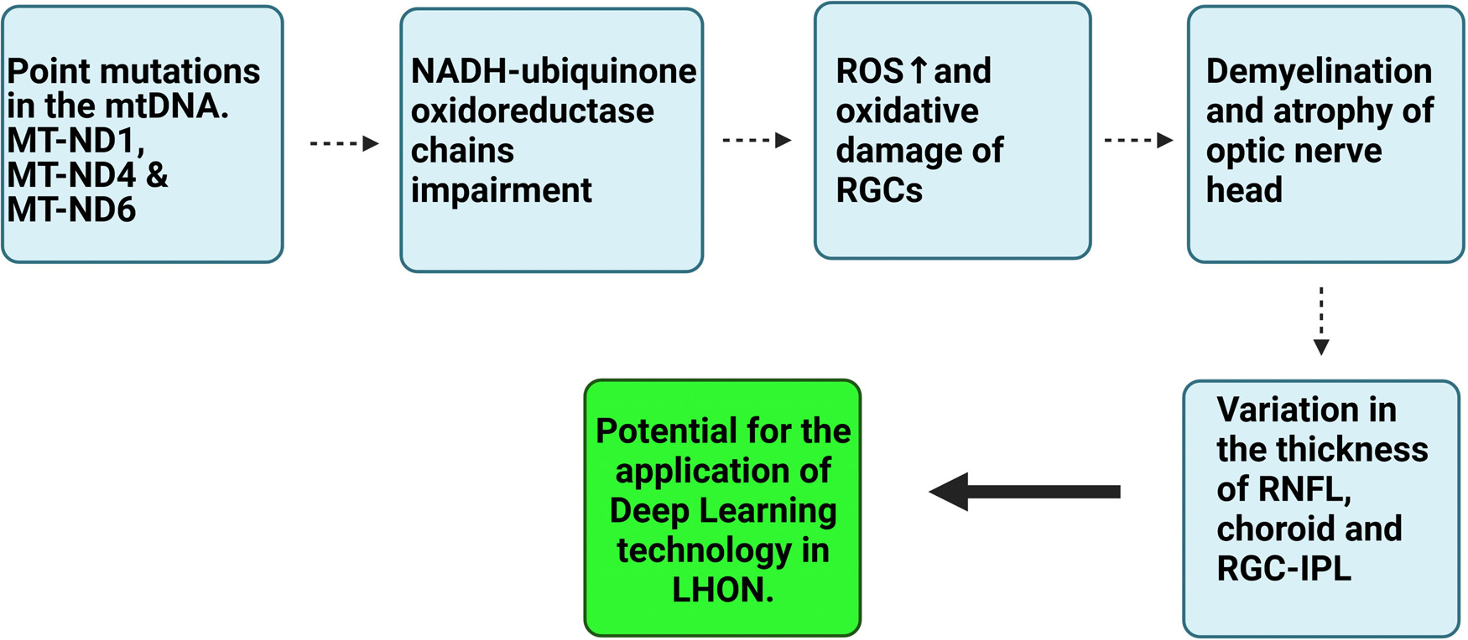

**Fig.3.**StepwisepathophysiologicalchangesinLHONfrommtDNAmutationleveltoopticnerveatrophyforunderstandingDLapplication.

ageofthecells[80].Asthenervecellsarevulnerabletomitochondrial dysfunction,theretinalganglioncells(RGC)intheaxonalregionof theopticnervediscdegeneratesduetoapoptosis[81,82].Thiscauses opticneuropathyandaffectsthevisualpathwayforimageperception. Thefollowingeventscontributetobilateralvisuallossintheindividual andpathologicalchangesobservedattheopticnerve.Thepathophysi-ologicalchangesattheopticnervediscincludedemyelinationandat-rophy.Intheacutestage,theRNFLswellsintheareasurroundingthe opticnervehead.Itisthenfollowedbypersistentthinningoftheselay-ersduetocompensatoryresponseinthechronicLHON.Thesechanges werestudiedinOCTimaging[83].Fewstudiessuggestedthat,inacute LHON,bothRNFLandchoroidalthickeningwereobserved.Ontheother hand,inchronicLHON,bothRNFLandchoroidalbecomethin[84]. ThepathologicalchangesintheRGCsaffectthevascularityofthereti-nalganglioncell-innerplexiformlayer(RGC-IPL).Boththemacularand peripapillarychoroidthinninginprogressedLHONcorrelateswiththe RGC-IPLthickness[85].EvaluationofretinalvasculatureinacuteLHON usingOCTangiography(OCT-A)outlinesthemarkedvasculardilatation andtortuosityclinically.Infundusexaminationafterdilation,peripapil-larytelangiectasiaswithhyperaemicopticnerveareobservedandserve forclinicaldiagnosisofLHON.Inthechronicstage,opticatrophyis seenatthenervehead[83].Toexcludetheothercausesofdemyeli-nationandcompressivelesionsfromLHON,Magneticresonanceimag-ing(MRI)aidstonarrowdownthedifferentialdiagnosis.InLHON,in-creasedT2signalsarenotedinthechiasmandopticnervetract.Optic nerveandchiasmalenhancementsmimicopticneuritisinMR.Follow-ingpathologicalchangesobservedonLHONincomparisonwiththe healthyindividualanditmayserveasatoolfortheapplicationofDL infaceofLHONdiagnosis(Fig.3).

**PotentialofDLinthediagnosisofLHON**

Currently,DLmodelsarewidelyusedonlyinthediagnosisofDR, AMD,cataract,andglaucoma[86,87].Itsapplicationisnotyetinves-tigatedinLHON.Althoughthedemandforthedataexiststotrainthe DLmodels,sinceLHONisararedisease,atargetedmulti-centricstudy canprovideenoughinformationtofeedtheDLsystem.Successfulap-plicationofDLinLHONwillrevolutionizethediagnosisandprecision inneuro-ophthalmology.Inrecentyears,DLtechnologyiswellestab-lishedespeciallyintheDR,andenablestheclassificationofthembased onthetypesandseverity[88].InDR,fundusexaminationshowsmicro-aneurysms,dothemorrhages,intraretinalmicrovascularabnormalities, neovascularizationwhichservesasanessentialtoolforclinicaldiag-nosis[89].Thecolourfundusimagesdisplayingthesepeculiarchanges inDRaretakenintoconsiderationbytheDLalgorithmtoformCNN

5

*M.D.Subramaniam,A.K.B,R.B.Chirayathetal.*  *ArtificialIntelligenceintheLifeSciences1(2021)100018*

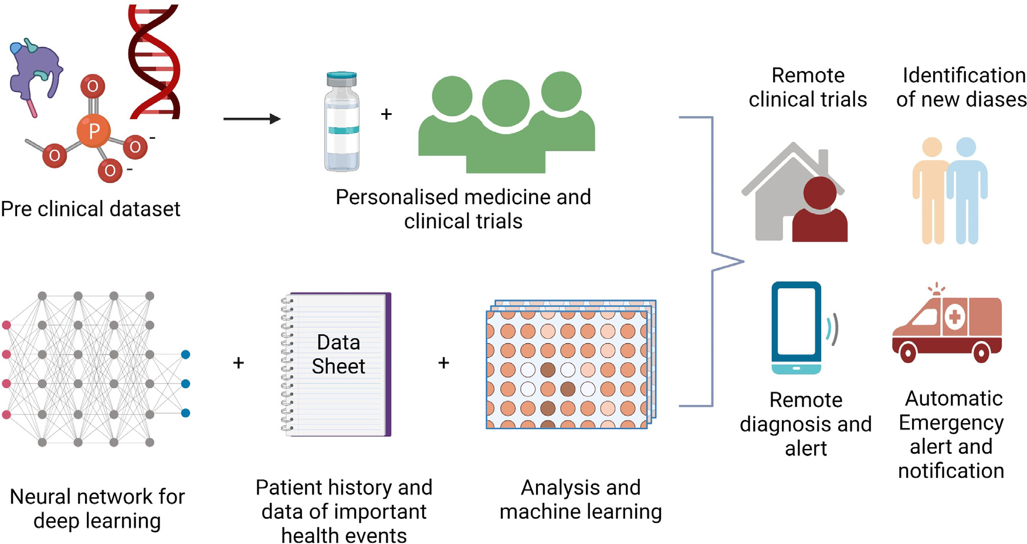

**Fig.4.**RemoteassessmentinOphthalmology.TelemedicineemployingAItechnologyasaprospectiveforlongitudinaldiagnosisofocularconditions.

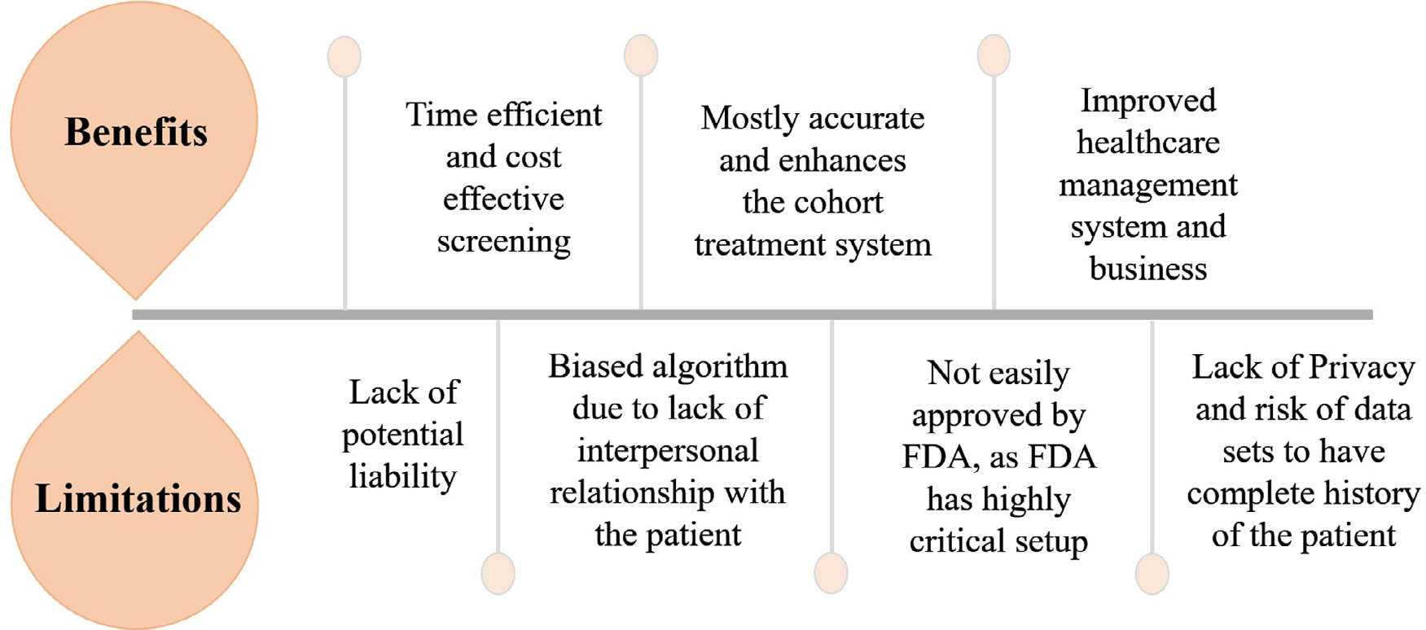

**Fig.5.**ThisfiguredepictsthemajorbenefitsandlimitationsofAIinhealthcare.

*vitro*studiestotrackdownthemorphologicalchanges,progression,and understandingofLHON.

**AdvantagesofemployingtelemedicineinOphthalmology**

TrialsareongoingtoexpandAIplatformsviadigitalinnovations intheinternetofthings,5thgenerationtelecommunicationnetworks, andthecreationofanecosystemthatisself-dependantandprovides theprospecttoadvancethelatestmodelsrelatedtoOphthalmologyad-dressingvariouschallenges[94].Oneofthemajoradvantagesofusing telemedicineisthatitmadepossibleforclinicianstoevaluatethepa-tientfromanygivenlocation.Replicatingroutineclinicalexamination, AIandtelemedicineareimprovisingtobebetterbyincorporatingvast informationabouttheprogressionofdiseases,longitudinaldatausage, andreal-timecalculationofincidencesinthereal-world[95,96].The applicationofAIcanmakedatacollectionpossibleandstorebigdataof patients.Manydigitalinnovationsrunfromdiagnosticstohelpinginthe treatmentofeyediseases.Screeningofeyediseaseswasmajorlycarried withthehelpofAI.Tele-screeningthroughAIhasexpandeditsapplica-tiontowardsophthalmologicalissueslikeDR,ROP,glaucoma,myopia,

6

*M.D.Subramaniam,A.K.B,R.B.Chirayathetal.*

beenapprovedbytheFDA,whichhascriticalacceptancecriteriafor themajorityofthesystemsincludingclinicaltrialsandtransparency. ThereareslightchancesthatAIcommitsminorerrorswhichmay beahindranceintheprocessofoperationsanddiseasediagnosiscon-siderably[99].Tooriginatevariouswaysforgatheringdataaswellas analysingthemconsideringthelegalformalityisoneamongsttheprin-cipalchallengestobeconfrontedbytheupcomingAIsystem.Artificial Intelligenceusesdifferentapproachestoassigngroundlabelswhichare AIreferencestandards,andtheyaresubjectedtohumanerror.With evidence,itcanbeeasilystatedthatthereisahighriskofAIsystem producingbiasedassessmentbythemethodologicalindexfornonran-domizedstudies(MINORS),whichisyettobeusedcompletelyasan applicationduetotesting[100].Everynewsystemandalgorithmmust gothroughalargeamountoftestingandtrialswhichistime-consuming asitmustcrossmanyapprovals,asthewholesystemisdependantona trial-and-errorprocedure.

NeuralnetworkinginDL,alsoknownasAIparadigms,trainsdataset dependingontheinputfed.Insomecases,thevariabilitymayoccurin theoutputdatawhichistermedasablack-boxproblem[101].TheAI wouldefficientlyworkonlyifthedatabasehasallthesufficientinfor-mationtounderstandtheparticularcondition[102].Thebiasedalgo-rithmisnotaverycommonmistakeofAIbutoccursinthreediffer-entformsofcomponentsnamelyModelvariance(Insufficientdataset), Modelbias(selectedmajorityandunder-representedgroups),andout-comenoise(Interactionthroughmodelpredictionsunaffectedbysub-population)[99].Despitevariouschallengesandrisks,AI/DLsystemis stillchangingthefaceofthehealthcareecosystemuniversally(Fig.5).

**Conclusion**

Accurateandefficientimageinterpretationandsatisfactoryprelim-inaryoutcomeofAIhaveasignificantimpactonOphthalmology.The fusionofautomaticdiagnosticsthroughAIwiththetraditionalsystem ofOphthalmologywouldhelpophthalmologistsinunderstandingthe pathophysiologyofocularconditions.DiagnosisofLHONrequirescom-plexgenetictastingswhichistime-consuming.Therefore,theapplica-tionofAIintheobservationofclinicalimagesincreasesprecisioninthe provisionaldiagnosisandhelpsintheearlymanagement.

**DeclarationofCompetingInterest**

Theauthorsdeclarethattherearenoconflictsofinterest.

**Acknowledgements**

TheauthorswouldliketothanktheScienceandEngineering ResearchBoard(SERB)forprovidingEarlyCareerResearchAward (ECR/2018/000718),Indiatocompletethisarticlesuccessfully.

**References**

[1]LeeA,TaylorP,Kalpathy-Cramer[J,TufailA.Machinelearningha](https://doi.org/10.1016/j.ophtha.2017.08.046)sarrived!.Oph- thalmology2017;124:1726–8.doi[:10.1016/j.ophtha.2017.08.046.](https://doi.org/10.1016/j.ophtha.2017.08.046)

[2]LeC[unY,BengioY,H](https://doi.org/10.1038/nature14539)intonG[.Deeplearning.Nature20](https://doi.org/10.1016/j.ophtha.2017.08.046)15;521:436–44. doi[:10.1038/nature14539.](https://doi.org/10.1038/nature14539)

[3]Gul[shanV,PengL,Cora](https://doi.org/10.1038/nature14539)mM,StumpeMC,WuD,NarayanaswamyA,etal.

Developmentandvalidationofadeeplearningalgorithmfordetectionofdi-abe[ticretinopathyinretinal](https://doi.org/10.1001/jama.2016.17216)fundusphotographs.JAMA2016;316:2402–10. doi[:10.1001/jama.2016.17216.](https://doi.org/10.1001/jama.2016.17216)

[4]Tin[gDSW,CheungCYL,LimG](https://doi.org/10.1001/jama.2016.17216),TanGSW,QuangND,GanA,etal.Development andvalidationofadeeplearningsystemfordiabeticretinopathyandrelatedeye diseasesusingretinali[magesfrommultiethnicpo](https://doi.org/10.1001/jama.2017.18152)pulationswithdiabetes.JAMA [2017;318:2211–23](http://refhub.elsevier.com/S2667-3185(21)00018-0/sbref0005).[doi:10.10](http://refhub.elsevier.com/S2667-3185(21)00018-0/sbref0005)[01/jama.2017.18152.](https://doi.org/10.1001/jama.2017.18152)

[[5]MileaD,SinghalS,NajjarRP.](http://refhub.elsevier.com/S2667-3185(21)00018-0/sbref0005)[Artificia](https://doi.org/10.1001/jama.2017.18152)l[intelligence](https://doi.org/10.1001/jama.2017.18152)[fordetectionofopticdiscab-](http://refhub.elsevier.com/S2667-3185(21)00018-0/sbref0005) [normalities.CurrOpinNeurol2020:33.](http://refhub.elsevier.com/S2667-3185(21)00018-0/sbref0005)

[[6]MayroEL,WangM,ElzeT,PasqualeLR.Theimpactofartificia](http://refhub.elsevier.com/S2667-3185(21)00018-0/sbref0005)l[intelli-](http://refhub.elsevier.com/S2667-3185(21)00018-0/sbref0005)gen[ceinthediagnosisandmana](https://doi.org/10.1038/s41433-019-0577-x)gementofglaucoma.Eye(Lond)2020;34:1–11. doi[:10.1038/s41433-019-0577-x.](https://doi.org/10.1038/s41433-019-0577-x)

[7]Boh[rA,MemarzadehK.Theriseo](https://doi.org/10.1038/s41433-019-0577-x)fa[rtificia](https://doi.org/10.1016/B978-0-12-818438-7.00002-2)l[intelligenceinhealthcareapplica](https://doi.org/10.1016/B978-0-12-818438-7.00002-2)tions. ArtifIntellHealthc2020:25–60.doi[:10.1016/B978-0-12-818438-7.00002-2.](https://doi.org/10.1016/B978-0-12-818438-7.00002-2)

7

*M.D.Subramaniam,A.K.B,R.B.Chirayathetal.*

[36]SosaleB,AravindSR,MurthyH,NarayanaS,SharmaU,GowdaSGV,etal.

Simple,mobile-basedartificialintelligencealgorithminthedetectionofdia-beti[cretinopathy(SMART)study.](https://doi.org/10.1136/bmjdrc-2019-000892)BMJOpenDiabetesResCare2020;8:e000892. doi[:10.1136/bmjdrc-2019-000892.](https://doi.org/10.1136/bmjdrc-2019-000892)

[37]Sos[aleB,SosaleAR,MurthyH,N](https://doi.org/10.1136/bmjdrc-2019-000892)arayanaS,SharmaU,GowdaSGV,etal.51-OR:medios-asmartphone-basedartificialintellige[ncealgorithminscree](https://doi.org/10.2337/db19-51-OR)ningfor diabeticretinopathy.Diabetes2019;68:51-OR.doi[:10.2337/db19-51-OR.](https://doi.org/10.2337/db19-51-OR)

[38]HuemerJ,WagnerSK,SimDA.Theevolutionof[diabeticretinopathys](https://doi.org/10.2337/db19-51-OR)creening programmes:achronologyofretinalphotographyfr[om35mmslidestoartif](https://doi.org/10.2147/OPTH.S261629)icial intelligence.ClinOphthalmol2020;14:2021–35.doi[:10.2147/OPTH.S261629.](https://doi.org/10.2147/OPTH.S261629)

[39]MohanaDeviS,MahalaxmiI,KaavyaJ,Chinnkulan[dhaiV,BalachandarV.D](https://doi.org/10.2147/OPTH.S261629)oes epigeneticshavearoleinagerelate[dmaculardegenerationanddi](https://doi.org/10.1016/j.gendis.2020.01.003)abeticretinopa-thy?GenesDis2021;8:279–86.doi[:10.1016/j.gendis.2020.01.003.](https://doi.org/10.1016/j.gendis.2020.01.003)

[40]GrassmannF,MengelkampJ,Bran[dlC,HarschS,Zimmermann](https://doi.org/10.1016/j.gendis.2020.01.003)ME,LinkohrB, etal.Adeeplearningalgorithmforpredictionofage-relatedeyediseasestudy severityscaleforage-relatedmacularde[generationfromcolorfundusph](https://doi.org/10.1016/j.ophtha.2018.02.037)otography. Ophthalmology2018;125:1410–20.doi[:10.1016/j.ophtha.2018.02.037.](https://doi.org/10.1016/j.ophtha.2018.02.037)

[41]YanQ,WeeksDE,XinH,SwaroopA,[ChewEY,HuangH,etal.Dee](https://doi.org/10.1016/j.ophtha.2018.02.037)p-learning-basedpredictionoflatea[ge-relatedmaculardegenerat](https://doi.org/10.1038/s42256-020-0154-9)ionprogression.NatMach Intell2020;2:141–50.doi[:10.1038/s42256-020-0154-9.](https://doi.org/10.1038/s42256-020-0154-9)

[42]BurlinaP,PachecoKD,[JoshiN,FreundDE,Bressler](https://doi.org/10.1038/s42256-020-0154-9)NM.Comparinghumans anddeeplearningperformanceforgradingAMD:astudyinusinguniversaldeep featuresandtrans[ferlearningforautomatedAMDan](https://doi.org/10.1016/j.compbiomed.2017.01.018)alysis.ComputBiolMed 2017;82:80–6.doi[:10.1016/j.compbiomed.2017.01.018.](https://doi.org/10.1016/j.compbiomed.2017.01.018)

[43]TrederM,Lauer[mannJL,EterN.Automateddete](https://doi.org/10.1016/j.compbiomed.2017.01.018)ctionofexudativeage-relatedmaculardegenerationinspectraldomainopticalcoherencetomogra-phy[usingdeeplearning.Graefe’](https://doi.org/10.1007/s00417-017-3850-3)s.ArchClinExpOphthalmol2018;256:259–65. doi[:10.1007/s00417-017-3850-3.](https://doi.org/10.1007/s00417-017-3850-3)

[44]Sch[leglT,WaldsteinSM,B](https://doi.org/10.1007/s00417-017-3850-3)ogunovicH,EndstraßerF,SadeghipourA, PhilipAM,etal.Fullyautomateddetectionandquantificationofmac-ula[rflui](https://doi.org/10.1016/j.ophtha.2017.10.031)d[inOCTusingdeep](https://doi.org/10.1016/j.ophtha.2017.10.031)learning.Ophthalmology2018;125:549–58. doi[:10.1016/j.ophtha.2017.10.031.](https://doi.org/10.1016/j.ophtha.2017.10.031)

[45]Hw[angDK,HsuCC,ChangKJ,](https://doi.org/10.1016/j.ophtha.2017.10.031)ChaoD,SunCH,JhengYC,etal.Artificial intelligence-baseddecision[-makingforage-relat](https://doi.org/10.7150/thno.28447)edmaculardegeneration.Thera-nostics2019;9:232–45.doi[:10.7150/thno.28447.](https://doi.org/10.7150/thno.28447)

[46]Bogunović H,Waldstein[SM,SchleglT,Lan](https://doi.org/10.7150/thno.28447)gsG,SadeghipourA,LiuX, etal.Predictionofanti-VEGFtreatmentrequirementsinneovascularAMDus-ing[amachinelearningap](https://doi.org/10.1167/iovs.16-21053)proach.InvestOphthalmolVisSci2017;58:3240–8. doi[:10.1167/iovs.16-21053.](https://doi.org/10.1167/iovs.16-21053)

[47]Kva[nnliL,KrohnJ.Switch](https://doi.org/10.1167/iovs.16-21053)ingfromprorenatatotreat-and-extendregimenim-provesvisualacuityinpatientswithneo[vascularage-related](https://doi.org/10.1111/aos.13356)maculardegeneration. ActaOphthalmol2017;95:678–82.doi[:10.1111/aos.13356.](https://doi.org/10.1111/aos.13356)

[48]PrahsP,RadeckV,MayerC,Cvetkov[Y,CvetkovaN,Helb](https://doi.org/10.1111/aos.13356)igH,etal.OCT-based deeplearningalgorithmfortheevaluationoftreatmentindicationwithanti-vascularendothelial[growthfactormedications.G](https://doi.org/10.1007/s00417-017-3839-y)raefe’sArchClinExpOphthalmol 2018;256:91–8.doi[:10.1007/s00417-017-3839-y.](https://doi.org/10.1007/s00417-017-3839-y)

[49]BhuiyanA,Wong[TY,TingDSW,Govindaiah](https://doi.org/10.1007/s00417-017-3839-y)A,SouiedEH,SmithRT.Artifi-cialintelligencetostratifyseverityofage-relatedmaculardegeneration(AMD) and[predictriskofpro](https://doi.org/10.1167/tvst.9.2.25)gressiontolateAMD.TranslVisSciTechnol2020;9:25. doi[:10.1167/tvst.9.2.25.](https://doi.org/10.1167/tvst.9.2.25)

[50]Gao[X,LinS,Wong](https://doi.org/10.1167/tvst.9.2.25)TY.Automaticfeaturelearningtogradenuclear cat[aractsbasedondeeplearning](https://doi.org/10.1109/TBME.2015.2444389).IEEETransBiomedEng2015;62:2693–701. doi[:10.1109/TBME.2015.2444389.](https://doi.org/10.1109/TBME.2015.2444389)

[51]Liu[X,JiangJ,ZhangK,LongE,](https://doi.org/10.1109/TBME.2015.2444389)CuiJ,ZhuM,etal.Localizationanddiagnosis [frameworkforpediatriccataractsbasedonslit-lampimagesusingdeepfeaturesof aconvolutionalneuralnetwork.PLoSONE2017;12:e0168606.doi:10.1371/jour-](https://doi.org/10.1371/journal.pone.0168606)[nal.pone.0168606.](http://refhub.elsevier.com/S2667-3185(21)00018-0/sbref0052)

[[52]MohammadiSF,SabbaghiM,Z-MehrjardiH,HashemiH,AlizadehS,Ma-jdiM,etal.Usingartificialintelligencetopredicttheriskforposteriorcap-suleopacificatio](http://refhub.elsevier.com/S2667-3185(21)00018-0/sbref0052)n[afterphacoemulsification](http://refhub.elsevier.com/S2667-3185(21)00018-0/sbref0052).[JCataractRefractSurg2012;38:403–408.](http://refhub.elsevier.com/S2667-3185(21)00018-0/sbref0052)

[[53]ÖhnellH,HeijlA,BrennerL,AndersonH,BengtssonB.Structuralandfunctional](http://refhub.elsevier.com/S2667-3185(21)00018-0/sbref0052) progres[sionintheearlymanifestglauc](https://doi.org/10.1016/j.ophtha.2016.01.039)omatrial.Ophthalmology2016;123:1173–80.doi[:10.1016/j.ophtha.2016.01.039.](https://doi.org/10.1016/j.ophtha.2016.01.039)

[54]Kapoor[R,WhighamBT,Al-AswadLA](https://doi.org/10.1016/j.ophtha.2016.01.039).Theroleofartificialintelligenceinthe dia[gnosisandmanagementofgla](https://doi.org/10.1007/s40135-019-00209-w)ucoma.CurrOphthalmolRep2019;7:136–42. doi[:10.1007/s40135-019-00209-w.](https://doi.org/10.1007/s40135-019-00209-w)

[55]Om[odakaK,AnG,TsudaS,Shiga](https://doi.org/10.1007/s40135-019-00209-w)Y,TakadaN,KikawaT,etal.Classificationof opticdiscshapeinglaucomausingmachinel[earningbasedonquantifie](https://doi.org/10.1371/journal.pone.0190012)d[ocu](https://doi.org/10.1371/journal.pone.0190012)lar parameters.PLoSONE2017;12:e0190012.doi[:10.1371/journal.pone.0190012.](https://doi.org/10.1371/journal.pone.0190012) [56]CerentiniA,WelferD,d’OrnellasMC,Haygert[CJP,DottoGN.Automaticide](https://doi.org/10.1371/journal.pone.0190012)nti- ficationofglaucoma[usingdeeplearningmethods.Stu](https://doi.org/10.3233/978-1-61499-830-3-318)dHealthTechnolInform 2017;245:318–21.doi[:10.3233/978-1-61499-830-3-318.](https://doi.org/10.3233/978-1-61499-830-3-318)

[57]MuhammadH,Fuchs[TJ,DeCuirN,DeMoraesCG,Blu](https://doi.org/10.3233/978-1-61499-830-3-318)mbergDM,LiebmannJM, etal.Hybriddeeplearningonsinglewide-fieldopticalcoherencetomogra-phy[scansaccuratelyclassifie](https://doi.org/10.1097/IJG.0000000000000765)s[glauco](https://doi.org/10.1097/IJG.0000000000000765)masuspects.JGlaucoma2017;26:1086–94. doi[:10.1097/IJG.0000000000000765.](https://doi.org/10.1097/IJG.0000000000000765)

[58]Ma[rtinKR,MansouriK,WeinrebRN,](https://doi.org/10.1097/IJG.0000000000000765)WasilewiczR,GislerC,HennebertJ,etal.

Useofmachinelearningoncontactlenssensor–derivedparametersforthedi-agn[osisofprimaryopen-angl](https://doi.org/10.1016/j.ajo.2018.07.005)eglaucoma.AmJOphthalmol2018;194:46–53. doi[:10.1016/j.ajo.2018.07.005.](https://doi.org/10.1016/j.ajo.2018.07.005)

[59]Niw[asSI,LinW,BaiX,K](https://doi.org/10.1016/j.ajo.2018.07.005)wohCK,JayKuoCC,SngCC,etal.Auto-matedanteriorsegmentOCTimageanalysisforAngleClosureGlaucoma me[chanismsclassification](https://doi.org/10.1016/j.cmpb.2016.03.018).[Comp](https://doi.org/10.1016/j.cmpb.2016.03.018)utMethodsProgramsBiomed2016;130:65–75. doi[:10.1016/j.cmpb.2016.03.018.](https://doi.org/10.1016/j.cmpb.2016.03.018)

8

*M.D.Subramaniam,A.K.B,R.B.Chirayathetal.*

[87]ZapataMA,Royo-FiblaD,FontO,VelaJI,MarcantonioI,Moya-SanchezEU,etal.

Artificialintelligencetoidentifyretinalfundusimages,qualityvalidation,lateral-ityevaluation,macu[lardegeneration,andsus](https://doi.org/10.2147/OPTH.S235751)pectedglaucoma.ClinOphthalmol 2020;14:419–29.doi[:10.2147/OPTH.S235751.](https://doi.org/10.2147/OPTH.S235751)

[88]BellemoV,LimG,Ri[mTH,TanGSW,Cheung](https://doi.org/10.2147/OPTH.S235751)CY,SaddaS,etal.Artificialintelli-gencescreeningfordiabet[icretinopathy:thereal-world](https://doi.org/10.1007/s11892-019-1189-3)emergingapplication.Curr [DiabRep2019;19:72.doi:10.1007/s11892-019-1189-3.](http://refhub.elsevier.com/S2667-3185(21)00018-0/sbref0089)

[[89]ViswanathK,McGavinDDM.Diabeticretinopathy:clinicalfinding](http://refhub.elsevier.com/S2667-3185(21)00018-0/sbref0089)s[andmanage-](http://refhub.elsevier.com/S2667-3185(21)00018-0/sbref0089) [ment.CommunityEyeHeal2003;16:21–4.](http://refhub.elsevier.com/S2667-3185(21)00018-0/sbref0089)

[[90]Theodorou-KanakariA,KarampitianisS,KarageorgouV,KampourelliE,Ka-](http://refhub.elsevier.com/S2667-3185(21)00018-0/sbref0089)pasakisE,TheodossiadisP,etal.Currentandemergingtreatmentmodalities forLeber’shereditary[opticneuropathy:areview](https://doi.org/10.1007/s12325-018-0776-z)oftheliterature.AdvTher 2018;35:1510–18.doi[:10.1007/s12325-018-0776-z.](https://doi.org/10.1007/s12325-018-0776-z)

[91]JonakK,KrukowP,S[ymmsM,MaciejewskiR,Gr](https://doi.org/10.1007/s12325-018-0776-z)ochowskiC.Neuroanatomical changesinLeber’shereditaryopticneuropathy:clinic[alapplicationof7TMRIsub](https://doi.org/10.3390/brainsci10060359)- millimetermorphometry.BrainSci2020;10:359.doi[:10.3390/brainsci10060359.](https://doi.org/10.3390/brainsci10060359) [92]RamosCdoVF,BellusciC,SaviniG,Carbonelli[M,BerezovskyA,TamakiC](https://doi.org/10.3390/brainsci10060359), etal.Associationofopticdiscsizewithdevelopmentandprognosisof Leb[er’shereditaryopticne](https://doi.org/10.1167/iovs.08-2695)uropathy.InvestOphthalmolVisSci2009;50:1666–74. doi[:10.1167/iovs.08-2695.](https://doi.org/10.1167/iovs.08-2695)

[93]Gro[chowskiC,JonakK,M](https://doi.org/10.1167/iovs.08-2695)aciejewskiM,StępniewskiA,Rahnama-HezavahM.Al-terationwithinthehippocampa[lvolumeinpatientswit](https://doi.org/10.3390/jcm10010014)hLHONdisease-7teslaMRI study.JClinMed2021;10.doi[:10.3390/jcm10010014.](https://doi.org/10.3390/jcm10010014)

[94]LiJPO,LiuH,TingDSJ,JeonS[,ChanRVP,KimJE,et](https://doi.org/10.3390/jcm10010014)al.Digitaltechnology,tele-medicineandartificialintellige[nceinophthalmology:aglobalper](https://doi.org/10.1016/j.preteyeres.2020.100900)spective.Prog RetinEyeRes2020:100900.doi[:10.1016/j.preteyeres.2020.100900.](https://doi.org/10.1016/j.preteyeres.2020.100900)

9