|  |  |  |  |
| --- | --- | --- | --- |
|  |  | Available online at www.sciencedirect.com |  |
| **ScienceDirect** |
| AASRI Procedia 8 ( 2014 ) 38 – 43 |
| 2014 AASR RI Conferen nce on Spor rts Engineer ring and Co omputer Sci ience (SECS S 2014)  Design ning a So oftware t to Count t the Bod dy Comp position n and  Somatoty ype and Its Role in Pursi ing the M Morphol logical S State of  Spotsm men  Asli H Houcine, A Atallah Ahm med, Zergu uine Sadde ek  *Partition n 88 Hai ben Dao oud N”02 Bir el D Djir Oran / Postco ode: 31000 / Alge eria* | | | |

*Sité 296 6 logements bloc E E N”6 Tgdit mos staganem /Postco de: 27000 / Alger ria*

|  |  |
| --- | --- |
| *Partition* | *187 Hai ben Dao oud N”02 Bir el D Djir Oran / Postc code: 31000 / Alg geria* |

**Abst tract**

Desig gning a softwa are to count the e body compos sition and som matotype and its s role in pursin ng the morphol logical state of f

sport tsmen

The objective fr from this study y is to design a software wh hich relies on t the Heat-Carte r method for o onthropometrie e

soma atotype and ma atiegka équation n in counting th he body mass (t the fat, the mus scle, the bones) )and among the e characteristics s

of th e software :

|  |  |  |
| --- | --- | --- |
| 1 . | Facilitatin ng the countab ble operations s for matiegka a équations an nd Heat-carter r method for | antropometric c |

soma atotype .

|  |  |  |  |
| --- | --- | --- | --- |
| 2 . | Counting | the results of t the body mass | and somatotype e for big numb ber of sportsmen n in short perio od of time ,less s |

effor rt and more accu uracy.

|  |  |  |  |  |
| --- | --- | --- | --- | --- |
| 3 . | Designing g basic data rich h of the body m mass ‘and the so omatotype ‘s re esults of many | | sportsmen ,So | that ,it helps in n |
| pursi ing their morph hological state a and the way to s select and guid | | them to the bes st sport activity . | | |
| 4 . | Designing g the somatocha art and diagram m for body comp position . | | | |
| As a future stud dy we are loak king for luiking g the software | | with the elect tronie side in o order to design n an outomatic c | | |
| mach hine which wor rks on taking th e anthropometr ric measurment s in human bod dy with high acc curary and to tr ransmit the data a | | | | |

to the e countable ma achine in which they will be tre eated and stored d in basic data o otomatically.

|  |  |  |  |  |  |
| --- | --- | --- | --- | --- | --- |
| © 2014 The Authors. Published by Elsevier B. V. This is an open access article under the CC BY-NC-ND license © 20 014. Published d by Elsevier B.V.  (http://creativecommons.org/licenses/by-nc-nd/3.0/). Sele ection and/or p peer review un nder responsib bility of Amer rican Applied Science Rese earch Institute  Peer-review under responsibility of Scientific Committee of American Applied Science Research Institute  *Keyw words:* Baseball F ielding Concept T Training; Animat tion Platform; Ta actical Cases Simu ulation; Tempora al Spatial Relation nship; | | | | | |
| **1. In ntroduction** | | | | | |
| The world of | computer sci ences has wi tnessed a lot | | | of success a as one of the | technological l advances in n |
| spar ing a lot of tim me and effort | | | ,it also increa ased the credib bility and con nfidence of the e results to alm most a perfect t | | |
| leve l . | | | | | |
| Computer and | | software sci entists succee eded in makin ng many com mputers for th he use in all f fields, among g | | | |

whic ch sports activ vities are cove ered.

In n fact all scie entific fields use computer rs to store, to o retrieve and d to analyse d data that is w why computer r

scien nces were intr roduced in spo ort activities to o match the sc cientific progr ress known to other scientif fic fields .

2212-6716 © 2014 The Authors. Published by Elsevier B. V. This is an open access article under the CC BY-NC-ND license

(http://creativecommons.org/licenses/by-nc-nd/3.0/).

Peer-review under responsibility of Scientific Committee of American Applied Science Research Institute

doi: 10.1016/j.aasri.2014.08.007

*Asli Houcine et al. / AASRI Procedia 8 ( 2014 ) 38 – 43*  39

Sports morphology is a science that is specialised in studying the changes of human body structure which occur under physical exercises ,The high performance of tained by athlets makes it necessary to evaluate the body capacity and the individual characteristics of each athlet .

This evaluation considers a number of parametrs such as weight ,height, body surface ,fat mass, muscle mass and bones mass .

From this logic stems the idea to design a software capable to treat in put data (Anthropometric measurements ) where the the out put data will be in form of Somatotype and body mass .

By using Matiegka equation and carter-heat method of anthropometric somatotype, as a consequence the objectives of this research are :   
 1) To simplify the computing operations of Matiegka equation and the carter-heat method.

2) To increase the precision of computing the results of body mass and somatotypes of several athlets in faster time and less efforts.

3) To design baseline data of body mass and somatotype for a big number of athlets to follow up their morpholic state,thier selection and thier guidance to the most appropriate sport ‘s activity.

4) To design a somatochart and body composition chart .

**2. Research terms**

Software: he’s a direction give to the computer to excute precise task in the time from .(Ghistaine and Patrick 2000).

Body composition (body mass) : is a term refers to the human body from three ingredients are ( muscles, fats, bones) . (Battinelli,2007)   
 Somatotype : is an expression refers to the morphology , and is expressed in three points , the first refers to the endomorphy(right), segond (midale)to mesomorphy , third (left) ectomorphy (carter,2002)

**3. Equations adopted in software**

We used the formulas of Mateigka (1921) :

*3.1. Fat mass*

MA = d. s.k.

MG : absolute fat mass in kg   
d:½�skinfold(subscapular, (biceps+triceps)/2chest,forearm,abdominal,thigh)/6 s : body surface calculated by the formula Izakson(1958) :   
 s = ( 100 + wieht + ( stature – 160 )) / 100   
k : constant = 1, 3   
- calculating the percentage of fat mass (relative) :   
MG% = (MA/ body mass).100

*3.2. Bones mass :*

MO = l.o².k   
MO: absolute bones mass in kg   
l : stature in cm   
o = (diameters distal arm, forearm, thigh and leg)/4 in cm   
k: constant = 1,2   
- calculating the percentage of bones mass (relative) :   
MO% = (MO/masse corporelle).100

*3.3. muscle mass :*

MM = l.r².k   
MO : absolute muscle mass in kg

40  *Asli Houcine et al. / AASRI Procedia 8 ( 2014 ) 38 – 43*

l : stature in cm   
r =(� circumference arm, forearm, thigh and leg) / 25.12 - ( �skinfold arm, forearm, thigh and leg) / 80 k : constant = 6,5   
- calculating the percentage of muscle mass (relative) :   
MM% = (MM/body mass).100 (Matiegka, 1921).

**4. Somatotype**

We used the Heath-carter Antropometric Somatotype (Duqaet and carter ,2001),(Heat and carter,1977),(Philipaerts,2002)

*4.1. How the software works:*

**programming language :**   
visual C sharp(C#)�Microsoft visual studio 2008   
Data base �MySQL (Wamp Server) (Mickey,2002),(Donis,2005),(Loca and John,2010) **Software platform :**   
32 bit ,64 bit Windows (XP , Windows 7)   
**Size of program :** 2 ,45 MB

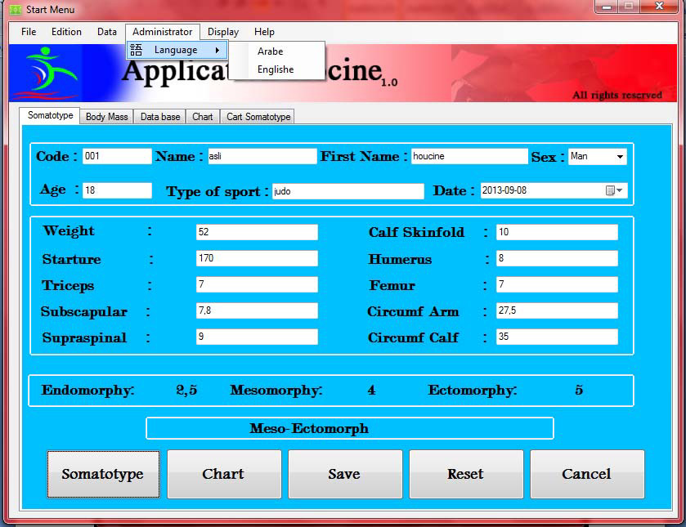

**First step :**   
 After fixing the program (setup software) you’ll see the next interface and it’s « somatotype interface » if you want to change the language from english to arab click on « administrator box ».

fill the information about somatotype then click on the « somatotype box » to show the results , if you want to represent data in the somatochart clik on « chart » , if you want to delete data click on « reset » , After making sure to fill the correct to data click « save » and you’ll see the message if you want to Continue calculate body mass click « OK » , and if want to save the results somatotype just click « NO » if you want to close program click on « cancel »   
 Observation : to fill the high side of the program (code ,Name , Age ….) are necessary to save the results in database.

Tel : 00213 552 94 20 59 Fax : 00213 45 30 59 52   
Email : asli.houcine_sport@yahoo.fr

*Asli Houcine et al. / AASRI Procedia 8 ( 2014 ) 38 – 43*  41

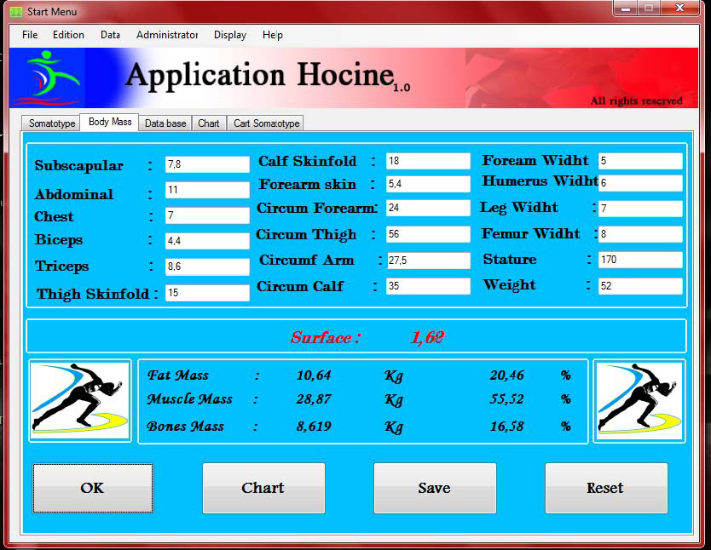

**The second step:**

Fill the data for body mass then click on « OK » to show results ,same previous steps if you want change the

language or graphical representation or delete afer confirming data click « save » then click on « data base»

box , to confirming data save in data base you will see the next interface .

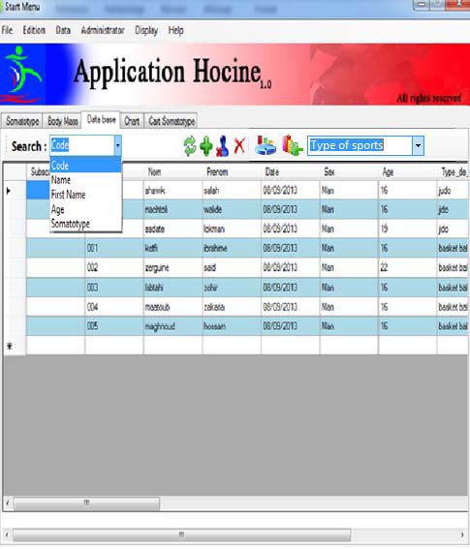

After clicking on « data base » you’ll see black page , click on execution for appearence of stored

information , if you want to research about ( Name or code or …..) entre Name …, in research box you will see

the spacial information in blue color .

If you want to delete the stored information for this code click on « delete » , and if you want to delete

all the information from data base click on « delet all »  ; if you want to change in some data click on 

then click on Name or code …., that you wanted to change then click on « somatotype » or « body mass » box ,

42  *Asli Houcine et al. / AASRI Procedia 8 ( 2014 ) 38 – 43*

You'll find that the data was automatically filled then make a change process then click on « Save » , if you

want data representation Somatotype or body mass choose the serie name then click on the boxand will apear to you the interface .

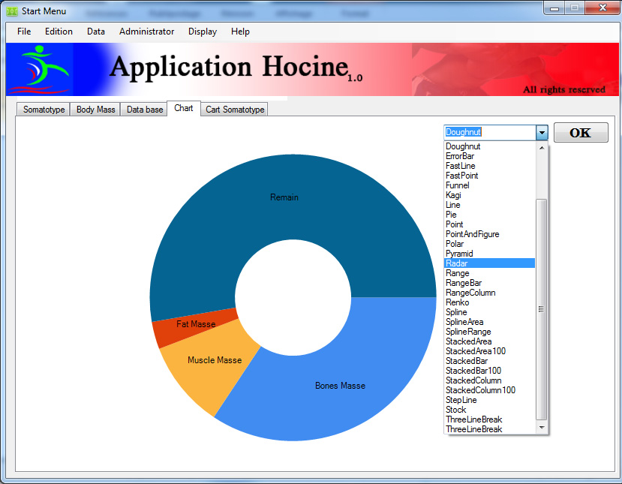

When the next interface apear choose graphical represetation chart type then click on « OK » then click on « somatochart ».

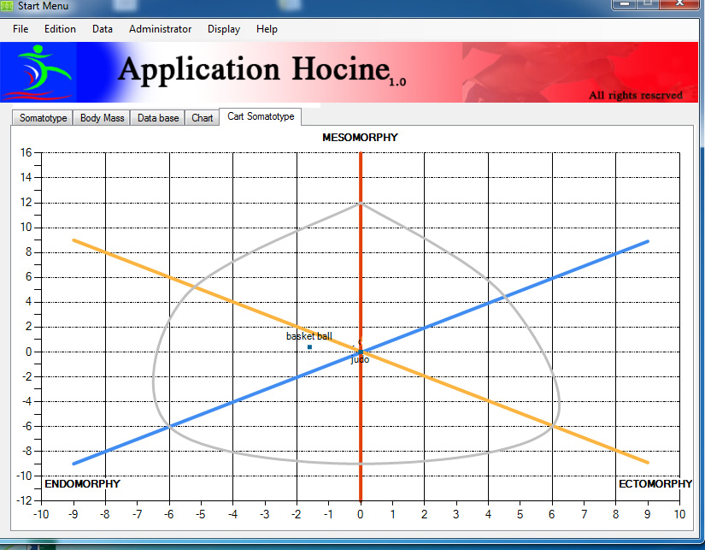

To apear somatochart as you see in the picture .

**5. Search Results**

1 ) Facilitating the countable operations for matiegka equations and Heat-carter method for antropometric somatotype .

2) Counting the results of the body mass and somatotype for big number of sportsmen in short period of time ,less effort and more accuracy.

3) Designing basic data rich of the body mass ‘and the somatotype ‘s results of many sportsmen ,So that ,it helps in pursing their morphological state and the way to select and guid them to the best sport activity. 4) Designing the somatochart and diagram for body composition .

Tel : 00213 552 94 20 59 Fax : 00213 45 30 59 52   
Email : asli.houcine_sport@yahoo.fr

*Asli Houcine et al. / AASRI Procedia 8 ( 2014 ) 38 – 43*  43

**6. Recommendations**

|  |  |
| --- | --- |
| 1)  2)  3) | Link this software to the hardware to the process to make measurs anthropometry .  Take care to the morphology side to estimate training program  It’s necesory to take care of somatotype in selection process and to direct athlets to the right physical |

activity .

4) Make more of meetings and conferences about the importance link to the sport domain with ather sciences especially electronic engineering science .

**References**

[1] Battinelli Thomas : *Physique, Fitness, and Performance*. 2nd Edition, CRC Press, Taylor & Francis Group, New York, 2007   
[2] Donis Marshall, Microsoft Visual C# 2005, Paris, Microsoft Press, coll. « Manuel de référence », 2006 (ISBN 978-2-10-049942-7)   
[3] Carter J.E.L : *The heath-Carter Anthropometric Somatotype -Instruction Manual*, Department of Exercise and Nutritional Sciences San Diego State University San Diego, CA. USA, 2002   
[4] Duquet, W. & Carter, J.E.L. (2001). Somatotyping. In: R. Eston & T. Reilly (Eds.), Kinanthropometry and Exercise Physiology Laboratory Manual: Tests, procedures and data. Vol. 1, Anthropometry, Chapt. 2. London: E & F.N. Spon   
[5] Ghislaine quintillan & patrick Dupuis : Informatique et sports collectifs. produits par l’institut du sport et de l’éducation physique , paris 2000   
[6] Heath-Carter: Growth and physical development applying the heathcarter somatotyp methods: Budapest, Eiben O.G., 1977.

[7] Izakson : Anatomie humaine et base de la morphologie dynamique et sportive : Moscou, Fiskultura i Sport, 1958   
[8] John Sharp, Microsoft Visual C# 2010, Paris, Microsoft Press, coll. « Étape par Étape », 2010, 640 p.

(ISBN 978-2-10-054741-8)   
[9] Luca Regnicoli, Paolo Pialorsi et Roberto Brunetti, Build Windows 8 Apps with Microsoft Visual C# and Visual Basic, Sebastopol, Microsoft Press, coll. « Step by Step », 2013, 368 p. (ISBN 978-0-7356-6695-5) [10] Mickey Williams - Manuel de référence Microsoft Visual C# - Collection Langages et Programmation, Éditions Dunod - 2002 – 784 pages - ISBN 2-10-006659-5   
[11] Mateigka J.: The testing of physical efficiency. American journal of physical anthropology, n°4, 1921. [12] Philipaerts R. M**.**: Change in somatotype of youth soccer players : Ghent youth soccer project: Athhens *7th Annual Congress of The European College of Sport Science*, 24 –28 July 2002, Tome 02 , p 821   
[13] Reilly T., Bangsbo J., Franks A**.**: Anthropometric and physiological predispositions for elite soccer *J Sports Sci*, 2000, 18:669-683 .