|  |  |  |  |
| --- | --- | --- | --- |
|  |  | Available online at www.sciencedirect.com |  |
| **ScienceDirect** |
| AASRI Procedia 9 ( 2014 ) 92 – 98 |

2014 AASRI Conference on Circuit and Signal Processing (CSP 2014)

Efficient Current Bleeding Mixer for WiMax Applications

A.M. Almohaimeed*, M.C.E. Yagoub

*School of Electrical Engineering and Computer Science, University of Ottawa, Ottawa, Ontario K1N 6N5 Canada*

**Abstract**

The Worldwide Interoperability for Microwave Access, or WiMax, is a wireless communication technique based on IEEE 802.16 standards. Its advantage of sending high-data rates over long distances, while using a single base station to cover a large area, has made this technique a flexible and reliable solution for public wireless networks. In this paper, a current-bleeding Gilbert Cell down-converter mixer is proposed for WiMax direct-conversion receivers. With 5.1 dB of conversion gain, 1.5 dBm of IIP3, 36 dBm of IIP2 as well as 11.6dB and 8.4dB of single sideband and double sideband noise figure, respectively, the proposed 0.15mm InGaAspHEMT mixer largely meets the WiMax standards as demonstrated though successful comparison with published designs.

|  |
| --- |
| © 2014 The Authors. Published by Elsevier B. V. This is an open access article under the CC BY-NC-ND license © 2014A.M. Almohaimeed and M.C.E. Yagoub. Published by Elsevier B.V.  (http://creativecommons.org/licenses/by-nc-nd/3.0/). Selection and/or peer review under responsibility of American Applied Science Research Institute  Peer-review under responsibility of Scientific Committee of American Applied Science Research Institute |

*Keywords:*Direct conversion; HEMT; Mixer; WiMax.

**1.Introduction**

The ever-increasing demand for secured high-speed high-data rates communication links, preferably accessible through laptops and smartphones via wireless connections, is making the Worldwide Interoperability for Microwave Access, or WiMax, one of the most promising technologies to explore. Furthermore, WiMax systems can cover long distance areas with fewer base stations compared to other wireless technologies, thus involving lower costs in maintenance, operation, and management (J. Malleket al.,

* Corresponding author. Tel.: +1-613-562-5800; fax: +1-613-562-5175.   
*E-mail address:* aalmo034@uottawa.ca.

2212-6716 © 2014 The Authors. Published by Elsevier B. V. This is an open access article under the CC BY-NC-ND license (http://creativecommons.org/licenses/by-nc-nd/3.0/).

Peer-review under responsibility of Scientific Committee of American Applied Science Research Institute doi: 10.1016/j.aasri.2014.09.016

*A.M. Almohaimeed and M.C.E. Yagoub / AASRI Procedia 9 ( 2014 ) 92 – 98*  93

2010). In WiMax technologies, the most widely-used RF transceiver is the Direct-Conversion Architecture mainly because of its high level of integration and less component requirements, leading to reduced power dissipation (Huanget al., 2007; Antonopouloset al., 2008; Atallahet al., 2007).

In a WiMax receiver, the down converter mixer is one of the most important devices to consider. Depending on the desired performance, various parameter objectives should be targeted while designing a mixer, such as high conversion gain, 1dB compression point (P-1dB), port-to-port isolation, input second-order intercept point (IIP2) and input third-order intercept point (IIP3) as well as low noise figure (NF) and voltage supply. In practice, these parameters cannot be achieved simultaneously. So, based on design constraints and standard specifications, different mixer types and topologies can be considered.

However, the Gilbert-cell down converter mixer is one of the most suitable for WiMax applications (Wei et al., 2010;Hsiao et al., 2010; Wu et al., 2010). In fact, The Gilbert-cell mixer exhibits major advantages over single and single-balanced mixers due to inherent port isolation, relatively high gain, moderate linearity, and efficient cancellation of even-order harmonic distortion.

In the last few years, significant work has been done to improve the Gilbert cell mixer performance, leading to folded mixers, current reuse mixers, and current bleeding mixers. In this paper, a current-bleeding Gilbert Cell down-converter mixer is proposed for WiMax direct-conversion receivers. The design was achieved using the 0.15mm InGaAspHEMT technology processfrom Win Semiconductor Crop.0. With 5.1 dB of conversion gain, 1.5 dBm of IIP3, 36 dBm of IIP2 as well as 11.6dB and 8.4dB of single sideband and double sideband noise figure, respectively, the proposed mixer largely meets the WiMax standards as demonstrated though successful comparison with published designs.

**2.Proposed Mixer Design**

Gilbert cell mixers are widespread utilized due to their high port isolation, excellent gain, and cancellation of all even harmonics. However, they require staking more transistors leading to more bias supply and power dissipation as well as poorer noise figure and linearity (Krcmaret al., 2007;Su et al., 2008). Therefore, some techniques have been proposed to enhance the conventional Gilbert cell mixer performance, leading to folded mixers, current reuse mixers, and current bleeding mixers (Krcmaret al., 2007;Su et al., 2008; Karanicolas, 1996; Lin et al., 2006).

In this work, the current bleeding technique has been retained as a suitable tool to improve the mixer response. In the proposed design (Fig. 1), the RF signal is applied to the gate of the differential transistors (M1 and M2). Such configuration produces relatively constant gain, cancels the even harmonics, and converts the M1 and M2 RF input signal voltage to output current. The LO signal is applied to M3-M6. These transistors operate near pinch-off region in order to accomplish the multiplication of the RF amplified signal with the LO signal.

A current mirror stage (M9 and M10) provides the required current for the circuit. Finally, two source follower buffers (M7 and M8) areadded to match the IF+/IF- outputs with baluns.

In order to get high conversion gain, the RF transistors should be larger than the LO transistors. On the other side, large size transistors increase DC and LO power consumption.

Therefore, a current bleeding block (*R*1 and *R*2) was added to M1 and M2 to enhance the conversion gain by increasing the current in the RF stage. This current should be enough to operate M1 and M2 in the saturation region while reducing the current in the LO stage; therefore, the voltage is dropped in the load resistors *R*6 and *R*7.(Tsai et al., 2007;Khyet al., 2010; Wuet al., 2010).

The transistor is sized based on minimum noise figure, power consumption and maximum frequency, i.e., 2×25 μm. Moreover, such small transistor size provides the ability to apply the current bleeding to reduce the circuit voltage.

94  *A.M. Almohaimeed and M.C.E. Yagoub / AASRI Procedia 9 ( 2014 ) 92 – 98*

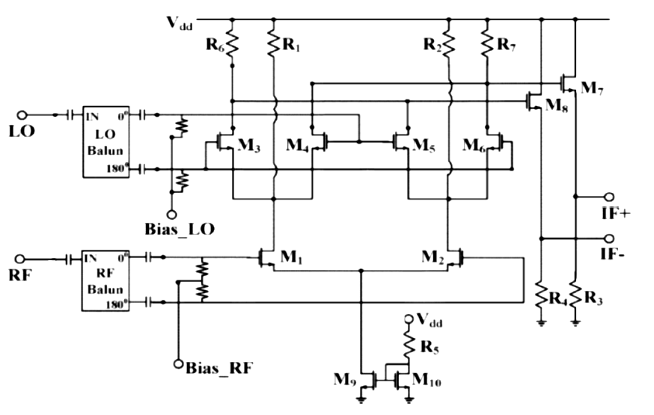

Fig.1. Proposed Gilbert-cell mixer using the current bleeding technique (Tsai et al., 2007)

**3.Results**

The mixer design, achieved in the commercial circuit simulator Agilent-

InGaAspHEMT technology process provided by Win Semiconductor Crop.0. A link budget was performed to deduce the desired specifications for the down-converter mixer to be designed (Table 1). The simulator was set up for input signal frequency from 3.493 to 3.507 GHz and LO signal frequency of 3.5 GHz in order to get the IF output frequency of 7 MHz. As seen in Fig. 2 (a) an optimum LO power of -3 dBm allows reaching the highest conversion gain value, i.e., 7.3 dB.

However, as displayed in Fig. 2 (b), the above LO power gives a relatively high single sideband noise figure of around 10 dB. Therefore, as compromise, we selected a LO power of 0 dBm, corresponding to a conversion gain of about 6 dB and a noise figure of 9.3 dB for single side band and 6 dB for double sideband, respectively. Figure 3 shows an IIP3 of 1 dBm while the IIP2 was found to be 39 dBm.

Table 1. Mixer Specifications

|  |  |  |  |  |  |  |
| --- | --- | --- | --- | --- | --- | --- |
| Parameters RF | LO | IF | Minimum | Maximum | Minimum | Minimum |
| Frequency(*GHz*) | Frequency(*GHz*) | Frequency(*MHz*) | Gain (*dB*) | Noise | IIP3(*dBm*) | IIP2(*dBm*) |

Figure(*dB*)

|  |  |  |  |  |  |  |  |
| --- | --- | --- | --- | --- | --- | --- | --- |
| Value | 3.493 - 3.507 | 3.5 | 7 | 5 | 11 | 0.3 dBm | 32.4 dBm |

As for the co-simulation (Fig. 4 and Fig. 5), the obtained conversion gain is displayed in Fig. 4 (a) while the noise figure for both single side and double side bands is shown in Fig. 4 (b). The corresponding IIP2 and IIP3 are found to be 36 dBm and 1.5 dBm, respectively (Fig. 5). The co-simulation layout is illustrated in

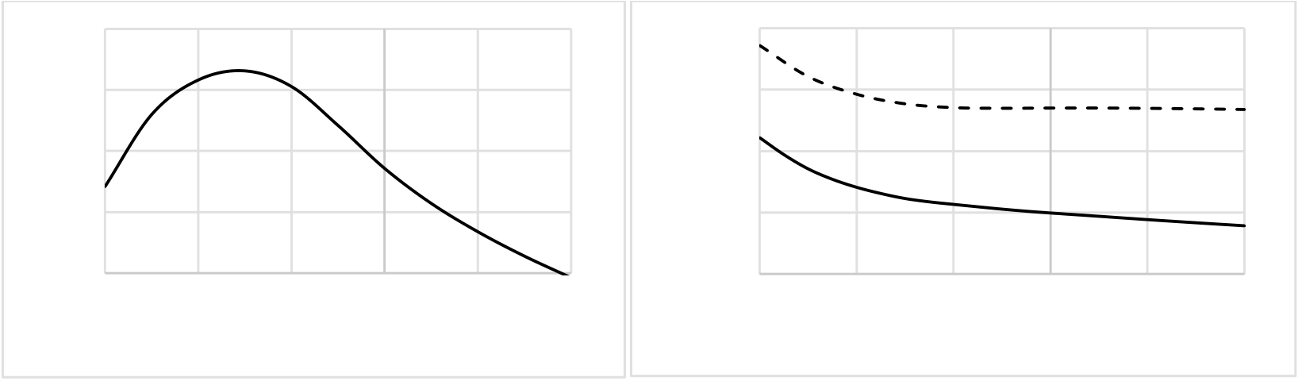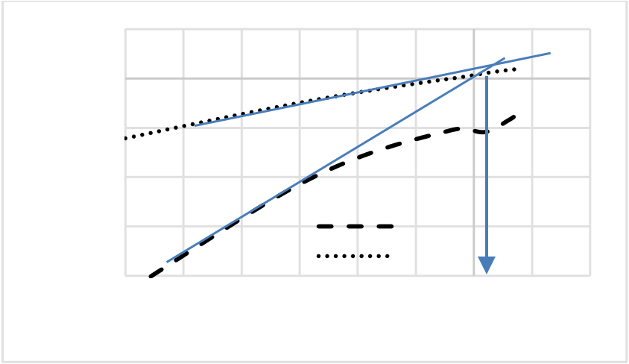

*A.M. Almohaimeed and M.C.E. Yagoub / AASRI Procedia 9 ( 2014 ) 92 – 98*  95

Fig.6. Such performance largely meets the WiMax standards as demonstrated though successful comparison

with published designs (Table 2).

|  |  |  |  |  |  |  |  |  |  |  |  |  |  |  |  |
| --- | --- | --- | --- | --- | --- | --- | --- | --- | --- | --- | --- | --- | --- | --- | --- |
| Conversion Gain, dB | 8 | -6 | -4 | -2 | 0 | 2 | 4 | Noise Figure, dB | 12 | -6 | -4 | -2 | 0 | 2 | 4 |
| 7 | 10 |
| 6 | 8 |
| 5 | 6 |
| 4 | 4 |
| LO Power, dB | | (a) | (b) | LO Power, dB | |

Fig.2. (a) Conversion Gainvs. LO Power Level, (b) SSB (- - -) and DSB (___) Noise Figure vs. LO Power Level

|  |  |  |  |  |  |  |  |  |  |  |
| --- | --- | --- | --- | --- | --- | --- | --- | --- | --- | --- |
| OutPut Power, dBm | 20 | -30 | -25 | -20 | -15 | -10 | IMD3 | 0 | IIP3 | 10 |
| 0 |
| -20 |
| -40 |
| -60 |
| -80 | Fund. |
| -5 | 5 |

Input Power, dBm

Fig.3. IIP3 Simulation

|  |  |  |  |  |  |  |  |  |  |  |  |  |  |  |  |  |  |  |
| --- | --- | --- | --- | --- | --- | --- | --- | --- | --- | --- | --- | --- | --- | --- | --- | --- | --- | --- |
| |  |  |  |  |  |  |  |  | | --- | --- | --- | --- | --- | --- | --- | --- | | Conversion Gain, dB | 6 |  | | | | | | | 5 | | 4 | | 3 | | 2 | | -6 | -4 | -2 | 0 | 2 | 4 |   LO Power, dB |

|  |  |  |  |  |  |  |  |  |  |  |  |  |  |  |  |  |  |  |
| --- | --- | --- | --- | --- | --- | --- | --- | --- | --- | --- | --- | --- | --- | --- | --- | --- | --- | --- |
| |  |  |  |  |  |  |  |  | | --- | --- | --- | --- | --- | --- | --- | --- | | Noise Figure, dB | 14 |  | | | | | | | 12 | | 10 | | 8 | | 6 | | -6 | -4 | -2 | 0 | 2 | 4 |   LO Power, dB |

(a) (b)

Fig.4. Co-simulation layout: (a) Conversion Gain vs. LO Power Level, (b) SSB (- - -) and DSB (___) Noise Figure

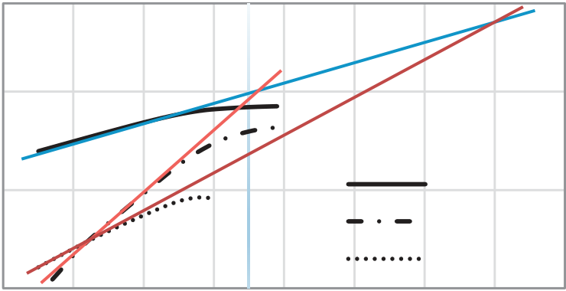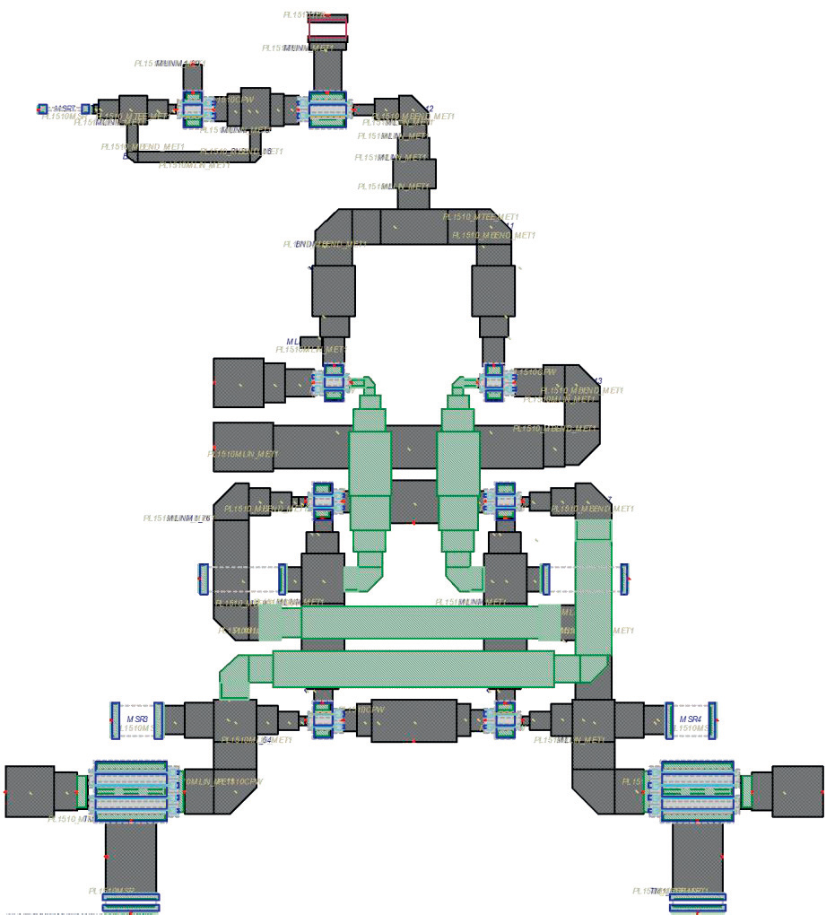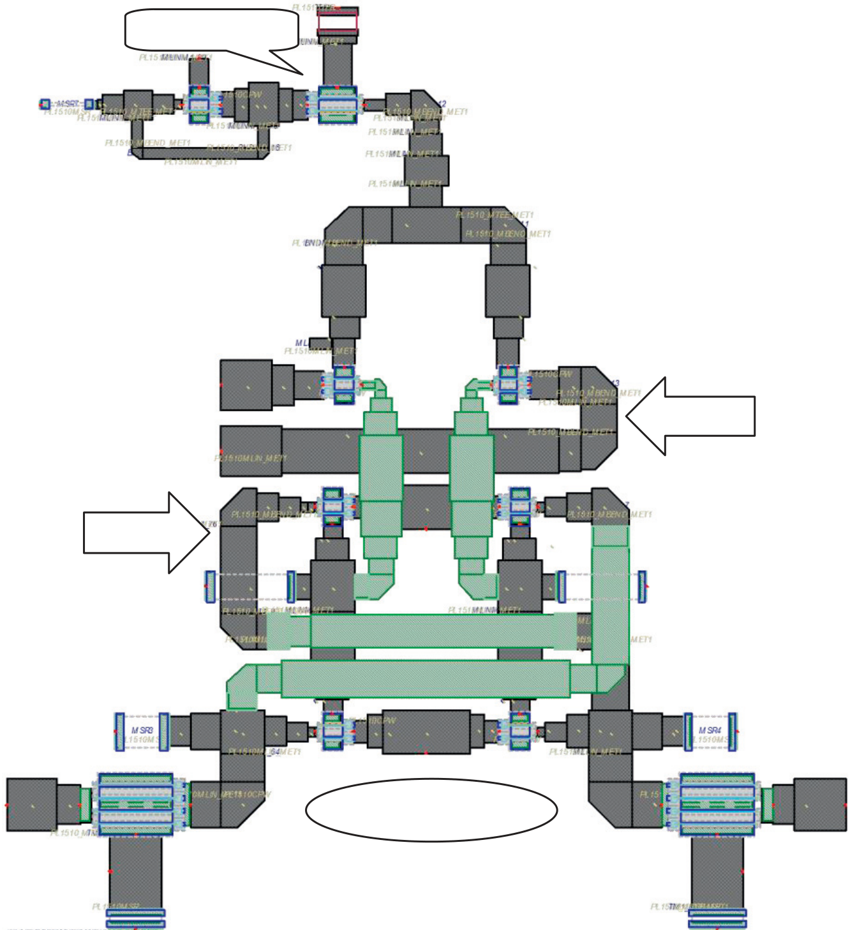

|  |  |
| --- | --- |
| 96 | *A.M. Almohaimeed and M.C.E. Yagoub / AASRI Procedia 9 ( 2014 ) 92 – 98* |

|  |  |  |  |  |  |  |  |  |  |  |  |  |  |  |  |  |  |  |  |  |  |  |
| --- | --- | --- | --- | --- | --- | --- | --- | --- | --- | --- | --- | --- | --- | --- | --- | --- | --- | --- | --- | --- | --- | --- |
| |  |  |  |  |  |  |  |  |  |  |  |  |  | | --- | --- | --- | --- | --- | --- | --- | --- | --- | --- | --- | --- | --- | | Output Power, dBm  5  -45  -95 | |  | | --- | |  | | Fund | | IMD3  IMD2 | | | | | | | | | | | -35 | -25 | -15 | -5 | 5 | 15 | 25 | 35 | 45 |   Input Power, dBm |

Fig.5. Co-simulation layout: IIP3 and IIP2

**Current Source**

**RF Stage**

**LO Stage**

**Source Follower**

Fig. 6. Mixer co-simulation layout

*A.M. Almohaimeed and M.C.E. Yagoub / AASRI Procedia 9 ( 2014 ) 92 – 98*  97

**4.Conclusion**

In this paper, the design of down converter Gilbert cell mixer for WiMax application was proposed. Implemented in the 0.15μm GaAs pHEMT technology, he exhibits a 5.1 dB of conversion gain, 1.5 dBm of IIP3, 36 dBm of IIP2 as well as 11.6dB and 8.4dB of single sideband and double sideband noise figure, respectively, thus largely meets the WiMax standards as demonstrated though successful comparison with published designs.

Table 2. Mixer Performance Compared with Published Works ((*) DSB - (**) RF Power - (***) Low Noise Figure Mixer)

|  |  |  |  |  |  |  |  |  |  |  |  |
| --- | --- | --- | --- | --- | --- | --- | --- | --- | --- | --- | --- |
| Ref | Technology | Topology | RF freq. | IF freq. | PLO | P-1dB | Gc | IIP3 | IIP2 | NF | Pdiss |
| (*GHz*) | (*MHz*) | (*dBm*) | (*dBm*) | (*dB*) | (*dBm*) | (*dBm*) | (*SSB*) | (*mW*) |
| Wu et al., | 0.15μm | Gilbert-Cell | 2.6 | N/A | 0 | -6 | 6 | -0.1 | 41 | 11(*) | 30 |
| 2010 | InGaAspHEMT |
| Wei et al., 2010 | 0.18μm CMOS | Gilbert-Cell | 2.4 | 10 | -6 | -9.8 | 0.44 | 10 | N/A | 11.4 | 5 |
| Weng et al., 2010 | 0.18μm RF CMOS | LNFM based | 3.5 | 20 | -20 (*) | -21 | 10.96 | -11 | N/A | 6.5 | 10 |
| Gilbert (**) |
| Lyu et al., 2010 | 0.18μm RF CMOS | Gilbert-Cell | 2-11 | 20 | 0 | N/A | 21 | 5 | N/A | 22 | 12 |
| cancelation |
| This work 0.15μm GaAs pHEMT | | Gilbert-Cell | 3.5 | 7 | 0 | -8 | 5.1 | 1.5 | 36 | 11.6 | 39.6 |

**Acknowledgements**

The authors would like to thank The Ministry of Higher Education in Saudi Arabia represented by Qassim University and Saudi Culture Bureau in Ottawa to their financial support.

**References**

[1] Mallek J, Mnif H, Loulou M. Analog digital conversion specifications for WiMAX homodyne receiver.Int.Conf. Microelectronics; 2010; 20-23.

[2] Huang D, Kao S, Pang Y. A WiMAX receiver with variable bandwidth of 2.5 - 20 MHz and 93 dB dynamic gain range in 0.13-μm CMOS process.IEEE Radio Frequency Integrated Circuits Symp.; 2007; 369-372.

[3] Antonopoulos A, Mavredakis N, Makris N, Bucher M. System level analysis of a direct-conversion WiMAX receiver at 5.3 GHz and corresponding mixer design.Int.Conf. Mixed Design of Integrated Circuits and Systems; 2008;291-296   
[4] Atallah J, Rodriguez S, Zheng L, Ismail M. A direct conversion WiMAX RF receiver front-end in CMOS technology,Int.Symp. Signals Circuits and Systems; 2007; 1-4.

[5] Wei H, Weng R, Wang J. A 1.5V high linearity down-conversion mixer for WiMAX applications. Int.Conf. Mechanical and Electronics Engineering.2010; 334-337.

[6] Hsiao C, Huang Y. A low power high linearity CMOS folded mixer for WiMAX application.IEEE Int.Conf. Semiconductor Electronics; 2010; 119-12.

[7] Wu J, Ye R, Horng T. A high IIP2 gilbert mixer-based downconverter design for direct-conversion WiMAX receivers.IEEE Radio and Wireless Symp.; 2010; 404-407.

98  *A.M. Almohaimeed and M.C.E. Yagoub / AASRI Procedia 9 ( 2014 ) 92 – 98*

[8] Win semiconductor crop., design Kit 0.15um InGaAspHEMT Low Noise Device; 2008.

[9] Krcmar M, Spiegel S, Ellinger F, Boeck G. A broadband folded gilbert-cell CMOS mixer.IEEE Int. Conf.Electronics, Circuits and Systems; 2007; 820-824.

[10] Su Z, Lin Z. A 18.9dB conversion gain folded mixer for WiMAX system.IEEE Asia Pacific Conf. Circuits and Systems; 2008; 292-295.

[11]Karanicolas A. A 2.7-V 900-MHz CMOS LNA and mixer, IEEE J.Solid-State Circuit; 1996; 31; 1939-1944.

[12] Lin C, Wu P, Chang H,Wang H. A 9-50-GHz Gilbert-cell down-conversion mixer in 0.13-μm CMOS technology,. IEEEMicrowave Wireless Components Lett.; 2006; 16; 293-295.

[13] Tsai J,Wu P, Lin,Huang T,Chern J, Huang W. A 25–75 GHz Broadband Gilbert-Cell mixer using 90-nm CMOS technology. IEEEMicrowave Wireless Components Lett.; 2007; 17; 247-249.

[14] KhyA, Huyart B. A (35 – 45) GHz low power direct-conversion gilbert-cell mixer in 0.13μm GaAs pHEMT technology.European Microwave Conf.; 2010; 1058-1061.

[15] Wu J, Ye R, Horng T. A high IIP2 gilbert mixer-based downconverter design for direct-conversion WiMAX receivers.IEEE Radio and Wireless Symp.; 2010; 404-407.

[16] Weng R, Liu S. A 1.5V low noise figure mixer for 3.5GHz WiMAX systems.IEEE Int.Symp. Circuits and Systems; 2010; 2211-2214.

[17] Lyu J, Lin Z. A 2�11 GHz direct-conversion mixer for WiMAX applications.TENCON Conf.; 2007; 1-4.