

[Applied Computing and Informatics 15 (2019) 7–11](https://doi.org/10.1016/j.aci.2018.03.001)

Contents lists available at [ScienceDirect](http://www.sciencedirect.com/science/journal/22108327)

Applied Computing and Informatics

journal homepage: [www.sciencedirect.com](http://www.sciencedirect.com)

|  |  |
| --- | --- |
| Implementation of a hybrid wind-solar desalination plant from an Internet of Things (IoT) perspective on a network simulation tool |  |

Umair Yaqub, Ahmad Al-Nasser, Tarek Sheltami⇑

Computer Engineering Department, King Fahd University of Petroleum and Minerals, Dhahran 31261, Saudi Arabia

|  |  |  |
| --- | --- | --- |
| a r t i c l e | i n f o | a b s t r a c t |
| Article history:  Received 18 December 2017  Revised 22 February 2018  Accepted 1 March 2018  Available online 14 March 2018 | | Desalination is one of the most important sources of water especially in Gulf countries like Saudi Arabia. For their sustainability and localized generation, it is important to switch to or start integrating renew-able technologies to the conventional grid for powering desalination plants. Furthermore, the control of these types of grids is now moving towards a cyber-physical system (CPS) approach rather than tradi-tional process control. In this paper, we show how the control and monitoring of renewable-based desali- |
| Keywords:  Internet of Things (IoT)  Desalination  Cyber-Physical Systems (CPS) Wind  Solar  Hybrid wind-solar | | nation plants can be done using Internet of things (IoT) as IoT comes under the framework of CPS. The system studied is a hybrid wind-solar energy driven desalination plant that is implemented from an IoT perspective using the network simulation tool Packet Tracer by CISCO. The plant is powered using renewable sources which operate the pumping station. In addition, the motors are automatically con-trolled according to the water level and demand whereas the boiler is also controlled automatically by a thermostat. However, there is also a web-accessible monitoring station housed on a server to which employees are given different levels of access according to their position. Lastly, NAT and ACL are used |

to implement network security and aid in access control.

� 2018 The Authors. Production and hosting by Elsevier B.V. on behalf of King Saud University. This is an

open access article under the CC BY-NC-ND license (<http://creativecommons.org/licenses/by-nc-nd/4.0/>).

Contents

1. Introduction . . . . . . . . . . . . . . . . . . . . . . . . . . . . . . . . . . . . . . . . . . . . . . . . . . . . . . . . . . . . . . . . . . . . . . . . . . . . . . . . . . . . . . . . . . . . . . . . . . . . . . . . . . . 7

2. Related work. . . . . . . . . . . . . . . . . . . . . . . . . . . . . . . . . . . . . . . . . . . . . . . . . . . . . . . . . . . . . . . . . . . . . . . . . . . . . . . . . . . . . . . . . . . . . . . . . . . . . . . . . . . 8

3. Implementation . . . . . . . . . . . . . . . . . . . . . . . . . . . . . . . . . . . . . . . . . . . . . . . . . . . . . . . . . . . . . . . . . . . . . . . . . . . . . . . . . . . . . . . . . . . . . . . . . . . . . . . . 8

3.1. CISCO packet tracer. . . . . . . . . . . . . . . . . . . . . . . . . . . . . . . . . . . . . . . . . . . . . . . . . . . . . . . . . . . . . . . . . . . . . . . . . . . . . . . . . . . . . . . . . . . . . . . . 8

3.2. Control station. . . . . . . . . . . . . . . . . . . . . . . . . . . . . . . . . . . . . . . . . . . . . . . . . . . . . . . . . . . . . . . . . . . . . . . . . . . . . . . . . . . . . . . . . . . . . . . . . . . . 9

3.3. Power station. . . . . . . . . . . . . . . . . . . . . . . . . . . . . . . . . . . . . . . . . . . . . . . . . . . . . . . . . . . . . . . . . . . . . . . . . . . . . . . . . . . . . . . . . . . . . . . . . . . . . 9

3.4. Pumping station and water level control. . . . . . . . . . . . . . . . . . . . . . . . . . . . . . . . . . . . . . . . . . . . . . . . . . . . . . . . . . . . . . . . . . . . . . . . . . . . . . 10

3.5. Boiler control. . . . . . . . . . . . . . . . . . . . . . . . . . . . . . . . . . . . . . . . . . . . . . . . . . . . . . . . . . . . . . . . . . . . . . . . . . . . . . . . . . . . . . . . . . . . . . . . . . . . 10

3.6. Providing secure access. . . . . . . . . . . . . . . . . . . . . . . . . . . . . . . . . . . . . . . . . . . . . . . . . . . . . . . . . . . . . . . . . . . . . . . . . . . . . . . . . . . . . . . . . . . . 10

4. Results and discussion . . . . . . . . . . . . . . . . . . . . . . . . . . . . . . . . . . . . . . . . . . . . . . . . . . . . . . . . . . . . . . . . . . . . . . . . . . . . . . . . . . . . . . . . . . . . . . . . . . 10

5. Conclusion . . . . . . . . . . . . . . . . . . . . . . . . . . . . . . . . . . . . . . . . . . . . . . . . . . . . . . . . . . . . . . . . . . . . . . . . . . . . . . . . . . . . . . . . . . . . . . . . . . . . . . . . . . . 11

Acknowledgments. . . . . . . . . . . . . . . . . . . . . . . . . . . . . . . . . . . . . . . . . . . . . . . . . . . . . . . . . . . . . . . . . . . . . . . . . . . . . . . . . . . . . . . . . . . . . . . . . . . . . 11

References . . . . . . . . . . . . . . . . . . . . . . . . . . . . . . . . . . . . . . . . . . . . . . . . . . . . . . . . . . . . . . . . . . . . . . . . . . . . . . . . . . . . . . . . . . . . . . . . . . . . . . . . . . . 11

⇑ Corresponding author.

E-mail address: [tarek@kfupm.edu.sa](mailto:tarek@kfupm.edu.sa) (T. Sheltami).

Peer review under responsibility of King Saud University.

1. Introduction

**Production and hosting by Elsevier**

<https://doi.org/10.1016/j.aci.2018.03.001>

Desalination process is one of the most common industrial pro-cesses because many countries do not have access to drinking

2210-8327/� 2018 The Authors. Production and hosting by Elsevier B.V. on behalf of King Saud University. This is an open access article under the CC BY-NC-ND license (<http://creativecommons.org/licenses/by-nc-nd/4.0/>).

8 U. Yaqub et al. / Applied Computing and Informatics 15 (2019) 7–11

water sources such as rivers and springs. Therefore, such countries rely on converting salty seawater into portable or drinking water. Most plants up to this day rely on fossil fuels to power their oper-ations. A report by the International Renewable Energy Agency in 2013 stated that only 1% of the energy for desalination plants comes from renewable sources [1].

Due to the focus on renewable energy nowadays and the prob-lems with sustainability of fossil fuels, the focus is on powering desalination plants using renewable sources. Furthermore, desali-nation plants are usually located at the coast. The weather in those places is quite windy and there is a lot of potential for the use of wind energy. In the Gulf countries like Saudi Arabia, sunlight is usually available all year round, so there is a terrific opportunity to power industrial operations by hybrid wind-solar energy. How-

A lot of work has also been carried out on the control strategies for the power supply of hybrid renewable sources and their eco-nomic analysis [9–11]. AbdelMageed et al. propose a neural network-based control strategy for a hybrid lead/PV battery sys-tem at the Mersa Matrouh plant in Egypt [9]. The authors carried out a theoretical investigation of the performance on integrated seawater desalination plant at Mersa Matrouh [10]. Both results were verified by simulations on MATLAB/Simulink. Smaoui et al. worked on the optimal sizing of the power plants based on hybrid PV-Wind with a battery for storage [11]. The sizing model was automated to adjust itself based on technical and economic vari-ables. A case study was conducted on the South of Tunisia.

Some researchers have carried out an economic feasibility anal-ysis on reverse osmosis based desalination plants run by renew-

|  |  |  |  |  |
| --- | --- | --- | --- | --- |
| ever, | these nations | severely lag in | renewable technologies; | able energy, especially for agricultural purposes [12–14]. Caldera |

although Saudi Arabia has recently begun work on such a plant.

The Gulf countries especially Saudi Arabia are an interesting subject because they produce the bulk of desalinated water. For example, Saudi Arabia produces 48.8% of the world’s share [2]. Fur-thermore, countries from the MENA region are expected to con-tribute 54% of the investment in this area and contain 9 of the top 15 countries investing in renewable desalination plants [3]. Therefore, now is the time for researchers from these countries to contribute heavily in this area.

In literature, a lot of work is there on using renewable sources to generate energy for desalination plants. They have been ana-lyzed from the perspective of the physical/chemical process as well as the engineering and financial aspects. However, as we will show in the next section, they have yet to be analyzed/simulated from the perspective of IoT. This is very important because renewable energies are part of the smart grids which come under the domain of cyber-physical systems (CPS).

This paper implements a small-scale desalination plant using the IoT framework in CISCO packet tracer. It is organized as fol-lows: Section 2 briefly reviews the work done in literature for renewable energy driven desalination plants. Section 3 describes the implementation logic of our hybrid wind-solar desalination plant and discusses the different components from an IoT perspec-tive. Section 4 presents some of the results and finally, Section 5 concludes the paper.

2. Related work

et al. perform the cost analysis that can be applied globally to local-ized desalination plants. The cost is found to be between $0.66 and $3.16, which is in stark contrast to the previous predicted costs of up to $9.00 [12]. Aparicio et al. carry out the economic analysis for small desalination plants from brackish acquirers located in the city of Cartagena in Spain [13]. Similar analysis for plants powering local agricultural needs is done by Jones et al. for hybrid wind-PV generators without storage. Several case studies were conducted in Jordan valley which showed the importance of favorable loca-tions and proper crop selection [14].

Hamed et al. recently analyzed the performance of a Fresnel solar collecting system. They showed that under certain conditions, solar power can achieve a reduction in cost by about $40 per barrel of drinking water produced [15]. Tsai et al. implement a novel innovative model which combines desalination and renewable energy for optimal power and water supply; which is different to most of the existing work that focuses only on one entity at a time [16]. A case study is done for the case of Taichung city to fulfill its electricity and water needs for the year 2030.

The most recent research for Saudi Arabia was done by Mokhei-mer et al. who propose a hybrid wind-solar that consists of 2 wind turbines, 40 PV modules and 6 storage batteries [17]. This system is expected to power a 1KW load all year round for 24 and 12 h a day. The expected cost is $0.672/kW h. We follow a similar model in our implementation but for a smaller scale because currently, our sys-tem cannot support such a large-scale plant. We hope to imple-ment this in a near future. Currently, the focus is on the IoT aspect of the plants rather than the mechanical/electrical aspects.

Wind and solar energy for desalination have long been a hot 3. Implementation

topic of research; especially with regards to the Gulf countries. Ismail assessed the optimal costs of using wind and solar energy for desalination on the Eastern Coast of Saudi Arabia [4]. He showed its economic feasibility where the hybrid wind-solar could produce unit distilled water from seawater at cost of 9.5–15 $/m3. He also showed that wind energy alone can be used for brackish water at lowly cost of about $1/m3.

Weiner et al. succeeded in practically implementing a small-scale desalination plant based on wind energy that converted brackish water to portable water for a small village [5]. Kershman et al. actually started-up one of the first research facilities for medium-scale integrated desalination plants [6,7]. The study is mainly focused on combining wind energy and photovoltaic tech-nologies with the conventional power grid. The long-term goal was to study standalone hybrid renewable systems for desalination.

IRENA and the Energy Technology System Analysis Programme (IEA-ETSAP) recently published brief and full reports about using renewable energy for water desalination. It contains technical details, economic feasibility analyses and highlights for policy

In this section, we discuss the CISCO Packet Tracer tool and briefly explain the desalination plant environment with the various sensors. The overall logic along with the individual components is presented in the sub-sequent sections. A security aspect based on NAT’ing and ACL’s is also discussed.

3.1. CISCO packet tracer

CISCO Packet Tracer is a cross-platform visual simulation tool designed by Cisco Systems [18]. It allows users to create network topologies and imitate modern computer networks. Users can sim-ulate the configuration of Cisco routers and switches using a com-mand line interface. The tool contains a wide variety of Smart Things and components that can be programmed. These smart things also have industrial components such as motors, solar pan-els, power meters and water control sensors and actuators.

Overall, the plant will be powered by wind turbines and solar panels. Once it is operational, the water will be continuously con-

makers [1,8]. verted to steam, the level will drain. More water will be pumped

U. Yaqub et al. / Applied Computing and Informatics 15 (2019) 7–11 9

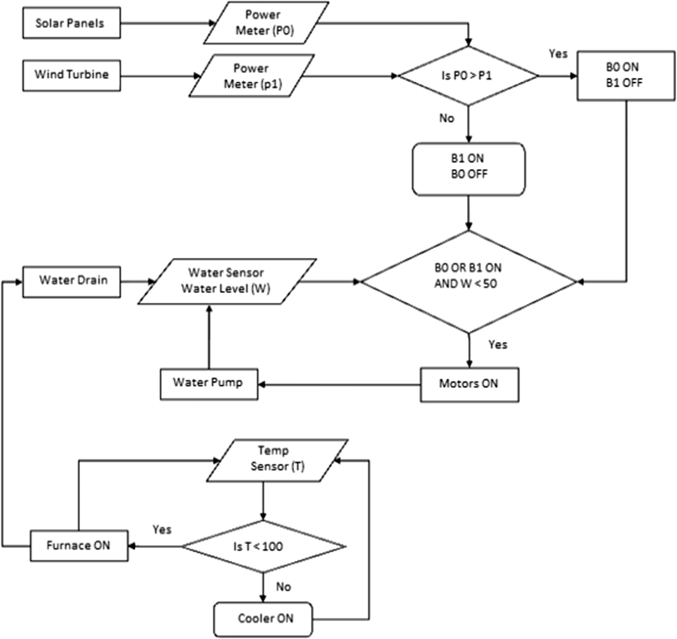

Fig. 1. Desalination plant logic.

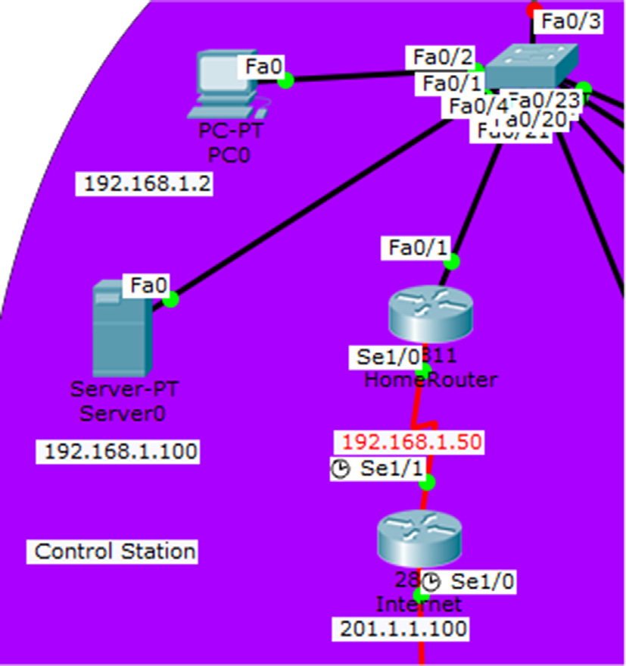

Fig. 2. Control station.

once the water level drops below the threshold, and this will turn on water sprinklers in the tanks and consequently the motors rep-resenting the pumps out at the sea. This will draw power from the battery which is constantly being supplied by the renewable sources. This logic is described by Fig. 1.

3.2. Control station

The plant devices are connected to a server, which can be used to control them, Fig. 2. It can be accessed through the company’s internal network and from outside by the manager if needed. The server can control the boiler thermostat and monitor the water level. The server also houses the registration for the web-based app for the IoT plant control.

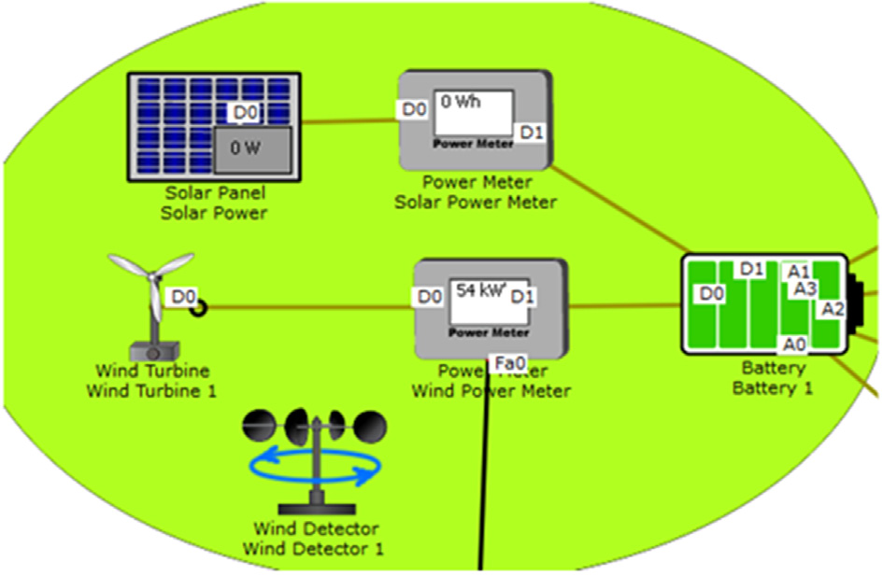

Fig. 3. Power station.

10 U. Yaqub et al. / Applied Computing and Informatics 15 (2019) 7–11

3.3. Power station motors are stopped. After the water drains to a set minimum level,

the drain closes, and the sprinkler and motors start again, Fig. 4.

The desalination plant has a power station. Power is generated

|  |  |
| --- | --- |
| from two sources, solar panels and wind turbines, Fig. 3. The gen-erated power is stored in a battery and then is fed to the motors in | 3.5. Boiler control |

the pumping station. So, during the daytime, most of the power is coming from the solar panels. At night when the sun goes down but it is windy, the turbine can provide the bulk of the power. The power is generated at all times and stored in a battery in case the sunlight is weak and there is no wind. Of course, the wind tur-bines are expected to provide more power than the solar panels.

The boiler is controlled through the thermostat, Fig. 5. It can be accessed directly from the device, or through the control server. It can be set as AUTO which will make it maintain a temperature between 100 and 101 �C. This is the temperature required to main-tain the boiling point of water. The temperature limits can be manipulated by the app or directly at the thermostat.

3.4. Pumping station and water level control 3.6. Providing secure access

The pumping station consists of multiple motors that act as pumps that take the water from the sea. A sprinkler is used to emu-late the water pumping effect. Once the water level rises to a cer-tain amount, the water drain is opened, and the sprinkler and

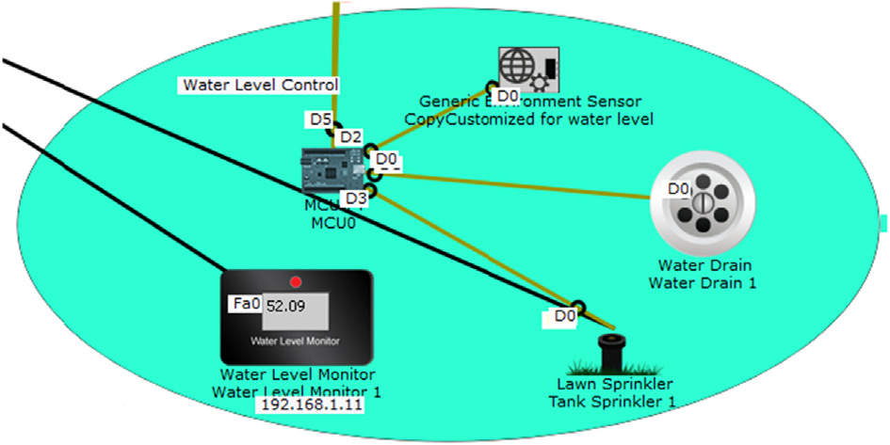

Fig. 4. Water level control.

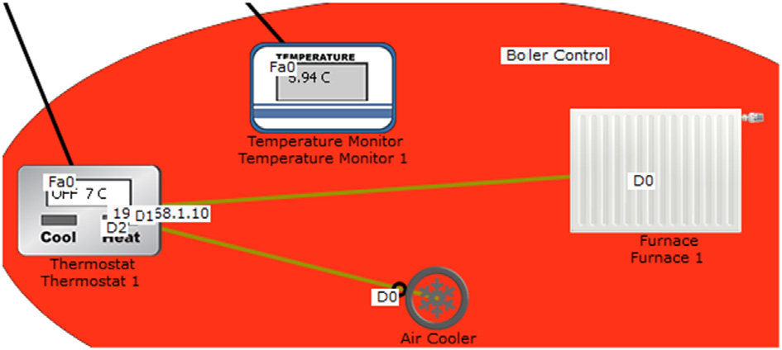

Fig. 5. Boiler control.

Network Address Translation or NAT’ing is chosen as the method to hide the system from the public network. It provides a barrier between IoT and the operational technology. Extended ACL is used at the plant router to restrict access to the server to allow top-level employees remote access in cases of emergency. ACL is also implemented inside the network. Normal employees without the privilege to access the control station of the plant are denied from access.

4. Results and discussion

You will usually want to divide your article into (numbered) sections and subsections (perhaps even subsubsections). Code sec-tion headings using the options in the ‘Text’ menu. Headings should reflect the relative importance of the sections. Note that text runs on after a 4th order heading. Use the heading style for the whole paragraph, but remove the bold coding except for the actual heading.

This section presents the results of our implemented hybrid wind-solar desalination plant. Fig. 6 shows the interface which dis-plays the monitor level and the boiler thermostat status. The sys-tem can be set to auto in order to maintain the temperature at nearly 100 degrees Celsius. It can also be shut down by clicking on off. The OFF status will actually turn the whole system down, a bit like a kill switch. This is not one of the most secure ways and, in the future, a separate kill switch for emergencies will be designed.

Fig. 7 shows the smart IoE app, which is employed and the two-factor authentication in combination with network-based controls is used. This is more secure than e-mail.

The next step was to use NAT along with ACL for security. Therefore, from the outside network, the server is accessed only

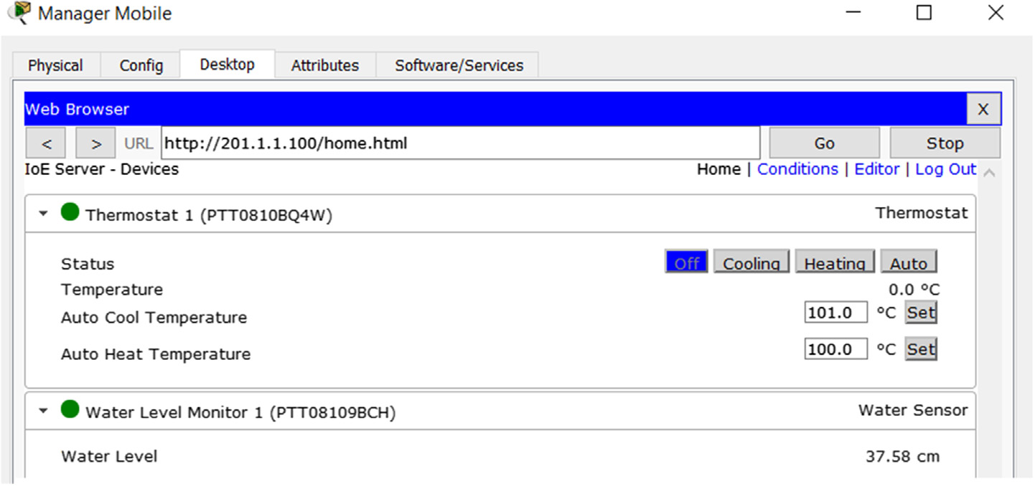

Fig. 6. Water level display.

U. Yaqub et al. / Applied Computing and Informatics 15 (2019) 7–11 11

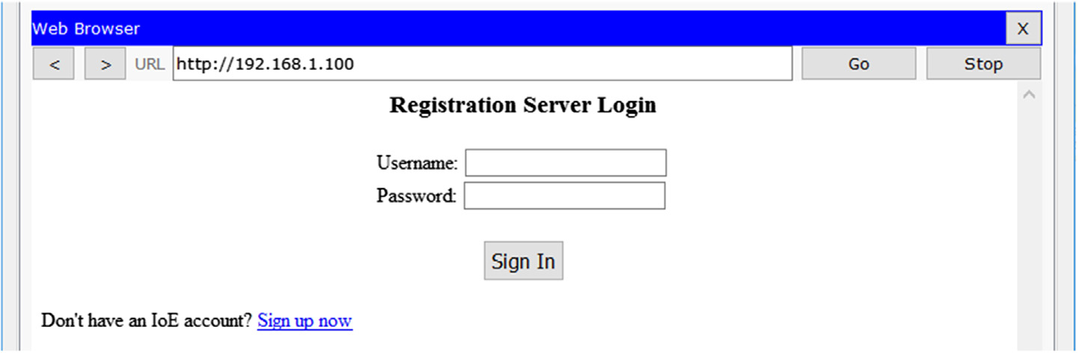

Fig. 7. Login page for the smart home app.

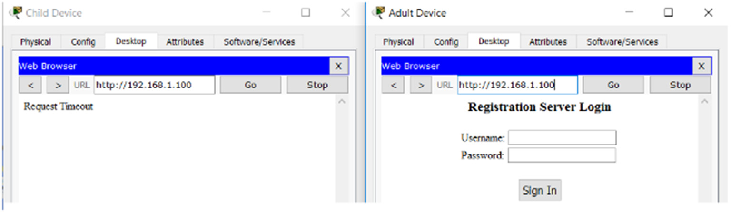

Fig. 8. The workings of the ACL.

|  |  |
| --- | --- |
| via a public IP address (in this case 200.1.1.101). whereas it can be accessed via the internal address (192.168.1.100). The ACL controls | References |

who can access from the outside networks as well as the home net-work. For example, a standard ACL is utilized at the home router to allow only the manager’s home IP or their ISP. Within the company network, an extended ACL is used to allow some devices access to the controls of the smart home and deny the others. For example, as Fig. 8 illustrates, the regular employee’s PC on the left is denied but the manager’s device on the right is allowed.

[1] M. Isaka, Water Desalination Using Renewable Energy, 2013.

[2] [E. Spang, The Potential for Wind-Powered Desalination in Water-Scarce](http://refhub.elsevier.com/S2210-8327(17)30354-X/h0010)  [Countries, Tufts University, The Fletcher School, 2006](http://refhub.elsevier.com/S2210-8327(17)30354-X/h0010).

[3] F. Diogo, A. Santos, M. Azevedo, Renewable Energy Powered Desalination Systems: Technologies and Market Analysis, Universidade De Lisboa, 2014. [4] B. Ismail, Optimal assessment of using solar and wind power for desalination on the Eastern Coast of Saudi Arabia, King Fahd University of Petroleum and Minerals, 1992.

[5] [D. Weiner, D. Fisher, E.J. Moses, B. Katz, G. Meron, Operation experience of a solar-and wind-powered desalination demonstration plant, Desalination 137 (2001) 7–13](http://refhub.elsevier.com/S2210-8327(17)30354-X/h0025).

|  |  |
| --- | --- |
| 5. Conclusion | [6] [S.A. Kershman, J. Rheinlader, H. Gablerb, Seawater reverse osmosis powered Tom renewable energy sources-hybrid wind/photovoltaic/grid power supply for small-scale desalination in Libya, Desalination 153 (1–3) (2002) 17–23](http://refhub.elsevier.com/S2210-8327(17)30354-X/h0030). |

In this research, we have implemented a hybrid wind-solar energy-based desalination plant using CISCO Packet Tracer simula-tor. The scope of the work is a practical proof-of-concept of imple-menting an industrial control system (ICS) as part of the IoT framework. To the best of our knowledge, this is one of the first attempts to simulate such a system from an IoT or CPS perspective. In our implementation, we used industrial sensors provided by Packet Tracer. The power supply, boiler thermostats and water levels, are automatically controlled based on the supply and demand of various variables such as current temperature and bat-tery level. In addition, we developed a smart interface on a web server that is accessible via an internal network to privileged users to monitor and control the plant. Furthermore, we secured the net-work via firewalls by applying NAT and ACL’s. We tested the sys-

|  |  |  |  |  |  |  |  |  |  |
| --- | --- | --- | --- | --- | --- | --- | --- | --- | --- |
| tem | with | different | inputs | and | it | worked | as | was | planned. |

However, there were some limitations on the simulation tool, such as data flow, data rate, etc. and we plan to use more powerful tool in our future work.

Acknowledgments

The authors would like to acknowledge King Fahd University of Petroleum and Minerals for the support of this work. Special thanks for Mr. Abdul-Rahman Al-Dubaikil for helping us imple-ment the smart home network in CISCO Packet Tracer.

[7] [S.A. Kershman, J. Rheinlader, T. Neumann, O. Goebel, Hybrid wind/PV and conventional power for desalination in Libya—GECOL’s facility for medium and small scale research at Ras Ejder, Desalination 182 (1–3) (2005) 1–12](http://refhub.elsevier.com/S2210-8327(17)30354-X/h0035).

[8] Mirei Isaka, Water Desalination Using Renewable Energy, 2012.

[9] [H.S. Abd-El Mageed, H.M. Farghally, F.H. Fahmy, M.A. Abuo-Elmagd, Control and modelling of PV–wind hybrid energy sources for desalination system, Telkomnika Indonesian J. Electric. Eng. 14 (1) (Apr. 2015) 24–33](http://refhub.elsevier.com/S2210-8327(17)30354-X/h0045).

[10] [T.M. Ismail, A.K. Azab, M.A. Elkady, M.M. Abo Elnasr, Theoretical investigation of the performance of integrated seawater desalination plant utilizing renewable energy, Energy Convers. Manage. 126 (2016) 811–825](http://refhub.elsevier.com/S2210-8327(17)30354-X/h0050).

|  |  |  |  |  |  |  |  |  |  |
| --- | --- | --- | --- | --- | --- | --- | --- | --- | --- |
| [11] [M.](http://refhub.elsevier.com/S2210-8327(17)30354-X/h0055) | [Smaoui,](http://refhub.elsevier.com/S2210-8327(17)30354-X/h0055) | [A.](http://refhub.elsevier.com/S2210-8327(17)30354-X/h0055) | [Abdelkafi](http://refhub.elsevier.com/S2210-8327(17)30354-X/h0055), | [L.](http://refhub.elsevier.com/S2210-8327(17)30354-X/h0055) | [Krichen,](http://refhub.elsevier.com/S2210-8327(17)30354-X/h0055) | [Optimal](http://refhub.elsevier.com/S2210-8327(17)30354-X/h0055) | [sizing](http://refhub.elsevier.com/S2210-8327(17)30354-X/h0055) | [of](http://refhub.elsevier.com/S2210-8327(17)30354-X/h0055) | [stand-alone](http://refhub.elsevier.com/S2210-8327(17)30354-X/h0055) |

[photovoltaic/wind/hydrogen hybrid system supplying a desalination unit, Solar Energy 120 (2015) 263–276](http://refhub.elsevier.com/S2210-8327(17)30354-X/h0055).

[12] [U. Caldera, D. Bogdanov, C. Breyer, Local cost of seawater RO desalination based on solar PV and wind energy: a global estimate, Desalination 385 (2016) 207–216](http://refhub.elsevier.com/S2210-8327(17)30354-X/h0060).

[13] [J. Aparicio, L. Candela, O. Alfranca, J.L. García-Aróstegui, Economic evaluation of small desalination plants from brackish aquifers. Application to Campo de Cartagena (SE Spain), Desalination 411 (2017) 38–44](http://refhub.elsevier.com/S2210-8327(17)30354-X/h0065).

[14] [M.A. Jones, I. Odeh, M. Haddad, A.H. Mohammad, J.C. Quinn, Economic analysis of photovoltaic (PV) powered water pumping and desalination without energy storage for agriculture, Desalination 387 (2016) 35–45](http://refhub.elsevier.com/S2210-8327(17)30354-X/h0070).

|  |  |  |  |  |  |  |  |  |  |
| --- | --- | --- | --- | --- | --- | --- | --- | --- | --- |
| [15] [O.A.](http://refhub.elsevier.com/S2210-8327(17)30354-X/h0075) | [Hamed,](http://refhub.elsevier.com/S2210-8327(17)30354-X/h0075) | [H.](http://refhub.elsevier.com/S2210-8327(17)30354-X/h0075) | [Kosaka,](http://refhub.elsevier.com/S2210-8327(17)30354-X/h0075) | [K.H.](http://refhub.elsevier.com/S2210-8327(17)30354-X/h0075) | [Bamardouf,](http://refhub.elsevier.com/S2210-8327(17)30354-X/h0075) | [K.](http://refhub.elsevier.com/S2210-8327(17)30354-X/h0075) | [Al-Shail,](http://refhub.elsevier.com/S2210-8327(17)30354-X/h0075) | [A.S.](http://refhub.elsevier.com/S2210-8327(17)30354-X/h0075) | [Al-Ghamdi,](http://refhub.elsevier.com/S2210-8327(17)30354-X/h0075) |

[Concentrating solar power for seawater thermal desalination q, Desalination 396 (2016) 70–78](http://refhub.elsevier.com/S2210-8327(17)30354-X/h0075).

[16] [Y.-C. Tsai, C.-P. Chiu, F.-K. Ko, T.-C. Chen, J.-T. Yang, Desalination plants and renewables combined to solve power and water issues, Energy 113 (2016) 1018–1030](http://refhub.elsevier.com/S2210-8327(17)30354-X/h0080).

[17] [E.M.A. Mokheimer, A.Z. Sahin, A. Al-Sharafi, A.I. Ali, Modeling and optimizatio](http://refhub.elsevier.com/S2210-8327(17)30354-X/h0085)n [of hybrid wind-solar-powered reverse osmosis water desalination system in Saudi Arabia, Energy Convers. Manage. 75 (2013) 86–97](http://refhub.elsevier.com/S2210-8327(17)30354-X/h0085).

[18] CISCO Networking Academy, CISCO Packet Tracer, 2018. Available: [https://](https://www.netacad.com/courses/packet-tracer-download/)

|  |  |  |
| --- | --- | --- |
| [www.netacad.com/courses/packet-tracer-download/](https://www.netacad.com/courses/packet-tracer-download/). | [Accessed: | 21-Feb- |

2018].