[Array 8 (2020) 100037](https://doi.org/10.1016/j.array.2020.100037)

|  |  |  |
| --- | --- | --- |
|  |  |  |
|  | Contents lists available at ScienceDirect |  |
| Array |
| journal homepage: www.elsevier.com/journals/array/2590-0056/open-access-journal |
|  | | |

Incorporating stakeholder concerns in Land Information Systems for urban flood management

Rathnayake Mudiyanselage Manjula Pradeepa,*, Nallaperuma Thanthirige Sohan Wijesekerab

a Department of Information Technology, Faculty of Computing, General Sir John Kothelawala Defence University, Kandawala, Rathmalana, Sri Lanka b Department of Civil Engineering, University of Moratuwa, Katubedda, Moratuwa, Sri Lanka

|  |  |
| --- | --- |
| A R T I C L E I N F O | A B S T R A C T |
| Keywords:  GIS Tool  Urban flood  Hydro model automation Stakeholder satisfaction | Urbanization increases urban flood. This urges hydrologically and economically planned land development de-cisions. When decision making, incorporation of hydrology model with GIS is a common practice due to the requirements of accuracy and efficiency. Nevertheless, GIS and hydrology incorporated tools (HydroGIS) should facilitate stakeholder concerns for practical implementation. But there were no single tool and developing such becomes a hard undertaking due to the absence of proper guidelines. Therefore, the present work is to identify the |

stakeholder concerns and incorporate those in a HydroGIS tool (Land Information System) for Urban Flood Management. For the purpose, it identified and verified the stakeholder concerns through a literature survey and stakeholder discussions. Then, incorporated those into the tool and evaluated the achievement. Present work identified and incorporated the stakeholder requirements; such as the requirement of an automated tool, User friendliness using novel GIS-GUI development guidelines, development of the software using a novel approach of development, security through novel security mechanism and, integrating the hydrology-GIS model using a suitable base software. The systematic incorporation of such requirements into the tool shows the growth in user satisfaction from 48% to 92%. The accurate recognition and incorporation of stakeholder requirements lead to the successful HydroGIS tool in urban flood management.

|  |  |
| --- | --- |
| 1. Introduction | urbanization on streams. Further, whilst attempting to model the urban |

flood, Xia [6], found that the rainfall excess overwhelming the drainage 1.1. Background capacity.

Meantime the guideline developed by Jha et al. [7], highlights the

Urbanization, which is mainly caused by the migration of people to seek employment opportunities and better services, creates high popu-lation densities because of land restrictions in designated areas [1]. The UN report on World Urbanization Prospects - 2018 [2] shows only 43% of world population lived in urban area in 1990. However, it has increased to 55% in 2018 and predicted to be 60% by 2030. This will definitely cause aggravated pressures on urban land development.

Demand for land development exerts pressure on surface runoff drainage systems and also on the available water storage in floodplains. Hellmers et al. [3], study shows the increment in flood inundations areas with the urban growth and existing drainage system. Carver [4] describes the reduction of lag time to collect runoff to drainage as a reason for flood. USGS fact sheet [5] also describes the negative effect of

* Corresponding author.

appearance of urban flood fatalities had not reduced in developing countries. The state of art review of Hammond et al. [8], describes the damages by grouping into two areas, tangible (destruction of properties) and intangible (effect on health, economical and etc.). Further Pregnolato et al. [9], describe the floods’ negative effect on transportation, and Elmoustafa’s [10] study shows all the above as repercussions of floods. Moreover, Xia et al. [6], study figures out devastating damage due to such urban flood. Therefore, flooding is described as a major factor that disrupts the equilibrium of economic activities in urban areas because of the damage to property, crippling of transport and other public utilities and increased pollution of the environment.

At 2011, Gunaruwan [11], found that the estimated damage in Colombo city, Sri Lanka for a 25 year flood is approximately 260,000

E-mail addresses: [pradeep@kdu.ac.lk](mailto:pradeep@kdu.ac.lk), [rayantha@gmail.com](mailto:rayantha@gmail.com) (R.M.M. Pradeep), [sohanw2@gmail.com](mailto:sohanw2@gmail.com) (N.T.S. Wijesekera). URL: <http://www.kdu.ac.lk/dit/major-rmm-pradeep> (R.M.M. Pradeep), https://uom.lk/staff/Wijesekera.NTS.php (N.T.S. Wijesekera).

[https://www.linkedin.com/in/sohan-wijesekera-a7b59a6a/?originalSubdomain](https://www.linkedin.com/in/sohan-wijesekera-a7b59a6a/?originalSubdomain=lk)¼[lk](https://www.linkedin.com/in/sohan-wijesekera-a7b59a6a/?originalSubdomain=lk) (N.T.S. Wijesekera)

<https://doi.org/10.1016/j.array.2020.100037>  
Received 22 October 2019; Received in revised form 14 May 2020; Accepted 24 June 2020   
Available online 8 August 2020   
2590-0056/© 2020 The Author(s). Published by Elsevier Inc. This is an open access article under the CC BY license (<http://creativecommons.org/licenses/by/4.0/>).

R.M.M. Pradeep, N.T.S. Wijesekera Array 8 (2020) 100037

$/km2. According to Huizinga [12], damage due to urban floods varies significantly from Asia to America. Word Bank [13] estimates the global flood loss will be 52 Bn $/year in 2050 which was only 6 Bn $/year in 2005. This points to the importance of achieving sustainable develop-ment in urban areas.

Apart from that Jha et al. [7], describe that the existing laws & reg-ulations are poorly controlling land enhancements which obstruct the natural water flow. Further Zhou [14] argues that urban land modifica-tions are only considering the economic factors, then those damage the natural water systems. Therefore, this “Hydrologically unplanned land and infrastructure development” becomes the most contributing factor for the undesirable increase in storm water runoff, shortening of time to respond and finally the flood. Hence, there is an urgent need to support and execute “hydrologically-planned land development” for sustainable urban environments.

Further, core of sustainable urban flood management is the avail-ability of a reliable hydrologic model for runoff estimation from urban land parcels. Then, when developing a system for urban flood manage-ment, the hydro model is the most important component. Development of urban hydrologic models spans over 50 years. In 1968, Geological Survey Circular [15] was developed to guide the hydrology for urban land planning. Furthermore, various other researches were carried out, such as, Mcpherson and Schneider [16] attempt to identify urban watershed modelling problems, Chan and Bras [17] analysis on urban flood volume distribution and Jacques et al. [18], model of urban runoff process. Maidment and Parzen [19] pay the attention to urban water use in 1984. Moreover, when Chow et al. writing their book on Applied Hy-drology [20], a special attention was paid to urban water to manage the flood. Since then, a number of books have been written and researches have been carried out on urban hydrology such as guiding the urban drainage design in the book of Smart and Herbertson [21], chapter on engineering application of urban hydrology by Shaw [22]. Djokic and Maidment [23] analyses the terrain for urban storm water modelling, and Mitchell et al. [24], model the urban water cycle. Apart from these at-tempts, UNESCO Urban Water Management Program (UWMP) which perform under International Hydrological Program –IHP has contributed to develop and accumulated number of hydro models and share the knowledge and experience on urban water among 36 UNESCO Member States [25].

However, there are inherent problems to be solved when hydrology modelling. Ficchi et al. [26], found that the hydrology models’ accuracy depends on the resolutions of the inputs. Even though the resolution increases the accuracy, Ichiba et al. [27], found that high resolution re-sults performance issues. When hydrology models generate outputs, Eger et al. [28], shows the importance of removing communication problem with the non-technical audiences. To solve such problem, Fatichi et al. [29], urge to improve the visualization of the outputs. However, ac-cording to Ogden et al. [30], the huge amount of data handling and manipulating capabilities of the GIS provide assistance to hydrology models to generate more accurate results. Thakur et al. [31], review shows that the most of hydrological modeling problems can be solved using GIS. Hence it can consider that the present hydrology models can highly dependent on the capabilities of GIS software.

Identifying the capabilities of the GIS in hydrology, the term“HydroGIS” was introduced in HydroGIS 93 conference, Vienna, April 1993, to describe the common ground between GIS and hydrological applications [32]. Pradeep and Wijesekera [33] have introduced the term“HydroGIS tool” which is a software tool that facilitates to practice the hydrologic models using spatial information management potential of GIS. When considering the HydroGIS tools, Assaf et al. [34], highlight an important requirement which should provide an interactive stakeholder decision making capability. Further S€orensen et al. [35], state that the GIS component of the tool should assist multi-stakeholder approach.

2

R.M.M. Pradeep, N.T.S. Wijesekera Array 8 (2020) 100037

[48] that provides online flood prediction information to the general public; Worku’s application of SWAT model [49] to analysis the water yield against the land modifications; ArcCN-Runoff [50] software which assist to calcualte hydrological parameters; Geo-PUMMA [51] toolbox that assist in urban hydrology modelling and NOAA [52] which allows users to calculate impervious surface area. Furthermore, there are other tools that are utilizing land information to arrive spatial decisions in different fields such as SOLARIS [53] for agriculture which manipulates

management for flood mitigation is a multi-stakeholder activity. Hence it is vital to identify all stakeholders and their requirements for sustainable implementation of mitigating measures [35].

At the same time, in the present theory and practices in software engineering [66, p. 71], the fundamental requirement for a successful system is to achieve the organizational goals (the business need of the system/the stakeholders), which stress to address the needs of stake-holders in a holistic manner. Hence there is an urgent need to contribute

soil and land information. However, users of all these tools should have towards stakeholder receptive tool development guidelines by

substantial technical knowledge on either input data prepara- adequately considering stakeholder concerns and demonstrating the

tion/carrying out processes/interpret the outputs. development of a HydroGIS for urban flood management.

Then when reviewing all these available software tools, there is a lack

|  |  |
| --- | --- |
| of an integrated, user-friendly tool for non-technical stakeholders (both the decision makers and land owners) to arrive at economically accept- | 1.4. Objective |

able, hydrologically sustainable optimum land development options.

1.3. Deficiency of stakeholder concerns in HydroGIS tools

As there are gaps in the initial review, a systematic literature review has been conducted following the guideline by Kitchenham and Charters [54]. Accordingly, a set of literature that describe the tool/procedur-e/guideline/framework which use for flood/water management are selected. Then literature is evaluated under two research questions (1) How the literature has identified the stakeholder concerns and (2) How those concerns are incorporated to the HydroGIS tool. Among the sur-veyed literatures, following are crucial for the overall study.

Criollo et al. [55], developed a tool, AkvaGIS to water management and describe how the stakeholders are interacting with that tool. Xu et al. [56], describe the integration of GIS for hydro modelling for the stake-holders’ concern on easy management decisions. However, both have predetermined the requirements of stakeholders without proper requirement gathering. However, Pingale et al. [57], having analyzed more than 35 case studies in integration of GIS and water resources models identify the model developers’ concerns but lack of operation-alization guideline to incorporate those.

Henriksen et al. [58], discusse how to involve stakeholders in hydro-GIS modelling with only elaborating the management of stake-holders than their concerns. Voinov et al. [59], provide a better guideline to Participatory Modelling (PM) which widely identify stakeholder concerns whilst model development. Leskens et al. [60], present a framework that allows flexible decision making using interactive models which are based on theory of collaborative knowledge construction. The analysis shows that only these three works discuss the stakeholders’concerns to a broader extend.

However, when Jessel and Jacobs [61] discuss the applicability of European Water Framework Directive (WFD) in land use development in watershed management partially identifying the requirements of outputs except the stakeholder concerns on the inputs. The 2D/3D flood visual-ization workflow of Macchione et al. [62], describes the stakeholder concerns on output visualization whilst Van Ackere et al. [63], identify the 2D and 3D simulations are more user-friendly visualization to stakeholders. Concomitantly, Leskens et al. [64], successfully identify and incorporate the dynamic output requirements of non-technical

The objective of the present work is to identify the stakeholder con-cerns with respect to hydrologically-planned land development and incorporate those into a Land Information Systems (HydroGIS tool) for Urban Flood Management. In this effort, a conceptual HydroGIS tool for urban flood management has systematically been developed on a GIS platform while incorporating the stakeholder requirements identified through literature survey and professional discussions.

2. Materials and methods

2.1. Method of incorporating stakeholder concerns

The present work demonstrates the HydroGIS tool which assists the existing land enhancement approval granting process by providing a new facility to evaluate the modification on hydrological perspective and opting to prevent urban flood. Previous works of the authors [67,68] described software development initiatives with rationale behind the selection of hydro & GIS models except the stakeholder concerns.

Then present work developed and analyzed the main approval granting use case to identify and classify the stakeholders. A compre-hensive literature survey was carried out to find the different concerns in GIS automating. Then the findings were discussed with the identified stakeholders and those were modified and enhanced. To implement those concerns when developing the tool, it attempted to apply the state of art methods. If there is no proper method, then present work devel-oped novel methods. When the tool was developed, it was evaluated with the potential stakeholders. Later, based on their views, the tool was further modified. This was repetitively done to reach to a substantial satisfaction of stakeholders.

2.2. Outline of HydroGIS tool

The development of HydroGIS tool is aimed at supporting the pre-vailing land approval procedure of urban development authority in Sri Lanka. This procedure requires a land developer to submit a hardcopy application containing details of a proposed development. At present the approval granting system does not carry out a systematic hydrologic evaluation and its impacts on flood. The Land parcels in Thimbirigasyaya municipal area in Colombo, Sri Lanka were selected as the spatial extent

practitioners; Luke et al. [65], study identify the importance of map for tool testing.

output visualization, customized legend and geospatial information to stakeholders. Nevertheless, all these works only consider the stake-holders’ output concerns.

Therefore, when reviewing the relevant literature, it has been proved that attention has been paid to stakeholders’ concerns on outputs rather than inputs and processes. Apart from that, the importance of the stakeholder incorporation to the water decision making and suggesting different work flows has also been discussed to a greater extent. Never-theless, specific concerns of stakeholders on the requirement to develop

Then proposed HydroGIS tool compares the pre and post develop-ment hydrology of the land allotment to grant approval with or without modifications following the procedure shown in Fig. 1. At the commencement, the tool facilitates the decision maker to perform land modifications (Phase one of Fig. 1). Then it visualizes modification’s effect on the runoff generation (Phase 2). Whilst Phase 3, the applicant and the decision maker are facilitated to perform interactive modifica-tions by carrying out consultative modifications to identify the best available alternative for sustainable flood management.

|  |  |  |  |  |  |  |  |  |  |
| --- | --- | --- | --- | --- | --- | --- | --- | --- | --- |
| tools have not been identified. On the other hand, urban land | The | HydroGIS | tool | development | used | a | cyclic | approach | to |

3

R.M.M. Pradeep, N.T.S. Wijesekera Array 8 (2020) 100037

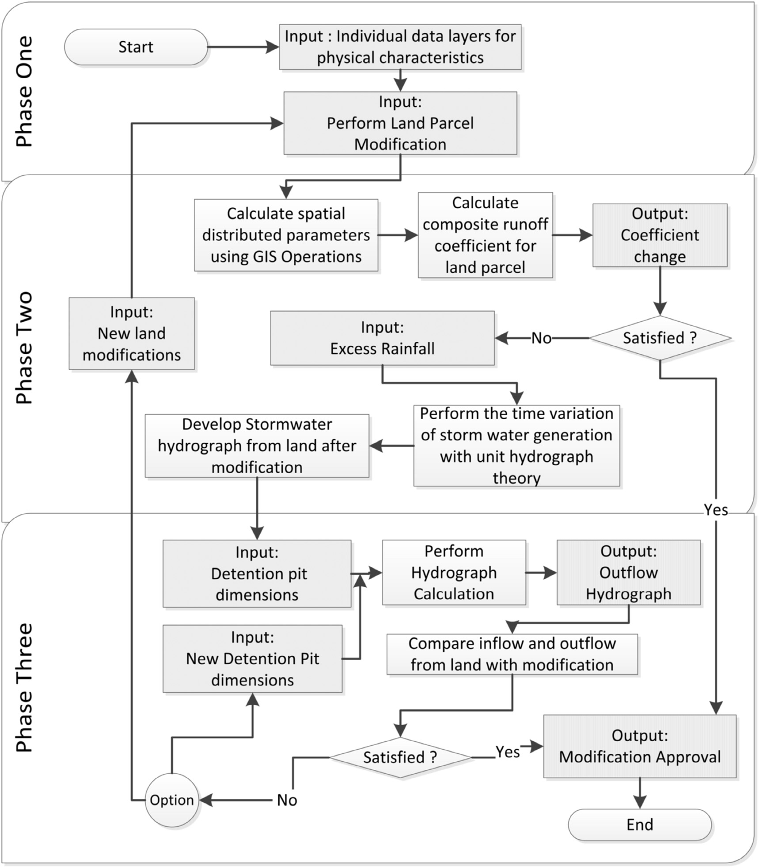

Fig. 1. The process of flood management decision making of the HydroGIS tool.

systematically accomplish the stakeholder aspirations by carrying out repeated evaluation of outputs against the objectives whilst the complex hydrologic calculations automate separately. This specific software development methodology is described in the previous work of the au-

granting approvals and they are mostly non-technical. System operators who perform a mandatory role by transferring information back and forth between the recipient stakeholder, regulators, decision makers, GIS experts, and hydrologic modelers making a variety of decisions are also

|  |  |
| --- | --- |
| thors [69]. | grouped with decision makers. Group 3 –The expert group consisting of hydrologic and GIS modelers are the technical stakeholders who imple- |

2.3. Stakeholder requirements

2.3.1. Key stakeholders

Key stakeholder groups were identified thorough Critical evaluation

of the main use case which is granting the approval for land modifica-

tions. It reveals that the stakeholders associated with urban flood man-

agement consist of four main groups; Group1 The recipient

–

stakeholders whose desire is to receive the land development approvals

are the individual land owners or real estate/construction agents. Group

2 –The decision making stakeholders are the policymakers and regulators

4

R.M.M. Pradeep, N.T.S. Wijesekera Array 8 (2020) 100037

requirements to the software developers. Therefore, in the present development, the key roles considered are those of the decision maker and the software developers.

2.3.2. Documented requirements   
 Identification of requirements affecting the stakeholders was first carried out by evaluating the state of art and then by performing a consultation of professionals for the confirmation and filling of gaps. Ramachandran [70] has urged to follow the best practices as those can produce high quality software products while securing stakeholder re-quirements and development costs. The system development methodol-ogy is a fundamental best practice. Since 1960s’ different methodologies are practiced, but today, the methods which are evolved to satisfy the user requirements are popular [71]. However, Shmueli and Ronen [72] warn the that greater attention on requirement development as it may

modifications, and competency to view and analysis extra spatial infor-mation by accessing base software whilst the tool is running were also requested by the non-technical decision makers. However, the decision makers as a critical concern cited the assurance of land information data security preventing unauthorized independent access to database and also preventing use of tool for unapproved alterations. System developers were concerned about the difficulty of achieving data security when using an off the shelf GIS platform for HydroGIS tool development.

System developers pointing to the challenge of achieving a user-friendly GIS map based hydro model without having structured guide-lines stressed the need to contribute towards better GIS-GUI development guidelines. The other key concern raised was the time constraint for modeler-developer interaction due to urgency for product development by adhering to independent development of the front end and the back end of tools. Developers highlighted the need for intensified stakeholder

negatively affect the system development project schedule, quality and interactions to achieve.

cost. Finally, the following six requirement classes have been identified

When considering the HydroGIS tool development, Sui and Maggio [73], review that the practice is either incorporation of GIS to hydrology model or vice-versa. However, Shamsi [74], recommends the hydro model to GIS software due to the modeling maturity of hydrology makes the use of technical maturity of GIS platforms.

When considering the information security requirements of the tool, the Department of Community Development of New Berlin city [75] has paid a special attention to security and integrity of spatial land data. It enhances the stakeholders’ confidence by protecting the urban land in-formation which are equally worth of urban lands. Further, Bertino et al. [76], who seek the research directions in spatial data security, state that the spatial data standards are important as it provides the interopera-bility whilst maintaining the privacy.

The design requirements of Decision Support Systems (DSS) are reasonably well documented. The study of Speier and Morris [77]; which is on decision making accuracy, mental workload and time consumption against the different user interfaces; reveals number of interface con-siderations when addressing problems with increased complexity in dy-namic environments. When Liang et al. [78], developed a land management system to Dingzhuang city of China, it has been ideintifed convenient and reversibility in operation, unanimity in interfaces and simple feedback are as the major design principles. C�azares-rodríguez el al. [79], show that the DSS should provide not only the solutions but also technical alternatives to develop stakeholders’ confidence.

Assaf et al. [34], whilst attempting to incorporate stakeholders for DSS system, found that the DSS should provide interactive graphical based stakeholder decision making facility. Singh and Kumar’s [80] re-view on the input data scale impacts on output found that the choice of spatial data, data resolution and efficiency of processes are depending on the stakeholders’ output requirements.

2.3.3. Professional view   
 A consultative survey to capture the aspirations of non-technical de-

from the literature review and stakeholder discussions were used as guidance for HydroGIS tool development. These requirement classes are: (1) Automated tool (2) Platform Selection/Suitable Base Software for the tool (3) Software Development (4) System Security (5) Dynamic Decision Making and (6) User Friendliness.

2.4. Stakeholder requirement integration

2.4.1. Automated tool and Platform Selection/Suitable Base Software for the tool   
 The present work selected GIS as the base software whilst the hy-drology model is embedded using codes due to the technological advancement of GIS software than hydrology modelling software. Then HydroGIS tool was developed as a Dynamic Link Library (DLL) extension to the off-the-shelf GIS software package, due to the flexibility to the users. ESRI’s ArcMap was selected as the base GIS software due to the higher popularity among communities. The details of the automation are described in author’s previous work [68].

2.4.2. Software development   
 The present work identified two main works whilst automation. One is the accurate automation of hydrology model with GIS and other is incorporating the user concerns sufficiently. Then a predictive develop-ment method was used as the core for the tool development however, whilst an adaptive development methodology with repetitive prototype development was utilized as a hybrid methodology for the present user interface development. In this effort, development works of both the user interface and the hydro & GIS model computational modules were simultaneously started by incorporating a combined modelling effort thus reflecting a development model which oriented a process centric development to achieve a user centric tool. The process is described in the previous work by the authors [69].

cision makers and GIS system developers on the development of a 2.4.3. System Security

HydroGIS tool for urban flood management was carried out with a sample of 31 non-technical decision makers and four GIS system developers.

The non-technical decision makers requested a software tool that can be installed with ease, enables trouble free data entry, capable of data manipulation without migrating to other tools, and facilitates a smooth execution of computations with a simple “Next-Next button click” pro-cess. Key requirements of the decision makers also included the need of a tool capable of easy map utilization for data handling, presentation, decision making and output map generation as hard copies. Specific re-quests were for the maps that enable easy understanding of land modi-fications, easy on screen map and attribute editing capability. Regarding hydrologic outputs, the stakeholder requirement was to receive easily understandable graphical results that could easily educate land owners. Trial and error capability to carry out a variety of alternative land

5

R.M.M. Pradeep, N.T.S. Wijesekera Array 8 (2020) 100037

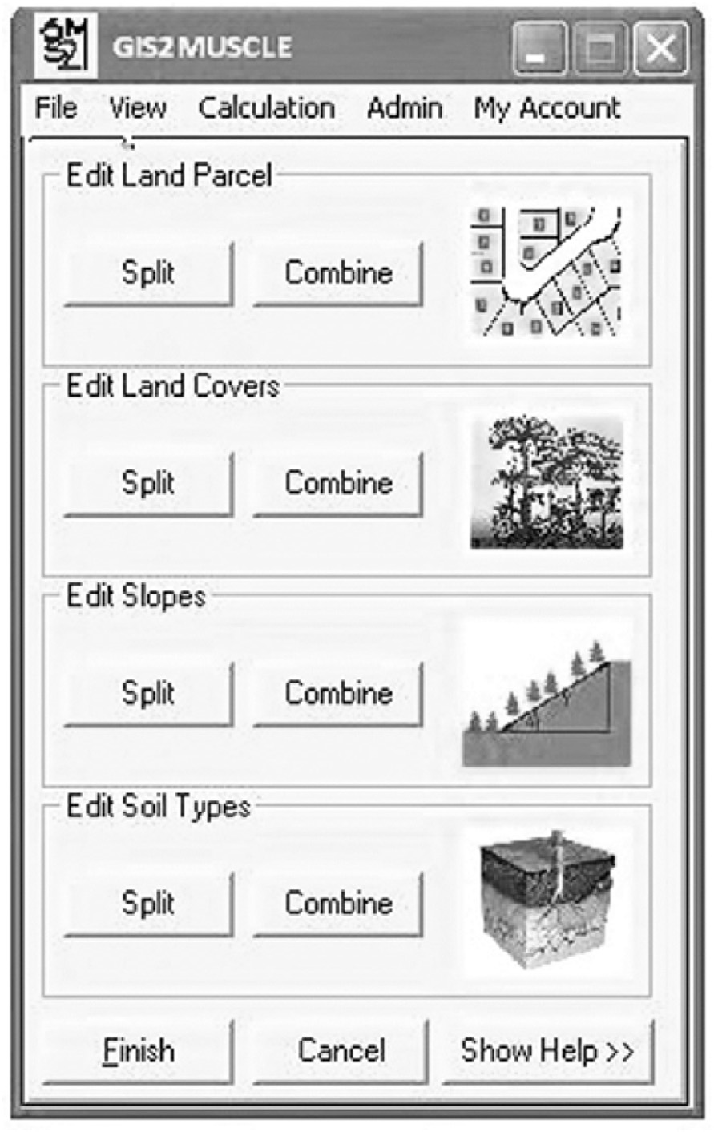

Fig. 2. Main GUI of the Tool, Note: The Figure shows a snapshot of on-screen parcel clipping action. Additionally, it shows three attribute update GUI parts which appear after on-screen map modifications.

satisfied through trial-and-error facility, the tool is developed with enabling the back and forth movement in process. Quick and repeated backward movements with undo facility provide the opportunity for a decision maker to rebound to an identified milestone. Further, the rapid dynamic decision making is always hindered by delays in feeding man-agement inputs. Therefore, the tool functionality presents default values/ suggestions that can be edited as necessary. Apart from that, as a measure to reduce incorrect executions either due to data or procedure errors, the tool design embedded a step wise requirement to obtain decision maker confirmation. Simultaneously, output presentations on map and cus-tomizable charts also intend to assist quick decision making whilst dy-namic decision making is made easy by enabling parallel use of tool and the base software for actions such as customizing and printing maps. This parallel access capability also enables the use of GIS software functions for spatial data manipulation while providing the users a feeling that the tool is a part of the familiar base software.

2.4.5. User friendliness   
 In the absence of guidelines to achieve user friendliness of GIS-GUI extension, a GIS-GUI development guideline has been developed (see authors’ previous work [82]). Then following such, the HydroGIS tool developed to carryout onscreen land modifications, to compare the executed land alterations, to easily add attributes and to perform sys-tematic confirmation of edits. Further, the tool designed to maximize map visualization by reducing the GUI window space. To enhance user confidence the tool has been further developed to display the modifica-tions on a map with customized print facility. To achieve user friendly easy operation, the tool designed to equipped with default data values

6

R.M.M. Pradeep, N.T.S. Wijesekera Array 8 (2020) 100037

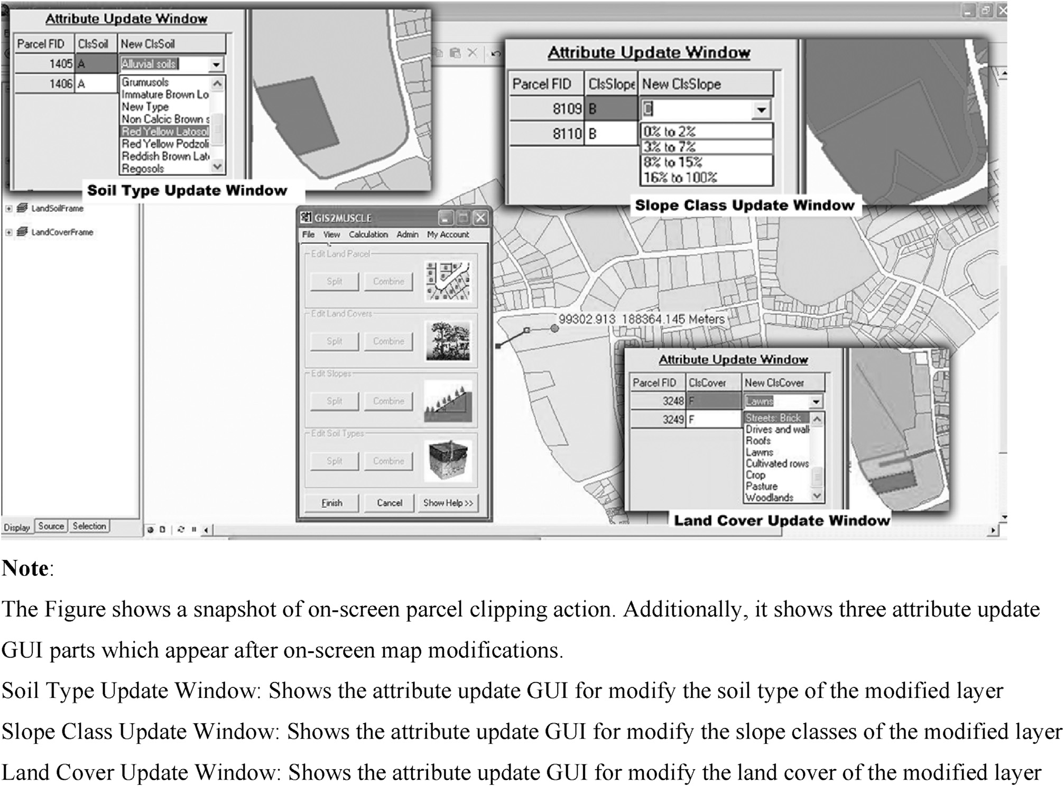

Fig. 3. On-screen dynamic map modification and attribute update GUIs of the Tool.

identification with automatic highlighting facility. Incorporation of these features raised the satisfaction level to 96%.

3.2.2. User friendliness   
 The final tool prior to stakeholder evaluation received a very low satisfaction rating of 46%. This evaluation resulted in requests for stan-dardized GUI sizes, user friendly control and text labels, pop-up help facility, facility to display progress of each GIS operation, feedback messages for modifications, and on screen printing capability. Incorpo-ration of these capabilities increased the tool satisfaction up to 65%. Stakeholder concerns were to incorporate error messages with recovery information, layer buttons with icons, maintenance of command button and text integrity, and small size GUI with more map layouts. Incorpo-ration of these improved the stakeholder satisfaction only up to 70%. Stakeholders expected the improvement of professional attire in maps, a size change of GUI during hydrograph manipulation, a user manual, vi-sual clarity and enhancement of hydrograph display. Once these were achieved the tool received a 92% satisfaction for user friendliness.

3.2.3. Incorporation of security

At the first evaluation, the tool lacked a security option, and hence the stakeholder satisfaction was 0%. The stakeholder sample also lacked suggestions. In the next development stage, many options were attemp-ted to secure the data from unauthorized manipulation. The option of physical access control through a lock and key arrangement in a stand-alone computer was incorporated. Stakeholders showed non-satisfaction with a 0% satisfaction. The development strategy of the tool was changed

7

R.M.M. Pradeep, N.T.S. Wijesekera Array 8 (2020) 100037

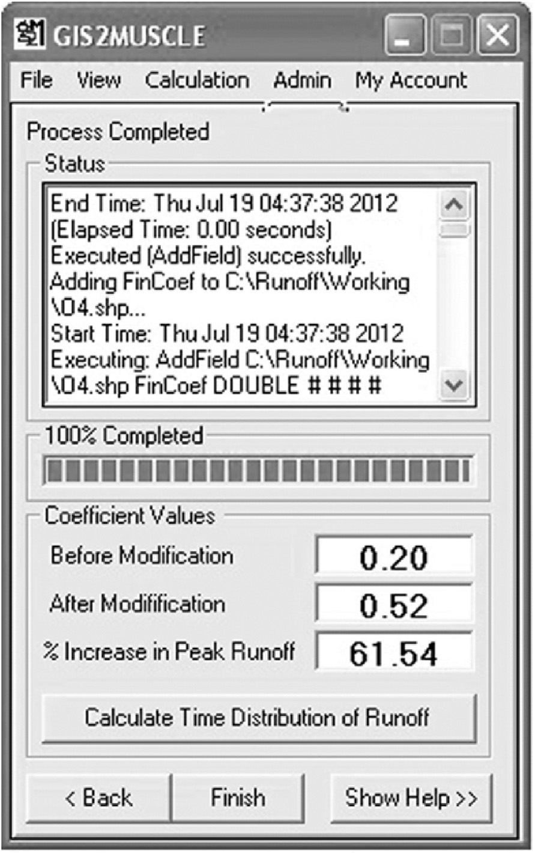

Fig. 4. GUI Showing land modification effect on runoff coefficients.

the tool received a stakeholder satisfaction of 58%. The stakeholders required dynamic map modifications with undo facility and the addition of this to the tool increased the satisfaction to 65%. However, the satis-faction level could be increased to 72% by adding the stakeholder re-quests to enable on screen dynamic changes to the hydrology parameter changes and manipulation of layer classification schema. At this stage of evaluation, a general request was for dynamic visualization of hydrologic results with the inclusion of a flood detention facility in the land parcel. These modifications enhanced the stakeholder satisfaction of the dy-namic nature of the tool up to 93%.

3.2.6. Stakeholder confidence   
 Stakeholder evaluations with the selected sample indicated an average overall satisfaction level of 92%, which can be considered as a very high achievement under the present setting of tools, methods and guidance material. Stakeholder confidence is always relative to the vis-ibility of present mechanisms and with respect to the time required for reliable outputs. The present HydroGIS demonstrated a vast improve-ment compared with the prevailing setup and highlighted the confir-mation of the success of developed tool using stakeholder based recognition of issues and evaluation of achievements. The present tool removed many decision making barriers to achieve the required services, accuracy and security. The present work demonstrates the need, possi-bility and method of incorporating the most essential stakeholder role when developing an urban flood mitigation decision tool.

through integrating the land development and flood management ac-tivities. Then development of such tool must strike a balance between the process automation and the achievement of stakeholder concerns & confidence. Another important consideration is the integration of hydro model and GIS software (HydroGIS) which are the most required com-ponents of urban land and flood management.

Among the hydro-GIS integration options, integration of hydro model into the GIS base software was selected since (1) GIS function automation requires complex coding and testing which becomes a laborious and time consuming task, (2) commercial or open source GIS platforms which are specially developed to perform GIS functions accurately and efficiently leads to better user confidence while saving tool development efforts and time and (3) availability of significant developer-community for GIS automation platforms. When considering the easy installation, the pre-sent work focused on the best architectural option as development of the HydroGIS tool to a Dynamic Link Library (DLL) extension in off-the-shelf GIS software package, ArcMap.

Bhathal and Singh [83] found that the available security products are insufficient to fulfill the unique stakeholder requirements in new IT paradigm like big-data management In the same way, there is a unique stakeholder concern which is to secure the author’s data-dictatorship in HydroGIS paradigm. In present setting, the intended spatial data of land allotments are managed by both local authorities and water management agencies. The possession of valuable urban land allotment boundaries, attributes and their security are not exclusively handled by a single agency, but simultaneously both need the ownership of the data. There are several spatial data security studies such as watermark, hash algo-rithms [84], GeoXACML [85] and Attribute Based Access Control [86], but those do not provide the required functionalities. Hence, a novel method was incorporated enabling the sharing of the dataset but recognizing any alterations made to data. The security concerns regarding the computations carried out by combining GIS functions also poses a challenge. The stakeholder expectation was to giving security related feedback whilst in the workflows rather than forensic analysis. Therefore, for the automation of processes, the option of developing codes that can be integrated to the security layer was chosen over the readily available Model Builder tool of ArcMap software.

In the absence of guidelines to achieve user friendliness of GIS-GUI, a novel guideline was developed following GNOME guideline of Benson et al. [87], European Union BEST-GIS guideline [88] and visual consis-tency guideline of Bloch [89]. It found that the fundamental rules of buttons, texts, icons, windows and feedback messages are common to HydroGIS tools too. However, to gain the maximum user friendliness, the HydroGIS tools should provide more attention to user interface of hy-drology calculations. Onscreen modification of parameter data, dynamic visual effect such as zoom in and out in hydrograph visualization and real-time result display on maps are few of them. Further, the work proved the successful application of the golden ratio for window sizes according to Gustav Fechner (stated by Stone and Collins) [90]. Even select a popular GIS base software to reduce the learning curves, it developed a user manual with tutorial to increase user friendliness as per Bloch’s [89] idea.

Overall, the dynamic nature of the tool gives the flexibility to tech-nical stakeholders to handle the hydrological parameter data such as runoff coefficient and designed rainfall values for local area whilst the non-technical stakeholders to perform calculations for required land parcels and customize flood management options align with hydrological requirements. Then these facilities ensure an active and lively environ-ment for the stakeholders to carry out the desired functionalities with less difficulties.

|  |  |
| --- | --- |
| 4. Discussion | 5. Conclusions |

Sustainable urban land development management is considered as the key to urban flood management. Such sustainability can be achieved

8

R.M.M. Pradeep, N.T.S. Wijesekera Array 8 (2020) 100037

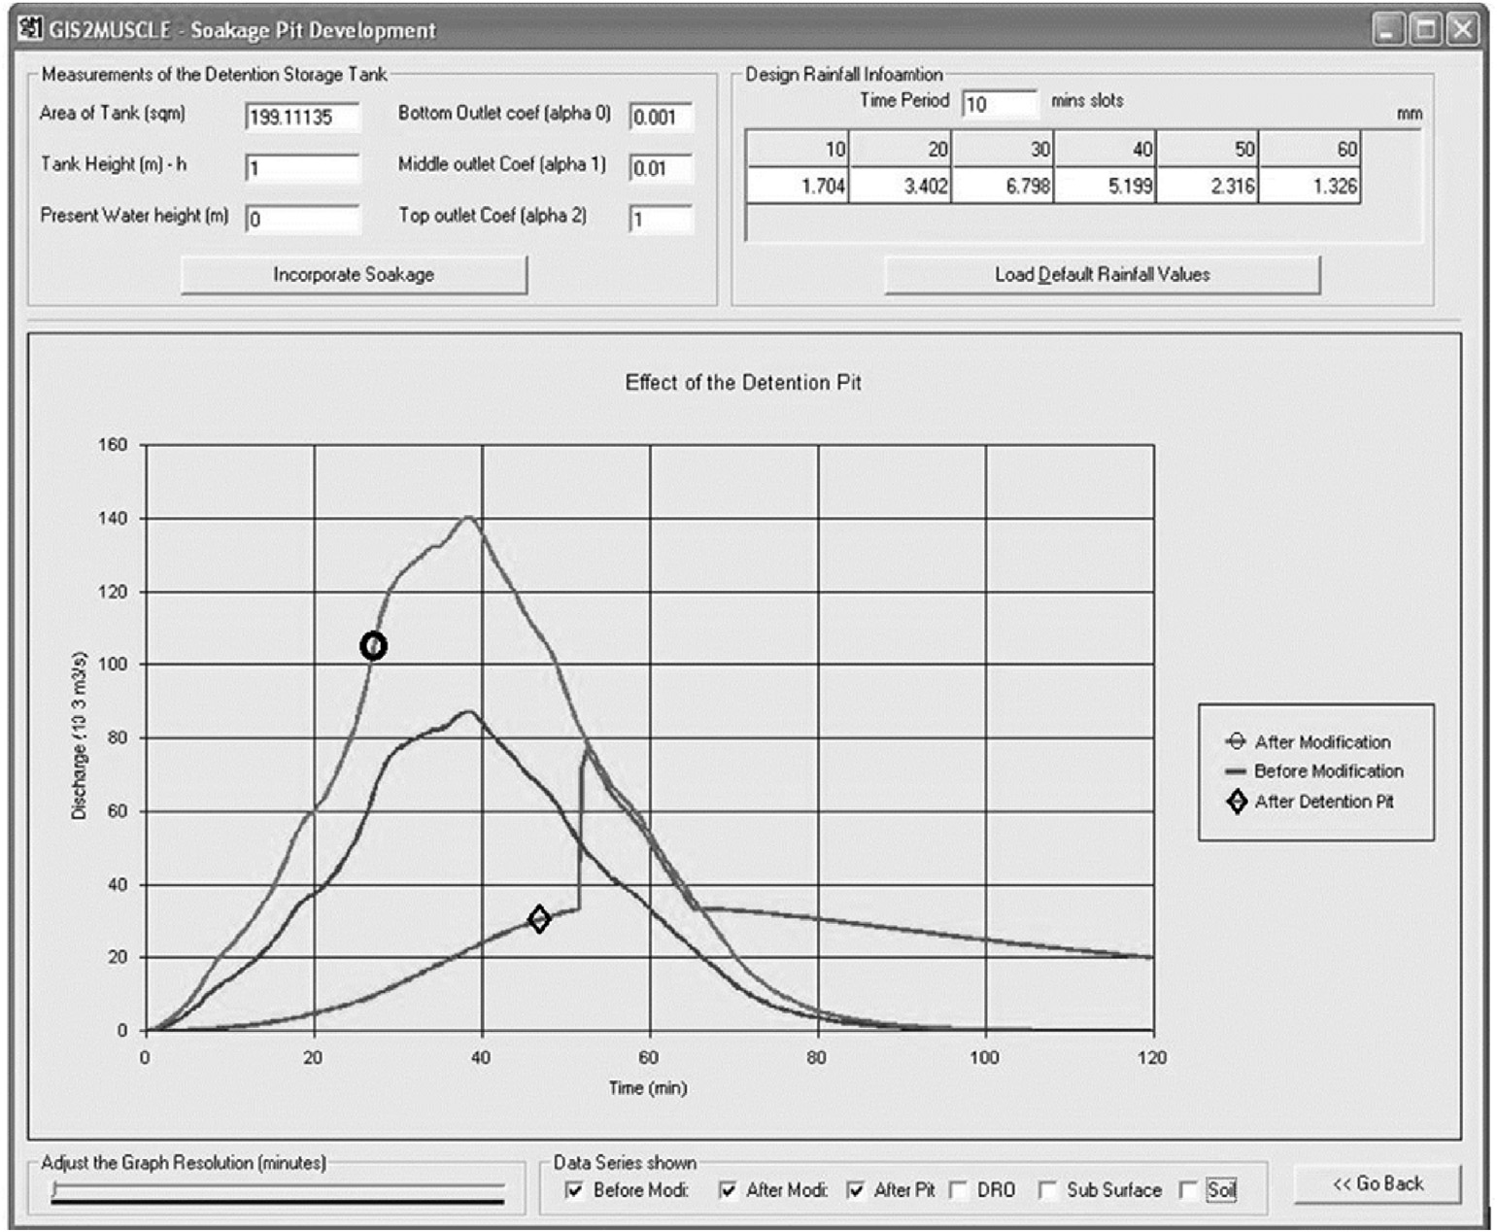

Fig. 5. GUI for visualization of storm water runoff before & after the land modifications and after incorporation of dynamic detention storage.

Table 1   
Tool evaluation results.

Further, the entire work has carried out a detailed study on; suitable hybrid software development methodology for stakeholder concerns incorporation [69], provide spatial data security for the scenario [81]

|  |  |  |  |  |  |
| --- | --- | --- | --- | --- | --- |
| Requirement | Evaluation cycle | |  |  | and GIS-GUI development guideline [82]. Then those proved that the |
|  | 1 | 2 | 3 | 4 | present work has carried out a substantial effort to fill the identified |

|  |  |  |  |  |
| --- | --- | --- | --- | --- |
| Development of Automated Tool | 72% | 77% | 78% | 96% |
| Achievement of User-friendliness | 46% | 65% | 70% | 92% |
| SW Development | Did not evaluated through users | | | 89% |
| Data and Output Security | 0% | 0% | 35% |
| Use of Appropriate Base Software | 65% | 72% | 76% | 93% |
| Dynamic Nature of the Tool | 58% | 65% | 72% | 93% |
| Average | 48% | 56% | 66% | 92% |

the key for successful HydroGIS development. The main stakeholder requirements of the HydroGIS tool were identified as, the development of an automated tool, selection of a suitable software platform, method of software development ensuring the incorporation of stakeholder aspira-tions, Data and System Security, Dynamic Decision Making capability and User Friendliness. More importantly, it incorporated the easy facil-itation of hydrologically as well as a stakeholder/decision maker agreed land development. Then present work could identify in-depth stake-holder concerns and successfully incorporated into the HydroGIS tool with the substantial satisfaction of the potential stakeholders.

The main contribution of the present work is a demonstration of how to identify, evaluate, incorporate and verify the stakeholders and their concerns which is lack of documentations for HydroGIS tool at present.

research gap.

Finally, the present work demonstrates the purport and the imple-mentation of a structured development approach and the way to verify the incorporation of urban flood management stakeholders’ needs with the scientific hydrology model.

Credit author statement

RMM Pradeep: Conceptualization, Methodology, Software, Valida-tion, Formal analysis, Investigation, Data curation, Writing - original draft, Visualization, Funding acquisition, NTS Wijesekera: Conceptuali-zation, Methodology, Resources, Writing - review & editing, Supervision, Project administration.

Declaration of competing interest

No potential conflict of interest was reported by the authors. This research did not receive any specific grant from funding agencies in the public, commercial, or not-for-profit sectors.

|  |  |
| --- | --- |
| Whilst the other works paying attention to stakeholders concern on output, the present work reveals that input, process and output re- | References |

quirements also to be automated for easy decision making. Those are practically implemented in the developed tool through providing in-terfaces to technical and non-technical stakeholders to evaluate, adjust, redo/undo and visualize hydro and GIS inputs, processes and outputs.

9

R.M.M. Pradeep, N.T.S. Wijesekera Array 8 (2020) 100037

[3] Hellmers S, Manojlovic N, Palmaricciotti G, Fr€ohle P. Modelling decentralised systems for urban drainage and flood mitigation. Journal of Applied Water Engineering and Research 2017;5(1):61–9. [https://doi.org/10.1080/ 23249676.2015.1128368](https://doi.org/10.1080/23249676.2015.1128368).

[4] Carver S. “Flood management and nature– can rewilding help? ECOS: A Rev Conserv 2016;37(1):32[–](https://www.ecos.org.uk/wp-content/uploads/2016/05/ECOS-37-1-32-Flood-management-and-nature.pdf)42. British Association of Nature Conservationists, [https: //www.ecos.org.uk/wp-content/uploads/2016/05/ECOS-37-1-32-Flood-manage](https://www.ecos.org.uk/wp-content/uploads/2016/05/ECOS-37-1-32-Flood-management-and-nature.pdf)

[30] Ogden FL, Garbrecht J, Debarry PA, Johnson LE. GIS and distributed watershed models. II: modules, interfaces and models. J Hydrol Eng 2001;6(6):515–23. <https://doi.org/10.1061/(ASCE)1084-0699(2001)6:6(515)>.

[31] Thakur JK, Singh SK, Ekanthalu VS. Integrating remote sensing, geographic information systems and global positioning system techniques with hydrological modeling. Appl. Water Sci. 2017;7(4):1595–608. <https://doi.org/10.1007/s13201-016-0384-5>.

[ment-and-nature.pdf](https://www.ecos.org.uk/wp-content/uploads/2016/05/ECOS-37-1-32-Flood-management-and-nature.pdf). [32] [Kovar K, Nachtnebel HP, editors. HydroGIS93: application of geographic](http://refhub.elsevier.com/S2590-0056(20)30022-9/sref32)

[5] Konrad CP. Effects of urban development on floods: USGS fact sheet FS-076-03. U.S.

[6] Xia J, Falconer RA, Lin B, Tan G. Modelling flash flood risk in urban areas. Water Geol. Surv.; 2003. p. 1–4. <https://pubs.usgs.gov/fs/fs07603/>.

[7] Jha AK, Bloch R, Lamond J. Cities and flooding: a guide to integrated urban flood Manag 2011;164(WM6):267–82. <https://doi.org/10.1680/wama.2011.164.6.267>.

risk management for the 21st century. Washington DC: World Bank; 2012. [http://h dl.handle.net/10986/2241](http://hdl.handle.net/10986/2241).

[8] Hammond OMMJ, Chen AS, Djordjevi�c S, D. B.. Urban flood impact assessment: a state-of-the-art. Urban Water J 2013;12(1):14[–](http://hdl.handle.net/10871/14066)29. [https://doi.org/10.1080/ 1573062X.2013.857421](https://doi.org/10.1080/1573062X.2013.857421). <http://hdl.handle.net/10871/14066>.

[9] Pregnolato M, Ford A, Wilkinson SM, Dawson RJ. The impact of flooding on road transport : a depth-disruption function. Transp. Res. Part 2017;55:67[–](https://www.sciencedirect.com/science/article/pii/S1361920916308367)81. [https:// doi.org/10.1016/j.trd.2017.06.020](https://doi.org/10.1016/j.trd.2017.06.020). [https://www.sciencedirect.com/science/artic le/pii/S1361920916308367](https://www.sciencedirect.com/science/article/pii/S1361920916308367).

[10] Elmoustafa AM. Weighted normalized risk factor for floods risk assessment. Ain Shams Eng. J. 2012;3:327[–](https://www.sciencedirect.com/science/article/pii/S2090447912000251)32. <https://doi.org/10.1016/j.asej.2012.04.001>. <https://www.sciencedirect.com/science/article/pii/S2090447912000251>.

[11] Gunaruwan TL. “Economics of flood damage prevention investment in Colombo metro Area : strategic perspectives explored through a viability threshold analysis.

In the 5th international Conference of SLFUE: Sri Lanka economics research conference.

[-Flood-Damage-Prevention-Investment-in-Gunaruwan/b1a7efd873538c61f8fae6f](http://www.semanticscholar.org/paper/Economics-of-Flood-Damage-Prevention-Investment-in-Gunaruwan/b1a7efd873538c61f8fae6f9dfb70f26ab92e4bc) SLERC) Volume V; 2016. p. 250[–](http://www.semanticscholar.org/paper/Economics-of-Flood-Damage-Prevention-Investment-in-Gunaruwan/b1a7efd873538c61f8fae6f9dfb70f26ab92e4bc)5. [www.semanticscholar.org/paper/Economics-of 9dfb70f26ab92e4bc](http://www.semanticscholar.org/paper/Economics-of-Flood-Damage-Prevention-Investment-in-Gunaruwan/b1a7efd873538c61f8fae6f9dfb70f26ab92e4bc).

[12] Huizinga J, De Moel H, Szewczyk W. Global flood depth-damage functions.

Methodology and the database with guidelines. EUR 28552. Luxembourg:   
Publications Office of the European Union; 2017. [https://ec.europa.eu/jrc/en/publi cation/global-f](https://ec.europa.eu/jrc/en/publication/global-flood-depth-damage-functions-methodology-and-database-guidelines)l[ood-depth-damage-functions-methodology-and-database-guideline s](https://ec.europa.eu/jrc/en/publication/global-flood-depth-damage-functions-methodology-and-database-guidelines).

[13] World Bank. High and dry: climate change, water, and the economy. Washington, DC: International Bank for Reconstruction and Development/The World Bank;

[information systems in hydrology and water resources management (proceedings of the Vienna conference, April 1993). Vienna: IAHS; 1993](http://refhub.elsevier.com/S2590-0056(20)30022-9/sref32).

[33] Pradeep RMM, Wijesekera NTS. Urban flash flood mitigation using a dynamic HydroGIS Tool. In: GeoConf 2014. Colombo: CRD; 2014. [https://doi.org/ 10.13140/RG.2.2.21437.56800](https://doi.org/10.13140/RG.2.2.21437.56800).

[34] Assaf H, et al. “Generic simulation models for facilitating stakeholder involvement in water resources planning and Management : a comparison , evaluation , and identification of future needs. In: Jakeman AJ, Voinov AA, Rizzoli AE, Chen SH, editors. In Developments in integrated environmental assessment, elsevier, vol. 3. Elsevier B.V.; 2008. p. 229–46. [https://www.sciencedirect.com/science/article/ pii/S1574101X08006133](https://www.sciencedirect.com/science/article/pii/S1574101X08006133).

[35] S€orensen J, et al. Re-thinking urban flood management-time for a regime shift. Water 2016;8(332):1[–](https://www.mdpi.com/2073-4441/8/8/332)15. <https://doi.org/10.3390/w8080332>. [https://www .mdpi.com/2073-4441/8/8/332](https://www.mdpi.com/2073-4441/8/8/332).

[36] Gray S, Paolisso M, Jordan R, Gray S, editors. Environmental modeling with stakeholders: theory, methods, and applications. Springer; 2017. [https://www.sp ringer.com/gp/book/9783319250519](https://www.springer.com/gp/book/9783319250519).

[37] Scott M, Edwards S, Rahall NJI, Nguyen T, Cragle J. GIS story maps: a tool to empower and engage stakeholders in planning sustainable places, vol. 25701. [”](http://udspace.udel.edu/handle/19716/21597)Newark, DE/Huntington, WV; 2016. [http://udspace.udel.edu/handle/19716/2159 7](http://udspace.udel.edu/handle/19716/21597).

[38] Han MY, Chen GQ, Dunford M. Land use balance for urban economy: a multi-scale and multi-type perspective. Land Use Pol 2019;83(March 2018):323[–](https://www.sciencedirect.com/science/article/abs/pii/S0264837718304022)33. [https:// doi.org/10.1016/j.landusepol.2019.01.020](https://doi.org/10.1016/j.landusepol.2019.01.020). [https://www.sciencedirect.com/scienc e/article/abs/pii/S0264837718304022](https://www.sciencedirect.com/science/article/abs/pii/S0264837718304022).

[39] Struyk RJ, Angelici K. The Russian dacha phenomenon. Hous Stud 1996;11(2):

[40] Bacco M, Barsocchi P, Ferro E, Gotta A, Ruggeri M. The digitisation of agriculture: a 233–50. <https://doi.org/10.1080/02673039608720854>.

survey of research activities on Smart Farming. Array 2019;3(4):100009. [https:// doi.org/10.1016/j.array.2019.100009](https://doi.org/10.1016/j.array.2019.100009). [https://www.sciencedirect.com/science/](https://www.sciencedirect.com/science/article/pii/S2590005619300098)

2016. [openknowledge.worldbank.org/handle/10986/23665](http://openknowledge.worldbank.org/handle/10986/23665). [article/pii/S2590005619300098](https://www.sciencedirect.com/science/article/pii/S2590005619300098).

[14] Zhou Q. A review of sustainable urban drainage systems considering the climate change and urbanization impacts. Water 2014;6(4):976[–](https://www.mdpi.com/2073-4441/6/4/976)92. [https://doi.org/ 10.3390/w6040976](https://doi.org/10.3390/w6040976). <https://www.mdpi.com/2073-4441/6/4/976>.

[15] Leopold L. Hydrology for urban land planning - a guidebook on the hydrologic effects of urban land use, vol. 554. Washington, D.C.: U.S. Geological Survey; 1968. <https://pubs.er.usgs.gov/publication/cir554>.

[16] Mcpherson MB, Schneider WJ. [“](https://doi.org/10.1029/WR010i003p00434)Problems in modeling urban watershed. Water resour Res 1974;10(3). <https://doi.org/10.1029/WR010i003p00434>.

[17] O Chan S, Bras RL. Urban storm water management: distribution of flood volumes. Water Resour Res 1979;15(2):371–82. [https://doi.org/10.1029/ WR015i002p00371](https://doi.org/10.1029/WR015i002p00371).

[18] Jacques WD, Stergios AD, McPherson MB. “Modeling the runoff process in urban areas,[”](https://doi.org/10.1080/10643388009381676) C R C. Crit Rev Environ Contr 1980;10(1):1–64. [https://doi.org/10.1080/ 10643388009381676](https://doi.org/10.1080/10643388009381676).

[41] Micropact Inc.. Land records management solutions. Texas: Court Mana. Tyler Technologies; 2019. [https://empower.tylertech.com/rs/015-NUU-525/images/Dat asheet_entellitrak_Land-Records-Management_1119.pdf](https://empower.tylertech.com/rs/015-NUU-525/images/Datasheet_entellitrak_Land-Records-Management_1119.pdf).

[42] Accela. Accela land management. California: Accela Inc; 2016. [https://accela.com](https://accela.com/images/resources/brochures/accela-land-overview.pdf)  [/images/resources/brochures/accela-land-overview.pdf](https://accela.com/images/resources/brochures/accela-land-overview.pdf).

[43] [Jain SK, Singh G, Gore MM. “Municipal GIS design and implementation of LRS](http://refhub.elsevier.com/S2590-0056(20)30022-9/sref43) – [a case study. in Map India Conference; 2003](http://refhub.elsevier.com/S2590-0056(20)30022-9/sref43).

[44] [General Code. Municity : parcel management software. 2014. New York](http://refhub.elsevier.com/S2590-0056(20)30022-9/sref44).

[45] Bhatt G, Kumar M, Duffy CJ. A tightly coupled GIS and distributed hydrologic modeling framework. Environ Model Software 2014;62:1[–](https://www.sciencedirect.com/science/article/abs/pii/S1364815214002266)15. [https://doi.org/ 10.1016/j.envsoft.2014.08.003](https://doi.org/10.1016/j.envsoft.2014.08.003). [https://www.sciencedirect.com/science/artic le/abs/pii/S1364815214002266](https://www.sciencedirect.com/science/article/abs/pii/S1364815214002266).

[46] Eslinger DL, Carter HJ, Pendleton M, Burkhalter S, Allen M. OpenNSPECT. 2012 [Online]. Available: <https://coast.noaa.gov/digitalcoast/tools/opennspect>.

[19] Maidment DR, Parzen E. Cascade model of monthly municipal water use. Water [Accessed 20 June 2018].

[20] Te Chow V, Maidment DR, Mays LW. Applied hydrology, internatio. McGraw-Hill; Resour Res 1984;20(1):15–23. <https://doi.org/10.1029/WR020i001p00015>.

1988. <http://ponce.sdsu.edu/Applied_Hydrology_Chow_1988.pdf>.

[21] Smart P, Herbertson G. Drainage design. first ed. New York: Springer Scienceþ Business Media; 1992. <https://www.springer.com/gp/book/9781475750294>.

[22] [Shaw EM. Hydrology in practice. third ed. Taylor](http://refhub.elsevier.com/S2590-0056(20)30022-9/sref22) & [Francis e-Library; 1994](http://refhub.elsevier.com/S2590-0056(20)30022-9/sref22). [23] Djokic D, Maidment DR. Terrain analysis for urban stormwater modelling. Hydrol

[24] Mitchell VG, Mein RG, McMahon TA. Modelling the urban water cycle. Environ Process 1991;5(1):115–24. <https://doi.org/10.1002/hyp.3360050109>.

Model Software 2001;16(7):615[–](https://www.sciencedirect.com/science/article/abs/pii/S1364815201000299)29. [https://doi.org/10.1016/S1364-8152(01) 00029-9](https://doi.org/10.1016/S1364-8152(01)00029-9). [https://www.sciencedirect.com/science/article/abs/pii/S1364815 201000299](https://www.sciencedirect.com/science/article/abs/pii/S1364815201000299).

[25] Makarigakis AK, Jimenez-Cisneros BE. [“](https://doi.org/10.3390/w11020388)UNESCO[’](https://doi.org/10.3390/w11020388)s contribution to face global water challenges. Water 2019;11(2). <https://doi.org/10.3390/w11020388>. [https://](https://www.mdpi.com/2073-4441/11/2/388/pdf)  [www.mdpi.com/2073-4441/11/2/388/pdf](https://www.mdpi.com/2073-4441/11/2/388/pdf).

[26] Ficchì A, Perrin C, Andr�eassian V. Impact of temporal resolution of inputs on hydrological model performance: an analysis based on 2400 flood events. J Hydrol 2016:454[–](https://www.sciencedirect.com/science/article/abs/pii/S0022169416301974)70. <https://doi.org/10.1016/j.jhydrol.2016.04.016>. [https://www.scienc edirect.com/science/article/abs/pii/S0022169416301974](https://www.sciencedirect.com/science/article/abs/pii/S0022169416301974).

[27] Ichiba A, et al. Scale effect challenges in urban hydrology highlighted with a distributed hydrological model. Hydrol Earth Syst Sci 2018;22:331[–](https://hess.copernicus.org/articles/22/331/2018/)50. [https:// doi.org/10.5194/hess-22-331-2018](https://doi.org/10.5194/hess-22-331-2018). [https://hess.copernicus.org/articles/22/331/](https://hess.copernicus.org/articles/22/331/2018/)

[47] [Innovyze Inc.. InfoWorks ICM suite. 2020](http://refhub.elsevier.com/S2590-0056(20)30022-9/sref47).

[48] Al-Sabhan W, Mulligan M, Blackburn GA. A real - time hydrological model for flood prediction using GIS and the WWW. Comput Environ Urban Syst 2003;27:9[–](https://www.sciencedirect.com/science/article/pii/S0198971501000102)32. <https://doi.org/10.1016/S0198-9715(01)00010-2>. [https://www.sciencedirect.co m/science/article/pii/S0198971501000102](https://www.sciencedirect.com/science/article/pii/S0198971501000102).

[49] Worku T, Khare D, Tripathi SK. “Modeling runoff–sediment response to land use/ land cover changes using integrated GIS and SWAT model in the Beressa watershed.

[3](https://doi.org/10.1007/s12665-017-6883-3). Environ. Earth Sci. 2017;76:550 1–14. https://doi.org/10.1007/s12665-017-6883-[50] Zhan X, Huang ML. ArcCN-Runoff: an ArcGIS tool for generating curve number and runoff maps. Environ Model Software 2004;19(10):875[–](https://pubs.er.usgs.gov/publication/70026763)9. [https://doi.org/ 10.1016/j.envsoft.2004.03.001](https://doi.org/10.1016/j.envsoft.2004.03.001). <https://pubs.er.usgs.gov/publication/70026763>.

[51] Sanzana P, et al. A GIS-based urban and peri-urban landscape representation toolbox for hydrological distributed modeling. Environ Model Software 2017; 91(May):168[–](https://www.sciencedirect.com/science/article/abs/pii/S1364815216305679)85. <https://doi.org/10.1016/j.envsoft.2017.01.022>. [https://www.sci encedirect.com/science/article/abs/pii/S1364815216305679](https://www.sciencedirect.com/science/article/abs/pii/S1364815216305679).

[52] [NOAA Inc.. ISAT : impervious surface analysis tool. NOAA Off](http://refhub.elsevier.com/S2590-0056(20)30022-9/sref52)i[ce for Coastal](http://refhub.elsevier.com/S2590-0056(20)30022-9/sref52)  [Management; 2017](http://refhub.elsevier.com/S2590-0056(20)30022-9/sref52).

[53] [Miah MG, Islam MR. “Use of GIS and RS in agriculture of Bangladesh : present status and prospect. In: Proceedings of international workshop on advanced use of satellite- and geo-information for agricultural and environmental intelligence; 2011](http://refhub.elsevier.com/S2590-0056(20)30022-9/sref53).

[2018/](https://hess.copernicus.org/articles/22/331/2018/). [54] Kitchenham B, Charters S. Guidelines for performing systematic literature reviews

[28] Eger CG, Chandler DG, Driscoll CT. Hydrologic processes that govern stormwater infrastructure behaviour. Hydrol Process 2017;31(25):4492–506. [https://doi.org/ 10.1002/hyp.11353](https://doi.org/10.1002/hyp.11353).

[29] Fatichi S, et al. An overview of current applications , challenges , and future trends in distributed process-based models in hydrology. J Hydrol 2016;537:45[–](https://www.sciencedirect.com/science/article/abs/pii/S0022169416301317)60. <https://doi.org/10.1016/j.jhydrol.2016.03.026>. [https://www.sciencedirect.c om/science/article/abs/pii/S0022169416301317](https://www.sciencedirect.com/science/article/abs/pii/S0022169416301317).

10

R.M.M. Pradeep, N.T.S. Wijesekera Array 8 (2020) 100037

[57] [Pingale S, Jat MK, Khare D. Integration of GIS in environmental modelling and hydrological Analysis : a review of integration technologies. In: National conference on infrastructure development in civil engineeringin civil engineering; 2012](http://refhub.elsevier.com/S2590-0056(20)30022-9/sref57).

[58] Henriksen HJ, Refsgaard JC, Hojberg AL, Ferrand N, Gijsbers P, Scholten H.

Harmonised principles for public participation in quality assurance of integrated water resources modelling. Water Resour Manag 2009;23(12):2539–54. [https:// doi.org/10.1007/s11269-008-9395-9](https://doi.org/10.1007/s11269-008-9395-9).

[59] Voinov A, et al. Modelling with stakeholders - next generation. Environ Model Software 2016;77(January):196[–](https://www.sciencedirect.com/science/article/abs/pii/S1364815215301055)220. [https://doi.org/10.1016/ j.envsoft.2015.11.016](https://doi.org/10.1016/j.envsoft.2015.11.016). [https://www.sciencedirect.com/science/article/abs/pii /S1364815215301055](https://www.sciencedirect.com/science/article/abs/pii/S1364815215301055).

[60] [Leskens JG, Brugnach M, Hoekstra A. How do interactive f](http://refhub.elsevier.com/S2590-0056(20)30022-9/sref60)l[ood simulation models](http://refhub.elsevier.com/S2590-0056(20)30022-9/sref60)  [inf](http://refhub.elsevier.com/S2590-0056(20)30022-9/sref60)l[uence decision-making? an observations-based evaluation method. Water; 2019](http://refhub.elsevier.com/S2590-0056(20)30022-9/sref60). [61] Jessel B, Jacobs J. Land use scenario development and stakeholder involvement as tools for watershed management within the Havel River Basin. Limnol. Elsevier [www.sciencedirect.com/science/article/pii/S0075951105000460](https://www.sciencedirect.com/science/article/pii/S0075951105000460). 2005;35(3):220[–](https://www.sciencedirect.com/science/article/pii/S0075951105000460)33. <https://doi.org/10.1016/j.limno.2005.06.006>. [https://](https://www.sciencedirect.com/science/article/pii/S0075951105000460) [62] Macchione F, Costabile P, Costanzo C, De Santis R. Moving to 3-D flood hazard maps for enhancing risk communication. Environ. Model. Softw., no. January 2019: 510[–](https://www.sciencedirect.com/science/article/abs/pii/S1364815218300690)22. <https://doi.org/10.1016/j.envsoft.2018.11.005>. [https://www.sciencedir ect.com/science/article/abs/pii/S1364815218300690](https://www.sciencedirect.com/science/article/abs/pii/S1364815218300690).

[63] Van Ackere S, Glas H, Beullens J, Deruyter G, De Wulf A, De Maeyer P.

Development of a 3D dynamic flood WEB GIS visualisation tool. Int. J. Saf. Secur.

[://www.witpress.com/elibrary/sse-volumes/6/3/1350](https://www.witpress.com/elibrary/sse-volumes/6/3/1350). Eng. 2016;6(3):560[–](https://www.witpress.com/elibrary/sse-volumes/6/3/1350)9. <https://doi.org/10.2495/SAFE-V6-N3-560-569>. https [64] Leskens JG, Kehl Christian, Tutenel Tim, Kol Timothy, Haan Gerwin de,   
 Stelling Guus, et al. An interactive simulation and visualization tool for flood analysis useable for practitioners. Mitig Adapt Strategies Glob Change 2017;22(2):

[65] Luke A, Sanders BF, Goodrich KA, Feldman DL, Boudreau D, Eguiarte A, et al. Going 307–24. <https://doi.org/10.1007/s11027-015-9651-2>.

beyond the flood insurance rate map: insights from flood hazard map co-production. Nat Hazards Earth Syst Sci 2018;18(4):1097[–](https://escholarship.org/uc/item/30z7z36p)120. [https://doi.org/ 10.5194/nhess-18-1097-2018](https://doi.org/10.5194/nhess-18-1097-2018). <https://escholarship.org/uc/item/30z7z36p>.

[66] Otero C. Software engineering design: theory and practice. first ed. New York: CRC Press; 2016. <https://www.taylorfrancis.com/books/e/9780429100376>.

[74] Shamsi UM. GIS and water resources modeling :state-of-the-art. J. Water Manag. Model. 1999. <https://doi.org/10.14796/JWMM.R204-05>. [https://www.chijournal. org/Content/Files/R204-05.pdf](https://www.chijournal.org/Content/Files/R204-05.pdf).

[75] DCD. Enterprise geographic & land information systems: plans, policies and procedures. City of New Berlin Department of Community Development; 2007. New Berlin, Wisconsin,   
 <https://www.newberlin.org/DocumentCenter/View/113/GIS-Policy?bidId=>. [76] Bertino E, Gertz M, Thuraisingham B, Damiani ML. Security and privacy for geospatial Data : concepts and research directions. In: ACM SPRINGLWorkshop.

[77] Speier C, Morris MG. The influence of query interface design on decision-making ACM; 2008. p. 6–19. <https://doi.org/10.1145/1503402.1503406>.

performance. MIS Q 2003;27(3):397[–](https://www.jstor.org/stable/30036539)423. <https://doi.org/10.2307/30036539>. <https://www.jstor.org/stable/30036539>.

[78] Liang Y, Sun W, Diao H, Li Y. The design and development of the land management system in Dingzhuang town based on spatial data, comput. Comput. Technol. Agric. IV. CCTA 2010. IFIP Adv Inf Commun Technol 2010;346:57–65. [https://doi.org/ 10.1007/978-3-642-18354-6_9](https://doi.org/10.1007/978-3-642-18354-6_9).

[79] C�azares-rodríguez JE, Vivoni ER, Mascaro G. Comparison of two watershed models for addressing stakeholder flood mitigation Strategies : case study of hurricane alex in monterrey , m�exico. J Hydrol Eng 2017;22(9):1–16. [https://doi.org/10.1061/ (ASCE)HE.1943-5584.0001560](https://doi.org/10.1061/(ASCE)HE.1943-5584.0001560).

[80] Singh G, Kumar E. Input data scale impacts on modeling output results : a review.

J Spatial Hydrol 2017;13(1). [https://www.researchgate.net/prof](https://www.researchgate.net/profile/Gurdeep_Singh22/publication/321759023_Input_data_scale_impacts_on_modeling_output_results_A_review/links/5a30b748a6fdccbf7ef154da/Input-data-scale-impacts-on-modeling-output-results-A-review.pdf)i[le/Gurdeep_Sin gh22/publication/321759023_Input_data_scale_impacts_on_modeling_output_res ults_A_review/links/5a30b748a6fdccbf7ef154da/Input-data-scale-impacts-on-modeling-output-results-A-review.pdf](https://www.researchgate.net/profile/Gurdeep_Singh22/publication/321759023_Input_data_scale_impacts_on_modeling_output_results_A_review/links/5a30b748a6fdccbf7ef154da/Input-data-scale-impacts-on-modeling-output-results-A-review.pdf).

[81] Pradeep RMM, Wijesekera NTS. Development of security stamp for desktop spatial data modification in unrestricted access platform. In: In 8th intrernational research conference. Ratmalana: KDU; 2015. <http://ir.kdu.ac.lk/handle/345/1057>.

[82] Pradeep RMM, Wijesekera NTS. Modification of user friendliness in to a HydroGIS tool. In: 8th intrernational research conference. Ratmalana: KDU; 2015. [http:// ir.kdu.ac.lk/handle/345/1138](http://ir.kdu.ac.lk/handle/345/1138).

[83] Bhathal GS, Singh A. Big Data: hadoop framework vulnerabilities, security issues and attacks. Array 2019;1[–](https://www.sciencedirect.com/science/article/pii/S2590005619300025)2:100002. [https://doi.org/10.1016/ j.array.2019.100002](https://doi.org/10.1016/j.array.2019.100002). [https://www.sciencedirect.com/science/article/pii/S25](https://www.sciencedirect.com/science/article/pii/S2590005619300025)

[67] Pradeep RMM, Wijesekera NTS. Development of a GIS tool to capture changing land [90005619300025](https://www.sciencedirect.com/science/article/pii/S2590005619300025).

allotment parameters for urban runoff computation. In: 16th ERU symposium, 2010. Moratuwa: ERU, UoM; 2010. <http://dl.lib.mrt.ac.lk/handle/123/8191>. [68] Pradeep RMM, Wijesekera NTS. GIS tool to mitigate urban flash floods through capturing land allotment modifications and incorporating conceptual detention pit.

In: ITRU 2012. Moratuwa: ITRU, UoM; 2012. [http://dl.lib.mrt.ac.lk/handle](http://dl.lib.mrt.ac.lk/handle/123/9792)

[84] Li A, Lin B, Chen Y, Lü G. Study on copyright authentication of GIS vector data based on zero-watermarking. Int Arch Photogram Rem Sens Spatial Inf Sci 2008; XXXVII(B4):1783[–](https://pdfs.semanticscholar.org/54d3/69f51b837eac9dfc7df65e0aaa4a38084051.pdf)6. [https://pdfs.semanticscholar.org/54d3/69f51b837ea c9dfc7df65e0aaa4a38084051.pdf](https://pdfs.semanticscholar.org/54d3/69f51b837eac9dfc7df65e0aaa4a38084051.pdf).

[85] Le Thi KT, Thi QNT, Dang TK. An enhanced access control model for gis database

[/123/9792](http://dl.lib.mrt.ac.lk/handle/123/9792). security. Electr. Electron. Eng. Comput. Inf. Eng. 2014;3(1):40.

[69] Pradeep RMM, Wijesekera NTS. Predictive cum adaptive systems development methodology for HydroGIS tool development. In: 10th international research conference. Ratmalana: KDU; 2017. <http://ir.kdu.ac.lk/handle/345/1682>.

[70] Ramachandran M. Guidelines based software engineering for developing software components. J Software Eng Appl 2012;5:1[–](https://www.scirp.org/pdf/JSEA20120100005_95712632.pdf)6. [https://doi.org/10.4236/ jsea.2012.51001](https://doi.org/10.4236/jsea.2012.51001). <https://www.scirp.org/pdf/JSEA20120100005_95712632.pdf>. [71] Lei H, Ganjeizadeh F, Jayachandran PK, Ozcan P. A statistical analysis of the effects

[http://www.aseanengineering.net/aej/issue/2014-v3-1/new/34-45%20AN% 20ENHANCE%20ACCESS%20CONTROL%20MODEL%20FOR%20GIS% 20DATABASE%20SECURITY(f](http://www.aseanengineering.net/aej/issue/2014-v3-1/new/34-45%20AN%20ENHANCE%20ACCESS%20CONTROL%20MODEL%20FOR%20GIS%20DATABASE%20SECURITY(final).pdf)i[nal).pdf](http://www.aseanengineering.net/aej/issue/2014-v3-1/new/34-45%20AN%20ENHANCE%20ACCESS%20CONTROL%20MODEL%20FOR%20GIS%20DATABASE%20SECURITY(final).pdf).

[86] [Hu VC, et al. Guide to attribute based access control (ABAC) def](http://refhub.elsevier.com/S2590-0056(20)30022-9/sref86)i[nition and considerations. National Institute of Standards and Technology; 2014](http://refhub.elsevier.com/S2590-0056(20)30022-9/sref86).

[87] Benson C, Clark B, Nickell S. GNOME human interface guidelines 2.0. Free Software Foundation; 2004. [https://developer.gnome.org/hig-book/hig-book-html-3.8.0.tar.](https://developer.gnome.org/hig-book/hig-book-html-3.8.0.tar.gz)

of Scrum and Kanban on software development projects. Robot Comput Integrated [gz](https://developer.gnome.org/hig-book/hig-book-html-3.8.0.tar.gz).

Manuf 2015;43:59[–](https://www.sciencedirect.com/science/article/abs/pii/S0736584515301599)67. <https://doi.org/10.1016/j.rcim.2015.12.001>. [https://www. sciencedirect.com/science/article/abs/pii/S0736584515301599](https://www.sciencedirect.com/science/article/abs/pii/S0736584515301599).

[72] Shmueli O, Ronen B. Excessive software development: practices and penalties. Int J

Proj Manag 2017;35(1):13[–](https://www.sciencedirect.com/science/article/abs/pii/S026378631630182X)27. <https://doi.org/10.1016/j.ijproman.2016.10.002>. <https://www.sciencedirect.com/science/article/abs/pii/S026378631630182X>.

[73] Sui DZ, Maggio RC. Integrating GIS with hydrological modeling: practices,

problems, and prospects. Comput Environ Urban Syst 1999;23(1):33[–](https://www.sciencedirect.com/science/article/pii/S0198971598000520)51. [https:// doi.org/10.1016/S0198-9715(98)00052-0](https://doi.org/10.1016/S0198-9715(98)00052-0). [https://www.sciencedirect.com/scienc](https://www.sciencedirect.com/science/article/pii/S0198971598000520)

[e/article/pii/S0198971598000520](https://www.sciencedirect.com/science/article/pii/S0198971598000520).

11