[Array 18 (2023) 100285](https://doi.org/10.1016/j.array.2023.100285)

|  |  |  |
| --- | --- | --- |
|  | Contents lists available at [ScienceDirect](https://www.elsevier.com/locate/array) |  |
| Array |
| journal homepage: [www.elsevier.com/locate/array](http://www.elsevier.com/locate/array) |
|  | | |

IoT-MAC: A Channel Access Mechanism for IoT Smart Environment Md. Arifuzzaman Mondala,∗, Nurzaman Ahmedb,1, Md. Iftekhar Hussaina,1   
a *Department of Information Technology, North-Eastern Hill University, Shillong, 793022, India*   
b *Dartmouth College, USA*

|  |  |  |
| --- | --- | --- |
| A R T I C L E | I N F O | A B S T R A C T |
| *Keywords:*  IoT  IEEE 802.11ah  Smart environment  MAC protocol  Restricted access window | | A large number of sensor and actuator devices are being deployed for sensing and automation in a smart environment. While enabling communication for a large number of stations with RAW in IEEE 802.11ah, the state-of-the-art solutions for channel access are deficient in dealing with both periodic uplink and event-driven downlink actuation at the same time, as per the application’s criteria. In this paper, we propose *IoT-MAC*, a downlink traffic-aware Medium Access Control (MAC) protocol for automation in smart spaces. The proposed scheme uses new RAW frames to schedule downlink actuation traffic, considering the periodicity and freshness of uplink traffic. IoT-MAC identifies the periodicity of uplink traffic and schedules a frame without further contention. It then prioritizes critical downlink traffic without losing fresh uplink data. The performance analysis of the proposed scheme shows significant improvement in terms of throughput, delay, power consumption and packet loss for running different IoT applications. |

**1. Introduction**

The evolution of Machine-to-Machine (M2M) communication al-lowed machines to exchange instructions or information without the need for human intervention. A massive number of devices can be grouped together to form an M2M network by having an interconnected link with the network that is deployed over a large area. It is expected that M2M networks will be widely used in a range of smart space applications [1], including those for the home, workplace, health-care, smart city, industrial automation, smart parking, etc. A wireless network technology for M2M communication is necessary for these extensive IoT applications in order to manage the system efficiently and effectively.

The IEEE 802.11ah standard (also called Wi-Fi HaLow) is expected to be the solution for M2M communications in the future. Exciting features of IEEE 802.11ah consist of: (i) transmission range of up to 1 km in outdoor areas, which is much longer than Wireless Personal Area Network (WPAN), (ii) data rate of at least 100 kbps for IEEE 802.11ah, that is higher than Low-Power Wide Area Network (LPWAN), and (iii) it can associate up to 8191 numbers of devices with an Access Point (AP) [2]. Theoretically, the signal coverage range of an IEEE 802.11ah AP is up to 1 km. A hierarchical identifier structure, also known as an Association Identifier (AID), is adopted to handle a huge number of stations (STAs). By using these AIDs, all the stations of an AP are detached into several segments, known as Traffic Indication Map

∗ Corresponding a[uthor.](mailto:arifphd18@gmail.com)

*E-mail address:* [arifphd18@gmail.com](mailto:arifphd18@gmail.com) (M.A. Mondal). 1 Member IEEE.

(TIM) segments. Due to these features, IEEE 802.11ah has been widely used for smart space implementation.

However, such applications require a massive volume of automation based on context or commands, consequently involving both uplink and downlink traffic. The gap between Wireless Personal Area Networks (WPAN) and Low-Power Wide Area Networks (LPWAN) is filled by IEEE 802.11ah, which compromises range and throughput. It offers higher throughput compared to the existing LPWAN technologies and also provides both range and throughput to WPAN technologies. There are severe downlink traffic restrictions for LoRa and SigFox. Because of this limitation, bidirectional communication (i.e., uplink and downlink communication) becomes inconvenient. IEEE 802.11ah offers a simi-lar data rate for both uplink and downlink traffic and fills the gap. However, most of the proposed algorithms improve the performance for only traditional Wireless Sensor Networks (WSN) monitoring traf-fic. Most of the research [3–5] which are available for the standard 802.11ah focus on use cases with uplink traffic, and less concentration has been given to the use cases with downlink traffic.

As shown in Fig. 1, IoT deploys a large number of sensor and actuator nodes for providing the required services as controllers from the cloud or the fog. Traffic in actuation, sensing, uplink, and downlink is increased by the presence of various types of sensor nodes. Although a few technologies, such as LoRa and SigFox [6] offer solutions, but the uplink and downlink traffic issues still need to be resolved. Hence, we need a solution for IEEE 802.11ah for traffic handling situations.

<https://doi.org/10.1016/j.array.2023.100285>  
[Received 2 January 2023; Received in revise](https://doi.org/10.1016/j.array.2023.100285)d form 18 February 2023; Accepted 26 February 2023 Available online 28 February 2023

2590-0056/© 2023 The Authors. Published by Elsevier Inc. This is an open access article under the CC BY license (<http://creativecommons.org/licenses/by/4.0/>).

*M.A. Mondal et al.*  *Array 18 (2023) 100285*

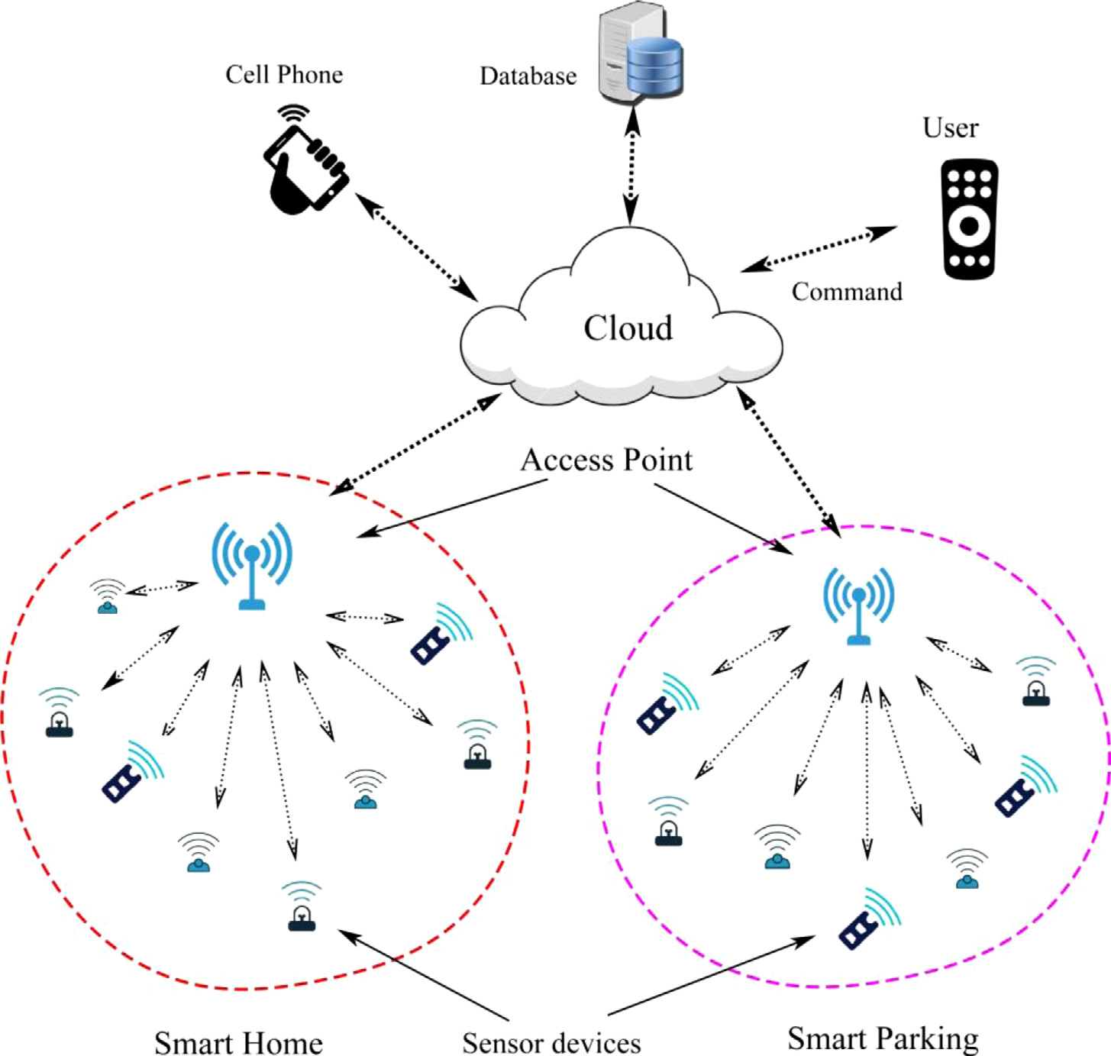

**Fig. 1.** IEEE 802.11ah based network architecture for smart environment.

In this work, we propose a scheduling algorithm for uplink and downlink traffic. The proposed scheme solves the issues of event-driven downlink and homogeneous uplink traffic over an optimized RAW frame subject to improved latency and throughput. The key *contributions* of this work are as follows:

(1) We propose a RAW architecture for IoT networks having both uplink and downlink traffic for monitoring and taking actions for automation.

(2) A traffic prediction model is developed for homogeneous uplink traffic in an IoT scenario where IoT nodes sense the environ-ment and periodically send the information to the cloud server through AP.

(3) A conflict resolution scheme is proposed for scheduling critical downlink traffic over uplink traffic to improve reliability and reduce latency in taking action.

The remaining paper is organized into four different sections. Some related works of IEEE 802.11ah are discussed in Section 2. Section 3 explains the proposed model to optimize the RAW for bidirectional traffic. Performance evaluation of our proposed scheme is presented in Section 4. Finally, Section 5 concludes the paper.

**2. Related works**

In spite of its novelty, many provisions of IEEE 802.11ah have been effectively concentrated in the literature. The improvement of the 802.11ah network’s performance has drawn the attention of various research-oriented organizations. Many researchers have been made a lot of work to enhance the RAW performance of the network. Some of the existing research for the optimization of MAC layers is presented in Table 1.

2

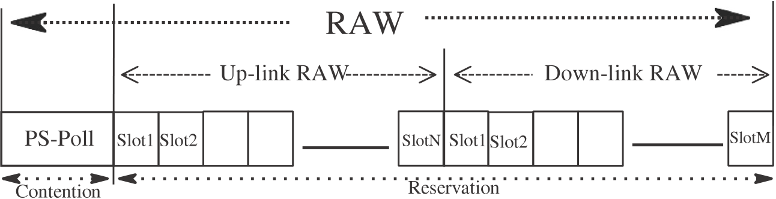

|  |  |  |  |
| --- | --- | --- | --- |
| *M.A. Mondal et al.* |  |  | *Array 18 (2023) 100285* |

**Fig. 2.** Bidirectional RAW frame structure for IEEE 802.11ah.

proposed an efficient window control algorithm that utilizes the next empty slot for uplink retransmission. Badihi et al. [10] investigated an actuation case and checked the performance of the network, tak-ing power consumption and latency at the actuator side. The author of [11] predicted a method consisting of a saturated network with uplink traffic conditions, and all the stations are grouped based on their geographical positions. Hazmi et al. [12] examined the network performance considering RAW features in non-cross slot boundary use cases for various schemes. Kureev et al. [9] considered the throughput and energy efficiency of IEEE 802.11 ah considering a heterogeneous network and a faultless mathematical model proposed for evaluating energy consumption and average throughput of the network.

By assuming a saturated network with downlink traffic (having transmission limited to each device once a RAW), Damayanti et al. [13] proposed a RAW grouping method based on the carrier-sensitivity table, which was constructed earlier, whereas the author of [14] recognizes all the hidden nodes in the uplink transmission by non-acknowledging Power-Saving-Poll (PS–Poll) transmissions. Predicting the traffic condition of each station known by Access Point (AP), Chang et al. [15] proposed a load-balancing device grouping RAW method. A mathematical model was developed by [16], which is used to find the time required for any station to transmit its frames in a RAW slot, assuming that there are no hidden nodes and transmission errors and AP transmits only acknowledgments (ACKs). Quality of service (QoS)-aware priority grouping and RAW scheduling algorithm were proposed by [8] for the real-time event-driven traffic. Event-driven traffic was prioritized over periodic traffic and assigned stations to RAW accordingly. The stations have a higher priority to get access at the beginning of a RAW.

Various algorithms have been proposed for IEEE 802.11ah to im-prove the performance of the network, which is shown in Table 1. The state-of-the-art solutions on this standard focus on either uplink traffic or downlink traffic. But, in the actual IoT network, which requires bidi-rectional traffic support for the applications having high throughput, frequent actuation use cases (i.e., control loops), etc. Therefore, we can say that a channel access mechanism considering both uplink and downlink traffic is needed for the better performance of the network.

**3. The proposed scheme**

In this work, we propose a RAW scheduling scheme for uplink and downlink traffic, considering various network requirements in the case of an IoT environment. The proposed solution uses – (i) up-link/downlink prediction and (ii) RAW frame structure for better traffic scheduling over the network. A hybrid MAC mechanism is proposed with two different phases called the *Contention* phase and *Reservation* phase to ensure that all the stations are properly assigned to respective RAWs. The station in the contention phase can effectively inform the AP about the presence of their buffered data. In the reservation phase, stations successfully transmit their frames. As shown in Fig. 2, the proposed RAW is a union of uplink RAW (UL–RAW) and downlink RAW (DL–RAW). Again UL–RAW and DL–RAW are divided into two parts, namely the *Contention* and *Reservation* phase. The STAs in the

3

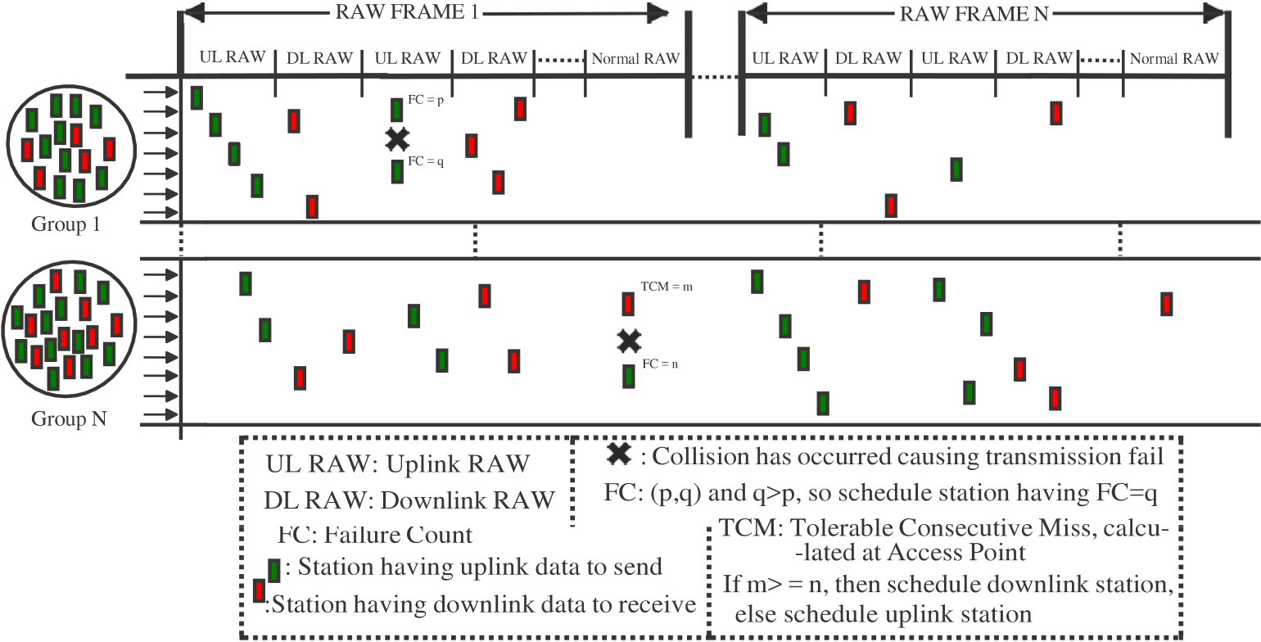

*M.A. Mondal et al.*  *Array 18 (2023) 100285*

**Fig. 3.** Illustration of the proposed bidirectional transmission procedures in IEEE 802.11ah.

|  |  |  |
| --- | --- | --- |
| The AP calculates the packet interval (*i*) of each incoming packet of a node and grouping the STAs in RAW by observing the initial *𝛾* number of packets received at a specific time interval. The *i* value at any time *𝑡𝑖* from the same type of traffic can be calculated in [17] as | | |
| *𝑖* = | (*𝑡𝑝𝑎*2 − *𝑡𝑝𝑎*1) + (*𝑡𝑝𝑏*2 − *𝑡𝑝𝑏*1) + ⋯ + (*𝑡𝑝𝑚*2 − *𝑡𝑝𝑚*1) | (1) |
| *𝛾* |
| where *𝑡𝑝* holds the time duration of a packet *𝑝* calculated by an AP node and (*𝑎1, 𝑎2*)*,* (*𝑏1, 𝑏2*)*,* … *,* (*𝑚1, 𝑚2*) are sequentially received packets from the stations *𝐴*1, *𝐴*2, ..., *𝐴𝑚* respectively. Stations are categorized depending on the *i* value. These method helps to perceive the traffic nature of the network. All the homogeneous traffic is assumed to be periodic, and event-driven traffic is assumed to be critical. The stations having downlink traffic are given preference without losing sufficient information for making decisions. | | |

**Algorithm 1** Uplink traffic scheduling and smart environment activity

**Initialize:**   
*𝐼* ← periodicity of flows, *𝐹𝑢* ← uplink frames, i/j=1, 2, 3...

|  |
| --- |
| 1: **for** Uplink frames *𝐹𝑢* **do**  2: *𝐼𝑖*= calculate periodicity of flow *𝑖* as in Eq. (1)  3: **for** *𝑠𝑙𝑜𝑡𝑠* ∈ RAW **do**  4: **if** *𝐹𝑢𝑖* at AP **then**  5:   Schedule next frame without further contention 6: Schedule *𝐹𝑢𝑖* in *𝑠𝑙𝑜𝑡* after interval *𝐼*  7: **if** *𝐹𝑢𝑖* and *𝐹𝑢𝑗* in same *𝑠𝑙𝑜𝑡* **then**  8: Schedule *𝐹* with highest failure count  9:   **else** 10: Wait for next frame  11: **end if**  12: **end if**  13:   **end for** 14: **end for** |

Algorithm 1 presents the uplink scheduling of traffic. After iden-tifying the periodicity for uplink frames from a station, AP allocates dedicated slots for future transmission. The AP creates a list of slots for all such types of stations in the network. Our scheme allows uplink and downlink transmission at the same time. Fig. 3 shows the illustration of the proposed bidirectional transmission procedures in IEEE 802.11ah. This scheme allows all the uplink transmission in the UL-RAW slots,

4

*M.A. Mondal et al.*  *Array 18 (2023) 100285*

**Algorithm 2** Conflict resolution scheme for downlink traffic

**Initialize:**   
*𝑥𝑚*= maximum tolerable consecutive miss, *𝑡𝑥* ←transmission, *𝐹𝑑* ←downlink frames, i/j=1, 2, 3...

|  |
| --- |
| 1: **for** downlink frames *𝐹𝑑* **do**  2: Schedule *𝐹𝑑𝑖* in first come first service  3: **for** *𝑠𝑙𝑜𝑡𝑠* ∈ RAW **do**  4: **if** station has a uplink frame *𝑓* at *𝑠𝑙𝑜𝑡𝑗* **then**  5: Find *𝑥*: previous consecutive up-link tx failure count  6: **if** *𝑥* ≤ *𝑥𝑚* **then**  7: Reject *𝑓* and Schedule *𝐹𝑑𝑖*  8: **else**  9: Schedule *𝐹𝑑𝑖*  10: **end if**  11: **else**  12: Schedule *𝐹𝑑𝑖*  13: **end if**  14: **end for**  15: **end for** |

stage’’. However, for convenience *𝑊* = *𝐶𝑊𝑚𝑖𝑛*. At each transmission attempt, and regardless of the number of retransmissions suffered, each packet collides with constant and independent probability *𝑝*, *𝑝* will be referred to as conditional collision probability, meaning that this is the probability of a collision seen by a packet being transmitted on the channel. The bi-dimensional process *𝑠*(*𝑡*)*, 𝑏*(*𝑡*) is a discrete-time Markov Chain model.

Now, we can express the probability *𝜏* that a station transmits in a randomly chosen slot time. When the backoff time counter is equal to zero, and any transmission occurs regardless of the backoff stage, it is given [18] as:

|  |  |  |  |  |
| --- | --- | --- | --- | --- |
| = | 2(1 − 2*𝑝*) | | (2) | |
| *𝜏* | (1 − 2*𝑝*)(*𝑊* + 1) + *𝑝𝑊* (1 − (2*𝑝*)*𝑚*) | |  | |
| When m = 0, that is no exponential backoff is considered, the probability *𝜏* results to be independent of p, and Eq. (2) becomes: | | | | |
| *𝜏* = | 2 | (3) | | |
| (*𝑊* + 1) |
| However, *𝜏* depends on the conditional probability *𝑝*. The probabil-ity *𝑝* that a transmitted packet encounters a collision is the probability that, in a time slot, at least one of the (n–1) remaining stations transmit. At a steady state, each remaining station transmits a packet with probability *𝜏*, which provides: | | | | |
| *𝑝* = 1 − (1 − *𝜏*)*𝑛*−1 | | | | (4) |

Let the normalized throughput (*𝑇 ℎ𝑟*) be defined as the fraction of time for the channel used to transmit payload bits successfully. Let the probability *𝑃𝑡𝑟* be present at least once in the transmission of the considered slot time. If stations (say *𝑛*) contend on the channel having transmission probability *𝜏* for each of the stations is given by:

*𝑃𝑡𝑟* = 1 − (1 − *𝜏*)*𝑛*  (5)

Let *𝑃𝑇 ℎ𝑟* be the probability for a successful transmission in a slot on the channel, which can be determined as:

|  |  |
| --- | --- |
| *𝑃𝑇 ℎ𝑟* =*𝑛𝜏*(1 − *𝜏*)*𝑛*−1 *𝑃𝑡𝑟*  =*𝑛𝜏*(1 − *𝜏*)*𝑛*−1 1 − (1 − *𝜏*)*𝑛*  Now, we are able to express *𝑇 ℎ𝑟* as the ratio of: | (6) |
| *𝑇 ℎ𝑟* =*𝐸*[payload information transmitted in a slot time] *𝐸*[length of a slot time] | (7) |
| *𝐸*[*𝑃* ] is the average packet payload size that is the average amount of payload information successfully transmitted in a slot time is | |

5

*M.A. Mondal et al.*  *Array 18 (2023) 100285*

*3.3.2. Average delay*   
 In IoT, the primary delay issue is channel access as a huge number of devices try to contend for the channel. When many stations try to contend for the channel choosing the same backoff slot, a collision occurs. With the assumption of very low frame drop probability, the average frame delay *𝐸𝑑* is calculated in [20,21] as-

*𝐸𝑑* = *𝐸𝑥* × *𝐸𝑠𝑙𝑜𝑡*_*𝑠𝑖𝑧𝑒*  (11)

where,

*𝑠*−1

*𝐸𝑥* =∑(*𝑃𝑖* ×*𝑊𝑖* + 1 2 ) + 1 − *𝑃*× *~~𝑊~~𝑠* + 1 (12)

*𝐸𝑥* is the required time period for empty slots before transmitting a frame successfully. *𝑃𝑖* is the probability that a STA transmits in stage *𝑖* of the backoff window (*𝑊𝑖*). Bianchi et al. [18] calculates the value of *𝑃* as-

*𝑃* = 1 − (1 − *𝜏*)*𝑛*−1

|  |
| --- |
| Again, *𝜏* (i.e., probability of an STA transmitting a packet) is de-pendent on the number of STAs (*𝑛*) and duration of collision *𝑇𝑐*, and  *𝜏* =  64 as the initial backoff window size, m = 6, from Eq. (11), for 100 *𝑛*√ 1  *𝑇𝑐*  2   . For 100 STAs in a group, *𝜏* ≈ 0*.*001. Also, as we have used  STAs, *𝐸𝑑* = 0*.*6047 Sec. |

*3.3.3. Power consumption*   
 Let *𝑡𝑡𝑥, 𝑡𝑟𝑥, 𝑡𝑖𝑑,* and *𝑡𝑠𝑙* be the time duration of transmitting, receiving, idle, and sleeping modes for the IEEE 802.11 ah transceiver within a DTIM, respectively. Now, for an STA within a DTIM, the total energy consumption (*𝐸*) can be determined by multiplying these time dura-tions of a transceiver for each operation to their corresponding power consumptions as [22]:

*𝐸* = *𝑡𝑡𝑥𝑝𝑡𝑥* + *𝑡𝑟𝑥𝑝𝑟𝑥* + *𝑡𝑖𝑑𝑝𝑖𝑑* + *𝑡𝑠𝑙𝑝𝑠𝑙*

where *𝑝𝑟𝑥, 𝑝𝑡𝑥, 𝑝𝑠𝑙*, and *𝑝𝑖𝑑* are the power consumption chosen in Rx, Tx, sleep, and Idle mode, respectively.

**4. Performance evaluation**

The performance of the proposed scheme is evaluated through sim-ulations using [23]. The parameters which are used in the simulations are presented in Table 3. We evaluate RAW performance in terms of *throughput*, *latency*, *energy consumption*, and *packet delivery ratio*.

*4.1. Performance metrics*

• Throughput: We calculate the amount of data received by AP (for uplink traffic) or STA (for downlink traffic) per second. We use this metric to see how much uplink and downlink traffic data it can support over time.

• Latency: We calculate the average uplink and downlink traffic latency. We are mostly interested in the downlink latency during an actuation.

• Packet delivery ratio: The ratio between the number of success- fully sent frames and over 100 frames sent.

*4.2. Benchmarks*

The proposed scheme is compared with traditional 802.11ah, and PTS–MAC [17] in terms of throughput, delay, energy consumption, and packet delivery ratio. Compared to 802.11ah, PTS–MAC uses a hybrid channel access mechanism to find the number of periodic uplink stations and their periodicity. Later, as per their periodicity, a slot is assigned without further contention. PTS–MAC shows better per-formance in terms of uplink throughput, delay, and energy consump-tion, as compared to traditional 802.11ah. The proposed MAC proto-col (i.e., IoT–MAC) additionally considers downlink traffic scheduling, along with periodic uplink traffic scheduling, while enabling a novel conflict resolution method.

6

*M.A. Mondal et al.*  *Array 18 (2023) 100285*

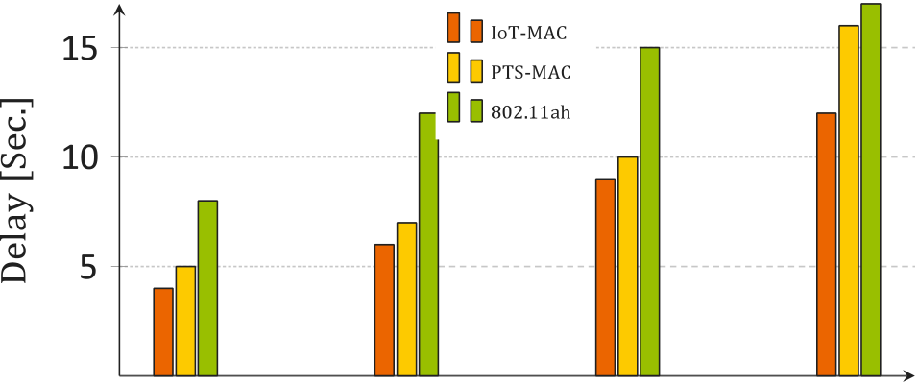

|  |  |  |  |
| --- | --- | --- | --- |
|  |  |  |  |



**Fig. 5.** Delay incurs with increasing number of streaming flows.

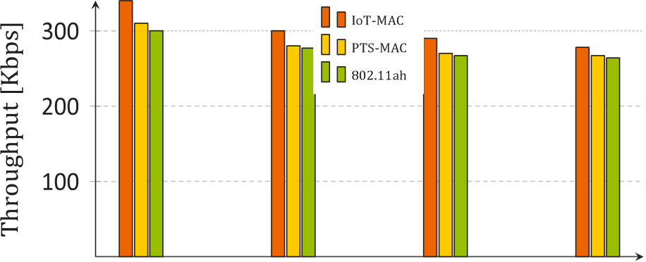

|  |  |  |  |
| --- | --- | --- | --- |
|  |  |  |  |



**Fig. 6.** Throughput analysis of streaming data flows.

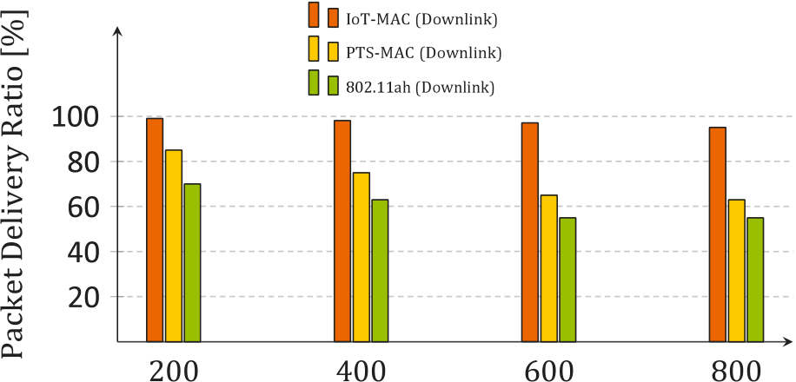



**Fig. 7.** Packet delivery ratio considering downlink traffic.

in PTS–MAC and 802.11ah; they show almost similar performance. However, due to the conflict-aware downlink scheduling in our scheme, it shows better PDR and delay.

Fig. 9 shows energy consumption for our proposed scheme. As our scheme uses conflict resolution for both uplink and downlink traffic, the number of retransmissions has been reduced significantly. Consequently, the energy consumption is also reduced in the case of both types of traffic in an IoT environment. In PTS and traditional IEEE 802.11ah, downlink traffic is not considered explicitly for scheduling, causing contention, which reduces the sleeping time of the nodes and degrades the overall performance. Our proposed method solves this issue and improves energy consumption.

**5. Conclusion**

This paper presented a RAW mechanism for an IEEE 802.11ah net-work having uplink and downlink traffic (i.e., bidirectional traffic). The proposed scheme considers challenges related to finding optimal RAW size over event-driven downlink and periodic uplink traffic. Our scheme can predict the traffic accurately and schedule appropriately with less

7

*M.A. Mondal et al.*  *Array 18 (2023) 100285*

**References**

[1] [Zhang Y, Yu R, Nekovee M, Liu Y, Xie S, Gjessing S. Cognitive machine-to-machine communications: Visions and potentials for the smart grid. IEEE Netw 2012;26(3):6–13.](http://refhub.elsevier.com/S2590-0056(23)00010-3/sb1)

[2] [Qiao L, Zheng Z](http://refhub.elsevier.com/S2590-0056(23)00010-3/sb1)[, Cui W, Wang L. A survey on Wi-Fi HaLow technology for Internet of Things. In: 2018 2nd IEEE conference on energy internet and energy system integration. IEEE; 2018, p. 1–5.](http://refhub.elsevier.com/S2590-0056(23)00010-3/sb2)

[3] [Charania NF, Giluka MK, Tamma BR,](http://refhub.elsevier.com/S2590-0056(23)00010-3/sb2) Franklin A. DEARF: Delay and energy aware RAW formation scheme to support delay sensitive M2M traffic in IEEE 802.11 ah networks. 2017, arXiv preprint [arXiv:1709.03723](http://arxiv.org/abs/1709.03723).

[4] [Nawaz N, Hafeez M, Zaidi SAR, McLernon](http://refhub.elsevier.com/S2590-0056(23)00010-3/sb4) [DC, Ghogho M. T](http://arxiv.org/abs/1709.03723)[hroughput enhance-](http://refhub.elsevier.com/S2590-0056(23)00010-3/sb4) [ment of restricted access window for uniform grouping scheme in IEEE 802.11](http://refhub.elsevier.com/S2590-0056(23)00010-3/sb4)  [ah. In: IEEE international conference on communications. IEEE; 2017, p. 1–7.](http://refhub.elsevier.com/S2590-0056(23)00010-3/sb4) [5] [Wang Y, Chai KK, Chen Y, Schormans J, Loo J. Energy-aware restricted access](http://refhub.elsevier.com/S2590-0056(23)00010-3/sb5)  [window control with retransmission scheme for IEEE 802.11 ah (Wi-Fi HaLow)](http://refhub.elsevier.com/S2590-0056(23)00010-3/sb5)  [based networks. In: 13th annual conference on wireless on-demand network](http://refhub.elsevier.com/S2590-0056(23)00010-3/sb5)  [systems and services. IEEE; 2017, p. 69–76.](http://refhub.elsevier.com/S2590-0056(23)00010-3/sb6)

[6] [Šljivo A, Kerkhove D, Tian L, Famaey J, Munteanu A, Moerman I, et al.](http://refhub.elsevier.com/S2590-0056(23)00010-3/sb6)

[Performance evaluation of IEEE 802.11 ah networks with high-throughput bidirectional traffic. Sensors 2018;18(2):325.](http://refhub.elsevier.com/S2590-0056(23)00010-3/sb6)

[7] [Khorov E, Krotov A, Lyakhov A, Yusupov](http://refhub.elsevier.com/S2590-0056(23)00010-3/sb6) [R, Condoluci M, Dohler M, et al.](http://refhub.elsevier.com/S2590-0056(23)00010-3/sb7)

[Enabling the Internet of Things with Wi-Fi Halow—Performance evaluation of the restricted access window. IEEE Access 2019;7:127402–15.](http://refhub.elsevier.com/S2590-0056(23)00010-3/sb7)

[8] [Ahmed N, De D, Hussain MI. A QoS-aware MAC protocol fo](http://refhub.elsevier.com/S2590-0056(23)00010-3/sb7)[r IEEE 802.11 ah-based Internet of Things. In: 2018 fifteenth international conference on wireless and optical communications networks. IEEE; 2018, p. 1–5.](http://refhub.elsevier.com/S2590-0056(23)00010-3/sb8)

[9] [Kureev A, Bankov D, Khorov E, Lyakhov A. Improving efficiency of heteroge-neous Wi-Fi networks with joint usage of TIM segmentation and restricted access window. In: 2017 IEEE 28th annual international symposium on personal, indoor, and mobile radio communications. IEEE; 2017, p. 1–5.](http://refhub.elsevier.com/S2590-0056(23)00010-3/sb9)

[10] [Badihi B, Del Carpio LF, Amin P, Larmo A, Lopez M, D](http://refhub.elsevier.com/S2590-0056(23)00010-3/sb9)[enteneer D. Performance evaluation of IEEE 802.11 ah actuators. In: IEEE 83rd vehicular technology conference. IEEE; 2016, p. 1–5.](http://refhub.elsevier.com/S2590-0056(23)00010-3/sb10)

[11] [Dong M, Wu Z, Gao X, Zhao](http://refhub.elsevier.com/S2590-0056(23)00010-3/sb10) [H. An efficient spatial group restricted access window scheme for IEEE 802.11 ah networks. In: 2016 sixth international conference on information science and technology. IEEE; 2016, p. 168–73.](http://refhub.elsevier.com/S2590-0056(23)00010-3/sb11)

8