[Array 14 (2022) 100158](https://doi.org/10.1016/j.array.2022.100158)

|  |  |  |
| --- | --- | --- |
|  | Contents lists available at [ScienceDirect](http://www.elsevier.com/locate/array) |  |
| Array |
| journal homepage: [www.elsevier.com/locate/array](http://www.elsevier.com/locate/array) |
|  | | |

Minute-wise frost prediction: An approach of recurrent neural networks Ian Zhoua,b,∗, Justin Lipmana,b, Mehran Abolhasana, Negin Shariatia,b   
a *University of Technology Sydney, Australia*   
b *Food Agility CRC Ltd, 81 Broadway, Ultimo, NSW, 2007, Australia*

|  |  |  |
| --- | --- | --- |
| A R T I C L E | I N F O | A B S T R A C T |
| *Keywords:*  Frost prediction  Internet of Things  Machine learning  Recurrent neural network Temporal prediction | | Frost events incur substantial economic losses to farmers. These events could induce damage to plants and crops by damaging the cells. In this article, a recurrent neural network-based method, automating the frost prediction process, is proposed. The recurrent neural network-based models leveraged in this article include the standard recurrent neural network, long short-term memory, and gated recurrent unit. The proposed method aims to increase the prediction frequency from once per 12–24 h for the next day or night events to minute-wise predictions for the next hour events. To achieve this goal, datasets from NSW and ACT of Australia are obtained. The experiments are designed considering the scene of deploying the model to the Internet of Things systems. Factors such as model processing speed, long-term error and data availability are reviewed. After model construction, there are three experiments. The first experiment tests the errors between different model types. The second and third experiments test the effect of sequence length on error and performance for recurrent neural network-based models. All tests introduce artificial neural network models as the baseline. Also, all tests for model error are conducted in two rounds with testing datasets from the current year (2016) and next year (2017). As a result, recurrent neural network-based models are more suitable for short-term deployment with a smaller sequence length. In contrast, artificial neural network models demonstrate a lower error over the long term with faster processing time. With the results presented, the limitations of the proposed method are discussed. |

**1. Introduction**

In the field of agriculture, frosts occur when ice crystals are formed within the plants and damage the cells [1]. As a result, frost could cause significant losses on the economy and ecosystem [2]. Currently, there are many active and real-time protection methods against frost, including heaters, sprinklers, artificial fog, and air disturbance tech-nologies [3]. However, the frost prediction methods automating the activation of these protection methods can still be improved [3]. This article focuses on predicting the condition of future frost damage to plants. The potential of Recurrent Neural Networks (RNNs) in frost prediction is explored in this article. RNNs are a special form of artificial neural network (ANN) with recurrent connections, which provide the capability to recognize sequential patterns [4]. RNNs are different from the basic ANN that only accepts one input at a time. RNNs can accept several inputs in a sequence. In terms of time-series data, individual data points are processed at once in the sequence of time [4]. The output of the current time state is generated from the input of the current time state and the output of the previous time state, recursively [5]. The standard RNN has issues such as gradient explosion

and gradient vanishing [4]. To address these issues, Long Short-Term Memory (LSTM) and Gated Recurrent Unit (GRU) are proposed as variants of the RNN [5]. This article leverages RNN, LSTM, and GRU models for frost prediction.

In recent years, the Internet of Things (IoT) technologies have been widely applied in the field of agriculture to provide real-time moni-toring and actuation services [6]. There are also a few IoT-based frost protection systems. However, most of these frost protection systems rely on thresholds of real-time sensor readings to trigger the frost pro-tection equipment [3]. The effect of these simple mechanisms is limited compared to the accuracy of the prediction algorithms [3]. Therefore, this article considers a few factors related to the future deployment of frost prediction algorithms. These factors include model processing speed, long-term accuracy and data availability. Since system resources are limited for IoT systems, the model should require a faster pro-cessing speed [7]. Also, IoT systems should eliminate extra human interventions [6]. Therefore, the deterioration of model accuracy over time should be minimum to ensure manual updates to IoT nodes are infrequent. Finally, as most frost prediction models depend on on-site

∗ Corresponding au[thor at: University of Techno](mailto:ian.zhou@student.uts.edu.au)logy Sydne[y, Australia.](mailto:justin.lipman@uts.edu.au)

*E-mail addresses:* [ian.zhou@student.uts.edu.au](mailto:ian.zhou@student.uts.edu.au) (I. Zhou), [justin.lipman@uts.edu.au](mailto:justin.lipman@uts.edu.au) (J. Lipman), [mehran.abolhasan@uts.edu.au](mailto:mehran.abolhasan@uts.edu.au) (M. Abolhasan), [negin.shariati@uts.edu](mailto:negin.shariati@uts.edu.au)[.au (N. Shariati).](mailto:ian.zhou@student.uts.edu.au)

<https://doi.org/10.1016/j.array.2022.100158>  
[Received 7 October 2021; Received in revise](https://doi.org/10.1016/j.array.2022.100158)d form 4 March 2022; Accepted 1 April 2022   
Available online 9 April 2022   
[2590-0056](http://creativecommons.org/licenses/by-nc-nd/4.0/)/© 2022 The Authors. Published by Elsevier Inc. This is an open access article under the CC BY-NC-ND license (<http://creativecommons.org/licenses/by-nc-nd/4.0/>).

*I. Zhou et al.*  *Array 14 (2022) 100158*

historical data [3], data availability is important when creating these models. Since a large amount of historical data cannot be assumed to be available at all sites, our set scene assumes that only a small amount (three months) of data is available to minimize the data collection time for new models.

*1.1. Related work*

In [3], frost prediction methods are categorized as ‘‘classification methods’’ and ‘‘regression methods’’. Classification methods predict the occurrence of frost as a percentage in a future time, whereas regression methods predict the minimum temperature in a future period [3]. Both methods rely on climate data as the model input. Since the frost resis-tances for different species of plants are different [8], frost regression prediction methods are proposed in this article to provide the farmers future environmental insights and provide a more generalized solution avoiding the differences between individual plant species.

There are a few existing frost regression prediction methods. In [9–11], traditional machine learning methods are leveraged to predict temperature or minimum temperature in the next day or night. Random forest models are used in [11] to predict next-day minimum tempera-ture with temperature and humidity inputs. Linear regression is used in both [9] and [10]. Environmental parameters such as temperature, dew point, and humidity are inserted as model inputs in [10]. On the other hand, to consider the effect of wind machines, the authors of [9] introduced the distance to wind machines along with elevation, time of local sunset, and radiation received during the previous day as input parameters.

Apart from the traditional machine learning models. ANN with fully connected layers, as a deep learning model, can also predict future minimum temperatures [12–14]. Models in [12–14], predict minimum temperature in the next 12–24 h as a numerical value. These three works all implement prediction models with air temperature, relative humidity, precipitation, wind direction and speed. However, [12] also includes daytime length, daytime maximum and minimum temperature to support night temperature predictions with a daytime baseline. In [13], precipitation, cloud cover, moisture, and pressure are included as model inputs. The authors also considered humidity and wind ve-locity at 19:00. The authors of [14] predicted next day minimum temperature with fewer input parameters, but introduced radiation to build their prediction ANN.

The above machine learning and deep learning models all predict frost conditions in the next 12–24 h [9–14]. Therefore, in extreme conditions, protection equipment might need to be switched on for 12–24 h to ensure zero frost damage when solely considering model predictions. However, by constant manual observations, the opera-tional time of protection equipment could be reduced [3]. Hence, to reduce the operational time automatically, the major aim of this article is to implement minute-wise next hour minimum temperature predic-tion for frost prediction. Also, as mentioned in the above paragraphs, the potential of RNN-based models (RNN, LSTM, GRU) are explored to solve this prediction problem. The performance of different RNN-based models is also compared in this article. In conclusion, the major contributions of this article are presented as follows.

1. Application of an RNN-based frost prediction method.

2. Increasing the prediction frequency from once per 12–24 h for the next day or night events to minute-wise predictions for the next hour events.

3. Evaluated the limitations of RNN-based frost prediction.

The rest of this paper is arranged as follows. Section 2 describes the methodology and experiment settings with the study area, data pro-cessing procedures, and experiments. Experiments include comparing temperature prediction models (ANN, RNN, LSTM, GRU), analyzing dif-ferent RNN model settings, and the performance of predicting minimum temperature with other frost-related parameters. Then, the experimen-tal results are discussed in Section 3 and lead towards limitations with open challenges. In the end, Section 4 concludes the whole article.

2

*I. Zhou et al.*  *Array 14 (2022) 100158*

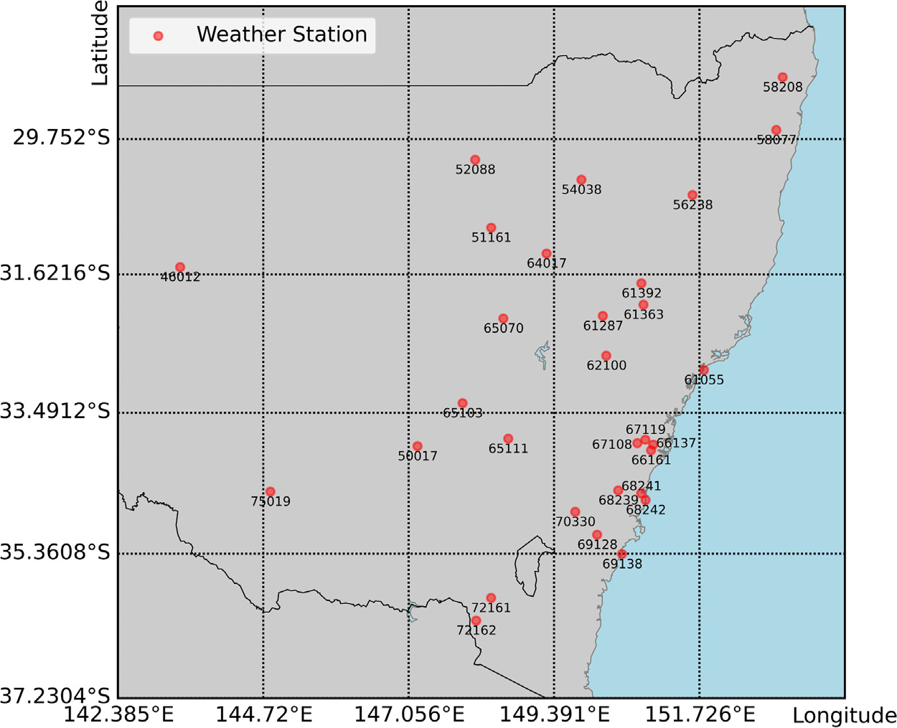

**Fig. 1.** Weather stations with ID.

sequence *𝑡*, the sequence from one minute before is added to the current entry and defined as sequence *𝑡* − 1. Similarly, the sequence from two minutes before is added and defined as sequence *𝑡* − 2. Since the maximum sequence length of the experiments is 120, sequences from previous entries are added to the current entry from one minute before until 119 min before. Therefore, each entry includes 120 sequences from sequence *𝑡* − 119 to sequence *𝑡*.

The timestamp column is a tool to help extract the data from the desired time period. Now, as all of the features and sequences are generated, the timestamp column can be removed in step 4. Then, in the final step of phase 1, the listwise deletion data imputation technique is applied to eliminate data entries with empty features [20]. This also includes the removal of data sequences with missing features to preserve the time differences between observations. The final product of phase 1 is output to hard disk to be used in phase 2. For every weather station dataset, the steps in phase 1 are conducted for data in years 2016 and 2017.

In phase 2 of data preprocessing, the results from phase 1 are trans-formed to the required form for different models with different settings. After reading an output from phase 1, step 6 of data preprocessing removes excess data sequences. For ANN models, only one sequence is required. Therefore, sequences *𝑡* − 119 to *𝑡* − 2 should be removed. For RNN, LSTM, and GRU models, sequences are removed according to the sequence length of the target model. For example, with a desired sequence length of 20, sequences *𝑡* − 119 to *𝑡* − 20 are removed, leaving only 20 data sequences (Fig. 2).

Step 7 of data preprocessing is only executed to prepare the data for RNNs and their variants. Every entry in the dataset is converted to a 2D structure. Each row of this 2D structure represents a sequence of a specific time. The rows are structured top to bottom from an earlier time to a more recent time. At this stage, the data can proceed to model construction.

Table 1 describes the features at the end of data preprocessing. Most features demonstrate a normal distribution. The relative humidity is the only skewed-left feature. Table 2 shows the Pearson correlation matrix of the processed features. Dew point and relative humidity show strong correlations to temperature. Other features are relatively independent of each other.

3

*I. Zhou et al.*  *Array 14 (2022) 100158*

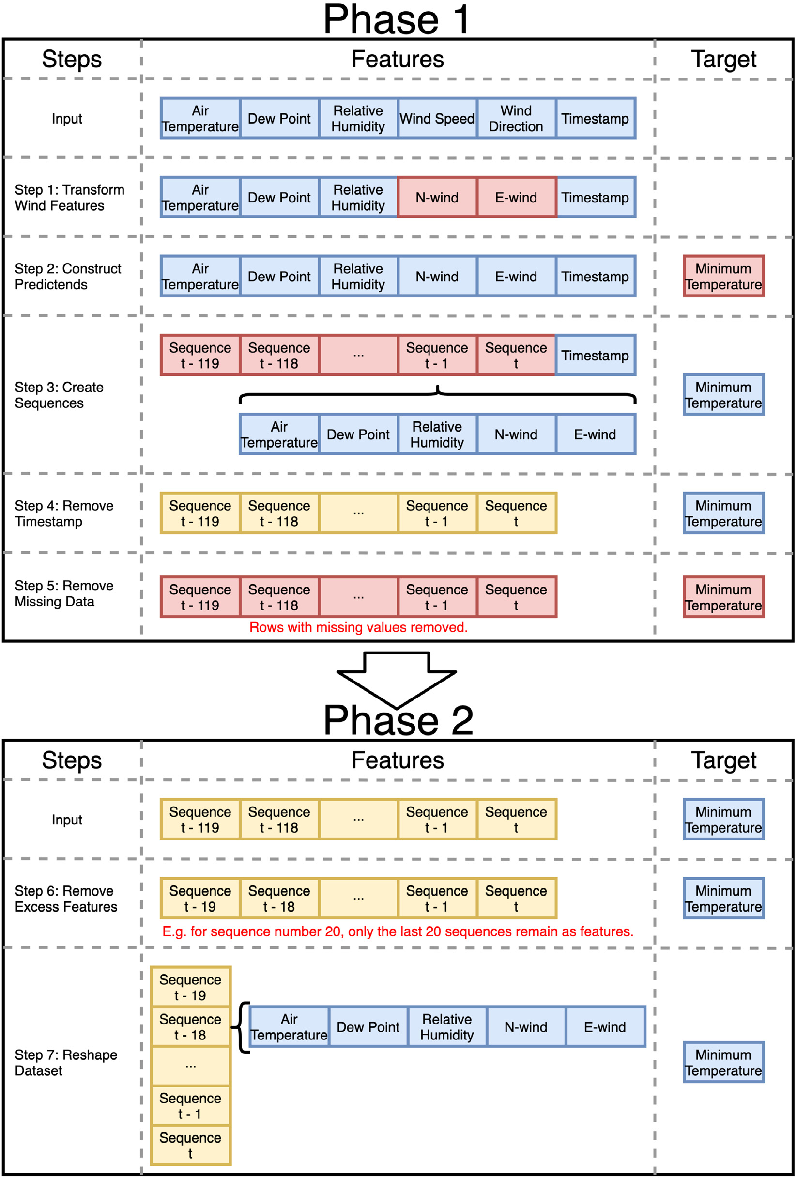

**Fig. 2.** Data preprocessing steps. (For interpretation of the references to colour in this figure legend, the reader is referred to the web version of this article.)

functions with relevant cells to the models. Also, for the first layer of RNN, LSTM, and GRU models, the hidden state of the cells is output as sequential inputs of the second layer. The third layer only consists of a single linear cell to output the result.

Adam is the optimizer used during training. Learning rate, *𝛽*1, *𝛽*2, and *𝜖*, are the hyperparameters required for Adam [21]. In the experiments, learning rate is set to the ‘‘good default settings’’ as 0.001,

4

*I. Zhou et al.*  *Array 14 (2022) 100158*

**Table 1**

Description of the processed training features.

Feature

|  |  |  |  |  |  |  |  |  |
| --- | --- | --- | --- | --- | --- | --- | --- | --- |
| Item | Temperature (◦C) | Dew point (◦C) | | Relative  humidity (%) | | N-wind  (km/h) | | E-wind  (km/h) |
| Min  Mean  Max  Std  Distribution | −5.4000 10.4629 31.0000 5.0328  Normal | −37.8000 6.3262  23.2000  4.2037  Normal | | 2.0000  78.1665  100.0000  18.0907  Skewed-left | | −86.2608 −1.9071  81.8329  10.7936  Normal | | −78.0689 4.8393  95.3837  11.3289  Normal |
| **Table 2**  Pearson correlation matrix of the processed training features. | | | | | | | |  |
| Temperature | | | Dew point | | Relative humidity | | N-wind | E-wind |
| Temperature  Dew point  Relative humidity N-wind  E-wind | 1.0000  0.6391 −0.5744−0.1330 0.0181 | 0.6391  1.0000  0.2474 −0.0946 −0.1613 | | −0.5744  0.2474  1.0000  0.0659 −0.2059 | | −0.1330 −0.0946  0.0659  1.0000 −0.1814 | | 0.0181 −0.1613−0.2059−0.1814 1.0000 |

are trained for all 30 weather stations. There are 6 different sequence length settings (20, 40, 60, 80, 100, 120). Altogether, the second group outputs 540 models. Overall, there are 570 models constructed for this article. The usage of these models in experiments is explained in the next subsection.

*2.4. Experiments*

There are three experiments conducted to test the model error and performance of models. In the first experiment, the errors of different model types (ANN, RNN, LSTM, GRU) are compared. ANN models from the first model group are the baseline of this experiment. For each weather station, there are eight conducted tests to measure the losses from the current year and next year data for the four model types. RNN models and their variants are tested with a sequence length of 120. Then, in the second experiment, the effect of the sequence length of RNN, LSTM, and GRU models are compared. Additional to the results obtained in the first experiment, 30 more tests are conducted for each weather station to obtain the results of the three RNN-based model types with five sequence number settings, and tested with the current year and next year testing datasets. Model errors of all RNN-based model types are compared with different sequence length settings against the ANN baseline. Similarly, in the final experiment, the train-ing time and inference time of different sequence length settings are compared against the ANN baseline.

**3. Results and discussions**

To validate and compare different model settings for next hour frost prediction models, three experiments are conducted. The first experiment compares the MSE between ANN and RNN-based model types. Then, in the second experiment, MSEs of RNN-based models with different sequence lengths are assessed. Finally, processing time related factors are also analyzed with different sequence lengths. This provides an overview of different models’ real-time computation abilities.

*3.1. Model error*

In this experiment, the model errors of RNN-based models with a sequence length of 120 are evaluated with ANN models. Fig. 3 shows that when testing with testing datasets derived from the same year when the training datasets is collected, LSTM seems to perform with the best accuracy with the lowest MSE loss. LSTM is also the only RNN-based model type to exceed the accuracy of ANN models. This result is also confirmed with one-sided paired T-tests. From the *𝑝*-values (RNN: 0.1544; LSTM: 6.1225e−12; GRU: 0.2644), LSTM is the only model type that the *𝑝*-value is smaller than the 0.05 *𝛼* value. This means the

5

*I. Zhou et al.*  *Array 14 (2022) 100158*

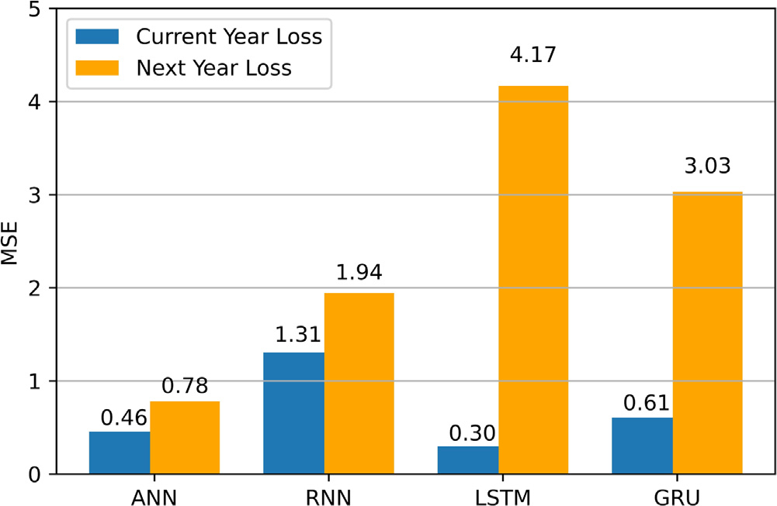

**Fig. 3.** Average MSE tested with current and next year datasets.

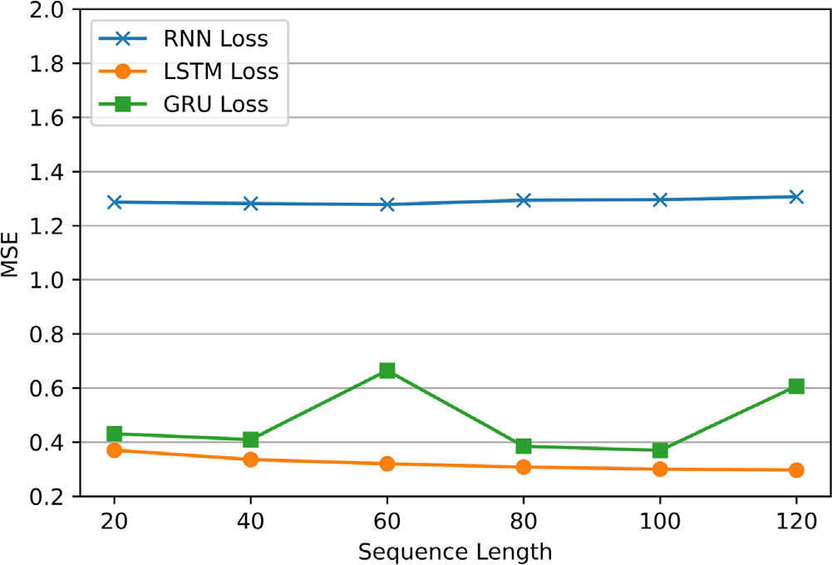

**Fig. 4.** Average MSE tested with current year datasets for different sequence lengths.

**Table 3**   
*𝑃* -values of comparing average MSEs between ANN and RNN-based models with different model sequence lengths (current year).

Model type

|  |  |  |  |
| --- | --- | --- | --- |
| Sequence length | RNN | LSTM | GRU |
| 20  40  60  80  100  120 | 0.1603  0.1617  0.1628  0.1581  0.1576  0.1544 | 3.4979e−10  6.9911e−11  1.0544e−10  3.0000e−11  2.1009e−11  6.1225e−12 | 0.0032  1.3249e−5 0.1591  4.2542e−7 4.2930e−7 0.2644 |

Fig. 5 is the average MSEs for RNN-based models with different sequence lengths tested by the next year testing datasets. Similar to the reverse of results in Experiment 1, all RNN-based models have a higher loss than the ANN MSE (0.7813). Table 4 is the *𝑝*-values obtained from one-sided paired T-tests with an alternative hypothesis that each tested model has a greater MSE than the ANN baseline. The alternative hypothesis is in favor of LSTM and GRU models as their *𝑝*-values are less than *𝛼*. This means LSTM and GRU models are likely to perform with higher errors than ANN models in the next year. Also, as explained in Experiment 1, the change of climate patterns in the future is unknown. This could be the reason of the additional noise in Fig. 5, compared to Fig. 4.

6

*I. Zhou et al.*  *Array 14 (2022) 100158*

**Table 5**   
*𝑃* -values of comparing average training time per epoch between ANN and RNN-based models with different model sequence lengths.

Model type

|  |  |  |  |
| --- | --- | --- | --- |
| Sequence length | RNN | LSTM | GRU |
| 20  40  60  80  100  120 | 5.3068e−32 1.4240e−31 1.5350e−31 4.3655e−32 7.6250e−32 1.2237e−31 | 1.4421e−30 1.5839e−31 2.2799e−32 5.7483e−32 2.8775e−31 5.4545e−32 | 7.5427e−31 2.1966e−31 1.3996e−31 1.4185e−31 6.2908e−31 2.6502e−31 |

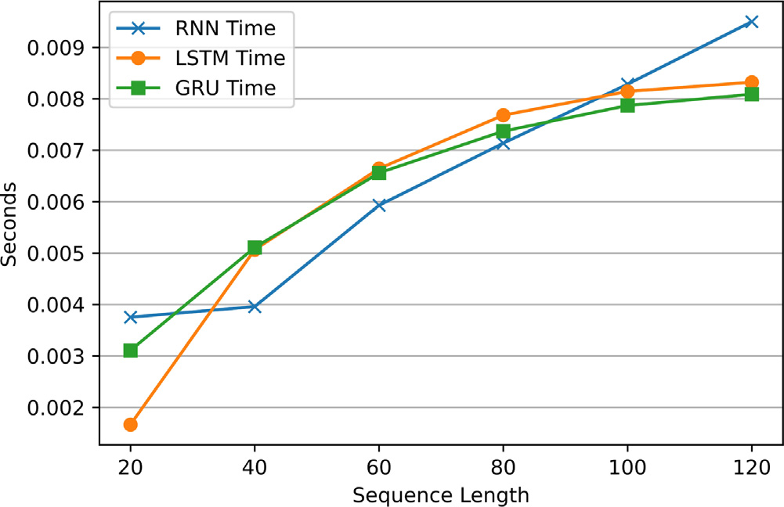

**Fig. 7.** Average inference time per input for different sequence lengths.

**Table 6**   
*𝑃* -values of comparing average inference time per input between ANN and RNN-based models with different model sequence lengths.

Model type

|  |  |  |  |
| --- | --- | --- | --- |
| Sequence length | RNN | LSTM | GRU |
| 20  40  60  80  100  120 | 2.5574e−45 5.0297e−49 6.7674e−62 2.1246e−60 1.9803e−54 1.0382e−58 | 1.0941e−17 2.1683e−37 3.7983e−42 1.0625e−44 2.7216e−46 5.9795e−48 | 1.7544e−35 2.6969e−42 2.6171e−42 1.5319e−42 1.2132e−37 1.6906e−46 |

Fig. 7 demonstrates the average inference time per input for RNN-based models with different sequence lengths. There is a trend of increase in inference time, along with the increase of sequence length. Similar to training time, a higher sequence length of RNN-based models implies a larger input sequence and a model structure with more pa-rameters. Thus, the inference time increases with the sequence length. Also, the inference time for all RNN-based settings is significantly larger than ANN inference time (4.5214e−4 s). This statement is supported with the one-sided paired T-test results as all *𝑝*-values are less than the *𝛼* (Table 6).

*3.4. Limitations and open challenges*

Experiment 1 shows that RNN-based models have lower model errors than ANN models when tested with current year datasets. LSTM models have the lowest errors and highest accuracy. However, RNN-based models’ accuracy declines and is exceeded by ANN when tested with next year datasets. This decline is likely to be caused by climate pattern change over time [4,5,23,24]. Also, the models in this article are constructed with one year of data. From [27], RNN models often require data from more years to fully learn the seasonality patterns. However, this would increase the dependency on historical data, which is a limitation mentioned in the next subsection. With both sources of accuracy deterioration, RNN-based models are only suitable for a

7

*I. Zhou et al.*  *Array 14 (2022) 100158*

*3.4.4. Models depend on previous year data*   
 All models constructed for this article depend on previous years of data. Therefore, model accuracy is dependent on the quality of historical data. This is a limitation on all machine learning models [31]. As more recent researches are site-specific, sites without any record of historical climate data require an IoT data collection system to be deployed for data collection. To ensure similar performance to the results of this article, the system must be deployed at least a year prior to produce a prediction model and provide frost prediction services. This increases the deployment time of the system. A possible solution is to explore the performance of models based on previous months of data. This solution could substantially reduce development time. However, it cannot eliminate this excess system development time for data collection. Methods eliminating the requirement of on-site historical data need to be developed. Another possible direction is to explore the generalization or transfer of models to similar locations.

*3.4.5. Lack of stopping conditions*   
 The frost prediction models constructed in this article only predict the start of a frost event with real-time sensor readings. This predic-tion could be the trigger of a frost protection mechanism. However, there are limited mentions of predicting the end of a frost event to switch off any protection mechanisms. As most frost protection systems rely only on a single sensor node [3], activation of a nearby protection mechanism might affect the sensor readings and contam-inate the prediction outcomes of frost prediction models. Therefore, future prediction models could be developed to eliminate the effect of frost protection mechanisms. As a possible benefit, frost protection mechanisms could be switched off earlier to reduce the operational cost.

**4. Conclusion**

The primary aim is to increase the prediction frequency from once per 12–24 h for the next day or night events to minute-wise predictions for the next hour events. RNN-based models are selected to learn the sequence pattern of historical data. ANN models are used as a baseline. Datasets from weather stations in the NSW and ACT areas of Australia are obtained. These datasets are recorded during the years 2016 and 2017. With these datasets, it is assumed that our models are built during the year 2016 (current year) and deployed in year 2017 (next year). Therefore, datasets from 2016 are used for model construction and preliminary testing. Datasets from 2017 are used for final testing. After constructing the models, there are three experiments testing the model errors, also the effect of sequence lengths on errors and processing time for RNN-based models. The errors of models is tested with both the current and next year datasets. LSTM seems to have the highest accuracy when tested with the current year testing datasets. However, the accuracy for all RNN-based models reduces when tested with the next year testing datasets. ANN models have the highest accuracy with the next year testing datasets. When testing RNN-based models with different sequence lengths, it seems that sequence lengths cannot affect the accuracy of models significantly. However, training and inference time increases with the sequence length. Therefore, RNN-based models should be used for short-term deployments with a shorter sequence length to ensure accuracy and performance. On the other hand, ANN models demonstrate the lowest error when tested with next year datasets. Also, the training and inference speeds of ANN models are faster than RNN-based models. Therefore, in the long term, ANN models are more suitable than RNN-based models due to better accuracy and performance.

There are limitations determined. Firstly, the model accuracy re-quirements are not specified in this article due to a lack of studies on precise frost sensitivities to individual frost factors. Secondly, the cur-rent model and most previous models are constructed with local data. The lack of standard datasets limits unbiased comparisons between

8

*I. Zhou et al.*  *Array 14 (2022) 100158*

|  |  |  |
| --- | --- | --- |
| **Table A.8**  Weather station location coordinates continue. | |  |
| Station ID | Latitude (degrees) | Longitude (degrees) |
| 72161  51161  70330  61055  66137  64017  68239  66161  68241  58077  69128  65111  56238  65103  52088 | −35.9371 −30.9776 −34.8085 −32.9184 −33.9176 −31.3330 −34.5253 −33.9925 −34.5638 −29.6224 −35.1103 −33.8382 −30.5273 −33.3627 −30.0372 | 148.3779  148.3798  149.7311  151.7985  150.9837  149.2699  150.4217  150.9489  150.7900  152.9605  150.0826  148.6540  151.6158  147.9205  148.1223 |

**References**

[1] Webb L, Snyder RL. Frost hazard. In: Bobrowsky PT, editor. Encyclopedia of natural hazards. Dordrecht: Springer Netherlands; 2013, p. 363–6. [http://dx.doi. org/10.1007/978-1-4020-4399-4_148](http://dx.doi.org/10.1007/978-1-4020-4399-4_148).

[2] [Ma Q, Huang J-G, Hänninen H, Ber](http://dx.doi.org/10.1007/978-1-4020-4399-4_148)ninger F. Divergent trends in the risk of spring frost damage to trees in Europe with recent warming. Global Change Biol 2019;25(1):351–60. <http://dx.doi.org/10.1111/gcb.14479>.

[3] Zhou I, Lipman J, [Abolhasan M, Shariati N, Lamb](http://dx.doi.org/10.1111/gcb.14479) DW. Frost monitoring cyber–physical system: A survey on prediction and active protection meth-ods. IEEE Internet Things J 2020;7(7):6514–27. [http://dx.doi.org/10.1109/JIOT. 2020.2972936](http://dx.doi.org/10.1109/JIOT.2020.2972936).

[4] [Goodfellow I, Bengio Y, Courville A. Sequence modeling: Recurrent and recursive](http://refhub.elsevier.com/S2590-0056(22)00024-8/sb4)  [nets. In: Deep learning. MIT Press; 2016, p. 363–408.](http://refhub.elsevier.com/S2590-0056(22)00024-8/sb4)

[5] [Salehinejad H, Sankar S, Barfett J, Colak E, Valae](http://refhub.elsevier.com/S2590-0056(22)00024-8/sb4)e S. Recent advances in recurrent neural networks. 2017, arXiv preprint [arXiv:1801.01078](http://arxiv.org/abs/1801.01078).

[6] Farooq MS, Riaz S, Abid A, Abid K, Naeem [MA. A survey](http://arxiv.org/abs/1801.01078) on the role of IoT in agriculture for the implementation of smart farming. IEEE Access 2019;7:156237–71. <http://dx.doi.org/10.1109/ACCESS.2019.2949703>.

[7] Sarker VK, Gia TN, [Tenhunen H, Westerlund T. Lightweight security](http://dx.doi.org/10.1109/ACCESS.2019.2949703) algorithms for resource-constrained IoT-based sensor nodes. In: ICC 2020 - 2020 IEEE international conference on communications. 2020. p. 1–7. Dublin, Ireland. <http://dx.doi.org/10.1109/ICC40277.2020.9149359>.

[8] [di Francescantonio D, Villagra M, Goldstein G, Cam](http://dx.doi.org/10.1109/ICC40277.2020.9149359)panello PI. Drought and frost resistance vary between evergreen and deciduous Atlantic forest canopy trees. Funct Plant Biol 2020. <http://dx.doi.org/10.1071/FP19282>.

[9] Halley V, Eriksson M, N[unez M. Frost prevention and predi](http://dx.doi.org/10.1071/FP19282)ction of temperatures and cooling rates using GIS. Aust Geogr Stud 2003;41(3):287–302. [http://dx.doi. org/10.1046/j.1467-8470.2003.00235.x](http://dx.doi.org/10.1046/j.1467-8470.2003.00235.x).

[10] [Iacono LE, Vázquez Poletti JL, Garcí](http://dx.doi.org/10.1046/j.1467-8470.2003.00235.x)[a Garino C, Llorente IM. Performance models for frost prediction in public cloud infrastructures. Comput Inform 2018;37(4):815–37.](http://refhub.elsevier.com/S2590-0056(22)00024-8/sb10)

[11] [Diedrichs AL, Brom](http://refhub.elsevier.com/S2590-0056(22)00024-8/sb10)berg F, Dujovne D, Brun-Laguna K, Watteyne T. Prediction of frost events using machine learning and IoT sensing devices. IEEE Internet Things J 2018;5(6):4589–97. <http://dx.doi.org/10.1109/JIOT.2018.2867333>.

[12] Ghielmi L, Eccel E. Descrip[tive models and artificial neural networks](http://dx.doi.org/10.1109/JIOT.2018.2867333) for spring frost prediction in an agricultural mountain area. Comput Electron Agric 2006;54(2):101–14. <http://dx.doi.org/10.1016/j.compag.2006.09.001>.

9