|  |  |  |
| --- | --- | --- |
|  | Available online at www.sciencedirect.com |  |
| **ScienceDirect** |
| AASRI Procedia 5 ( 2013 ) 249 – 261 |

2013 AASRI Conference on Parallel and Distributed Computing and Systems

Modeling and Simulation of Different System Topologies for DSTATCOM

Pradeep Kumar*, Niranjan Kumar, A.K.Akella

*Electrical Engineering Department, National Institute of Technology Jamshedpur, 831014, Jharkhand, India*

**Abstract**   
Power Quality enhancement in a distribution network is achieved by shunt compensation device known as Distribution static compensator (DSTATCOM).In this paper, three different system topologies for Distribution Static Compensators (DSTATCOMs) are modeled and tested using Simulink’SimPowerSystem Toolbox for power system quality studies. Simulation tests on a distribution system, equipped with the unbalanced and non-linear load. With the different system topologies of Distribution Static Compensators (DSTATCOMs) it is observed that power factor can be improved in supply system. The DSTATCOM controls are based on Synchronous Reference Frame control. The modeled DSTATCOM topologies can be used to develop and test different, control strategies and methods for the DSTATCOM. These models can also aid instructors in teaching power quality courses.

© 2013 The Authors. Published by Elsevier B.V. Open access under [CC BY-NC-ND license.](http://creativecommons.org/licenses/by-nc-nd/3.0/)

Selection and/or peer review under responsibility of American Applied Science Research Institute

*Keywords:* Distribution Static Compensator (DSTATCOM); Simulink’SimPowerSystemToolbox; Control; Modeling; Simulation; power quality; Synchronous Reference Frame (SRF)

**1. Introduction**   
 Distribution static compensator (DSTATCOM) is one of the power custom device that is used for Power Factor Improvement on source side [1]. The DSTATCOM has a Six-leg Voltage-Sourced Converter (VSC) with Insulated Gate Bipolar Transistor (IGBT) as a switching element. Different studies have been performed

* Pradeep Kumar . Tel.:+91-9905205302; fax:+91-657-2382246.   
 *E-mail address:* kumarcs08@gmail.com.

2212-6716 © 2013 The Authors. Published by Elsevier B.V. Open access under [CC BY-NC-ND license.](http://creativecommons.org/licenses/by-nc-nd/3.0/) Selection and/or peer review under responsibility of American Applied Science Research Institute doi: 10.1016/j.aasri.2013.10.086

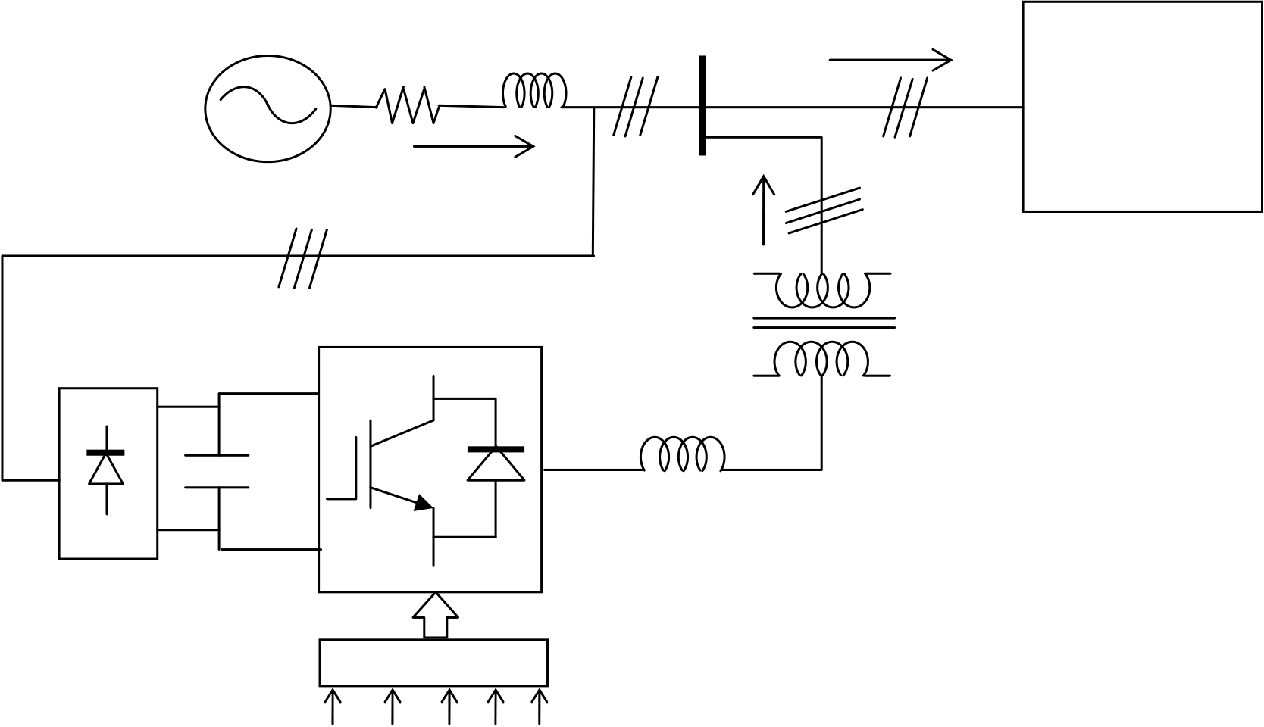

250  *Pradeep Kumar et al. / AASRI Procedia 5 ( 2013 ) 249 – 261*

to evaluate the performance or propose control strategies for DSTATCOM to improve its performance [2-10]. Time domain simulations and /or practical experiments have been used to perform these studies.Time domain simulations have been shown to provide accurate prediction of the behaviour of Voltage-Sourced Converter (VSC) based FACTS devices [11]. There are many packages available to model and simulate VSC based FACTS devices such as EMTP, PSCAD, MATLAB/SIMULINK, PSIM. MATLAB/SIMULINK is the most widely used package in engineering sciences since it has many toolboxes that cover all engineering applications [12]. This paper models and simulates three different system topologies for Distribution static compensator (DSTATCOM) using Simulink’SimPowerSystem Toolbox. The DSTATCOM topologies are based on Synchronous Reference Frame (SRF) control [13].

**2. System Topologies for DSTATCOM**   
There are different system topologies for the DSTATCOM. Out of which, three are selected and used in this paper. The selected systems are:   
 1- DSTATCOM with supply side-connected rectifier shown in Fig.1. (System 1)   
 2- DSTATCOM with load-side-connected rectifier shown in Fig.2. (System 2)   
 3- DSTATCOM with constant dc voltage shown in Fig.3. (System 3)   
 The load which has been selected for these topologies are three phase unbalanced R-L load and diode rectifier as a nonlinear load. A step-up transformer for stepping up the voltage has been used in between the STATCOM and distribution system.

|  |  |  |  |  |  |  |  |  |  |  |  |  |  |  |  |  |
| --- | --- | --- | --- | --- | --- | --- | --- | --- | --- | --- | --- | --- | --- | --- | --- | --- |
| |  |  |  |  |  |  | | --- | --- | --- | --- | --- | --- | | *Sv* | *R s* | *sL* | *tv* | *Li* | Unbalanced |   &Non-linear   |  |  |  | | --- | --- | --- | | *Si* | *Ci* | Load |   Three-phase  Uncontrolled   |  |  |  | | --- | --- | --- | | rectifier | *Cdc* | *fL* |   SRF controller   |  |  |  |  | | --- | --- | --- | --- | | *V* dc | *i*La | *i*Lb | *i* Lc*tV* | |

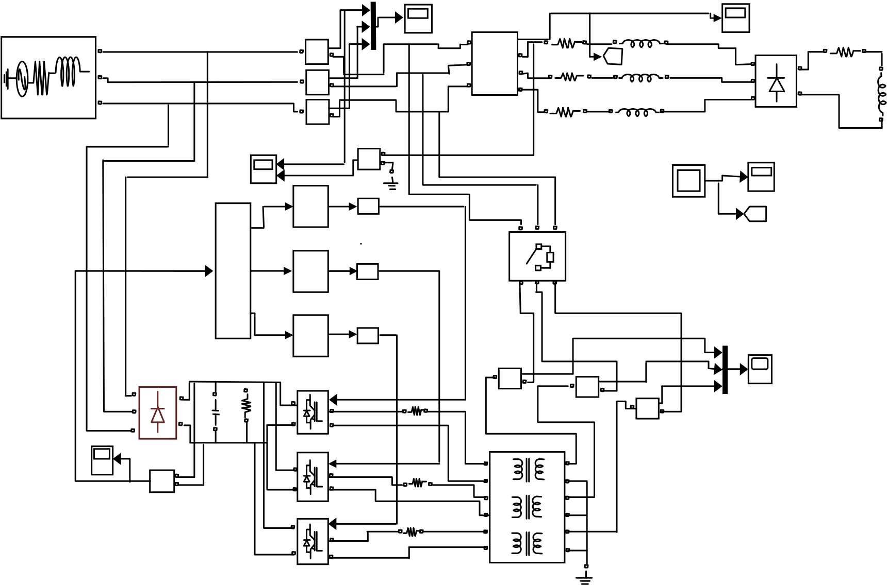

|  |  |  |  |  |  |  |  |  |  |  |  |  |  |  |
| --- | --- | --- | --- | --- | --- | --- | --- | --- | --- | --- | --- | --- | --- | --- |
| A | *Pradeep Kumar et al. / AASRI Procedia 5 ( 2013 ) 249 – 261* | | | | | | | | | | Vt1 | Rd | Ld | 251 |
| | | IS | A | Vabc | | | | | | |
| + | B | | | a | Ra | | [A] | | La |
| -  Current | b | A |
| B | Goto | | + |
| | |
| + | C | | | c | | Rb | | Lb | | B |
| C | -  Current1 | - |
| Three-Phase | | | | | C |
| | |
| Three-Phase Source | + | V-I Measurement | | | | | Universal Bridge |
| -  Current2 | Rc | | | | | | Lc | | |
| Isa&Vta | Volt1   + | | | | | | | | |

V   
 -

3

|  |  |  |  |  |  |  |  |
| --- | --- | --- | --- | --- | --- | --- | --- |
| Out1 | 1/Z | Three-Phase Breaker | a A | b B | c C | |La, |Lb, |Lc | |L |
| Unit Delay1 | [B] |
| Discrete | Goto1 |
| In1 Out2 | PWM Generator |
| 1/Z |

Unit Delay2

Discrete

|  |  |  |  |  |  |  |  |  |  |  |
| --- | --- | --- | --- | --- | --- | --- | --- | --- | --- | --- |
| DC LINK | Out3 | | | PWM Generator1 | | Lf2 | | | ICa | ICb | IC |
| SRF controller | | | 1/Z | |
| Unit Delay3 | |
| Discrete | |
| PWM Generator2 | |
| A | | | + | g | + | | | ICc |
| -  Current3 | + |
| + | | | -  Current4 | | |
| B | Odc | Rdc | A | | +   - |
| - | | | = | B | Lf1 | A1+ A2+ | Current5 |
| C | | | IGBT Bridge 2 arm | |
| Universal Bridge1 | | |
| Volt | | | + | g |
| V | +  - | | A | | A1 A2 |
| = | B | Lf | B1+ B2+ |
| IGBT Bridge 2 arm1 | |
| B1 B2 |
| + | g | C1+ C2+ |
| A | |
| = | B | C1 C2 |
| Three-phase |
| IGBT Bridge 2 arm2 | |
| Linear Transformer |

Fig. 1. DSTATCOM with supply side-connected rectifier including Simulink Model

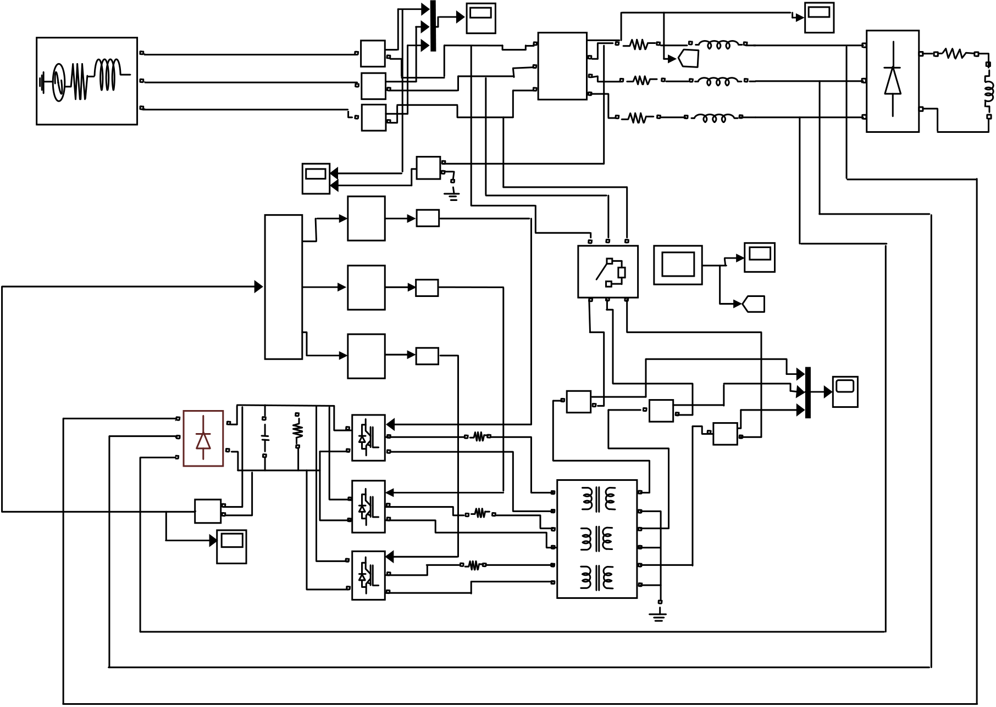

|  |  |  |  |  |  |  |  |  |  |  |  |  |  |  |  |  |
| --- | --- | --- | --- | --- | --- | --- | --- | --- | --- | --- | --- | --- | --- | --- | --- | --- |
| 252 | A | *Pradeep Kumar et al. / AASRI Procedia 5 ( 2013 ) 249 – 261* | | | | | | | | | | Vt1 | A | | Rd | Ld |
| | | IS | A | Vabc | | | | | | |
| + | B | | | a | Ra | | [A] | | La | + | | |
| -  Current | A | Rd | |
| B | b | Goto | | B | +  B | |
| | |
| + | C | | | c | | Rb | | Lb | | Ld |
| -  Current1 | - | | |
| C | Three-Phase | | | | | C | | |
| | | Universal Bridge C | | - |
| Three-Phase Source | + | V-I Measurement | | | | |
| -  Current2 | Rc | | | | | | Lc | | |
| Universal Bridge | | |
| Isa&Vta | Volt1   + | | | | | | | | |

V   
 -

3

|  |  |  |  |  |  |  |  |  |  |  |  |  |  |  |
| --- | --- | --- | --- | --- | --- | --- | --- | --- | --- | --- | --- | --- | --- | --- |
| DC LINK | Out1 | | | 1/Z | | Three-Phase Breaker | | | a A | b B | c C | 3 | |La, |Lb, |Lc | |L |
| Unit Delay1 | | IL | [B] |
| Goto1 |
| Discrete | |
| PWM Generator | |
| In1 Out2 | | |
| 1/Z | |
| Ila, Ilb, Ilc |
| Out3 | | | Unit Delay2 | | | | | | | | | [B] | IC |
| Discrete | | Goto1 |
| PWM Generator1 | | ICa |
| 1/Z | |
| SRF controller | | | ICb |
| Unit Delay3 | |
| Discrete | | | |
| PWM Generator2 | | ICc |
| + | | | | | |
| Lf2 | -  Current3 | | | | | + |
| A | | | + | g | -  Current4 | | |
| + | | |
| B | Odc | Rdc | A | | + |
| - |
| - | | | = | B | A1+ A2+ | | | | | | Current5 |
| C | | | IGBT Bridge 2 arm | |
| Universal Bridge1 | | |
| Volt | | | + | g |
| V | +  - | | A | | Lf1 | | A1 A2 | | | |
| DC LINK | | | = | B | B1+ B2+ | | | | | |
| IGBT Bridge 2 arm1 | |
| Lf | B1 B2 | | | | |
| + | g |
| C1+ C2+ | | | | | |
| A | |
| C1 C2 | | | | | |
| = | B |
| Three-phase | | | | | |
| IGBT Bridge 2 arm2 | |
| Linear Transformer | | | | | |

Fig. 2. DSTATCOM with Load side-connected rectifier including Simulink Model

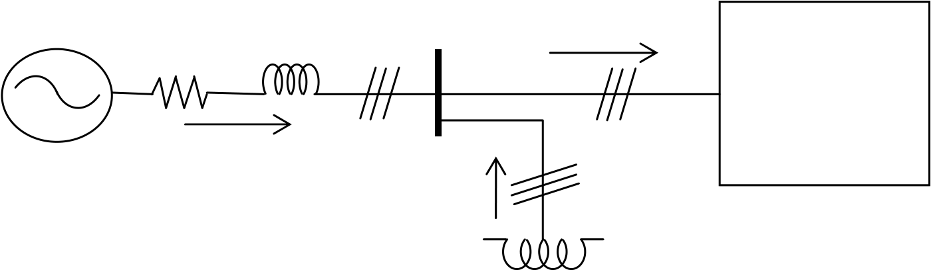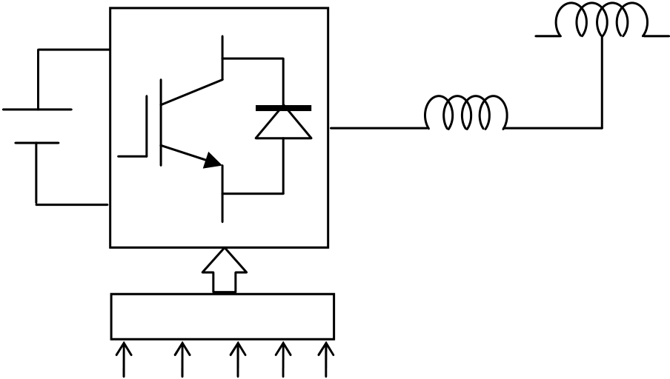

*Pradeep Kumar et al. / AASRI Procedia 5 ( 2013 ) 249 – 261*  253

|  |  |  |  |  |  |  |  |  |  |  |  |  |  |  |  |  |  |  |
| --- | --- | --- | --- | --- | --- | --- | --- | --- | --- | --- | --- | --- | --- | --- | --- | --- | --- | --- |
| |  |  |  |  |  |  | | --- | --- | --- | --- | --- | --- | | *Sv* | *R s* | *sL* | *tv* | *Li* | Unbalanced |   &Non-linear   |  |  |  | | --- | --- | --- | | *Si* | *Ci* | Load |        |  |  |  | | --- | --- | --- | | *V dc* | **+** | *fL* | | **|** |   SRF controller   |  |  |  |  |  | | --- | --- | --- | --- | --- | | *V* dc | *i*La | *i*Lb | *i* Lc | *tV* | |

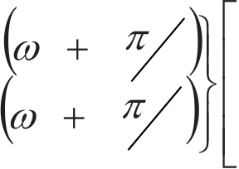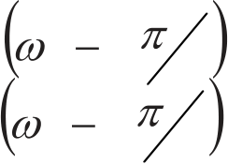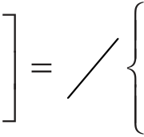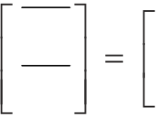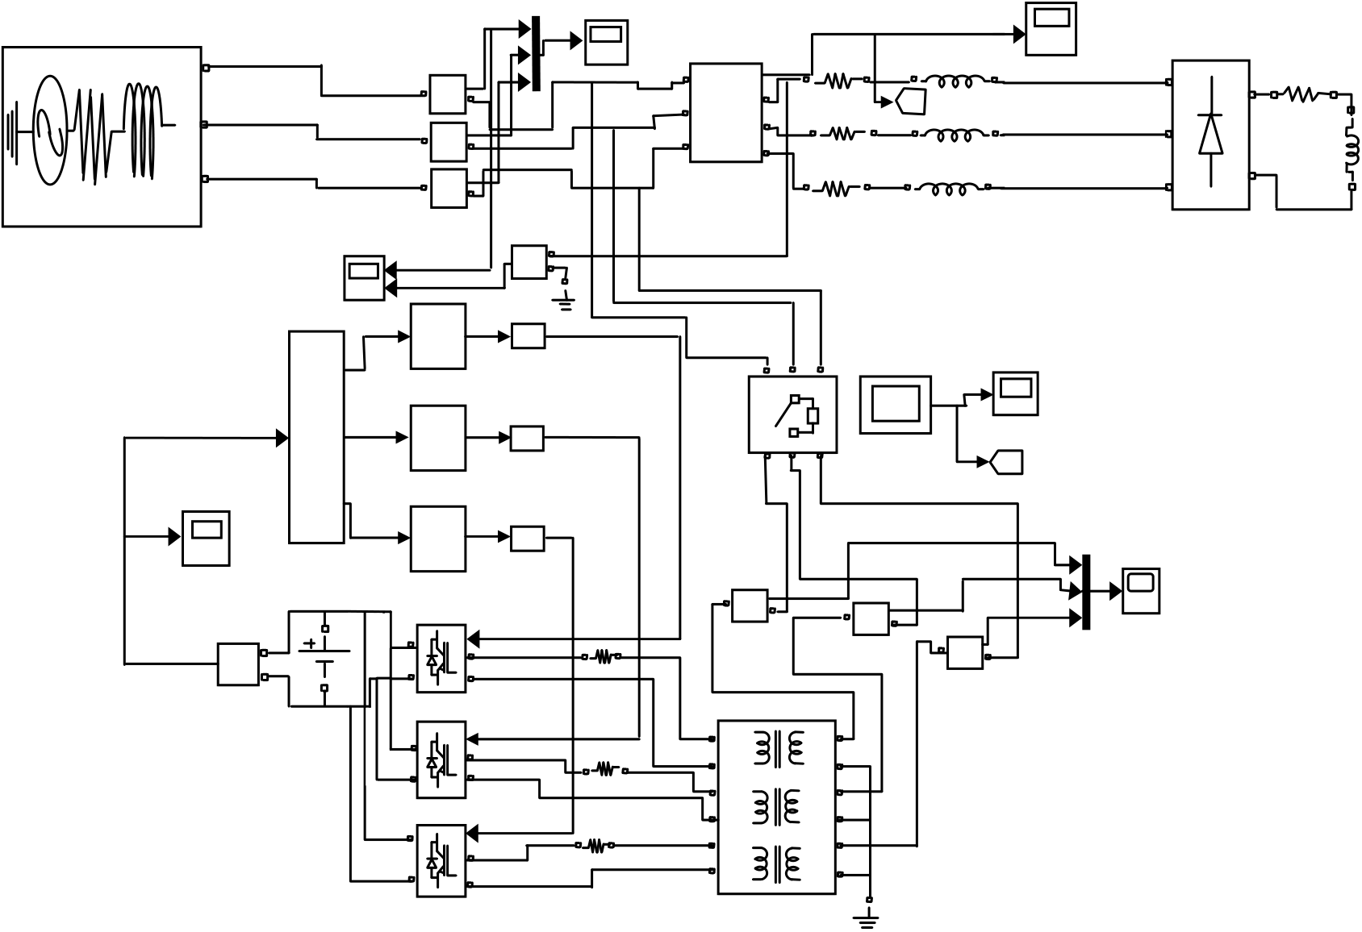

|  |  |  |  |  |  |  |  |  |  |  |  |  |  |  |  |  |  |  |
| --- | --- | --- | --- | --- | --- | --- | --- | --- | --- | --- | --- | --- | --- | --- | --- | --- | --- | --- |
| 254 | A | A | Isa&Vta | *Pradeep Kumar et al. / AASRI Procedia 5 ( 2013 ) 249 – 261* | | | | | | | | | | Vt1 | A | | Rd | Ld |
| | | IS | A | Vabc | | | | Vt1 | | |
| + | B | | | a | Ra | | [A] | | La | + | | |
| -  Current | A | Rd | |
| B | B | b | Goto | | B | +  B | |
| | |
| + | C | | | c | | Rb | | Lb | | Ld |
| -  Current1 | - | | |
| C | C | Three-Phase | | | | | C | | |
| | | Universal Bridge C | | - |
| Three-Phase Source | + | V-I Measurement | | | | |
| -  Current2 | Rc | | | | | | Lc | | |
| Three-Phase Source | Universal Bridge | | |
| Volt1 | | | | | | | | | |
| + | | | | | | | | | |

V   
 -

3

|  |  |  |  |  |  |  |  |  |  |  |  |  |  |  |  |  |
| --- | --- | --- | --- | --- | --- | --- | --- | --- | --- | --- | --- | --- | --- | --- | --- | --- |
| DC LINK | Out1 | | | | | 1/Z | | Three-Phase Breaker | | | a A | b B | c C | 3 | |La, |Lb, |Lc | |L |
| Unit Delay1 | | IL | [B] |
| Goto1 |
| Discrete | |
| PWM Generator | |
| In1 Out2 | | | | |
| 1/Z | |
| Ila, Ilb, Ilc |
| Out3 | | | | | Unit Delay2 | | | | | | | | | [B] | IC |
| Discrete | | Goto1 |
| PWM Generator1 | | ICa |
| 1/Z | |
| SRF controller | | | | | ICb |
| Unit Delay3 | |
| DC LINK | | | | | Discrete | | | |
| PWM Generator2 | | ICc |
| + | | | | | |
| Lf2 | -  Current3 | | | | | + |
| A | + | Volt | | DC | + | g | -  Current4 | | |
| B | v | | + Odc | A | | + |
| - |
| - | | - | | | = | B | A1+ A2+ | | | | | | Current5 |
| C | | | | | IGBT Bridge 2 arm | |
| Universal Bridge1 | | | | |
| Volt | | | | | + | g |
| V | +  - | | | | A | | Lf1 | | A1 A2 | | | |
| = | B | B1+ B2+ | | | | | |
| IGBT Bridge 2 arm1 | |
| Lf | B1 B2 | | | | |
| DC LINK | | | | |
| + | g |
| A | | C1+ C2+ | | | | | |
| = | B | C1 C2 | | | | | |
| Three-phase | | | | | |
| IGBT Bridge 2 arm2 | |
| Linear Transformer | | | | | |

Fig. 3. DSTATCOM with constant DC voltage including Simulink Model   
**3. Control Scheme**   
 DSTATCOM Topologies are controlled using Synchronous Reference Frame (SRF) theory.

The three phase load current in *a*–*b*–*c* frame are converted to the two phase load current in *d*–*q* frame using the following formulation

|  |  |  |  |  |  |  |  |  |  |  |  |  |  |  |  |  |  |  |  |  |  |
| --- | --- | --- | --- | --- | --- | --- | --- | --- | --- | --- | --- | --- | --- | --- | --- | --- | --- | --- | --- | --- | --- |
|  | *i* | *Ld* | 2 | 3 | cos |  | *t* | L d | cos | *t* |  | 2 | 3 | cos | *t* | 2 | 3 | *i* | *La* |  | (1) |
| *i* |
| *i* | sin |  | *t* | sin | *t* | 2 | sin | *t* | 2 | *Lb* |
| *Lq* |
| 3 | 3 | *i* | *Lc* |
| i | | G (s )i | L d |
| i | | G (s )i | (2) |
| L q | L q |

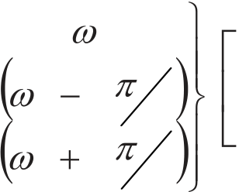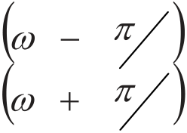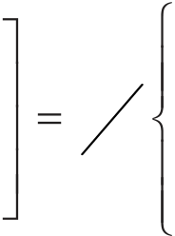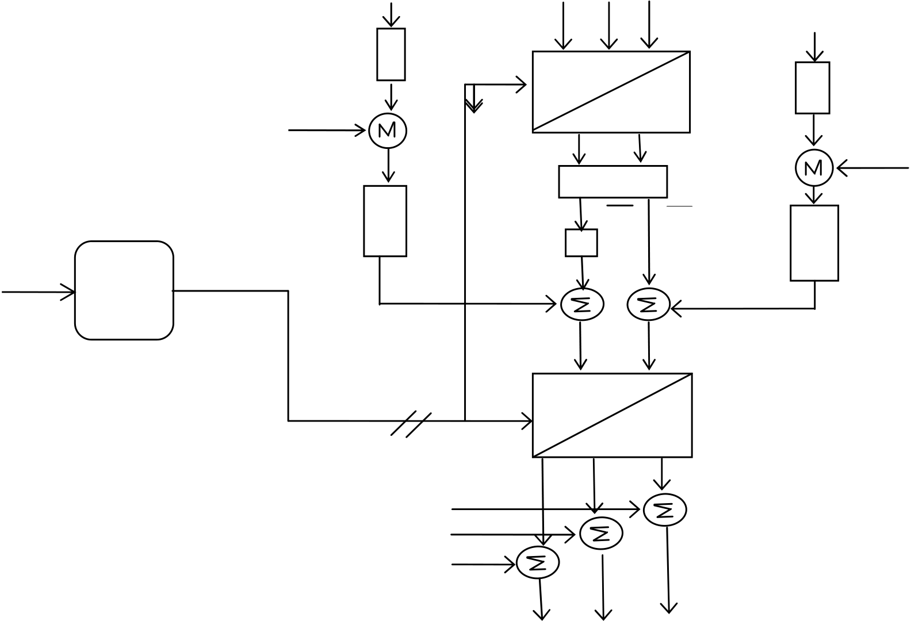

*Pradeep Kumar et al. / AASRI Procedia 5 ( 2013 ) 249 – 261*  255

Vt iLa iLb iLc   
 Vdc

a-b-c

|  |  |  |  |  |  |  |  |  |  |  |  |
| --- | --- | --- | --- | --- | --- | --- | --- | --- | --- | --- | --- |
| Vt | PLL | Vt* | - | Kq | d-q | | | - | + | Vdc | * |
| + |
| iLq | iLd iLd | |
| LPF | | |
| iLq iLq | iLd | |
| uiCq | + | + | | | i*Cd* |
| + | *i *Sq* | i | * + |
| sinwt & coswt | d-q | Sd |

a-b-c

|  |  |  |  |  |  |
| --- | --- | --- | --- | --- | --- |
| iLa | - | *i *Sc* | *i *Sb* | - | *i *Sa* |
| - | + | |
| iLb |
| + |
| iLc | + |

*i*Cc*\*i*Cb*\*i*Ca*

Fig. 4. Block diagram for Synchronous Reference Frame (SRF) Control Scheme

|  |  |  |  |  |  |  |  |  |  |  |  |  |
| --- | --- | --- | --- | --- | --- | --- | --- | --- | --- | --- | --- | --- |
| Gain | K is defined as the ratio of q | | | | | | | | | | Q to *  S | Q and its value will be Zero for Power Factor Improvement. |
| The d-q component of reference source currents are obtained as | | | | | | | | | | | | |
| i | | * | | i |  |  | i | Cd | | | | |
| Sd | | i | Ld |  |
| i *  Sq | | | K i q Lq | | | | |  |  | Cq |  | |
| ui | (3) | |

The d-q component of reference source currents are converted to the three phase a*-b-c* frame using the following formulation

|  |  |  |  |  |  |  |  |  |  |  |  |  |  |  |  |  |  |  |  |
| --- | --- | --- | --- | --- | --- | --- | --- | --- | --- | --- | --- | --- | --- | --- | --- | --- | --- | --- | --- |
|  | *i* | * | *sa* | 2 | 3 | cos | cos |  | *t* | 3 | sin | sin | *t* | 3 | *i* | * | *sd* |  | (4) |
| *i* | * | *sb* | *t* | 2 | | *t* | 2 |
| *i* | * |
| *i* | * | *sc* | cos | *t* | 2 | | sin | *t* | 2 | *sq* |
| 3 | 3 |

The desired compensator currents can be obtained as

|  |  |  |
| --- | --- | --- |
| i *  Ca | i La | i *  Sa |
| i *  Cb | i Lb | i *  Sb |

|  |  |  |  |
| --- | --- | --- | --- |
| 256 | *Pradeep Kumar et al. / AASRI Procedia 5 ( 2013 ) 249 – 261* | | |
| i *  Cc | i Lc | i *  Sc |

**4. Simulation Results**   
 The three DSTATCOM topologies have been simulated for the power factor improvement mode. The total simulation period is 1.0 s. Based on the simulation results,the following analysis can be prepared:   
 (1)The simulation results of sysem1 are depicted in Fig. 6. Load current is unbalanced and non-sinusoidal. Compensator current is sinusoidal in nature. The phase angle between source current and Terminal voltage are Zero degree. This ensure Power factor will be unity i.e. Power factor can be improved after the DSTATCOM is switched on. The dc link voltage Vdc as shown in Fig continues to increase until the DSTATCOM is switched on and finally reach the steady state value of 500V. It starts settling after 0.2 s. The dc voltage Vdc starts to build up on the dc capacitor Cdc.

(2)The simulation results of sysem2 are depicted in Fig.7. The waveform of Load current, Compensator current, Source current and Terminal Voltage are same as in Fig.6 but the magnitude of load current is comparatively increased. Power factor can be improved after the DSTATCOM is switched on. The DC link voltage Vdc exponentially increasing with time as shown in Fig. The DC link voltage is not maintained constant but tending towards the value of 250 V.

(3)The simulation results of sysem3 are depicted in Fig.8. The waveform of Load current, Compensator current, Source current and Terminal Voltage are same as in Fig. 6. Power factor can be improved after the DSTATCOM is switched on. The DC link voltage is maintained constant at 500 V before and after the DSTATCOM is switched on. This allows the DSTATCOM to improve Power Factor with almost no interruption in the load current.

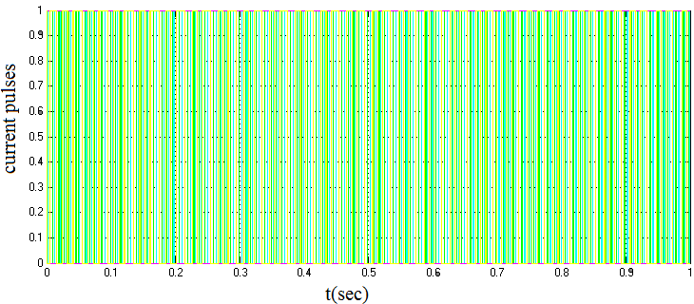

Fig.5. PWM pulses for IGBT

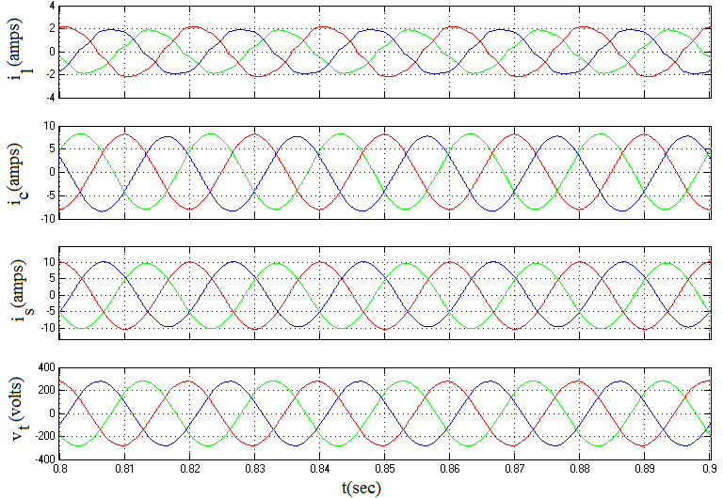

|  |  |  |
| --- | --- | --- |
| Vdc(volts) | *Pradeep Kumar et al. / AASRI Procedia 5 ( 2013 ) 249 – 261* | 257 |
| 600  300  200  100  500  400  0 0 0.1 0.2 0.3 0.4 0.5 0.6 0.7 0.8 0.9 1 |

t(sec)

Fig. 6. System response with Power Factor Improvement (system1)

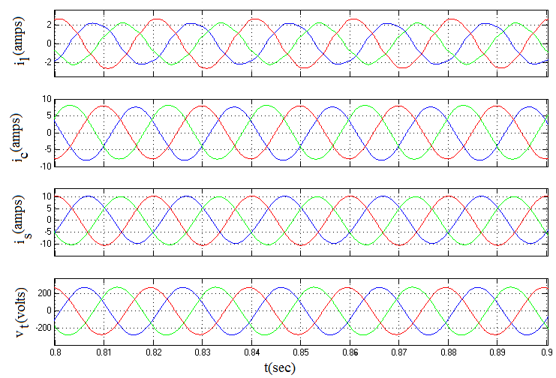

|  |  |  |
| --- | --- | --- |
| 258 | Vdc(volts) | *Pradeep Kumar et al. / AASRI Procedia 5 ( 2013 ) 249 – 261* |
| 250  100  50  0  200  150  0 0.1 0.2 0.3 0.4 0.5 0.6 0.7 0.8 0.9 1 |

t(sec)

Fig. 7. System response with Power Factor Improvement (system2)

*Pradeep Kumar et al. / AASRI Procedia 5 ( 2013 ) 249 – 261*  259

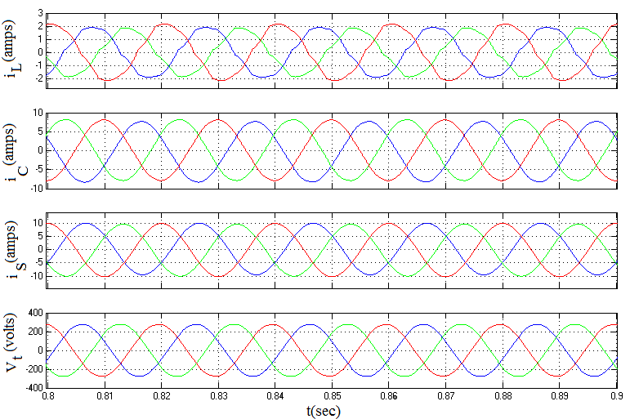

|  |  |  |  |  |  |  |  |  |  |  |  |  |  |  |  |  |  |  |  |  |  |  |  |  |  |  |  |  |  |  |  |  |  |  |  |  |  |  |  |  |  |  |  |  |  |  |  |  |  |  |  |  |  |  |  |  |  |  |  |  |  |  |  |  |  |  |  |  |  |  |  |  |  |  |  |  |  |  |  |  |  |  |  |  |  |  |  |  |  |  |  |  |  |  |  |  |  |  |  |  |
| --- | --- | --- | --- | --- | --- | --- | --- | --- | --- | --- | --- | --- | --- | --- | --- | --- | --- | --- | --- | --- | --- | --- | --- | --- | --- | --- | --- | --- | --- | --- | --- | --- | --- | --- | --- | --- | --- | --- | --- | --- | --- | --- | --- | --- | --- | --- | --- | --- | --- | --- | --- | --- | --- | --- | --- | --- | --- | --- | --- | --- | --- | --- | --- | --- | --- | --- | --- | --- | --- | --- | --- | --- | --- | --- | --- | --- | --- | --- | --- | --- | --- | --- | --- | --- | --- | --- | --- | --- | --- | --- | --- | --- | --- | --- | --- | --- | --- | --- | --- | --- |
| 501  499.8  499.6  499.4  499.2  500   |  |  |  |  |  |  |  |  |  |  | | --- | --- | --- | --- | --- | --- | --- | --- | --- | --- | |  |  |  |  |  |  |  |  |  |  | |  |  |  |  |  |  |  |  |  |  | |  |  |  |  |  |  |  |  |  |  | |  |  |  |  |  |  |  |  |  |  | |  |  |  |  |  |  |  |  |  |  | |  |  |  |  |  |  |  |  |  |  | |  |  |  |  |  |  |  |  |  |  | |  |  |  |  |  |  |  |  |  |  | |  |  |  |  |  |  |  |  |  |  | |  |  |  |  |  |  |  |  |  |  |   500.8  500.6  500.4  500.2  Vdc(volts)  499 0 0.1 0.2 0.3 0.4 0.5 0.6 0.7 0.8 0.9 1 |

t(sec)

Fig. 8. System response with Power Factor Improvement (system3)

260  *Pradeep Kumar et al. / AASRI Procedia 5 ( 2013 ) 249 – 261*

**5. Conclusion**   
This paper has developed models for different system topologies of the Distribution Static Compensator (DSTATCOM) using Simulink’SimPowerSystem Toolbox. The control of the DSTATCOM system topologies is based on Synchronous Reference Frame control. Time domain simulations have been used to verify the operation of these models. These models can be easily modified to:   
1- Perform different types of power quality studies in a user friendly simulation environment for teaching and researching.

2- Test control strategies and methods for the DSTATCOM.

3- Develop models for other system topologies of the DSTATCOM, which is not considered is this paper, by modifying the existing modeled topologies.

**Acknowledgments**   
We would like to thank Director,NIT Jamshedpur for providing financial support to complete the research work under TEQIP scheme for Mr Pradeep Kumar.

**References**   
[1]Chen B S, Hsu Y Y.A minimal harmonic controller for a STATCOM.IEEE Trans. Ind. Electron. Feb. 2008; 55(2): pp. 655–664.

[2]Akagi H, Watanabe E H, Aredes M . Instantaneous Power Theory and Applications to Power Conditioning. Hoboken: NJ Wiley;2007.

[3] Herrera R S, Salmeron P, Kim H.Instantaneous reactive power theory applied to active power filter compensation: Different approaches, assessment, and experimental results.IEEE Trans. Ind. Electron. Jan. 2008; 55(1): pp. 184–196.

[4] Divan D M, Bhattacharya S, Banerjee B.Synchronous frame harmonic isolator using active series filter. inProc. Eur. Power Electron. Conf. 1991; pp. 3030–3035.

[5] Singh B,Verma V.Selective compensation of power-quality problems through active power filter by current decomposition. IEEE Trans. Power Del.Apr. 2008; 23(2): pp. 792–799.

[6] Lascu C,Asiminoaei L,Boldea I, Blaabjerg F.Frequency response analysis of current controllers for selective harmonic compensation in active power filters.IEEE Trans. Ind. Electron. Feb. 2009;56(2): pp. 337– 347.

[7] Luo A, Shuai Z, Zhu W, Shen Z J.Combined system for harmonic suppression and reactive power compensation.IEEE Trans. Ind Electron. Feb. 2009; 56(2): pp. 418–428.

[8] Shyu K K, Yang M J, Chen Y M, Lin Y F. Model reference adaptive control design for a shunt active- power-filter system. IEEE Trans. Ind. Electron. Jan. 2008; 55(1): pp. 97–106.

[9] Mohagheghi S, Valle Y,Venayagamoorthy G K, Harley R G. A proportional-integrator type adaptive critic design-based neurocontroller for a static compensator in a multimachine power system. IEEE Trans. Ind. Electron.Feb. 2007; 54(1); pp. 86–96.

[10] Shu Z, Guo Y, Lian J. Steady-state and dynamic study of active power filter with efficient FPGA-based control algorithm.IEEE Trans. Ind. Electron. Apr. 2008; 55(4): pp. 1527–1536.

[11]Sen K. K, Keri A J F. Comparison of field results and digital simulation results of Voltage-Sourced Converter-based FACTS controllers.IEEE Trans. Power Delivery. January 2003;18(1): pp. 300-306.

[12] https:\\www.mathworks.com   
[13]Padiyar K R. FACTS controllers in power transmission and distribution. India: New age international publishers; 2007.

**APPENDIX**

AC line voltage: VLL= 415 V, 50 Hz, Source inductance and resistance: Ls= 42 mH, Rs= 1.57

Unbalanced R-L Load at each phases: Phase a- 45, 195 mH, Phase b- 70, 220 mH,

Phase c- 30, 170 mH

Diode resistance and inductance- 120, 35 mH   
Proportional controller gain: Kp= 0.6 , Proportional gain = -0.2 , Integral gain = -40

|  |  |  |
| --- | --- | --- |
| *Pradeep Kumar et al. / AASRI Procedia 5 ( 2013 ) 249 – 261* |  | 261 |
| DC Voltage : Vdc = 400V, DC capacitance: Cdc = 3500 μF, DC resistance: Rdc = 5500 |
| Filter inductance: Lf = 5.0 mH, PWM switching frequency: 20 kHz |