|  |  |  |
| --- | --- | --- |
|  | Available online at www.sciencedirect.com |  |
| **ScienceDirect** |
| AASRI Procedia 4 ( 2013 ) 104 – 109 |
| 2013 AAS SRI Confere ence on Inte elligent Syst tems and Co ontrol | | |
| On Perf formanc e Analy sis of IA ASEN–3 | | in Fault ty and N Non– |
| Faulty N Network k Condit tions  Ved Praka ash Bhardw waj and Nit tin, *Senior Member, I IEEE*\*  *De epartment of Com mputer Science & & Engineering and d Information & Communication T Technology,* | | |

*Jayp pee University of f Information Tech hnology, Waknag ghat, Solan–1732 234, Himachal Pr radesh, INDIA*

|  |  |  |  |  |  |  |  |  |
| --- | --- | --- | --- | --- | --- | --- | --- | --- |
| *ved.juit@ @gmail.com and delnitin@ieee.or rg* | | | | | | | | |
| **Abst tract** | | | | | | | | |
| This | paper presents | a new fault sus stainable interc onnection netw work (IN) called d as Irregular A Augmented Shuf ffle Exchange | | | | | | |
| Netw work–3 (IASEN N–3) and its rou uting algorithm m. The Performa ance of IASEN N–3 has been ev valuated and co ompared with | | | | | | | | |
| exist ting IASEN–2. | | The experimen ntal results show ws that IASEN––3 is more effic cient than IASE EN–2 in terms o of throughput | | | | | | |
| and p processor utiliz ation. These res sults are analyz zed in faulty and d non–faulty ne etwork environm ments. | | | | | | | | |
| © 2013 The Authors. Published by Elsevier B.V.© 20 013. Published d by Elsevier B.V. | | | Open access under [CC BY-NC-ND license.](http://creativecommons.org/licenses/by-nc-nd/3.0/) | | | | | |
| Selection and/or peer review under responsibility of American Applied Science Research Institute earch Institute  *Keyw words:*Interconnec ction Network; M Multistage Intercon nnection Network k; IASEN–2; IAS SEN–3; Fault. | | | | | | | | |
| **1.In ntroduction a and Motivatio on** | | | | | | | | |
| Presence of M Multi–stage In nterconnection n Networks | | | | | (MINs) in al ll parallel an nd distributed d computing | | | |
| appl lications make es them fast a and reliable. T The efficiency y, cost and va arious other fa actors makes i it better and | | | | | | | | |
| more e robust than | | the other INs s [1, 2]. Some etimes, MINs | | | faces the fau ulty situations | | during data t transmission | |
| proc cess [2–5]. Th his situation m may arise due | | | | to any link f failure or any | | switch failur re. Both condi itions create | | |
| distu urbance in the e network and d degrade the | | | performance | | of network [3 3–8]. This pa aper deals with h the switch | | | |
| failu ure problem an nd presents a n new IN name d Irregular Au ugmented Shu uffle Exchang e Network–3 | | | | | | | | (IASEN–3). |
| The | IASEN–3 pe erforms well i in case of mu ultiple faulty | | | | switching ele ements (SEs). The designe ed pattern of | | | |
| IASE EN–3 is inspi red by IASEN N–2 [8] and th herefore, perfo ormance of IA ASEN–2 is com mpared with I IASEN–3 on | | | | | | | | |
| * Nitin Tel.: +91-1 1792-239-369; fax x: +91-1792-245 | | | 362. | | | | | |

*E-mail address:* de elnitin@juit.ac.in n

2212-6716 © 2013 The Authors. Published by Elsevier B.V. Open access under [CC BY-NC-ND license.](http://creativecommons.org/licenses/by-nc-nd/3.0/)

Selection and/or peer review under responsibility of American Applied Science Research Institute

doi: 10.1016/j.aasri.2013.10.017

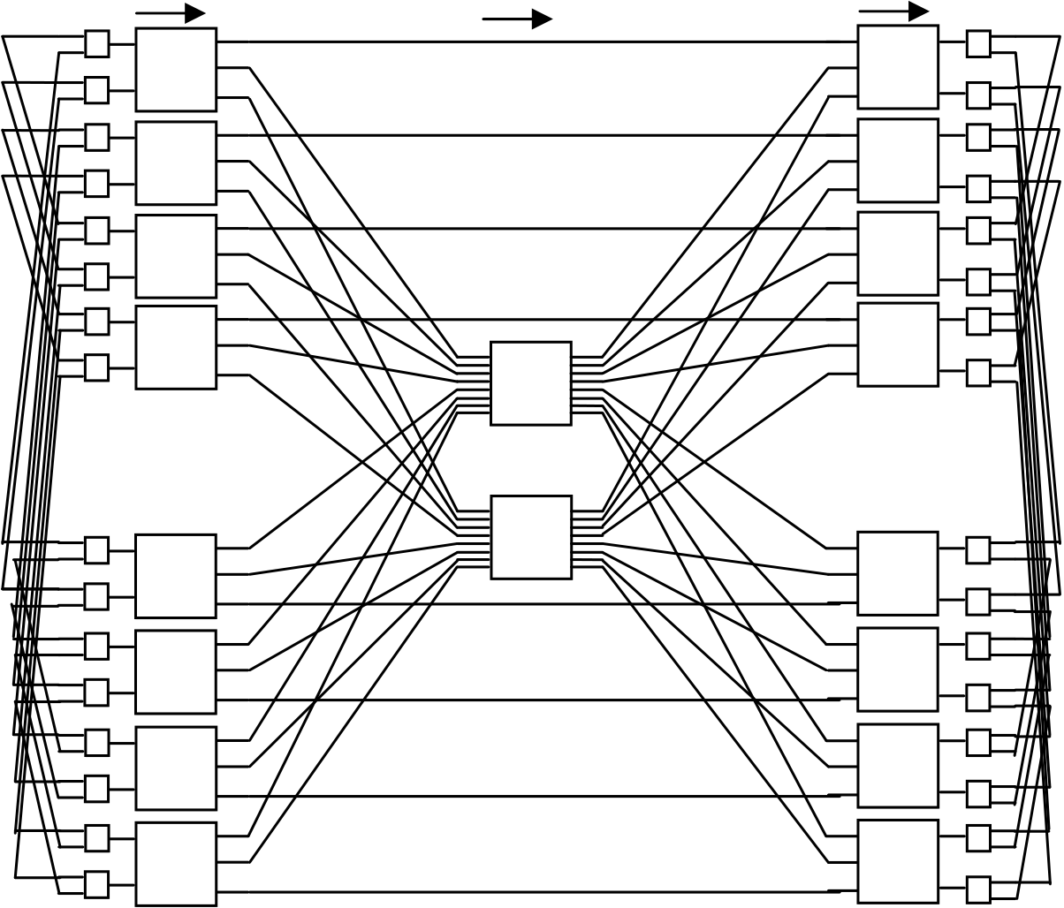

*Ved Prakash Bhardwaj and Nitin / AASRI Procedia 4 ( 2013 ) 104 – 109*  105

the basis of various performance parameters. Data packets are transmitted through IASEN–2 [8] and IASEN–3 to a preset number of destinations. Results show that IASEN–3 has better throughput and processor utilization than the IASEN–2 [8] in faulty and non–faulty network scenario.

The rest of the paper is structured as follows: In section 2, structure of IASEN–3 is discussed. Section 3 shows the routing algorithm. In section 4, the performances factors are explained. Results are shown in section 5. At last, section 6 is followed by conclusion and references.

**2.Proposed Interconnection Network**

The structure of Irregular Augmented Shuffle Exchange Network–3 is based on IASEN–2 [8]. In Fig. 1, we can see that it has 16 sources and 16 destinations, hence the size of IASEN–3 is N =16. All the sources and destinations are tightly coupled with the complete network through multiplexers (Mux) and demultiplexers (Demux). This is a 3–stage MIN. In first and last stage, each source or each destination is connected with three switching elements (SEs) of that particular stage e.g. source 11 is connected with SE *f*, *a* and *d* and therefore *f*, *a* and *d* are the primary, first alternate and second alternate SEs for source 11. Similarly, we can find out the primary, first alternate and second alternate SEs for other sources and destinations. The size of each SE in first and third stage is 2×3 and 3×2 respectively. In stage 2, the size of each SE is 8×8.

Source Mux Stage1 Stage2 Stage3 Demux Destination

|  |  |  |  |  |
| --- | --- | --- | --- | --- |
| 0 | *a* | *i* | *k* | 0 |
| 1 | *b* | *l* | 1 |
| 2 | 2 |
| 3 | *m* | 3 |
| 4 | *c* | 4 |
| 5 | *n* | 5 |
| 6 | *d* | 6 |
| 7 | 7 |
| 8 | *e* | *j* | *o* | 8 |
| 9 | *f* | *p* | 9 |
| 10 | 10 |
| 11 | *g* | *q* | 11 |
| 12 | 12 |
| 13 | *r* | 13 |
| 14 | *h* | 14 |
| 15 | 15 |

Fig. 1. irregular augmented shuffle exchange network–3

**3.Routing Algorithm of IASEN–3**

In the routing algorithm of IASEN–3, if request arrives at the primary SE of first stage (PSE1) or primary SE of third stage (PSE3), then we have to check that SE. If it is busy or faulty (FBY) then first alternate SE

106  *Ved Prakash Bhardwaj and Nitin / AASRI Procedia 4 ( 2013 ) 104 – 109*

(AE1) will get the request of that particular stage. If AE1 is busy or faulty then request will be arrived at second alternate SE (AE2). In case all the SEs i.e. PSE1, AE1 and AE2 of first stage or PSE3, AE1 and AE2 of third stage are not responding properly then request will be dropped. If request arrives at SE *i* of second stage and it is busy or faulty then SE *j* of second stagewill receive the request. If it is also busy or faulty then request will be dropped. Finally, we can say that, if the required SEs of all three stages are in working condition then data will be transmitted from the given source to its given destinations otherwise data transmission process will be stopped. In third step of algorithm the term “Node” may be the SE of second stage or the given destination.

Algorithm_IASEN–3   
______________________________________________________________________________________ Input: N, Source, Destinations   
Output: Data Packets Reached Successfully or Drop the Request   
______________________________________________________________________________________ **BEGIN**   
 1.**if***PSE1 == FBY || PSE3 == FBY*  *// FBY means busy or faulty*   
 2. **then**  *AE1*   
 3.**else***Send Request to Next Appropriate Node*   *// Here Node may be SE or destination*  4.**if** *AE1 == FBY*   
 5. **then** *AE2*   
 6.**else***Send Request to Next Appropriate Node*   
 7.**if***AE2 == FBY*   
 8. **then** *Drop the Request*   
 9.**if***i == FBY*   
 10. **then** *j*   
 11.**else***Send Request to Appropriate SE of Third Stage*   
 12.**if** *j == FBY*   
 13. **then***Drop the Request*

|  |  |
| --- | --- |
| **End** | 14.**else***Send Request to Appropriate SE of Third Stage* |

______________________________________________________________________________________ **Theorem:** IASEN-3 is a single switch fault tolerant network in every stage.

**Proof:** Let the source is 2 and destinations is 9. We assumed that SEs *b*, *i*, and *o* are faulty. In this situation the rest of the paths are as follows:   
*Path 1: 2-6-Mux-d-j-k-Demux-1-9*   
*Path 2: 2-10-Mux-f-j-k-Demux-1-9*   
*Path 3: 2-6-Mux-d-j-q-Demux-13-9*   
*Path 4: 2-10-Mux-f-j-q-Demux-13-9*   
These available paths prove that IASEN-3 is a single switch fault tolerant network in every stage.

**4.Performance Evaluation Parameters**

This section discusses the various performance factors of IASEN–2 and IASEN–3.

*Ved Prakash Bhardwaj and Nitin / AASRI Procedia 4 ( 2013 ) 104 – 109*  107

*4.1.Bandwidth (BW)*

*“BW is defined as the expected number of destination receiving requests in any given cycle. It means it is the total number of requests matured [5– 7]”.* It is calculated as follows:

 

Here, is the request generation probability and  is the total number of destinations. The general probability equation can be written as:

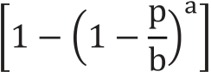 

Here a & b are the total number of inputs and output lines of a SE respectively.

Probability equation for IASEN–2

|  |  |  |  |
| --- | --- | --- | --- |
|  | | ). |  |
|  | |  |
|  | |  |
|  | |  |
| Here | and therefore |

Probability equation for IASEN–3

|  |  |  |  |  |
| --- | --- | --- | --- | --- |
|  | | | ). |  |
|  | | |  |
|  | | |  |
| Here | and therefore |  |

108  *Ved Prakash Bhardwaj and Nitin / AASRI Procedia 4 ( 2013 ) 104 – 109*

*4.2.Message Transmission Time (tt)*

It is the time that all generated data packets will take from a given source to a single destination. It is given by the following formula:

 

 

: Total number of data packets

 : Total number of stages in the network

: Routing time between two nodes and node may be source, destination or any SE.

: Transmission time when single SE is faulty in every stage of the network

*4.3.Throughput(TP)*

*“TP means average number of cells delivered by a network per unit time. It is also defined as maximum number of traffic accepted by a network per unit time [5–7]”.*TP can be calculated using the given formula:

 

*4.4.Processor Utilization(PU)*

*“It is defined as percentage of time the processor is active doing computation without accessing the global memory [5–7]”.*PU can be calculated using the given formula:

 

**5.Performance Comparison of IASEN–2 and IASEN–3**

In order to compare the performance of IASEN–2 [8] and IASEN–3, message multicasting is performed in faulty and non–faulty network condition. Let the source is 5 and it has transmitted the data packets to destinations 1, 3, 5, 9 and 11. Data is transmitted in non–faulty and single switch faulty conditions. In this

|  |  |  |
| --- | --- | --- |
| paper, we assumed that routing time |  | of a data packet is 0.01 ms in non–faulty case and 0.02 ms in single |

switch faulty case. In this research work, both terms “Single switch faulty” and “faulty” represents that single switch is faulty in each stage during the transmission of data packets. The offered load or request generation probability is and it is assumed to be . Data packets are generated on the given probabilistic values and then sent to destinations 1, 3, 5, 9 and 11. As explained in equation (10) and (11), we will calculate the transmission time of IASEN–2 [8] and IASEN–3 in faulty and non–faulty cases. Equations of section 4 are used to calculate the throughput and processor utilization of IASEN–2 [8] and IASEN–3 in faulty and non–faulty condition. IASEN–2_F and IASEN–3_F are the IASEN–2 and IASEN–3 in faulty case as shown in Fig. 2. On the basis of the bandwidth, TP of IASEN–2 and IASEN–3 have been calculated.

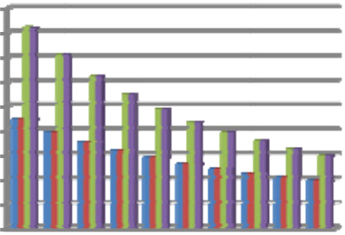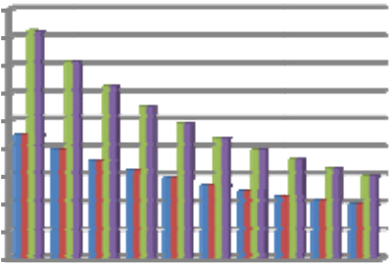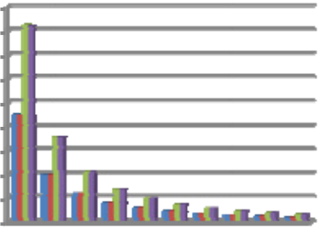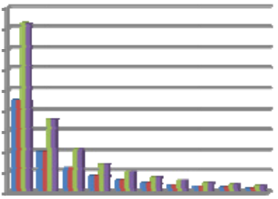

|  |  |  |  |  |  |  |  |  |  |  |  |  |  |  |  |  |  |  |  |
| --- | --- | --- | --- | --- | --- | --- | --- | --- | --- | --- | --- | --- | --- | --- | --- | --- | --- | --- | --- |
|  | *Ved Prakash Bhardwaj and Nitin / AASRI Procedia 4 ( 2013 ) 104 – 109* | | | | | | | | | | | | | | | | | | 109 |
| |  | | --- | | **TP** | | **Throughput** | | **Comparison** | **of** | **IASEN-2** | | | **and** | **Processor** | | | **Utilization Com mparison of IAS SEN-2** | | | | | | |  |
| **IASEN-3 in n Faulty and N Non-faulty Con ndition** | | | | | | | | **and** | | **IASE EN-3** | | **in** | **Faul lty** | **and** | | **Non-f faulty** | |
| **when N=16** | | | | | | | | **Condition** | | | **when N=16** | | | | | | |
| 0.45 | | | | | | | | 4.5 | | | | | | | | | |
| 0.4 | | | | | | | | 4 | | | | | | | | | |
| 0.35 | | | | | | | | 3.5 | | | | | | | | | |
| 0.3 | | | |  | | IA ASEN-2 | | **PU** | 3 | |  | | | | | | IA ASEN-2 |
| 0.25 | | | | 2.5 | |
| 0.2 | | | |  | | IA ASEN-2_F | | 2 | |  | | | | | | IA ASEN-2_F |
| 0.15 | | | | 1.5 | |
| 0.1 | | | |  | | IA ASEN-3 | | 1 | | |  | | | | | | IA ASEN-3 |
| 0.05 | | | | 0.5 | | |
| 0 | 0.1 0.2 2 0.3 0.4 0.5 0.6 0.7 0 .8 0.9 | | | 1 |  | IA ASEN-3_F | | 0 | | 0.1 0 | .2 0.3 0.4 0.5 0.6 0.7 0. .8 0.9 | | | | 1 |  | IA ASEN-3_F |
| **Offered Load** | | | | | | | | |  | | --- | | **Offered Load** | | | | | | | | | | |

Fig. 2 2. throughput and d processor utiliza ation comparison

|  |  |  |  |  |  |
| --- | --- | --- | --- | --- | --- |
| **6.C Conclusion**  In n this paper, w we have exam mined the perf formance of I IASEN–2 and d the proposed d MIN in faul lty and non– | | | | | |
| fault ty network co onditions. Dat ta packets hav ve been transm mitted through h IASEN–2 a and IASEN–3 | | | | | and in both |
| cond ditions it is se een that IASE EN–3 produce s results that | | | are better tha an IASEN–2. | The theorem | and routing |
| algo orithm makes | | it reliable and d more fault t tolerant as co ompared to IA ASEN–2. Futu ure work may y include the | | | |
| follo owing things: | | | | | |
|  | Generaliza ation of IASE EN–3, | | | | |
|  | Compariso on of perform mance paramete er of IASEN––3 and IASEN N–2 at network k size 32, 64 a and 128. | | | | |

**Refe erences**

|  |
| --- |
| [1] W William Dally and d Brian Towles, P Principles and Pra actices of Intercon nnection Network ks, Morgan Kaufm mann, San Franci isco, ISBN  978–0 0–12–200751–4, 2004.  [2] Ch henggong Charle es Fan and Jehosh hua Bruck, Tolera ating Multiple Fa ults in Multistage e Interconnection n Networks with M Minimal Extra  Stage es, IEEE Transact tions on Compute ers, Volume 49, N Number 9, pp. 99 98–1004, 2000.  [3] V Ved Prakash Bhard dwaj and Nitin, A A New Fault Tole erant Routing Alg gorithm for Advan nce Irregular Alp pha Multistage Int terconnection  Netw work, Advances in n Intelligent and S Soft Computing, S Springer–Verlag, , ISSN: 1867–566 62, pp. 979–987, 2012.  [4] V Ved Prakash Bhard dwaj and Nitin, A A New Fault Tole erant Routing Alg gorithm for Advan nce Irregular Aug gmented Shuffle Exchange  Netw work, Proceedings s of the 14th IEEE E International co onference on Com mputer Modeling and Simulation ( IEEE UKSIM), E Emmanuel  Colle ege, Cambridge, U UK, March 28–30 0, pp. 505–509, 2 2012.  [5] R ita Mahajan and R Renu Vig, Perfor rmance and Relia ability Analysis of f New Fault Tole erant Advance Om mega Network, W WSEAS |

Trans sactions on Comp puters, Volume 7, , pp. 1280–1290, 2008.

[6] A Amardeep Gupta a and Pawan Kuma ar Bansal, Fault T olerant Irregular Modified Alpha Network and Eva aluation of Perfor rmance

Param meters, Internatio nal Journal of Co omputer Applicat tions, Volume 4, N Number 1, pp. 9––13, 2010.

[7] M Mamta Ghai, Vina ay Chopra and Ka aramjit Kaur Chee ema, Performanc e Analysis of Fau ult–Tolerant Irr regular Baseline M Multistage

Interc connection Netwo ork, International l Journal on Comp mputer Science and d Engineering, V Volume 2, Number r 9, pp. 3079–308 84, 2010.

[8] V Ved Prakash Bhard dwaj and Nitin, A A New Fault Tole erant Routing Alg gorithm for IASEN N–2, Proceeding s of the 2nd IEEE E International

Confe erence on Advanc ces in Computing g and Communica ations, pp. 199–2 202, 2012.