[Array 7 (2020) 100034](https://doi.org/10.1016/j.array.2020.100034)

|  |  |  |
| --- | --- | --- |
|  |  |  |
|  | Contents lists available at ScienceDirect |  |
| Array |
| journal homepage: www.elsevier.com/journals/array/2590-0056/open-access-journal |
|  | | |

Process-monitoring-for-quality — A machine learning-based modeling for rare event detection   
Carlos A. Escobara,*, Ruben Morales-Menendezb, Daniela Maciasb   
a Global Research & Development, General Motors, Warren, MI, USA   
b Tecnol�ogico de Monterrey, School of Engineering and Sciences, Monterrey NL, Mexico

|  |  |
| --- | --- |
| A R T I C L E I N F O | A B S T R A C T |
| Index Terms:  Quality control  Manufacturing systems Machine learning  Feature elimination  Model selection  Unbalanced binary data Defect detection | Process Monitoring for Quality is a Big Data-driven quality philosophy aimed at defect detection through binary classification and empirical knowledge discovery. It is founded on Big Models, a predictive modeling paradigm that applies Machine Learning, statistics and optimization techniques to process data to create a manufacturing functional model. Functional refers to a parsimonious model with high detection ability that can be trusted by engineers, and deployed to control production. A parsimonious modeling scheme is presented aimed at rare quality event detection, parsimony is induced through feature selection and model selection. Its unique ability to deal with highly/ultra-unbalanced data structures and diverse learning algorithms is validated with four case studies, using the Support Vector Machine, Logistic Regression, Naive Bayes and k-Nearest Neighbors learning algo- |

rithms. And according to experimental results, the proposed learning scheme significantly outperformed typical learning approaches based on the l1-regularized logistic regression and Random Undersampling Boosting learning algorithms, with respect to parsimony and prediction.

|  |  |
| --- | --- |
| 1. Introduction | [6] and promotes explainability [7]; desired characteristics for a classi- |

fier to be deployed into production, Fig. 2. PMQ has the potential to solve

Because of ever increasing customer demands, manufacturers are in a constant competition for improving quality and reliability in products. These attributes are achieved by correct execution of the manufacturing process and by an effective process monitoring system.

Several researchers have worked on this problem. A framework for multiple release problems using a two-step fault detection procedure and fault removal process was proposed by Ref. [1]. A state-of-the-art report of the most important papers in this domain is presented in Refs. [2]. A similar project, but based on Bayesian Nets was suggested by Ref. [3]. A data mining approach for defect analysis and prevention of industrial

engineering intractable problems e.g., detecting defects that are not detected by Statistical Process Control methods.

Constant product innovation forces manufacturing engineers to launch production systems even without a comprehensive understanding of the process. Therefore, the huge amount of process data (e.g., signals) is used to create hundreds or even thousands of features i.e., hyper-dimensional feature spaces. Which frequently include irrelevant and redundant ones [8,9] that tend to hamper the learning process [10].

Since most manufacturing companies generate only a few Defects Per Million of Opportunities (DPMO), rare quality event detection is one of the

products in Ref. [4]. modern intellectual challenges posed to this industry. From ML

Process Monitoring for Quality (PMQ) is a Big Data-driven quality philosophy aimed at defect detection through binary classification (good/bad) and empirical knowledge discovery through feature/model interpretation [5]. It is a blend of process monitoring and quality control founded on Big Models (BM); a predictive modeling paradigm that uses Machine Learning (ML), statistics and optimization techniques, Fig. 1, to develop a manufacturing functional model: final model (classifier). Functional, refers to a parsimonious classifier with a high detection ca-

perspective, manufacturing-derived data sets for binary classification of quality tend to be highly/ultra-unbalanced (minority class count < 1%). The problem with these data structures is that the learning algorithms misclassify most of the minority class as the majority class, e.g., fail to detect. Since it is harder for the algorithm to learn the minority class.

The unbalanced classification problem is taking a lot of attention from the ML community [11,12]. Extensive efforts and significant progress have been made in recent years to address this intellectual challenge. The

|  |  |  |  |  |  |  |  |  |  |  |
| --- | --- | --- | --- | --- | --- | --- | --- | --- | --- | --- |
| pacity; parsimony facilitates information extraction, induces model trust | main | research | efforts | are | broken | down | in | five | categories: | (1) |

* Corresponding author.

E-mail address: [carlos.1.escobar@gm.com](mailto:carlos.1.escobar@gm.com) (C.A. Escobar).

<https://doi.org/10.1016/j.array.2020.100034>  
Received 24 January 2020; Received in revised form 31 May 2020; Accepted 1 July 2020   
Available online 6 August 2020   
2590-0056/© 2020 The Authors. Published by Elsevier Inc. This is an open access article under the CC BY license (<http://creativecommons.org/licenses/by/4.0/>).

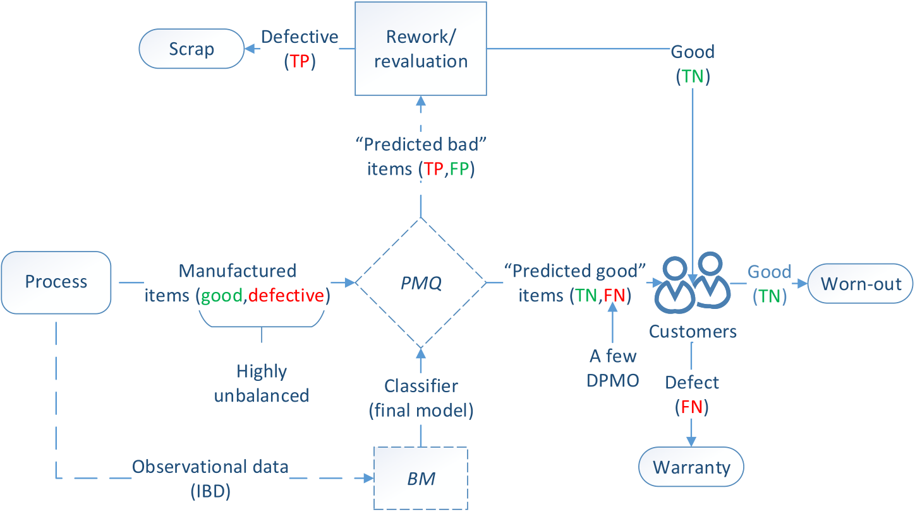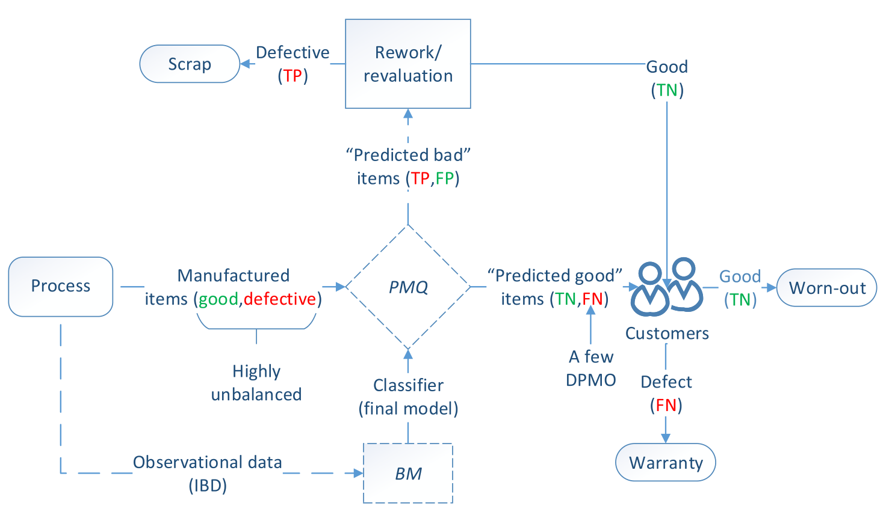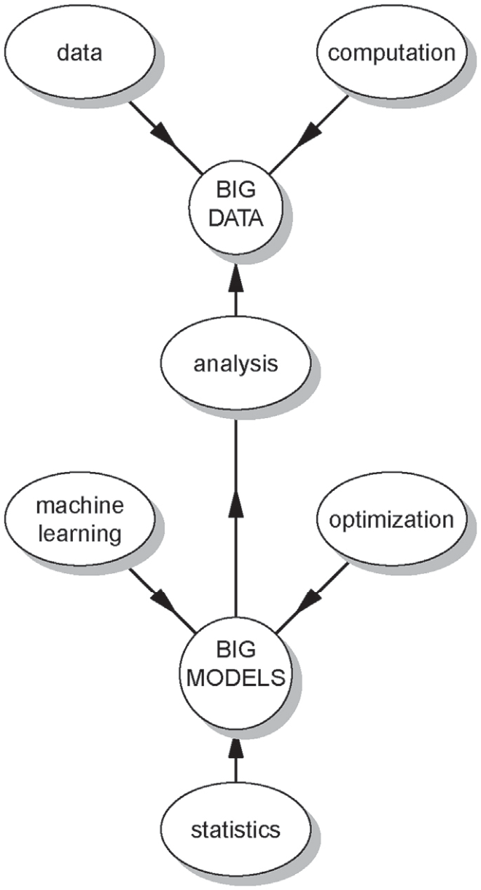

C.A. Escobar et al. Array 7 (2020) 100034

manipulations. Comprehensive reviews of unbalanced learning are pre-  
sented in Ref. [12,13].

The feature explosion (hyperdimensional feature spaces) combined   
with high conformance production rates (unbalanced binary data) are   
two of the most important challenges of Big Data initiatives in   
manufacturing that inspired the development of PMQ-Learning (PMQ-L).   
The Hybrid Feature Selection and Pattern Recognition (HFSPR) approach   
proposed in this paper with the capacity to effectively learn from the   
original data set and to identify the driving features.

The proposal is a novel parsimonious modeling scheme, that can be   
applied to train the Naive Bayes (NB), Support Vector Machine (SVM), K-  
Nearest Neighbor (KNN), Logistic Regression (LR) and Fisher Linear   
Discriminant (FLD) learning algorithms. The goal is a rare quality event   
detection through parsimonious modeling, where parsimony is induced   
through Feature Selection (FS) and Model Selection (MS).

The proposed scheme combines the Hybrid Correlation and Ranking-  
based (HCR) and ReliefF filtering algorithms to select the most relevant   
features. To boost parsimony, a set of nested Candidate Models (CM) is   
developed and then, the Penalized Maximum Probability of Correct Decision   
(PMPCD) MS criterion is applied to select the final model. It can be   
virtually applied to any learning algorithm in which complexity is   
defined by the number of features in the model. Its universal applicability   
is demonstrated by analyzing four highly/ultra-unbalanced data sets   
using different learning algorithms. Empirical results demonstrate its   
capacity of finding a good quality solution after creating a few CM.

This paper is organized as follows: A review of the theoretical back-  
ground is in section 2. Section 3 describes the PMQ-L framework, fol-  
lowed by four binary classification empirical studies in section 4. A   
comparative analysis is given in Section 5. Finally, section 6 concludes   
the research.

|  |  |  |  |  |  |  |  |
| --- | --- | --- | --- | --- | --- | --- | --- |
| Fig. 1. Big data – big models. | | | | | | | 2. Theoretical background 2.1. FS methods |
| over/under-sampling | methods, | (2) | cost | sensitive | learning, | (3) |
| kernel-based learning, (4) active learning and (5) novelty detection. | | | | | | |

Where oftentimes the inherent ad hoc data manipulation (e.g., over/-under sampling, miss-classification costs, using small pools of data) approach lacks of theoretical foundation and principles to guide the development of systematic methods that can be efficiently generalized. In this context, learning from the original data set is identified as further research work [12]. Basically, the authors encourage the research com-munity to investigate the development of algorithms/methods that could learn from whatever highly/ultra unbalanced data is presented without

FS is the procedure of choosing a subset of good features by elimi-nating irrelevant and redundant ones. From a given data set, evaluating all possible combinations (2n) becomes a NP-hard problem as the number of features grow up [14]. The advantages of FS methods are: (1) enable the learning algorithm to train faster, (2) reduce over-complexity of a model making it easier to understand/interpret, (3) improve general-ization (prediction on unseen data) if the right subset is chosen, and (4)

Fig. 2. PMQ-based quality control.   
2

|  |  |  |
| --- | --- | --- |
| C.A. Escobar et al. | Table 2 | Array 7 (2020) 100034 |
| Table 1 |
| Confusion matrix. | Confusion matrix. |

|  |  |  |
| --- | --- | --- |
|  | Predicted good | Predicted bad |
| Good item | True Negative (TN) | False Positive (FP) |
| Bad item | False Negative (FN) | True Positive (TP) |

prevent over-fitting. The FS methods broadly fall into 3 classes: filters, wrappers, and embedded [15].

Filter (preprocessing) methods are applied before the learning process

|  |  |  |  |  |  |  |
| --- | --- | --- | --- | --- | --- | --- |
| to | eliminate | irrelevant/redundant | features. | Relevant | features | are |

selected using a predefined fitness function, which can be based on de-

|  |  |  |  |  |  |  |
| --- | --- | --- | --- | --- | --- | --- |
| pendency, | distance, | consistency | or | discriminative | capacity | [16]. |

Computed scores are used to determine the fitness of each feature and are compared with a relevance threshold to select a subset of relevant fea-tures [10]. These methods select features independently of the learning algorithm.

In contrast, wrappers methods use the learning algorithm as a black-box to evaluate the relative performance of a feature subset [17,18]. In this procedure, a set of candidate features are input to the learning al-gorithm, and the prediction performance is used as the objective function to evaluate the feature subset. Although wrapper methods tend to be computationally intensive, they perform better than filters, due to the bias induced by the algorithm [15].

In embedded methods, the FS task is integrated as part of the learning process. The LASSO with the L1 penalty and Ridge with the L2 penalty are the most common approaches in this category. They shrink irrelevant and trivial features to zero or almost zero respectively [19,20].

Hybrid approaches have been proposed to take advantage of the particular characteristics of each method [21]. These approaches mainly

4). Solution, evaluation and discussion: Although the feature combination is subject to combinatorial explosion, 1:8 � 1016of combinations, the PMQ-L approach only required 83 models to find a solution. To evaluate its relative quality, an exhaustive search was performed with all the possible combinations – up to two features – and compared with the final model. Since no MS is performed, the training set is used to develop the models and the testing set to evaluate their generalization ability: (1) 54ðC1Þ 1-feature models, Fig. 7(top); and (2) 1431ðC2Þ 2-feature models,   
Fig. 7(bottom).

|  |  |  |
| --- | --- | --- |
|  | Predicted good | Predicted bad |
| Good item | 9488 | 5 |
| Bad item | 0 | 7 |

defective (bad) item, whereas a negative label refers to a good quality item. The prediction performance of a classifier is summarized in a confusion matrix [26]. This table is used to contrast predicted labels with the real quality characteristic, Table 1, and to compute relevant measures of classification performance.

A type-I error (α) is compared with a FP prediction; a type-II (β) error is compared with a FN [25]:

|  |  |
| --- | --- |
| α ¼ | FP FN  FP þ TN; β ¼ FN þ TP (1)  The MPCD is a probabilistic measure of classification performance |

that is driven by detection. Since it is very sensitive to FN (missing defective items) in highly/ultra-unbalanced classes [5]. The α and β er-rors are combined to estimate its score:

|  |  |  |
| --- | --- | --- |
| focus on combining filter algorithms with either wrappers or regulariza- | MPCD ¼ ð1 � αÞð1 � βÞ | (2) |
| tion to solve the scalability problem, induce parsimony, and to achieve |

the best possible learning performance. The basic idea is to break down

|  |  |  |  |  |  |  |  |  |
| --- | --- | --- | --- | --- | --- | --- | --- | --- |
| the | FS | problem | into | several | stages, | namely | feature | ranking, |

correlation-based feature elimination, and prediction optimization.

where higher score indicates better classification, MPCD 2 ½0; 1�. 2.5. Penalized Maximum Probability of Correct Decision

2.2. ReliefF It is a MS criterion based on MPCD that efficiently solves the posed

ReliefF ranks features according to their discriminative capacity [22]. It searches for k number of nearest neighbors of the same class (hits), as well as of the different class (misses) to evaluate the fitness of each feature. This procedure is repeated m times, which is the number of randomly selected instances. Features are weighted and ranked based on the average of the distances of all hits and all misses [23,24]. k is a hyperparameter (user-specified) that provides protection to the effect of noise and controls the locality of the estimates. Once all features have been ranked, they are selected based on τ, a significance threshold pro-posed by Ref. [22]. Features with an estimated weight below τ are considered irrelevant and therefore eliminated. The proposed limits for τ are 0 < τ � 1= irrelevant feature as relevant. ReliefF does not eliminate redundant pαm ffiffiffiffiffiffiffi [23]; where α is the probability of accepting an

features.

2.3. Correlation-based redundancy measure

measure of redundancy between two random variables [25]. It is a The Pearson product-moment correlation coefficient ðrxyÞ is used as a

measure of strength of linear relationship between two variables ðx; yÞ, and it can take a range of values ½ � 1; 1�. A value of 0 indicates there is no linear relationship, while an absolute value of 1 (or close to 1) indicates strong linear relationship, and therefore considered highly redundant.

2.4. Maximum probability of Correct Decision — A measure of prediction performance

In the context of binary classification, a positive label refers to a

3

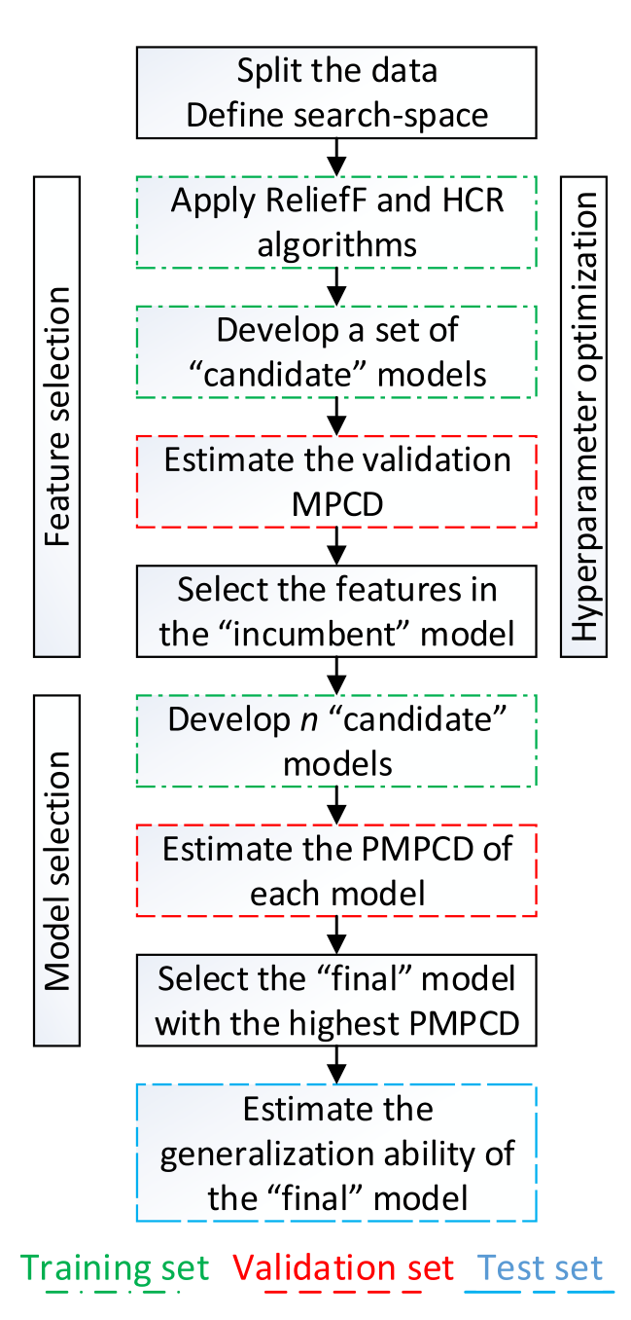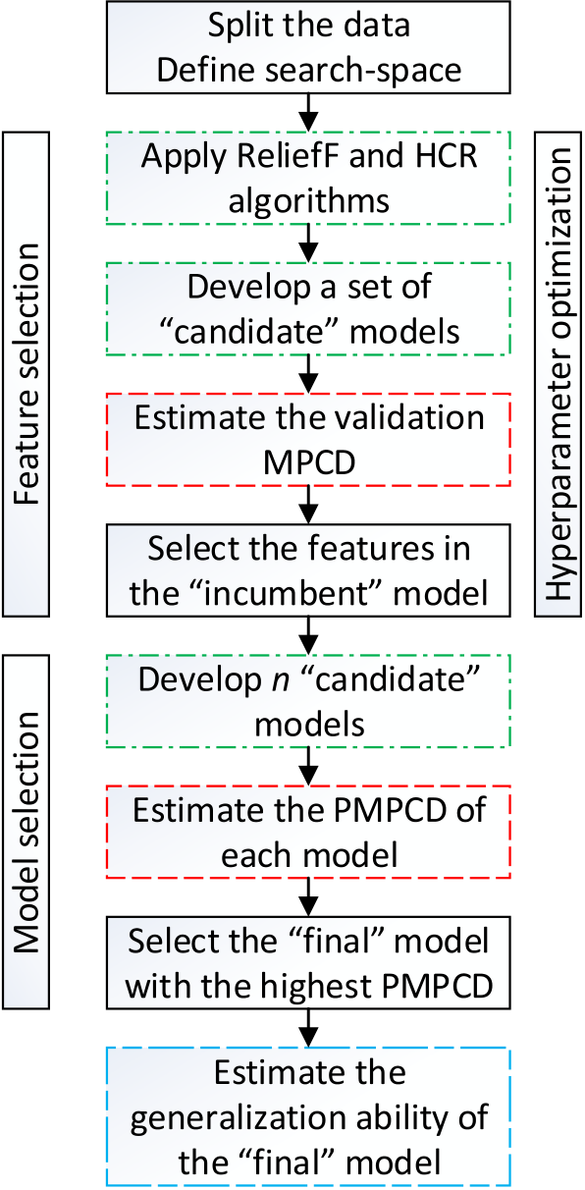

C.A. Escobar et al. Array 7 (2020) 100034

1) Feature Selection (FS): The primary purpose of this step, Fig. 3, is to   
find a small subset of relevant features with high prediction capacity.   
Since the optimal combination – with respect to prediction – of k and   
δ is not known in advance, a hyperparameter optimization [32], is   
performed through a grid search [33,34]. Using the training set,   
irrelevant and redundant features are eliminated by applying ReliefF   
and HCR algorithms. Features are ranked based on ReliefF and irrel-  
evant features are eliminated based on τ – significance threshold.   
From the selected features, high correlations are eliminated based on   
δ. These two steps are performed in a filter-type approach, where the   
learning algorithm is not considered.

A CM is developed with the subset of features at each pairwise   
combination, and the predictive fitness of each model is evaluated to find   
the incumbent (best) model – highest validation MPCD. The features in the   
incumbent model are selected and their associated ReliefF ranking   
recorded.

2) Model Selection (MS): Although a good feature subset has been ob-  
tained in the FS step, Fig. 3, their individual relevance in the model is   
not known. To evaluate their prediction-contribution, a set of n nested   
CM is developed – n is the number of selected features – using the top   
1 feature in the first CM, the top 2 features in the second one, and so   
on. Finally, the PMPCD of each CM is estimated and used as a MS   
criterion to induce parsimony – solve the tradeoff between model   
complexity and prediction ability. The final model is the one with the   
highest PMPCD score.

3) Generalization evaluation: To obtain an unbiased estimation (or closest   
to) of the generalization ability of the final model, the prediction on   
testing set (unseen data) should be reported in a confusion matrix, last   
step Fig. 3.

The outcome of this method is a parsimonious classifier with high

Fig. 3. PMQ-L framework.

As depicted in Fig. 2, a typical manufacturing process generates only a few DPMO. The BM learning paradigm is applied to process data to design a classifier with high detection capacity to be deployed at the plant, e.g., final model. Since prediction is performed under uncertainty, a classifier can commit FP and FN (i.e., fail to detect) errors. Whereas a good item predicted as bad (FP) would not generate a critical problem, since in a second level inspection/revaluation would be back in the value-adding process, a FN would become a warranty event. And if this“miss” is a critical component/device, then it could have a serious economic impact as well as on the company’s reputation.

3. PMQ-learning — a Hybrid Feature Selection and Pattern Recognition approach

A new parsimonious modeling method is presented, it is a flexible

detection ability, as the analytical tools used are aimed at analyzing highly/ultra-unbalanced data structures. Parsimony does not only improve the learning ability, but also helps to identify the few driving features of the system.

In concordance with PMPCD, the application of the proposed learning scheme is limited to classifiers in which their complexity is mainly defined by the number of features in the model, e.g., SVM, LR, NB, KNN and FLD. Therefore, learning algorithms such as neural networks, random forest, etc. are out of the scope.

4. Case studies

Four highly/ultra-unbalanced data sets were analyzed using the SVM, LR, NB, and KNN learning algorithms [35]. First, a full analysis is pre-sented using the NB algorithm on a manufacturing-derived data set. Then, the same procedure was applied to three different data sets. Due to space limitations, only results were reported.

|  |  |
| --- | --- |
| approach with a unique ability to deal with highly/ultra-unbalanced data structures and diverse learning algorithms to model linear and no-linear | 4.1. Case study 1 |

patterns.

Parsimonious modeling is induced through FS and MS, Fig. 3. Since

|  |  |  |  |  |  |
| --- | --- | --- | --- | --- | --- |
| most | manufacturing | systems | are | time-dependent, | cross-validation |

methods are not encouraged. Instead, time-ordered hold-out method seems to be more appropriate. The data set should be partitioned into three subsets (i.e., training, validation, testing) [29]. And the search space is defined by many candidate pairwise combinations – based on different values of k for ReliefF and δ for HCR. The values of k can be determined by generating a logarithmically spaced vector [31] e.g., p logarithmically spaced points between decades ½10a; 10b�, where X ¼ sumðbadÞ in the training set, a ¼ 0 and b ¼ log10ðXÞ.

4

C.A. Escobar et al. Array 7 (2020) 100034

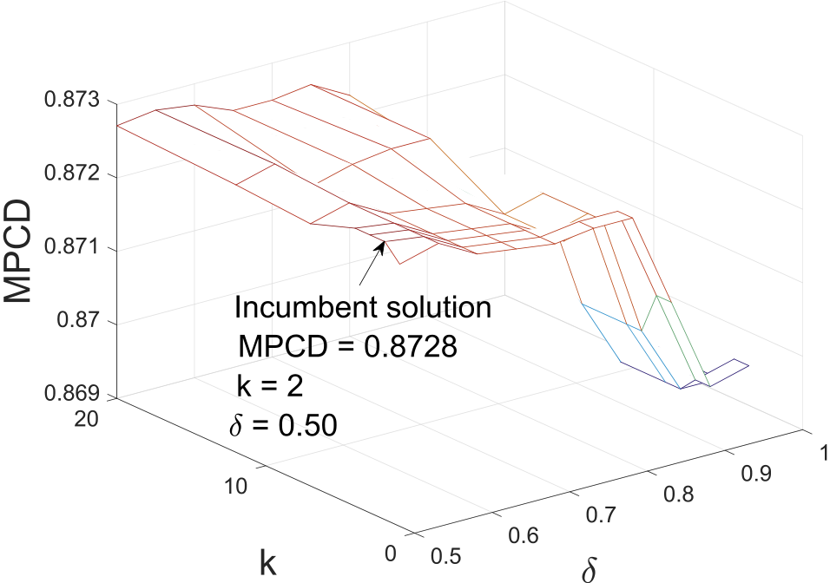

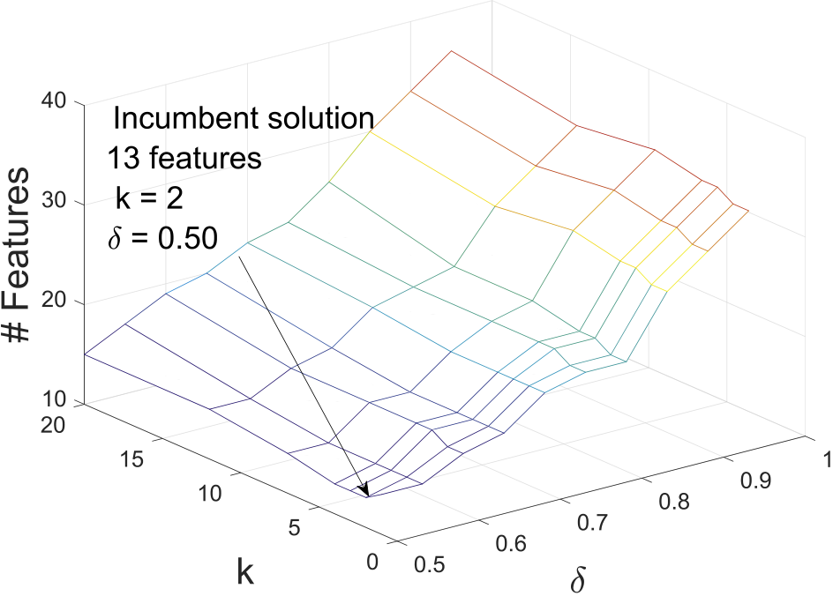

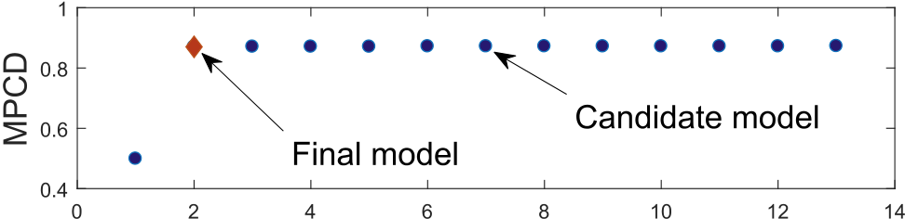

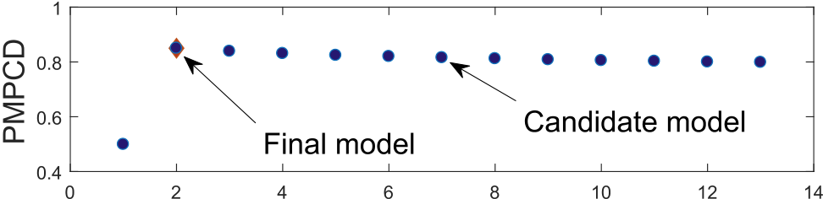

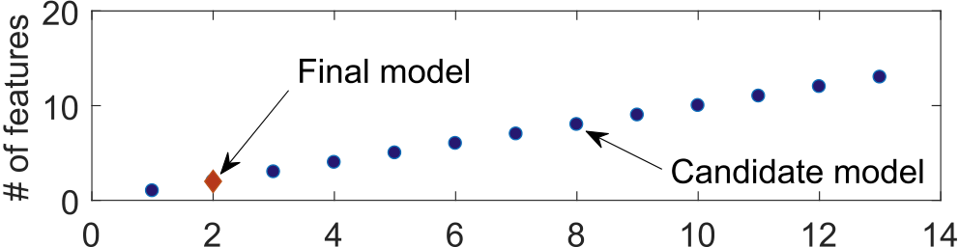



Fig. 6. CM using the top 13 features.

3). Generalization evaluation: The testing set (9500 - including 7 bad) was used to estimate the unbiased generalization ability of the final model, recognition rates are summarized in the confusion matrix, Table 2. This model includes only two features (25, 5), and it correctly detected the seven defective items with only five FPs – MPCD ¼ 0:9995. It is clear that the system can be justified by only these two features.

Table 3   
Top models (*PMQ-L solution).

|  |  |  |  |
| --- | --- | --- | --- |
| Model index | Features | MPCD | FN |
| 1032 | 26, 33 | 0.9998 | 2 |

|  |  |  |  |  |
| --- | --- | --- | --- | --- |
| Fig. 4. CM information (denoted by line intersections). | 1035 | 26, 36 | 0.9998 | 2 |
| 413 | 9, 26 | 0.9997 | 3 |
| 1042 | 26, 43 | 0.9997 | 3 |
| 1044 | 26, 45 | 0.9997 | 3 |

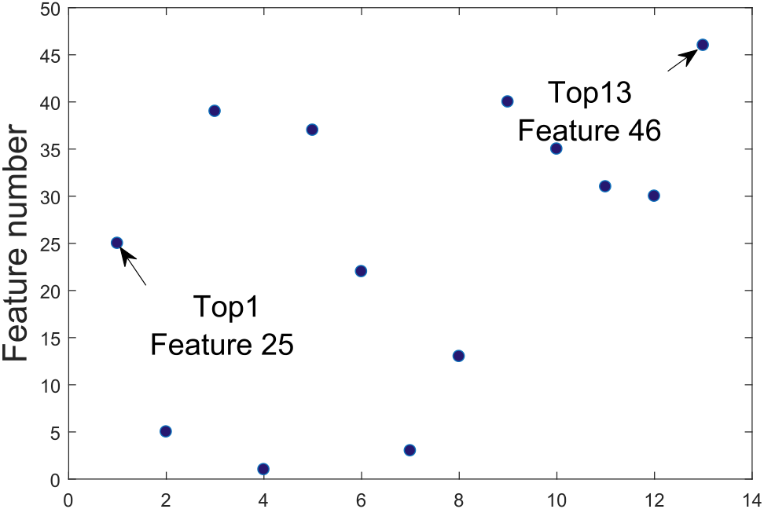

|  |  |  |  |
| --- | --- | --- | --- |
| 1045 | 26, 46 | 0.9996 | 4 |
| Final | 5, 25 | 0.9995 | 5* |

According to the grid search results, the incumbent model has an estimated validation MPCD ¼ 0:8728, Fig. 4(top), and 13 features, Fig. 4(bottom). This model was developed with these relevant hyper-parameters: k ¼ 2;τ ¼ 0:0329;δ ¼ 0:50. All CM failed to detect one of the defective items; therefore, the β ¼ 0:125 in all models. And they are basically competing over the α error. As displayed by the plots, as the number of low quality features included in the model increases, the α error increases too. The proposed hyperparameter optimization allowed to find a good subset of features.

2) Model Selection (MS): To induce parsimony, 13 CM were created, and PMPCD was used as a MS criterion to find the final model. The basic idea is to evaluate the individual prediction-contribution of each of

|  |  |
| --- | --- |
|  | the 13 selected features, Fig. 5 shows the selected features and their associated ranking. CM-1 contains top-1 feature (25), CM-2 contains |

Fig. 5. Features in the incumbent model.

1) Feature Selection (FS): The search space contains 70 pairwise combi-

nations; for ReliefF, 7 logarithmically spaced points were defined –k ¼ f1; 2; 3; 4; 7; 12; 20g – and for δ, 10 even spaced points – δ ¼ f0:50; 0:55; …; 0:95g. At each combination, feature relevance was determined by comparing their weights with τ ¼ 0:0329 – calculated with an α of 0.05, and m of 18,495. Fig. 4 shows prediction results

(validation MPCD) and number of features of each CM.

5

C.A. Escobar et al. Array 7 (2020) 100034

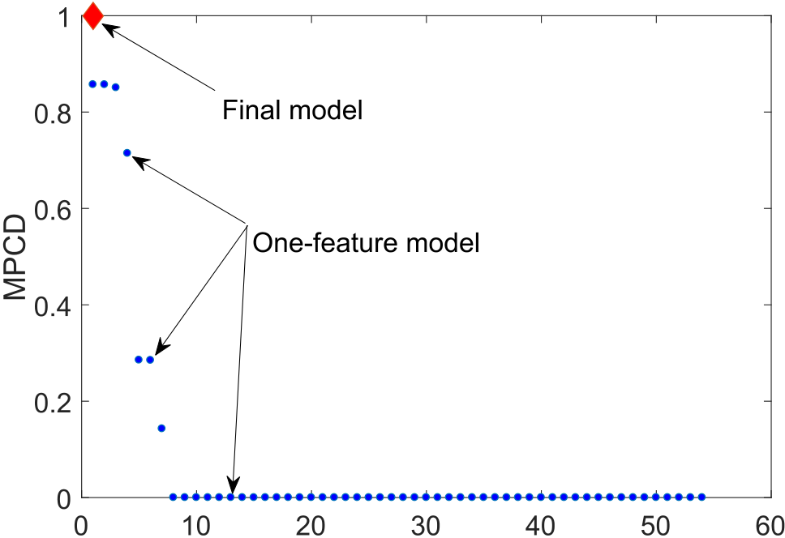



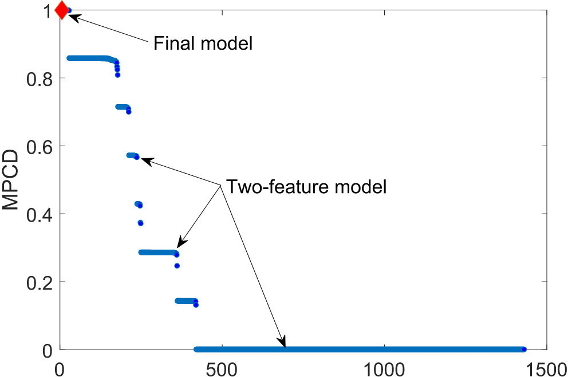

the meaning/name of each feature, they are referred to as feature 1,2, …48.

The KNN learning algorithm is applied with the same number of

neighbors, used for the ReliefF algorithm. The search space contains 70

pairwise combinations; for ReliefF and KNN, 7 logarithmically spaced

points are defined – k ¼ f1; 2; 4; 7; 13; 24; 45g – and for δ, 10 even spaced points – δ ¼ f0:50; 0:55; …; 0:95g. Feature relevance is determined by comparing their weights with τ ¼ 0:0245. The incumbent model with 3 features (9,11,21) is found with k ¼ 45 and δ ¼ 0:85. Then, three CM are created (feature 9, features 9,11, features 9,11,21) and the PMPCD is

used as a MS criterion to select the final model. According to the criterion,

the 3rdmodel should be selected (PMPCD ¼ 0:9573), final model has an estimated testing MPCD ¼ 0:9857. Although the search space of the application of the KNN in this data

set is subject to combinatorial explosion – 8:7 � 1017(248� 3100) – a good quality solution is found after creating 73 models.

4.3. Case study 3

Statlog (Landsat Satellite) [38], the original data set contains 36

features with 7 classes. Only class 1 is considered – class 1 vs all –, the data set is split as follows: training set (4435 - including 1072), validation

set (1000–293), and testing set (1000–168).

The SVM learning algorithm is applied to the same search space

described in Case Study 2 (70 pairwise combinations). Feature relevance

is determined by comparing their weights with τ ¼ 0:0672. The incum-bent model with 8 features (33,21,25,13,5,14,2,30) is found with k ¼ 7 and. Then, 8 CM are created and the PMPCD is used as a MS criterion to

select the final model. According to the criterion, the 8thmodel should be

selected (PMPCD ¼ 0:8748), final model has an estimated testing MPCD ¼ 0:9976.

4.4. Case study 4

|  |  |
| --- | --- |
|  | Occupancy Detection [38,39], the data set contains 5 features. To |

Fig. 7. MPCD exhaustive search in the 1-feature and 2-feature spaces.

evaluating all possible combinations to find an optimal solution rapidly becomes unfeasible as the feature space grows up.

The optimal solution could be defined as the model with the least number of features and the highest prediction ability. In this case study, if there is no other model with an estimated MPCD > 0:9998, the optimal solutions would be model indexes 1032 and 1035 Table 3. However, since the number of combinations is huge, a model with more features may have greater MPCD. Oftentimes due to the tradeoff between model complexity and prediction ability, there is no straight forward optimal solution, this tradeoff should be solved.

Although the PMQ-L did not find the optimal solution, it did promptly find a good quality solution – a model that efficiently addresses the posed tradeoff. Fig. 7 shows the relative location of the solution – final model.

generate an unbalanced data structure, one out of 10 instances labeled as class 1 are included in the data set (index 1, 10, 20, etc.) and the remaining nine eliminated, all 0 class are included. The data set is split as follows: training set (6587 - including 173), validation set (1791 - 98), and testing set (7908 - 205).

The LR learning algorithm is applied to the same search space described in Case Study 2. Feature relevance is determined by comparing respect to MPCD algorithm is used to obtain the classification threshold of their weights with τ ¼ 0:0551. The Optimal Classification Threshold with each CM [30]. The incumbent model with 2 features (feature 3 - CO2, feature 1 -Humidity) is found with k ¼ 1 and δ ¼ 0:50. Then, 2 CM are created, according to the criterion, the single-feature model should be selected (PMPCD ¼ 0:9681), final model has an estimated testing MPCD ¼ 0:9879.

4.5. Discussion

Most of Big Data initiatives are subject to feature combinatorial ex-plosion, a situation that gets aggravated by the hyperparameter tuning process e.g., Case Study 2. One of the main challenges, is to detect which

|  |  |
| --- | --- |
| 4.2. Case study 2 | features actually contain discriminative information, since oftentimes most of them are either irrelevant or redundant. In the four case studies, a |

Sensorless Drive Diagnosis [36], the data set contains 48 numerical features (plus the class label), which are extracted from motor current [37], the motor has good and defective components. This results in 11 different classes with different conditions. The goal of this study is to detect only class one. This data set is highly unbalanced (58509 instances- including 5319 class 1) and it is split as follows: training set (33,409 -including 3100), validation set (12,100 - 1319), and testing set (13, 00–900). Since the data set does not provide specific information about

6

C.A. Escobar et al. Array 7 (2020) 100034

Table 4

Data sets information, positive class count in parenthesis.

|  |  |  |  |  |  |  |
| --- | --- | --- | --- | --- | --- | --- |
| Data | Description | Features | Training set | Validation set | Test set | Ratio (overall) |
| 1 | UMW | 54 | 18,495 (20) | 12,236 (9) | 9500 (7) | 0.09b |
| 2 | Statlog (class 1) | 36 | 4435 (1072) | 1000 (293) | 1000 (168) | 23.82a |
| 3 | Credit Card Fraud | 29 | 200,000 (385) | 40,000 (52) | 44,807 (55) | 0.17b |
| 4 | Occupancy Detection | 5 | 6587 (173) | 1791 (98) | 7908 (205) | 2.92a |
| 5 | HTRU2 | 8 | 12,000 (1484) | 2000 (91) | 3898 (64) | 9.16a |

a Highly-unbalanced.

b Ultra-unbalanced The preprocessing information can be found in Refs. [43].

Table 5

Solutions by data set, comparative analysis 1.

|  |  |  |  |  |  |  |
| --- | --- | --- | --- | --- | --- | --- |
| Data set | l1-regularized LR |  |  | PMQ-L | | |
|  | Features | Hyperparameter (λ) | Testing MPCD | Features | Hyperparameters (k,δ) | Testing MPCD |
| 1 | 42 | 7.168e-07 | 0.8567 | 2 | 12,0.65 | 0.9956 |
| 2 | 34 | 4.721e-05 | 0.9929 | 8 | 1,0.95 | 0.9976 |
| 3 | 21 | 2.738e-05 | 0.8268 | 10 | 1,0.50 | 0.8033 |
| 4 | 5 | 9.839e-06 | 0.6784 | 1 | 1,0.50 | 0.9879 |
| 5 | 7 | 5.520e-05 | 0.8727 | 4 | 1,0.90 | 0.8758 |
|  |  |  |  | addition to the data sets of case studies 1,3,4, two publicly available data | | |
| sets are also included in this analysis.2First, for each data set 70 CM are | | |

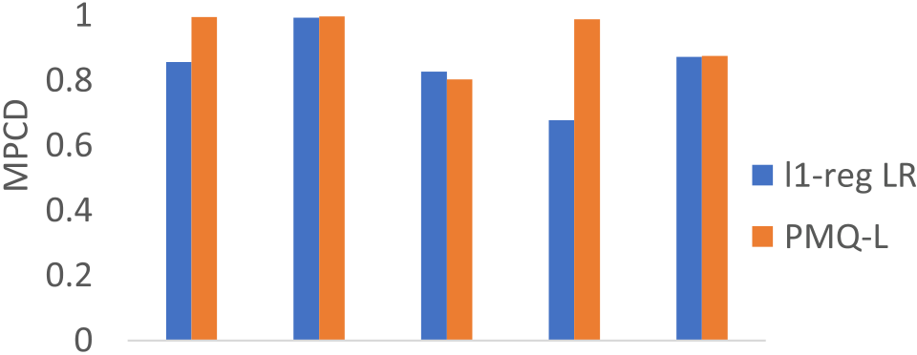

|  |  |  |  |  |
| --- | --- | --- | --- | --- |
|  |  |  |  |  |

developed and the final model selected using the PMQ-L modeling scheme. Then, following the learning approach in Ref. [30], the l1-regularized LR learning algorithm is applied to the same data set to develop 100 CM by varying the regularization values (λ) [41]. Finally, the Akaike information criterion [42] is used to select the final model. The solutions of the two learning approaches are evaluated in terms of the number of CM developed, the number of features in the final model and their generalization ability. Results are presented in Table 5. For repro-ducibility purposes the hyperparameters values of the final models are included.

According to experimental results, four (data sets 1,2,4,5) out of five

|  |  |  |
| --- | --- | --- |
|  |  | solutions of the proposed learning scheme outperforms the l1-regularized |

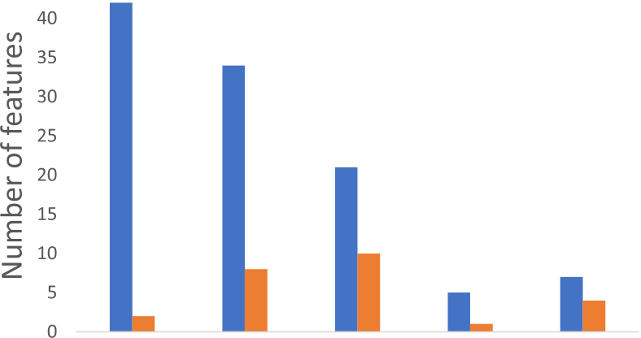

|  |  |  |  |  |
| --- | --- | --- | --- | --- |
|  |  |  |  |  |



Fig. 8. Comparative analysis, MPCD and number of features by data set.

comparative analyses are presented: (1) vs. the l1-regularized LR learning algorithm [19], this algorithm induces parsimony, therefore the goal of this analysis is to evaluate how PMQ-L solves the posed tradeoff between complexity and parsimony; (2) vs. the Random Undersampling Boosting (RUSBoost) learning algorithm [40], this algorithm is designed specif-ically to analyze highly/ultra unbalanced data structures, but it does not induce parsimony, therefore prediction analysis is the main goal of this comparative study.

Five highly/ultra-unbalanced data sets are analyzed, Table 4. In

2 Since the data set of case study 2 does not exhibit a linear pattern (classes

LR-based solutions, since they have a lesser number of features and exhibit better generalization performance. In the third solution, the tradeoff is solved differently. The final model developed by PMQ-L ex-hibits slightly lower generalization ability (0.8033 vs 0.8268), but it includes significantly smaller number of features (10 vs 21). This comparative analysis is graphically presented in Fig. 8.

A second comparative analysis with a widely used learning algorithm in the category of over/under-sampling method is presented. The RUS-Boost is a combination of random undersampling and AdaBoost [44] specifically designed to analyze highly/ultra unbalanced data structures. Random undersampling is applied to the majority class to balance the ratio between minority and majority classes, then AdaBoost is applied to the balanced-subset to build a model. For this analysis, the RUSBoost is applied to the 4 data sets3of the case studies presented in Section 4. With a search space of 10–150 trees, the testing results of each of the final models are summarized in Table 6.

In this analysis, highly/ultra unbalanced data structures that exhibit both, linear and non-linear patterns are analyzed. According to empirical results, the PMQ-L developed better predictive models than RUSBoost in all data sets, Table 6. Since in most of the cases, because of the hyper-dimensional feature spaces, the pattern is not known in advance, there-fore it is recommended to apply all the learning algorithms that can be handled by PMQ-L to find the best one.

3 Since the RUSBoost can handle linear and non-linear patterns the four data

cannot be separated by a linear classifier), it is not included in this analysis. sets are analyzed.

7

C.A. Escobar et al. Array 7 (2020) 100034

Table 6

Solutions by data set, comparative analysis 2.

|  |  |  |  |  |  |  |
| --- | --- | --- | --- | --- | --- | --- |
| Case study | RUSBoost |  | PMQ-L | | | |
|  | Features | Hyperparameter (trees, learning | Testing MPCD | Features | Hyperparameters (k,δ) | Testing MPCD |
| rate) |
| 1 | 54 | 40,0.1 | 0.9980 | 2 | 2,0.50 | 0.9995 |
| 2 | 48 | 140,0.1 | 0.8838 | 3 | 45,0.85 | 0.9857 |
| 3 | 36 | 140,0.1 | 0.8377 | 8 | 7,0.95 | 0.9976 |
| 4 | 5 | 10,0.1 | 0.9883 | 1 | 1,0.50 | 0.9885 |
| 6. Conclusions |  |  | [6] [Ribeiro MT, Singh S, Guestrin C. Why should I trust you?: explaining the predictions](http://refhub.elsevier.com/S2590-0056(20)30019-9/sref6) | | | |
| [of any classif](http://refhub.elsevier.com/S2590-0056(20)30019-9/sref6)i[er. In: Proc of the 22nd ACM SIGKDD int Conf on knowledge](http://refhub.elsevier.com/S2590-0056(20)30019-9/sref6) | | | |

A new Hybrid Feature Selection and Pattern Recognition method with the capacity to learn from the original data set was proposed, PMQ-L. It is aimed at detecting rare quality events through parsimonious modeling. Although the proposed approach does not guarantee to find the optimal solution (if it exists), it did promptly find a good quality solution. Its unique ability to deal with highly/ultra-unbalanced data structures and diverse learning algorithms to model linear and no-linear patterns was demonstrated in the 4 case studies, which also exhibited its capacity of selecting the driving features of the system.

According to empirical results, the proposed modeling scheme out-performed widely-used modeling approaches based on the l1-regularized logistic regression and the Random Undersampling Boosting learning al-gorithms in terms of parsimony, generalization ability and the number of candidate models needed to develop a good solution.

Since rare event detection and information extraction are two of the main modern challenges in the application of ML across industries, the proposed modeling approach can be generalized to other domains – as supported by the case studies – facing the same challenges.

In this research, hyperparameters (k, δ) optimization was performed with respect to validation MPCD only. If it is considered that greater separability between classes is preferred for generalization purposes. Future research along this path, can focus on formulating the model assessment task as a two objective optimization problem. In which separability would be the second fitness attribute to be considered to further discriminate between two or more competing models.

Credit author statement

Carlos Alberto Escobar: Developed the method and led all the sections and analysis. Ruben Morales-Menendez: Helped to run the comparative analyses and contrast the contribution of the method. Daniela Macias Arregoyta: Collaborated with the literature review of the paper.

Declaration of competing interest

The authors declare that they have no known competing financial interests or personal relationships that could have appeared to influence the work reported in this paper.

[7] [Gunning D. Explainable artif](http://refhub.elsevier.com/S2590-0056(20)30019-9/sref7)i[cial intelligence (XAI). Defense Advanced Research](http://refhub.elsevier.com/S2590-0056(20)30019-9/sref7) [Discovery and data mining; 2016. p. 1135](http://refhub.elsevier.com/S2590-0056(20)30019-9/sref6)[–](http://refhub.elsevier.com/S2590-0056(20)30019-9/sref7)[44](http://refhub.elsevier.com/S2590-0056(20)30019-9/sref6).

[Projects Agency; 2017](http://refhub.elsevier.com/S2590-0056(20)30019-9/sref7).

[8] [Shao C, Paynabar K, Kim T, Jin J, Hu S, Spicer J, Wang H, Abell J. Feature selection](http://refhub.elsevier.com/S2590-0056(20)30019-9/sref8)

[for manufacturing process monitoring using cross-validation. J Manuf Syst 2013;10](http://refhub.elsevier.com/S2590-0056(20)30019-9/sref8).

[9] [Wuest T, Weimer D, Irgens C, Thoben K-D. Machine learning in manufacturing:](http://refhub.elsevier.com/S2590-0056(20)30019-9/sref9)

[10] [Yu L, Liu H. Feature selection for high-dimensional data: a fast correlation-based](http://refhub.elsevier.com/S2590-0056(20)30019-9/sref10) [advantages, challenges, and applications. Prod Manuf Res 2016;4(1):23](http://refhub.elsevier.com/S2590-0056(20)30019-9/sref9)[–](http://refhub.elsevier.com/S2590-0056(20)30019-9/sref10)[45](http://refhub.elsevier.com/S2590-0056(20)30019-9/sref9).

[f](http://refhub.elsevier.com/S2590-0056(20)30019-9/sref10)i[lter solution. In: ICML, vol. 3; 2003. p. 856](http://refhub.elsevier.com/S2590-0056(20)30019-9/sref10)[–](http://refhub.elsevier.com/S2590-0056(20)30019-9/sref11)[63](http://refhub.elsevier.com/S2590-0056(20)30019-9/sref10).

[11] [Haixiang G, Yijing L, Shang J, Mingyun G, Yuanyue H, Bing G. Learning from class-](http://refhub.elsevier.com/S2590-0056(20)30019-9/sref11)

[imbalanced data: review of methods and applications. Expert Syst Appl 2017;73:](http://refhub.elsevier.com/S2590-0056(20)30019-9/sref11)

[12] [He H, Ma Y. Imbalanced learning: foundations, algorithms, and applications. John](http://refhub.elsevier.com/S2590-0056(20)30019-9/sref12) [220](http://refhub.elsevier.com/S2590-0056(20)30019-9/sref11)[–](http://refhub.elsevier.com/S2590-0056(20)30019-9/sref12)[39](http://refhub.elsevier.com/S2590-0056(20)30019-9/sref11).

[Wiley](http://refhub.elsevier.com/S2590-0056(20)30019-9/sref12) & [Sons; 2013](http://refhub.elsevier.com/S2590-0056(20)30019-9/sref12).

[13] [Shukla S, B.S. R. Online sequential class-specif](http://refhub.elsevier.com/S2590-0056(20)30019-9/sref13)i[c extreme learning machine for](http://refhub.elsevier.com/S2590-0056(20)30019-9/sref13)

[14] [Chandrashekar G, Sahin F. A survey on feature selection methods. Comput Electr](http://refhub.elsevier.com/S2590-0056(20)30019-9/sref14) [binary imbalanced learning. Neural Network 2019;119(235](http://refhub.elsevier.com/S2590-0056(20)30019-9/sref13)[–](http://refhub.elsevier.com/S2590-0056(20)30019-9/sref14)[248)](http://refhub.elsevier.com/S2590-0056(20)30019-9/sref13).

[15] [Ng A. On feature selection: learning with exponentially many irrevelant features as](http://refhub.elsevier.com/S2590-0056(20)30019-9/sref15) [Eng 2014;40(1):16](http://refhub.elsevier.com/S2590-0056(20)30019-9/sref14)[–](http://refhub.elsevier.com/S2590-0056(20)30019-9/sref15)[28](http://refhub.elsevier.com/S2590-0056(20)30019-9/sref14).

[training examples. In: Proc of the 15thint Conf on machine learning. MIT, Dept. of](http://refhub.elsevier.com/S2590-0056(20)30019-9/sref15)

[16] [De Silva AM, Leong PH. Feature selection. In: Grammar-based feature Generation](http://refhub.elsevier.com/S2590-0056(20)30019-9/sref16) [Electrical Eng and Computer Science; 1998. p. 404](http://refhub.elsevier.com/S2590-0056(20)30019-9/sref15)[–](http://refhub.elsevier.com/S2590-0056(20)30019-9/sref16)[12](http://refhub.elsevier.com/S2590-0056(20)30019-9/sref15).

[17] [Deng H, Runger G. Feature selection via regularized trees,. In: Int J Conf on neural](http://refhub.elsevier.com/S2590-0056(20)30019-9/sref17) [for time-series prediction. Springer; 2015. p. 13](http://refhub.elsevier.com/S2590-0056(20)30019-9/sref16)[–](http://refhub.elsevier.com/S2590-0056(20)30019-9/sref17)[24](http://refhub.elsevier.com/S2590-0056(20)30019-9/sref16).

[18] [Weston J, Mukherjee S, Chapelle O, Pontil M, Poggio T, Vapnik V. Feature selection](http://refhub.elsevier.com/S2590-0056(20)30019-9/sref18) [networks; 2012. p. 1](http://refhub.elsevier.com/S2590-0056(20)30019-9/sref17)–[8](http://refhub.elsevier.com/S2590-0056(20)30019-9/sref17).

[19] [Tibshirani R. Regression shrinkage and selection via the LASSO,. J Roy Stat Soc B](http://refhub.elsevier.com/S2590-0056(20)30019-9/sref19) [for SVMs. In: NIPS, vol. 12; 2000. p. 668](http://refhub.elsevier.com/S2590-0056(20)30019-9/sref18)[–](http://refhub.elsevier.com/S2590-0056(20)30019-9/sref19)[74](http://refhub.elsevier.com/S2590-0056(20)30019-9/sref18).

[20] [Ng A. Feature selection L1 vs L2 regularization and rotational invariance. In: Proc.](http://refhub.elsevier.com/S2590-0056(20)30019-9/sref20) [1996:267](http://refhub.elsevier.com/S2590-0056(20)30019-9/sref19)[–](http://refhub.elsevier.com/S2590-0056(20)30019-9/sref20)[88](http://refhub.elsevier.com/S2590-0056(20)30019-9/sref19).

[Of the 21stint Conf on machine learning. ACM; 2004. p. 78](http://refhub.elsevier.com/S2590-0056(20)30019-9/sref20).

[21] [Wang F, Yang Y, Lv X, Xu J, Li L. Feature selection using feature ranking, correlation](http://refhub.elsevier.com/S2590-0056(20)30019-9/sref21)

[analysis and chaotic binary particle swarm optimization. In: 5thint Conf on software](http://refhub.elsevier.com/S2590-0056(20)30019-9/sref21)

[22] [Kira K, Rendell L. The feature selection problem: traditional methods and a new](http://refhub.elsevier.com/S2590-0056(20)30019-9/sref22) [Eng and service science; 2014. p. 305](http://refhub.elsevier.com/S2590-0056(20)30019-9/sref21)[–](http://refhub.elsevier.com/S2590-0056(20)30019-9/sref22)[9](http://refhub.elsevier.com/S2590-0056(20)30019-9/sref21).

[23] [Robnik-](http://refhub.elsevier.com/S2590-0056(20)30019-9/sref23)�S[ikonja M, Kononenko I. Theoretical and empirical analysis of ReliefF and](http://refhub.elsevier.com/S2590-0056(20)30019-9/sref23) [algorithm. In: AAAI, vol. 2; 1992. p. 129](http://refhub.elsevier.com/S2590-0056(20)30019-9/sref22)[–](http://refhub.elsevier.com/S2590-0056(20)30019-9/sref23)[34](http://refhub.elsevier.com/S2590-0056(20)30019-9/sref22).

[24] [Kononenko I. Estimating attributes: analysis and extensions of RELIEF. In: European](http://refhub.elsevier.com/S2590-0056(20)30019-9/sref24) [RReliefF. Mach Learn 2003;53(1](http://refhub.elsevier.com/S2590-0056(20)30019-9/sref23)[–](http://refhub.elsevier.com/S2590-0056(20)30019-9/sref24)[2):23](http://refhub.elsevier.com/S2590-0056(20)30019-9/sref23)[–](http://refhub.elsevier.com/S2590-0056(20)30019-9/sref24)[69](http://refhub.elsevier.com/S2590-0056(20)30019-9/sref23).

[25] [Devore J. Probability and statistics for engineering and the sciences. Cengage](http://refhub.elsevier.com/S2590-0056(20)30019-9/sref25) [Conf on machine learning. Springer; 1994. p. 171](http://refhub.elsevier.com/S2590-0056(20)30019-9/sref24)[–](http://refhub.elsevier.com/S2590-0056(20)30019-9/sref25)[82](http://refhub.elsevier.com/S2590-0056(20)30019-9/sref24).

[Learning; 2015](http://refhub.elsevier.com/S2590-0056(20)30019-9/sref25).

[26] [Fawcett T. An introduction to ROC analysis. Pattern Recogn Lett 2006;27(8):](http://refhub.elsevier.com/S2590-0056(20)30019-9/sref26)

[861](http://refhub.elsevier.com/S2590-0056(20)30019-9/sref26)–[74](http://refhub.elsevier.com/S2590-0056(20)30019-9/sref26).

[27] [Escobar CA, Morales-Menendez R. Process-Monitoring-for-Quality](http://refhub.elsevier.com/S2590-0056(20)30019-9/sref27) — [a model](http://refhub.elsevier.com/S2590-0056(20)30019-9/sref27)

[28] [Arlot S, Celisse A. A survey of cross-validation procedures for model selection. Stat](http://refhub.elsevier.com/S2590-0056(20)30019-9/sref28) [selection criterion. SME Manuf Lett 2018;15:55](http://refhub.elsevier.com/S2590-0056(20)30019-9/sref27)[–](http://refhub.elsevier.com/S2590-0056(20)30019-9/sref28)[8](http://refhub.elsevier.com/S2590-0056(20)30019-9/sref27).

[29] [Friedman J, Hastie T, Tibshirani R. The elements of statistical learning, vol. 1.](http://refhub.elsevier.com/S2590-0056(20)30019-9/sref29) [Surv 2010;4:40](http://refhub.elsevier.com/S2590-0056(20)30019-9/sref28)[–](http://refhub.elsevier.com/S2590-0056(20)30019-9/sref29)[79](http://refhub.elsevier.com/S2590-0056(20)30019-9/sref28).

[Berlin: Statistics Springer; 2001](http://refhub.elsevier.com/S2590-0056(20)30019-9/sref29).

[30] [Escobar CA, Morales-Menendez R. Machine learning techniques for quality control](http://refhub.elsevier.com/S2590-0056(20)30019-9/sref30)

[31] The MathWorks Inc. Logspace. [Online]. 2017. Available: [www.mathworks.com/h](http://www.mathworks.com/help/matlab/ref/logspace.html) [in high conformance manufacturing environment. Adv Mech Eng 2018;10(2):1](http://refhub.elsevier.com/S2590-0056(20)30019-9/sref30)–[12](http://refhub.elsevier.com/S2590-0056(20)30019-9/sref30).

|  |  |
| --- | --- |
| References | [elp/matlab/ref/logspace.html](http://www.mathworks.com/help/matlab/ref/logspace.html).  [32] [Kuhn M, Johnson K. Applied predictive modeling, vol. 26. Springer; 2013](http://refhub.elsevier.com/S2590-0056(20)30019-9/sref32). |

[1] [Kumar V, Mathur P, Sahni R, Anand M. Two-dimensional multi-release software](http://refhub.elsevier.com/S2590-0056(20)30019-9/sref1)  [reliability modeling for fault detection and fault correction processes. Int J Reliab](http://refhub.elsevier.com/S2590-0056(20)30019-9/sref1) [2] [He Y, Liu F, Cui J, Han X, Zhao Y, Chen D, Zhou Z, A Z. Reliability-oriented design](http://refhub.elsevier.com/S2590-0056(20)30019-9/sref2) [Qual Saf Eng 2016;23(3):164](http://refhub.elsevier.com/S2590-0056(20)30019-9/sref1)[–](http://refhub.elsevier.com/S2590-0056(20)30019-9/sref2)[78](http://refhub.elsevier.com/S2590-0056(20)30019-9/sref1).

[of integrated model of preventive maintenance and quality control policy with time-](http://refhub.elsevier.com/S2590-0056(20)30019-9/sref2)[3] [Cai B, Zhao Y, Liu H, Xie M. A data-driven fault Diagnosis methodology in three-](http://refhub.elsevier.com/S2590-0056(20)30019-9/sref3)[between-events control chart. Comput Ind Eng 2019;(129):228](http://refhub.elsevier.com/S2590-0056(20)30019-9/sref2)[–](http://refhub.elsevier.com/S2590-0056(20)30019-9/sref3)[38](http://refhub.elsevier.com/S2590-0056(20)30019-9/sref2).

[phase inverters for PMSM drive systems. IEEE Trans Power Electron 2016;32(7):](http://refhub.elsevier.com/S2590-0056(20)30019-9/sref3) [4] [Kang S, Kim E, Shim J, Cho S, Chang W, Kim J. Mining the relationship between](http://refhub.elsevier.com/S2590-0056(20)30019-9/sref4) [5590](http://refhub.elsevier.com/S2590-0056(20)30019-9/sref3)[–](http://refhub.elsevier.com/S2590-0056(20)30019-9/sref4)[600](http://refhub.elsevier.com/S2590-0056(20)30019-9/sref3).

[production and customer service data for failure analysis of industrial products.](http://refhub.elsevier.com/S2590-0056(20)30019-9/sref4) [5] [Abell JA, Chakraborty D, Escobar CA, Im KH, Wegner DM, Wincek MA. Big data](http://refhub.elsevier.com/S2590-0056(20)30019-9/sref5) [Comput Ind Eng 2017;106:137](http://refhub.elsevier.com/S2590-0056(20)30019-9/sref4)[–](http://refhub.elsevier.com/S2590-0056(20)30019-9/sref5)[46](http://refhub.elsevier.com/S2590-0056(20)30019-9/sref4).

[driven manufacturing](http://refhub.elsevier.com/S2590-0056(20)30019-9/sref5) [— process-monitoring-for-quality philosophy. ASME J Manuf Sci Eng Data Sci Enhanc Manuf 2017;139(10)](http://refhub.elsevier.com/S2590-0056(20)30019-9/sref5).

8

C.A. Escobar et al. Array 7 (2020) 100034

[40] [Seiffert C, Khoshgoftaar TM, Van Hulse J, Napolitano A. Rusboost: a hybrid](http://refhub.elsevier.com/S2590-0056(20)30019-9/sref40)  [approach to alleviating class imbalance. IEEE Trans Syst Man Cybern Syst Hum](http://refhub.elsevier.com/S2590-0056(20)30019-9/sref40)

[41] T. M. Inc. Lasso. 2011 [Online]. Available: [https://www.mathworks.com/help/](https://www.mathworks.com/help/stats/lasso.html) [2009;40(1):185](http://refhub.elsevier.com/S2590-0056(20)30019-9/sref40)–[97](http://refhub.elsevier.com/S2590-0056(20)30019-9/sref40).

[stats/lasso.html](https://www.mathworks.com/help/stats/lasso.html).

[42] [Burnham KP, Anderson DR. Model selection and multimodel inference: a practical](http://refhub.elsevier.com/S2590-0056(20)30019-9/sref42)  [information-theoretic approach. Springer Science](http://refhub.elsevier.com/S2590-0056(20)30019-9/sref42) & [Business Media; 2003](http://refhub.elsevier.com/S2590-0056(20)30019-9/sref42).

9