[Array 1-2 (2019) 100003](https://doi.org/10.1016/j.array.2019.100003)

|  |  |  |
| --- | --- | --- |
|  |  |  |
|  | Contents lists available at ScienceDirect |  |
| Array |
| journal homepage: www.elsevier.com/journals/array/2590-0056/open-access-journal |
|  | | |

Signal processing techniques for motor imagery brain computer interface: A review

Swati Aggarwal*, Nupur Chugh

Division of Computer Engineering, Netaji Subhas University of Technology, Delhi, India

|  |  |
| --- | --- |
| A R T I C L E I N F O | A B S T R A C T |
| Keywords:  Brain computer interface  Motor imagery  Electroencephalogram (EEG)  Motor task classification  Signal analysis | Motor Imagery Brain Computer Interface (MI-BCI) provides a non-muscular channel for communication to those who are suffering from neuronal disorders. The designing of an accurate and reliable MI-BCI system requires the extraction of informative and discriminative features. Common Spatial Pattern (CSP) has been potent and is widely used in BCI for extracting features in motor imagery tasks. The classifiers translate these features into device commands. Many classification algorithms have been devised, among those Support Vector Machine (SVM) and |

Linear Discriminate Analysis (LDA) have been widely used. In recent studies, the researchers are using deep neural networks for the classification of motor imagery tasks. This paper provides a comprehensive review of dominant feature extraction methods and classification algorithms in brain-computer interface for motor imagery tasks. Authors discuss existing challenges in the domain of motor imagery brain-computer interface and suggest possible research directions.

|  |  |
| --- | --- |
| 1. Introduction | by controlling robotic prostheses, wheelchairs, and other devices [15]. |

MI BCI has a wide range of applications, such as controlling a

A Brain Computer Interface (BCI) utilizes signals to establish a connection between a person’s state of mind and a computer-based signal processing system, which interprets the signals [1]. BCI provides a direct communicational channel between the brain and an external device without involving any muscular activities. These systems either use electroencephalogram (EEG) activity recorded from the scalp or the ac-tivity of individual cortical neurons recorded from implanted electrodes [2].

EEG has relatively short time constants, and requires simple and inexpensive equipment; therefore at present EEG-based BCI systems are widely used [2–6]. Various forms of electrical brain activities have been used to discern EEG based BCI systems, such as mu rhythm [7,8], slow cortical potential [9], event-related p300 [10] and steady-state visual evoked potential [11,12]. Among various types of electrical brain ac-tivities, the one related to motor tasks is mu rhythm [13].

Motor imagery (MI) is defined as the cognitive process of imagining the movement of your own body part without actually moving that body part [14]. Motor imagery based Brain Computer Interface (MI BCI) provides an interface for the patients with motor impairment or those who are in completely locked-in-state to interact with the environment

* Corresponding author.

wheelchair, virtual reality, neurorehabilitation and controlling devices such as quadcopters in 2-D/3-D space [16–19].

The EEG signal processing for MI BCI involves feature extraction and classification. In feature extraction phase the EEG signal acquired for MI BCI reveals task-specific features in both spectral domain and spatial domain [20]. Several spectral processing methods such as wavelet transform [21–23], fourier transform [24], autoregressive model [25] and spatial method such as common spatial pattern (CSP) [26–29] have been used in literature to extract the features from these EEG signals. CSP algorithm is the most successful and is widely used in MI BCI due to its high recognition rate and computational simplicity [30].

The goal of classification is to translate the signal features provided by the feature extractor into commands or orders that carry out user’s intent [2]. In MI BCI, classifiers convert discriminative features into different MI tasks such as left-right hand movement, foot movement, tongue move-ment or word generation. Copious classification algorithms, such as support vector machines [31,32], linear discriminate analysis (LDA) [26–28] neural networks [22,33,34], and deep neural networks [23,24, 35–38] have been applied on MI BCI.

E-mail addresses: [swati1178@gmail.com](mailto:swati1178@gmail.com) (S. Aggarwal), [nupur.chugh@gmail.com](mailto:nupur.chugh@gmail.com) (N. Chugh).

<https://doi.org/10.1016/j.array.2019.100003>  
Received 16 January 2019; Received in revised form 4 June 2019; Accepted 1 August 2019   
Available online 7 August 2019   
2590-0056/© 2019 The Authors. Published by Elsevier Inc. This is an open access article under the CC BY license (<http://creativecommons.org/licenses/by/4.0/>).

S. Aggarwal, N. Chugh Array 1-2 (2019) 100003

2. Related work deep learning in BCI has been highlighted by different researchers

The relevant reviews available on signal processing techniques mostly focus either on feature extraction methods or on classification tech-niques. Table 1 shows all reviews that are related to feature extraction and classification techniques. The label Yes in table implies that article presented that particular technique and label No implies vice versa.

Swati Vaid et al. [39] describe the model of BCI system. The author categorized the techniques into basic techniques and advanced tech-niques. The basic techniques are time domain and frequency domain techniques. Advanced techniques are classified into time frequency domain and space-time frequency domain. Further, they have summa-rized the features and its techniques in respective domains.

M. Rajya Lakshmi et al. [40] briefly describe the feature extraction techniques, which are Principal Component Analysis (PCA), Independent Component Analysis (ICA), Auto Regressive Model (AR), Wavelet Transform (WT) and Wavelet Packet Decomposition (WPD). Further-more, the paper has explored the signal processing methods used in each stage of brain computer interface.

Amjed S. Al-Fahoum and Ausilah A. Al-Fraihat [25] discuss the feature extraction techniques in frequency domain and time frequency domain such as fast fourier transform, auto regressive model, wavelet transform, eigen vectors and time frequency distribution. The authors have provided recommendations based on the performance.

Lotte et al. [41] discussed the classification algorithms used for EEG based brain computer interfaces. The authors described the properties of algorithms in detail and compared the performances of the classifiers. Based on the performances the authors provide the guidelines for selecting the best-suited classifier.

Rupal Chaudhary et al. [42] described the different stages of BCI. The authors provided a review of classification of motor imagery tasks. It has provided a summary of the paper selected and studied by the author.

All the works discussed in Table 1 provide brief description about any one of the two important components of signal processing, that is feature extraction or classification. Though M. Rajya et al. has discussed both feature extraction and classification but discussion is not comprehensive. Certainly, the description and discussion of various signal-processing components needs further elaboration. It is understood that it would be more helpful if all the elements of signal processing were presented in a comprehensive and holistic manner. Based on this perspective the au-thors have summarized the algorithms available for feature extraction and classification for brain computer interfaces.

Authors in this paper have presented the variants available for feature extraction methods and all the components are classified appropriately. Recently Deep Learning has been introduced as the classification methods for brain computer interfaces [23,24,35–38], which has not been discussed in previous related works listed in Table 1. As benefits of

Table 1   
Signal Processing techniques presented in related work.

[35–38], authors in this paper have included a discussion on deep learning classification methods for BCI. Furthermore, the review also critically examines the various challenges of different modules of BCI.

3. Working principle of BCI system

The working of the BCI system requires three modules that are signal acquisition module, signal processing, and application module. This section describes the working of each module. Fig. 1 shows the compo-nents of BCI and their interactions.

3.1. Signal acquisition module

The Signal Acquisition Module is liable for recording the electro-physiological signals that provide input to the BCI. These signals are recorded from the scalp or from the surface of the brain or neuronal activity [43]. BCI might use either invasive methods or non-invasive methods for signal acquisition. Invasive methods are electrocardio-grams (ECoG) and single-neuron recordings [43,44] and have better signal quality as compared to non-invasive methods. Non-invasive

|  |  |  |  |  |
| --- | --- | --- | --- | --- |
| methods | are | Electroencephalogram | (EEG), | Magnetoencephalogram |

(MEG), Positron Emission Tomography (PET), Functional Magnetic Resonance Imaging (fMRI) and Near-Infrared Spectroscopy (NIRs) [44].

The acquired signals are amplified to enhance the strength and are digitized before they are used by any of the computer application.

3.2. Signal processing module

3.2.1. Preprocessing   
 The task of preprocessing is to prepare the recorded signals for pro-cessing by enhancing the signal –to- noise ratio (SNR). The part of EEG signal that comes from muscular activity of head, and eye movement generate electrical activity that is unrelated to the brain. Such part of signal is considered as artifact and should not be processed in order to preserve and exhibit the relevant information; therefore preprocessing is done to remove artifacts in EEG signals. In BCI research, the proper preprocessing of EEG signal is important in order to obtain high classi-fication accuracy. Preprocessing of BCI is based on the Covariance Matrix Adaptation Evolution Strategy (CMA-ES) which obtains the spatial and frequency selection filters automatically [45].

3.2.2. Feature extraction   
 After preprocessing the signal is fed into one or more type of feature extraction algorithms. This component extracts features in the time domain and frequency domain that encode messages or commands [43]. Wide varieties of feature extraction methods are used in BCI system;

|  |  |  |  |  |  |  |
| --- | --- | --- | --- | --- | --- | --- |
| Category | Techniques | Article |  |  |  |  |
| Feature | Fast Fourier Transform | Rupal Chaudhari et al. | Swati Vaid et al. | M. Rajya Lakshmi et al. | Amjed S. Al-Fahoum1 | F Lotte et al. |
| (2017) [42] | (2015) [39] | (2014) [40] | (2014) [25] | (2007) [41] |
| Yes | Yes | Yes |
| Extraction | Short Term Fourier | Yes | No | No |

Transform

|  |  |  |  |
| --- | --- | --- | --- |
| Auto Regressive Model | Yes | Yes | Yes |
| Wavelet Transform | Yes | Yes | Yes |
| Wavlet Packet | Yes | Yes | No |

Decomposition

|  |  |  |  |  |  |  |
| --- | --- | --- | --- | --- | --- | --- |
| Classification | Common Spatial Pattern | Yes | Yes | No | No | Yes |
| Linear Discriminant | Yes |

Analysis

|  |  |  |  |  |
| --- | --- | --- | --- | --- |
| Support Vector Machine | Yes | No | Yes | Yes |
| Artificial Neural | No | Yes | Yes |

Network

|  |  |  |
| --- | --- | --- |
| Deep Learning | No | No |

2

S. Aggarwal, N. Chugh Array 1-2 (2019) 100003

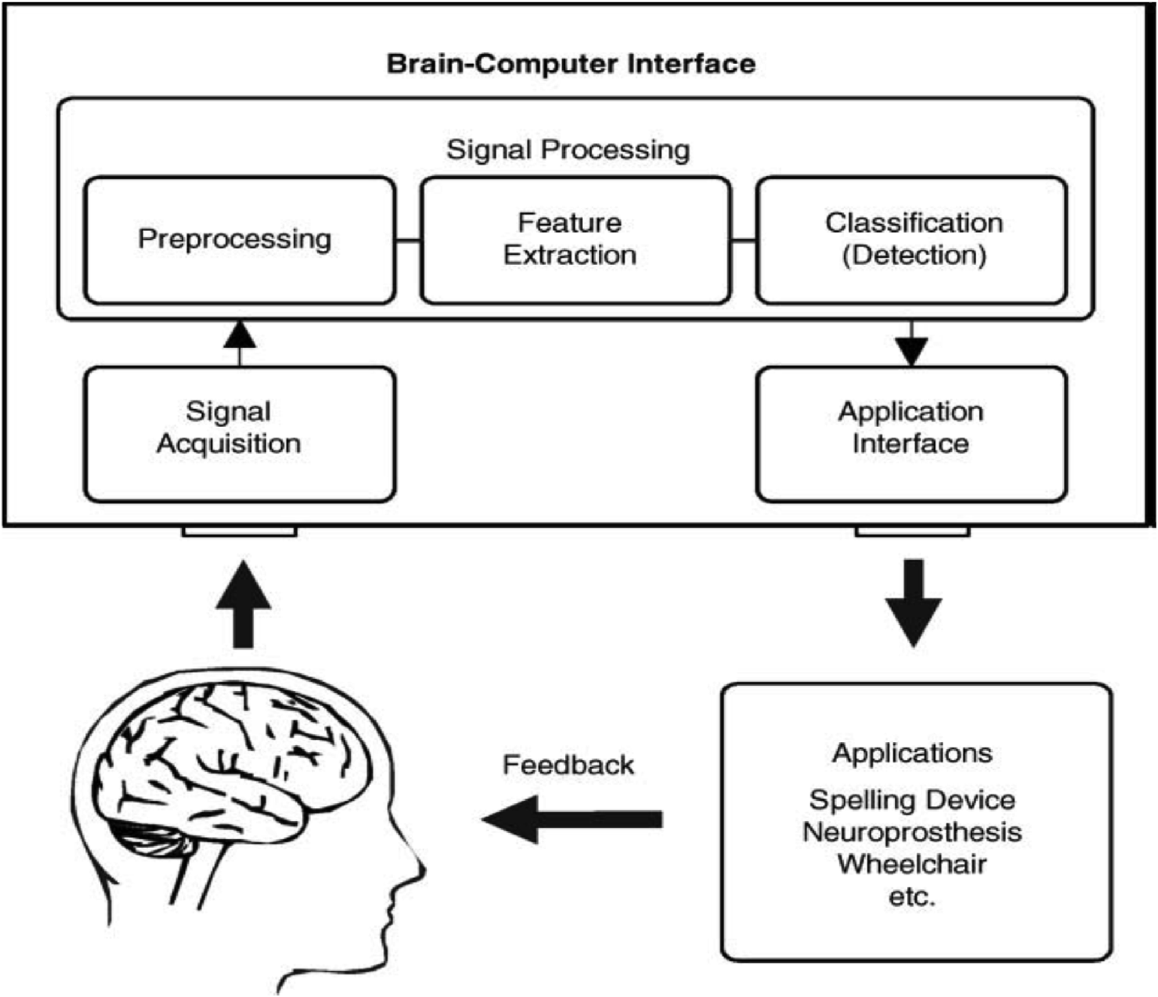

Fig. 1. Components of a BCI system [21].

some of these methods include amplitude measures, band power, Hjorth of communication.

parameters, autoregressive models, and wavelets and spatial filters [9].

There are various key components in the BCI closed loop, one is feature extraction and the other is classification. There is a large diversity

3.2.3. Classification of feature extraction and classification methods that have been explored

The task of the classification component is to translate the features provided by the feature extractor to a category of brain patterns; that is the independent variable is converted into the dependent variable. The classification algorithms may use linear methods like Linear Discriminant

in BCI for motor imagery tasks. This paper gives an extensive review of these two components that are described in the following sections.

4. Feature extraction techniques

Analysis (LDA) and Support Vector Machine (SVM) or non-linear

methods such as neural networks.

3.3. Application module   
 For most current BCIs, the output device is a computer screen and the output is the selection of targets, letters, or icons presented on it [19]. Some BCIs provide an output, such as cursor movement toward the item

During Feature extraction, features are extracted from the signals in either time domain or frequency domain. As shown in Fig. 2 the feature extraction process involves frequency filtering, windowing in which short segments are selected, feature extractor and the feature selection which outputs the selected features that are being fed into the classifier. In BCI, frequency band power features and time domain features repre-sent EEG signals. Band power features represent the power of EEG signals

prior to its selection. for a given frequency band averaged over a time window and time

The output generated by the output device is the feedback provided to the user to notify the user about the recognized brain activity pattern. This pattern is then used to sustain and enhance the accuracy and speed

domain features are the combination of EEG signals from all channels. MI BCI extensively uses band power features. Based on the literature found and studied as shown in Table 4 it has been noticed that most of the used

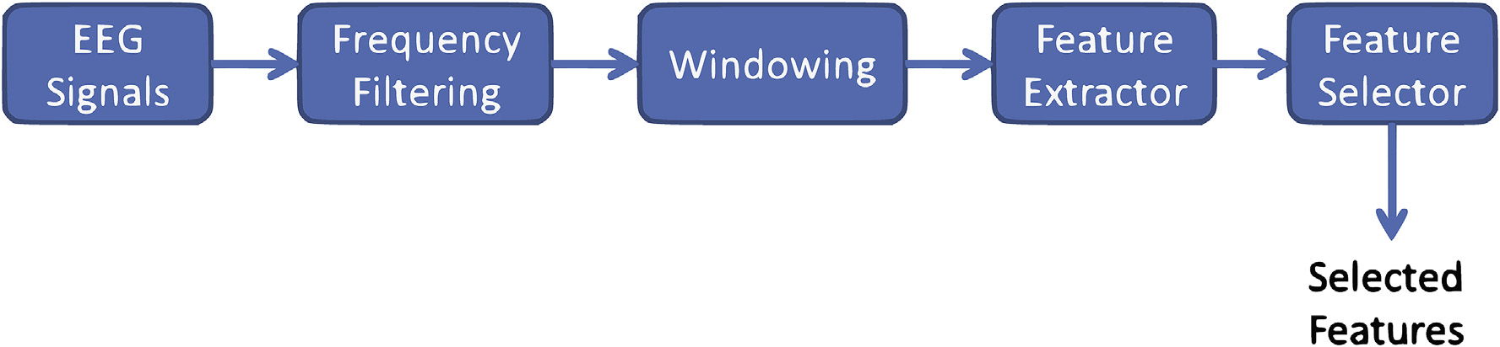

Fig. 2. Processes involved in Feature Extraction.

3

S. Aggarwal, N. Chugh Array 1-2 (2019) 100003

or referenced techniques for feature extraction in motor imagery brain computer interfaces are Short Term Fourier Transform (STFT), Auto Regressive Model (AR), Wavelet Transform (WT), and Common Spatial Pattern (CSP). This section gives detailed description of the varied feature extraction methods used for motor imagery tasks.

4.1. Fast fourier transform (FFT)

The first feature extraction method used for MI BCI was based on Fast Fourier Transform [25] that is applied to estimate the power at chosen frequency bands in FFT generated spectra. Fourier analysis decomposes the signal into its frequency components and determines their relative strengths. FFT does not consider time information, thus it is not able to

|  |  |  |  |  |  |  |  |  |
| --- | --- | --- | --- | --- | --- | --- | --- | --- |
| analyze | non-stationary | EEG | signals. | In | order | to | represent | the |

non-stationary signal the author uses Short Term Fourier Transform (STFT) [25,46]. In STFT, the signal is divided into small overlapping frames on which FFT is applied by placing a window function on time axis as shown in Fig. 3.

When fixed time window function is applied to STFT, it produces fixed time-frequency resolution that limits the use of STFT. This means that one can only trade time resolution for frequency resolution or vice versa.

4.2. Autoregressive (AR) model

The Autoregressive model is the parametric approach that estimates the Power Spectrum Density (PSD) of the signal. Typically, short epochs are preferred over longer epochs for analysis in order to characterize the rapid changes that occur in EEG signal. The spectra obtained from FFT on short epochs have poor resolution when compared to an autoregressive model. Although the resolution of FFT could be improved by applying window function such as Hanning window, but still it have poor reso-lution as compared to autoregressive model as shown in Fig. 4. The validity of spectral estimate depends on the selection of proper model order where model order roughly determines the number of spectral peaks that need to be captured. If the model order is too low, AR yields smooth spectrum whereas, if it is too high the spectrum has spurious peaks [19]. The model order for EEG ranges from 3 to 20 [47].

4.3. Wavelet transform (WT)

Wavelet Transform is the feature extraction technique that extracts features in time-domain and is used to represent the function by an infinite number of wavelets where each wavelet has specific time-frequency characteristics. The above two techniques, FFT and AR model uncover only spectral characteristics of signals and do not obtain good performance with non-stationary EEG signal. Wavelet Transform combines frequency information and time domain information, which gives better performance as compared to FFT or AR [25]. WT uses varying size window such that high frequencies are evaluated on the shorter window and low frequencies over longer window [48,49] thus WT performs better in time resolution of high frequencies as compared to STFT as shown in Fig. 5. The other extensions of WT have also been used in MI BCI such as Wavelet Packet Transform (WPT) [50] and Wavelet Packet Best Basis Decomposition (WPBBD) [51].

4.4. Common spatial pattern (CSP)

In MI BCI, spatial information is required in multichannel EEG re-cordings to discriminate intent patterns and therefore, the spatial filters have been used to extract spatial information from the signal. Common Spatial Pattern generates spatial filters that minimize the variance of one class and maximize the variance of other class simultaneously. The multichannel EEG signal is passed into bandpass filter for selecting the frequency. After frequency filtering, spatial filtering is performed that uses spatial filters and FIR filters. The process of common spatial pattern

4

S. Aggarwal, N. Chugh Array 1-2 (2019) 100003

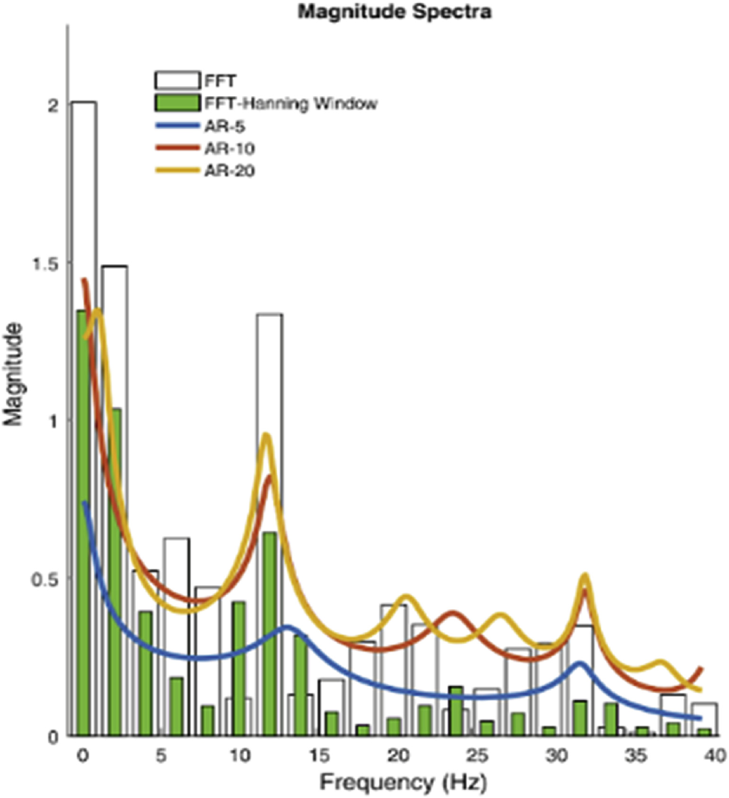

Fig. 4. Comparison of Spectra generated by FFT and AR model [47].

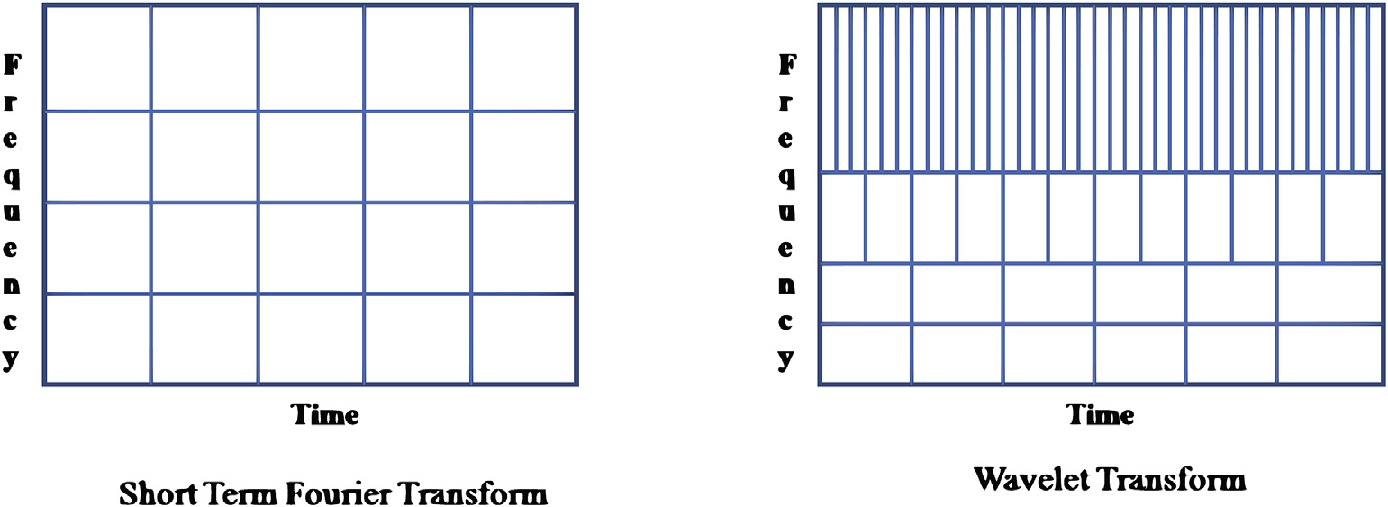

Fig. 5. Comparison of resolution obtained by STFT and WT.

is shown in Fig. 6. CSP is one of the most effective feature extraction methods used in binary motor imagery task classification.

In brain computer interface the objective of spatial filtering used by the CSP algorithm is to compute features whose variances are optimal for discriminating two classes of EEG measurements [52]. The performance

subject-specific frequency range for CSP algorithm. One such approach is the Common Spatio-Spectral Pattern (CSSP) [53], which optimizes sim-ple filters with a spatial filter. Another approach was the Common Sparse Spectral-Spatial Pattern (CSSSP) [54]. It improves the CSSP algorithm by performing simultaneous optimization of an arbitrary FIR filter within

of this spatial filtering depends on the operational frequency band of the CSP algorithm.

EEG. Several approaches have been proposed to fine-tune the An alternative approach called Sub Band Common Spatial Pattern

5

S. Aggarwal, N. Chugh Array 1-2 (2019) 100003

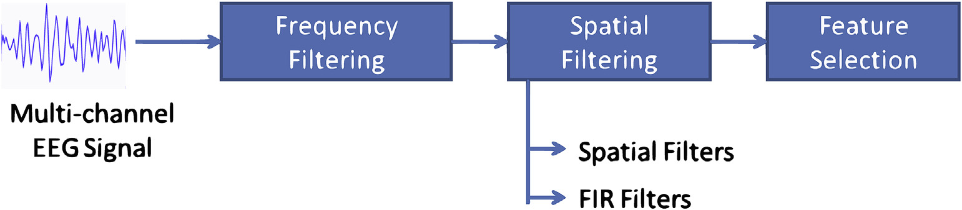

Fig. 6. Process of common spatial pattern.

(SBCSP) [55] was proposed in which EEG signals are decomposed into sub-bands. CSP is applied to each sub-band that defines sub-band score and then these scores are fused together to derive the final decision. SBCSP has improved classification accuracy when compared to CSSP and

model as shown in Fig. 7. The same model is then used in the testing phase to extract the output. In motor imagery brain computer interface the features extracted by various feature extraction techniques are con-verted into different motor imagery tasks like hand movements, foot

CSSSP. movement, word generation and alike through classification algorithms.

As compared to SBCSP, a more generalized approach called Filter Bank Common Spatial Pattern (FBCSP) [56] was proposed that comprised of four stages: frequency filtering, spatial filtering, feature selection, and classification. It deploys a small subset of effective spatial filters that reduces computational complexity against SBCSP. A variant, named Discriminative FBCSP (DFBCSP) [57] was proposed to enhance classification accuracy. DFBCSP extracts subject specific discriminative frequency bands from the set of filters instead of using fixed frequency bands for all subjects as in FBCSP.

In 2016, Separable Common Spatio Spectral Patterns (SCSSP) [20] had been proposed that jointly processed the data in both spectral and spatial domains and had low computational cost over FBCSP. This approach was suitable for wearable mobile BCI systems. FBCSP used the fixed partition of a frequency band that leads to loss of information in the frequency domain. The augmented CSP [58] based on varying partition of the frequency band with different bandwidths had solved the problem of information loss.

Some other variants of CSP found in literature are sparse CSP [59] that impose sparsity on weights by adding regularization factor on spatial filter, stationary CSP [60] that uses stationary subspaces, divergence CSP [61] that utilizes information from other subjects and enforce different invariance formulating divergence maximization problem, and probabi-listic CSP [62] that solves the problem of overfitting.

While all these variants improve the standard CSP algorithm, they are still unable to characterize temporal (time-related) dynamics; thus, more sophisticated techniques that consider time-related information are required. The features extracted from CSP are then fed into various classifiers for classification.

The different prominent feature extraction techniques used for MI BCI along with advantages and limitations are summarized in Table 2.

5. Classification techniques

The classification is a process of predicting the target variables or classes from the given input. To build the classification model, learning algorithm is applied in the training phase to adjust the parameters of the

Table 2   
Comparison of Feature Extraction Techniques used for MI BCI.

The authors have classified the classification algorithms used in the literature as linear classifiers, neural networks, non-linear classifiers, and deep neural networks. Linear Classifiers use the linear function to distinguish classes. Two main types of linear classifiers are Linear Discriminant Analysis (LDA) [26–38] and Support Vector Machine (SVM) [29,31,63] and have been commonly used in testing of BCI. Neural Network (NN) is an assembly of different artificial neurons, which en-ables to produce nonlinear decision boundaries. The NN specifically created and used for BCI is Gaussian Classifier [41]. Non-linear classifiers produce non-linear decision boundaries and are generative. These clas-sifiers are not widespread and not popular as the linear classifier and neural networks in MI BCI. Deep Neural network (DNN) is an artificial network with multiple layers called as hidden layers between input and output layers and is used to model complex non-linear relationships. The classifiers based on deep neural networks have been used in MI BCI research to improve the accuracy of multiclass signal analysis.

This section gives a detailed description of the linear classifier,

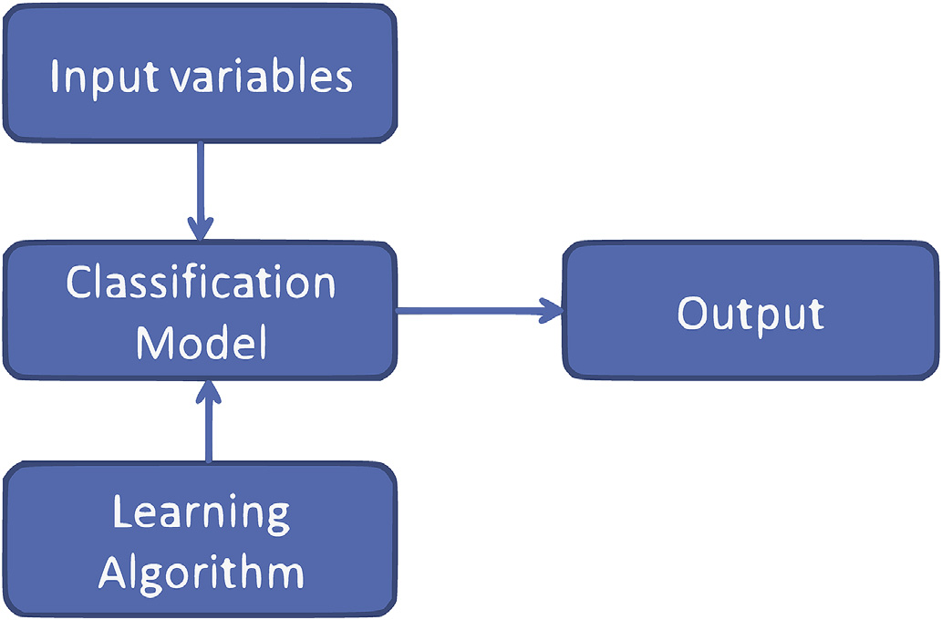

Fig. 7. Classification process.

|  |  |  |  |
| --- | --- | --- | --- |
| Technique | Advantages | Limitations | Analysis |

Method

|  |  |  |  |
| --- | --- | --- | --- |
| Fast Fourier | � FFT is accurate at frequency composition of a signal.  � It has enhanced speed over all other methods.  � It provides good frequency resolution.  � It has reasonable spectral estimates for short segments.� WT provides improved balance between window length and spectral resolution. | � FFT is not suitable for analyzing non- linear signals.  � It does not take into time information into account. Validity of the model depends upon the proper selection of | Frequency |
| Transform(FFT) | Frequency |
| Autoregressive Model (AR) |
| Wavelet Transform(WT) | model order. | Time- |
| Proper selection of appropriate mother wavelet is required. |
| Frequency |
| Common Spatial Pattern | � It is better suited for sudden changes in signal.� CSP is suitable for multichannel signal analysis.� It is used to tune subject specific frequency range. | � CSP does not able to handle temporal dynamics.� It has slow convergence. | Spatial Filters |
| (CSP) |

6

S. Aggarwal, N. Chugh Array 1-2 (2019) 100003

classifier based on neural network and the deep neural network that is used in the field of MI BCI.

5.1. Linear discriminative analysis (LDA)

LDA classifier has the low computational requirement that makes it a commonly used classifier in EEG based BCI applications. LDA projects data into new space using projection y ¼ wTx that minimizes the scatter within the class and maximizes between the classes as illustrated in Fig. 8.

specifically created for BCI is the Gaussian classifier [65,66]. Each unit of this NN is a Gaussian discriminant function representing a class proto-type. This classifier has been applied with success to motor imagery [22] and mental task classification [34]. Other NN architectures such as Multilayer Perceptron (MLP), neural network based on Radial Basis Function (RBF), spiking neural network [67] that uses Online Meta neuron based Learning Algorithm (OMLA) has been applied for classifi-cation of MI tasks. NN has also been successfully applied for multiclass multiuser MI tasks [22] classification.

LDA has been successfully used for classification of right and left-hand 5.4. Deep learning

motor imagery [41]. The main drawback of LDA is that it provides the

poor result on complex nonlinear EEG data [65]. Regularized Fisher LDA [27], an enhancement of LDA has also been used for right and left-hand motor imagery that uses decision boundary or hyperplane in feature space for classifying features in distinct classes. Fisher LDA obtains better generalization capabilities and gives better results than LDA [65].

5.2. Support vector machine (SVM)

Support Vector Machine has been very popular in BCI research. SVM selects the hyperplane that maximizes the distance from the nearest training points. Linear SVM uses the linear function as decision bound-aries while nonlinear SVM uses the kernel function to map the data into higher dimensional space [29]. Linear SVM and non-linear SVM is shown

In the traditional neural network, weights have to be chosen very carefully. This is a major obstacle in the effective use of the neural network in many applications of BCI. In recent studies, researchers have been using deep learning approach as deep neural network has high descriptive power and thus improves the accuracy of the system. Deep learning has successful performance in the field of computer vision and in recent years has also been applied in classification of motor imagery tasks [24,68]. Initially, Na Lu et al. [24] proposed an approach to use manually extracted features from the channels based on FFT and then feed them into a Deep Belief Network (DBN). Among various deep learning archi-tectures Convolutional Neural Network (CNN) is effectively used for classification of motor imagery tasks [23,35–38,69] due to its regulari-zation structure and degree of translation invariance. The Convolutional

in Fig. 9. neural network is a class of deep feed-forward artificial neural network

Md Rabiul Islam et al. (2017) [63] uses SVM on features with reduced dimension obtained by employing multiband TSM and PCA respectively for four class classification problems. Some other flavors of SVM like Transition Detection based SVM (TD-SVM) [31] and Evolved filters based SVM [32] have been used for MI BCI. In TD-SVM, the classification problem is divided into two sub-problems: detecting class transitions and determining the class for sequences of instances between transitions.

that uses a variation of multilayer perceptrons. A simple CNN is a sequence of layers, and every layer of a CNN transforms one volume of activations to another through a differentiable function. CNN architec-ture consists of the input layer, convolution layer, pooling layer, fully connected layer and output layer as shown in Fig. 10. The Convolutional layer is the core building block of CNN and does most of the computation. Pooling layer reduces the spatial size of representation and neurons in

|  |  |  |  |  |  |  |  |  |
| --- | --- | --- | --- | --- | --- | --- | --- | --- |
| Evolved | filters | based | SVM | algorithm | optimizes | spatial | and | fully connected layer have full connections to the previous layer. |

frequency-selection filters by means of the Covariance Matrix Adaptation Evolution Strategy. SVM is known to have good generalization properties and is insensitive to the curse-of-dimensionality [64].

5.3. Neural network (NN)

SVM gives high-quality results but is not able to handle the multiclass problem and dynamic nature of EEG signal effectively. Robust classifiers give better performance but need more time; therefore, there is a tradeoff between accuracy and speed. As the neural network provides reasonable tradeoff, it has been extensively used in BCI research. There are several NN architectures used in the field of BCI, the one that has been

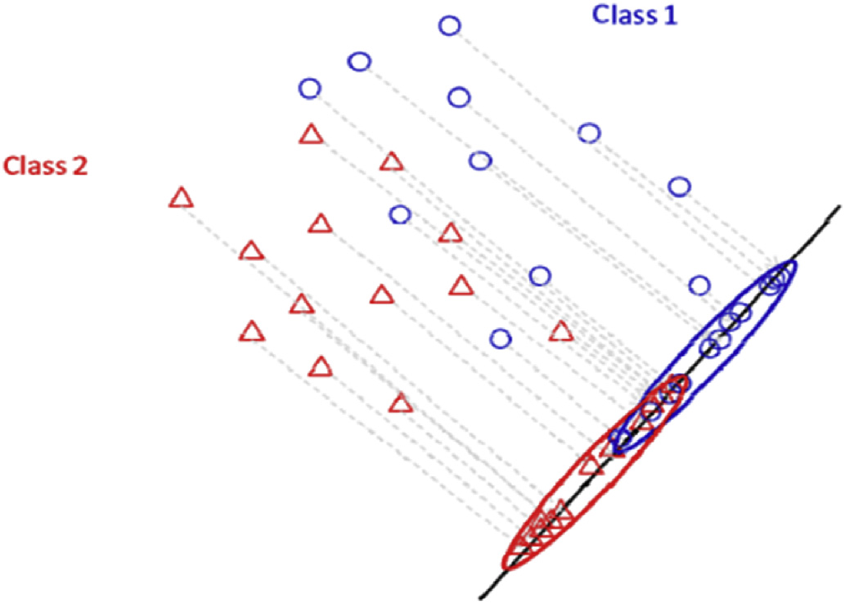

Fig. 8. Linear Discriminant Analysis (LDA) projection [26].

7

S. Aggarwal, N. Chugh Array 1-2 (2019) 100003

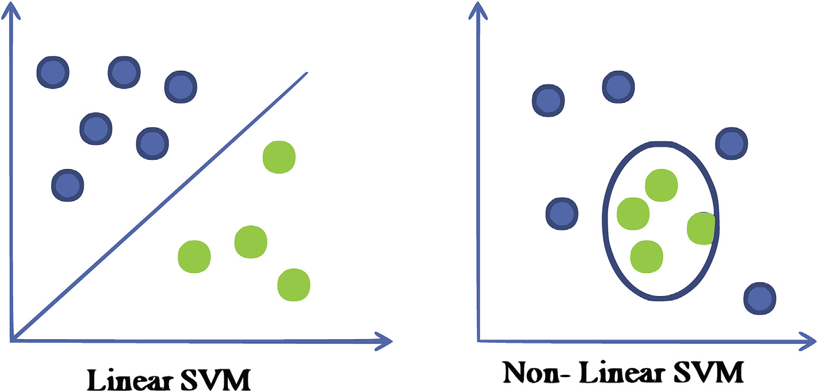

Fig. 9. Linear and non-linear support vector machine.



Fig. 10. Convolutional neural network.

|  |  |  |  |
| --- | --- | --- | --- |
| Table 3  Comparison of classification algorithms used for MI BCI. | | | Pertaining to open issues and challenges are listed in Table 6. |
| Technique | Advantages | Limitations | 7.1. Feature extraction |
| Linear | � LDA has low computational requirement. | It is not suitable for | EEG signal is usually very noisy and time-variable; therefore, it is challenging to extract relevant features from EEG measurements in a very short time window. Although Common Spatial Pattern (CSP) and its variants are popular and extensively used in BCI, it does not consider the |
| Discriminant | complex non-linear EEG |
| Analysis (LDA) | � It is Simple to use.  � SVM has better generalisation properties. | data. |
| Support Vector | It is not suitable for |
| Machine (SVM) | handling dynamic nature |

|  |  |  |
| --- | --- | --- |
| Neural Networks | � It is insensitive to curse to dimensionality. | of signal. |
| NN provides reasonable tradeoff | Weights have to be chosen |
| (NN) | between accuracy and speed. | carefully. |
| Deep Neural | It is able to learn discriminat | DNN has large |
| Networks | features and classifier | computational complexity |
| (DNN) | simultaneously from raw EEG | for training and testing. |

data.

to upper limb imageries. Among the classification methods, SVM is commonly used and has promising results. Although Shallow CNN has shown the promising results in MI BCI research; still the deep neural networks is lagging in performance due to unavailability of the large training dataset. The earlier studies focus on two class motor imagery that is now shifting towards multiclass and multilabel motor imageries in recent studies.

Table 4 presents the summary of the literature studied related to the motor imagery brain computer interface.

Table 5 shows the performance comparison of Common Spatial Pattern and Wavelet Transform with different classification techniques using publicly available dataset BCI Competition III. The table reveals that the Wavelet Transform has accuracy of 86.20% with CNN classifier, which is highest among all other classifiers, used with Wavelet Trans-form. Moreover, Common Spatial Pattern is also effective with the clas-sification techniques that are based on Deep Learning or Deep Neural Network.

7. Challenges

Various feature extraction and classification algorithms have been applied successfully for EEG based BCI for motor imagery tasks and ob-tained good accuracy results, still, there are some unresolved issues and challenges that attract attention from researchers from varied domains.

8

S. Aggarwal, N. Chugh Array 1-2 (2019) 100003

Table 4   
Summary of literature studied in MI BCI.

|  |  |  |  |  |  |  |  |  |
| --- | --- | --- | --- | --- | --- | --- | --- | --- |
| Paper Title | Year | Feature Extraction | EEG Features | Class | Motor Imagery | Classification | Dataset | Accuracy |

technique

|  |  |  |  |  |  |  |  |  |
| --- | --- | --- | --- | --- | --- | --- | --- | --- |
| Evolving Spatial and | 2010 | CSP | Frequency based | 3 | Left hand, Right hand | SVM | BCI-III | Evolved Filters- |
| Frequency Selection | and generation of | competition | Subject1- 77.96%, |
| Filters for Brain- | words | Subject2-75.11%, |
| Computer Interfaces | Subject-3 57.76% |

[32]

|  |  |  |  |  |  |  |  |  |
| --- | --- | --- | --- | --- | --- | --- | --- | --- |
| EEG feature comparison | 2013 | CSP | Band Power | 7 | Compound(both | SVM | Author Prepared | 70% |
| and classification of | 2014 | CSP | Spatial features | 2 | hands, left hand þ  right foot, right hand | LDA | Author prepared | 91.25 |
| simple and compound |
| limb motor imagery | þ left foot), rest state |
| [71] |
| Left and Right Motor |
| A Novel Classification |
| Method for Motor | Imagery |

Imagery Based on   
Brain-Computer   
Interface [26]

|  |  |  |  |  |  |  |  |  |
| --- | --- | --- | --- | --- | --- | --- | --- | --- |
| Increase performance of | 2014 | CSP | ERD/ERS | 4 | Left hand, right hand, | LDA, QDA, | BCI competition | LDA- 78.82% |
| four-class classification | foot and tongue | SVM | 2008 (Graz data |
| for Motor-Imagery | set 2A) |

based Brain-Computer   
Interface [29]

|  |  |  |  |  |  |  |  |  |
| --- | --- | --- | --- | --- | --- | --- | --- | --- |
| Neural Network-based | 2014 | Root mean Square | Time domain | 3 | Left hand, right hand | Neural | Author Prepared | MLP RMS- |
| Three-Class Motor | and integrated | and tongue | network | 82.50%,IEEG- 81.07% |
| Imagery Classification | EEG | RBF RMS- 84.94%, |
| Using Time-Domain | IEEG- 81.52% |

Features for BCI   
Applications [33]

|  |  |  |  |  |  |  |  |  |
| --- | --- | --- | --- | --- | --- | --- | --- | --- |
| Parallel Convolutional- | 2015 | FBCSP | Energy based | 4 | Left hand, right hand, | CNN | BCI competition | 70.60% |
| Linear Neural Network | feet and tongue | IV dataset 2A |

For Motor Imagery   
Classification [36]

|  |  |  |  |  |  |  |  |  |
| --- | --- | --- | --- | --- | --- | --- | --- | --- |
| On the Use of | 2015 | Augemented CSP | Frequency based | Multi | Left hand, right hand, | CNN | BCI competition | Complementary |
| Convolutional Neural | class | both feet and tongue | IV dataset 2A | feature map selection |
| Networks and | scheme – 68.45%, Full map scheme – 69.27% |
| Augmented CSP |
| Features for Multi-class |

Motor Imagery of EEG   
Signals Classification   
[58]

|  |  |  |  |  |  |  |  |  |
| --- | --- | --- | --- | --- | --- | --- | --- | --- |
| A Multi-label | 2015 | CSP | Band Power | 4 | Rest, right hand, left | LDA | Author Prepared | 51.67% |
| Classification Method | hand and both hands |

for Detection of   
Combined Motor   
Imageries [72]

|  |  |  |  |  |  |  |  |  |
| --- | --- | --- | --- | --- | --- | --- | --- | --- |
| A Deep Learning Scheme | 2016 | Fast Fourier | Frequency | 2 | Left and Right motor | Deep Neural | BCI competition | Not Provided |
| for Motor Imagery | Transform and | domain features | imagery | Network | IV data set 2B |
| Classification based on | wavelet packet |
| Restricted Boltzmann | decomposition |

Machines [24]

|  |  |  |  |  |  |  |  |  |
| --- | --- | --- | --- | --- | --- | --- | --- | --- |
| EEG Feature Extraction | 2017 | Wavelet | Sensorimotor | Multi | Rest state, left fist, | Neural | Physionet dataset | 93.05% |
| and Classification in | decomposition | rhythms | class | both fists, right fist, | network | record |
| Multiclass Multiuser | both feet movement |

Motor Imagery Brain   
Computer Interface   
using Bayesian   
Network and ANN [22]

|  |  |  |  |  |  |  |  |  |
| --- | --- | --- | --- | --- | --- | --- | --- | --- |
| A Deep Learning | 2017 | Common Spatial | Variance based | 2 | Left and Right hand | Deep Neural | BCI competition | Not Provided |
| Approach for Motor | Pattern | CSP features | Network | III dataset 4A |

Imagery EEG Signal   
Classification [68]

|  |  |  |  |  |  |  |  |  |
| --- | --- | --- | --- | --- | --- | --- | --- | --- |
| A Convolution Neural | 2018 | Continous | Time -frequency | 2 | Left and Right hand | CNN | BCI competition | Morlet- 78.93%, |
| Networks Scheme for | Wavelet | Representations | IV dataset 2B | Bump-77.25% |
| Classification of Motor | transform |

Imagery EEG based on   
Wavelet Time-  
Frequency Image [23]

|  |  |  |  |  |  |  |  |  |
| --- | --- | --- | --- | --- | --- | --- | --- | --- |
| Deep Convolutional | 2017 | STFT | Time -frequency | 2 | Left and Right hand | CNN | Author Prepared | CNN(RELU)- 86.74%, |
| Neural Network for | Representations | CNN(ELU) – 88.92,  CNN(SELU)- 92.73% |
| Decoding Motor |

Imagery based Brain   
Computer Interface   
[35]

|  |  |  |  |  |  |  |  |  |
| --- | --- | --- | --- | --- | --- | --- | --- | --- |
| Classification of Motor | 2018 | CSP | Log variance | 2 | Motor þ ear | RLDA | Dataset 1: Author | Dataset 1: 77.71%, |
| Imagery for Ear-EEG | features | prepared, Dataset | Dataset 2: 74.28% |

(continued on next page)

9

S. Aggarwal, N. Chugh Array 1-2 (2019) 100003

Table 4 (continued)

|  |  |  |  |  |  |  |  |  |
| --- | --- | --- | --- | --- | --- | --- | --- | --- |
| Paper Title | Year | Feature Extraction | EEG Features | Class | Motor Imagery | Classification | Dataset | Accuracy |

technique

|  |  |
| --- | --- |
| based Brain-Computer  Interface [73] | 2: BCI  Competition III |

dataset 4A

|  |  |  |  |  |  |  |  |  |
| --- | --- | --- | --- | --- | --- | --- | --- | --- |
| Learning Temporal | 2018 | FBCSP | Temporal | 4 | Left, right, feet and | CNN | BCI competition | 74.46% |
| Information for Brain- | tongue | IV dataset 2A |

Computer Interface   
Using Convolutional   
Neural Networks [38]

|  |  |  |  |  |  |  |  |  |
| --- | --- | --- | --- | --- | --- | --- | --- | --- |
| Deep Recurrent Spatio- | 2018 | Recurrent CNN | Spatial and | 4 | Left hand, right hand, | Recurrent | BCI Competition | 45% |
| Temporal Neural | temporal | feet and tongue | CNN | IV dataset 2A |
| Network for Motor | features |

Imagery based BCI [37]

Table 5   
Performance Comparison of Common Spatial Pattern and Wavelet Transform on different Classifiers.

|  |  |  |  |  |
| --- | --- | --- | --- | --- |
| Paper Title | Feature | Classification | Dataset | Accuracy |

Extraction

|  |  |  |  |  |
| --- | --- | --- | --- | --- |
| Evolving Spatial and Frequency Selection Filters for Brain-Computer | CSP | SVM | BCI-III | Evolved Filters- Subject1- 77.96%, Subject2- |
| Interfaces [32] | CSP | RLDA | competition | 75.11%, Subject-3 57.76% |
| Classification of Motor Imagery for Ear-EEG based Brain-Computer | BCI-III | 74.28% |
| Interface [70] | CSP | DNN | competition | Percentage Error- 10% |
| A Deep Learning Approach for Motor Imagery EEG Signal | BCI-III |
| Classification [65] | WT | LDA | competition | MisClassification Rate: 0.1286 |
| A Motor Imagery BCI Experiment using Wavelet Analysis and Spatial | BCI III |
| Patterns Feature Extraction [74] | WT | SVM | Competition | 85.54% |
| Enhancing EEG Signals in Brain Computer Interface Using Wavelet | BCI III |
| Transform [75] | WT | NN | Competition | 82.43% |
| Enhancing EEG Signals in Brain Computer Interface Using Wavelet | BCI III |
| Transform [75] | WT | CNN | Competition | 86.20% |
| Deep Fusion Feature Learning Network for MI-EEG Classification [76] | BCI III |

Competition

|  |  |
| --- | --- |
| Table 6 | 7.3. Hardware and BCI functioning |

Category wise reported challenges.

|  |  |  |
| --- | --- | --- |
| Category | Challenges | Papers |

Chih-Yu Chen et al. [26] proposed a novel classification method that has used CSP for feature extraction and LDA for classification to solve the

|  |  |  |  |
| --- | --- | --- | --- |
| Feature Extraction | Time series modeling techniques [TSM] | [36, | misclassifying problem. The proposed method is efficient and has high |
| Classification | Automatic selection of subject specific | 70] | accuracy. The author also suggested having algorithm-device integration |
| [28] | to make the system more efficient and practicable. |
| characteristics [ASSC] |
| [29] | In traditional methods of signal processing, feature extraction and |
| Number of components to be chosen in feature |
| classification was performed separately which associates heavy compu- |
| selection [NCC] |
| [33] |
| Robust classifiers [RC] | tational burden. The concept of neural network combines the feature |
| Signal | Classification methods considering user in the loop | [21, | extraction and classification in one pipeline and has been explored for |
| [CM] | 71] |
| binary classification [24]. However, the use of neural network is suc- |
| Interpretability of learned algorithms [ILA] | [36] |
| cessful in binary classification but increases the calibration time in BCI |
| Interpretability |
| Hardware | Algorithm device integration [ADI] | [26] | [38]. The author suggested adopting transfer learning and domain |
| Data collection | Gathering data for individual subject [GD] | [36] | adaptation to have calibration free BCIs. Moreover pipelining in multi- |
| BCI functioning | Long caliberation time [LCI] | [38] | class classification is still a challenge [29]. |
| Signal processing pipeline in multiclass | [29] |
| Modality | classification [SPP] | [36] | 7.4. Data collection and modality |
| High dimensionality of EEG signal [HD] |

Low signal to noise ratio[SNR]

Presence of noise [PON]

processing. Thus, there is a need to test and validate classification algo-rithms online as they are computationally efficient and can be used in real time. Further, in order to provide a reasonable tradeoff between accuracy and efficiency, robust classifiers have to be developed that can be easily used online and are able to work with non-stationary data efficiently. Furthermore, the authors in Refs. [19,74] suggested a new generation of classification methods considering the user in the loop has to be developed to ensure efficient brain computer interfaces.

10

S. Aggarwal, N. Chugh Array 1-2 (2019) 100003

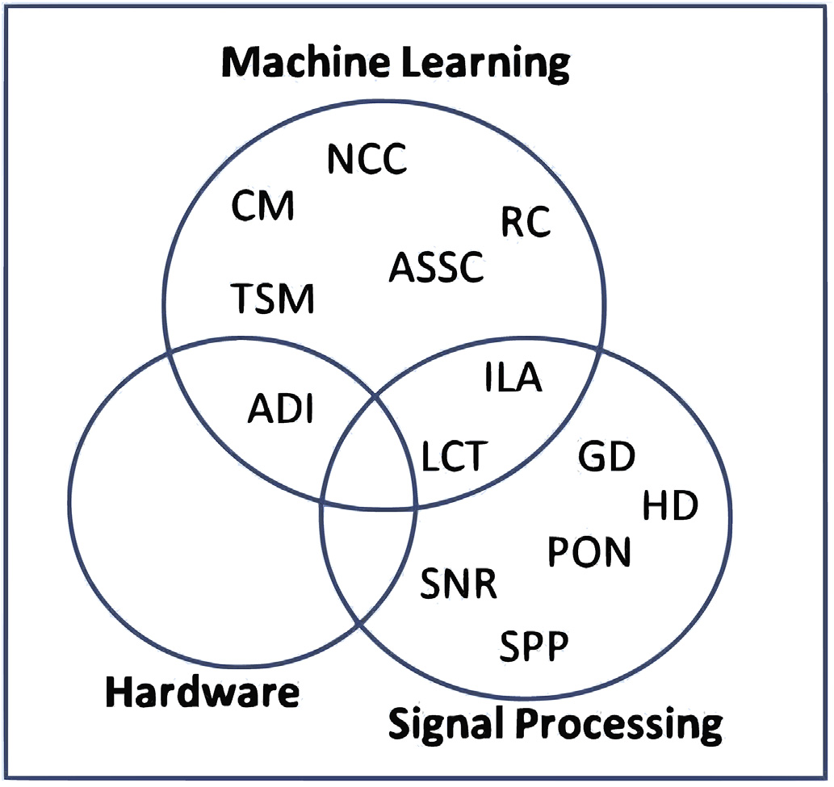

Fig. 11. Challenges coverage across varied domains. The challenges are Time Series Modeling Techniques (TSM), Automatic selection of Subject Specific Characteristics (ASSC), Number of Components (NCC), Classification Methods (CM), Interpretability of Learned Algorithms (ILA), Algorithm-Device Integra-tion (ADI), Gathering Data (GD), Long Calibration Time (LCT), Signal Processing Pipelining (SPP), High Dimensionality of EEG (HD), Signal to Noise Ratio (SNR), Presence of Noise (PON).

8. Conclusion

The paper presented the comprehensive comparison of prominent feature extraction techniques used for EEG based BCI for motor imagery tasks. Currently CSP is the most preferred method of feature extraction. The presented review highlighted the various features like frequency band, spatial filters, and presence of artifacts in the signal on which the performance of CSP is highly dependent.

This paper also discussed the various classification methods currently used for motor imagery BCI. Classification methods are detailed by various categories: linear, non-linear, neural network and deep learning. Support vector machine is the commonly used classifier as it is insensitive to curse of dimensionality. In recent studies, several deep learning ar-chitectures were also used as a classification method for motor imagery tasks, among that shallow convolutional neural network is the prominent

|  |  |  |  |  |  |  |  |
| --- | --- | --- | --- | --- | --- | --- | --- |
| architecture | and | has | outperformed | the | traditional | methods | of |

classification.

Authors have explored the various challenges of different modules of BCI and these challenges were mapped with the domains of machine learning, signal processing and hardware specifications.

Future work related to MI BCI should focus on developing informa-tion extraction techniques that consider the automatic selection of sub-ject relevant temporal information. Additionally, robust classifiers needs to be evolved so as to work with noisy signals and high dimensionality data. There is also a need to develop the new generation of classification methods that should consider the user in the loop to provide feedback from which the user can learn; and help to build an accurate and efficient BCI system.

Declaration of Competing Interest

The authors declare no conflict of interest.

11

S. Aggarwal, N. Chugh Array 1-2 (2019) 100003

[31] [Aler Ricardo, Galv](http://refhub.elsevier.com/S2590-0056(19)30003-7/sref31)�a[n In](http://refhub.elsevier.com/S2590-0056(19)30003-7/sref31)�e[s M, Valls Jos](http://refhub.elsevier.com/S2590-0056(19)30003-7/sref31)�e [M. Transition detection for brain computer interface classif](http://refhub.elsevier.com/S2590-0056(19)30003-7/sref31)i[cation. In: International joint conference on biomedical engineering systems and technologies. Berlin, Heidelberg: Springer; 2009](http://refhub.elsevier.com/S2590-0056(19)30003-7/sref31).

[32] [Aler Ricardo, Galv](http://refhub.elsevier.com/S2590-0056(19)30003-7/sref32)�a[n In](http://refhub.elsevier.com/S2590-0056(19)30003-7/sref32)�e[s M, Valls Jos](http://refhub.elsevier.com/S2590-0056(19)30003-7/sref32)�e [M. Evolving spatial and frequency selection f](http://refhub.elsevier.com/S2590-0056(19)30003-7/sref32)i[lters for brain-computer interfaces, Evolutionary Computation (CEC), 2010 IEEE Congress on. IEEE; 2010](http://refhub.elsevier.com/S2590-0056(19)30003-7/sref32).

[33] [Hamedi M, Salleh SH, Noor AM, Mohammad-Rezazadeh I. Neural network-based three-class motor imagery classif](http://refhub.elsevier.com/S2590-0056(19)30003-7/sref33)i[cation using time-domain features for BCI applications. Region 10 Symposium. Kuala Lumpur, Malaysia: IEEE; 2014 Apr 14-](http://refhub.elsevier.com/S2590-0056(19)30003-7/sref33)

[56] [Ang Kai Keng, et al. Filter bank common spatial pattern (FBCSP) in brain-computer](http://refhub.elsevier.com/S2590-0056(19)30003-7/sref56)  [interface, Neural Networks. In: 2008, IJCNN 2008,(IEEE world congress on](http://refhub.elsevier.com/S2590-0056(19)30003-7/sref56)  [computational intelligence), IEEE international joint conference on. IEEE; 2008](http://refhub.elsevier.com/S2590-0056(19)30003-7/sref56). [57] [Thomas KP, Guan C, Lau CT, Vinod AP, Ang KK. A new discriminative common](http://refhub.elsevier.com/S2590-0056(19)30003-7/sref57)  [spatial pattern method for motor imagery brain–computer interfaces. IEEE (Inst](http://refhub.elsevier.com/S2590-0056(19)30003-7/sref57)  [Electr Electron Eng) Trans Biomed Eng 2009;56:2730](http://refhub.elsevier.com/S2590-0056(19)30003-7/sref57)[–](http://refhub.elsevier.com/S2590-0056(19)30003-7/sref58)[3](http://refhub.elsevier.com/S2590-0056(19)30003-7/sref57).

[58] [Yang Huijuan, et al. On the use of convolutional neural networks and augmented CSP features for multi-class motor imagery of EEG signals classif](http://refhub.elsevier.com/S2590-0056(19)30003-7/sref58)i[cation. In: Engineering in medicine and biology society (EMBC), 2015 37th annual](http://refhub.elsevier.com/S2590-0056(19)30003-7/sref58)

[16](http://refhub.elsevier.com/S2590-0056(19)30003-7/sref33). [international conference of the IEEE. IEEE; 2015](http://refhub.elsevier.com/S2590-0056(19)30003-7/sref58).

[34] [Agarwal SK, Shah S, Kumar R. Classif](http://refhub.elsevier.com/S2590-0056(19)30003-7/sref34)i[cation of mental tasks from EEG data using](http://refhub.elsevier.com/S2590-0056(19)30003-7/sref34)  [backtracking search optimization based neural classif](http://refhub.elsevier.com/S2590-0056(19)30003-7/sref34)i[er. Neurocomputing 2015;](http://refhub.elsevier.com/S2590-0056(19)30003-7/sref34)

[35] [Zhang Jin, Yan Chungang, Gong Xiaoliang. Deep convolutional neural network for](http://refhub.elsevier.com/S2590-0056(19)30003-7/sref35) [166:397](http://refhub.elsevier.com/S2590-0056(19)30003-7/sref34)[–](http://refhub.elsevier.com/S2590-0056(19)30003-7/sref35)[403](http://refhub.elsevier.com/S2590-0056(19)30003-7/sref34).

[decoding motor imagery based brain computer interface, Signal Processing, Communications and Computing (ICSPCC). IEEE International Conference on, IEEE, 2017; 2017](http://refhub.elsevier.com/S2590-0056(19)30003-7/sref35).

[36] [Sakhavi Siavash, Guan Cuntai, Yan Shuicheng. Parallel convolutional-linear neural network for motor imagery classif](http://refhub.elsevier.com/S2590-0056(19)30003-7/sref36)i[cation, Signal Processing Conference (EUSIPCO), 2015 23rd European. IEEE; 2015](http://refhub.elsevier.com/S2590-0056(19)30003-7/sref36).

[37] [Ko Wonjun, et al. Deep recurrent spatio-temporal neural network for motor imagery](http://refhub.elsevier.com/S2590-0056(19)30003-7/sref37)  [based BCI. In: Brain-computer interface (BCI), 2018 6th international conference](http://refhub.elsevier.com/S2590-0056(19)30003-7/sref37)

[59] [Goksu Fikri, Ince N Firat, Tewf](http://refhub.elsevier.com/S2590-0056(19)30003-7/sref59)i[k Ahmed H. Sparse common spatial patterns in brain computer interface applications, Acoustics, Speech and Signal Processing (ICASSP). In: 2011 IEEE international conference on. IEEE; 2011](http://refhub.elsevier.com/S2590-0056(19)30003-7/sref59).

[60] [Samek W, Vidaurre C, Müller KR, Kawanabe M. Stationary common spatial patterns](http://refhub.elsevier.com/S2590-0056(19)30003-7/sref60)

[61] [Samek W, Kawanabe M, Müller KR. Divergence-based framework for common](http://refhub.elsevier.com/S2590-0056(19)30003-7/sref61) [for brain](http://refhub.elsevier.com/S2590-0056(19)30003-7/sref60)–[computer interfacing. J Neural Eng 2012;9:026013](http://refhub.elsevier.com/S2590-0056(19)30003-7/sref60).

[62] [Wu W, Chen Z, Gao X, Li Y, Brown EN, Gao S. Probabilistic common spatial patterns](http://refhub.elsevier.com/S2590-0056(19)30003-7/sref62) [spatial patterns algorithms. IEEE Rev. Biomed. Eng. 2014;7:50](http://refhub.elsevier.com/S2590-0056(19)30003-7/sref61)–[72](http://refhub.elsevier.com/S2590-0056(19)30003-7/sref61).

[for multichannel EEG analysis. IEEE Trans Pattern Anal Mach Intell 2015;37:](http://refhub.elsevier.com/S2590-0056(19)30003-7/sref62)

[63] [Islam, Rabiul Md, et al. Classif](http://refhub.elsevier.com/S2590-0056(19)30003-7/sref63)i[cation of motor imagery BCI using multiband](http://refhub.elsevier.com/S2590-0056(19)30003-7/sref63) [639](http://refhub.elsevier.com/S2590-0056(19)30003-7/sref62)–[53](http://refhub.elsevier.com/S2590-0056(19)30003-7/sref62).

[tangent space mapping. In: Digital signal processing (DSP), 2017 22nd international](http://refhub.elsevier.com/S2590-0056(19)30003-7/sref63)

[on. IEEE; 2018](http://refhub.elsevier.com/S2590-0056(19)30003-7/sref37). [conference on. IEEE; 2017](http://refhub.elsevier.com/S2590-0056(19)30003-7/sref63).

[38] [Sakhavi Siavash, Guan Cuntai, Yan Shuicheng. Learning temporal information for brain-computer interface using convolutional neural networks. IEEE Transactions on Neural Networks and Learning Systems; 2018](http://refhub.elsevier.com/S2590-0056(19)30003-7/sref38).

[39] [Vaid Swati, Singh Preeti, Kaur Chamandeep. EEG signal analysis for BCI interface: a](http://refhub.elsevier.com/S2590-0056(19)30003-7/sref39)  [review. In: 2015 f](http://refhub.elsevier.com/S2590-0056(19)30003-7/sref39)i[fth international conference on advanced computing](http://refhub.elsevier.com/S2590-0056(19)30003-7/sref39) &

[40] [Lakshmi M Rajya, Prasad TV, Chandra Prakash Dr V. Survey on EEG signal](http://refhub.elsevier.com/S2590-0056(19)30003-7/sref40) [communication technologies. IEEE; 2015. p. 143](http://refhub.elsevier.com/S2590-0056(19)30003-7/sref39)[–](http://refhub.elsevier.com/S2590-0056(19)30003-7/sref40)[7](http://refhub.elsevier.com/S2590-0056(19)30003-7/sref39).

[processing methods. Int J Adv Res Comput Sci Softw Eng 2014;4(1)](http://refhub.elsevier.com/S2590-0056(19)30003-7/sref40).

[64] [Mill](http://refhub.elsevier.com/S2590-0056(19)30003-7/sref64)�a[n JR, Renkens F, Mourino J, Gerstner W. Noninvasive brain-actuated control](http://refhub.elsevier.com/S2590-0056(19)30003-7/sref64)

[65] [Garcia, Gary N., Touradj Ebrahimi, and J-M. Vesin. Support vector EEG](http://refhub.elsevier.com/S2590-0056(19)30003-7/sref65) [of a mobile robot by human EEG. IEEE Trans Biomed Eng 2004;51:1026](http://refhub.elsevier.com/S2590-0056(19)30003-7/sref64)–33.

[classif](http://refhub.elsevier.com/S2590-0056(19)30003-7/sref65)i[cation in the Fourier and time-frequency correlation domains, Neural Engineering. In: 2003, conference proceedings, f](http://refhub.elsevier.com/S2590-0056(19)30003-7/sref65)i[rst international IEEE EMBS conference on. IEEE; 2003](http://refhub.elsevier.com/S2590-0056(19)30003-7/sref65).

[66] Introduction to support vector machine. 2017. [https://medium.com/@LSchultebr aucks/introduction-to-support-vector-machines-9f8161ae2fcb/](https://medium.com/@LSchultebraucks/introduction-to-support-vector-machines-9f8161ae2fcb/). [Accessed 22

[41] [Lotte F, Congedo M, L](http://refhub.elsevier.com/S2590-0056(19)30003-7/sref41)�e[cuyer A, Lamarche F, Arnaldi B. A review of classif](http://refhub.elsevier.com/S2590-0056(19)30003-7/sref41)i[cation](http://refhub.elsevier.com/S2590-0056(19)30003-7/sref41)  September 2017].

[42] [Chaudhari Rupal, Galiyawala Hiren J. A review on motor imagery signal](http://refhub.elsevier.com/S2590-0056(19)30003-7/sref42) [algorithms for EEG-based brain](http://refhub.elsevier.com/S2590-0056(19)30003-7/sref41)[–](http://refhub.elsevier.com/S2590-0056(19)30003-7/sref42)[computer interfaces. J Neural Eng 2007;4:R1](http://refhub.elsevier.com/S2590-0056(19)30003-7/sref41). [67] Niranjani A Naga, Sivachitra M. Motor imagery signal classification using spiking

[neural network. In: 2017 international conference on intelligent sustainable](http://refhub.elsevier.com/S2590-0056(19)30003-7/sref67)

[classif](http://refhub.elsevier.com/S2590-0056(19)30003-7/sref42)i[cation for BCI. Signal Process Int J(SPIJ) 2017;11(2)](http://refhub.elsevier.com/S2590-0056(19)30003-7/sref42). [systems (ICISS). IEEE; 2017](http://refhub.elsevier.com/S2590-0056(19)30003-7/sref67).

[43] [Donoghue JP. Connecting cortex to machines: recent advances in brain interfaces.](http://refhub.elsevier.com/S2590-0056(19)30003-7/sref43)  [Nat Neurosci 2002;5:1085](http://refhub.elsevier.com/S2590-0056(19)30003-7/sref43).

[44] [Serruya Mijail D, et al. Brain-machine interface: instant neural control of a](http://refhub.elsevier.com/S2590-0056(19)30003-7/sref44)  [movement signal. Nature 2002;416:141](http://refhub.elsevier.com/S2590-0056(19)30003-7/sref44).

[45] [Aler R, Galv](http://refhub.elsevier.com/S2590-0056(19)30003-7/sref45)�a[N IM, Valls JM. Applying evolution strategies to preprocessing EEG](http://refhub.elsevier.com/S2590-0056(19)30003-7/sref45)

[46] [Suleiman Abdul-Bary Raouf, Toka Abdul-Hameed Fatehi. Features extraction](http://refhub.elsevier.com/S2590-0056(19)30003-7/sref46) [signals for brain](http://refhub.elsevier.com/S2590-0056(19)30003-7/sref45)[–](http://refhub.elsevier.com/S2590-0056(19)30003-7/sref46)[computer interfaces. Inf Sci 2012;215:53](http://refhub.elsevier.com/S2590-0056(19)30003-7/sref45)[–](http://refhub.elsevier.com/S2590-0056(19)30003-7/sref46)[66](http://refhub.elsevier.com/S2590-0056(19)30003-7/sref45).

[techniques of EEG signal for BCI applications. Iraq: Faculty of Computer and Information Engineering Department College of Electronics Engineering, University of Mosul; 2007](http://refhub.elsevier.com/S2590-0056(19)30003-7/sref46).

[47] [Chang-Hwan Im, editor. Computational EEG analysis: methods and applications.](http://refhub.elsevier.com/S2590-0056(19)30003-7/sref47)

[68] [Kumar Shiu, et al. A deep learning approach for motor imagery EEG signal classif](http://refhub.elsevier.com/S2590-0056(19)30003-7/sref68)i[cation. In: Computer science and engineering (APWC on CSE), 2016 3rd asia-pacif](http://refhub.elsevier.com/S2590-0056(19)30003-7/sref68)i[c world congress on. IEEE; 2016](http://refhub.elsevier.com/S2590-0056(19)30003-7/sref68).

[69] [Zhao Yiran, et al. On the improvement of classifying EEG recordings using neural networks, Big Data (Big Data). In: 2017 IEEE international conference on. IEEE; 2017](http://refhub.elsevier.com/S2590-0056(19)30003-7/sref69).

[70] [Schirrmeister RT, Springenberg JT, Fiederer LD, Glasstetter M, Eggensperger K, Tangermann M, Hutter F, Burgard W, Ball T. Deep learning with convolutional neural networks for EEG decoding and visualization. Hum Brain Mapp 2017;38:](http://refhub.elsevier.com/S2590-0056(19)30003-7/sref70)

[71] [Yi W, Qiu S, Qi H, Zhang L, Wan B, Ming D. EEG feature comparison and](http://refhub.elsevier.com/S2590-0056(19)30003-7/sref71) [5391](http://refhub.elsevier.com/S2590-0056(19)30003-7/sref70)[–](http://refhub.elsevier.com/S2590-0056(19)30003-7/sref71)[420](http://refhub.elsevier.com/S2590-0056(19)30003-7/sref70).

[Springer; 2018](http://refhub.elsevier.com/S2590-0056(19)30003-7/sref47). [classif](http://refhub.elsevier.com/S2590-0056(19)30003-7/sref71)i[cation of simple and compound limb motor imagery. J NeuroEng Rehabil](http://refhub.elsevier.com/S2590-0056(19)30003-7/sref71)

[48] Wavelet transform. <https://en.wikipedia.org/wiki/Wavelet_transform/>. [2013;10:106](http://refhub.elsevier.com/S2590-0056(19)30003-7/sref71).

[49] [Wang Y, Veluvolu KC, Lee M. Time-frequency analysis of band-limited EEG with](http://refhub.elsevier.com/S2590-0056(19)30003-7/sref49)

[BMFLC and Kalman f](http://refhub.elsevier.com/S2590-0056(19)30003-7/sref49)i[lter for BCI applications. J NeuroEng Rehabil 2013;10:109](http://refhub.elsevier.com/S2590-0056(19)30003-7/sref49).

[50] [Ting W, Guo-zheng Y, Bang-hua Y, Hong S. EEG feature extraction based on wavelet](http://refhub.elsevier.com/S2590-0056(19)30003-7/sref50)

[51] [Yang BH, Yan GZ, Yan RG, Wu T. Adaptive subject-based feature extraction in](http://refhub.elsevier.com/S2590-0056(19)30003-7/sref51) [packet decomposition for brain computer interface. Measurement 2008;41:618](http://refhub.elsevier.com/S2590-0056(19)30003-7/sref50)[–](http://refhub.elsevier.com/S2590-0056(19)30003-7/sref51)[25](http://refhub.elsevier.com/S2590-0056(19)30003-7/sref50).

[brain–computer interfaces using wavelet packet best basis decomposition. Med Eng](http://refhub.elsevier.com/S2590-0056(19)30003-7/sref51)

[52] [Müller-Gerking J, Pfurtscheller G, Flyvbjerg H. Designing optimal spatial f](http://refhub.elsevier.com/S2590-0056(19)30003-7/sref52)i[lters for](http://refhub.elsevier.com/S2590-0056(19)30003-7/sref52) [Phys 2007;29:48](http://refhub.elsevier.com/S2590-0056(19)30003-7/sref51)[–](http://refhub.elsevier.com/S2590-0056(19)30003-7/sref52)[53](http://refhub.elsevier.com/S2590-0056(19)30003-7/sref51).

[single-trial EEG classif](http://refhub.elsevier.com/S2590-0056(19)30003-7/sref52)i[cation in a movement task. Clin Neurophysiol 1999;110:](http://refhub.elsevier.com/S2590-0056(19)30003-7/sref52)

[53] [Lemm S, Blankertz B, Curio G, Muller KR. Spatio-spectral f](http://refhub.elsevier.com/S2590-0056(19)30003-7/sref53)i[lters for improving the](http://refhub.elsevier.com/S2590-0056(19)30003-7/sref53) [787](http://refhub.elsevier.com/S2590-0056(19)30003-7/sref52)[–](http://refhub.elsevier.com/S2590-0056(19)30003-7/sref53)[98](http://refhub.elsevier.com/S2590-0056(19)30003-7/sref52).

[54] [Dornhege G, Blankertz B, Krauledat M, Losch F, Curio G, Muller KR. Combined](http://refhub.elsevier.com/S2590-0056(19)30003-7/sref54) [classif](http://refhub.elsevier.com/S2590-0056(19)30003-7/sref53)i[cation of single trial EEG. IEEE Trans Biomed Eng 2005;52:1541](http://refhub.elsevier.com/S2590-0056(19)30003-7/sref53)[–](http://refhub.elsevier.com/S2590-0056(19)30003-7/sref54)[8](http://refhub.elsevier.com/S2590-0056(19)30003-7/sref53).

[optimization of spatial and temporal f](http://refhub.elsevier.com/S2590-0056(19)30003-7/sref54)i[lters for improving brain-computer](http://refhub.elsevier.com/S2590-0056(19)30003-7/sref54)

[55] [Novi Quadrianto, et al. Sub-band common spatial pattern (SBCSP) for brain-](http://refhub.elsevier.com/S2590-0056(19)30003-7/sref55)[interfacing. IEEE Trans Biomed Eng 2006;53:2274](http://refhub.elsevier.com/S2590-0056(19)30003-7/sref54)[–](http://refhub.elsevier.com/S2590-0056(19)30003-7/sref55)[81](http://refhub.elsevier.com/S2590-0056(19)30003-7/sref54).

[computer interface, Neural Engineering. In: 2007, CNE’07, 3rd international IEEE/ EMBS conference on. IEEE; 2007](http://refhub.elsevier.com/S2590-0056(19)30003-7/sref55).

12