|  |  |  |  |
| --- | --- | --- | --- |
|  |  | Available online at www.sciencedirect.com |  |
| **ScienceDirect** |
| AASRI Procedia 9 ( 2014 ) 72 – 77 |

2014 AASRI Conference on Circuit and Signal Processing (CSP 2014)

Three-Dimensional Reconstruction from Projections Based On Incidence Matrices of Patterns

Zakharov Alexei, Zhiznyakov Arkady*

*Murom Institut, Vladimir State University, Murom, 602264, Russian Federation*

**Abstract**

Task of automatic reconstruction of three-dimensional objects by drawing views presented. The algorithm based on a boundary representation of three-dimensional models. The algorithm consists of the following steps: automatic separation of the drawing per the views, determination of three-dimensional coordinates of vertices, definition and marking of wire model primitives, reconstruction of model faces and model elements. The fundamental concept of the algorithm is to find the structural elements of three-dimensional model with usage of pre-specified patterns. The templates are described by means of matrices. Matching algorithm uses invariants: the number of vertices, type of edges.

|  |
| --- |
| © 2014 Zakharov A.A., Zhiznyakov A.L. Published by Elsevier B.V. © 2014 The Authors. Published by Elsevier B. V. This is an open access article under the CC BY-NC-ND license  Selection and/or peer review under responsibility of American Applied Science Research Institute (http://creativecommons.org/licenses/by-nc-nd/3.0/).  Peer-review under responsibility of Scientific Committee of American Applied Science Research Institute |

*Keywords:* three-dimensional reconstruction, CAD-system, incidence matrix.

**1. Introduction**

For the moment, a large number of the technical drawings, submitted in both paper and electronic form are accumulated in the archives of the enterprises. An additional point is that the development of many objects often begins with the drawing instead of three-dimensional model usage. Two-dimensional drawings are often

* Corresponding author. Tel.: 8(49234) 77236.   
E-mail address: aa-zaharov@ya.ru.

2212-6716 © 2014 The Authors. Published by Elsevier B. V. This is an open access article under the CC BY-NC-ND license (http://creativecommons.org/licenses/by-nc-nd/3.0/).

Peer-review under responsibility of Scientific Committee of American Applied Science Research Institute doi: 10.1016/j.aasri.2014.09.013

*Zakharov Alexei and Zhiznyakov Arkady / AASRI Procedia 9 ( 2014 ) 72 – 77*  73

difficult to understand, they are inconvenient to update and the ones can not serve as a basis for further developments with computer systems usage.

The three-dimensional computer model of the object, which can be used for development of supervisor programs, engineering analysis, visualization, etc., is one of the components of electronic model of product. The modern CAD-systems have the following bevy of tools to generate the three-dimensional models “with a clean slate”: Boolean operations, the operations of object-oriented modeling, 2.5D-operations, modification operations of vertices, edges and faces. Practically all CAD-systems allow the generation of drawings with usage of three-dimensional model. However, generation of three-dimensional model per drawing causes the designers difficulties, related to the lack of software.

**2. Survey of algorithms of three-dimensional reconstruction per technical drawing**

All algorithms of three-dimensional models regenerating per drawings can be divided into two groups: CSG- and B-rep approaches. CSG-oriented (constructive solid geometry) approach uses “top to bottom” regenerating strategy (Geng, 2002; Cicek, 2004; Lee, 2005; Wang, 2007; You, 2008; Xie, 2009). The approach is based on the fact that each three-dimensional object can be built with usage of specific two-dimensional primitive in a hierarchical manner. Patterns are found in the drawing, which will serve as a base and they will be used for transformation into three-dimensional model. That done, the designed primitives are collected in the resulting three-dimensional model, using the Boolean operations. The disadvantage of CSG-oriented approach is the fact that with its usage it is difficult to recognize the basic primitives on complex drawings. As well as, it is difficult to imagine the surfaces of complicated shape, when using the CSG-geometry.

B-rep-oriented (bounding representation) approach uses “ascending” technology. B-rep-oriented algorithms generally consist of the following steps: generation of possible three-dimensional vertices from drawing; edges synthesis per received coordinates of vertices; design of faces from edges, lying in plane; the formation of three-dimensional object from faces (Masuda, 1997; Shin, 1998; Watanable, 1998; Liu, 2001; Golovin, 2007).

Boundary representation provides considerable opportunities for modeling of object complex geometry, it is impossible to reach when using of CSG-approach. However, when using B-rep-representation the more storage space for storage and processing of data is required. An additional point is that, the created model is logically less stable, in other words it is possible to build controversial configurations.

The existing algorithms of reconstruction per drawings are characterized by the following characteristics: the degree of operator involvement in the reconstruction process, the surfaces geometry, the number of views on the drawing, the possibility of error correction, the sections processing, etc.

The analysis has shown that existing approaches are generally designed for the objects with sufficiently simple geometry. These algorithms often do not allow performing of reconstruction of polygonal surfaces, fillets, slots, holes. In this paper the algorithm, which allows recognizing these structural elements on the basis of predetermined patterns, is presented.

**3. Automatic reconstruction algorithm using patterns**

Presented algorithm is developed on the basis of B-rep-representation that provides the significant opportunities as to the description of the complex shape geometry. The fundamental concept of the algorithm is to find the structural elements of three-dimensional model with usage of pre-specified patterns. The templates are described by means of matrices. On the basis of the patterns, such elements as holes, slots, chamfers, etc. are described.

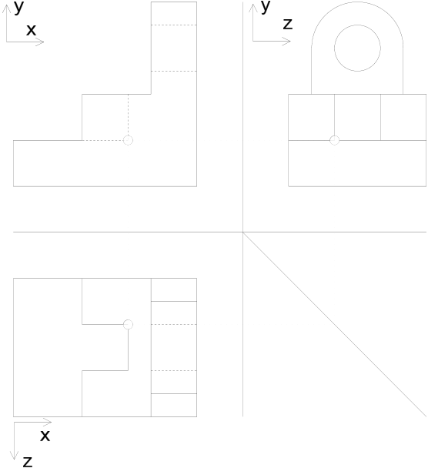

74  *Zakharov Alexei and Zhiznyakov Arkady / AASRI Procedia 9 ( 2014 ) 72 – 77*

The developed algorithm processes the data of vector drawing, saved in DXF (Drawing eXchange Format - format of drawings exchange) format. The algorithm consists of the following steps.

Step 1. Drawing read of vector file. The primitives’ parameters (values of vertex coordinates, radius, centers of circles, etc.) are read off.

Step 2. Automatic separation of the drawing per the views. The algorithm operates for the drawings, consisting of three views: front view, top view and view from the left. In this case, the location of the drawing primitives in reference to horizontally and vertically moving straight lines shall be checked. For example, the process of the drawing separation into the main view and the view from the left is finished when there are the primitives that are on the left and on the right from the straight line that is described by the equation *x* �*A* . At that this straight line does not intersect any primitive of the drawing. In this case, for each vertex of the primitive either condition *xi* �*A* or condition *xi* �*A* shall be met. Similarly, the drawing separation into the main view and top view is carried out.

Step 3 . Finding of the coordinates of the vertices of the three-dimensional model on the basis of view (Fig. 1). If the main view to indicate as F (Front), left-side view as L (Left), top view as T (Top), then it is possible to determine the three-dimensional coordinates of the vertices from the following conditions: , *z F*�*z L* . It is understood that the drawings are designed in the CAD-system with usage *x F*�*x T* , *y F*�*y L*   
of standard tools: object snap, snap to grid, etc. Any inaccuracy in the creation of the primitives leads to an ambiguous interpretation of the image.

Step 4. Definition and marking of wire model primitives. The wire model consists of the segments of straight lines, arcs, circles, splines, etc. If at least two primitives’ projections on views coincide, then there are corresponding to primitive vertices, the coordinates of which are computed at step 3. Description of the primitive in three-dimensional space shall be fed into memory and it shall be assigned with number.

Step 5. Definition and construction of reconstructed object model faces. The face is constructed on the basis of the closed loop of primitives, belonging to the same plane. The closed loop must consist of as low as practicable number of primitives.

Step. 6. Definition and construction of structural components of the model on the basis of patterns. Each typical element can be determined on the basis of the adjacency of three-dimensional primitives (segments of straight lines, circles and arcs), extracted from the drawing. We will assume the primitives that have the common vertex as incidence ones.

|  |  |  |
| --- | --- | --- |
|  | ������������������������������������� |  |
| a) b) | |

Fig.1. (a) conformance of coordinates of the vertices on drawing views; (b) reconstructed three-dimensional model

*Zakharov Alexei and Zhiznyakov Arkady / AASRI Procedia 9 ( 2014 ) 72 – 77*  75

Each structural component can be represented by wire model (Table 2). The relative positions of the primitives can be described on the basis of the incidence matrix. Each column describes vertex *V*, and the row is the edge *E* (arc, circle, segment of the straight line). Last two columns describe the number of vertices adjacent to edge *K* and edge type *P*. The figure that determines both adjacency of primitives and their designation on the drawing is at the intersection of row and column.

Table 1. Structural components and their incidence matrix

|  |  |  |
| --- | --- | --- |
| Structural  components | Wire models of structural components | Incidence matrix |
| Cylindrical hole |  | |  |  |  |  |  |  |  |  |  |  |  | | --- | --- | --- | --- | --- | --- | --- | --- | --- | --- | --- | |  | *V*1 | *V*2 | *V*3 | *V*4 | *V*5 | *V*6 | *V*7 | *V* 8 | *K* | *P* | | *E*1 | 5 | 5 | 5 | 5 |  |  |  |  | 4 | 5 | | *E*2 |  |  |  |  | 5 | 5 | 5 | 5 | 4 | 5 | | *E*3 | 2 |  |  |  | 2 |  |  |  | 2 | 2 | | *E*4 |  | 2 |  |  |  | 2 |  |  | 2 | 2 | | *E*5 |  |  | 2 |  |  |  | 2 |  | 2 | 2 | | *E*6 |  |  |  | 2 |  |  |  | 2 | 2 | 2 | |
| Round slot |  | |  |  |  |  |  |  |  |  |  | | --- | --- | --- | --- | --- | --- | --- | --- | --- | |  | *V*1 | *V*2 | *V*3 | *V*4 | *V*5 | *V*6 | *K* | *P* | | *E*1 | 1 | 1 |  |  |  |  | 2 | 1 | | *E*2 |  |  | 2 | 2 |  |  | 2 | 2 | | *E*3 |  |  |  |  | 1 | 1 | 2 | 1 | | *E*4 | 3 |  | 3 |  | 3 |  | 3 | 3 | | *E*5 |  | 3 |  | 3 |  | 3 | 3 | 3 | |
| Round boss |  | |  |  |  |  |  |  |  |  |  |  |  | | --- | --- | --- | --- | --- | --- | --- | --- | --- | --- | --- | |  | *V*1 | *V*2 | *V*3 | *V*4 | *V*5 | *V*6 | *V* 7 | *V* 8 | *K* | *P* | | *E*1 | 5 | 5 | 5 | 5 |  |  |  |  | 4 | 5 | | *E*2 |  |  |  |  | 5 | 5 | 5 | 5 | 4 | 5 | | *E*3 | 1 |  |  |  | 1 |  |  |  | 2 | 1 | | *E*4 |  | 1 |  |  |  | 1 |  |  | 2 | 1 | | *E*5 |  |  | 1 |  |  |  | 1 |  | 2 | 1 | | *E*6 |  |  |  | 1 |  |  |  | 1 | 2 | 1 | |
| Fillet |  | |  |  |  |  |  |  |  |  |  | | --- | --- | --- | --- | --- | --- | --- | --- | --- | |  | *V*1 | *V*2 | *V*3 | *V*4 | *V*5 | *V*6 | *K* | *P* | | *E*1 | 1 | 1 |  |  |  |  | 2 | 1 | | *E*2 |  |  | 1 | 1 |  |  | 2 | 1 | | *E*3 |  |  |  |  | 1 | 1 | 2 | 1 | | *E*4 | 3 |  | 3 |  | 3 |  | 3 | 3 | | *E*5 |  | 3 |  | 3 |  | 3 | 3 | 3 | |

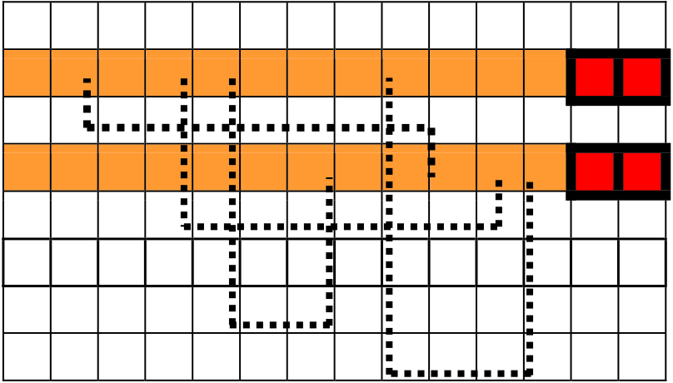

76  *Zakharov Alexei and Zhiznyakov Arkady / AASRI Procedia 9 ( 2014 ) 72 – 77*

The matrices that define the patterns of the structural components are saved in the system beforehand. Depending on the relative positions of segment of straight line and circle (or arc) the matrix elements can

|  |  |  |  |  |
| --- | --- | --- | --- | --- |
| possess the following values: | | | | |
| � | *Mi j* � | 0 | , if vertex and segment of the straight line (arc, circle) are not adjacent; | |
| � | *Mi j* � | 1 | , if vertex and segment of the straight line are adjacent ones. Segment of the straight line is | |
| represented by unbroken line; | | | | |
| � | *Mi j* � | 2 | | , if vertex and segment of the straight line are adjacent ones. Segment of the straight line is |
| represented by dashed line; | | | | |
| � | *Mi j* � | 3 | , if vertex and arc are adjacent ones. Arc is represented by unbroken line; | |
| � | *Mi j* � | 4 | | , if vertex and arc are adjacent ones. Arc is represented by dashed line; |
| � | *Mi j* � | 5 | , if vertex and circle are adjacent ones. Arc is represented by unbroken line; | |
| � | *Mi j* � | 6 | , if vertex and circle are adjacent ones. Arc is represented by dashed line. | |

**4. Matching of the incidence matrix**

Matrix of model and matrix of primitive are compared. Invariants are used to reduce computations. Invariants are the number of vertices and type of edge. The algorithm consists of the following steps: Step 1. All edges are defined in matrix. Compares the values of *K* and *P* (Figure 2 (a));   
 Step 2. Adjacent edges found in matrix (Figure 2 (b)).

Step 3. All adjacent edges form 3D-primitive.

|  |  |  |  |  |  |  |  |  |  |  |  |  |  |  |  |  |  |  |  |  |  |  |  |  |  |  |  |  |  |  |  |  |  |  |  |  |  |  |  |  |  |  |  |  |  |  |  |  |  |  |  |  |  |  |  |  |  |  |  |  |  |  |  |  |  |  |  |  |  |  |  |  |  |  |  |  |  |  |  |  |  |  |  |  |  |  |  |  |  |  |  |  |  |  |  |  |  |  |  |  |  |  |  |  |  |  |  |  |  |  |  |  |  |  |  |  |  |  |  |  |  |  |  |
| --- | --- | --- | --- | --- | --- | --- | --- | --- | --- | --- | --- | --- | --- | --- | --- | --- | --- | --- | --- | --- | --- | --- | --- | --- | --- | --- | --- | --- | --- | --- | --- | --- | --- | --- | --- | --- | --- | --- | --- | --- | --- | --- | --- | --- | --- | --- | --- | --- | --- | --- | --- | --- | --- | --- | --- | --- | --- | --- | --- | --- | --- | --- | --- | --- | --- | --- | --- | --- | --- | --- | --- | --- | --- | --- | --- | --- | --- | --- | --- | --- | --- | --- | --- | --- | --- | --- | --- | --- | --- | --- | --- | --- | --- | --- | --- | --- | --- | --- | --- | --- | --- | --- | --- | --- | --- | --- | --- | --- | --- | --- | --- | --- | --- | --- | --- | --- | --- | --- | --- | --- | --- | --- | --- |
| |  |  |  |  |  |  |  |  |  |  |  |  |  |  | | --- | --- | --- | --- | --- | --- | --- | --- | --- | --- | --- | --- | --- | --- | |  |  |  |  |  |  |  |  |  |  |  |  | *K* | *P* | |  | 5 |  | 5 | 5 |  |  |  | 5 |  |  |  | 4 | 5 | |  | 1 |  |  |  |  |  |  |  | 1 |  |  | 2 | 1 | |  |  |  |  |  |  | 5 |  |  | 5 | 5 | 5 | 4 | 5 | |  |  |  | 1 |  |  |  |  |  |  | 1 |  | 2 | 1 | | 5 |  | 5 |  |  | 5 |  | 5 |  |  |  |  | 4 | 5 | |  |  |  |  | 1 |  | 1 |  |  |  |  |  | 2 | 1 | |  |  |  |  |  |  |  |  | 1 |  |  | 1 | 2 | 1 |   � | 5 | 5 | 5 | 5 | 5 | 5 | 5 | 5 | 5 | *KP* | |
| 4 5 | |
| 1 | 1 | 1 | 1 | 1 | 2 1 |
| 5 5 5 4 5 | |
| 1 | 2 1 |
| 1 | 4 5 | |
| 2 1 | |
| 1 2 1 | |
| a) | b) |

Fig.2. Matching of the incidence matrix: (a) step 1; (b) step 2.

**5. The results of the reconstruction**

On the basis of the information, extracted from the drawing, the matrices shall be developed and they shall be compared with patterns, stored in the system. If the patterns parameters coincide, then it is possible to conclude as to the presence of one or another structural component. Further, the boundary representation of component form is created. As test example, the drawing, shown in Figure 1 (�) was taken. The result of reconstruction of views is shown in Figure 1 (b).

*Zakharov Alexei and Zhiznyakov Arkady / AASRI Procedia 9 ( 2014 ) 72 – 77*  77

**6. Conclusions**

The developed algorithm is fully automatic one and it operates only with the drawings, presented in vector

form. The algorithm presents high requirements to the accuracy of drawing construction, the one treats

invisible lines and curved surfaces. It is necessary to describe the patterns of all primitives that can occur,

when simulating, so that the system would be fully universal for various geometrical shapes. Test modules of

the system are developed in the terms of AutoLISP language for AutoCAD system.

**Acknowledgements**

This work was supported by RFBR (projects � 13-07-97523, 13-07-00825), job number 2014/13 on the implementation of public works in the field of scientific activities of the base part of the state task Russian

Ministry of Education.

**References**

[1] Geng W, Wang J, Zhang Y. Embedding visual cognition in 3D reconstruction from multi-view engineering drawings, Computer-Aided Design, 2002, Vol. 34, � 4, pp. 321-336.

[2] Cicek A, Gulesin M. Reconstruction of 3D models from 2D orthographic views using solid extrusion and revolution, Journal of Materials Processing Technology, 2004, Vol. 152, � 3, pp. 291-298.

[3] Lee H, Han S. Reconstruction of 3D interacting solids of revolution from 2D orthographic views, Computer-Aided Design, 2005, Vol. 37, � 13, pp. 1388-1398.

[4] Wang Z, Latif M. Reconstruction of 3D Solid Models Using Fuzzy Logic Recognition, Proceedings of the World Congres on Engineering, 2007, Vol. 1, pp 37-42.

[5] You CF, Yang SS. Automatic Feature Recognition from Engineering Drawings, The International Journal of Advanced Manufacturing Technology, 2008, Vol. 14, � 7, pp. 495-507.

[6] Xie B, Chen L, Chen L. A new reconstruction method based on the volume-based approach, Proceedings

of the 2009 International Symposium on Information Processing, 2009, pp 132-135.

[7] Masuda H, Numao M. A cell-based approach for generating solid objects from orthographic projections, Computer-Aided Design, 1997, Vol. 29, � 3, pp. 177-187.

[8] Shin B S, Shin YG. Fast 3D solid model reconstruction from orthographic views, Computer-Aided Design, 1998, Vol. 30, � 1. pp. 63-76.

[9] Watanabe T. Revision of Inconsistent Orthographic Views, Journal for Geometry and Graphics, 1998, Vol. 2, � 1, pp 45-53.

[10] Liu SX. Reconstruction of curved solids from engineering drawings, Computer-Aided Design, 2001, Vol. 33, � 14, pp. 1059-1072.

[11] Golovin SI, Veselov NA. Automatic reconstruction of curved solids from three orthographic projections,

Proceedings of SYRCoSE 2007, 2007, Vol. 2, pp. 53-58.

[12] You CF, Yang SS. Reconstruction of curvilinear manifold objects from orthographic views, Computers & Graphics, 2009, Vol. 20, � 2, pp. 275-293.