Available online at [www.sciencedirect.com](http://www.sciencedirect.com/)



AASRI Procedia 2 (2012) 127 – 133

AASRI

Procedia

[www.elsevier.com/locate/procedia](http://www.elsevier.com/locate/procedia)

2012 AASRI Conference on Power and Energy Systems

# A Brief Review of the Application and Problems in Ultrasonic Fatigue Testing

Wenjie Peng*, Yanwen Zhang, Baowen Qiu and Huan Xue

*Research and Development center of Wuhan Iron and Steel group Corporation, 430080, Wuhan, China*

Abstract

In the present paper, the characteristic and the application of ultrasonic fatigue testing technology is illuminated, as well as the difference of ultrasonic fatigue testing between the conventional fatigue testing. The main problems i.e. the thermal effect and frequency effect due to the high frequency is briefly reviewed and discussed

© 2012 Published by Elsevier B.V. Selection and/or peer review under responsibility of American Applied Science Research Institute

© 2012 Published by Elsevier B.V. Selection and/or peer review under responsibility of American Applied Science Research Institute

© 2012 Published by Elsevier B.V.

Selection and/or peer review under responsibility of American Applied Science Research Institute

Open access under [CC BY-NC-ND license.](http://creativecommons.org/licenses/by-nc-nd/3.0/)

*Keywords*: Ultrasonic fatigue testing, Conventional fatigue testing, thermal effect, frequency effect

1. Introduction

Current fatigue design criteria supposed that if the metal can endure 107 fatigue loading cycles without damage, then it can endure an infinite number of cyclic loading [1]. However, the designed fatigue life of some high-strength steel applied as key structural components or structural steel endured by high-frequency and low-stress loads can reach 108~1010 cycles, such as the bearing steel and cartwheel steel. Additionally, in practice, it is confirmed that the fatigue damage of some steel structure still occurred over 107cycles or at the stress lower than the fatigue limit [2].At these cases, adopting conventional fatigue design criteria will lead to

* Corresponding author. Tel.:027-86487725.

*E-mail address:* [ppengwenjie@gmail.com.](mailto:ppengwenjie@gmail.com)

2212-6716 © 2012 Published by Elsevier B.V. Selection and/or peer review under responsibility of American Applied Science Research Institute

Open access under [CC BY-NC-ND license.](http://creativecommons.org/licenses/by-nc-nd/3.0/) doi:10.1016/j.aasri.2012.09.024

security risk. Therefore, the very high cycle fatigue testing over 107 cycles is particularly important for more safe fatigue design.

The ultrasonic fatigue test machine utilities a piezoelectric or magnetostrictive transducer excited by the power generator to transform the electrical longitudinal ultrasonic waves into mechanical vibration of the same frequency. Thus, a vibratory stress and displacement field is generated in the specimen. The ultrasonic fatigue test machine is mainly used in the two aspects due to the very high frequency of 20 kHz or 30 kHz: 1. Accelerate the conventional fatigue tests. The ultrasonic fatigue testing completes a group of fatigue tests in several hours in spite of about one month needed at conventional 100Hz; 2. Study the very high cycle fatigue property of the high-strength steel endured high-frequency and low-stress loads. As the ultrasonic fatigue test machine is different from the conventional one, the design, the loading and the unloading of the specimens is also different. Meanwhile, the very high frequency occasionally causes some problems such as thermal effect and frequency effect. These problems are briefly illuminated and discussed in this paper.

1. The design of the ultrasonic fatigue sample

Differing from the conventional fatigue specimen with two tips gripped, one tip of the ultrasonic specimen is fixed with the amplifying horn and the other is free. The ultrasonic fatigue specimen must meet the condition of resonance with the experimental system.Assuming the specimen axis is *x* axis, *U*(*x*, *t*) is the longitudinal displacement of the section of the specimen at the *t* time, we can derive the resonant length of an ultrasonic fatigue specimen as follows.

One-dimensional longitudinal wave equation is:

2*U* ( *x*, *t*)

*E* 2*U* ( *x*)

*S* ' ( *x*) *U* ( *x*, *t*)

*t* 2

 ** ( *x*2

 )

*S* ( *x*) *x*

(1)

Assuming the specimen meeting the resonance condition, *u*( *x*, *t*) can be separated as *u*(*x*, *t*)  *U* (*x*)*eit* , Eq.1 can be rewritten as:

2*U* ( *x*)

*U* ( *x*) 2

*x*2

* *P*( *x*)

*x*

* *k U* ( *x*)  0

*S* ' ( *x*) **

(2)

Where, *U* ( *x*) is the displacement formation of the specimen, *P*( *x*)  ; *k*   , *c* is the speed of the

*S* ( *x*) *c*

ultrasonic wave, *c*  , *E* is the tensile modulus; **  2** *ƒ* , *ƒ* is the frequency of the testing system.

*E*

**

Two typical geometries are used for ultrasonic fatigue specimen: smooth specimen and notch specimen.

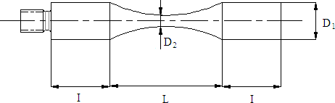

Fig.1 Smooth specimen.

A smooth specimen is shown in Fig.1, assuming the axial center of the specimen is the coordinate origin and *L*2 is the resonant length. Substituting Eq.2 with the specimen contour equation, the analytical solution of the resonant length can be obtained combined with the boundary conditions˖

*I*  1 arctan 1  2**  ** tanh(** *L* )

(3)

*k* *k*  tanh(** *L*) 2 

  

Where, **  2 arccos *h*( *D*1 ) , **  .

** 2  *k* 2

*L D*2

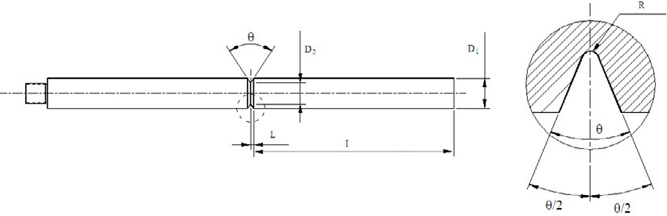Similarly, for a notch specimen, the analytical solution of resonant length *L*2 can also be obtained˖

Fig.2 Notch specimen.

*I*  1 arctan  *k*  *k* 2 cot *kL*

(4)

*k*  *D* 

 0 

 *R*(1 sin ** )  *D L*

Where, *L*  tan **  2  *D*1  *D*2  , *D*  1 .

2  **

2 2 

0 *D*  *D*

 sin

 2

 1 2



Eq.3 and Eq.4 show the analytical solution of the resonant length. For the assigned specimen geometry, given the other sizes of the specimen, the resonant length *L*2 can be obtained according to Eq.3 and Eq.4.

1. Thermal effect in the ultrasonic fatigue test

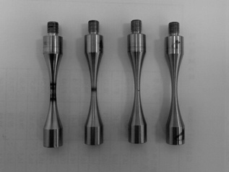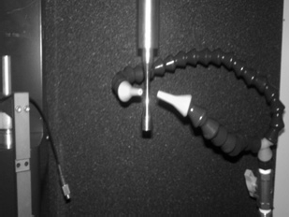The tests are conduct with symmetric cycle stress *R*=ˉ1 at room temperature in air. While conducting the ultrasonic fatigue tests, it is found that if the specimen is loading directly with no pause at the frequency of 20 kHz, the temperature of the concentration would increase due to the high frequency and the specimen may burn as shown in Fig.3. In order to suppress the temperature increase, we cool the specimen with cold air as shown in Fig.3. Meanwhile, an intermittent manner is conducted and we can decrease the oscillation time or increase the stop time. As the intermittent condition changes i.e. the oscillation time decreases or the stop time increases, the increase of the temperature will decrease and consequently the burn of the specimen will be weakened as shown in Fig.3.

Fig.3 The thermal effect of the specimen at different control conditions and the cold air cooling.

It is supposed that the intermittent manner may affect the test results. In order to investigate the effect of

the intermittent manner on the test results, fatigue tests of a high-strength steel are conducted in four different conditions at a same stress amplitude, the test results are shown in Fig.4. From Fig.4, it is shown that the intermittent manner have a certain impact on the test results, the mean result increase as the stop time increases, despite that the amplitude of increase of the mean result is not significant. Therefore, for a group of specimens, the same intermittent condition should be assigned and the intermittent conditions are designed to maintain the surface of the specimen not burned.

200:1000

: the number of cycles to failure

: the mean number

200:800

200:600

200:400

105 106 107

Number of cycles to failure

Intermittent tesing condition

Fig.4. The effect of the intermittent condition on the test results at a same stress amplitude.

Through the ultrasonic fatigue tests for different kinds of steel, it is found that the structural steel with tensile strength less than 1000MPa is prone to burn. At these cases, the specimen surface would burn at high stresses despite that the oscillation time is designed to the minimum value and the stop time is designed to the maximal value. However, for the structural steel with strength higher than 1000MPa, the specimen will heat during the tests, but the specimen rarely burn. It is pointed out by Ranc [3] that, the heat generation ε in one cycle per unit crack length is related with the material yield strength σy and stress intensity range K˖

**  **

*a*2 **a**** 4  *a*

36** 4** 4 , *a*  *bft*

0

(5)

*y* (1

)2

2*a*0

In which, η is a material coefficient; σ is the stress amplitude, a is the crack radius related with time, b is the mode of vector of Burgers dislocation, f is the frequency, t is the time. It can be seen from Eq. (5) that the heat generation attributes mainly to the low yield strength and the high applied stress.

1. Frequency effect

Accelerating the fatigue tests through improving the frequency dramatically may lead to a difference of the test results of ultrasonic fatigue tests and the conventional fatigue tests. It is so-called “frequency effect”ǄIn order to verify the frequency effect, the tests of smooth specimens of a high strength steel for welded structure were carried out at 20k Hz and 150 Hz [4] respectively. The test results are shown in Fig.5Ǆ

360

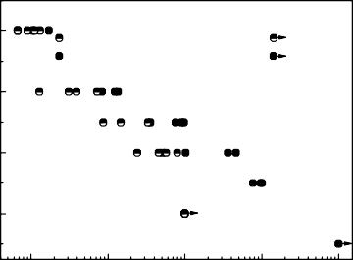

Smooth specimen,150Hz,*R*= -1, Not broken

Smooth specimen,20kHz,*R*= -1, Not broken

340

Stress amplitude,a / MPa

320

300

105 106 107 108 109

Number of cycles / N

Fig.5. The test results of a high strength steel for welded structure at different frequency.

From Fig.5, it is seen that the ultrasonic fatigue testing revealed longer lifetime for the smooth specimen at a same stress level. The difference is mainly attributable to an intrinsic strain rate effect. Thus, when applying the ultrasonic fatigue test results, the frequency effect must be carefully examined. Particularly, the comparison with the conventional fatigue tests along with the correction of the ultrasonic fatigue tests is a very important point of view and there is no unified conclusion until recently. Wang Hong [5] point that the ultrasonic frequency will lead to a longer lifetime and a modifying coefficient of load frequency is used to describe the effect of load frequency on fatigue behavior in ultrasonic fatigue tests. The modifying coefficient equals the ratio of fatigue strength coefficient of lower frequency load and high frequency load. Some researchers point that [6-7] the frequency effect is related to the crystal structure of metallic materials. For the body-centered cubic metals, the frequency effect is obvious. However, for the face-centered cubic metals and alloys of metallic materials, the frequency effects are negligible [8]. This conclusion can be interpreted as: the dislocation activation energy of the face-centered cubic metal materials is smaller, the slip under the high and low frequency is the same active, as a result, the effect of loading frequency is not obvious. Reversely, the dislocation activation energy of the body-centered cubic metal materials and the critical shear stress are higher, the degrees of slip under the high and low frequency are different, consequently, the effect of loading frequency is obvious.

Although there is difference between the ultrasonic and conventional fatigue tests, for some cases, what is concerned is the difference in fatigue properties of high strength steel in two different smelting processes and the comparison of the fatigue properties before and after the smelting process refined as shown in Fig.6 can be conducted through ultrasonic fatigue tests.

980

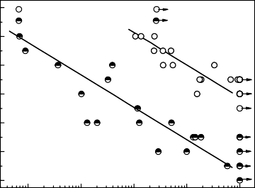

after smelting process refined , not broken before smelting process refined , not broken

900

820

Stress amplitude,a / MPa

740

660

580

500

105 106 107 108 109

Number of cycles / N

Fig.6. Ultrasonic fatigue properties of a high strength steel at two smelting processes.

1. Fracture surface

The fracture of conventional fatigue tests typically starts at the surface of the specimen processing defects. Differing from conventional fatigue, the fracture of the ultrasonic fatigue tests of high-strength steel typically starts from the internal defect or inclusion as shown in Fig.7.

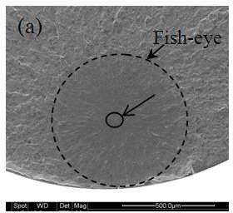 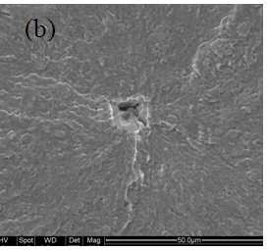

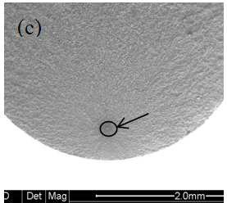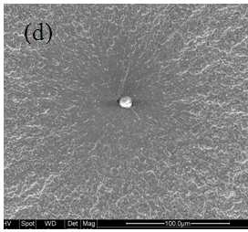

Fig.7 Typical ultrasonic fracture surface for specimens of high-strength steel by SEM: (a) and (c) whole view; (b) and (d) subsurface crack from internal defect or non-metallic inclusion.

The whole region of crack initiation and early propagation exhibits a pattern of “fish-eye” as shown in Fig.7 (a). Through the EDX analysis and inclusion size measurements of the ultrasonic fatigue fracture surface, the quality of smelting process can be determined.

1. Conclusions

As the development of industrial technology, the design fatigue life of a lot of metal components is increasingly high. Therefore, the high cycle fatigue behavior of metallic materials has become a research focus. Utilizing ultrasonic fatigue testing technology, it became possible for the research of the high cycle fatigue behavior of metallic materials. There exist some problems to be solved in the high cycle fatigue tests. In despite of this, with these problems solved step by step and the establishment of very high cycle fatigue test standard in the near future, the ultrasonic fatigue testing technology will have broad application prospects.

References

1. Suresh S. The fatigue of materials (x). Beijing: National Defense Industry Press 1999,243.
2. Nishijima S,Kanazawa K.Stepwise *S—N* curve and fish-eye failure in gigacycle fatigue.Fatigue and Fracture of Engineering Materials and Structures, 1999, 22:601-607.
3. Ranc N, Wagner D, Paris P C. Study of thermal effects associated with propagation during very high cycle fatigue tests. Acta Mater, 2008, 56:4012-4021.
4. Wenjie Peng, Baowen Qiu, Rongfeng Li and Huan Xue. Ultrasonic fatigue tests on a high strength steel for welded structure. Advanced Materials Research, 2012,503-504:714-717.
5. Wang Hong, Gao Qing. Effect of load frequency on fatigue behavior of material in ultrasonic fatigue testing (In Chinese). PTCA (Part: A Phys.test), 2005,41(9):433-435.
6. Ebara R. The present situation and future problems in ultrasonic fatigue testing-mainly reviewed on environmental effects and materials' screening. Int J Fatigue,2006,28: 1465-70.
7. Laird C, Charsley P. Strain rate sensitivity effects in cyclic deformation and fatigue fracture. Proceeding of first international conference on fatigue and corrosion fatigue up to ultrasonic frequencies. Philadelphia: The Metall Soc of AIME; 1982. p. 187̢205.
8. H. Mayer, M. Papakyriacou, R. Pippan, S. Stanzl-Tschegg. Influence of loading frequency on the high cycle fatigue properties of AlZnMgCu1.5 aluminium alloy. Materials Science and Engineering A, 2001,314:48-54.