

[Applied Computing and Informatics (2011) 9, 95–106](http://dx.doi.org/10.1016/j.aci.2011.05.003)

King Saud University

Applied Computing and Informatics

[www.ksu.edu.sa](http://www.ksu.edu.sa/) [www.sciencedirect.com](http://www.sciencedirect.com/science/journal/22108327)

ORIGINAL ARTICLE

A GPS-based Mobile Dynamic Service Locator System

Hassan I. Mathkour

*Department of Computer Science, King Saud University, Riyadh 11653, Saudi Arabia*

Received 17 December 2010; accepted 11 March 2011

Available online 27 May 2011

Abstract The mobile network providers have provided the most widely used means of communication. In an attempt to expand on this frontier, we propose and develop a GPS-based Mobile Service Locator System to help individuals in different walks of life, find addresses and locate their services of interest using their mobile devices. Notably, the proposed system is able to determine the prox- imity distances between the user and the locations of the desired service. It is flex- ible and extendible to easily incorporate additional mobile service providers and new services. A main point of departure from existing similar systems is that it is the GPS-based rather than the mobile-based service provider to allow for a more accurate location calculation.

ª 2011 King Saud University. Production and hosting by Elsevier B.V.

KEYWORDS

Mobile Service Locator Systems; GPS;

LBS;

Mobile positioning; Wireless communication

All rights reserved.

1. Introduction

In this age of significant telecommunication competition, mobile network operators continuously seek new and innovative ways to create differentiation

E-mail addresses: [binmathkour@yahoo.com](mailto:binmathkour@yahoo.com), [mathkour@ccis.ksu.edu.sa](mailto:mathkour@ccis.ksu.edu.sa) 2210-8327 ª 2011 King Saud University. Production

and hosting by Elsevier B.V. All rights reserved.

Production and hosting by Elsevier

Peer review under responsibility of King Saud University.

doi:[10.1016/j.aci.2011.05.003](http://dx.doi.org/10.1016/j.aci.2011.05.003)

and to increase profits ( Hjelm, 2002; Lindgren et al., 2002; Kalakota and Robinson, 2001). One of the best and most productive ways to accomplish this is through the delivery of highly personalized services. One of the most powerful ways to personalize mobile services is based on location. The purpose of mobile positioning is to provide location-based services (LBS), including wireless emer- gency services (Bisdikian et al., 2001; Chen and Kotz, 2000; Giaglis et al., 2002). Locating the nearest emergency, public, private, and social services as well as the nearest service provider efficiently using mobile devices involves the process of creating applications for mobile devices and maintaining connectivity over slow, inexpensive, and unreliable networks ( Burnham, 2001; May, 2001). This paper describes an attempt to a system which facilitates such a process. Required services may range from emergency locations, such as hospitals, clinics and pharmacies, or public and governmental services locations to private services locations, such as restaurants, shops, malls, etc.

The terms mobile positioning and mobile location are sometimes used inter- changeably in conversation, but they are in fact two different terminologies. Mo- bile positioning refers to determining the position of a mobile device. Mobile location refers to the location estimate derived from the mobile positioning oper- ation. Mobile positioning can be divided into two major categories – network based and handset based positioning.

* 1. *Network-based mobile positioning*

This category is referred to as ‘‘network based’’ because the mobile network, in conjunction with the network-based position determination equipment (PDE) is used to position the mobile device. One of the easiest means of positioning the mo- bile user is to leverage the SS7 network to derive location (Kaasinen, 2003; Jagoe, 2002).

* 1. *Handset mobile positioning*

This category is referred to as ‘‘handset based’’ because the handset itself is the primary means of positioning the user. The network can be used to provide assis- tance to the mobile device in making position estimate determinations based on data measurement and handset based position determination algorithms. The STK allows for communication between the SIM (which may contain additional algorithms for positioning) and a location server application (which may contain additional algorithms to assist in mobile positioning) (Lidgren et al., 2002).

Mobile IN Technologies for Positioning (Chen and Kotz, 2000) can also be deployed to assist in the positioning process. GSM and ANSI-41 based networks may employ the use of the GSM MAP, Any Time Interrogation (ATI), and Position Request (PosReq) messages, respectively, for mobile positioning. These mobile IN procedures require a LBS application middle-ware as a Service Control

Function (SCF) to launch a message (MAP ATI or PosReq) to the HLR for posi- tion information. The HLR may respond with approximate information such as the content of the cell of origin (COO) or more precise information such as timing advance (TA) or network measurement report (NMR) as in the case with GSM. LBS middleware is used to facilitate location based services; this functional ele- ment acts as a gateway or a hub for a location. One of the most obvious technol- ogies behind LBS is positioning, and the most widely recognized system is the Global Positioning System (GPS) (Hjelm, 2002; Djuknic and Richton, 2001). Geo- graphic data are also an important aspect of any location system. There must be a location management function to process positioning and GIS data on behalf of LBS applications. The location management acts as a gateway between position-

ing equipment and LBS infrastructure.

In this paper, we review existing processes in view of mobile positioning, and then describe a new, efficient, flexible, and affordable system – a GPS-based Mo- bile Service Locator System – to facilitate such a process. A GPS-based Mobile Service Locator System locates the nearest emergency, public, private, and social services as well as the nearest service provider efficiently using mobile devices.

1. Related work

Location Based Services for Network devices, and particularly for WAP-enabled phones, are currently prominent in the market. Research in the area of location- based systems has been going on for over a decade. The pager system is one of the oldest applications to provide the conventional method for personnel location. In order to locate someone, a signal is sent out by a central facility that addresses a particular receiver unit (beeper) and produces an audible signal. In addition, it may display a number to which the recipient could call the sender back. Some sys- tems allow a vocal message to be transmitted back to the call-back number. The recipient could use the conventional telephone system to call back to confirm the signal and to provide appropriate response (Kaasinen, 2003, Bisdikian et al., 2001, Chen and Kotz, 2000).

Earlier work such as the Active Location Badge system (Want et al., 1992) uses infra-red technology to provide products in the realms of outdoor location-track- ing, using GSM and GPS technologies. Such location-based services are limited to mobile phones. There are some other commercially products, such as Webraska, IntelliWhere, Openwave, and Esri (Dey et al., 1999), which are regarded as geo-ref- erenced mobile phone applications.

Some other related products that are focused on special interest like user inter- action can be shown in a game scenario. An example is the context-aware games (Romero et al., 2004). The first commercial location-aware game was launched in 2004 by SingTel in Singapore. Gunslingers is a multi-player network game where players move around, and eventually track and engage other players (‘‘enemies’’) within their physical vicinity.

Most recent research that provides location-based services is increasingly becoming diverse and wide. Examples are the Guide project (Cheverst et al., 2000) and Cyber Guide (Abowd et al., 1997). Most of these applications use the position-aware approach, meaning that application’s actions are based on its knowledge of its own position. Location-tracking services (Marmasse and Schmandt, 2003) such as the safety-based ones, for children or the elderly, are commercially available. Some applications like ‘friend finder’ services are available on some mobile phone service providers’ offers (Hanrahan, 2003).

In general, location is a dynamic attribute of mobile computing. Tracking has large application areas, ranging from the fleet applications to enabling mo- bile commercial services. Fleet application typically entails tracking vehicles for the purpose of the owner company to know the whereabouts of its vehicles and/or operators. Tracking is also used in mobile commercial services. A mo- bile user could track and be provided with predetermined information (such as notification of a sale on men’s suits at a store close to the user’s current loca- tion) that he desires. Mobile positioning technology is also crucial to wireless emergency services. GPS provides a good facility to locate co-ordinates but does not provide a website access, or detailed information about the desired location. In addition, it is not user friendly when it comes to locations’ images in high resolution. Mobility application on the other hand is considered the best user friendly application to provide detailed information or data on the run.

1. The proposed system

Most applications in the market are not user friendly, do not provide precise data, nor allow multiple ways to access the data, such as SMS, web access and real time feed back to the requester. The proposed system is meant to resolve such deficien- cies. It uses the cell phone service provider to locate the requester for a registered service. It is not necessary to have an Internet connection as the requester can use SMS to request a service location.

It is a location-based service provider. It differs from many other types of mo- bile services because it is not just mobile in the sense that it can be carried with the user but it can actually be used on the move. In addition, it takes into consider- ation the usage situations that may affect the location’s physical environment (e.g., background noise, illumination, weather).

* 1. *Communication scenarios*

The communication scenario retrieves the mobile location as provided by the cell provider and this is used to send an SMS to the services’ server to retrieve the re- quested service. There are two possible scenarios in this respect.

* + 1. *First proposed scenario (network-based mobile positioning technology)*

A user, using his handset, requests a service and asks for the nearest location where the service can be provided.

1. The proposed handset application retrieves the user’s mobile location sent by the mobile service provider.
2. An SMS request is sent to the service’s centre with the current user location.
3. Services’ server sends an SMS back to the handset of the user, showing available services based on the user’s request and location.
   * 1. *Second proposed scenario (handset-based mobile positioning technology)*
4. The application sends SMS/MMS to cell phone service provider to request the current handset location.
5. The cell phone service provider sends an SMS/MMS back to the handset with the current location.
6. The application parses the SMS/MMS and then sends SMS to the services’ ser- ver to get the requested service location.
7. The server sends back an SMS with the requested service location.

The first scenario merely determines the location based on the nearest tower and not the exact co-ordinates, which results in an inaccurate determination of the right services at the right locations. The second scenario gives a more accurate information and faster determination of the location. It is based on ‘‘Handset Positioning Technology’’ where user’s handset is used to determine the right loca- tion of the user. Thus, the second scenario is adopted.

* 1. *System architecture scenario (B)*

Fig. 1 shows the system architecture for the proposed scenario (B). It consists of a mobile finder cell component, a mobile finder server component, a tablet PC, a database server, and an application server with SMS as the communication medium.

* 1. *Hardware and software requirements*

The hardware requirements are:

1. A GSM modem: A GSM modem can be an external modem device, a PC card installed in a notebook computer, or a standard GSM mobile phone.
2. A cell phone (handset): a tablet PC, or pocket PC with GSM support.
3. A server: Intel Pentium Server 3.0 GHz with 1 GB RAM.

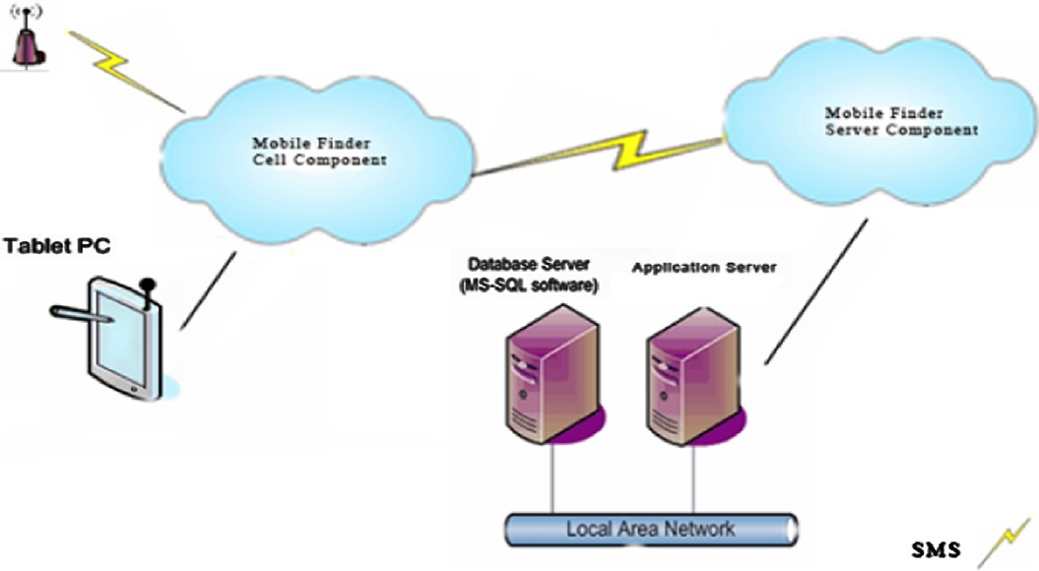

100 H.I. Mathkour

Figure 1 System architecture.

1. SIM cards: GSM SIM card. Supports (900,1850,950). The software requirements are:
   1. Mobile finder cell component.
   2. Mobile finder server component.
   3. Database client – MS SQL database client.
   4. Server operating system: windows operating system.

The system structure follows the IEEE standard consisting of four system inter- faces, which are:

1. The hardware interface, through which the user’s handset (mobile) is used to communicate with (i) the cell phone provider tower by sending an SMS package through SIM card to retrieve the location of the handset; (ii) the server GSM gateway modem used to retrieve the requested service at the current location of the handset.
2. The software interface is the cell phone provider. From here, a client applica- tion component communicates with the cell phone provider gateway to retrieve the location of the handset.
3. The communication interface, in which communication is done through an SMS sent using the SIM of the handset to the cell phone provider. Communi- cation is also done with the services’ server gateway application component in order to retrieve the requested service at the current location of the handset.
4. The graphical user interface comprises the following:

Location & services information

**Client**

Service Provider

**Mobile Services Finder System**

**Administrator**

Services Data

Services Data

Provider Data

Location & Services Information

Statistical report

Figure 2 Context diagram of the system.

s A client interface on mobile device allowing the user to request certain ser- vices from his current location.

s A web interface on the server allowing the service provider to register, update its service information, and gather statistical data on clients requesting this service.

s A desktop interface on the server allowing the system administrator to add, maintain and manage services and users on the system.

Figs. 2 and 3 show, respectively, (i) the variability of the data flows across the domain boundary (Bisdikian et al., 2001) and (ii) the class diagram of the pro- posed system.

1. Implementation

The mobile finder system requires the following for its implementation.

Hardware requirements:

* Handset with windows Os mobile system (2003 or above).
* GPS receiver (Bluetooth).
* PCMCIA GPS receiver.
* Laptop with windows OS. Software requirements:
* Developed handset service request application.
* Compact .Net Framework 2.0 or above.
* GPS.Net library.
* OPENCF library.

The implementation is based on a 2-tier client server technology, consisting of two major components, the client side and the server side.

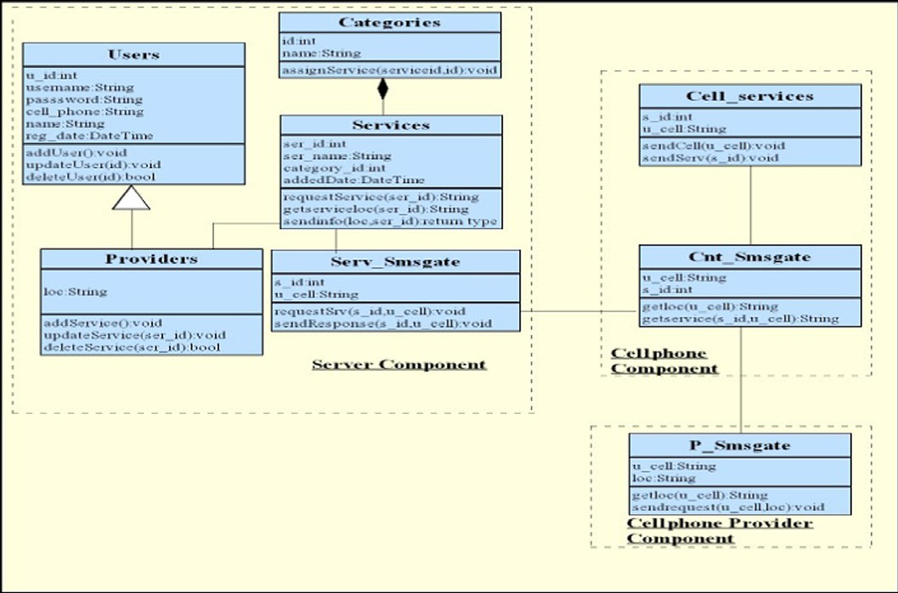

102 H.I. Mathkour

Figure 3 Class diagram of the system.

* 1. *Client side component: handset service finder component (HSFC)*

The HSFC includes two modules, namely, request service, Get a reply. The user connects his mobile to a GPS receiver through the mobile Bluetooth. HSFC dis- plays a list of most demandable common services (based on statistics carried out by marketing specialists). The user chooses (i) a service from the drop down list, and (ii) the desired service information (such as service ID, longitude, lati- tude). The user then submits his request to the server by clicking a submit button in an SMS.

* 1. *Server side component: server service finder component (SSFC)*

The SSFC includes two modules, namely, the service provider and request manip- ulation. A client connects through an online system to provide his services details, such as locations (latitude and longitude can be provided by tech support) of the offered services, addresses and phone numbers. The provider information (GPS decimal locations, name, service provided, phone and address) is added to data- base. The received SMS is deleted, and a new SMS is sent back to the hand- set along the requested services information.

The requested service together with the handset location is processed by using the .net framework library to read the incoming SMS message (which is organized

in a specific form) and is parsed using the parsetolist () method to extract the demandable service ID and the handset latitude and longitude values. (Class Dia- gram: SSMS CLASS – parsetolist ().) This is done by scanning the sms text coming from the handset and parsing it.

Locating the nearest service and sending an SMS message back to the handset with the nearest service details are determined using the proximity search method (Bisdikian et al., 2003; Dey et al., 1999).

1. System validation

As indicated above, the finder system is composed of two components, a client (Handset Service Finder Component ‘‘HSFC’’) and a server (Server Service Finder Component ‘‘SSFC’’). The HSFC was installed on an I-mate hand-held (I-mate JASJAR) equipped with GPS (HOLUX GPSSLIM236), and the SSFC was installed as a server component on – Intel Pentium 4 PC.

* 1. *Test data*

One of the critical issues of the finder system is the accuracy and the response time it yields for the user request. These two issues were evaluated in real time. Some data (Table 1) were entered via administration access right.

A set of services were used for validation. The set covers two types of services, namely hospital and food (supermarkets), as shown in Table 1.

Values of measured alpha and beta (longitude, latitude) were obtained by site life measurements where the PDA equipped with GPS (see section for used hard- ware) was placed at each of the services shown in the above table and readings of alpha and beta were recorded and inserted in the database along with provider data including service category, name, address, phone. A cross validation of the measured alpha and beta was performed by comparing our measurements to values obtained from Google earth as shown in Table 1. The comparison shows agreement between the measured and Google values; hence it validates the mea- sured values.

|  |  |  |  |  |  |
| --- | --- | --- | --- | --- | --- |
| Table 1 Set of data used for validation.  # Service name Type Measured alpha Measured beta Google alpha Google beta  1 Alhabib Hospital 24°42016.0200N 46°40035.1100E 24°42016.3500N 46°40036.1100E | | | | | |
| 2 Hammadi | Hospital | 24°42032.400N | 46°40050.1200E | 24°42036.4200N | 46°40052.8900E |
| 3 Dallah | Hospital | 24°44047.9800N | 46°3907.2100E | 24°44048.9500N | 46°3907.3300E |
| 4 Altakhasosi | Hospital | 24°40013.0100N | 46°40032.1400E | 24°40015.6700N | 46°40035.2700E |
| 5 King Fahd | Hospital | 24°40010.2100N | 46°40027.8000E | 24°4008.9700N | 46°40029.3900E |
| 6 Al Othaim Supermarket | Shopping mall | 24°4609.8800N | 46°45051.1800E | 24°4609.0400N | 46°45051.8300E |
| 7 Careffour Granada | Shopping mall | 24°46050.9800N | 46°43055.1200E | 24°46055.0600N | 46°43055.8700E |
| 8 Careffour Albustan | Shopping mall | 24°42051.1000N | 46°40024.0400E | 24°42050.2100N | 46°40020.3700E |
| 9 Careffour Le Mall | Shopping mall | 24°46017.3000N | 46°40010.1000E | 24°46018.6200N | 46°4009.0600E |
| 10 Hypermarket – Al azizia | Shopping mall | 24°35035.8000N | 46°46027.2100E | 24°35037.4400N | 46°46026.0800E |
|  |  |  |  |  |  |

Table 2 Test cases.

Test

case

1

Goal

Pre-condition

Post-condition

Pass/fail Comment

Determining

handset location using (PDA, laptop)

A mobile handset

with blue tooth enabled is placed at a known location

Location is ready to

be sent an SMS message

Pass

2 Requesting a

service

A mobile handset

with blue tooth enabled is placed at a known location SMS is sent to the server with requested service and location information

A SMS message is

sent to the server

Pass

3 Finding a

requested service

A SMS message is

sent with requested service information

Pass

The client uses the client

application component to request determination of handset’s location using SMS

Services provider’s request statistical reports generated by the server application component Services provider’s request statistical reports generated by the server application component

* 1. *Test scenarios*

The finder system validation was investigated by using two different types of hard- ware; namely, a PDA equipped with GPS and a notebook equipped with PCMCI GPS card (see Section 3.2). The test cases discussed below in Table 2 were carried out using both the PDA and the notebook. From client application interface, a user selects a service, e.g., Hospitals. The client application retrieves the current handset GPS location latitude and longitudes, calculates the client location, and sends the location of the service to the user via SMS.

The test cases listed above were executed and the test results showed a ‘pass’ for all cases.

1. Conclusion

We have developed a GPS-based mobile finder system that would help individuals in different walks of life to find addresses and to locate theie services of interest using their mobile devices. Required services may range from emergency locations, such as hospitals, clinics and pharmacies, or public and governmental services locations to private services locations, such as restaurants, shops, malls and etc.

Although this project was developed and tested in Saudi Arabia, using the two widely available Saudi mobile providers (AlJawal and Mobily), we believe that the system can be used easily in other environments with similar mobile providers.

The proposed solution has distinct advantages over the solutions offered by both mobile service providers. Notable advantages of this system are:

1. It determines the proximity distances between the user and the locations of the desired service. Thus the user has a valuable distance information that would be beneficial in his decision making process to select the most appropriate service

providers for the service he is looking for. It should, however, be pointed out that the indicated distance is not a real physical one since it is GPS-based. It does not also take into consideration the real traffic map of the area. Neverthe- less, it certainly offers valuable information to the user.

1. The system is flexible and extendible easily to incorporate additional mobile ser- vice providers and new services.
2. The main point of departure from existing similar systems is that it is GPS- based rather than mobile-based service provider in which distance determina- tion is based on tower-based triangulation that is limited to just the suburb. Thus a more accurate calculation is given by our system.

As for future work, a client handset test program may be developed to compare the accuracy of tower-based triangulation with a GPS-based solution.

Acknowledgement

This work is supported by the Research Center of the College of Computer and Information Sciences in King Saud University.

References

Abowd, G.D., Atkeson, C.G., Hong, J., Long, S., Kooper, R., Pinkerton, M., 1997. Cyber guide: a mobile context aware tour guide. Wireless Networks 3 (October), 421–433.

Bisdikian, C., Christensen, J., Davis, J., Ebling, M.R., Hunt, G., Jerome, W., Lei, H., Maes, S., Sow, D., 2001. Enabling location-based applications. In: Proceedings of the 1st International Workshop on Mobile Commerce, pp. 38–42.

Burnham, J.P., 2001. The Essential Guide to the Business of US Mobile Wireless Communications. Prentice-Hall PTR, Upper Saddle River, NJ, 2001.

Chen, G., Kotz, D., 2000. A Survey of Context-Aware Mobile Computing Research, Dartmouth Computer Science Technical Report TR 2000-381. Hanover, NH, USA.

Cheverst, K., Davies, N., Mitchell, K., 2000. A Friday, experiences of developing and deploying a context-aware tourist guide: the GUIDE project. In: Proceedings of the 6th Annual International Conference on Mobile Computing and Networking, Boston, MA, pp. 20–31.

Dey, A.K., Salber, D., Abowd, G.D., Futakawa, M., 1999. An Architecture to Support Context-Aware Applications. Technical Report GIT-GVU, Georgia Institute of Technology, College of Computing.

Djuknic, G.M., Richton, R.E., 2001. Geolocation and assisted GPS. IEEE Computer 34 (2), 123–125.

Giaglis, G.M., Kourouthanassis, P.K., Tsamakos, A., 2002. Towards a classification framework for mobile location services. In: Mennecke, B.E., Strader, T.J. (Eds.), Mobile Commerce. Technology, Theory, and Applications. Idea Group Publishing.

Hanrahan, T., 2003. AT&T find friends location service. The Wall Street Journal Online (June 4). Hjelm, J., 2002. Creating Location Services for the Wireless Web. John Wiley & Sons, New York. Jagoe, A., 2002. Mobile Location Services. Pearson Education, New Jersey.

Kaasinen, E., 2003. User needs for location-aware mobile services. Springer-Verlag London Limited 7 (1), 70–79. Kalakota, R., Robinson, M., 2001. M-Business: The Race to Mobility. McGraw-Hill Publishing Company, New

York.

Lindgren, M., Svensson, E., Jedbratt, J., 2002. Beyond Mobile: People, Communications and Marketing in a Mobilized World. Palgrave Global Publishing.

Marmasse, N., Schmandt, C., 2003. Safe and sound – a wireless leash. Proceedings of CHI, 726–727.

May, P., 2001. Mobile Commerce: Opportunities, Applications, and Technologies of Wireless Business.

Cambridge University Press, Cambridge.

Romero, L., Santiago, J., Correia, N., 2004. Contextual information access and storytelling in mixed reality using hypermedia. ACM Computers in Entertainment 2 (3).

Want, R., Hopper, A., Falca˜ o, V., Gibbons, J., 1992. The active badge location system. ACM Transaction on Information Systems 10 (1), 91–102.