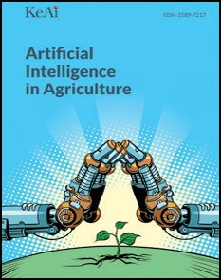[Artificial Intelligence in Agriculture 2 (2019) 1–12](https://doi.org/10.1016/j.aiia.2019.05.004)

Contents lists available at [ScienceDirect](http://www.sciencedirect.com/science/journal/25897217)

Artificial Intelligence in Agriculture

journal homepage: [http://www.keaipublishing.com/en/j ournals/artificial- intelligence-in-agriculture/](http://www.keaipublishing.com/en/journals/artificial-intelligence-in-agriculture/)

[](http://crossmark.crossref.org/dialog/?doi=10.1016/j.aiia.2019.05.004&domain=pdf)A comprehensive review on automation in agriculture using artificial intelligence

Kirtan Jha a, Aalap Doshi b, Poojan Patel c, Manan Shah d,⁎

a *Gandhinagar Institute of Technology, Gandhinagar, Gujarat, India*

b *Lalbhai Dalpatbhai College of Engineering, Ahmedabad, Gujarat, India*

c *Vishwakarma Government Engineering College, Chandkheda, Ahmedabad, Gujarat, India*

d *School of Technology, Pandit Deendayal Petroleum University, Gandhinagar, Gujarat, India*

a r t i c l e i n f o

*Article history:*

Received 6 November 2018

Received in revised form 25 May 2019

Accepted 25 May 2019

Available online 17 June 2019

*Keywords:*

Automation artificial intelligence Irrigation

Machine learning

Contents

a b s t r a c t

Agriculture automation is the main concern and emerging subject for every country. The world population is in- creasing at a very fast rate and with increase in population the need for food increases briskly. Traditional methods used by farmers aren't sufficient enough to serve the increasing demand and so they have to hamper the soil by using harmful pesticides in an intensified manner. This affects the agricultural practice a lot and in the end the land remains barren with no fertility. This paper talks about different automation practices like IOT, Wireless Communications, Machine learning and Artificial Intelligence, Deep learning. There are some areas which are causing the problems to agriculture field like crop diseases, lack of storage management, pesti- cide control, weed management, lack of irrigation and water management and all this problems can be solved by above mentioned different techniques. Today, there is an urgent need to decipher the issues like use of harm- ful pesticides, controlled irrigation, control on pollution and effects of environment in agricultural practice. Auto- mation of farming practices has proved to increase the gain from the soil and also has strengthened the soil fertility. This paper surveys the work of many researchers to get a brief overview about the current implementa- tion of automation in agriculture. The paper also discusses a proposed system which can be implemented in bo- tanical farm for flower and leaf identification and watering using IOT.

© 2019 The Authors. Production and hosting by Elsevier B.V. on behalf of KeAi Communications Co., Ltd. This is an open access article under the CC BY-NC-ND license (<http://creativecommons.org/licenses/by-nc-nd/4.0/>).

1. Introduction 1
2. Literature survey 3
3. Artificial neural networks in agriculture 3
4. Automation and wireless system networks in agriculture 5
5. Implementation of fuzzy logic systems in agriculture 8
6. Proposed idea 10
7. Future scope 10
8. Conclusion 10

Authors contribution 11

Declaration of Competing Interests 11

Acknowledgements 11

Availability of data andmaterial 11

Funding 11

Consent for publication 11

Ethics approval and consent to participate 11

References 11

* Corresponding author.

*E-mail address:* [Manan.shah@spt.pdpu.ac.in](mailto:Manan.shah@spt.pdpu.ac.in) (M. Shah).

<https://doi.org/10.1016/j.aiia.2019.05.004>

2589-7217/© 2019 The Authors. Production and hosting by Elsevier B.V. on behalf of KeAi Communications Co., Ltd. This is an open access article under the CC BY-NC-ND license ([http://](http://creativecommons.org/licenses/by-nc-nd/4.0/) [creativecommons.org/licenses/by-nc-nd/4.0/](http://creativecommons.org/licenses/by-nc-nd/4.0/)).

1. Introduction

With the advent of technology in this digital world, we humans have pushed our limit of the thinking process and are trying to coalesce nor- mal brain with an artificial one. This continuing exploration gave birth to a whole new field Artificial intelligence. It is the process by which a human can make an intelligent machine. AI comes under the domain area of computer science which can be able to discern its milieu and should thrive to maximize the rate of success. AI should be able to do work based on past learning. Deep learning, CNN, ANN, Machine learn- ing are certain domains which enhances the machine work and helps to develop a more advance technology.

The term IOT is elucidated as “thing to thing” communication. The

three main targets are communication, automation and cost saving in the system. Dr. D.K. Sreekantha, Kavya.A.M provides the in-depth appli- cation of IOT in the field of agriculture and how it can be helpful to the humans.

AI has penetrated in medical science, education, finance, agriculture, industry, security, and many other sectors. Implementation of AI in- volves learning process of machines. This brings us to a sub-domain in this AI field “Machine learning”. The sole purpose of machine learning is to feed the machine with data from past experiences and statistical data so that it can perform its assigned task to solve a particular prob- lem. There are many applications which exist today which includes an- alyzing of data from past data and experience, speech and face recognition, weather prediction, medical diagnostics. It is because of machine learning that the domain of big data and data science has evolved to such a great extent. Machine learning is a mathematical ap- proach to build intelligent machines.

As AI stimulated, many new logics and method were invented and discovered which makes the process of problem- solving more simple. Such methods are listed below.

1. Fuzzy logic
2. Artificial neural networks (ANN)
3. Neuro-fuzzy logic
4. Expert systems

Among all of these, the most widely used and constantly applied method for research purposes is ANN. Our human brain is the most com- plex part of the body. Based on the inter linked neural networks, electric signals traverses through the neurons with the help of axons. Synapses which are at the end of each node passes the signal ahead. ANN method was invented by keeping in mind the same concept of the working of the human brain. There are various algorithms of this approach such as for training this particular model algorithms like Silva and Almeida's algo- rithm, Delta-bar-delta, Rprop, The Dynamic Adaption algorithm, Quickprop are used based on its application. 9 neurons are used in the process. ANN is a task- based method which tells the system to operate based on some inbuilt task rather than a conventional computational programmed task. The architecture of ANN consists of three layers:

1. Input layer
2. Hidden (middle) layer
3. Output layer (Fig. 1)

Feedforward back propagation mechanism and its parameters are shown above: Input Layer–7, output layer-1, hidden layer-50, number of iterations – 1200. Activation layer- Sigmoidal function in hidden and output layer, linear function in input layer.

Moreover, Artificial intelligence and machine learning are mostly hypothesis and theories. These are programming and algorithms. For the implementation of these algorithms and logic based concepts, there should be a hardware- software interface. The system through which this can be achieved is “Embedded systems”. Embedded systems are hardware built systems consisting of memory chips with custom software programmed in it (Fig. 2).

This paper encompasses the links which make embedded systems and AI coherent with the agriculture sector. Implementation of AI and expert systems in agriculture is a narrowly defined subject. This topic was discussed by McKinion and Lemmon (1985). Agriculture is the es- sential part of any country. At present South Korea, China, North America are investing trillions of money for development in the agricul- ture sector and implementing more advance technologies. The popula- tion is increasing at a very high rate which is directly related to the

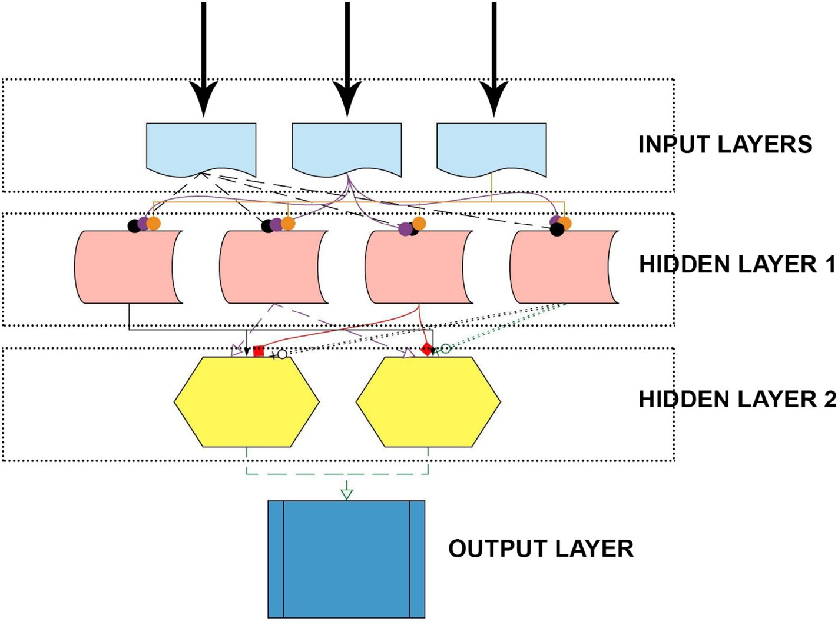

Fig. 1. Artificial neural network layers.

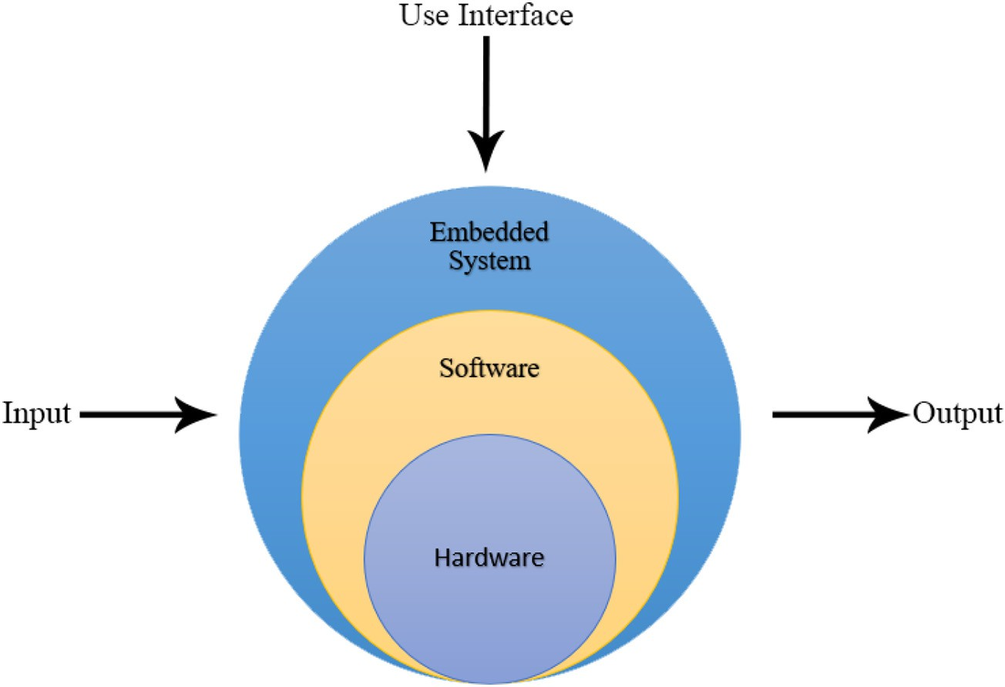

Fig. 2. Embedded systems.

increase in the demand for food. India is a rich source for food crops and especially for species. The agriculture sector is one of the most sensitive sectors of the Indian economy, supporting all other sectors and spread- ing its importance in far- reaching areas. With the advent of technology in other industries, it is a very crucial point to implement automation in agriculture.

The pressure on the agriculture sector will increase with the con- tinuing expansion of the human population and so agri-technology and precision farming have gained much importance in today's world. This are also termed as digital agriculture which means the use of hi- tech computer systems to calculate different parameters such as weed detection, crop prediction, yield detection, crop quality and many more machine learning techniques (Liakos et al., 2018). This paper dis- cusses about the different applications of ANN, ML, and IOT in agricul- ture and many models which helps in precision farming.

1. Literature survey

Over the past 50 years, there has been a sustainable development in artificial intelligence due to its robustness in the application and is per- vasive in every field. One such field is agriculture.

Agriculture faces many challenges on a daily basis and is not smooth running business. Some of the pith problems faced by farmers from seed sowing to harvesting of crops are as follows:

1. Crop diseases infestations
2. Lack of storage management.
3. Pesticide control
4. Weed management
5. Lack of irrigation and drainage facilities.

Artificial Intelligence and Machine learning has penetrated each and every category mentioned above. Bannerjee et al. (2018) segregated ad- vancements in AI category wise and gave a brief overview on various AI techniques. Computers and technology started penetrating in this sec- tor from 1983 onwards. Since then, there have been many suggestions and proposed systems for betterment in agriculture from the database to decision making process. Filtering out every process, only AI based systems have proved to be the most feasible and reliable one. The AI- based method does not generalize the problem and gives a particular solution to a particular defined complex problem. The literature survey covers major breakthroughs in the domain of agriculture from early

1980s to 2018. The paper discusses more than fifty advancement in technologies in the sub domain of agriculture. First it discusses penetra- tion of Artificial neural networks and expert systems to solve above mentioned problems, then machine learning and fuzzy logic system. Lastly it covers automation and IOT in the agriculture.

1. Artiﬁcial neural networks in agriculture

Artificial neural networks have been incorporated in the agriculture sector many times due to its advantages over traditional systems. The main benefit of neural networks is they can predict and forecast on the base of parallel reasoning. Instead of thoroughly programming, neu- ral networks can be trained. Gliever and Slaughter (2001) used ANN to differentiate weeds from the crops. Maier and Dandy (2000) used neu- ral networks for forecasting water resources variables.

Song and He (2005) brought together expert systems and Artificial neural networks in predicting nutrition level in the crop. Traditional ES (Expert systems) have considerable backdrops when it is being im- plemented. Use of ANN makes it up to all glitches of ES. The whole sys- tem is built on a single chip computer. Neural networks always prove to be the best when it comes to predicting methods. Neural networks can predict the complex mappings if a reliable set of variables are fed. To dodge the problems of frost formation in the fields of the island of Sicily, Robinson and Mort (1997) developed a prediction model using neural networks. The model is first to feed with the raw data like humidity, temperature, precipitation, cloud cover, wind direction (all these data were taken from 1980 to 1983). Then, the data gathered got converted into binary data. These data, now are divided into two strings (input and output for the neural network model). The back-propagation network was used as a neural network predictor. A total of 10 trial sets were de- veloped and trained by the model initially. The frost was predicted more efficiently when a range of values of parameters (mentioned above) was taken rather than single values.

Within the span of three years, two expert systems had been devel- oped to increase the production of cotton crop. First, COMAX. In 1986, Lemmon made a successful attempt in developing an expert system called Comax (COtton Management eXpert). Lemmon, being the pio- neer in AI in agriculture sector, develped a program called Gossym which is microcomputer friendly and bolster the use of Comax (Lemmon, 1986). For the first ever, the expert system (Comax) was suc- cessfully integrated with a computer model (Gossym) and simulated for the growth of cotton crops. This expert system was developed in order

to operate continuosly throughout the year in cotton crop fields. Comax takes three parameters of the field into consideration; scheduling of ir- rigation, maintaining nitrogen content in the field, and growth in the cotton crop.

Second, COTFLEX. Another expert system for the cotton crop was developed by Stone and Toman (1989). The system was named as COTFLEX. The system was made worked on Pyramid 90× computer which used UNIX as its operating system. The system incorporated the field and farm databases to provide important information re- garding the cotton crop to the farmer so that it becomes easy for the grower to take critical and tactical decisions. The system devel- oped in Texas, and it created simulation models and databases in the rule-based expert system to help Texan farmers take prudent economic and lucrative decisions. After successful testings, COTFLEX was imported to IBM microcomputer and was made open for the use.

Batchelor et al. (1989) discusses about the soyabean crop growth model which is defined as SMARTSOY in the paper and the model is called SOYGRO. The model is explained by knowledge based approach where it is divided into two approaches first being the positivistic ap- proach stating the attempts to duplicate the processes of domain ex- perts in order to come to a conclusion while the second approach being the normative approach which attempts to duplicate the conclu- sions excluding the processes of the domain experts. The damages caused by insects are determined by systematic method for determining the damage rates and the cost control. Here, the positivistic and norma- tive approach collapses because the later method helps it the selection of insecticide and application rate. However, the systematic method does not help to find the insect damage rate on yield. This is a major drawback for generating recommendation because we need to mix both the approach as the yield reduction is calculated by previous expe- riences of the similar insect attack, pesticides used and the outcomes of the crops in the end. The goal to generate recommendation specifically for soyabean crop is based on calculation of the damage rate and the cost to treat the plant and gain the yield. This calculation is derived by both the approaches.

An expert system PRITHVI based on fuzzy logic was developed in Ra- jasthan, India by Prakash et al. (2013). The system was designed explic- itly for Soybeans crop. This system gathered its knowledge base from agricultural officers, published literature, and experts of soybean crops. Fuzzy logic was considered in studying the whole system and ad- vising the farmer as an expert. PRITHVI was divided into five modules. The main aim of developing this expert system was to help the farmers in the region increase their soybean production. The system used MATLAB as a user interface module.

Researchers developed an expert system which helped the farmers with when to spray insectisides on the apple fruit to avoid the damage due to insects and atmosphere. The system was named as POMME. Along with the time, it also advised the farmers what to spray. Instead of theoretical values from the infection table, here apple scab disease cycle model was used in POMME. The results of the system were satis- factory and system was approved by the experts who had used it on trial basis. (Roach et al., 1987).

A method is suggesting the use of ANN algorithms for crop predic- tion in smartphones had been successfully tested in 2016 by researchers Ravichandran and Koteshwari. A prediction model was developed. As mentioned above, the prediction model of this system had three layers (Ravichandran and Koteshwari, 2016). The efficiency of the model was dependent on the number of the hidden layers. First and foremost, the ANN model was built and trained using various algorithms such as Silva and Almeida's algorithms, Delta-bar-delta, Rprop, and various other to find the most favourable configuration. Trial and error method was implemented to choose the number of hidden layers. There should be a précised way to scrutinize the selection of some hidden layers be- cause the prediction system's accuracy is dependent on the number of hidden layers. It was observed in the research that more the number

of hidden layers in the ANN model; the more accurate were the prediction.

Since the purpose of the system was to make it handy for the farmers, it is developed on APK platform. The source code was written in Eclipse with Java codes in the backhand, and the algorithm was devel- oped using Matlab and ANN toolbox. The whole file was then extracted on the Android platform so that it can be utilized by smartphones. Be- sides suggesting the crop to the farmer, the system also has the addi- tional advantage of advising the farmer for the fertilizer to be used if the farmer wishes to use the crop of his choice. (Ravichandran and Koteshwari, 2016) (Fig. 3).

Evapotranspiration process is imperative for maintaining the stabil- ity in the hydrologic cycle, sustainable irrigation method, and water management. Parameters- Elevation, Mean daily Temperature, Max. daily temperature, Min. daily temperature, Wind Speed, Relatuve Hu- midity, Sunshine Hours, Daylight hours, Latitude, Condition coefficient. There are more than 20 established method to determine ET which is dependent on several parameters.

A profound study was carried out in the valley of Dehradun; India was assessing the importance of the addition of ANN in several tech- niques of estimation of ET. Researchers gathered monthly climate data from the Forest research institute (FRI) Dehradun for ET estimation. The methods on which the algorithms were applied were: 1. Penman- Monteith method 2. Levenberg-Marquardt back propagation. It was ob- served that increasing the number of hidden layers in the system re- sulted in instability in the ET estimation. So, training function with optimum trial and error method is to be chosen for the overall opti- mized estimation of ET. It was observed that out of six training algo- rithms of ANN model, function training with 75% data feed in it was precise and had the best number of neurons. Furthermore, there was a gauging between PM method and ANN model with the single layer feed forward back propagation algorithm. ANN model was designed and developed using Matlab. Six algorithms were conjured and assessed. As evapotranspiration is of vital importance in irrigation and water management, this research manifested the predictive prowess of ANN structure if implemented correctly. (Nema et al., 2017).

Furthermore, also a method was created to discriminate weed from crops with the help of image analysis and neural networks. It had the ac- curacy of more than 75% without any beforehand plant information fed into the system. (Aitkenhead et al., 2003). Shahzadi et al. (2016) devel- oped expert systems based smart agriculture system. The concept of IoT in this system was to send the data to the server so that actuators of the field should be able to take appropriate decisions. For that, the server should be intelligent enough to take decisions independently. This sys- tem consists of temperature, humidity, leaf wetness, and soil sensors. It only gives the information about the field and doesn't act on the irriga- tion process.

Arif et al. (2012) developed two ANN models to estimate soil mois- ture in Paddy fields using decidedly less meteorological data. Both these models were then corroborated and validated by studying ob- served and estimated soil moisture values. The first ANN model was generated to get the estimate ET. The help of minimum, average, and the maximum air temperature was taken. To develop the second model, solar radiation, precipitation, and air temperature data was gath- ered. Both these models resulted in the accurate and reliable estimation of soil moisture in the paddy fields by using the least meteorological data, less labor and time consumption.

Hinnell et al. (2010) discuss the neuro drip irrigation systems where ANNs were developed to predict the spatial water distribution in the subsurface. For drip irrigation method to properly function, water distri- bution in the lower level of the soil is of the grave importance. Here, ANNs makes the prediction which comes handy for the user which in turn results in the fast decision-making process. ANN models give the result of wetting patterns (first and second) after the soil is infiltrated with the water from the emitter which is on the surface of the land. Thus, the ANN model provides continuous patterns to the user. Also,

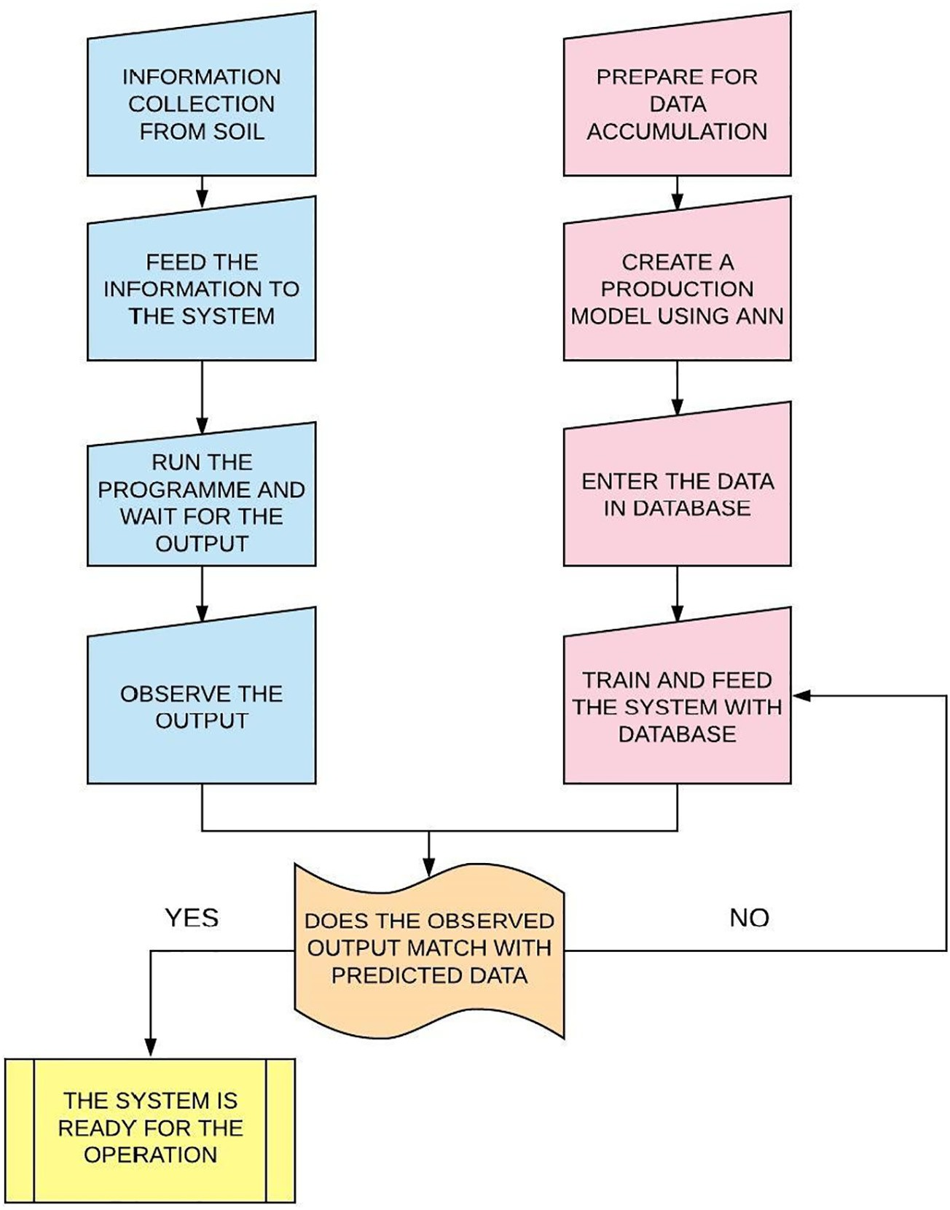

Fig. 3. Flowchart of ANN-based crop predictor using smartphones.

researchers developed a model to study the yield of the maize crop. A multi-layered feedforward ANN (MLFANN) is used. To fuel such net- work, learning algorithms like GDA (gradient descent algorithms) and CGDA (Conjugate gradient descent algorithm) are employed. Both the algorithms have been written and simulated in the MATLAB using nueral network toolbox (Singh and Prajneshu, 2008).

Precision agriculture and WSN applications combine an exciting new area of research that will greatly improve quality in agricultural production, precision irrigation and will have dramatic reduction in cost needed. Furthermore, the ease of deployment and system mainte- nance, monitoring opens the way for the acceptation of WSN systems in precision agriculture. Using the proposed methodology, in finding the optimal sensor topology, we contrive to lower implementation cost and thus make WSN a more appealing solution for all kinds of fields and cultivations. (Keshtgari and Deljoo, 2012).

1. Automation and wireless system networks in agriculture

It is imperative for any sector to evolve with time. The agriculture sector had to adapt the breakthroughs and inventions which came along in automation field. Yong et al. (2018) came forward with emerg- ing research area of embedded intelligence (EI). Embedded intelligence in agriculture sector includes smart farming, smart crop management, smart irrigation and smart greenhouses. It is necessary for a nation to in- clude these growing technologies in agriculture sector for growth of a

nation as many sectors are inter-dependent on agriculture. Also, re- searchers of this paper demonstrated Technology roadmap (TRM) which in turn clarifies the qualms regarding the areas of agriculture mentioned above (smart farming, smart irrigation etc).

Taking into consideration the socio and economic vitality of agricul- ture in India, researchers Patil and Thorat (2016) developed a system which predicted grape disease beforehand. Any anomaly in the grape plant was noticed only after it was infected and this had a considerable deteriorating effect on the whole vineyard. The system employed vari- ous sensors such as temperature sensor, leaf wetness sensors, and hu- midity sensors in the vineyard. These sensors send the data sensed to the database in the ZigBee server which is linked to the sensors. Deploy- ment of Wireless System Network (WSN) in any field needs to satisfy certain criteria and Zigbee alliance has developed open global standards called ZIGBEE. Zigbee compliances of four layers namely physical layer, medium access control layer, network layer, application layer as stated. The three devices: Zigbee Co-coordinator (ZC), Zigbee Router(ZR), Zigbee End Device(ZED) has different function in the WSN. Kalaivani et al. (2011) discusses end to end approach of Zigbee in agriculture. The server will store the data. The server is commissioned with a hidden Markov model algorithm in it. This algorithm is present to train the nor- mal data sensed by the sensors and report any aberration in tempera- ture, humidity or leaf wetness which can result in grape disease to farmer via SMS. Machine learning is blended in the system beforehand for astute deduction of disease in grapes. The additional advantage of

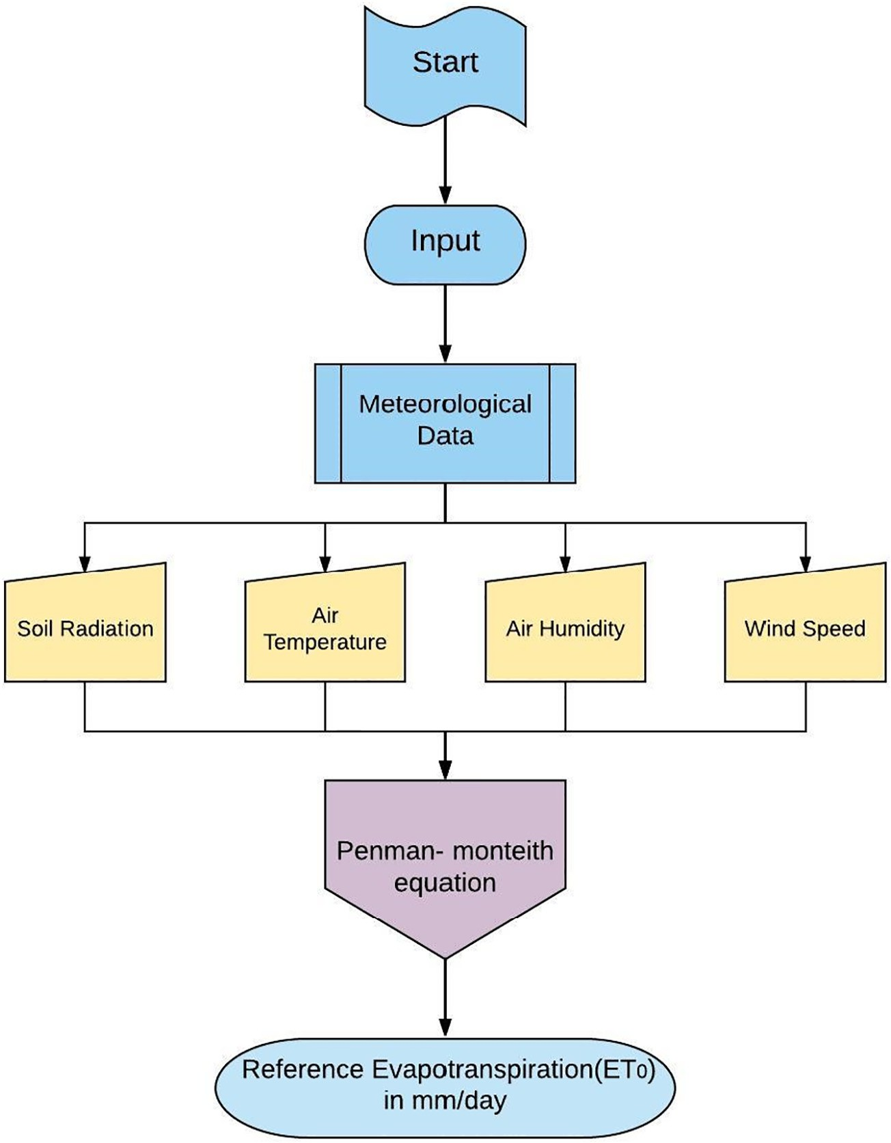

Fig. 4. Flowchart explaining evapotranspiration process.

this system is it also suggests the farmer pesticides and pacifies manual effort in the detection of disease. (Patil and Thorat, 2016). While a sim- ilar method of machine learning was employed in monitoring the growth of Paddy crops. This system was developed for increasing the yield and productivity of paddy crops. It also proved to be cost effective and durable. (Kait et al., 2007) (Fig. 4).

The sensors used in Fig. 5 are for monitoring agricultural field are shown in Fig. 6. Sensors such as MQ4 and MQ7 are used for Natural Gas sensing and Carbon Monoxide sensing respectively. DHT11 is used for Temperature and Humidity monitoring of the environment, soil moisture sensor is used for measuring soil moisture level and have con- tinuous monitoring. Esp8266 is a wifi module which helps in communi- cation between the hardware system and the device which users use.

In one of the research conducted in Ankara, Turkey, implementing IIS (intelligent irrigation system), numerous positive perks were ob- served such as less moisture and temperature stress on soil, efficient water consumption, and neglecting human intervention in case of flood irrigation. The developed system works on three units. Base unit (BU), Valve unit (VU), and Sensor unit (SU). The whole system is powered by solar panels. After the successful installation of every unit, BU will send the address to which the data is to be sent to SU. Sensors from the SU will sense the moisture content and send the detected data to a specific address in the BU. If required, BU will send a signal to VU so that it can calibrate the position of the valve in order to provide

the soil with water. However, site- specific use of automatic irrigation system took birth in the early 21st century; this method proved to be a significant success as it reduced the cost, feasibility, and complexity of the developed system. Furthermore, the unit can be set up which transports the fertilizers and pesticides in the field using the same method. For that, new kind of sensors would have to calibrate for trans- mitting accurate information. (Dursun and Ozden, 2011).

Research has been conducted to test the ET based, ICT based, and IIS based technology. In Riyadh, a research was conducted in Wheat and Tomato field in which both sprinkler and drip irrigation method were employed and tested with ICT as well as IIS. A graph of water depth ver- sus growth period of the crop (weekly) was plotted for all three methods. A concise observation concluded that IIS was far more feasible in a matter of water usage than ICT and ET based system. It skyrocketed the frugality of water usage from 18% to a whopping 27%. (Al-Ghobari and Mohammad, 2011).

Also, Kodali and Sahu (2016) presented the use of Losant platform for monitoring the agriculture farmland and intimate the farmer via SMS or e-mail if any anomaly is observed by the system. Losant is a sim- ple Iot based most powerful cloud platform. It offers real-time observa- tion of data stored in it irrespective of the position of the field. Gutiérrez et al. (2014) came up with an automated irrigation system which uses the GPRS module as a communication device. The system is pro- grammed into a microprocessor-based gateway which controls the

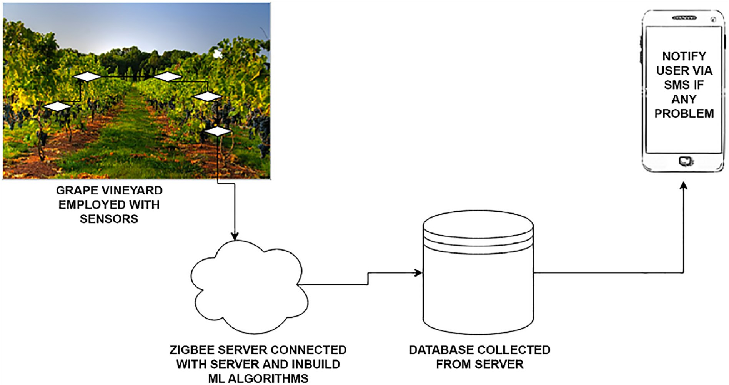

Fig. 5. Grape disease detection system using ML algorithms.

water quantity. It was proved that water savings were 90% more than the conventional irrigation system. Kim et al. (2008) used a distributed wireless network for sensing and control of irrigation process from a re- mote location.

To improve efficiency, productivity, global market and to reduce human intervention, time and cost there is a need to divert towards new technology named Internet of Things. IoT is the network of devices to transfer the information without human involvement. Hence, to gain high productivity, IoT works in synergy with agriculture to obtain smart farming. Malavade and Akulwar (2016) focused on role of IoT in agricul- ture that leads to smart framing (Malavade and Akulwar, 2016).

Use of wireless communication has changed the standards of com- munication in today's world and this can also raise the standards of ag- riculture automation. Logatchevl et al. (1998) has bifurcated the IOT gateway into different nodes such as actuator, sensor, interface and wireless link which give assistance to communication between them. Frequency estimation and the bandwidth requirement for this

communication has also been elaborated which can be very beneficial for automation.

Implementation of WSN (Wireless sensor network) in the agricul- ture sector and its different approaches is defined by this paper. Many different IEEE standards describe sensor networks, standards like IEEE

802.15.1 PAN/Bluetooth, IEEE 802.15.4 ZigBee and many more are nec- essary to know while planning its application. Researchers also discussed about IPV6 the Internet Protocol for wireless communication and also many hardware system for establishing a WSN. By using WSN, Precision farming is possible and the strategy is used for crop manage- ment. Different data is recorded by the sensors and stored in the system. The system is made to learn by the previous data from the sensors and future actions are taken accordingly (Shiravale and Bhagat, 2014).

Ganjegunte et al. (2012) studied three soil moisture sensors in Peacan crop field and came to a conclusion that the sensors used (ECH2O-5TE, Watermark 200SS and Tensiometer model R) need site specific calibration in order to bring accurate results.

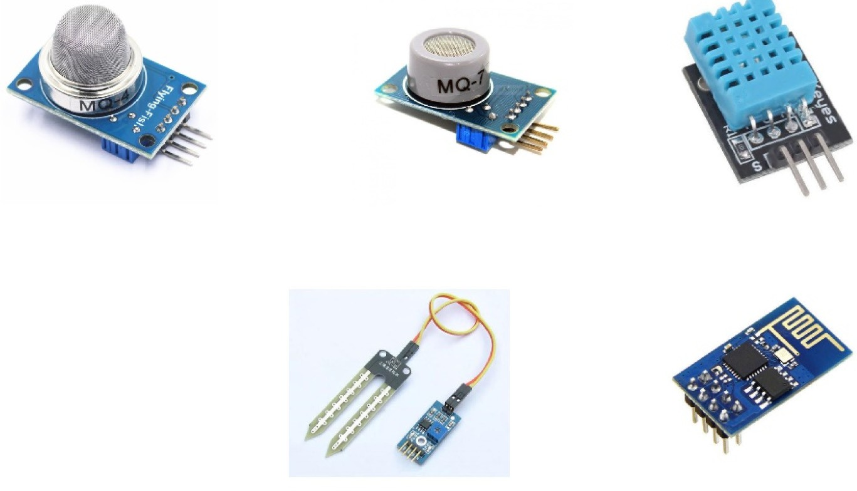

**MQ4**

**MQ7**

**DHT11**

**Soil Moisture Sensor**

**Esp8266**

Fig. 6. Different type of sensors used for detection.

The highlighting features of the paper presented by Gondchawar and Kawitkar (2016) includes smart GPS based remote controlled robot to perform tasks like; weeding, spraying, moisture sensing, bird and animal scaring, keeping vigilance, etc. Secondly, it includes smart ir- rigation with smart control based on real time field data. Thirdly, smart warehouse management which includes; temperature maintenance, humidity maintenance and theft detection in the warehouse. Control- ling of all these operations will be through any remote smart device or computer connected to Internet and the operations will be performed by interfacing sensors, Wi-Fi or ZigBee modules, camera and actuators with micro-controller and raspberry pi.

Thermal Imaging is a noncontact and nonintrusive technique which analysis the surface temperature of the agricultural field and provides valuable feedback to the farmer. Roopaei et al. (2017) discussed the use of cloud based thermal imaging system which helps the irrigation by incorporating the performance of the equipment's and determine the area of field which requires the water most. The absence of unifor- mity will hamper the crop growth and thermal imaging can help to consolidate this loss. Also, Thermal Imaging is put to use in agricul- ture sector truly because of its wide application. The paper by Manickavasagan et al. (2005) discusses various application of thermal imaging like Pre-harvest operations, Field nursery, Irrigation schedul- ing, Yield Forecasting, Green house gases, Termite Attack, Farm machinery.

Katariya et al. (2015) discussed the use of robot in the agriculture field. The robot is designed to follow the track of white line where actu- ally there is a need to work and other surface is considered as black or brown. Working of robot is for spraying of pesticide, dropping of seed's, water supply and ploughing. In 2016 a group of researchers came up with e-Agriculture Application based on the framework consisting of KM-Knowledge base and Monitoring modules.The systems developed in IOT and Cloud Computing emphasizes on reliable architectures to provide timely information from the field over 3G or Wi-Fi. TI CC 3200 (RFID) launchpad was used to build the prototype with other necessary devices. Knowledge base has advantage over conventional IOT based systems; Knowledge Base is constructed to store vast complex struc- tured and unstructured information to assist farmers or even an individ- ual with no prior knowledge of farming. But finding right information in an appropriate manner is difficult where providing relevant knowledge should be distributed not only in an organised and complete manner, but also in absolute way. The knowledge based infrastructure allows adapting the changes in agriculture for a better extension and adding advisory services. (Mohanraj et al., 2016).

As degree of automation is required in each and every field so the

human intervention becomes less and it is very important to design a layout in the early stages of the mechanics and electronics. Weed man- agement is the issue which farmers face a lot and computer vision can help to solve the issue. There is particular difference between a weed and the desired crop. CNN can help to distinguish among them and no- tify us to cut only the unnecessary plant. CNN has many algorithms which can even be used to identify plants and get the data accordingly for plantation. (Möller, 2010).

R-CNN extensively used in object detection and in automation it is used for fruit detection and counting of fruits. Bargoti and Underwood (2017) discusses the use of R-CNN in fruit detection of orchards, while training the input to the network is 3 channel colour image (BGR) of ar- bitrary size. They have used VGG16 NET with 13 convolutional network and also ZF network which has 5 convolutional layers. Data augmenta- tion is used because it helps in artificially enlarging the dataset and changing the variability of the training data. The results discussed by them are promising as for both mangoes and apples Faster R-CNN outperformed the ZF network approach. (R-CNN stands for regional convolutional neural network).

Cloud based decisions and support in the agriculture is booming now a days. The Decision support and Automation system (DSAS) helps the farmers of the growers to control all the applications through

its web portal. DSAS as different stages where the it can interconnect many devices on the single time and give the real time data to the farmer. The farmer plays the vital role as he can monitor the real time data and also control all the machine through software's. Systems like spray controller will spray the pesticide on the field in a defined amount. Similarly, irrigation controller helps to manage irrigation and fertilizer controller manages fertilizer. DSAS works through the data given by different sensors like soil moisture sensor, nitrogen sensor, etc. (Tan, 2016).

Kumar (2014) used fertility and pH meter to take out the percentage of ingredients of the soil and developed wireless sensor based drip irri- gation system. Ingale and Kasat (2012) used IC 89c52 microcontroller to build a smart irrigation system. The prototype supplies water only when humidity and moisture drops below a standard decided value hence it conserves water to a certain extent. A semi-automatic irrigation system was developed and tested on the field of Okra crops (*Abelmoschus esculentus*). The system used four moisture sensors and PIC16F877A processor was used. The valves in the system turns ON only when there is a voltage drop across any two sensors in the filed drops below a fixed value and remains ON until the value comes to the decided threshold value. (Soorya et al., 2013).

1. Implementation of fuzzy logic systems in agriculture

Sicat et al. (2005) developed an FK-based fuzzy model to decide the land suitability. Various fuzzy sets were generated using farmer's as well as scientific knowledge congruently. The sets used S-membership func- tions and were used to determine soil texture, slope, and colour. The re- search work was done in several villages of Nizamabad district of Andhra Pradesh state of India. In FK-based fuzzy factor maps, it is not necessary to take the lower and upper limits 0 and 1 respectively. This is because in knowledge-driven fuzzy modeling there is no constraint on choosing the membership functions as long as the functions are in context of the factor which has to be modeled (in this case FK-based model).

Another implementation of fuzzy modeling was done for land level- ling by Si et al. (2007). They employed fuzzy control theory in the con- troller of the system. By implementing fuzzy control theory, a precision based result was obtained. High accuracy fuzzy control theory translates the variables (the deviation in the height of the field and expected the height of the field) into the defined variables sets (E and EC) which con- tains fuzzy terminologies such as ‘High’, ‘Very high’ and so on. There are nine sets defined for variable set E and two for variable set EC. This the- ory helps the controller deduce the position of the bucket which is inturned will be the height of the field. The bucket receives the signal from the receiver. Sannakki et al. (2011) developed an innovative sys- tem for grading the leaf diseases. The system was segregated into five parts namely Image acquisition where the researchers have captured images of Pomegranate leaves, image pre-processing where the cap- tured image is then resized, filtered, and processed according to the re- quired parameter. Then comes colour image segmentation where k- means clustering is used to isolate the healthy part of leave with the dis- ease infected part. Afterward from the resized image, total leaf area is calculated, and with the help of the third part, infected disease area of the leaf is calculated. Finally, in the last part, with the help of a fuzzy in- ference system, accurate grading of the disease can be taken out.

FIS (Fuzzy inference system) was developed by Tremblay et al. (2010) to determine optimum rates of N fertilizer on the basis of field and crop features. Also, Valdés-Vela et al. (2015) implemented FIS to es- timate stem water potential. Kavdir and Guyer (2003) applied FL model in determining the quality of Apple fruit. Gottschalk et al. (2003) devel- oped fuzzy logic based air controllers to maintain the temperature of storage facilities for Potato. Escobar and Galindo (2004) came up with a simulation software (SCD) which came in handy for many fuzzy based controllers. The software used rule-based knowledge base with IF. THEN condition type. Its graphical characteristics make the software

adaptable to any fuzzy algorithm simulations. Another Fuzzy inference system using IF…THEN condition type was developed by Tilva et al. (2013). The model forecasted plant disease on the base of weather data. The system was developed to avoid diseases in plant beforehand as disease occurs in specific range of temperature and humidity in the weather.

India and China alone constitute 2.7 billion people living under the stress of water shortage. Out of overall water consumption, 70% is con- sumed in the agricultural process. Remaining is used in infrastructural pipelines and other miscellaneous works. Water leakage is inevitable and uncontrollable in cities. Water demand will shoot up by 50% shortly and this fact cannot be vetoed away. The farming fraternity is the only option in which water usage can be optimized by employing smart irri- gation systems. By inculcating smart irrigation system, wastage of water can culminate to a great extent can abridge water consumption by 20%. (Gupta et al., 2016).

There is a major problem of water wastage and a dearth of water in conventional irrigation methods employed. To give an example, Egypt faces a problem of water distribution from the Nile river with neighbor- ing countries. Ample research had been carried out to solve the prob- lems faced in the irrigation, process. Many companies have developed a sensor-based smart irrigation system. These systems have been devel- oped for optimal water usage, monitoring of water pollution, and to take care of some other grave problems. Soil moisture and temperature sen- sors interact directly with embedded components in the field and take

care of required water distribution among crops without farmer's inter- action. Water which is to be fed to the farms, either by the means of smart irrigation or any other conventional method, should be of a good quality. Researchers have started implementing IOT systems and Artificial intelligence techniques in aquaculture sector along with agri- culture. The system designed by Encinas et al. (2017) monitors the qual- ity of water by deploying state-of-the-art automation techniques.

Wall and King (2004) came up with a smart system which con- trolled valves of sprinklers with the help of temperature and moisture sensors deployed in the field. However, this system did not consider the water pollution problem. Miranda et al. (2003) came up with a dis- tributed irrigation system which works on soil water measurement. M2M (machine-to-machine) technology which allows machines to in- teract with each other autonomously and store the data directly in a cloud-based server online. This M2M technology is in an incipient stage and is developing steadfastly. Shekhar et al. (2017) developed a technology which allows machines to communicate themselves. Yang et al. (2007) also developed a complete sensor-based intensive irriga- tion method which is self-organizing. This system constructed a bottom and upper layer. Pawar et al. (2018) tried to demonstrate a prototype of the small-scale smart irrigation system. Savitha and UmaMaheshwari (2018) considered only automation and IoT I in their quest for an intel- ligent irrigation system.

So far, there hasn't been such advent which allows complete free- dom of human intervention. This paper tries to bring forward a method

|  |  |  |  |  |  |  |
| --- | --- | --- | --- | --- | --- | --- |
| Sr no | Crop/fruit name | Technology | System name | Results/description | Limitations/future scopes | Country Reference |
| 1 | Tea | Object-oriented expert system | TEAPEST | Total of 65 real field cases were taken from the system which evaluated the relevant parameters and the results were almost | The accuracy of the system was only 90%. The remaining inaccuracy was the result of inappropriate diagnosis. | India (Ghosh and Samanta, 2003) |
| 2 | Tea | Radial basis | Modified | satisfactory. The system was stationed in the tea fields for two years  The hidden layers of this neural networks are | The developed system detects only three | India (Banerjee et al., |
| 3 | General | function networks.  Rule based | TEAPEST.  PEST | 31. This hidden layers gave the detection accuracy of 99.99%. There was testing error of only 1%.  The system gave satisfactory results for wich | major pests of tea crops. Also it is limited to only tea and not all the cash crops.  As the system was developed in late 1980's | 2017)  Australia (Pasqual and |
| 4 | crops  Mango | expert system  Artificial neural | (Pest Expert System)  N/A | it was developed. (Identification and control of insects).  The developed model used three neurons in | the resources and development in this sector wasn't much and due to it the prototype couldn't cover many development parameters like Crop nutrition, salinity, variety selection etc.  The system do not consider beforehand | Mansfield, 2003)  France and (Hernandez-Perez |
|  | and  Cassava | networks |  | the hidden layer of the network to identify  dryness in the given fruits. This study showed | predictions and assumptions. Also,  temperature predictions cannot be done | Mexico et al., 2004) |
| 5 | Hop plant | Rule based | Corac | neural networks can be used for procuring dryness patterns in food.  This was developed for detecting diseases | correctly.  There are models in the system like LANCE | Czech (Mozny et al., |
| 6 | Jute | expert system  Artificial neural | N/A | like downy mildew, hop aphid and weevil. System provided growth of disease, estimation of harm caused and correct treatment for the disease in the hop plant  With 9 to 5 neurons in the hidden layer, the | and MESA which creates problems while estimating disease harm and also meteoro- logical data varies according to the local climate.  Predicted results matched correctly with the | republic 1993)  Bangladesh (Rahman and Bala, |
| 7 | Different | networks  Fuzzy logic | N/A | model accurately predicted the growth of jute crops. It used back propagation for training the model.  The platform used for grading and | observed results (bark, roots, leaf) and if trained properly the model can predict results for different crops.  There were misclassification problems in the | 2010)  Malaysia (Mustafa et al., |
| 8 | fruits  Wheat | Image | N/A | classification of different fruits is MATLAB. Support vector Machine technique was used for classification of the fruits and fuzzy logic was used for grading.  Two machine algorithms SVM and neural | developed system. But it can be mitigated adding features of colour and texture of fruits.  More precised algoritmns can be designed | 2009)  India (Punn and Bhalla, |
| 9 | Rice | processing  Pattern | N/A | networks were used for classification process. The accuracy of SVM was 86.8% and neural network was 94.5% accurate. The algorithm used was more accurate then manually developed algorithm.  Morphological and colour features were | which will have less computational cost. Additionally various varieties of wheat can be classified using different feature sets.  Only rice crop was considered in the study. | 2013)  India (Shantaiya and |
|  |  | classification, A  back propaga- tion neural |  | taken into account for developing algorithm.  Nine morphological and six colour features were acquired from Images. The accuracy of | Further infections on various crops can be identified and placated using this system. | Ansari, 2010) |
|  |  |  |  |  |  | *(continued on next page)* |

(*continued*)

Sr Crop/fruit no name

Technology System name

Results/description Limitations/future scopes Country Reference

networks classification dataset ranged from 74 to 90%.

10 Lentils Machine Vision N/A A Flatbed scanner was used as a hardware

component with a pentium CPU. Various methods including K-NN, neural networks etc. were used for colour grading of lentil crops. Additionally an online neural classifier was used which gave almost 90% accuracy in grading of crops.

Cost effective and smaller scanner can be used instead of a large scanner which can give only required information required for lentil classification. Owing to the size of scanner, it gave variety of information which is less useful for the purpose of classification and grading.

Canada (Shahin and Symons, 2001)

through which with the help of AI and embedded technology which eliminates the glitches emphasized in the past.

1. Proposed idea

Need of automation in the agriculture sector is must and there are many ways it can be implemented in practice. Irrigation is the foremost thing where automation is necessitate for optimal water usage. Soil moisture sensor helps to monitor the moisture level of the soil and starts watering the farm as the value get below the threshold level set by the farmer. The embedded system and Internet of Things help to de- velop a compact system which monitors the water level of the farm without human interaction.

There are many different techniques that we can implement as auto- mation through different forms like using Machine learning, Artificial Intelligence, Deep learning, Neural network, Fuzzy logic. The idea is to use any of these extended methods to reduce human intervention and human efforts. All this methods have their own advantages and disad- vantages, but the way they are used differentiate them from each other. The meagre research in the field of deep learning technique which analyses the dataset of images from the past data fed and clas- sifies the plants or flowers. Kamilaris and Prenafeta-Boldú (2018) dis- cusses the Deep learning concepts in the agriculture and the efforts that apply to execute deep learning techniques, in various agricultural sectors. Deep learning application is required in this field as it provides major impact on the modern techniques, it extends the Machine learn- ing by adding more depth into the model. The main feature of the deep learning is the raw data process to increase accuracy and classification. Plant recognition, fruit counting, predicting future crop yield are the main target where deep learning can be implemented. Large dataset of images are required to train the model, while some techniques use text data to train the model. Data source, Data pre-processing, Data Var- iation and Data augmentation techniques are necessary for the Deep learning to train the model. Future of deep learning in agriculture has many environments and it can proliferate agriculture sector. Ferentinos (2018) have worked with convolution neural network models and used deep learning in the system by training the model with different images of healthy and diseased plants. Plant disease rec- ognition has a high degree of complexity and so many agronomists fail to diagnose specific disease. The model represented perfectly identifies and gives accuracy upto 99.53%.

The idea is to train the model such a way that it identifies plants or

flowers when in future any image is fed to the model. To train the model, VGG16 is used as it is the simplest model among all other convolutional networks. This network is characterized by its simplicity, using only 3 × 3 convolutional layers stacked on top of each other in in- creasing depth. Reducing volume size is handled by max pooling. Two fully-connected layers, each with 4096 nodes are then followed by a softmax classifier. In VGG16, ‘16’ stands for the number of weight layers in the network. Keras library in python includes VGG, ResNet, Inception, and Xception network architectures. A large image data of different plants and different flowers is used to train the model and check the

accuracy. The model then accurately predicts the plant or flower when any random image is fed in the system.

This system is necessary in the agricultural sector as every plant has some particular need of environment. A fixed amount of water at regu- lar time and favourable environmental gases around helps the plant to grow perfectly healthy. By classification through deep learning it be- comes easy for the farmers or botanist to grow plant, as by identification of plant and its favourable conditions, farmers and botanist can provide such environment and proper irrigation.

1. Future scope

The farmers who are young will make more investments in automa- tion with much interest than the elder farmers. The technology which is new has to be introduced slowly with time. Slowly the agriculture sec- tor is moving towards precision farming in which management will we done on the basis of individual plant. Deep learning and other extend methods are used to detect the plant or flower type, this will help farmers to provide favourable environment to the plant for sustainable growth. Eventually the production of more customised fruits and plants will grow, which leads to an increase in the diversity of products and production method. Artificial intelligence techniques are growing at a rapid scale and it can be used to detect disease of plants or any un- wanted weed in the farm by using CNN, RNN or any other computa- tional network. Green house farming can provide a particular environment to the plants but it is not possible without human inter- vention. Here, wireless technology and IOT comes in the run and using the latest communication protocols and sensors we can implement weather monitoring and control without human presence in the farm. Harvesting of fruits and crops can also be incorporated by robots which are specialized in working round the clock for quick harvesting. Application of robotics are vast in farming such as the robots can be used in seeding and planting, fertilizing and irrigation, crop weeding and spraying, harvesting and shepherding. To complete the same work in many cases, it would take approximately 25 to 30 workers. Thermal Imaging can also be implemented by using drones and thermal camera in it. The drones monitor the farm and gives continuous real time data of the field so that the farmers could know in which area of the field the water quantity is less and can only start irrigation in that particular area. This will prevent water flooding or scarcity of water in the field and the crops get advent amount of water all the time. Many different integrated approaches can be used to provide a viable environ- ment and increased growth.

1. Conclusion

Agriculture monitoring is the much necessitate reducing human in- terventions in practice. Day by day demand for food is reaching its high peak and the without execution of the modern methods in agriculture it is very hard to achieve the increasing demand. Agriculture monitoring is the prime concern as it helps to reduce labour and increase the produc- tion. Artificial Intelligence has been implemented in crop selection and to help the farmer in the selection of the fertilizers. With the help of

the database which the user has gathered and specified to the system, the machine communicates among themselves to decide which crop is suitable for harvesting and also the fertilizers which promote the maximum growth. Deep learning has wide reach and its application in industry has received tremendous advancement. Using deep learning is an added advantage over machine learning and it adds depth to ma- chine learning. Many significant methods can ensure the farmers with better crops and proper field management. This in the end helps in overall growth of the country as food is the foremost need of any human being. IOT marked its significance to help in the real-time mon- itoring of the data. IOT is mainly used in an intelligent watering system. Because, effective use of the available fresh water is essential and with the advancement in the technology and application of automation water crisis can be solved. Traditional methods in agriculture have minor effects in this modern world. Water scarcity and flooding both are the major problems farmers are facing using the traditional ap- proach. Many loop holes in this system and the alarming need to protect the agricultural land leads to the development of agriculture automa- tion. This paper represents an idea to make a system with the use of sen- sors, IOT and machine learning to automate the traditional practices in agriculture.

Authors contribution

All the authors make a substantial contribution to this manuscript. KJ, AD and PP participated in drafting the manuscript. KJ and AD wrote the main manuscript; all the authors discussed the results and implica- tion on the manuscript at all stages.

Declaration of Competing Interests

The authors declare that they have no competing interests.

Acknowledgements

The authors are grateful to Gandhinagar Institute of Technology, Lalbhai Dalpatbhai College of Engineering, Vishwakarma Government Engineering College and Pandit Deendayal Petroleum Universityfor the permission to publish this research.

Availability of data and material

All relevant data and material are presented in the main paper.

Funding

Not Applicable.

Consent for publication

Not applicable.

Ethics approval and consent to participate

Not applicable.

References

Aitkenhead, M.J., Dalgetty, I.A., Mullins, C.E., McDonald, A.J.S., Strachan, N.J.C., 2003. [Weed](http://refhub.elsevier.com/S2589-7217(19)30018-2/rf0005) [and crop discrimination using image analysis and artificial intelligence methods.](http://refhub.elsevier.com/S2589-7217(19)30018-2/rf0005) [Comput. Electron. Agric. 39 (3), 157–17](http://refhub.elsevier.com/S2589-7217(19)30018-2/rf0005)1.

Al-Ghobari, H.M., Mohammad, F.S., 2011. [Intelligent irrigation performance: evaluation](http://refhub.elsevier.com/S2589-7217(19)30018-2/rf0010) [and quantifying its ability for conserving water in arid region. Appl Water Sci 1,](http://refhub.elsevier.com/S2589-7217(19)30018-2/rf0010) [73–83](http://refhub.elsevier.com/S2589-7217(19)30018-2/rf0010).

Arif, C., Mizoguchi, M., Setiawan, B.I., Doi, R., 2012. [Estimation of soil moisture in paddy](http://refhub.elsevier.com/S2589-7217(19)30018-2/rf0015) [field using Artificial Neural Networks. International Journal of Advanced Research](http://refhub.elsevier.com/S2589-7217(19)30018-2/rf0015) [in Artificial Intelligence. 1 (1), 17–21](http://refhub.elsevier.com/S2589-7217(19)30018-2/rf0015).

Banerjee, G., Sarkar, U., Ghosh, I., 2017. [A radial basis function network based classifier for](http://refhub.elsevier.com/S2589-7217(19)30018-2/rf0020) [detection of selected tea pests. International Journal of Advanced Research in Com-](http://refhub.elsevier.com/S2589-7217(19)30018-2/rf0020) [puter Science and Software Engineering. 7 (5), 665–66](http://refhub.elsevier.com/S2589-7217(19)30018-2/rf0020)9.

Bannerjee, G., Sarkar, U., Das, S., Ghosh, I., 2018. [Artificial Intelligence in Agriculture: A Lit-](http://refhub.elsevier.com/S2589-7217(19)30018-2/rf0025) [erature Survey. International Journal of Scientific Research in Computer Science Ap-](http://refhub.elsevier.com/S2589-7217(19)30018-2/rf0025) [plications and Management Studies. 7 (3), 1–](http://refhub.elsevier.com/S2589-7217(19)30018-2/rf0025)6.

Bargoti, S., Underwood, J., 2017. [Deep Fruit Detection in Orchards. 2017 IEEE International](http://refhub.elsevier.com/S2589-7217(19)30018-2/rf0030) [Conference on Robotics and Automation (ICRA) 3626–3633](http://refhub.elsevier.com/S2589-7217(19)30018-2/rf0030).

Batchelor, W.D., McClendon, R.W., Adams, D.B., Jones, J.W., 1989. [Evaluation of](http://refhub.elsevier.com/S2589-7217(19)30018-2/rf0035) [SMARTSOY: an expert simulation system for insect pest management. Agric. Syst.](http://refhub.elsevier.com/S2589-7217(19)30018-2/rf0035) [31 (1), 67–81](http://refhub.elsevier.com/S2589-7217(19)30018-2/rf0035).

Dursun, M., Ozden, S., 2011. [A wireless application of drip irrigation automation sup-](http://refhub.elsevier.com/S2589-7217(19)30018-2/rf0040) [ported by soil moisture sensors. Sci. Res. Essays 6 (7), 1573–158](http://refhub.elsevier.com/S2589-7217(19)30018-2/rf0040)2.

Encinas, C., Ruiz, E., Cortez, J., Espinoza, A., 2017. [Design and implementation of a distrib-](http://refhub.elsevier.com/S2589-7217(19)30018-2/rf0045) [uted IoT system for the monitoring of water quality in aquaculture. Wireless Tele-](http://refhub.elsevier.com/S2589-7217(19)30018-2/rf0045) [communications Symposium (WTS). 2017, 1–](http://refhub.elsevier.com/S2589-7217(19)30018-2/rf0045)7.

Escobar, C., Galindo, J., 2004. [Fuzzy Control in Agriculture: Simulation Software. Industrial](http://refhub.elsevier.com/S2589-7217(19)30018-2/rf0050) [Simulation Conference. pp. 45–49](http://refhub.elsevier.com/S2589-7217(19)30018-2/rf0050).

Ferentinos, K.P., 2018. [Deep learning models for plant disease detection and diagnosis.](http://refhub.elsevier.com/S2589-7217(19)30018-2/rf0055)

[Comput. Electron. Agric. 145, 311–31](http://refhub.elsevier.com/S2589-7217(19)30018-2/rf0055)8.

Ganjegunte, G.K., Sheng, Z., Clark, J.A., 2012. [Evaluating the accuracy of soil water sensors](http://refhub.elsevier.com/S2589-7217(19)30018-2/rf0060) [for irrigation scheduling to conserve freshwater. Appl Water Sci 2, 119–12](http://refhub.elsevier.com/S2589-7217(19)30018-2/rf0060)5.

Ghosh, I., Samanta, R.K., 2003. [Teapest: an expert system for insect pest management In](http://refhub.elsevier.com/S2589-7217(19)30018-2/rf0065) [Tea. Appl. Eng. Agric. 19 (5), 619–62](http://refhub.elsevier.com/S2589-7217(19)30018-2/rf0065)5.

Gliever, C., Slaughter, D.C., 2001. [Crop verses weed recognition with artificial neural net-](http://refhub.elsevier.com/S2589-7217(19)30018-2/rf0070) [works. ASAE paper. 01-3104 (2001), 1–12](http://refhub.elsevier.com/S2589-7217(19)30018-2/rf0070).

Gondchawar, N., Kawitkar, R.S., 2016. [IoT based smart agriculture. International Journal of](http://refhub.elsevier.com/S2589-7217(19)30018-2/rf0075) [Advanced Research in Computer and Communication Engineering. 5 (6), 838–84](http://refhub.elsevier.com/S2589-7217(19)30018-2/rf0075)2.

Gottschalk, K., Nagy, L., Farkas, I., 2003. [Improved climate control for potato stores by](http://refhub.elsevier.com/S2589-7217(19)30018-2/rf0080) [fuzzy controllers. Comput. Electron. Agric. 40, 127–140](http://refhub.elsevier.com/S2589-7217(19)30018-2/rf0080).

Gupta, A., Mishra, S., Bokde, N., Kulat, K., 2016. [Need of smart water systems in India. Int.](http://refhub.elsevier.com/S2589-7217(19)30018-2/rf0085)

[J. Appl. Eng. Res. 11 (4), 2216–2223](http://refhub.elsevier.com/S2589-7217(19)30018-2/rf0085).

Gutiérrez, J., Medina, J.F.V., Garibay, A.N., Gándara, M.A.P., 2014. [Automated irrigation sys-](http://refhub.elsevier.com/S2589-7217(19)30018-2/rf0090) [tem using a wireless sensor network and GPRS module. IEEE Trans. Instrum. Meas. 63](http://refhub.elsevier.com/S2589-7217(19)30018-2/rf0090) [(1), 1–11](http://refhub.elsevier.com/S2589-7217(19)30018-2/rf0090).

Hernandez-Perez, J.A., Garcıa-Alvarado, M.A., Trystram, G., Heyd, B., 2004. [Neural net-](http://refhub.elsevier.com/S2589-7217(19)30018-2/rf0095) [works for the heat and mass transfer prediction during drying of cassava and](http://refhub.elsevier.com/S2589-7217(19)30018-2/rf0095) [mango. Innov. Food Sci. Emerg. Technol. 5, 57–64](http://refhub.elsevier.com/S2589-7217(19)30018-2/rf0095).

Hinnell, A.C., Lazarovitch, N., Furman, A., Poulton, M., Warrick, A.W., 2010. [Neuro-drip: es-](http://refhub.elsevier.com/S2589-7217(19)30018-2/rf0100) [timation of subsurface wetting patterns for drip irrigation using neural networks.](http://refhub.elsevier.com/S2589-7217(19)30018-2/rf0100) [Irrig. Sci. 28, 535–54](http://refhub.elsevier.com/S2589-7217(19)30018-2/rf0100)4.

Ingale, H.T., Kasat, N.N., 2012. [Automated irrigation system. Int. J. Eng. Res. Dev. 4 (11),](http://refhub.elsevier.com/S2589-7217(19)30018-2/rf0105) [51–54](http://refhub.elsevier.com/S2589-7217(19)30018-2/rf0105).

Kait, L.K., Kai, C.Z., Khoshdelniat, R., Lim, S.M., Tat, E.H., 2007. [Paddy growth monitoring](http://refhub.elsevier.com/S2589-7217(19)30018-2/rf0110) [with wireless sensor networks. International Conference on Intelligent and Advanced](http://refhub.elsevier.com/S2589-7217(19)30018-2/rf0110) [Systems, IEEE 966–97](http://refhub.elsevier.com/S2589-7217(19)30018-2/rf0110)0.

Kalaivani, T., Allirani, A., Priya, P., 2011. [A survey on Zigbee based wireless sensor net-](http://refhub.elsevier.com/S2589-7217(19)30018-2/rf0115) [works in agriculture. IEEE 85–89](http://refhub.elsevier.com/S2589-7217(19)30018-2/rf0115).

Kamilaris, A., Prenafeta-Boldú, F.X., 2018. [Deep learning in agriculture: a survey. Comput.](http://refhub.elsevier.com/S2589-7217(19)30018-2/rf0120)

[Electron. Agric. 147, 70–90](http://refhub.elsevier.com/S2589-7217(19)30018-2/rf0120).

Katariya, S.S., Gundal, S.S., Kanawade, M.T., Mazhar, K., 2015. [Automation in agriculture.](http://refhub.elsevier.com/S2589-7217(19)30018-2/rf0125)

[International Journal of Recent Scientific Research. 6 (6), 4453–4456](http://refhub.elsevier.com/S2589-7217(19)30018-2/rf0125).

Kavdir, S., Guyer, D.E., 2003. [Apple grading using fuzzy logic. Turk J Agric. 27, 375–38](http://refhub.elsevier.com/S2589-7217(19)30018-2/rf0130)2. Keshtgari, M., Deljoo, A., 2012. [A wireless sensor network solution for precision agricul-](http://refhub.elsevier.com/S2589-7217(19)30018-2/rf0135)

[ture based on ZigBee technology. Wirel. Sens. Netw. 4 (1), 1–](http://refhub.elsevier.com/S2589-7217(19)30018-2/rf0135)7.

Kim, Y.J., Evans, R.G., Iversen, W.M., 2008. [Remote sensing and control of an irrigation sys-](http://refhub.elsevier.com/S2589-7217(19)30018-2/rf0140) [tem using a distributed wireless sensor network. IEEE Trans. Instrum. Meas. 57 (7),](http://refhub.elsevier.com/S2589-7217(19)30018-2/rf0140) [1379–138](http://refhub.elsevier.com/S2589-7217(19)30018-2/rf0140)7.

Kodali, R.K., Sahu, A., 2016. [An IoT based soil moisture monitoring on Losant platform. 2nd](http://refhub.elsevier.com/S2589-7217(19)30018-2/rf0145) [International Conference on Contemporary Computing and Informatics, IEEE,](http://refhub.elsevier.com/S2589-7217(19)30018-2/rf0145)

[pp. 764–76](http://refhub.elsevier.com/S2589-7217(19)30018-2/rf0145)8.

Kumar, G., 2014. [Research paper on water irrigation by using wireless sensor network. In-](http://refhub.elsevier.com/S2589-7217(19)30018-2/rf0150) [ternational Journal of Scientific Engineering and Technology 123–125 IEERT confer-](http://refhub.elsevier.com/S2589-7217(19)30018-2/rf0150) [ence Pape](http://refhub.elsevier.com/S2589-7217(19)30018-2/rf0150)r.

Lemmon, H., 1986. [Comax: an expert system for cotton crop management. Science. 233](http://refhub.elsevier.com/S2589-7217(19)30018-2/rf0155) [(4759), 29–33](http://refhub.elsevier.com/S2589-7217(19)30018-2/rf0155).

Liakos, K.G., Busato, P., Moshou, D., Pearson, S., Bochtis, D., 2018. [Machine Learning in Ag-](http://refhub.elsevier.com/S2589-7217(19)30018-2/rf0160) [riculture: A Review. Sensors. 18 (2674), 1–29](http://refhub.elsevier.com/S2589-7217(19)30018-2/rf0160).

Logatchevl, A.A., Afanas'evl, V.P., Shkol'nik, S.M., Pursch, H., Jiittner, B., 1998. [The behav-](http://refhub.elsevier.com/S2589-7217(19)30018-2/rf0165) [iour of vacuum arc discharges at hydrogen impregnated electrodes. IEEE 18th Int.](http://refhub.elsevier.com/S2589-7217(19)30018-2/rf0165) [Symp. on Discharses and Electrical Insulation in Vacuum-Eindhoven, pp. 288–29](http://refhub.elsevier.com/S2589-7217(19)30018-2/rf0165)1.

Maier, H.R., Dandy, G.C., 2000. [Neural networks for the prediction and forecasting of](http://refhub.elsevier.com/S2589-7217(19)30018-2/rf0170) [water resources variables: a review of modeling issues and applications. Environ-](http://refhub.elsevier.com/S2589-7217(19)30018-2/rf0170) [mental Modeling & Software 101–12](http://refhub.elsevier.com/S2589-7217(19)30018-2/rf0170)4.

Malavade, V.N., Akulwar, P.K., 2016. [Role of IoT in Agriculture. National Conference On](http://refhub.elsevier.com/S2589-7217(19)30018-2/rf0175)

[“Changing Technology and Rural Development”. pp. 56–57](http://refhub.elsevier.com/S2589-7217(19)30018-2/rf0175).

Manickavasagan, A., Jayas, D.S., White, N.D.G., Paliwal, J., 2005. Applications of Thermal Imaging in Agriculture – A Review. CSAE/SCGR 2005 Meeting Winnipeg, Manitoba. 1–11.

McKinion, J.M., Lemmon, H.E., 1985. [Expert systems for agriculture. Comput. Electron.](http://refhub.elsevier.com/S2589-7217(19)30018-2/rf0180)

[Agric. 1 (1), 31–40](http://refhub.elsevier.com/S2589-7217(19)30018-2/rf0180).

Miranda, F.R., Yoder, R., Wilkerson, J.B., 2003. [“A Site-specific Irrigation Control System”,](http://refhub.elsevier.com/S2589-7217(19)30018-2/rf0185) [Presented at the ASAE Annu. Int. Meeting, Las Vegas, NV, Jul. 27–30](http://refhub.elsevier.com/S2589-7217(19)30018-2/rf0185).

Mohanraj, I., Ashokumar, K., Naren, J., 2016. [Field monitoring and automation using IOT in](http://refhub.elsevier.com/S2589-7217(19)30018-2/rf0190) [agriculture domain. 6th International Conference on Advances in Computing & Com-](http://refhub.elsevier.com/S2589-7217(19)30018-2/rf0190) [munications, ICACC 2016, 6–8 September 2016, Cochin, India, 93, pp. 931–93](http://refhub.elsevier.com/S2589-7217(19)30018-2/rf0190)9.

Möller, J., 2010. [Computer vision – a versatile technology in automation of agriculture](http://refhub.elsevier.com/S2589-7217(19)30018-2/rf0195) [machinery. 21st Annual Meeting Bologna. EIMA International 1–16](http://refhub.elsevier.com/S2589-7217(19)30018-2/rf0195).

Mozny, M., Krejci, J., Kott, I., 1993. [CORAC, hops protection management systems. Comput.](http://refhub.elsevier.com/S2589-7217(19)30018-2/rf0200)

[Electron. Agric. 9, 103–11](http://refhub.elsevier.com/S2589-7217(19)30018-2/rf0200)0.

Mustafa, N.B.M., Ahmed, S.K., Ali, Z., Yit, W.B., Abidin, A.A.Z., Md Sharrif, Z.A., 2009. [Agri-](http://refhub.elsevier.com/S2589-7217(19)30018-2/rf0205) [cultural produce sorting and grading using support vector machines and fuzzy](http://refhub.elsevier.com/S2589-7217(19)30018-2/rf0205) [logic. IEEE International Conference on Signal and Image Processing Applications.](http://refhub.elsevier.com/S2589-7217(19)30018-2/rf0205) [391–39](http://refhub.elsevier.com/S2589-7217(19)30018-2/rf0205)6.

Nema, M.K., Khare, D., Chandniha, S.K., 2017. [Application of artificial intelligence to esti-](http://refhub.elsevier.com/S2589-7217(19)30018-2/rf0210) [mate the reference evapotranspiration in sub-humid Doon valley. Appl Water Sci 7,](http://refhub.elsevier.com/S2589-7217(19)30018-2/rf0210) [3903–3910](http://refhub.elsevier.com/S2589-7217(19)30018-2/rf0210).

Pasqual, G.M., Mansfield, J., 2003. [Development of a prototype expert system for identifi-](http://refhub.elsevier.com/S2589-7217(19)30018-2/rf0215) [cation and control of insect pests. Comput. Electron. Agric. 2 (4), 263–276](http://refhub.elsevier.com/S2589-7217(19)30018-2/rf0215).

Patil, S.S., Thorat, S.A., 2016. [Early detection of grapes diseases using machine learning and](http://refhub.elsevier.com/S2589-7217(19)30018-2/rf0220) [IoT. Second International Conference on Cognitive Computing and Information Pro-](http://refhub.elsevier.com/S2589-7217(19)30018-2/rf0220) [cessing (CCIP), IEEE 1–](http://refhub.elsevier.com/S2589-7217(19)30018-2/rf0220)5.

Pawar, S.B., Rajput, P., Shaikh, A., 2018. [Smart irrigation system using IOT and raspberry](http://refhub.elsevier.com/S2589-7217(19)30018-2/rf0225) [pi. International Research Journal of Engineering and Technology. 5 (8), 1163–1166.](http://refhub.elsevier.com/S2589-7217(19)30018-2/rf0225) Prakash, C., Rathor, A.S., Thakur, G.S.M., 2013. [Fuzzy Based Agriculture Expert System for](http://refhub.elsevier.com/S2589-7217(19)30018-2/rf0230)

[Soyabean. pp. 1–13](http://refhub.elsevier.com/S2589-7217(19)30018-2/rf0230).

Punn, M., Bhalla, N., 2013. [Classification of wheat grains using machine algorithms. Inter-](http://refhub.elsevier.com/S2589-7217(19)30018-2/rf0235) [national Journal of Science and Research. 2 (8), 363–366](http://refhub.elsevier.com/S2589-7217(19)30018-2/rf0235).

Rahman, M.M., Bala, B.K., 2010. [Modelling of jute production using artificial neural net-](http://refhub.elsevier.com/S2589-7217(19)30018-2/rf0240) [works. Biosyst. Eng. 105, 350–35](http://refhub.elsevier.com/S2589-7217(19)30018-2/rf0240)6.

Ravichandran, G., Koteshwari, R.S., 2016. [Agricultural crop predictor and advisor using](http://refhub.elsevier.com/S2589-7217(19)30018-2/rf0245) [ANN for smartphones. IEEE 1–](http://refhub.elsevier.com/S2589-7217(19)30018-2/rf0245)6.

Roach, J., Virkar, R., Drake, C., Weaver, M., 1987. [An expert system for helping apple](http://refhub.elsevier.com/S2589-7217(19)30018-2/rf0250) [growers. Comput. Electron. Agric. 2 (2), 97–10](http://refhub.elsevier.com/S2589-7217(19)30018-2/rf0250)8.

Robinson, C., Mort, N., 1997. [A neural network system for the protection of citrus crops](http://refhub.elsevier.com/S2589-7217(19)30018-2/rf0255) [from frost damage. Comput. Electron. Agric. 16 (3), 177–18](http://refhub.elsevier.com/S2589-7217(19)30018-2/rf0255)7.

Roopaei, M., Rad, P., Choo, K.K.R., 2017. [Cloud of things in smart agriculture: intelligent ir-](http://refhub.elsevier.com/S2589-7217(19)30018-2/rf0260) [rigation monitoring by thermal imaging. IEEE Computer society. 10–15](http://refhub.elsevier.com/S2589-7217(19)30018-2/rf0260).

Sannakki, S.S., Rajpurohit, V.S., Nargund, V.B., Kumar, A., Yallur, P.S., 2011. [Leaf disease](http://refhub.elsevier.com/S2589-7217(19)30018-2/rf0265) [grading by machine vision and fuzzy logic. Int. J. Comp. Tech. Appl. 2 (5), 1709–1716.](http://refhub.elsevier.com/S2589-7217(19)30018-2/rf0265)

Savitha, M., UmaMaheshwari, O.P., 2018. [Smart crop field irrigation in IOT architecture](http://refhub.elsevier.com/S2589-7217(19)30018-2/rf0270) [using sensors. Int. J. Adv. Res. Comput. Sci. 9 (1), 302–306](http://refhub.elsevier.com/S2589-7217(19)30018-2/rf0270).

Shahin, M.A., Symons, S.J., 2001. [A machine vision system for grading lentils. Can. Biosyst.](http://refhub.elsevier.com/S2589-7217(19)30018-2/rf0275)

[Eng. 43, 7–14](http://refhub.elsevier.com/S2589-7217(19)30018-2/rf0275).

Shahzadi, R., Tausif, M., Ferzund, J., Suryani, M.A., 2016. [Internet of things based expert](http://refhub.elsevier.com/S2589-7217(19)30018-2/rf0280) [system for smart agriculture. Int. J. Adv. Comput. Sci. Appl. 7 (9), 341–35](http://refhub.elsevier.com/S2589-7217(19)30018-2/rf0280)0.

Shantaiya, S., Ansari, U., 2010. [Identification of food grains and its quality using pattern](http://refhub.elsevier.com/S2589-7217(19)30018-2/rf0285) [classification. International Journal of Computer & Communication Technology. 2](http://refhub.elsevier.com/S2589-7217(19)30018-2/rf0285) [(2), 70–74](http://refhub.elsevier.com/S2589-7217(19)30018-2/rf0285).

Shekhar, Y., Dagur, E., Mishra, S., Tom, R.J., Veeramanikandan, M., Sankaranarayanan, S., 2017. [Intelligent IoT based automated irrigation system. Int. J. Appl. Eng. Res. 12](http://refhub.elsevier.com/S2589-7217(19)30018-2/rf0290) [(18), 7306–7320](http://refhub.elsevier.com/S2589-7217(19)30018-2/rf0290).

Shiravale, S., Bhagat, S.M., 2014. [Wireless sensor networks in agriculture sector imple-](http://refhub.elsevier.com/S2589-7217(19)30018-2/rf0295) [mentation and security measures. International Journal of Computer Applications.](http://refhub.elsevier.com/S2589-7217(19)30018-2/rf0295) [92 (13), 25–29](http://refhub.elsevier.com/S2589-7217(19)30018-2/rf0295).

Si, Y., Liu, G., Lin, J., Lv, Q., Juan, F., 2007. [Design of control system of laser leveling machine](http://refhub.elsevier.com/S2589-7217(19)30018-2/rf0300) [based on fussy control theory. International Conference on Computer and Computing](http://refhub.elsevier.com/S2589-7217(19)30018-2/rf0300) [Technologies in Agriculture, pp. 1121–1127](http://refhub.elsevier.com/S2589-7217(19)30018-2/rf0300).

Sicat, R.S., Carranza, E.J.M., Nidumolu, U.B., 2005. [Fuzzy modeling of farmers' knowledge](http://refhub.elsevier.com/S2589-7217(19)30018-2/rf0305) [for land suitability classification. Agric. Syst. 83, 49–75](http://refhub.elsevier.com/S2589-7217(19)30018-2/rf0305).

Singh, R.K., Prajneshu, 2008. [Artificial neural network methodology for modelling and](http://refhub.elsevier.com/S2589-7217(19)30018-2/rf0310) [forecasting maize crop yield. Agric. Econ. Res. Rev. 21, 5–10](http://refhub.elsevier.com/S2589-7217(19)30018-2/rf0310).

Song, H., He, Y., 2005. [Crop nutrition diagnosis expert system based on artificial neural](http://refhub.elsevier.com/S2589-7217(19)30018-2/rf0315) [networks. Third International Conference on Information Technology and Applica-](http://refhub.elsevier.com/S2589-7217(19)30018-2/rf0315) [tions (ICITA'05), Sydney, NSW, 2005, 1, pp. 357–36](http://refhub.elsevier.com/S2589-7217(19)30018-2/rf0315)2.

Soorya, E., Tejashree, M., Suganya, P., 2013. [Smart drip irrigation system using sensor net-](http://refhub.elsevier.com/S2589-7217(19)30018-2/rf0320) [works. International Journal of Scientific & Engineering Research 4 (5), 2039–2042](http://refhub.elsevier.com/S2589-7217(19)30018-2/rf0320).

Stone, N.D., Toman, T.W., 1989. [A dynamically linked expert-database system for decision](http://refhub.elsevier.com/S2589-7217(19)30018-2/rf0325) [support in Texas cotton production. Comput. Electron. Agric. 4 (2), 139–14](http://refhub.elsevier.com/S2589-7217(19)30018-2/rf0325)8.

Tan, L., 2016. [Cloud-based decision support and automation for precision agriculture in](http://refhub.elsevier.com/S2589-7217(19)30018-2/rf0330) [orchards. IFAC-Papers OnLine. 49 (16), 330–33](http://refhub.elsevier.com/S2589-7217(19)30018-2/rf0330)5.

Tilva, V., Patel, J., Bhatt, C., 2013. [Weather based plant diseases forecasting using fuzzy](http://refhub.elsevier.com/S2589-7217(19)30018-2/rf0335) [logic. Nirma University International Conference on Engineering (NUiCONE). 1–](http://refhub.elsevier.com/S2589-7217(19)30018-2/rf0335)5.

Tremblay, N., Bouroubi, M.Y., Panneton, B., Guillaume, S., Vigneault, P., Be'lec, C., 2010. [De-](http://refhub.elsevier.com/S2589-7217(19)30018-2/rf0340) [velopment and validation of fuzzy logic inference to determine optimum rates of N](http://refhub.elsevier.com/S2589-7217(19)30018-2/rf0340) [for corn on the basis of field and crop features. Precision Agric. 11, 621–63](http://refhub.elsevier.com/S2589-7217(19)30018-2/rf0340)5.

Valdés-Vela, M., Abrisqueta, I., Conejero, W., Vera, J., Ruiz-Sánchez, M.C., 2015. [Soft com-](http://refhub.elsevier.com/S2589-7217(19)30018-2/rf0345) [puting applied to stem water potential estimation: a fuzzy rule based approach.](http://refhub.elsevier.com/S2589-7217(19)30018-2/rf0345) [Comput. Electron. Agric. 115, 150–16](http://refhub.elsevier.com/S2589-7217(19)30018-2/rf0345)0.

Wall, R.W., King, B.A., 2004. [Incorporating Plug and Play Technology Into Measurement](http://refhub.elsevier.com/S2589-7217(19)30018-2/rf0350) [and Control Systems for Irrigation. Management, 2004, Ottawa, Canada August 1–](http://refhub.elsevier.com/S2589-7217(19)30018-2/rf0350)4. Yang, H. Liusheng, W. Junmin, X. Hongli, Wireless Sensor Networks for Intensive Irrigated Agriculture,‖ Consumer Communications and Networking Conference, 2007. CCNC

2007. 4th IEEE, pp.197–201, Las Vegas, Nevada, Jan. 2007.

Yong, W., Shuaishuai, L., Li, L., Minzan, L., Arvanitis, K.G., Georgieva, C., Sigrimis, N., 2018. [Smart sensors from ground to cloud and web intelligence. IFAC-Papers OnLine 51](http://refhub.elsevier.com/S2589-7217(19)30018-2/rf0355) [(17), 31–38](http://refhub.elsevier.com/S2589-7217(19)30018-2/rf0355).