[Applied Computing and Informatics 15 (2019) 114–119](https://doi.org/10.1016/j.aci.2017.10.002)



Contents lists available at [ScienceDirect](http://www.sciencedirect.com/science/journal/22108327)

Applied Computing and Informatics

journal homepage: [www.sciencedirect.com](http://www.sciencedirect.com/)

Original Article

[](http://crossmark.crossref.org/dialog/?doi=10.1016/j.aci.2017.10.002&domain=pdf)A novel cloud based auxiliary medical system for hypertension management

Rui Zhou a,1, Yunshan Cao b,1, Rui Zhao a, Qingwei Zhou c, Jun Shen d, Qingguo Zhou a,⇑, Haifeng Zhang e

a *School of Information Science & Engineering, Lanzhou University, Lanzhou, Gansu, China*

b *Department of Cardiology, Gansu Provincial Hospital, Lanzhou, Gansu, China*

c *Department of Nuclear Medicine, Provincial Clinical Hospital of Fujian Medical University, Fuzhou, Fujian, China*

d *School of Computing and Information Technology, University of Wollongong, NSW 2522, Australia*

e *Department of Cardiology, The First Affiliated Hospital with Nanjing Medical University, Nanjing, Jiangsu, China*

# a r t i c l e i n f o

*Article history:*

Received 28 October 2016

Revised 17 September 2017

Accepted 6 October 2017

Available online 15 November 2017

*Keywords:* Hypertension Telemedicine Cloud computing Mobile internet

# a b s t r a c t

As a common disease, hypertension (HTN) can lead to severe complications such as heart failure, renal failure and stroke. However, delayed diagnosis often happens because of no obvious symptoms in earlier stage. This paper addresses the issue through a novel cloud based auxiliary medical system for HTN. Nowadays, telemedicine has been used to diagnose and monitor HTN by sharing and consulting personal health status with doctors. Its high flexibility and processing ability have helped to reduce the overall cost of medical care and enhanced the control rate. Technically, telemedicine uses communication, holo- graphic imaging and computer science to achieve the management for long-distance patients. This paper presents a novel system based on cloud computing and mobile Internet, which can provide telemedicine services for HTN patients. This system could help patients reduce costs, provide flexible communication platform and powerful computing services, and also automatically collect patients’ blood pressure status. As an auxiliary medical system, the data of patients can be processed with instant status feedbacks in the cloud environment, thus patients can actually know their current cardiac status and take necessary mea- sures for efficient management. Also, related doctors could help patients resolve mild symptoms out of office.

© 2017 The Authors. Production and hosting by Elsevier B.V. on behalf of King Saud University. This is an

open access article under the CC BY-NC-ND license (<http://creativecommons.org/licenses/by-nc-nd/4.0/>).

1. Introduction

In recent years, ICT (Information and Communications Technol- ogy) has been playing an important role in health care industry, which introduces the telemedicine into the area of health care [1]. Telemedicine is a technology that combines health care with telecommunications and information technologies. It provides

* Corresponding author.

*E-mail addresses:* [zr@lzu.edu.cn](mailto:zr@lzu.edu.cn) (R. Zhou), [yunshancao@126.com](mailto:yunshancao@126.com) (Y. Cao), [rzhao14@lzu.edu.cn](mailto:rzhao14@lzu.edu.cn) (R. Zhao), [zhouqingwei.fjmu@gmail.com](mailto:zhouqingwei.fjmu@gmail.com) (Q. Zhou), jshen@ uow.edu.au (J. Shen), [zhouqg@lzu.edu.cn](mailto:zhouqg@lzu.edu.cn) (Q. Zhou), [haifeng_zhang@163.com](mailto:haifeng_zhang@163.com) (H. Zhang).

1 These authors contributed equally to this work and are considered as co-first authors.

Peer review under responsibility of King Saud University.

**Production and hosting by Elsevier**

clinical health care remotely, helps patients who are unable or unnecessary to access to health care services, e.g. in distant rural communities, obtain better health care, and regularly allocates medical resources used to deal with emergent situations [1,2].

In the past few years, telemedicine has been considerably developed, which utilizes telecommunication technologies to pro- vide medical information and services [3]. With the emergence of less expensive equipment and simpler manipulation, and the increasing patient costs and expectations, there is more interest in alternative modes of health care delivery, such as the use of tel- emedicine [4]. Considering the advantages of telemedicine, previ- ous studies have shown its effectiveness that patients can obtain facilitating health care services via mobile terminals or PC (Per- sonal Computer), which saves time and money from home to hos- pital [5]. Also, telemedicine can optimize the allocation of medical resources so that emergent situations could be dealt more promptly. Experts in different medical areas can easily collect nec- essary information and communicate with each other by telecon- ferences, emails, instant messenger, etc. [6,7]. Furthermore as medical data grows, telemedicine could be combined with Big Data

<https://doi.org/10.1016/j.aci.2017.10.002>

2210-8327/© 2017 The Authors. Production and hosting by Elsevier B.V. on behalf of King Saud University.

This is an open access article under the CC BY-NC-ND license (<http://creativecommons.org/licenses/by-nc-nd/4.0/>).

to make medical analysis more accurate. It can provide a popular and convenient way for those who hope to research the cutting- edge health care technologies [8].

For the application of telemedicine, hypertension (HTN) could be an entry point. HTN is well known to affect patients and cause severe complications such as heart failure, renal failure and stroke [9–11]. It is characterized by high prevalence with low control and awareness rate [12]. Also, it needs long-term treatment and follow- up care [12]. And with the increasing data of HTN collected through medical equipment, there is an urgent need of efficient and reasonable management and analysis for hypertension patients. The traditional way to manage blood pressure is seeing doctor in clinic, for which it is difficult to treat and monitor HTN in time [13]. According to the advantages of telemedicine, this technology is considered to be introduced. With the collected med- ical records, personal health condition can be monitored and ana- lyzed periodically at home, and then the diagnoses or treatment can be proposed or improved in time.

This paper implements a telemedicine system which introduces cloud computing aiming at better management of health status for hypertension patients, and providing basic medical knowledge and alarm of danger status. The system contains mobile client, cloud server, and web portal to satisfy the requirements of hypertension treatment. Cloud server can lastingly store patients’ medical records for long-term treatment, and process data to supervise patient status. The mobile client adopts Android to provide a low-cost, flexible and general environment to deal with the strong burst of hypertension. In Section 2, there is investigation for related work. The system architecture will be shown in Section 3. Section 4 presents the system details. Conclusion and future work will be in Section 5.

1. Related work

Previous research of telemedicine has focused on the issues that how to collect and transmit medical data. In [14] a monitor plat- form presents a method utilizing sensors to get patients’ data. However the sensors used in the platform are specific nodes to fin- ish the whole process, which confines the flexibility and extensibil- ity of this platform. A new way to collect patients’ data is presented in [15]. Sensors connected to medical equipment can automatically transfer patients’ data to cloud. And the client can fetch specific data stored in the cloud server and then process. Though it only presents a general method and a good framework, it will provide a good reference by introducing cloud computing into the frame- work. But it is necessary to collect the medical data through the specific medical sensors. The work in [16] proposes a solution based on wireless web access. In this solution, mobile devices use processing power from cloud server to HTML parser of a web page. This work shows how cloud computing is an alternative for processing intensive solutions. Huang et al. [17] only presents the analysis and system design of a hypertension intelligent con- trol system.

Mair and Whitten [18] reviews the patient satisfaction with tel- emedicine. The patient satisfaction requires further research from the perspectives of both patients and hospitals. It inspires some meaningful issues for telemedicine applications, such as (1) Which diagnosis and treatment phase is telemedicine suitable for? (2) What kind of disease can be evaluated for telemedicine applica- tion? (3) What are the expected effects of telemedicine? Consider- ing these issues, Piette et al. [19] tries a hypertension management using mobile technology and home blood pressure monitoring in two Low/Middle-Income Countries: Honduras and Mexico. It mainly utilizes automated calls for management support. Vilaplana et al. [20] presents the computer application Hypertension Patient

Control (H-PC), which allows patients with hypertension to send their readings through mobile phone Short Message Service (SMS) or e-mail to a cloud computing datacenter. However, Vila- plana et al. [20] did not achieve a reliable telemedicine system for characteristics of smart phone. Gokhale [21] shows the details of whole process that smart phone communicates critical biomet- ric measurements to one’s physician, reduces in-person hospital visits, and still allows for the patient to receive feedback from the doctor. Mena et al. [22] utilizes Android to monitor and analyze blood pressure and heart rate data to detect and prevent hyperten- sion, which collects data from sensors that can collect body health status. After processing, doctors can receive data and then feed back with advice. This is a feasible framework for communication between doctors and patients. However, two issues should be con- sidered: one is that how these data are managed and analyzed, and another is how doctors can deal with these data. Martínez-Alcalá et al. [23] provides a user centric framework to implement teleme- dicine system. Although this framework adopts some methods to manage and analyze the data, it still has a gap for the analysis of medical data. However, it is helpful to provide enough functions aiming at not only patients but also doctors for the system in this paper. This paper takes consideration of the cloud computing and cloud storage, hence utilizes them to achieve the data processing of patients’ hypertension symptoms in a much smarter way.

1. System design

Aiming at the features of hypertension, the system presented in this paper should provide the capacity of long-term storage, flexi- ble and convenient communication, etc. And what is more impor- tant is that the system should provide applicable cloud computing to process the hypertension symptom data. As shown in Fig. 1, the system contains three main components: cloud platform, client and data collection.

* 1. *Cloud platform*

The cloud platform provides functions of data managing, com- municating and computing. It is the core of this system, and con- tains four parts: instant messenger, database, computing engine and web service. This platform can effectively store and display massive patients’ data for long time, and provide distributed com- puting and communication environment for patients and doctors.

* + 1. *Database*

For cloud computing, database is indispensible. Here database is used to store data from both patients and doctors. It should be deployed in stable servers and backed up periodically. Taking seri- ous patients who suffer from hypertension as example, they need measure blood pressure every half an hour, so there would be almost 18,000 records for one patient per year. The total number of records of each hospital should be concerned. For data managing and processing, the security and query efficiency should be consid- ered, which is implemented by distributed database in this system.

* + 1. *Instant messenger*

The cloud platform needs to provide a flexible and convenient communicating platform for both doctors and patients. The system provides an instant messenger based on XMPP (Extensible Messag- ing and Presence Protocol) in cloud server. As an open standard and protocol, XMPP can help reduce developing time and cost [24]. As the XMPP network is distributed and there is no central master ser- ver, for the medical system, it is easy and flexible to build novel functions on top of XMPP. As XMPP servers can be isolated from

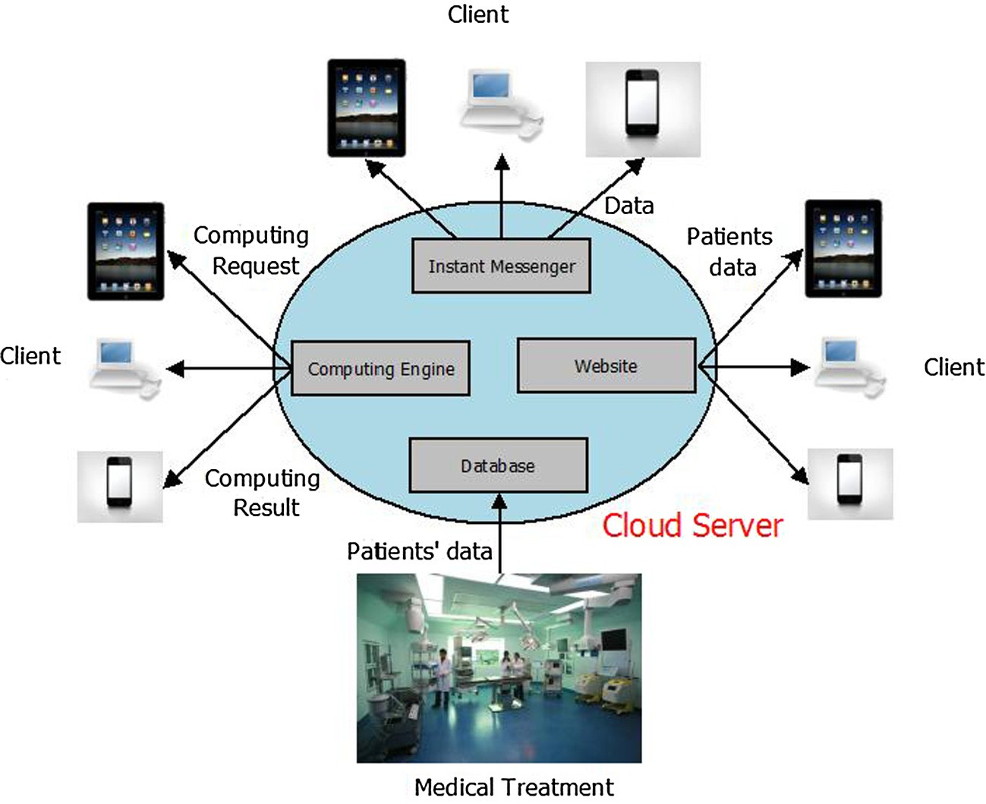

Fig. 1. The structure of hypertension auxiliary medical system.

the public XMPP network, strong security could be built into the core XMPP specifications to protect patients’ privacy.

* + 1. *Computing engine*

This part provides a computing platform when client sends computing request. At present, it only provides data statistics.

* + 1. *Web service*

Web service is the main way via which the client can access data. Data in web service include patients’ data, treatment plan and notice of doctor. Data statistics should be displayed in intuitive ways through website. Doctors cannot only manage their own information but also the patients’ data, including download and upload. In details, the cloud platform should contain all services as follows:

* + - * The brief introduction of hypertension and basic measures to prevent, which provides immediate way for those who are not familiar with hypertension.
      * The introduction to the system, which provides convenient guidance for users.
      * Registration of doctors and patients. This is the only way to get privileges for system use. Once registering successfully, the patient and doctor have each record. The different registration between the doctor and patient is to verify the qualification of doctor. This is essential to assure the high quality of treatment.
      * Verification of doctor. Now the qualification of doctor needs to be verified manually by the administrator. Main tasks of verifi- cation include checking if the certificate number existed and if all information is matched.
      * Upload, download and search. Blood pressure data can be uploaded to database and downloaded from website. Different data can be searched by time and key word.
      * Diagnoses services. Advices given by doctors aiming at special case will be added to patients’ record and displayed directly in website.
  1. *Client*

With the wide utilization of smart phones, the client figures out the problem about fetching data and communicating with the cloud server. It also provides a flexible instant messenger function. Two clients can send and receive messages in real-time. By means of client, patients can send the data, which are measured by them- selves to doctors and receive an instant feedback. When the treat- ment plan is changed, the client will be noticed in time. The client functions are similar to website. The difference is that the client includes communication part. The details will be described in Section 4.

The client has the duty to access and view patients’ data easily and flexibly. So tasks of client mainly contain:

* Providing instant messenger service.
* Sending computing request to cloud server.
* Accessing data easily.
  1. *Data collection*

The system stores and processes the hypertension symptom data. In this part, software is connected to medical equipment to automatically collect patients’ data. Then these data are sent to cloud via Internet, which can be either wired connection or wire- less connection. Due to different medical equipment, this system only provides functions for specific equipment so far. This part col- lects data in medicine equipment automatically and transfers to cloud server via Internet.

1. System implementation

The combination of Client/Server (C/S) and Browser/Server (B/S) is considered for system implementation, which not only provides flexible platform but also supports enough functions to meet requirements during the whole treatment. The C/S framework

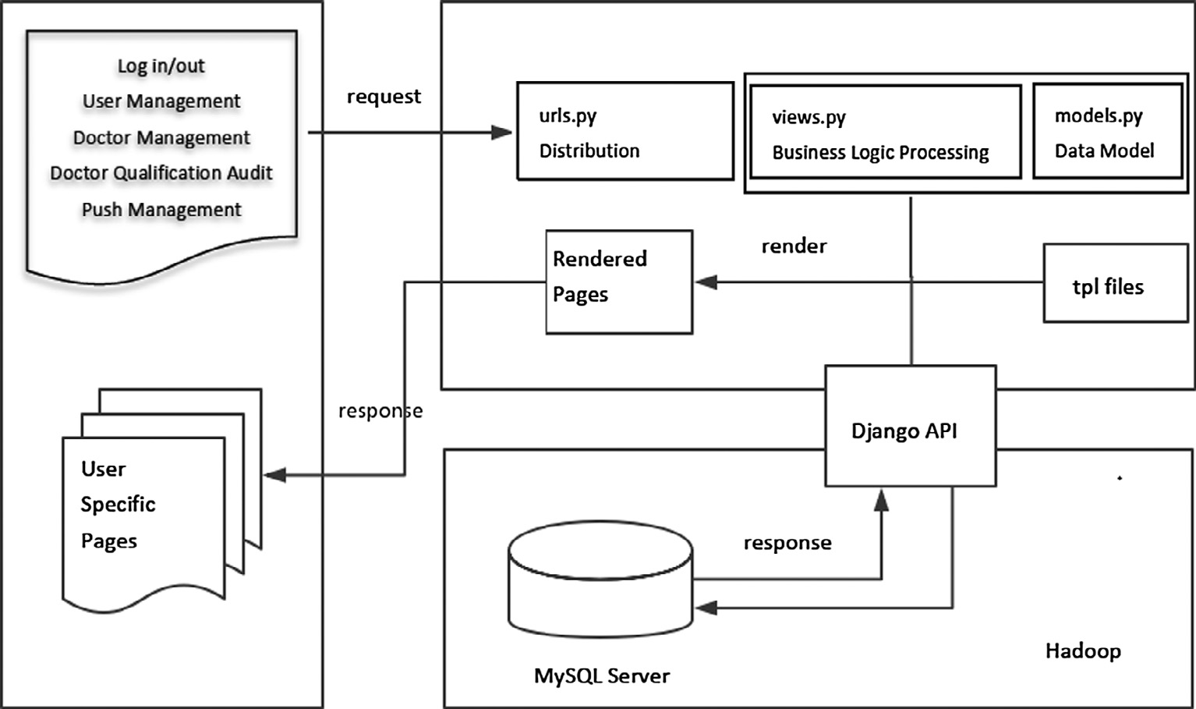

Fig. 2. Server background management [25].

Table 1

Personal information in database.

ID String

Name String

Introduction String

Blood systolic pressure data Number Blood diastolic pressure data Number

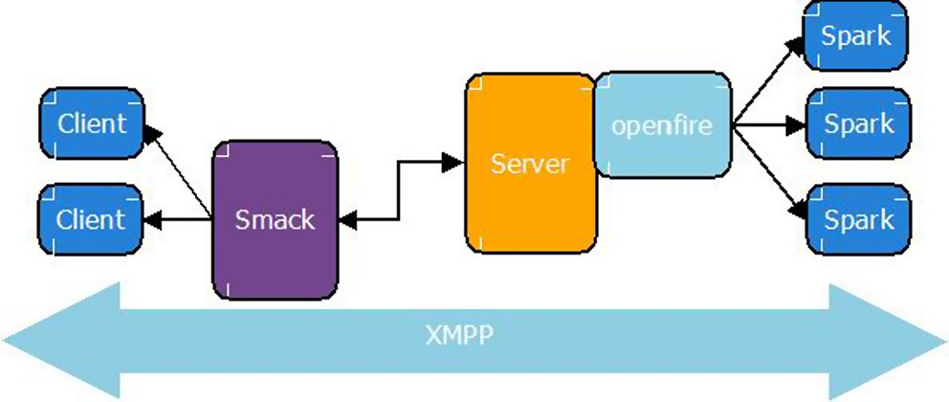

Fig. 3. XMPP protocol applied in the system.

offers these functions: patients’ data transferring, notice of doctor, information share, and data processing instruction. The B/S frame- work provides easily access to data via Internet.

The server processing flow is implemented as Fig. 2. Hadoop is the main framework in the server. It processes the collected data in distributed environment, and is able to extend the server due to increasing demand. The analyzed results are stored in MySQL data- base, which could be accessed or manipulated via Django models. Tables in database contain: personal information of patients and doctors including ID, name, introduction, and, blood pressure data of patients including systolic and diastolic pressure (Table 1).

The background is mainly implemented as four parts: user and authority management, user information database interface, push management and instant messenger. As Django is a MVC (Model View Controller) framework, after the server receives requests, urls.py will distribute the http requests and send to corresponding views.py for processing. And the built-in engine will render the template pages and return them for page access.

As shown in Fig. 3, Openfire [26,27] is the instant messenger server in the system. For clients, spark [26,28] is for desktop, and smack [26,29] for the mobile with Android. Different clients can communicate each other through the server. Now this system only provides text transfer, and media transfer will be implemented later.

The sample data collected is shown as Table 2. There are differ- ent tables and figures due to gender difference. For more details, there could be the average value of systolic, diastolic pressure and abnormal point to save time for doctors to review massive

Table 2

Details in blood pressure statistic.

Date (year/month/day) 2013/10/23 Gender Female

|  |  |  |  |  |  |
| --- | --- | --- | --- | --- | --- |
| Time (h/min) |  | Systolic pressure (mmHg) | Diastolic pressure (mmHg) | Pulse pressure (mmHg) |  |
| 0/0 |  | 117 | 81 | 36 |  |
| 1/0 |  | 120 | 85 | 35 |  |
| 2/0 |  | 130 | 79 | 51 |  |
| 3/0 |  | 115 | 83 | 32 |  |
| Average systolic pressure (mmHg) |  |  | 120.5 |  |  |
| Average diastolic pressure (mmHg) |  |  | 82 |  |  |
| Average pulse pressure (mmHg) |  |  | 38.5 |  |  |
| Abnormal point (h/min) | 1/0, 2/0 | Reason | High diastolic and high systolic pressure |  |  |
| Abnormal point (h/min) | 2/0 | Reason | High pulse pressure |  |  |

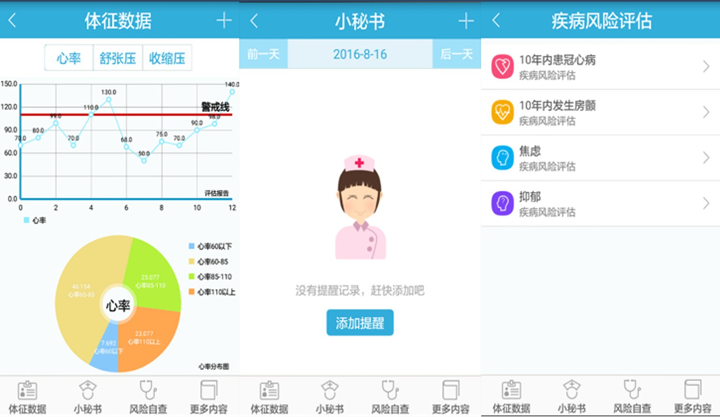

Fig. 4. The application user interface.

data. As high systolic or diastolic pressure could imply prehyper- tension or even hypertension [30], and pulse pressure could imply preclinical cardiovascular disease [31], there are abnormal points according to the high values of these items as reminders.

Besides data collection, this paper designs and implements an Android application to transfer the health status such as blood pressure and heart rate to doctors. The statistic data will be pro- duced once client sends a computing request. The connection between Android client and the server is implemented by XMPP. The application provides visualized user interface for the medical signs related to hypertension, including heart rate, diastolic and systolic pressure, and the statistic chart of heart rate during a per- iod of time, etc. (Fig. 4). Also, there are features as reminder and disease risk evaluation (Fig. 4).

1. Conclusions and future works

Hypertension is one disease hard to treat due to its features of strong burst, long-cycle treatment and high cost. This paper pre- sents a new hypertension auxiliary medical system based on cloud, which is dedicated to improving the patients’ satisfaction about the treatment. The auxiliary medical system aims to help patients take advantages of the cloud computing ability and cloud storages. This system achieves the communication between doctors and patients in time, efficient way to manage patients’ data and provid- ing flexibility to access patients’ data. The cloud server enables effi- cient massive data computing. Basically, hypertension symptoms are a bit more complicated and require a much more complex model to process the hypertension symptom’s data. So far this part only provides limited functions, and new functions such as auto- matic treatment making, preparatory data analysis can be imple- mented easily in cloud server. The client has friendly user interface to access data and provides a convenient way to transfer patients’ data. This system helps patients who are suffering hyper- tension receive better treatment.

Acknowledgment

This work was supported by National Natural Science Foundation of China under Grant No. 61402210 and 60973137, Natural Science Foundation of Gansu Province under Grant No.

1506RJZA163, Program for New Century Excellent Talents in University under Grant No. NCET-12-0250, Major Project of High Resolution Earth Observation System under Grant No. 30-Y20A34- 9010-15/17, Strategic Priority Research Program of the Chinese Academy of Sciences under Grant No. XDA03030100, Gansu Sci. &Tech. Program under Grant No. 1104GKCA049, 1204GKCA061 and 1304GKCA018, The Fundamental Research Funds for the Cen- tral Universities under Grant No. lzujbky-2016-140, Gansu Telecom Cuiying Research Fund under Grant No. lzudxcy-2013-4, Google Research Awards and Google Faculty Award, China.

References

1. <https://en.wikipedia.org/wiki/Telemedicine>.
2. [D. Hailey, R. Roine, A. Ohinmaa, Systematic review of evidence for the benefits](http://refhub.elsevier.com/S2210-8327(16)30068-0/h0010) [of telemedicine, J. Telemed. Telec. 8 (suppl. 1) (2002) 1–7](http://refhub.elsevier.com/S2210-8327(16)30068-0/h0010).
3. An Overview of Managed Care <<http://web.sph.rutgers.edu/omcweb/>>.
4. [F.F. Fenech, Telemedicine: an educational and healthcare tool, Med. Princip.](http://refhub.elsevier.com/S2210-8327(16)30068-0/h0020) [Pract. 10 (2001) 59–60](http://refhub.elsevier.com/S2210-8327(16)30068-0/h0020).
5. [Keith A. Bauer, Home-based telemedicine: a survey of ethical issues, Cambr.](http://refhub.elsevier.com/S2210-8327(16)30068-0/h0025) [Quart. Healthc. Ethics 10 (2) (2001) 137–146](http://refhub.elsevier.com/S2210-8327(16)30068-0/h0025).
6. [A.G. Ekeland, A. Bowes, S. Flottorp, Effectiveness of telemedicine: a systematic](http://refhub.elsevier.com/S2210-8327(16)30068-0/h0030) [review of reviews, Int. J. Med. Informat. 79 (11) (2010) 736–771](http://refhub.elsevier.com/S2210-8327(16)30068-0/h0030).
7. [G. Paré, M. Jaana, C. Sicotte, Systematic review of home telemonitoring for](http://refhub.elsevier.com/S2210-8327(16)30068-0/h0035) [chronic diseases: the evidence base, J. Am. Med. Informat. Assoc. 14 (3) (2007)](http://refhub.elsevier.com/S2210-8327(16)30068-0/h0035) [269–277](http://refhub.elsevier.com/S2210-8327(16)30068-0/h0035).
8. Devon M. Herrick, Linda Gorman, John C. Goodman, Health Information Technology: Benefits and Problems, National Center for Policy Analysis <[http://](http://www.ncpa.org/pdfs/st327.pdf) [www.ncpa.org/pdfs/st327.pdf](http://www.ncpa.org/pdfs/st327.pdf)>.
9. <https://en.wikipedia.org/wiki/Hypertension>.
10. M. Hamilton, E.N. Thompson, T.K.M. Wisniewski, The role of blood-pressure control in preventing complications of hypertension, Lancet 283(7327) (1964) 235–238, doi:10.1016/S0140-6736(64)92344-X (ISSN 0140-6736).
11. Markus MacGill, Hypertension: Causes, Symptoms, and Treatments <[http://](http://www.medicalnewstoday.com/articles/150109.php) [www.medicalnewstoday.com/articles/150109.php](http://www.medicalnewstoday.com/articles/150109.php)>.
12. Global Health Risks Mortality and Burden of Disease Attributable to Selected Major Risks, World Health Organization, 2009.
13. P.E. Drawz, M. Abdalla, M. Rahman, Blood pressure measurement: clinic, home, ambulatory, and beyond, Am. J. Kidney Dis.: Off. J. Nat. Kidney Found. 60

(3) (2012) 449–462, <https://doi.org/10.1053/j.ajkd.2012.01.026>.

1. J.W.P Ng, B.P.L. Lo, O. Wells, et al., Ubiquitous monitoring environment for wearable and implantable sensors (UbiMon), in: International Conference on Ubiquitous Computing (Ubicomp), 2004
2. C.O. Rolim, F.L. Koch, C.B. Westphall, et al., A cloud computing solution for patient’s data collection in health care institutions, in: Second International Conference on eHealth, Telemedicine, and Social Medicine, 2010. ETELEMED’10, IEEE, 2010, pp. 95–99.
3. Y. Xiao, Y. Tao, Q. Li, A new wireless web access mode based on cloud computing, in: 2008 PACIIA’08 Pacific-Asia Workshop on Computational Intelligence and Industrial Application, vol. 1, IEEE, 2008, pp. 645–649.
4. [Youliang Huang, Xing Zhai, Fengying Guo, Sajid Ali, Renquan Liu, Chronic](http://refhub.elsevier.com/S2210-8327(16)30068-0/h0085) [diseases based on cloud computing platform (hypertension) intelligent control](http://refhub.elsevier.com/S2210-8327(16)30068-0/h0085) [system design and analysis, Int. J. Comput. Eng. Res. (IJCER) 06 (02) (2016) 1–4](http://refhub.elsevier.com/S2210-8327(16)30068-0/h0085).
5. [F. Mair, P. Whitten, Systematic review of studies of patient satisfaction with](http://refhub.elsevier.com/S2210-8327(16)30068-0/h0090) [telemedicine, BMJ: Brit. Med. J. 320 (7248) (2000) 1517–1520](http://refhub.elsevier.com/S2210-8327(16)30068-0/h0090).
6. John D. Piette, Hema Datwani, Sofia Gaudioso, Stephanie M. Foster, Joslyn Westphal, William Perry, Joel Rodríguez-Saldaña, Milton O. Mendoza- Avelares, Nicolle Marinec, Hypertension management using mobile technology and home blood pressure monitoring: results of a randomized trial in two low/middle-income countries, Telemed. e-Health 18 (8) (2012) 613–620, <https://doi.org/10.1089/tmj.2011.0271>.
7. J. Vilaplana, F. Solsona, F. Abella, et al., H-PC: a cloud computing tool for supervising hypertensive patients, J. Supercomput. 71 (2) (2015) 591–612, <https://doi.org/10.1007/s11227-014-1312-9>.
8. Vaidehee Padgaonkar Gokhale, Enabling Telemedicine with Smartphones, Presented to the Faculty of the Graduate School of the University of Texas at Austin in Partial Fulfillment of the Requirements for the Degree of Master of Science in Engineering, 2011
9. L.J. Mena, V.G. Felix, R. Ostos, et al., Mobile personal health system for ambulatory blood pressure monitoring, Comput. Math. Meth. Med. 2013 (2013) 598196 (13 pages).
10. C.I. Martínez-Alcalá, M. Muñoz, J. Monguet-Fierro, Design and customization of telemedicine systems, Comput. Math. Meth. Med. 2013 (2013) 618025 (16 pages).
11. <https://en.wikipedia.org/wiki/Comparison_of_instant_messaging_protocols>.
12. Chenwei Wang, The Design and Implementation of the XinTang System Based on Android Platform, Master Thesis, Lanzhou University, 2017.
13. S. Zhao, F. Xia, Z. Chen, et al., Mobimsg: a resource-efficient location-based mobile instant messaging system, in: 2012 Second International Conference on Cloud and Green Computing (CGC), IEEE, 2012, pp. 466–471.
14. <https://en.wikipedia.org/wiki/Openfire>.
15. <https://en.wikipedia.org/wiki/Spark>.
16. <https://en.wikipedia.org/wiki/Smack>.
17. <https://en.wikipedia.org/wiki/Blood_pressure>.
18. Giovanni de Simone, Mary J. Roman, Michael H. Alderman, Maurizio Galderisi, Oreste de Divitiis, Richard B. Devereux, Is high pulse pressure a marker of preclinical cardiovascular disease?, Hypertension 45 (2005) 575–579 [http://](http://hyper.ahajournals.org/content/hypertensionaha/45/4/575.full.pdf) [hyper.ahajournals.org/content/hypertensionaha/45/4/575.full.pdf](http://hyper.ahajournals.org/content/hypertensionaha/45/4/575.full.pdf).