[Array 13 (2022) 100114](https://doi.org/10.1016/j.array.2021.100114)



Contents lists available at [ScienceDirect](https://www.elsevier.com/locate/array)

Array

journal homepage: [www.elsevier.com/locate/array](http://www.elsevier.com/locate/array)

A prospective interoperable distributed e-Health system with loose coupling in improving healthcare services for developing countries

Mahnuma Rahman Rinty, Uzzal Kumar Prodhan, Md. Mijanur Rahman ∗

*Department of Computer Science and Engineering, Jatiya Kabi Kazi Nazrul Islam University, Trishal, Mymensingh 2224, Bangladesh*

A R T I C L E I N F O A B S T R A C T

*Keywords:*

Distributed database Distributed e-Health system Electronic Health Record (EHR) Health level 7 (HL7) Interoperability

Loose coupling

A loosely coupled distributed system enables interoperability in healthcare structures and can be used to create flexible architecture. The key limitation in adopting electronic health (e-Health) services in developing countries is the health data interoperability problem. Most developing countries are being confronted with the utilization of e-Health systems for their health care services. This study aims to develop a prospective e- Health system for developing countries to improve the effectiveness of health care services. This paper presents an enhanced e-Health framework using distributed memory and heterogeneous data handling mechanisms with loose coupling. The distributed e-Health has been designed using e-Health standards that are compatible with health level 7 (HL7) and can facilitate interoperability among health information systems. The Message Passing Interface (MPI) has been implemented to store regular backups of heterogeneous health data. The HL7 standards can also handle security threats. Data interchange from one e-Health system server to another has been conducted based on the experimental results. The distributed database has been made accessible from a remote server by using loosely coupled technology. It also provided the e-Health data recovery features and handled an extensive database through a distributed environment. According to the study, the developed system can deliver a low-cost service to the intended developing-country community effectively.

# Introduction

Electronic health (e-Health) and Telemedicine services are benefits of information and communication technology (ICT). Electronic medi- cal records (EMR) and other health information systems (HIS) can help enhance health care facilities [1]. Electronic health record (EHR) is broadly used by most developed countries in Europe and the USA to improve health care quality [2]. Massive volumes of medical informa- tion are now available because of the healthcare system’s digitization [3]. The ability to generate healthcare-related records allows the health management information system to combine all people’s health care services [4]. E-Health, if well performed, significantly increases the de- livery of healthcare to individuals in low-resource nations. Healthcare Quality and cost are the most crucial factor in the success of these e- Health services [5]. Still, only a few developing countries have e-Health systems capable of implementing digital interventions on a small scale [6]. Like e-Health, m-Health (Mobile Health) enhances the performance of existing health schemes by utilizing automated tools and mobile networks to strengthen health system tasks [7]. However, eye programs in developing countries are still insufficient, as they are designed to provide effective acute treatment at secondary and tertiary levels. An eye program-related study [8] emphasized the need to improve primary

health care services to avoid diabetes-related blindness. In addition, it requires reorganizing health services to focus on lifelong preventative and integrated standards. Thus, the study is essential in settling how to combine these, avoiding further weakening wellness methods. Flexible designs that promote health care structure’s interoperability can be realized via a loosely coupled distributed system [9]. But, there is a lack of interoperability, which is one of the key obstructions in adapting e-Health services [10]. Most of the developing countries do not follow a proper electronic health standard. Data interoperability of distributed EHR is critical for bettering medical decision-making, saving health care costs, and enhancing health care quality. As the e-Health system’s data are fragmented, it leads a costly service in fragmentation results [11]. The HL7 standard, a worldwide health level 7 standard that can be integrated into various systems, is considered the convergence of healthcare and information technology [12]. Authors in [13] applied a ‘‘Service Oriented Approach (SOA)’’based on HL7 and ‘‘Fast Healthcare Interoperability Resources (FHIR)’’ to provide interoperability, security, and secrecy at every level. This method resulted in considerable im- provements in service delivery. A study [14] showed that women in Pakistan’s rural regions confront various hurdles to healthcare, making gender-responsive health programs critical, particularly for tuberculosis

∗ Corresponding author.

*E-mail addresses:* [mahnumarinty@gmail.com](mailto:mahnumarinty@gmail.com) (M.R. Rinty), [uzzal_bagerhat@yahoo.com](mailto:uzzal_bagerhat@yahoo.com) (U.K. Prodhan), [mijan@jkkniu.edu.bd](mailto:mijan@jkkniu.edu.bd) (M.M. Rahman).

<https://doi.org/10.1016/j.array.2021.100114>

Received 28 August 2021; Received in revised form 4 November 2021; Accepted 23 November 2021

Available online 18 December 2021

2590-0056/© 2021 The Author(s). Published by Elsevier Inc. This is an open access article under the CC BY license (<http://creativecommons.org/licenses/by/4.0/>).

(TB). Therefore, the focus group discussion platform included peo- ple’s queries on different healthcare/TB care systems and community standards. In addition, a recorded deficiency of TB-related stigma, intermediate awareness about TB disease, and complete perception of tuberculosis as a treatable illness were all identified as facilitators to TB care access. During the COVID-19 pandemic, an evaluation

[15] intended to outline activities in judging the satisfaction of help- less people with teleconsultation, like e-Health assistance provided by healthcare professionals in their areas. As a result, we added studies of teleconsultation-based services extended to low-income and clinically susceptible people worldwide. It emphasizes COVID-19 monitoring, treatment, and prevention as well as enhances/delivers services and offers treatment from a human rights viewpoint.

The key objective of this study is to attain interoperability among e-Health systems for connecting each other and share data in a secure way involving efficient health data management. Data interchange standards, such as HL7 standard, as well as digital imaging and commu- nications in medicine (DICOM), can help with interoperability [16,17]. The feature of DICOM telemedicine is to increase radiology system services so that underprivileged remote people can avail the services easily. It also mitigates the technology gap, reduces the cost and ensures faster treatment. The message passing interface (MPI), which provides key virtual topology, synchronization, and communication functionality among a set of processes, is another solution to the data interoperability challenge [18]. Information technology, such as the EHR, is changing healthcare and we need to cope up with it effectively [19]. The importance of openness or interoperable EHR of effective health information exchange becomes an urgent topic of study in the current situation [20]. In developing countries e-Health services are limited in use. Due to the lack of interoperability, health standard and heterogeneous data make it difficult to manage. There were substantial challenges, such as a lack of required technology, tech- nological incompatibilities, limited network coverage areas, restricting the number of health institutions that could participate in various e-Health programs, and distribution techniques [21]. The mobile multi- agent based distributed information platform provided a new way to integrate and evaluate the massive amounts of data generated by patient monitoring [22]. It offered a lot of promise to change the way health care monitoring is done, and potentially even the outcome. Apart from, in the biomedical field, loosely coupled technology enables for adapting to the digital data collection and integration [23]. But it includes utilizing Web services to design strategies for transmitting data across an environment with limited resources.

The comparison behind this study is that there have not been many efforts to establish interoperability across different e-Health systems. On the other hand, the key downsides are the system’s complexity, expenses, database integrity control, lack of standards, and database design complexity. Because existing standards were difficult and expen- sive to adopt, HL7 is formed. All the current EHR records in developing nations use centralized databases. Link failure and minimal or no-fault tolerance are two significant drawbacks of such a centralized web- based system. In this regard, a decentralized, distributed database is an appropriate solution for maintaining e-Health care remotely. According to a survey [24] conducted in Bangladesh, a tiny developing nation in South Asia, 94.80% of expert physicians, 74% of local doctors, 91.42% of patients, and 80.32% of pharmacy owners wish to pro- vide telemedicine services to the Bangladesh vast rural population. As shown in a case study [25] from Saudi Arabia, around 70% of pro- fessionals knew e-Health, even though the majority had never utilized it. ‘‘Electronic Health Records’’, ‘‘Patient Information Systems’’, and ‘‘Hospital Information Systems’’ were all recognized as very or highly beneficial by more than 80%of underprivileged nations [21]. Nowa- days, the e-Health system is underutilized, cost-effective, and facing technical obstacles to implementation in developing countries. Thus, the distributed EHR system’s acceptance and potential for improving e-Health care is very high in consideration. In the literature, it is

found that distributed EHR has some advantages over centralized EHR. However, the people of urban areas are only familiar with the central e-Health system. Furthermore, the absence of a backup plan is another trouble for centralized EHR. The study aims to develop an interoperable distributed system integrated EHR where data is made flexible by loose coupling to overcome these difficulties. The data recovery, MPI, is also included in the proposed framework.

The remainder of this paper is organized as follows. In Section 2, a literature related to the problem domain is described and reviewed. Section 3 describes the system architecture and development phases. The experimental results and the evaluation of this study are discussed in Section 4. Section 5 presents the conclusion.

# Background and significance

The idea behind this study comes from the analysis of the re- cent works related to e-Health systems. The literature helps us to find out the different approaches on the e-Health frameworks and guides an advanced approach to overcome the current health care challenges. In the treatment of chronic disease, an ICT-based method was developed, which has a number of foreseeable future trends and scenarios in e-Health [26]. A study on telehealth and e-Health found the cost-effectiveness of telehealth and e-Health services for primary care patients [27]. There is a tremendous improvement in e-Health services and people are evolving with the innovative technologies of health [10]. Depends on the availability of smart devices and systems, health management and treatment have changed drastically [28].

* 1. *E-Health systems and its challenges in developing countries*

An improvement of the effectiveness of e-Health services in de- veloping countries still needs more attention. According to a 2016 assessment, around 70% of physicians were aware of e-Health, al- though the majority of them had never used it [25]. A distributed e-Health system was more efficient in terms of better managing health professional personnel, reducing travel times, and facilitating medical information interchange between sites via electronic communications [29]. It lowers the cost of healthcare services, yet there are several impediments to e-Health adoption in developing nations. According to a study [30] on e-Health in low and middle-income countries, the evolution of e-Health has resulted in the reduction of numerous obstacles due to the widespread use of ICT. Health systems in low- and middle-income nations confront issues such as a paucity of medical examiners in remote areas, varying quality of care, lack of patient compliance, and fraud. A study conducted by health ICT profession- als [31] with ‘‘Botswana’s National e-Health Strategy’’ analyzed the benefits of interoperability, possibilities, and difficulties and drew the study’s significant future direction. Respondents described that the existing m-Health applications and e-Record systems were implemented based on the expectations of the then-draft ‘‘National e-Health Strat- egy’’. In contrast, e-Record systems in the private sector were based on in-house ‘‘standard operating procedures (SOPs)’’, following with the ‘‘Southern African Development Community Accreditation Services (SADCAS)’’ standards. The resulting study discovered some challenges of interoperability among e-Record systems, included:

1. A lack of e-Record system law and governance.
2. A lack of ICT support.
3. Insufficient support funds.
4. A lack of expertise to use e-Record systems.
5. Non-uniform unique patient identifiers (UPI).
6. Non-enforcement of interoperability standards.

In addition, at the district level, internet connectivity was described as poor and inconsistent, with some facilities lacking both access and energy.

**Table 1**

Different types of health facilities of Bangladesh [34].

|  |  |  |
| --- | --- | --- |
| Level of the Health care Center (higher to lower) | Health Services | Service Delivery Platform |
| Divisional Level Hospital | (i) Nursing Institutes in Medical College Hospitals, (ii) Nursing Institute and as well as General Hospital, (iii) Hospital for Infectious Diseases, (iv) Health Technology Center | Based on hospitals and clinics |
| District Level Hospital | (i) Nursing Institutes in District Hospitals, (ii) Nursing Institute and General Hospital, (iii) Nursing Institute of Medical College Hospital, (iv) Clinic for Chest Disease and Tuberculosis, (v) Laproscopy Hospitals and MATS | Hospital and clinic based |
| Upazila Level Hospital | (i) Health Complex of Upazila | Onsite services |
| Union Level Hospital | (i) Health Center for Rural Communities, (ii) Substation Union, (iii) Union Health and Family Welfare Center (non-profit organization that provides health and family welfare services to the community) | Onsite services |
| Hospital at Ward Level | (i) Community Health Clinic | Onsite services |

The applicability of the technology acceptance model (TAM) [32] was later proven in Pakistan, with the addition of additional factors to simulate the uptake of telemedicine services in poor nations. This model provided useful information for policymakers and health care professionals in determining the facilitators and inhibitors to large-scale e-Health service deployment. Personal motivation, innovativeness, and cultural constructions were the restrictions, which should be inves- tigated further to reveal more trustworthy findings of the suggested model for the adoption of e-Health services in a developing nation. In light of Ghana’s status as a developing country, the authors [21] discovered that the country was also having difficulty adopting e- Health due to its incapacity to appreciate the potential benefits. They drew attention to some of the most pressing issues confronting devel- oping countries, which, regrettably, are the engine of any economic development and the driving force behind successful e-initiatives.

The restrictions included gaining vital insight from lessons learned from the successes and failures of e-commerce, e-government, and e-Health in industrialized countries by rigorous evaluation of those ex- periences. In order to address issues and opportunities in Zambia,[33] an e-Health system was presented in that combined e-Health with a new paradigm for information exchange. The study found that while e-Health core design and information products were deemed com- petent in the past, workforce training, clinical compliance, gover- nance, legislation, and policy, as well as change management, re- mained severely lacking, owing to insufficient ICT infrastructure. Thus, it requires some knowledge about challenges to adopt e-Health sys- tem, potential techniques and technologies, as well as the scope of advancements.

But the actual healthcare facilities in developing countries are par- tially unalike, and most of them are hospital based. For this instant, this study addresses the different types of health facilities and their plat- forms of a developing country, especially Bangladesh perspective (see Table 1). In Bangladesh, the rural people receive primary healthcare services through ward, union, and upazila level hospitals or medical centers. The secondary level hospitals are more advanced and provide special care to the patients, and it is given through district and divi- sional level hospitals. But there are some hospitals that deliver high-end health care services are also called tertiary hospitals. As the number of secondary and tertiary hospitals is limited in Bangladesh, the rural people are deprived of the advanced level health services. Most of the e- Health services focus on tertiary and secondary care through hospitals. These services can be extended to the primary healthcare from rural areas through the proposed system. The people can get the profes- sional health services through the proposed e-Health platform from the primary healthcare centers. As a result, an interoperable distributed e- Health system can play a critical role in improving healthcare for rural people in developing countries such as Bangladesh.

* 1. *Design issues in interoperable distributed EHRs*

Electronic Health Record (EHR) is a vital part of a digitized health care delivery centers [35]. EHR maintains the medical record of a person’s lifetime health condition and medication electronically. It replaces the paper-based health records to the digital platform. In e- Health, the sharing of health data among multiple health care centers with the common structures and organizations is called interoperability [36]. Interoperability among health care centers impedes to maintain EHR, and a distributed EHR is the main solution to the interoperability problem. Very few developing countries nowadays are familiar with distributed EHRs, and most of the developing countries are suffering from interoperability problems. Thus, the people in rural areas of developing countries are mostly affected for this scenario. Also, they are not motivated and willing to adapt to an EHR system. But a distributed EHR system can only enable health data interoperability.

This study reviewed various methods and technologies related to the interoperable distributed EHR systems. Rubi et al. [37] proposed an interoperable internet of medical things platform by the joint use of Open Electronic Health Record (openEHR) and semantic sensor network semantics. For continuous patient monitoring in emergency wards, a vertical IoT architecture using open protocols was employed in [38]. They developed an e-Health system that utilized open commu- nication protocols and openEHR standards, allowing interoperability across various devices and software, ranging from wired sensors to databases. It was also discovered during the deployment of an advanced telemedicine service for Bangladesh’s rural population, where they developed a centralized electronic health system (EHS) for telemedicine services [39]. The development of a distributed architecture model to integrate personal health information yielded significant benefits, particularly in terms of digital storage of patients’ health records [40]. In 2018, authors in [41] worked about the open-access of health care including its confidentiality. They also discovered that patients were more worried about having simple access to their EHR from health care personnel other than doctors. Enterprise e-Health inte- gration and interoperability challenges the use of information and communication technology (ICT) and health information systems (HIS) in health care was the responsibility of architecture [42]. An estimation presents the current state of interoperability in health care to assess its progress [43]. It also found that interoperability saves cost and improves health care service quality. Lehne et al. [44] proposed the digital medicine platform depends on interoperability that can improve medical information communication worldwide.

* 1. *Some e-Health models and related technologies*

This study reviewed various methods and technologies related to the distributed EHR systems, and investigated their findings, outcomes, and limitations. Some of them are centralized and some of them are decentralized or distributed. Some of the potential solutions and related technologies are described in the following sub-sections.

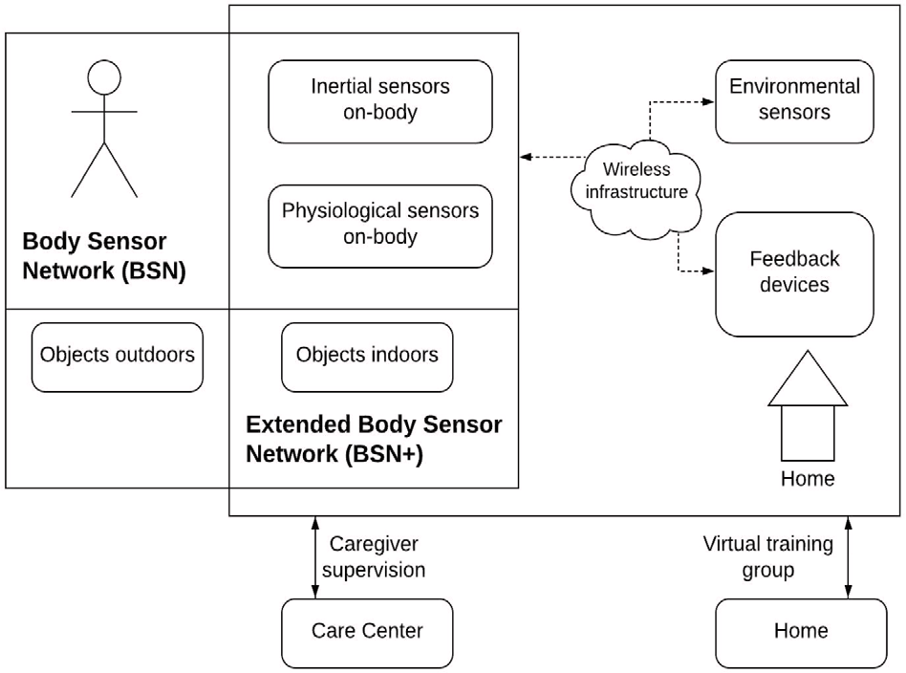

**/ig. 1.** The architecture of the IS-ACTIVE system [26].

* + 1. *An e-Health system model with centralized technology*

Today ICT is responsible for reducing healthcare costs. The analysis

[26] examined the existing state of e-Health solutions for chronic illnesses and forecasted future trends and scenarios. The wireless sensor collected data. IS-ACTIVE (‘‘Inertial Sensing Systems for Advanced Chronic Condition Monitoring and Risk Prevention’’) architectural com- ponents are shown in Fig. 1. IS-ACTIVE intended to provide person- centric healthcare solutions for chronic diseases based on new wireless inertial sensing devices. The sensor-based system suggested by IS- ACTIVE offers a beneficial strategy for patients. It analyzes their phys- ical activity and condition in real-time with an effective remote moni- toring tool that allows them to investigate the success of physical ther- apy and adapt it accordingly. IS-ACTIVE technology included ‘‘Wire- less Sensors Networks (WSNs)’’ or ‘‘Body Sensor Networks (BSNs)’’. They contain various sensors used for signaling possible adverse en- vironmental conditions concerning the user-specific condition. TAOs were technology-aided objects that helped monitor patients’ physical training performance remotely. The ‘‘Extended Body Sensor Network (BSN+)’’ was made up of on-body sensors and TAOs. Feedback Devices covered all user interaction elements, supplying the user with the information detected and processed by the WSN. The wireless commu- nication infrastructure seamlessly connected the following components, like WSNs, technology-assisted items, feedback devices, etc. Multiple users allowed numerous patients to exercise and used the IS-ACTIVE system at the same time. Communication with the Caregiver permitted them to assess the patient’s progress and provide appropriate advice based on the present condition and progression of the disease. This system was established centrally. There was no distributed feature in this study.

* + 1. *EHR model with decentralized technology*

Normally, most of the health care IT are very fragmented, health data are scattered across different hospitals. The goal of this study [45] was to propose a solution to the interoperability problem by fast health care interoperability resources (FHIR) framework. This technology was effective for decentralized, secure and trustless personal health records management. The front-end application [45] of this technique is repre- sented by a flowchart in Fig. 2. For the front-end application, the React Java script framework was used here. For the client the official libraries of Ethereum, BigchainDB, IPFS and FHIR were used, where Ethereum, BigchainDB, and IPFS are applying logic, database, and file system respectively. Although this system was able to enable interoperability and security, but it had some significant drawbacks such as, health data were immutable with this decentralized technology, public DLTs (decongestive lymphatic therapy) were not desirable for the private

**/ig. 2.** Basic front-end application flowchart [45].

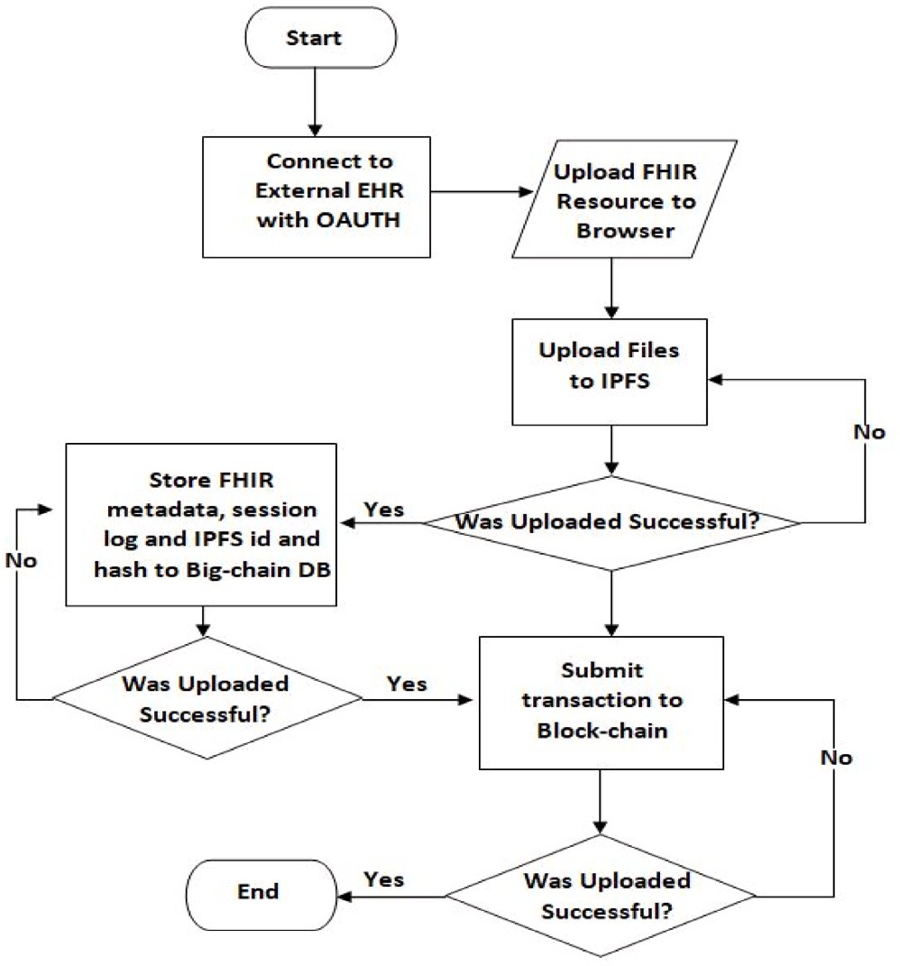health record and Ethereum was a blockchain technology which was slow and not familiar.

Developed countries are more advanced in technologies about e- Health care. The purpose of our study introduces an effective approach into the distributed EHS in developing countries which provides the conceptual architecture for the implementation of an interoperable distributed EHR.

* + 1. *Some developed e-Health system models in Bangladesh*

Developing countries require e-Health applications that may assist in a variety of conditions, such as when physicians are in short supply in comparison to the population. Among them, we need to consider some e-Health system models of Bangladesh developed by the Bangladeshi researchers. In 2015, a sensor-based remote patient diagnostic center

[46] was established to provide telemedicine to South Asia’s poor and emerging countries. The patient’s data were collected using four sensors: an electrocardiogram (ECG), a blood-oxygen saturation (SpO2) level, temperature, and blood pressure. The main objective was to deliver primary health care to the unprivileged community of the rural area. But the limitations were central server was used for data storage and system was not interoperable with the other health system.

In 2016, authors performed a smartphone-based telemedicine tech- nique [47] for a remote patient monitoring system. Biomedical sensors and photo-electronic sensors were employed to collect input param- eters. The method was created to keep track of hypertensive and hypotensive patients in rural India. This system was also centralized and a small number of sensors were used here for data collection. In 2017, Bangladesh created a wireless health monitoring system [48] that employed passive wifi sensing to track three activities: respiratory rate, essential tremor, and falls. The goal of this study was to demonstrate the accuracy rate of employing a passive wifi system rather than tradi- tional intrusive health sensors. There was no any distributed feature in the developed model. In 2018, a telemedicine toolkit [39] was created to provide e-Health services to Bangladesh’s rural population. The approach prioritized primary health care for the underserved rather than specialized treatment. But the system was centralized so that any failure of the central server causes system failure.

**Table 2**

Developed e-Health system models of Bangladesh.

|  |  |  |  |  |
| --- | --- | --- | --- | --- |
| SL. | E-Health system | Features | Technology | Limitations |
| 1 | A remote diagnostic center with four sensor [46] | Primary health care: ECG, blood pressure, SPO2 and temperature | Centralized | Lack of interoperability with other health systems |
| 2 | A smartphone-based telemedicine system for remote patient monitoring [47] | Rural patient monitoring suffering from hypertension and hypotension | Centralized | System needs to include more sensors |
| 3 | Passive Wi-Fi sensing allows for wireless health monitoring [48] | As a conventional tool for health care, it replaces invasive medical instruments | Centralized | – |
| 4 | An Advanced Telemedicine Toolkit for Bangladesh [39] | Primary health care services with nine sensors | Centralized | System was centralized without no data recovery |

From the above discussion, Table 2 summarizes the e-Health system models of Bangladesh perspective. Moreover, the developed models of e-Health in Bangladesh are a few in number and all of them are centralized. In case developing countries (like Bangladesh) needs to adopt a distributed e-Health system following an open source health standard.

* 1. *HL7, loosely coupled technology, and message passing interface in e-Health*

At present the hospitals themselves do not use an appropriate e- Health standard for system integration. It is one of the most common reasons about lack of interoperability. HL7 [49] is a set of international standards, norms, and definitions that is used to communicate and transfer medical information across health care practitioners, and it is considered here in relation to the proposed system. It is one of the most significant design patterns in health data standards. The goal of the HL7 is to provide standards for exchanging and sharing health care information electronically, which enables health data interoperability. Loose coupling or loosely coupled technology [50] is an approach to interconnecting the components independently that provides stability by allowing persistent behavior of the system for certain inputs. A change made to one element in a coupling architecture will cause unin- tended modifications to other elements. A loose coupling architecture is designed to minimize the risk of unplanned changes. Loosely coupled technology enables the synchronization of the different institutional application platform. Loosely coupled distributed technology for the e- Health system is capable of executing health data independently. Loose coupling enables the interoperation between health data sources and makes the system flexible. To design a flexible, decentralized e-Health system we must consider the advantages of loose coupling in e-Health. The message passing interface (MPI) is one of the most extensively used methods for specifying applications that will execute on scalable distributed memory systems, which are made up of several compute nodes connected by one or more interconnection networks. The goal of this study is to design a distributed e-Health system which has the ability of parallel computing to exchange data from one site to another. MPI comes up with parallel and distributed application which has the ability of achieving an efficient environment by the host network in- terface required [51].MPI’s communication section includes traditional point-to-point communication as well as collaborative communication [18]. Also the performance of MPI broadcast is comparatively fast. We have considered the use of MPI in this study for regular backup of heterogeneous health data. Based on the above findings on e-Health,

there are several issues of consideration, including-

1. lack of skill and experience in e-Health,
2. most of the expert doctors and health care centers are urban based in developing countries,
3. more than half of the doctors in hospitals are not connected with the e-Health system but most of them want to introduce e-Health services and want to connect with the EHS,
4. in order to get proper health care services, rural people will have to go to urban areas, and
5. although a few number of e-Health services exists but still health data are not interoperable with the other services.

Considering this practical scenario, a loosely coupled distributed interoperable e-Health system will be a feasible solution and has vast potential in developing countries. It can be an appropriate tool to serve the huge number of rural people of developing countries through local health care centers.

# Materials and methodology

The study presents the overall design and development of the e-Health model for improving health care services. The system archi- tecture, data storage and EHR server module, data backup system, and implementation phase are discussed in the following subsections.

* 1. *Proposed system architecture*

As HL7 based e-Health care is a new paradigm based on the use of distributed computing and interoperability, this system uses the standard structure of HL7 to interchange health information and design the framework. Fig. 3 shows the system architecture. The distributed e-Health system is a loosely coupled architecture that separates the interface from the implementation. The servers are connected to other servers via standard protocols.

To interface with the GNU Health open source HL7 based e-Health system ‘Tryton’ client [52] is used. Since Tryton supports hospitals, health care modules such as complete clinical workflow, patient records management, laboratory management, medical stock management, and more have been available.

* + 1. *HL7 based clinical document architecture (CDA)*

The primary framework for arranging electronic health records is CDA designed by HL7. The HL7 CDA is a markup standard for clinical documents that defines their structure, semantics and specifies how to organize health records and encode data pieces for exchange. The CDA document structure [53] is illustrated in Table 3. The CDA document’s output seems to be an XML-based document. The layout for converting a CDA document to another format is valuable to the designer in creating a readable document that contains information about the patient’s health. The conversion process is pictured by Fig. 4.

* + 1. *Functionality of the e-Health system*

We have considered the architecture of the search component and local EHR data sources which focuses on the interfaces between them. Figure 3 depicts the conceptual architecture. End users of the e-Health system can request health-related information via electronic commu- nication from anywhere and at any time. Then the health system administrator distributes the request to the local administrator and co- ordinates their execution. At the same time health system administrator controls the limit of concurrent searches that are running concurrently so as to avoid overloading. Local administrator analyzes and translates the request into executable statements and sends it to the local EHR

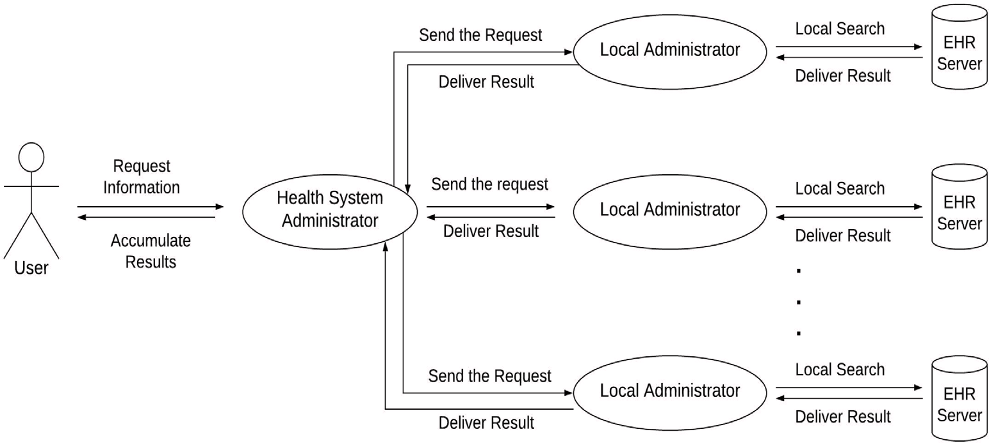

**/ig. 3.** Conceptual architecture.

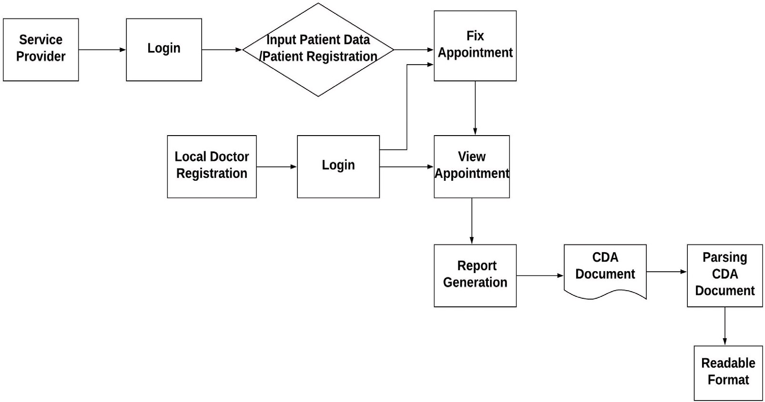

**/ig. 4.** Conversion flow of XML based CDA file to readable format.

server of the e-Health system. The executable statements are suitable to run on the EHR server. Getting the results from the EHR server local administrator delivers the results to the health system administrator. Finally the health system administrator accumulates the individual re- sults and delivers back to the users. With this configuration the system enables loose coupling and interoperability between health data and search interface. Thus, this architecture allows flexible implementation of individual e-Health systems.

* 1. *Data flow diagram of loosely coupled distributed EHR system*

To demonstrate the design and development of the distributed EHR system with loose coupling, an architectural schematic dataflow between communication modules is used. Fig. 5 represents the dataflow diagram of the system with n nodes. This figure shows that each remote area has its own e-Health system where it is connected with the central or main server. Furthermore, Tryton is used here to enter the e-Health system by the health professionals or service providers. The working place of health professionals is considered as a service delivery center. Patients can register and send/receive data from anywhere. Local doctors can log in to the system, observe the patient’s profile, and send medication according to the patient’s problem to the health pro- fessionals. Then patients receive information from health professionals. For any kind of system failure, a data backup operation is performed

so that data can be recovered from the main server since our system is distributed in nature.

* 1. *Components of the system*

The proposed e-Health system was developed with different com- ponents, such as an EHR server module, user login module, HL7 based health system, server data backup. The major components along with the deployment diagram are described in the following subsections.

* + 1. *Login module*

Two login modules, one for the client and another for the local doctor, have been developed in the system; the client module will act as the remote health care center for the rural patients with the neces- sary components. Rural patients will come to the remote health care service center or a pharmacy for e-Health service. The administrator in pharmacy will input the patient history to the health system. In order to connect the service center with electronic health system for patient registration and service delivery, we have followed the following steps to implement this module:

Step 1. Install GNU Health server Step 2. Install Tryton client

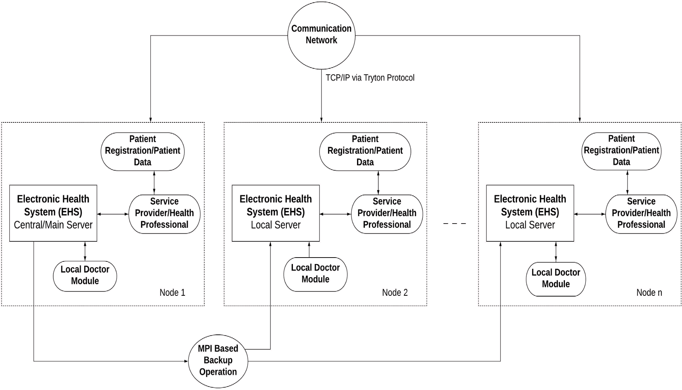

**/ig. 5.** Dataflow diagram of distributed e-Health system with n nodes.

**Table 3**

HL7 CDA document structure [53].

<ClinicalDocument>

... CDA Header ...

<StructuredBody>

<section>

<text>...</text>

<Observation>...</Observation>

<Observation>

<reference>

<ExternalObservation>... </ExternalObservation>

</reference>

</Observation>

< /section>

<section>

<section>...</section>

</section>

</StructuredBody>

</ClinicalDocument>

<ClinicalDocument>

... CDA Header ...

<StructuredBody>

<section>

<text>...</text>

<Observation>...</Observation>

<Observation>

<reference>

<ExternalObservation>... </ExternalObservation>

</reference>

</Observation>

</section>

<section>

<section>...</section>

</section>

</StructuredBody>

</ClinicalDocument>

Step 3. Connect with electronic health system by using valid user-name and password.

Local doctors provide the primary health care to the rural patients. Following patient registration, local doctors will collect data from patients and verify everything before uploading it to the server. Expert doctors can also communicate with the local doctor through the health

system. To implement this module we have followed the following steps:

Step 1. Arrange the patient data in a logical manner in HL7 based e-Health system

Step 2. Give access to the patient profile to make medication plan Step 3. Upload the prescription or further update to the server.

* + 1. *Electronic Health Record (EHR) server module*

In this system, we have used an EHR server module for each e- Health sub-system. Fig. 6 shows data importing mechanisms to the server. In each server, we are storing patient-wise different basic data by using individual patient ID and test ID. Each data is unique and can be easily searched, managed, and used for distributed EHR services. All patients’ data are stored in a local database primarily and all data of the local database are exported in the main server database. If the patient result is ready, the local database gets updated. Finally, after the finalization of patient data from the server, we export patient-wise data to the e-Health system module for EHR services. Generally, the patient is registered with a local server in our model. If the patient changes his/her geographical position and wants to take a service from our system, he/she can receive the service from the local server of the new location in the same system. Then the patients’ new data will be exported to the main server again.

* + 1. *Health Level 7 (HL7) based health system*

In designing our system, we employed an open source health system based on Health Level Seven International (HL7). We have customized the health system according to the requirements of developing coun- tries. All the electronic health record will be stored in the electronic health system. The developed model will be interoperable with other HL7 based health systems.

* 1. *Data preparation*

The data preparation includes the storage of all health related information of patient, doctor, and health professional. To test the e- Health system we use here the demo dataset of the GNU Health system where GNU Health is an open-source hospital information management

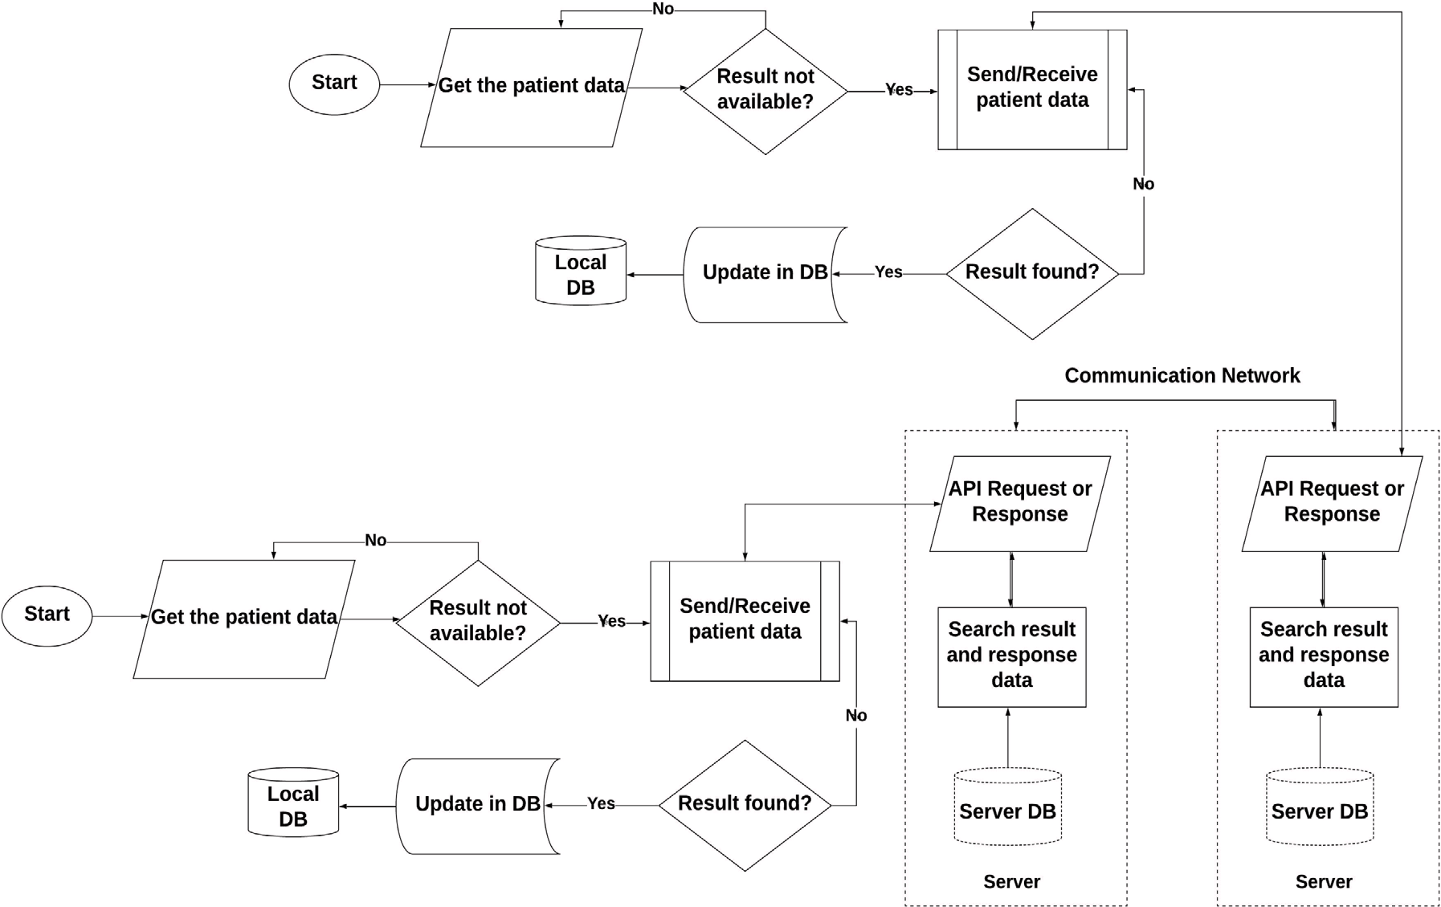

**/ig. 6.** Flowchart of the EHR server module.

system that is free to use (HIS). The demo database of GNU Health makes it easier to use the interchangeable demo data. The dataset includes the heterogeneous amount of data under 40 modules of the health system. We have randomly evaluated 100 patients’ data who receive treatment from 20 health professionals under 5 different health care centers for our experiment.

* 1. *Server data backup operation*

It must require server data backup from the central server if a local server of an EHR system goes in failure. The ‘‘Message Passing Interface (MPI)’’ module performs server data backup operations to recover data for a system, and helps to create a new one. The overall MPI-based data backup procedure is summarized in the following steps:

Step 1. Initialize the MPI execution environment which is the first call that can be made by any MPI program by MPI_Init (&argc,&argv).

Step 2. Declare and set an integer variable *𝑟* by system(‘‘sshpass -

p "REMOTE_USER_PASSWORD" scpfile.sqlremote_username@

remote_ip:/remote/directory’’) [ssh (keyboard-interactive pass- word authentication) transfer file from local to remote server], and Print (r).

Step 3. Determine the number of processes in the group associated with a communicator by MPI_Comm_size(MPI_Commcomm, int

*size), where size = number of processes.

Step 4. Determine the rank of the calling process in the communicator by MPI_Comm_rank(MPI_Comm comm, int *rank), where rank

= rank of a calling process.

Step 5. Return the name of processor on which it was called at the moment of the call by MPI_Get_processor_name(char *name, int

*resultlen).

Step 6. Provide a notification to confirm backup is sent from one processor to another.

Step 7. End the MPI program to terminate the MPI execution environ- ment by MPI_Finalize().

* 1. *Deployment diagram of developed distributed e-HealthSystem*

A deployment diagram is also presented here to represent the devel- oped system. Fig. 7 shows the deployment diagram of the developed loosely coupled distributed EHR system. The developed distributed EHR system will be used in remote rural locations with access to the internet. We have considered pharmacy as an EHR service delivery center. The server part consists of an EHR server for primary storage of vital health information. There is an interface with the health system for pharmacy administrators through Tryton. Remote users will communicate with the e-Health system through the pharmacy module.

* 1. *Implementation of the system*

We have developed the system according to the system design and methods. For the practical implementation of the system, we have used three nodes (see Fig. 7) for creating a distributed environment in which node 1 is considered as the main server and other nodes are considered as local servers. Each node has its own e-Health system. We have installed HL7 based open source e-Health system for each node. Here, we have considered each node as a loosely coupled distributed remote health care center of the e-Health system. All the electronic health records are stored in the electronic health systems. In our system, main server contains all data of other nodes. If the storage of the local server fails, data are retrieved from the main server. The e-Health system is hosted on a central server that is distributed and accessible from any remote location with a health care facility. The servers are connected via a communication network.

To store health data in the server database, we have used the PostgreSQL [54] database which is an open-source secured database. Each node is able to send, receive, and update data. For a distributed e-Health system, it is necessary to store a regular backup of data. MPI is used here for the backup operation which stores data in the main server. The results of the implemented system ensure the e-Health system’s distributed qualities, which are briefly detailed in the results and discussion section.

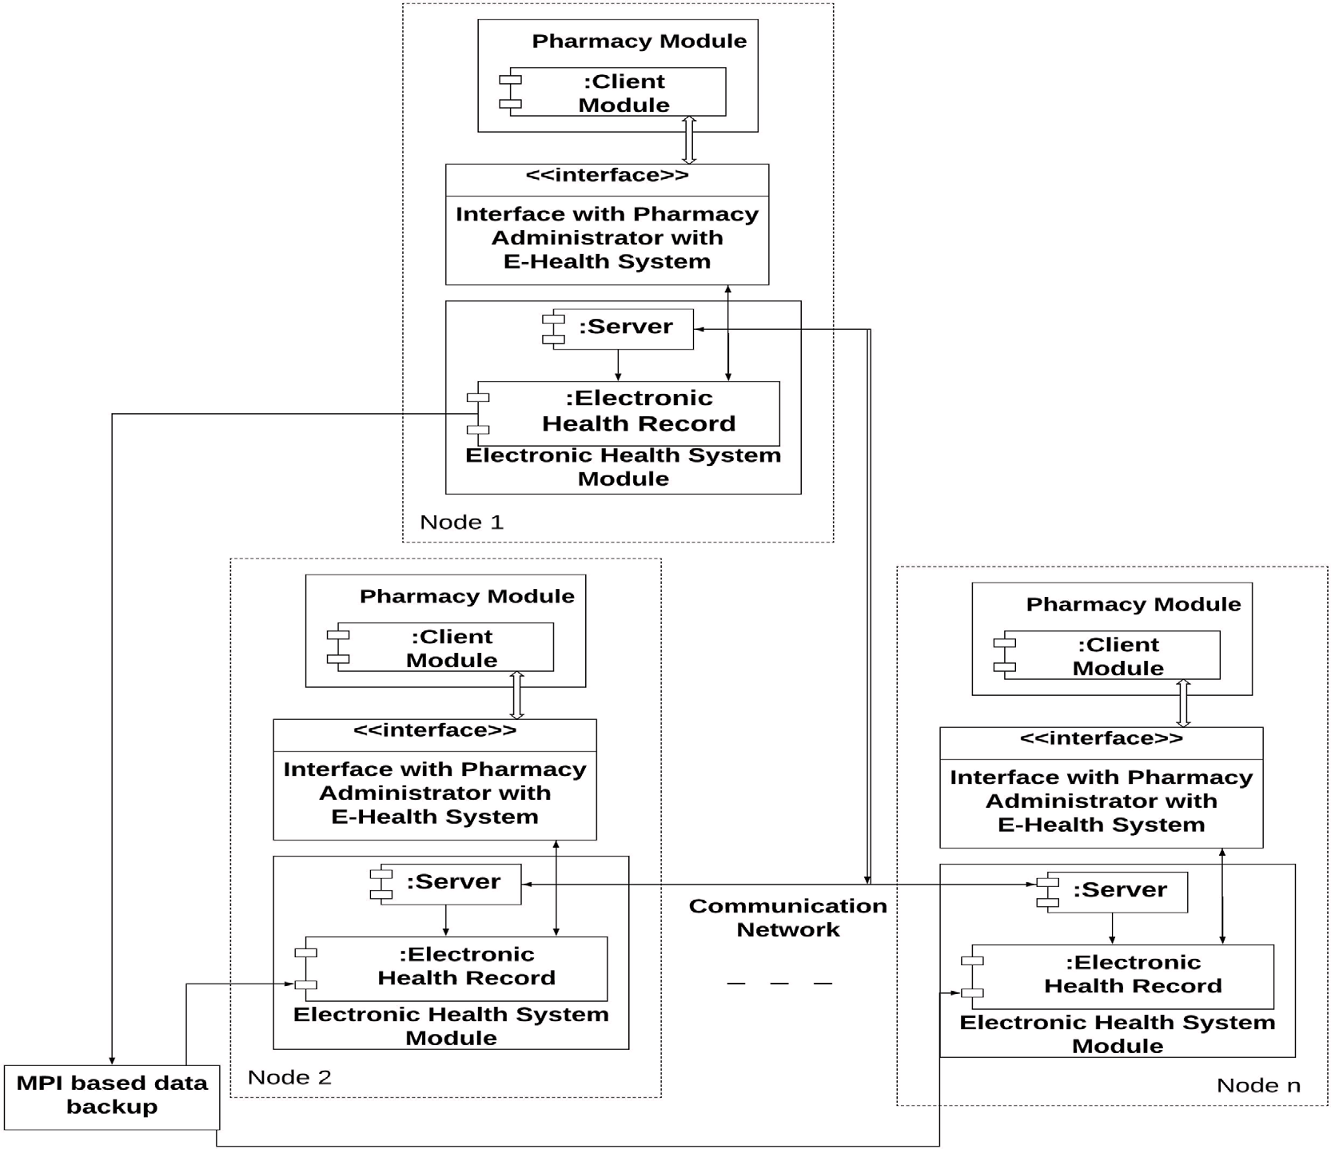

**/ig. 7.** Deployment diagram of developed distributed EHR system.

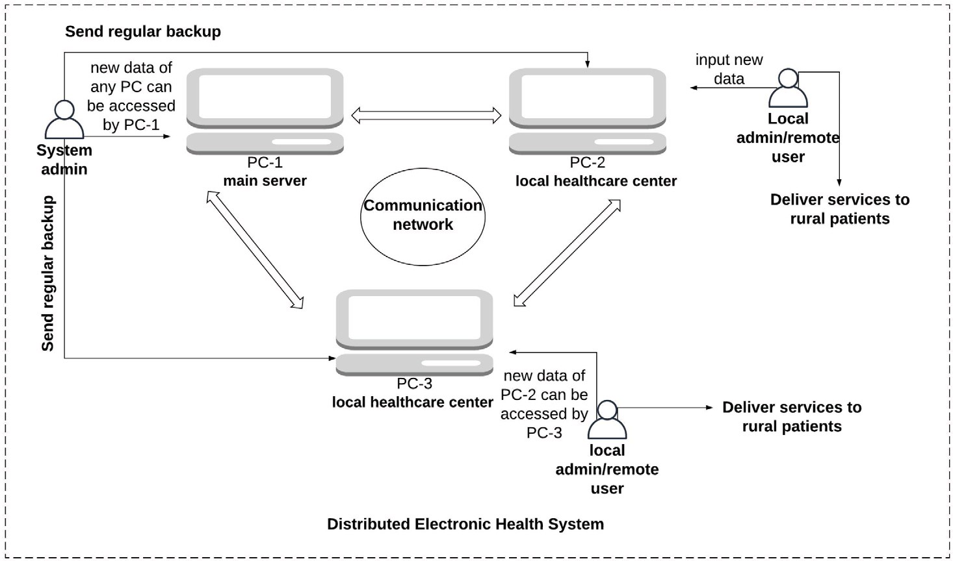

**/ig. 8.** Results of the developed e-Health system.

# Results and discussion

We have established a proposed low-cost distributed EHR with loose coupling in this study. We have used HL7 compatible electronic health system (EHS) in each health care center. Each center has its own e-Health system which is connected through a communication

network. Create, delete, backup, and restore data are all administrative actions available through the Tryton client for databases. For testing, we created a distributed environment using personal computers in health care center in which one is for the main server and others are for local servers. The overall result of the developed system is pictured by a diagram in Fig. 8, and the key outcomes are summarized below:

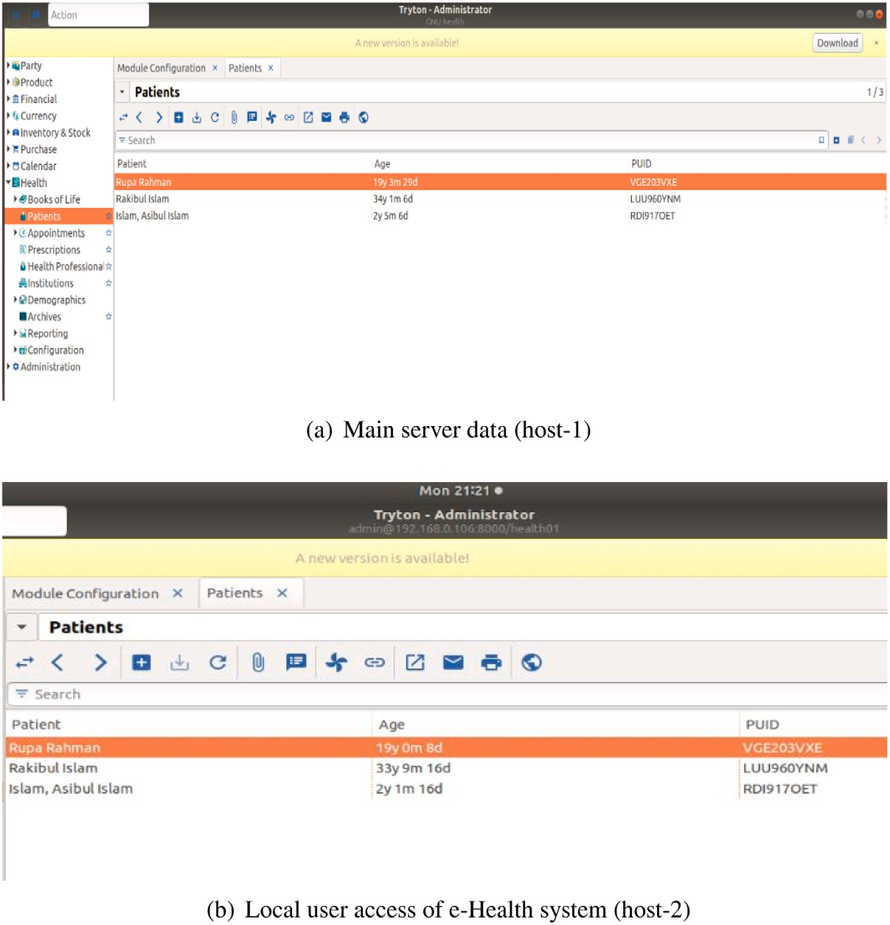

**/ig. 9.** Illustration of system-to-system data exchange.

1. Accessibility of the e-Health system from anywhere of the coun- try through local service provider.
2. Health data of any local health care center are interoperable with the other health care center in the e-Health system (Fig. 9).
3. A rural patient easily gets the service through distributed envi- ronment with multiple hosts.
4. There is no need to change the geographical position of the patients, patients can get any kind of update or retrieve their history from the local service center of their location when required. If a new record added or any information gets updated into a local health care center, the update will be available in the other health care center connected to the e-Health system (Fig. 10).
5. Regular backup of data prevents the data loss from any local system failure (Fig. 11).
   1. *Health data intercommunication with multiple hosts*

Fig. 9 depicts data interoperation from system to system. Main server data are represented by Fig. 9(a). Any local user connected to this system can successfully access the system by user ID and password. Fig. 9(b) shows the same data of the main server from the local user end. Any local user from any network can get their required infor- mation whenever they want. Therefore, both figures show the same content that means interoperation among all EHS is achieved. There is easy access to health data so that loose coupling is also achieved. Health professionals can add new records or delete some records among which many of them need to be modified. All users of the system will be aware of this modification by accessing the system from anywhere.

* 1. *Health data update/delete operation*

Patients’ registration, new records addition or deletion, prescrip- tions generation of doctors is possible in our system. New record

insertion process in the local server is shown in Fig. 10(a). Moreover, Fig. 10(b) and Fig. 10(c) depict the status of the database after new patient record inserted in the local and main server respectively. If any of the information gets updated, all users of the system will be aware of the changes in their records by accessing into the system from anywhere.

* 1. *Health data backup operation*

If any of the hosts of distributed EHR fails, the whole system will be stopped and the total service will be hampered. In this regard, a backup operation is performed using MPI to recover any uncertainty between any servers. Fig. 11 shows the backup file creation.

The black arrow sign of Fig. 11(a) marks the ‘‘healthbackup.sql’’ file which is the backup database of the system. It shows the time of the backup file creation is 23:11 (in black rectangle mark of the figure) and Fig. 11(b) shows the ‘‘healthbackup.sql’’ file is received in a local EHS but here the time is 23:13 (in black rectangle mark of the figure). That means, the created backup database is sent to and received from the local servers successfully. The time depends on the size of the database and the network or internet connectivity. The more the database becomes larger, the more it takes time to send to all the local servers. Generally, data backup operation is performed at a specific time per day in our system. Therefore, the backup operation of health data has performed here.

In such digitized era e-Health systems have great importance in developing countries. So it is clear that developed interoperable dis- tributed e-Health system plays a significant role in the health care of developing countries. This section presents the current health care chal- lenges and how these challenges are addressed in-terms of advanced and sustainability.

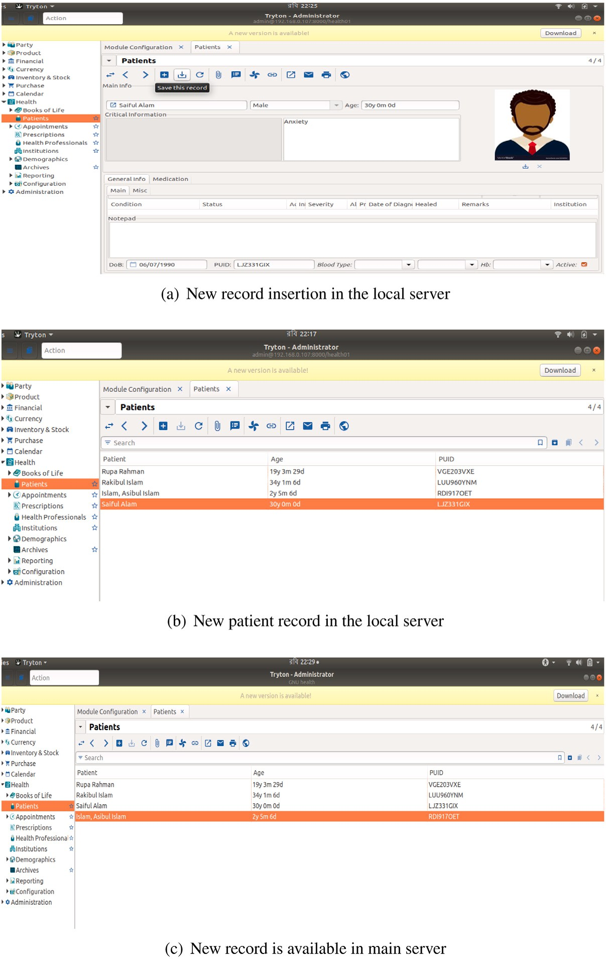

**/ig. 10.** New record added or information updated in e-Health system.

* 1. *Comparison of the proposed systems with existing systems*

Unlike related work that offered distributed components or client– server architecture, but with tightly coupled technology, the proposed system provides a loose coupling that allows flexibility across e-Health systems. In addition, it makes the database distributed for developing nations. Although similar system databases in developed countries are distributed, most techniques in developing and undeveloped countries pretend centralized databases, limiting the EHR’s scalability. Further- more, most systems lack data recovery, whereas the proposed approach provides MPI-based data recovery. Thus, adapting with HL7 CDA to provide interoperability for developing countries is a challenge ad- dressed in this study compared to developed countries. The compar- ative analysis of the proposed work with related studies is summarized in Table 4.

* 1. *Comparative advantages of developed loosely coupled distributed EHR*

As a result, people in developing countries are unfamiliar with the e-Health system, and e-Health services are ineffective for rural people. But, the developed system can be accessed from any remote areas anytime. People need not to change their position to use this service. Patients and doctors can use the system according to their desired. No matter that the database becomes larger; the term distribution in this regard maintains it smoothly. Table 5 clarifies the potential advantages derived from the developed distributed e-Health system over present systems.

As compared to the centralized shared memory health systems have so many limitations such as, database gets larger day by day and maintaining such kind of database is really difficult, also if the central system collapses, the whole system will be stopped and the total service will be hampered. A distributed database is an acceptable approach for remotely sustaining e-Health care in this case. Current e- Health service focuses on urban health care. This study focuses on rural

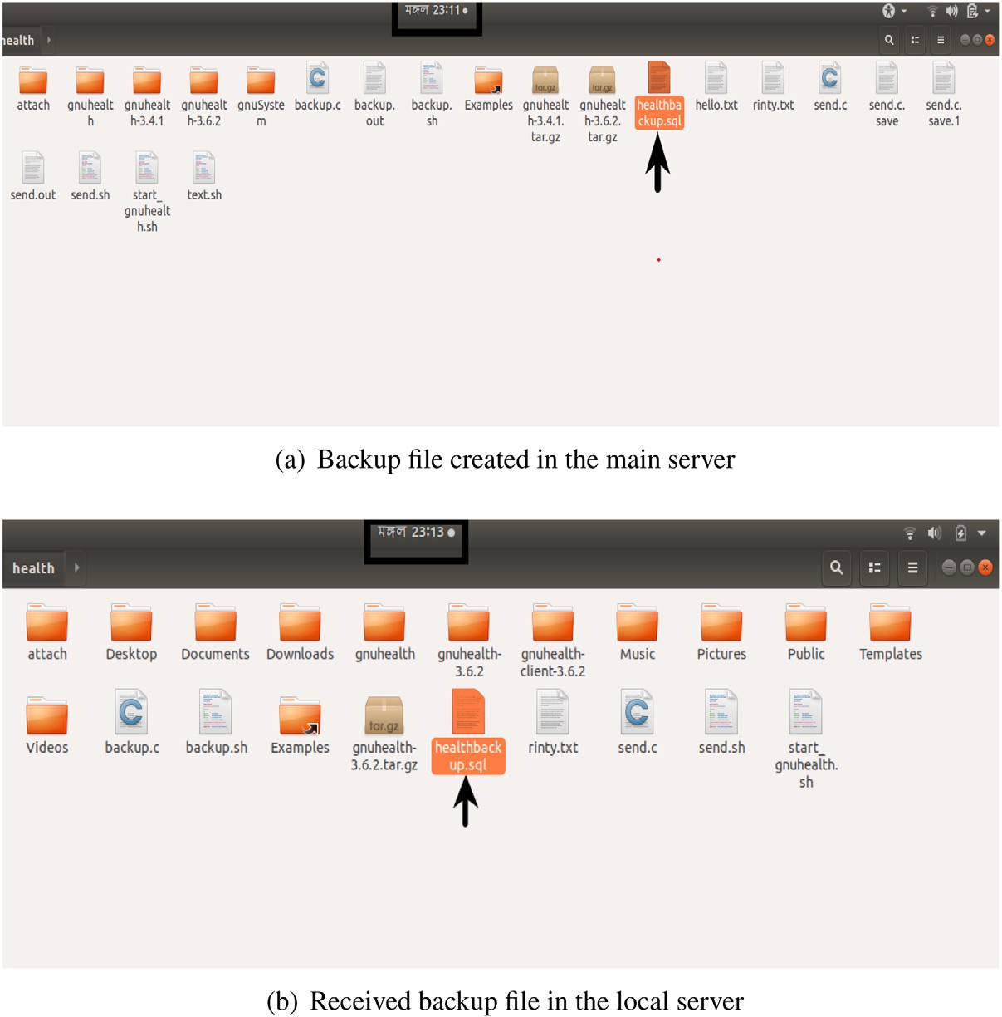

**/ig. 11.** Backup file send and receive operation.

**Table 4**

Comparison among proposed system and other related systems based on key features.

|  |  |  |  |  |  |  |  |  |
| --- | --- | --- | --- | --- | --- | --- | --- | --- |
| Systems/Year | Architectural Model | Database | Access Management | Interconnection Model | Interoperability | Authentication | Data Backup | Perspective |
| Proposed | Distributed with | Distributed | Health service | Loosely coupled | HL7 CDA | Login by user ID and | MPI based regular | Developing |
| System (2021) | loose coupling |  | provider |  |  | Password | backup | countries |
| HL7 FHIR & | Distributed | Distributed | Both patient and | – | HL7 FHIR, | HTTP request and | No (two server’s data | – |
| GraphQL | Components |  | professional |  | openEHR | access token | are not same at a time) |  |
| Approach |  |  |  |  |  |  |  |  |
| (2021) [55] |  |  |  |  |  |  |  |  |
| Regional HIS | Client–Server | Centralized | Professional | Tightly coupled | HL7 and FHIR | Login by user ID and | – | Regional |
| (2021) [13] |  |  |  |  |  | Password |  |  |
| Distributed | Distributed | Distributed | Both patient and | – | HL7/CDA2 | HTTP request and | Infrastructure as a | Regional |
| Integration | Components with |  | professional |  |  | software as a service | service (IaaS) |  |
| System (2019) | cloud |  |  |  |  | (SaaS) tools |  |  |
| [9] |  |  |  |  |  |  |  |  |
| Distributed | Distributed | Distributed | Both patient and | – HL7 with FHIR, Digital signature | | | – – | |
| Architecture | peer-to-peer |  | professional | openEHR | | |  | |
| Model (2017) | network |  |  |  | | |  | |
| [40] |  |  |  |  | | |  | |
| HL7 & SOA | Distributed | Distributed | Professional | – HL7 CDA Login by user ID and | | | – – | |
| based System | Components |  |  | Password | | |  | |
| (2014) [56] |  |  |  |  | | |  | |

**Table 5**

Advanced features of developed system compared to present systems.

Present health care challenges Advantages of developed distributed EHS

Provides hospital based services Provides rural local health care center based services

Accessibility Anytime

Health data interoperability problem HL7 based e-Health system enables interoperability

Focus on urban health care Focus on rural health care

High costs Affordable

Rural patient needs to travel urban area to receive health services Patient does not need to change position Centralized and no data recovery Distributed, MPI based data recovery

Fail to maintain large database Distributed feature handles large database smoothly

health care because a large number of people live in the rural areas of developing countries. Health care facilities are inadequate for them. So, the developed system will be beneficial and people will not suffer from cost issues.

The authorities and health care organizations tend to be developed a distributed e-Health system to enhance public well-being and improved healthcare outcomes with lower costs. Distributed e-Health, or the use of ICT tools in the healthcare system, recommend benefits in world- wide health care, such as remote interactions with patients, fast access to medical care specialists, and remote monitoring skills. As technolog- ical advancements compete effectively into the third world, e-Health and medical information technology is anticipated to rise rapidly in developing countries.

* 1. *Challenges and prospective*

The experimental results of the developed system emphasize the presence of many challenges. The shift from hospital based health care services to electronic health care services needs organizational, cultural, and technical changes and supports. An incomplete health standard also gives us trouble to develop a complete health care sys- tem. Without greater knowledge rural doctors, patients, and health professionals cannot cope up with this system.

Because of the distributed nature this application is built with mul- tiple hosts, so the testing environment is simulated. But the simulated result may not reflect on the real health care services. Moreover, loose coupling leads to a price because a tightly coupled system has the prop- erty of reducing security attack, but loose coupling may limit security. The data layer is made up of a server database that stores the patient information. Another significant problem for this system is ensuring the data’s authenticity. In this regard, we have used PostgreSQL which is an open source database with the highest level of security. The security of this database is enriched by First Health care Interoperability Resource recommended by Health Level Seven International. We have discussed the potential advantages of the developed distributed e-Health system. This work could be expanded in the future in the areas listed below.

1. Although the health standard and database provides potential security, but a security model can be developed to show the security level of the developed system.
2. A real time e-Health system can be implemented by using this technology.
3. Large scale practical implementation of this model can be carried out in the rural areas of Bangladesh.
4. Low cost portable e-Health system tool kit can be used with it to collect vital signs of patients.
5. Internet of Things based distributed health care system will be developed where IoT and distributed databases will use to connect various medical resources.
6. Cloud based distributed e-Health care system can be developed to improve the efficiency of health care.
7. Machine learning (ML) procedures in health care applications will attempt to acquire patient distinctiveness or comprehend the possibility of disease impacts.

However, authors expect that the results and the proposed technol- ogy of this study will add a new paradigm and advance the e-Health services of developing countries. This study will help the researchers in the further development of the standard loosely coupled distributed e-Health system in developing countries.

# Conclusion

Being the world’s most populous countries, developing countries face significant challenges in serving people in various industries, including health care. The use of ‘‘information and communication

technology (ICT)’’ plays a critical role in increasing efficiency and ac- cess to services. The capacity to integrate and synchronize data supplied from health information (e-Health) systems with other heterogeneous platforms is the major problem associated with data interoperability. The objective of this study was to provide a framework for data interoperability and information interchange among e-health systems. The interoperability of the developed e-Health system allows different information systems and organizations to collaborate. Interoperability among e-Health systems is complicated by heterogeneities in data representation and care procedures (EHRs). The developed system can integrate distributed technologies into the e-Health systems and independently track the health records of various organizations. Each remote region has its e-Health system linked to the central server according to the system architecture. In rural health care, the developed system employs HL7 CDA to manage decentralized health data. How- ever, the designed system is distributed among multiple hosts to avoid the challenges of a central system. Because most current healthcare services are hospital-based, the developed system is made cheap to the general public in developing countries so that the system may last for a long time. In the event of a breakdown, a regular backup operation of health data has been undertaken to recover data from the backup server. In summary, the contribution of this study is the use of the HL7 standard and MPI-based data recovery in the construction of a loosely coupled distributed e-Health system, which is truly revolutionary in developing countries. It is concluded that the established system helps to progress e-Health in developing nations throughout the world.

The approach will require more evaluations in the future, partic- ularly in terms of security and privacy. Although the system design shows the considerable potential of privacy preservation, more protec- tion and privacy testing are necessary. A security mechanism based on blockchain technology might be created in the future to ensure that only authorized informants have access to health information. Devel- oped technology may be used to create a real-time e-Health system, and it is possible to carry out a large-scale practical implementation for further development. As a follow-up study, we will look at the acceptability of combining multiple healthcare systems. It will allow us to monitor patient behavior using a data mining and machine learning tools.

# CRediT authorship contribution statement

**Mahnuma Rahman Rinty:** Conceptualization, Methodology, Software, Data curation, Writing – original draft, Visualization. **Uzzal Kumar Prodhan:** Conceptualization, Validation, Investigation, Resources, Writing – review & editing, Supervision. **Md. Mijanur Rahman:** Methodology, Validation, Formal analysis, Resources, Writing – original draft, Writing – review & editing.

# Declaration of competing interest

No author associated with this paper has disclosed any potential or pertinent conflicts which may be perceived to have impending conflict with this work.

# Acknowledgments

The authors wish to acknowledge the ICT Division (Ministry of Posts, Telecommunications and Information Technology, Bangladesh) for their ICT fellowship, and the department of Computer Science and Engineering of Jatiya Kabi Kazi Nazrul Islam University (@JKKNIU, Bangladesh) for their supports in conducting the research.

# References

1. [Jawhari B, Ludwick D, Keenan L, Zakus D, Hayward R. Benefits and challenges](http://refhub.elsevier.com/S2590-0056(21)00053-9/sb1) [of EMR implementations in low resource settings: A state-of-the-art review. BMC](http://refhub.elsevier.com/S2590-0056(21)00053-9/sb1) [Med Inform Decis Mak 2016;16(1):1–12.](http://refhub.elsevier.com/S2590-0056(21)00053-9/sb1)
2. [Williams F, Boren S. The role of the electronic medical record (EMR) in care](http://refhub.elsevier.com/S2590-0056(21)00053-9/sb2) [delivery development in developing countries: A systematic review. J Innov](http://refhub.elsevier.com/S2590-0056(21)00053-9/sb2) [Health Inform 2008;16(2):139–45.](http://refhub.elsevier.com/S2590-0056(21)00053-9/sb2)
3. [Goenaga I, Lahuerta X, Atutxa A, Gojenola K. A section identification tool:](http://refhub.elsevier.com/S2590-0056(21)00053-9/sb3) [Towards HL7 CDA/CCR standardization in spanish discharge summaries. J](http://refhub.elsevier.com/S2590-0056(21)00053-9/sb3) [Biomed Inform 2021;121:103875.](http://refhub.elsevier.com/S2590-0056(21)00053-9/sb3)
4. [Rahman MM, Khatun F, Uzzaman A, Sami SI, Bhuiyan MA-A, Kiong TS. A](http://refhub.elsevier.com/S2590-0056(21)00053-9/sb4) [comprehensive study of artificial intelligence and machine learning approaches in](http://refhub.elsevier.com/S2590-0056(21)00053-9/sb4) [confronting the coronavirus (COVID-19) pandemic. Int J Health Serv 2021;1–16.](http://refhub.elsevier.com/S2590-0056(21)00053-9/sb4)
5. [Archer N, Lokker C, Ghasemaghaei M, DiLiberto D, et al. Ehealth implementation](http://refhub.elsevier.com/S2590-0056(21)00053-9/sb5) [issues in low-resource countries: Model, survey, and analysis of user experience.](http://refhub.elsevier.com/S2590-0056(21)00053-9/sb5) [J Med Internet Res 2021;23(6):e23715.](http://refhub.elsevier.com/S2590-0056(21)00053-9/sb5)
6. [Shull JG. Digital health and the state of interoperable electronic health records.](http://refhub.elsevier.com/S2590-0056(21)00053-9/sb6) [JMIR Med Inform 2019;7(4):e12712.](http://refhub.elsevier.com/S2590-0056(21)00053-9/sb6)
7. [Khan A, Mir MS. E health and m health: Future of healthcare. J Anat Physiol](http://refhub.elsevier.com/S2590-0056(21)00053-9/sb7) [2021;2(3):38.](http://refhub.elsevier.com/S2590-0056(21)00053-9/sb7)
8. [Maseko SN, van Staden D, Mhlongo EM. The rising burden of diabetes-related](http://refhub.elsevier.com/S2590-0056(21)00053-9/sb8) [blindness: A case for integration of primary eye care into primary health care in](http://refhub.elsevier.com/S2590-0056(21)00053-9/sb8) [eswatini. In: Healthcare, vol. 9. (7):Multidisciplinary Digital Publishing Institute;](http://refhub.elsevier.com/S2590-0056(21)00053-9/sb8) [2021, p. 835.](http://refhub.elsevier.com/S2590-0056(21)00053-9/sb8)
9. [Muriana C, Gilia G, Mistretta V, Piazza T, Vizzini GB. A distributed integration](http://refhub.elsevier.com/S2590-0056(21)00053-9/sb9) [system enabling electronic health records: An Italian experience. Int J Med Eng](http://refhub.elsevier.com/S2590-0056(21)00053-9/sb9) [Inform 2019;11(1):1–13.](http://refhub.elsevier.com/S2590-0056(21)00053-9/sb9)
10. [Tsiouris KM, Gatsios D, Tsakanikas V, Pardalis AA, Kouris I, Androutsou T,](http://refhub.elsevier.com/S2590-0056(21)00053-9/sb10) [Tarousi M, Vujnovic Sedlar N, Somarakis I, Mostajeran F. Designing interoperable](http://refhub.elsevier.com/S2590-0056(21)00053-9/sb10) [telehealth platforms: Bridging IoT devices with cloud infrastructures. Enterp Inf](http://refhub.elsevier.com/S2590-0056(21)00053-9/sb10) [Syst 2020;14(8):1194–218.](http://refhub.elsevier.com/S2590-0056(21)00053-9/sb10)
11. ATA. Telehealth interoperability. 2020, [https://www.americantelemed.org/](https://www.americantelemed.org/initiatives/interoperability/)

[initiatives/interoperability/](https://www.americantelemed.org/initiatives/interoperability/). Online. [Accessed 5 October 2020].

1. [Mursi MF, Salama MA, Emad SE. Towards A secure E-health system for](http://refhub.elsevier.com/S2590-0056(21)00053-9/sb12) [public healthcare sector in Egypt using HL7.(dept. A). MEJ Mansoura Eng J](http://refhub.elsevier.com/S2590-0056(21)00053-9/sb12) [2021;46(2):11–22.](http://refhub.elsevier.com/S2590-0056(21)00053-9/sb12)
2. [Lazarova E, Mora S, Rubartelli P, Vitale AC, Pareto L, Maggi N, Ruggiero C,](http://refhub.elsevier.com/S2590-0056(21)00053-9/sb13) [Giacomini M. Integrating an electronic health record system into a regional](http://refhub.elsevier.com/S2590-0056(21)00053-9/sb13) [health information system: An HL7 FHIR architecture. Stud Health Technol](http://refhub.elsevier.com/S2590-0056(21)00053-9/sb13) [Inform 2021;281:1087–8.](http://refhub.elsevier.com/S2590-0056(21)00053-9/sb13)
3. [Habib SS, Jamal WZ, Zaidi SMA, Siddiqui J-U-R, Khan HM, Creswell J, Batra S,](http://refhub.elsevier.com/S2590-0056(21)00053-9/sb14) [Versfeld A, et al. Barriers to access of healthcare services for rural women—](http://refhub.elsevier.com/S2590-0056(21)00053-9/sb14) [Applying gender lens on TB in a rural district of Sindh, Pakistan. Int J Environ](http://refhub.elsevier.com/S2590-0056(21)00053-9/sb14) [Res Public Health 2021;18(19):10102.](http://refhub.elsevier.com/S2590-0056(21)00053-9/sb14)
4. [Silva AB, Sindico SRF, Carneiro AC, Henrique SM, Fernandes AG, Gomes JP, Mar-](http://refhub.elsevier.com/S2590-0056(21)00053-9/sb15) [inho TP, Fernandes VR. COVID-19 remote consultation services and population](http://refhub.elsevier.com/S2590-0056(21)00053-9/sb15) [in health inequity-concentrating territories: A scoping review. Telemed E-Health](http://refhub.elsevier.com/S2590-0056(21)00053-9/sb15) [2021;27(8):881–97.](http://refhub.elsevier.com/S2590-0056(21)00053-9/sb15)
5. [Bidgood W, Tucker M, Prior F, Hagan G, Mattison J. The role of digital](http://refhub.elsevier.com/S2590-0056(21)00053-9/sb16) [imaging and communications in medicine in an evolving healthcare computing](http://refhub.elsevier.com/S2590-0056(21)00053-9/sb16) [environment: The model is the message. J Digit Imaging 1998;11(1):1–9.](http://refhub.elsevier.com/S2590-0056(21)00053-9/sb16)
6. [Blazona B, Koncar M. HL7 and DICOM based integration of radiology de-](http://refhub.elsevier.com/S2590-0056(21)00053-9/sb17) [partments with healthcare enterprise information systems. Int J Med Inform](http://refhub.elsevier.com/S2590-0056(21)00053-9/sb17) [2007;76:S425–32.](http://refhub.elsevier.com/S2590-0056(21)00053-9/sb17)
7. [Bruck J, Dolev D, Ho C-T, Roşu M-C, Strong R. Efficient message passing](http://refhub.elsevier.com/S2590-0056(21)00053-9/sb18) [interface (MPI) for parallel computing on clusters of workstations. J Parallel](http://refhub.elsevier.com/S2590-0056(21)00053-9/sb18) [Distrib Comput 1997;40(1):19–34.](http://refhub.elsevier.com/S2590-0056(21)00053-9/sb18)
8. [Borycki E, Kushniruk A, Armstrong B, Joe R, Otto T. Integrating electronic health](http://refhub.elsevier.com/S2590-0056(21)00053-9/sb19) [records into health professional and health informatics education: A continuum](http://refhub.elsevier.com/S2590-0056(21)00053-9/sb19) [of approaches, faculty publications (human & social development). UVicSpace](http://refhub.elsevier.com/S2590-0056(21)00053-9/sb19) [2010;18(1).](http://refhub.elsevier.com/S2590-0056(21)00053-9/sb19)
9. [Garber S, Gates SM, Keeler EB, Vaiana ME, Mulcahy AW, Lau C, Kellermann AL.](http://refhub.elsevier.com/S2590-0056(21)00053-9/sb20) [Redirecting innovation in US health care: Options to decrease spending and](http://refhub.elsevier.com/S2590-0056(21)00053-9/sb20) [increase value. Rand Health Q 2014;4(1).](http://refhub.elsevier.com/S2590-0056(21)00053-9/sb20)
10. [Yusif S, Jeffrey S. Preparedness for e-health in developing countries: the case of](http://refhub.elsevier.com/S2590-0056(21)00053-9/sb21) [ghana. J Health Inform Dev Countries 2014;8(2).](http://refhub.elsevier.com/S2590-0056(21)00053-9/sb21)
11. [Su CJ. Mobile multi-agent based, distributed information platform (MADIP) for](http://refhub.elsevier.com/S2590-0056(21)00053-9/sb22) [wide-area e-health monitoring. Comput Ind 2008;59(1):55–68.](http://refhub.elsevier.com/S2590-0056(21)00053-9/sb22)
12. [Ndume V, Nkansah-Gyekye Y, Lyatu I, Ko J. A methodology for data collection](http://refhub.elsevier.com/S2590-0056(21)00053-9/sb23) [and integration of e-health records: A case study of ifakara health institute in](http://refhub.elsevier.com/S2590-0056(21)00053-9/sb23) [tanzania. In: 2013 Pan African international conference on information science,](http://refhub.elsevier.com/S2590-0056(21)00053-9/sb23) [computing and telecommunications. IEEE; p. 131–6.](http://refhub.elsevier.com/S2590-0056(21)00053-9/sb23)
13. [Prodhan UK, Rahman MZ, Jahan I. A survey on the telemedicine in Bangladesh.](http://refhub.elsevier.com/S2590-0056(21)00053-9/sb24) [In: 2016 International conference on computing, communication and automation.](http://refhub.elsevier.com/S2590-0056(21)00053-9/sb24) [IEEE; 2016, p. 857–61.](http://refhub.elsevier.com/S2590-0056(21)00053-9/sb24)
14. [Alajmi D, Khalifa M, Jamal A, Zakaria N, Alomran S, El-Metwally A, Al-](http://refhub.elsevier.com/S2590-0056(21)00053-9/sb25) [Salamah M, Househ M. The role and use of telemedicine by physicians in](http://refhub.elsevier.com/S2590-0056(21)00053-9/sb25) [developing countries: A case report from Saudi Arabia. In: Transforming public](http://refhub.elsevier.com/S2590-0056(21)00053-9/sb25) [health in developing nations. IGI Global; 2015, p. 293–308.](http://refhub.elsevier.com/S2590-0056(21)00053-9/sb25)
15. [Felizardo V, Sousa P, Sabugueiro D, Alexandre C, Couto R, Garcia N, Pires I. E-](http://refhub.elsevier.com/S2590-0056(21)00053-9/sb26) [health: Current status and future trends. In: Handbook of research on democratic](http://refhub.elsevier.com/S2590-0056(21)00053-9/sb26) [strategies and citizen-centered E-government services. IGI Global; 2015, p.](http://refhub.elsevier.com/S2590-0056(21)00053-9/sb26) [302–26.](http://refhub.elsevier.com/S2590-0056(21)00053-9/sb26)
16. [Dixon P, Hollinghurst S, Edwards L, Thomas C, Gaunt D, Foster A, Large S,](http://refhub.elsevier.com/S2590-0056(21)00053-9/sb27) [Montgomery AA, Salisbury C. Cost-effectiveness of telehealth for patients with](http://refhub.elsevier.com/S2590-0056(21)00053-9/sb27) [raised cardiovascular disease risk: Evidence from the healthlines randomised](http://refhub.elsevier.com/S2590-0056(21)00053-9/sb27) [controlled trial. BMJ Open 2016;6(8):e012352.](http://refhub.elsevier.com/S2590-0056(21)00053-9/sb27)
17. Kher RK. Mobile and E-healthcare: Recent trends and future directions. J Health Med Econ 2016;2:10. <http://dx.doi.org/10.21767/2471-9927.100010>.
18. [Kasemsap K. Telemedicine and electronic health: Issues and implications in](http://refhub.elsevier.com/S2590-0056(21)00053-9/sb29) [developing countries. In: Health information systems and the advancement of](http://refhub.elsevier.com/S2590-0056(21)00053-9/sb29) [medical practice in developing countries. IGI Global; 2017, p. 149–67.](http://refhub.elsevier.com/S2590-0056(21)00053-9/sb29)
19. [Lewis T, Synowiec C, Lagomarsino G, Schweitzer J. E-health in low-and middle-](http://refhub.elsevier.com/S2590-0056(21)00053-9/sb30) [income countries: Findings from the center for health market innovations. Bull](http://refhub.elsevier.com/S2590-0056(21)00053-9/sb30) [World Health Organ 2012;90:332–40.](http://refhub.elsevier.com/S2590-0056(21)00053-9/sb30)
20. [Ndlovu K, Scott RE, Mars M. Interoperability opportunities and challenges in](http://refhub.elsevier.com/S2590-0056(21)00053-9/sb31) [linking mhealth applications and erecord systems: Botswana as an exemplar.](http://refhub.elsevier.com/S2590-0056(21)00053-9/sb31) [BMC Med Inform Decis Mak 2021. Preprint.](http://refhub.elsevier.com/S2590-0056(21)00053-9/sb31)
21. [Kamal SA, Shafiq M, Kakria P. Investigating acceptance of telemedicine ser-](http://refhub.elsevier.com/S2590-0056(21)00053-9/sb32) [vices through an extended technology acceptance model (TAM). Technol Soc](http://refhub.elsevier.com/S2590-0056(21)00053-9/sb32) [2020;60:101212.](http://refhub.elsevier.com/S2590-0056(21)00053-9/sb32)
22. [Gregory M, Tembo S. Implementation of E-health in developing coun-](http://refhub.elsevier.com/S2590-0056(21)00053-9/sb33) [tries challenges and opportunities: A case of Zambia. Sci Technol Soc](http://refhub.elsevier.com/S2590-0056(21)00053-9/sb33) [2017;7(2):41–53.](http://refhub.elsevier.com/S2590-0056(21)00053-9/sb33)
23. Management Information System (MIS), Directorate General of Health Ser- vices (DGHS). Health bulletin 2016. 2021, [https://dghs.gov.bd/index.php/en/](https://dghs.gov.bd/index.php/en/publications/) [publications/](https://dghs.gov.bd/index.php/en/publications/). Online [Accessed 1 May 2021].
24. [Odekunle Florence F. Current roles and applications of electronic health record](http://refhub.elsevier.com/S2590-0056(21)00053-9/sb35) [in the healthcare system. Health Sci 2016;5(12):48–51.](http://refhub.elsevier.com/S2590-0056(21)00053-9/sb35)
25. [Cardoso L, Marins F, Quintas C, Portela F, Santos M, Abelha A, Machado J.](http://refhub.elsevier.com/S2590-0056(21)00053-9/sb36) [Interoperability in healthcare. In: Health care delivery and clinical science:](http://refhub.elsevier.com/S2590-0056(21)00053-9/sb36) [concepts, methodologies, tools, and applications. IGI Global; 2018, p. 689–714.](http://refhub.elsevier.com/S2590-0056(21)00053-9/sb36)
26. [Rubí JNS, Gondim PRdL. Interoperable internet of medical things platform for](http://refhub.elsevier.com/S2590-0056(21)00053-9/sb37) [e-health applications. Int J Distrib Sens Netw 2020;16(1):1550147719889591.](http://refhub.elsevier.com/S2590-0056(21)00053-9/sb37)
27. [Pereira C, Mesquita Ja, Guimarães D, Santos F, Almeida L, Aguiar A. Open IoT](http://refhub.elsevier.com/S2590-0056(21)00053-9/sb38) [architecture for continuous patient monitoring in emergency wards. Electronics](http://refhub.elsevier.com/S2590-0056(21)00053-9/sb38) [2019;8(10):1074.](http://refhub.elsevier.com/S2590-0056(21)00053-9/sb38)
28. [Prodhan UK, Rahman MZ, Jahan I. Design and implementation of an advanced](http://refhub.elsevier.com/S2590-0056(21)00053-9/sb39) [telemedicine model for the rural people of Bangladesh. Technol Health Care](http://refhub.elsevier.com/S2590-0056(21)00053-9/sb39) [2018;26(1):175–80.](http://refhub.elsevier.com/S2590-0056(21)00053-9/sb39)
29. [Roehrs A, Da Costa CA, da Rosa Righi R. Omniphr: A distributed architecture](http://refhub.elsevier.com/S2590-0056(21)00053-9/sb40) [model to integrate personal health records. J Biomed Inform 2017;71:70–81.](http://refhub.elsevier.com/S2590-0056(21)00053-9/sb40)
30. [MS A, GF H, SHE L, ANSJ J. EMR access and confidentiality based on patient](http://refhub.elsevier.com/S2590-0056(21)00053-9/sb41) [and hospital staff perspectives. Open Public Health J 2018;11(1).](http://refhub.elsevier.com/S2590-0056(21)00053-9/sb41)
31. [Adenuga OA, Kekwaletswe RM, Coleman A. Ehealth integration and interoper-](http://refhub.elsevier.com/S2590-0056(21)00053-9/sb42) [ability issues: Towards a solution through enterprise architecture. Health Inf Sci](http://refhub.elsevier.com/S2590-0056(21)00053-9/sb42) [Syst 2015;3(1):1–8.](http://refhub.elsevier.com/S2590-0056(21)00053-9/sb42)
32. [Holmgren AJ, Patel V, Adler-Milstein J. Progress in interoperability: Mea-](http://refhub.elsevier.com/S2590-0056(21)00053-9/sb43) [suring US hospitals’ engagement in sharing patient data. Health Affairs](http://refhub.elsevier.com/S2590-0056(21)00053-9/sb43) [2017;36(10):1820–7.](http://refhub.elsevier.com/S2590-0056(21)00053-9/sb43)
33. [Lehne M, Sass J, Essenwanger A, Schepers J, Thun S. Why digital medicine](http://refhub.elsevier.com/S2590-0056(21)00053-9/sb44) [depends on interoperability. NPJ Digit Med 2019;2(1):1–5.](http://refhub.elsevier.com/S2590-0056(21)00053-9/sb44)
34. Karadimos A. Personal health records management with decentralized technolo- gies and the FHIR framework. 2019, [http://dx.doi.org/10.13140/RG.2.2.10299.](http://dx.doi.org/10.13140/RG.2.2.10299.46889) [46889](http://dx.doi.org/10.13140/RG.2.2.10299.46889), Preprint January 2019, University of Patras.
35. [Jafar IB, Shahin MZI, Chakraborty P. Prospect and implementation of](http://refhub.elsevier.com/S2590-0056(21)00053-9/sb46) [telemedicine centers in south Asian countries. In: International conference on](http://refhub.elsevier.com/S2590-0056(21)00053-9/sb46) [electrical engineering and information communication technology. IEEE; 2015,](http://refhub.elsevier.com/S2590-0056(21)00053-9/sb46)

[p. 1–5.](http://refhub.elsevier.com/S2590-0056(21)00053-9/sb46)

1. [Ahmed SST, Thanuja K, Guptha NS, Narasimha S. Telemedicine approach for](http://refhub.elsevier.com/S2590-0056(21)00053-9/sb47) [remote patient monitoring system using smart phones with an economical hard-](http://refhub.elsevier.com/S2590-0056(21)00053-9/sb47) [ware kit. In: International conference on computing technologies and intelligent](http://refhub.elsevier.com/S2590-0056(21)00053-9/sb47) [data engineering. IEEE; 2016, p. 1–4.](http://refhub.elsevier.com/S2590-0056(21)00053-9/sb47)
2. [Khan UM, Kabir Z, Hassan SA. Wireless health monitoring using passive](http://refhub.elsevier.com/S2590-0056(21)00053-9/sb48) [WiFi sensing. In: 2017 13th international wireless communications and mobile](http://refhub.elsevier.com/S2590-0056(21)00053-9/sb48) [computing conference. IEEE; p. 1771–6.](http://refhub.elsevier.com/S2590-0056(21)00053-9/sb48)
3. [Dolin RH, Alschuler L. Approaching semantic interoperability in health level](http://refhub.elsevier.com/S2590-0056(21)00053-9/sb49) [seven. J Am Med Inform Assoc 2011;18(1):99–103.](http://refhub.elsevier.com/S2590-0056(21)00053-9/sb49)
4. [Glassman RB. Persistence and loose coupling in living systems. Behav Sci](http://refhub.elsevier.com/S2590-0056(21)00053-9/sb50) [1973;18(2):83–98.](http://refhub.elsevier.com/S2590-0056(21)00053-9/sb50)
5. [Hariri S, Park J, Yu F-K, Parashar M, Fox GC. A message passing interface](http://refhub.elsevier.com/S2590-0056(21)00053-9/sb51) [for parallel and distributed computing. In: Proceedings the 2nd international](http://refhub.elsevier.com/S2590-0056(21)00053-9/sb51) [symposium on high performance distributed computing. IEEE; 1993, p. 84–91.](http://refhub.elsevier.com/S2590-0056(21)00053-9/sb51)
6. trytonorg. Tryton - modularity, scalability & security for your business. 2020, <https://docs.tryton.org/en/latest/>. Online [Accessed 7 October 2020].
7. Duteau J, Madra J. Introduction to CDA and C-CDA. 2016, [https:](https://www.hl7.org/documentcenter/public/calendarofevents/himss/2016/Introduction%20to%20Clinical%20Document%20Architecture%20%28CDA%29%20and%20Consolidated%20CDA%20%28C-CDA%29.pdf)

[//www.hl7.org/documentcenter/public/calendarofevents/himss/2016/](https://www.hl7.org/documentcenter/public/calendarofevents/himss/2016/Introduction%20to%20Clinical%20Document%20Architecture%20%28CDA%29%20and%20Consolidated%20CDA%20%28C-CDA%29.pdf) [Introduction%20to%20Clinical%20Document%20Architecture%20%28CDA%](https://www.hl7.org/documentcenter/public/calendarofevents/himss/2016/Introduction%20to%20Clinical%20Document%20Architecture%20%28CDA%29%20and%20Consolidated%20CDA%20%28C-CDA%29.pdf) [29%20and%20Consolidated%20CDA%20%28C-CDA%29.pdf](https://www.hl7.org/documentcenter/public/calendarofevents/himss/2016/Introduction%20to%20Clinical%20Document%20Architecture%20%28CDA%29%20and%20Consolidated%20CDA%20%28C-CDA%29.pdf). Online. [Accessed 5 October 2020].

1. The PostgreSQL Global Development Group. PostgreSQL: The world’s most advanced open source relational database. 2019, <https://www.postgresql.org/>. Online. [Accessed 1 May 2021].
2. [Mukhiya SK, Lamo Y. An HL7 FHIR and graphql approach for interoperabil-](http://refhub.elsevier.com/S2590-0056(21)00053-9/sb55) [ity between heterogeneous electronic health record systems. Health Inform J](http://refhub.elsevier.com/S2590-0056(21)00053-9/sb55) [2021;27(3):14604582211043920.](http://refhub.elsevier.com/S2590-0056(21)00053-9/sb55)
3. [Kalode P, Kemkar OS, Gundalwar P. HL7 and SOA based distributed electronic](http://refhub.elsevier.com/S2590-0056(21)00053-9/sb56) [patient record architecture using open EMR. Int J Innov Res Comput Commun](http://refhub.elsevier.com/S2590-0056(21)00053-9/sb56) [Eng 2014;2(12).](http://refhub.elsevier.com/S2590-0056(21)00053-9/sb56)