[Array 15 (2022) 100230](https://doi.org/10.1016/j.array.2022.100230)

Contents lists available at [ScienceDirect](http://www.sciencedirect.com/science/journal/25900056)

Array

journal homepage: [www.sciencedirect.com/journal/array](https://www.sciencedirect.com/journal/array)

A robust and secure watermarking algorithm based on DWT and SVD in the fractional order fourier transform domain

Ming Tang a,*, Fuken Zhou b

a *Department of Educational Technology, College of Humanities and Education, Foshan University, Foshan, 528000, People’s Republic of China*

b *Department of Computer Science and Technology, School of Computer, Neusoft Institute Guangdong, Foshan, 528000, People’s Republic of China*

A R T I C L E I N F O

*Keywords:*

Watermarking

Fractional order fourier transform Singular value decomposition Discrete wavelet transform

A B S T R A C T

The present paper aims to develop and validate a robust and secure watermarking algorithm. Firstly, the algo- rithm transforms the cover image and the watermark image separately by FRFT to obtain the amplitudes of both the cover image and watermark image, and then the two-level DWT transformation only carries out for the amplitude of the cover image. Secondly, the algorithm applies the SVD to the low-frequency sub-band of the second level DWT of the cover image and the amplitude of the watermark image. Thirdly, a new matrix is constructed based on the singular values from both the cover and watermark images to embed watermark in- formation. Lastly, the algorithm takes the preliminary numerical calculation to determine an appropriate transformation order of FRFT for the cover image and to provide an outstanding balance between the imper- ceptibility and robustness in the proposed watermarking scheme. Moreover, it guarantees the security of watermarking scheme by the transformation order of FRFT. Experimental results demonstrate that the proposed watermarking scheme provides better performance in imperceptibility and resistance against traditional signal processing and geometric attacks, especially in image rotation, image cropping, average filtering, median filtering, and Gaussian filtering in comparison with the existing methods in the literature.

# Credit author statement

Data curation, M .T; methodology, M T and F.K Zhou; project administration, M.T.; validation, M .T; Writing-original draft, T. M; writing-review and editing, M. T, F.K Zhou. All authors have read and agreed to the published version of the manuscript.

# Introduction

Digital watermarking is a research topic in modern information se- curity, which involves many research fields such as encryption, digital signal processing, communication technology and multimedia applica- tion. The importance of digital watermarking technology in protecting an image from various attacks is highlighted by embedding secret in- formation to a specific host image. With the progress and application of digital multimedia and information technology, the application scopes of digital watermarking have covered information hiding, copyright protection, content integrity authentication, product anti-

counterfeiting, product traceability, etc. [1–5] There have been numerous publications over the last 20 years on digital watermarking

technology to meet the growing needs of the information age [6–10]. Based on different application fields, many digital watermarking

schemes have been focused and advanced in different perspectives.

It is well known that digital watermarking can be divided into two categories, the spatial domain and the transform domain [11–20]. Most of the previous works on digital watermarking technologies have been conducted in the spatial domain [21–23]. Spatial domain-based trans- form methods embed watermark information into a host image by

directly altering the pixel values of a cover image. The spatial domain-based watermarking schemes have the merits of low complexity and easy implementation, but they are vulnerable to be attacked. The transform domain-based watermarking schemes embed watermark in- formation into a host image by altering the frequency coefficients of an image after various different transformations. In fact, the transform domain-based schemes are mainly based on considerations of both spectral features of images and human visual system to hide the infor- mation. At present, the main transformation methods applied to digital

watermarking include DCT [15,16,24–27], DWT [28,29] and SVD [30–33] and so on. Most existing schemes in digital watermarking have

been proposed based on DCT, SVD, DWT and other technologies in transform domain [6–8,12,17–20,33–36]. The research progress of

* Corresponding author.

*E-mail addresses:* [hunutangming@fosu.edu.cn](mailto:hunutangming@fosu.edu.cn) (M. Tang), [zhoufuken@nuit.edu.cn](mailto:zhoufuken@nuit.edu.cn) (F. Zhou).

<https://doi.org/10.1016/j.array.2022.100230>

Received 28 April 2022; Received in revised form 6 July 2022; Accepted 6 July 2022

Available online 16 July 2022

2590-0056/© 2022 The Authors. Published by Elsevier Inc. This is an open access article under the CC BY-NC-ND license ([http://creativecommons.org/licenses/by-](http://creativecommons.org/licenses/by-nc-nd/4.0/) [nc-nd/4.0/](http://creativecommons.org/licenses/by-nc-nd/4.0/)).

# Background theory

**Abbreviations**

**FRFT** Fractional order Fourier transform

**DCT** Discrete cosine transform **DWT** Discrete wavelet transform **SVD** Singular Value Decomposition **PSNR** Peak signal to noise ratio **SSIM** Structural similarity

**NC** Normalized correlation

**BER** Bit error rate

* 1. *Discrete wavelet transform*

digital watermarking technologies has been greatly promoted by the aforementioned schemes.

The research field of digital image watermarking has gradually broadened as FRFT domain. FRFT is a new transformation method, which maps information from time (space) axis to frequency axis, and can be rotated by any angle [37]. Compared to the other transformation methods, the watermarking schemes in FRFT domain have offered greater flexibility with regards to the fact that FRFT can simultaneously represent the spatial and frequency information. Tsai et al. [36] embedded watermark information in the domain of FRFT and its four kinds of generalized transforms. Vicente et al. [38] proposed to use the fractional Fourier transform for analyzing and reconstructing the magnetization of the object in the presence of the secondary field. Rawat et al. [39] put forward a robust watermarking algorithm in FRFT domain, where the original image was not altered by embedding the watermark information into the original image. Zhang et al. [40] pre- sented a digital image watermarking technique in FRFT domain and analyzed the energy distribution of the transform image. A chirp typed watermark information was embedded into the spatial domain directly, and detected in the FRFT domain in the paper. Shi et al. [41] designed a novel fractional wavelet transform in order to correct the boundedness of the wavelet and the FRFT. The proposed transform method could provide signal representations in the time-fractional- frequency plane. By analyzing the previous works of literature, these studies have emphasized on watermarking algorithms only in FRFT itself, as opposed to the combination of SVD, DWT and FRFT. These findings suggest that the watermarking schemes only in FRFT domain might not be so effec- tive against different malicious attacks, especially for geometric attacks. There are many alternative methods available for improving the imperceptibility and robustness in a variety of situations. In all of these cases, a robust digital watermarking scheme is proposed based on DWT and SVD in FRFT domain. The proposed watermarking scheme inherits

the advantages of multi-resolution analysis of the DWT and the stabil-

DWT is an invertible transform in the frequency domain, the working principle of which is based on the wavelets with varying transform frequency. The significance of DWT lies in the ability to decompose signals at different scales, and the selection of different scales can be determined according to different targets. For many signals, the low- frequency component is very important, which often contains the characteristics of the signal, while the high-frequency component gives the details or differences of the signal. Approximation component and detail component are often used in wavelet analysis. Generally speaking, approximation component represents the high-scale of the signal, that is, the low-frequency information; Details component represent the high- scale signal, that is, high-frequency information.

It is a powerful and useful means for signal analyzing and processing, which decomposes a 2D image into four independent sub-bands, namely LL (approximate component details), HL (horizontal component de- tails), LH (vertical component details) and HH (diagonal component details) [5]. An image can be transformed repeatedly by DWT to get multi-scale wavelet decomposition, so as to make it have multiplied approximations and details. The highest coefficient in low-resolution band LL of DWT denotes the most information. The DWT has the char- acteristics of multi-resolution and multi-layering, and accords with the human vision system. It has certain advantages in improving the imperceptibility of watermark. The formula of DWT can be expressed as follows:

*W*(*a*, *b*) = 〈*f* (*t*), *ψ*(*a*, *b*)〉 (1)

where *a* is the scaling factor and *b* is the translation factor; *f*(*t*) represents the specific signal, and *ψ*(*a*, *b*) is the wavelet function. *W*(*a*, *b*) is the result of the wavelet transform, which is a function of *a* and *b.*

* 1. *Singular value decomposition*

SVD, as an effective algebraic feature extraction method in linear algebra, has been widely used in the fields of data dimensionality reduction algorithm, recommendation system, natural language pro- cessing and so on. This mainly origin from its good properties, such as good stability. When one image is subject to small disturbance, the singular value of it will not change greatly. In many digital water- marking schemes based on SVD, most watermark information is embedded in a cover image built on a new matrix of singular values.

We study an *m* × *n* matrix *A* for an image and get the following re- sults by performing SVD on matrix *A*, as shown in expression (2) [30]:

ities of SVD as well as the capability of signal representations in FRFT domain. The primary objective of our proposed scheme is to improve the imperceptibility, robustness and security of digital watermarking.

*A* = *U*( *D* 0 )

*m*×*n*

*VT* (2)

The main focus of this paper is to propose a robust and secure watermarking scheme based on the new blend of DWT and SVD in FRFT domain. It provides an alternative for more secure watermarking embedding technology. In the field of image watermarking based on FRFT, the transformation order of FRFT can be used as a secret key in the process of embedding and extracting watermark information.

0 0

The organizational structure of the rest of our paper is as follows. We introduce the fundamental theories in Section 2. Section 3 gives more details of our proposed watermarking scheme. In Section 4, the exper- imental results and analysis are presented in detail, and the advantages of the proposed scheme compared with other existing schemes are given. Finally, Section 5 summarizes this paper and draws conclusions.

where *U* is a matrix with dimensions *m* × *m* and *VT* is a diagonal matrix with dimensions *n* × *n*. The columns of *U* and*VT* are referred to as the left

and right singular vectors of *A*, respectively. *D* ∈ *Rr*×*r* is a square diag- onal matrix, *D* = *diag*(*σ*1, *σ*2, ..., *σr*) with positive diagonal entries called

the singular values of *A*, which are arranged in descending order:

*σ*1 ≥ *σ*2 ≥ ... ≥ *σr* > 0.

* 1. *Fractional order Fourier transform theory and analysis*

FRFT is an important method in information analysis and processing for non-stationary signals, which can represent the information in both spatial and frequency domain simultaneously. It is totally different from the conventional Fourier transform that only expresses the information in frequency domain or spatial domain. The two-dimensional fractional order Fourier transform is extended from the one-dimensional fractional order Fourier transform. Suppose that for any two-dimensional signal

*f*(*s*,*t*), the two-dimensional continuous FRFT can be expressed as follows

(3) [37]:

analyzing and processing stationary signals, but it is weak for processing

and analyzing time-varying non-stationary signals. This is because the traditional Fourier transform uses the global basis function, which

*Fp*1,*p*2 *u v*

∫ +∞ ∫ +∞ *f s t*

*s t u v dsdt*

highlights the good characteristics of FRFT to analyze some non-

( , ) =

—∞

—∞

( , )঩*p*1,*p*2( , , , )

(3)

stationary signals.

the above two-dimensional FRFT inverse transform can be expressed by the following formula (4):

* 1. *FRFT of two-dimensional watermark image*

*f s t*

∫ +∞ ∫ +∞ *Fp p u v*

*s t u v dudv*

( , ) =

1, 2

—∞

—∞

( , )঩—*p*1,—*p*2( , , , )

(4)

Fig. 1(a)-Fig. 1(f) show the FRFT results of the watermark image for

*Foshan University* with different transformation orders. In our paper, we

where ঩*p*1,*p*2(*s*, *t*, *u*, *v*) is the kernel function of two-dimensional FRFT*α* =

*p*1*π*/2, *β* = *p*2*π*/2.

exp *j*

(5)

only study the cases of transformation order (*p*1 = *p*2). As shown in Fig. 1, the information of the two-dimensional watermark image in the spatial-frequency domain is changed with the transformation order of

,1̅̅̅̅—̅̅̅̅̅*j*̅̅c̅̅o̅̅̅t̅̅*α*̅̅̅,1̅̅̅̅—̅̅̅̅̅*j*̅̅c̅̅̅o̅̅t̅̅̅*β*̅̅

*π*

঩*p*1,*p*2(*s*, *t*, *u*, *v*) =

exp *j*

2

2 cot *α* — sin *α*

[ (*s*2 + *u*2

*su* )]

[ (*t*2 + *v*2

*tv* )]

it is found from the expression (5) that the transform kernel of two- dimensional FRFT can be decomposed into the product of two trans- form kernels of one-dimensional FRFT, namely:

2 cot *β* — sin *β*

঩*p p* (*s*, *t*, *u*, *v*) = ঩*p* (*s*, *u*) × ঩*p* (*t*, *v*), (6)

1, 2

1

2

FRFT. When the transformation order (*p*1, *p*2) = (0, 0), the watermark image presents complete spatial domain feature information [Fig. 1(a)]. When the transformation order (*p*1, *p*2) = (1, 1), the watermark image presents complete frequency domain feature information [Fig. 1(f)]. The more the transformation order (*p*1, *p*2) is close to(0, 0), the more spatial

information of the watermark image is reflected in the transformed

where *α* = *β* = 0, the two-dimensional FRFT is equal to the function itself; when *α* = 0,*β* = *π*/2, the two-dimensional FRFT is DFT only for *t*; when *α* = *π*/2,*β* = 0, the two-dimensional FRFT is DFT only for *s*; when *α* = *β* = *π*/2, the two-dimensional FRFT is equivalent to the conven- tional two-dimensional Fourier transform.

According to formula (3), *α* and *β* are the fractional order of the fractional Fourier transform, the rotation angles of the coordinate axes. When the rotation angle *α* and *β* is an integer multiple of *π*/2, the above fractional Fourier transform becomes the traditional Fourier transform. The traditional Fourier transform is a standard and powerful tool for

image after FRFT. The more the transformation order (*p*1, *p*2) is close to(1, 1), the more frequency information of the watermark image is re- flected in the transformed image after FRFT. In other graphs, the spatial

and frequency domain feature components of watermark images are simultaneously included. [Fig. 1(b)–1(e)]. In addition, the watermark images have different transformation coefficients with different trans-

formation orders of FRFT, the transformation coefficients of which corresponds to the ratio of spatial information to frequency information. It should be noted that the FRFT transform images of the watermark image have certain confidentiality. The original image feature infor-

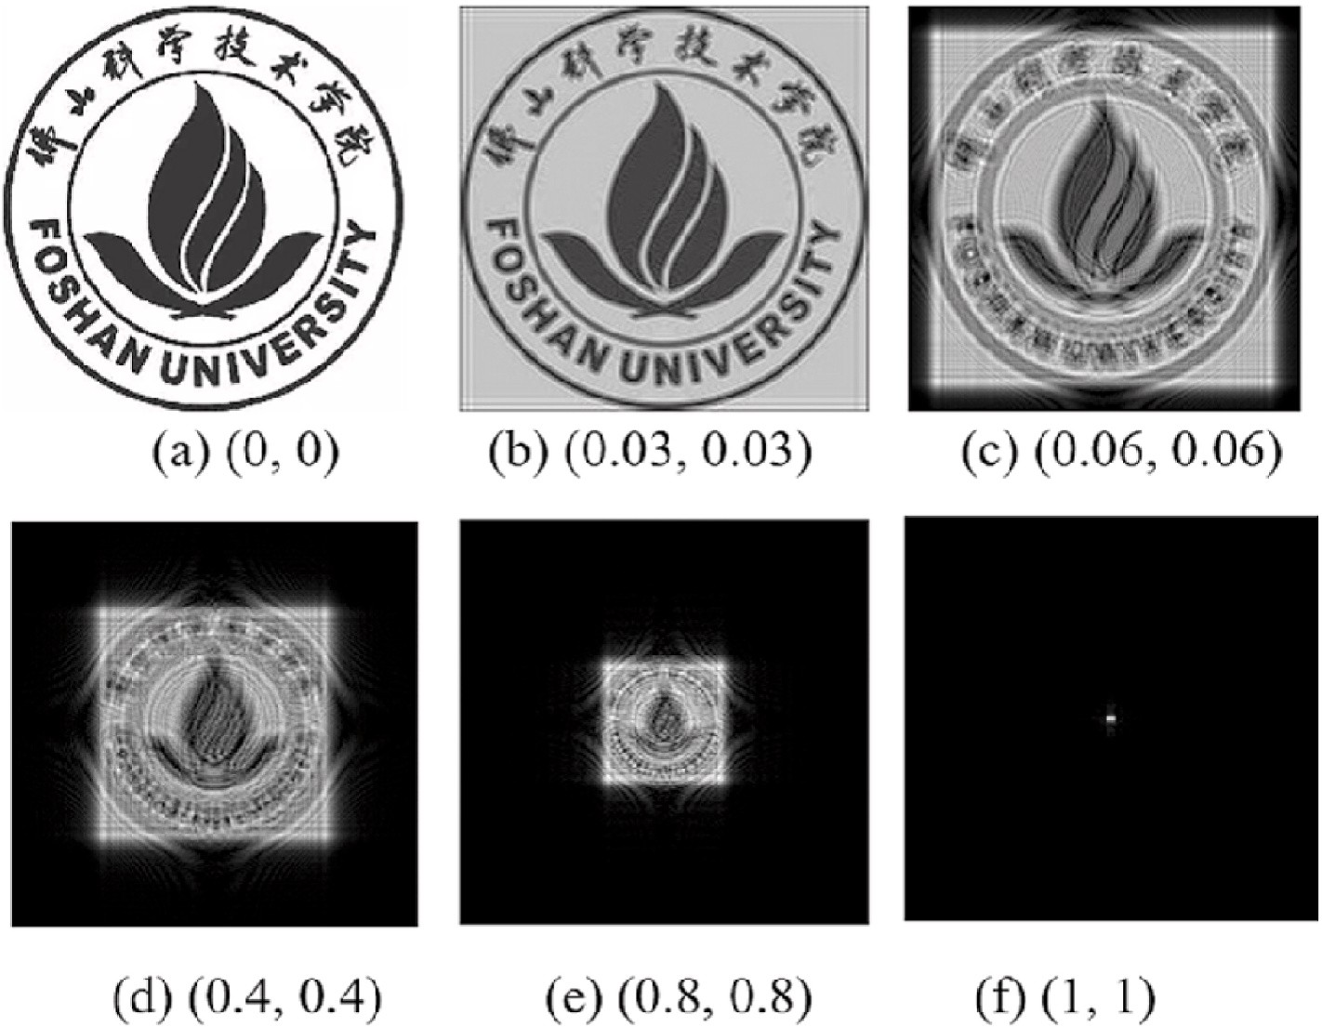

**Fig. 1.** Two-dimensional image is transformed by FRFT with different transformation orders.

mation can be restored from the transformed image after FRFT with the same transformation order of (*p*1, *p*2). If we have no correct trans- formation order, the original image feature information is not obtained correctly. The transformation order of FRFT (*p*1, *p*2) can be used as a key for image encryption. Therefore, the proposed scheme based on the

combined FRFT and other image watermarking technology will have

more freedom, security, and flexibility.

**Step (3)**: Based on the singular values *S*1 and*S*2 obtained in steps (1) and (2), a new matrix*S* is constructed according to formula (9) below. Where *k* is embedding strength. We obtain the low frequency coefficient matrix *LL IW* by applying inverse SVD transform to the new matrix *S* based on Eq. (10).

*S* = *S* + (*S* * *k*) (9)

1

1

2

# A robust watermark embedding and extracting structure based on DWT-SVD in FRFT domain

*LL IW* = *U*1\**S*\**VT*

(10)

In this study, a novel image watermarking scheme has been proposed based on DWT-SVD combined technology in FRFT domain. In this sec- tion, we comprehensively discuss the proposed watermarking scheme, including the process of watermark embedding and extraction. Suppose *I* and *W* indicate the gray cover image with dimension size *M*×*M* and the watermark image with dimension size *L* × *L*. *I_W* represents the water- marked image.

The frame diagram of watermark embedding process is illustrated in Fig. 2. The detailed steps of watermark embedding are given as follows:

**Step (1):** First, perform FRFT on the cover image *I* with the trans- formation order (*p*1, *p*2). The amplitude of the cover image after FRFT is obtained, which is implemented by the first level DWT. A low frequency approximation component (*LL1*) and three high frequency

detail components (*HL1, LH1, HH1*) of the first layer are generated after the first level of DWT. Next, the low frequency approximation coefficient (*LL1*) of the first layer is carried out by the second level DWT to produce a low frequency approximation component (*LL2*) and three high frequency detail components (*HL2, LH2, HH2*) of the second layer. Following that we apply SVD transform to the low frequency approximate coefficient *I F* (*LL2*) of the second layer and get the singular value *S*1 based on the following formula (7).

[*U*1*S*1*V*1] = *SVD*(*I F*) (7)

**Step (2)**: Perform FRFT on the watermark image W with the trans- formation order (*p*1, *p*2). Apply the SVD transform to the amplitude (*W F*) of the transformed watermark image after FRFT, and get the

corresponding singular value *S*2 according to formula (8).

**Step (4)**: The low frequency coefficient matrix *LL IW* of the above- mentioned image with watermark information features and three detail high frequency coefficients (HL2, LH2, HH2) in step (1) are transformed by the first level DWT inverse transform to obtain the

LL2′matrix coefficient, and then LL2’ matrix coefficient and three high frequency coefficients (HL1, LH1, HH1) are implemented by the

second level DWT inverse transform to obtain the low frequency coefficient matrix LL1’.

**Step (5)**: Perform FRFT inverse transform on LL1’ to form the

watermarked image I_W.

The process framework of watermark extraction is illustrated in Fig. 3, and the specific steps of watermark extraction are given as follows:

**Step (1)**: We conduct FRFT on the watermarked image I_W and obtain its amplitude as I_W’.

**Step (2)**: The first level DWT is exerted to the amplitude I_W′ and the

low frequency approximate component (LL1) of the first layer is obtained. Then the low frequency approximate component (LL1) is carried out by the second level DWT. The low frequency approximate coefficient matrix *I F*′ (LL2) of the second layer is obtained after the second level DWT transform.

**Step (3)**: The singular value matrix *S*′ is obtained by applying SVD decomposition to*I F*′ according to formula (11) below. Then the singular value matrix *S*′ corresponding to the watermark informa- tion is obtained by the rule of embedding watermark according to formula (12).

2

[*U*′ *S*′ *V*′ ] = *SVD*( *I F*′ ) (11)

2 2

*U*2*S*2*V*2] = *SVD*(*W F*) (8) ′ ′

[ *S*2 = (*S* — *S*1)/*k* (12)

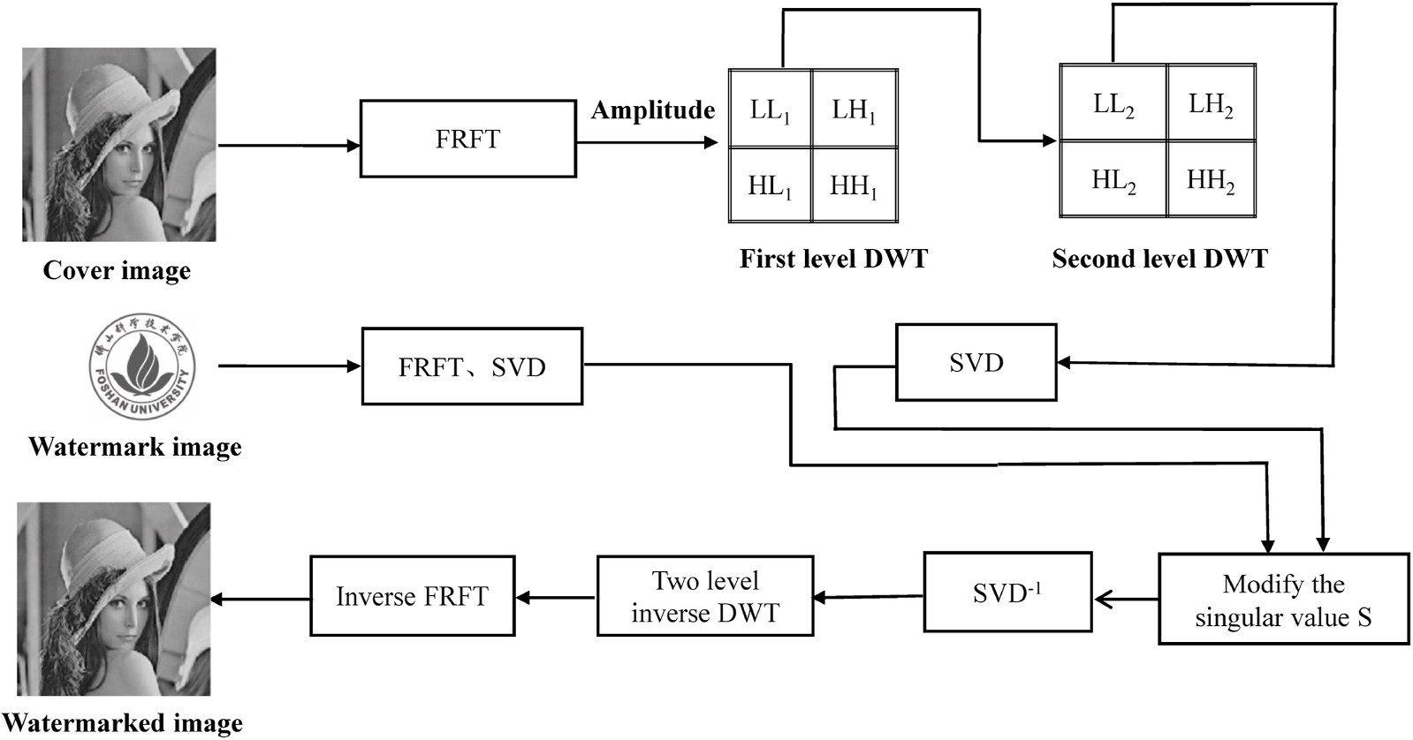

**Fig. 2.** The process diagram of watermark embedding.

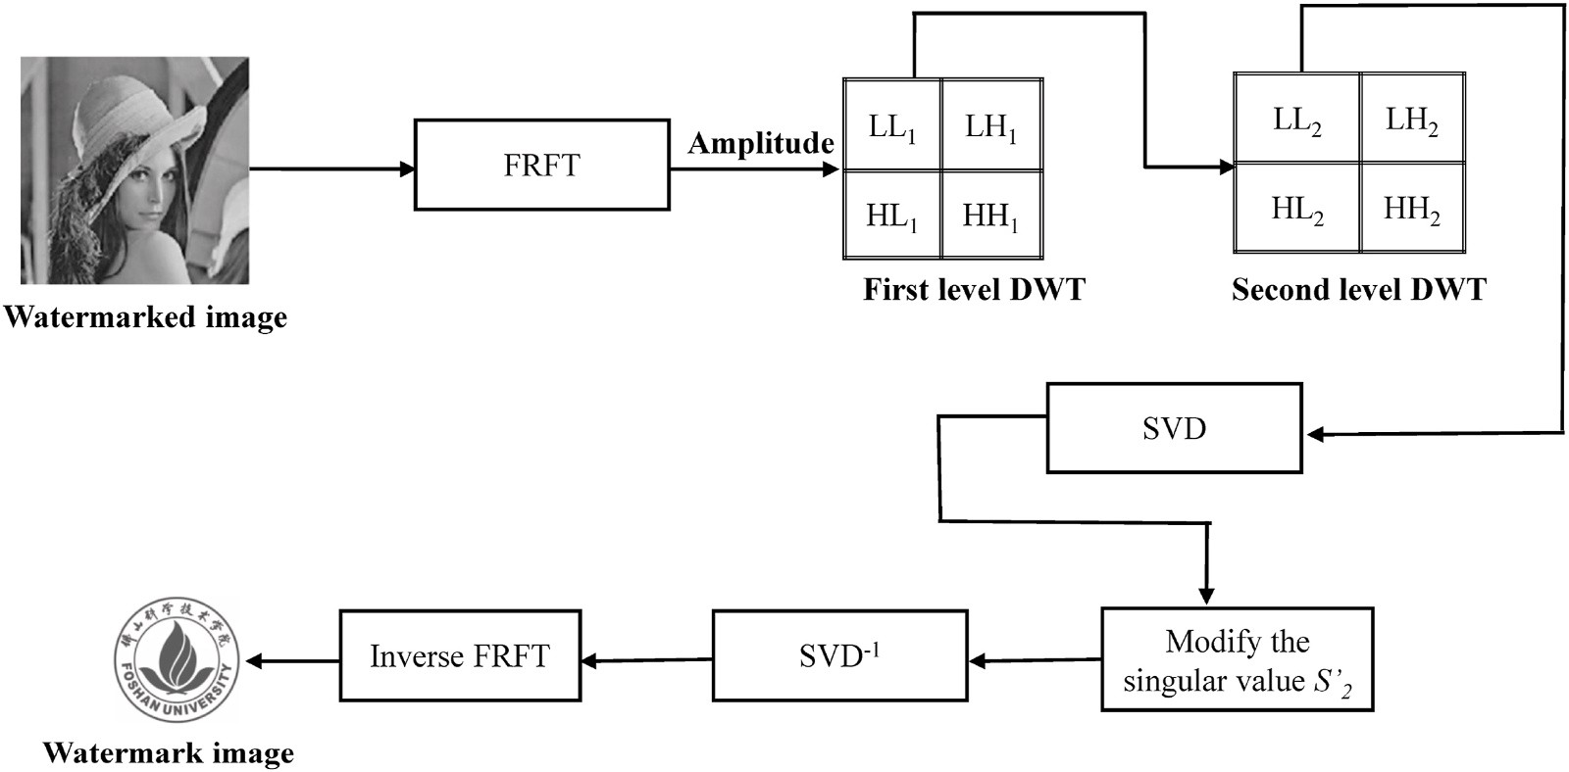

**Fig. 3.** The process diagram of watermark extracting.

**Step (4)**: For the singular value matrix *S*′

2

corresponding to the

* 1. *Means of performance evaluation*

extracted watermark information, we apply the inverse SVD decomposition on*S*′ according to formula (13) and obtain the new matrix *W*′ . Then we use the same transformation order (*p*1, *p*2) as the watermark embedding and implement inverse FRFT on the *W*′ to obtain the final watermark information.

2

Imperceptibility and robustness are two major contents of evaluation for the research of digital image watermarking algorithms. Impercepti- bility is used to assess the distortion degree of the original image after embedding watermark information. In general, *PSNR* (Peak Signal to Noise Ratio), *SSIM* (Structural Similarity), *NC* (Normalized Correlation)

*W*′ = *U* ∗*S*′ \**VT*

(13)

and *BER* (Bit Error Rate) are main means of performance evaluation for

2 2 2

# Experiment results and discussions

The cover gray-scale images with the size of 512 × 512 [Fig. 4(a) - Fig. 4(d)] and the *Foshan University* watermark gray-scale image with the

watermarking schemes. *PSNR* [18] is used to evaluate the visual quality of the image after embedding watermark information. *PSNR* is repre- sented by the following Eq. (14):

⎛⎜ 2 ⎞⎟

size of 128 × 128 [Fig. 4(e)] are selected as the simulation objects to

*PSNR* = 10log

10 ⎜

*fpeak*

*M N*

⎟

*MN i*=1 *j*=1

*dB* (14)

analyze and discuss the watermark embedding and extracting mecha- nism proposed in this paper. All numerical calculations are completed in MATLAB 2019b.

⎜⎝ 1 ∑ ∑[*f* (*i*, *j*) — *g*(*i*, *j*)]2 ⎟⎠

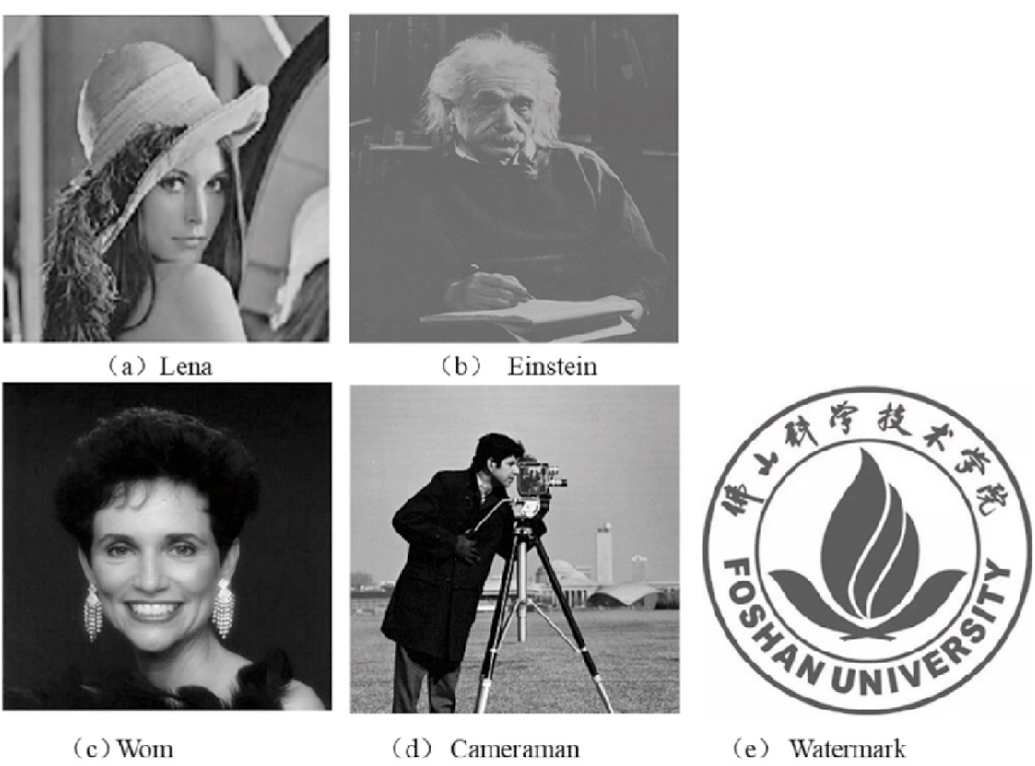

**Fig. 4.** Cover images (a)–(d) and watermark image for *Foshan University* (e).

where *fpeak* is the peak intensity of original cover image, the value of which is obtained as 255 for the commonly used 8-bit gray-scale image. *f*(*i*, *j*), *g*(*i*, *j*) Denote the gray pixel value of the original cover image and

the watermark image corresponding to the location(*i*, *j*). *M*, *N* are the

width and height of all above images. Generally speaking, the higher the *PSNR* value, the better the imperceptibility of the image, and the less the image distortion.

*PSNR* usually ignores the sensitivity of the human visual system, while *SSIM* [18] reflects the similarity of objects in the scene from image brightness, contrast and structure attributes, which can represent the lack of *PSNR* to measure the similarity of image structure. Its definition is expressed by the following formula (15):

*SSIM* = [*L*(*f* , *g*)]*α* * [*C*(*f* , *g*)]*β* *[*S*(*f* , *g*)]*γ* , (15)

*L f g* 2*μf μg* + *C*1

*μ*2 *μ*2 *C*1

*f*

*g*

extracted one with the same dimension size of*PW* × *QW* respectively in formula (19). The symbol ⊕ indicates XOR operation. Generally, the smaller the value of *BER*, the better the robustness of the watermark image.

* 1. *The determination of FRFT transformation order*

The imperceptibility and robustness are two contradictory criteria for almost all the watermarking schemes. When a watermarking scheme has higher imperceptibility, it has weaker robustness, and vice versa. In the specific evaluation index, the higher the *PSNR* and *SSIM*, the better the imperceptibility will be. In fact, lower *BER* and higher *NC* value means greater watermarking robustness. How to balance the imper- ceptibility and robustness is the first problem for the further studying of the proposed watermarking scheme in FRFT domain. The trans- formation order of FRFT must be determined so that the imperceptibility and robustness can be acceptable. We have established the quantitative

⎪⎨ *C f g*

2*σf σg* + *C*2

relationship between FRFT transformation order and *PSNR*, *SSIM*, *BER*

( , ) = *σ*2 +

*f*

*g*

⎪ + +

⎧⎪ ( , ) =

⎪

*σ*2 + *C*2

(16)

and *NC*, as shown in Fig. 5(a) to Fig. 5(d). Fig. 5(a) and (b) show the

*PSNR* and *SSIM* values of embedding watermark information in the

⎪⎪⎩ *S*(*f* , *g*) = *σfg* + *C*3

*σf σg* + *C*3

where three functions *L*(*f*, *g*), *C*(*f*, *g*), *S*(*f*, *g*) denote the comparison functions of brightness, contrast and structure respectively in formula

(16). *α*, *β*, *γ* Are parameters that represent the proportion among

brightness, contrast and structure. The larger the parameter value, the more important it will be. *μf* , *μg* Denote the mean luminance value of image*f* and image*g* respectively, and *σf* , *σg* express the variance of luminance value of image*f* and image*g* respectively. *σfg* is the covariance between image*f* and image*g*. *C*1, *C*2, *C*3 are relatively small constant terms. If *α* = *β* = *γ* = 1 and *C*2 = 2*C*3, *SSIM* index can be reduced to the following formula (17):

original cover image Lena with different FRFT transformation orders. At the same time, the average *BER* and the average *NC* of Lena are calcu- lated with FRFT transformation orders against four typical attacks, as shown in Fig. 5(c) and (d). The four typical attacks are Gaussian noise (m = 0, v = 0.05), Gaussian filtering (s = 1), histogram equalization and rotation attack (rotation angle = 30◦). As shown in Fig. 5(a) and (b), the watermarked image has better transparency with the increase of FRFT transformation order. The larger the FRFT transformation order, the larger the overall trend value of *PSNR* and *SSIM* values in a certain range will be. As shown in Fig. 5(c) and (d), the average *NC* decreases with the increasing FRFT transformation order against four typical attacks while the average *BER* shows up an opposite tendency. It means that the robustness of watermark becomes worse with the increase of FRFT

transformation order.

(

*SSIM*(*f* , *g*) =

*μ*2 + *μ*2 + *C*1)(*σ*2 + *σ*2 + *C*2

2*μf μg* + *C*1) 2*σfg* + *C*2)

*f*

*f*

(18)

*g*

*g*

From the results of Fig. 5, it is shown that the range of the appro-

priate transformation order of FRFT can be determined, to achieve a

The robustness of the algorithm is the ability of the watermarked image to against various attacks, mainly including image processing and geometric transformation. *NC* and *BER* between the original watermark and the extracted watermark are two widely common means to estimate the quality of extraction watermark. They measure the difference be- tween the extracted watermark image and the original watermark image. The larger the *NC* value, the smaller the *BER* value will be. It indicates the extracted watermark image is more similar to the original watermark image; otherwise, the extracted watermark image is less similar to the original watermark image. The *NC* is expressed as follows (17):

),

relative balance between imperceptibility and robustness. When the

transformation order of FRFT is in the range of 0–0.1, the *PNSR* and

*SSIM* values and average *NC* are relatively high and the average *BER* is low, so the imperceptibility and robustness are acceptable in this appropriate range of transformation order of FRFT.

* 1. *The analysis and discussion of imperceptibility*

In this subsection, we select four different cover images and embed the watermark into four different cover images to estimate the imper- ceptibility of our proposed watermarking scheme. The corresponding values of *PSNR* and *SSIM* have been calculated in selecting an appro-

*PW QW*

∑ ∑

*i*

[*W*(*i*, *j*) × *W*′ (*i*, *j*)]

priate FRFT transformation order *p1* = *p2* = 0.05, as described in

Table 1. The corresponding values of *PSNR* and *SSIM*, which are rela-

1 *j* 1

= =

*NC*

= √̅*P*̅̅̅̅̅̅*Q*̅̅̅̅̅̅̅̅̅̅̅̅̅̅̅̅̅̅̅̅√̅*P*̅̅̅̅̅̅*Q*̅̅*Q*̅̅̅̅̅̅̅̅̅̅̅̅̅̅̅̅̅̅̅̅̅,

∑ ∑ ( )

∑ ∑ ( )

tively high and stable, are shown in Table 1. The average value of *PSNR*

*W W W*2 *i*, *j*

*i*=1 *j*=1

*W W W*′ 2 *i*, *j*

*i*=1 *j*=1

is 57.53 and the average value of *SSIM* is 0.885, both of which are at a high level. As we can see in Table 2, the obtained PSNR for the proposed scheme are satisfactory in comparison experiments. It is demonstrated

where *W*, *W*′ indicate that the original watermark image with the same

dimension size of*PW* × *QW* as the extracted watermark. Generally, the range of *NC* value is (0, 1). The more the value of *NC* is close to 1, the more similar the two images.

The *BER* is defined as the ratio of the number of error bits to the total number of bits to measure the accuracy of data transmission. It can be expressed by formula (19) as follows:

*PW QW*

*BER* = [*W*(*i*, *j*) ⊕ *W*′ (*i*, *j*)] × 100%, (18)

1 ∑ ∑

that the proposed watermarking scheme in our paper meets the re- quirements of the imperceptibility of cover images.

* 1. *The analysis and discussion of robustness in digital watermarking*

In this section, we evaluate the robustness of our proposed water- marking scheme against many typical attacks by calculating *BER* value and *NC* value between the original watermark and the extracted one.

Generally, typical attacks mainly consist of signal processing and geo-

*PW* × *QW*

*i*=1

*j*=1

metric transformation. Signal processing attacks mainly include median filtering, Gaussian filtering, average filtering, Gaussian noise, salt and

where *W*(*i*, *j*), *W*′ (*i*, *j*) represent the original watermark image and the

pepper noise, speckle noise, JPEG compression, histogram equalization,



**Table 1**

**Fig. 5.** Relationship between transformation order of FRFT (*p1* = *p2*) and *PSNR*, *SSIM*, *NC*, *BER*.

than 0.98, while the corresponding values of *BER* are generally less than

|  |  |  |  |  |
| --- | --- | --- | --- | --- |
|  |  |  |  |  |
|  |  |  |  |  |
|  |  |  |  |  |

|  |  |  |  |  |
| --- | --- | --- | --- | --- |
|  |  |  |  |  |
|  |  |  |  |  |
|  |  |  |  |  |

0.25. In addition, the cover image Einstein containing the watermark

Objective evaluation of imperceptibility for four different cover images.

Cover image *PSNR SSIM*

|  |  |  |
| --- | --- | --- |
| Lena | 57.31 | 0.87 |
| Wom | 57.61 | 0.91 |
| Camera | 57.60 | 0.88 |
| Einstein | 57.59 | 0.88 |
| Average | 57.53 | 0.885 |

**Table 2**

Imperceptibility results comparison with related work.

image is attacked against many signal processing and geometric trans- formations and the watermark are extracted in Fig. 6. Fig. 6 illustrates the visual effect of the watermark extracted against the noise attack is slightly general, while the effect of the extracted watermark is very satisfactory against other image attacks. The above results show our proposed scheme in the paper has strong robustness for typical attacks such as image filtering, rotation attack, scaling attack, salt and pepper noise, image cropping, JPEG compression, histogram equalization, Gaussian noise, speckle noise and so on.

In the field of digital watermark, geometric attacks are often encountered, such as image rotation and image scaling. Many existing

Our Lai & al

[47]

Ganic & al

[48]

Zermi

[44]

Liu and Tan

[30]

schemes are not very strong robustness against geometric attacks [42–44]. We investigate the quality of the extracted watermark against

PSNR 57.53 50 35 55.85 53.83

contrast adjustment, motion blur, etc. Geometric transformations include image cropping, image scaling, rotation attacks, etc. The *NC* values and *BER* values are calculated for the four watermarked images, corresponding to the extracted watermark image against the above signal processing and geometric attacks, as shown in Table 3 and Table 4. The majority NC values of the extracted watermark are greater

the two geometric attacks. Specifically, the quantitative relationship

between the *NC* and *BER* values with the rotation angle and size of scale has been established, as shown in Fig. 7 and Fig. 8. As shown in Fig. 7(a) and (b), the *NC* and *BER* values change continuously with the rotation

angle in range of 0◦–90◦. When the rotation angle is greater than 50◦, most *NC* values are more than 0.97, while the *BER* value is less than

15%. In addition, the larger the rotation angle, the smaller the *BER* value will be. In the whole range of rotation angle, the values of *NC* and *BER*

|  |  |  |  |  |
| --- | --- | --- | --- | --- |
|  |  |  |  |  |
|  |  |  |  |  |
|  |  |  |  |  |
|  |  |  |  |  |
|  |  |  |  |  |

|  |  |  |  |  |
| --- | --- | --- | --- | --- |
|  |  |  |  |  |
|  |  |  |  |  |
|  |  |  |  |  |
|  |  |  |  |  |
|  |  |  |  |  |

**Table 3**

Image processing and geometric attacks (1).

Attack type Einstein Lena Wom Cameraman

*NC BER NC BER NC BER NC BER*

Gaussian filtering (3 × 3) 0.990 0.057 0.992 0.058 0.991 0.063 0.991 0.065

Gaussian filtering (5 × 5) 0.992 0.070 0.992 0.059 0.991 0.063 0.991 0.065

Gaussian filtering (9 × 9) 0.992 0.058 0.992 0.059 0.991 0.063 0.991 0.065

Median filtering (3 × 3) 0.990 0.064 0.991 0.066 0.988 0.072 0.989 0.074

Median filtering (5 × 5) 0.987 0.074 0.988 0.075 0.985 0.082 0.984 0.083

Average filtering (3 × 3) 0.989 0.068 0.990 0.069 0.988 0.074 0.987 0.078

Average filtering (5 × 5) 0.984 0.084 0.985 0.084 0.981 0.089 0.979 0.098

JPEG compression (Q = 30) 0.984 0.101 0.981 0.112 0.965 0.159 0.973 0.238

JPEG compression (Q = 60) 0.938 0.242 0.848 0.380 0.932 0.218 0.703 0.567

JPEG compression (Q = 90) 0.865 0.245 0.865 0.271 0.920 0.237 0.855 0.279

Contrast adjustment 0.954 0.563 0.958 0.624 0.635 0.716 0.945 0.589

Histogram equalization 0.984 0.215 0.981 0.215 0.987 0.215 0.988 0.215

Rotation attacks 30◦ 0.953 0.136 0.956 0.219 0.954 0.145 0.925 0.244

Rotation attacks 60◦ 0.967 0.128 0.968 0.216 0.976 0.121 0.872 0.025

Rotation attacks 90◦ 0.992 0.059 0.991 0.062 0.989 0.067 0.989 0.072

Image cropping 25% 0.970 0.125 0.979 0.532 0.991 0.063 0.941 0.182

Image cropping 50% 0.875 0.289 0.916 0.262 0.941 0.223 0.877 0.278

Image scaling 0.5 0.910 0.660 0.948 0.643 0.958 0.588 0.872 0.660

Image scaling 1.2 0.980 0.099 0.987 0.072 0.985 0.119 0.986 0.216

Image scaling 1.5 0.969 0.105 0.970 0.098 0.970 0.182 0.986 0.119

**Table 4**

Image processing and geometric attacks (2).

Attack type Einstein Lena Wom Cameraman

*NC BER NC BER NC BER NC BER*

Gaussian noise (m = 0,v = 0.01) 0.800 0.215 0.804 0.215 0.808 0.215 0.797 0.215

Gaussian noise (m = 0,v = 0.05) 0.827 0.214 0.825 0.215 0.828 0.215 0.828 0.215

Salt and pepper noise (d = 0.01) 0.883 0.213 0.886 0.213 0.887 0.213 0.884 0.213

Salt and pepper noise (d = 0.05) 0.891 0.215 0.890 0.215 0.890 0.215 0.888 0.214

Salt and pepper noise (d = 0.4) 0.801 0.215 0.811 0.215 0.810 0.215 0.807 0.215

Speckle noise (v = 0.2) 0.866 0.236 0.849 0.259 0.911 0.232 0.831 0.270

Speckle noise (v = 0.6) 0.879 0.226 0.867 0.245 0.922 0.219 0.838 0.250

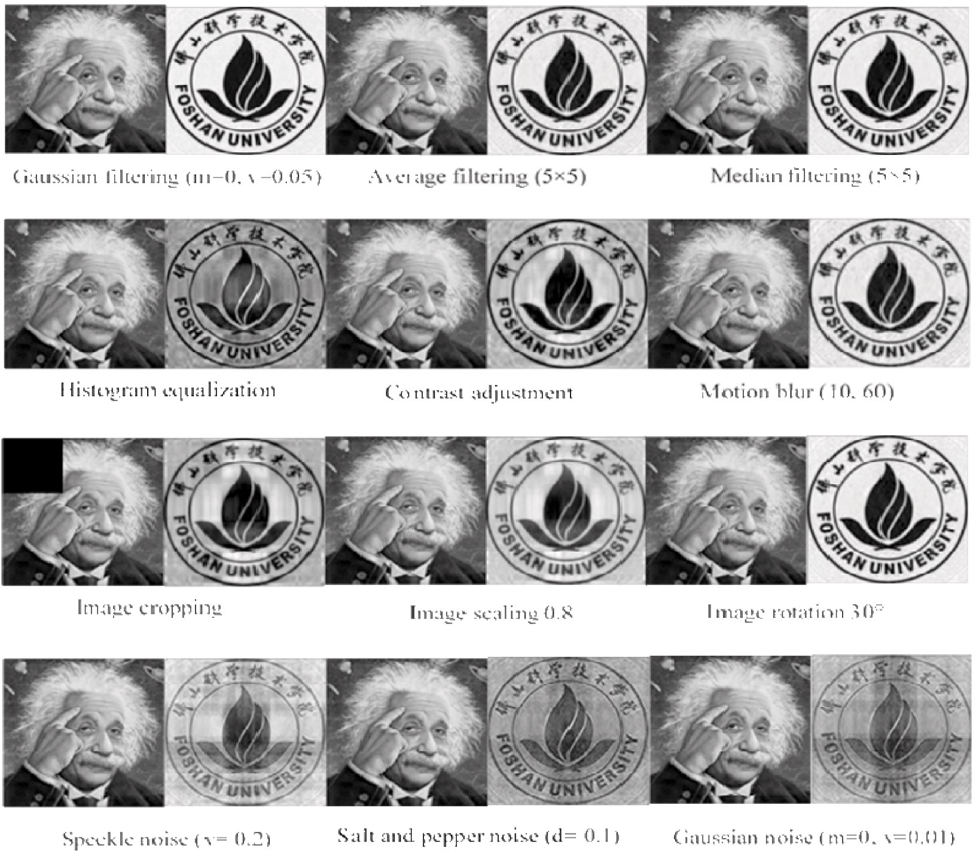

**Fig. 6.** Einstein embedded with watermark image and the extracted watermarks against different attacks.

are relatively good and acceptable. Fig. 8(a) and (b) illustrate that the *NC* values and *BER* values change with the size of scale against image scaling attacks. Here, we explore the case the size of scale is 0.5–2.5.

When the size of scale is less than 1.5, the *NC* values is greater than 0.98,

and the *BER* values is also within the acceptable range. It is demon- strated that our proposed watermarking scheme in this paper has strong robustness in anti-rotation attack and anti-scaling attack.

We calculate the *NC* values of Lena cover image against image pro- cessing, and compare them with other schemes, which are shown in Table 5 [19,36,46]. These image processing attacks include Gaussian filter (3 × 3, 5 × 5), median filter (3 × 3, 5 × 5), Gaussian noise (m = 0,

v = 0.03), pepper and salt noise (d = 0.02), average filtering (3 × 3) and histogram equalization. As shown in Table 4, the *NC* values of our proposed scheme are almost in the high range, which are slightly lower than those of Ernawan [36] for Gaussian filter (5 × 5) and median filter (3 × 3). The values of *NC* in our proposed scheme are higher than those of *NC* corresponding to Liu [19] except the Pepper and salt noise (d =

0.02) and corresponding to Zhou [46] except the Gaussian noise (m = 0, v = 0.03) and Pepper and salt noise (d = 0.02). More importantly, our proposed scheme has more obvious and outstanding advantages in anti-geometric attacks. We also calculate the values of *NC* against geo- metric attacks and compare them with the other watermarking schemes.

Fig. 9 shows the *NC* values of the extracted watermark image using different schemes [42–45]. In terms of image rotation and image crop- ping, the *NC* values of the proposed scheme in this paper are greater than those of the other four schemes [42–45], indicating its great advantages. In the aspect of image scaling, the *NC* values of our proposed scheme are

slightly larger than those of Jimson [42]and Zear [43], but much larger than those of the other two schemes.

From the experimental comparison results in Figs. 5–9 and Tables 1- 5, it is proved that our proposed scheme based on DWT and SVD in FRFT

domain provides greater imperceptibility and robustness. It has good imperceptibility and robustness for the following reasons: (1) We make use of FRFT with the ability to express the information characteristics in

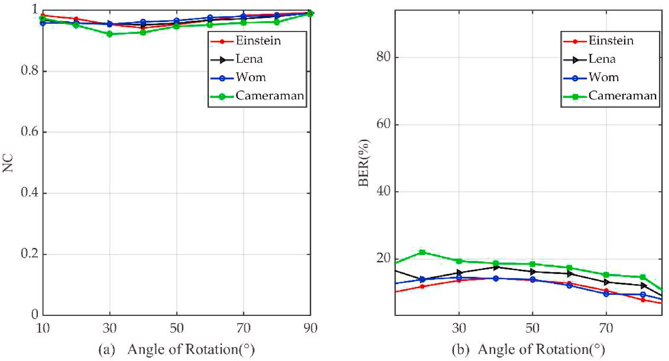

**Fig. 7.** *NC* and *BER* values of the extracted watermark with different angles against rotation attacks.

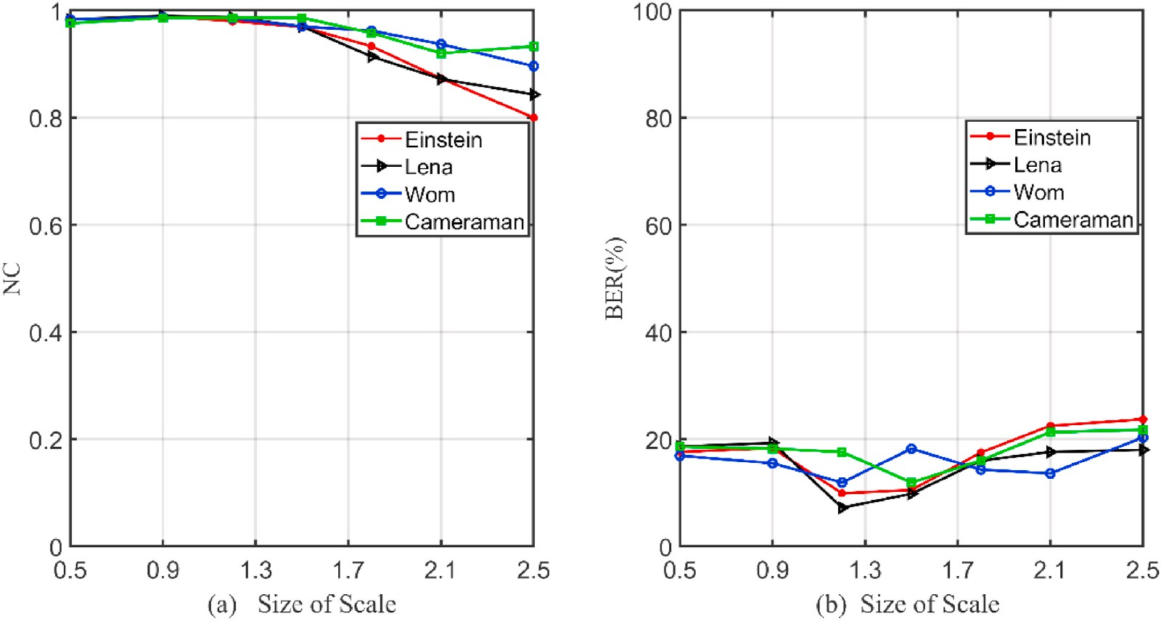

**Fig. 8.** *NC* and *BER* values of the extracted watermark with different sizes against scaling attacks.

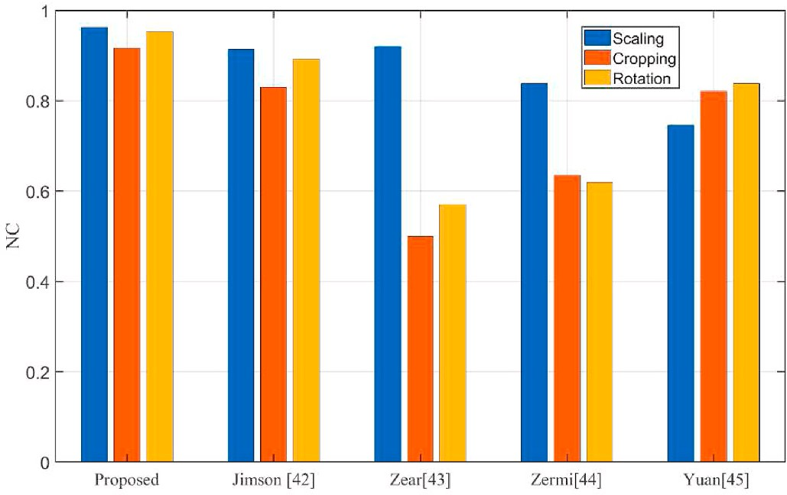**Table 5**

Comparison of *NC* values for the several schemes against different image processing.

3)

|  |  |  |  |  |
| --- | --- | --- | --- | --- |
| Attack type | Liu et al. | Ernawan et al. | Zhou et al. | Proposed |
|  | [19] | [36] | [46] |  |
| Gaussian filtering (3 × | 0.975 | 0.987 | 0.963 | **0.992** |

Gaussian filtering (5 ×

5)

0.967 0.999 0.935 **0.992**

Median filtering (3 × 3) 0.969 0.999 0.979 **0.991**

Median filtering (5 × 5) 0.945 0.710 0.972 **0.988**

Gaussian noise (m = 0, v = 0.03)

Pepper and salt noise (d = 0.02)

Average filtering (3 ×

3)

0.802 0.725 0.998 **0.825**

0.998 0.880 0.972 **0.893**

0.953 0.809 0.974 **0.990**

Histogram equalization 0.987 **—** 0.857 **0.981**

JPEG compression 0.968 0.923 0.931 **0.978** **Fig. 9.** Comparison of NC values of the extracted watermarks by different

watermarking schemes against geometric attacks ([42]Jimson et al., 2018 [43]; Zear et al., 2018 [44];Zermi et al., 2021 [45];Yuan et al., 2019).

spatial and transform domain simultaneously; (2) We have the advan- tages of both spatial and transform domain in watermarking algorithm, combining the multi-resolution features of DWT with the stability of SVD; (3) The transformation order of FRFT is used as a key in the process of extracting watermark, which can make the proposed scheme more secure.

# Conclusion

To improve the imperceptibility and robustness in invisible water- marking systems, we propose a robust and secure algorithm based on DWT and SVD transform in FRFT domain in this paper. In the pre- liminary experiment, an appropriate transformation order of FRFT is determined to offer a better balance between imperceptibility and robustness. In addition, the original cover image and watermark image are transformed by FRFT with regards to the fact that FRFT has the ability to simultaneously represent the information in spatial domain and transform domain. Furthermore, in DWT transform, the LL (low frequency component) sub-band, which has the largest energy, is selected to embed the watermark information that improves the robustness against malicious attacks. Then, the watermark embedding is implemented in SVD decomposition by adding the singular values of the original cover image with the singular values of the watermark image multiplied by a scaling factor. Besides, the safety of watermarking scheme is improved by utilizing the transformation order of FRFT. Moreover, the proposed watermarking scheme is based on DWT and SVD transforms in FRFT, which can protect the useful and informative image against various of different extreme signal processing and geo- metric attacks. The above experimental results confirm that our pro- posed scheme provides greater visual imperceptibility and robustness, especially in terms of image rotation, image cropping, average filtering, median filtering and Gaussian filtering compared to other literature schemes. In future, the authors are interested in seeking a new robust image watermarking scheme invariant to extreme signal attacks, such as speckle noise and pepper and salt noise in future communications.

# Availability of data and materials

Algorithmic data sharing is not applicable to this paper because no datasets were generated or analyzed in this study.

# Declaration of competing interest

The authors declare that they have no known competing financial interests or personal relationships that could have appeared to influence the work reported in this paper.

# Acknowledgements

We would like to acknowledge our sincere thanks to the Management of our Colleges, our Colleagues of Foshan University.

# References

1. [Dashti MT, Mauw S. Handb Financ Cryptogr Secur 2010:109–32](http://refhub.elsevier.com/S2590-0056(22)00069-8/sref1).
2. [Niu XM, Lu ZM, Sun SH, S H. Digital watermarking of still images with gray-level](http://refhub.elsevier.com/S2590-0056(22)00069-8/sref2) [digital watermarks. IEEE Trans Consum Electron 2000;46:137](http://refhub.elsevier.com/S2590-0056(22)00069-8/sref2).
3. [Hsu CT, Wu JL. Hidden digital watermarks in images. IEEE Trans Image Process](http://refhub.elsevier.com/S2590-0056(22)00069-8/sref3) [1999;8:58](http://refhub.elsevier.com/S2590-0056(22)00069-8/sref3).
4. [Shieh CS, Huang HC, Wang FH, Pan JS. Genetic watermarking based on transform-](http://refhub.elsevier.com/S2590-0056(22)00069-8/sref4) [domain techniques. Pattern Recogn 2004;37:555](http://refhub.elsevier.com/S2590-0056(22)00069-8/sref4).
5. [Mallat SG. A theory for multiresolution signal decomposition: the wavelet](http://refhub.elsevier.com/S2590-0056(22)00069-8/sref5) [representation. IEEE Trans Pattern Anal Mach Intell 1989;11:674](http://refhub.elsevier.com/S2590-0056(22)00069-8/sref5).
6. [Ariatmanto D, Ernawan F. An improved robust image watermarking by using](http://refhub.elsevier.com/S2590-0056(22)00069-8/sref6) [different embedding strengths. Multimed Tool Appl 2020;79:12041](http://refhub.elsevier.com/S2590-0056(22)00069-8/sref6).
7. [Thanki RM, Kothari AM. Hybrid domain watermarking technique for copyright](http://refhub.elsevier.com/S2590-0056(22)00069-8/sref7) [protection of images using speech watermarks. J Ambient Intell Hum Comput](http://refhub.elsevier.com/S2590-0056(22)00069-8/sref7) [2020;11:1835](http://refhub.elsevier.com/S2590-0056(22)00069-8/sref7).
8. [Fares K, Amine K, Salah E. A robust blind color image watermarking based on](http://refhub.elsevier.com/S2590-0056(22)00069-8/sref8) [Fourier transform domain. Optik 2020;208](http://refhub.elsevier.com/S2590-0056(22)00069-8/sref8).
9. [Tsui TK, Zhang XP, Androutsos D. Color image watermarking using](http://refhub.elsevier.com/S2590-0056(22)00069-8/sref9) [multidimensional fourier transforms. IEEE Trans Inf Forensics Secur 2008;3:16](http://refhub.elsevier.com/S2590-0056(22)00069-8/sref9).
10. [Verma VS, Jha RK, Ojha A. Digital watermark extraction using support vector](http://refhub.elsevier.com/S2590-0056(22)00069-8/sref10) [machine with principal component analysis based feature reduction. J Vis](http://refhub.elsevier.com/S2590-0056(22)00069-8/sref10) [Commun Image Represent 2015;31:75](http://refhub.elsevier.com/S2590-0056(22)00069-8/sref10).
11. [Su Q, Niu Y, Wang G, Jia S, Yue J. Color image blind watermarking scheme based](http://refhub.elsevier.com/S2590-0056(22)00069-8/sref11) [on QR decomposition. Signal Process 2014;94:219](http://refhub.elsevier.com/S2590-0056(22)00069-8/sref11).
12. [Singh AK, Dave M, Mohan A. Hybrid technique for robust and imperceptible](http://refhub.elsevier.com/S2590-0056(22)00069-8/sref12) [multiple watermarking using medical images. Multimed Tool Appl 2016;75:8381](http://refhub.elsevier.com/S2590-0056(22)00069-8/sref12).
13. [Tao P, Eskicioglu AM. An adaptive method for image recovery in the DFT domain.](http://refhub.elsevier.com/S2590-0056(22)00069-8/sref13) [J Multimed 2006;1:36](http://refhub.elsevier.com/S2590-0056(22)00069-8/sref13).
14. [Run RS, Horng SJ, Lai JL, Kao TW, Chen RJ. An improved SVD-based](http://refhub.elsevier.com/S2590-0056(22)00069-8/sref14) [watermarking technique for copyright protection. Expert Syst Appl 2012;39:673](http://refhub.elsevier.com/S2590-0056(22)00069-8/sref14).
15. [Patra JC, Phua JE, Bornand C. A novel DCT domain CRT-based watermarking](http://refhub.elsevier.com/S2590-0056(22)00069-8/sref15) [scheme for image authentication surviving JPEG compression. Digit Signal Process](http://refhub.elsevier.com/S2590-0056(22)00069-8/sref15) [A Rev J 2010;20:1597](http://refhub.elsevier.com/S2590-0056(22)00069-8/sref15).
16. [Rabie T, Kamel I. Toward optimal embedding capacity for transform domain](http://refhub.elsevier.com/S2590-0056(22)00069-8/sref16) [steganography: a quad-tree adaptive-region approach. Multimed Tool Appl 2017;](http://refhub.elsevier.com/S2590-0056(22)00069-8/sref16) [76:8627](http://refhub.elsevier.com/S2590-0056(22)00069-8/sref16).
17. [Singh S, Rathore VS, Singh R. Hybrid NSCT domain multiple watermarking for](http://refhub.elsevier.com/S2590-0056(22)00069-8/sref17) [medical images. Multimed Tool Appl 2017;76:3557](http://refhub.elsevier.com/S2590-0056(22)00069-8/sref17).
18. [Wang Z, Bovik AC, Sheikh HR, Simoncelli EP. Image quality assessment: from error](http://refhub.elsevier.com/S2590-0056(22)00069-8/sref18) [visibility to structural similarity. IEEE Trans Image Process 2004;13:600](http://refhub.elsevier.com/S2590-0056(22)00069-8/sref18).
19. [Makbol NM, Khoo BE, Rassem TH. Block-based discrete wavelet transform-singular](http://refhub.elsevier.com/S2590-0056(22)00069-8/sref19) [value decomposition image watermarking scheme using human visual system](http://refhub.elsevier.com/S2590-0056(22)00069-8/sref19) [characteristics. Image Process Iet 2016;10:34](http://refhub.elsevier.com/S2590-0056(22)00069-8/sref19).
20. [Ahmadi SBB, Zhang G, Wei S. Robust and hybrid SVD-based image watermarking](http://refhub.elsevier.com/S2590-0056(22)00069-8/sref20) [schemes:: a survey. Multimed Tool Appl 2020;79:1075](http://refhub.elsevier.com/S2590-0056(22)00069-8/sref20).
21. [Van Schyndel RG, Tirkel AZ, Osborne CF. A digital watermark. In: Proc. - Int. Conf.](http://refhub.elsevier.com/S2590-0056(22)00069-8/sref21) [Image process. ICIP; 1994. p. 86–90](http://refhub.elsevier.com/S2590-0056(22)00069-8/sref21).
22. [Petrovic R, Tehranchi B, Winograd JM. Digital watermarking security](http://refhub.elsevier.com/S2590-0056(22)00069-8/sref22)

[considerations. In: Proc. Multimed. Secur. Work. 2006; 2006. p. 152–7. MM](http://refhub.elsevier.com/S2590-0056(22)00069-8/sref22) [Sec’06](http://refhub.elsevier.com/S2590-0056(22)00069-8/sref22).

1. [Bender W, Gruhl D, Morimoto N, Lu A. Techniques for data hiding. IBM Syst J](http://refhub.elsevier.com/S2590-0056(22)00069-8/sref23) [1996;35:313](http://refhub.elsevier.com/S2590-0056(22)00069-8/sref23).
2. [Abdulrahman AK, Ozturk S. A novel hybrid DCT and DWT based robust](http://refhub.elsevier.com/S2590-0056(22)00069-8/sref24) [watermarking algorithm for color images. Multimed Tool Appl 2019;78:17027](http://refhub.elsevier.com/S2590-0056(22)00069-8/sref24).
3. [Lin SD, Shie SC, Guo JY. Improving the robustness of DCT-based image](http://refhub.elsevier.com/S2590-0056(22)00069-8/sref25) [watermarking against JPEG compression. Comput Stand Interfac 2010;32:54](http://refhub.elsevier.com/S2590-0056(22)00069-8/sref25).
4. [Parah SA, Sheikh JA, Loan NA, Bhat GM. Robust and blind watermarking](http://refhub.elsevier.com/S2590-0056(22)00069-8/sref26) [technique in DCT domain using inter-block coefficient differencing. Digit Signal](http://refhub.elsevier.com/S2590-0056(22)00069-8/sref26) [Process A Rev J 2016;53:11](http://refhub.elsevier.com/S2590-0056(22)00069-8/sref26).
5. [Parah SA, Sheikh JA, Akhoon JA, Loan NA, Bhat GM. Information hiding in edges:](http://refhub.elsevier.com/S2590-0056(22)00069-8/sref27) [a high capacity information hiding technique using hybrid edge detection.](http://refhub.elsevier.com/S2590-0056(22)00069-8/sref27) [Multimed Tool Appl 2018;77:185](http://refhub.elsevier.com/S2590-0056(22)00069-8/sref27).
6. [Sharma A, Singh AK, Kumar P. Combining Haar wavelet and Karhunen-Loeve](http://refhub.elsevier.com/S2590-0056(22)00069-8/sref28) [transform for robust and imperceptible data hiding using digital images. J Intell](http://refhub.elsevier.com/S2590-0056(22)00069-8/sref28) [Syst 2018;27:91](http://refhub.elsevier.com/S2590-0056(22)00069-8/sref28).
7. [Wang Y, Doherty JF, Van Dyck RE. A wavelet-based watermarking algorithm for](http://refhub.elsevier.com/S2590-0056(22)00069-8/sref29) [ownership verification of digital images. IEEE Trans Image Process 2002;11:77](http://refhub.elsevier.com/S2590-0056(22)00069-8/sref29).
8. [Liu R, Tan T. An SVD-based watermarking scheme for protecting rightful](http://refhub.elsevier.com/S2590-0056(22)00069-8/sref30) [ownership. IEEE Trans Multimed 2002;4:121](http://refhub.elsevier.com/S2590-0056(22)00069-8/sref30).
9. [Anand A, Singh AK. An improved DWT-SVD domain watermarking for medical](http://refhub.elsevier.com/S2590-0056(22)00069-8/sref31) [information security. Comput Commun 2020;152:72](http://refhub.elsevier.com/S2590-0056(22)00069-8/sref31).
10. [Wang S, Meng X, Yin Y, Wang Y, Yang X, Zhang X, Peng X, He W, Dong G, Chen H.](http://refhub.elsevier.com/S2590-0056(22)00069-8/sref32) [Optical image watermarking based on singular value decomposition ghost imaging](http://refhub.elsevier.com/S2590-0056(22)00069-8/sref32) [and lifting wavelet transform. Opt Laser Eng 2019;114:76](http://refhub.elsevier.com/S2590-0056(22)00069-8/sref32).
11. [Bagheri Baba Ahmadi S, Zhang G, Wei S, Boukela L. An intelligent and blind image](http://refhub.elsevier.com/S2590-0056(22)00069-8/sref33) [watermarking scheme based on hybrid SVD transforms using human visual system](http://refhub.elsevier.com/S2590-0056(22)00069-8/sref33) [characteristics. Vis Comput 2020;3](http://refhub.elsevier.com/S2590-0056(22)00069-8/sref33).
12. [Ernawan F, Ramalingam M, Sadiq AS, Mustaffa Z. An improved imperceptibility](http://refhub.elsevier.com/S2590-0056(22)00069-8/sref34) [and robustness of 4x4 DCT-SVD image watermarking using modified entropy.](http://refhub.elsevier.com/S2590-0056(22)00069-8/sref34)

[J Telecommun Electron Comput Eng 2017;9:111](http://refhub.elsevier.com/S2590-0056(22)00069-8/sref34).

1. [Kumar Arvind, Agarwal Pragya, Choudhary Ankur. A digital image watermarking](http://refhub.elsevier.com/S2590-0056(22)00069-8/sref35)

[technique using cascading of DCT and biorthogonal wavelet transform. In: Proc.](http://refhub.elsevier.com/S2590-0056(22)00069-8/sref35) [Int. Conf. Recent Cogniz. Wirel. Commun. Image process.; 2016. p. 21–9](http://refhub.elsevier.com/S2590-0056(22)00069-8/sref35).

1. [Ernawan F, Kabir MN. A blind watermarking technique using redundant wavelet](http://refhub.elsevier.com/S2590-0056(22)00069-8/sref36)

[transform for copyright protection. In: Proc. - 2018 IEEE 14th Int. Colloq. Signal](http://refhub.elsevier.com/S2590-0056(22)00069-8/sref36) [process. Its Appl. CSPA 2018; 2018. p. 221–6](http://refhub.elsevier.com/S2590-0056(22)00069-8/sref36).

1. [Sejdi´c E, Djurovi´c I, Stankovi´c L. Fractional Fourier transform as a signal](http://refhub.elsevier.com/S2590-0056(22)00069-8/sref37)

[processing tool: an overview of recent developments. Signal Process 2011;91:1351](http://refhub.elsevier.com/S2590-0056(22)00069-8/sref37).

1. [Parot V, Sing-Long C, Lizama C, Tejos C, Uribe S, Irarrazaval P. Application of the](http://refhub.elsevier.com/S2590-0056(22)00069-8/sref38) [fractional fourier transform to image reconstruction in MRI. Magn Reson Med](http://refhub.elsevier.com/S2590-0056(22)00069-8/sref38) [2012;68:17](http://refhub.elsevier.com/S2590-0056(22)00069-8/sref38).
2. [Rawat S, Raman B. A blind watermarking algorithm based on fractional Fourier](http://refhub.elsevier.com/S2590-0056(22)00069-8/sref39) [transform and visual cryptography. Signal Process 2012;92:1480](http://refhub.elsevier.com/S2590-0056(22)00069-8/sref39).
3. [Zhang F, Mu X, Yang S. Multiple-chirp typed blind watermarking algorithm based](http://refhub.elsevier.com/S2590-0056(22)00069-8/sref40) [on fractional fourier transform. In: Proc. 2005 Int. Symp. Intell. Signal process.](http://refhub.elsevier.com/S2590-0056(22)00069-8/sref40)

[Commun. Syst. ISPACS 2005; 2005. p. 141–4](http://refhub.elsevier.com/S2590-0056(22)00069-8/sref40).

1. [Shi J, Zhang NT, Liu XP. A novel fractional wavelet transform and its applications.](http://refhub.elsevier.com/S2590-0056(22)00069-8/sref41) [Sci China Inf Sci 2012;55:1270](http://refhub.elsevier.com/S2590-0056(22)00069-8/sref41).
2. [Jimson N, Hemachandran K. DFT based coefficient Exchange digital image](http://refhub.elsevier.com/S2590-0056(22)00069-8/sref42) [watermarking. In: Second International Conference on Intelligent Computing and](http://refhub.elsevier.com/S2590-0056(22)00069-8/sref42) [Control systems, Madurai, India; 2018](http://refhub.elsevier.com/S2590-0056(22)00069-8/sref42).
3. [Zear, Singh AK, Kumar P. A proposed secure multiple watermarking technique](http://refhub.elsevier.com/S2590-0056(22)00069-8/sref43)

[based on DWT, DCT and SVD for application in medicine. Multimed Tool Appl](http://refhub.elsevier.com/S2590-0056(22)00069-8/sref43) [2018;77:4863–82](http://refhub.elsevier.com/S2590-0056(22)00069-8/sref43).

1. [Zermi N, Khaldi A, Kafi MR, et al. A lossless DWT-SVD domain watermarking for](http://refhub.elsevier.com/S2590-0056(22)00069-8/sref44)

[medical information security. Multimed Tool Appl 2021;(4)](http://refhub.elsevier.com/S2590-0056(22)00069-8/sref44).

1. [Yuan Z, Liu D, Zhang X, et al. New image blind watermarking method based on](http://refhub.elsevier.com/S2590-0056(22)00069-8/sref45) [two-dimensional Discrete Cosine Transform. Optik - Int J Light Electron Opt 2019;](http://refhub.elsevier.com/S2590-0056(22)00069-8/sref45) [204:164152](http://refhub.elsevier.com/S2590-0056(22)00069-8/sref45).
2. [Zhou X, Zhang H, Wang C. A robust image watermarking technique based on DWT,](http://refhub.elsevier.com/S2590-0056(22)00069-8/sref46) [APDCBT, and SVD[J]. Symmetry 2018;10(3):77](http://refhub.elsevier.com/S2590-0056(22)00069-8/sref46).
3. [Lai CC. Digital image watermarking using discrete wavelet transform and singular](http://refhub.elsevier.com/S2590-0056(22)00069-8/sref47) [value decomposition[J]. IEEE Trans Instrum Meas 2010;59(11):3060–3](http://refhub.elsevier.com/S2590-0056(22)00069-8/sref47).
4. [Ganic E, Eskicioglu AM. Robust DWT-SVD domain image watermarking:](http://refhub.elsevier.com/S2590-0056(22)00069-8/sref48)

[embedding data in all frequencies. In: Proc. Workshop multimedia security,](http://refhub.elsevier.com/S2590-0056(22)00069-8/sref48) [Magdeburg, Germany; 2004. p. 166–74](http://refhub.elsevier.com/S2590-0056(22)00069-8/sref48).