[Array 14 (2022) 100155](https://doi.org/10.1016/j.array.2022.100155)

Contents lists available at [ScienceDirect](http://www.sciencedirect.com/science/journal/25900056)

Array

journal homepage: [www.sciencedirect.com/journal/array](https://www.sciencedirect.com/journal/array)

An appropriate discrete-transformation technique for order reduction methodology

Amit Kumar Choudhary a,*, Praveen Kumar a, Santosh Kumar Verma b

a *Department of Electrical Engineering, BIT Sindri, Dhanbad 828123, Jharkhand, India*

b *Department of Electronics & Instrumentation, Assam Energy Institute, Sivasagar 785697, Assam, India*

A R T I C L E I N F O

*Keywords:*

Discrete-time domain Error analysis Interval systems

Reduction methodology Step response Transformation techniques

*A B S T R A C T*

Various transformation techniques are known for transforming continuous-time to discrete-time domains and vice-versa, among which only two techniques are used in application frequently. This paper attempts to access both the techniques presenting a suitable consequence of their sole importance. The assessment of these two techniques is made on the basis of computation of reduced order model of discrete-time interval systems. Approximate models obtained after the transformations lead to the same response, and the outcome in favor of one technique. As a conclusion, the appropriate transformation is mathematically preferred over another based on its simplicity and ease of computation. Examples illustrating the comparisons are accompanied. Eventually, the assessment demonstrated in this article would be helpful to the mathematicians, mathematics educators and researchers working in the area of model order reduction.

# Introduction

Discretization is an important data processing task and includes many advantages as; it is less prone to variance in estimation from small fragmented data; amount of data under consideration is reduced as redundant data can be recognized and neglected; provides better per- formance for the rule extraction. There are numerous ways of trans- formation from continuous-time domain to discrete-time domain and

vice-versa and can be accessed in Refs. [1–4]. But well-known and easily accessible are *i*) Eulers Forward differentiation method, *ii*) Eulers

Backward differentiation method, *iii*) Zero Order Hold (*ZOH*) method,

*iv*) Tustins method with frequency prewarping, or Bilinear trans- formation, and *v*) Matched Pole-Zero mapping. All these transformations fall under frequency-domain. In addition, time-domain transformations are impulse-invariance and step-invariance methods. Each of the transformations has their own practical and theoretical importance with differences among each other, which when studied would be lengthy and exhaustive. At par, their individual study is out of scope for this article. However, an attempt to present an appropriate transformation techniques for its wide application to order reduction methodologies in discrete-time domain is made here.

Till date, to the authors’ knowledge, no discussion is available that specifies, which of the either transformation is more accurate or

preferable for obtaining reduced order models. This sets the motive of the paper to attempt for a convincing difference between the two transformation methods based on their simplicity and ease of compu- tation via order reduction of discrete-time interval systems. Moreover, this assessment of the frequently used transformation techniques would be helpful to the researchers who work on a higher order system for improvement of the system performance. Also, this paper does not provide any new outcome, but attempts to offer a firm justification, in a manner to directly aim which of the two transformation techniques is to be used.

In this exploration, focus is on the two frequently used discretization techniques, which are different from the computation point of view. A brief about the outcome of the discussion made in this submission is presented in section 1 followed by a literature survey section 2, for the methodologies available for order reduction using different trans- formation techniques. In section 3, the two transformation techniques chosen for realization or assessment in the presented illustration is re- ported. Section 4 comprises the preliminaries required throughout the discussion to validate the statement of proof for the conclusion derived. This section is divided in two subsections *a*) reduction methodology used and *b*) the performance measure of the obtained results via two transformations. Section 5 aim to present some numerical examples to solidify the findings via varied transformations. Assessment and

* Corresponding author.

*E-mail address:* [amit.ee@bitsindri.ac.in](mailto:amit.ee@bitsindri.ac.in) (A.K. Choudhary).

<https://doi.org/10.1016/j.array.2022.100155>

Received 25 September 2021; Received in revised form 17 February 2022; Accepted 1 April 2022

Available online 6 April 2022

2590-0056/© 2022 The Authors. Published by Elsevier Inc. This is an open access article under the CC BY-NC-ND license ([http://creativecommons.org/licenses/by-](http://creativecommons.org/licenses/by-nc-nd/4.0/) [nc-nd/4.0/](http://creativecommons.org/licenses/by-nc-nd/4.0/)).

validation of the obtained results through step responses of the higher- order and obtained reduced-order systems is in section 6 along with the computed errors. The limitation found during the findings of the outcome from this article is discussed in section 7. Finally, the key dif- ference between the two methods is offered in section 8 as conclusions with a possible future scope.

# Literature survey

Systems with huge parameters are represented through finite dif- ferential equations, resulting in an overall higher order system transfer function. It then becomes anticipated for researchers to represent such models by an approximate model of lower order. Here, outburst the idea of order reduction, to estimate the original large-scale system by a smaller model, which recovers the former information numerically by integrating the model of reduced size. The reduced models also preserve

fewer of the dynamic characteristic like time moments, markov pa- rameters, and stability. Literature in Refs. [5–11] extensively provide numerous techniques for order reduction of non-interval, which now

have advanced to interval systems.

With time span and easy access of digital signals and systems, discrete-time systems gained their consideration over analogue systems for control and analysis. Since, the study and analysis of such systems of higher order in their raw form is uneasy; they also demand their order reduction for easy access. Order reduction techniques available in literature showcase the advancement of fewer order reduction tech- niques in continuous-time domain directly to the discrete-time domain, both for non-interval and interval systems. Such type of algorithms in- cludes Pade approximation, balanced truncation, direct truncation, ag- gregation. Apart from these, an algorithm like Routh approximation in the continuous-time domain is not applicable to discrete-time domain directly. A vast range of algorithms based on Routh approximation is consisted in Ref. [12]. This call for an appropriate discretization tech- nique of the discrete-time systems to continuous-time and vice-versa with an ease of computation. Precisely, the transformation modifies the discrete-time system to continuous-time system; order reduction methodology applied, and finally, an appropriate inverse transformation results in the desired reduced model in discrete-time domain.

From the literature available, transformation techniques used widely for either discrete-time non-interval or interval systems are namely Tustin or bilinear or trapezoidal method [13–21] and Eulers Forward

differentiation method [22–25]. In recent literature, Ruchira [26]

employed bilinear transformation and Potturu and Prasad [27], used linear transformation. In 2020, Deveerasetty and Nagar [28] proposed reduction of discrete-time interval systems using both linear and bilinear transformations.

Available library of literature represent the possible dilemma of the researchers in terms of which transformation technique to be employed for better outcome. The present article might be a possible solution to

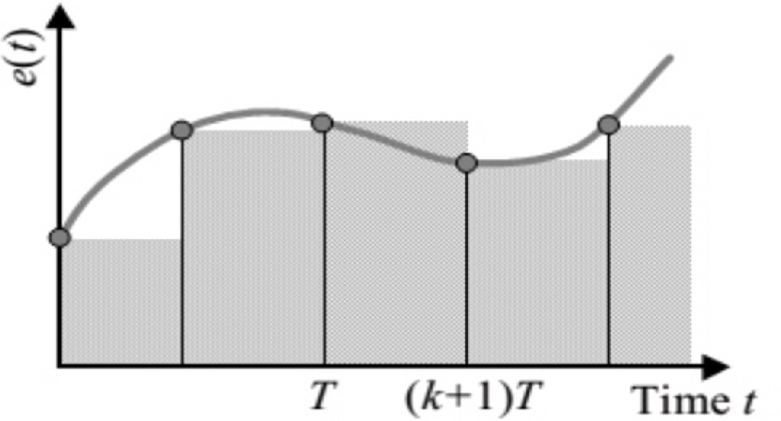

**Fig. 1.** Bilinear or Tustin or trapezoidal transformation (*w*-domain).

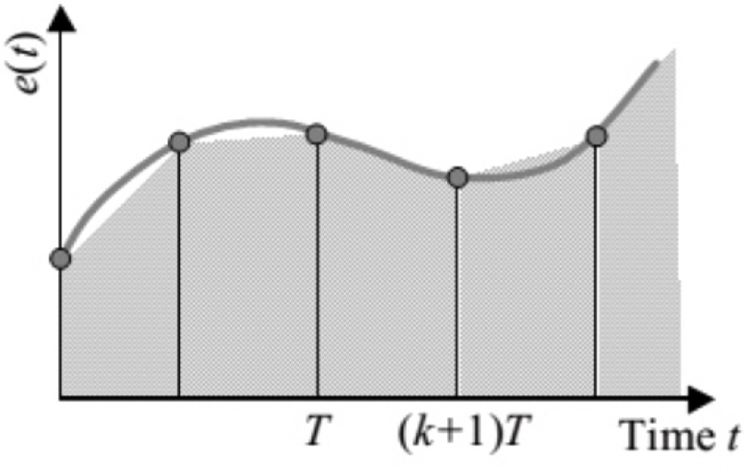

**Fig. 2.** Forward difference or linear transformation (*p*-domain).

* 1. *Bilinear or tustin or trapezoidal transformation (w-domain)*

In *z*-plane, the frequency appears as *z* = *ejωt*, and its response loses the simplicity of logarithmic plots. It is to be noted that the *z*-trans- formation maps the primary and complementary strips of the left of the *s*-plane into the unit circle in the *z*-plane. Thus conventional frequency response methods, do not apply to the *z*-plane. To overcome this diffi- culty, the pulse transfer function in the *z*-plane is transformed to *w*-

plane. The *w*-transformation states *z* = (1+(*T*/2)*w*), where *T* is the sam-

1—(*T*/2)*w*

pling period. The inverse transformation is *w* = 2 *z*—1).

*T*

*z*+1

Through the *z*-transformation and the *w*-transformation, the primary strip of the left half of the *s*-plane is first mapped inside the unit circle in the *z*-plane and then mapped to the entire left half of the *w*-plane. The

origin in the *z*-plane maps to the point *w* = —2 in the w-plane.

such researchers. *ω T*

As *s* varies from 0→*j s* along *jω* axis, *z* varies from 1 to —1 along the

2

# Transformation techniques

unit circle in *z*-plane, and *w* varies from 0 to 1 along the imaginary axis in the *w* plane. The difference between the *s*-plane and *w*-plane is that

the frequency range —1*ωs* ≤ *ω* ≤ 1*ωs* in the *s*-plane maps to the range in

Conversion from discrete-time to continuous-time domain is impor- 2 2

tant in a manner to apply the continuous-time algorithms to discrete- time systems. As stated in introduction, there are many transformation techniques but only two of them, namely, Tustin and Forward difference transformation techniques are considered in this paper, as these are applied widely for order reduction of discrete-time systems as survey in section 2. Here, they have been chosen to establish their grandness in the area of discrete-time interval system, stating a significant difference among each other. Short discussion about both the techniques is offered in this section for their better understanding [29]. Their integral ap- proximations can be seen in Fig. 1 for bilinear or Tustin or trapezoidal transformation (*w*-domain) and Fig. 2 for forward difference respectively.

the *w*-plane, where *v* is the fictitious frequency. Thus, there is a compression of the frequency scale. Although, the *w*-plane resembles the *s*-plane geometrically, the frequency axis in the *w*-plane is distorted.

* 1. *Forward difference or linear transformation (p-domain)*

Tustin transformation had fever difficulties in its application to filter design, thus calling for matched *z*-transformation where *z* = *ept*. This was successfully implemented and used in digital control systems. It’s a

simpler version where *z* = 1 + *p* and is prevailed by employing forward

Euler rule to the matched *z*-transform equality and retaining the first two terms in the resultant expansion. Such transformations are of special

significance in the design of audio and telephone networks.

* 1. *Comparison between the techniques based on stability*

In terms of stability transformation from *z*-to-*w* or *p*-domain can be better understood by the figures below. Fig. 3 and Fig. 4, illustrates stability region Re*(s) < 0* mapped on the complex *z*-plane for the for- ward difference and trapezoidal approximation respectively. By using forward difference approximation, the stability region (*LHP*) is mapped to the half-plane to the left of 1 on the complex *z*-plane. Thus, with forward difference approximation, it is possible that a stable discrete- time controller will be approximated by an unstable continuous-time controller.

The bilinear transformation (trapezoidal or Tustin approximation) maps the left half s-plane into the unit disc. Hence, stable discrete (continuous) controllers are approximated by stable continuous (discrete) controllers and unstable continuous (discrete) controllers are mapped to unstable discrete (continuous) controllers. In practice, the Tustins approximation (bilinear transformation) is the approximation of choice for converting continuous-time (discrete) controllers to discrete- time (continuous) controllers.

# Preliminaries

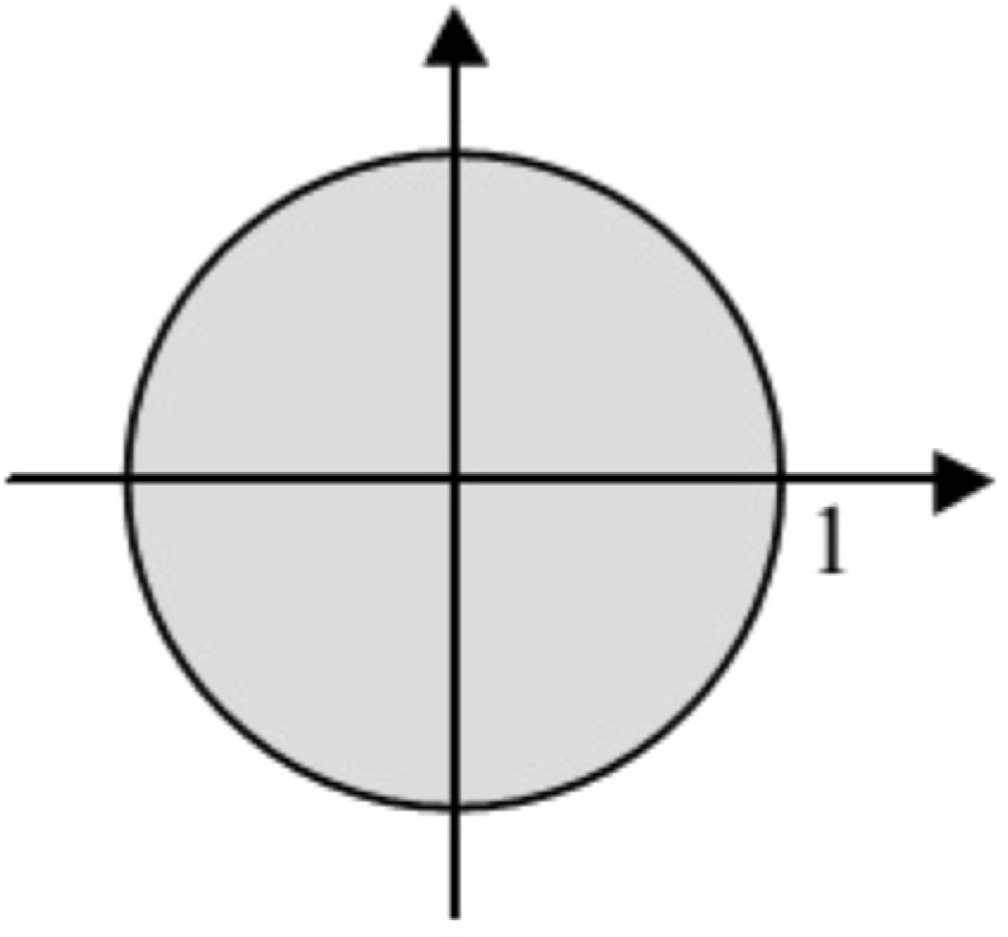

**Fig. 4.** Bilinear or Tustin or trapezoidal transformation (*w*-domain).

This section is divided under two subheadings to understand the discovery of the paper through *a*) Reduction methodology applied for the approximation and *b*) the Performance Analysis of the obtained systems on the basis of error computation and step response.

*Tn*(*z*) = *Cn* (*z*)

*D z*

*n*( )

where *Cn*(*z*) = [*C*—, *C*+]*zn*—1 + [*C*—, *C*+]*zn*—2 + ... + [*C*—, *C*+]

(1)

1 1 2 2 *n n*

* 1. *Reduction methodology*

Till date, there are numerous order reduction methodologies avail- able both in continuous-time as well as discrete-time domain ranging

from non-interval systems to interval systems. Any of the prevailing

*Dn*(*z*) = [*D*—, *D*+]*zn* + [*D*—, *D*+]*zn*—1 + ... + [*D*—, *D*+]

*Rk*(*z*) = *Ck* (*z*)

0 0 1 1 *n n*

*Dk*(*z*)

(2)

where *Ck*(*z*) = [*c*—, *c*+]*zk*—1 + [*c*—, *c*+]*zk*—2 + ... + [*c*—, *c*+]

reduction algorithms can be chosen for deriving the reduced models. The methodology considered here is available from the literature as

*Gamma-Delta approximation* [13]. The desires of the reductions meth- odologies to be depicted below;

Consider a higher order system (1) whose equivalent model of reduced dimension (2) is to be derived, where *k* < *n*.

1 1 2 2 *k k*

*Dk*(*z*) = [*d*—, *d*+]*zk* + [*d*—, *d*+]*zk*—1 + ... + [*d*—, *d*+]

0 0 1 1 *k k*

Furthermore, the algorithmic rules illustrated in the flowchart in Fig. 5, pose all the similarities step by step, except the transformations

techniques, *z* = 1+*w*) in *w*-domain and *z* = 1 + *p* in *p*-domain and their

1—*w*

respective inversions.

As depicted, the essentials of the higher-order systems and reduced- order models are understood, an illustrative explanation of the employed approximation methodology is performed here for both the transformation techniques.

* + 1. *Bilinear transformation (w-domain)*

The mentioned transformation on (1) results the higher-order in- terval system as

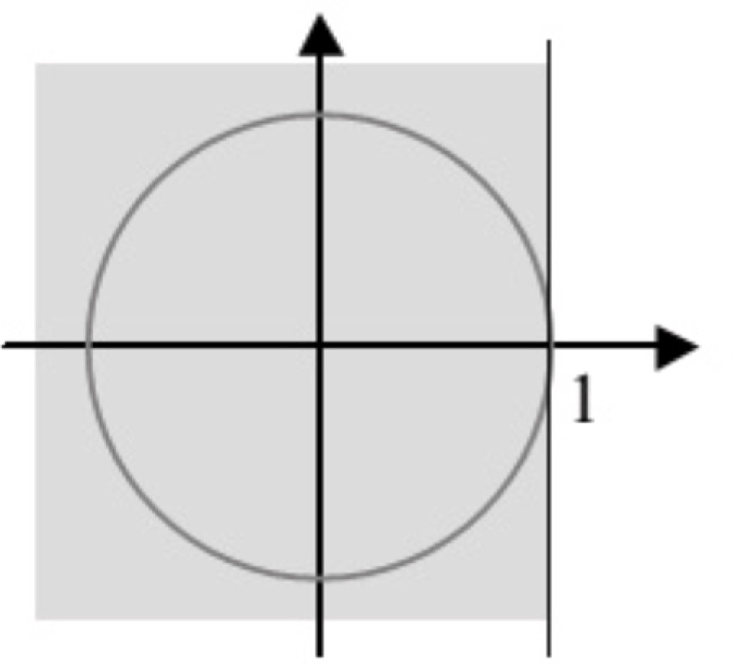*Tn*(*w*) = *Nn* (*w*)

*Dn*(*w*)

where *Nn*(*w*) = [*n*—, *n*+]*wn* + [*n*—, *n*+]*wn*—1 + ... + [*n*—, *n*+]

(3)

0 0 1 1 *n n*

*Dn*(*w*) = [*d*—, *d*+]*wn* + [*d*—, *d*+]*wn*—1 + ... + [*d*—, *d*+]

0

0

1

1

*n*

*n*

Now, tabulate the first two rows of Tables 1 and 2 using the *Dn*(*w*)

and *Nn*(*w*) respectively of *Tn*(*w*).

The coefficients from third rows of Tables 1 and 2 are computed by the Routh algorithm with *i* = *2; 3* and *j* = *0; 1; 2*.

[*d*

—

[ — +] [ —

+ ] *i*—2,0

+

*i*—2,0

, *d*

[*d* ,

—

*i*—1,*j*+1

][*d*

+

*i*—1,*j*+1

, *d*

]

**Fig. 3.** Forward difference or linear transformation (*p*-domain).

*di*,*j* , *di*,*j*

= *di*—2,*j*+1 , *di*—2,*j*+1 —

—

*i*—1,0

+

*i*—1,0

*d*

] (4)

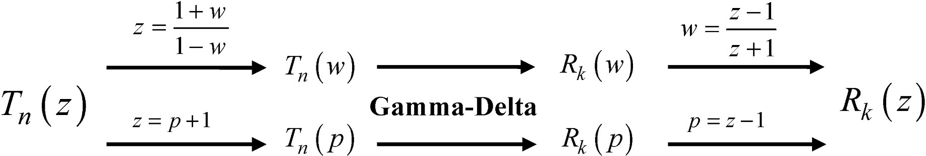

**Table 1**

Routh table for Denominator.

[*d*—, *d*+] = [*d*— , *d*+ ] [*d*—

, *d*+

**Fig. 5.** Flowchart of the algorithmic rules of Gamma-Delta Approximation.

*z*—1 *z*+1

).

* + 1. *Euler forward difference transformation (p-domain)*

] = [*d*— , *d*+ ] [*d*— , *d*+ ] = [*d*— , *d*+ ]

*n n* 0,0

0,0

*n*—2

*n*—2

0,1

0,1

*n*—4

*n*—4

0,2

0,2

For analysis through this transformation, replace *z* in the higher

[*d*—

,*d*+

] = [*d*— ,*d*+ ] [*d*—

, *d*+

] = [*d*— , *d*+ ] [*d*—

, *d*+

] = [*d*— , *d*+ ]

*n*—1

…

—

[*d*

*n*—1,0

*n*—1

*n*—1,0 ]

, *d*

+

1,0

1,0

*n*—3

*n*—3

1,1

1,1

*n*—5

*n*—5

1,2

1,2

order transfer function (1) by *z* = 1 + *p* and proceed through algorithmic steps from (3) to (11) and apply inverse transformation *p* = *z* — 1 to get

the system in *z*-domain.

[*d*— , *d*+ ]

*n*,0 *n*,0

* 1. *Performance Analysis*

**Table 2**

Routh table for Numerator.

[*n*—, *n*+] = [*n*—0 , *n*+0 ] [*n*— 2 , *n*+ 2 ] = [*n*—1 , *n*+1 ] [*n*— 4 , *n*+ 4 ] = [*n*—2 , *n*+2 ]

*n*

*n*

1,

1,

*n*—

*n*—

1,

1,

*n*—

*n*—

1,

1,

Gamma-Delta approximation, is used to retain the dynamic charac- teristic of the reduced model comparable to higher order system. Step response, a common analysis tool and Integral Square Error, most

[*n*— 1 ,*n*+ 1 ] = [*n*—0 ,*n*+0 ] [*n*— 3 , *n*+ 3 ] = [*n*—1 , *n*+1 ] [*n*— 5 , *n*+ 5 ] = [*n*—2 , *n*+2 ]

practiced performance measure (both available in literature) is used to

*n*—

…

—

[*n*

*n*—1,0

*n*— 2, 2,

*n*—1,0 ]

, *n*

+

*n*— *n*—

2, 2,

*n*— *n*—

2, 2,

validate the obtained reduced models after the two transformations.

Since, the paper deals with discrete-time interval systems, perfor-

[*n*— , *n*+ ]

*n*,0 *n*,0

[ ][ ]

*ni*—2,*j*+1 , *ni*—2,*j*+1

—

—

+

[*d*

—

*d*+

+

] (5)

+

mance measure *J* is modified as weighted error sum over a fixed interval of time, determined by the error between the transient responses of the higher order system, and the lower order system, expressed as;

[ — + ] [ —

*ni*,*j* , *ni*,*j*

=

] *ni*—2,0 , *ni*—2,0

*di*—2,*j*+1 , *di*—2,*j*+1

∑∞

*J* =

[*yn*(*k*) — *yk*(*k*)]2 (12)

—

*i*—2,0

,

*i*—2,0

*k*=0

The completion of the two tables formulate towards the desired *k*th order reduced model which is obtained by retaining the *γ*— *δ* parameters of first *k* rows of Tables 1 and 2

The desired interval parameters *γ*' *s* and *δ*' *s* are obtained from Tables 1 and 2 respectively as

where *yn*(*k*) and *yk*(*k*) are the step responses of the higher order *Tn*(*z*)

and reduced order system *Rk*(*z*) respectively.

The obtained reduced system is guaranteed to be approximate when *J* is minimum. For this analysis, the higher and reduced systems are considered as, *1*) Transfer function with only lower limits and *2*)

[*d*—

, *d*+ ]

[*n*— , *n*+ ]

Transfer function with only upper limits. Thereafter, *J* is computed

[*γ*—, *γ*+] =

[*d* ,

*k k*

*k*—1,0

—

*k*,0

*k*—1,0 *and*

+

*k*,0

[*δ*—, *δ*+]

*k*,0

=

[*d*—

*d* ]

*k k*

*k*,0 ,

*k*,0

(6)

+

*k*,0

independently for the two transfer functions for observation under the

error column for lower limit and upper limit as shown in the tables in section 6. The stated section also offers the step responses of the higher

with *k* = *1, 2, 3, …*

*d* ]

On appropriate substitution of the computed *γ* — *δ* parameters, the reduced model is observed as

and reduced order interval systems.

# Experimental results

*Rk*(*w*) = *Nk* (*w*)

*D w*

*k*( )

with

(7)

Two examples with the same reduction methodology, but varied in the realization of transformation are provided here to solidify the ob- servations made in the previous sections. This would help in under- standing the difference between the two techniques.

*Dk*(*w*) = *w*2*Dk*—2(*w*) + [*γ*—, *γ*+]*Dk*—1(*w*) (8)

Example 1: Consider the third order interval system as

*k k*

[ ] [ ]

*Nk*(*w*) = *δ*—, *δ*+ *wk*—1 + *w*2*Nk*—2(*w*) +

*γ*—, *γ*+ *Nk*—1(*w*) (9)

*T*3(*z*) =

(13)

[5.4, 5.5]*z* + [1, 1.1]*z* + [1.5, 1.6]*z* + [2.1, 2.15]

*k*

*k*

*k*

*k*

[3.25, 3.35]*z*2 + [3.5, 3.65]*z* + [2.8, 3]

3

2

where *D*—1(*w*) = 1, *D*0(*w*) = 1, *N*—1(*w*) = 0, *N*0(*w*) = 0.

*w*

Considering equations (7)–(9), the first and second order reduced models obtained are

1. The Tustin transformation (*w*-domain) *z* = 1+*w*) leads to

*T* [—2.85, —2.4]*w*3 + [1.3, 2.35]*w*2 + [—9.05, —8.9]*w* + [9.55, 10]

1—*w*

[*δ*—, *δ*+]

3(*w*) =

[3.65, 4]*w*3 + [19.8, 20.45]*w*2 + [9.15, 9.8]*w* + [10, 10.35]

*R*1(*w*) = 1 1

(10)

*w* + [*γ*—, *γ*+]

(14)

1 1

' '

[*δ*—, *δ*+]*w* + [*γ*—, *γ*+][*δ*—, *δ*+]

*w*2 + [*γ*—, *γ*+]*w* + [*γ*—, *γ*+][*γ*—, *γ*+]

Interval parameters *γ s* and*δ s*, are computed as

*R*2(*w*) = 2 2

2

2

2 2 1 1

2

2

1

1

(11)

[*γ γ* ]

[*γ γ* ]

The computed reduced model in *w*-domain, is reversed back to its

—, +

= [1.02, 1.13] ;

—, +

= [0.51, 0.69]

1

1

2

2

1

1

2

2

equivalent *z*-domain by enforcing inverse Tustin transformation *w* =

[*δ*—, *δ*+] = [0.97, 1.09] ; [*δ*—, *δ*+] = [—0.63, — 0.49]

1. The forward difference or linear transformation (*p*-domain) *z* = 1 + *p* transforms (13) to (15) and the respective *γ*' *s* and*δ*' *s*, pa- rameters as

*T* [3.25, 3.35]*p*2 + [10, 10.35]*p* + [9.55, 10]

**Table 4**

Error for 2nd order for example 1.

|  |  |  |  |
| --- | --- | --- | --- |
| Transformation | Error |  |  |
|  | Lower Limit | Upper Limit |
| *w*-domain | 0.0822 | 0.0116 |  |
| *p*-domain | 0.0011 | 0.0441 |  |

3(*p*) =

[5.4, 5.5]*p*3 + [17.2, 17.6]*p*2 + [19.7, 20.3]*p* + [10, 10.35]

(15)

[*γ*—, *γ*+] = [0.49, 0.53] ; [*γ*—, *γ*+] = [1.12, 1.18]

1 1 2 2

[*δ*—, *δ*+] = [0.47, 0.51] ; [*δ*—, *δ*+] = [0.57, 0.60]

1

1

2

2

**Table 5**

Error for 2nd order for example 2.

On substitution of the above obtained parameters in (11), results in simplified z-domain model with varied transformations as

*R* [—0.137, 0.244]*z*2 + [0.85, 1.107]*z* + [0.995, 1.376]

2*w*(*z*) = 2 (16)

[2.032, 2.464]*z* + [—0.958, —0.447]*z* + [0.834, 1.266]

Transformation Error

Lower Limit Upper Limit

*w*-domain 0.1158 0.1352

*p*-domain 0.0016 0.1724

*R*2*p*

[0.568, 0.601]*z* + [—0.475, —0.402]

(*z*) =

*z*2 + [—0.881, —0.820]*z* + [0.550, 0.619]

(17)

The step responses of the reduced models and higher order systems for Example 1 and 2 are shown in Figs. 6 and 7 respectively. The heavy

Example 2: Consider an eighth order interval real-time system as

solid line represents the response of the higher-order system and the other dotted lines depict the responses of the reduced models through

*T* (*z*) = *C*7 (*z*)

8 *D* (*z*)

8

where

(18)

both transformation techniques respectively.

From Figs. 6 and 7, it can observed that the step responses of the higher order and reduced order systems for both the examples via two transformations are almost identical. Similarly, the errors in Tables 4

*C*7(*z*) = [1.6484, 1.7156]*z*7 + [1.0937, 1.1383]*z*6 + [—0.2142, —0.2058]*z*5 + [0.1490, 0.1550]*z*4

+ [—0.5263, —0.5057]*z*3 + [—0.2672, —0.2568]*z*2 + [0.0431, 0.0449]*z* + [—0.0061, —0.0059]

*D*8(*z*) = [23.52, 24.48]*z*8 + [—1.7156, —1.6484]*z*7 + [—1.1383, —1.0937]*z*6

+ [0.2058, 0.2142]*z*5 + [—0.1550, —0.1490]*z*4 + [0.5057, 0.5263]*z*3

+ [0.2568, 0.2672]*z*2 + [—0.0449, —0.0431,]*z* + [0.0059, 0.0061]

Upon respective transformation, the *γ*' *s* and*δ*' *s*, parameters are in Table 3. Further, using the computed parameters, the reduced order models in respective domains after inverse transformation into *z*-domain are obtained as

and 5 respectively are comparatively minimum and can be considered accordingly. Thus, the above results and thorough observations of the methodologies, evoke that *p*-domain discretization technique is quite simple and easy to transform, making it preferable over the *w*-domain techniques to produce similar reduced models.

Briefly, the validation of the obtained reduced models is performed on the basis of minimum error computation and approximate tracking of the step responses.

# 7. Limitation

*R* (*z*

[0.0332, 0.0400]*z*2 + [0.0070, 0.0102]*z* + [—0.0345, —0.0246]

(19)

A feasible query developed or the limitation about the offered

2*w* ) = [1.3645, 1.4733]*z*2 + [—1.9224, —1.8902]*z* + [0.6204, 0.7292]

*R* (*z*) = [0.0302, 0.0394]*z* + [—0.0358, —0.0250] (20)

2*p* 2

*z* + [—1.6665, —1.5683]*z* + [0.6080, 0.7232]

# Assessment and validation

This section attempts to assess the transformation techniques based on the computation of errors and step responses obtained between the higher-order and reduced lower-order models obtained through the different transformation techniques. Errors obtained for the Examples 1 and 2 from section 5 are shown in Tables 4 and 5 correspondingly.

**Table 3**

*w*-Domain and *p*-Domain *γ* — *δ* Parameters For Example 2.

parameters *w*-domain *p*-domain

assessment is its relevance for comparison of the performance based on the model reduction as the result may depend on the reduction tech- niques as well as the numerical examples. The answer is; yes, they are a major factor to be considered but on a large scale of simplification, the linear transformation can be applied directly to obtain an acceptable result.

# 8. Conclusions

The analysis of the two transformation techniques having their own advantages and disadvantages is outlined individually in this paper. The main goal to examine which of them supplies more convenient dis- cretization with ease is performed successfully. It is found in general that, forward difference achieves the advantages of being easy and

simple at every step. The main reason is its form of linearity *i.e. z* = 1 + *p*

instead of using rational form as *z* = 1+*w*). These observations indicate

1—*w*

that any of the two techniques can be used; as both of them result in

[*γ*—, *γ*+] [0.1190, 0.1313] [0.1189, 0.1314]

1

1

almost equivalent reduced forms but for convenience and ease of

[*γ*—, *γ*+] [0.3257, 0.4184] [0.3335, 0.4317]

2 2 computation, *p*-domain proves to be superior. The achieved results are

[*δ*—, *δ*+] [0.0107, 0.0121] [0.0107, 0.0121]

1

1

[*δ*—, *δ*+] [0.0297, 0.0380] [0.0302, 0.0394]

found a basis for further work in the area of discrete-time to continuous-

2 2 time transformation and vice-versa. Overall, the conclusion is that the

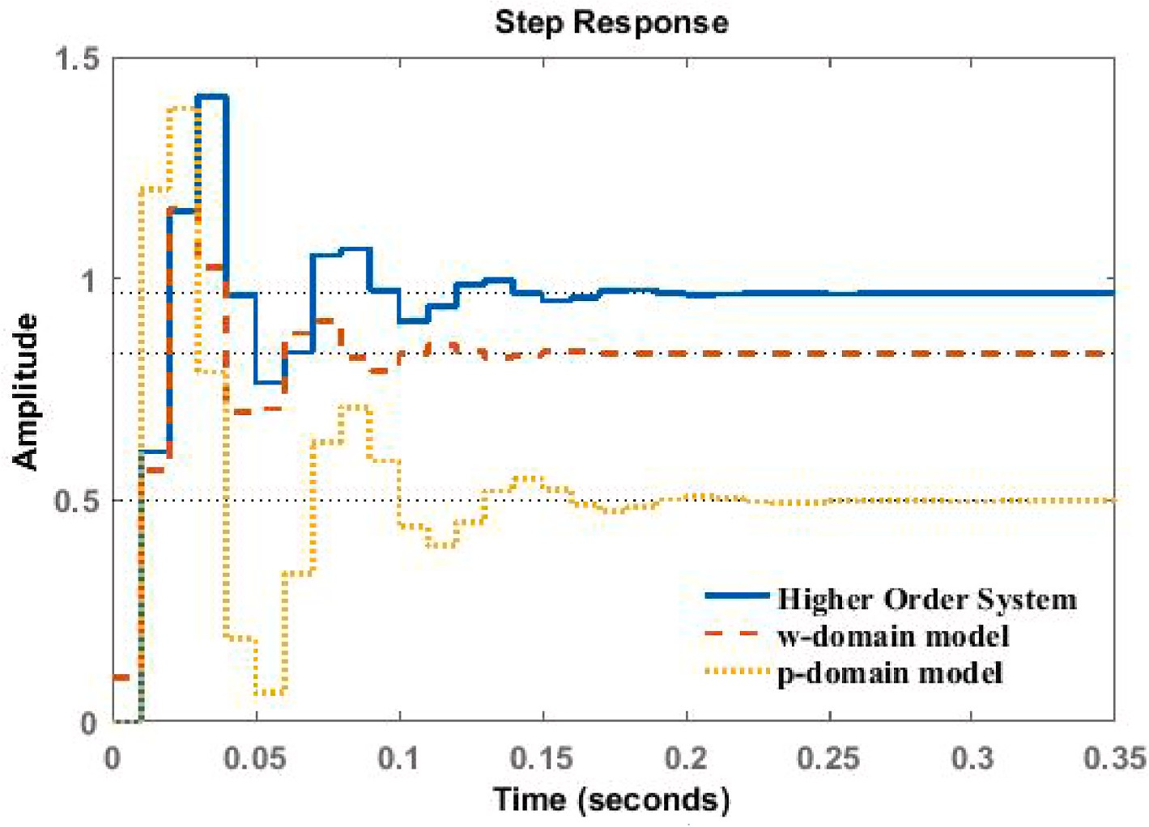

**Fig. 6.** Step response for 2nd system for Example 1.

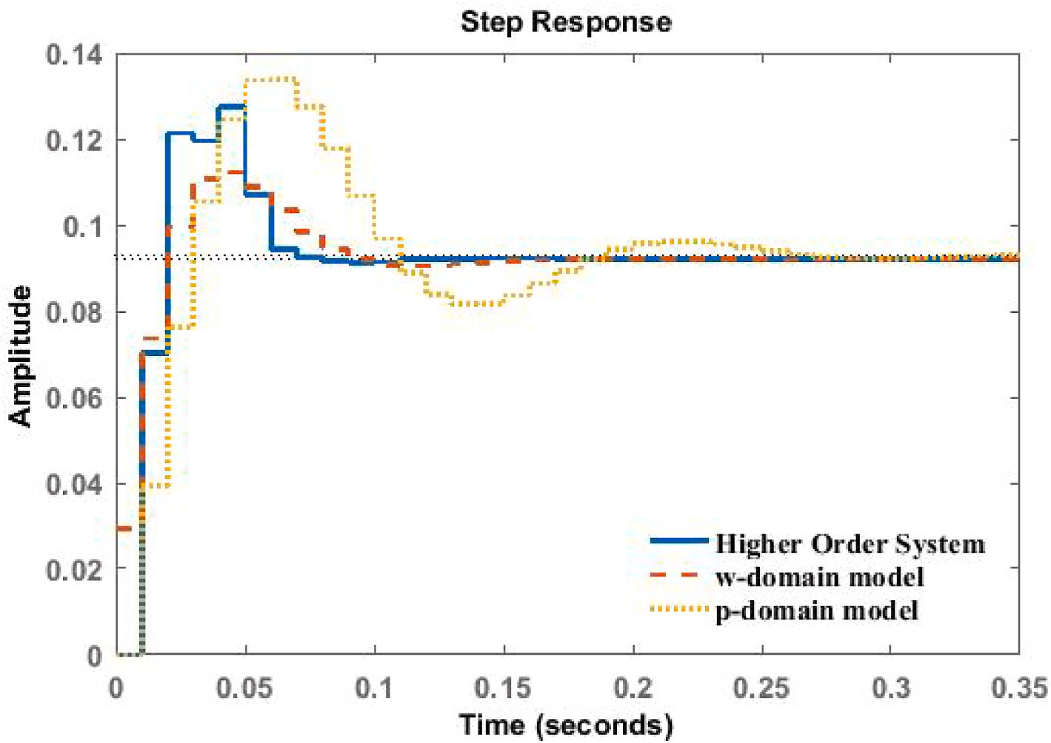

**Fig. 7.** Step response for 2nd system for Example 2.

latter technique is much simpler, matches as many moments as the former one does and hence appears to be better than the former tech- nique. Lastly, the attempt made in this paper is believed to be helpful to the researchers working on higher order systems. A future work devel- oped from this presented discussion is its practical approach on physical

system models.

# Declaration of interest statement

Authors have no conflicts of interest to declare.

# Appendix

Intervals *a* = [*a*—, *a*+] = {*a* ∈: *a*— ≤ *a* ≤ *a*+}

*b* = [*b*—, *b*+] = {*b* ∈ : *b*— ≤ *b* ≤ *b*+}

Lower Limits of interval systems *a*—, *b*—

Upper Limits of interval systems *a*+, *b*+

Arithmetic operations where ⊙ ∈ {+, —, ×, 𝚵} [*a*] ⊙ [*b*] = {*a* ⊙*b* /*a* ∈ [*a*], *b* ∈ [*b*]}

End point formulas for arithmetic operations

*a* + *b* = [*a*— + *b*—, *a*+ + *b*+] *a* — *b* = [*a*— — *b*+, *a*+ — *b*—]

*a* × *b* = [min*C*, max*C*], *C* = [*a*—*b*—, *a*—*b*+, *a*+*b*—, *a*+*b*+] *a* / *b* = *a* × (1 / *b*); 1 / *b* = [1 / *b*+, 1 / *b*—], 0 ∈/ *b*

Order of higher order systems *n*

Higher-order interval transfer function *Tn*(*z*)

Higher-order numerator interval polynomial *Cn*(*z*)

Higher-order denominator interval polynomial *Dn*(*z*) Higher order interval transfer function in *w*-domain *Tn*(*w*) Higher order interval transfer function in *p*-domain *Tn*(*p*) Order of reduced order systems *k*

Reduced - order interval transfer function *Rk*(*z*) Reduced -order numerator interval polynomial *Ck*(*z*) Reduced -order denominator interval polynomial *Dk*(*z*)

Reduced order interval transfer function in *w*-domain *Rk*(*w*) Higher order interval transfer function in *p*-domain *Rk*(*p*) Modified weighted error sum *J*

Step response of higher order interval transfer function *Tn*(*z*) *yn*(*k*) Step response of reduced order interval transfer function *Rk*(*z*) *yk*(*k*) Second order reduced model via *w*-domain *R*2*w*(*z*)

Second order reduced model via *p*-domain *R*2*p*(*z*)

# References

1. [Chen CT. Analog and digital control system design: transfer function, state-space,](http://refhub.elsevier.com/S2590-0056(22)00023-6/sref1) [and algebraic methods. Philadelphia: Harcourt Brace Jovanovich College](http://refhub.elsevier.com/S2590-0056(22)00023-6/sref1) [Publishers; 2006](http://refhub.elsevier.com/S2590-0056(22)00023-6/sref1).
2. [Franklin GF, Powell JD, Workman ML. Digital control of dynamic systems.](http://refhub.elsevier.com/S2590-0056(22)00023-6/sref2) [Addison-Wesley; 1980](http://refhub.elsevier.com/S2590-0056(22)00023-6/sref2).
3. [Haugen F. Article: discretization of simulator, filter, and PID controller. TechTeach;](http://refhub.elsevier.com/S2590-0056(22)00023-6/sref3) [2010](http://refhub.elsevier.com/S2590-0056(22)00023-6/sref3).
4. [Ogata K. Discrete-time control systems. Englewood Cliffs, New Jersey: Perentice-](http://refhub.elsevier.com/S2590-0056(22)00023-6/sref4) [Hall International, Inc.; 1995](http://refhub.elsevier.com/S2590-0056(22)00023-6/sref4).
5. [Aoki M. Some approximation methods for estimation and control of large scale](http://refhub.elsevier.com/S2590-0056(22)00023-6/sref5) [systems. IEEE Trans Automat Control 1978;23(2):173–82](http://refhub.elsevier.com/S2590-0056(22)00023-6/sref5).
6. [Antoulas AC. An overview of approximation methods for large-scale dynamical](http://refhub.elsevier.com/S2590-0056(22)00023-6/sref6)

[systems. Annu Rev Control 2005;29(2):181–90](http://refhub.elsevier.com/S2590-0056(22)00023-6/sref6).

1. [Gugercin S, Antoulas AC. A survey of model reduction by balanced truncation and](http://refhub.elsevier.com/S2590-0056(22)00023-6/sref7) [some new results. J. Contr. 2004;77(8):748–66](http://refhub.elsevier.com/S2590-0056(22)00023-6/sref7).
2. [Bosley MJ, Lees FP. A survey of simple transfer-function derivations from high-](http://refhub.elsevier.com/S2590-0056(22)00023-6/sref8)

[order state-variable models. Automatica 1972;8(6):765–75](http://refhub.elsevier.com/S2590-0056(22)00023-6/sref8).

1. [Bultheel A, Barel MV. Pade techniques for model reduction in linear system theory:](http://refhub.elsevier.com/S2590-0056(22)00023-6/sref9) [a survey. J Comput Appl Math 1986;14(3):401–38](http://refhub.elsevier.com/S2590-0056(22)00023-6/sref9).
2. [Genesio R, Milanese M. A note on the derivation and use of reduced-order models.](http://refhub.elsevier.com/S2590-0056(22)00023-6/sref10)

[IEEE Trans Automat Control 1976;21(1):118–22](http://refhub.elsevier.com/S2590-0056(22)00023-6/sref10).

1. [Penzl T. Algorithms for model reduction of large dynamical systems. Linear](http://refhub.elsevier.com/S2590-0056(22)00023-6/sref11) [Algebra Appl. 2006;415(2–3):322–43](http://refhub.elsevier.com/S2590-0056(22)00023-6/sref11).
2. Choudhary AK, Nagar SK. Order reduction techniques via Routh approximation: a

critical survey. IETE J Res 2018. [https://doi.org/10.1080/](https://doi.org/10.1080/03772063.2017.1419836) [03772063.2017.1419836](https://doi.org/10.1080/03772063.2017.1419836).

1. [Choudhary AK, Nagar SK. Gamma-Delta approximation for reduction of discrete](http://refhub.elsevier.com/S2590-0056(22)00023-6/sref13) [interval system. In: Proc. Of international joint conference on ARTCom and ARTEE,](http://refhub.elsevier.com/S2590-0056(22)00023-6/sref13) [vol. 13; 2013](http://refhub.elsevier.com/S2590-0056(22)00023-6/sref13).
2. [Choudhary AK, Nagar SK. Novel arrangement of Routh array for order reduction of](http://refhub.elsevier.com/S2590-0056(22)00023-6/sref14) [z -domain uncertain system. Syst. Sci. Contr. Eng. 2017;5(1):232–42](http://refhub.elsevier.com/S2590-0056(22)00023-6/sref14).
3. [Dinesh NS, Kumar MS, Rao DS. Order reduction of discrete time systems using](http://refhub.elsevier.com/S2590-0056(22)00023-6/sref15) [modified pole clustering technique. J. Eng. Res. Appl. 2013;3(6):565–9](http://refhub.elsevier.com/S2590-0056(22)00023-6/sref15).
4. [Hwang C, Shih YP, Hwang RY. A combined time and frequency domain method for](http://refhub.elsevier.com/S2590-0056(22)00023-6/sref16)

[model reduction of discrete systems. J Franklin Inst 1981;311(6):391–402](http://refhub.elsevier.com/S2590-0056(22)00023-6/sref16).

1. [Kumar KK, Sastry GVKR. An approach for interval discrete-time systems reduction](http://refhub.elsevier.com/S2590-0056(22)00023-6/sref17) [using least squares method. J. Eng. Res. Appl. 2012;2(5):2096–9](http://refhub.elsevier.com/S2590-0056(22)00023-6/sref17).
2. [Pan S, Pal J. Reduced order modelling of discrete-time systems. Appl Math Model](http://refhub.elsevier.com/S2590-0056(22)00023-6/sref18)

[1995;19:133–8](http://refhub.elsevier.com/S2590-0056(22)00023-6/sref18).

1. [Shih YP, Wd WT. Simplification of z -transfer functions by continued fractions.](http://refhub.elsevier.com/S2590-0056(22)00023-6/sref19)

[J. Contr. 1973;17(5):1089–94](http://refhub.elsevier.com/S2590-0056(22)00023-6/sref19).

1. [Shieh LS, Dadkhah KM, Yates RE. Reduction of z-transfer-function matrices by](http://refhub.elsevier.com/S2590-0056(22)00023-6/sref20)

[means of the mixed method. IEEE Trans Ind Electron Control Instrum 1976;23(4):](http://refhub.elsevier.com/S2590-0056(22)00023-6/sref20) [371–5](http://refhub.elsevier.com/S2590-0056(22)00023-6/sref20).

1. [Therapos CP. A direct method for model reduction of discrete systems. J Franklin](http://refhub.elsevier.com/S2590-0056(22)00023-6/sref21)

[Inst 1984;318(4):243–51](http://refhub.elsevier.com/S2590-0056(22)00023-6/sref21).

1. [Deveerasetty KK, Nagar SK. Mixed method for reducing the order of a linear](http://refhub.elsevier.com/S2590-0056(22)00023-6/sref22) [discrete time interval system. In: Proc. Of international conference on advances in](http://refhub.elsevier.com/S2590-0056(22)00023-6/sref22) [computing, vol. 14. Communication and Information Technology CCIT; 2014](http://refhub.elsevier.com/S2590-0056(22)00023-6/sref22).
2. [Farsi M, Warwick K, Guilandoust M. Stable reduced-order models for discrete-time](http://refhub.elsevier.com/S2590-0056(22)00023-6/sref23) [systems. IEEE Proc. 1986;133(3):137–41](http://refhub.elsevier.com/S2590-0056(22)00023-6/sref23).
3. [Parthasarathy R, Jayasimha KN. Modelling of linear discrete-time systems using](http://refhub.elsevier.com/S2590-0056(22)00023-6/sref24)

[modified Cauer continued fraction. J Franklin Inst 1983;316(1):79–86](http://refhub.elsevier.com/S2590-0056(22)00023-6/sref24).

1. [Tewari JP, Bhagat SK. Simplification of discrete-time systems by improved Routh](http://refhub.elsevier.com/S2590-0056(22)00023-6/sref25) [stability criterion via p-domain. IE (I) Journal EL 2004;84:189–92](http://refhub.elsevier.com/S2590-0056(22)00023-6/sref25).
2. [Ruchira. An approximation technique for order reduction of interval system. In:](http://refhub.elsevier.com/S2590-0056(22)00023-6/sref26)

[Proc. international conference on recent developments in control, automation and](http://refhub.elsevier.com/S2590-0056(22)00023-6/sref26) [power engineering; 2015. p. 346–9](http://refhub.elsevier.com/S2590-0056(22)00023-6/sref26).

1. Potturu SR, Prasad R. Model order reduction of LTI interval systems using

differentiation method based on kharitonov’s theorem. IETE J Res 2019. [https://](https://doi.org/10.1080/03772063.2019.1686663) [doi.org/10.1080/03772063.2019.1686663](https://doi.org/10.1080/03772063.2019.1686663).

1. Deveerasetty KK, Nagar SK. Model order reduction of interval systems using an arithmetic operation. Int J Syst Sci 2020. [https://doi.org/10.1080/](https://doi.org/10.1080/00207721.2020.1746433) [00207721.2020.1746433](https://doi.org/10.1080/00207721.2020.1746433).
2. [Peng H, Chiu GTC, Tsao TC. Digital control of physical systems. 2008](http://refhub.elsevier.com/S2590-0056(22)00023-6/sref29).