[](http://crossmark.crossref.org/dialog/?doi=10.1016/j.aiia.2020.06.002&domain=pdf)[](Journal%20logo)An integrated foot transducer and data logging system for dynamic assessment of lower limb exerted forces during agricultural machinery operations

Contents lists available at [ScienceDirect](http://www.sciencedirect.com/science/journal/25897217)

Artificial Intelligence in Agriculture

journal homepage: [http://www.keaipublishing.com/en/j ournals/artificial- intelligence-in-agriculture/](http://www.keaipublishing.com/en/journals/artificial-intelligence-in-agriculture/)

Smrutilipi Hota a, V.K. Tewari a, Abhilash K. Chandel b,⁎, Gajendra Singh a

a *Indian Institute of Technology Kharagpur, West Bengal, India*

b *Center for Precision and Automated Agricultural Systems, Washington State University, Prosser, WA, USA*

# a r t i c l e i n f o

*Article history:*

Received 16 May 2020

Received in revised form 13 June 2020

Accepted 14 June 2020

Available online 16 June 2020

*Keywords:*

Agricultural machinery operations Lower limb exerted forces Instrumented foot transducer

Autonomous data logging and visualization Ergonomics and safety

# a b s t r a c t

Agricultural machinery typically requires lower limb actuation forces for operations such as treadling, pedaling and tractor based. However, limited systems exist for assessment of such forces that have ergonomic influence. This study, therefore developed and evaluated a single board computer integrated foot transducer (IFT) and au- tonomous data logging and visualization system to monitor dynamic lower limb exerted forces. The system con- sists of custom developed load sensors sandwiched into foot shaped units that fit operator's both feet. Stamped forces at crank angles for operations typical to pedaling while at height (above ground level) for operation representing typical treadling operations were recorded on-board a memory card and displayed on a liquid crys- tal display. Evaluations were conducted by imposing external loads that significantly increased (*p* b 0.05) the foot exerted forces. Force trends were periodic with peaks of 73, 85, 110.5 and 145.4 N for left foot and 41, 50, 131.7 and 145.4 N for right foot at loads of 10, 30, 50 and 70 N, respectively during pedaling operations. Similarly, the left lower actuation limb exerted forces of 139, 249 and 255 N at 5, 10 and 15 N of imposed loads, respectively during treadling operation. System was also evaluated for tractor operations and exerted forces ranged from 92 to 164 and 107–176 N for clutch pedal engagement at lower to higher tractor speeds on farm and tarmacadam roads, respectively. Similarly, for brake pedal engagement, such forces ranged from 106 to 173 and 120–204 N on farm and tarmacadam roads. These forces varied significantly at different forward speeds. Results suggest poten- tial of such system for foot exerted force assessments typical to agricultural machinery systems in real field. De- signs may be evaluated or reconsidered to minimize musculoskeletal disorder risks during prolonged operations. Work-rest schedules protocols can be developed by ergonomists for safe, efficient and comfortable operations.

© 2020 The Authors. Publishing services by Elsevier B.V. on behalf of KeAi Communications Co. Ltd. This is an open access article under the CC BY-NC-ND license (<http://creativecommons.org/licenses/by-nc-nd/4.0/>).

1. Introduction

Lower limb forces are critical to operate most agricultural machinery systems that could be small (stationary or self-propelled) and large sys- tems such as tractors or tractor driven. Small systems are typical to small scale growers (e.g. in developing countries) such as pedal operated threshers and millers, treadle operated pumps, maize shellers etc. Such systems either require continuous or periodic actuation forces or forces for brake, clutch and foot throttle operations in tractors (Agrawal et al., 2007).

Ergonomics has been concerned about ‘fitting the task to the human’ through identification and quantification of threats to human health in various work environments and eliminate them through user centered product design (Miles and Steinke, 1993; Agrawal et al., 2007; Chowdhury et al., 2012; Waters, 2012; Patel

* Corresponding author.

*E-mail address:* [abhilash.chandel@wsu.edu](mailto:abhilash.chandel@wsu.edu) (A.K. Chandel).

et al., 2013). For example, foot operated tractor controls significantly contribute to the lower back pain due to lumbar spine flattening and disc pressures (Jafrey and Haslegrave, 1995). Newtonian anthropome- try reveals limitation of lower limb application forces to 30% of the 5th percentile strength for agricultural operations and are limited to 50% for short durations (up to 5 min) (Agrawal et al., 2009; Gite et al., 2009; Tiwari et al., 2010; Patel et al., 2014). Moreover, male workers can apply 1.5 times more force and power than females due to a greater muscle strength, muscle fibers and muscle cross section area (Miller et al., 1993; Agrawal et al., 2009; Gite et al., 2009; Tiwari et al., 2010). On the contrary, female muscles are more fatigue resistant and recover faster than male muscles (Fulco et al., 1999; Glenmark et al., 2004). Poor ergonomic designs of agricultural machinery may lead to lower limb musculoskeletal disorders such as acute trauma and cumulative trauma (Whiting & Zerrnicke, 1998). Acute trauma is a result of occupational load imposition exceeding the human tolerance limits while repetition of such imposition causes cumulative trauma (Carter and Banister, 1994). Similarly, working in a standing posture for a high duration

<https://doi.org/10.1016/j.aiia.2020.06.002>

2589-7217/© 2020 The Authors. Publishing services by Elsevier B.V. on behalf of KeAi Communications Co. Ltd. This is an open access article under the CC BY-NC-ND license ([http://](http://creativecommons.org/licenses/by-nc-nd/4.0/) [creativecommons.org/licenses/by-nc-nd/4.0/](http://creativecommons.org/licenses/by-nc-nd/4.0/)).

[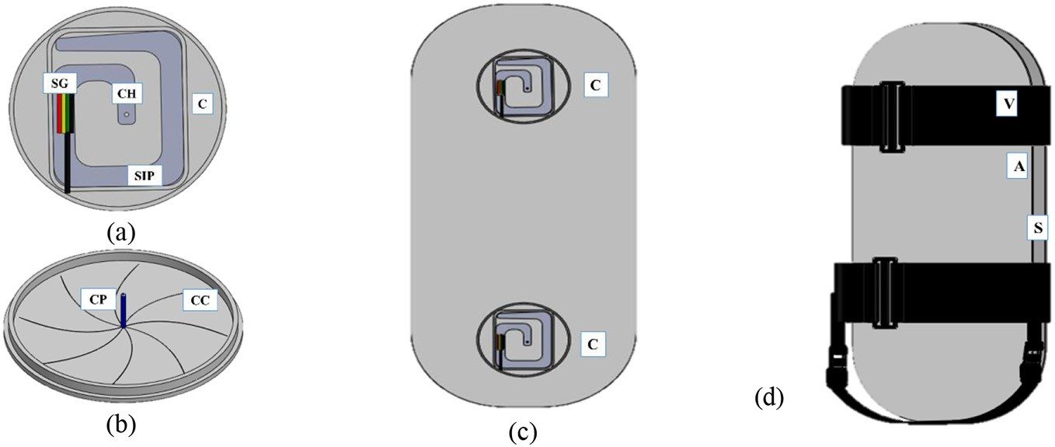](Image%20of%20Fig.%201)

Fig. 1. Blue print of the Instrumented foot transducer (IFT) (a) load sensor unit (C: Casing, SG: Strain gauge, CH: Conical hole), (b) casing cover with the conical pin (CC: Casing cover, CP: Conical pin), (c) transducer arrangement (C: Casing), and (d) complete IFT (A: Aluminum plate, V: Velcro, S: Sponge).

may cause discomforts and musculoskeletal disorders in the back and feet (Arcand et al., 2000; Gregory & Callaghan, 2008; Roelen et al., 2008; Tissot et al., 2009) that creates energy substrates, metabolic fa- tigue, tissue strain and deformation due to compression (Laperriere et al., 2006).

Above studies indicate lower limb actuation forces to be critical for ef- ficient agricultural operations. Moreover, estimation of such forces and force requirements may assist in design reconsideration and ergonomic optimization of agricultural machinery to improve tolerance limits and minimize health hazards (Mehta et al., 2007; Agrawal et al., 2009). Com- mercial lower limb force assessment units are majorly employed by the automobile or large-scale manufacturing industries for example; braking pedal force transducer (Tokyo Measuring Instruments Laboratory Co., Ltd., Tokyo, Japan), pedal dynamometer (Professional Calibrated Equip- ment instruments, Southampton, UK), compression force transducer (Wika Instruments, Lawrenceville, GA, USA), pedal force sensor (Monad Electronics). However, such systems are expensive and their application by small-scale agricultural machinery related industries is very limited.

Custom grade lower limb force transducers have been developed and experimented but majorly for sports or medical purposes. A force trans- ducer with hall-effect sensor mounted between crank and pedal was de- veloped to measure actuation forces and power employed during bicycle pedaling that reported an accuracy of 97% (Stapelfeldt et al., 2007). A pedal was instrumented with strain gauges to measure actuation forces and peak torque during cycling (Bini et al., 2013). A piezoresistive dyna- mometer was also developed to estimate pedaling force reporting 99% of accuracy (Valencia et al., 2007). These systems are majorly accompanied with complex data logging systems in addition to their utility for sports and medical purposes under controlled laboratory conditions. Any such system has not been developed or experimented for agricultural ma- chinery systems in real field conditions that offer with minimum data

recording complexities. A study was therefore conducted to develop a customized instrumented foot transducer (IFT) system integrated to a simplified data visualization and logging system to evaluate dynamic forces exerted by lower limbs during agricultural machinery operations. Included are also the preliminary evaluations under varied load imposi- tions and under real operating conditions of treadle, pedal and tractor operations.

1. Materials and methods
   1. *Foot force transducer and data logging system*

An instrumented foot transducer (IFT) was designed and developed to measure forces applied by the lower limbs of an agricultural machinery operator. The system is a sandwiched structure with plastic foam sponge placed between two shoes shaped flat aluminum plates (Fig. 1a). At two shoe ends, plastic casings were placed (Fig. 1b) as per the instep length of 95th percentile male agricultural workers (208 mm) with the total length based on the 95th percentile foot length (269 mm) to accommo- date all the male and female agricultural workers (Gite et al., 2009). The plastic casings consist of small bevel type spiral iron plate with the end at the geometrical center having a conical hole. A conical pin in the casing cover inserts into this hole (Fig. 1c & d) to induce compressive forces when acted upon by an external force on the aluminum plates. To esti- mate these forces, two strain gauges were mounted on each spiral iron plate making it a load sensor. Each load sensor then forms a half bridge and two load sensors on each sandwich unit forms a Wheatstone bridge that outputs voltage in proportion to applied force. Pair of Velcro strips were attached to the aluminum plates for attachment to operator's feet (Fig. 2).

[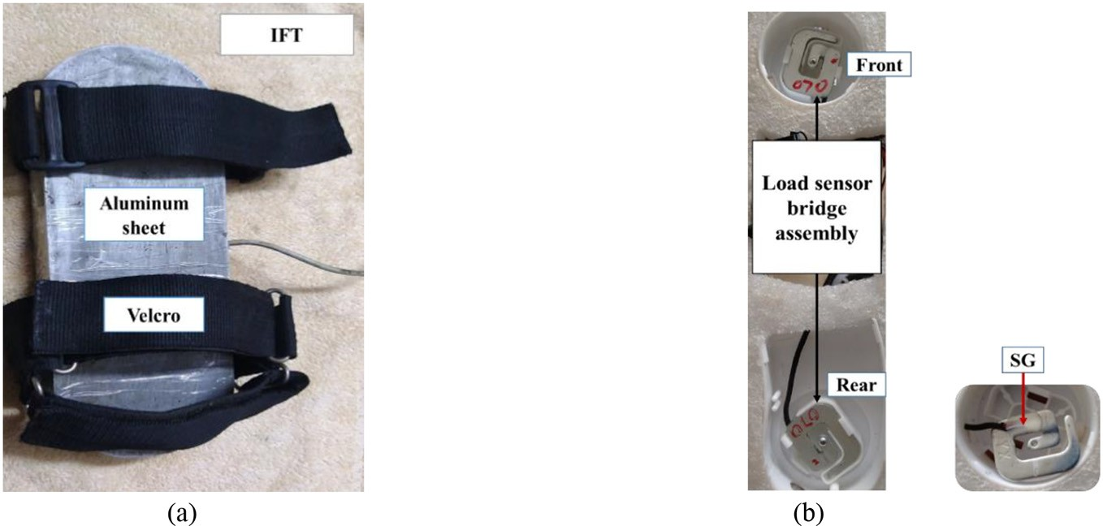](Image%20of%20Fig.%202)

Fig. 2. Fabricated unit of instrumented foot transducer (IFT) with (a) ready to use unit and (b) components (SG: Strain gauge).

The output of Wheatstone bridge was connected to the single board computer (Arduino Uno, ATmega328P, Open source community) via an amplifier (HX711, Avia Semiconductor, Xiamen, China) to obtain the net actuation force. This board (Fig. 3) was custom programmed to ac- quire actuation forces values with respect to position (height/angle). A hall-effect sensor and magnet strips were used to provide the position (or angle) information. A data storage module (SD card, Sparkfun Elec- tronics, Boulder, Colorado) was used to record these forces. These units were ensembled in a plastic box mounted with a liquid crystal display (LCD, Winstar Display Co. Ltd. Taiwan, China) to display forces in real time. This box was also provisioned for attachment to the operator's lower back.

* 1. *System functionality*

Pertinent to force assessments during a treadling operation, the hall- effect sensor was first mounted on the treadle platform opposite to a rigid bar with three magnet cells at three heights (110, 167 and 225 mm) fixed along entire stroke of the treadle platform (Fig. 4a). This arrangement was made in order to record the actuation forces with respect to the height. Similarly, for the force assessment during a pedaling operation, the hall-effect sensor was fixed on a rigid bar against the pedal gear mounted with twelve magnet cells around its cir- cumference (Fig. 4b). This arrangement provides force measurements with respect to the angle of pedal crank from vertical at a resolution of 30°. Here 0° represents left pedal at the extreme top while right pedal at the extreme bottom position. Similarly, 180° from vertical represents left pedal at the extreme bottom while right pedal at the extreme top position.

The single-board computer was custom programed for different op- erations (treadling, pedaling and tractor) in the Integrated Develop- ment Environment (Arduino IDE v1.8.4, [www.arduino.cc](http://www.arduino.cc/)) for all autonomous data logging, storage and visualization process. The system on switching ON (Fig. 5) scans if the operating unit is at the base location (height = 0 cm for treadle and angle = 0° for pedal). Once the operating unit reaches base location, the actuation force is applied via the instru- mented foot transducer for the continuous treadling and pedaling actu- ation. During the actuation, the hall-effect sensor keeps on scanning for

the magnet cells along the operation stroke. As a magnet cell is detected by the hall-effect sensor, its position is registered in the single board computer and pertinent actuation forces detected by IFTs at these posi- tions are also recorded. This position stamped force data is then stored on-board the memory card, displayed on the LCD screen and sent via se- rial communication to the receiving computer.

* 1. *Calibration and preliminary assessments*

The IFTs were initially calibrated to eliminate any systematic mea- surement errors. Each IFT was imposed over by dead weights from 0 to 30 kg incremented by 1 kg. Corresponding output loads were recorded, and calibration curves were obtained (Fig. 6) that were significantly lin- ear (Simple linear regression, Fl, 28 (left) = 3.13 × 1032, Fl, 28 (Right) =

9.77 × 1031, *p* b 0.05) with determination coefficient (R2) of 0.99. These equations for both IFTs were inserted in the single board program to obtain lower limb exerted forces.

IFTs were employed to measure the lower limb actuation forces dur- ing typical pedaling (Fig. 7a), treadling (Fig. 7b) and tractor operations (Fig. 7c) for a random selected human subject. Forces exerted by the right and left lower limbs were recorded with respect to height for trea- dling operation at external imposed loads of 5, 10, and 15 N and with re- spect to crank angle for pedaling operation at loads of 10, 30, 50 and 70 N. These loads were suspended through a belt pulley system at the shaft center of the custom treadling and pedaling platform. The operator used his right foot on the operating treadle while the left foot on the ground during the treadling operation. The actuation forces for engage- ment and disengagement of the brake and clutch pedals were measured during a tractor hauling operation at three different forward speeds and on two different land surfaces (tarmacadam and farm road).

1. Results and discussions
   1. *Force measurement during pedaling operation*

Pertinent to a typical pedaling operation the actuation force exerted by the right foot under 10 N of externally applied load ranged from

−32 N at the crank angle of 60° to 23 N at the crank angle of 210°.

[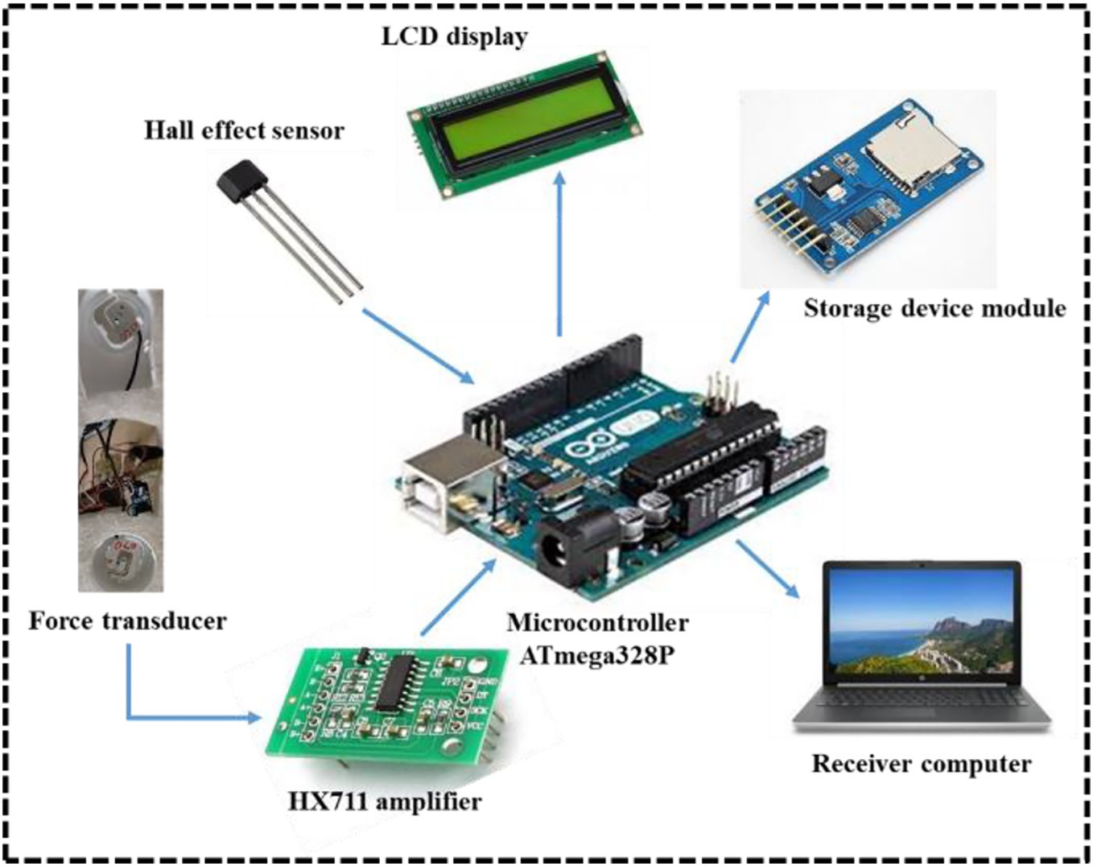](Image%20of%20Fig.%203)

Fig. 3. Block diagram of the integrated data logging and visualization unit for lower limb exerted forces.

[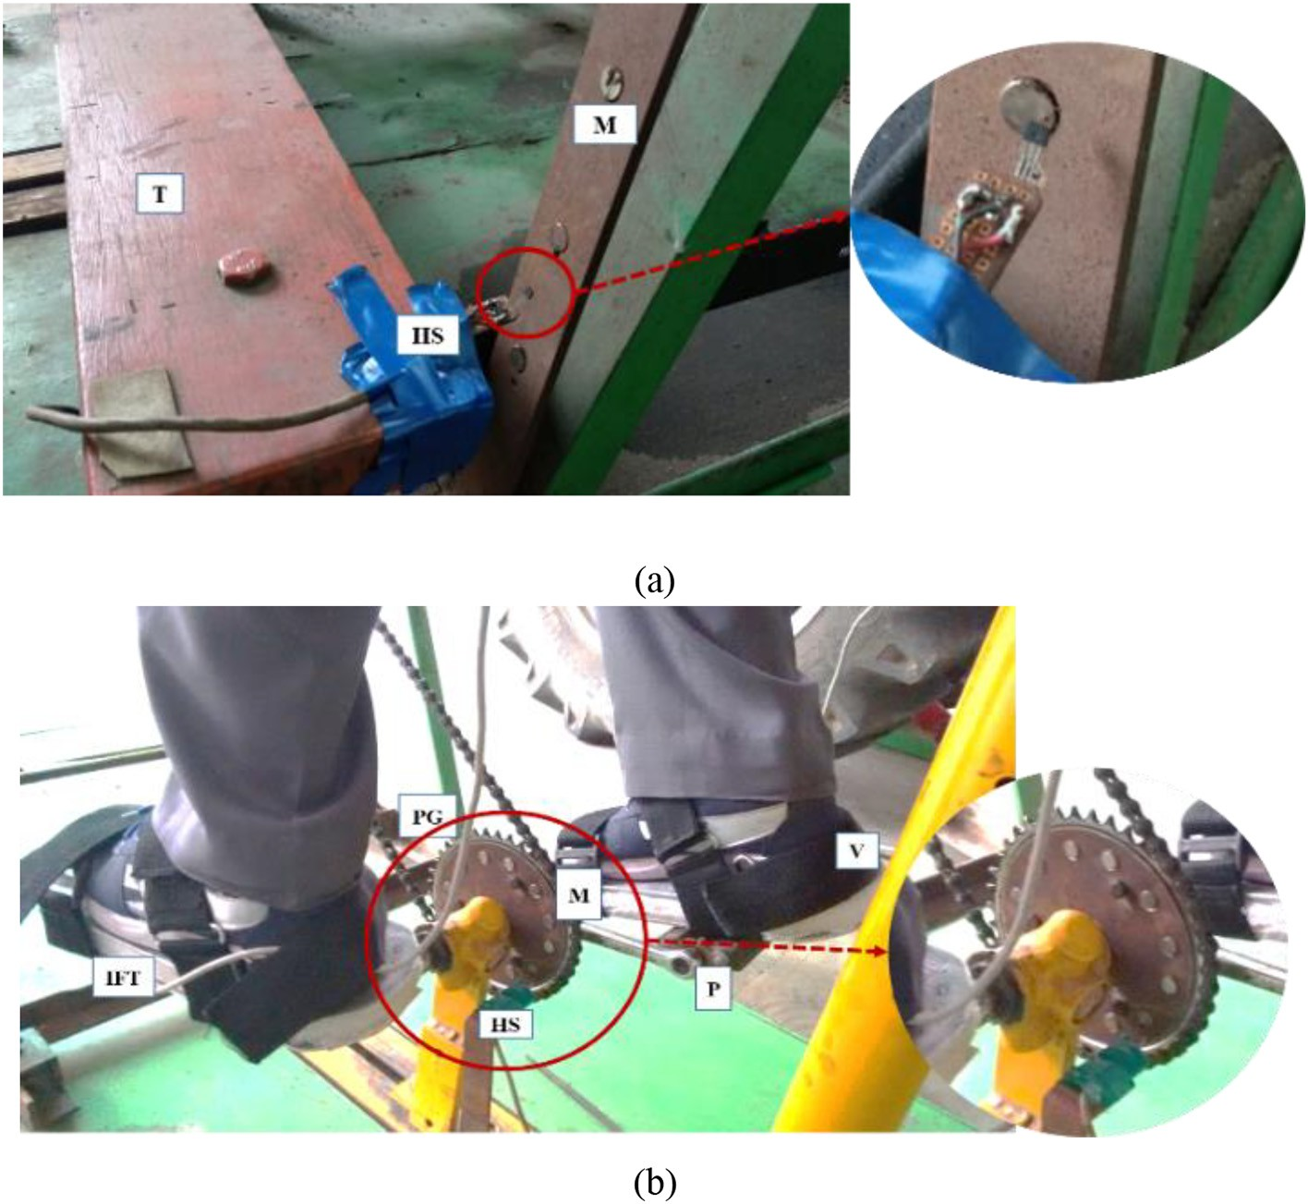](Image%20of%20Fig.%204)

Fig. 4. Sensor arrangement for measurement of actual forces during (a) treadling (HS: hall-effect sensor, M: magnet, T: treadle platform) and (b) pedaling operation (P: Pedal, V: velcro attachment, IFT: instrumented foot transducer, PG: pedal gear).

Similarly, the force exerted by the left foot ranged from −38 N at the crank angle of 240° to 63 N at the crank angle of 30° (Fig. 8a). At 30 N of external load, right foot exerted pedal force ranged from −16 N at

[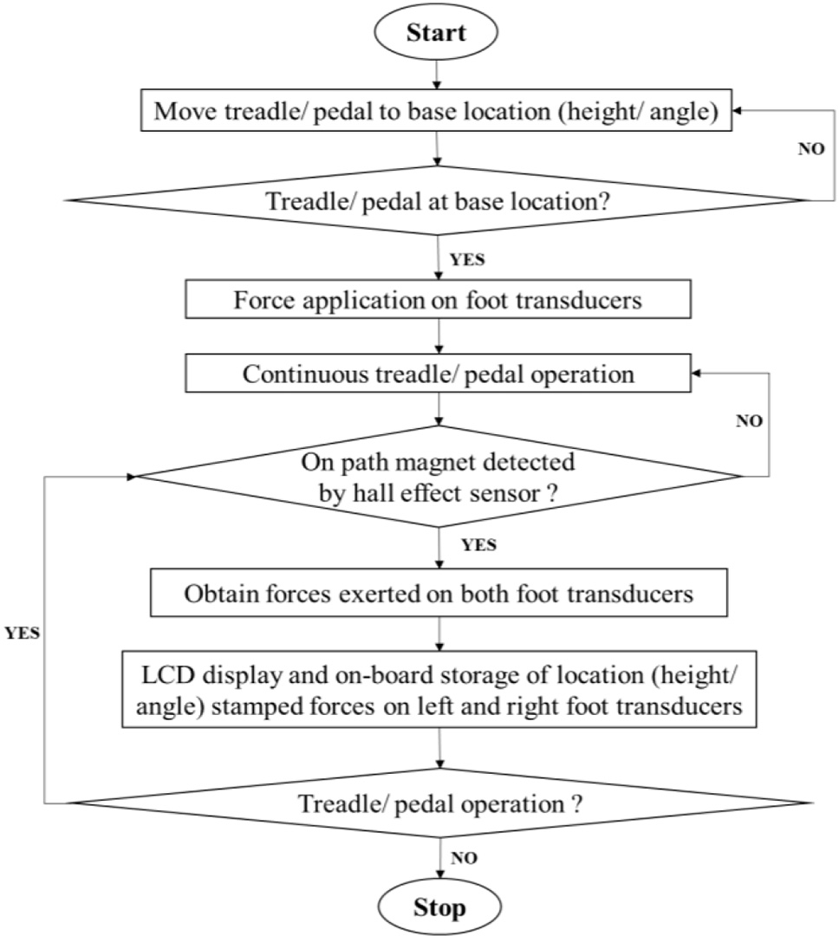](Image%20of%20Fig.%205)

Fig. 5. Flow chart for force assessments and data logging during typical pedaling and treadling operation.

30° crank angle to 42 N at 210° crank angle and that for left foot ranged from −23 N at 210° to 84 N at 30° crank angle (Fig. 8b). With an exter- nal load of 50 N, pedal forces ranged from −23 N at 60° to 63 N at 210° for right foot and − 32 N at 240° to 99 N at 30° (Fig. 8c) for left foot. Pedal force with 70 N external load ranged from −40 N at 60° to 82 N at 240° for right foot while for left foot it ranged from −14 N at 210° to 104 N at 30° crank angle (Fig. 8d). It was also observed that for the cy- cles where force exerted by one foot was positive, the force exerted by the other foot was negative similar to as observed by Bini et al. (2013). This can be attributed to the fact that while one foot applies force, the other foot experiences the reaction force to maintain the equi- libria of system forces. At the 0° crank angle, the right crank pedal is at the extreme bottom position where the force is typically exerted by the left foot while at the 180°, the left crank pedal is at the extreme bot- tom experiencing the force exerted by the right foot (Bini et al., 2013). It was also observed that the magnitude of pedal actuation forces also in- creased with the increasing external loads. These pedal actuation forces for both right and left foot were significantly different under different crank angle (one-way ANOVA, F1,22(left) = 27.23, F1,22(right) = 27.58, *p* b 0.05).

The force exerted by the foot was also observed with respect to time since the operation initiation (Fig. 9). During initiation, forces by both feet tended to 0 N followed by a peak actuation force at 30° crank angle to overcome the system operational inertia. Exerted forces then tended to be steady with respect to time once a steady operational speed was maintained (Balbinot et al., 2014; Quintana-Duque et al., 2015). Trends of pedal actuation forces for both right and left foot were similar with peaks of 73, 85, 110.5, and 145.4 N for left foot and 41, 50, 131.7, and 145.4 N for right foot at external loads of 10, 30, 50 and 70 N, respectively. Similarly for a 15 s period, mean exerted forces of 16.1, 30.8, 40.6 and 41.8 N by the left foot and 15.5, 20.3, 37, 38.5 N by the right foot were observed at external loads of 10, 30, 50 and

[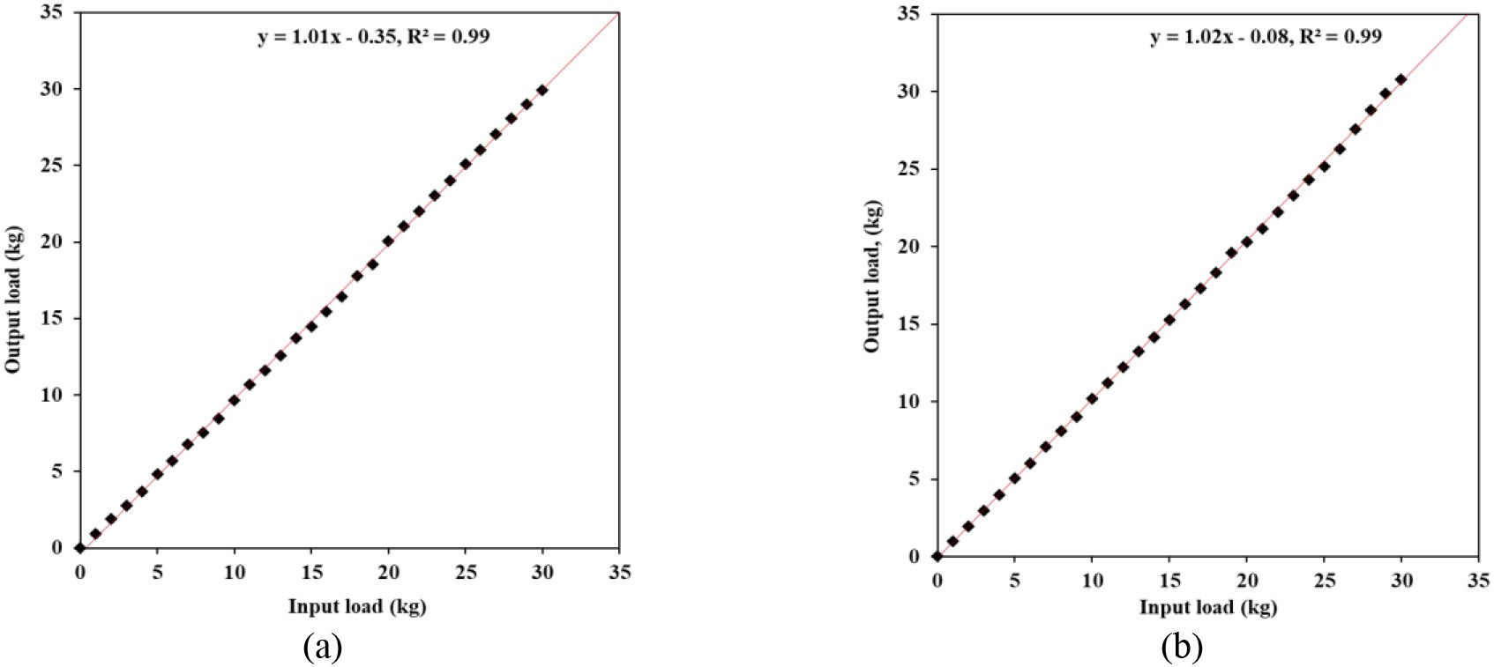](Image%20of%20Fig.%206)

Fig. 6. Calibration curves of the developed instrumented force transducers for (a) left and (b) right lower limbs.

70 N, respectively. These actuation forces by both feet were significantly different under different external loads and increased with the increas- ing loads (one-way ANOVA, F3,36(left) = 406.11, F3,36(right) = 478.28, *p* b 0.05).

* 1. *Force measurement during treadling operation*

Lower limb exerted forces for a typical treadling operation were measured at average speed of 60 strokes/min at three different external loads with height above ground (Fig. 10) and time since operation (Fig. 11). Force trends for two limbs showed periodic increase and

decrease for application by the right foot with peak at 225 mm above ground and support by left foot. At 5 N of external load, peak force exerted by the right foot was 128 N and minimum at 110 mm height above ground (−212 N). While at 15 N of external load, maximum re- corded force on left IFT was 218 N at 225 mm height from the ground and that by right foot was 159 N and at 10 N was 188 N.

Force application peaked at operation initiation to overcome the sys- tem inertia and thereafter a steady state trend followed. Irregular pat- terns between the force trends of the left and right limbs indicate the impact of dynamic reactions experienced by the operator. Moreover, the negative forces and opposite phase indicate the rising of treadle

[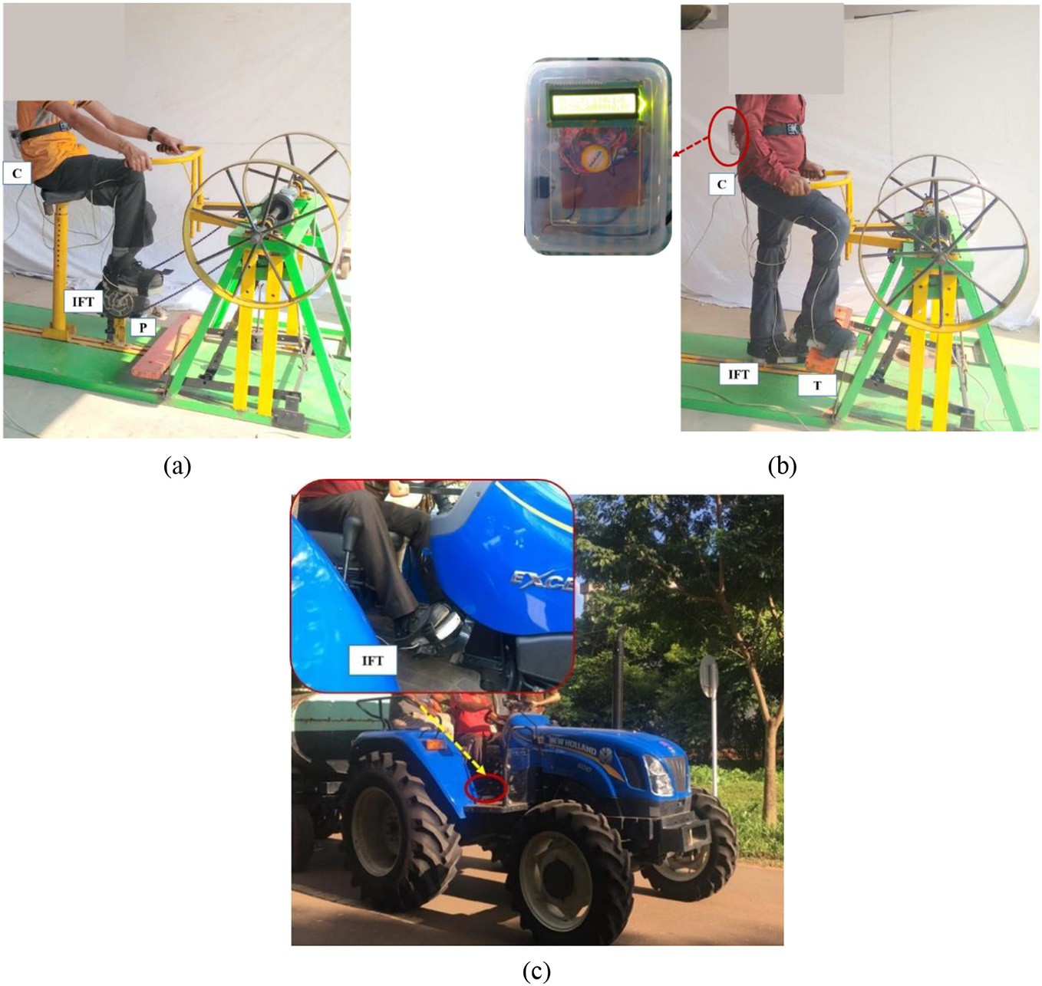](Image%20of%20Fig.%207)

Fig. 7. Measurement of forces exerted by the operator lower limbs using instrumented foot transducers during typical (a) pedaling (b) treadling, and (c) tractor operations. (C: controller, IFT: instrumented foot transducer, P: Pedal, T: treadle platform).

[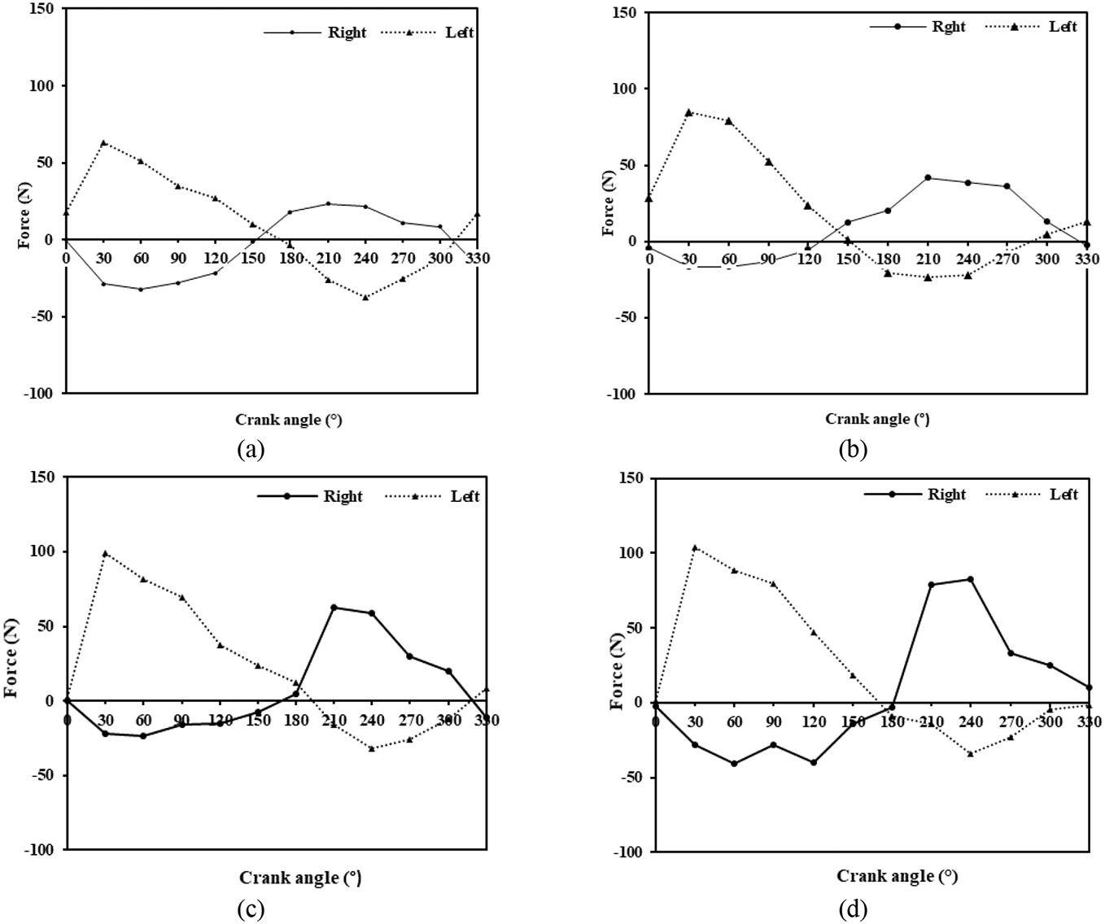](Image%20of%20Fig.%208)

Fig. 8. Graphed steady state curves for the pedal actuation forces exerted by right and left foot with respect to pedal crank angles at imposed loads of (a) 10 N, (b) 30 N, (c) 50 N and

(d) 70 N.

platform majorly by the system gained inertia whereas, the positive forces indicate that the operator had to apply force to push down the treadle platform. With respect to time of operation, force exerted by the actuating lower limb (right) ranged within −228 N to 218 N and the reaction on support limb (left) ranged within −166 to 139 N at 5 N of external applied load. Similarly, at 10 N, the right limb exerted forces ranged from −295 N to 249 N and for left limb it ranged from

−195 N to 255 N. At 15 N of external imposed load, right limb exerted forces were recorded in the ranges of −295 to 269 N and that for left limb in ranges of −211 N to 287 N. Mean right limb exerted forces for 15 min duration of operation were 87.8 N, 111.7 N and 145.6 N at the external loads of 5 N, 10 N and 15 N, respectively. Similarly, left limb

support forces were 95.2 N, 128.6 N and 175 N at the external loads of 5 N, 10 N and 15 N, respectively. It was also observed that maximum force was exerted at the topmost position whereas, the minimum force was exerted at the bottommost position of the treadle platform.

* 1. *Force measurement during tractor operation*

Average actuation forces required for tractor clutch and brake pedal engagement are shown in Fig. 12. H1, H2 and H3 represent the high range of forward speeds of the tractor where H3 is the highest and H1 is the lowest. Clutch pedal engagement forces ranged from 92 to 164 N and 107–176 N for H1–H3 speed ranges on farm and tarmacadam

[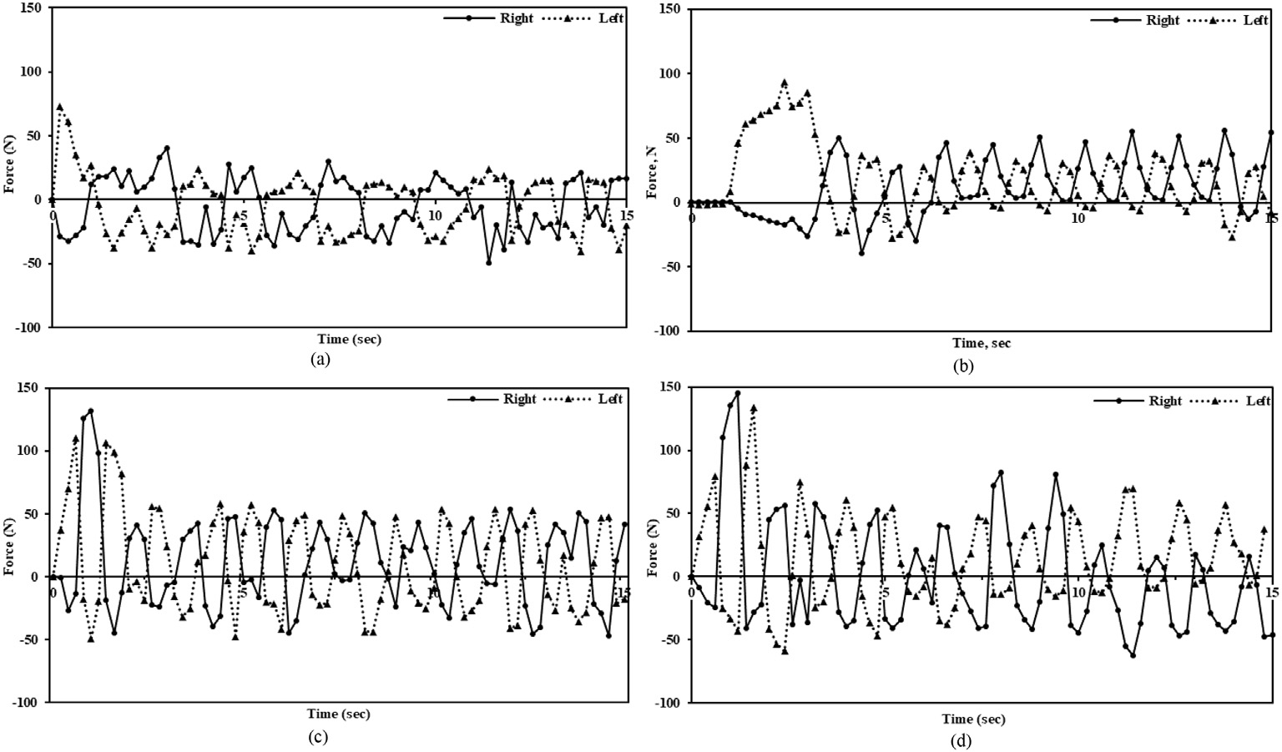](Image%20of%20Fig.%209)

Fig. 9. Assessment curves for the forces exerted by left and right foot of an evaluation human subject with respect to time at imposed loads of (a) 10 N, (b) 30 N, (c) 50 N, and (d) 70 N.

[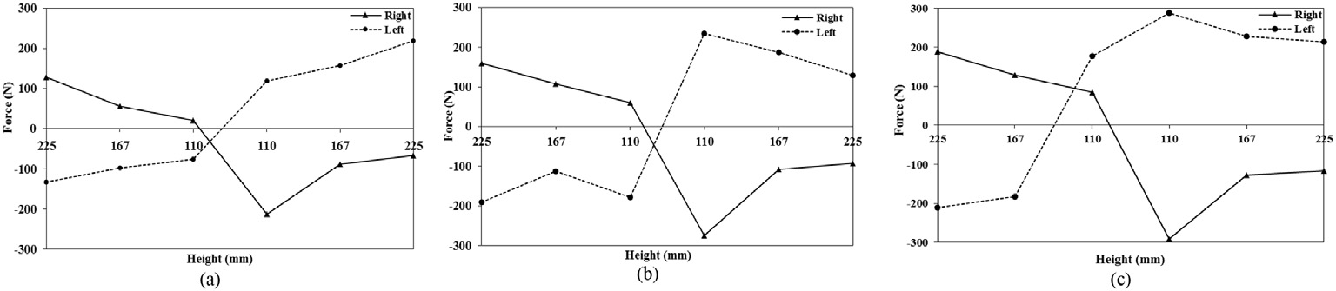](Image%20of%20Fig.%2010)

Fig. 10. Graphed steady state curves for the actuation forces exerted by right and left foot with respect to height of treadle from ground at imposed loads of (a) 5 N, (b) 10 N, (c) 15 N.

[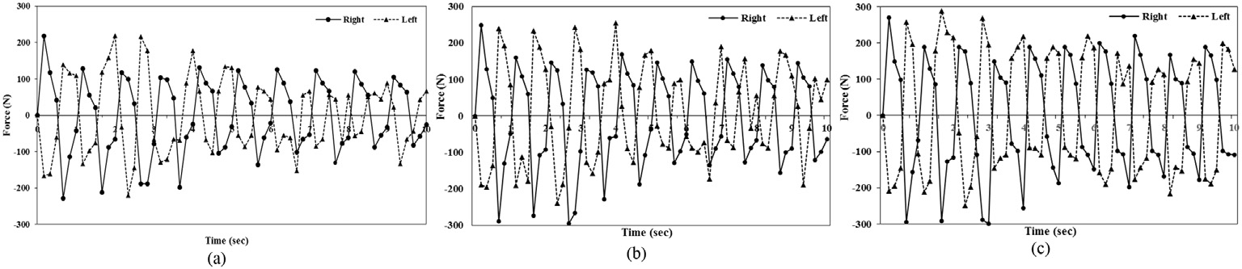](Image%20of%20Fig.%2011)

Fig. 11. Graphed steady state curves for the treadle actuation forces exerted by right and left foot with respect to time with different imposed loads of (a) 5 N, (b) 10 N, (c) 15 N.

roads, respectively. Similarly, for brake pedal engagement, such forces ranged from 106 to 173 N and 120–204 N on farm and tarmacadam roads. It was apparent that the high actuation forces were exerted for brake and clutch engagement at high speeds. This can be attributed to the fact that a high resistive force is required to counter the body at high momentum. Similarly, a lesser force is required to stop the tractor moving at slower speed. It was also observed that the pedal actuation forces were comparatively higher on tarmacadam surface as compared to the farm road due to lower friction coefficient of the tarmacadam sur- face. Higher actuation force for brake pedal engagement was observed compared to the clutch pedal engagement during the tractor operation (Mehta et al., 2007).

1. Conclusion

Customized instrumented foot transducers were successfully devel- oped and preliminarily evaluated for measurement of the forces exerted by the lower limbs during typical small to large scale agricultural oper- ations of treadling, pedaling and tractor or any foot operated systems. Custom load sensors based on strain gauges were developed and inte- grated to the single board computer for data logging, on-board storage and visualization in real time. Evaluation of the developed system for pedaling operation indicated peak pedal actuation forces of 73 N, 85 N, 110.5 N and 145.4 N for left foot and 41 N, 50 N, 131.7 N and

145.4 N for right foot at external loads of 10 N, 30 N, 50 N and 70 N,

respectively. Similarly, maximum forces exerted by actuating lower limb (right) during treadling operations were 139 N, 249 N and 255 N for 5 N, 10 N and 15 N of external loads, respectively. Clutch pedal en- gagement forces ranged from 92 to 164 N and 107–176 N for lower (H1) to higher tractor speed (H3) ranges on farm and tarmacadam roads, respectively. Similarly, for brake pedal engagement, such forces were higher than clutch engagement and ranged from 106 to 173 N and 120–204 N on farm and tarmacadam roads.

Major advantages of the system were its operator friendliness and limited dependencies for field evaluations. Developed IFT can be used for dynamic force assessment at different position, different joint angles during adaptation of different working postures, so that the risk assess- ment of the operation can be achieved. Such system may be utilized by the agricultural machinery manufacturers for force assessments, design reconsiderations and enhancing any potential safety features to mini- mize the musculoskeletal disorders due to improper design and dimen- sions. Moreover, protocols can be developed by the ergonomists for efficient work-rest schedule pertinent to any operation. This system may also be highly applicable in the developing countries where small scale growers form the major population and small-scale agricultural machinery is representative in the farms.

Conflict of interest

The authors declare no conflict of interest.

[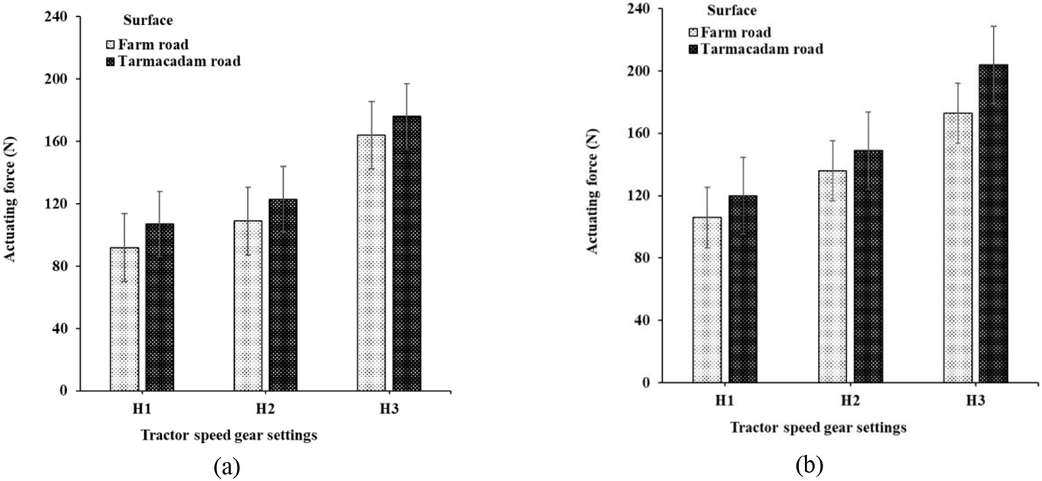](Image%20of%20Fig.%2012)

Fig. 12. Average actuating force exerted by the tractor operator during typical (a) clutch and (b) brake pedal engagement at different speeds as measured using the instrumented foot transducers.

CRediT authorship contribution statement

Smrutilipi Hota: Conceptualization, Data curation, Writing - original draft. V.K. Tewari: Supervision, Writing - review & editing. Abhilash K. Chandel: Software, Formal analysis, Investigation, Writing - original draft, Writing - review & editing. Gajendra Singh: Resources, Software, Data curation.

Acknowledgement

This study was funded by the All India Coordinated Research Pro- jects on Ergonomics and Safety in Agriculture (ESA), Indian Council of Agricultural Research, Govt. of India, New Delhi.

References

Agrawal, K.N., Tiwari, P.S., Gite, L.P., Majumdar, J., Pharade, S., Bhusan, B.V., 2007. [Leg](http://refhub.elsevier.com/S2589-7217(20)30017-9/rf0005) [strength of agricultural workers in Central India. Developments in Agricultural and](http://refhub.elsevier.com/S2589-7217(20)30017-9/rf0005) [Industrial Ergonomics: General studies 1, 189–20](http://refhub.elsevier.com/S2589-7217(20)30017-9/rf0005)1.

Agrawal, K.N., Singh, R.K.P., Satapathy, K.K., 2009. [Isometric strength of agricultural](http://refhub.elsevier.com/S2589-7217(20)30017-9/rf0010) [workers of Meghalaya: a case study of an Indian population. Int. J. Ind. Ergon. 39](http://refhub.elsevier.com/S2589-7217(20)30017-9/rf0010) [(6), 919–923](http://refhub.elsevier.com/S2589-7217(20)30017-9/rf0010).

Arcand, R., Labreche, F., Messing, K., Stock, S., Tissot, F., 2000. [Travail et santé [work &](http://refhub.elsevier.com/S2589-7217(20)30017-9/rf0015) [health]. In: Daveluy, C., Pica, L., Audet, N., Courtemanche, R., Lapointe, F. (Eds.),](http://refhub.elsevier.com/S2589-7217(20)30017-9/rf0015) [Enquête Sociale et de Santé 1998 [1998 Québec Health and Social Survey], 2nd ed](http://refhub.elsevier.com/S2589-7217(20)30017-9/rf0015) [Institut de la Statistique du Québec, Québec, pp. 525–570](http://refhub.elsevier.com/S2589-7217(20)30017-9/rf0015).

Balbinot, A., Milani, C., Nascimento, J., 2014. [A new crank arm-based load cell for the 3D](http://refhub.elsevier.com/S2589-7217(20)30017-9/rf0020) [analysis of the force applied by a cyclist. Sensors 14 (12), 22921–22939](http://refhub.elsevier.com/S2589-7217(20)30017-9/rf0020).

Bini, R., Hume, P., Croft, J.L., Kilding, A., 2013. [Pedal force effectiveness in cycling: a review](http://refhub.elsevier.com/S2589-7217(20)30017-9/rf0025) [of constraints and training effects. J. Sci. Cycling 2 (1), 11–24](http://refhub.elsevier.com/S2589-7217(20)30017-9/rf0025).

Carter, J.B., Banister, E.W., 1994. [Musculoskeletal problems in VDT work: a review. Ergo-](http://refhub.elsevier.com/S2589-7217(20)30017-9/rf0030) [nomics 37 (10), 1623–1648](http://refhub.elsevier.com/S2589-7217(20)30017-9/rf0030).

Chowdhury, A., Sanjog, J., Reddy, S.M., Karmakar, S., 2012. [Nanomaterials in the field of](http://refhub.elsevier.com/S2589-7217(20)30017-9/rf0035) [design ergonomics: present status. Ergonomics 55 (12), 1453–1462.](http://refhub.elsevier.com/S2589-7217(20)30017-9/rf0035)

Fulco, C.S., Rock, P.B., Muza, S.R., Lammi, E., Cymerman, A., Butterfield, G., Moore, L.G., Braun, B., Lewis, S.F., 1999. [Slower fatigue and faster recovery of the adductor pollicis](http://refhub.elsevier.com/S2589-7217(20)30017-9/rf0040) [muscle in women matched for strength with men. Acta Physiol. Scand. 167 (3),](http://refhub.elsevier.com/S2589-7217(20)30017-9/rf0040) [233–24](http://refhub.elsevier.com/S2589-7217(20)30017-9/rf0040)0.

Gite, L.P., Majumder, J., Mehta, C.R., Khadatkar, A., 2009. [Anthropometric and Strength](http://refhub.elsevier.com/S2589-7217(20)30017-9/rf0045) [Data of Indian Agricultural Workers for Farm Equipment Design. CIAE, Bhopal, India](http://refhub.elsevier.com/S2589-7217(20)30017-9/rf0045).

Glenmark, B., Nilsson, M., Gao, H., Gustafsson, J.A., Dahlman-Wright, K., Westerblad, H., 2004. [Difference in skeletal muscle function in males vs. females: role of estrogen](http://refhub.elsevier.com/S2589-7217(20)30017-9/rf0050) [receptor-β. Am. J. Physiol. Endocrinol. Metab. 287 (6), 1125–1131](http://refhub.elsevier.com/S2589-7217(20)30017-9/rf0050).

Gregory, D.E., Callaghan, J.P., 2008. [Prolonged standing as a precursor for the development](http://refhub.elsevier.com/S2589-7217(20)30017-9/rf0055) [of low back discomfort: an investigation of possible mechanisms. Gait Posture 28 (1),](http://refhub.elsevier.com/S2589-7217(20)30017-9/rf0055)

[86–92](http://refhub.elsevier.com/S2589-7217(20)30017-9/rf0055).

Jafrey, T., Haslegrave, C.M., 1995. [The Effects of Tractor Foot Pedal Operation on Spinal](http://refhub.elsevier.com/S2589-7217(20)30017-9/rf0060) [Loading, in: United Kingdom Informal Group Meeting on Human Response to Vibra-](http://refhub.elsevier.com/S2589-7217(20)30017-9/rf0060) [tion. Silsoe Research Institute, Silsoe](http://refhub.elsevier.com/S2589-7217(20)30017-9/rf0060).

Laperriere, E., Ngomo, S., Thibault, M.C., Messing, K., 2006. [Indicators for choosing an op-](http://refhub.elsevier.com/S2589-7217(20)30017-9/rf0065) [timal mix of major working postures. Appl. Ergon. 37 (3), 349–35](http://refhub.elsevier.com/S2589-7217(20)30017-9/rf0065)7.

Mehta, C.R., Tiwari, P.S., Rokade, S., Pandey, M.M., Pharade, S.C., Gite, L.P., Yadav, S.B., 2007. [Leg strength of Indian operators in the operation of tractor pedals. Int. J. Ind. Ergon.](http://refhub.elsevier.com/S2589-7217(20)30017-9/rf0070) [37, 283–28](http://refhub.elsevier.com/S2589-7217(20)30017-9/rf0070)9.

Miles, J., Steinke, W., 1993. [Identification of Repetitive Trauma Hazards in the Orchard and](http://refhub.elsevier.com/S2589-7217(20)30017-9/rf0075) [Lumbering Industry. Unpublished work Biological and Agricultural Engineering De-](http://refhub.elsevier.com/S2589-7217(20)30017-9/rf0075) [partment. University of California-Davis](http://refhub.elsevier.com/S2589-7217(20)30017-9/rf0075).

Miller, A.E.J., MacDougall, J.D., Tarnopolsky, M.A., Sale, D.G., 1993. [Gender differences in](http://refhub.elsevier.com/S2589-7217(20)30017-9/rf0080) [strength and muscle fiber characteristics. Eur. J. Appl. Physiol. Occup. Physiol. 66](http://refhub.elsevier.com/S2589-7217(20)30017-9/rf0080) [(3), 254–262](http://refhub.elsevier.com/S2589-7217(20)30017-9/rf0080).

Patel, T., Sanjog, J., Chowdhury, A., Karmakar, S., 2013. [Applications of DHM in agricultural](http://refhub.elsevier.com/S2589-7217(20)30017-9/rf0085) [engineering: a review. Adv. Eng. Forum 10, 16–21](http://refhub.elsevier.com/S2589-7217(20)30017-9/rf0085).

Patel, T., Sanjog, J., Kumar, P., Karmakar, S., 2014. [Isometric muscular strength data of](http://refhub.elsevier.com/S2589-7217(20)30017-9/rf0090) [Indian agricultural workers for equipment design: critical analysis. E-j. - CIGR 16](http://refhub.elsevier.com/S2589-7217(20)30017-9/rf0090) [(2), 70–79](http://refhub.elsevier.com/S2589-7217(20)30017-9/rf0090).

Quintana-Duque, J.C., Dahmen, T., Saupe, D., 2015. [Estimation of torque variation from](http://refhub.elsevier.com/S2589-7217(20)30017-9/rf0095) [pedal motion in cycling. Int. J. Comput. Sci. Sport 14, 34–50](http://refhub.elsevier.com/S2589-7217(20)30017-9/rf0095).

Roelen, C.A.M., Schreuder, K.J., Koopmans, P.C., Groothoff, J.W., 2008. [Perceived job de-](http://refhub.elsevier.com/S2589-7217(20)30017-9/rf0100) [mands relate to self-reported health complaints. Occup. Med-Oxf. 58 (1), 58–63](http://refhub.elsevier.com/S2589-7217(20)30017-9/rf0100).

Stapelfeldt, B., Mornieux, G., Oberheim, R., Belli, A., Gollhofer, A., 2007. [Development and](http://refhub.elsevier.com/S2589-7217(20)30017-9/rf0105) [evaluation of a new bicycle instrument for measurements of pedal forces and power](http://refhub.elsevier.com/S2589-7217(20)30017-9/rf0105) [output in cycling. Int. J. Sports Med. 28 (4), 326–33](http://refhub.elsevier.com/S2589-7217(20)30017-9/rf0105)2.

Tissot, F., Messing, K., Stock, S., 2009. [Studying the relationship between low back pain](http://refhub.elsevier.com/S2589-7217(20)30017-9/rf0110) [and working postures among those who stand and those who sit most of the working](http://refhub.elsevier.com/S2589-7217(20)30017-9/rf0110) [day. Ergonomics 52 (11), 1402–1418](http://refhub.elsevier.com/S2589-7217(20)30017-9/rf0110).

Tiwari, P.S., Gite, L.P., Majumder, J., Pharade, S.C., Singh, V.V., 2010. [Push/pull strength of](http://refhub.elsevier.com/S2589-7217(20)30017-9/rf0115) [agricultural workers in Central India. Int. J. Ind. Ergon. 40 (1), 1–](http://refhub.elsevier.com/S2589-7217(20)30017-9/rf0115)7.

Valencia, J.S.O., Cardona, S.G., Mejia, S.R., 2007. [Design and construction of a bicycle pedal](http://refhub.elsevier.com/S2589-7217(20)30017-9/rf0120) [based on piezo resistive sensors to determine the resulting force. Rev. Ing. Biomed. 1](http://refhub.elsevier.com/S2589-7217(20)30017-9/rf0120) [(2), 55–60](http://refhub.elsevier.com/S2589-7217(20)30017-9/rf0120).

Waters, T.R., 2012. [Ergonomics in design: interventions for youth working in the agricul-](http://refhub.elsevier.com/S2589-7217(20)30017-9/rf0125) [tural industry. Theor. Issues. Ergon. Sc. 13 (2), 270–285](http://refhub.elsevier.com/S2589-7217(20)30017-9/rf0125).

Whiting, W.C., Zernicke, R.F., 1998. [Biomechanics of Musculoskeletal Injury. Human Ki-](http://refhub.elsevier.com/S2589-7217(20)30017-9/rf0130) [netics, Champaign, IL](http://refhub.elsevier.com/S2589-7217(20)30017-9/rf0130).