[Array 19 (2023) 100302](https://doi.org/10.1016/j.array.2023.100302)

Contents lists available at [ScienceDirect](http://www.sciencedirect.com/science/journal/25900056)

Array

journal homepage: [www.sciencedirect.com/journal/array](https://www.sciencedirect.com/journal/array)

An optimized hybrid methodology for non-invasive fetal electrocardiogram signal extraction and monitoring

Theodoros Lampros a, Konstantinos Kalafatakis a,b, Nikolaos Giannakeas a,

Markos G. Tsipouras c, Euripidis Glavas a, Alexandros T. Tzallas a,*

a *Human-Computer Interaction Laboratory, Department of Informatics and Telecommunications, School of Informatics and Telecommunications, University of Ioannina, 47100, Arta, Greece*

b *Institute of Health Sciences Education, Barts and the London School of Medicine & Dentistry, Queen Mary University of London (Malta Campus), Triq L-Arc*˙*isqof Pietru*

*Pace, VCT 2520, Victoria (Gozo), Malta*

c *Department of Electrical and Computer Engineering, School of Engineering, University of Western Macedonia, 50100, Kozani, Greece*

A R T I C L E I N F O

*Keywords:*

Fetal electrocardiogram ICA

EMD

Wavelet thresholding Signal quality indices Correlation analysis

A B S T R A C T

*Background and objective:* Electronic fetal heart monitoring is currently used during pregnancy throughout most of the developed world to detect risk conditions for both the mother and the fetus. Non-invasive fetal electro- cardiogram (NI-fECG), recorded in the maternal abdomen, represents an alternative to cardiotocography, which could provide a more accurate estimate of fetal heart rate. Different methodologies, with varying advantages and disadvantages, have been developed for NI-fECG signal detection and processing.

*Methods:* In this context, we propose a hybrid methodology, combining independent component analysis, signal quality indices, empirical mode decomposition, wavelet thresholding and correlation analysis for NI-fECG optimized signal extraction, denoising, enhancement and addressing the intrinsic mode function selection problem.

*Results:* The methodology has been applied in four different datasets, and the obtained results indicate that our method can produce accurate fetal heart rate (FHR) estimations when tested against different datasets of variable quality and acquisition protocols, on the FECGDARHA dataset our method achieved average values of Sensitivity

= 98.55%, Positive Predictive Value = 91.73%, F1 = 94.92%, Accuracy = 90.91%, while on the ARDNIFECG dataset it achieved average values of Sensitivity = 92.96%, Positive Predictive Value = 91.66%, F1 = 93.60%, Accuracy = 90.45%.

*Conclusions:* The proposed methodology is completely unsupervised, has been proven robust in different signal-

to-noise ratio scenarios and abdominal signals, and could potentially be applied to the development of real-time fetal monitoring systems.

# Credit author statement

Conceptualization, Thodoris Lampros, Konstantinos Kalafatakis, Nikolaos Giannakeas, Markos Tsipouras, Euripidis Glavas and Alexan- dros Tzallas; Data curation, Thodoris Lampros, Markos Tsipouras, Alexandros Tzallas; Formal analysis, Thodoris Lampros, Markos Tsi- pouras and Alexandros Tzallas; Funding acquisition, Alexandros Tzallas; Investigation, Thodoris Lampros, Konstantinos Kalafatakis, Nikolaos Giannakeas, Markos Tsipouras, Euripidis Glavas, and Alexandros Tzal- las; Methodology, Thodoris Lampros, Konstantinos Kalafatakis, Nikolaos

Giannakeas, Markos Tsipouras, Euripidis Glavas and Alexandros Tzallas; Project administration, Alexandros Tzallas; Software, Thodoris Lamp- ros; Supervision, Konstantinos Kalafatakis, Nikolaos Giannakeas, Mar- kos Tsipouras, Euripidis Glavas and Alexandros Tzallas; Validation, Nikolaos Giannakeas and Alexandros Tzallas; Visualization, Alexandros

Tzallas; Writing – original draft, Thodoris Lampros, Konstantinos Kala-

fatakis, Nikolaos Giannakeas, Markos Tsipouras, Euripidis Glavas and Alexandros Tzallas; Writing – review & editing, Thodoris Lampros, Konstantinos Kalafatakis, Nikolaos Giannakeas, Markos Tsipouras,

Euripidis Glavas and Alexandros Tzallas.

* Corresponding author. Department of Informatics & Telecommunications School of Informatics & Telecommunications University of Ioannina Kostakioi, GR- 47100, Arta Greece

*E-mail address:* [tzallas@uoi.gr](mailto:tzallas@uoi.gr) (A.T. Tzallas).

<https://doi.org/10.1016/j.array.2023.100302>

Received 14 November 2022; Received in revised form 20 June 2023; Accepted 24 June 2023

Available online 8 July 2023

2590-0056/© 2023 The Authors. Published by Elsevier Inc. This is an open access article under the CC BY-NC-ND license ([http://creativecommons.org/licenses/by-](http://creativecommons.org/licenses/by-nc-nd/4.0/) [nc-nd/4.0/](http://creativecommons.org/licenses/by-nc-nd/4.0/)).

# Introduction

Prenatal cardiac monitoring is an extremely important aspect in the early detection of pathological conditions of the fetus. Electronic fetal heart monitoring is currently used in most of the developed world to detect risk conditions for both mother and fetus. The main goals are to rule out possible conditions that could lead to fetal morbidity or even death. Early and more effective detection of fetal abnormalities can help obstetricians and pediatric cardiologists prescribe appropriate medica- tions in a timely manner or take necessary precautions during delivery or after birth. The main purpose of fetal monitoring during childbirth is the early recognition of intrauterine hypoxic infection, to lead the clinician to timely intervention to avoid any complications in the health

of the fetus. Suffocation during childbirth causes 10–15% of all cases of cerebral edema in newborns [1]. Modern methods of assessing and

monitoring the general condition of the fetus help to significantly reduce the risk of endometrial death by suffocation and the risk of giving birth to a newborn with respiratory problems.

Non-invasive fetal electrocardiogram (NI-fECG), recorded in the maternal abdomen represents an alternative to cardiotocography, which could provide a more accurate estimate of fetal heart rate. Moreover, electrocardiographic fetal heart activity could be obtained by studying the morphology of the ECG. However, the fetal ECG (fECG) is difficult to be extracted by the mixed abdominal signal, mainly due to the poor signal-to-noise ratio (SNR), which has limited its use to date. Noninva- sive fetal ECG has some limitations and potential problems that should be considered.

* Signal quality: Noninvasive fetal ECG signals can be affected by maternal and fetal movements, uterine contractions, and other

external interferences. This can lead to poor signal quality and affect the accuracy of the measurements.

* Gestational stage limitations: Noninvasive fetal ECG is generally

more accurate in the later stages of pregnancy when the fetus is

larger and has a stronger signal. In early gestational stages, the signal can be weak, and the accuracy of the measurements can be affected.

* Fetal position: The position of the fetus can affect the quality of the

noninvasive fetal ECG signal. For example, if the fetus is in a breech

position, the electrodes may not be able to pick up the signal effectively.

* Interference with other devices: The use of other electronic devices

such as cell phones or wireless networks in close proximity to the

fetal ECG device may interfere with the signal quality.

After the Covid-19 pandemic, it became evident that there was a need to advance the digitization of prenatal healthcare further. In a recent study [2], pregnant women reported that the frequency of their regular checkups was cut back during the pandemic. They frequently changed hospitals and doctors to receive proper prenatal care and advice. The increasing sophistication of technologies for monitoring fetal well-being during gestation, though still requiring improvement, enables more comprehensive prenatal care for women across a broader range of circumstances. Fetal ECG monitoring can help detect potential complications earlier, reduce the need for unnecessary in-person visits, and provide timely interventions or guidance when necessary.

Recently developed fetal monitoring systems utilizing noninvasive fetal electrocardiography have become commercially accessible to expectant parents as alternatives to conventional prenatal care practices [3,4]. Some other alternative monitoring systems [5,6], which allow for the remote collection and real-time sharing of critical maternal and fetal biometrics, include the beltless pod and patch duo transmitting elec- trocardiographic (ECG) and electromyographic (EMG) data signaling fetal and maternal heart rates and uterine action. While there have been advancements in the development of fetal ECG monitoring devices, the analysis and interpretation of the recorded abdominal ECG signals can still be challenging due to the abovementioned reasons.

# Motivation for our hybrid approach

Developing robust and efficient signal processing techniques for extracting fetal ECG signals from noisy recordings remains a research challenge. Noise from maternal ECG, uterine contractions, and move- ment artifacts can significantly affect the quality of the fetal ECG signal. Further research is needed to improve the accuracy of signal processing algorithms for better fetal ECG extraction. Although currently, available fetal electrocardiogram monitoring systems have primarily focused on temporary, short-term surveillance, An overhaul of the current ap- proaches to investigating fetal heart function will be necessary if we are to engineer unobtrusive technologies sophisticated enough to scrutinize cardiac rhythms indefinitely, allowing for continuous evaluation of the

developing heart’s pulsations over protracted intervals, such as during precarious gestations or when congenital anomalies are suspected.

Accurate acquisition of the fetal cardiac signal is an open problem consisting of two main aspects. i) Extraction of the raw fetal ECG component from abdominal recordings and ii) Denoising the extracted fECG in order to improve SNR and enhance fetal heart rate (FHR)

detection. In the context of fECG extraction, signal processing tech- niques such as Template Subtraction [7–9], Blind Source separation (BSS) [10–12], Adaptive Filtering [13–16], Artificial Neural Networks [17,18] have been proposed in the literature. In order to denoise and

enhance the fECG, some of the most common approaches are Empirical Mode Decomposition (EMD) [19–21], Wavelet-Based denoising (WD) [22–24] and Extended Kalman Smoothing (EKS) [25,26]. Hybrid

methods [27–30], a combination of adaptive and non-adaptive tech-

niques can provide improved results compared to the use of only one technique, albeit at the cost of increased computational complexity.

Independent Component Analysis [31] is a signal decomposition technique frequently used in fECG extraction [31–33]. ICA extracts statistically independent sources (called independent components- IC’s)

from a set of recorded signals. In the ICA method, the mixture is modeled

as a matrix, which is considered unchangeable during the process. This is related to the assumption that the mixed signals are stationary. However, physiological processes often produce mixtures of multivar- iate signals that are not stationary [34], and therefore, their proportions in the mixture can change over time, although the mixing matrix can be considered stationary for short time periods [35]. In a fECG extraction scenario, this could lead to the fetal component being corrupted and not useful for further processing.

Since its introduction, Empirical Mode Decomposition (EMD) [36] has widely been used to denoise non-linear and nonstationary mixed signals. In EMD based techniques, signals are decomposed into a set of oscillatory components, which are called intrinsic mode functions (IMF). Denoising in the EMD domain translates into a partial reconstruction of the signal using only IMFs containing useful information and rejecting IMFs that carry mainly noise. Determining and removing the

noise-dominant IMF’s is the core process of denoising a signal using EMD, however the IMF selection problem remains a subject of research

until this day, mostly due to mode mixing, which can be described as the occurrence of very different oscillations in one mode, or very similar oscillations in different modes [37].

This work introduces a hybrid algorithm based on the above- mentioned techniques and several optimizations that enable real-time, continuous, and efficient monitoring of fetal status. Our goal is to facilitate the development of robust automated fetal monitoring systems for remote assessment in several stages of pregnancy.

# Materials and methods

The algorithm proposed in this work consists of two distinct pipe- lines. In the extraction stage, Independent Component Analysis (ICA) is applied on the mixed abdominal signal to separate the maternal, fetal and noise components and the produced Independent Components (IC) are assessed using fetal signal Quality Indices. In the denoisisng stage the

selected raw fetal ECG (rfECG) is decomposed into Intrinsic Mode Functions (IMF’s) using Empirical Mode Decomposition, and undesired artifacts, such as baseline wander and high frequency noise, are

removed by Wavelet thresholding. Finally, we introduce an algorithm- based correlation analysis to detect the optimal IMF subset, and the fetal ECG signal is reconstructed from the selected IMF’s.

Our proposed hybrid method introduces several improvements in the

application of the techniques, which allow for high-quality fetal ECG acquisition from abdominal recordings. In the extraction stage, we proposed the application of signal quality indices (sQi’s) that take into

account the linear and non-linear characteristics of the fetal ECG. These

indices can identify if the ICA algorithm has achieved an accurate sep- aration of the fetal component and determine if the fetal ECG extracted is suitable for further processing. Also, they provide an automatic method for the selection of the fetal ECG, something that was mostly

achieved through visual inspection of the IC’s. To further enhance the extracted fetal ECG signal we introduced a novel combination of

Empirical mode Decomposition with Wavelet Thresholding that can successfully remove the residue maternal ECG (mECG) presence. The application of Wavelet Transform in the EMD domain is proven to greatly enhance Fetal Heart Rate (FHR) estimation even in low SNR scenarios. We also addressed a significant issue with Empirical Mode Decomposition which is the IMF selection problem, by introducing a

novel correlation algorithm that can determine which IMF’s should contribute in reconstructing the enhanced fetal ECG. Finally, we pro-

vided quantitative data that demonstrate the importance of accurate selection of the intrinsic functions derived from EMD in improving FHR estimation. The improved hybrid method that is proposed in this work is proven to be robust in producing highly accurate FHR estimations when dealing with abdominal ECG recordings of varying quality and acqui- sition protocols. Furthermore, the low computational complexity of our algorithm makes it suitable for real-life fetal ECG monitoring applica- tions. An overview of the method can be seen in Fig. 1.

* 1. *extraction*

To extract the raw fetal ECG from the mixed-channel abdominal signal we employed a technique based on Blind Source Separation for component separation and Signal Quality Indices to verify that the selected fetal component is of sufficient quality for accurate FHR estimation.

* + 1. *independent component analysis*

The Blind Source Separation problem in the context of ECG signals can be described as: suppose an ECG recording consists of p channels,

and suppose p independent channels *s*1(*t*), *s*2(*t*)…, *sp*(*t*) and respectively p observed mixed signals *m*1(*t*),*m*2(*t*),...,*mp*(*t*). The observed signals m(t) are a linear combination:

*p*

*mi*(*t*) = *aijsj*(*t*), *i* = 1, 2…*p*, *aij* ∈ *R*. (1)

∑

*j*=1

equivalent to: *M* = *AS*, where *S* = [*s*1(*t*), *s*2(*t*), …, *sp*(*t*)]*T* is a vector col- Using array notation, the set of m equations of the above form is umn representing the source signals, *M* = [*m*1(*t*), *m*2(*t*), …, *mp*(*t*)]*T* a corresponding vector representing the observed signals and A is the *p* ×

*p* mixing matrix.

Independent Component Analysis (ICA) algorithms estimate the unmixing matrix *W* by exploiting the non-Gaussianity of the individual signals. The purpose of ICA is to carry out a transformation that will separate the mixed signal recorded in the abdomen in its distinct com- ponents, which, in the context of fECG extraction, include the fetal signal, the maternal ECG and various residual noise signals.

In order to extract the raw fetal ECG, the FastICA algorithm was employed (Fig. 2). Typically, the FastICA algorithm can be described in the following steps.

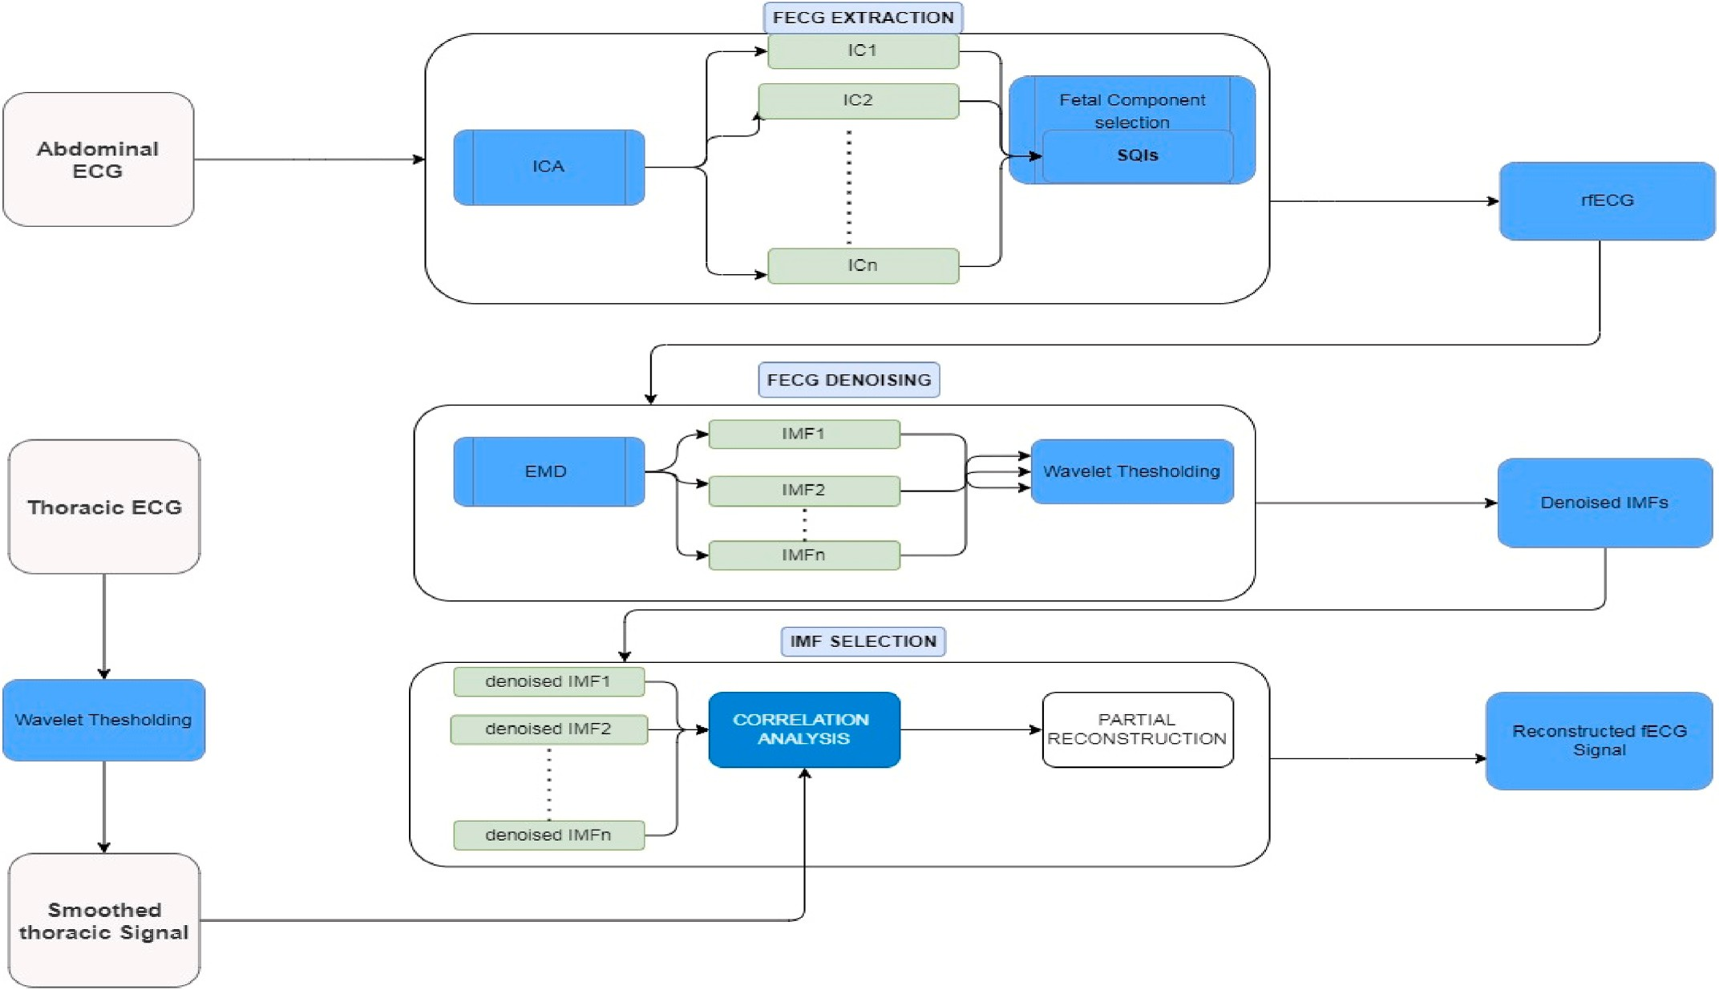

**Fig. 1.** Overview of the proposed method.

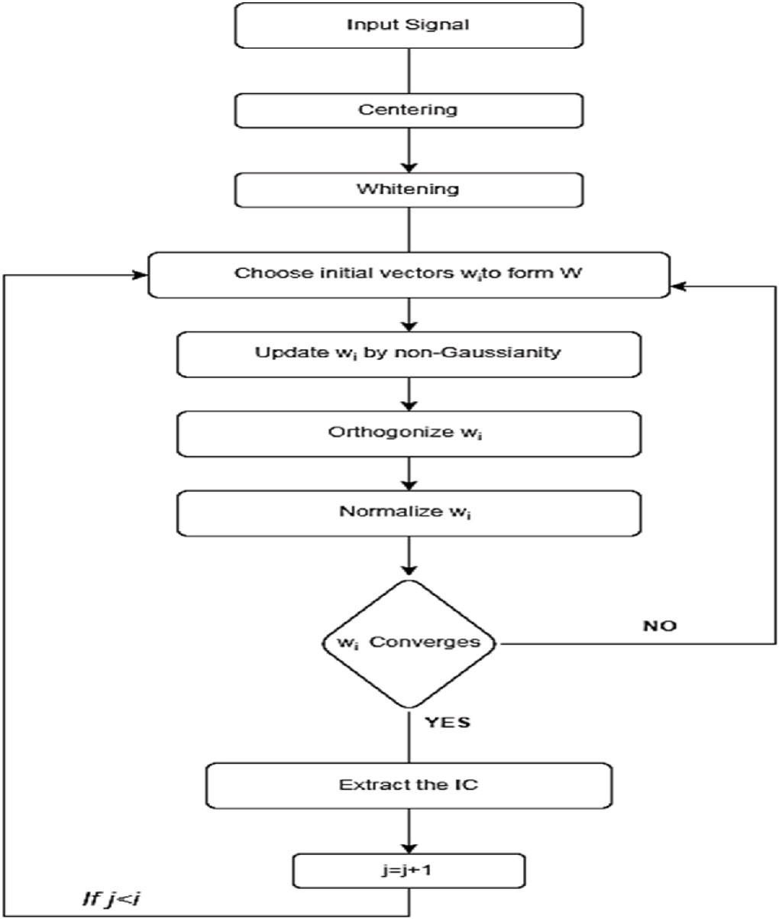

**Fig. 2.** Overview of the FastICA algorithm.

* Centering: Normalization of the signals so they have zero mean and unit variances.
* Whitening: Using a linear transform like Principal Component Analysis (PCA) to obtain the matrix *Z* = *VX* where *V* is a whitening matrix such that *E*{*ZZT*} = *I*. The total unmixing matrix is then *W*← *WV*.
* Choose initial vectors *wi* to form *W*.
* Iteration: after the pre-processing of the data, an iterative algorithm is used to detect the independent elements.
  + Update w: *wi*←*E*{*zf*((*wiTz*)} — *E*{*zf*(*wiTz*)}*wi*, *wi* ∈ Wˆ , *z* ∈ *Z*.
  + Orthogonize w: *wi*←*wi* — ∑*i*—1(*wiTwj*)*wj wi* ∈ Wˆ .

— Normalize w: *wi*← *wi* , *wi* ∈ *W*.

*j*=1

‖*wi* ‖

* + - 1. *signal quality indices.* The performance of the ICA algorithm in fECG recordings can be greatly hindered by the assumption of a sta- tionary composite signal. In real life scenarios, fetal movements that occur inside the uterus can lead to a variation in the position of the fetal heart in respect to the abdominal electrode positions [38]. These amplitude modulations can potentially obstruct the performance of the ICA process and the quality of the separated signals can be reduced.

Furthermore, ICA application on the four abdominal channels results in four IC’s, consisting of the fetal and maternal signal in addition to re- sidual signals containing various noise artifacts. However, there is no certain order in which the IC’s are derived from the algorithm which, in

most cases leads to a need for visual inspection of the produced IC’s to

identify the fetal component. In order to assess the accuracy of the separation algorithm and to identify the signal of interest automatically out of all other contaminations after ICA post-processing rather than

depending only on visual observations, we propose the use of fetal Signal Quality Indices (sQi’s) proposed in the literature. The sQi’s used in this study are described in detail in the experiments section.

* 1. *FECG denoising*

The fECG component obtained by the ICA method is not completely noise-free, i.e. a perfect separation is not achieved. It still contains several types of noise, such as electrode artifacts, baseline wander, and other high frequency noise that can be attributed to maternal ECG interference. In order to remove such artifacts that can affect further fECG analysis a denoising algorithm needs to be applied in the rFECG extracted from the abdominal channels. The proposed algorithm con- sists of the following steps.

**Step 1**. The rFECG is decomposed by EMD into their respective IMF’s.

**Step 2**. The IMF’s are denoised by Wavelet soft thresholding.

**Step 3**. The reference thECG which is considered to contain mainly the maternal signal is also denoised by Wavelet Decomposition and a soft thresholding function. This step is useful as it improves the correlation process in the next step.

**Step 4**. An algorithm based on correlation analysis produces the optimal IMF subset.

**Step 5**. After the IMF selection process, the fECG signal is recon- structed based on the optimal IMF subset.

* + 1. *Empirical mode decomposition*

Empirical Mode Decomposition, proposed by Huang [36], is a time-frequency analysis technique that produces all the oscillation levels contained in a signal without requiring linearity or some periodicity of the signal. The generated instantaneous frequencies are well defined (accurate estimation of information) and can be hypothetically related to specific physical aspects of the phenomenon under investigation. Any complex set of elements can be decomposed through Empirical Mode Decomposition into a finite and small number of intrinsic mode func- tions (IMF). Decomposition is based on the local characteristics of the elements (amplitude-frequency). The basic functions of EMD are driven entirely by the data itself, which makes it efficient for processing non-linear and non-static signals.

The EMD algorithm includes the following steps (Fig. 3).

1. Find all maxima and minima of x(t),
2. Interpolate all maxima to get the upper envelope curve *xu*(*t*). Respectively, all the minima in the lower envelope curve *xl*(*t*).
3. Calculate the local mean of *xu*(*t*), *xl*(*t*),

*m*(*t*) = (*xu*(*t*) + *xl*(*t*)) (2)

1. Calculate the deviations from the mean,

*d*(*t*) = *x*(*t*) — *m*(*t*) (3)

Two conditions must be checked for d(t).

* + If d(t) satisfies the IMF conditions, IMF is generated. Replace x(t) with

*r*(*t*) = *x*(*t*)–*d*(*t*) (4)

* + If d(t) is not an IMF: *x*(*t*) = *d*(*t*).

1. Repeat steps 1 through 5 until we have a monotonic residual or a

residual that satisfies a predefined stopping criterion.

At the end of the process, the signal x(t) can be expressed as:

*N*

*x*(*t*) = *ci*(*t*) + *rN*(*t*), (5)

∑

*i*=1

where *Ni* represents the IMF’s and *rN* the residual.

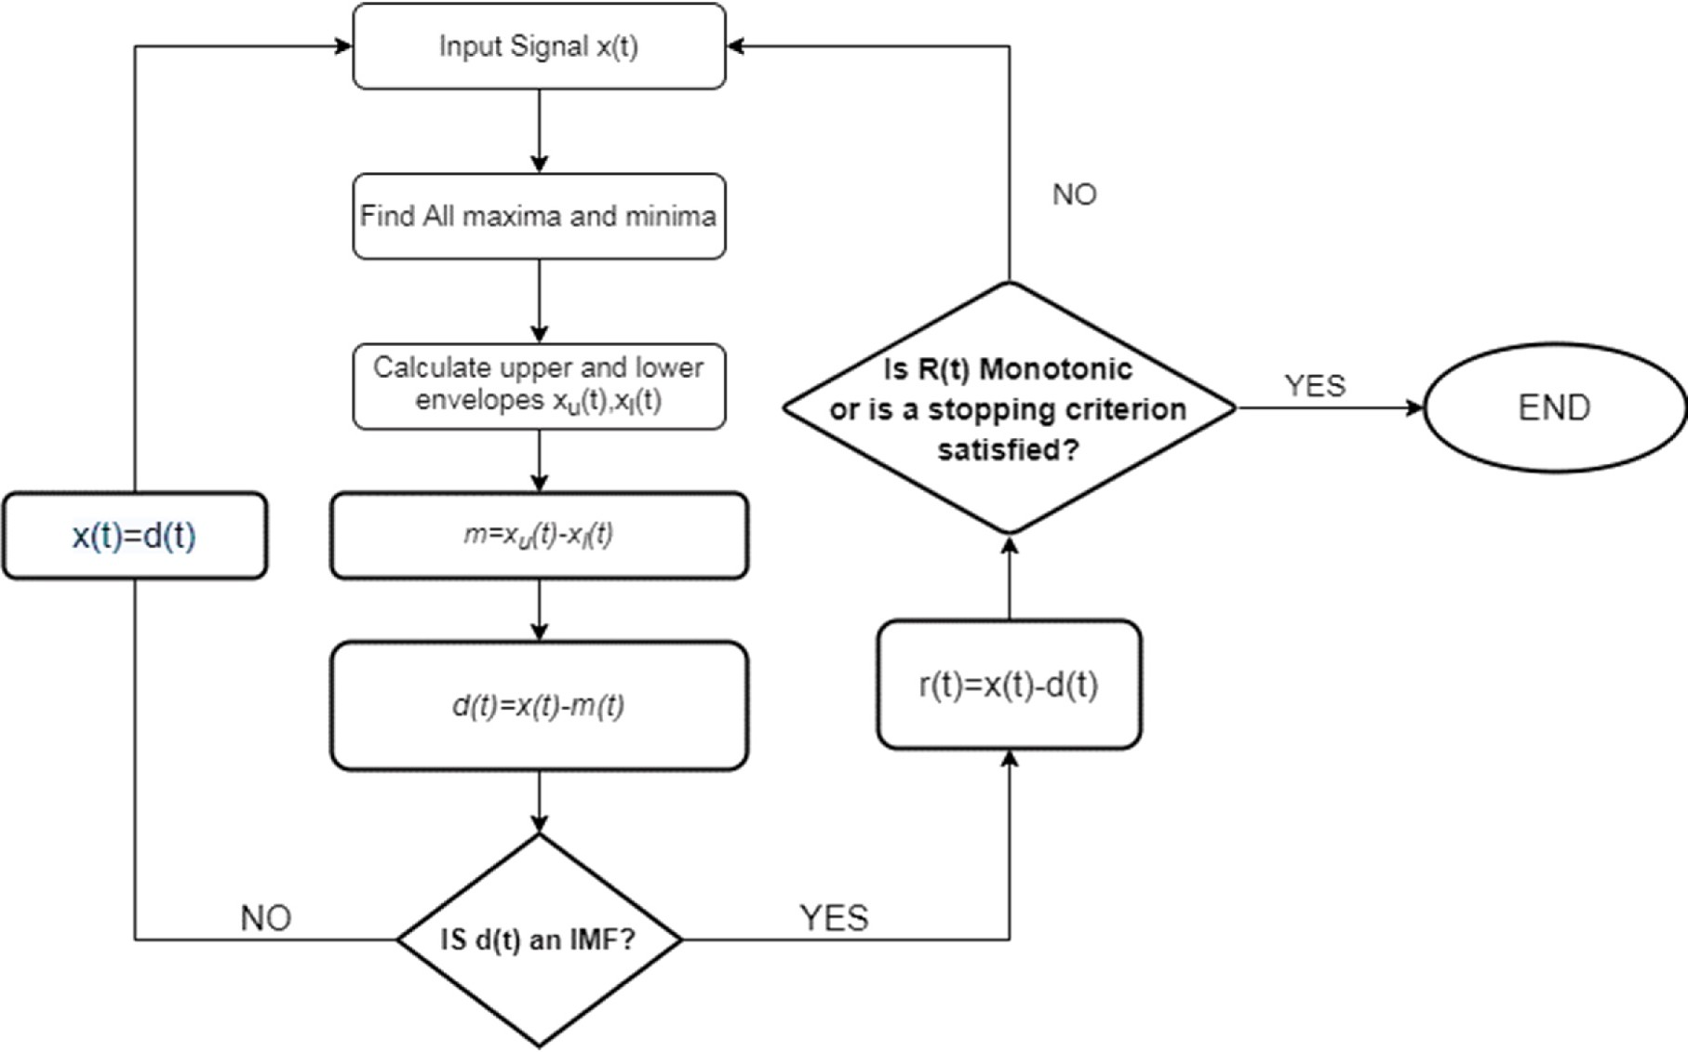

**Fig. 3.** Overview of the EMD algorithm.

* + 1. *Wavelet thresholding*

Wavelet transform is a signal processing tool that is widely used in biomedical signal processing because of its ability to produce a sparse representation for many real-world signals [39]. In the context of fetal ECG processing wavelet transforms have been used as a denoising tool in the form of Wavelet Thresholding (WT) [40]. Taking into advantage the ability of wavelets localize data on different scales, WT can preserve important signal features while removing noise. Denoising a signal using wavelets usually consists of three main steps.

* The Discrete Wavelet Transform (DWT) decomposes the signal into a few large-magnitude wavelet coefficients called detail coefficients

(decomposition).

* Wavelet coefficients which are small in value are typically noise and can be “shrinked” or removed without affecting the signal or image

quality (thresholding).

* After the coefficients are thresholded, the data is reconstructed using the inverse wavelet transform (Synthesis).

In this work, we propose the use of WT in the EMD domain, i.e. applying WT to each of the IMF’s. A description of our proposed approach is presented in the experiments section.

* 1. *Experimental setup*

This section describes in detail the datasets used in this study as well as the parameters and optimizations of all the algorithms used in the proposed hybrid system. We also describe in detail a new method for

identifying the most useful IMF’s that are produced after the EMD process.

* + 1. *Datasets*
       1. *Simulated dataset.* Simulated signals were produced using the *fecgsyn* simulator, which can create maternal-fetal ECG mixtures with realistic width, morphology, heart rate variability, heart rate changes

and noise [41]. Two different cases are examined, namely the normal state of the fetus (*Case 1*) and the case of uterine contractions (*Case 2*). Each simulation consists of 5-min abdominal mixtures projected on 34 channels (32 ventricular electrodes and 2 reference thoracic electrodes). A total of 40 simulated signals corresponding to 3.3 h of recording are produced, with a sampling frequency of 1 KHz (Fig. 4).

* + - 1. *Real datasets.* To test the performance of the proposed method in real data, the following datasets were used: A dataset available in the *PHYSIONET* database [42], namely the *Abdominal and Direct Fetal ECG Database (ADFECGDB)* [43] from here on denoted db1, the *Fetal Elec- trocardiograms, Direct and Abdominal with Reference Heartbeats Annota- tions* (*FECGDARHA*) [44] dataset, openly available in *figshare* repository

[45] denoted db2 and the recently published *Annotated Real Dataset for Non-Invasive Fetal Electrocardiography (ARDNIFECG)* [46] denoted db3 (Fig. 5). A brief description of the datasets as well as their use in this study is presented below.

* + - * + db1 contains five multichannel signals recorded in labor, between 38 and 41 weeks of gestation. Four channels were acquired from

maternal abdomen, and a direct electrocardiogram was recorded simultaneously from fetal head. The positioning of electrodes was constant during all recordings and the sampling rate was 1 kHz. For

the purposes of this work, db1 was utilized to test the hypothesis that removal of IMF’s during the fECG reconstruction stage can provide an improvement in FHR estimation.

* + - * + db2 [41] consists of 10 recordings obtained from pregnant women

between the 38th and 42 nd week of gestation. The recordings were

obtained using the KOMPOREL system with a sampling frequency of 500 Hz, and each signal duration is 20 min long. Each recording contains four abdominal signals after preliminary filtering and four indirect fECG signals after the suppression of the interfering MECG by subtracting the maternal PQRST complex pattern and the first derivative of the QRS complex. Additionally,a maternal signal con- taining the fiducial points of the MECG is provided for each record.

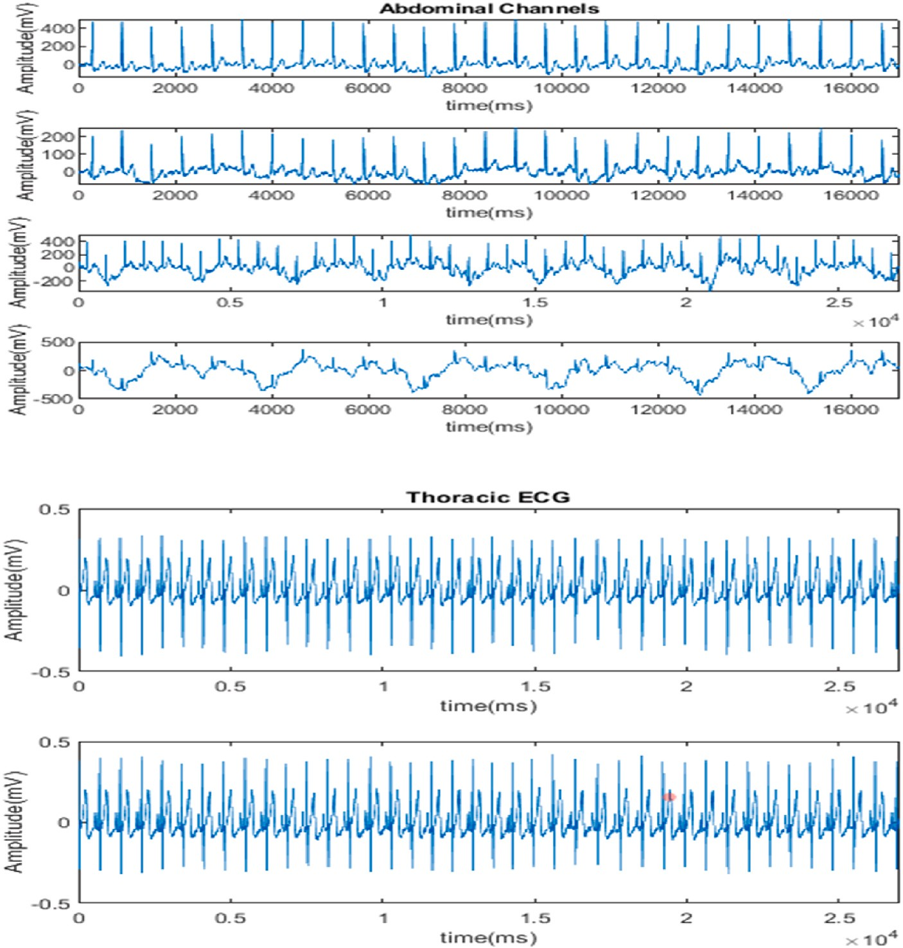

**Fig. 4.** Examples of signals generated with the *fecgsyn* simulator.

* + - * + db3 [43] consists of 18 signals originated from pregnant women between the 21st and 27th weeks of gestation. Signals were sampled

at 2048 Hz, with a duration of 15 s each. Each signal contains three differential maternal channels extracted from the thorax, and three unipolar abdominal leads. db2 and db3 were employed in order to provide quantitative results of the algorithm in terms of FHR estimation.

* + 1. *System setup*
       1. *FastICA.* In this work, the Independent Components (ICs) were extracted with a deflation approach. PCA deflation is a way to iteratively compute the principal components of a dataset. It starts by computing the first principal component and removing its effect from the data. This is done by projecting the data onto the first principal component and subtracting the resulting projection from the original data. The process is then repeated with the new, deflated data to compute the second principal component, and so on. The nonlinearity in the fixed-point al- gorithm is calculated using the hyperbolic tangent function:

*f* (*w*) = *tanh*(*a* ∗ *w*). (6)

The FastICA algorithm produced four components, corresponding to

the maternal ECG, the abdominal ECG signal containing the fetal ECG component and a noise signal. Fig. 6 shows the output of the FastICA algorithm on a multichannel abdominal fetal ECG.

* + - 1. *signal quality indices.* sQi’s can be calculated using various methods, such as time-domain analysis, frequency-domain analysis, and

wavelet analysis. They can be used to identify low-quality signals after the application of the ICA. An average sQI computed from the above indices is used to determine if accurate fECG separation is achieved. The indices used in this study are.

* + - * + bSQi [47]: The bSQi index uses the detection of QRS complexes by 2 detection algorithms and detects the percentage of common strokes

in algorithms. The QRS detection algorithms used on this work are the JQRS detector [45], and the MaxSearch algorithm available in Open-Source Electrophysiological Toolbox (OSET) [46]. The index is then computed as:

bSQI(k) = Nmatched(k, w) / Nall(k, w), (7)

where Nmatched is the number of common values of the algorithms (in a

150 m s window) and Nall is the number of all beats detected by an al-

gorithm (without double counting of the corresponding beats). bSQI ranges from 0 to 1. For N rhythms, there are N windows that have a

length w = 10sec., centered ±5 s around the k beat.

* + - * + xSQi [48]: A measure of contrast between the detected QRS complex and the embedded noise. Using a ~25 m s window around the po-

sition of each individual EQRS, the ECG peak range is compared to the signal strength within three times the window length. Therefore, xSQI calculates a measure representing how strong the currently detected beat is compared to ambient noise.

* + - * + kSQi: fourth moment (Kurtosis) of signal. Kurtosis is a widely used

measure of the non-Gaussianity of a signal. When several non-

Gaussian signals are added, the resulting mixed signal gains

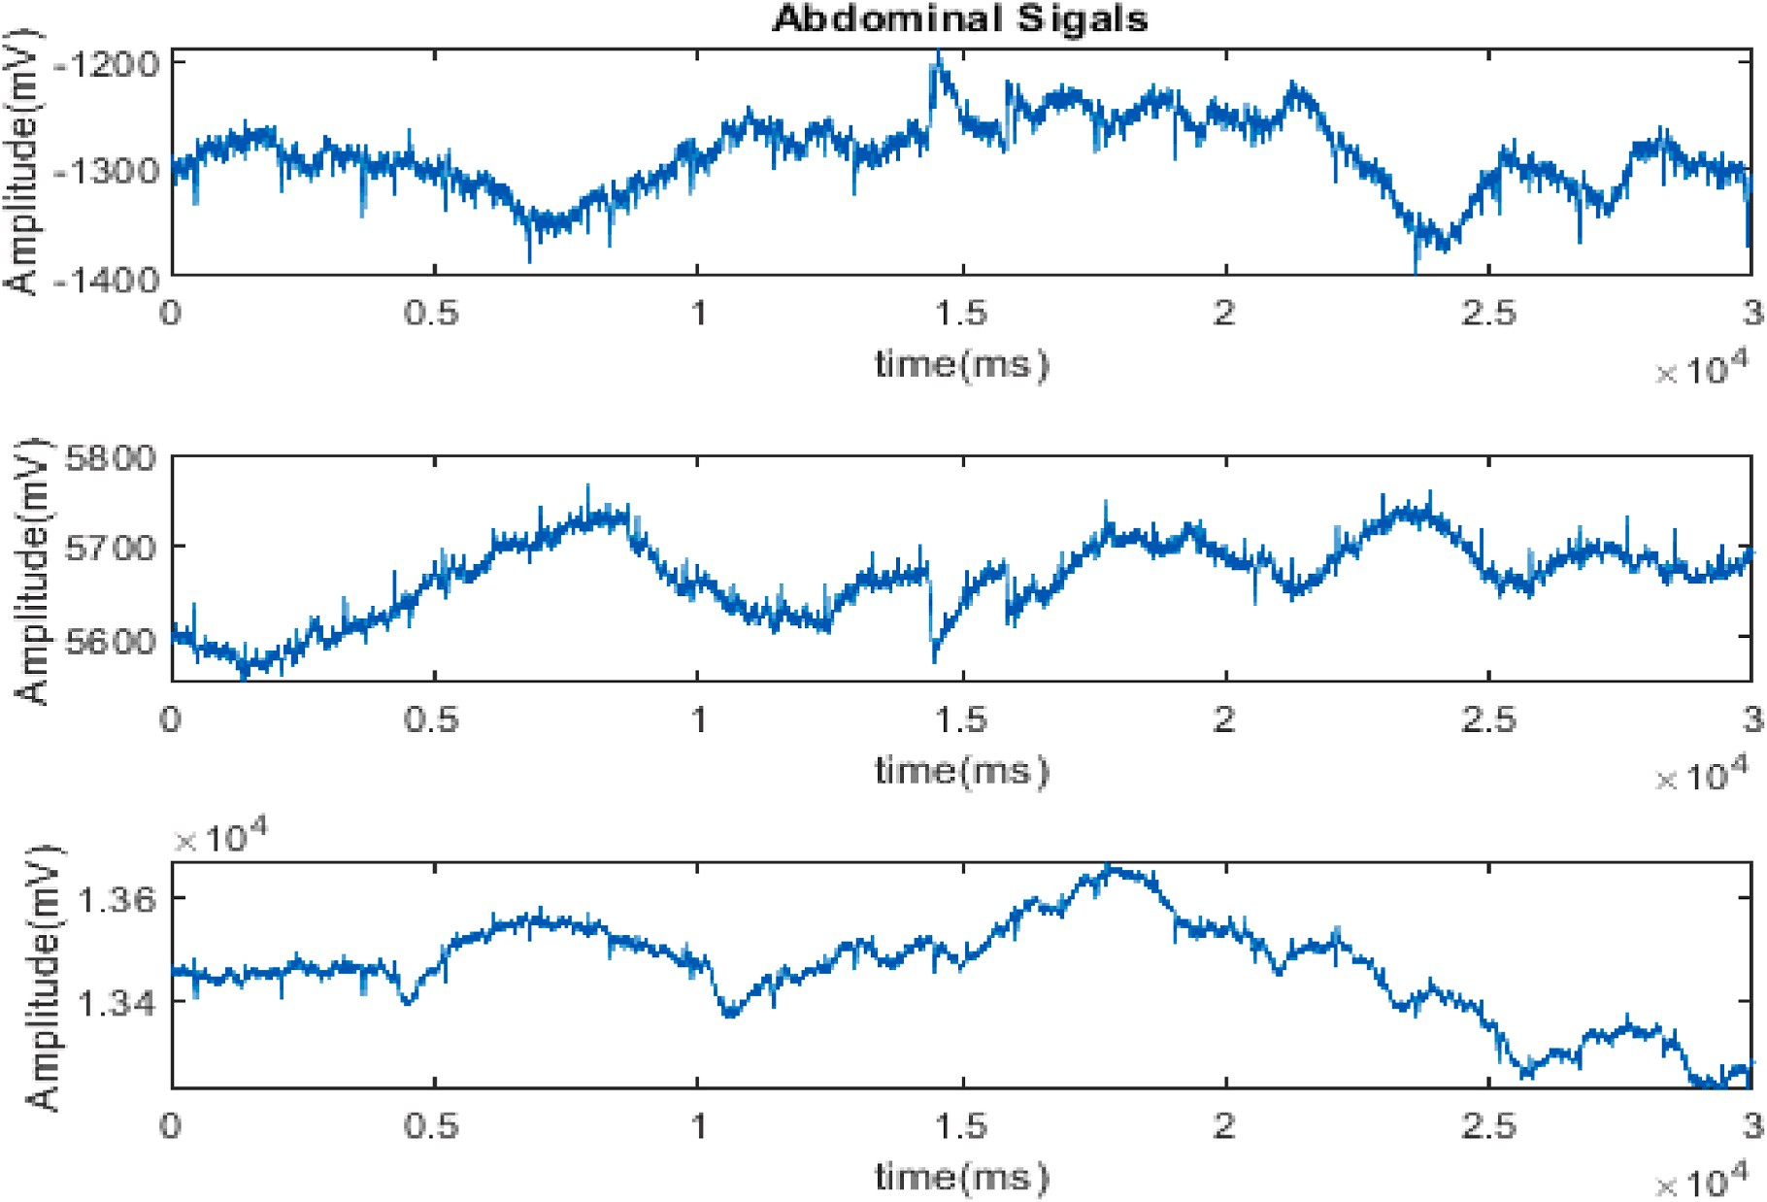

**Fig. 5.** Examples of abdominal signals in db3.

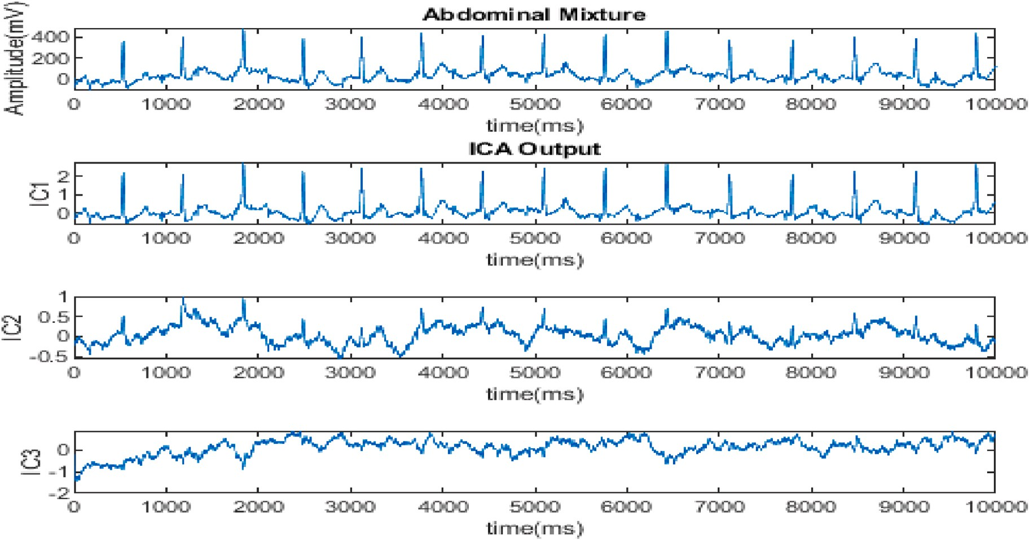

**Fig. 6.** Output of ICA algorithm (db3).

Gaussianity over the addend signals. A high Kurtosis index would therefore indicate the presence of an independent signal.

* + - 1. *Empirical mode decomposition.* To estimate the upper and lower envelopes we implemented the use of Hermite Polynomials, proposed in Ref. [49]. Hermite polynomial Interpolation can be described as such:

:Suppose *yi*(*t*) are the local maxima and minima of a time series at each given time *xi*(*t*), and *di* is the fist derivative of *yi* at each given time

*xi*: *di* = *dy*(*t*)/*dx*(*t*). The rational Hermite interpolation can be con- structed in each *xk*,*xk*+1, , *k* = 0, 1, ….*N* — 1 as:

*sk*(*x*) = *Fi*(*t*)*yi* + *Fi*+1(*t*)*yi*+1*Gi*(*t*)*hidi* + *Gi*+1(*t*)*hi*+1*di*+1. (8) Where *hi* = *xi*+1 — *xi*, *t* = (*x* —*xi*) /*hi* (9)

⃒ ⃒

And *Fi*(*t*), *Gi*(*t*) are the basis functions of the rational Hermite

interpolation. Also, after experimenting with the number of IMF’s pro-

duced to optimize the efficiency of FHR estimation, we set a stopping

criterion at 10 IMF’s (Fig. 7).

* + - 1. *Wavelet thresholding.* In this work we applied the Wavelet Thresholding directly in each IMF produced in the EMD domain. This

where, *σ* and *N* denote the standard deviation and the length of the wavelet coefficients at a given level. We use a soft thresholding function as,

approach takes advantage of the Fact that EMD uses data-driven basis functions adaptively which means that no fixed wavelet base function

needs to be specified for the wavelet decomposition.

|*Wi*[7]| — *εi*, |*Wi*[7]| ≥ *εi*,

0, |*Wi*[7]| < *εi*,

Ẃ*i*[7]{

(12)

Suppose that *IMF*[*n*] is the noisy IMF and *IMF*[*n*] indicates the denoised IMF. Then:

̂

*IMF* = *Thr*[*IMF*, *ε*] (10)

̂

where *Thr* is the threshold operator and ε is the threshold value. Each

IMF is decomposed into four levels using the seventh order *Symlet*

wavelet (Sym7) [50]. The threshold value is calculated according to the equation:

*ε* = *σ*√2*logN* (11)

where *W*, Ẃ are the initial and thresholded wavelets. Fig. 8 illustrates

the results of the proposed approach.

* + - 1. *IMF selection-fECG reconstruction.* Accurate and automatic distinguishing of effective IMFs for real-time signal processing and how

to process different types of IMF’s remains an open problem. While it is

always possible to decompose a signal by EMD, an extensive interpre- tation of the derived IMFs and their features has to be done. When dealing with nonlinear and nonstationary time series such as the ECG, although the derived decomposition is always correct from a mathe- matical standpoint, it may be the case that there is not a corresponding

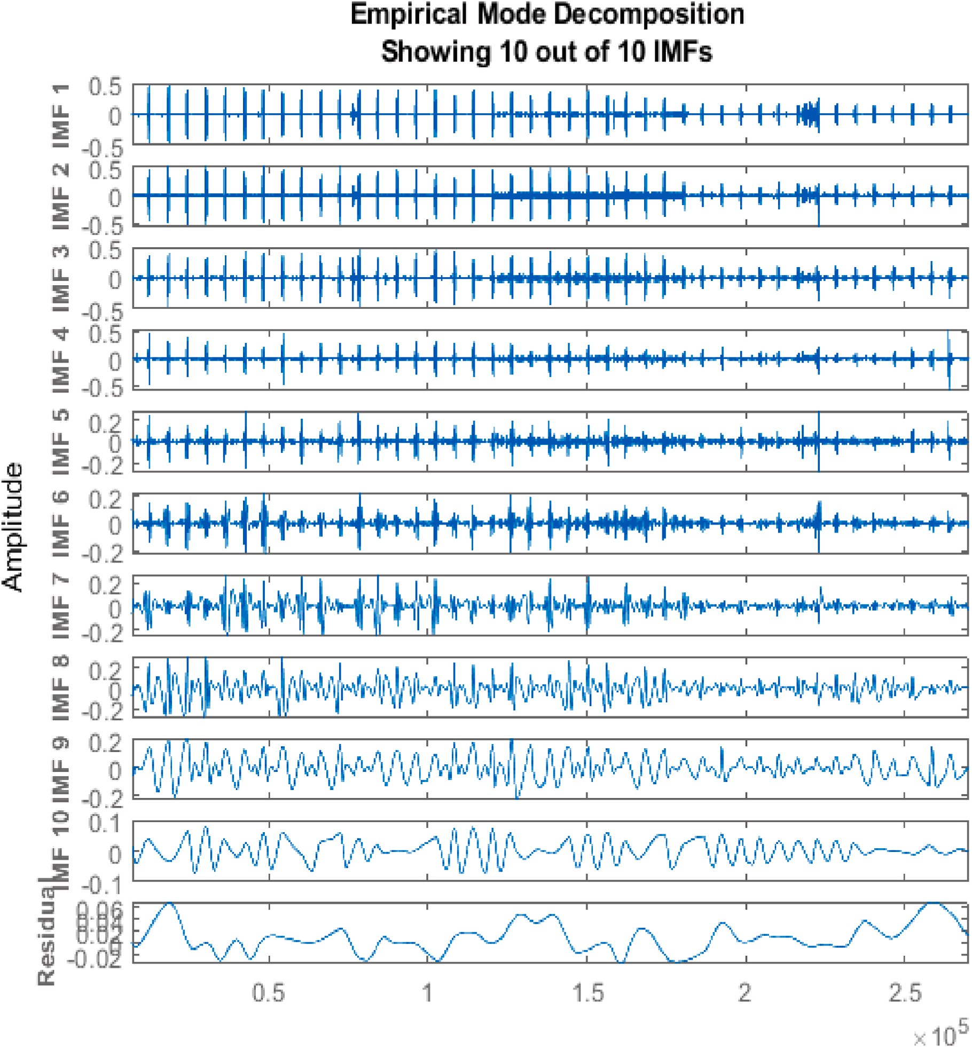**Fig. 7.** Empirical Mode Decomposition applied on rFECG.

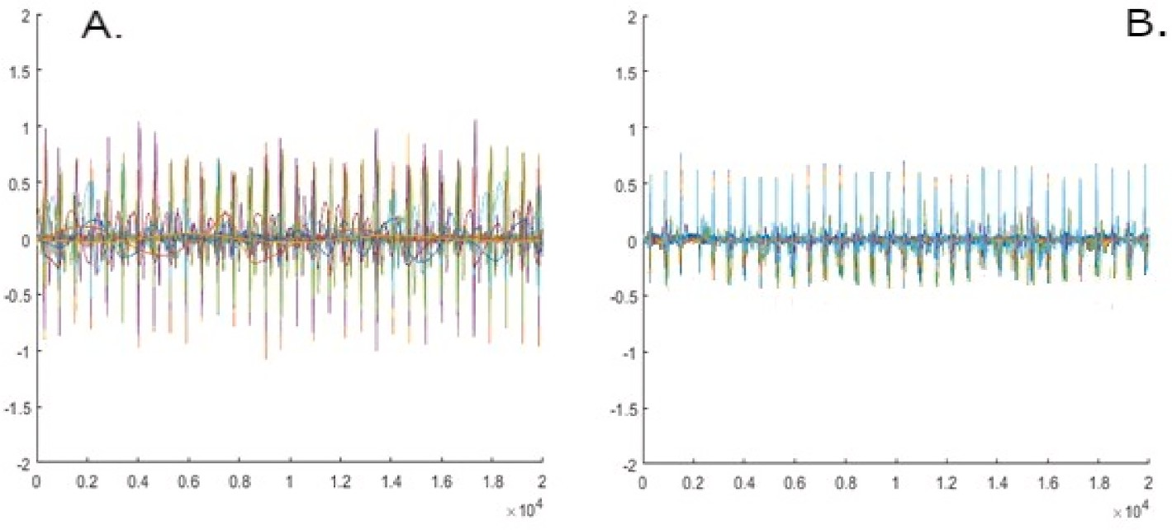

**Fig. 8.** A) The produced IMF’s before application of the Wavelet Thresholding. B) The IMF’s after the denoising process.

evident physical meaning of each IMF. If not properly handled, this could lead to an artefact-prone decomposition of the original signal causing significant information losses in the reconstructed fetal ECG signals. To address these problems, we developed an algorithm based on

cross-correlation that considers each IMF’s specific presence in both the extracted fetal ECG signal and the reference thoracic The proposed al-

gorithm computes the Pearson’s correlation coefficient of the produced IMF ‘S, both with the raw fetal ECG as well as with the maternal thoracic

ECG signals. A sensitivity factor is computed based on the computed coefficients and the IMF’s are ranked accordingly. Finally a distance

(*continued* )

bj = Corr (IMFj, thECG), j = 1 ……n

1. Compute the coefficients

cj = aj + (1 — bj)

1. Normalize the coefficients

criterion is used to select the optimal number of IMF’s that will be used in partially reconstructing the denoised. fECG signal. The algorithm is

presented below (Fig. 9).

*d*  *cj* — *min*(*c*)

*max*(*c*) — *min*(*c*)

*j* =

//sensitivity factor//

Correlation Algorithm for selecting the optimal IMF subset based on Correlation Analysis (using thoracic ECG)

1 Input: S = {IMF1 … …. IMFn}

2 Correlate IMF(j) with fECG signal

aj = Corr (IMFj, fECG), j = 1 ……n

1. Rank the sensitivity factor of the IMF’s in descending order:

*d*′ ≥ *d*′ …… ≥ *d*′ ≥ *d*′ //these correspond to IMF ranking

1

2

*j*—1

*j*

1. Rank the IMF’s according to their respective sensitivity factors *dj*
2. Calculate the highest difference between adjacent factors

*m* = *max*(*d*′ — *d*′ )

*j*

*j*—1

3 Correlate IMF(i) with thECG

(*continued on next column*)

1. Select the first m IMF’s (ranked by the sensitivity factor)

(*continued on next page*)

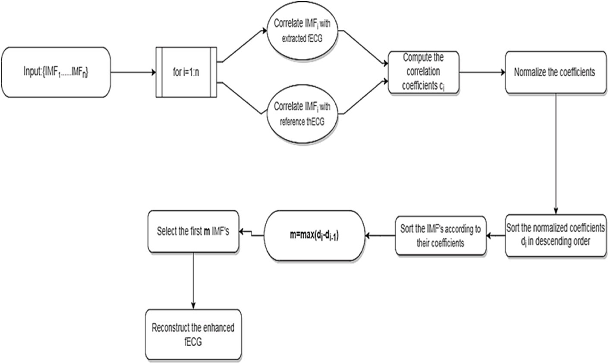

**Fig. 9.** Overview of the proposed IMF selection algorithm.

(*continued* )

1. Reconstruct the FECG signal as the sum of the selected IMF’s as

optimal IMF selection in the context of improving Fetal Heart Rate estimation. To provide such data, we used the publicly available Abdominal and Direct Fetal ECG Database (db1). This database was

*fECG*

∑ IMF i

where *m*

*max*(*d*′

*d*′ )

considered optimal for this test since the fetal heart rate was extracted

=

*m*

*I*=1

( ),

= *j* — *j*—1

from the fetal scalp electrode, thus providing an accurate FHR reference. After extracting and enhancing the fetal ECG signal using our proposed methodology, we employed a heuristic search algorithm in order to

* + 1. *IMF selection problem*

Denoising using EMD consists of removing non-essential IMF’s and partially reconstructing the signal using the IMF’s that contain the most useful information. Each IMF indicates the oscillation characteristics of

the signal [51]. Initial IMFs contain high-frequency information, and

search for the IMF subset that optimizes FHR. The algorithm steps are described below (Fig. 10). A detailed presentation of the optimization results can be found at the results section.

Heuristic Algorithm for selecting the optimal IMF subset Based on QRS detection

higher-order IMFs express low-frequency information [52]. The initial

attempt to use EMD as a denoising tool arose from the need to know if a particular IMF contains useful information or mainly noise. If one is aware of the energy of IMF resulting from the decomposition of a single signal, then in real case signals that include information and noise with specific characteristics, a significant deviation between the energy of an IMF and the corresponding noisy ECG signal indicates presence of useful information.

Nonstationary and nonlinear signals can be decomposed into IMFs, and this basis functions can reflect the components of the main signal. However, some of these components are not useful, while some of them reflect the characteristics of the original signal. Hence, selecting the effective IMFs has been an important process while processing signals in the EMD domain.

To date, no quantitative study exists that examines the results of

Input: S = {IMF1 … …. IMFi} i = 1 … …N.

1. for i = 1: N compute all the possible subsets of set S.
2. Detect estimated R peaks for each subset.
3. Compute detection performance measures based on reference R peaks.
4. The subset with the highest performance measures is selected as the optimal subset.

# Results

R-peak detection was performed using the JQRS detector [53,54], which is an implementation of the Pan&Tompkins algorithm [55] modified for fetal ECG QRS detection with the following parameters: 0.6 detector threshold, 15-s window size, 150-ms refractory period.

The efficiency of the proposed methodology is evaluated in simu-

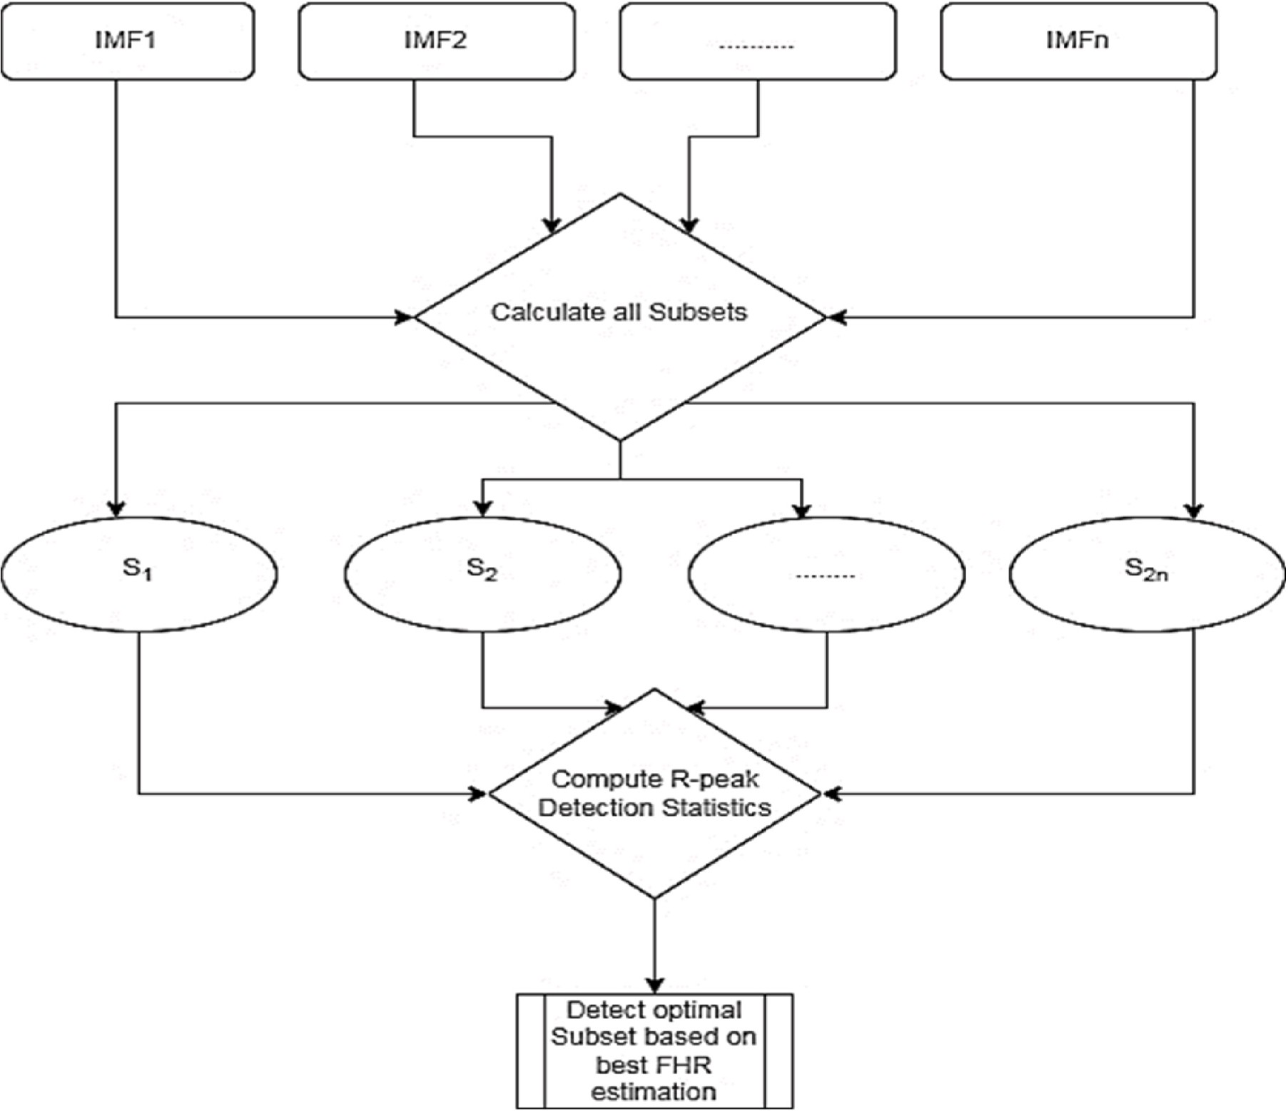

**Fig. 10.** Overview of the optimal search algorithm.

lated and real data by comparing the detected QRS complexes (QRSdet) with the reference QRS provided in the datasets (QRSref). There are several statistics that should be mentioned when evaluating the per- formance of any NI-fECG extraction algorithm. The classic statistics for evaluating a QRS detection algorithm, which were also used in this study include: The Sensitivity (SE), Positive Predictive Value (PPV), Accuracy (ACC), and F1 score (F1). Beyond these metrics, we also calculated the Mean Average Error (MAE), which represents the absolute time differ- ence, expressed in milliseconds between the reference QRS values and the detected QRS values. The statistical measures used in this study are described below:

*SE* = *TP*⁄ ((*TP* + *FN*)) (13)

*PPV* = *TP*⁄ ((*TP* + *FP*)) (14)

*ACC* = *TP* / ((*TP* + *FP* + *FN*)). (15)

*F*1 = (2 ∗ *SE* ∗ *PPV*) / (*SE* + *PPV*) (16)

# Discussion

Recent advances in the field of noninvasive fetal ECG analysis have shown that hybrid systems that combine adaptive and non-adaptive algorithms can outperform the use of singular methods, both in the context of fECG extraction as well as its denoising and enhancement. Studies that combine ICA with adaptive filters like the Recursive least Squares (RLS) [56] algorithm, the Least Mean Squares (LMS) [57] filter, decomposition techniques as the ensemble EMD or Wavelet Decompo- sition or more advanced methods as Artificial Neural Networks like an Adaptive Neuro-Fuzzy System (ANFIS) [58] have recently been pro- posed in the literature. However, implementation of such complex techniques comes at the cost of high computational complexity which makes them unsuitable for real-time applications. An overview of recently published studies in the field of NI-fECG extraction with a brief comment on their advantages and limitations is presented below (Table 6).

* The authors in Ref. [59] presented an algorithm based on using ICA

*MAE* =

*TP*

⃒*QRSref*

∑

— *QRSdet*⃒

(17)

to obtain the raw fetal ECG from the abdominal mixture and per-

*i*=*n* ⃒

*i*

*i*

Where *TP* stands for True Positive, *FP* for False Positive and *FN* for False

Negative.

* 1. *IMF selection algorithm evaluation*

Tables 1 and 2 demonstrate the results of optimal IMF subset selec- tion after EMD decomposition in db1. Statistical measures were obtained using the reference R peaks included in the dataset. In Table 1 the signal

was reconstructed as a sum of all the produced IMF’s while Table 2 presents the IMF subset that achieved the highest scores in terms of FHR

estimation as well as the IMF’s that were removed. Results have shown an improvement in FHR estimation and therefore demonstrate the

effectiveness of the EMD decomposition/IMF selection approach to processing fetal ECG signals.

* 1. *Fetal heart rate estimation*
     1. *Simulated data*

Each simulation is repeated 5 times, with different abdominal mix- tures and different FHR/MHR.Four different levels of additional noise (0, 3, 6 and 9 dB) are included in each case. Table 3 shows the average scores in every simulation.

* + 1. *Real data*

An automated multi-stage procedure to detect FQRS complexes was developed in order to provide the reference QRS complexes contained in the dataset. The determined locations of all fetal heartbeats (R waves) were validated by clinical experts, and each identified R-peak is com- plemented by a verification flag provided by the expert. For coherence reasons, only the first three abdominal channels are maintained. The results of our approach are presented in Table 4.

**Table 1**

Results before the IMF removal Process.

BEFORE NON-USEFULL IMF REMOVAL

|  |  |  |  |  |  |  |
| --- | --- | --- | --- | --- | --- | --- |
| RECORD | MEAN HR | PPV (%) | SE (%) | F1 (%) | ACC (%) | MAE (ms) |
| r01 | 143.67 | 92.59 | 95.03 | 93.79 | 88.31 | 7.84 |
| r04 | 146.45 | 87.33 | 89.4 | 88.35 | 79.13 | 12.47 |
| r07 | 125.91 | 94.14 | 83.73 | 90.28 | 82.29 | 9.58 |
| r08 | 142.97 | 92.08 | 91.09 | 91.58 | 84.47 | 7.19 |
| r10 | 141.71 | 92.85 | 91.68 | 92.26 | 85.63 | 10.55 |
| Average | 140.142 | 91.79 | 90.18 | 91.25 | 83.966 | 9.39 |

formed Template Subtraction using PCA to remove the maternal signal presence. They tested their algorithm on 75 recordings con- tained in the Physionet 2013 challenge dataset and reported average

values of SE = 93.8%, PPV = 92,2%, F1 = 93%. The method was

reported to have the advantage of a low computational load. Its

limitations included the distortion of the extracted signal morphology and a decrease in performance in the presence of ectopic beats.

* In Ref. [60] the authors used EMD to directly in the multichannel

abdominal signal and Non-Negative Matrix factorization to separate

the maternal and fetal ECG. The method was tested in the MiT Arrhythmia Database but no statistical results were reported and by visual comparison of the extracted figures there is not enough evi- dence that fECG extraction was achieved.

* In Ref. [61], a combination of Discrete Wavelet Transform with a

average values of SE = 100%, PPV = 91, 3% when testing on the Recursive Inverse algorithm was tested. The authors reported DAISY dataset. It is important to mention however that the DaISy

dataset consists of a single 8-lead signal, 10 s long which is obviously not enough data to provide acceptable statistical results.

* A combination Short Time Fourier transform and Generative

ported results were SE = 92.7%, PPV = 90.32%, F1 = 93.69% in the challenge dataset and SE = 89.7%, PPV = 93.02%, F1 = 90.05% Adversarial Neural Networks was proposed in Ref. [62]. The re-

when tested on the ADFECGDB which are worse results than those

achieved in this study. The authors report that use of a neural network eliminates the need for maternal ECG suppression. How- ever, being a data driven method, training the model requires the use of many similar data, which limits its usability in real-world scenarios.

* In Ref. [63], the authors devised a time-specific fetal quality index

reported average values of SE = 99.38%, PPV = 99.38%, F1 = for fECG extraction. When tested on the challenge Dataset, results 99.38%. However, their approach included an MECG cancelling step

and the Quality index devised did not consider the non-linear char- acteristics of a fECG signal.

* In Ref. [64] a hybrid method using Short-Time Vibrational Mode

Decomposition and PCA was devised by the authors. The challenge

2013 was used to test the algorithm and the reported results were SE

= 90.50%, PPV = 89.40%, F1 = 80.50%. Although the method was reported to be computationally efficient, it did not perform well on

low SNR scenarios.

* A combination of Wavelet based preprocessing and a clustering al- values of SE = 97.30%, PPV = 98.40%, F1 = 98.86%, ACC = 98.63% gorithm was proposed in Ref. [65]. The authors reported average

on the challenge dataset and SE = 97.08%, PPV = 97.93%, F1 =

Results after IMF removal Process.

AFTER NON-USEFULL IMF REMOVAL

|  |  |  |  |  |  |  |  |
| --- | --- | --- | --- | --- | --- | --- | --- |
| RECORD | MEAN HR | PPV(%) | SE (%) | F1 (%) | ACC (%) | MAE | IMF’S removed |
| r01 | 141.43 | 94.41 | 97.05 | 95.71 | 91.78 | 4.43 | 3,7,8,9,10 |
| r04 | 131.38 | 94.68 | 87.34 | 90.86 | 84.01 | 6.34 | 2,3,8 |
| r07 | 125.09 | 97.95 | 92.19 | 93.15 | 87.18 | 9.57 | 1,2,6 |
| r08 | 138.6 | 94.13 | 93.55 | 93.84 | 88.39 | 5.38 | 6,8,9 |
| r10 | 142.11 | 93.17 | 92.15 | 92.66 | 87.32 | 10.03 | 2,5,9,10 |
| Average | 135.722 | 94.86 | 92.45 | 93.24 | 87.736 | 7.15 |  |

**Table 3**

Simulated data results (average values).

|  |  |  |  |  |  |
| --- | --- | --- | --- | --- | --- |
|  | SNR | SE (%) | PPV (%) | ACC (%) | F1 (%) |
| Case 1 | 0 | 94.3 | 94.9 | 94.8 | 97.1 |
|  | 3 | 95.7 | 100.0 | 95.3 | 97.8 |
|  | 6 | 97.9 | 98.9 | 94.0 | 95.0 |
|  | 9 | 93.4 | 99.7 | 93.3 | 94.2 |
| Case 2 | 0 | 99.3 | 90.8 | 92.2 | 94.9 |
|  | 3 | 98.6 | 84.3 | 90.6 | 92.6 |
|  | 6 | 97.1 | 89.6 | 87.2 | 93.1 |
|  | 9 | 91.3 | 95.5 | 87.9 | 89.1 |

97.91%, ACC = 98.52% on the ADFECGDB dataset, which are better than the results reported in this study. While the method is reported

to produce consistent results across multiple datasets, it requires extensive parameter optimization which makes it difficult to imple- ment in real-time medical applications.

* In Ref. [66], the authors propose a hybrid algorithm consisting of ICA and Recursive Least Squares Adaptive filtering with Wavelet

were achieved for recordings from the FECGDARHA database (SE = 89.70%, PPV = 92.41%, F1 = 90.99%, ACC 85.92%) than those Thresholding. According to the statistical evaluation, worse results

achieved using the algorithm proposed in the present paper. The

authors also excluded low quality inputs from their study.

* Finally the authors in Ref. [67] tested an algorithm combining ICA with a Fast Transversal Adaptive Filter and Complete Ensemble EMD

dataset (SE = 95.33%, PPV = 96.49%, F1 = 95.86%, ACC = 92.8%) with Adaptive Noise. The reported results on the FECGDARHA

are better than the ones reported in this study. The proposed hybrid

system is reported to achieve high quality fECG extraction across different noise scenarios However, the system is reported to require extensive parameter optimization in order to operate consistently across different datasets. Furthermore the use of Complete Ensemble EMD increases the computational load of the algorithm.

**Table 4**

Results of the algorithm in db2. The R-peaks annotations provided in db3 were used to produce the statistical metrics. Annotation of the fetal QRS complexes was performed manually and validated by a cardiologist with the help of a simultaneous cardiac fetal pulsed-wave Doppler signal recorded during the procedure. Table 5 presents the results of our approach.

|  |  |  |  |  |  |  |  |  |  |
| --- | --- | --- | --- | --- | --- | --- | --- | --- | --- |
| Record | REFqrs | TP | FP | FN | SE (%) | PPV(%) | F1 (%) | ACC(%) | MAE (ms) |
| B1_01 | 3120 | 2813 | 307 | 22 | 99.92 | 90.16 | 95.37 | 90.53 | 8.17 |
| B1_02 | 2801 | 2429 | 375 | 36 | 98.54 | 86.63 | 92.29 | 85.53 | 11.47 |
| B1_03 | 2565 | 2209 | 356 | 11 | 99.5 | 86.12 | 92.23 | 85.75 | 9.37 |
| B1_04 | 2774 | 2693 | 81 | 3 | 99.89 | 97.18 | 98.46 | 96.98 | 4.32 |
| B1_05 | 2770 | 2704 | 66 | 2 | 99.93 | 97.62 | 98.76 | 97.55 | 2.81 |
| B1_06 | 2889 | 2456 | 433 | 43 | 98.28 | 85.61 | 91.17 | 84.95 | 11.38 |
| B1_07 | 1969 | 1830 | 1 | 140 | 92.89 | 99.95 | 96.29 | 92.84 | 5.91 |
| B1_08 | 2911 | 2751 | 160 | 0 | 100 | 90.18 | 94.84 | 94.18 | 4.36 |
| B1_09 | 2866 | 2485 | 381 | 17 | 99.32 | 86.71 | 92.59 | 86.19 | 10.43 |
| B1_10 | 2592 | 2519 | 73 | 71 | 97.26 | 97.18 | 97.22 | 94.59 | 4.41 |
| *Average* |  |  |  |  | 98.55 | 91.734 | 94.92 | 90.90 | 7.26 |

**Table 5**

Results of the algorithm in db3.

|  |  |  |  |  |  |  |  |  |  |
| --- | --- | --- | --- | --- | --- | --- | --- | --- | --- |
| Record | QRSref | TP | FP | FN | SE (%) | PPV(%) | F1 (%) | ACC(%) | MAE (ms) |
| Real_traces_1 | 34 | 32 | 1 | 1 | 96.97 | 96.97 | 96.97 | 94.12 | 10.31 |
| Real_traces_2 | 32 | 31 | 2 | 1 | 96.88 | 93.94 | 95.38 | 91.18 | 7.17 |
| Real_traces_3 | 34 | 34 | 1 | 0 | 100.0 | 97.14 | 98.55 | 97.14 | 11.97 |
| Real_traces_4 | 39 | 37 | 3 | 2 | 94.87 | 92.5 | 93.67 | 88.14 | 17.79 |
| Real_traces_6 | 34 | 33 | 3 | 1 | 97.06 | 91.67 | 94.29 | 89.19 | 8.36 |
| Real_traces_7 | 34 | 34 | 3 | 0 | 100.0 | 91.89 | 95.77 | 91.89 | 13.53 |
| Real_traces_8 | 38 | 38 | 6 | 0 | 100.0 | 89.17 | 88.37 | 89.17 | 11.29 |
| Real_traces_10 | 36 | 34 | 2 | 2 | 94.44 | 94.44 | 94.44 | 89.47 | 14.18 |
| Real_traces_11 | 34 | 34 | 8 | 0 | 100.0 | 90.95 | 89.47 | 90.95 | 15.79 |
| Real_traces_12 | 36 | 36 | 4 | 0 | 100.0 | 91.82 | 94.05 | 91.82 | 18.89 |
| Real_traces_13 | 34 | 34 | 3 | 0 | 100.0 | 91.89 | 95.77 | 91.89 | 16.85 |
| Real_traces_14 | 32 | 30 | 2 | 2 | 97.55 | 93.75 | 93.75 | 88.24 | 7.73 |
| Real_traces_15 | 34 | 34 | 2 | 0 | 100.0 | 94.44 | 97.14 | 94.44 | 5.35 |
| Real_traces_16 | 34 | 34 | 4 | 0 | 100.0 | 89.47 | 94.35 | 89.47 | 5.36 |
| Real_traces_18 | 38 | 38 | 5 | 0 | 97.37 | 88.37 | 93.83 | 88.37 | 7.92 |
| Real_traces_19 | 35 | 35 | 7 | 0 | 100.0 | 86.09 | 86.42 | 86.09 | 8.23 |
| Real_traces_20 | 35 | 34 | 6 | 1 | 97.14 | 85.95 | 88.31 | 87.07 | 5.23 |
| Real_traces_21 | 34 | 34 | 4 | 0 | 100.0 | 89.47 | 94.23 | 89.47 | 3.68 |
| Average |  |  |  |  | 92.96 | 91.662 | 93.60 | 90.45 | 10.54 |

**Table 6**

Comparison of recent studies on FHR estimation metrics. (Average values of records tested in each study).

|  |  |  |  |  |  |  |
| --- | --- | --- | --- | --- | --- | --- |
| Author(s) | Methodology | Dataset | Results |  |  | Advantages/limitations |
|  |  |  | SE (%) PPV | F1 (%) | ACC |  |
|  |  |  | (%) |  | (%) |  |
| Behar et al. [59] | ICA -TSPCA | Challenge 2013 | 93.8 92.2 | 93.0 | – | -Does not preserve signal morphology  -Poor performance on presence of ectopic beats |
| He et al. [60] | EMD-NMF | MIT Arrhythmia | – – | – | – | + Single channel method suitable for multiple births |
|  |  | Database |  |  |  | - Not tested on actual recordings |
| Al-Sheikh et al. [61] | DWT- RI | DAISY | 100 91.3 | – | 91.3 | + Effective on low SNR scenarios |
|  |  |  |  |  |  | -Use of a reference electrode |
| Zhong et al. [62] | STFT-GAN | Challenge 2013 | 92.7 93.69 | 93.02 | – | + No need for MECG suppression |
|  |  | ADFECGDB | 90.32 89.7 | 90.05 | – | -Poor performance in case of overlapping Signals |
| Billecci & Varanini | BSS-QIO | Challenge 2013 | 99.38 99.38 | 99.38 | – | +Unsupervised method, robust to high noise level |
| [63] |  |  |  |  |  | -Requires maternal ECG cancelling |
| Lee et al. [64] | STVD -PCA | Challenge 2013 | 90.50 89.40 | 89.90 | – | +Computationally efficient |
|  |  |  |  |  |  | -Poor performance for low SNR levels |
| Castillo et al. [65] | WT-CLUSTERING | Challenge 2013 | 97.30 98.40 | 98.86 | 98.63 | + Stability across different datasets |
|  |  | ADFECGDB | 97.08 97.93 | 99.11 | 98.52 | -Requires extensive parameter optimization |
| Jaros et al. [58] | ICA-RLS-WT | FECGDARHA | 85.92 89.70 | 92.41 | 90.99 | + Robust FHR estimation |
|  |  | Challenge 2013 | 68.25 72.60 | 81.31 | 75.68 | -Requires high quality signal inputs |
| Singh et al. [66] | K/ICA-WT | ADFECGDB | 96.1 98.5 | 97.3 | 94.8 | +Fast convergence of the ICA algorithm |
|  |  |  |  |  |  | -Not tested on datasets with variable SNR |
| Barnova et al. [67] | ICA-FTF-CEEMDAN | FECGDARHA | 95.33 96.49 | 95.86 | 92.8 | + High Quality extraction of fECG signal on variable noise |
|  |  | Challenge 2013 | 82.06 87.9 | 84.62 | 78.47 | scenarios |
|  |  |  |  |  |  | -Requires continuous parameter optimization |
| Proposed Method | ICA/sQIEMD/WT- | ADFECGDB | 92.45 94.86 | 93.24 | 87.73 | + Fully automated FHR estimation process |
|  | CA | FECGDARHA | 98.55 91.73 | 94.92 | 90.91 | +Computationally efficient Due to the use of EMD and WT, |
|  |  | ARDNIFECG | 92.96 91.66 | 93.60 | 90.45 | -Requires a thoracic reference electrode |

Evaluation of ECG signal quality has been addressed in several studies in adult ECG monitoring [68,69]. However, in the case of fetal ECG processing the presence of a Maternal ECG signal can greatly distort

the Quality Indices performance. Andreotti et al. [70] proposed specific sQI’s targeted at NI-FECG applications and tested their applicability on previously extracted fECG signals. In this work we propose a combina-

tion of an ICA algorithm with fetal quality indices that can extract a raw unprocessed fECG signal from multichannel abdominal recordings of different noise levels and acquisition quality.

Accurate and automatic distinguishing of IMFs for real-time signal processing and how to process different types of IMFs remains an open problem. In the conventional EMD noise reduction method, higher order IMFs are often discarded to reduce noise. However, this process causes significant information losses in the reconstructed signals. Algorithms for assessing the importance of IMFs were developed by Flandrin et al.

[71] and Wu et al. [72] based on the statistical analysis of the functions resulting from the decomposition of the signals. In the field of nonin- vasive fetal ECG analysis there is a lack of research on the selection of optimal IMFs while using EMD and other similar decomposition methods. The correlation algorithm presented in this work takes advantage of signal specific characteristics of the produced IMFs to partially reconstruct a fECG signal that improves FHR detection.

Results presented in this paper show that our method can produce accurate FHR estimations when tested against different datasets of variable quality and acquisition protocols. When tested on the FECG-

DARHA database our method achieved average values of SE = 98.55%, PPV = 91.73%, F1 = 94.92%, ACC = 90.91%. Testing on the ARDNI-

FECG achieved average values of SE = 92.96%, PPV = 91.66%, F1 =

93.60%, ACC = 90.45%.The heuristic search on algorithm showed that on the ADFECGDB by average values of SE = 3.07%, PPV = 2.27%, F1 = 2.00%, ACC = 3.77%. It should be noted that our results were consistent optimal IMF selection demonstrated an improvement on FHR estimation

across all datasets tested in this work.

The proposed system has several advantages in speed, efficient FECG processing and adaptability. More specifically.

* The FastIca algorithm selected for abdominal signal separation is computationally efficient and requires less memory than other blind

source separation algorithms, for example Infomax. Another

advantage is that the independent components can be evaluated one by one, which further reduces the computational burden.

* The application of quality indices to the results of FastIca allows the

automatic and accurate selection of the component of interest.

* The noise reduction algorithm is adaptive, in the sense that during the noise reduction process the noise-dominated IMFs can be

distinguished from the total signal adaptively. That is, the correlation algorithm can decide which IMFs should be processed according to the signal itself. In addition, the level of wavelet decomposition can

be adjusted to achieve the optimal enhancement of the IMF’s without distorting their morphology.

* 1. *Limitations and future work*

The hybrid system proposed in this work focuses on improving the performance of some frequently used algorithms in the field of fetal ECG processing. While our method is proven to be highly efficient and robust in extracting an accurate FHR estimation from multichannel abdominal recordings, some limitations should be considered. First, the usage of a maternal thoracic electrode could be unsuitable for real-time fetal monitoring applications as it could discomfort the mother during the monitoring process. Furthermore, the application of Wavelet Threshold in the EMD domain has a negative effect on the reconstructed signal morphology, thus impeding further analysis. Finally the fastICA algo- rithm requires the use of multiple abdominal electrodes in order to produce reliable results.

Future work will focus on addressing these shortcomings by exploring the applicability of more sophisticated source separation techniques such as the Non-Negative matrix factorization [73] which could allow for fetalECG extraction from single channel abdominal re- cordings as well as newly introduced decomposition algorithms such as the Empirical Wavelet Transform (EWT) [74], recently applied to adult ECG analysis by Singh et al. [75], and the research and development of IMF selection algorithms that do not require the use of a reference thoracic electrode. We also aim at using our algorithm on the classifi- cation of fetal ECG signals based on their Heart Rate variability mea- sures. Since our method can produce accurate FHR estimations, combining it with machine learning algorithms such as k-Nearest

Neighbors (kNN), Random Forests [76] or Support Vector Machines could provide insight into pathological conditions related to fetal ar- rhythmias. Such classification approaches are nowadays becoming growingly popular in daily clinical practice, solving diagnostic and prognostic challenges in various medical settings, such as the moni- toring of the recent COVID-19 pandemic [77].

# Conclusion

Non-invasive fetal ECG is becoming an increasingly popular approach to fetal heart monitoring since its application is relatively simple and thus can be used for long-term recordings to assess fetal cardiac status. We presented a comprehensive methodology for the non- invasive extraction of the fetal electrocardiogram from abdominal re- cordings, denoising and enhancement of the extracted fECG, and the extraction of the Fetal Heart Rate, using Blind Source Separation to separate the mixed abdominal signal in its Independent Components, signal specific indices to select the IC that carries the most information related to the fetal ECG, a hybrid method based on Empirical Decom- position and Wavelet thresholding of each IMF to remove noise artifacts and enhance the extracted fetal component and a novel algorithm based

on correlation analysis in order to partially reconstruct the fECG from the IMF’s. We provided quantitative data that demonstrate the impor- tance of accurate selection of the intrinsic functions derived from EMD

in improving FHR estimation. Our method was evaluated on a simulated dataset as well as two real datasets, providing adequate results to sup- port our approach, and the results were compared with other method- ologies published on the same problem. The methodology we presented in this work is completely unsupervised and has proven to be robust in different SNR scenarios and variable abdominal signals while its low computational complexity makes it suitable for the development of efficient real-time fetal monitoring applications.

# Declaration of competing interest

The authors declare the following financial interests/personal re- lationships which may be considered as potential competing interests: Alexandros Tzallas reports financial support was provided by University of Ioannina - Arta. Alexandros Tzallas reports a relationship with Uni- versity of Ioannina - Arta that includes: non-financial support.

# Data availability

Data will be made available on request.

# Acknowledgments

We acknowledge support of this work by the project “Immersive Virtual, Augmented and Mixed Reality Center Of Epirus” (MIS:5047221) which is implemented under the Action “Reinforcement of the Research and Innovation Infrastructure”, funded by the Operational Programme “Competitiveness, Entrepreneurship and Innovation” (NSRF 2014–2020) and co-financed by Greece and the European Union (Eu- ropean Regional Development Fund).

# References

1. Lawn JE, Blencowe H, Pattinson R, Cousens S, Kumar R, Ibiebele I, Gardosi J,

Day LT, Stanton C. Stillbirths: where? When? Why? How to make the data count? Lancet 2011;377(9775):1448–63. [https://doi.org/10.1016/s0140-6736(10)](https://doi.org/10.1016/s0140-6736(10)62187-3)

[62187-3](https://doi.org/10.1016/s0140-6736(10)62187-3).

1. Karavadra B, Stockl A, Prosser-Snelling E, Simpson P, Morris E. Women’s perceptions of COVID-19 and their healthcare experiences: a qualitative thematic

analysis of a national survey of pregnant women in the United Kingdom. BMC Pregnancy Childbirth 2020;20(1):600. [https://doi.org/10.1186/s12884-020-](https://doi.org/10.1186/s12884-020-03283-2) [03283-2](https://doi.org/10.1186/s12884-020-03283-2).

1. Mindchild. [https://www.mindchild.com](https://www.mindchild.com/).
2. Nemo Healthcare. [https://nemohealthcare.com](https://nemohealthcare.com/).
3. Avalon Fetal Monitor. [https://www.usa.philips.com/healthcare/resources/landi](https://www.usa.philips.com/healthcare/resources/landing/avalon) [ng/avalon](https://www.usa.philips.com/healthcare/resources/landing/avalon).
4. Mhajna M, Schwartz N, Levit-Rosen L, Warsof S, Lipschuetz M, Jakobs M, et al. Wireless, remote solution for home fetal and maternal heart rate monitoring. Am J Obstet Gynecol MFM 2020;2(2):100101. [https://doi.org/10.1016/j.](https://doi.org/10.1016/j.ajogmf.2020.100101) [ajogmf.2020.100101](https://doi.org/10.1016/j.ajogmf.2020.100101).
5. Martens SMM, Rabotti C, Mischi M, Sluijter RJ. A robust fetal ECG detection method for abdominal recordings. Physiol Meas 2007;28(4):373–88. [https://doi.](https://doi.org/10.1088/0967-3334/28/4/004) [org/10.1088/0967-3334/28/4/004](https://doi.org/10.1088/0967-3334/28/4/004).
6. Vullings R, Peters CHL, Sluijter RJ, Mischi M, Oei SG, Bergmans JWM. Dynamic segmentation and linear prediction for maternal ECG removal in antenatal

abdominal recordings. Physiol Meas 2009;30(3):291–307. [https://doi.org/](https://doi.org/10.1088/0967-3334/30/3/005) [10.1088/0967-3334/30/3/005](https://doi.org/10.1088/0967-3334/30/3/005).

1. Liu H, Chen D, Sun G. Detection of fetal ECG R wave from single-lead abdominal ECG using a combination of RR time-series smoothing and template-matching

approach. IEEE Access 2019;7:66633–43. [https://doi.org/10.1109/](https://doi.org/10.1109/access.2019.2917826) [access.2019.2917826](https://doi.org/10.1109/access.2019.2917826).

1. Ghazdali A, Hakim A, Laghrib A, Mamouni N, Raghay S. A new method for the extraction of fetal ECG from the dependent abdominal signals using blind source separation and adaptive noise cancellation techniques. Theor Biol Med Model 2015;12(1). <https://doi.org/10.1186/s12976-015-0021-2>.
2. Zarzoso V, Nandi A. Noninvasive fetal electrocardiogram extraction: blind separation versus adaptive noise cancellation. IEEE (Inst Electr Electron Eng) Trans

Biomed Eng 2001;48(1):12–8. <https://doi.org/10.1109/10.900244>.

1. Ramli DA, Shiong YH, Hassan N. Blind source separation (BSS) of mixed maternal

and fetal electrocardiogram (ECG) signal: a comparative study. Proc Comput Sci 2020;176:582–91. <https://doi.org/10.1016/j.procs.2020.08.060>.

1. Liu SJ, Liu DL, Zhang JQ, Zeng YJ. Extraction of fetal electrocardiogram using

recursive least squares and normalized least mean squares algorithms. In: 3rd international conference on advanced computer control; 2011. [https://doi.org/](https://doi.org/10.1109/icacc.2011.6016426) [10.1109/icacc.2011.6016426](https://doi.org/10.1109/icacc.2011.6016426). 2011.

1. Martinek R, Kahankova R, Skutova H, Koudelka P, Zidek J, Koziorek J. Adaptive signal processing techniques for extracting abdominal fetal electrocardiogram. In: 10th international symposium on communication systems, networks and digital signal processing (CSNDSP); 2016. [https://doi.org/10.1109/](https://doi.org/10.1109/csndsp.2016.7573974) [csndsp.2016.7573974](https://doi.org/10.1109/csndsp.2016.7573974). 2016.
2. Behar J, Johnson A, Clifford GD, Oster J. A comparison of single channel fetal ECG

extraction methods. Ann Biomed Eng 2014;42(6):1340–53. [https://doi.org/](https://doi.org/10.1007/s10439-014-0993-9) [10.1007/s10439-014-0993-9](https://doi.org/10.1007/s10439-014-0993-9).

1. Swarnalath R, Prasad D. A novel technique for extraction of FECG using multistage adaptive filtering. J Appl Sci 2010;10(4):319–24. [https://doi.org/10.3923/](https://doi.org/10.3923/jas.2010.319.324) [jas.2010.319.324](https://doi.org/10.3923/jas.2010.319.324).
2. Zhong W, Liao L, Guo X, Wang G. A deep learning approach for fetal QRS complex detection. Physiol Meas 2018;39(4):045004. [https://doi.org/10.1088/1361-6579/](https://doi.org/10.1088/1361-6579/aab297) [aab297](https://doi.org/10.1088/1361-6579/aab297).
3. Вin Ibne Reaz M, Lee Sze Wei. Adaptive linear neural network filter for fetal ECG extraction. In: International conference on intelligent sensing and information processing, 2004. Proceedings of; 2004. [https://doi.org/10.1109/](https://doi.org/10.1109/icisip.2004.1287675) [icisip.2004.1287675](https://doi.org/10.1109/icisip.2004.1287675).
4. Pal S, Mitra M. Empirical mode decomposition based ECG enhancement and QRS detection. Comput Biol Med 2012;42(1):83–92. [https://doi.org/10.1016/j.](https://doi.org/10.1016/j.compbiomed.2011.10.012) [compbiomed.2011.10.012](https://doi.org/10.1016/j.compbiomed.2011.10.012).
5. Li H, Wang X, Chen L, Li E. Denoising and R-peak detection of electrocardiogram signal based on EMD and improved approximate envelope. Circ Syst Signal Process 2013;33(4):1261–76. <https://doi.org/10.1007/s00034-013-9691-3>.
6. Zhang SC, Sui LL. A new denoising method via empirical mode decomposition.

Appl Mech Mater 2014;651–653:2090–3. [https://doi.org/10.4028/www.scientific.](https://doi.org/10.4028/www.scientific.net/amm.651-653.2090) [net/amm.651-653.2090](https://doi.org/10.4028/www.scientific.net/amm.651-653.2090).

1. Wang Y, Fu Y, He Z. Fetal electrocardiogram extraction based on Fast ICA and wavelet denoising. 2018 2nd IEEE advanced information management, communicates. In: Electronic and automation control conference (IMCEC); 2018. <https://doi.org/10.1109/imcec.2018.8469501>.
2. Ishikawa Y, Horigome H, Kandori A, Toda H, Zhang Z. Noise reduction by perfect- translation-invariant complex discrete wavelet transforms for fetal electrocardiography and magnetocardiography. Int J Wavelets, Multiresolut Inf Process 2014;12(4):1460008. <https://doi.org/10.1142/s021969131460008x>.
3. Ahmadi M, Ayat M, Assaleh K, Al-Nashash H. Fetal ECG signal enhancement using polynomial classifiers and wavelet denoising. In: Cairo international biomedical engineering conference; 2008. <https://doi.org/10.1109/cibec.2008.4786095>. 2008.
4. Li G, Zeng X, Zhou X, Li G, Liu Q. Robust adaptive fetal heart rate estimation for single-channel abdominal ECG recording. In: 5th international conference on BioMedical engineering and informatics; 2012. [https://doi.org/10.1109/](https://doi.org/10.1109/bmei.2012.6513193) [bmei.2012.6513193](https://doi.org/10.1109/bmei.2012.6513193). 2012.
5. Panigrahy D, Sahu PK. Extraction of fetal electrocardiogram (ECG) by extended

state Kalman filtering and adaptive neuro-fuzzy inference system (ANFIS) based on single channel abdominal recording. Sadhana 2015;40(4):1091–104. [https://doi.](https://doi.org/10.1007/s12046-015-0381-7) [org/10.1007/s12046-015-0381-7](https://doi.org/10.1007/s12046-015-0381-7).

1. Taha LY, Abdel-Raheem E. Fetal ECG extraction using input-mode and output- mode adaptive filters with blind source separation. Can J Electr Comput Eng 2020;

43(4):295–304. <https://doi.org/10.1109/cjece.2020.2984602>.

1. Gupta A, Srivastava MC, Khandelwal V, Gupta A. A novel approach to fetal ECG extraction and enhancement using blind source separation (BSS-ICA) and adaptive fetal ECG enhancer (AFE). In: 6th international conference on information, communications & signal processing; 2007. [https://doi.org/10.1109/](https://doi.org/10.1109/icics.2007.4449716) [icics.2007.4449716](https://doi.org/10.1109/icics.2007.4449716). 2007.
2. Ionescu V. Fetal ECG extraction from multichannel abdominal ECG recordings for health monitoring during labor. Procedia Technology 2016;22:682–9. [https://doi.](https://doi.org/10.1016/j.protcy.2016.01.143) [org/10.1016/j.protcy.2016.01.143](https://doi.org/10.1016/j.protcy.2016.01.143).
3. Liu G, Luan Y. An adaptive integrated algorithm for noninvasive fetal ECG separation and noise reduction based on ICA-EEMD-WS. Med Biol Eng Comput

2015;53(11):1113–27. <https://doi.org/10.1007/s11517-015-1389-1>.

1. Hyva¨rinen A, Oja E. Independent component analysis: algorithms and applications.

Neural Network 2000;13(4–5):411–30. [https://doi.org/10.1016/s0893-6080(00)](https://doi.org/10.1016/s0893-6080(00)00026-5) [00026-5](https://doi.org/10.1016/s0893-6080(00)00026-5).

1. Manorost P, Theera-Umpon N, Auephanwiriyakul S. Fetal electrocardiogram extraction by independent component analysis. In: 2017 7th IEEE international conference on control system, computing and engineering (ICCSCE); 2017. [https://](https://doi.org/10.1109/iccsce.2017.8284408) [doi.org/10.1109/iccsce.2017.8284408](https://doi.org/10.1109/iccsce.2017.8284408).
2. Yuan L, Zhou Z, Yuan Y, Wu S. An improved FastICA method for fetal ECG extraction. Comput Math Methods Med 2018:1–7. [https://doi.org/10.1155/2018/](https://doi.org/10.1155/2018/7061456) [7061456](https://doi.org/10.1155/2018/7061456). 2018.
3. Rieta JJ, Sa´nchez C, Sanchis JM, Castells F, Millet J. Mixing matrix pseudostationarity and ECG preprocessing impact on ICA-based atrial fibrillation

analysis. Independent Component Analysis and Blind Signal Separation 2004: 1079–86. <https://doi.org/10.1007/978-3-540-30110-3_136>.

1. Nejad MRE, Rizi FY. An adaptive FECG extraction and analysis method using ICA,

ICEEMDAN and wavelet shrinkage. In: Electrical engineering (ICEE), Iranian conference on; 2018. <https://doi.org/10.1109/icee.2018.8472478>.

1. Huang NE, Shen Z, Long SR, Wu MC, Shih HH, Zheng Q, Yen NC, Tung CC, Liu HH. The empirical mode decomposition and the Hilbert spectrum for nonlinear and non-stationary time series analysis. In: Proceedings of the royal society of london.

Series A: mathematical, physical and engineering sciences, 454; 1998. p. 903–95. <https://doi.org/10.1098/rspa.1998.0193>. 1971.

1. Liu T, Luo Z, Huang J, Yan S. A comparative study of four kinds of adaptive decomposition algorithms and their applications. Sensors 2018;18(7):2120. <https://doi.org/10.3390/s18072120>.
2. Rooijakkers MJ, Song S, Rabotti C, Oei SG, Bergmans JWM, Cantatore E, Mischi M.

Influence of electrode placement on signal quality for ambulatory pregnancy monitoring. Comput Math Methods Med 2014:1–12. [https://doi.org/10.1155/](https://doi.org/10.1155/2014/960980) [2014/960980](https://doi.org/10.1155/2014/960980). 2014.

1. Wu S, Shen Y, Zhou Z, Lin L, Zeng Y, Gao X. Research of fetal ECG extraction using wavelet analysis and adaptive filtering. Comput Biol Med 2013;43(10):1622–7. <https://doi.org/10.1016/j.compbiomed.2013.07.028>.
2. Vigneron V, Paraschiv-Ionescu A, Azancot A, Sibony O, Jutten C. Fetal electrocardiogram extraction based on non-stationary ICA and wavelet denoising. In: Seventh international symposium on signal processing and its applications. Proceedings; 2003. <https://doi.org/10.1109/isspa.2003.1224817>. 2003.
3. Behar J, Andreotti F, Zaunseder S, Li Q, Oster J, Clifford GD. An ECG simulator for generating maternal-foetal activity mixtures on abdominal ECG recordings. Physiol

Meas 2014;35(8):1537–50. <https://doi.org/10.1088/0967-3334/35/8/1537>.

1. Jezewski J, Matonia A, Kupka T, Roj D, Czabanski R. Determination of fetal heart rate from abdominal signals: evaluation of beat-to-beat accuracy in relation to the direct fetal electrocardiogram. Biomedizinische Technik/Biomedical Engineering 2012;57(5). <https://doi.org/10.1515/bmt-2011-0130>.
2. Goldberger AL, Amaral LAN, Glass L, Hausdorff JM, Ivanov PC, Mark RG, Mietus JE, Moody GB, Peng CK, Stanley HE. PhysioBank, PhysioToolkit, and PhysioNet. Circulation 2000;101(23). [https://doi.org/10.1161/01.cir.101.23.](https://doi.org/10.1161/01.cir.101.23.e215) [e215](https://doi.org/10.1161/01.cir.101.23.e215).
3. Matonia A, Jezewski J, Kupka T, Jezewski M, Horoba K, Wrobel J, Czabanski R, Kahankowa R. Fetal electrocardiograms, direct and abdominal with reference heartbeat annotations. Sci Data 2020;7(1). [https://doi.org/10.1038/s41597-020-](https://doi.org/10.1038/s41597-020-0538-z) [0538-z](https://doi.org/10.1038/s41597-020-0538-z).
4. Figshare. Fetal electrocardiograms. direct and abdominal with reference heartbeat annotations 2020. June 17, [https://springernature.figshare.com/articles/dataset/](https://springernature.figshare.com/articles/dataset/Fetal_electrocardiograms_direct_and_abdominal_with_reference_heart_beats_annotations/10311029?backTo=/collections/Fetal_electrocardiograms_direct_and_abdominal_with_reference_heart_beats_annotations/4740794)

[tions/10311029?backTo=/collections/Fetal_electrocardiograms_direct_and_a](https://springernature.figshare.com/articles/dataset/Fetal_electrocardiograms_direct_and_abdominal_with_reference_heart_beats_annotations/10311029?backTo=/collections/Fetal_electrocardiograms_direct_and_abdominal_with_reference_heart_beats_annotations/4740794) [Fetal_electrocardiograms_direct_and_abdominal_with_reference_heart_beats_annota](https://springernature.figshare.com/articles/dataset/Fetal_electrocardiograms_direct_and_abdominal_with_reference_heart_beats_annotations/10311029?backTo=/collections/Fetal_electrocardiograms_direct_and_abdominal_with_reference_heart_beats_annotations/4740794) [bdominal_with_reference_heart_beats_annotations/4740794](https://springernature.figshare.com/articles/dataset/Fetal_electrocardiograms_direct_and_abdominal_with_reference_heart_beats_annotations/10311029?backTo=/collections/Fetal_electrocardiograms_direct_and_abdominal_with_reference_heart_beats_annotations/4740794).

1. Baldazzi G, Sulas E, Urru M, Tumbarello R, Raffo L, Pani D. Annotated real and synthetic datasets for non-invasive foetal electrocardiography post-processing benchmarking. Data Brief 2020;33:106399. [https://doi.org/10.1016/j.](https://doi.org/10.1016/j.dib.2020.106399) [dib.2020.106399](https://doi.org/10.1016/j.dib.2020.106399).
2. Li Q, Mark RG, Clifford GD. Robust heart rate estimation from multiple asynchronous noisy sources using signal quality indices and a Kalman filter.

Physiol Meas 2007;29(1):15–32. <https://doi.org/10.1088/0967-3334/29/1/002>.

1. Andreotti F, Grasser F, Malberg H, Zaunseder S. Non-invasive fetal ECG signal quality assessment for multichannel heart rate estimation. IEEE (Inst Electr

Electron Eng) Trans Biomed Eng 2017;64(12):2793–802. [https://doi.org/10.1109/](https://doi.org/10.1109/tbme.2017.2675543) [tbme.2017.2675543](https://doi.org/10.1109/tbme.2017.2675543).

1. Liu Shulin, Zhao Haifeng, Wang Hui, Ma Rui. Application of improved EMD algorithm for the fault diagnosis of reciprocating pump valves with spring failure. In: 9th international symposium on signal processing and its applications; 2007. <https://doi.org/10.1109/isspa.2007.4555473>. 2007.
2. Donoho D. De-noising by soft-thresholding. IEEE Trans Inf Theor 1995;41(3):

613–27. <https://doi.org/10.1109/18.382009>.

1. [Boudraa AO, Cexus JC. Denoising via empirical mode decomposition proceedings](http://refhub.elsevier.com/S2590-0056(23)00027-9/sref51) [of the IEEE international symposium on control. Communications and Signal](http://refhub.elsevier.com/S2590-0056(23)00027-9/sref51) [Processing (ISCCSP ‘06) 2006;4](http://refhub.elsevier.com/S2590-0056(23)00027-9/sref51).
2. Li H, Wang X, Chen L, Li E. Denoising and R-peak detection of electrocardiogram

signal based on EMD and improved approximate envelope. Circ Syst Signal Process 2013;33(4):1261–76. <https://doi.org/10.1007/s00034-013-9691-3>.

1. Johnson AEW, Behar J, Andreotti F, Clifford GD, Oster J. Multimodal heart beat

detection using signal quality indices. Physiol Meas 2015;36(8):1665–77. [https://](https://doi.org/10.1088/0967-3334/36/8/1665) [doi.org/10.1088/0967-3334/36/8/1665](https://doi.org/10.1088/0967-3334/36/8/1665).

1. R. Sameni, OSET: The open-source electrophysiological toolbox. Version 3.14,URL: [https://www.oset.ir](https://www.oset.ir/).
2. Pan J, Tompkins WJ. A real-time QRS detection algorithm. IEEE Transactions on Biomedical Engineering, BME- 1985;32(3):230–6. [https://doi.org/10.1109/](https://doi.org/10.1109/tbme.1985.325532) [tbme.1985.325532](https://doi.org/10.1109/tbme.1985.325532).
3. Jaros R, Martinek R, Kahankova R, Danys L, Baros J, Ladrova M, Sidikova M. Optimization of RLS algorithm for hybrid method ICA-RLS. IFAC-PapersOnLine

2019;52(27):530–5. <https://doi.org/10.1016/j.ifacol.2019.12.718>.

1. Praneeth CNVS, Abel JDK, Samiappan D, Kumar R, Kumar SP, Nitin PV.

A comparison on variants of LMS used in fir adaptive noise cancellers for fetal ECG extraction. Biomed Eng: Applications, Basis and Communications 2020;32(4): 2050026. <https://doi.org/10.4015/s101623722050026x>.

1. Jaros R, Martinek R, Kahankova R, Koziorek J. Novel hybrid extraction systems for fetal heart rate variability monitoring based on non-invasive fetal

electrocardiogram. IEEE Access 2019;7:131758–84. [https://doi.org/10.1109/](https://doi.org/10.1109/access.2019.2933717) [access.2019.2933717](https://doi.org/10.1109/access.2019.2933717).

1. Behar J, Oster J, Clifford GD. Combining and benchmarking methods of foetal ECG

extraction without maternal or scalp electrode data. Aug Physiol Meas 2014;35(8): 1569–89. <https://doi.org/10.1088/0967-3334/35/8/1569>. Epub 2014 Jul 29.

PMID: 25069410.

1. He P, Chen X. A method for extracting fetal ECG based on EMD-NMF single channel blind source separation algorithm. Technol Health Care 2015;24(s1):S17–26. <https://doi.org/10.3233/thc-151044>.
2. Al-Sheikh B, Salman MS, Eleyan A, Alboon S. Non-invasive fetal ECG extraction

using discrete wavelet transform recursive inverse adaptive algorithm. Technol Health Care 2020;28(5):507–20. <https://doi.org/10.3233/thc-191948>.

1. Zhong W, Zhao W. Fetal ECG extraction using short time Fourier transform and

generative adversarial networks. Physiol Meas 2021;42(10):105011. [https://doi.](https://doi.org/10.1088/1361-6579/ac2c5b) [org/10.1088/1361-6579/ac2c5b](https://doi.org/10.1088/1361-6579/ac2c5b).

1. Billeci L, Varanini M. A combined independent source separation and quality index optimization method for fetal ECG extraction from abdominal maternal leads. Sensors 2017;17(5):1135. <https://doi.org/10.3390/s17051135>.
2. Lee K, Lee B. Sequential total variation denoising for the extraction of fetal ECG from single-channel maternal abdominal ECG. Sensors 2016;16(7):1020. [https://](https://doi.org/10.3390/s16071020) [doi.org/10.3390/s16071020](https://doi.org/10.3390/s16071020).
3. Castillo E, Morales DP, García A, Parrilla L, Ruiz VU, A´lvarez-Bermejo JA.

A clustering-based method for single-channel fetal heart rate monitoring. PLoS One 2018;13(6):e0199308. <https://doi.org/10.1371/journal.pone.0199308>.

1. Singh R, Rajpal N, Mehta R. An empirical sequence to extract fetal electrocardiogram using the Kernel and wavelet optimization. J Inf Optim Sci

2020;41(1):107–18. <https://doi.org/10.1080/02522667.2020.1715562>.

1. Barnova K, Martinek R, Jaros R, Kahankova R, Behbehani K, Snasel V. System for adaptive extraction of non-invasive fetal electrocardiogram. Appl Soft Comput 2021;113:107940. <https://doi.org/10.1016/j.asoc.2021.107940>.
2. Shahriari Y, Fidler R, Pelter MM, Bai Y, Villaroman A, Hu X. Electrocardiogram

signal quality assessment based on structural image similarity metric. IEEE (Inst Electr Electron Eng) Trans Biomed Eng 2018;65(4):745–53. [https://doi.org/](https://doi.org/10.1109/tbme.2017.2717876) [10.1109/tbme.2017.2717876](https://doi.org/10.1109/tbme.2017.2717876).

1. Zhao Z, Zhang Y. SQI quality evaluation mechanism of single-lead ECG signal based on simple heuristic fusion and fuzzy comprehensive evaluation. Front Physiol 2018;9. <https://doi.org/10.3389/fphys.2018.00727>.
2. Flandrin P, Gonçalv`es P, Rilling G. Emd equivalent filter banks, from interpretation

to applications. Hilbert-Huang Transform and Its Applications 2005:57–74. <https://doi.org/10.1142/9789812703347_0003>.

1. Andreotti F, Grasser F, Malberg H, Zaunseder S. Non-invasive fetal ECG signal

quality assessment for multichannel heart rate estimation. IEEE (Inst Electr Electron Eng) Trans Biomed Eng 2017;64(12):2793–802. [https://doi.org/10.1109/](https://doi.org/10.1109/tbme.2017.2675543) [tbme.2017.2675543](https://doi.org/10.1109/tbme.2017.2675543).

1. Wu Z, Huang NE. Statistical significance test of intrinsic mode functions. Interdisciplinary Mathematical Sciences 2014:149–69. [https://doi.org/10.1142/](https://doi.org/10.1142/9789814508247_0007) [9789814508247_0007](https://doi.org/10.1142/9789814508247_0007).
2. Wang H, Wang M, Li J, Song L, Hao Y. A novel signal separation method based on improved sparse non-negative matrix factorization. Entropy 2019;21(5):445. <https://doi.org/10.3390/e21050445>.
3. Gilles J. Empirical wavelet transform. IEEE Trans Signal Process 2013;61(16):

3999–4010. <https://doi.org/10.1109/tsp.2013.2265222>.

1. Singh O, Sunkaria RK. ECG signal denoising via empirical wavelet transform.

Australas Phys Eng Sci Med 2016;40(1):219–29. [https://doi.org/10.1007/s13246-](https://doi.org/10.1007/s13246-016-0510-6) [016-0510-6](https://doi.org/10.1007/s13246-016-0510-6).

1. [Abdullayeva Fargana J, Suleymanzade Suleyman. Diagnosis of pneumonia in the](http://refhub.elsevier.com/S2590-0056(23)00027-9/sref76)

[lungs in the conditions of the COVID-19 pandemic using ensemble learning](http://refhub.elsevier.com/S2590-0056(23)00027-9/sref76) [methods. Int J Reas base Intell Syst 2022;14(2–3):114–22](http://refhub.elsevier.com/S2590-0056(23)00027-9/sref76).

1. [Abdullayeva Fargana J. Internet of Things-based healthcare system on patient](http://refhub.elsevier.com/S2590-0056(23)00027-9/sref77)

[demographic data in Health 4.0. CAAI Transactions on Intelligence Technology](http://refhub.elsevier.com/S2590-0056(23)00027-9/sref77) [2022;7(4):644–57](http://refhub.elsevier.com/S2590-0056(23)00027-9/sref77).