[](Journal%20logo)[Artificial Intelligence in Agriculture 4 (2020) 104–115](https://doi.org/10.1016/j.aiia.2020.06.003)

Contents lists available at [ScienceDirect](http://www.sciencedirect.com/science/journal/)

Artificial Intelligence in Agriculture

journal homepage: [http://www.keaipublishing.com/en/j ournals/artificial- intelligence-in-agriculture/](http://www.keaipublishing.com/en/journals/artificial-intelligence-in-agriculture/)

[](http://crossmark.crossref.org/dialog/?doi=10.1016/j.aiia.2020.06.003&domain=pdf)Applications of electronic nose (e-nose) and electronic tongue

(e-tongue) in food quality-related properties determination: A review

Juzhong Tan a,⁎, Jie Xu b

a *Department of Food Science, Rutgers University, New Brunswick, NJ 08901, USA*

b *Department of Food Science and Technology, The Ohio State University, Columbus, OH 43210, USA*

a r t i c l e i n f o

*Article history:*

Received 15 June 2020

Received in revised form 23 June 2020

Accepted 24 June 2020

Available online 28 June 2020

*Keywords:*

E-nose

E-tongue

Food quality assessments

a b s t r a c t

*Background:* An e-nose or an e-tongue is a group of gas sensors or chemical sensors that simulate human nose or human tongue. Both e-nose and e-tongue have shown great promise and utility in improving assessments of food quality characteristics compared with traditional detection methods.

*Scope and approach:* This review summarizes the application of e-nose and e-tongue in determining the quality-related properties of foods. The working principles, applications, and limitations of the sensors employed by electronic noses and electronic tongues were introduced and compared. Widely employed pattern recognition algorithms, including artificial neural network (ANN), convolutional neural network (CNN), principal component analysis (PCA), partial least square regression (PLS), and support vector machine (SVM), were introduced and compared in this review.

*Key findings and conclusions:* Overall, e-nose or e-tongue combining pattern recognition algorithms are very pow- erful analytical tools, which are relatively low-cost, rapid, and accurate. E-nose and e-tongue are also suitable for both in-line and off-line measurements, which are very useful in monitoring food processing and detecting the end product quality. The user of e-nose and e-tongue need to strictly control sample preparation, sampling, and data processing.

© 2020 The Authors. Publishing services by Elsevier B.V. on behalf of KeAi Communications Co. Ltd. This is an open access article under the CC BY-NC-ND license (<http://creativecommons.org/licenses/by-nc-nd/4.0/>).

Contents

1. Introduction 105
2. Electronic nose 105
   1. Sensors of e-nose 105
      1. Metal oxide semiconductor (MOS) sensors 105
      2. Conducting polymers (CP) sensors 106
      3. Acoustic wave sensors 106
   2. Electronic nose system 107
   3. Pattern recognition algorithms and classification methods for e-nose data 107
      1. PCA 108
      2. SVM 108
      3. ANN 108
      4. Convolutional neural network (CNN) 109
      5. Decision tree and RF 109
      6. Selection of classifier algorithms 110
   4. Limitations and future trends of e-noses in determining food qualities 110
3. Electronic tongue 110
   1. Taste sensors 110
      1. Potentiometric chemical sensors 110
      2. Voltammetric chemical sensors 111

* Corresponding author.

*E-mail address:* [jt928@sebs.rutgers.edu](mailto:jt928@sebs.rutgers.edu) (J. Tan).

<https://doi.org/10.1016/j.aiia.2020.06.003>

2589-7217/© 2020 The Authors. Publishing services by Elsevier B.V. on behalf of KeAi Communications Co. Ltd. This is an open access article under the CC BY-NC-ND license ([http://](http://creativecommons.org/licenses/by-nc-nd/4.0/) [creativecommons.org/licenses/by-nc-nd/4.0/](http://creativecommons.org/licenses/by-nc-nd/4.0/)).

* + 1. Bioelectric sensors 111
  1. Electronic tongue system 112
  2. Pattern recognition algorithms and classification methods for e-tongue data 112
  3. Limitations and future trends of e-tongues 112

1. Conclusion 113

References 113

1. Introduction

A e-nose or e-tongue is combination of gas sensors or chemical sen- sors which mimics human nose or human tongue. Gas sensor arrays are defined as ‘electronic nose (e-nose),’ while chemical sensor arrays are referred to as ‘electronic tongue (e-tongue)’. (Orlandi et al., 2019). Typ- ically, rapid sensing can be achieved by those sensor arrays, and the price of a sensor array is relatively lower than the standard analytical equipment, such as gas chromatography–mass spectrometry (GC– MS), laser scatting analyzer, and high-performance liquid chromatogra- phy (HPLC). Sensor arrays have broad applications in determining food quality-related properties, such as sensory attributes, microbiological properties, and processing quality (Matindoust et al., 2016). Those ap- plications are achieved with the help of sensor arrays combined with corresponding data pattern recognition approaches and classification algorithms.

Many attentions have been focused on the applications of e-nose

and e-tongue in food quality determination. In previous review and re- search publications, the working principles of e-nose and e-tongue, and their applications in determining the quality of foods were introduced (Ali et al., 2020; Matindoust et al., 2016). However, detailed information on each commonly used sensor and its working principles were not discussed. The working principles of pattern recognition algorithms employed by e-nose and e-tongue were mentioned in many previous studies (X. Wu et al., 2020; Zhang and Zhang, 2018). However, there is no review paper that has summarized commonly used pattern recognition algorithms for e-nose and e-tongue, and compared their performances in determining food quality. No review article has discussed e-nose and e-tongue together. In addition, future trends, lim- itations, and implementation guild of e-nose and e-tongue were not discussed together in any review manuscript. In this review, the appli- cations of e-nose and e-tongue in determining food quality were sum- marized, and the working principles of each commonly used sensor were discussed. The review paper also summarized the pattern recogni- tion algorithms used for e-nose and e-tongue, introducing the working principles and their applications. The future trends, limitations, and im- plementation guild of e-nose and e-tongue were also discussed.

1. Electronic nose

In daily life, the human nose is a useful analytical tool to evaluate the quality of foods before consuming and identifying potentially hazardous gas in the environment. In many industries, the quality of drinks, food, perfumes, cosmetic, and volatile chemical products are accessed by sen- sory panels, which are groups of trained or untrained peoples who fill out evaluation questionnaires based on the smells of the products. It has been reported that the human nose has around 400 scent receptors and can detect at least one trillion odors (Bushdid et al., 2014). Although the human nose can rate a smell, individuals' judgments may be bias, and human nose cannot be used to sense toxic gases. In addition, human nose has detection limits for difference gases. Those limitations prevent the human nose from being a universal tool for all smell-related discrimination and classification.

An electronic nose (e-nose) is a gas sensor array that gives finger- print response to specific volatiles, which then can be used by pattern recognition algorithms, such as artificial neural network (ANN), to

perform discrimination and classification. The sensing-interpreting- discriminating process of an electronic nose is a mimic of human olfac- tion (Fig. 1).

Typically, the volatile molecules react with the sensing materials of the gas sensor and cause irreversible changes in electrical related prop- erties, such as conductivity. These changes are then detected and char- acterized by pattern recognition algorithms to perform discrimination or classification. Compared with traditional gas analytical equipment in- cluding, GC–MS, high-performance liquid chromatography (HPLC), and Fourier transform infrared (FT-IR) spectrometry, e-nose is a relatively inexpensive and less time-consuming approach. Compared with sen- sory panels, e-noses are less biased and give more consistent measure- ments between devices. Therefore, e-noses have broad applications in monitoring smell related processing, including cocoa bean/tea fermen- tation (Tan and Kerr, 2019; Yang et al., 2018), cocoa/coffee bean roasting (Dong et al., 2019; Tan, 2017; Tan and Kerr, 2018b), and choc- olate conching time (Tan and Kerr, 2019). E-noses can also be used to determine the smell related quality of food, such as the varieties of vin- egar (X. H. Wu et al., 2020), the freshness of meat (Chen et al., 2019), meat spoilage (Kodogiannis, 2018).

* 1. *Sensors of e-nose*

Depending on the sensing materials, gas sensors can be classified into several types including, conducting polymers (CP), metal-oxide- semiconductor (MOS), quartz crystal microbalance (QCM), and surface acoustic wave (SAW) sensors (Wilson, 2012). The target gases react with the sensing materials, causing reversible electrical properties, such as conductivity. The measurement of conductivity is typically ob- tained by measuring the output voltage of the sensor and characterizes the output voltage pattern by parameters such as voltage peak, response time, and recovery time (Fig. 1).

* + 1. *Metal oxide semiconductor (MOS) sensors*

MOS is the most widely used technology for electronic noses, and the most common sensing materials of MOS are metal-oxides or semi- conducting including, tin dioxides, zinc oxides, iron oxides, titanium di- oxide, nickel oxide, cobalt oxide. The sensing materials are coated onto a ceramic substrate, such as alumina. Typically, the device also has a heating element (Burgués and Marco, 2018). Depending on the types of the sensing materials (reduction or oxidization), there are two types of gas sensors, n-type sensors (made from oxides of zinc, tin or iron) which respond mainly to reducing compounds (e.g., H2, CH4, CO, C2H5 or H2S), and p-type sensor (made from oxides of nickel oxides or cobalt oxides) which respond mainly to oxidizing compounds (O2, NO2, and Cl2) (Nazemi et al., 2019). The working principle of MOS sen- sors is summarized in Fig. 2. The reactions occurring between sensing materials and gases are described in Eqs. (1)–(2):

1 *O*2 + *e*− → *O*−(*s*) (1)

2

*R*(*g*) + *O*−(*s*) → *RO*(*g*) + *e* (2)

where *e* is an electron from the oxide, *R*(*g*) is the reducing gas, *g* is the sensing materials, and *s* is gas. In the first step, oxygen from the environ- ment is incorporated in the surface semiconductors' lattice of the

[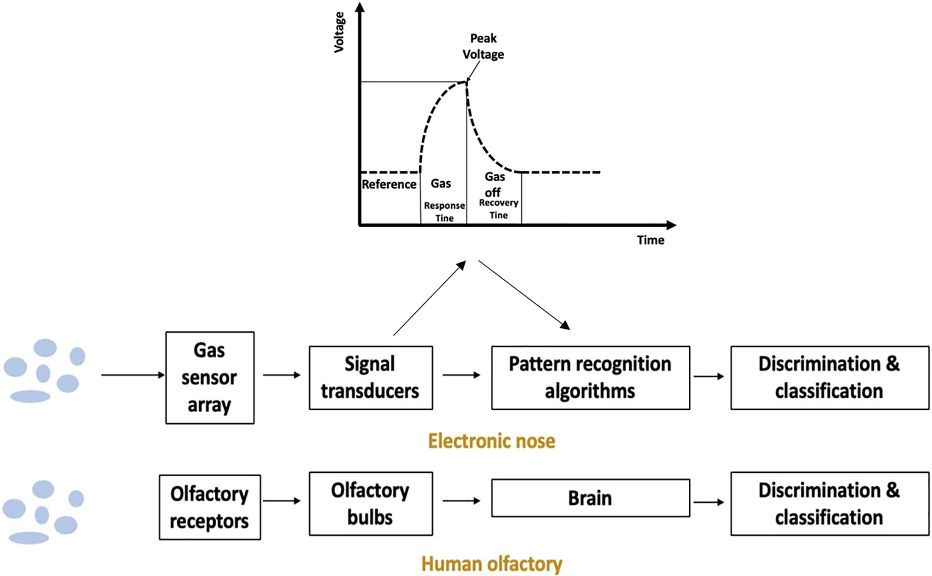](Image%20of%20Fig.%201)

Fig. 1. Sensing-interpreting-discriminating process of an electronic nose.

sensor, setting its electrical resistance to a stable state. During the mea- surement, target volatile molecules near the surface of the sensing ma- terial react (oxidation/reduction) with the incorporated oxygen species causing a change of the electrical properties, such as capacitance and re- sistance of the device (Liu et al., 2012; Tan and Kerr, 2017, 2018a).

It was reported that MOS gas sensors are sensitive to hydrogen and unsaturated hydrocarbons or solvent vapors containing hydrogen atoms (Dey, 2018). Some food-derived volatile compounds that can be detected by MOS sensors include alcohols, (e.g., ethanol and1- Hexanol), organic acids (e.g., acetic acid and butyric acid), sulfide (e.g., dimethyl sulfide), alkanes (e.g., hexane), esters (e.g., ethyl ester), aldehyde (e.g., benzaldehyde and nonanal) and ketones (e.g., acetone, butanone, and propyl decanoate) (Pacioni et al., 2014; Tan and Kerr, 2018b). The detection threshold of commercial MOS sensors varied be- tween 1 ppm–1000 ppm based on the specification provided by some major MOS sensor producers, including Figaro, and Nemoto.

The main disadvantage of the MOS sensor array is that the devices require to operate at temperatures between 150 and 400 °C (Nazemi et al., 2019). Therefore, they consume a significant amount of energy and need a relatively long time for heating before they are ready to take measurements.

* + 1. *Conducting polymers (CP) sensors*

CP (also called intrinsically conducting polymer, ICP) composites consist of conducting particles such as polypyrrole, polyaniline, and polythiophene interspersed in an insulating polymer matrix (Megha et al., 2018). According to a previous study, CP gas sensors might be the second widely used gas sensor after MOS sensors (Dey, 2018). When the sensing materials are exposed to chemical vapors, the reac- tions between the sensing materials and the chemical vapors introduce impunity into the sensing materials (doping). The doping level in CPs transfers electrons to or from the analytes, causing a change in

conductivity (Bai and Shi, 2007). CPs have good sensitives (thresh- old b 10 ppm) to many food-derived volatile compounds including al- dehyde (e.g., act aldehyde), acetates, and alcohols (e.g., butanol) from pears, ammonia from food spoilage (Matindoust et al., 2017), alcohols from drinks (Péres et al., 2012), and alcoholic volatile organic com- pounds (VOCs) associated with spoiled beef (Khot et al., 2011).

CP gas sensors can operate without extra heating; thus, they exhibit a considerably lower power consumption than metal-oxide gas sensors. In addition to that, conducting polymers are easily synthesized through chemical or electrochemical processes. The structure of CP molecular chains can be modified by copolymerization or structural derivations. Furthermore, CPs have good mechanical properties, which make them more durable and easier to be shipped (Megha et al., 2018).

The major disadvantage of CP sensor arrays is that they are suscepti- ble to humidity and similar to MOS sensors, they also require high oper- ating temperatures to ensure the chemical reaction between sensing materials and the target gases (Megha et al., 2018). Therefore, it is nec- essary to control humidity between each measurement. The vapor pres- sure can also affect the response of the sensing film, which requires the film being placed in a chamber when the environment is controlled, such as a reaction chamber of an e-nose.

* + 1. *Acoustic wave sensors*

An acoustic wave sensor typically consists of a piezoelectric sub- strate such as (quartz crystal, ZnO, lithium niobite), coated with sensing material (polymeric film), and two interdigital transducers (one input and one output) (Go et al., 2017). Voltage induced shear or compression deformation of the piezoelectric substrate generates acoustic waves, and the waves propagate through the substrate. Upon reaction between compatible analyte and sensing material, the mass of the gas-sensitive membrane of the sensor is changed, causing the change in SAW velocity and attenuation. The effect of mass change (Δ*m*) on the SAW along with

[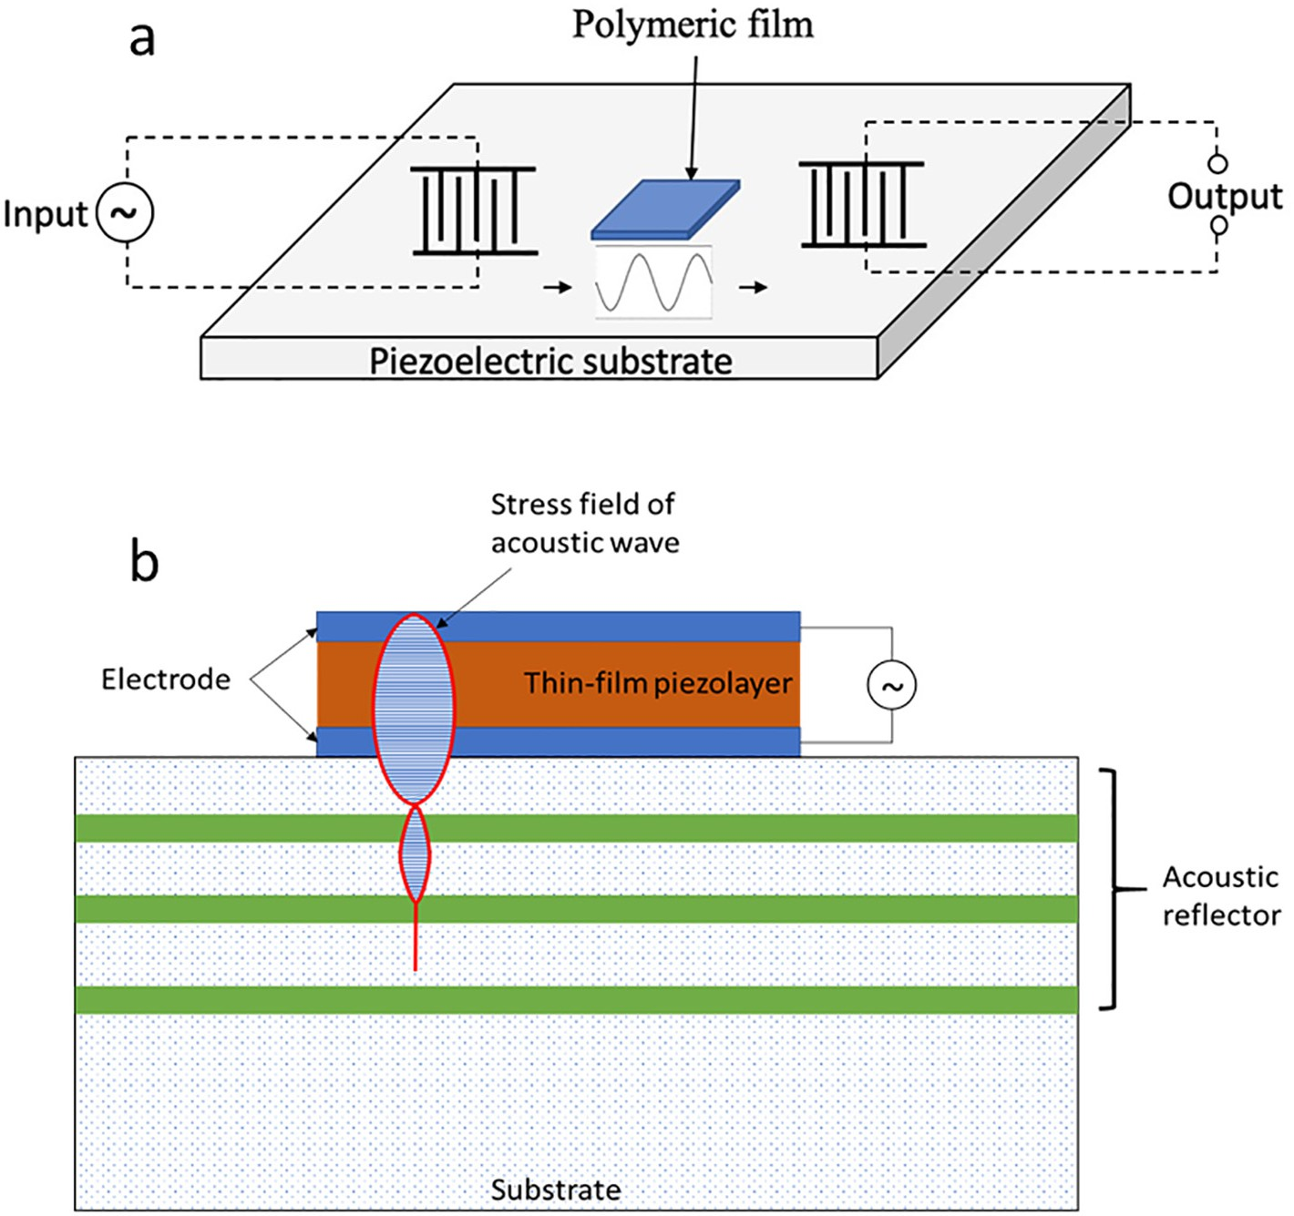](Image%20of%20Fig.%202)

Fig. 2. Schematic diagram of a SAW (a) and BAW (b) sensor.

other factors including the change of mechanical (*Pmec*) factors (e.g., viscosity and elasticity), electric (*Pele*) factors (e.g., conductivity and permittivity), and environmental (*Penv*) factors (e.g., temperature and humidity). is given by Eq. (3):

Although both QCM and SW have good precision, high sensitivity, and diverse target gases, there are still some limitations to the sensors. For example, QCM sensors have complex circuitry, poor signal-to- noise ratio, and can be influenced by humidity (Länge, 2019).

Δγ ∂γ ∂γ

∂γ ∂γ

* 1. *Electronic nose system*

*k*0 = ∂*m* Δ*m* + ∂*Pmec* Δ*Pmec* + ∂*P*

*ele*

Δ*Pele* + ∂*Penv* Δ*Penv* (3)

The physical part of a typical e-nose system that consists of gas sen-

where γ is the complex propagation coefficient of the propagating wave and *k*0 is the wave number in unperturbed state (Devkota et al., 2017). There are two types of acoustic wave gas sensors, bulk acoustic wave transducers (BAW) sensor, and surface acoustic wave transducers (SAW) sensor (Go et al., 2017). The acoustic wave propagates on the surface of the substrate is called SAW, while the wave propagates through the substrate is called BAW. The schematic diagram of a SAW gas sensor and a BAW gas sensor (quartz crystal microbalance (QCM) gas sensor) were shown in Fig. 2a and b, respectively. Both types of sen- sors exhibit frequency shifts related to absorbed analytes by their sens-

ing materials.

SAW gas sensors had been used for the rapid detection of food path- ogens and spoilages (Kordas et al., 2016; Lamanna et al., 2020; Xu and Yuan, 2019). The volatiles from olive oils, vegetable oil, and coconut oil, including organic acids (e.g., acetic acid, propanoic acid, pentanoic acid, and hexanoic acid), ethyl acetate, and hexanal were quantified by using SAW gas sensor coupling with Solid Phase Microextraction (SPME) (Marina et al., 2010). Similar to SAW sensors, BAW gas sensors also have broad applications in determining food volatiles. QCM sensors were used to detect tea aroma (e.g., linalool, geraniol, linalool oxide, Methyl salicylate, and Trans-2-hexenal) from the process of black tea fermentation (Sharma et al., 2015). The sensor was also used to deter- mine the freshness of Chinese Quince and kiwifruits (Yen and Yao, 2018; Zheng et al., 2016).

sor arrays, reaction chamber, valves, air pumps for sampling and cleaning, control devices, and data acquisition (DAQ) devices (Tan et al., 2019). One example of a typical e-nose system is shown in Fig. 3. The design of an e-nose system can be varied depending on the pur- pose of the application. A commercial e-nose is typically handy and compact. However, there is no commercial e-nose that can test all food volatiles. Therefore, some researchers customized their e-nose to obtain unique functions for different samples. In a previous study, the volatile compounds of cocoa beans were captured by placing heated cocoa beans in a syringe and injected into the reaction chamber by a sy- ringe pump (Tan and Kerr, 2018b). In another e-nose design, a sensor array was placed directly at the headspace of the sample instead of in a reaction chamber (Tan and Kerr, 2019). Multiple reaction chambers were used in an e-nose system to achieve mobile sensing (Arroyo

et al., 2020; Fan et al., 2019).

* 1. *Pattern recognition algorithms and classification methods for e- nose data*

Signals obtained by an e-nose system combined with pattern- recognition algorithms or pattern classifiers such as Principal Compo- nent Analysis (PCA), support vector machines (SVM), artificial neural networks (ANN), random forest (RF), and other machine learning clas- sifiers enable the recognition of different sample types via aggregation

[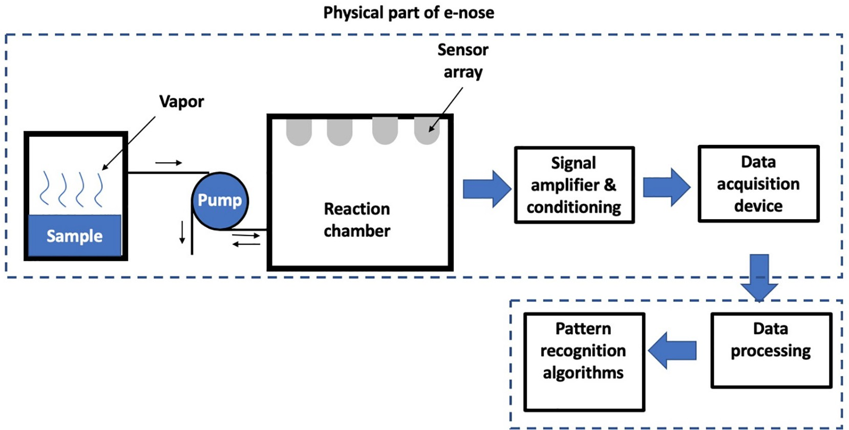](Image%20of%20Fig.%203)

Fig. 3. Schematic diagram of a typical e-nose system.

of similar emissions into clusters representing compounds from related food volatiles.

* + 1. *PCA*

PCA is a widely used basic classification technique, which had been successfully used gas sensor applications. It is a linear and unsupervised pattern-recognition method. Data collected by e-noses are typically in high-dimensional space due to the relatively high number of employed gas sensors and multiple extracted signal characters. PCA reduces the dimension of high-dimensional data to lower-dimensional space (Hong et al., 2018).

The signals data obtained from an e-nose is represented by an M by N matrix, A. The goal of PCA is to project A to x (x b N) linearly uncorre- lated (orthogonal) vectors, PC1, PC2, …, PCx, also known as principal components with maximum variance, in another word, data is most spread out when projected onto it. Statistically, the principal compo- nents are the eigenvectors of the covariance matrix of A (Ripley, 2014). After PCs were selected, the signals data are projected to the PCs, and classification or pattern recognition are conducted based on se- lected criteria, such as the Euclidean space between each data set.

* + 1. *SVM*

SVM is another widely used classification and pattern recognition technology based on statistical learning theory (SLT). Its applications were reported in previous studies, including face identification, chemi- cal classification, text categorization, bioinformatics, data mining (Chauhan et al., 2019). The SVM approach places the original data points from their input space into a higher dimensional feature space using a kernel function. The commonly employed kernel functions include lin- ear, nonlinear, polynomial, Gaussian kernel, Radial basis function (RBF), and sigmoid (Papadopoulou et al., 2013). Based on that, the working principle of SVM is to separate the data with known categories or groups with a particular hyperplane, which maximizes the distance from a hyperplane to the nearest point in the separated dataset or max- imize the margin. The search for the hyperplane is typically achieved by solving objective function (margin) with inequality constraints, using the Lagrange multiplier method and applying Karush-Kuhn-Tucker (KKT) conditions (necessary and sufficient for the solution) (Kefi- Fatteh et al., 2019). In this step, the SVM is trained. Once the hyperplane is determined, in this next step, unclassified data were projected to the realm of SVM and classified based on their location to the hyperplane.

SVM had been intensively reported to classify food materials based

on e-nose signals. The microbiological quality and freshness of beef fillet

(Kodogiannis, 2017; Mohareb et al., 2016) were determined by using SVM-electronic nose methods. Strawberry juice processed microwave pasteurization, steam blanching, high-temperature short-time pasteur- ization, frozen-thawed, and freshly squeezed were discriminated by SVM-electronic nose (Qiu et al., 2014). In one other study, food addi- tives, including benzoic acid and chitosan were detected by e-nose using the SVM classifier (Qiu and Wang, 2017). The ripeness of banana (Sanaeifar et al., 2014), olfactory information of beer (Shi et al., 2019), variety and geographical origin of apples (Wu et al., 2018), and detec- tion of moldy apple (Jia et al., 2019), were also reported can be deter- mined through SVM-electronic nose approach. In the mentioned studies, the performance of SVM was also compared with other classi- fiers including, PCA, extreme learning machine (ELM), linear discrimi- nant analysis (LDA), partial least squares regression (PLS), and RF.

* + 1. *ANN*

ANN is a powerful machine learning-based classifier, which has non- linear mapping capability. Various types of ANN, such as multi-layer perceptron (MLP), learning vector quantization (LVQ), and Kohonen networks, have been employed for e-nose data classification (Sanaeifar et al., 2017). An ANN classifier consists of interconnected layers of artificial neurons, and it is trained to perform a classification by adjusting the weight and biases of the connections between the neu- rons. The structure of the neuron pattern, the learning process, and the activation function of the neurons determine the functions of an ANN. A schematic of an ANN is shown in Fig. 4a.

In the training step of an ANN, input, and corresponding target (out- put) pairs are required. The weights of the connections are adjusted based on a comparison of the output and the target. The training will be continuously repeated until the network outputs match a termina- tion criteria (Kumar et al., 2015). Typically transfer functions for train- ing ANNs include the sigmoid function, step function, linear combination, and the rectifier. The performance of an ANN depends on many factors, such as the number of training pairs, the structure of the ANN, the selection of a transfer function and activation function, and training termination criteria.

In earlier studies on ANN-electronic nose, ANNs trained by backpropagation errors were often used to determine the beer quality (Gonzalez Viejo et al., 2020), the sensory attributes of foods (Zhong, 2019), aging of rice (Rahimzadeh et al., 2019), types of French cheese (Ghasemi-Varnamkhasti et al., 2019), and the presence of foodborne pathogens in foods (Bonah et al., 2019). In more recent studies, diversi- fied training methods were employed, and multiple classifiers were

[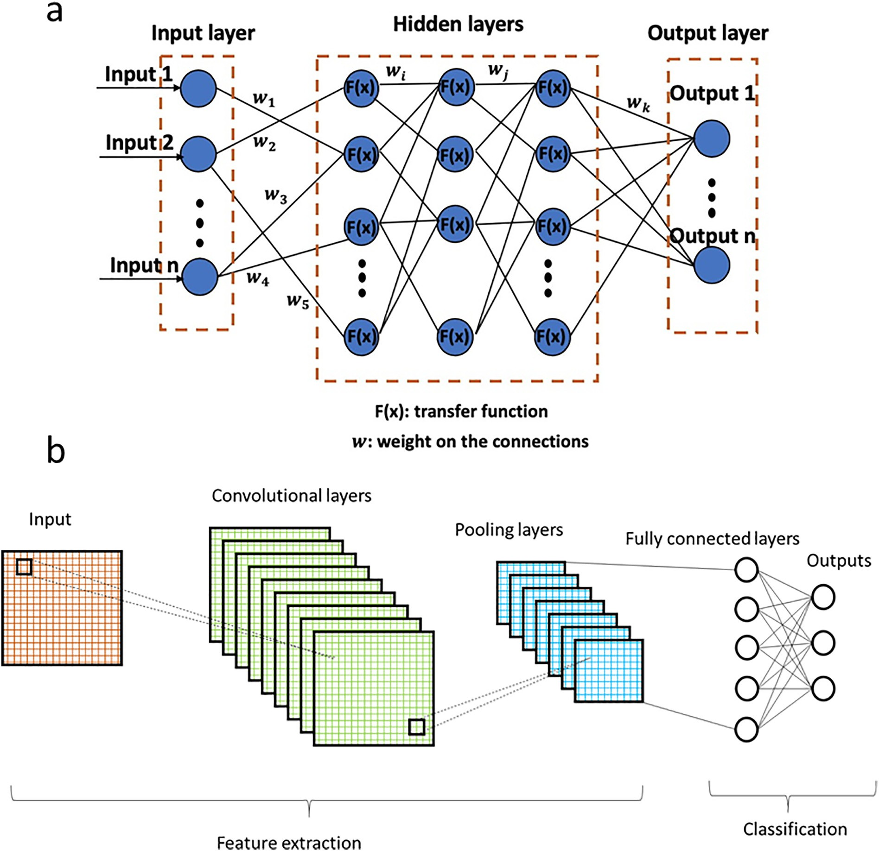](Image%20of%20Fig.%204)

Fig. 4. A schematic diagram of an ANN (a) and a CNN (b).

combined with ANN to process data obtained by e-noses. Quadratic polynomial step regression (QPSR) and multiple linear regression (MLR) were used to determine the firmness of fruits based on e-nose data as a comparison of using backpropagation ANN (Zhang et al., 2008). ANN, combined with PCA, was used to determine the freshness of chicken meat (Timsorn et al., 2014) and the roasting degree of cocoa beans (Tan and Kerr, 2018b). PCA reduces the dimension of the data before an ANN was trained, which significantly decreases the num- ber of inputs (Ordukaya and Karlik, 2017). In another study, a probabilistic neural network (PNN) was trained to classify the quality of Orange, Lemon, Sweet Lime, and Tomato (Narendra and Govardhan Hegde, 2019). The general regression neural network (GRNN) is an- other type of ANN that had been used to determine food authenticity based on e-nose (Peris and Escuder-Gilabert, 2016).

* + 1. *Convolutional neural network (CNN)*

CNN is a type of deep learning neural network that has been widely used for image recognition. Briefly, the image data (e.g., intensity and RGB value) is passed through a series of convolutional layer contains fil- ters (or neuron, or core), pooling layers, and fully connected layers, and then generates the output. A schematic diagram of a basic form of CNN

architecture is shown in Fig. 4b. In short, the filters carry out convolutional operations to the input data and extract the high-level features such as edges, from the input image. Then the pooling layers continuously reduce the image size and the computation in the network by approaches such as max pooling and average pooling. After input data going through the above processes, the data are feed to regular ANN (fully connected layers) for classification (Phung and Rhee, 2019). In a previous review paper, CNN was identified as a good tool for recognizing foods, estimating food calorie, and detecting fruit, vege- table, and meat quality (Zhou et al., 2019).

* + 1. *Decision tree and RF*

A decision tree is a tree structure classifier consists of layers of inter- nal and external nodes connected by branches. Each internal node has a selected decision function, which determines which node to be trans- ferred to (Cho and Kurup, 2011). External nodes indicate the output cor- responding to an input vector.

The ID3 (by Quinlan) algorithm is the most used training algorithm for a decision tree. The ID3 algorithm builds the decision tree using a top-to-bottom and greedy approach. In the first step, it selects one attri- bute, N, as the first node. N has the most information gain, which

indicates how well the attribute classifies the data. In the next step, it creates a new descendant of the node for each N. After that, ID3 sorts the training samples to the appropriate descendant node leaf. If all the training samples were successfully classified, then iteration is termi- nated. Otherwise, the iteration continues until other termination criteria met.

A RF is a collection of multiple trained decision trees, and when a sample is to be classified, each decision tree will “vote” for the class of the sample. The sample is then assigned based on the majority vote (Schroeder et al., 2019). Due to the relatively large number of decision trees, the attributes for training the decision trees can be randomly selected from all the attributes without necessarily choos- ing the one with most information gain. The training of a RF can be achieved by many different approaches. For example, m random samples are selected from the training sample pool with replace- ment to train the decision trees (bootstrap RF). Alternatively, train- ing can be conducted by maintaining a set of weights over the original training set S and adjusts these weights based on successful classification. The weights of examples that are misclassified are in- creased, and the weights of examples that are correctly classified are reduced (Elith et al., 2008).

* + 1. *Selection of classifier algorithms*

The selection of a classifier depends mainly on the type of dataset (continuous, categorical, or binary), the number of the features of each dataset, number of the dataset, and supervised or unsupervised learn- ing. For most of the cases, supervised machine learning classifiers were employed. Unsupervised training is typically designed to discover unknown, but useful, classes of items (Kotsiantis, 2007). In many cases, hybrid approaches such as PCA coupled with ANN, was used because the number of features is relatively big. In Table 1, the performance of some typical classifier algorithms was summarized based on a previous review paper (Kotsiantis, 2007):

* 1. *Limitations and future trends of e-noses in determining food qualities*

It is well-known that sample preparation and sampling are error- prone steps for e-nose measurements. Gas sensors are very sensitive to temperature, humidity, pressure, gas velocity, and vapor concen- tration. Sample preparation of e-nose sensing is also very challeng- ing since the amount of volatiles released from foods depends on many factors such as temperature, pressure, and humidity. High re- peatability and precision of e-nose measurement require strict con- trol of sample preparation and sampling environment (Kiselev et al., 2018). Therefore, it is difficult to use e-noses in an open field or mobile sensing. A great number of sample size (typically N10) for each type of sample is often required for training and validation. In some cases, the sample size needs to be even greater. Some types of gas sensors, such as MOS sensors, required heating to reach an

Table 1

The performance of different classifier algorithms.

|  |  |  |  |  |
| --- | --- | --- | --- | --- |
|  | ANN | SVM | KNN | Decision tree |
| Learning speed | Slow | Slow | Fast | Moderate |
| Overall accuracy | Moderate | High | Low | Low |
| Classification speed | Fast | Fast | Slow | Fast |
| Tolerance to missing values | Low | Moderate | Low | High |
| Tolerance to irrelevant | Low | High | Moderate | Moderate |

attributes

equilibrium state before measuring, which is both time and energy consuming. Also, high energy demands also limit the portability of the e-noses. Unlike the human nose where hundreds of scent recep- tors reside, one e-nose typically employs a few numbers of sensors (less than 20); thus, their capability to discriminate different aroma is hampered. Techniques, such as ANN and PCA, employed to process e-nose data were developed for classifying static features. Therefore, only time-invariant information from the e-nose can be used. Comparing e-nose measurements from literature is another challenge. The difference in sensor array selection, sampling prepa- ration, sampling approach, pattern recognition algorithm, and train- ing data pool resulted in incomparable published works.

One direction for future e-nose development is to minimize sample handling procedures and reduce the influences of the sampling environ- ment. This requires the development of new sensing materials that are insensitive to environment variation while having high specification to some volatiles. E-nose will also employ nano gas sensors so that the number of gas sensors employed by an e-nose will be close to the num- ber of scene receptors in the human nose. This will expand the capabil- ity of e-nose to differentiate different aroma. Another trend for e-nose is the employment of big data and artificial intelligence. For example, the development of a shared online library where data obtained from users all over the world using standardized e-noses can be used by other users to train their e-nose. In summary, e-noses will have more universal ap- plications, smaller size, more user-friendly, and invariant to measuring the environment.

1. Electronic tongue

The human sense of taste consists of five basic tastes, including sweetness, sourness, bitterness, saltiness, and umami. Human sensory panel (trained or untrained) has been employed to conduct taste evalu- ations on many food products (Jiang et al., 2018). However, running and training a sensory panel is relatively time-consuming and expensive. In some cases, sensory panels may introduce biases if the panelists were not well-trained. Therefore, e-tongue, a rapid-sensing, unbiased, and in- expensive alternative for the human tongue were employed by many researchers (Schlossareck and Ross, 2019).

* 1. *Taste sensors*

The chemical sensors commonly employed for an e-tongue include electrochemical sensors, biosensors, and optical mass sensors (Jiang et al., 2018). Similar to gas sensors of e-nose, the chemical sensors employed by e-tongue react with analytes, creating reversible changes of electrical properties. Measurable electrical signals are then being used to do pattern recognition and classification.

* + 1. *Potentiometric chemical sensors*

Potentiometric chemical sensors are the most commonly used sen- sors for e-tongue. Potentiometric sensors measure the voltage differ- ence between the working electrodes and the reference electrode. The reference electrode is submerged in an electrolyte solution, and the voltage of the reference sensor is constant. The voltage of the working electrode, on the other hand, depends on the concentration of the ana- lyte in the solution phase (Winquist et al., 2002). The potential of the electrode (*E*) as a function of the concentration of ratio of the oxidized (*Co*) to the reduced form (*Cr*) of the analyte can be expressed by Nernst equation:

Tolerance to redundant attributes

Low High Moderate Moderate

*RT*

*E* = *Eo* + *nF* *lnln*

*C* (4)

Dealing with discrete/binary/continuous attributes

Cannot be discrete

Cannot be discrete

Cannot be directly discrete

No restriction

*Cr*

where *Eo* (V) is the potential of the electrode at standard conditions, *T*

Tolerance to noise Moderate Moderate Low Moderate Dealing with overfitting Poor Moderate Good Moderate

(°C) is the temperature. One example of a two-electrode potentiometric chemical sensor was shown in Fig. 5a. The electrode has an ion-selective

membrane, which allows the uptake of only one specific ion. Some po- tentiometric chemical sensors have three electrodes, and in some cases, membranes were not used.

Commonly used membranes for potentiometric chemical sensors are glass membrane, crystalline/solid-state membrane, liquid mem- brane, and polymer membrane (e.g., polyvinylchloride) (Moreno et al., 2018). Glass membrane electrodes are made from silicate glass, which is typically used for the determination of H+ or pH and Na+. Crystalline/solid-state membrane is composed of inorganic salts, such as AgCl, Ag2S, and LaF3. Crystalline/solid-state membrane sensors are used to determine Cl− and F−. A liquid membrane is made by dissolving one ion-exchanger or ionophore in a viscous or- ganic membrane. Liquid membrane electrodes are widely used for determining Ca2+. A polymer membrane is typically composed of PVC, plasticizers, and the ion carrier or exchanger. Polymer mem- brane electrodes have been used to determine ions such as K+, Ca2

+, Cl− and NO3− (Ding et al., 2017).

Potentiometric electronic tongues have been used for classifying olive oils obtained from single olive cultivars (Dias et al., 2014), differen- tiating honey produced from different states in the United States (Escriche et al., 2012), discriminating different commercial beers and wines (Nery and Kubota, 2016), and quantifying sugar content in solu- tions (Arca et al., 2019). Those studies have shown good accuracies, comparing to standard analytical methods.

The main advantage of using potentiometric sensors is they can se- lect many different, both specific and less specific, membranes for its electrodes. Therefore, potentiometric sensors can measure a very broad range of chemical compounds in solutions (Winquist, 2008). One of the main disadvantages of potentiometric sensors is that they are sensitive to temperature. The membrane may adsorb the solution components, which can affect the nature of the charge transfer. There- fore, the temperature needs to be controlled, and the electrodes need to be washed by solvents to minimize the effect (Ciosek and Wróblewski, 2011).

* + 1. *Voltammetric chemical sensors*

Similar to potentiometric sensors, a voltammetric sensor consists of one working electrode and one reference electrode. Upon measuring, a potential (voltage) is applied to the working electrode and the resulting current generated due to the reduction and oxidization of the analytes

(Winquist, 2008). The value of the current is related to the concentra- tion of the target analytes. The relation between *E* and resulting current

(*I*) follows:

*Ee* −

*t*

(*BRs* )

*I* = *RS* (5)

where *RS* is the resistance of the analyte solution, *t* is the time elapsed after the onset of a voltage pulse, and *B* is an electrode related equiva- lent capacitance constant. Typically, pulse voltammetry is used for voltammetric e-tongue. The most widely used pulse voltammetry are large amplitude pulse voltammetry (LAPV) and small amplitude pulse voltammetry (SAPV). In some cases, staircase voltammetry has also been used (Alcañiz et al., 2012).

In previous studies, voltammetric e-tongues were used to detect the percentages of adulteration of argan oil with sunflower oil (Bougrini et al., 2014), monitor the quality and storage time of un- sealed pasteurized milk (Wei et al., 2013), discriminate honey sam- ples based on their floral types (Tiwari et al., 2013), and conduct a quantitative analysis of quality parameters in spring water (Carbó et al., 2018).

* + 1. *Bioelectric sensors*

Bioelectric sensors are electronic sensors employing biomaterials as their sensing materials. Biological materials, including enzymes, whole cells, tissues, receptors, or antibodies, were widely used to construct sensors, such as voltammetric sensors, impedimetric sensors, potentio- metric sensors, and conductometric sensors, for the application of e- tongue. The working principle of a sensor typically involves a series of biochemical reactions, such as enzyme-substrate reaction, leading to the transport of electrons, ions, or molecules. The working principle of bioelectric sensors was summarized in a schematic diagram shown in Fig. 5b.

Sweeteners and acids are important ingredients for foods, which providing sweetness and sourness to the products. The voltammetric bioelectric sensors are typically employed to deter- mine sweeteners such as glucose, lactate, sucrose, or acids such as lactic acid, acetic acid, and sialic acid. In previous studies, glucose was determined based on glucose oxidase, which consumed oxygen and produced hydrogen peroxide. The quantity of the hydrogen

[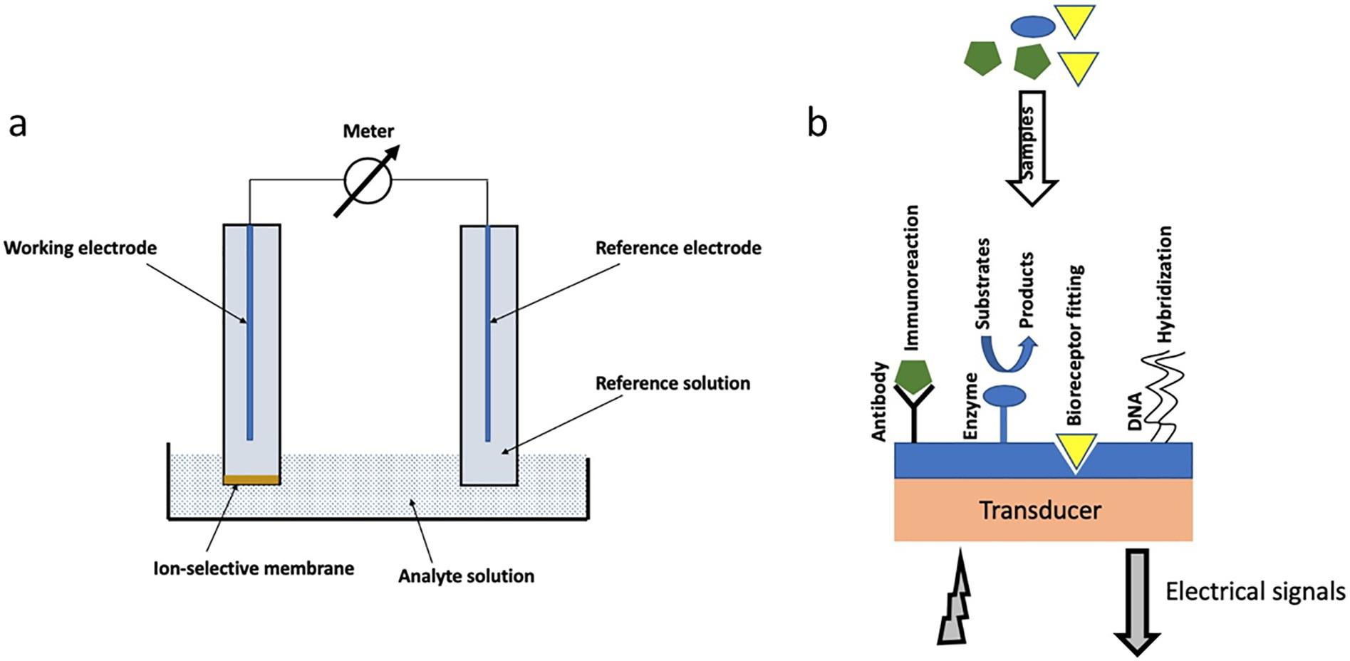](Image%20of%20Fig.%205)

Fig. 5. An example of a potentiometric chemical sensor (a) and a biosensor (b).

peroxide was then determined by voltammetric bioelectric sensors (Hong Wu et al., 2009). The reactions can be summarized as Eqs. (6) and (7):

*D*−*glucose* + *O*2 *glucoseoxidase* → *D*−*gluconicacid* + *H*2*O*2 (6)

*H*2*O*2 + [*Med*]*red peroxidase* → [*Med*]*Ox* + *H*2*O* (7)

Fructose is typically determined based on D-fructose-5-dehydroge- nase (FDH) using an electron acceptor serving as an electrochemical mediator (Monosik et al., 2012):

*D*−*frucose* + [*Med*]*OxFDH* → 5−*keto*−*D*−*frucose* + [*Med*]*red* (8)

Sucrose and galactose were determined by quantifying the glucose obtained from the enzymatic hydrolysis of sucrose and galactose. The enzymes used to hydrolyze sucrose and galactose were invertase and galactosidase, respectively. Similar working principles were also employed to enzymatically determine citric acid, lactic acid, malic acid, ascorbic acid, and acetic acid (Monosik et al., 2012).

An impedimetric biosensor typically includes two to three elec- trodes with applied sinusoidal voltage. It measures the change of im- pedance (*Z*) due to the result of the analyte binding to the electrodes:

*Z*2 = *R*2 + *XC* 2 (9)

where *R* and *XC* is the components resistance and the capacitive reac- tance, respectively. The biomaterials commonly used to immobilize analytes on the surface of the electrode include antibodies, nucleic acids, bacteriophages, and lectins. Therefore, impedimetric biosensors were generally classified into four categories, including antibody-based sen- sors, nucleic acid-based sensors, bacteriophage-based sensors, and lectin-based sensors.

Impedimetric biosensors had been used to determine herbicide and pesticide residues in food (Malvano et al., 2017) and detect food toxins (Solanki et al., 2010; Srivastava et al., 2014). Impedimetric biosensors

[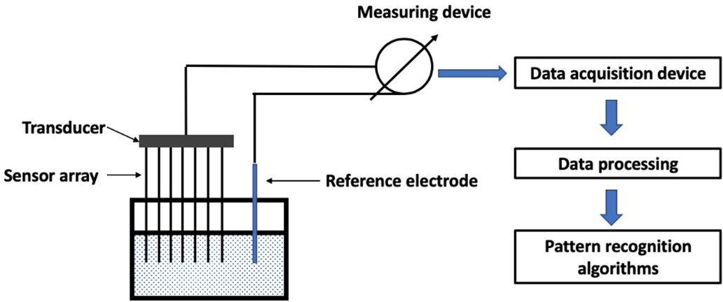](Image%20of%20Fig.%206)

Fig. 6. Schematic of a typical e-tongue system.

are also widely used to detect microbial growth through direct binding of the target bacteria or immobilizing the conductive metabolites of the target microorganisms (Rengaraj et al., 2018). In previous studies, food pathogens, including *E. coli* O157: H7 (Lin et al., 2019), *Salmonella Typhimurium* (Sheikhzadeh et al., 2016), *Staphylococcus aureus*, and *Ba- cillus cereus* (Reich et al., 2017).

* 1. *Electronic tongue system*

A typical e-tongue system consists of a chemical sensor array, a reac- tion vessel, measuring devices, transducers, and data acquisition de- vices, and data processing and pattern recognition algorithms (Fig. 6). The functions of an e-tongue system can be changed by using different types of sensors, different data processing strategies, and pattern recog- nition algorithms.

* 1. *Pattern recognition algorithms and classification methods for e- tongue data*

Electronic tongue signals are typically processed by the same classi- fiers, including RF, PCA, PLS, ANN, and SVM, to conduct pattern recogni- tion. In Table 2, some examples of the classifiers used for e-tongue within ten years are summarized.

* 1. *Limitations and future trends of e-tongues*

A sensor employed by an e-tongue presents a specific response to- ward the target analyte. However, most of the chemical sensors employed by e-tongue encountering significant matrix effects when dealing with real food samples (Cetó et al., 2016). Therefore, a sample pre-treatment step is typically added so that the sensors are designed to work toward specific analytes in certain types of samples. This pre- treatment step is time-consuming when multiple analytes are analyzed at a time. Another limitation of e-tongue is the relatively short lifetime of the sensing materials, especially biomaterials, of the sensors. It re- quires the users to frequently examine the performances of the e- tongue. In addition, a great number of sample size (typically N10) for each type of sample is often required for training and validation. In some cases, the sample size needs to be even greater.

One trend of e-tongue is the employment of biosensors with high se- lectivity and specificity, which reduces the impact of a complex and interferents. More biomaterials, including nucleic acids and aptamers, antibodies, cells, phages, and, namely, enzymes, will be used as recogni- tion elements for those sensors. The development of standardized uni- versal functions e-tongues will be very useful for food processors to determine the quality of their products. Similar to e-nose, the develop- ment of a shared online library where store pattern classifiers trained by data obtained from standardized e-tongue. This can significantly

Table 2

E-tongues and their pattern recognition algorithms.

E-tongue sensor Objective Classifiers Reference

Potentiometric and voltammetric sensors

Beer types PCA and LDA (Gutiérrez et al., 2013)

Potentiometric sensors Bittiness of coffee N/A (X. Wu et al., 2020)

Voltammetric sensors Commercial beer types Multivariate data analysis (Blanco et al., 2015)

Voltammetric sensors Olive oil geographic origins SVM (Haddi et al., 2013)

Commercial e-tongue Discriminate type and brand recognition of orange beverage and

Chinese vinegar

RF, ANN, and SVM (Liu et al., 2013)

Potentiometric sensors Evaluation of umami taste in mushroom extracts ANOVA (Phat et al., 2016)

Potentiometric sensors Detection of adulteration in argan Oil PCA, SVM, and discriminant factor analysis (DFA)

Potentiometric sensors Detection of adulteration in cherry tomato juices PCA, SVM, and Principle Components

Regression (PCR)

(Bougrini et al., 2014)

(Hong and Wang, 2014)

Commercial e-tongue Non-volatile compounds and sensory attributes of beef ANOVA and PLS (Ismail et al., 2020) Voltammetric sensors Monitoring of quality and storage time of unsealed pasteurized milk PCA, SVM, and PLS (Wei et al., 2013) Commercial e-tongue Sensory attributes of liquors PCA and fuzzy evaluation (Liu et al., 2020)

improve the precision of e-tongues and make universal function e- tongues possible.

1. Conclusion

This review summarized the applications of e-nose and e-tongue in determining the quality-related properties of foods. The working princi- ples of various sensors were introduced, and electronic devices employed those sensors, including e-noses and e-tongues were also discussed in this review. The working principles of commonly used pat- tern recognition algorithms and classification methods, such as ANN, CNN, PCA, PLS, and SVM were introduced and discussed. Overall, e- nose and e-tongue combing pattern recognition algorithms are very powerful analytical tools, which are relatively low-cost, rapid, and accu- rate. E-nose and e-tongue are also suitable for both in-line and off-line measurements, which are very useful in monitoring food processing and detecting the end product quality. The user of e-nose and e- tongue need to strictly control sample preparation, sampling, and data processing. Relatively poor repeatability and comparability of e-nose and e-tongue measurement and data processing are still two challenges that need to be proper addressed. For e-nose and e-tongue approaches, great number of sample size (typically N10) for each type of sample is often required for training and validation. In some cases, the sample size needs to be even greater. Online shared library for training data pool, standardized device with multiple functions, mobile sensing, and smartphone interface will boost the power of e-nose and e-tongue in the future.

References

Alcañiz, M., Vivancos, J.L., Masot, R., Ibañez, J., Raga, M., Soto, J., Martínez-Máñez, R., 2012. Design of an electronic system and its application to electronic tongues using variable amplitude pulse voltammetry and impedance spectroscopy. J. Food Eng. 111 (1), 122–128. <https://doi.org/10.1016/j.jfoodeng.2012.01.014>.

Ali, M.M., Hashim, N., Abd Aziz, S., Lasekan, O., 2020. [Principles and recent advances in](http://refhub.elsevier.com/S2589-7217(20)30018-0/rf0010) [electronic nose for quality inspection of agricultural and food products. Trends](http://refhub.elsevier.com/S2589-7217(20)30018-0/rf0010) [Food Sci. Technol. 99, 1–10](http://refhub.elsevier.com/S2589-7217(20)30018-0/rf0010).

Arca, V. da C., Peres, A.M., Machado, A.A.S.C., Bona, E., Dias, L.G., 2019. Sugars’ quantifica- tions using a potentiometric electronic tongue with cross-selective sensors: influence of an ionic background. Chemosensors 7 (3). [https://doi.org/10.3390/](https://doi.org/10.3390/chemosensors7030043) [chemosensors7030043](https://doi.org/10.3390/chemosensors7030043).

Arroyo, P., Meléndez, F., Suárez, J.I., Herrero, J.L., Rodríguez, S., Lozano, J., 2020. Electronic nose with digital gas sensors connected via bluetooth to a smartphone for air quality measurements. Sensors (Switzerland). <https://doi.org/10.3390/s20030786>.

Bai, H., Shi, G., 2007. Gas sensors based on conducting polymers. Sensors 7 (3), 267–307. <https://doi.org/10.3390/s7030267>.

Blanco, C.A., De La Fuente, R., Caballero, I., Rodríguez-Méndez, M.L., 2015. Beer discrimina- tion using a portable electronic tongue based on screen-printed electrodes. J. Food Eng. 157, 57–62. <https://doi.org/10.1016/j.jfoodeng.2015.02.018>.

Bonah, E., Huang, X., Aheto, J.H., Osae, R., 2019. Application of electronic nose as a non- invasive technique for odor fingerprinting and detection of bacterial foodborne path- ogens: a review. J. Food Sci. Technol. <https://doi.org/10.1007/s13197-019-04143-4>.

Bougrini, M., Tahri, K., Haddi, Z., Saidi, T., El Bari, N., Bouchikhi, B., 2014. Detection of adul- teration in argan oil by using an electronic nose and a voltammetric electronic tongue. J. Sensors 2014. <https://doi.org/10.1155/2014/245831>.

Burgués, J., Marco, S., 2018. Low power operation of temperature-modulated metal oxide semiconductor gas sensors. Sensors (Switzerland). [https://doi.org/10.3390/](https://doi.org/10.3390/s18020339) [s18020339](https://doi.org/10.3390/s18020339).

Bushdid, C., Magnasco, M.O., Vosshall, L.B., Keller, A., 2014. Humans can discriminate more than 1 trillion olfactory stimuli. Science 343 (6177), 1370–1372. [https://doi.org/](https://doi.org/10.1126/science.1249168) [10.1126/science.1249168](https://doi.org/10.1126/science.1249168).

Carbó, N., Carrero, J.L., Garcia-Castillo, F.J., Tormos, I., Olivas, E., Folch, E., Fillol, M.A., Soto, J., Martínez-Máñez, R., Martínez-Bisbal, M.C., 2018. Quantitative determination of spring water quality parameters via electronic tongue. Sensors (Switzerland) 18

(1). <https://doi.org/10.3390/s18010040>.

Cetó, X., Voelcker, N.H., Prieto-Simón, B., 2016. Bioelectronic tongues: new trends and ap- plications in water and food analysis. Biosensors Bioelectron. 79, 608–626. [https://](https://doi.org/10.1016/j.bios.2015.12.075) [doi.org/10.1016/j.bios.2015.12.075](https://doi.org/10.1016/j.bios.2015.12.075).

Chauhan, V.K., Dahiya, K., Sharma, A., 2019. Problem formulations and solvers in linear SVM: a review. Artif. Intell. Rev. <https://doi.org/10.1007/s10462-018-9614-6>.

Chen, J., Gu, J., Zhang, R., Mao, Y., Tian, S., 2019. Freshness evaluation of three kinds of meats based on the electronic nose. Sensors (Switzerland) [https://doi.org/10.3390/](https://doi.org/10.3390/s19030605) [s19030605](https://doi.org/10.3390/s19030605).

Cho, J.H., Kurup, P.U., 2011. Decision tree approach for classification and dimensionality reduction of electronic nose data. Sensors Actuators B Chem. 160 (1), 542–548. <https://doi.org/10.1016/j.snb.2011.08.027>.

Ciosek, P., Wróblewski, W., 2011. Potentiometric electronic tongues for foodstuff and biosample recognition-an overview. Sensors 11 (5), 4688–4701. [https://doi.org/](https://doi.org/10.3390/s110504688) [10.3390/s110504688](https://doi.org/10.3390/s110504688).

Devkota, J., Ohodnicki, P.R., Greve, D.W., 2017. SAW sensors for chemical vapors and gases. Sensors (Switzerland) 17 (4). <https://doi.org/10.3390/s17040801>.

Dey, A., 2018. Semiconductor metal oxide gas sensors: a review. Mater. Sci. Eng. B Solid- State Mater. Adv. Technol. <https://doi.org/10.1016/j.mseb.2017.12.036>.

Dias, L.G., Fernandes, A., Veloso, A.C.A., Machado, A.A.S.C., Pereira, J.A., Peres, A.M., 2014. Single-cultivar extra virgin olive oil classification using a potentiometric electronic tongue. Food Chem. 160, 321–329. <https://doi.org/10.1016/j.foodchem.2014.03.072>. Ding, J., He, N., Lisak, G., Qin, W., Bobacka, J., 2017. Paper-based microfluidic sampling and separation of analytes for potentiometric ion sensing. Sensors Actuators B Chem.

<https://doi.org/10.1016/j.snb.2016.11.128>.

Dong, W., Hu, R., Long, Y., Li, H., Zhang, Y., Zhu, K., Chu, Z., 2019. Comparative evaluation of the volatile profiles and taste properties of roasted coffee beans as affected by drying method and detected by electronic nose, electronic tongue, and HS-SPME-GC-MS. Food Chem. <https://doi.org/10.1016/j.foodchem.2018.08.068>.

Elith, J., Leathwick, J.R., Hastie, T., 2008. A working guide to boosted regression trees.

J. Anim. Ecol. 77 (4), 802–813. <https://doi.org/10.1111/j.1365-2656.2008.01390.x>.

Escriche, I., Kadar, M., Domenech, E., Gil-Sánchez, L., 2012. A potentiometric electronic tongue for the discrimination of honey according to the botanical origin. Comparison with traditional methodologies: physicochemical parameters and volatile profile.

J. Food Eng. 109 (3), 449–456. <https://doi.org/10.1016/j.jfoodeng.2011.10.036>.

Fan, H., Bennetts, V.H., Schaffernicht, E., Lilienthal, A.J., 2019. Towards gas discrimination and mapping in emergency response scenarios using a mobile robot with an elec- tronic nose. Sensors (Switzerland) <https://doi.org/10.3390/s19030685>.

Ghasemi-Varnamkhasti, M., Mohammad-Razdari, A., Yoosefian, S.H., Izadi, Z., Siadat, M., 2019. Aging discrimination of French cheese types based on the optimization of an electronic nose using multivariate computational approaches combined with re- sponse surface method (RSM). Lwt 111, 85–98. [https://doi.org/10.1016/j.](https://doi.org/10.1016/j.lwt.2019.04.099) [lwt.2019.04.099](https://doi.org/10.1016/j.lwt.2019.04.099).

Go, D.B., Atashbar, M.Z., Ramshani, Z., Chang, H.C., 2017. Surface acoustic wave devices for chemical sensing and microfluidics: a review and perspective. Anal. Methods [https://](https://doi.org/10.1039/c7ay00690j) [doi.org/10.1039/c7ay00690j](https://doi.org/10.1039/c7ay00690j).

Gonzalez Viejo, C., Fuentes, S., Godbole, A., Widdicombe, B., Unnithan, R.R., 2020. Develop- ment of a low-cost e-nose to assess aroma profiles: an artificial intelligence applica- tion to assess beer quality. Sensors Actuators B Chem. 308. [https://doi.org/10.1016/j.](https://doi.org/10.1016/j.snb.2020.127688) [snb.2020.127688](https://doi.org/10.1016/j.snb.2020.127688).

Gutiérrez, J.M., Haddi, Z., Amari, A., Bouchikhi, B., Mimendia, A., Cetó, X., Del Valle, M., 2013. Hybrid electronic tongue based on multisensor data fusion for discrimination of beers. Sensors Actuators B Chem. 177, 989–996. [https://doi.org/10.1016/j.](https://doi.org/10.1016/j.snb.2012.11.110) [snb.2012.11.110](https://doi.org/10.1016/j.snb.2012.11.110).

Haddi, Z., Alami, H., El Bari, N., Tounsi, M., Barhoumi, H., Maaref, A., Jaffrezic-Renault, N., Bouchikhi, B., 2013. Electronic nose and tongue combination for improved classifica- tion of Moroccan virgin olive oil profiles. Food Res. Int. 54 (2), 1488–1498. [https://doi.](https://doi.org/10.1016/j.foodres.2013.09.036) [org/10.1016/j.foodres.2013.09.036](https://doi.org/10.1016/j.foodres.2013.09.036).

Hong, X., Wang, J., 2014. Detection of adulteration in cherry tomato juices based on elec- tronic nose and tongue: comparison of different data fusion approaches. J. Food Eng. 126, 89–97. <https://doi.org/10.1016/j.jfoodeng.2013.11.008>.

Hong, D., Balzano, L., Fessler, J.A., 2018. Asymptotic performance of PCA for high- dimensional heteroscedastic data. J. Multivar. Anal. [https://doi.org/10.1016/j.](https://doi.org/10.1016/j.jmva.2018.06.002) [jmva.2018.06.002](https://doi.org/10.1016/j.jmva.2018.06.002).

Ismail, I., Hwang, Y.H., Joo, S.T., 2020. Low-temperature and long-time heating regimes on non-volatile compound and taste traits of beef assessed by the electronic tongue sys- tem. Food Chem. 320. <https://doi.org/10.1016/j.foodchem.2020.126656>.

Jia, W., Liang, G., Tian, H., Sun, J., Wan, C., 2019. Electronic nose-based technique for rapid detection and recognition of moldy apples. Sensors (Switzerland) 19 (7). [https://doi.](https://doi.org/10.3390/s19071526) [org/10.3390/s19071526](https://doi.org/10.3390/s19071526).

Jiang, H., Zhang, M., Bhandari, B., Adhikari, B., 2018. Application of electronic tongue for fresh foods quality evaluation: a review. Food Rev. Int. [https://doi.org/10.1080/](https://doi.org/10.1080/87559129.2018.1424184) [87559129.2018.1424184](https://doi.org/10.1080/87559129.2018.1424184).

Kefi-Fatteh, T., Ksantini, R., Kaâniche, M.B., Bouhoula, A., 2019. A novel incremental one- class support vector machine based on low variance direction. Pattern Recogn. <https://doi.org/10.1016/j.patcog.2019.02.027>.

Khot, L.R., Panigrahi, S., Lin, D., 2011. Development and evaluation of piezoelectric- polymer thin film sensors for low concentration detection of volatile organic com- pounds related to food safety applications. Sensors Actuators B Chem. 153 (1), 1–10. <https://doi.org/10.1016/j.snb.2010.05.043>.

Kiselev, I., Sysoev, V., Kaikov, I., Koronczi, I., Tegin, R.A.A., Smanalieva, J., Sommer, M., Ilicali, C., Hauptmannl, M., 2018. On the temporal stability of analyte recognition with an e-nose based on a metal oxide sensor array in practical applications. Sensors (Switzerland) 18 (2). <https://doi.org/10.3390/s18020550>.

Kodogiannis, V.S., 2017. Application of an electronic nose coupled with fuzzy-wavelet network for the detection of meat spoilage. Food Bioprocess Technol. [https://doi.](https://doi.org/10.1007/s11947-016-1851-6) [org/10.1007/s11947-016-1851-6](https://doi.org/10.1007/s11947-016-1851-6).

Kodogiannis, V.S., 2018. A rapid detection of meat spoilage using an electronic nose and fuzzy-wavelet systems. Lecture Notes Netw. Syst. [https://doi.org/10.1007/978-3-](https://doi.org/10.1007/978-3-319-56994-9_36) [319-56994-9_36](https://doi.org/10.1007/978-3-319-56994-9_36).

Kordas, A., Papadakis, G., Milioni, D., Champ, J., Descroix, S., Gizeli, E., 2016. Rapid Salmo- nella detection using an acoustic wave device combined with the RCA isothermal DNA amplification method. Sens. Bio-Sens. Res. [https://doi.org/10.1016/j.](https://doi.org/10.1016/j.sbsr.2016.10.010) [sbsr.2016.10.010](https://doi.org/10.1016/j.sbsr.2016.10.010).

Kotsiantis, S.B., 2007. Supervised machine learning: a review of classification techniques.

Informatica (Ljubljana) 31 (3), 249–268. <https://doi.org/10.31449/inf.v31i3.148>.

Kumar, R., Singh, B., Shahani, D.T., Chandra, A., Al-Haddad, K., 2015. Recognition of power- quality disturbances using S-transform-based ANN classifier and rule-based decision

tree. IEEE Trans. Ind. Appl. 51 (2), 1249–1258. [https://doi.org/10.1109/](https://doi.org/10.1109/TIA.2014.2356639) [TIA.2014.2356639](https://doi.org/10.1109/TIA.2014.2356639).

Lamanna, L., Rizzi, F., Bhethanabotla, V.R., De Vittorio, M., 2020. Conformable surface acoustic wave biosensor for E-coli fabricated on PEN plastic film. Biosens. Bioelectron. <https://doi.org/10.1016/j.bios.2020.112164>.

Länge, K., 2019. Bulk and surface acoustic wave sensor arrays for multi-analyte detection: a review. Sensors (Switzerland). <https://doi.org/10.3390/s19245382>.

Lin, D., Pillai, R.G., Lee, W.E., Jemere, A.B., 2019. An impedimetric biosensor for E. coli O157:H7 based on the use of self-assembled gold nanoparticles and protein G. Microchim. Acta <https://doi.org/10.1007/s00604-019-3282-3>.

Liu, X., Cheng, S., Liu, H., Hu, S., Zhang, D., Ning, H., 2012. A survey on gas sensing technol- ogy. Sensors (Switzerland) 12 (7), 9635–9665. <https://doi.org/10.3390/s120709635>.

Liu, M., Wang, M., Wang, J., Li, D., 2013. Comparison of random forest, support vector ma- chine and back propagation neural network for electronic tongue data classification: application to the recognition of orange beverage and Chinese vinegar. Sensors Actu- ators B Chem. 177, 970–980. <https://doi.org/10.1016/j.snb.2012.11.071>.

Liu, J., Zuo, M., Low, S.S., Xu, N., Chen, Z., Lv, C., Cui, Y., Shi, Y., Men, H., 2020. Fuzzy eval- uation output of taste information for liquor using electronic tongue based on cloud model. Sensors (Switzerland) 20 (3). <https://doi.org/10.3390/s20030686>.

Malvano, F., Albanese, D., Pilloton, R., Di Matteo, M., Crescitelli, A., 2017. A new label-free impedimetric affinity sensor based on cholinesterases for detection of organophos- phorous and carbamic pesticides in food samples: impedimetric versus amperomet- ric detection. Food Bioprocess Technol. 10 (10), 1834–1843. [https://doi.org/10.1007/](https://doi.org/10.1007/s11947-017-1955-7) [s11947-017-1955-7](https://doi.org/10.1007/s11947-017-1955-7).

Marina, A.M., Man, Y.B.C., Amin, I., 2010. Use of the SAW sensor electronic nose for detect- ing the adulteration of virgin coconut oil with RBD palm kernel olein. JAOCS J. Am. Oil Chem. Soc. 87 (3), 263–270. <https://doi.org/10.1007/s11746-009-1492-2>.

Matindoust, S., Baghaei-Nejad, M., Abadi, M.H.S., Zou, Z., Zheng, L.R., 2016. Food quality and safety monitoring using gas sensor array in intelligent packaging. Sens. Rev. 36 (2), 169–183. <https://doi.org/10.1108/SR-07-2015-0115>.

Matindoust, S., Farzi, A., Baghaei Nejad, M., Shahrokh Abadi, M.H., Zou, Z., Zheng, L.R., 2017. Ammonia gas sensor based on flexible polyaniline films for rapid detection of spoilage in protein-rich foods. J. Mater. Sci. Mater. Electron. 28 (11), 7760–7768. <https://doi.org/10.1007/s10854-017-6471-z>.

Megha, R., Ali, F.A., Ravikiran, Y.T., Ramana, C.H.V.V., Kiran Kumar, A.B.V., Mishra, D.K., Vijayakumari, S.C., Kim, D., 2018. Conducting polymer nanocomposite based temper- ature sensors: a review. Inorg. Chem. Commun. [https://doi.org/10.1016/j.](https://doi.org/10.1016/j.inoche.2018.09.040) [inoche.2018.09.040](https://doi.org/10.1016/j.inoche.2018.09.040).

Mohareb, F., Papadopoulou, O., Panagou, E., Nychas, G.J., Bessant, C., 2016. Ensemble- based support vector machine classifiers as an efficient tool for quality assessment of beef fillets from electronic nose data. Anal. Methods [https://doi.org/10.1039/](https://doi.org/10.1039/c6ay00147e) [c6ay00147e](https://doi.org/10.1039/c6ay00147e).

Monosik, R., Stredansky, M., Tkac, J., Sturdik, E., 2012. Application of enzyme biosensors in analysis of food and beverages. Food Anal. Methods 5 (1), 40–53. [https://doi.org/](https://doi.org/10.1007/s12161-011-9222-4) [10.1007/s12161-011-9222-4](https://doi.org/10.1007/s12161-011-9222-4).

Moreno, T.V., Malacarne, L.C., Baesso, M.L., Qu, W., Dy, E., Xie, Z., Fahlman, J., Shen, J., Astrath, N.G.C., 2018. Potentiometric sensors with chalcogenide glasses as sensitive membranes: a short review. J. Non-Cryst. Solids [https://doi.org/10.1016/j.](https://doi.org/10.1016/j.jnoncrysol.2018.04.057) [jnoncrysol.2018.04.057](https://doi.org/10.1016/j.jnoncrysol.2018.04.057).

Narendra, V.G., Govardhan Hegde, K., 2019. Intelligent system to evaluate the quality of orange, lemon, sweet lime and tomato using back-propagation neural-network (BPNN) and probabilistic neural network (PNN). Commun. Comput. Inform. Sci. <https://doi.org/10.1007/978-981-15-0108-1_34>.

Nazemi, H., Joseph, A., Park, J., Emadi, A., 2019. Advanced micro-and nano-gas sensor technology: a review. Sensors (Switzerland) 19 (6). [https://doi.org/10.3390/](https://doi.org/10.3390/s19061285) [s19061285](https://doi.org/10.3390/s19061285).

Nery, E.W., Kubota, L.T., 2016. Integrated, paper-based potentiometric electronic tongue for the analysis of beer and wine. Anal. Chim. Acta 918, 60–68. [https://doi.org/](https://doi.org/10.1016/j.aca.2016.03.004) [10.1016/j.aca.2016.03.004](https://doi.org/10.1016/j.aca.2016.03.004).

Ordukaya, E., Karlik, B., 2017. Quality control of olive oils using machine learning and elec- tronic nose. J. Food Qual. 2017. <https://doi.org/10.1155/2017/9272404>.

Orlandi, G., Calvini, R., Foca, G., Pigani, L., Vasile Simone, G., Ulrici, A., 2019. Data fusion of electronic eye and electronic tongue signals to monitor grape ripening. Talanta 195, 181–189. <https://doi.org/10.1016/j.talanta.2018.11.046>.

Pacioni, G., Cerretani, L., Procida, G., Cichelli, A., 2014. Composition of commercial truffle flavored oils with GC-MS analysis and discrimination with an electronic nose. Food Chem. 146, 30–35. <https://doi.org/10.1016/j.foodchem.2013.09.016>.

Papadopoulou, O.S., Panagou, E.Z., Mohareb, F.R., Nychas, G.J.E., 2013. Sensory and micro- biological quality assessment of beef fillets using a portable electronic nose in tandem with support vector machine analysis. Food Res. Int. 50 (1), 241–249. [https://doi.org/](https://doi.org/10.1016/j.foodres.2012.10.020) [10.1016/j.foodres.2012.10.020](https://doi.org/10.1016/j.foodres.2012.10.020).

Péres, L.O., Li, R.W.C., Yamauchi, E.Y., Lippi, R., Gruber, J., 2012. Conductive polymer gas sensor for quantitative detection of methanol in Brazilian sugar-cane spirit. Food Chem. 130 (4), 1105–1107. <https://doi.org/10.1016/j.foodchem.2011.08.014>.

Peris, M., Escuder-Gilabert, L., 2016. Electronic noses and tongues to assess food authen- ticity and adulteration. Trends Food Sci. Technol. 58, 40–54. [https://doi.org/10.1016/j.](https://doi.org/10.1016/j.tifs.2016.10.014) [tifs.2016.10.014](https://doi.org/10.1016/j.tifs.2016.10.014).

Phat, C., Moon, B., Lee, C., 2016. Evaluation of umami taste in mushroom extracts by chemical analysis, sensory evaluation, and an electronic tongue system. Food Chem. 192, 1068–1077. <https://doi.org/10.1016/j.foodchem.2015.07.113>.

Phung, V.H., Rhee, E.J., 2019. A high-accuracy model average ensemble of convolutional neural networks for classification of cloud image patches on small datasets. Appl. Sci. (Switzerland) 9 (21), 4500. <https://doi.org/10.3390/app9214500>.

Qiu, S., Wang, J., 2017. The prediction of food additives in the fruit juice based on elec- tronic nose with chemometrics. Food Chem. 230, 208–214. [https://doi.org/10.1016/](https://doi.org/10.1016/j.foodchem.2017.03.011) [j.foodchem.2017.03.011](https://doi.org/10.1016/j.foodchem.2017.03.011).

Qiu, S., Wang, J., Gao, L., 2014. Discrimination and characterization of strawberry juice based on electronic nose and tongue: comparison of different juice processing ap- proaches by LDA, PLSR, RF, and SVM. J. Agric. Food Chem. 62 (27), 6426–6434. <https://doi.org/10.1021/jf501468b>.

Rahimzadeh, H., Sadeghi, M., Ghasemi-Varnamkhasti, M., Mireei, S.A., Tohidi, M., 2019. On the feasibility of metal oxide gas sensor based electronic nose software modification to characterize rice ageing during storage. J. Food Eng. 245, 1–10. [https://doi.org/](https://doi.org/10.1016/j.jfoodeng.2018.10.001) [10.1016/j.jfoodeng.2018.10.001](https://doi.org/10.1016/j.jfoodeng.2018.10.001).

Reich, P., Stoltenburg, R., Strehlitz, B., Frense, D., Beckmann, D., 2017. Development of an impedimetric aptasensor for the detection of Staphylococcus aureus. Int. J. Mol. Sci. <https://doi.org/10.3390/ijms18112484>.

Rengaraj, S., Cruz-Izquierdo, Á., Scott, J.L., Di Lorenzo, M., 2018. Impedimetric paper-based biosensor for the detection of bacterial contamination in water. Sensors Actuators B Chem. <https://doi.org/10.1016/j.snb.2018.03.020>.

Ripley, B.D., 2014. Pattern recognition and neural networks. Pattern Recogn. Neural Netw. <https://doi.org/10.1017/CBO9780511812651>.

Sanaeifar, A., Mohtasebi, S.S., Ghasemi-Varnamkhasti, M., Ahmadi, H., Lozano, J., 2014. De- velopment and application of a new low cost electronic nose for the ripeness moni- toring of banana using computational techniques (PCA, LDA, SIMCA, and SVM). Czech J. Food Sci. 32 (6), 538–548. <https://doi.org/10.17221/113/2014-cjfs>.

Sanaeifar, A., ZakiDizaji, H., Jafari, A., Guardia, M. de la, 2017. Early detection of contami- nation and defect in foodstuffs by electronic nose: a review. TrAC Trends Anal. Chem. <https://doi.org/10.1016/j.trac.2017.09.014>.

Schlossareck, C., Ross, C.F., 2019. Electronic tongue and consumer sensory evaluation of spicy paneer cheese. J. Food Sci. <https://doi.org/10.1111/1750-3841.14604>.

Schroeder, V., Evans, E.D., Wu, Y.C.M., Voll, C.C.A., McDonald, B.R., Savagatrup, S., Swager, T.M., 2019. Chemiresistive sensor array and machine learning classification of food. ACS Sensors 4 (8), 2101–2108. <https://doi.org/10.1021/acssensors.9b00825>.

Sharma, P., Ghosh, A., Tudu, B., Sabhapondit, S., Baruah, B.D., Tamuly, P., Bhattacharyya, N., Bandyopadhyay, R., 2015. Monitoring the fermentation process of black tea using QCM sensor based electronic nose. Sensors Actuators B Chem. 219, 146–157. <https://doi.org/10.1016/j.snb.2015.05.013>.

Sheikhzadeh, E., Chamsaz, M., Turner, A.P.F., Jager, E.W.H., Beni, V., 2016. Label-free impedimetric biosensor for Salmonella Typhimurium detection based on poly [pyr- role-co-3-carboxyl-pyrrole] copolymer supported aptamer. Biosens. Bioelectron. 80, 194–200. <https://doi.org/10.1016/j.bios.2016.01.057>.

Shi, Y., Gong, F., Wang, M., Liu, J., Wu, Y., Men, H., 2019. A deep feature mining method of electronic nose sensor data for identification identifying beer olfactory information.

J. Food Eng. <https://doi.org/10.1016/j.jfoodeng.2019.07.023>.

Solanki, P.R., Kaushik, A., Manaka, T., Pandey, M.K., Iwamoto, M., Agrawal, V.V., Malhotra, B.D., 2010. Self-assembled monolayer based impedimetric platform for food borne mycotoxin detection. Nanoscale 2 (12), 2811–2817. [https://doi.org/10.1039/](https://doi.org/10.1039/c0nr00289e) [c0nr00289e](https://doi.org/10.1039/c0nr00289e).

Srivastava, S., Ali, M.A., Umrao, S., Parashar, U.K., Srivastava, A., Sumana, G., Malhotra, B.D., Pandey, S.S., Hayase, S., 2014. Graphene oxide-based biosensor for food toxin detec- tion. Appl. Biochem. Biotechnol. 174 (3), 960–970. [https://doi.org/10.1007/s12010-](https://doi.org/10.1007/s12010-014-0965-4)

[014-0965-4](https://doi.org/10.1007/s12010-014-0965-4).

Tan, J., 2017. [Development of Fast and Affordable Methods for Measuring Quality Related](http://refhub.elsevier.com/S2589-7217(20)30018-0/rf0415) [Properties of Confections. University of Georgi](http://refhub.elsevier.com/S2589-7217(20)30018-0/rf0415)a.

Tan, J., Kerr, W.L., 2017. Determination of glass transitions in boiled candies by capaci- tance based thermal analysis (CTA) and genetic algorithm (GA). J. Food Eng. 193, 68–75. <https://doi.org/10.1016/j.jfoodeng.2016.08.010>.

Tan, J., Kerr, W.L., 2018a. Determination of chocolate melting properties by capacitance based thermal analysis (CTA). J. Food Measur. Character. 12 (1), 641–649. [https://](https://doi.org/10.1007/s11694-017-9677-0) [doi.org/10.1007/s11694-017-9677-0](https://doi.org/10.1007/s11694-017-9677-0).

Tan, J., Kerr, W.L., 2018b. Determining degree of roasting in cocoa beans by artificial neu- ral network (ANN)-based electronic nose system and gas chromatography/mass spectrometry (GC/MS). J. Sci. Food Agric. 98 (10), 3851–3859. [https://doi.org/](https://doi.org/10.1002/jsfa.8901) [10.1002/jsfa.8901](https://doi.org/10.1002/jsfa.8901).

Tan, J., Kerr, W.L., 2019. Characterizing cocoa refining by electronic nose using a Kernel distribution model. Lwt 104, 1–7. <https://doi.org/10.1016/j.lwt.2019.01.028>.

Tan, J., Balasubramanian, B., Sukha, D., Ramkissoon, S., Umaharan, P., 2019. Sensing fer- mentation degree of cocoa (Theobroma cacao L.) beans by machine learning classifi- cation models based electronic nose system. J. Food Process Eng. 42 (6). [https://doi.](https://doi.org/10.1111/jfpe.13175) [org/10.1111/jfpe.13175](https://doi.org/10.1111/jfpe.13175).

Timsorn, K., Wongchoosuk, C., Wattuya, P., Promdaen, S., Sittichat, S., 2014. Discrimina- tion of chicken freshness using electronic nose combined with PCA and ANN. 2014 11th International Conference on Electrical Engineering/Electronics, Computer, Tele- communications and Information Technology, ECTI-CON 2014 [https://doi.org/](https://doi.org/10.1109/ECTICon.2014.6839777) [10.1109/ECTICon.2014.6839777](https://doi.org/10.1109/ECTICon.2014.6839777).

Tiwari, K., Tudu, B., Bandyopadhyay, R., Chatterjee, A., 2013. Identification of monofloral honey using voltammetric electronic tongue. J. Food Eng. 117 (2), 205–210. [https://](https://doi.org/10.1016/j.jfoodeng.2013.02.023) [doi.org/10.1016/j.jfoodeng.2013.02.023](https://doi.org/10.1016/j.jfoodeng.2013.02.023).

Wei, Z., Wang, J., Zhang, X., 2013. Monitoring of quality and storage time of unsealed pas- teurized milk by voltammetric electronic tongue. Electrochim. Acta 88, 231–239. <https://doi.org/10.1016/j.electacta.2012.10.042>.

Wilson, A.D., 2012. Review of electronic-nose technologies and algorithms to detect haz- ardous chemicals in the environment. Proc. Technol. 1, 453–463. [https://doi.org/](https://doi.org/10.1016/j.protcy.2012.02.101) [10.1016/j.protcy.2012.02.101](https://doi.org/10.1016/j.protcy.2012.02.101).

Winquist, Fredrik, 2008. Voltammetric electronic tongues - basic principles and applica- tions. Microchim. Acta 163 (1–2), 3–10. <https://doi.org/10.1007/s00604-007-0929-2>. Winquist, F., Krantz-Rülcker, C., Lundström, I., 2002. Electronic tongues and combinations of artificial senses. Sensors Update 11 (1), 279–306. [https://doi.org/10.1002/](https://doi.org/10.1002/seup.200211107)

[seup.200211107](https://doi.org/10.1002/seup.200211107).

Wu, Hong, Wang, J., Kang, X., Wang, C., Wang, D., Liu, J., Aksay, I.A., Lin, Y., 2009. Glucose biosensor based on immobilization of glucose oxidase in platinum nanoparticles/

graphene/chitosan nanocomposite film. Talanta 80 (1), 403–406. [https://doi.org/](https://doi.org/10.1016/j.talanta.2009.06.054) [10.1016/j.talanta.2009.06.054](https://doi.org/10.1016/j.talanta.2009.06.054).

Wu, Hao, Yue, T., Yuan, Y., 2018. Authenticity tracing of apples according to variety and geographical origin based on electronic nose and electronic tongue. Food Anal. Methods 11 (2), 522–532. <https://doi.org/10.1007/s12161-017-1023-y>.

Wu, X., Miyake, K., Tahara, Y., Fujimoto, H., Iwai, K., Narita, Y., Hanzawa, T., Kobayashi, T., Kakiuchi, M., Ariki, S., Fukunaga, T., Ikezaki, H., Toko, K., 2020a. Quantification of bit- terness of coffee in the presence of high-potency sweeteners using taste sensors. Sen- sors Actuators B Chem. 309. <https://doi.org/10.1016/j.snb.2020.127784>.

Wu, X.H., Zhu, J., Wu, B., Huang, D.P., Sun, J., Dai, C.X., 2020b. Classification of Chinese vin- egar varieties using electronic nose and fuzzy Foley–Sammon transformation. J. Food Sci. Technol. 57 (4), 1310–1319. <https://doi.org/10.1007/s13197-019-04165-y>.

Xu, Z., Yuan, Y.J., 2019. Quantification of: Staphylococcus aureus using surface acoustic wave sensors. RSC Adv. <https://doi.org/10.1039/c8ra09790a>.

Yang, X., Liu, Y., Mu, L., Wang, W., Zhan, Q., Luo, M., Tian, H., Lv, C., Li, J., 2018. Discriminant research for identifying aromas of non-fermented Pu-erh tea from different storage years using an electronic nose. J. Food Process. Preserv. [https://doi.org/10.1111/](https://doi.org/10.1111/jfpp.13721) [jfpp.13721](https://doi.org/10.1111/jfpp.13721).

Yen, T.Y., Yao, D.J., 2018. Freshness detection of kiwifruit by gas sensing array based on surface acoustic wave technique. NEMS 2018 - 13th Annual IEEE International

Conference on Nano/Micro Engineered and Molecular Systems [https://doi.org/](https://doi.org/10.1109/NEMS.2018.8556907) [10.1109/NEMS.2018.8556907](https://doi.org/10.1109/NEMS.2018.8556907).

Zhang, L., Zhang, D., 2018. Efficient solutions for discreteness, drift, and disturbance (3D) in electronic olfaction. IEEE Trans. Syst. Man Cyber. Syst. 48 (2), 242–254. [https://doi.](https://doi.org/10.1109/TSMC.2016.2597800) [org/10.1109/TSMC.2016.2597800](https://doi.org/10.1109/TSMC.2016.2597800).

Zhang, H., Chang, M., Wang, J., Ye, S., 2008. Evaluation of peach quality indices using an electronic nose by MLR, QPST and BP network. Sensors Actuators B Chem. 134 (1), 332–338. <https://doi.org/10.1016/j.snb.2008.05.008>.

Zheng, L., Gao, Y., Zhang, J., Li, J., Yu, Y., Hui, G., 2016. Chinese quince (Cydonia oblonga Miller) freshness rapid determination method using surface acoustic wave resonator combined with electronic nose. Int. J. Food Prop. [https://doi.org/10.1080/](https://doi.org/10.1080/10942912.2016.1169285) [10942912.2016.1169285](https://doi.org/10.1080/10942912.2016.1169285).

Zhong, Y., 2019. [Electronic nose for food sensory evaluation. Evaluation Technologies for](http://refhub.elsevier.com/S2589-7217(20)30018-0/rf0525) [Food Quality. Elsevier, pp. 7–22](http://refhub.elsevier.com/S2589-7217(20)30018-0/rf0525).

Zhou, L., Zhang, C., Liu, F., Qiu, Z., He, Y., 2019. Application of deep learning in food: a re- view. Compr. Rev. Food Sci. Food Saf. 18 (6), 1793–1811. [https://doi.org/10.1111/](https://doi.org/10.1111/1541-4337.12492) [1541-4337.12492](https://doi.org/10.1111/1541-4337.12492).