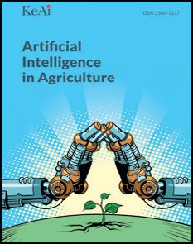[Artificial Intelligence in Agriculture 5 (2021) 278–291](https://doi.org/10.1016/j.aiia.2021.11.004)

Contents lists available at [ScienceDirect](http://www.sciencedirect.com/science/journal/)

Artificial Intelligence in Agriculture

journal homepage: [http://www.keaipublishing.com/en/journa ls/artificial- intelligence- in-agriculture/](http://www.keaipublishing.com/en/journals/artificial-intelligence-in-agriculture/)

[](http://crossmark.crossref.org/dialog/?doi=10.1016/j.aiia.2021.11.004&domain=pdf)Automation and digitization of agriculture using artificial intelligence and internet of things

# A. Subeesh ⁎, C.R. Mehta

*ICAR-Central Institute of Agricultural Engineering (CIAE), Bhopal, Madhya Pradesh, India*

## a r t i c l e i n f o

*Article history:*

Received 26 March 2021

Received in revised form 1 November 2021 Accepted 25 November 2021

Available online 29 November 2021

*Keywords:*

Agriculture automation Artificial intelligence Deep learning

Internet of things Smart farm machinery

Contents

## a b s t r a c t

The growing population and effect of climate change have put a huge responsibility on the agriculture sector to increase food-grain production and productivity. In most of the countries where the expansion of cropland is merely impossible, agriculture automation has become the only option and is the need of the hour. Internet of things and Artificial intelligence have already started capitalizing across all the industries including agriculture. Advancement in these digital technologies has made revolutionary changes in agriculture by providing smart systems that can monitor, control, and visualize various farm operations in real-time and with comparable intel- ligence of human experts. The potential applications of IoT and AI in the development of smart farm machinery, irrigation systems, weed and pest control, fertilizer application, greenhouse cultivation, storage structures, drones for plant protection, crop health monitoring, etc. are discussed in the paper. The main objective of the paper is to provide an overview of recent research in the area of digital technology-driven agriculture and iden- tification of the most prominent applications in the field of agriculture engineering using artificial intelligence and internet of things. The research work done in the areas during the last 10 years has been reviewed from the scientific databases including PubMed, Web of Science, and Scopus. It has been observed that the digitization of agriculture using AI and IoT has matured from their nascent conceptual stage and reached the execution phase. The technical details of artificial intelligence, IoT, and challenges related to the adoption of these digital technol- ogies are also discussed. This will help in understanding how digital technologies can be integrated into agricul- ture practices and pave the way for the implementation of AI and IoT-based solutions in the farms.

© 2021 The Authors. Publishing services by Elsevier B.V. on behalf of KeAi Communications Co., Ltd. This is an open access article under the CC BY-NC-ND license (<http://creativecommons.org/licenses/by-nc-nd/4.0/>).

1. Introduction 279
2. Internet of things and artificial intelligence 279
3. Generalized architecture of AI powered IoT ecosystem for agriculture 280
4. Applications of IoT and AI in agriculture automation 281
   1. Smart farm machinery 281
      1. Navigation and performance monitoring of tractors 281
      2. Autonomous tractors and farm machinery 282
      3. UAV or drones 284
      4. Irrigation systems 284
      5. Fertilizer application 285
      6. Pest and weed control 285
   2. Automated livestock management 286
   3. Greenhouse management 287
   4. Farm produce storage systems 288
5. Challenges and opportunities 288

* Corresponding author.

*E-mail address:* [subeesh.a@icar.gov.in](mailto:subeesh.a@icar.gov.in) (A. Subeesh).

<https://doi.org/10.1016/j.aiia.2021.11.004>

2589-7217/© 2021 The Authors. Publishing services by Elsevier B.V. on behalf of KeAi Communications Co., Ltd. This is an open access article under the CC BY-NC-ND license ([http://](http://creativecommons.org/licenses/by-nc-nd/4.0/) [creativecommons.org/licenses/by-nc-nd/4.0/](http://creativecommons.org/licenses/by-nc-nd/4.0/)).

1. Conclusions 289

Declaration of interests 289

References 289

1. Introduction

World's population is growing at a rapid pace and is estimated to reach 10 billion by 2050. This puts an immense responsibility on the ag- riculture sector to enhance crop production and increase yield per hect- are (FAO, 2017). Several pain points for farmers such as small land holdings, labor shortage, climate change, extreme weather conditions, reduction in soil fertility, etc. are making agriculture less profitable. For the last few years, agriculture is continuously challenged by climate change and other environmental problems and they create a huge hur- dle in achieving enhanced productivity. Two possible options to tackle the food shortage are increasing land usage and practicing farming in large area or adapting best practices and technology support to enhance productivity. Considering the case of developing countries with highly populated areas where increasing the land area is merely impossible, the only way is to go smarter with the help of cutting edge technologies like the internet of things (IoT) and allied technologies like Artificial In- telligence (AI). The recent advancement in ICT (Information and Com- munication Technology) and associated researches have identified the ‘Internet of things’ and 'Artificial Intelligence' as key technologies for revolutionizing modern agriculture practices. By incorporating the use of digital technologies like artificial intelligence and internet of things, better insights can be formed effectively from data gathered from the field and allowing farming practices to be planned systematically with minimal manual labor. Over the decades, the agriculture sector has realised the importance of precision farming. Precision farming is a sus- tainable alternative that will enhance production by providing a precise amount of inputs reducing the overuse of potential environmentally damaging pesticides and other inputs. Despite the challenges due to cli- mate change and other factors, the digital technology driven agriculture provides a plethora of methodologies for automating and enhancing ag- riculture production and productivity. Digitization in agriculture en- ables real-time analysis that helps in more effective spraying, land management, water management, and even land surveillance. The use of emerging digital technology will allow the agriculture industry to achieve several other benefits such as reducing input costs and wastage, achieving sustainable practices along with enhancing productivity to meet the growing food demand. Digital technology driven agriculture is gaining more and more global attention due to the incredibly easy

field management capability and powerful real-time monitoring systems.

Mechanization converted agricultural activities that require days of human sweat and draft animal labor into a few hours of activities. This can be considered as the first level of automation that transformed agri- culture tasks in developing countries like India. Agriculture mechaniza- tion in India is at an early stage and growing at a rate of 7.5% per annum and this is going to get smarter and faster with the advancement in dig- ital technologies. One of the main issues of recent times is extensive labor migration. When studying the workforce employed in Indian agri- culture, it was observed that the percentage of agricultural workers to total workers decreased from 59.1 in 1991 to 54.6% in 2011 and was ex- pected to be 40.6% in 2020 (Mehta et al., 2014). All these were a few main reasons for moving towards mechanization along with reducing the drudgery. Minimizing the drudgery associated with the agriculture tasks helps the women workers to step forward and make a key contri- bution to agriculture activities.

Fig. 1 shows the levels of mechanization in the agriculture activities of rice crops. In developing countries like India, agriculture mechaniza- tion played a crucial role in uplifting economic growth hammering all these hurdles (Mehta et al., 2019).

Now in the digital era, further automation through digital technolo- gies has widened the horizon of agriculture mechanization especially when backed up with the Internet of things and allied technologies.

1. Internet of things and artiﬁcial intelligence

Technology adoption is the need of the hour as our current tradi- tional farming practices would not be sufficient for meeting the food de- mand. The Internet of things has a huge potential to become a game- changer in agriculture automation and it is already doing wonders in the field. It is referred to as a network of physical objects called ‘things’ with network connectivity that can enable these objects to collect and exchange data and interact with the environment (Matta and Pant, 2019). The application of the internet of things backed up with an effi- cient intelligent decision-making system can lead to a significant reduc- tion in human intervention in various agricultural tasks. This intelligent decision-making is the brain of the system, which decides the success, and failure of automated activities. The amalgamation of the internet

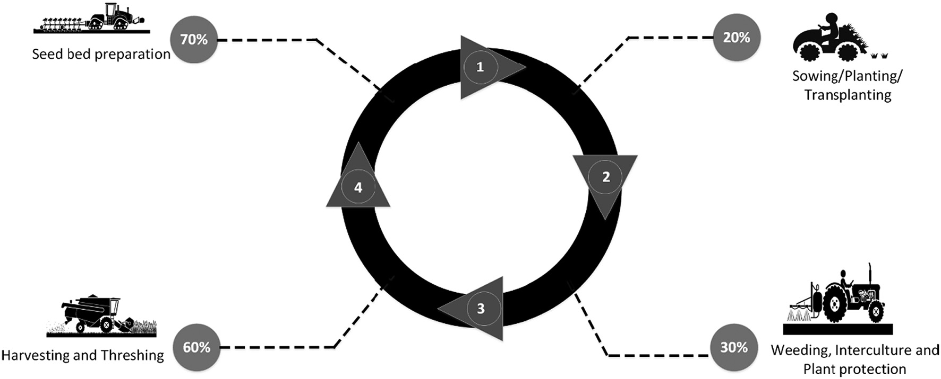

Fig. 1. Mechanization levels for farm operations in rice crop (Mehta et al., 2019).

of things with artificial intelligence results in powerful systems that can even beat human decisions in terms of accuracy. Artificial Intelligence enabled systems are computer systems that can able to perform opera- tions that generally require human intelligence such as speech recogni- tion, visual perception, decision making, and language translations (Yang, 2020). The Internet of things and artificial intelligence are con- sidered two sides of the same coin when it comes to the automation of agriculture tasks.

Being connected to the internet, the main goal of the IoT device is to generate real-time data and these data are mostly unstructured. During the early stages of IoT, when the device was simpler, the data generated were very few and used to trigger simple alert messages without much processing. There, the AI algorithms had no role to play. As the IoT sys- tems got more complex and sophisticated, this huge data (Big Data) gave rise to the need for data analysis. AI algorithms have the capability to handle and derive meaningful insights from the data which can lead to high-quality decision-making. Problem solving and automation have been made quite simple by the introduction of new logic and methods such as Machine Learning, Natural Language Processing, Machine Vi- sion, Artificial Neural Network (ANN) etc. Out of all these, Machine learning and ANN are the most widely applied methods in researches related to automation in agriculture (Jha et al., 2019). Machine learning algorithms can work with labeled (supervised learning) as well as unla- beled data (unsupervised learning). Most of the data driven automation and related operations follow the supervised learning algorithms. The current agriculture automation systems highly rely on the Artificial Neural Network (ANN) which performs well on complex classification tasks. ANN is inspired by the biological neurons and is architectured in a layer fashion. The architecture enables them to learn complex non- linear relationships. Deep learning based computer vision techniques that are widely used in agriculture automation are generally built based on Convolutional Neural Network (CNN).

CNN has made tremendous progress and has shown exemplary per- formance in image segmentation, classification, detection, and retrieval related tasks, thus reviving the interest of scientific community in ANNs (Cireşan et al., 2012; Indolia et al., 2018). The powerful learning ability of CNN is mainly due to the multiple feature extraction stages using a set of layers and convolution operations (Fig. 2). For a CNN model to classify an image, it has to go through a series of layers that are convolutional (with kernels/filters), pooling and fully connected layers. Convolution layer is responsible for extracting the features from the im- ages using kernels. A 2D kernel is a matrix of weights that slides over the input image data and performs elementwise multiplication with the part of the input that it is currently on, then it sums the results to a single pixel. This repetitive sliding operation generates a feature map of the image. Convolutional operations with different kernels are helpful in operations such as edge detection, sharpening, blurring, etc. This output of the convolutional kernels is assigned to the activation units, where the non-linearity is added to the model. Tanh, Singmoid and ReLU are the most commonly used activation functions. Pooling operation is per- formed in the next stage of the CNN in which a significant reduction in number of parameters is performed especially when the images are too

large. Max pooling, average pooling, min pooling and sum pooling are the important pooling operations applied over the feature map. Max pooling identifies the largest element from the output of previous layer. Average pooling identifies the average of each patch from the fea- ture map. In the next step, the matrix of values is flattened to vector form and fed to a fully connected neural network. With all these fea- tures, a neural network model is constructed and activation functions such as softmax or sigmoid are used to classify the outputs into the var- ious classes based on the identified probability. Over the years, there were modifications in-depth and structure of CNN and this resulted in improved performance and learning capacity. The workflow operations in image classification using CNN is given in Fig. 3.

There are several deep learning architectures commonly used for image classification such as AlexNet (Krizhevsky et al., 2012), VGGNet (Simonyan and Zisserman, 2015), GoogLeNet (Szegedy et al., 2014), InceptionNet (Szegedy et al., 2016), ResNet50 (He et al., 2015), DenseNet (Huang et al., 2018), XceptionNet (Chollet, 2017), EfficientNet (Tan and Le, 2020) and NASNet (Adam and Lorraine, 2019), etc. Table 1 shows the major CNN architectures used by re- searchers for image classification.

Briefly, the Internet of Things and Artificial Intelligence have enough potential for revolutionizing the agriculture sector to fulfill the increas- ing food demand and reduce the drudgery of agriculture workers.

1. Generalized architecture of AI powered IoT ecosystem for agricul- ture

An IoT based agriculture automation system comprises multiple technologies glued together for achieving the intended task. At the low- est level of the system, it has the IoT sensors deployed on the targeted site (Fig. 4). This could be fields for soil monitoring, ear tag for cattle, or sensors deployed in a greenhouse, farm machines, and so on. An IoT device used in the agricultural site has multiple components. Rasp- berry Pi, Arduino, and Beagle Bone are some of the most commonly used devices, which normally have limited processing memory but can communicate effectively to outside using the communication mod- ule. They can send/receive signals from the external environment (Fig. 5). Any changes in the environment are captured by the sensors on a real-time basis and will be sent to a remote server or cloud through an IoT Gateway. The remote server/cloud server is responsible for data management. Data are normally stored in the database. Since the data are huge and unstructured, traditional relational databases are not pre- ferred for storing this sort of data. NoSQL databases are mostly adopted across the cloud and found to be the best fit for the unstructured data and faster accessibility. Features like auto-scaling, availability, and secu- rity make cloud servers a good choice for IoT based applications.

In an AI-enabled data pipeline, the data are retrieved from the data- base as CSV, Excel, Images, or any format that can be handled by the an- alyzing program. The data pre-processing involves mainly the data cleaning in terms of removing outliers, normalizing, and so on. For a su- pervised algorithm, the data are divided into a train, validation and test set. Based on the data and the type of operation to be performed, a

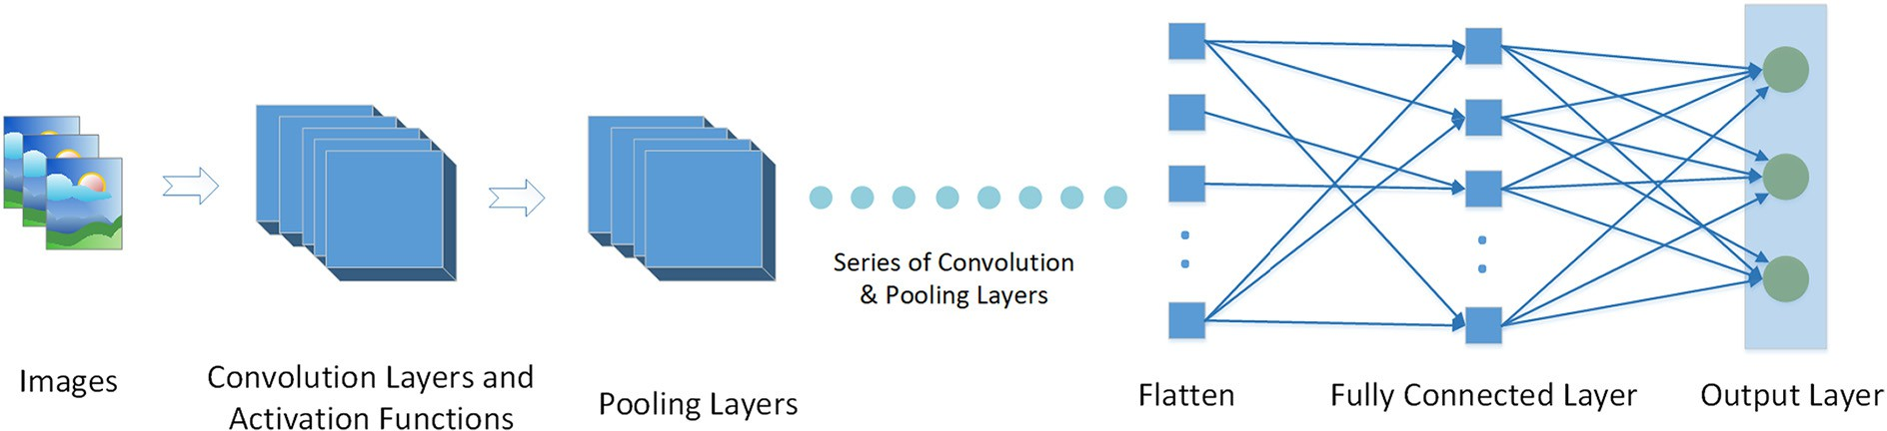

Fig. 2. Architecture of convolutional neural network.

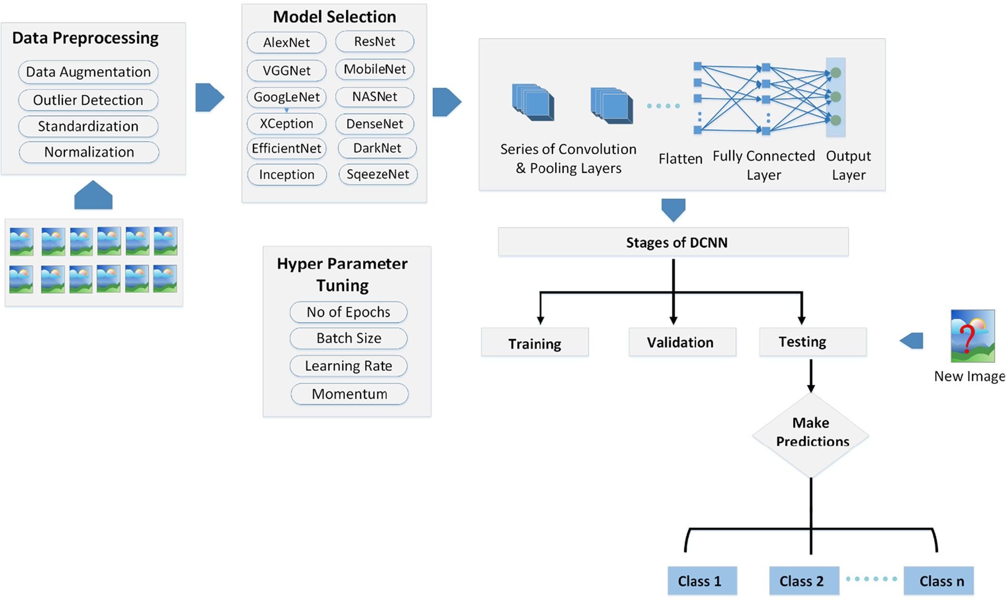

Fig. 3. Pre-trained CNN model based image classification pipeline.

variety of algorithms can be applied to the data. Table 2 shows a sum- mary of various AI/ML algorithms that are commonly used for agricul- ture applications. A model is created and trained using the training dataset and to check the performance and accuracy of the model, the validation and test data are utilized. K-Fold Cross-validation methods are widely used to check model stability. Confusion matrices and the precision, recall values derived are used to estimate the quality of a clas- sification model. In the case of image data, CNN (Convolutional Neural Network) and its architecture variations have given very promising re- sults. CNN is a type of artificial neural network with a specific architec- ture that uses convolution operation to extract image features. Once the model is properly validated, it can be deployed in the cloud for generat- ing results for unknown data. Now based on the incoming data, the AI model can generate intelligent predictions and decisions and these can be further communicated to the farmers or utilized for initiating any operations in the farm. Farmers who are equipped with a smart- phone can easily get the recommendation, prediction results in simpler forms, and take necessary actions. The notifications can be in the form of

Table 1

Comparison of Common CNN based deep learning architectures.

|  |  |  |  |  |  |
| --- | --- | --- | --- | --- | --- |
| Model | Year | Image Size | Depth | Size (in MB) | No. of Parameters (million) |
| AlexNet | 2012 | 227 × 227 | 8 | 227 | 61 |
| VGG16 | 2014 | 224 × 224 | 16 | 515 | 138 |
| VGG19 | 2014 | 224 × 224 | 19 | 535 | 144 |
| GoogleNet | 2014 | 224 × 224 | 22 | 27 | 7.0 |
| InceptionV3 | 2015 | 299 × 299 | 48 | 89 | 23.9 |
| ResNet50 | 2015 | 224 × 224 | 50 | 96 | 25.6 |
| ResNet101 | 2015 | 224 × 224 | 101 | 167 | 44.6 |
| Xception | 2017 | 299 × 299 | 71 | 85 | 22.9 |
| MobileNet | 2017 | 224 × 224 | 53 | 13 | 3.5 |
| DarkNet53 | 2018 | 256 × 256 | 53 | 155 | 41.6 |

SMS and email. During the recent period, farmer-friendly mobile and web applications are also widely used for communicating information to the farmers. The farmer can control the farm activities through mo- bile applications as well. They can send control signals and accordingly, the actuators can perform necessary actions.

1. Applications of IoT and AI in agriculture automation

AI-powered IoT ecosystem has tremendous potential to make the farming practice more controlled and precise by introducing smarter applications. The scope of recent advancements in these technologies is endless in agriculture practices as it can automate complex tasks with minimal manual intervention. The brief details of applications of AI and IoT in Agricultural Engineering are given below (Fig. 6).

* 1. *Smart farm machinery*
     1. *Navigation and performance monitoring of tractors*

Modern farmers use various farm equipment and machinery to per- form various agriculture tasks. Among those, tractors are considered the most essential and irreplaceable farm power unit. Undoubtedly tractors are an integral part of farm mechanization and constantly helping to raise agriculture productivity day by day. Being a vital part of the agri- culture mechanization system, the performance monitoring of the tractor-implement system is very crucial.

The tractor performance monitors measure, record, and help in re- motely visualizing the entire operation. The parameters generally taken into consideration are power, fuel consumption, draught and wheel slip. Optimization of these parameters can greatly improve the tractor performance. The draught was measured by strain-gauge mounted on a ring transducer at the front end of the drawbar. The fuel consumption was measured by a positive displacement flow meter and wheel speed by using toothed gears and magnetic pick-ups

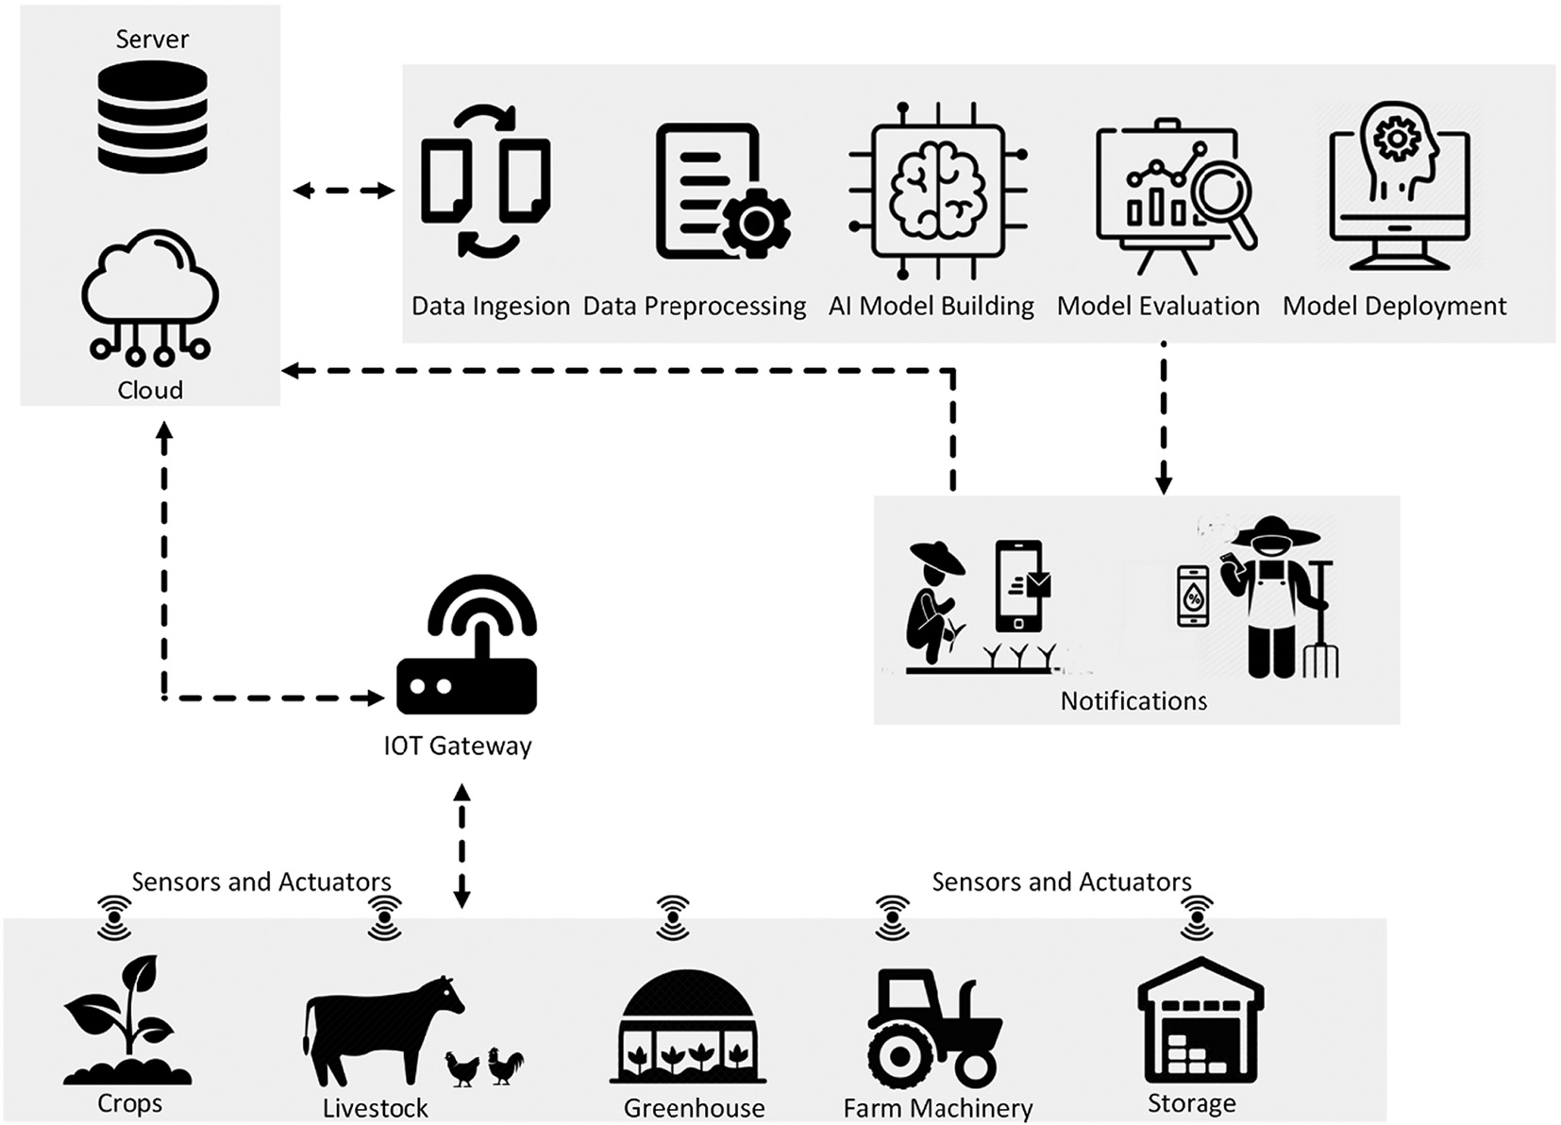

Fig. 4. Generalized internet of things – artificial intelligence/machine learning workflow for agricultural solutions.

(Grogan et al., 1987). A data acquisition system is also handy for moni- toring the performance wherein the transducers are mounted for mea- suring the various operational parameters. The spatial mapping of the tractor-implement performance can be made possible using the Differ- ential Global Position System (DGPS). Global Positioning System (GPS) acts as a major component of this system that provides spatial values. This enables the system to measure, record, and monitor the perfor- mance of the tractor-implement system relative to the position. Since the performance of a tractor-implement system is influenced by the

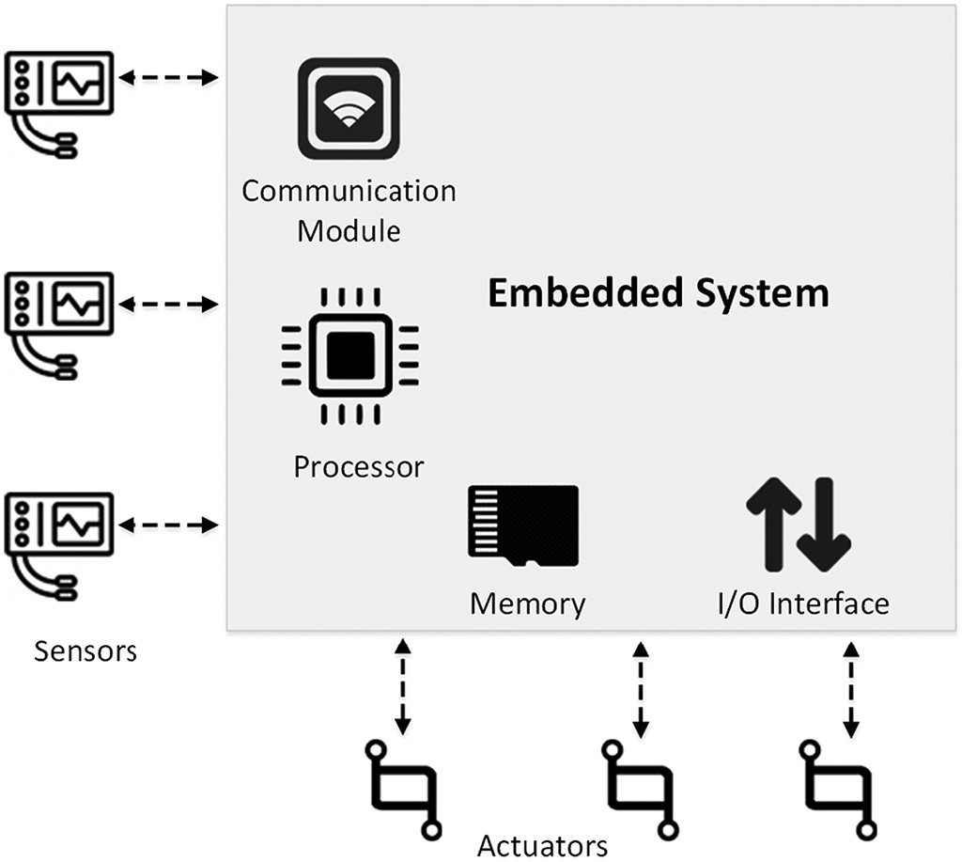

Fig. 5. Architecture of an IoT device.

factors of soil condition and land slope, this mapping system is highly beneficial for calculation of the cost of crop production within the field boundary (Yahya et al., 2009; Yule et al., 1999).

Farms in developed countries now have tractors with an in-built navigation system and sensors, monitoring all macro-scopic and micro-scopic elements in the field. Nowadays, as farms have become more and more connected and internet-enabled, the real potential of the internet of things and allied technologies can be effectively utilized in monitoring the performance of tractors. A general system that mon- itors the tractor navigation and performance includes both hardware and software parts. The hardware section encompasses the essential sensors for measuring geo-location, fuel flow, and power consumption and these data are transferred to a processing unit or PCB. With a suit- able communication technology like LPWAN (Low Powered Wide Area Network), the data are transferred to the network. For the software side, web applications developed by connecting with the real-time and scalable database is utilized (Civele, 2019).

* + 1. *Autonomous tractors and farm machinery*

The agriculture sector is continuously challenged by the shortage of skilled laborers and low productivity. The advancement in technology has introduced tractors, cultivators, and plows that require minimum human dependency (Mehta et al., 2021). Farmland is undoubtedly the best place for the use of autonomous machines since they are free from crowds and pedestrians and activities can be carried out with min- imum risk. Sensors like radars and lasers are generally used in an auton- omous vehicle to identify any obstacles and handle them intelligently. But the same cannot be applied in the case of tractors as it cannot distin- guish between grass and obstacles. So it cannot be operated like normal autonomous vehicles. One general approach is to use GNSS (Global Nav- igation and Satellite System) using which the machine can locate its po- sition and move to an area autonomously. But since the system would be unaware of the surroundings, this can lead to a collision. Also, in an orchard like environment, autonomous driving will not be possible

Table 2

AI/ML algorithms and applications in agriculture.

ML/AL Algorithm Type Applications Description

Convolutional Neural Network

Classification Plant Disease Classification (Ashwinkumar et al., 2021; Atila et al., 2021; Bedi and Gole, 2021; Rangarajan Aravind et al., 2020; Singh et al., 2021)

Seed Classification (Loddo et al., 2021; Nie et al., 2019) Crop Classification (Zhong et al., 2019)

Weed Identification (Dyrmann et al., 2016; Hu et al., 2021; Yu et al., 2019)

Land Cover Classification (Pan et al., 2020)

Object Detection Behavior Recognition in cattle and goat (Fuentes et al., 2020; Jiang et al., 2020)

Weed Detection (Puerto et al., 2020)

Identification of Productive Tillers (Deng et al., 2020)

Models used are: AlexNet, VGG16, VGG19, InceptionV3, DenseNet201, MobileNet, EfficientNet, Xception, InceptionResNetV2 and NASNetMobile

SqueezeNet and Data consist of Images and Videos

Models used: Faster R-CNN, SSD, YOLO models, Mask-RCNN (For segmentation), Data source is Image/Video.

Support Vector Machines

Classification and Regression

Soil Moisture Estimation (Liu et al., 2016b; Malajner et al., 2019; Taneja et al., 2021)

Vegetable/Fruit Grading (Cen et al., 2016; Yimyam and Clark, 2016)

Disease Detection (Islam et al., 2017; Omrani et al., 2014; Selvaraj et al., 2013)

Stress detection (Karimi et al., 2006; Naik et al., 2017) Insect Detection (Kasinathan et al., 2020)

Classification of linear and non-linear data, Image classification

Naïve Bayes Classification Stress detection (Naik et al., 2017)

Weeds Identification (Mursalin and Mesbah-Ul-Awal, 2014; Pereira et al., 2012)

Vegetable Grading (Cen et al., 2016)

Disease Detection (Phadikar et al., 2013; Stegmayer et al., 2013)

Classification using probabilistic model

Tree Based Models

Classification and Regression

Stress detection (Naik et al., 2017)

Crop Classification (Ok et al., 2012; Tatsumi et al., 2015) Environment Monitoring (Shackelford et al., 2018)

Crop Yield Prediction (Jeong et al., 2016)

Weed Detection (Alam et al., 2020; De Castro et al., 2018; Gašparović et al., 2020)

Tree based classification and Regression.

K-NN Model Classification Stress detection (Naik et al., 2017)

Weed Detection (Ahmad et al., 2011)

Seed Classification (Kurtulmuş and Unal, 2014) Vegetable/Fruit Grading (Cen et al., 2016; Yimyam and Clark, 2016)

Insect Detection (Kasinathan et al., 2020)

Classification using non-parametric instance based model

Recurrent Neural Networks and LSTM

Time Series Analysis and Classification

Land Cover Classification (Rußwurm and Körner, 2018; Sun et al., 2019)

Agricultural Yield and Price Forecasting (Haider et al., 2019; Khaki et al., 2020; Kurumatani, 2020)

Disease localization (Lee et al., 2020)Nutrient Analysis(Moon et al., 2019)

Text classification, Summarization, Time series analysis, Forecasting.

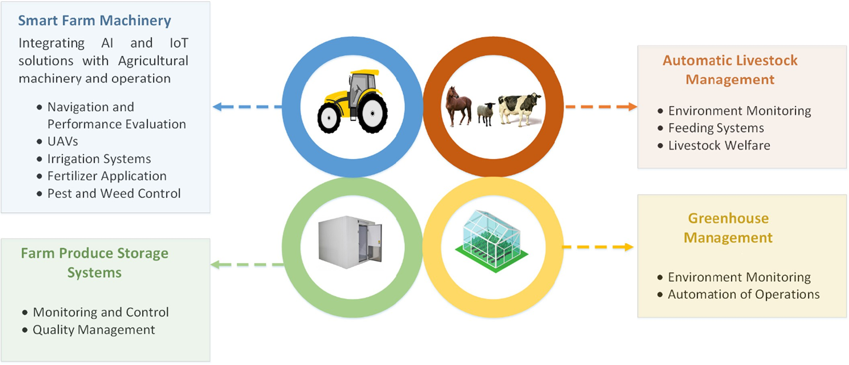

Fig. 6. Agriculture automation applications using AI-IoT.

with GNSS as the satellite positioning will be less accurate. So recent au- tonomous systems in agriculture are heavily dependent on stereo- cameras, sensors and deep learning algorithms. RGB camera with mul- tiple infrared cameras is used to capture the depth images via stereo matching. A popular object detection algorithm YOLO (Redmon et al., 2016), which is based on CNN, is used for object detection. This detects the objects in the bounding boxes of pixels (Inoue et al., 2019). In the in- dustry abroad, tractor manufacturers like John Deere and Case IH have already started offering autonomous tractors to the farmers. Case IH's concept tractor was enabled with cameras and LiDAR (Light Imaging, Detection, and Ranging) which can accurately identify the obstacles. Faster RCNN (Ren et al., 2016) and SSDs (Liu et al., 2016a) are other few object detection models that are being utilized for object detection in agriculture applications.

Autonomous tractors, rice transplanters, and harvesters have been developed by researchers with nearly the same human efficiency using deep learning based computer vision methods. The autonomous fruits harvester prototype consisted of mainly an image acquisition module and followed by an image manipulator module that was mounted on a self-propelled carrier (Blok et al., 2016). The input was fed into the computer vision-based object detection algorithm to iden- tify the vegetables and fruits for harvesting.

* + 1. *UAV or drones*

Even though the initial introduction of drones was into military appli- cations, slowly it has capitalized on agriculture applications. The intro- duction of drones into agriculture has become another breakthrough in automating many of the agriculture tasks such as pesticide spraying, land monitoring, etc. Agricultural drones are a class of Unmanned Aerial vehicles (UAVs) considered as aircraft without a human pilot aboard. A generic drone system is shown in Fig. 7. The ground station is responsible for communicating to the drone with the help of protocols such as Mavelink. Most of the ground control stations are equipped with a user interface to monitor the drone. The hardware is essential in controlling the row, pitch, and yaw for the UAVs. The drone device consists of actu- ators and motors for performing necessary operations, a set of sensors such as laser, radar, camera, gyroscope, accelerometer, compass, GPS receiver for reading the environment information and a central process- ing unit. To communicate with this, the remote control is used and

communication is done in the radio frequency range. UAVs are capable of monitoring hectares of fields in a single flight using the thermal and multi-spectral cameras mounted on them (El Hoummaidi et al., 2021; Mogili and Deepak, 2018). The cameras can capture the bands with dif- ferent wavelengths and based on the reflectance values, indices such as Normalized Difference Vegetation Index (NDVI) can be calculated using the formula.

NDVI = (RINR–RRED)/(RINR + RRED)

Where, RINR = Reflectance in the Near Infra-red band, RRED = Reflectance in the Red range of the red band.

NDVI value ranges from −1 to 1 and 1 being the highest density of

crops (Bhandari et al., 2012; Reinecke and Prinsloo, 2017) and 0 indi- cates no vegetation. These kinds of analyses help to access the health of the crops and identify the pest attacks.

The pesticide application is another key focus area of drone applica- tion. The two main components of the system are the spraying system and the controller. The spraying system is normally attached to the lower part of the UAV and is connected to the pesticide tank. The nozzle of the sprayer is activated using the controller. At present, the agricul- tural sector has embraced drone technology with both hands to trans- form modern precision farming (van der Merwe et al., 2020). In India, start-up and research organizations are leveraging the opportunity of drones in agriculture to make data-driven decision-making on the soil as well as crop health monitoring. The opportunities for drone-based so- lutions in India are endless as the landscape makes ground-based sur- veys costly and time-consuming. The major challenge is setting clear regulations for drone usage (Sylvester, 2018).

* + 1. *Irrigation systems*

For our future food requirement, efficient usage of water has para- mount importance and the “per drop more crop” strategy has been identified for right utilization of the scarce water resources. Technolog- ical intervention for efficient water management has been started for years, but the evolution of the Internet of Things (IoT) has taken it to an- other level. The complete workflow of an irrigation system can be intel- ligently automated using the Internet of things and decision support systems enabled with artificial intelligence and cloud computing (Fig. 8). The soil moisture, temperature, and humidity sensors act as

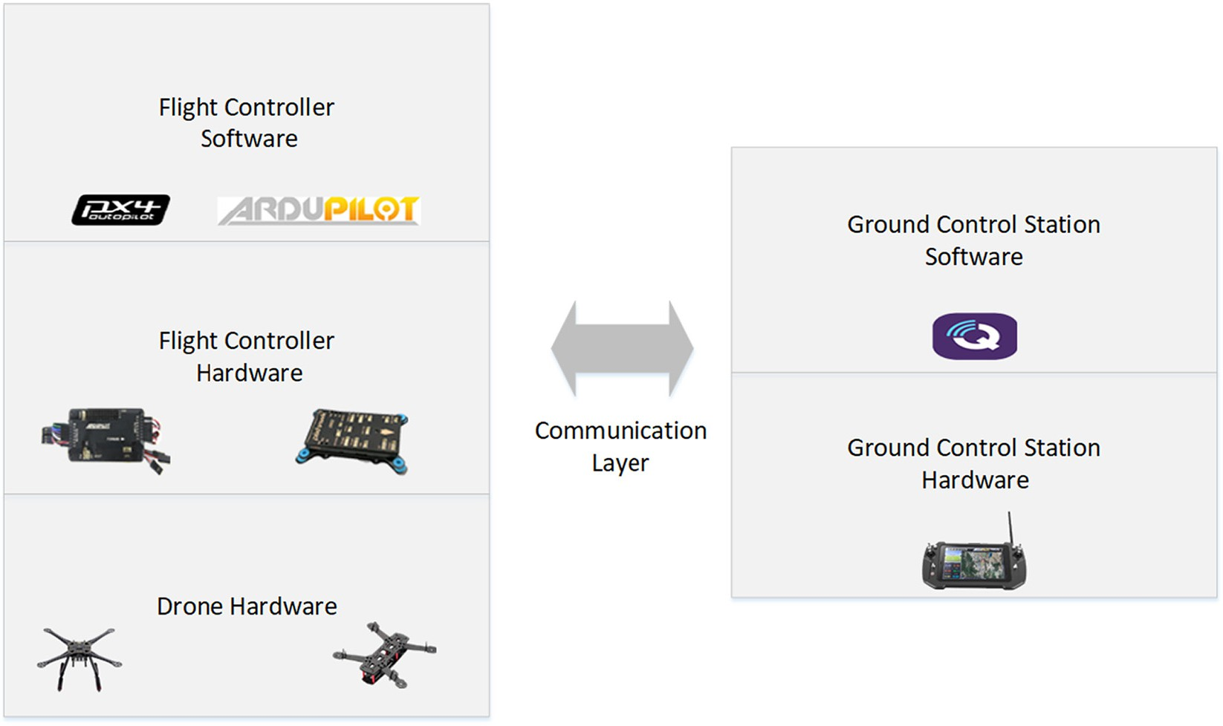

Fig. 7. High level architecture of drones.

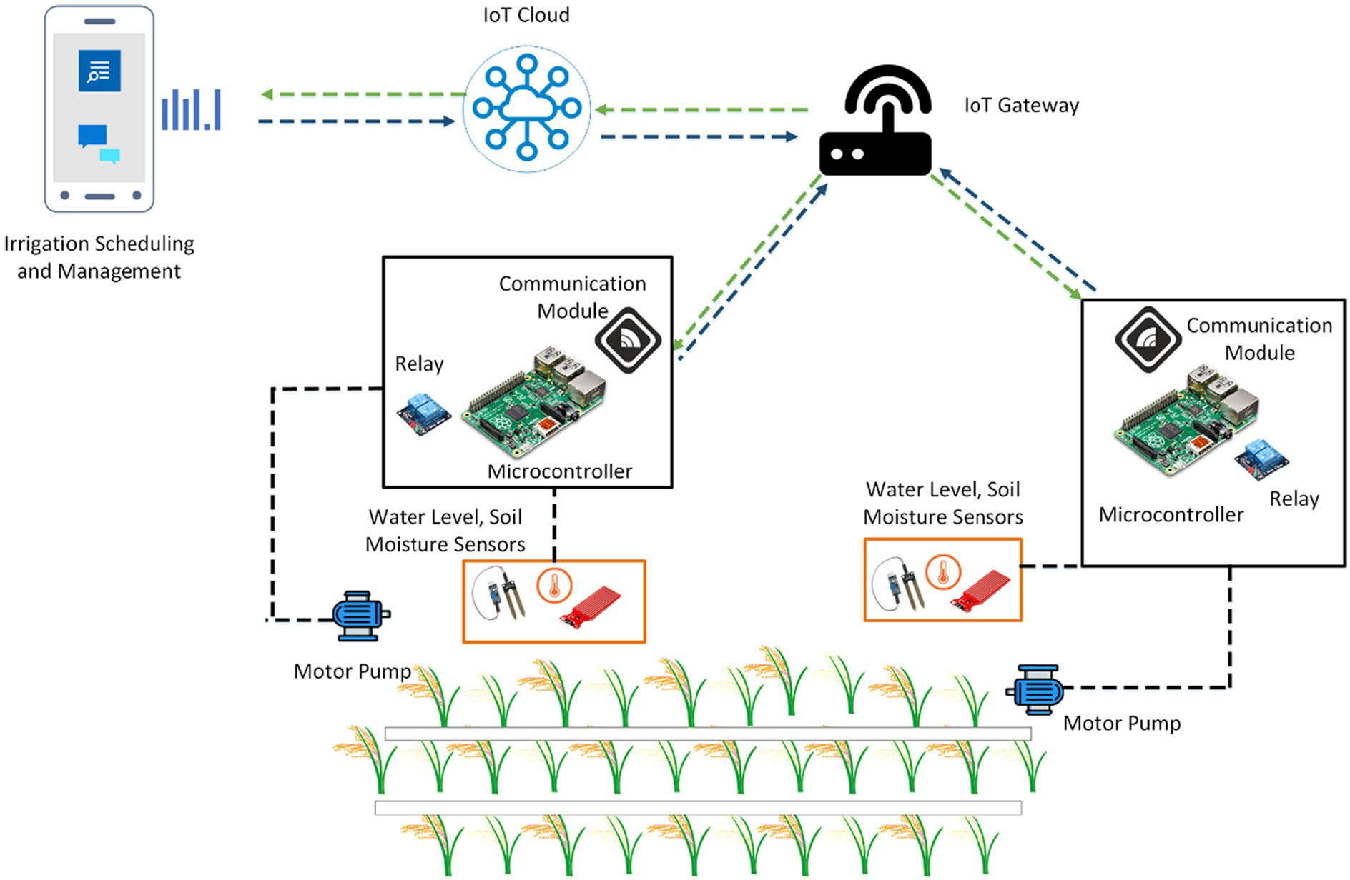

Fig. 8. Automated irrigation systems using internet of things.

the major source of data that are fed into the system. For a detailed anal- ysis, the data are stored in a database where historic data can be utilized for training the model. The artificial neural network serves as the good- to-go classification technique which can be trained with data taken from the database for building the model. Once the model is trained, it can be further used to classify unknown data. Real-time monitoring is made possible by transferring the data from the sensors through proto- cols like MQTT. In MQTT, the data are published to topics and only those who subscribed to the topics can only view the data. The advantage of using MQTT is that it is lightweight and can be managed easily by the network. The processing unit will be ready to accept requests from out- side and the module contains a relay and motor connected to it. The data can be visualized in an MQTT dashboard (Nawandar and Satpute, 2019).

In remote locations where water scarcity is profound, irrigation heavily depends on underground water. Depending on the water level inside the well, the pumps should be turned on and off. Diesel engine operated pumps are generally water-cooled, so the condition of low water level can also damage the pump. Hence, proper monitoring of water level inside the well may be considered along with the irrigation planning. In regions with water scarcity and power shortage, an IoT based solar energy system for smart irrigation can be developed. In those systems, during sunshine, the battery can be charged using solar energy. As in other irrigation systems, these systems are also equipped with sensors for measuring soil moisture, humidity, and temperature. Along with that, the flow rate can also be controlled using a flow rate sensor. These systems are designed to focus on the energy-saving criteria in mind. A control algorithm using fuzzy logic adds value to the existing irrigation method. Using various combinations of the input values, conditions can be made to operate the water pump on ap- propriate occasions. Remote monitoring using mobile or web applica- tions makes these systems accessible from anywhere (Al-Ali et al., 2019).

* + 1. *Fertilizer application*

Along with the presence of weeds, under or over-application of fer- tilizers is another major reason for low yield from the agricultural land. Soil testing is inevitable before adding the fertilizers and this reveals the nutrient requirements of the crop. Because of the complex laboratory procedures, the farmers often skip this process. These days, organiza- tions are motivating the farmers to go digital and practice technology- enabled farming practices. IoT technology can help in the application of fertilizers more smartly. Nitrogen (N), phosphorous (P) and potas- sium (K) levels can be measured using an NPK sensor which can be de- signed using light-emitting diodes (LED), light-dependent resistor, and resistors. The sensor works based on the Colorimetric and photo- conductivity principles. The values from the NPK sensor are directly read into a processing unit or system-on-chip. Further analysis is carried out either using fog computing or edge computing. Fog computing is performed by the processor directly in contact with the sensors and edge computing is done by an edge server connected through the inter- net. Fuzzy logic helps to analyze and arrive at a conclusion about the amount of fertilizer that needs to be applied. Since cloud services like google cloud platforms provide scalable, timely, uninterrupted service and this option can be utilized for SMS service. The recommended fertil- izer quantities are generally sent as text messages to the farmer's mobile phones (Lavanya et al., 2019).

The low-cost SPAD has been developed at CIAE, Bhopal for indirect measurement of chlorophyll content of leaves of crops in the field. It is a compact handheld, portable unit and can be plugged into OTG enabled android smartphone for display and data logging of SPAD values. It helps in assessment of the nitrogen requirement of the crop.

* + 1. *Pest and weed control*

The targeted application of herbicide for controlling weeds remains a challenge as it induces harmful effects such as health and environment-related problems. Moreover, conventional weeding

methods apply herbicides uniformly in the entire field irrespective of the presence of weeds and result in increased herbicide cost and more GHG emissions. To avoid all these problems, one effective approach is to develop a site-specific system combining the Internet of Things, Ro- botics, and advanced image analysis techniques. For weed detection on a field, both RGB and Infrared (IR) imaging sensors can be used. These captured images from the fields are fed into a pre-processing component. The pre-processing component is responsible for resizing, transforming, alteration of the color spaces, and normalization opera- tions. Segmentation is performed on the pre-processed output which groups the associated pixels for forming a connected object that has ho- mogeneous properties. This includes separating the plants from the soil and other backgrounds and collecting only the vegetation part. The es- sential features from the segments are taken out in the next stage called feature extraction. These include biological morphology, spectral fea- tures, visual textures and spatial contexts. The extraction and combin- ing of various features result in an increased dimensionality. For effectiveness, only the essential feature combinations are selected using various algorithms such as Stepwise Linear Discriminant Analysis (SWLDA), Principal Component Analysis (PCA), Linear Discriminant Analysis (LDA), and so on. For the final classification of weeds and crops, either conventional machine learning-based classification or deep learning-based algorithms can be employed. Two major classifiers that are broadly applied in weed detection are support vector machines (SVM) and artificial neural networks. The SVMs have been successfully used in fields for the identification of weeds in maize fields (Akbarzadeh et al., 2018). Based on the recent studies, Convolutional Neural Network (CNN) is found to outperform the other classifiers while analyzing the image. The only limitation of the CNN is that when the features are large, and many parameters are to be learned. It imparts heavy compu- tational load and demands higher hardware costs. This can be bypassed using pre-trained models which can give the state of the art perfor- mance (Wang et al., 2019).

Internet of Things based systems for weed control are enabled with

processing components or system-on-chip such as Raspberry Pi, sen- sors, cameras, and sprayer (for spraying the herbicide on the weed). The vital part of the system is handled by an artificial intelligence- based weed classification model, which identifies and separates the weed from the crop. The convolutional neural networks are used for building image classifiers that can give high accuracy. Based on the out- put of the classifier model, the sprayer gets triggered. The IoT- based weed control system is very promising automation as it can drastically decrease the usage of herbicides and thus a significant reduction in health-related problems (Dankhara et al., 2019).

Traditional pest control methods are heavily dependent on the chemicals and the consumers are increasingly concerned about the im- pact of these on the soil and human health. Various strategies can be planned for saving crops from pests using the internet of things. Remote monitoring of pests and their activities such as codling moths in apple orchards can be done using IoT devices. This helps to get prepared for the counter measures. Weather also plays a key role in increasing the population of pests. IoT can help remote weather monitoring very pre- cisely and at a very low cost. Another key aspect to be considered is crop health. Image processing and AI-enabled systems can automati- cally assess crop growth and alert the probabilities of pest attacks. One of the recent trends that have been observed in pest control is the devel- opment of early warning models. These models are big-data driven and as a first step collect various information that can cause pest growth. This involves real-time data collection from the fields which are related to soil, weather, other environmental conditions, and a neural network is trained to predict the degree of pest occurrence in the field (Cai et al., 2019). Object detection using Faster R-CNN (faster region-based convolutional neural network) is also found to be very effective in pests identification in large farms and greenhouses (Karar et al., 2021). Innovative spraying equipment such as air-assisted sprayers, ULV sprayers, ultrasonic sensor-based sprayers, canopy sprayers, and

electrostatic sprayers can improve the efficacy of spray. This will reduce the application rate as well as the number of sprays in the field and hor- ticultural crops, thereby, reducing the pesticide requirement, hazards of over-application, and reducing the pollution of soil and groundwater.

* 1. *Automated livestock management*

Livestock plays a vital role in rural development and the livelihood. Studies show that there is a huge yield gap since the farmers are follow- ing old age practices. The biggest concern is how to manage and orga- nize the growth of this livestock sector in such a way that the yield gap can be minimized. Due to this, there is a research opportunity with the help of advanced technologies that can provide a sustainable solution. The Precision Livestock Farming (PLF) system automates the complete process of monitoring, analyzing and decision making thus ensuring the health and wellbeing of the livestock.

Backyard poultries are one of the old age practices of most of the rural villages and a great asset to the women groups. A poultry manage- ment system facilitates automation through real-time advanced data analysis (Ren et al., 2020). There are three main sections for precision poultry farming namely the environment, precision feeding system, and poultry welfare. Environment monitoring systems comprise multi-sensors that are capable of reading temperature, humidity, and gases like CO2 and ammonia which can impact the bird's health. Also, deep learning-based prediction models can predict the broiler weight up to 72 h in advance. Robotics also serves as an essential technology in managing poultry activities (Astill et al., 2020). Autonomous robots can enhance bird health by inducing the movement of birds. Advanced robots can aerate the litter on the poultry floor. This will decrease the chance of infections and prevent diseases like Salmonella. The precision feeding systems can precisely control the intake of feed. Recent re- searches have proved that precision-fed broiler breeders contribute to more fertile eggs (Zuidhof et al., 2017). Welfare monitoring systems, on the other hand, are equipped with non-invasive technologies like digital imaging and vocalization analysis which are backed up with ad- vanced big data analytics.

Behavior analysis of cattle provides better insights into their health, early disease detection, feed intake, heat, and estrus events. Monitoring all the cattle on the farm is often a tedious job and requires close obser- vation. Animal-attached sensors are one solution that can be employed for automated monitoring and may be implemented in various small and large-scale cattle farms (Williams et al., 2020). The current behavior monitoring and analysis automation system is commonly equipped with components such as sensors attached to the leg, neck, or ear of an- imals, sensor nodes to process and transmit the observations, and an AI- enabled model to update the status of the animal (Fig. 9). The machine learning models developed are fed with the time-series data generated from the sensors. It is often a good practice to select only the relevant features required to build the AI model. For this feature selection, methods are employed which identify the best combination of features that can be handy in performing the decision making based on the sta- tistical importance of a combination of features. The algorithm perfor- mance is evaluated in two approaches viz. Leave Out One Animal (LOOA) and Stratified Cross-Validation (SCV). In LOOA, the data from all the remaining animals act as the test set and others become the train- ing set. In the SCV approach, data from all the animals are combined and evaluated similar to the K fold cross-validation (Rahman et al., 2018).

The productivity on a dairy farm is heavily dependent on the effi- cient and timely reproductivity of the cattle. The traditional system of artificial insemination is not accurate because of the lack of techniques for timely identification of the estrus and calving events. Automated systems using sensors like accelerometer, pedometer, temperature sen- sor, etc. can collect information about the current state of the cattle. Dur- ing estrus and calving events, their activity duration and patterns vary from a normal state. From the data collected, an artificial intelligence model can analyze this pattern to identify anomalies in the activity

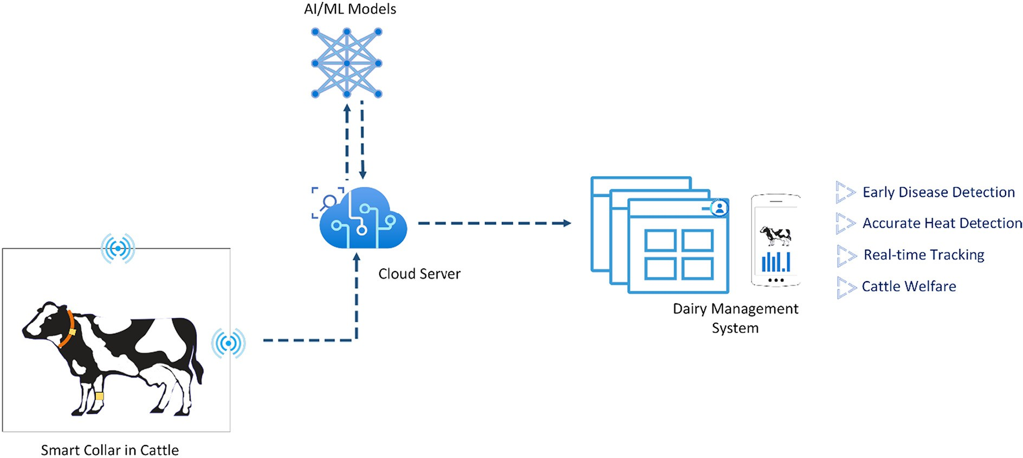

Fig. 9. Smart collar system for smart dairy management.

and thereby conclude that the cow is undergoing the calving or estrus event. The most important three parameters that can determine the state of the cattle are hourly ruminating time, feeding time, and resting time. These can be easily obtained from the accelerometer data. The ru- minating time and feeding time are extracted from the accelerometer mounted on the neck and standing time from the accelerometer mounted on the leg of the cattle. While detecting the cattle is in estrus or not, any binary classification models such as logistic regression can be used (Benaissa et al., 2020).

An IoT based livestock management system requires complex deci- sion making, often the data analysis is performed on the cloud or remote servers. This is because of micro-controller inside the collar or ear, has very limited processing and consumes a lot of power in complex com- putations. Livestock automation systems are also data-driven and these livestock data are generally unstructured. It can fall into any cate- gories of text, image, audio and so on. Generally, the statistical methods perform poorly on the unstructured and noisy data. In simple classifica- tion problems and pattern recognition, multi-layer perceptron feed for- ward neural networks work well (Gutierrez-Galan et al., 2018). However, for image analysis, Convolutional Neural Networks (CNN) and their variations are proved to be much more accurate.

* 1. *Greenhouse management*

Maintaining the environmental variables inside the greenhouse is a tedious activity due to involvement of many parameters. These fluctua- tions in climate can damage the crops as well, so it is one of the areas where technological intervention can make the life of farmers easier than ever before. The local climate and environment parameters of modern greenhouses can be measured using sensors. Wireless Sensor Networks with a large number of nodes have the capability to perform sensing, actuating, and communicating the information to the stake- holders. The architecture generally consists of a wireless sensor network data management sub-systems and a base station which are responsible for monitoring (Akkaş and Sokullu, 2017). For data storage, a remote server or cloud server is preferred. The general architecture of the sys- tem is quite similar to other IoT based monitoring systems. Along with the monitoring, a significant level of actuation can also be done with the help of these systems. The systems can be connected with any connecting protocols like bluetooth or zigbee and collect the moisture data from the soil. The connected micro-irrigation system can get trig- gered when the moisture level is below the threshold level. Similar ac- tivities can be performed in case of temperature and humidity as well.

The data can be made available in a public dashboard that can be accessed remotely from any location. Providing summary data on a daily basis can help in planning for the upcoming days (Ullah et al., 2018).

Another looming issue that greenhouses currently face is the pest at- tacks because of the favourable conditions inside the greenhouse. So In- tegrated Pest Management (IPM) is one of the core aspects of efficient greenhouse implementation. The most basic method that generally im- plemented is the use of sticky paper traps which can attract pests. This sticky paper can give the approximate population density of the pest. This helps in planning precise pest control and management strategies. This manual inspection can further be automated using image process- ing algorithms which partially solves this problem. To have a fully auto- mated system, the micro-controller enabled monitoring can be employed. This method can collect sticky paper images using RGB cam- eras installed in various locations of the greenhouse. The core process- ing element of the system is Raspberry Pi or Arduino with an RGB camera interfaced with it. The sensor nodes are designed normally in a waterproof structure and the nodes can be connected in a topology like a star, such that they can send the data to the outside world through the Gateway. Images can be transferred to the remote server using HTTP POST protocol. Further image analysis can be performed at the server. The findings of the analysis are directly visible in a dashboard main- tained by the server. Conventional machine learning algorithms like SVM (Support Vector Machines) with a suitable kernel (radial basis ker- nel) can be used for analysis purposes. Labeling of the insects is done by the entomologists so that the data can be modelled and trained effec- tively for identification of unknown pests (Rustia et al., 2020). Object detection models are also found to be effective in identifying tiny pests present in the greenhouses (Li et al., 2021).

Prior to the actual cultivation of crops inside the greenhouses, it is recommended to go for an evaluation of the micro-climatic conditions inside the greenhouses. This helps in an optimal design of energy- efficient greenhouses with adaptive climate control methods. Data ac- quisition and interpretation help to monitor and plan strategies for min- imizing the cost of cooling systems that are often affordable for growers. Also with the help of the IoT and decision support system, a relationship can be established between the micro-climate variation and the growth of the crops which can help the growers, a better insight about the crop growth rate before the cultivation. A model that is built processes the data from the field which may include temperature, humidity, vapour pressure, solar radiation, etc. and simulates the comfort ratio for differ- ent growth stages of the crops. This can be used to plan better control

recommendations for managing the greenhouses effectively (Shamshiri et al., 2020).

* 1. *Farm produce storage systems*

Despite all the technologies and innovations that have become a part of the regular agricultural activities, some tasks such as monitoring the farm produce storage systems continued to be done manually. A very small human error in this activity can create a recurring and serious issue for the farm and supply chain beyond. As there is a common ten- dency to look at the technology for assistance, the internet of things can provide a good solution in this case as well. Wireless sensor nodes can be effectively used for monitoring the quality of the farm produce inside the storage units. For ensuring the optimum temperature and humidity inside the storage, temperature and humidity sensors can be deployed. The time series values of the sensor reading may vary by a small margin. Cumulative values are derived from this to assess the temperature and humidity variations in storage system. The threshold for each of these parameters is set with respect to the farm produce stored in the storage structure. Sensor nodes to the internet through a gateway and data ag- gregation is performed at the remote database server. Connecting the data insights to the graphical user interface can help the farmers locally monitor the storage conditions. This technique is adopted by farmers and widely used in seed potato storage systems in developed countries (Tervonen, 2018). Detection and removal of pesticide residues are also very important during the storage to ensure food safety. For effective detection of pesticide residues, CNN models can be applied on the hyperspectral images of the fruits and vegetables (Jiang et al., 2019).

A cold storage management system is generally designed to operate in a controlled environment. Automated cold storage systems are also beneficial for storing agricultural produce for a longer duration. The sys- tem design remains the same as that of the normal storage system ex- cept automation using IoT. Connecting an appropriate alarming system or mobile application that can help in local monitoring and con- trol of the system (Kumar et al., 2018). Apart from the temperature and humidity of the container, often the carbon monoxide levels are also monitored for better control using MQ sensors. Some of the storage sys- tems use LDR sensors for providing proper lighting and smoke sensors to detect any forms of fire. If the system does not require advanced an- alytics, the data are managed locally than in the cloud platforms.

1. Challenges and opportunities

Despite the fact that technology can revolutionize the agriculture sector, a lack of technical knowledge among farmers to use the technology-led machinery is a major challenge in the ecosystem. The best way to tackle this is to keep the farmers in mind while developing the systems. The designers need to focus on the user interface in the case of digital products and providing solutions in local languages are the possible ways to overcome the challenge. The quality and cost of the devices and sensors are major concerns for small scale farmers, to adopt the advanced technology. The reliability of the system also has paramount importance in IoT solutions. The decision made using the decision support systems directly impacts the agriculture practices so any threats to the operation or failure of any component will lead to re- liability issues. Regarding the data management and security of the gen- eral IoT applications, being a network of small objects which are widely distributed, IoT systems have very limited resources in terms of their processing and storage. Proper data management strategies are to be employed to make the most out of these resource constraint networks. Since the IoT devices are heterogeneous, interoperability is very crucial and the devices need to be in proper synchronization for a better oper- ation. The presence of multiple vendors and a large number of devices make this a difficult task. The data from the IoT devices are increasing day by day and horizontal scaling will be required at any point in time (Villa-Henriksen et al., 2020). The heterogeneity of the data from the devices is also a major challenge that has been addressed by re- searchers, as the data can be structured, semi-structured, or even un- structured.

The system should be able to handle and process all forms of data. Designing cloud-based architecture for IoT applications can be used to tackle this challenge as the cloud service can provide immense comput- ing power, huge storage capacity, and is highly scalable. Also in the case of AI algorithms, the quality and quantity of data decide the quality of decision making. Getting a huge volume of quality data is a big concern for building AI-based models.

Fig. 10 shows five major challenges in the adoption of IoT and analyt- ics solutions and it is clear that security is a major concern among all (Bosche et al., 2018). The agriculture solutions deal with very less per- sonal data as compared to other health care and military applications. Still, the farm and crop information is passed through a channel, there

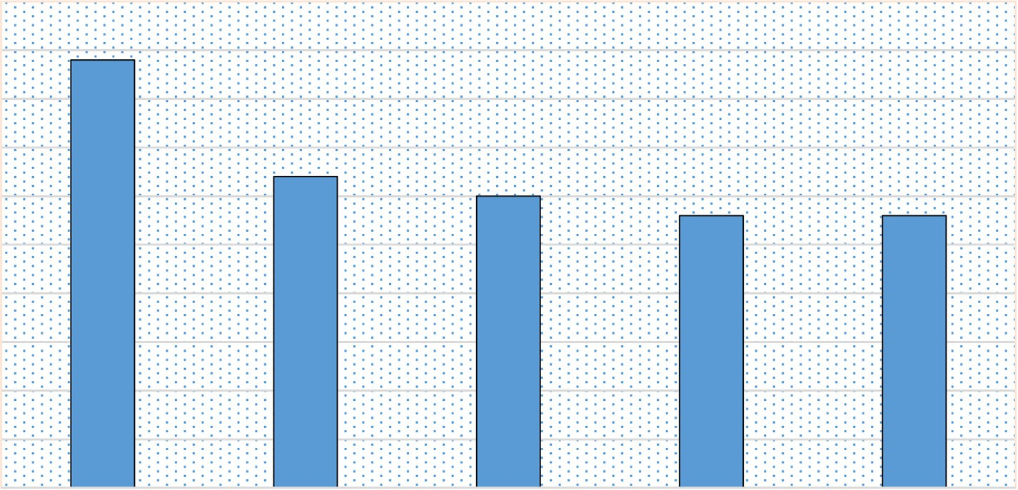50

45

Percentage of Respondents

40

35

30

25

20

15

10

5

0

## Security IT/OT Integration Unclear ROI Technical

Expertise

Interoperability

# Challenges Identified

Fig. 10. Top 5 barriers in the adoption of IoT/analytics solutions (Bosche et al., 2018).

are high chances for a security breach. The communication delay is an- other major area that needs to be focused on. Since IoT solutions are targeted to work in real-time, the messages and information passed to the end user should reach them on time. Any delayed information will be of no use as the user has to act on it spontaneously.

IoT and AI systems are continuing to grow and they enhance the op- portunities for increased value creation and capture. Despite all the challenges, they are expected to contribute in future to make agriculture automated and smart. There are opportunities for these technologies in transforming the agriculture activities. The evolution of 5G technology will be pivotal in enhancing the opportunity of the Internet of things in the upcoming years. 5G is having a hundred times better capacity than 4G networks and this can incredibly contribute to increased inter- net speed. Since the communication delay is a constraint of current IoT systems, this will be solved by the evolution of 5G, wherein the response can be obtained faster than the blink of an eye. The sensors and embed- ded technologies will continue to be cheaper and widely available in the future and will make IoT very promising in the future. The growth of Ar- tificial intelligence and advanced algorithms fuel up the decision mak- ing of smarter applications.

1. Conclusions

In this work, a comprehensive review of digitization and automation in agriculture using AI and IoT has been presented. When it comes to digitization and automation in agriculture, IoT and AI play a key role in every phase of farming activities during pre and post-harvest opera- tions. Adoption of these technologies from crop monitoring to autono- mous harvesting robots are slowly transforming agriculture and making the life of farmers easier and faster.

The following conclusions can be drawn from the study.

* Artificial Intelligence and Internet of Things are contributing signifi- cantly in the area of modern agriculture by controlling and automat- ing farming activities.
* Data generated by various sensors are of paramount importance and

require to be managed and analysed using machine learning and deep learning based approaches to foresee upcoming challenges in farming practices.

* The potential areas of application of digitization and automation in ag- riculture include the development of smart farm machinery, smart ir- rigation systems, weed and pest control, fertilizer application, greenhouse management, storage systems, etc.
* Classification and object detection using Convolutional Neural Net-

works (CNN) and their variants have made immense contributions in solving image recognition and automating agricultural activities.

* The challenge in the adoption of digitization lies in the security part. The local networks have to be secured against interference from other networks as the approach is fully data-driven.
* IoT and AI-enabled products are becoming cost-effective and robust,

their widespread adoption in the agricultural field is inevitable.

The most recent information and analysis of deep learning models presented in the paper can enrich the future of researchers, agriculture entrepreneurs and other stakeholders for selecting the best models and techniques for the implementation of a specific task.

Declaration of interests

The authors declare that they have no known competing financial interests or personal relationships that could have appeared to influ- ence the work reported in this paper.

References

Adam, G., Lorraine, J., 2019. [Understanding Neural Architecture Search Techniques.](http://refhub.elsevier.com/S2589-7217(21)00035-0/rf0005)

[ArXiv190400438 Cs Stat](http://refhub.elsevier.com/S2589-7217(21)00035-0/rf0005).

Ahmad, I., Siddiqi, M., Fatima, I., Lee, S., 2011. Weed classification based on Haar wavelet transform via k-Nearest Neighbor (*k*-NN) for real-time automatic sprayer control sys- tem. Proceedings of the 5th International Conference on Ubiquitous Information Management and Communication. 2011. ICUIMC. [https://doi.org/10.1145/1968613.](https://doi.org/10.1145/1968613.1968634) [1968634](https://doi.org/10.1145/1968613.1968634).

Akbarzadeh, S., Paap, A., Ahderom, S., Apopei, B., Alameh, K., 2018. Plant discrimination by support vector machine classifier based on spectral reflectance. Comput. Electron. Agric. 148, 250–258. <https://doi.org/10.1016/j.compag.2018.03.026>.

Akkaş, M.A., Sokullu, R., 2017. An IoT-based greenhouse monitoring system with Micaz motes. Procedia Comput. Sci., The 8th International Conference on Emerging Ubiqui- tous Systems and Pervasive Networks (EUSPN 2017) / The 7th International Confer- ence on Current and Future Trends of Information and Communication Technologies in Healthcare (ICTH-2017) / Affiliated Workshops. 113, pp. 603–608. [https://doi.org/](https://doi.org/10.1016/j.procs.2017.08.300) [10.1016/j.procs.2017.08.300](https://doi.org/10.1016/j.procs.2017.08.300).

Al-Ali, A.R., Al Nabulsi, A., Mukhopadhyay, S., Awal, M.S., Fernandes, S., Ailabouni, K., 2019. IoT-solar energy powered smart farm irrigation system. J. Electron. Sci. Technol. 17, 100017. <https://doi.org/10.1016/j.jnlest.2020.100017>.

Alam, Mansoor, Muhammad, Alam, Roman, M., Tufail, M., Khan, U., Khan, M., 2020. Real- Time Machine-Learning Based Crop/Weed Detection and Classification for Variable- Rate Spraying in Precision Agriculture. [https://doi.org/10.1109/ICEEE49618.2020.](https://doi.org/10.1109/ICEEE49618.2020.9102505) [9102505](https://doi.org/10.1109/ICEEE49618.2020.9102505).

Ashwinkumar, S., Rajagopal, S., Manimaran, V., Jegajothi, B., 2021. Automated plant leaf disease detection and classification using optimal MobileNet based convolutional neural networks. Mater. Today Proc. <https://doi.org/10.1016/j.matpr.2021.05.584>.

Astill, J., Dara, R.A., Fraser, E.D.G., Roberts, B., Sharif, S., 2020. Smart poultry management: smart sensors, big data, and the internet of things. Comput. Electron. Agric. 170, 105291. <https://doi.org/10.1016/j.compag.2020.105291>.

Atila, Ü., Uçar, M., Akyol, K., Uçar, E., 2021. Plant leaf disease classification using EfficientNet deep learning model. Ecol. Inform. 61, 101182. [https://doi.org/10.1016/](https://doi.org/10.1016/j.ecoinf.2020.101182) [j.ecoinf.2020.101182](https://doi.org/10.1016/j.ecoinf.2020.101182).

Bedi, P., Gole, P., 2021. Plant disease detection using hybrid model based on convolutional autoencoder and convolutional neural network. Artif. Intell. Agric. 5, 90–101. [https://](https://doi.org/10.1016/j.aiia.2021.05.002) [doi.org/10.1016/j.aiia.2021.05.002](https://doi.org/10.1016/j.aiia.2021.05.002).

Benaissa, S., Tuyttens, F.A.M., Plets, D., Trogh, J., Martens, L., Vandaele, L., Joseph, W., Sonck, B., 2020. Calving and estrus detection in dairy cattle using a combination of indoor lo- calization and accelerometer sensors. Comput. Electron. Agric. 168, 105153. [https://](https://doi.org/10.1016/j.compag.2019.105153) [doi.org/10.1016/j.compag.2019.105153](https://doi.org/10.1016/j.compag.2019.105153).

Bhandari, A.K, Kumar, A., Singh, G.K., 2012. Feature Extraction using Normalized Differ- ence Vegetation Index (NDVI): A Case Study of Jabalpur City. Procedia Technology 6, 612–621. <https://doi.org/10.1016/j.protcy.2012.10.074>.

Blok, M.P., Barth, R., den van Berg, W., 2016. [Machine vision for a selective broccoli har-](http://refhub.elsevier.com/S2589-7217(21)00035-0/rf0060) [vesting robot. IFAC-Pap. 66–71](http://refhub.elsevier.com/S2589-7217(21)00035-0/rf0060).

Bosche, A., Crawford, D., Jackson, D., Schallehn, M., Schorling, C., 2018. [Unlocking Oppor-](http://refhub.elsevier.com/S2589-7217(21)00035-0/rf0065) [tunities in the Internet of Things. Bain & Company](http://refhub.elsevier.com/S2589-7217(21)00035-0/rf0065).

Cai, J., Xiao, D., Lv, L., Ye, Y., 2019. An early warning model for vegetable pests based on multidimensional data. Comput. Electron. Agric. 156, 217–226. [https://doi.org/10.](https://doi.org/10.1016/j.compag.2018.11.019) [1016/j.compag.2018.11.019](https://doi.org/10.1016/j.compag.2018.11.019).

Cen, H., Lu, R., Zhu, Q., Mendoza, F., 2016. Nondestructive detection of chilling injury in cu- cumber fruit using hyperspectral imaging with feature selection and supervised clas- sification. Postharvest Biol. Technol. 111, 352–361. [https://doi.org/10.1016/j.](https://doi.org/10.1016/j.postharvbio.2015.09.027) [postharvbio.2015.09.027](https://doi.org/10.1016/j.postharvbio.2015.09.027).

Chollet, F., 2017. [Xception: Deep Learning with Depthwise Separable Convolutions.](http://refhub.elsevier.com/S2589-7217(21)00035-0/rf0080)

[ArXiv161002357 Cs](http://refhub.elsevier.com/S2589-7217(21)00035-0/rf0080).

Cireşan, D., Meier, U., Masci, J., Schmidhuber, J., 2012. Multi-column deep neural network for traffic sign classification. Neural Netw. 32, 333–338. [https://doi.org/10.1016/j.](https://doi.org/10.1016/j.neunet.2012.02.023) [neunet.2012.02.023](https://doi.org/10.1016/j.neunet.2012.02.023).

Civele, Ç., 2019. Development of an Iot based tractor tracking device to be used as a pre- cision agriculture tool for Turkey’s agricultural tractors. Sch. J. Agric. Vet. Sci. 6, 199–203. <https://doi.org/10.36347/SJAVS.2019.v06i09.001>.

Dankhara, F., Patel, K., Doshi, N., 2019. Analysis of robust weed detection techniques based on the internet of things (IoT). Procedia Comput. Sci., The 10th International Conference on Emerging Ubiquitous Systems and Pervasive Networks (EUSPN- 2019) / The 9th International Conference on Current and Future Trends of Informa- tion and Communication Technologies in Healthcare (ICTH-2019) / Affiliated Work- shops. 160, pp. 696–701. <https://doi.org/10.1016/j.procs.2019.11.025>.

De Castro, A., Torres-Sánchez, J., Peña-Barragán, J.M., Jiménez-Brenes, F., Csillik, O., López- Granados, F., 2018. An automatic random forest-OBIA algorithm for early weed map- ping between and within crop rows using UAV imagery. Remote Sens. 10. [https://doi.](https://doi.org/10.3390/rs10020285) [org/10.3390/rs10020285](https://doi.org/10.3390/rs10020285).

Deng, R., Jiang, Y., Tao, M., Huang, X., Bangura, K., Liu, C., Lin, J., Qi, L., 2020. Deep learning- based automatic detection of productive tillers in rice. Comput. Electron. Agric. 177, 105703. <https://doi.org/10.1016/j.compag.2020.105703>.

Dyrmann, M., Karstoft, H., Midtiby, H.S., 2016. Plant species classification using deep convolutional neural network. Biosyst. Eng. 151, 72–80. [https://doi.org/10.1016/j.](https://doi.org/10.1016/j.biosystemseng.2016.08.024) [biosystemseng.2016.08.024](https://doi.org/10.1016/j.biosystemseng.2016.08.024).

El Hoummaidi, L., Larabi, A., Alam, K., 2021. Using unmanned aerial systems and deep learning for agriculture mapping in Dubai. Heliyon 7, e08154. [https://doi.org/10.](https://doi.org/10.1016/j.heliyon.2021.e08154) [1016/j.heliyon.2021.e08154](https://doi.org/10.1016/j.heliyon.2021.e08154).

FAO, 2017. [The Future of Food and Agriculture: Trends and Challenges. FA](http://refhub.elsevier.com/S2589-7217(21)00035-0/rf0120)O.

Fuentes, A., Yoon, S., Park, J., Park, D.S., 2020. Deep learning-based hierarchical cattle be- havior recognition with spatio-temporal information. Comput. Electron. Agric. 177, 105627. <https://doi.org/10.1016/j.compag.2020.105627>.

Gašparović, M., Zrinjski, M., Barković, Đ., Radočaj, D., 2020. An automatic method for weed mapping in oat fields based on UAV imagery. Comput. Electron. Agric. 173, 105385. <https://doi.org/10.1016/j.compag.2020.105385>.

Grogan, J., Morris, D.A., Searcy, S.W., Stout, B.A., 1987. Microcomputer-based tractor per- formance monitoring and optimization system. J. Agric. Eng. Res. 38, 227–243. <https://doi.org/10.1016/0021-8634(87)90091-6>.

Gutierrez-Galan, D., Dominguez-Morales, J.P., Cerezuela-Escudero, E., Rios-Navarro, A., Tapiador-Morales, R., Rivas-Perez, M., Dominguez-Morales, M., Jimenez-Fernandez, A., Linares-Barranco, A., 2018. Embedded neural network for real-time animal behav- ior classification. Neurocomputing 272, 17–26. [https://doi.org/10.1016/j.neucom.](https://doi.org/10.1016/j.neucom.2017.03.090)

[2017.03.090](https://doi.org/10.1016/j.neucom.2017.03.090).

Haider, S.A., Naqvi, S.R., Akram, T., Umar, G.A., Shahzad, A., Sial, M.R., Khaliq, S., Kamran, M., 2019. [LSTM Neural Network Based Forecasting Model for Wheat Production in](http://refhub.elsevier.com/S2589-7217(21)00035-0/rf0145) [Pakistan (Agronomy)](http://refhub.elsevier.com/S2589-7217(21)00035-0/rf0145).

He, K., Zhang, X., Ren, S., Sun, J., 2015. [Deep Residual Learning for Image Recognition.](http://refhub.elsevier.com/S2589-7217(21)00035-0/rf0150)

[ArXiv151203385 Cs](http://refhub.elsevier.com/S2589-7217(21)00035-0/rf0150).

Hu, C., Thomasson, J.A., Bagavathiannan, M.V., 2021. A powerful image synthesis and semi-supervised learning pipeline for site-specific weed detection. Comput. Electron. Agric. 190, 106423. <https://doi.org/10.1016/j.compag.2021.106423>.

Huang, G., Liu, Z., van der Maaten, L., Weinberger, K.Q., 2018. [Densely Connected](http://refhub.elsevier.com/S2589-7217(21)00035-0/rf0160) [Convolutional Networks. ArXiv160806993 Cs](http://refhub.elsevier.com/S2589-7217(21)00035-0/rf0160).

Indolia, S., Goswami, A.K., Mishra, S., Asopa, P., 2018. Conceptual understanding of convolutional neural network- a deep learning approach. Procedia Comput. Sci. 132, 679–688. <https://doi.org/10.1016/j.procs.2018.05.069>.

Inoue, K., Kaizu, Y., Igarashi, S., Imou, K., 2019. The development of autonomous naviga- tion and obstacle avoidance for a robotic mower using machine vision technique. IFAC-Pap., 6th IFAC Conference on Sensing, Control and Automation Technologies for Agriculture AGRICONTROL 2019. 52, pp. 173–177. [https://doi.org/10.1016/j.](https://doi.org/10.1016/j.ifacol.2019.12.517) [ifacol.2019.12.517](https://doi.org/10.1016/j.ifacol.2019.12.517).

Islam, M., Dinh, A., Wahid, K., Bhowmik, P., 2017. Detection of Potato Diseases Using Image Segmentation and Multiclass Support Vector Machine. [https://doi.org/10.](https://doi.org/10.1109/CCECE.2017.7946594) [1109/CCECE.2017.7946594](https://doi.org/10.1109/CCECE.2017.7946594).

Jeong, J.H., Resop, J.P., Mueller, N.D., Fleisher, D.H., Yun, K., Butler, E.E., Timlin, D.J., Shim, K.-M., Gerber, J.S., Reddy, V.R., Kim, S.-H., 2016. Random forests for global and re- gional crop yield predictions. PLoS One 11. [https://doi.org/10.1371/journal.pone.](https://doi.org/10.1371/journal.pone.0156571) [0156571](https://doi.org/10.1371/journal.pone.0156571).

Jha, K., Doshi, A., Patel, P., Shah, M., 2019. A comprehensive review on automation in ag- riculture using artificial intelligence. Artif. Intell. Agric. 2, 1–12. [https://doi.org/10.](https://doi.org/10.1016/j.aiia.2019.05.004) [1016/j.aiia.2019.05.004](https://doi.org/10.1016/j.aiia.2019.05.004).

Jiang, B., He, J., Yang, S., Fu, H., Li, T., Song, H., He, D., 2019. Fusion of machine vision tech- nology and AlexNet-CNNs deep learning network for the detection of postharvest apple pesticide residues. Artif. Intell. Agric. 1, 1–8. [https://doi.org/10.1016/j.aiia.](https://doi.org/10.1016/j.aiia.2019.02.001) [2019.02.001](https://doi.org/10.1016/j.aiia.2019.02.001).

Jiang, M., Rao, Y., Zhang, J., Shen, Y., 2020. Automatic behavior recognition of group- housed goats using deep learning. Comput. Electron. Agric. 177, 105706. [https://doi.](https://doi.org/10.1016/j.compag.2020.105706) [org/10.1016/j.compag.2020.105706](https://doi.org/10.1016/j.compag.2020.105706).

Karar, M.E., Alsunaydi, F., Albusaymi, S., Alotaibi, S., 2021. A new mobile application of ag- ricultural pests recognition using deep learning in cloud computing system. Alex. Eng. J. 60, 4423–4432. <https://doi.org/10.1016/j.aej.2021.03.009>.

Karimi, Y., Prasher, S.O., Patel, R.M., Kim, S.H., 2006. Application of support vector machine technology for weed and nitrogen stress detection in corn. Comput. Electron. Agric. 51, 99–109. <https://doi.org/10.1016/j.compag.2005.12.001>.

Kasinathan, T., Singaraju, D., Uyyala, S.R., 2020. Insect classification and detection in field crops using modern machine learning techniques. Inf. Process. Agric. [https://doi.org/](https://doi.org/10.1016/j.inpa.2020.09.006) [10.1016/j.inpa.2020.09.006](https://doi.org/10.1016/j.inpa.2020.09.006).

Khaki, S., Wang, L., Archontoulis, S.V., 2020. A CNN-RNN framework for crop yield predic- tion. Front. Plant Sci. 10. <https://doi.org/10.3389/fpls.2019.01750>.

Krizhevsky, A., Sutskever, I., Hinton, G.E., 2012. [ImageNet classification with deep](http://refhub.elsevier.com/S2589-7217(21)00035-0/rf0220) [convolutional neural networks. In: Pereira, F., Burges, C.J.C., Bottou, L., Weinberger,](http://refhub.elsevier.com/S2589-7217(21)00035-0/rf0220)

[K.Q. (Eds.), Advances in Neural Information Processing Systems. 25. Curran Associ-](http://refhub.elsevier.com/S2589-7217(21)00035-0/rf0220) [ates, Inc, pp. 1097–1105](http://refhub.elsevier.com/S2589-7217(21)00035-0/rf0220).

Kumar, T.N.A., Lalswamy, B., Raghavendra, Y., Usharani, S.G., Usharani, S., 2018. [Intelligent](http://refhub.elsevier.com/S2589-7217(21)00035-0/rf0225) [food and grain storage management system for the warehouse and cold storage. Int.](http://refhub.elsevier.com/S2589-7217(21)00035-0/rf0225)

[J. Res. Eng. Sci. Manag.](http://refhub.elsevier.com/S2589-7217(21)00035-0/rf0225) 1.

Kurtulmuş, F., Unal, H., 2014. Discriminating rapeseed varieties using computer vision and machine learning. Expert Syst. Appl. 42. <https://doi.org/10.1016/j.eswa.2014.10.003>. Kurumatani, K., 2020. Time series forecasting of agricultural product prices based on re- current neural networks and its evaluation method. SN Appl. Sci. 2, 1434. [https://](https://doi.org/10.1007/s42452-020-03225-9)

[doi.org/10.1007/s42452-020-03225-9](https://doi.org/10.1007/s42452-020-03225-9).

Lavanya, G., Rani, C., Ganeshkumar, P., 2019. An automated low cost IoT based Fertilizer Intimation System for smart agriculture. Sustain. Comput. Inform. Syst. [https://doi.](https://doi.org/10.1016/j.suscom.2019.01.002) [org/10.1016/j.suscom.2019.01.002](https://doi.org/10.1016/j.suscom.2019.01.002).

Lee, S.H., Goëau, H., Bonnet, P., Joly, A., 2020. Attention-based recurrent neural network for plant disease classification. Front. Plant Sci. 11. [https://doi.org/10.3389/fpls.](https://doi.org/10.3389/fpls.2020.601250) [2020.601250](https://doi.org/10.3389/fpls.2020.601250).

Li, W., Wang, D., Li, M., Gao, Y., Wu, J., Yang, X., 2021. Field detection of tiny pests from sticky trap images using deep learning in agricultural greenhouse. Comput. Electron. Agric. 183, 106048. <https://doi.org/10.1016/j.compag.2021.106048>.

Liu, W., Anguelov, D., Erhan, D., Szegedy, C., Reed, S., Fu, C.-Y., Berg, A.C., 2016a. SSD: Sin- gle shot multibox detector. In: Leibe, B., Matas, J., Sebe, N., Welling, M. (Eds.), Com- puter Vision – ECCV 2016, Lecture Notes in Computer Science. Springer International Publishing, Cham, pp. 21–37 [https://doi.org/10.1007/978-3-319-](https://doi.org/10.1007/978-3-319-46448-0_2) [46448-0_2](https://doi.org/10.1007/978-3-319-46448-0_2).

Liu, D., Mishra, A.K., Yu, Z., 2016b. Evaluating uncertainties in multi-layer soil moisture es- timation with support vector machines and ensemble Kalman filtering. J. Hydrol. 538, 243–255. <https://doi.org/10.1016/j.jhydrol.2016.04.021>.

Loddo, A., Loddo, M., Di Ruberto, C., 2021. A novel deep learning based approach for seed image classification and retrieval. Comput. Electron. Agric. 187, 106269. [https://doi.](https://doi.org/10.1016/j.compag.2021.106269) [org/10.1016/j.compag.2021.106269](https://doi.org/10.1016/j.compag.2021.106269).

Malajner, M., Gleich, D., Planinsic, P., 2019. Soil type characterization for moisture estima- tion using machine learning and UWB-time of flight measurements. Measurement 146, 537–543. <https://doi.org/10.1016/j.measurement.2019.06.042>.

Matta, P., Pant, B., 2019. [Internet-of-things: genesis, challenges and applications. J. Eng.](http://refhub.elsevier.com/S2589-7217(21)00035-0/rf0275)

[Sci. Technol. 14, 1717–1750](http://refhub.elsevier.com/S2589-7217(21)00035-0/rf0275).

Mehta, C.R., Chandel, N.S., Rajwade, Yogesh, 2021. [Smart farm mechanization for sustain-](http://refhub.elsevier.com/S2589-7217(21)00035-0/rf0355) [able Indian agriculture. Agric. Mech. Asia Afr. Lat. Am. 50, 99–105](http://refhub.elsevier.com/S2589-7217(21)00035-0/rf0355).

Mehta, C.R., Chandel, N.S., Senthilkumar, T., 2014. [Status, challenges and strategies for](http://refhub.elsevier.com/S2589-7217(21)00035-0/rf0280) [farm mechanization in India. Agric. Mech. Asia Afr. Lat. Am. 45, 43–50](http://refhub.elsevier.com/S2589-7217(21)00035-0/rf0280).

Mehta, C.R., Chandel, N.S., Jena, P.C., Jha, A., 2019. [Indian agriculture counting on farm](http://refhub.elsevier.com/S2589-7217(21)00035-0/rf0285) [mechanization. Agric. Mech. Asia Afr. Lat. Am. 50, 84–89](http://refhub.elsevier.com/S2589-7217(21)00035-0/rf0285).

Mogili, U.R., Deepak, B.B.V.L., 2018. Review on application of drone systems in precision agriculture. Procedia Comput. Sci., International Conference on Robotics and Smart Manufacturing (RoSMa2018). 133, pp. 502–509. [https://doi.org/10.1016/j.procs.](https://doi.org/10.1016/j.procs.2018.07.063)

[2018.07.063](https://doi.org/10.1016/j.procs.2018.07.063).

Moon, T., Ahn, T.I., Son, J.E., 2019. Long short-term memory for a model-free estimation of macronutrient ion concentrations of root-zone in closed-loop soilless cultures. Plant Methods 15, 59. <https://doi.org/10.1186/s13007-019-0443-7>.

Mursalin, M., Mesbah-Ul-Awal, M., 2014. Towards classification of weeds through digital image. 2014 Fourth International Conference on Advanced Computing Communica- tion Technologies. Presented at the 2014 Fourth International Conference on Ad- vanced Computing Communication Technologies, pp. 1–4 [https://doi.org/10.1109/](https://doi.org/10.1109/ACCT.2014.101) [ACCT.2014.101](https://doi.org/10.1109/ACCT.2014.101).

Naik, H.S., Zhang, J., Lofquist, A., Assefa, T., Sarkar, S., Ackerman, D., Singh, A., Singh, A.K., Ganapathysubramanian, B., 2017. A real-time phenotyping framework using ma- chine learning for plant stress severity rating in soybean. Plant Methods 13, 23. <https://doi.org/10.1186/s13007-017-0173-7>.

Nawandar, N.K., Satpute, V.R., 2019. IoT based low cost and intelligent module for smart irrigation system. Comput. Electron. Agric. 162, 979–990. [https://doi.org/10.1016/j.](https://doi.org/10.1016/j.compag.2019.05.027) [compag.2019.05.027](https://doi.org/10.1016/j.compag.2019.05.027).

Nie, P., Zhang, J., Feng, X., Yu, C., He, Y., 2019. Classification of hybrid seeds using near- infrared hyperspectral imaging technology combined with deep learning. Sensors Ac- tuators B Chem. 296, 126630. <https://doi.org/10.1016/j.snb.2019.126630>.

Ok, A., Akar, Ö., Gungor, O., 2012. [Evaluation of random forest method for agricultural](http://refhub.elsevier.com/S2589-7217(21)00035-0/rf0320) [crop classification. Eur. J. Remote Sens. 45, 421–43](http://refhub.elsevier.com/S2589-7217(21)00035-0/rf0320)2.

Omrani, E., Mohtasebi, S., Band, S., Saboohi, H., Anuar, N., Md Nasir, M., Khoshnevisan, B., 2014. Potential of radial basis function-based support vector regression for apple dis- ease detection. Measurement 55. [https://doi.org/10.1016/j.measurement.2014.05.](https://doi.org/10.1016/j.measurement.2014.05.033) [033](https://doi.org/10.1016/j.measurement.2014.05.033).

Pan, S., Guan, H., Chen, Y., Yu, Y., Nunes Gonçalves, W., Marcato Junior, J., Li, J., 2020. Land- cover classification of multispectral LiDAR data using CNN with optimized hyper- parameters. ISPRS J. Photogramm. Remote Sens. 166, 241–254. [https://doi.org/10.](https://doi.org/10.1016/j.isprsjprs.2020.05.022) [1016/j.isprsjprs.2020.05.022](https://doi.org/10.1016/j.isprsjprs.2020.05.022).

Pereira, L.A.M., Nakamura, R.Y.M., de Souza, G.F.S., Martins, D., Papa, J.P., 2012. [Aquatic](http://refhub.elsevier.com/S2589-7217(21)00035-0/rf0335) [Weed Automatic Classification Using Machine Learning Techniques](http://refhub.elsevier.com/S2589-7217(21)00035-0/rf0335).

Phadikar, S., Sil, J., Das, A.K., 2013. Rice diseases classification using feature selection and rule generation techniques. Comput. Electron. Agric. 90, 76–85. [https://doi.org/10.](https://doi.org/10.1016/j.compag.2012.11.001) [1016/j.compag.2012.11.001](https://doi.org/10.1016/j.compag.2012.11.001).

Puerto, A., Pedraza, C., Jamaica-Tenjo, D.A., 2020. A deep learning approach for weed de- tection in lettuce crops using multispectral images. AgriEngineering 2. [https://doi.](https://doi.org/10.3390/agriengineering2030032) [org/10.3390/agriengineering2030032](https://doi.org/10.3390/agriengineering2030032).

Rahman, A., Smith, D.V., Little, B., Ingham, A.B., Greenwood, P.L., Bishop-Hurley, G.J., 2018. Cattle behaviour classification from collar, halter, and ear tag sensors. Inf. Process. Agric. 5, 124–133. <https://doi.org/10.1016/j.inpa.2017.10.001>.

Rangarajan Aravind, K., Maheswari, P., Raja, P., Szczepański, C., 2020. Chapter nine - Crop disease classification using deep learning approach: an overview and a case study. In: Das, H., Pradhan, C., Dey, N. (Eds.), Deep Learning for Data Analytics. Academic Press,

pp. 173–195 <https://doi.org/10.1016/B978-0-12-819764-6.00010-7>.

Redmon, J., Divvala, S., Girshick, R., Farhadi, A., 2016. You only look once: unified, real- time object detection. 2016 IEEE Conference on Computer Vision and Pattern Recog- nition (CVPR). Presented at the 2016 IEEE Conference on Computer Vision and Pat- tern Recognition (CVPR), pp. 779–788 <https://doi.org/10.1109/CVPR.2016.91>.

Reinecke, Marthinus, Prinsloo, Tania, 2017. The influence of drone monitoring on crop health and harvest size. 1st International Conference on Next Generation Computing Applications (NextComp), 5–10 <https://doi.org/10.1109/NEXTCOMP.2017.8016168>.

Ren, S., He, K., Girshick, R., Sun, J., 2016. [Faster R-CNN: Towards Real-Time Object Detec-](http://refhub.elsevier.com/S2589-7217(21)00035-0/rf0370) [tion with Region Proposal Networks. ArXiv150601497 Cs](http://refhub.elsevier.com/S2589-7217(21)00035-0/rf0370).

Ren, G., Lin, T., Ying, Y., Chowdhary, G., Ting, K.C., 2020. Agricultural robotics research ap- plicable to poultry production: a review. Comput. Electron. Agric. 169, 105216. <https://doi.org/10.1016/j.compag.2020.105216>.

Rußwurm, M., Körner, M., 2018. Multi-temporal land cover classification with sequential recurrent encoders. ISPRS Int. J. Geo-Inf. 7, 129. <https://doi.org/10.3390/ijgi7040129>. Rustia, D.J.A., Lin, C.E., Chung, J.-Y., Zhuang, Y.-J., Hsu, J.-C., Lin, T.-T., 2020. Application of an image and environmental sensor network for automated greenhouse insect pest monitoring. J. Asia Pac. Entomol. 23, 17–28. [https://doi.org/10.1016/j.aspen.2019.11.](https://doi.org/10.1016/j.aspen.2019.11.006)

[006](https://doi.org/10.1016/j.aspen.2019.11.006).

Selvaraj, A., Shebiah, N., Ananthi, S., Varthini, S., 2013. [Detection of unhealthy region of](http://refhub.elsevier.com/S2589-7217(21)00035-0/rf0390) [plant leaves and classification of plant leaf diseases using texture features. Agric.](http://refhub.elsevier.com/S2589-7217(21)00035-0/rf0390) [Eng. Int. CIGR J. 15, 211–21](http://refhub.elsevier.com/S2589-7217(21)00035-0/rf0390)7.

Shackelford, G.E., Haddaway, N.R., Usieta, H.O., Pypers, P., Petrovan, S.O., Sutherland, W.J., 2018. Cassava farming practices and their agricultural and environmental impacts: a systematic map protocol. Environ. Evid. 7, 30. [https://doi.org/10.1186/s13750-018-](https://doi.org/10.1186/s13750-018-0142-2) [0142-2](https://doi.org/10.1186/s13750-018-0142-2).

Shamshiri, R.R., Bojic, I., van Henten, E., Balasundram, S.K., Dworak, V., Sultan, M., Weltzien, C., 2020. Model-based evaluation of greenhouse microclimate using IoT- sensor data fusion for energy efficient crop production. J. Clean. Prod. 263, 121303. <https://doi.org/10.1016/j.jclepro.2020.121303>.

Simonyan, K., Zisserman, A., 2015. [Very Deep Convolutional Networks for Large-Scale](http://refhub.elsevier.com/S2589-7217(21)00035-0/rf0405) [Image Recognition. ArXiv14091556 Cs](http://refhub.elsevier.com/S2589-7217(21)00035-0/rf0405).

Singh, P., Verma, A., Alex, J.S.R., 2021. Disease and pest infection detection in coconut tree through deep learning techniques. Comput. Electron. Agric. 182, 105986. [https://doi.](https://doi.org/10.1016/j.compag.2021.105986) [org/10.1016/j.compag.2021.105986](https://doi.org/10.1016/j.compag.2021.105986).

Stegmayer, G., Milone, D.H., Garran, S., Burdyn, L., 2013. Automatic recognition of quaran- tine citrus diseases. Expert Syst. Appl. 40, 3512–3517. [https://doi.org/10.1016/j.eswa.](https://doi.org/10.1016/j.eswa.2012.12.059) [2012.12.059](https://doi.org/10.1016/j.eswa.2012.12.059).

Sun, Z., Di, L., Fang, H., 2019. Using long short-term memory recurrent neural network in land cover classification on Landsat and cropland data layer time series. Int. J. Remote Sens. 40, 593–614. <https://doi.org/10.1080/01431161.2018.1516313>.

Sylvester, G., 2018. [E-Agriculture in Action: Drones for Agriculture. FAO, Bangkok,](http://refhub.elsevier.com/S2589-7217(21)00035-0/rf0425) [Thailand](http://refhub.elsevier.com/S2589-7217(21)00035-0/rf0425).

Szegedy, C., Liu, W., Jia, Y., Sermanet, P., Reed, S., Anguelov, D., Erhan, D., Vanhoucke, V., Rabinovich, A., 2014. [Going Deeper with Convolutions. ArXiv14094842 Cs](http://refhub.elsevier.com/S2589-7217(21)00035-0/rf0430).

Szegedy, C., Ioffe, S., Vanhoucke, V., Alemi, A., 2016. [Inception-v4, Inception-ResNet and](http://refhub.elsevier.com/S2589-7217(21)00035-0/rf0435) [the Impact of Residual Connections on Learning. ArXiv160207261 Cs](http://refhub.elsevier.com/S2589-7217(21)00035-0/rf0435).

Tan, M., Le, Q.V., 2020. [EfficientNet: Rethinking Model Scaling for Convolutional Neural](http://refhub.elsevier.com/S2589-7217(21)00035-0/rf0440) [Networks. ArXiv190511946 Cs Stat](http://refhub.elsevier.com/S2589-7217(21)00035-0/rf0440).

Taneja, P., Vasava, H.K., Daggupati, P., Biswas, A., 2021. Multi-algorithm comparison to predict soil organic matter and soil moisture content from cell phone images. Geoderma 385, 114863. <https://doi.org/10.1016/j.geoderma.2020.114863>.

Tatsumi, K., Yamashiki, Y., Canales Torres, M.A., Taipe, C.L.R., 2015. Crop classification of upland fields using random forest of time-series Landsat 7 ETM+ data. Comput. Elec- tron. Agric. 115, 171–179. <https://doi.org/10.1016/j.compag.2015.05.001>.

Tervonen, J., 2018. Experiment of the quality control of vegetable storage based on the internet-of-things. Procedia Comput. Sci., The 9th International Conference on Ambi- ent Systems, Networks and Technologies (ANT 2018) / The 8th International Confer- ence on Sustainable Energy Information Technology (SEIT-2018) / Affiliated Workshops. 130, pp. 440–447. <https://doi.org/10.1016/j.procs.2018.04.065>.

Ullah, M.W., Mortuza, M.G., Kabir, M.H., Ahmed, Z.U., Supta, S.K.D., Das, P., Hossain, S.M.D., 2018. Internet of things based smart greenhouse: remote monitoring and automatic

control. DEStech Trans. Environ. Energy Earth Sci. 0. [https://doi.org/10.12783/dteees/](https://doi.org/10.12783/dteees/iceee2018/27803) [iceee2018/27803](https://doi.org/10.12783/dteees/iceee2018/27803).

van der Merwe, D., Burchfield, D.R., Witt, T.D., Price, K.P., Sharda, A., 2020. Chapter one - drones in agriculture. In: Sparks, D.L. (Ed.), Advances in Agronomy. Academic Press,

pp. 1–30 <https://doi.org/10.1016/bs.agron.2020.03.001>.

Villa-Henriksen, A., Edwards, G.T.C., Pesonen, L.A., Green, O., Sørensen, C.A.G., 2020. Inter- net of things in arable farming: implementation, applications, challenges and poten- tial. Biosyst. Eng. 191, 60–84. <https://doi.org/10.1016/j.biosystemseng.2019.12.013>.

Wang, A., Zhang, W., Wei, X., 2019. A review on weed detection using ground-based ma- chine vision and image processing techniques. Comput. Electron. Agric. 158, 226–240. <https://doi.org/10.1016/j.compag.2019.02.005>.

Williams, L.R., Moore, S.T., Bishop-Hurley, G.J., Swain, D.L., 2020. A sensor-based solution to monitor grazing cattle drinking behaviour and water intake. Comput. Electron. Agric. 168, 105–141. <https://doi.org/10.1016/j.compag.2019.105141>.

Yahya, A., Zohadie, M., Kheiralla, A.F., Giew, S.K., Boon, N.E., 2009. Mapping system for tractor-implement performance. Comput. Electron. Agric. 69, 2–11. [https://doi.org/](https://doi.org/10.1016/j.compag.2009.06.010) [10.1016/j.compag.2009.06.010](https://doi.org/10.1016/j.compag.2009.06.010).

Yang, L.B., 2020. Application of artificial intelligence in electrical automation control. Procedia Comput. Sci., Proceedings of the 3rd International Conference on Mechatronics and Intelligent Robotics (ICMIR-2019). 166, pp. 292–295. [https://doi.](https://doi.org/10.1016/j.procs.2020.02.097) [org/10.1016/j.procs.2020.02.097](https://doi.org/10.1016/j.procs.2020.02.097).

Yimyam, P., Clark, A.F., 2016. [3D Reconstruction and Feature Extraction for Agricultural](http://refhub.elsevier.com/S2589-7217(21)00035-0/rf0495) [Produce Grading. pp. 136–14](http://refhub.elsevier.com/S2589-7217(21)00035-0/rf0495)1.

Yu, J., Sharpe, S.M., Schumann, A.W., Boyd, N.S., 2019. Deep learning for image-based weed detection in turfgrass. Eur. J. Agron. 104, 78–84. [https://doi.org/10.1016/j.eja.](https://doi.org/10.1016/j.eja.2019.01.004) [2019.01.004](https://doi.org/10.1016/j.eja.2019.01.004).

Yule, I.J., Kohnen, G., Nowak, M., 1999. A tractor performance monitor with DGPS capabil- ity. Comput. Electron. Agric. 23, 155–174. [https://doi.org/10.1016/S0168-1699(99)](https://doi.org/10.1016/S0168-1699(99)00029-0) [00029-0](https://doi.org/10.1016/S0168-1699(99)00029-0).

Zhong, L., Hu, L., Zhou, H., 2019. Deep learning based multi-temporal crop classification.

Remote Sens. Environ. 221, 430–443. <https://doi.org/10.1016/j.rse.2018.11.032>.

Zuidhof, M.J., Fedorak, M.V., Ouellette, C.A., Wenger, I.I., 2017. Precision feeding: innova- tive management of broiler breeder feed intake and flock uniformity. Poult. Sci. 96, 2254–2263. <https://doi.org/10.3382/ps/pex013>.