Available online at [www.sciencedirect.com](http://www.sciencedirect.com/)



**ScienceDirect**

AASRI Procedia 8 (2014) 44 – 49

2014 AASRI Conference on Sports Engineering and Computer Science (SECS 2014)

Communication Model for Sports Media Web Portals

Artur Afonso Sousaa *, Pedro Aganteb, Luís Borges Gouveiac

*aPolytechnic Institute of Viseu, Campus Politecnico,Viseu, 3504-510, Portugal bLibertrium, Quinta de Santa Comba, Lote 13, Viseu, 3500-728, Portugal cUniversity Fernando Pessoa, Pr. 9 de Abril - 349, Porto, 4249-004, Portugal*

**Abstract**

This paper presents a proposal of digital mediation for enhancing the communication between sports media and its user community. The proposal is based on a conceptual model and a proof of concept in the form of a Web application. It is believed that the proposed application can contribute to enrich sports media Web portals with innovative features and to strengthen the relationship with their user community, exploiting the potential contributions of its members. This project also aims at fostering user participation and sharing of opinions in sports media Web portals.

© 2014 The Authors. Published by Elsevier B. V. This is an open access article under the CC BY-NC-ND license ([http://creativecommons.org/licenses/by-nc-nd/3.0/).](http://creativecommons.org/licenses/by-nc-nd/3.0/))

© 2014 . Published by Elsevier B.V.

Selection and/or peer review under responsibility of American Applied Science Research Institute

Peer-review under responsibility of Scientific Committee of American Applied Science Research Institute

*Keywords:* Digital mediation; Conceptual modelling; Liberopinion; Sports media

# Introduction

In recent times, uses of the Internet are becoming relatively more interactive and user-oriented. The Web

2.0 and more recently the rise of Social Media have not only created new playing fields for communication and self-expression but also new forms of social behavior. A key factor of both Web 2.0 and Social Media is participation.

* Corresponding author. Tel.: +351933204044.

*E-mail address:* [ajas@di.estv.ipv.pt.](mailto:ajas@di.estv.ipv.pt)

2212-6716 © 2014 The Authors. Published by Elsevier B. V. This is an open access article under the CC BY-NC-ND license ([http://creativecommons.org/licenses/by-nc-nd/3.0/).](http://creativecommons.org/licenses/by-nc-nd/3.0/))

Peer-review under responsibility of Scientific Committee of American Applied Science Research Institute doi:10.1016/j.aasri.2014.08.008

After observing users participation in sports media Web portals we realized that, in most cases, it is reduced to posting comments. Moreover, when we analyzed the type of communication between sports media and its user community, we verified that it is mostly concentrated in using unidirectional communication.

Thus, as a result of these findings, we believe that it would be useful and desirable to develop a technological solution that promotes structured and multidirectional communication between sports media and its user community, in a single, neutral and regulated place.

This paper is structured as follows: In section 2 it is proposed a communication model for sports media Web portals. Section 3 describes the proof of concept of the model – a Web application named *Liberopinion*. Section 4 contains the conclusions and some topics for future research and development.

# Communication model for sports media web portals

Conceptual modeling is the activity of formally describing some aspects of the physical and social world for understanding and communication purposes [1]. It is an abstract representation of reality, highlighting the most important aspects in a specific context or under a particular viewpoint.

The first construction phase of the proposed model focused on the identification of key stakeholders and their roles. Thus, as a result of the research on sports media Web portals and the feedback gathered from personalities with expertise in this field, we considered the following actors for a communication model for sports media Web portals: users (citizens), sports analysts, sportspersons, guests, and sports media representatives.

Users are understood as people that access sports media Web portals. Sports analysts encompass professionals specialized in sports, such as sports commenters and journalists. Sportspersons include amateur and professional athletes, coaches, and executives in sports institutions (e. g. presidents of sports clubs and associations). Guests are people invited by the platform editor to discuss (synchronously or asynchronously) about sports with the user community. Note that a guest is not necessarily an expert in sports. It can be, for instance, a celebrity. Sports media representatives are employees of the sports media company that incorporates the (*Liberopinion*) participation Web platform. They can be, for example, journalists, directors, among others. Fig.1 illustrates the proposed communication model for sports media Web portals.

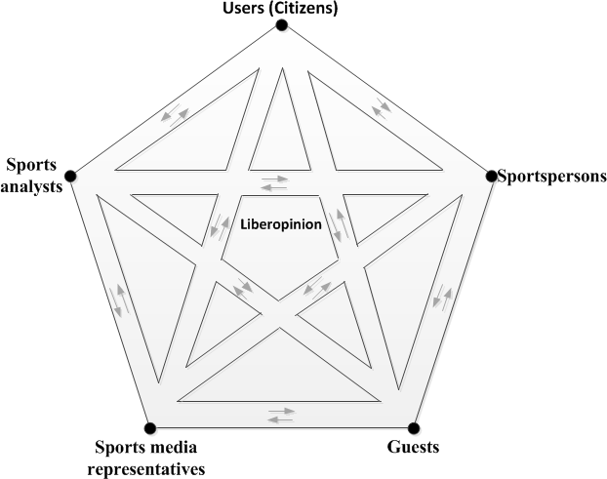

Fig.1. Communication Model for Sports Media Web Portals

The arrows stand for the open channels of multidirectional communication among key actors. In the model above, technology is not explicitly depicted, since it is considered that the digital dimension is implicitly part of the model. Note that a Web application was implemented based on the proposed model. Similarly, the editor is not explicitly represented, since, as well as technology, it is inherent to the model. It is a neutral element, whose main functions are to create, manage, boost and moderate the participation events, according to the terms of usage and to ensure the users management. This role can be played by a team or by a single person that belongs to the staff of the sports media company which incorporates the *Liberopinion* platform in its web portal. What matters is that the editor has absolute neutrality and behaves as an authentic information curator of the participation platform [2].

1. **Proof of concept – the *liberopinion* platform**

*Liberopinion* was designed and developed from scratch, based on the proposed model, to allow, through multiple participation events, a structured, mediated and multidirectional communication between sports media and its user community. *Liberopinion* can be easily integrated (embed) into any sports media website. Then it can be used as a participation area that is continuously available. Alternatively, *Liberopinion* can be used as a separate tool to create sporadic participation events that can then be easily incorporated into the sports media Web site. Note that this alternative way requires less editorial effort, since is not necessarily to boost participation initiatives 24 hours a day, 7 days a week. In [*http://desporto.liberopinion.com/index.php*](http://desporto.liberopinion.com/index.php)is available a demo version of the platform (in Portuguese). In Fig.2 a simplified UML (*Unified Modeling Language*) class diagram is presented showing the actors, their roles and the different kinds of participation events which can be carried out on the *Liberopinion* platform.

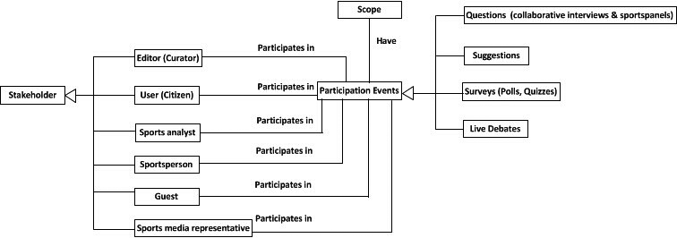

Scope

Questions (collaborative interviews & sports panels)

Participates in

Have

Editor (Curator)

Suggestions

Stakeholder

User (Citizen)

Participates in Participation Events

Surveys (Polls, Quizzes)

Participates in

Sports analyst

Live Debates

Participates in

Sportsperson

Participates in

Guest

Sports media representative Participates in

Fig.2. UML class diagram of the *Liberopinion* platform

Succinctly, the sports media user community (citizens), sports analysts, sportspersons, guests, and sports media representatives participate in events, which are created, managed, boosted and moderated by the editor (curator) of the platform. The participation events may consist of four different types, namely: (1) questions from the users and corresponding answers from the recipient (sports analyst, sportsperson, guest, or sports media representative); (2) suggestions and ideas from the user community; (3) surveys and (4) live debates.

We believe that online social networks will be increasingly important for communities and citizens. We considered from very important to provide *Liberopinion* platform with social networking features at an early

stage. Therefore, a registered user can follow other users registered on the platform, and see all the questions, suggestions and comments made by those users.

Seamless integration of the platform with existing social networks is also of paramount importance [3]. For this reason, and as a first step in that direction, it is possible for a user to publish questions and suggestions to Twitter and Facebook directly from the *Liberopinion* platform. Thus provide a more open interface to foster participation of enhanced opinion voice, as it augments the scope and potential impact of each individual’s participation*.*

In relation to user registration and access to the platform, by default, each user must be previously registered on the platform and have to login to take advantage of key capabilities such as submit questions, suggestions, comments and voting. If the user is not logged in, it is only possible to view the contents of the application. Nevertheless, it is possible to configure *Liberopinion* for different settings so as to enable interaction by non-registered users. For example, there is a setting in which non-registered users can vote but cannot introduce content and other that allows voting and content introduction. In the latter configuration, the only limitation to unregistered users is the lack of email notifications and additional features known from social networks such as following user and the access to a public profile.

By default, all the content submitted by users (citizens) is subject to moderation [4] according to the platform terms of use. When the user registers in the platform, the user must accept these terms of use. The actions of the sports analysts, guests, sportspersons and sports media representatives, on the other hand, are not moderated. However, the *Liberopinion* platform is configured to support different settings for moderation. For example, it is possible to publish directly all content, i.e., disable moderation, or moderate only entries denounced by the platform users. In order to encourage participation, citizens are permitted to request anonymity for all content submitted to the platform.

Currently, *Liberopinion* can be configured regarding the type of interaction of the sports analysts, guests, sportspersons and sports media representatives. *Liberopinion* is foreseen to be used in two scenarios: with or without direct interaction by these stakeholders. With interaction, these actors have an access account and are responsible for the introduction of content, allowing direct communication with other users. In the absence of interaction, the editor is responsible for communicate (outside *Liberopinion*) with sports analysts, guests, sportspersons and sports media representatives and for publishing, in the platform, the contents they provide. Then, *Liberopinion* users can analyse, compare and comment those contents.

In the following sections, the functional areas of the *Liberopinion* platform are described in more detail.

* 1. *Questions from the user community*

The main purpose of this area is to conduct online collaborative interviews and sports panels. If the context is an interview, in a first step, the editor of the platform challenges users to submit questions about a hot (sports) topic. Note that when creating a new event to collect questions, the editor defines whether the questions have an underlying theme, such as the national football premier league journey (fixture), or, on the contrary, have an open scope. The questions are then voted by the users on its relevance during a predetermined period of time, enabling this way to distinguish the best ones (that is, the most voted/rated) from the whole set of questions. In a second step, if *Liberopinion* is configured to be used without direct interaction of the interviewed person, the editor selects the (top) questions and send them to the interviewee (invited guest, sports analyst, sportsperson, or sports media representative). In a last step, the interviewee’s answers are inserted into the platform and published by the editor. Note that in a more interactive mode, interviewees have an access account to *Liberopinion* and this area allows them to directly answer questions from users.

If the context is a sports panel, the workflow is similar to the previous description. The main difference is

that there are several persons (invited guests, sports analysts, sportspersons or sports media representatives) to answer simultaneously the users’ best questions. One interesting feature is the possibility to compare side by side the answers of different interviewees to the same question. As previously mentioned, if *Liberopinion* is configured to be used with direct interaction of the interviewed persons, these actors have a dedicated interface in the application where they can write the reply and automatically publish it. In order to help the candidate draft a reasoned and thorough answer, it is possible to save the answer as a draft to be finished and published at a later stage.

In order to foster communication, all interactions between users and interviewees or sports panel members are associated with a specific comments area. The comments section associated with every question and answers allows easy and intuitive follow up of discussion threads by implementation of a “reply to comment” mechanism.

* 1. *Suggestions and ideas from the user community*

Whenever there is a wish to discuss and gather ideas and opinions about sports news and events, the editor of the platform can open a new participation initiative to collect suggestions from the community. The interaction model used in this area of the platform is similar to the questions area. Users are stimulated to provide their own ideas and encouraged to comment on and to vote on all the ideas submitted, enabling this way to highlight the best ones as seen by the overall community. One possible usage scenario is inviting users to expose what they would do if they were sports decision makers (e. g. coaches, presidents of sports clubs and associations, politicians, etc.) and highlight the best ideas. Then, in an interactive configuration mode, decision makers (in the role of guests) are also given the chance to provide, in this area, feedback on the proposals by leaving comments on a text area designed for this purpose. To foster constant feedback and to provide means to ascertain the community reaction to the comments, all these entries are also subject to rating by the citizens.

* 1. *Community surveys – polls*

Similarly to known e-consulting approaches, in this section, several questions are presented to the community members about sports news. Through a simple and intuitive interface users are invited to give their opinion through voting. In the setting where users are required to register to vote, each user can only vote once, but it is always possible change the vote. The main purpose of this section is to know the community opinion in relation to key topics of the sports actuality. Note that from the overall voting the statistics are gathered being therefore possible to ascertain the opinion of the community as a whole on the issues presented. One possible usage scenario is inviting users to vote the best football player of the team, match, week, month or year.

* 1. *Live debates*

In this area of *Liberopinion*, users can read archived discussions, gather information about scheduled debates, and if there is a live debate ongoing, they can access and participate in this debate. Note that, the discussions in this area are moderated and will not require that citizens log in to submit questions and comments. One of the innovative features of the *Liberopinion* consists of the use of the section dedicated to questions and suggestions for the creation of TOPs that can then be used during live debates. With the purpose of creating these TOPs, the community members are initially invited to submit questions and suggestions and vote on their relevance for a predetermined period of time. Then, along with the statistical

information collected in the section dedicated to community surveys, the TOP questions and suggestions may be used to feed the live debates.

* 1. *Personal area*

All registered users have a profile area where they can insert personal information, including contact details, links to their pages on social networks, blogs and their websites. Each user’s public profile also presents its recent activity (questions, suggestions and comments) in the *Liberopinion* platform, in addition to their social network (followers and users followed).

In this area, users can also set criteria for receiving notifications (e.g. when a sports analyst, sportsperson, guest, and sports media representative answers a question or publishes a comment to the user submitted suggestion, when another user replies to a submitted comment, when initiates an participation event about the user’s favorite sports, among others), and propose improvements to the *Liberopinion* platform.

# Conclusion

In this paper an approach for fostering user participation in sports media Web portals is proposed. It is intended to improve the communication between sports media and its user community, through open, multidirectional and regulated communication channels. We believe that tools as *Liberopinion* can also contribute from a pedagogic perspective because they allow the stimulus of a civic spirit, foster collaboration and sharing, and provide support to open and civilized dialog.

Considering future work in the *Liberopinion* platform, after a more detailed consultation of the stakeholders, the main needed functionalities are: optimize the platform to be used with mobile devices, and to check if there is a requirement for implementing a reputation mechanism based in the Gamification theories [5]. We believe that, as in [6], reputation mechanisms have potential to increase contribution quality and provide a user stimulus to participate and offer them some level of notoriety as a reward. As a topic for further research, it would be interesting to study the impact of live debates and of promotion and advertising of e- participation events in the number of user visits and participation actions.

# References

1. Larman, C. Applying UML and Patterns: An Introduction to Object-Oriented Analysis and Design and Iterative Development. Addison Wesley, 2004.
2. Rosembaum, S. Curation Nation: How to Win in a World Where Consumers are Creators. McGraw-Hill, 2011.
3. Taylor-Smith, E. and Lindner, R. Using Social Networking Tools to Promote eParticipation Initiatives. In: Alexander Prosser and Peter Parycek (eds.) Proceedings of EDEM 2009, pp. 115 -121. Vienna, 2009.
4. Wright, S. Government-run Online Discussion Fora: Moderation, Censorship and the Shadow of Control. British Journal of Politics and International Relations, Vol. 8 No.4, pp.550-568, 2006.
5. Pew Research Center. Gamification: Experts expect “game layers” to expand in the future, with positive and negative results. Pew Research Center’s Internet & American Life Project, 2012.
6. Velikanov, C. Requirements and Tools for an Efficient eParticipation. Proceedings of the 11th Annual International Conference on Digital Government Research. ACM. 32-40. Puebla, Mexico, 2010.