Available online at [www.sciencedirect.com](http://www.sciencedirect.com/)



AASRI Procedia 2 (2012) 31 – 38

AASRI

Procedia

[www.elsevier.com/locate/procedia](http://www.elsevier.com/locate/procedia)

2012 AASRI Conference on Power and Energy Systems

# Comparisons of Different Power Generation Processes by LNG Cold Energy

Lixi Zhang*a*,Qiong Tang*b*\*

*School of Engine and Energy, Northwestern Polytechnical University, Xi'an, Shaanxi, 710072, China*

Abstract

Power generation is one of the effective utilization ways of LNG cold energy. To use LNG cold energy to generate electricity, three kinds of generation processes are designed, which are the processes of single-stage direct expansion, single-stage recycling direct expansion and multi-stage recycling direct expansion. The generation rate of each process at the same initial and final states are calculated, they are separately 19.1%, 20.1% and 28.7%. The LNG cold energy of multi-stage recycling process is used more efficient, but the number of equipments and the cost of investment of it are also much more. The investment of equipments, the operation difficulties and the percentage of LNG cold energy utilization are needed to be taken into account in selecting of process program. Single-stage direct expansion process is more suitable to be used in small power generation stations; multi-stage recycling process is suitable to middle or large scales ones.

© 2012 Published by Elsevier B.V. Selection and/or peer review under responsibility of American Applied Science Research Institute

© 2012 Published by Elsevier B.V. Selection and/or peer review under responsibility of American Applied Science Research Institute

© 2012 Published by Elsevier B.V.

Selection and/or peer review under responsibility of American Applied Science Research Institute

Open access under [CC BY-NC-ND license.](http://creativecommons.org/licenses/by-nc-nd/3.0/)

*Key words: liquefied natural gas, cold energy, power generation*

1. Introductions

With the rapid development of national economy, China has become the second largest energy consuming country in the world. Importing liquefied natural gas (LNG) has become one of the effective methods for mitigating energy tension. The investigation of International Energy Agency shows that the international natural gas trade volume will reach 40% of the total output of natural gas in 2020, and an annual growth rate of 2%-3%. The consumption of LNG will be an annual increase of 10% in China, what's more, LNG imports will grow by more than 3 times, and the total import volume is expected to 9×1010m3 during the "Twelfth Five-Year Plan" period of China [1].

* Lixi Zhang. Tel.:+86-029-88492440; Fax: +86-029-88495911.

*E-mail address:* [zhanglixi@nwpu.edu.cn.](mailto:zhanglixi@nwpu.edu.cn)

2212-6716 © 2012 Published by Elsevier B.V. Selection and/or peer review under responsibility of American Applied Science Research Institute

Open access under [CC BY-NC-ND license.](http://creativecommons.org/licenses/by-nc-nd/3.0/) doi:10.1016/j.aasri.2012.09.010

LNG not only is a high-quality chemical raw materials and fuel, but also has the potential cold energy. At atmospheric pressure, pure methane gas is liquefied at - 162 ć. It consumes about 2930kJ / kg in the process of liquefaction, of which about 2093 kJ/kg dissipated as the form of heat, the remaining 837 kJ / kg called cold energy is stored in the LNG [2]. As the density of LNG is 450kg / m3, the volume of 9×1010m3 LNG, which is equivalent to the amount of importing LNG during the "Twelfth Five-Year Plan" period, contains of approximately 33.9×1015kJ cold energy. If energy can fully be used, it will produce considerable economic benefit and provide tremendous amounts of energy.

A lot of LNG cold energy utilization factories have been built in the world. Japan used LNG cold energy earlier than other countries and its technologies is more advanced [3]. In the gasification process, LNG releasing cold energy, it can be used for power generation, air liquefaction, food refrigeration, desalination of sea water, etc. [4,5]. Using LNG cold energy generation has the following characteristics: ķit makes LNG comprehensive energy utilization rate and economic benefits get promoted; ②the generating process doesn't use other fuels, and LNG doesn't contact with other combustion gas; Ĺthe work consumption of each normal LNG receiving station is about 40-50kW, the electricity generated by LNG cold energy can be used in by the receiving station itself; ĺgenerating capacity changes with natural gas consumption in the downstream of receiving station. In the view of above reasons, the power generation by LNG cold energy gets more attention now.

In China, the LNG receiving stations almost located in the southeastern areas of it, where the electric power resource is relatively nervous. So that using LNG cold energy to generate electricity and supply it to LNG receiving station is a reasonable method [6]. For the purpose of researching LNG cold energy generation, three different cold energy combined generation process are designed in this paper. In order to get better performance of power generation technology, the cold energy generation capacities of the different process are calculated and compared in the same conditions.

1. Power generation by LNG cold energy
   1. *Typical process of cold energy generation*

## Using cold energy of liquefied natural gas to power generation has a variety of processes. The representative process is: ķRankine cycle, it main uses LNG cold energy; ②Direct expansion cycle, by using gas pressure energy after LNG gasified; ĹGas expansion cycle, using LNG cooling compressor's imported gas, thereby reducing the compression energy consumption [7.8].

The process of Rankine cycle power generation is similar to the one of steam turbine cycle. It can use seawater or other waste heat as high-temperature heat source. If using seawater as heat source, for the annual average temperature of seawater is low, and its temperature varies with seasons, the key to improve the efficiency of the system is to improve the efficiency of the heat exchanger and choose the suitable working medium. If using hot steam, or hot water, or other industry residue heat as heat source, and increasing steam pressure into the turbine, the energy recovery capacity of the system can be improved.

By utilizing helium gas closed expansion cycle, and using LNG cold energy to cool the compressor inlet gas, it can enhance the efficiency of LNG cold energy generation unit, and reduce its energy consumption. According to the calculation, if the temperature of compressor suction gas is - 130ć, the temperature of turbine inlet gas is 720 ć, the average heat transfer temperature differences in the exchanger is 15 ć, the efficiency of heating furnace is 90%, then the entire unit efficiency is up to 53%.

* 1. *Cold energy generation calculations*

LNG is a low temperature liquid mixture, and it has both cold energy and pressure energy. Neither the Rankine cycle nor the natural gas direct expansion cycle can fully and effectively use this energy. Combing natural gas direct expansion with Rankine cycle can obtain more energy recovery [9]. In this paper, it designs three kinds of combination process to compare their utilization rate of cold energy generation.

In the condition of medium pressure supplied by the gas, the single stage simplex working medium Rankine cycle and single stage gas direct expansion are combined together, the procedure of the design as shown in Figure 1. In the process, Rankine cycle consist with evaporator (E-1), condenser (E-2B) and pump (J-1), which use mixed refrigerant (MFR) as the working fluid. LNG gasification through heat exchanger heating the high-pressure into the turbine expansion of power generation in J-2, and then heated by the heat exchanger (E-3B), supply to natural gas users. The system of heat exchanger in E-1, E-3A, E-3B are heated by seawater.

* + 1. Combination process II

Single stage Rankine cycle with a recycling of natural gas direct expansion combined, the process is shown in Figure 2. In the process, Rankine cycle consists of evaporator (E-1), condenser (E-2B) and pump (J- 1), which uses mixed refrigerant (MFR) as the circulating medium. Turbine J-2 is a direct expansion cycle expansion device, natural gas with a small amount of liquid from the turbine, a part of them condense into LNG through the heat exchanger J-2A, and is pressurized by the pump to re-enter the system cycle, another apart of the gas supply to the users after heating by E-3B.

* + 1. Combination process III

This process consists of a single-Rankine cycle and two-level direct expansion of natural gas contained one-step recycling, which is shown in Figure 3, in which Rankine cycle consist with evaporator(E-1), condenser(E-2B) and pump (J-1) , which use mixed refrigerant (MFR) as the working fluid. Gas turbine J-2, J-3 composed of two-level direct expansion cycle of natural gas. partially wet natural gas after the first stage expansion condense into liquid LNG through the heat exchanger E-2A, then pressurized by the pump into the systemic circulation, another part of natural gas arrive to supply pressure by second stage turbine J-3 expansion, the E-3C heater supplied to users.

* + 1. Process calculation and comparison
       1. *Determination of process parameters*

In the entrance of device, the LNG temperature is - 156 ć, the pressure is 15MPa, flow rate is 90t / h, the pressure of natural gas after gasification is 0.5MPa, molar composition of LNG: methane is 95%, ethane is 3%, propane is 2% [10].

Multi-component mixed refrigerant (MFR) is generally the mixture of methane, thane, propane and butane, which is prepared by the raw materials of liquefied natural gas and liquefied petroleum gas. In this design, through the control of the inlet and outlet temperature for the device of MFR, and the outlet temperature of LNG, MFR condenser side reaches the dew point feeding, bubble point discharge, as well as the cold terminal temperature difference of condenser, to determine the composition of MFR. Based on the above design principles, the MFR molar composition: ethane is 20%, propane is 70%, and n-butane is 10%.

According to the requirement for the pressure of the re-gasification natural gas, the pressure of each node can be calculated in accordance with the definite expansion ratio and pressure loss of pipeline and equipment.

Take the seawater average temperature as 25?. In order to protect the marine ecological balance, the seawater temperature range between inlet and outlet in the evaporator is not more than 4-5 ?, therefore, take the out seawater temperature from evaporator as 22?.

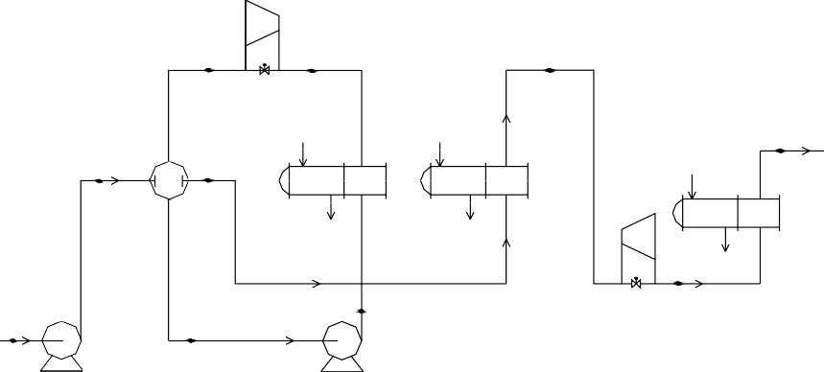

3

6

8

10

2

7

9

5

LNG 1

4



Fig1.Combination process I



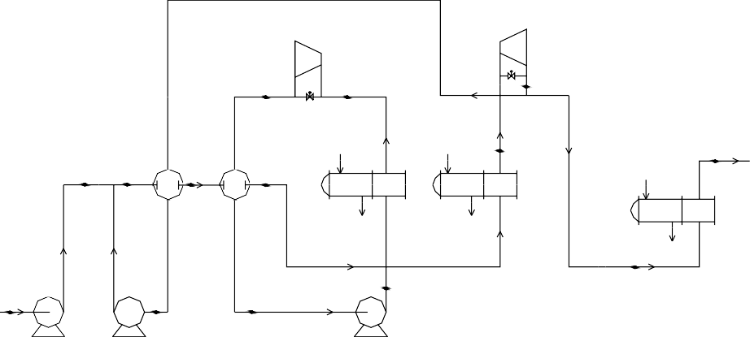

5

8

12

11

14

2

3

4

10

13

7

LNG 1

14

6

Fig.2 Combination process II

14 16



5

8

12 13

15

11

2

3

4

10

7

LNG 1

6

Fig.3 Combination process III

## The best expansion ratio for turbine is 3-4. For the combination processes I, II, III, take the turbine J-1 expansion ratio of 4, the turbine J-2, J-3 expansion ratio of 3.

* + - 1. *Energy balance and efficiency calculation equation*

According to the energy balance, it is established the energy balance equation and efficiency calculation equation for the process [11].

The power consumption for pump P1, P2, P3 is:

*WP*  *m*  *hout*  *hin* 

The output power for turbine J1, J2, J3 is:

*(1)*

*WJ*  *m*  *hin*  *hout* 

*(2)*

The net power generation efficiency for the cold energy is:

**  *WPj*  *WJj*

*m*  *q*

In above formula: *m*--LNG mass flow rate in the inlet of system, kg/s;

*(3)*

*hin* --specific enthalpy of

working medium into the system, kJ/kg; *hout* --specific enthalpy of working medium out the system, kJ/kg; *q*-

-cold energy of unit mass of LNG, kJ/kg.

* + - 1. *Process calculation results*

Calculated on the processes I, II, III respectively by calculating software, the calculation results of the main nodes are shown in table 1, 2, 3 separately.

Table 1.Calculation results for main node of process I

|  |  |  |  |  |  |
| --- | --- | --- | --- | --- | --- |
| Node | Gas fraction | Temperature/? | Pressure/kPa | Flow rate/t/h | Enthalpy/kJ/s |
| 1 | 0.00 | -155.9 | 150 | 90 | -7.03×103 |
| 2 | 0.00 | -155.1 | 1540 | 90 | -6.92×103 |
| 3 | 1.00 | -23.3 | 120 | 130 | 9.69×103 |
| 4 | 0.00 | -51.1 | 100 | 130 | -7.22×103 |

|  |  |  |  |  |  |
| --- | --- | --- | --- | --- | --- |
| 7 | 1.00 | -55.4 | 1520 | 90 | 1.00×104 |
| 10 | 1.00 | 20 | 500 | 90 | 5.06×104 |
| Table 2.Calculation results for main node of process II | | | | | |
| Node | Gas fraction | Temperature/? | Pressure/kPa | Flow rate/t/h | Enthalpy/kJ/s |
| 1 | 0.00 | -155.9 | 150 | 90 | -7.03×103 |
| 2 | 0.00 | -155.1 | 1560 | 90 | -6.92×103 |
| 4 | 0.00 | -130.0 | 1540 | 102 | -5.36×103 |
| 5 | 1.00 | -23.3 | 120 | 120 | 8.94×103 |
| 6 | 0.00 | -51.2 | 100 | 120 | -6.67×103 |
| 10 | 0.99 | -70.4 | 1520 | 120 | 1.03×104 |
| 12 | 1.00 | -37.7 | 505 | 102 | 1.30×104 |
| 13 | 1.00 | -37.7 | 505 | 90 | 1.14×104 |

Table 3.Calculation results for main node of process III

|  |  |  |  |  |  |
| --- | --- | --- | --- | --- | --- |
| Node | Gas fraction | Temperature/? | Pressure/kPa | Flow rate/t/h | Enthalpy/kJ/s |
| 1 | 0.00 | -155.9 | 150 | 90 | -7.03×103 |
| 2 | 0.00 | -153.4 | 4605 | 90 | -6.69×103 |
| 4 | 0.00 | -130.0 | 4585 | 101.5 | -5.31×103 |
| 5 | 1.00 | -23.3 | 120 | 110 | 8.19×103 |
| 6 | 0.00 | -51.1 | 100 | 110 | -6.61×103 |
| 10 | 1.00 | -55.5 | 4565 | 101.5 | 9.00×104 |
| 12 | 1.00 | -45.3 | 1520 | 101.5 | 1.19×104 |
| 15 | 1.00 | -33.9 | 505 | 90 | 1.16×104 |
| 16 | 1.00 | 20.0 | 500 | 90 | 1.46×104 |

* + - 1. *Comparison of the calculated results*

According to calculation results of three processes, the output power of turbine and the consumption power of pump, and the net generation capacity can be calculated. In the light of the parameters of LNG and gasified gas, it's concluded that 1kg LNG contains of 232.5W cold energy; according to the net generation capacity, it can calculate cold energy generation rate of LNG. The calculated results of each process are shown in Table 4.

Table 4. Comparison of three combination process

|  |  |  |  |
| --- | --- | --- | --- |
| Process | Process I | Process II | Process III |
| Flow rate/kg/h | 9.0×104 | 9.0×104v | 9.0×104 |
| Supply pressure/kPa | 0.5×103 | 0.5×103 | 0.5×103 |
| Turbine 1 | 1690 | 1560 | 1430 |
| Output power Turbine 2 | 2460 | 2770 | 2490 |
| /kW Turbine 3 | - | - | 2490 |
| Total | 4150 | 4330 | 6410 |
| Pump1 | 107 | 108 | 342 |
| Consumption Pump2 | 31 | 11.4 | 30.8 |
| power/kW Pump3 | - | 28.6 | 26.1 |
| Total | 138 | 148 | 399 |
| Net power generation/kW | 4110 | 4180 | 6110 |
| Generation rate | 19.1% | 20.1% | 28.7% |

In the different cold energy generation processes, LNG enters generation system in the same initial state, and it leaves the system also in the same gasified state, but their net generation capacities are different. For the process III, as it adopts a re-circulating direct expansion process that makes the cold energy and the pressure energy of LNG used in multi-level, so its net power generation is larger than that of process I 2.0×103kW, or relatively increased by about 50%. But at the same time, the expansion equipments, the heat transfer equipments and the difficulty of operation are all increased for the process III.

* + 1. Conclusions

In this paper, three power generation processes are designed, which contain single level direct expansion process, single stage re-circulating direct expansion process and multistage re-circulating direct expansion process. The net generating capacities are calculated and analyzed in the same initial and final states for every process. The following conclusions are derived from the analysis:

1. The net generation capacity rates of single stage direct expansion type and single stage recycle direct expansion process are 19.1% and20.1%, and multi-stage re-circulating direct expansion type is 28.7%, it is increased by about 50% than the single level direct expansion type. The LNG cold energy utilization rate is increased significantly by the use of the multistage utilization, but the equipment investment and the difficulty of the operation also increased.
2. When choosing the cold energy generation process ,they are must be taken into consideration, which is the equipment investment, difficulty of the operation and cold energy utilization rate .It could use the single level direct expansion process scheme which has less equipments than others for small cold energy generation device, and for the large cold energy generation apparatus, it can choose the multistage re-circulating direct expansion process scheme whose obtain net power is larger than others.

If the 90 billion m3 of the LNG (contains general cold energy of 33.9×1012MJ ) are all used to achieve the generation electricity according to the LNG cold energy rate is 28.7% during "the Twelfth Five-Year Plan", it would get 9.73×1012MJ power, which is equivalent to the power generations of 8.11×108tons of standard coal produced, or the capacity of the twenty large scale thermal power plants whose installed capacity is 3.0×106 kW.

References

1. The "Twelfth Five-Year Plan" of energy science and technology [z]. Liquefied natural gas online; 2011.12.
2. Chinese Petroleum Association. Liquefied natural gas technology manual [M]. Taiwan, the CPC corporation of Taiwan Sales Department; 1990.
3. S Hirakawa ,K Kosugi. Utilization of LNG cold energy [J]. International Journal of Refrigeration; 1981,4(1):7-21.
4. Yanchao Hou. The risk discussion of importing LNG pilot project in Guangdong [J]. Energy of China; 2000(2): 27-31.
5. Development status of liquefied natural gas industry in China [J].Department of Energy and Power Engineering; 2010 (4).
6. Ben Hua. The Progress Prospect of LNG Cold Energy Utilization in China [J] .Natural Gas Industry; 2005(5):103-105.
7. Qiang Wang. Prospect of LNG cold energy recovery and utilization in China [J]. Journal of Shandong Jianzhu University; 2008(4):361-365.
8. Jie Li. Preliminary study of generation technology by LNG cold energy [J]. Science and Technology Information; 2010(9):27-34.
9. Anzhong Gu. LNG cold energy utilization technology and economy analysis [J], HVAC Technology; 2007(4):1-10.
10. Anzhong Gu. LNG technology manual [M].Beijing, China Machine Press; 2010.

[11]T.Lu,K.S.W. Analysis and optimization of a cascading power cycle with LNG energy recovery [J].Applied Thermal Engineering; 2009,29:1478-1484.