[Artificial Intelligence in the Life Sciences 3 (2023) 100074](https://doi.org/10.1016/j.ailsci.2023.100074)

 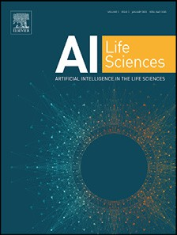

Contents lists available at [ScienceDirect](http://www.ScienceDirect.com/)

Artificial Intelligence in the Life Sciences

journal homepage: [www.elsevier.com/locate/ailsci](http://www.elsevier.com/locate/ailsci)

Corrigendum

Corrigendum to “Optimizing active learning for free energy Calculations” [Artificial Intelligence in the Life Sciences, 2 (2022) 100050]

James Thompsona, W Patrick Waltersb, Jianwen A Feng a, Nicolas A Pabonb, Hongcheng Xua,

Brian B Goldman b, Demetri Moustakasb, Molly Schmidtb, Forrest York b

a *Google Research, Mountain View, CA, United States*

b *Computation, Relay Therapeutics, Cambridge, MA, United States*

The authors regret that one of the authors, Michael Maser, was inadvertently omitted from the author list.

The authors’ list for this paper should read James Thompsona, W Patrick Waltersb, Jianwen A Fenga, Nicolas A Pabonb, Hongcheng Xua, Michael Masera, Brian B Goldmanb, Demetri Moustakasb, Molly Schmidtb, Forrest Yorkb

a Google Research, Mountain View, CA, United States

b Computation, Relay Therapeutics, Cambridge, MA, United States The authors would like to apologise for any inconvenience caused. James Thompson

Google, Cambridge, MA, USA

DOI of original article: [10.1016/j.ailsci.2022.100050](https://doi.org/10.1016/j.ailsci.2022.100050)

*E-mail address:* [thompj@google.com](mailto:thompj@google.com) (J. Thompson). <https://doi.org/10.1016/j.ailsci.2023.100074>

Available online 6 May 2023

2667-3185/© 2023 The Authors. Published by Elsevier B.V. All rights reserved.