Available online at [www.sciencedirect.com](http://www.sciencedirect.com/)

**ScienceDirect**

AASRI Procedia 4 (2013) 64 – 71

2013 AASRI Conference on Intelligent Systems and Control

Cultural Heritage Sites Visualization System Based on Outdoor Augmented Reality

Jong-Gil Hana, Kyoung-Wook Parkb, Kyeong-Jin Bana, Eung-Kon Kima*

*aDepartment of Computer Engineering, Sunchon National University, Korea*

*bDivision of Culture Contents, Chonnam National University, Korea*

**Abstract**

Recently, as importance of history is being emerged, IT-grafted cultural contents industry has been extensively grown. In particular, a study on development of cultural heritage sites, architectural cultural property and digital contents for historical remains restoration by using augmented reality technology has been performed. However, most of the existing restoration system of digital contents is being mainly performed indoors in reality. In this paper, 3D model visualization system of cultural heritage sites by using outdoor augmented reality, not indoor augmented reality, is intended to be presented. Presented visualized system augments 3D model of cultural heritage sites in video image inputted from outdoor by using object panorama, SURF and GPS. And the users may be provided with information for cultural heritage sites without difficulty through this visualized system.

© 2013 The Authors. Published by Elsevier B.V. Open access under [CC BY-NC-ND license.](http://creativecommons.org/licenses/by-nc-nd/3.0/)

© 2013. Published by Elsevier B.V.

Selection and/or peer review under responsibility of American Applied Science Research Institute

Selection and/or peer review under responsibility of American Applied Science Research Institute

*Keywords:* Augmented Reality, Cultural Heritage Sites, SURF, Object Panorama

* Corresponding author. Tel.: +82-10-7250-3627; fax: +82-10-755-7999.

*E-mail address:* [kek@sunchon.ac.kr.](mailto:kek@sunchon.ac.kr)

2212-6716 © 2013 The Authors. Published by Elsevier B.V. Open access under [CC BY-NC-ND license.](http://creativecommons.org/licenses/by-nc-nd/3.0/) Selection and/or peer review under responsibility of American Applied Science Research Institute doi:10.1016/j.aasri.2013.10.011

# Introduction

Recently, as importance of history is being emerged at home and abroad, cultural contents industry has been developed. IT-grafted restoration contents field among those industries is drawing attention from the relevant industry. As smart phone was emerged, a lot of applications have been developed. In particular, as application based on augmented reality technology has been developed, such application is being utilized in architectural cultural property, cultural heritage sites and restoration contents of historical remains of cultural contents industry. Only traces of most of cultural heritage sites, architectural cultural property and historical remains are left or negligent management for such heritages continues. In order to ensure efficient management of cultural heritage sites being left in traces only or managed negligently, contents restoration by using augmented reality would be effective. But as most of existing contents restoration is being taken place indoors, such efforts faces with locational limitation.

In this paper, 3D model visualization system of cultural heritage sites by using outdoor augmented reality, not indoor augmented reality, is intended to be presented. Presented visualized system augments 3D model of cultural heritage sites in video image inputted from outdoor by using object panorama, SURF algorithm [1] and GPS. The objective of this study is to have students, teachers and general public watch cultural heritage sites with immersion and realistic sense through 3D model visualization system of cultural heritage sites.

# Relevant Research

Augmented reality (AR) is a field of virtual reality (VR) in which actual world visually watched by the users and virtual world having additional information are shown as one image through its combination. AR is a term derived from virtual environment and reality and this technology is to make the users enhance understanding for the real world and a realistic sense by providing an image in which image of actual world being watched by the users and virtual image generated by computer are synthesized in real time by mixing real time image with virtual image after inserting computer graphic image in actual environment [2].

Outdoor augmented reality is a technology of implementing augmented reality by using outdoor (not indoor) GPS, compass, gyroscope sensor based on augmented reality technology. Contrary to indoor augmented reality, outdoor augmented reality is not subject to spatial limitation. While indoor augmented reality uses a marker for ensuring convenient synthesis of virtual object as it is taken place in relative narrow space, outdoor augmented reality uses location information as well, not a marker being used in indoor system as it is taken place in relatively wide area [3-4].

# Design of 3D Model Visualization System of Cultural Sites

In this study, 3D visualization system configuration of cultural sites based on outdoor augmented reality is as shown on Fig. 1.

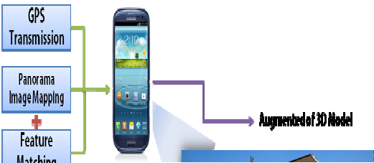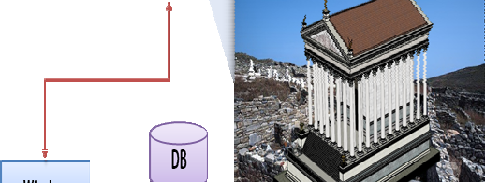

Augmented of 3D Model

Feature Matching

Panorama Image Mapping

GPS Transmission

Wireless

Fig. 1. Cultural sites 3D visualization system configuration

In order to implement 3D model visualization system of cultural sites based on outdoor augmented reality, 3D model of cultural sites to be shown in actual world is required. In order to create actual 3D model, stone tomb and dolmen were targeted.

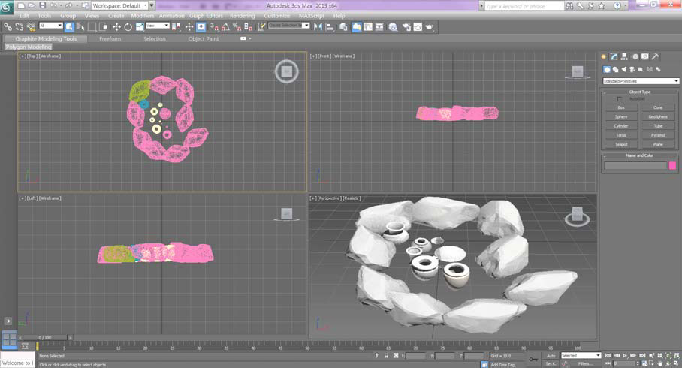

Fig. 2. Creation of Stone tomb 3D models

3D stone tomb was created by utilizing 3ds Max, a program of creating 3D model, as shown on Fig. 2. As utilization to other contents form is not easy when data of 3D model is enlarged, this model was created by minimum capacity by using triangular polygon.

As 3D model visualization system of cultural sites augments 3D model based on cultural sites, video generation based on object panorama, not on existing background panorama, is required. Object panorama is to show object-based panoramic video in order to provide realistic video information for a specific object to the users in a virtual space. Contrary to background panorama, in case of panorama space model for observing

object in object panorama, spatial form should be modeled considering not only shooting angle ((a) of Fig. 3) but also camera moving location ((b) of Fig. 3)

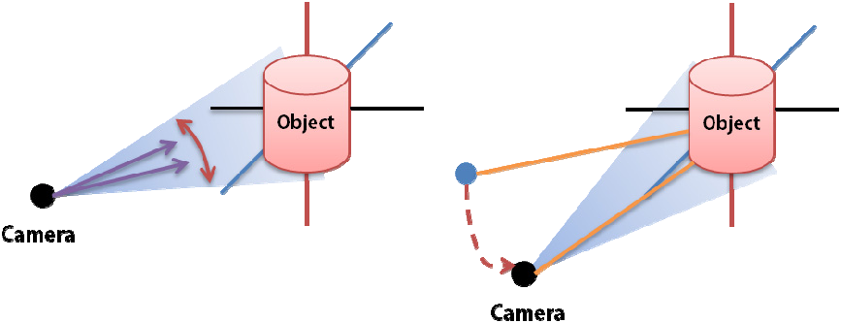

Object

Object

Camera

Camera

(a) (b)

Fig. 3. Object panorama creation process

By using object panorama of cultural sites, it is created depending on each angle as shown on Fig. 5.

Created video could be matched with inputted camera image at diversified angles with ease.

In order to match image inputted from smart phone with object panorama image, exact feature point matching is required by using feature point algorithm. Typical feature point algorithm includes SIFT (Scale Invariant Feature Transform) [5] and SURF (Speeded up Robust Features) [6]. And these two algorithms have something in common in that feature point invariant to scale and rotation transform is searched from black and white image and its descriptor is configurated. Time of extracting feature point by SURF is faster than that of SIFT by app. 4 times and so, in mobile devices such as smart phone or tablet PC of which processing speed is restricted, feature point is matched by application of SURF algorithm rather than SIFT.

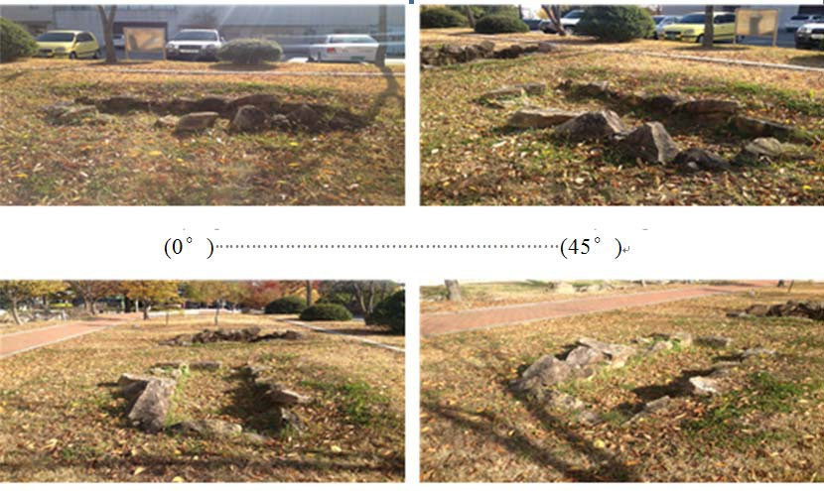

(90 )

(135 )

(0 ) (45 )

(270 ) (315 )

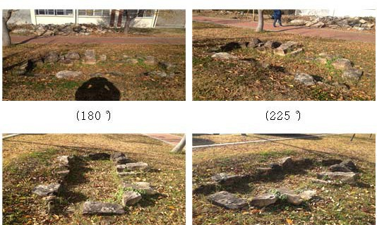

(180 ) (225 )

Fig. 4. Cultural sites-object panorama

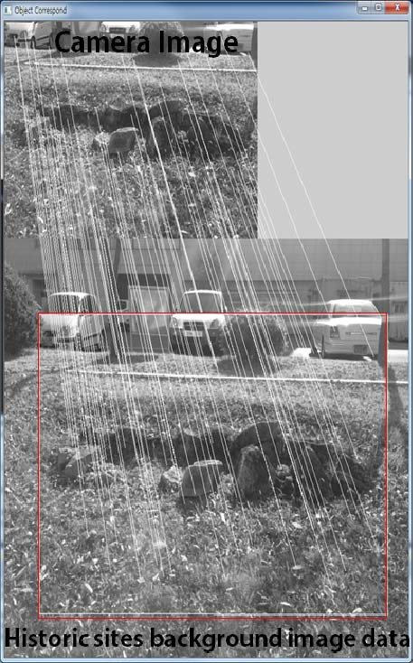

Fig. 5. Object panorama creation process

As shown on Fig. 5, feature point is matched with background image of cultural sites and camera image by using SURF algorithm.

# Design of 3D Model Visualization System of Cultural Sites

Proposed 3D model visualization system of cultural sites is as shown on Fig. 6.

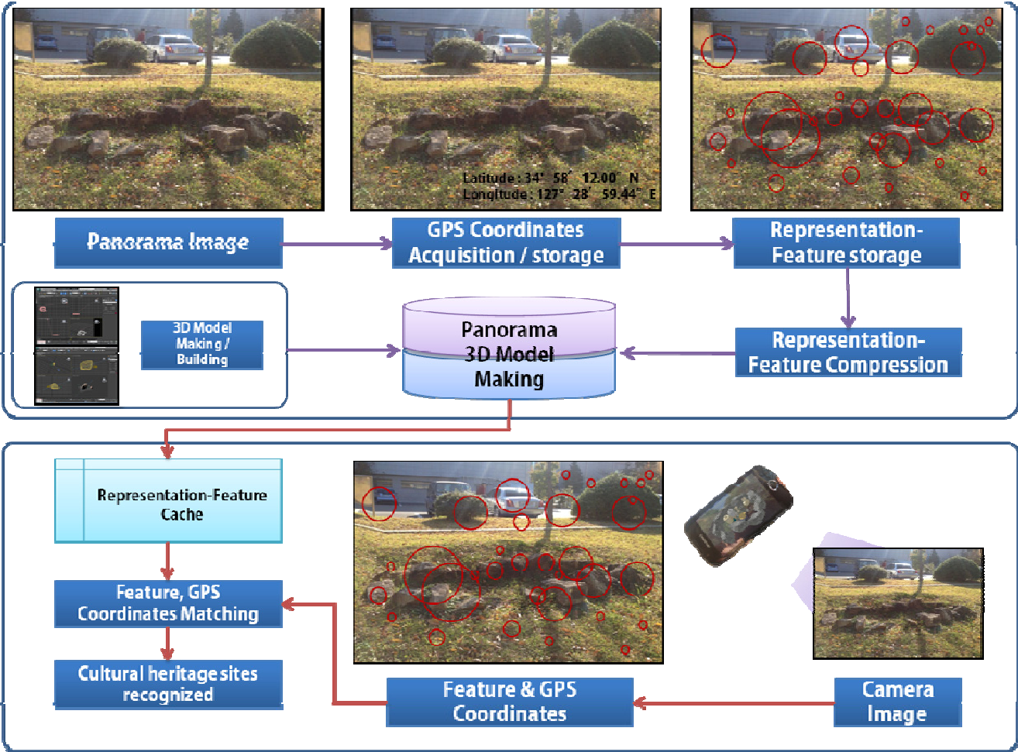

Camera Image

Feature & GPS Coordinates

Cultural heritage sites recognized

Feature, GPS Coordinates Matching

Representation- Feature Compression

3D Model Making/ Building

Representation- Feature storage

GPS Coordinates Acquisition/storage

Panorama Image

Fig. 6. Cultural sites 3D visualization system process

Fig. 6. shows 3D model visualization process of cultural sites through feature point matching of image of cultural sites inputted from smart phone camera and stored object panorama image.

Android 2.3.4 developed by Google through use of minimum system implementation environment was used. Library used for cultural sites 3D model visualization system is as shown on below Table. 1.

Table. 1. Min3D Library

Library Function

Animation 3D Model Motion Setting Core Color, Edge, Object, Texture Interfaces Object, Interface

Vos Camera, Light, Render, Type Parser 3D Extension Load, Object Angle

For Min3D library, Parser library that may load 3D object, object movement and core library that enables texture mapping were used together with camera review and rendering of 3D object.

Through above visualization system process as shown on Fig. 10, 3D model visualization system of cultural sites based on outdoor augmented reality was implemented. As shown on Fig. 10, 3D model was augmented in cultural sites by using smart phone camera. In diversified angles of camera, free augmentation of 3D model is allowed.

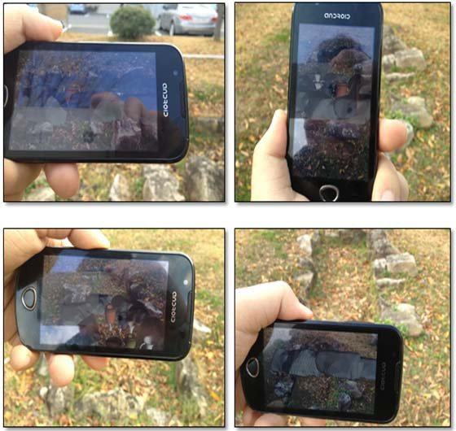

Fig. 7. Implementation of Cultural Sites visualization system

# Conclusion

In this paper, 3D model visualization system based on augmented reality in which overall 3D cultural sites model image is visualized in smart phone by using video image of actual cultural sites was proposed.. Existing method was to show restored contents of cultural sites being progressed based on marker that is usable under indoor environment only to the users. However, as watching cultural sites was allowed in a limited space, it was hard for the users to use such method. If 3D model visualization system of cultural sites of this thesis should be utilized, the users may utilize information for cultural sites without difficulty at any outdoor place as well as indoor.

# Acknowledgements

This research was financially supported by the Ministry of Education, Science Technology (MEST) and National Research Foundation of Korea (NRF) through the Human Resource Training Project for Regional Innovation.

# References

1. H. Bay, E. Andreas, T.Tuytelaars and L.V. Gool, “Speeded-up robust Features”, Computer Vision and Image Understanding, 2008;346-359:110
2. Azuma, R. T.“A Survey of Augmented Reality”, Teloperators and Virtual Environment, 1997;355-385:6-4
3. Kamat, V. and EI-Tawil, S. “Evaluation of Augmented Reality for Rapid Assessment of Earthquake-Induced Building Damage”,

Computing in Civil Engineering, 2007;303-310: 21

1. S.Feiner, B.MacIntyre, T. Hollerer, and A.Webster, “A Touring Machine:Prototyping 3D Mobile Augmented Reality Systems for Exploring the Urban Environment”, Proc, of International Symposium on Wearble Com-puters 1997;74-81
2. D.G. Lowe, “Distinctive image Features From scale invariant keypoints”, preprint 2004;91-110:60-2
3. D.Lowe, “Object Recognition from Local Scale-Invariant Features”, International Conference on Computer Vision, 1999;1150- 1157;2