Available online at [www.sciencedirect.com](http://www.sciencedirect.com/)



**ScienceDirect**

AASRI Procedia 9 (2014) 51 – 56

2014 AASRI Conference on Circuit and Signal Processing (CSP 2014)

Design and Implementation of SORIGA-optimized Powers-of- two FIR Filter on FPGA

Abhijit Chandraa*, Sudipta Chattopadhyayb, Beetan Ghoshc

*aDepartment of Electronics & Telecommunication Engineering, Indian Institute of Engineering Science and Technology, Shibpur, India*

*bDepartment of Electronics & Telecommunication Engineering, Jadavpur University, Kolkata, India*

*cDepartment of Electronics & Communication Engineering, National Institute of Technology, Durgapur, India*

**Abstract**

With the introduction of sophisticated algorithms, the field of signal processing has experienced enormous diversification of late. In addition to this, design of hardware efficient digital systems has grown sufficient interest amongst the researchers in recent past. In this article, an attempt has been made to realize hardware friendly powers-of-two FIR filter by using an evolutionary computation, called Self-organizing Random Immigrants Genetic Algorithm (SORIGA). In connection to this, this work makes one comparative study amongst various multiplier-less FIR filters in terms of hardware complexity when implemented on an FPGA chip. Finally, supremacy of the proposed design has firmly been established by comparing its hardware cost with many of the state-of-the-art powers-of-two FIR filters.

© 2014 The Authors. Published by Elsevier B. V. This is an open access article under the CC BY-NC-ND license ([http://creativecommons.org/licenses/by-nc-nd/3.0/).](http://creativecommons.org/licenses/by-nc-nd/3.0/))

© 2014 Abhijit Chandra, Sudipta Chattopadhyay and Beetan Ghosh. Published by Elsevier B.V. Selection and/or peer review under responsibility of American Applied Science Research Institute

Peer-review under responsibility of Scientific Committee of American Applied Science Research Institute

*Keywords:* Finite impulse response (FIR) filter; Field Programmable Gate Array (FPGA), hardware cost, multiplier-less filter, Self- organizing Random Immigrants Genetic Algorithm (SORIGA).

* Corresponding author. Abhijit Chandra Tel.: +913326684561.

*E-mail address:* [abhijit922@yahoo.co.in](mailto:abhijit922@yahoo.co.in)

2212-6716 © 2014 The Authors. Published by Elsevier B. V. This is an open access article under the CC BY-NC-ND license ([http://creativecommons.org/licenses/by-nc-nd/3.0/).](http://creativecommons.org/licenses/by-nc-nd/3.0/))

Peer-review under responsibility of Scientific Committee of American Applied Science Research Institute doi:10.1016/j.aasri.2014.09.010

# Introduction

Implementation of a general purpose multiplier in an FIR or IIR structure by means of Very Large Scale Integration (VLSI) technique is becoming a very complicated and costlier task to be performed. This

problem may be solved by considering multiplication operation as repeated addition and hence substituting the filter coefficients as sequence of shifts and additions. These multiplier-less filters are less power hungry and require less hardware blocks for its implementation [1-2]. In connection to this, SPT representation of filter coefficients is very much popular where the effect of multiplier is substituted by means of adders and delay elements only [3-8].

Several algorithms have been proposed so far in the literature where each of which deals with the powers- of-two design of FIR filter. These include traditional techniques like mixed integer linear programming [9], polynomial time algorithm [10], discrete semi-infinite linear programming [11], branch & bound technique

[12] and so on. Recently, the domain of circuit and system design has been noticeably influenced by means of a variety of intelligent optimization techniques of current interest like Genetic Algorithm (GA) [13], Orthogonal Genetic Algorithm (OGA) [14], and Differential Evolution (DE) [15-16] and so on.

In this communication, we have employed Self-organizing Random Immigrants Genetic Algorithm (SORIGA) for the design of multiplier-less low-pass FIR filters. Designed filter has been implemented on real time hardware and the requirement of resulting hardware blocks like digital gates, latches, buffers and so on has been calculated using XILINX Design Suite 12.3 software.

# Design Strategy

* 1. *Theoretical background of multiplier-less FIR filter*

System function ܪሺݖሻ and the corresponding transfer function ܪሺ݁௝ఠሻ of any causal FIR filter of length

ܮ with impulse response ݄ሺ݇ሻ can simply be written in accordance with the following equations [1-2]:

ܪሺݖሻ ൌ σ௅ିଵ ݄ሺ݇ሻݖି௞ ܪሺ݁௝ఠሻ ൌ σ௅ିଵ ݄ሺ݇ሻ݁ି௝ఠ௞

௞ୀ଴

௞ୀ଴

*(1)*

*(2)*

Filters, in which multiplication operation is carried out by means of shifting and addition, will be characterized by its impulse response as outlined below [2]:

݄ሺ݇ሻ ൌ σοିଵ ܾ௠௞Ǥ ʹି௠

௠ୀ଴

݇׊ ൌ ͲǡͳǡʹǡǥǤǤǡܮ െ ͳ *(3)*

For binary representation scheme, ܾ௠௞ may assume a value from the set ९ ൌ ሼͲǡ ͳሽ and ǻ signifies the precision of an individual coefficient and formally known as word length of the filter coefficient. Response of such a filter due to an excitation ݔሺ݊ሻ is given by

*(4)* ݊׊ ሻ݇ െ ݊ሺݔ ሻǤ݇ሺ݄ σ௅ିଵ ൌ ሻ݊ሺݕ

௞ୀ଴

In order to compute the output of this filter at any instant ݊Ǣ at most ܮ multiplications and ሺܮ െ ͳሻ

additions are required. Substituting (3) into (4), we get

ݕሺ݊ሻ ൌ σ௅ିଵ σοିଵ ܾ௠௞Ǥ ʹି௠Ǥ ݔሺ݊ െ ݇ሻ

*(5)*

௞ୀ଴ ௠ୀ଴

The parameter ܾ௠௞ does not put any overheads as far as the computational or hardware complexity is concerned since, for every ݇ and ݉, it keeps the term ʹି௠Ǥ ݔሺ݊ െ ݇ሻ intact or make it zero depending upon its assignment over the binary space. The term ʹି௠, when multiplied with ݔሺ݊ െ ݇ሻ, causes the multiplier to get shifted right by ݉ bits. For an input word length of ܹ, allowable maximum word length of the product ʹି௠Ǥ ݔሺ݊ െ ݇ሻ thus becomes ሺܹ ൅ οሻ. As a matter of fact, resulting complexity from the architecture of full- adder is proportionately related to ሺܹ ൅ οሻ in accordance with equation (5).

* 1. *Design of powers-of-two FIR filter using SORIGA*

SORIGA [17-18] has been judiciously employed in this work for the synthesis of FIR tap coefficients which are encoded in the form of sum of signed powers-of-two. In connection to this, any arbitrary coefficient

݄ሺ݇ሻmay be represented by means of a binary row vector as shown below:

݄ሺ݇ሻ ൌ ൣܾ଴ǡ௞ ܾଵǡ௞ ܾଶǡ௞ ܾଷǡ௞ ܾସǡ௞ ǥǤǤ ܾሺοିଵሻǡ௞൧ ݇׊ ൌ ͲǡͳǡʹǡǥǤǤǡܮ െ ͳ *(6)*

In order to synthesize linear phase low-pass FIR filter, tap coefficients are chosen to be symmetric around its central coefficient. Proposed scheme has accumulated all such ܮہΤʹۂ different binary vectors into a single row vector of length ࣦ ൌ ܮہΤʹۂǤο which has been regarded as a single chromosome ࣜ in the process of evolutionary computation. Being a population-based algorithm, our design strategy generates Զ such chromosomes randomly of length ࣦ which form the pool of potential solution. Based upon the fitness of individual chromosome, subsequent genetic operations like selection, cross-over and mutation are carried out subsequently in accordance with the steps of SORIGA. This has been symbolically outlined as follows:

ࣜௌ ൌ ्ሼڂԶ

௜ୀଵ

ࣜ௜ሽ

*(7)*

ࣜ஼ ൌ ՁሼڂԶ಴ ࣜௌሽ

*(8)*

௜ୀଵ ௜

ࣜெ ൌ ैሼࣜ஼ሽ ݅׊ ൌ ͳǡʹǡ͵ǡ ǥǤǤǡ Զெ *(9)*

௜

Where, the operations of selection, cross-over and mutation are symbolized by ्ǡ Ձ ݀݊ܽ ै respectively. Parameter Զ஼ and Զெ identify the total number of chromosomes allowed to take part in the operation of cross-over and mutation respectively.

Selection of competent chromosomes from the pool of Զ such members is executed on the basis of their individual fitness which is considered to be the degree of proximity with the ideal response. Proposed algorithm calculates this fitness as an inverse of the maximum difference between the designed and ideal frequency response of the low-pass filter and makes an attempt to minimize this difference to a significant extent. In this connection, maximum difference over the entire frequency band of interest has been regarded as the cost function of the individual chromosome.

# Results and Analysis

This section demonstrates the outcome of the proposed algorithm analytically. Since the design incorporates evolutionary algorithm, convergence characteristics of our proposition has been depicted in Fig. 1 below which exhibits the variation of averaged cost function with the number of iterations for three different values of cross-over probability. Size of population has been considered as 100 in the entire analysis.

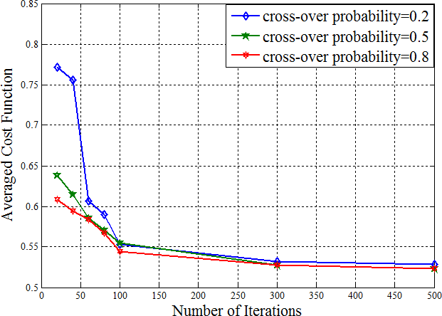

Fig. 1: Convergence characteristics of the proposed scheme

In order to establish the supremacy of the proposed design, frequency response of SORIGA-optimized multiplier-less low-pass FIR filter of order 35 has been compared with few such state-of-the-art filters in Fig. 2 below.

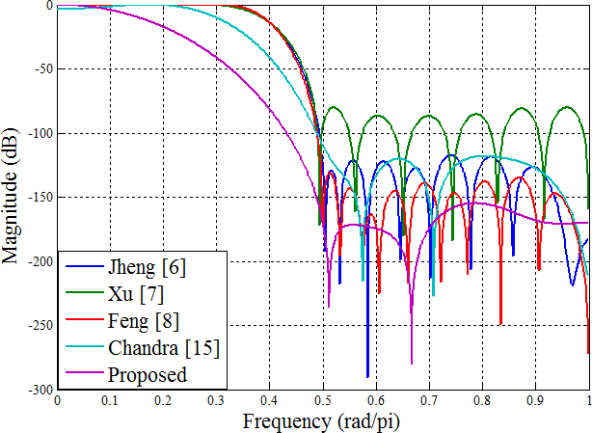

Fig. 2: Comparison in terms of frequency response amongst various multiplier-less low-pass FIR filters

It can be well apprehended from the above comparison that the proposed filter yields more attenuation in transition and stop-band region of frequency characteristics. As for example, at a frequency of 0.65 rad/pi, SORIGA-optimized filter produces an attenuation of about 193.9 dB while the filters designed in [6], [7], [8] and [15] yields approximately 151.6 dB, 180.3 dB, 157.1 dB and 120.6 dB attenuation respectively.

Subsequent part of this section elaborately describes the requirement of different hardware blocks used to realize the powers-of-two filter on an FPGA chip. Quite a few recent algorithms, nurturing the concept of multiplier-less FIR filter design, have also been considered into our analysis and the resulting hardware elements have been listed in Table 1 below. Since the filters designed by means of different algorithms are of

different length; required number of hardware blocks per unit length of the filter has also been included for fair comparison. Word length of input signal has been taken as 8 in the entire analysis.

Table 1 Comparison in terms of hardware elements amongst different multiplier-less FIR filters

|  |  |  |  |  |  |  |  |  |  |  |
| --- | --- | --- | --- | --- | --- | --- | --- | --- | --- | --- |
| Algorithms | Name of the hardware block | | | | | | | | | |
| 2-input OR 2-input AND 2-input XOR Flip flop I/O buffer | | | | | | | | | |
| Total | Per  unit length | Total | Per  unit length | Total | Per  unit length | Total | Per  unit length | Total | Per  unit length |
| Samueli [3] | 672 | 26.88 | 763 | 30.52 | 672 | 26.88 | 184 | 7.36 | 125 | 5 |
| Chen [4] | 1012 | 36.143 | 1134 | 40.5 | 1012 | 36.143 | 240 | 8.571 | 151 | 5.393 |
| Yao [5] | 1395 | 49.821 | 465 | 16.607 | 1355 | 48.393 | 216 | 7.714 | 145 | 5.179 |
| Jheng [6] | 1016 | 35.034 | 508 | 17.517 | 1016 | 35.034 | 232 | 8 | 153 | 5.276 |
| Xu [7] | 580 | 20.714 | 290 | 10.357 | 580 | 20.714 | 119 | 4.25 | 93 | 3.321 |
| Feng [8] | 871 | 25.618 | 1163 | 34.206 | 1356 | 39.882 | 285 | 8.382 | 138 | 4.059 |
| Chandra[15] | 530 | 18.276 | 531 | 18.31 | 352 | 12.138 | 65 | 2.241 | 128 | 4.414 |
| Proposed | 425 | 11.806 | 487 | 13.528 | 378 | 10.5 | 184 | 5.111 | 139 | 3.861 |

It can be unambiguously observed from Table 1 that the proposed architecture outperforms most of the state-of-the-art multiplier-less FIR filters by a large margin in terms of the hardware blocks. However, performance of the proposed SORIGA-optimized filter is slightly inferior to that of [7] in terms of 2-input AND, flip-flop and I/O buffer counts. Architecture of the proposed filter as obtained using XILINX Design Suite 12.3 has been depicted in Fig. 3 below.

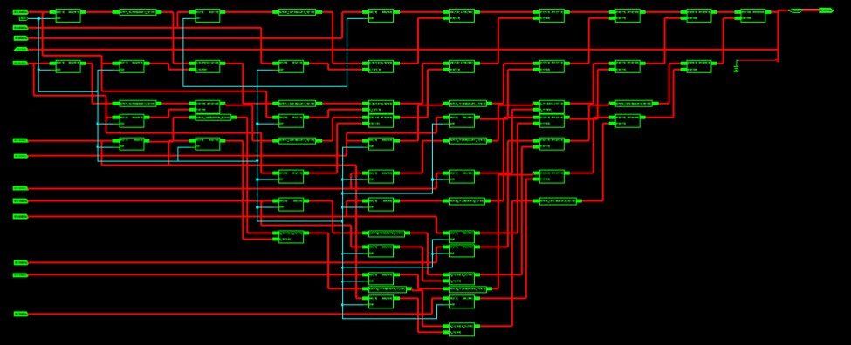

Fig. 3: RTL schematic of the proposed multiplier-less FIR filter realized on FPGA

# Conclusion

This article deals with design of a multiplier-less low-pass FIR filter has been carried out by means of a recently proposed evolutionary optimization algorithm, called Self-organizing Random Immigrants Genetic Algorithm (SORIGA). Effectiveness of the optimization technique has been evaluated in terms of its convergence speed. Moreover, the supremacy of the proposed design has been established in terms of frequency response of the filter. Furthermore, tap coefficients of the designed filter have been encoded as sums of powers-of-two and implemented on a real time hardware chip using XILINX Design Suite 12.3. It

has been observed that the proposed architecture is superior to other existing design methodologies as far as hardware complexity of the design is concerned. Performance of the solution may further be improved by proper modification of the fitness function of the optimization process as a future scope of this work.

# References

1. Mitra S. K. Digital Signal Processing: A Computer–based Approach, 2nd ed. McGraw Hill; 2001.
2. Proakis J. G. Digital Signal Processing: Principles, Algorithms and Applications, Prentice Hall; 1997.
3. Samueli H. An Improved Search Algorithm for the Design of Multiplier-less FIR Filters with Power-of Two Coefficients. IEEE Trans. on Circuits and Systems 1989:36:1044-1047.
4. Chen C. and Willson A. N. A Trellis Search Algorithm for the Design of FIR Filters with Signed-Powers- of-Two Coefficients. IEEE Trans. on Circuits and Systems-II: Analog and Digital Signal Processing 1999:46:1:29-39.
5. Yao, C. Y. A Study of SPT-Term Distribution of CSD Numbers and Its Application for Designing Fixed- point Linear Phase FIR Filters. Proc. 2001 IEEE International Symposium for Circuits and Systems 2001: 2:301-304.
6. Jheng, K., Jou, S., and Wu, A. A Design Flow for Multiplierless Linear-Phase FIR Filters: from System Specification to Verilog Code. Proc. 2004 IEEE International Symposium on Circuits and Systems, 2004: 5 293-296.
7. Xu, F., Chang, C. H., and Jong, C. C. Design of Low-Complexity FIR Filters Based on Signed-Powers-of- Two Coefficients with Reusable Common Subexpressions. IEEE Transactions on Computer Aided Design of Integrated Circuits and Systems 2007: 26: 10: 1898-1907.
8. Feng, Z. G., and Teo, K. L.: A Discrete Filled Function Method for the Design of FIR Filters with Signed- Powers-of-Two Coefficients. IEEE Transactions on Signal Processing 2008: 56:1:134-139.
9. Lim Y. C. and Parker S. R. FIR Filter Design over a Discrete Powers-of-Two Coefficient Space. IEEE Trans. on Acoustic, Speech, Signal Processing 1983:31:3:583-591.
10. Li D., Song J., and Lim Y. C. A Polynomial-Time Algorithm for Designing Digital Filters with Power- of-Two Coefficients, in Proc. 1993 IEEE International. Symposium for Circuits and Systems 1993:1:84-87.
11. Ito R. and Hirabayashi R. Design of FIR Filter with Discrete Coefficients Based on Semi-Infinite Linear Programming Method. Pacific Journal of Optimization 2007:3:1:73-86.
12. Yan T. Y. and Yao K.A Multiplication-free Solution for Linear Minimum Mean-square Estimation and Equalization using the Branch-and –bound Principle. IEEE Trans. on Information Theory 1980:26:316-326.
13. Gentili P., Piazza F., and Uncini A. Efficient Genetic Algorithm Design for Power-of-two FIR Filters, in proc. of IEEE International. Symposium on Circuits and Systems 1995:2:1268-1271.
14. Ahmad S. U. and Antoniou A. Cascade-form Multiplierless FIR Filter Design Using Orthogonal Genetic Algorithm, in Proc. 2006 IEEE International Symposium on Signal Processing and Information Technology 2006:932-937.
15. Chandra A. and Chattopadhyay S. A Novel Approach for Coefficient Quantization of Low-pass Finite Impulse Response Filter using Differential Evolution Algorithm. Signal Image and Video Processing 2012:1-

15. DOI: 10.1007/s11760-012-0359-4.

1. Karaboga N. and Cetinkaya B. Design of Digital FIR Filters using Differential Evolution Algorithm. Circuits Systems and Signal Processing 2006:25:5:649-660.
2. Tinos R. and Yang, S. Self-organizing Random Immigrants Genetic Algorithm for Dynamic Optimization Problems. Genetic Programming and Evolvable Machines, 2007:8:3:255-286.
3. Bak P. How Nature Works: The Science of Self-organized Criticality. Oxford University Press, 1997.