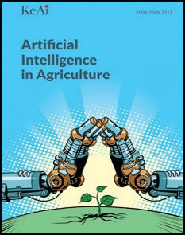[Artificial Intelligence in Agriculture 5 (2021) 175–184](https://doi.org/10.1016/j.aiia.2021.08.001)

Contents lists available at [ScienceDirect](http://www.sciencedirect.com/science/journal/)

Artificial Intelligence in Agriculture

journal homepage: [http://www.keaipublishing.com/en/journa ls/artificial- intelligence- in-agriculture/](http://www.keaipublishing.com/en/journals/artificial-intelligence-in-agriculture/)

[](http://crossmark.crossref.org/dialog/?doi=10.1016/j.aiia.2021.08.001&domain=pdf)Development of embedded automatic transplanting system in seedling transplanters for precision agriculture

Abhijit Khadatkar a,⁎, S.M. Mathur b, K. Dubey a, V. BhusanaBabu a

a *ICAR, Central Institute of Agricultural Engineering, Bhopal 462038, India*

b *College of Technology and Engineering, MPUAT, Udaipur 313001, India*

a r t i c l e i n f o

*Article history:*

Received 5 March 2021

Received in revised form 28 July 2021 Accepted 17 August 2021

Available online 20 August 2021

*Keywords:* Automation Precision Seedlings Transplanting Embedded system Sustainable

a b s t r a c t

Hand transplanting of vegetable seedlings is always been a time consuming and labourious activity which often leads to muscular fatigue. Use of hitech instrumentation increased to achieve precision and automation in agri- cultural operations. At present the transplanting is done manually which accounts for large amount of hand la- bour and time. To ensure precision and timeliness in operation, an automatic transplanting based on embedded system for use in seedling transplanters was developed. The developed system consists of feed roller, pro-tray belt, a pair of L-shaped rotating fingers, embedded system, DC and stepper motor. The plug seedlings were released into the furrow with use of developed embedded system by actuating DC as well as stepper motor. The performances of the developed system was tested rigorously at four different operating speeds (1.0, 1.5, 2.0 and 2.5 km/h) and three angles of pro-tray feed roller (00, 300, 450) for attaining optimum plant to plant spacing in soil bin. The result indicated that percent transplanting and plant to plant spacing was found optimum at 2.0 km/h forward speed and 300 angle of pro-tray feed roller. The average plant spacing, transplanting efficiency, furrow closer, angle of inclination and miss planting were 600 mm, 91.7%, 90.3%, 18.30 and 2.1%, respectively. The developed system ensures the precision by sigulating the placement of seedlings at optimum spacing for sustainable agriculture production. It also enabled the optimum transplanting rate, the abil- ity to transplant at higher speeds and maintaining proper plant to plant spacing.

© 2021 The Authors. Publishing services by Elsevier B.V. on behalf of KeAi Communications Co., Ltd. This is an open access article under the CC BY-NC-ND license (<http://creativecommons.org/licenses/by-nc-nd/4.0/>).

1. Introduction

Precision is very important criteria for transplanting of vegetable seedlings at right time, at right moisture content and at equal interval to facilitate other intercultural operations. Also, the crop yield increases when optimum plant to plant spacing was maintained (Liang et al., 2015; Miller et al., 2012; Zhan et al., 2010). In other words, using automatic vegetable transplanters (AVTs) cut down the production cost, timeliness in operation, labour shortage during peak season causes delay in transplanting, leading to drastic reduction in yields (Chaudhari et al., 2002). The low mechanization level for seeding and planting i.e. below 40% as well as unhealthy seedlings is the key factor for lower vegetable productivity. Hence, to increase crop yield and quality, im- proved crop production practices with mechanized cultivation should be followed. Commercial transplanting with hand by manually is a drudgerious, time consuming and expensive operation that often re- sulted in non-uniform distribution of plants compared with mechanical transplanters (Orzolek, 1996). Also, feeding of seedlings to the delivery unit in semi-automatic transplanters were difficult due to singulation,

* Corresponding author.

*E-mail address:* [abhijitnu2@gmail.com](mailto:abhijitnu2@gmail.com) (A. Khadatkar).

selection, alignment and manual transfer of seedlings that depends on the skill of the operator. The vegetable transplanter developed for plug-type seedlings are generally of semi-automatic type which consists of either pocket-type, cup or bucket-type or conveyor-type metering mechanism that uses bare root, plug or pot type seedlings for transplanting. Also, it was observed that the existing system is costly, la- bour intensive and has low field efficiency.

For attaining uniform plant spacing, the performance of trans- planters during planting plays a crucial role. The type of metering mech- anism used in the transplanter is the most important component that directly affects its performance (Miller et al., 2012; Karayel et al., 2006; Navid et al., 2011; Yazgi and Degirmencioglu, 2014). Several stud- ies have been reported on the development of metering mechanism used in the transplanters for seedling pick-up from pro-tray and deliv- ery into the furrow. The most advance type of vegetable transplanter uses application of robotics where the pick-up mechanism is mostly controlled with electronics in AVTs. This type of mechanism is gaining attention for efficient planting of seedlings, maintaining the accuracy, precision and effectiveness in planting seedlings with minimum human intervention. Here, the seedling pick-up is an important concept, where a single seedling is extracted automatically from the tray with the help of a pair of pin or fork, then discharged into the furrow and

<https://doi.org/10.1016/j.aiia.2021.08.001>

2589-7217/© 2021 The Authors. Publishing services by Elsevier B.V. on behalf of KeAi Communications Co., Ltd. This is an open access article under the CC BY-NC-ND license ([http://](http://creativecommons.org/licenses/by-nc-nd/4.0/) [creativecommons.org/licenses/by-nc-nd/4.0/](http://creativecommons.org/licenses/by-nc-nd/4.0/)).

again retracting back to its starting position. Developing a robotic trans- planter requires specialized mechanism. This type of mechanism uses computer graphics or machine vision system and end-effector mecha- nism for extracting the seedling (Ting et al., 1992; Tai et al., 1994); grip- per and a manipulator (Brewer, 1994; Hwang and Sistler, 1986; Ishak et al., 2008); indexing drum type seedling removal device with ejector (Williames, 1997; Shaw, 1997); or a pick-up system, a planting system and a feeding system (Kim et al., 2001; Ryu et al., 2001; Choi et al., 2002; Park et al., 2005; Hua et al., 2015).

Simonton (1991) developed an end-effector for controlling the posi- tion, velocity and force to minimize damage to the petioles and main stem of geranium cuttings. An end-effector that uses rack and pinion type mechanism to convert rotational motion of the stepping motor to the clipping motion of the finger was reported by Kim et al. (1995). A machine vision system was reported to detect the unsuccessful transplanting (Beam et al., 1991). Whereas Tai et al. (1994) used ma- chine vision system to locate empty cells on the tray and guiding healthy plugs into empty cells to re-transplant. In another study, Ryu et al. (2001) developed an end-effector which can grip, hold and release a seedling plug using a pneumatic system. The performance was evalu- ated by identifying empty cells in 72- and 128-cell trays with 16 days old cucumber seedlings using vision based system.

Working with robotic transplanters that uses electronic system has specific requirements viz. micro-controller based system, stepper and DC motors, data interface system, complex calibration processes, plant to plant spacing, etc. Furthermore, these developed AVTs with different metering mechanism either are of very expensive or not meeting the farmer's expectations (Khadatkar et al., 2018). Some experimental stud- ies to overcome the limitations mentioned in the existing transplanters and to provide a solution that can singulate and precisely deliver the seedling into the furrow at specified interval are still under progress. This study describes the design, development and performance of an in- novative Embedded System based Automatic Transplanting of plug- type vegetable seedlings used in seedling transplanter.

1. Structure and working principle of machine
   1. *Transplanting object*

The vegetable seedlings of chilli (Variety-Pusa Jwala) are used as transplanting object. The seedling tray is a conical tray having 104 pots. The depth of the pot is 30 mm. The spacing between the consecu- tive pots is about 4 mm. Each pot section has a top and bottom diameter of 32 mm and 20 mm, respectively. Generally, the seedling substrate i.e. coco peat, vermiculite and perilite were used in desired proportion of

3:1:1, respectively for raising vegetable nursery in pro-trays. The 30 days old seedlings having 4–5 leaf are suitable for transplanting in field (Fig. 1a). Since, the testing of the developed transplanter requires lots of seedlings, so dummy seedling of similar dimension i.e. height and weight was prepared (Fig. 1b). Seedling properties need to be con- sidered while designing the transplanter (Khadatkar et al., 2020). The average stem diameter, height and weight of the seedling were

0.1 mm, 96 mm and 14.7 g. The mixture used for growing nursery in- cludes coco-peat, vermiculite, perilite and soil in proportion of 2:1:1:1, respectively. The soil of the farm was black cotton soil (plasticity index 20–65%) with 95% of clay and silt, and 5% sand. The average bulk density and moisture content (db) of testing plot was 1.6 g/cm3 and 14%, respectively. The soil used had an average pH = 6.2, EC =

0.045 mhos/cm2 with nutrient contents of *N* = 0.012%, *P* = 4 ppm, K = 85 ppm and organic C = 0.38%. The sand was the other component mixed with soil in equal proportion to add air space and weight to the potting mixture. Cleaned and washed medium sand with particles in the range of 0.425–2 mm was used.

* 1. *Design requirement of the seedling transplanter*
     1. *Structure of seedling transplanter*

To avoid damage to the seedling, the seedling should be released as close as possible to the ground from the pro-tray in the direction of for- ward travel of the transplanter. The transplanting system mainly con- sists of a feed roller, pro-tray belt, a pair of L-shaped rotating fingers, embedded system, DC and stepper motor (Khadatkar and Mathur, 2020). The “L-shaped” rotating fingers are mounted on the metering shaft which is connected with the ground wheel as well as with the stepper motor (Fig. 2). The ground wheel is used to rotate the shaft at a specified forward speed whereas the stepper motor is used to move the metering shaft to and fro using micro-controller. The electronic switches are connected to change the direction of the metering shaft. The DC motor was used to move the protray forward direction so that the next row comes to the striking position when the leaf switch was pressed. The ground wheel used to rotate the metering shaft which ejects the seedling from the pro-tray into the delivery box.

* + 1. *Working principle of seedling transplanter*

For automatic control and functioning of seedling transplanter, em- bedded system was developed. The working principle of the seedling transplanter is briefed in Fig. 3. The developed system was driven by ground wheel, stepper motor and DC motor. The ground wheel was pro- vided on one side of seedling transplanter, which is used to rotate the metering shaft in the forward direction whereas the stepper motor was

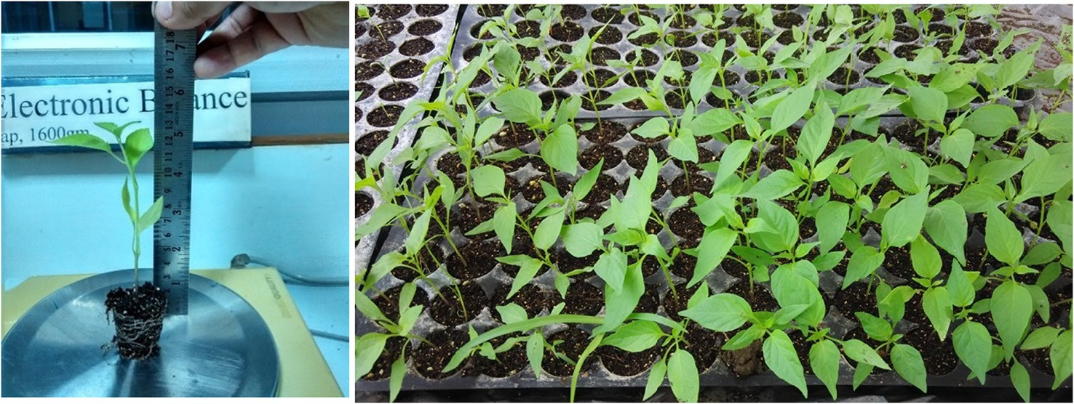

Fig. 1. aSeedlings at 30 days old for transplanting. Fig. 1b Dummy seedlings developed for prior testing.

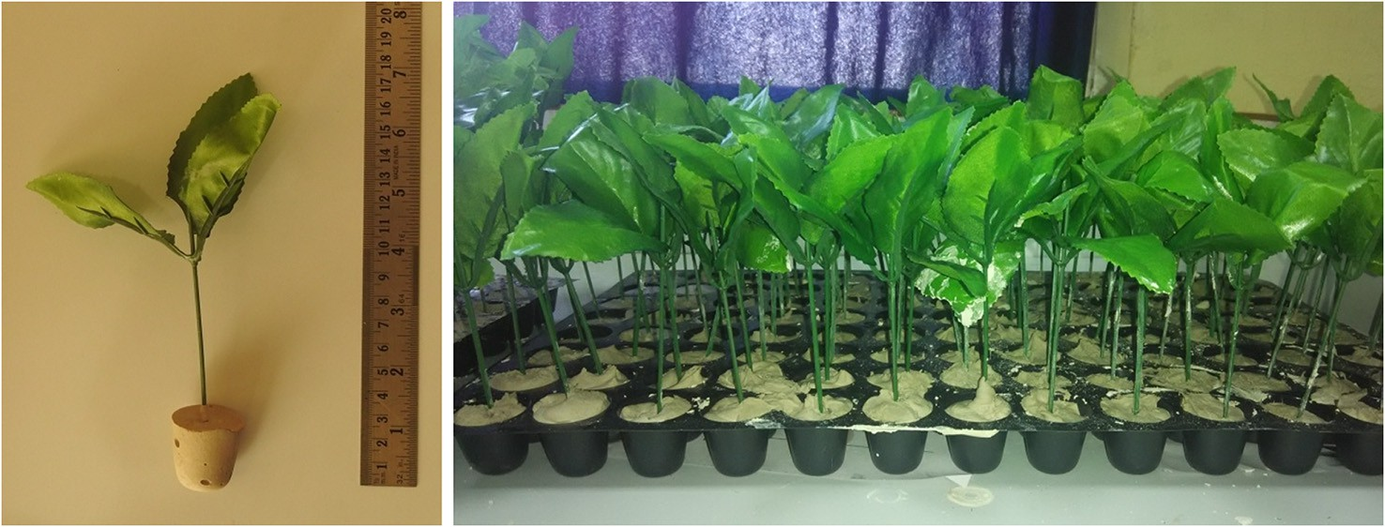

Fig. 1 (*continued*).

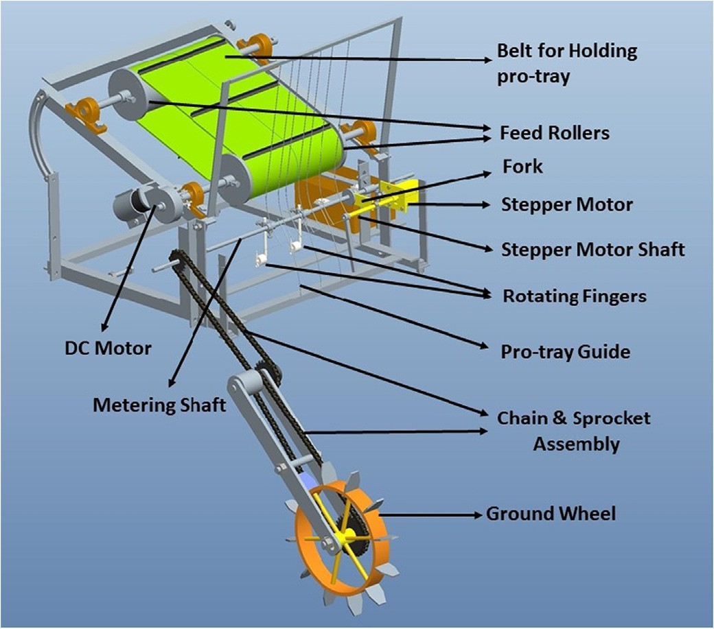

Fig. 2. Schematic diagram of automatic precision seedling transplanter.

used to move the metering shaft to and fro. The DC motor was used to move the protray forward as per the programme. The metering mecha- nism was also controlled by programming using micro-controller, step- per motor and DC motor. The feed roller has to feed one pro-tray of seedlings at a time to the metering system. The sprocket of the ground wheel has 28 teeth and 14 teeth sprocket on the idler shaft. The increase in speed is in a ratio of 2:1.

The idler shaft has sprocket with 20 teeth and sprocket on metering shaft with 12 teeth. The increase in speed is about 1.7 times. This rota- tional speed is used to eject out the plug seedling from the pro-tray into the delivery box. To maintain the optimum plant to plant spacing, the velocity ratio between ground wheel shaft of the feeding mecha- nism and metering shaft is kept as 3.4:1.

* + 1. *Design of embedded system for automatic transplanting*

To release seedling at optimum spacing, a novel transplanting mech- anism was developed which is controlled by electro-mechanic system to automate the operation. In this system ArduinoUno microcontroller is used for operating the driver of DC motor and stepper motor (Fig. 4). Mi- crocontroller generates Pulse Width Modulation (PWM) signals of differ- ent pulse width for both DC and stepper motor. Here, two leaf switches are used for changing the direction of stepper motor attached at

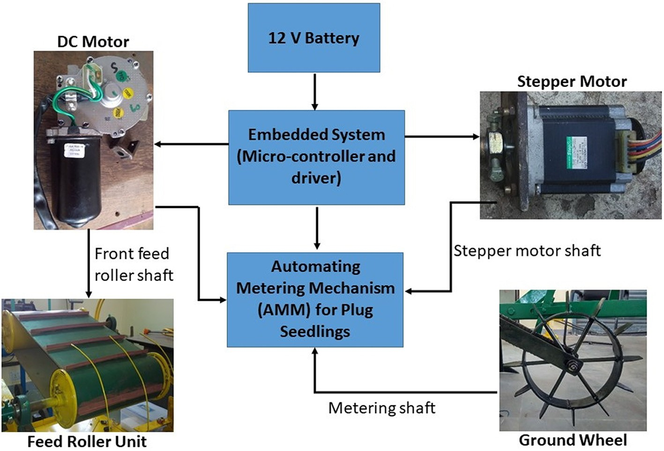

Fig. 3. Working principle of the developed seedling transplanter.

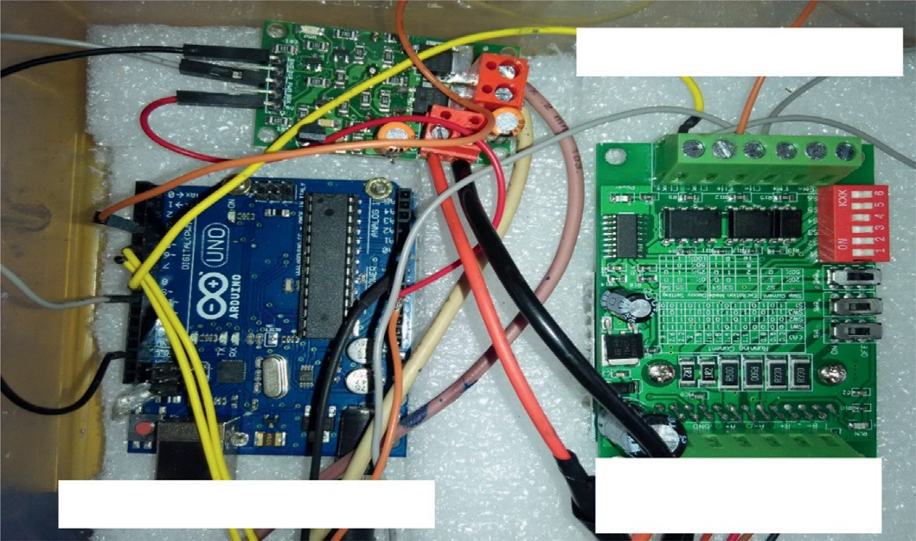

**Driver board for DC motor**

**Arduino for micro-controller**

**Driver board for Stepper motor**

Fig. 4. Electronic components for the developed Embedded System.

120 mm apart from one end. Both the switches were pressed with the help of special bush attached on the metering shaft. When stepper motor moves and its presses the right switch, then controller receive sig- nal from switch digital pin and it gives digital output at direction pin of stepper motor driver. Thus, motor rotates in clockwise direction and when left switch is pressed stepper motor moves in anti-clockwise direc- tion. As the direction of stepper motor changes, DC motor turn ON with delay of 1 s and after 75 milliseconds DC motor becomes off. The DC motor makes to moves only in anticlockwise direction so that the feed roller rotates in forward direction. The microcontroller provides 5 V DC voltage as power supply for both drivers. A 12 V DC battery is used as power supply for both motors and microcontroller.

* 1. *Design and development of experimental transplanting system for plug-type seedling*

The experimental setup was designed and run in soil bin. The differ- ent components of the setup were as follows:

1. Experimental transplanting system
2. Embedded system
   * 1. *Experimental transplanting system for seedling transplanter*

A seedling transplanter was designed and developed which con- sists of a pair of “L-shaped” rotating fingers, pro-tray feed rollers, belt,

metering shaft, pro-tray guides, delivery unit and embedded system. The developed experimental setup was test in soil bin (Fig. 5). To ad- dress the two rows, pair of “L-shaped” rotating fingers was mounted on the metering shaft at distance of 120 mm from one end. The metering shaft is connected with the ground wheel as well as stepper motor. The ground wheel rotates the metering shaft at a specified for- ward speed and rotating fingers ejects the seedling from the pro-tray. The forward and backward motion to the metering shaft was given by the stepper motor.

A single seedling was pushed out from the pro-tray into the delivery tube by striking it from below and placed in the furrow. For more effec- tive delivery of single seedling, pro-tray guide and pro-tray press as- sembly were provided. The pro-tray guide was used to guide the pro- tray in the specified path whereas, pro-tray press assembly “1” was used to press the pro-tray horizontally and pro-tray press assembly “2” was used to press the pro-tray vertically. The seedlings spacing be- tween them can be adjusted by increasing/decreasing the forward speed of the machine. The spacing can also be changed by changing the ratio between forward speed and rpm of the metering shaft (Table 1).

* + 1. *Embedded system*

An embedded system for seedling transplanter comprised of micro- controller board (Arduino Uno), DC motor, stepper motor and button switch. Arduino board has 2 kB SRAM and 1 kB EEPROM, it have 14 dig- ital input/output (I/O) pins (of which 6 can be used as PWM outputs), 6 analog inputs, a USB port, a 16 MHz crystal oscillator, a power jack, an in-circuit serial programming (ICSP) header, and a reset switch. The micro-controller was configured by using open source Arduino software to upload new code without use of an external hardware programmer. The micro-controller board can be powered via USB cable from laptop as well as external power supply adapter. The programming of microcon- troller based system was done in C language.

* + 1. *DC motor actuating unit*

Microcontroller provides a maximum 5 V DC output voltage and to actuate DC motor requires 12 V, hence an intermediator is required be- tween controller and motor. This mediator is DC motor H- bridge driver, it transfers PWM control signal from microcontroller and 12 V power from battery to motor. Driver is able to change the speed of motor on the basis of duty cycle of PWM signal and also vary the direction of

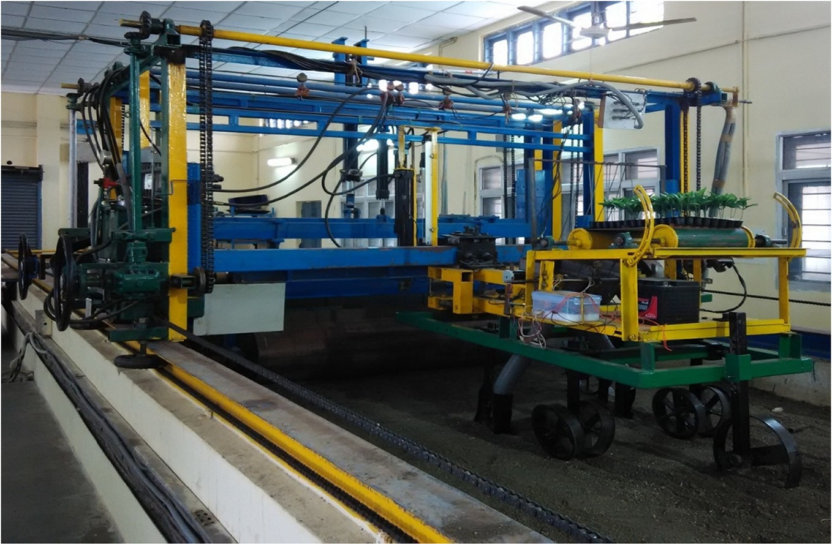

Fig. 5. Developed experimental setup in soil bin laboratory.

Table 1

Specifications of developed two row seedling transplanter.

Sl. No. Particulates Specifications

* + - 1. Processor ATmega328
      2. Power supply mode 12 V DC Battery
      3. Digital I/O pins 6
      4. DC current per I/O pin 40 mA
      5. SRAM 2 kB
      6. EEPROM 1 kB
      7. Typical light running 3 A current, A
      8. Rated torque, Nm 50 Nm (feed roller unit);

2.2 Nm (metering unit)

* + - 1. Normal speed, rpm 72 (feed roller unit); 82 (metering unit)
      2. Overall dimension (l x b x h) 2030 × 1295 × 1015 mm
      3. Weight of seedling transplanter 210 kg

motor according to controller command. The controller provides three types of signal to driver they are: PWM, enable and direction. Enable signal used to actuate the motor or halt the operation of motor, if it is high it turns ON motor, otherwise vice versa. DC motor was operated at 12 V and 5 V was providing to DC motor driver by Arduino for oper- ating the motor at constant speed. Controller generates PWM for con- trolling the speed of motor and it also set the direction of motor clockwise or anticlockwise. DC motor was used for controlling the lon- gitudinal movement of feed roller.

* + 1. *Stepper motor actuating unit*

Stepper motor also requires H-bridge driver for actuating it on the basis of control signals provided by microcontroller. TB6560 driver was used here for stepper motor operation. It also works on the princi- ple of PWM signal and requires both direction and enable signal from controller for performing the operation. Stepper motor move the shaft in which L type rotating fingers are attach used for striking the pro- tray so that seedling comes out from the tray.

* 1. *Design of seedling transplanter*
     1. *System working principle*

The system mainly consists of pro-tray feed roller unit, metering unit, delivery unit and corresponding embedded system. The embed- ded system developed is used to drive the metering mechanism and the mechanical system used to drive the system at optimum rota- tional speed at 3.4:1 transmission ratio to obtain recommended plant to plant spacing. At the same time, the seedling pro-tray feed rollers and metering shaft is driven by DC motor and stepper motor to supply the seedlings transversely and longitudinally, respectively, so as to eject the seedling from the pro-tray and releasing into the fur- row. The entire operation was controlled by embedded system. The pro-trays are fed longitudinally and metering shaft moves trans- versely. The seedlings are ejected by rotating fingers mounted on the metering shaft.

* 1. *Design of control system*
     1. *Component for control system*

ArduinoUno microcontroller is used for operating the driver of DC motor and stepper motor. Microcontroller generates PWM signals of different pulse width for both DC and stepper motor. Here, two leaf switches are used for changing the direction of stepper motor attached at 120 mm apart. When the switch was pressed, the controller receive signal from switch digital pin and it gives digital output at direction pin of stepper motor driver. Thus, motor rotates in clockwise direction and vice-versa. The embedded system works as per the flow chart for developed seedling transplanter (Fig. 6). The micro-controller provides

5 V DC voltage as power supply for both drivers. A 12 V DC battery is used as power supply for both motors and microcontroller.

* + 1. *Complete circuit and software interface of the system*

CNC Router Single Axis 3A Stepper Motor driver board was used for axis control with Input signal high-speed opto-coupler isolation, large heat sink to ensure good heat dissipation. Coding of embedded system had been done in Arduino software in C language as per the circuit dia- gram (Fig. 7). Stepper motor driver is semi-flow mode adjustable, semi- flow current adjustable, with a variety of semi-flow model and semi- flow current setting functions.

* 1. *Performance Evaluation of developed seedling transplanter*
     1. *Experimental protocol*

The developed seedling transplanter unit was fixed to the carriage mounted on soil bin rails. This unit consisted of developed transplanter with metering mechanism, ground wheel and the power transmission. The soil bin experiments were conducted to check the working of the developed system. They were operated simultaneously at factorial com- binations of four levels of forward speed of transplanter (S1 = 1.0, S2 = 1.5, S3 = 2.0 and S4 = 2.5 km/h) and three levels of angle of protray feed roller (A1 = 00, A2 = 300 and A3 = 450), respectively with three replications. Soil bin experiments were conducted on transplanting mechanism to study the effect of machine parameters viz. speed of op- eration on furrow closure, uniformity in spacing and success of transplanting plug seedlings (Table 2). Observations for angle of inclina- tion of stem with vertical, proper furrow closure and plant spacing were recorded at different forward speed. The performance of the system was indicated by measure of plant to plant spacing (PS), planting depth (PD), transplanting efficiency (T), percent furrow closer (FC), angle of inclination of seedling (AI) and miss planting (MP).

* + 1. *Test parameters*

The important performance parameters required to evaluate the transplanting system are plant to plant spacing, planting depth, transplanting efficiency, furrow closer, angle of inclination and miss planting. The equations for calculation of above parameters are given below:

Plant to plant spacing (PS): The distance between plant to plant was measured with the help of measuring tape.

Planting depth (PD): The standard method for measuring depth of planting is by uprooting seedlings and then measuring the depth by steel tape.

Transplanting efficiency (T): The transplanting efficiency was calcu- lated by the ratio of seedlings inclined less than 30° from the vertical and proper soil compaction around roots to the total number of seed- lings transplanted and expressed by equation given below.

Transplanting efficiency, T = *Nt* × 100 (1)

*N*

Where, *Nt* = Number of seedlings successfully transplanted with angle of inclination less than 30° from the vertical and proper soil com- paction around roots.

*N* = Total number of seedlings transplanted.

Furrow closer (FC): For a seedling to be counted as successfully transplanted, the plug of the seedling must be covered and compacted properly with soil. The furrow was said to be properly closed if the root plug of the seedling was not visible and covered completely with soil. Visual observations for furrow closure were recorded as “1” for proper furrow closure and “0” for the rest.

Angle of Inclination (AI): For a seedling to be counted as successfully transplanted, in addition to furrow closer of stem from vertical, the transplanted seedling must be having angle of inclination <300 from the vertical.

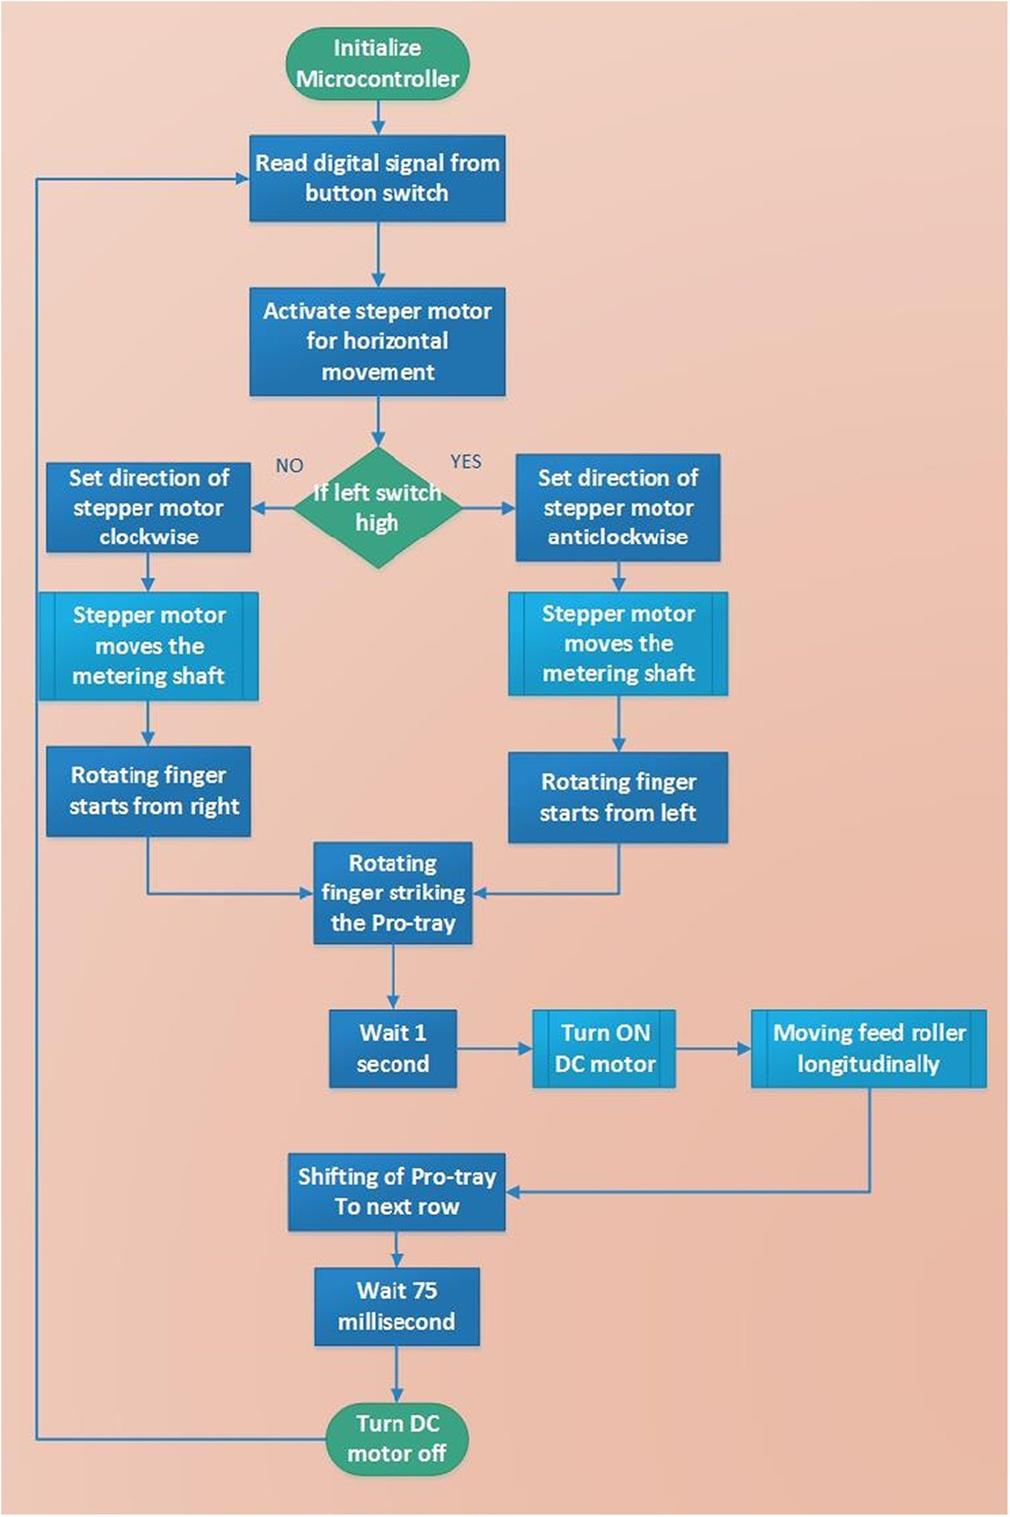

Fig. 6. Flow chart of the embedded automatic transplanting system.

Miss planting (MP): The miss planting can be defined as percent of seedling those were missed to transplant and was expressed by equa- tion given below.

of speed of operation and angle of pro-tray feed roller on different per- formance parameters were studied (Table 3).

The correlations among the application variables S, A, indicators for seedling uniformity that is measured variables (PS, PD, T, FC, AI and

Miss planting, Mp =

*N1*

*N2* ×

100

(2)

MP), the physical rule regarding the operation of the metering mecha- nism and statistical values viz. Standard Error (SE), Standard Deviation (SD) and Coefficient of Variance (CV), related with plant spacing distri- bution according to developed system (Table 4). There is very strong

Where, *N1* = Number of seedlings missed to plant.

*N2* = Number of seedlings to be planted.

1. Results and discussion

The experiment were carried on soil bin at four forward speed of op- eration and at three different inclination of feed roller to get the best combination of result on the basis of performance (Fig. 5). The effect

correlation between many of the physical rules regarding the operation of the metering mechanism and indicator values for seedling uniformity that is the measured variables (PS, PD, T, FC, AI and MP).

* 1. *Plant to plant spacing*

The results of plant to plant spacing for different forward speed and angle of pro-tray feed roller are shown in Fig. 8. The result indicated that

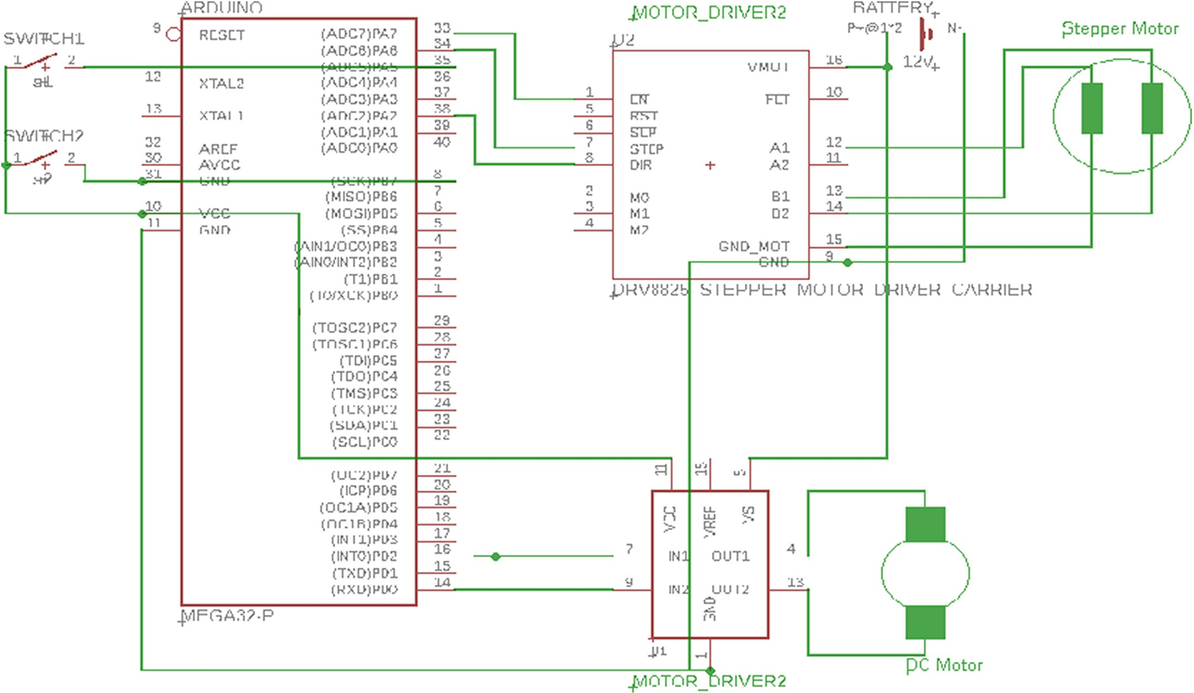

Fig. 7. Circuit diagram used for embedded automatic transplanting system.

Table 2

Experimental design for laboratory tests.

|  |  |  |  |
| --- | --- | --- | --- |
| Sl. No. | Parameters | Levels | Details |
| 1 | Forward speed (0.5–2.5 km/h), (S) | 4 | S1 = 1.0, S2 = 1.5, S3 = 2.0 and S4 = 2.5 km/h |
| 2 | Angle of protray feed roller (00 to 450), (A)* | 3 | A1 = 00, A2 = 300 and A3 = 450 |

* A1 = Angle of protray feed roller (00); A2 = Angle of protray feed roller (300); A3 = Angle of protray feed roller (450).

Table 3

Performance parameters with respect to speed and angle of pro-tray feed roller.

|  |  |  |  |  |  |
| --- | --- | --- | --- | --- | --- |
| Plant spacing (PS), mm | Planting depth (PD), mm | Transplanting efficiency (T), % | Furrow closer (FC), % | Angle of inclination (AI), 0 | Miss Planting (MP), % |
| Speed, S1 = 1.0 km/h  *A1 = 00 749.2 | 52.7 | 73.6 | 77.8 | 19.5 | 4.2 |
| *A2 = 300 710.4 | 52.4 | 77.1 | 79.2 | 21.8 | 4.2 |
| *A3 = 450 636.7 | 52.4 | 67.4 | 69.4 | 23.5 | 8.3 |
| Speed, S2 = 1.5 km/h A1 = 00 681.5 | 51.5 | 75.0 | 82.6 | 20.4 | 4.2 |
| A2 = 300 622.9 | 51.2 | 76.4 | 79.9 | 22.1 | 2.1 |
| A3 = 450 618.7 | 51.2 | 69.4 | 74.3 | 25.6 | 10.4 |
| Speed, S3 = 2.0 km/h A1 = 00 603.2 | 47.1 | 81.3 | 77.1 | 18.4 | 2.1 |
| A2 = 300 600.0 | 46.4 | 91.7 | 90.3 | 18.3 | 2.1 |
| A3 = 450 546.3 | 46.2 | 70.1 | 77.8 | 26.2 | 8.3 |
| Speed, S4 = 2.5 km/h A1 = 00 508.6 | 44.8 | 68.8 | 69.4 | 29.0 | 8.3 |
| A2 = 300 520.2 | 44.7 | 70.8 | 68.1 | 26.9 | 6.3 |
| A3 = 450 451.5 | 43.5 | 61.1 | 60.4 | 31.8 | 20.8 |

* A1 = Angle of protray feed roller (00); A2 = Angle of protray feed roller (300); A3 = Angle of protray feed roller (450).

Table 4

Correlation between operational parameters and performance parameters in the developed system.

|  |  |  |  |  |  |  |  |  |
| --- | --- | --- | --- | --- | --- | --- | --- | --- |
|  | S | A | PS | PD | T | FC | AI | MP |
| PS | −0.801 | −0.315 | 1 |  |  |  |  |  |
| PD | <0.0001  −0.799 | <0.0001  −0.0707 | –  0.70966 | 1 |  |  |  |  |
|  | <0.0001 | 0.399 | <0.0001 | – |  |  |  |  |
| T | 0.136 | −0.295 | 0.10876 | −0.2435 | 1 |  |  |  |
|  | 0.1033 | 0.0003 | 0.1944 | 0.0033 | – |  |  |  |
| FC | 0.032 | −0.468 | 0.21576 | −0.1086 | 0.8914 | 1 |  |  |
|  | 0.699 | <0.0001 | 0.0094 | 0.1951 | <0.0001 | – |  |  |
| AI | 0.490 | 0.408 | −0.6149 | −0.2521 | −0.6162 | −0.682 | 1 |  |
|  | <0.0001 | <0.0001 | <0.0001 | 0.0023 | <0.0001 | <0.0001 | – |  |
| MP | 0.199 | 0.790 | −0.4075 | −0.2213 | −0.2413 | −0.4066 | 0.44318 | 1 |
|  | <0.0001 | <0.0001 | <0.0001 | 0.0077 | 0.0036 | <0.0001 | <0.0001 | – |
| SE | 0.093 | 0.068 | 0.785 | 0.342 | 0.905 | 0.988 | 0.402 | 0.662 |
| SD | 1.122 | 0.819 | 9.423 | 4.102 | 10.859 | 11.859 | 4.824 | 7.94 |
| CV (%) | 44.877 | 40.967 | 15.594 | 8.426 | 17.043 | 17.559 | 20.439 | 66.28 |

 A1  A2  A3 60

A1

A2

A3

80

60 40

Plant spacing, cm

Planting depth, mm

40 20

20

0

S1 S2 S3 S4

0

S1 S2 S3 S4

# Speed of operation, km/h

Speed of opeartion, km/h

Fig. 9. Effect of forward speed and angle of portray feed roller on planting depth

Fig. 8. Effect of forward speed and angle of protray feed roller on plant spacing

the developed transplanter transplants seedling at optimum spacing when the speed of operation is 2.0 km/h (Table 3). The developed mechanism was driven by wheels which rolled over soil bin rails with- out skid. Therefore, there was less chance of variations to be observed in uniformity of spacing in soil bin. However, higher variation in spacing may be expected in actual field conditions due to high skid values of ground wheel.

* 1. *Planting depth*

The observed depth of planting for different forward speed and angle of pro-tray feed roller are shown in Fig. 9. The result indicated that depth of planting decreases with speed of operation irrespective of angle of the pro-tray feed roller. The best results were obtained for S3 and A2 combination.

* 1. *Transplanting efficiency*

The average percentage of seedlings transplanted irrespective of proper furrow closure for selected forward speed and angle of pro- tray feed roller are shown in Fig. 10. In order to achieve higher field ca- pacity, it is desirable to transplant the seedling at higher speeds i.e.

2.0 km/h beyond which the transplanting efficiency reduces. At this speed, the transplanting efficiency was 90.3% which is considered very good (Khadatkar et al., 2018). It was observed from the result that transplanting percentage increases with increase in speed of operation and then reduces afterwards, which may be due to the reason that at higher speed the soil covering was not proper.

* 1. *Furrow closure*

Proper furrow closure with sufficient compaction around the vege- table seedlings is critical criteria for establishment of seedlings after transplanting and also to uphold the seedlings at a transplanted position during early growth stage. The average values of furrow closure out of total seedling transplanted for different forward speed and angle of feed roller are shown in Fig. 11. The result indicated that the percentage furrow closer decreases with increase in speed of operation and angle of pro-tray feed roller upto S3 and then decreases which may be due to bending of seedling at higher speed.

100

A1

A2

A3

80

Transplanting, %

60

40

20

0

S1 S2 S3 S4

# Speed of opeartion, km/h

Fig. 10. Effect of forward speed and angle of portray feed roller on transplanting efficiency

100

80

Furrow closer, %

60

40

20

0

S1 S2 S3 S4

A1

A2

A3

# Speed of opeartion, km/h

At S3 = 2.0 km/h speed and A2 = 300, the miss planting was 2.1% which is considered very good (Khadatkar et al., 2018).

The results above indicated that the developed embedded system work satisfactory with developed programme. It also indicated the test values obtained during the study may be used to carry out the field trial for its efficient working and further development. The results also show that optimum speed of operation as well as angle of pro-tray feed roller can improve the efficiency of the transplanter. Therefore, speed of operation and angle of pro-tray should be optimized to use in the new prototype for further application.

1. Conclusion

The seedling transplanter with embedded automatic transplanting

Fig. 11. Effect of forward speed and angle of portray feed roller on furrow closer

40

A1

A2

A3

Angle of inclination, degrees

30

20

10

0

S1 S2 S3 S4

# Speed of operation, km/h

Fig. 12. Effect of forward speed and angle of protray feed roller on angle of inclination

*3.5. Angle of inclination*

For proper transplanting, it was necessary that the angle on inclina- tion of seedling should be less than 300 from the vertical. The average values of angle on inclination out of total seedling transplanted for dif- ferent forward speed and angle of feed roller are shown in Fig. 12. The result indicated that angle of inclination of seedling increases with in- crease in speed of operation as well as increase in angle of feed roller.

*3.6. Miss planting*

The percent missing of seedlings transplanted at selected forward speed of operation and angle of pro-tray feed roller are shown in Fig. 13. The result indicated that missing per cent increases with in- crease in speed of operation as well as increase in angle of feed roller.

10

A1

A2

A3

8

Miss planting, per cent

6

4

2

0

S1 S2 S3 S4

# Speed of opeartion, km/h

Fig. 13. Effect of forward speed and angle of portray feed roller on miss planting

system that would enable the singulation and optimum plant to plant spacing was developed and tested. An embedded system based soft- ware programme was developed, the hardware design was fabricated and it was integrated successfully with the seedling transplanter. The average values of performance parameters obtained with the developed system was found to be closer to the recommended values. The result indicated that average values of plant to plant spacing, planting depth, transplanting efficiency, percent furrow closer, angle of inclination and miss planting were 600 mm, 46 mm, 90.0%, 84.2%, 180 and 3%, respec- tively. The developed system ensures the optimum transplanting rate, the ability to transplant at higher speeds, singulation of seedlings and maintaining proper plant to plant spacing. The study indicated that speed of operation and angle of pro-tray feed roller are important fac- tors in improving the efficiency of the transplanter.

Funding

The project is a part of the research project that supported by the PRISM, DSIR, New Delhi vide Sanction No. DSIR/PRISM/36/2016 dated 26/10/2016.

Authors credit statement

AK and SMM planned the study, data collected and analyzed. AK and KD developed the electronic circuit. AK and VBB did the statistical anal- ysis. AK, SMM, KD and VBB edited the final article.

Declaration of Competing Interest

The authors declare that there are no conflicts of interest.

Acknowledgement

The authors are thankful to the Dean, CTAE, MPUAT Udaipur and Di- rector, ICAR-CIAE, Bhopal for providing testing facility in this research project. The authors are also grateful DSIR, New Delhi for financial sup- port for this project.

References

Beam, S.M., Miles, G.E., Treece, G.J., Hammer, P.A., Kutz, L.J., Richey, C.B., 1991. [Robotic](http://refhub.elsevier.com/S2589-7217(21)00025-8/rf0005) [transplanting: simulation, design, performance tests. ASAE paper no. 91-7027. St. Jo-](http://refhub.elsevier.com/S2589-7217(21)00025-8/rf0005) [seph, MI, USA, 1991](http://refhub.elsevier.com/S2589-7217(21)00025-8/rf0005).

Brewer, H.L., 1994. [Conceptual modeling automated seedling transfer from growing trays](http://refhub.elsevier.com/S2589-7217(21)00025-8/rf0010) [to shipping modules. Transact. ASAE 37 (4), 1043–1051](http://refhub.elsevier.com/S2589-7217(21)00025-8/rf0010).

Chaudhari, D., Singh, V.V., Dubey, A.K., 2002. [Refinement and adoption of mechanical veg-](http://refhub.elsevier.com/S2589-7217(21)00025-8/rf0015) [etable Transplanter for Indian condition. Ag. Engg. Today 26 (5–6), 11–20](http://refhub.elsevier.com/S2589-7217(21)00025-8/rf0015).

Choi, W.C., Kim, D.C., Ryu, I.H., Kim, K.U., 2002. [Development of a seedling pick-up device](http://refhub.elsevier.com/S2589-7217(21)00025-8/rf0020) [for vegetable transplanters. Transact. ASAE 45 (1), 13–19](http://refhub.elsevier.com/S2589-7217(21)00025-8/rf0020).

Hua, L., Weibin, C., Shufeng, L., Wei, F., Kaiqiang, L., 2015. [Kinematic analysis and test on](http://refhub.elsevier.com/S2589-7217(21)00025-8/rf0025) [automatic pick-up mechanism for chili plug seedling. Transact. Chinese Soc. Agricult.](http://refhub.elsevier.com/S2589-7217(21)00025-8/rf0025) [Eng. 31 (23), 20–27](http://refhub.elsevier.com/S2589-7217(21)00025-8/rf0025).

Hwang, H., Sistler, F.E., 1986. [A robotic pepper Transplanter. Appl. Eng. Agric. 2 (1), 2–](http://refhub.elsevier.com/S2589-7217(21)00025-8/rf0030)5.

Ishak, W.I.W., Awal, M.A., Elango, R., 2008. [Development of an automated transplanter for](http://refhub.elsevier.com/S2589-7217(21)00025-8/rf0035) [the gantry system. Asian J. Sci. Res. 1 (4), 451–45](http://refhub.elsevier.com/S2589-7217(21)00025-8/rf0035)7.

Karayel, D., Wiesehoff, M., Özmerzi, A., Müller, J., 2006. [Laboratory measurement of seed](http://refhub.elsevier.com/S2589-7217(21)00025-8/rf0040) [drill seed spacing and velocity of fall of seeds using high-speed camera system.](http://refhub.elsevier.com/S2589-7217(21)00025-8/rf0040) [Comput. Electron. Agric. 50, 89–96](http://refhub.elsevier.com/S2589-7217(21)00025-8/rf0040).

Khadatkar, A., Mathur, S.M., 2020. Design and development of automatic vegetable trans- planter using novel rotating finger device with push-type mechanism for plug-type seedlings. Int J Vegetable Science, 1–11 [https://doi.org/10.1080/19315260.2020.](https://doi.org/10.1080/19315260.2020.1848962) [1848962](https://doi.org/10.1080/19315260.2020.1848962).

Khadatkar, A., Mathur, S.M., Gaikwad, B.B., 2018. [Automation in transplanting: a smart](http://refhub.elsevier.com/S2589-7217(21)00025-8/rf0050) [way of vegetable cultivation. Curr. Sci. 115 (10), 1884–1892](http://refhub.elsevier.com/S2589-7217(21)00025-8/rf0050).

Khadatkar, A, Mathur, S.M., Gaikwad, B.B., Pandirwar, A.P., Shrinivas, D.J., 2020. [Biometric](http://refhub.elsevier.com/S2589-7217(21)00025-8/opt4okNSSuwWP) [properties of vegetable plug seedlings used in design of vegetable transplanter.](http://refhub.elsevier.com/S2589-7217(21)00025-8/opt4okNSSuwWP)

[J. Agric. Engg. 57 (1), 16–24](http://refhub.elsevier.com/S2589-7217(21)00025-8/opt4okNSSuwWP).

Kim, K.D., Ozaki, S., Kojima, T., 1995. [Development of an automatic robot system for a veg-](http://refhub.elsevier.com/S2589-7217(21)00025-8/rf0055) [etable factory. I. Transplanting and raising seedling robot in a nursery room. Proceed-](http://refhub.elsevier.com/S2589-7217(21)00025-8/rf0055) [ings of ARBIP95, Vol. 1. Kobe, Japan, pp. 157–16](http://refhub.elsevier.com/S2589-7217(21)00025-8/rf0055)3.

Kim, H.J., Park, S.H., Kwak, T.Y., 2001. [Development of an automatic transplanter for cab-](http://refhub.elsevier.com/S2589-7217(21)00025-8/rf0060) [bage cultivation. Korea Automatic Dynamic Analysis of Mechanical Systems Conf.,](http://refhub.elsevier.com/S2589-7217(21)00025-8/rf0060) [Seoul, Korea, 8–9 Nov](http://refhub.elsevier.com/S2589-7217(21)00025-8/rf0060).

Liang, Z., Zhang, D., Yang, L., Cui, T., Hao, Y., 2015. Experimental study on motor driven pneumatic precision seed-metering device for maize. ASABE paper no: 152189758, St Joseph, Michigan <https://doi.org/10.13031/aim.20152189758>.

Miller, E.A., Rascon, J., Koller, A., Porter, W.M., Taylor, R.K., Raun, W.R.B., Kochenower, R., 2012. [Evaluation of corn seed vacuum metering systems. Am. Soc. Agric. Biol. Eng.](http://refhub.elsevier.com/S2589-7217(21)00025-8/rf0070) [Annu. Int. Meet. 7004, 815–825](http://refhub.elsevier.com/S2589-7217(21)00025-8/rf0070).

Navid, H., Ebrahimian, S., Gassemzadeh, H.R., Mousavi, M.J., 2011. [Laboratory evaluation](http://refhub.elsevier.com/S2589-7217(21)00025-8/rf0075) [of seed metering device using image processing method. Aust. J. Agric. Engg. 2, 1–](http://refhub.elsevier.com/S2589-7217(21)00025-8/rf0075)4. Orzolek, M.D., 1996. [Stand establishment in plasti-culture systems. Hort. Technol. 6 (3),](http://refhub.elsevier.com/S2589-7217(21)00025-8/rf0080)

[181–185](http://refhub.elsevier.com/S2589-7217(21)00025-8/rf0080).

Park, S.H., Kim, J.Y., Choi, D.K., Kim, C.K., Kwak, T.Y., Cho, S.C., 2005. [Development of walk-](http://refhub.elsevier.com/S2589-7217(21)00025-8/rf0085) [ing type chinese cabbage transplanter. J. Korea Soc. Agricult. Mach. 30 (2), 80–81](http://refhub.elsevier.com/S2589-7217(21)00025-8/rf0085).

Ryu, K.H., Kim, G., Han, J.S., 2001. [Development of a robotic transplanter for bedding](http://refhub.elsevier.com/S2589-7217(21)00025-8/rf0090) [plants. J. Agric. Eng. Res. 78 (2), 141–14](http://refhub.elsevier.com/S2589-7217(21)00025-8/rf0090)6.

Shaw, L.N., 1997. [Automatic transplanter for vegetables. Proceed. Florida State Horticult.](http://refhub.elsevier.com/S2589-7217(21)00025-8/rf0095)

[Soc. 110, 262–263](http://refhub.elsevier.com/S2589-7217(21)00025-8/rf0095).

Simonton, W., 1991. [Robotic end-effector for handling greenhouse plant material. Trans-](http://refhub.elsevier.com/S2589-7217(21)00025-8/rf0100) [act. ASAE 34 (6), 2615–2621.](http://refhub.elsevier.com/S2589-7217(21)00025-8/rf0100)

Tai, Y.W., Ling, P.P., Ting, K.C., 1994. [Machine vision assisted robotic seedling](http://refhub.elsevier.com/S2589-7217(21)00025-8/rf0105) [transplanting. Transact. ASAE 37 (2), 661–66](http://refhub.elsevier.com/S2589-7217(21)00025-8/rf0105)7.

Ting, K.C., Giacomelli, A., Ling, P.P., 1992. [Workability and productivity of robotic plug](http://refhub.elsevier.com/S2589-7217(21)00025-8/rf0110) [transplanting workcell. In Vitro Cell. Dev. Biol. 28, 5–10](http://refhub.elsevier.com/S2589-7217(21)00025-8/rf0110).

Williames, G.A., 1997. [Apparatus and method for transferring seedlings from plant trays.](http://refhub.elsevier.com/S2589-7217(21)00025-8/rf0115)

[United States patent application 5644999, 8 July](http://refhub.elsevier.com/S2589-7217(21)00025-8/rf0115).

Yazgi, A., Degirmencioglu, A., 2014. [Measurement of seed spacing uniformity perfor-](http://refhub.elsevier.com/S2589-7217(21)00025-8/rf0120) [mance of a precision metering unit as function of the number of holes on vacuum](http://refhub.elsevier.com/S2589-7217(21)00025-8/rf0120) [plate. Measurement 56, 128–13](http://refhub.elsevier.com/S2589-7217(21)00025-8/rf0120)5.

Zhan, Z., Yaoming, L., Jin, C., Lizhang, X., 2010. [Numerical analysis and laboratory testing of](http://refhub.elsevier.com/S2589-7217(21)00025-8/rf0125) [seed spacing uniformity performance for vacuum-cylinder precision seeder. Biosyst.](http://refhub.elsevier.com/S2589-7217(21)00025-8/rf0125) [Eng. 106, 344–35](http://refhub.elsevier.com/S2589-7217(21)00025-8/rf0125)1.