Available online at [www.sciencedirect.com](http://www.sciencedirect.com/)



AASRI Procedia 3 (2012) 203 – 208

2012 AASRI Conference on Modeling, Identification and Control

Distribution Network Reconfiguration Based on Differential Evolution Algorithm

Congjiao Wang  Xihuai Wang  Jidong Liu

*Department of Electrical Engineering, Logistic Engineering College, Shanghai Maritime University, Shanghai 201316 China*

—————————————————————————————————————————————————

Abstract:

According to the configuration of distribution network, this paper put forward the corresponding cyclic decimal coding solution and corresponding mutation, crossover and selection strategy according to problems that during the distribution network reconfiguration, large number of infeasible solutions are produced. Furthermore, we gave the definition of radial decision problem, and solve the reverse problem of the first and the end nodes after reconstruction. The experimental results of the methods of IEEE33 and PG&E69 node simulation show that this method can effectively solve the problem.

© 2012 The Authors. Published by Elsevier B.V. Open access under [CC BY-NC-ND license.](http://creativecommons.org/licenses/by-nc-nd/3.0/)

© 2012 Published by Elsevier B.V. Selection and/or peer [review under respo](http://creativecommons.org/licenses/by-nc-nd/3.0/)nsibility of American Applied Science Research Institute

Selection and/or peer review under responsibility of American Applied Science Research Institute

*Key words: Distribution network structure; Loop decimal coding; Differential evolution algorithm;*

———————————————————————————————————————————————————————

1. Introduction

Distribution network can change opening / closing status of large section switches and contact switches to adjust the structure of network in normal operation condition. In practical applications, distribution network needs to do the optimization reconstruction with the various requirements. But during the reconstruction process, the early branch algorithm brings a great deal of power flow calculation, which increases the computational burden. In order to solve this problem, various artificial intelligence algorithms are more and more applied in distribution network reconfiguration.

* Corresponding author: Congjiao Wang

*E-mail address:* [qinxiaojiayi@hotmail.com](mailto:qinxiaojiayi@hotmail.com)

2212-6716 © 2012 The Authors. Published by Elsevier B.V. Open access under [CC BY-NC-ND license.](http://creativecommons.org/licenses/by-nc-nd/3.0/) Selection and/or peer review under responsibility of American Applied Science Research Institute doi:10.1016/j.aasri.2012.11.034

Differential evolution algorithm, which is introduced by Storn and Price in 1995, has the advantage of less control parameters and good robustness. Some work has been done to extend this algorithm to solve distribution network [1-3].

This article put forward the loop encoding approach based on DE applied in the distribution network reconfiguration, and successfully corrects the insufficiency of the radial determination method of cyclic encoding; finally effectively solve the inconvenience of power flow calculation brought by the coding changes during the network reconstruction. The experimental results show that, the proposed method is effective.

1. Mathematical Model of Distribution Network

Distribution network reconfiguration is through the change of state of the network switch, reached the minimum network loss, highest reliability or multi objective mixed optimal control. This paper selects the least active power loss as objective function, the mathematical expression is:

*n*

*b*

2

min *ƒ*   *ri Ii ki*

*i*1

*(1)*

Where *nb*

represents the total number of branches in distribution network; *ri*

represents resistance of

branch i; *Ii* represents load current of branch i; *ki* represents state of branch i, 0 shows open, 1 shows closed.

Constraints that mathematical model needs to meet as following:

1. Voltage limitation:

*Vi*min *Vi* *Vi*max

Where *Vi* denotes voltage amplitude of node i;*Vi* min ,*Vi* max

1. Branch power constraint:

*S j*  *S j* max

denote voltage limits of node i.

*(2)*

Where *S j* , *S j* max denote power size and maximum transmission power of branch j.

1. The reconfigured network ensures radial structure.
2. The reconfigured network has no island.
3. Improved Coding Strategy
   1. *Cyclic Coding Strategy*

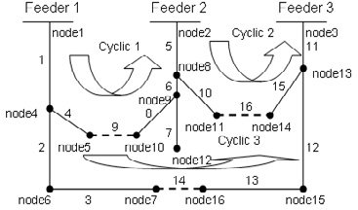Radial distribution network structure requires the number of network contact switches is a fixed number. That means whenever you open a sectionalizing switch you must close a tie switch to meet the requirements of power distribution network radically-running.

Figure.1. loop diagram of three-feeder system

We adopted the following strategies to meet the demand: Firstly, close all switches so a closed loop formed. Thus the loops number must be the same as the number of contact switches. Then encode each network switch according to natural number, and each numbered switch classification in their respective loops. The results are shown in Figure 1. Table 1shows the coding of switches in each loop with the above method.

|  |  |  |  |  |  |  |
| --- | --- | --- | --- | --- | --- | --- |
| Table.1 Coding of switches |  | | | | | |
|  | Cyclic No. |  |  |  |  |  |
|  | 1 | 4 | 9 | 8 | 6 |  |
|  | 2 | 10 | 16 | 15 |  |  |
|  | 3 | 2 | 3 | 14 | 13 | 12 |

By using the proposed method, the individual dimension of DE is equal to the number of contact switches or the number of network loops. Corresponding values of each dimension can be calculated from the respective loop.

The coding rules are suitable for single loop network. However, it still needs to do some certain rules to limit in the processing of the distribution network in which many common switches between the loops.

The author of [4] defined the tie switches as below three classes:

Class 1: Exist no common switch between two loops formed by closing their tie switches.

Class 2: Exist several common switches between two formed loops, but these public switches do not appear in the third loop.

Class 3: Exist several common switches among three formed loops, but these public switches do not appear in the other loops.

For the second case, is divided into 9 states shown in Figure.2:

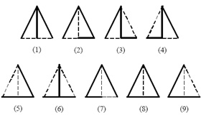

Figure.2 Nine states of class 2

Only the state 8 among them does not meet the requirements that distribution network must be radial because it formed a ring. Thus the rule proposed by author of [4] that determines infeasible solutions based on cyclic coding strategy is: If there are two or more than two public switches are opened, this individual is considered infeasible solution and should be removed. The author proposes the rule also applies to class 3.

However, the author of [5] doubted this representation is not exactly correct. As shown in Figure.3 of the third ring network. If the public switches are , then open switches , the network still forms the radial structure. So the judgment proposed by [5] is inaccurate.

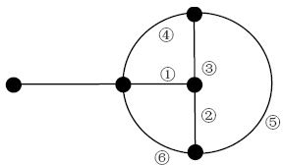

Figure.3 A state of class 3

In view of the above controversy, we redefined the rules for infeasible solutions based on cyclic coding strategy:

Rule 1: Each dimension of DE individual should be different from each other.

Rule 2: The number of the intersection of individual and the public switches between two loops cannot be more than one.

Rule 3: The number of the intersection of individual and the public switches among N loops cannot be more than N-1. (N  3)

Rule 1 successfully avoided the situation of state 8 mentioned in [5]; Rule 2 presented the original idea which [5] intended to express; Rule 3 handled the special case of the third ring network mentioned in [4].

* 1. *The Mutation Strategy Based on Decimal Cyclic Coding*

Each operator of DE population individuals comes from different natural number coding loop in the loop encoding strategy, and has no intrinsic connection between each other. So for DE algorithm, the mutation operation can be continued to do the selection operation accord with the distribution network radiating requirements. As Table.2 shown, each switch number are sequentially encoding with their corresponding loop number below which the number starting from 1, in addition to its own switch number in the loop.

Table.2 Mapping Relationship of the Cyclic Code

Cyclic No.

|  |  |  |  |  |  |
| --- | --- | --- | --- | --- | --- |
| 1 Loop Code | 4 | 9 | 8 | 6 |  |
| Mutation Code | 1 | 2 | 3 | 4 |
| 2 Loop Code | 10 | 16 | 15 |  |  |
| Mutation Code | 1 | 2 | 3 |  |  |
| 3 Loop Code | 2 | 3 | 14 | 13 | 12 |
| Mutation Code | 1 | 2 | 3 | 4 | 5 |

1. Order Adjustment of the First and the Last Nodes

As a result of the reconstruction method in this paper to generate all feasible solutions, run the breadth-first search over the network before load flow calculation. On the one hand, the method solved recoding problem, on the other hand, the method will be layered network in the search process, generate Branch-Level matrix B and Node-Level matrix N. Combined with the above information, it should be easy to calculate the load flow by using forward and backward substitution method.

Preserve the original network structure as shown in Table.3.

Table.3 Network Data Storage Structure

Branch Number(B) First Node(F) Last Node(L) Bi Fi Li

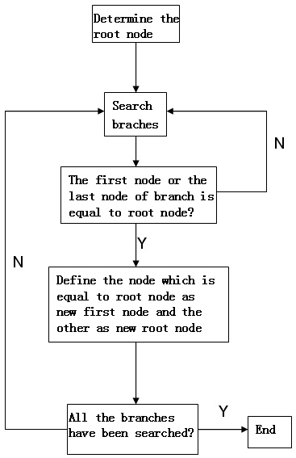Firstly, determine the root node and then search the branches one by one follow the Branch Number. If the number of the starting node or the terminating node is equal to the root node, then define the same one as new starting node and the other one as new root node. Maintain running until all the branches have been searched.

Figuer.4 Algorithm flow chart

After adjusting the nodes, each node in the network corresponds to a number of layers, the layer of original root node is 0 and the layer of each branch is same with that of its last node.

1. Experimental Result

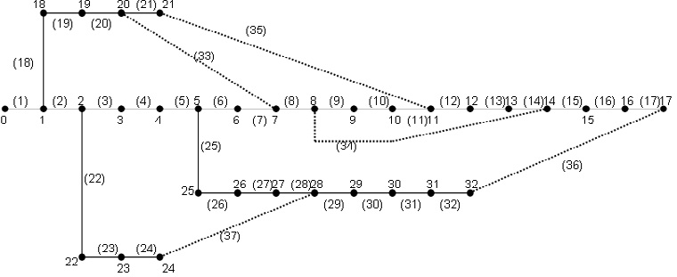The simulation calculation on IEEE 33-bus system was implemented by MATLAB with the minimum network loss as objective function.

Figure.5 IEEE 33-bus system

The distribution system with 32 branches and 5 contact switch branches as shown in Figure.5. The system load *Sbase* is set to 12.65KV. Select the maximum generation iterMax= 100, the initial population size NP=50, CR= 0.3and F= 0.5.The simulation result is shown in Table.4.

Table.4 Comparative Result

|  |  |  |
| --- | --- | --- |
|  | Initial configuration | After reconfiguration |
| Tie switches | 33,34,35,36,37 | 7,9,14,32,37 |
| Network loss/kW | 201.7 | 137.9 |
| Minimum node voltage/pu | 0.9129 | 0.9381 |
| Reduction rate of network loss | 31.58% | |

1. Conclusion

Based on the optimal flow method, this paper adopts a loop gene coding method which applies in Differential Evolution algorithm .And redefined the criteria for determining the radial structure based on this coding method. Put forward a decimal loop encoding strategies, with this method, the Differential Evolution mutation operator has the independent variation bitwise. Finally, this paper gives an adjustment of the order of nodes. The simulation results show that this method solved the problem of node numbering confusion after network reconfiguration, and are fast and efficient.

References

1. Youyun Ao, Hongqin Chi, “Experimental Study on Differential Evolution Strategies”, Global Congress on Intelligent Systems, vol.2, pp.19-24, 2009.
2. Yulin Zhao, Yu Qian and Chunguang Zhao, “Distribution Network Reactive Power Optimization Based on Ant Colony Optimization and Differential Evolution Algorithm”, 2nd IEEE International Symposium on Power Electronics for Distributed Generation Systems”, pp.471-476, 2010.
3. Hongjie He, “Research in Reconfiguration of Distribution Network Based on Binary Particle Swarm Optimization Algorithm”, Thesis of Master Degree, Zhejiang University, 2006.
4. MA Xiu-fang, ZHANG Li-zi, “Distribution Network Reconfiguration Based on Genetic Algorithm Using Decimal Encoding”, TRANSACTIONS OF CHINA ELECTROTECHNICAL SOCIETY, vol.19, No.10, pp.65-69, Oct 2004.
5. WANG Xiu-yun, REN Zhi-qiang and CHU Dong-qing, “Distribution Network Reconfiguration Based on Genetic Arithmetic”, POWER SYSTEM TECHNOLOGY, pp.154-157, Dec 2007.